Original Research Article

Perspective on Sustainable Natural Food Colorant Using Beetroot as a Natural Source

ABSTRACT
Color plays a vital role in the sensory quality of food products, influencing perceptions of safety, flavor, and nutritional value. Natural colorants, particularly those derived from plant sources, have gained popularity due to modern consumers' demand for food safety and the health benefits of natural nutrients. Beetroot, despite limited use in table applications, is rich in essential nutrients like protein, carbohydrates, calcium, and vitamins A and C. Its Betalain pigments provide red and yellow hues, enhancing food appearance. A study conducted in three districts of Assam explored the use of beetroot powder in home cooking. Beetroot powder was made from sun-dried slices and used in recipes such as Kheer, semolina, chicken, laddo, and squash. The recipes were evaluated for organoleptic qualities, and it was found that beetroot powder could be stored for three months without color loss. Additionally, this initiative helps farmers earn extra income while boosting community health with phytochemical benefits.
Keywords: Beetroot, Non-synthetic additive, Betalains, Natural food color, Sustainable food colorants
- INTRODUCTION
Foods are graded with its appearance along with their nutrition. At times, the appearance of the food product in terms of color gets more importance than nutrition itself. The color of a food is one of the essential components in any kind of recipe, as it can draw the attention of the consumer. Therefore, all commercial food producers widely use different colors in their products to attract consumers; even at the home scale level, people incorporate various colors in the preparation of foods. The choice of color used in the food product depends on the type of food item, the choice of the consumer, and also the knowledge of the cook. The right and judicial choice of color adds value to the food product. Magoulas (2009) found that the color of the food affects the perception of people in their choice of food. The Food Safety and Security Act of India standardized the right type and right amount of color components for specified recipes. Although a few sets of people follow the guidance set by FSSAI, people mostly prefer different synthetic colors that are easily available and cheaper in the market. Synthetic colors used in food have different side effects on human health if not applied in appropriate standard proportions. Research indicated that tartrazine and lipid-soluble formulations of erythrosine were associated with asthma, hypersensitivity, urticaria, and thyroid tumors, respectively (Msagati, 2013).
In general, people commonly use beetroot only for table purposes, which creates a surplus market in the locality, thus farmers are deprived of its actual price. Therefore, an alternate means for value addition is a wise choice for the farmers. Beetroot is widely used for obtaining a natural color. The pigments responsible for beetroot’s color are used as natural food colorants, offering a non-toxic alternative to synthetic dyes (Ravichandran et al., 2020). Betalains are nitrogen-containing, water-soluble pigments categorized into betacyanins (red-violet) and betaxanthins (yellow) (Esquivel, 2024). Besides being a food colorant, beetroot is also rich in nutrients. Beetroot contains vitamins A, C, and B complex, along with minerals like iron, calcium, and phosphorus (Masih et al., 2019; Bangar et al., 2023). Research revealed that beetroot supplementation has potential benefits in health and diseases (Clifford et al., 2015) because it has dietary nitrate for managing cardiovascular health. Several investigations have reported that betalains have high antioxidant and anti-inflammatory capabilities. Moreno-Ley et al. (2021) revealed that betalains possess strong anti-inflammatory properties, which can alleviate conditions associated with chronic inflammation. Studies also revealed that regular consumption of beetroot can lower lipid peroxidation, a key factor in oxidative damage, enhance endothelial function, and lower blood pressure, further supporting its therapeutic potential (Clifford et al., 2015; Hussain et al., 2018)
Among the safe food colors, betalain pigment present in red beetroot is widely used in different food products. Betalains are used in foods such as gelatins, desserts, confectionery, dry mixes, poultry, dairy, and meat products. Again, previous research also revealed that for the specific chemical properties of betalains present in beetroot it can be used in foods with short shelf-life, produced by minimum heat treatment, and packaged and marketed in a dry state under reduced levels of light, oxygen, and humidity (Agarwal, 2013). Thus, it is required to find out a few recipes to see the retention of color by using whole beet powder as a food colorant. The extraction of betalain is not an easy process for common people. Therefore, the study was carried out to find out a suitable process for whole beetroot powder preparation at home scale level.
Objectives:
- To find out the feasibility of beetroot powder preparation at home scale level
- To find out the acceptability of beetroot color (whole beetroot powder) in different recipes

- METHODOLOGY:
Matured beetroots (Beta vulgaris, family Chenopodiaceae) having a size of 6.5 – 8 cm in diameter, harvested within 1-2 days, were used for the experiment. The experiment was carried out in a food processing unit of a Self-help group of Barpeta district of Assam. The processing unit has an FSSAI license for food processing and Preservation. The research was conducted as part of the activities of Krishi Vigyan Kendra, Barpeta, Jorhat, and Sonitpur, Assam Agricultural University, Jorhat-13.
2.1 Preparation of beetroot powder at home scale level:
Beets were cleaned and peeled after removing excess water. Then, they were sliced into a 0.5 mm thin diameter. Beet slices were sun-dried till they became crispy. Dried beet slices were then powdered in a mixer grinder. A fine sieve was used to get finer powder. The beetroot powder was stored in a food-grade container at room temperature.
2.2 Incorporation/addition of beetroot powder in recipes:
The addition of more color makes a product duller instead of providing a bright clear color. The optimization of the color level is basically a matter of trial and error (Kamatar, 2013). Based on these principles and the chemical properties of the beet, three common recipes, including Kheer, Chicken Curry, and vermicelli (raw), were selected. The recipes were standardized with their ingredients so that the same recipe, same cooking method, and same serving condition were maintained to test different color effect and their acceptability. The recipes and beet color doses are as follows:
2.2.1 Kheer recipe: the color was used in three different ratios. They were as follows:
K1 = Rice:Beetroot powder; 100g:5g
K2 = Rice:Beetroot powder; 100g:10g
K3 = Rice:Beetroot powder; 100g:15g
2.2.2 Chicken recipe: the color was added as follows:
C1 = Broiler chicken (with bone):Beetroot powder; 1kg:15g
C2 = Broiler chicken (with bone):Beetroot powder; 1kg:20g
C3 = Broiler chicken (with bone):Beetroot powder; 1kg:25g
2.2.3 In Vermicelli preparation the color was added as follows:
V1 = Refined wheat flour:Beetroot powder; 1kg:15 g
V1 = Refined wheat flour:Beetroot powder; 1kg:20 g
V1 = Refined wheat flour:Beetroot powder; 1kg:25 g
2.2.4 Coconut Ladoo preparation, the color was added as follows:
L1 = Grated coconut:Beetroot powder; 1kg:15 g
L1 = Grated coconut:Beetroot powder; 1kg:20 g
L1 = Grated coconut:Beetroot powder; 1kg:25 g
2.3 Organoleptic evaluation of the recipes:
The sensory quality of prepared recipe was examined by a panel of 10 members. The scores on different sensory attributes were obtained by using a 9-point hedonic scale (Amerine et al.,1965). Mean scores for different sensory attributes were calculated to find out the best color dose for particular recipes. Overall, the acceptability score of the scale was considered as best acceptable recipe.
2.4 Details of the recipes:
2.4.1 Kheer:
Ingredients: Rice (local aromatic rice, Joha) 100 g, milk 500 ml, sugar 100 g, clove and cardamom 3-4 nos., 100 ml water, and beetroot powder
Method of cooking: The rice was thoroughly rinsed and soaked in room temperature water for a duration of 15 minutes prior to cooking. The entire mixture was then simmered in a covered pan on low heat for 20 minutes. After 15 minutes of cooking, beet powder was incorporated into the dish.
Sensory evaluation: The serving was done immediately after cooking for the panelists' evaluation.
2.4.2 Chicken preparation:
Ingredients: 1 kg of broiler chicken, cut into small pieces with the bone, 2 medium-sized onions, ½ inch piece of ginger, and 5 cloves of garlic.1 tsp of chicken masala, which is readily available in stores, along with 2 g of a mix of clove, cinnamon, and cardamom powder. Remember to add salt to taste. For a vibrant color effect from the beet, green chili is used instead of red chili. Lastly, 1 ½ tbsp of refined oil and some beetroot powder.
Method of cooking: Heat the oil in a kadhai (a flat pan with a lid) and fry the onions until they turn golden brown. Next, add the ginger-garlic paste and salt, and cook the chicken for 10 minutes uncovered. Then, add water for cooking, along with the remaining spices. Beetroot powder can be added for color. Remove the kadhai from the heat once the mixture reaches a thick consistency.
Sensory evaluation: Served hot to the panelists for judging.
2.4.3 Vermicelli preparation (Raw):
2.4.3.1 Preparation of raw Vermicelli
Ingredients: Refined wheat flour 1 kg, water for making dough, and beetroot powder
Method of preparation: Beet powder was blended into refined wheat flour and then sieved for a more uniform mixture. A firm dough was prepared by incorporating the appropriate amount of purified packaged water available on the market. The dough was then divided into small balls and extruded using a manually operated vermicelli press. The vermicelli was sun-dried for 12 hours until it became crispy and was subsequently stored in a plastic container.
2.4.3.2 Cooking of vermicelli for sensory testing:
Ingredients: Vermicelli 100 g, 2 tbsp ghee, 500 ml milk, sugar 30 g, and beet powder
Method of cooking: Roast cut vermicelli in ghee over low heat, being careful to avoid browning. Add boiled milk and sugar, and cook for 5-7 minutes over medium heat. The entire cooking process should be done without covering the pan. Once you turn off the heat, place the pan on the burner, cover it with a lid, and let it sit for an additional 3 minutes.
Sensory evaluation: Served hot to the panelists for sensory evaluation.
2.4.4 Coconut Ladoo preparation
Ingredients: Desiccated coconut 100 g, sugar 40 g, 2 tbsp ghee, 360 ml milk, cardamom powder, and beet powder
Method of cooking: Sauté grated coconut and beet powder in ghee until fragrant, then add milk and cook until the mixture thickens. Next, incorporate sugar and continue to cook until the mixture pulls away from the sides of the pan. Once this occurs, add cardamom powder. After allowing it to cool slightly, shape the mixture into small balls and roll them to finish.
Sensory evaluation: Served in a normal temperature to the panelists for judging.
- RESEARCH FINDINGS AND DISCUSSION
The results and discussion of the present study were presented under the following sub-heads:
3.1 Processing of beetroot powder at home scale level
Finer quality beetroot powder can be produced on a small scale at home. From one kilogram of beetroot, approximately 310 grams of high-quality beet powder can be obtained. For the recipes, beetroot powder was stored in a food-grade container and kept at room temperature for two months. The findings from the recipes indicated that the color pigment remained well-preserved after the beet slices were dried in sunlight and during the two months of storage. Previous research reported that the rate of betalain degradation increased 15.6% after pigment daylight exposure at 15ºC (Von Elbe et al., 1974). Degradation of light-exposed betalains followed a first-order kinetic (Agarwal, 2013).
3.2 Organoleptic evaluation of the prepared recipes:
Addition of beet color in kheer, chicken curry, vermicelli, and coconut laddo results in an attractive color of purple-pink in kheer and vermicelli and deep red in chicken curry and laddo. Previous research in this field also opined that compared to some other color pigments the color hue does not change with pH in the range of 4-7 thus, nowadays it is mostly used by different food industries.
3.2.1 Sensory evaluation of kheer, vermicelli and chicken curry and laddo:
3.2.1.1 Color:
Results revealed (Table 1) that color of kheer (K3) had the highest score of 8.2 followed by K2 and K1. The K3 had highest score in color attributes but judges opined that a beet smell was found in K3 for that reason they liked K2 as best recipe (7.7 in overall acceptability). Based on color of cooked vermicelli, V3 had the highest mean score of 8 followed by V2 and V1 (Table 2). From the experiment, it was found that care should be taken in roasting vermicelli in ghee as it easily turns brown color. This may be due to the fact that the major disadvantage of beetroot color is low heat stability (Agarwal, 2013). From table 3, it was found that among the chicken thick gravy recipes, C3 was found to be most acceptable recipe (overall acceptability is 8.5) by the judges followed by C2 and C1.
3.2.1.2 Flavor:
Table 1 shows that flavor of K1 and K2 of kheer is liked by the panelist compared to K3 which scored 4.3, disliked slightly. From the Table 2, it was found that all the vermicelli recipes with beet color was liked by the panel and V3 scored the highest of 8. Results from table 3, it was found that the flavor of chicken recipes with beet color was liked by the panel and C3 was liked very much (8.3). Therefore, from the experiment, it was found that addition of whole large quantity beetroot powder in milk recipes may have beet flavor. Kamatar (2013) also cited that some natural colors, especially beet, can produce undesirable flavor if used at too high level.
3.2.1.3 Taste:
Results revealed that kheer recipes K2 had the highest score of 7.5 followed by K1 and K3 which were equally scored as 7.3 (Table 1). In case of vermicelli and ladoo, V3 and L3 scored highest point of 8.6 (Table 2 and Table 4) and Chicken curry, C3 scored 8.2 as highest score. The taste of all the recipes with beet color was liked by the judges though among the recipes cooked vermicelli, laddo and chicken curry taste were liked very much by the judges.
3.2.1.4 Texture:
Table 1 shows that among the kheer recipes, K1 and K2 had equal scores of 7.7 which is slightly higher than K3. From table 2, it was found that V1 and V2 scored equally of 7.5 and V3 was higher score of 7.8. Texture for the chicken curry scored highest in C3 i.e., 7.8 followed by C1 and C2 scored 7.5. The texture of the all recipes scored in the same range of likeness as beet color had no adverse effect on texture of the cooked product.
Table 1: Mean scores of Organoleptic Evaluation of Kheer colored with beetroot powder (whole)
Parameters | Kheer
 | Beet powder @ 5g/100g rice | Beet powder @ 10g/100g rice | Beet powder @ 15g/100g rice
Color | 6.5 | 7.5 | 8.2
Flavor | 7.7 | 7.7 | 4.3
Taste | 7.5 | 7.5 | 7.3
Texture | 7.7 | 7.7 | 7.5
Overall acceptability | 7.5 | 7.7 | 7.4
*1-9 point scoring scale (1=Dislike extremely, 9=Like extremely)
Table 2: Mean scores of Organoleptic Evaluation of Vermicelli colored with beetroot powder (whole)
Parameters | Cooked vermicelli
 | Beet powder @ 15g/kg refined wheat flour | Beet powder @ 20g/kg refined wheat flour | Beet powder @ 25g/kg refined wheat flour
Color | 5.9 | 7 | 8
Flavor | 7.5 | 7.5 | 8
Taste | 6.9 | 7.3 | 8.6
Texture | 7.5 | 7.5 | 7.8
Overall acceptability | 6.8 | 7.4 | 7.9
*1-9 point scoring scale (1=Dislike extremely, 9=Like extremely)
Table 3: Mean scores of Organoleptic Evaluation of chicken curry colored with beetroot powder (whole)
Parameters | Chicken color
 | Beet powder @ 15g/kg broiler chicken | Beet powder @ 20g/kg broiler chicken | Beet powder @ 25g/kg broiler chicken
Color | 6.8 | 7.3 | 8.5
Flavor | 7.5 | 7.5 | 8.3
Taste | 7.5 | 7.8 | 8.2
Texture | 7.5 | 7.5 | 7.8
Overall acceptability | 7.5 | 7.8 | 8.2
*1-9 point scoring scale (1=Dislike extremely, 9=Like extremely)
Table 4: Mean scores of Organoleptic Evaluation of Coconut ladoo colored with beetroot powder (whole)
Parameters | Coconut Ladoo
 | Beet powder @ 15g/kg grated coconut | Beet powder @ 20g/kg grated coconut | Beet powder @ 25g/kg grated coconut
Color | 6.5 | 7.5 | 7.8
Flavor | 7.4 | 7.5 | 8.2
Taste | 7.5 | 7.6 | 8.6
Texture | 7.6 | 7.7 | 7.8
Overall acceptability | 6.8 | 7.2 | 7.9
*1-9 point scoring scale (1=Dislike extremely, 9=Like extremely)

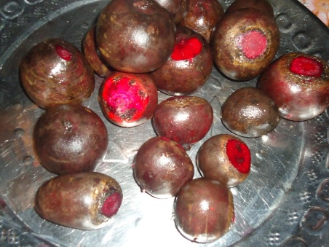 | 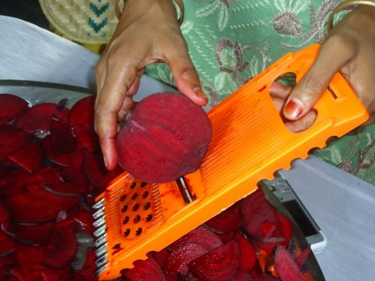 | 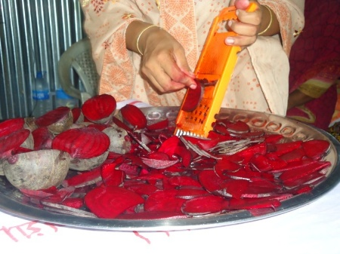
Fig. 1. Beet slice preparation

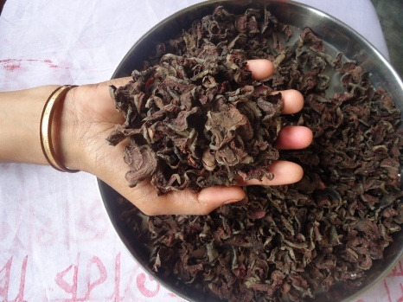 | 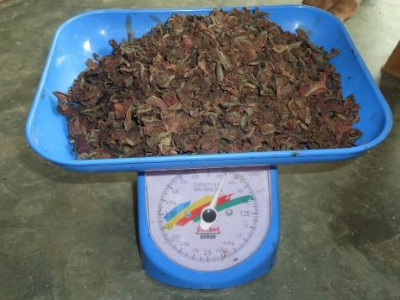 | 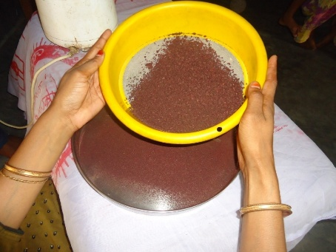
Fig. 2. Sun Dried beet slices

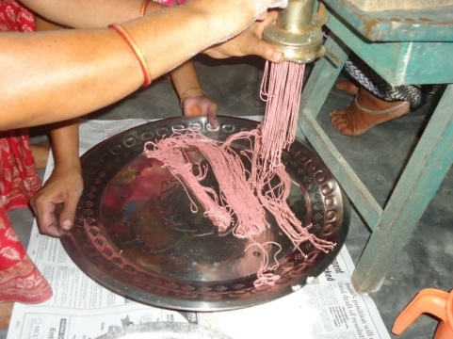 | 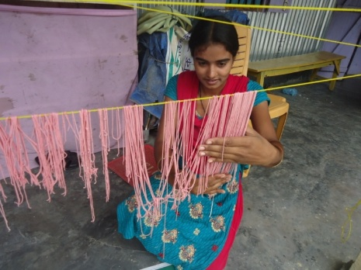 | 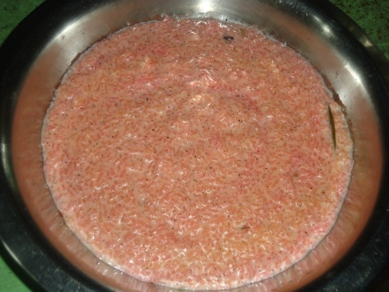
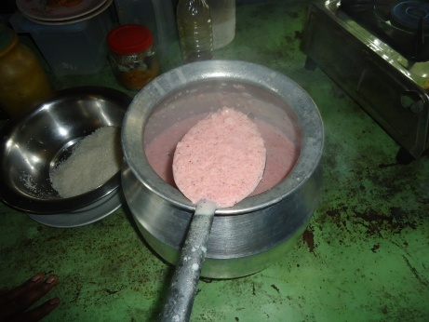 | 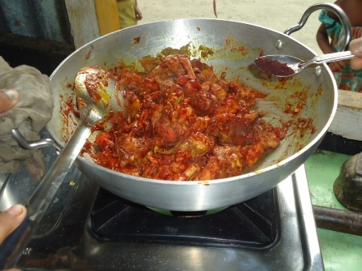 | 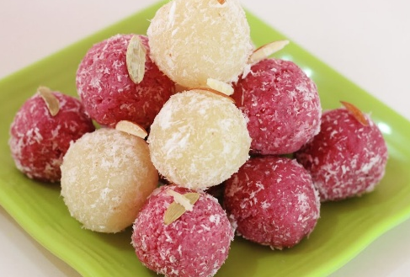
Fig. 3. Using beetroot color to food items

3.3 Overall acceptability:
The sensory quality of all cooked products was assessed based on their overall acceptability. The application of beetroot powder in kheer recipes indicated that formulation K2 received the highest score of 7.7 (as shown in Table 1). The light purple color enhanced the visual appeal of the kheer. According to Table 2, among the vermicelli recipes, V3 achieved the highest score of 7.9, with both raw and cooked vermicelli across all formulations exhibiting a light purple hue. Table 3 results demonstrated that in the chicken preparation, C3 attained the highest sensory score of 8.2. The judges particularly favored the bright reddish color observed in C3 and L3, which was the most appealing among all the beetroot-enhanced recipes.
- Conclusion
Beetroot color powder, made at home, can be effectively used as a natural food coloring in recipes such as kheer, vermicelli, laddo, and chicken dishes. It serves as a safe alternative to synthetic food colors readily available in the market. Incorporating whole beetroot powder into recipes not only adds color variety but also boosts the nutritional value of the diet. This powder can be easily prepared at home scale level using a simple mixer grinder and can be stored at room temperature for up to two months. Therefore, farmers can consider this value addition to beetroot as a means to generate supplemental income.
- REFERENCES
Amerine, M. A., Pangborn, R. M., & Roessler, E. B. (1965). Principles of sensory evaluation of food Academic Press. New York/London, 235, 241.
Kamatar, M. Y. (2013, February). Natural food colouring: A healthier alternative to artificial food colouring. In Proceedings of the Global Milling Conference: Saftey, Sustainability and Food Supply for the 21st Century, Chennai, India.
Agrawal, A. (2013). Scope of betalains as a food colorant. International J. of Advanced Scientific and Technical Research, 3(3), 22-36.
Von Elbe, J. H., Maing, I. Y., & Amundson, C. H. (1974). Color stability of betanin. Journal of Food Science, 39(2), 334-337.
Msagati, T. A. M. (2013). Chemistry of food additives and preservatives: emulsifiers.
Clifford, T., Howatson, G., West, D. J., & Stevenson, E. J. (2015). The potential benefits of red beetroot supplementation in health and disease. Nutrients, 7(4), 2801-2822.
Magoulas, C. (2009). How color affects food choices.
Masih, D., Singh, N., & Singh, A. (2019). Red beetroot: A source of natural colourant and antioxidants: A review. Journal of Pharmacognosy and Phytochemistry, 8(4), 162-166.
Bangar, S. P., Singh, A., Chaudhary, V., Sharma, N., & Lorenzo, J. M. (2023). Beetroot as a novel ingredient for its versatile food applications. Critical Reviews in Food Science and Nutrition, 63(26), 8403-8427.
Ravichandran, K., Smetanska, I., & Antony, U. (2020). Red beet. In Nutritional Composition and Antioxidant Properties of Fruits and Vegetables (pp. 315-321). Academic Press.
Esquivel, P. (2024). Betalains. In Handbook on natural pigments in food and beverages (pp. 147-167). Woodhead Publishing.
Moreno-Ley, C. M., Osorio-Revilla, G., Hernández-Martínez, D. M., Ramos-Monroy, O. A., & Gallardo-Velázquez, T. (2021). Anti-inflammatory activity of betalains: A comprehensive review. Human Nutrition & Metabolism, 25, 200126.
Clifford, T., Howatson, G., West, D. J., & Stevenson, E. J. (2015). The potential benefits of red beetroot supplementation in health and disease. Nutrients, 7(4), 2801-2822.
Hussain, E. A., Sadiq, Z., & Zia-Ul-Haq, M. (2018). Role of Betalain in Human Health. In Betalains: Biomolecular Aspects (pp. 97-107). Cham: Springer International Publishing.

APPENDIX
Hedonic 9-point scale
Participants likeness |  | Score
- Like extremely | ------------------------ | 9
- Like very much | ------------------------ | 8
- Like moderately | ------------------------ | 7
- Like slightly | ------------------------ | 6
- Neither like nor dislike | ------------------------ | 5
- Dislike slightly | ------------------------ | 4
- Dislike moderately | ------------------------ | 3
- Dislike very much | ------------------------ | 2
- Dislike extremely | ------------------------ | 1

