Review Article

A Review on Phytoremediation Using Organic Amendments - Opportunities and Limitations

Abstract-
Phytoremediation, an eco-friendly and cost-effective technology, employs plants to remove, stabilize, or degrade contaminants from soil and water systems. However, its efficiency is often constrained by poor plant growth and limited bioavailability of pollutants. The integration of organic amendments such as compost, biochar, farmyard manure, vermicompost, and green manure has emerged as a promising approach to enhance phytoremediation potential. These amendments improve soil physicochemical properties, increase microbial activity, and alter contaminant mobility through chelation, adsorption, and redox reactions. Recent studies have demonstrated that organic inputs can enhance plant biomass, root proliferation, and enzymatic activity, thereby accelerating the uptake or immobilization of heavy metals and organic pollutants. Despite these advantages, challenges remain regarding the inconsistent performance across soil types, potential release of secondary pollutants, and long-term stability of immobilized contaminants. This review examines the mechanisms through which organic amendments influence phytoremediation, highlights their synergistic effects with different plant species, and discusses key limitations and research gaps. A better understanding of amendment–soil–plant interactions will facilitate the development of sustainable remediation strategies for contaminated environments.
Keywords- Phytoremediation, Organic amendments, Biochar, Compost, Heavy metal remediation, Soil restoration and Sustainable remediation

Introduction
Traditional methods for environmental cleanup face numerous challenges, including the potential to shift problems into new environmental crises, non-sustainability, high costs, limited applicability, and an inability to integrate with other treatments or be used for in situ applications. These methods also often leave behind significant environmental footprints. Metallic elements (MEs) are particularly resistant to sustainable removal using existing commercial treatment technologies.
Additionally, new types of wastewater such as those generated by healthcare facilities, pharmacological industries, and hospitals are becoming increasingly prevalent due to the impacts of urbanization and overpopulation. These wastewaters contain a complex array of pollutants for which no effective traditional treatment methods currently exist. Consequently, research in this area focuses on addressing both health concerns and pollutant removal. Compounding the issue, many pollutants cannot be effectively treated in conventional wastewater treatment plants (Abbas et al., 2018).
This situation underscores the urgent need for innovative treatment techniques that are cost-effective (Yadav et al., 2023), environmentally sustainable (Xu et al., 2020), and capable of addressing a wide range of pollutants across various concentrations (Olivares, 2013). Such techniques should also support integration with other methods (Wang et al., 2024), allow for in situ applications (Cheng et al., 2015), and be scalable for large-scale use (Quilliam et al., 2012). Furthermore, they should work in conjunction with other cleanup strategies or enhancements, such as adsorbents (Rathankumar et al., 2022), nutrients, and organic amendments (Park et al., 2011), to effectively address current environmental pollution challenges.
Phytoremediation has emerged as a promising alternative for managing environmental pollution, offering the potential for higher efficiency, reduced ecological impact, and economic feasibility. This green technology has shown considerable success in addressing serious anthropogenic pollution. However, a fair assessment of its limitations is essential to optimize its use. Additionally, specifying its application to particular waste types, such as municipal wastewater (McGee, 2016), could help balance its advantages against its drawbacks. This review aims to provide a comprehensive evaluation of the merits and limitations of phytoremediation, offering insights to guide future studies and enhance the application of this innovative treatment method.

Source of heavy metal in polluted soil
Human activities, urban & rural waste,natural sources, pesticides and fertilizers, industrial waste products are the root cause of Heavy metalsin the soil, it can enter into the soil from a variety of human activities like mining and smelting, the heavy metals are released during operations. Industrial waste are the discarded materials during processing, which are not useful further in factories or miles, it can be liquid, solid, semisolid, may be hazardous for nature or human, Li et al.,(2021). It may include oil, solvents, chemicals, scrap, dirt and gravel or others.Heavy metals are released from mining and smelting operations,agricultural activities like use of different types of fertilizers and pesticides, sewage and wastewater output of industries. The burning of fossil fuel and coal releases,heavy metals in environment as well.The particulate matters present in our environment are also the cause of heavy metals in environment. Wang et al.,(2021). Other sources of heavy metals in our environment includes volcanic eruptions, weathering of rocks etc. The heavy metals are major environmental pollutants which are bio- accumulative, persistent and toxic for all living organism. The affecting by entering into food chain through water and soil. The techniqueremoves or restrict, decompose, detoxifyheavy metals from polluted soil by using plantare known as Phytoremediation. The rate of phytoremediation can be enhanced by putting organic amendments like Biochar, Kitchen waste, caw dung, FYM etc. This is very much economical process to do soil remediation.

FIG. 1 Sources of Heavy Metals in Soil Ecosystem

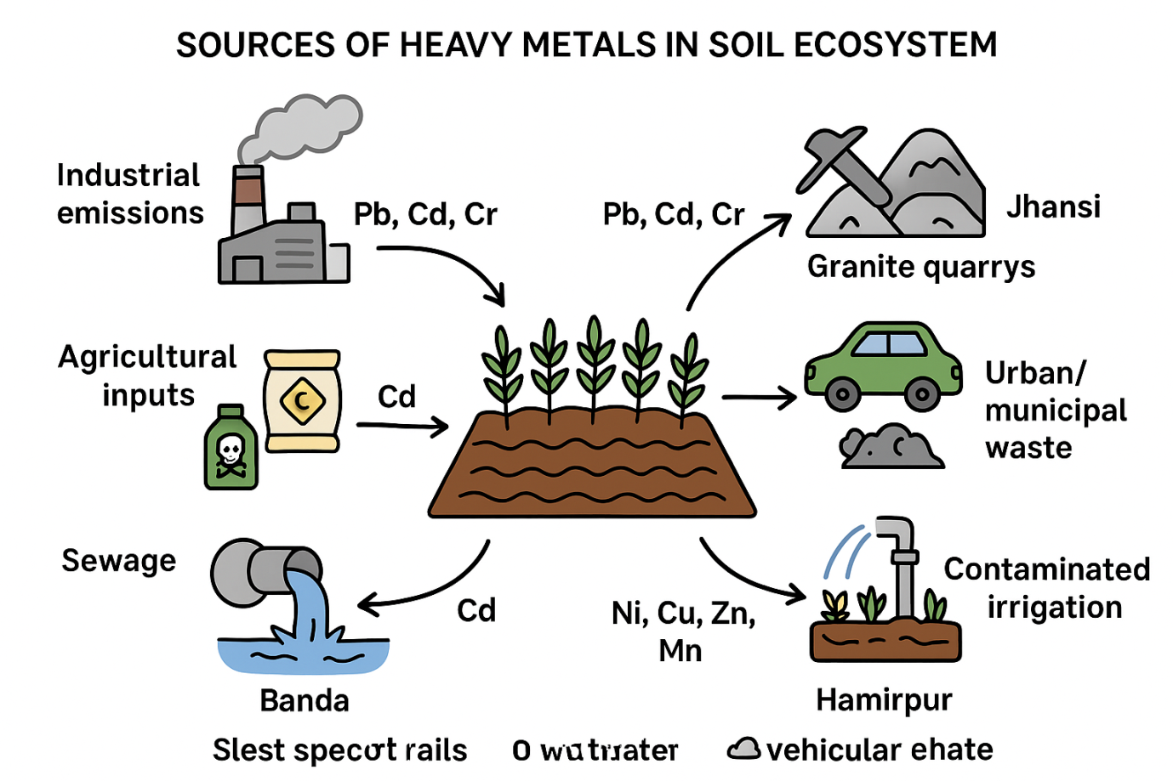

Agriculture soil and heavy metals in Bundelkhand region:
Bundelkhand region consists of seven districts of Uttar Pradesh (Jhansi, Jalaun, Lalitpur, Hamirpur, Mahoba, Banda, and Chitrakoot) and six district of Madhya Pradesh (Datia, Tikamgarh, Chatarpur, Damoh, Sagar, and Panna) of central India.
The Jhansi Bundelkhand region, located in central India, has a diverse agricultural landscape but faces several challenges due to its soil and climatic conditions. Agriculture and its associated industries are vital for the economy of Jhansi and the surrounding region. The soil in the area exhibits variations in depth, topography, and color. Based on these characteristics, two primary soil types are found: red (upland soil) and black (lowland soil), which further give rise to four distinct soil series: Rcker and Parwa for red soil, and Kabar and Mar for black soil. The soil texture in the region includes gravel and sandy loam on gentle slopes (0.5%) and clay loam on steeper slopes (10%). The organic carbon content ranges from low to medium, influencing soil fertility, while water retention capacity varies from very low to high. These factors, along with the availability of vegetation, livestock, and water resources, play a significant role in determining the cropping patterns and farming conditions in Jhansi and its neighboring areas (CGWB 2018).

Soil Characteristics of Jhansi (Bundelkhand Region):
- Soil Types: The region has a mix of sandy, loamy, and clayey soils.
- Soil Fertility: The soil is generally deficient in nutrients like nitrogen, phosphorus, and organic matter.
- pH Levels: The soil can be slightly acidic to neutral but varies in different parts of the region.
- Irrigation Issues: Due to low rainfall and groundwater depletion, the soil may face water stress.
The region primarily grows crops like wheat, maize, rice, and pulses such as gram and pigeon peas. Oilseeds like groundnut and mustard, along with cash crops such as cotton and sugarcane, are also cultivated. However, irregular rainfall, water scarcity, and droughts significantly impact crop production. The soils of Bundelkhand are mostly arid and semi-arid, with light sandy soils or sandy loams dominating the area, though black soils are found in some pockets, particularly suited for crops like cotton Qian et al.,(2023). The soil fertility is generally low, with a deficiency in organic matter and key nutrients like nitrogen and phosphorus. This necessitates the use of fertilizers and organic amendments. Furthermore, soil erosion is a concern, exacerbated by deforestation and intensive farming practices. To mitigate these issues, farmers are increasingly adopting water conservation practices, micro-irrigation techniques, and soil management strategies like composting and watershed management Li et al.,(2021). Despite these challenges, Bundelkhand’s agriculture holds potential, provided sustainable farming practices are promoted.
The Bundelkhand region is marked by a range of factors that severely constrain agricultural productivity and sustainability. Its shallow red soils are low in fertility and depth, making them unsuitable for intensive farming practices. The undulating topography further exacerbates the problem by causing excessive runoff and soil erosion, leading to significant nutrient loss Qayyum et al.,(2021).The region experiences extreme weather conditions, including high temperatures and erratic rainfall, which, combined with frequent and recurrent droughts, create a highly unpredictable environment for farming. These challenges result in low crop productivity, limited cropping intensity, and poor agricultural outputs.
Moreover, the low moisture-holding capacity of the soil makes it nearly impossible to sustain crops using residual moisture after the rainy season. This limitation is particularly problematic during the post-monsoon period when water becomes scarce. Recurrent droughts worsen the situation, as the lack of water severely restricts irrigation and reduces the viability of farming activities Labidi et al.,(2015).The cumulative effect of these issues not only impacts agricultural livelihoods but also accelerates environmental degradation. To address these challenges, the region requires a comprehensive approach that includes soil and water conservation, adoption of drought-resistant crop varieties, afforestation, and the development of efficient irrigation systems.
TABLE 1. Physicochemical Characteristics of Water Samples Compared with WHO Drinking Water Guidelines

Parameter | Average ± Std. Dev (±) | Min | Max | WHO Guideline Value
pH | 7.26 ± 0.163 | 7.11 | 7.61 | 6.5–8.5
EC (µS/cm) | 530.80 ± 98.46 | 324.00 | 657.00 | 300
TDS (mg/l) | 484.40 ± 117.69 | 356.00 | 612.00 | 500
Turbidity (mg/l) | 3.12 ± 0.644 | 1.90 | 4.10 | 5
DO (mg/l) | 3.58 ± 0.651 | 2.67 | 4.34 | -
BOD (mg/l) | 7.53 ± 1.085 | 5.38 | 8.97 | 6
Alkalinity (mg/l) | 216.40 ± 48.36 | 167.00 | 289.00 | 200
TH (mg/l) | 352.10 ± 49.63 | 287.00 | 456.00 | 150–500
Ca (mg/l) | 178.80 ± 47.76 | 100.00 | 278.00 | -
Mg (mg/l) | 115.00 ± 38.38 | 72.00 | 177.00 | 150
SO4 (mg/l) | 316.60 ± 8.119 | 300.14 | 324.64 | 250
Cl (mg/l) | 624.39 ± 35.67 | 589.49 | 713.71 | 500
Na (mg/l) | 50.70 ± 7.78 | 23.00 | 42.00 | -
K (mg/l) | 32.30 ± 10.80 | 30.00 | 21.00 | 30
Cd (mg/l) | 0.04 ± 0.012 | 0.02 | 0.02 | 0.01
Fe (mg/l) | 0.28 ± 0.09 | 0.18 | 0.46 | -
Mn (mg/l) | 0.16 ± 0.03 | 0.05 | 0.35 | -
Pb (mg/l) | 0.58 ± 0.16 | 0.10 | 0.22 | 0.01
Zn (mg/l) | 0.28 ± 0.37 | 0.00 | 0.09 | 3
The soil in the Bundelkhand region of India contains a variety of heavy metals, including: Iron (Fe), Copper (Cu), Chromium (Cr), Manganese (Mn), and Lead (Pb). Other heavy metals that can be found in soil include: Zinc (Zn), Mercury (Hg), Cadmium (Cd), Nickel (Ni), Aluminum (Al), Barium (Ba), Cobalt (Co), Selenium (Se), and Silver (Ag).The presence of heavy metals in soil can pose environmental and health risks.
The accumulation of heavy metals (HMs) in agricultural soil presents a serious environmental challenge. Concentrations of Cu, Mn, Zn, Cd, Pb, Ni, and Co were analyzed in soil samples to evaluate their potential impacts Kumpiene et al.,(2011). Various contamination indices, including the contamination factor, geo-accumulation index, and ecological risk index, indicated that Cd contributes significantly to moderate to high soil contamination.
Multivariate statistical analyses, such as PCA, HCA, and correlation matrices, revealed a mixed origin of the heavy metals, suggesting both natural and anthropogenic sources. Among the exposure pathways, ingestion was identified as the primary route, while dermal and inhalation exposure were found to be negligible.
Health risk assessments determined that non-carcinogenic risks are within safe limits for human health. However, children are more vulnerable than adults due to their higher exposure to toxic agents via hand-to-mouth activities Kumari et al.,(2011). Additionally, no carcinogenic risks were observed for inhalation exposure to Cd, Ni, and Co. These findings highlight the need for monitoring and managing heavy metal contamination in agricultural soils to mitigate potential risks to human health and the environment.
Phytoremediation Mechanism
Phytoremediation refers to the use of plants to remove, degrade, or stabilize environmental pollutants, offering an eco-friendly and cost-effective solution to contaminated soils, water, and air Hatzinger et al.,(1995). This natural process utilizes the unique abilities of certain plants to either absorb or transform harmful contaminants, making phytoremediation a viable alternative to more conventional methods like chemical treatments or excavation. The mechanisms through which plants accomplish phytoremediation are diverse and depend on the specific type of pollutant and plant involved Hassan et al.,(2024). This article delves into the primary mechanisms of phytoremediation, including phytoextraction, phytodegradation, phytovolatilization, phytostabilization, rhizodegradation, and rhizofiltration, highlighting their processes, advantages, and limitations.

1. Phytoextraction: Uptake and Accumulation of Pollutants
Phytoextraction is one of the most widely studied and applied mechanisms of phytoremediation. It involves the uptake of contaminants, primarily heavy metals, by plant roots, followed by their translocation and accumulation in the above-ground tissues such as stems and leaves. Cydzik et al.,(2022). In this process, plants act as "bioaccumulators" by absorbing pollutants from the soil or water and storing them in their tissues. This method is particularly effective for removing metals like lead, cadmium, copper.
Mechanism: The process begins when plants take up contaminants through their roots. These pollutants are then transported via the xylem (vascular tissue responsible for water and nutrient transport) to other parts of the plant. The pollutants may either accumulate in the roots, which is typically referred to as sequestration, or they can be translocated to the leaves and stems for storage, Clinton et al.,(2022). In some cases, the plants can accumulate a large amount of contaminants, making it possible to remove the pollutants by harvesting the plant material once it has reached the desired concentration, Cheng et al.,(2021).
Applications: Phytoextraction is particularly useful in cleaning up metal-contaminated soils, especially those affected by mining operations, industrial waste, or urban pollution. Certain plants, known as hyperaccumulators, are capable of accumulating exceptionally high concentrations of specific metals, Cheng et al.,(2020). For example, Thlaspi caerulescens, a type of mustard plant, is well-known for its ability to absorb and concentrate zinc, cadmium, and nickel. Once the plants reach a sufficient level of pollutant concentration, they can be harvested and disposed of or processed to recover the metals.
Limitations: While effective, phytoextraction has some limitations. It is a relatively slow process, and it may take several growing seasons to achieve substantial contaminant removal. Additionally, the amount of contaminants that can be accumulated by a plant is limited, and there is a risk of re-contaminating the environment if the plant material is not properly disposed of. Moreover, the effectiveness of phytoextraction can be influenced by soil conditions, the plant species used, and the type of contaminants present.
2. Phytodegradation: Breaking Down Contaminants
Phytodegradation, also known as phytotransformation, is a mechanism where plants degrade organic contaminants in their tissues or roots. This process involves the use of plant enzymes, microbial activity in the rhizosphere (root zone), or both, to break down complex pollutants into simpler, less toxic compounds. Phytodegradation is most commonly applied to organic pollutants like pesticides, herbicides, solvents, and petroleum hydrocarbons.
Mechanism: Plants can degrade contaminants in several ways. Some plants possess enzymes in their leaves, roots, or stems that can directly break down pollutants. Other plants rely on symbiotic microorganisms in the rhizosphere, which metabolize the contaminants and convert them into less harmful substances. These microbial communities are often stimulated by the organic compounds released by plant roots as exudates, Anand et al., (2023). For example, plant roots may release sugars, amino acids, or organic acids that serve as substrates for the microbes, enhancing their ability to degrade pollutants.
Applications: Phytodegradation is particularly useful for cleaning up environments contaminated with pesticides, herbicides, and petroleum products. For instance, Alfalfa and Willows have been shown to break down organic pollutants such as atrazine (a herbicide) and polycyclic aromatic hydrocarbons (PAHs), Asgher et al., (2015). In agricultural areas where pesticides are heavily used, phytodegradation can help reduce contamination levels in soils and groundwater, thereby improving the health of the ecosystem.
FIG 2.
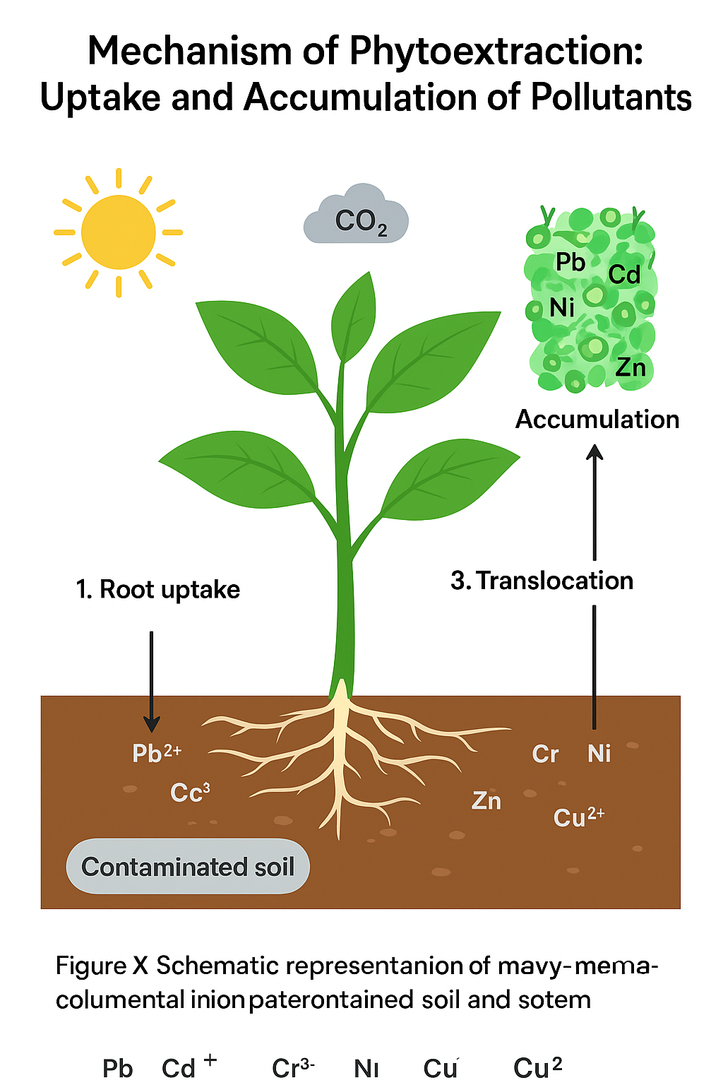
Limitations: While phytodegradation is an effective method for breaking down organic pollutants, it is not applicable to all types of contaminants. Some compounds are recalcitrant, meaning they resist breakdown even by plant enzymes or microbes. Furthermore, the breakdown products of some contaminants may still be toxic, making it essential to monitor the end products of degradation to ensure they do not cause additional harm.
3. Phytovolatilization: Emission of Contaminants into the Atmosphere
Phytovolatilization refers to the process by which plants absorb certain contaminants, particularly volatile organic compounds (VOCs) and metals, and then release them into the atmosphere in a transformed, often less toxic, form. This process primarily applies to compounds like mercury, selenium, and some organic pollutants, which can be volatilized by plants into the air Asgher et al.,(2015).
Mechanism: In phytovolatilization, the plant takes up contaminants from the soil or water through its roots, where they are either absorbed directly or transformed into volatile compounds. These volatile contaminants are then transported through the plant and released into the atmosphere through stomata (small pores in leaves and stems), Chen et al.,(2016). In some cases, the plant might chemically transform the contaminant into a more volatile form, allowing it to be released as a gas or vapor. For example, mercury taken up by plants can be converted into elemental mercury vapor and released into the air.
Applications: Phytovolatilization is useful in areas where volatile pollutants such as mercury or selenium contaminate soils or water, Chen et al.,(2011). Plants capable of volatilizing mercury, such as willows and poplars, can help remove these toxic metals from the environment. The process can also be used for cleaning up air contaminants, particularly in industrial areas where volatile organic solvents or chemicals are present.
Limitations: A major limitation of phytovolatilization is that it can result in the release of pollutants back into the environment, which could pose risks if the volatilized contaminants are toxic or harmful to human health or ecosystems. Additionally, phytovolatilization is most effective for specific contaminants, and it may not be suitable for less volatile substances or compounds that are difficult to volatilize.
4. Phytostabilization: Immobilization of Contaminants in Soil
Phytostabilization is the process by which plants stabilize or immobilize contaminants in the soil, preventing their spread or further contamination of the environment. Unlike phytoextraction, where contaminants are absorbed and stored in the plant, phytostabilization focuses on reducing the mobility and bioavailability of pollutants, often through processes like adsorption or precipitation in the root zone.
Mechanism: In phytostabilization, plant roots interact with contaminants in the soil, either by adsorbing the pollutants onto the root surface or by precipitating them as insoluble compounds. Some plants can alter the pH or produce organic acids around their roots, which can transform contaminants into less mobile forms. For example, certain plants can reduce the solubility of heavy metals by causing them to precipitate as solid compounds, thus reducing their bioavailability, Cao et al.,(2023).
Applications: Phytostabilization is particularly useful for stabilizing heavy metals and preventing their migration through groundwater or into the food chain. It is commonly used in areas where soil erosion or leaching might cause contaminants to spread. This process is beneficial in mining areas, landfills, or agricultural fields with elevated levels of metals like lead, and cadmium.
Limitations: While phytostabilization can effectively prevent contaminants from spreading, it does not remove the pollutants from the environment. As such, the contaminants remain in the soil, which could pose long-term risks to soil health and ecosystem functioning. Additionally, phytostabilization is typically used in conjunction with other phytoremediation methods, such as phytoextraction, for more comprehensive contamination management.
5. Rhizodegradation: Microbial Breakdown of Pollutants in the Root Zone
Rhizodegradation refers to the degradation of pollutants by microorganisms in the rhizosphere, which is the region surrounding plant roots. In this process, plants provide nutrients and a conducive environment for microorganisms that break down organic contaminants, such as pesticides, hydrocarbons, or industrial chemicals, Atakpa et al.,(2022).
Mechanism: Plants release organic compounds such as sugars, amino acids, and other exudates from their roots. These compounds serve as substrates for microorganisms in the rhizosphere, which metabolize the contaminants into less harmful substances. Rhizodegradation is a form of biodegradation, where microbial activity is directly linked to plant root exudates.
Applications: Rhizodegradation is widely used to clean up organic pollutants in soils contaminated by agricultural chemicals, petrochemical products, or solvents. Plants like willows and poplars have been found to enhance the activity of bacteria and fungi that degrade toxic compounds like polychlorinated biphenyls (PCBs) and petroleum hydrocarbons.
Limitations: The effectiveness of rhizodegradation depends on the specific plant and microorganism species involved, as well as environmental factors like soil temperature, moisture, and nutrient levels. Additionally, this process is generally slower than other remediation techniques and may not be sufficient for highly toxic or persistent pollutants.
6. Rhizofiltration: Removal of Contaminants from Water
Rhizofiltration is the process by which plant roots filter and absorb pollutants from contaminated water. It is particularly effective for removing heavy metals, radionuclides, and other contaminants from aquatic environments. In this process, plant roots act as a filter, trapping pollutants in the root system, Atakpa et al.,(2022).
Mechanism: Pollutants in contaminated water are absorbed by plant roots, where they can either be stored or transformed, Ashraf et al.,(2022). The plant may also secrete compounds that enhance the uptake of specific pollutants, thereby improving the removal efficiency. Once the pollutants are taken up, the plant can either store them in its tissues or transform them into less harmful forms.
Applications: Rhizofiltration is commonly applied to clean up contaminated groundwater, wastewater, or industrial effluents, Asadollahi, et al.,(2016). Aquatic plants like water hyacinth and duckweed have been successfully used to remove heavy metals, including and mercury, from water bodies.
Limitations: Rhizofiltration is typically limited to the treatment of water or shallow sediment contamination, Anerao, et al.,(2022). Additionally, the pollutants need to be concentrated enough in the water for the plants to be effective. The process can also become less efficient over time as the plant roots become saturated with contaminants.

FIG 3. Phytoremediation of Contaminated Water

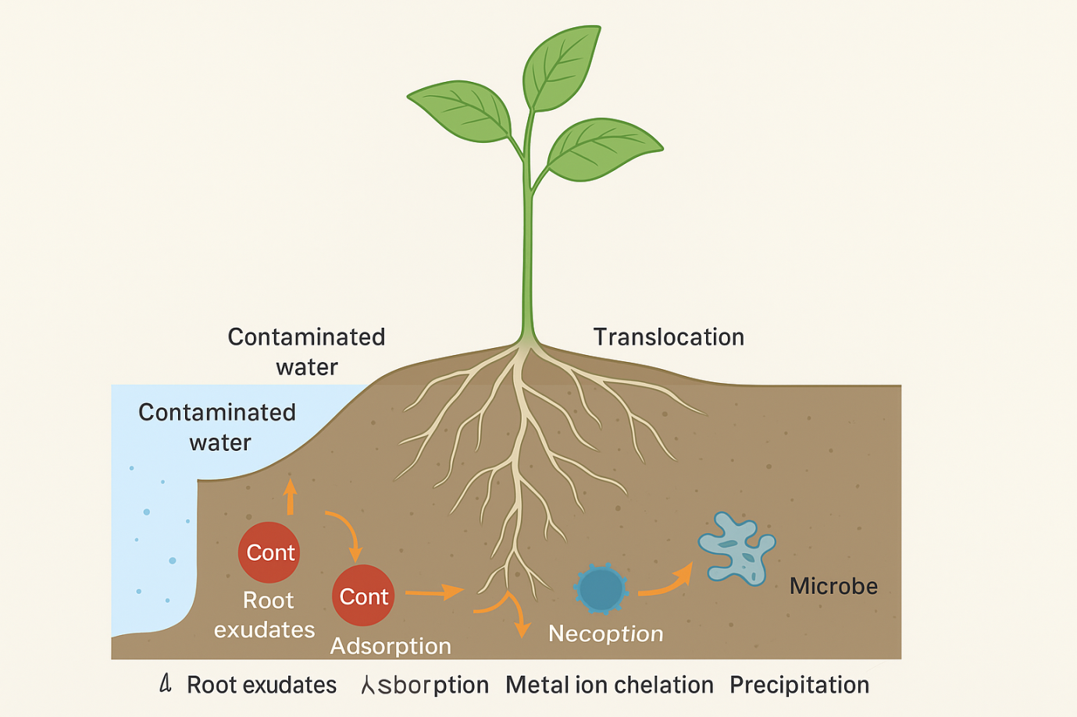

Conclusion
Phytoremediation offers a promising, sustainable, and cost-effective solution to addressing environmental contamination. The six primary mechanisms—phytoextraction, phytodegradation, phytovolatilization, phytostabilization, rhizodegradation, and rhizofiltration - each contribute to the removal, degradation, or stabilization of pollutants. While each mechanism has its specific applications and limitations, phytoremediation as a whole presents a valuable tool for cleaning up contaminated environments and restoring ecosystem health. However, for widespread application, further research into the enhancement of these processes, as well as the development of new plant varieties and remediation techniques, is needed to address the diverse and complex nature of environmental pollution.
Application of phyto remediation technology in polluted soil in situ, and exsitu remediation and combined approach
Phytoremediation is an environmentally friendly and cost-effective technology that uses plants to mitigate or remediate polluted soils, water, and air. This process can be applied in various ways, either in situ (on-site) or ex situ (off-site), or even through a combined approach. Below is an overview of each of these approaches:
1. In Situ Phytoremediation
In situ phytoremediation refers to the treatment of polluted soil or groundwater without moving the contaminated material from its original location. This approach has several key benefits, including minimal disturbance to the environment, reduced costs, and the avoidance of the need to transport contaminated soil. The process involves the use of plants to absorb, degrade, or immobilize pollutants in the contaminated site.
Mechanisms of In Situ Phytoremediation:
- Phytoextraction: Plants absorb contaminants (e.g., heavy metals) from the soil through their roots and accumulate them in the plant tissues. This is particularly useful for heavy metals such as lead, and cadmium, Asadollahi, et al.,(2016).
- Phytostabilization: Plants reduce the mobility and bioavailability of contaminants, stabilizing them in the soil. This is effective for preventing further spread of contaminants, particularly heavy metals or organic pollutants, Anerao et al.,(2022).
- Phytodegradation: Some plants can degrade organic pollutants (e.g., pesticides, petroleum hydrocarbons) in the soil through enzymatic processes within the plant, Amjad et al.,(2021).
- Rhizodegradation: Plant roots excrete substances that encourage the degradation of pollutants in the rhizosphere (the root zone), often through the activity of soil microorganisms stimulated by the plant, Alves et al.,(2022).
- Phytovolatilization: Some plants can absorb and transform pollutants into volatile forms that are released into the atmosphere, such as mercury or selenium, Alvarenga et al.,(2022).
Examples:
- The use of sunflower (Helianthus annuus) for extracting heavy metals from contaminated soils.
- Poplar trees (Populus spp.) have been used to degrade organic contaminants, such as petroleum hydrocarbons, through phytoremediation.
2. Ex Situ Phytoremediation
- Ex situ phytoremediation involves the removal of contaminated soil or water from the polluted site and treating it elsewhere, often in controlled environments, Camacho et al.,(2018). While this method can be more labor-intensive and costly, it provides more control over the remediation process and is sometimes necessary when in situ approaches are not feasible.
Mechanisms of Ex Situ Phytoremediation:
- Planting contaminated soil in controlled greenhouses or plant growth chambers allows for the direct manipulation of variables like soil composition, water supply, and temperature to optimize plant growth and pollutant uptake, Browar et al.,(2018).
- In some cases, plants are grown in hydroponic systems where the contaminated water can be treated through similar mechanisms such as phytoextraction and phytodegradation.
Example:
- Greenhouses have been used to grow specific plants like Indian mustard (Brassica juncea) to treat soils contaminated with metals like lead and cadmium.
3. Combined Approach (In Situ + Ex Situ)
A combined approach uses both in situ and ex situ methods to optimize the remediation process, Browar et al.,(2018).It is often used when pollution levels are too high for in situ remediation alone or when the remediation needs to be faster or more intensive.
Example:
- In situ remediation can be used for initial treatment, where plants are grown on the contaminated site to absorb or stabilize pollutants. After a period of time, the plants can be harvested and the contaminated biomass is then treated ex situ, either by composting or through other waste management techniques to handle the accumulated contaminants.
Key Benefits of the Combined Approach:
- Flexibility: It allows for the use of both local on-site and controlled off-site treatment methods, depending on the type and severity of contamination.
- Enhanced Efficiency: It allows for more rapid remediation by utilizing the strengths of both approaches, for example, quick stabilization of contaminants in situ followed by more thorough extraction or degradation ex situ.
- Reduced Environmental Impact: By combining both methods, it reduces the risk of further contamination during the remediation process and allows for better management of residual pollutants.
Challenges and Considerations:
- Plant Selection: Choosing the right plant species is crucial. Not all plants are effective in remediating every type of contaminant. For example, some plants are hyperaccumulators of metals, while others are better suited for organic pollutants.
- Timeframe: Phytoremediation is a slow process. In some cases, pollutants may persist in the environment for years, requiring long-term monitoring and management.
- Soil Properties: Soil texture, pH, and nutrient availability can significantly affect plant growth and the efficiency of phytoremediation.
- Economic Viability: While phytoremediation is generally cheaper than other methods (such as excavation and chemical treatments), it may require substantial investment in terms of research, management, and monitoring.
Conclusion:
Phytoremediation, whether used in situ, ex situ, or through a combined approach, offers a promising method for soil pollution mitigation. By leveraging the natural abilities of plants to absorb, degrade, or stabilize pollutants, this technology provides an eco-friendly and sustainable solution to environmental cleanup. However, its success depends on various factors such as plant species selection, pollutant type, and site-specific conditions. A combined approach often offers the most effective solution, addressing limitations of each individual method.
Pre- treatment method
Pre-treatment methods in phytoremediation are used to enhance the effectiveness of plants in removing or degrading contaminants from the environment. These methods typically involve preparing the contaminated site or the plants themselves to maximize the potential for successful phytoremediation. Here are some common pre-treatment methods:
- Soil Amendment:
  - Nutrient Addition: The addition of essential nutrients like nitrogen, phosphorus, and potassium can improve plant growth and enhance the uptake of contaminants
  - Organic Matter Addition: Adding organic matter (e.g., compost) can improve soil structure, increase microbial activity, and help plants absorb contaminants more efficiently.
  - pH Adjustment: The pH of the soil can be adjusted (with lime to raise pH or sulfur to lower it) to optimize conditions for plant growth and contaminant bioavailability.
- Biological Pretreatment:
  - Microbial Inoculation: Introducing specific microorganisms to the soil or root zone can aid in the degradation of contaminants, especially organic pollutants, and may help increase the bioavailability of heavy metals for plant uptake.
  - Mycorrhizal Fungi Inoculation: Mycorrhizal fungi form symbiotic relationships with plant roots, enhancing nutrient uptake and contaminant absorption.
- Irrigation and Soil Moisture Management:
  - Ensuring optimal moisture levels is essential for plant growth and contaminant uptake. Pre-treatment may include soil irrigation or moisture regulation to promote plant health and enhance the remediation process.
- Contaminant Mobilization:
  - Chelating Agents: The addition of chelating agents (e.g., EDTA) can help mobilize heavy metals, making them more available for plant uptake.
  - Acidification: In cases where the contaminants are metals that are less bioavailable in alkaline conditions, acidifying the soil can help release these metals into a form that is easier for plants to absorb.
- Selection of Suitable Plant Species:
  - The pre-treatment process may involve selecting plant species with the highest potential for contaminant uptake or degradation. Species that are more tolerant to stressors like high levels of pollution or drought conditions may be selected for the project.
- Site Preparation:
  - Physical Disturbance: This may involve tilling or aerating the soil to improve root penetration and oxygen availability, thus promoting better plant growth and contaminant uptake.
  - Surface Contamination Removal: In some cases, removing or covering highly contaminated topsoil can reduce the amount of pollutants available to plants and allow for more efficient phytoremediation.
These pre-treatment methods are often used in combination to optimize conditions for the plants, enhance contaminant availability, and promote the overall success of phytoremediation projects.
Application of organic amendments
Organic amendments have emerged as one of the most effective strategies to enhance phytoremediation by improving soil properties, increasing metal bioavailability, and stimulating plant growth, Organic amendments improve phytoremediation by influencing soil properties, enhancing plant growth, and affecting the bioavailability of heavy metals, Ayub et al.,(2024).
The interactions between organic materials and contaminated soil can alter the chemical, physical, and biological conditions of the soil, thereby facilitating the uptake, translocation, and detoxification of heavy metals by plants,Ayub et al.,(2024).
One of the primary functions of organic amendments in phytoremediation is the enhancement of soil quality. Organic materials can improve soil structure by increasing porosity and water retention, which, in turn, supports healthier root development. This is particularly important in heavy metal-contaminated soils, where metal toxicity can hinder plant growth. Organic amendments also promote microbial activity in the soil, enhancing the degradation of organic contaminants and aiding in the transformation of heavy metals into less toxic forms. The bioavailability of heavy metals in soil is a key factor in determining the success of 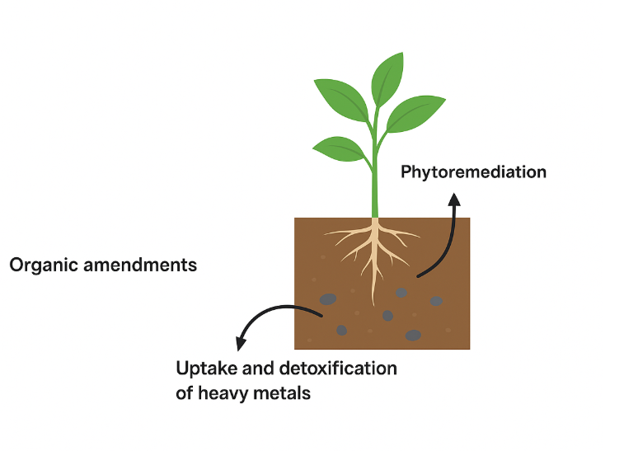
FIG 4. Phytoremediation with Organic Amendments for Heavy Metal Detoxification

phytoremediation, Bali et al.,(2020). Organic amendments can influence the solubility and mobility of metals, thereby facilitating their uptake by plants. For example, organic acids, such as humic substances, can chelate heavy metals, increasing their solubility and making them more available for uptake by plant roots, Benidire et al.,(2021). These materials can modify soil structure, pH, nutrient content, and microbial activity, all of which can significantly affect the uptake and tolerance of heavy metals by plants. In some cases, the organic amendments may reduce the mobility of metals, preventing their spread and limiting their harmful effects on surrounding ecosystems, Agnihotri et al.,(2022). Furthermore, organic materials can support the microbial transformation of metals into less toxic forms, such as the reduction of toxic hexavalent chromium (Cr(VI)) to less harmful trivalent chromium (Cr(III)). Organic amendments often stimulate plant growth, which is for effective phytoremediation, Ahmed et al.,(2020). Nutrients present in organic materials, such as nitrogen, phosphorus, and potassium, can alleviate nutrient deficiencies in contaminated soils, enabling plants to grow more vigorously. Healthier plants are generally more efficient in absorbing and accumulating heavy metals, Ajien et al.,(2023). Additionally, organic amendments may enhance the development of root systems, further increasing the plant’s ability to uptake metals from deeper soil layers. Certain organic amendments, such as bio char, can also modify the rhizosphere environment, enhancing the availability of metals to plants and increasing the expression of metal-transporting genes in plant roots, Ahmad et al.,(2014). Moreover, bio char has been shown to reduce metal toxicity in plants by adsorbing metals, preventing them from causing direct harm to plant tissues while still facilitating uptake, Ali et al.,(2017) and Ali et al.,(2021).The use of organic amendments in phytoremediation represents a promising strategy to improve the efficiency of heavy metal removal from contaminated environments. These amendments not only improve soil properties but also increase the bioavailability of heavy metals, support plant growth, and enhance metal accumulation, Al-Lami et al.,(2022). By combining phytoremediation with organic amendments, it is possible to develop a more effective, sustainable approach for cleaning up heavy metal contamination in soils and water bodies.
Research Gap in Phytoremediation-
Phytoremediation, the use of plants to remove, degrade, or stabilize pollutants from the environment, presents significant promise but still faces several research gaps that need addressing. One area is the selection and genetic improvement of plants, as there is limited understanding of which species are most effective for specific contaminants, and how to genetically enhance their ability to tolerate and uptake pollutants. Additionally, more research is needed to uncover the molecular mechanisms involved in the uptake, translocation, and detoxification of pollutants, which would allow for the development of plants specifically engineered for better remediation. Another gap lies in the understanding of plant-microbe interactions, as these relationships can potentially boost the efficiency of pollutant degradation or enhance nutrient cycling. Environmental factors, such as soil composition, temperature, and pH, also significantly influence phytoremediation outcomes, yet their specific impacts are not fully understood and need further investigation. Phytoremediation in complex, contaminated environments like industrial or mining sites has not been sufficiently explored, despite its potential for addressing more difficult pollution scenarios. Long-term effectiveness remains a concern, with little knowledge of how sustainable and stable phytoremediation systems are over time, especially in preventing recontamination. Furthermore, scaling phytoremediation to a large-scale, cost-effective approach is challenging, and research is needed to develop models for economic feasibility. The risks of bioaccumulation in plants, particularly in food chains, and the potential for toxicity need thorough investigation to ensure the safety of this method. Finally, integrating phytoremediation with other remediation techniques, such as bioremediation or chemical treatments, has not been sufficiently studied but may offer synergistic benefits for more complex contamination challenges. Addressing these gaps would enhance the viability, safety, and efficiency of phytoremediation as a sustainable solution for environmental cleanup.
Conclusion
The review likely concludes that while the use of organic amendments in phytoremediation presents significant opportunities for improving contaminant removal, promoting soil health, and offering a more sustainable alternative to traditional remediation methods, it also faces challenges related to efficiency, time requirements, and environmental factors. More research is needed to optimize the use of organic amendments, understand their interactions with contaminants and plant systems, and develop strategies for overcoming the limitations. Additionally, integrating phytoremediation with other remediation technologies may enhance overall success.

REFERENCES
- Abbas, T., Rizwan, M., Ali, S., Adrees, M., Zia-ur-Rehman, M., Qayyum, M. F.(2018). Effect of biochar on alleviation of cadmium toxicity in wheat (Triticum aestivum L.) grown on Cd-contaminated saline soil. Environmental Science and Pollution Research, 25, 25668–25680. https://doi.org/10.1007/s11356-017-8987-4
- Agnihotri, R., Sharma, M. P., Prakash, A. (2022). Glycoproteins of arbuscular mycorrhiza for soil carbon sequestration: Review of mechanisms and controls. Science of the Total Environment, 806, 150571. https://doi.org/10.1016/j.scitotenv.2021.150571
- Ahmad, M., Lee, S. S., Lim, J. E. (2014). Speciation and phytoavailability of lead and antimony in a small arms range soil amended with mussel shell, cow bone and biochar: EXAFS spectroscopy and chemical extractions. Chemosphere, 95, 433–441. https://doi.org/10.1016/j.chemosphere.2013.09.077
- Ahmed, B., Ameen, F., Rizvi, A., Ali, K., Sonbol, H., Zaidi, A. (2020). Destruction of cell topography, morphology, membrane, inhibition of respiration, biofilm formation, and bioactive molecule production by nanoparticles of Ag, ZnO, CuO, TiO₂, and Al₂O₃ toward beneficial soil bacteria. ACS Omega, 5, 7861–7876. https://doi.org/10.1021/acsomega.9b04084
- Ajien, A., Idris, J., Md Sofwan, N., Husen, R., & Seli, H. (2023). Coconut shell and husk biochar: A review of production and activation technology, economic, financial aspect and application. Waste Management & Research, 41, 37–51. https://doi.org/10.1177/0734242X221127167
- Ali, A., Guo, D., Zhang, Y. (2017). Using bamboo biochar with compost for the stabilization and phytotoxicity reduction of heavy metals in mine-contaminated soils of China. Scientific Reports, 7, 2690. https://doi.org/10.1038/s41598-017-03045-9
- Ali, M. H., Khan, M. I., Bashir, S. (2021). Biochar and Bacillus sp. MN54 assisted phytoremediation of diesel and plant growth promotion of maize in hydrocarbons contaminated soil. Agronomy, 11(9), 1795. https://doi.org/10.3390/agronomy11091795
- Ali, Q., Ayaz, M., Yu, C., Wang, Y., Gu, Q., Wu, H. (2022). Cadmium tolerant microbial strains possess different mechanisms for cadmium biosorption and immobilization in rice seedlings. Chemosphere, 303, 135206. https://doi.org/10.1016/j.chemosphere.2022.135206
- Al-Lami, M. K., Oustriere, N., Gonzales, E., & Burken, J. G. (2022). Phytomanagement of Pb/Zn/Cu tailings using biosolids-biochar or -humus combinations: Enhancement of bioenergy crop production, substrate functionality, and ecosystem services. Science of the Total Environment, 836, 155676. https://doi.org/10.1016/j.scitotenv.2022.155676
- Alvarenga, P., Gonçalves, A. P., Fernandes, R. M.(2009). Organic residues as immobilizing agents in aided phytostabilization: (I) Effects on soil chemical characteristics. Chemosphere, 74(10), 1292–1300. https://doi.org/10.1016/j.chemosphere.2008.11.063
- Alves, A. R. A., Yin, Q., Rui, S. O. (2022). Plant growth-promoting bacteria in phytoremediation of metal-polluted soils: Current knowledge and future directions. Science of the Total Environment, 838, 156435. https://doi.org/10.1016/j.scitotenv.2022.156435
- Amjad, M., Iqbal, M. M., Abbas, G., Farooq, A. B. U., Naeem, M. A., & Imran, M., et al. (2021). Assessment of cadmium and lead tolerance potential of quinoa (Chenopodium quinoa Willd.) and its implications for phytoremediation and human health. Environmental Geochemistry and Health, 1–14. https://doi.org/10.1007/s10653-021-00826-0
- Anand, S., Singh, A., & Kumar, V. (2023). Recent advancements in cadmium–microbe interactive relations and their application for environmental remediation: A mechanistic overview. Environmental Science and Pollution Research, 1–30. https://doi.org/10.1007/s11356-022-25065-3
- Anerao, P., Kaware, R., & Khedikar, A. K. (2022). Phytoremediation of persistent organic pollutants: Concept, challenges and perspectives. In V. Kumar, M. P. Shah, & S. K. Shahi (Eds.), Phytoremediation technology for the removal of heavy metals and other contaminants from soil and water (pp. 375–404). Elsevier. https://doi.org/10.1016/B978-0-323-85763-5.00018-0
- Asadollahi, A., Zamani, J., Hajabbasi, M. A., & Schulin, R. (2016). Using maize (Zea mays L.) and sewage sludge to remediate a petroleum-contaminated calcareous soil. Soil and Sediment Contamination: An International Journal, 25(1), 26–37. https://doi.org/10.1080/15320383.2016.1085835
- Asgher, M., Khan, M. I. R., Anjum, N. A., & Khan, N. A. (2015). Minimising toxicity of cadmium in plants—Role of plant growth regulators. Protoplasma, 252, 399–413. https://doi.org/10.1007/s00709-014-0710-4
- Ashraf, M., Shahzad, S. M., Abid, M., Mehmood, K., Aziz, A., Sarwar, A.(2022). Ionic homeostasis and growth characteristics of tomato (Solanum lycopersicum L.) grown with municipal wastewater by supplying silicon, farmyard manure and plant growth-promoting rhizobacteria. Silicon, 1–13. https://doi.org/10.1007/s12633-022-01961-8
- Atakpa, E. O., Zhou, H., Jiang, L. (2022). Improved degradation of petroleum hydrocarbons by co-culture of fungi and biosurfactant producing bacteria. Chemosphere, 290, 133337. https://doi.org/10.1016/j.chemosphere.2021.133337
- Ayub, A., Shabaan, M., Malik, M., Asghar, H. N., Zulfiqar, U., Ejaz, M., Alarjani, K. M., & Farraj, A. D. A. (2024). Synergistic application of Pseudomonas strains and compost mitigates lead (Pb) stress in sunflower (Helianthus annuus L.) via improved nutrient uptake, antioxidant defense and physiology. Ecotoxicology and Environmental Safety, 274, 116194. https://doi.org/10.1016/j.ecoenv.2024.116194
- Bali, A. S., Sidhu, G. P. S., & Kumar, V. (2020). Root exudates ameliorate cadmium tolerance in plants: A review. Environmental Chemistry Letters, 18, 1243–1275. https://doi.org/10.1007/s10311-020-01012-x
- Benidire, L., Madline, A., Pereira, S. I. A., Castro, P. M. L., & Boularbah, A. (2021). Synergistic effect of organo-mineral amendments and plant growth-promoting rhizobacteria (PGPR) on the establishment of vegetation cover and amelioration of mine tailings. Chemosphere, 262, 127803. https://doi.org/10.1016/j.chemosphere.2020.127803
- Bouida, L., Rafatullah, M., Kerrouche, A., Qutob, M., Alosaimi, A. M., Alorfi, H. S.(2022). A review on cadmium and lead contamination: Sources, fate, mechanism, health effects and remediation methods. Water, 14(21), 3432. https://doi.org/10.3390/w14213432
- Browar, A. W., Koufos, E. B., Wei, Y., Leavitt, L. L., Prozialeck, W. C., & Edwards, J. R. (2018). Cadmium exposure disrupts periodontal bone in experimental animals: Implications for periodontal disease in humans. Toxics, 6(2), 32. https://doi.org/10.3390/toxics6020032
- Camacho-Chab, J. C., Castañeda-Chávez, M. D. R., Chan-Bacab, M. J., Aguila-Ramírez, R. N., Galaviz-Villa, I., & Bartolo-Pérez, P. (2018). Biosorption of cadmium by non-toxic extracellular polymeric substances (EPS) synthesized by bacteria from marine intertidal biofilms. International Journal of Environmental Research and Public Health, 15(2), 314. https://doi.org/10.3390/ijerph15020314
- Cao, B., Shi, L., Brown, R. N., Xiong, Y., Fredrickson, J. K., & Romine, M. F. (2011). Extracellular polymeric substances from Shewanella sp. HRCR-1 biofilms: Characterization by infrared spectroscopy and proteomics. Environmental Microbiology, 13(4), 1018–1031. https://doi.org/10.1111/j.1462-2920.2010.02407.x
- Cao, Y., Ma, X., Chen, N., Chen, T., Zhao, M., & Li, H. (2023). Polypropylene microplastics affect the distribution and bioavailability of cadmium by changing soil components during soil aging. Journal of Hazardous Materials, 443, 130079. https://doi.org/10.1016/j.jhazmat.2022.130079
- Chen, Y., Chao, Y., Li, Y., Lin, Q., Bai, J., & Tang, L. (2016). Survival strategies of the plant-associated bacterium Enterobacter sp. strain EG16 under cadmium stress. Applied and Environmental Microbiology, 82(6), 1734–1744. https://doi.org/10.1128/AEM.03689-15
- Cheng, C., Han, H., Wang, Y., Wang, R., He, L., & Sheng, X. (2020). Biochar and metal-immobilizing Serratia liquefaciens CL-1 synergistically reduced metal accumulation in wheat grains in a metal-contaminated soil. Science of the Total Environment, 740, 139972. https://doi.org/10.1016/j.scitotenv.2020.139972
- Cheng, C., Wang, R., Sun, L., He, L., & Sheng, X. (2021). Cadmium-resistant and arginine decarboxylase-producing endophytic Sphingomonas sp. C40 decreases cadmium accumulation in host rice (Oryza sativa Cliangyou 513). Chemosphere, 275, 130109. https://doi.org/10.1016/j.chemosphere.2021.130109
- Clinton-Ezekwe, I., Osu, I., Ezekwe, I., & Raimi, M. (2022). Slow death from pollution: Potential health hazards from air quality in the Mgbede oil fields of south-south Nigeria. Open Access Journal of Science, 5, 61–69. https://doi.org/10.15406/oajs.2022.05.00177
- Cydzik-Kwiatkowska, A., Gusiatin, M. Z., Zielińska, M., Wojnowska-Baryła, I., Kulikowska, D., & Bernat, K. (2022). Alginate-like polymers from full-scale aerobic granular sludge: Content, recovery, characterization, and application for cadmium adsorption. Scientific Reports, 12, 22260. https://doi.org/10.1038/s41598-022-26743-5
- Hassan, S., Bhadwal, S. S., Khan, M. (2024). Revitalizing contaminated lands: A state-of-the-art review on the remediation of mine tailings using phytoremediation and genomic approaches. Chemosphere, 356, 141889. https://doi.org/10.1016/j.chemosphere.2024.141889
- Hatzinger, P. B., & Martin, A. (1995). Effect of aging of chemicals in soil on their biodegradability and extractability. Environmental Science & Technology, 29, 537–545. https://doi.org/10.1021/es00002a033
- Kumari, B., Kriti, K., Sinam, G. (2021). Comparative assessment of PAHs reduction in soil by growing Zea mays L. augmented with microbial consortia and fertilizer: Modulation in uptake and antioxidant defense response. Polycyclic Aromatic Compounds, 41, 1694–1711. https://doi.org/10.1080/10406638.2019.1694544
- Kumpiene, J., Mench, M., Bes, C. M., & Fitts, J. P. (2011). Assessment of aided phytostabilization of copper-contaminated soil by X-ray absorption spectroscopy and chemical extractions. Environmental Pollution, 159, 1536–1542. https://doi.org/10.1016/j.envpol.2011.03.005
- Labidi, S., Fontaine, J., Laruelle, F. (2015). Fly ash-aided phytostabilisation of highly trace element polluted topsoils improves the telluric fungal biomass: A long-term field experiment. Applied Soil Ecology, 85, 69–75. https://doi.org/10.1016/j.apsoil.2014.09.006
- Li, W., Zhang, Z., Sun, B. (2021). Combination of plant-growth promoting and fluoranthene-degrading microbes enhances phytoremediation efficiency in the ryegrass rhizosphere. Environmental Science and Pollution Research, 28, 6068–6077. https://doi.org/10.1007/s11356-020-10937-3
- Qayyum, M. F., ur Rehman, M. Z., Ali, S. (2017). Residual effects of monoammonium phosphate, gypsum and elemental sulfur on cadmium phytoavailability and translocation from soil to wheat in an effluent irrigated field. Chemosphere, 174, 515–523. https://doi.org/10.1016/j.chemosphere.2017.02.006
- Qian, S., Zhou, X., Fu, Y. (2023). Biochar-compost as a new option for soil improvement: Application in various problem soils. Science of the Total Environment, 870, 162024. https://doi.org/10.1016/j.scitotenv.2023.162024
- Quilliam, R. S., Marsden, K. A., Gertler, C. (2012). Nutrient dynamics, microbial growth and weed emergence in biochar amended soil are influenced by time since application and reapplication rate. Agriculture, Ecosystems & Environment, 158, 192–199. https://doi.org/10.1016/j.agee.2012.06.011
- Rathankumar, A. K., Saikia, K., Kumar, P. S. (2022). Surfactant-aided mycoremediation of soil contaminated with polycyclic aromatic hydrocarbon (PAHs): Progress, limitation, and countermeasures. Journal of Chemical Technology & Biotechnology, 97, 391–408. https://doi.org/10.1002/jctb.6721
- Wang, J., Aghajani Delavar, M. (2024). Modelling phytoremediation: Concepts, methods, challenges and perspectives. Soil & Environmental Health, 2, 100062. https://doi.org/10.1016/j.seh.2024.100062
- Wang, J., Jing, M., Zhang, W. (2021). Assessment of organic compost and biochar in promoting phytoremediation of crude-oil contaminated soil using Calendula officinalis in the Loess Plateau, China. Journal of Arid Land, 13, 612–628. https://doi.org/10.1007/s40333-021-0011-7
- Wang, Y., Li, F., Song, J. (2018). Stabilization of Cd-, Pb-, Cu- and Zn-contaminated calcareous agricultural soil using red mud: A field experiment. Environmental Geochemistry and Health, 40, 2143–2153. https://doi.org/10.1007/s10653-018-0089-9
- Xu, M., Fu, X., Gao, Y. (2020). Characterization of a biosurfactant producing bacteria isolated from marine environment: Surface activity, chemical characterization and biodegradation. Journal of Environmental Chemical Engineering, 8, 104277. https://doi.org/10.1016/j.jece.2020.104277
- Yadav, R., Tripathi, P., Singh, R. P., Khare, P. (2023). Assessment of soil enzymatic resilience in chlorpyrifos contaminated soils by biochar aided Pelargonium graveolens L. plantation. Environmental Science and Pollution Research, 30, 7040–7055. https://doi.org/10.1007/s11356-022-22679-5

