Original Research Article

Comparison of Radiographic and Tomographic Parameters to Determine the Accuracy and Reliability in Predicting the Difficulty of Mandibular Third Molars

.
ABSTRACT

Background: Compare and correlate different radiographic and toographic parameters in determining the degree of difficulty in the extraction of lower third molars.

Aims: To verify whether there is a statistically significant difference between predictive parameters of surgical difficulty for the removal of mandibular third molars obtained from panoramic radiographs compared to cone-beam computed tomography.

Methodology: The present study was a cross-sectional, retrospective analysis conducted through the examination of panoramic radiographs and cone-beam computed tomography scans obtained between 2018 and 2023 at the imaging sector of the undergraduate Dentistry program at the Federal University of Ceará (UFC), Sobral campus.

Results: The study revealed statistically significant differences between panoramic radiography and cone-beam computed tomography (CBCT) in the assessment of mandibular third molars, particularly regarding proximity to the inferior alveolar nerve canal, where panoramic radiographs showed high sensitivity (93.9%) but low specificity (0%). In the Pell and Gregory classification, panoramic radiographs demonstrated a sensitivity of 87.5% and a specificity of 61.1% (p = 0.004).

Conclusion: Cone-beam computed tomography is essential for a more accurate assessment of anatomy and surgical complexity, highlighting the limitations of panoramic radiographs in specific surgical planning contexts. The Pell and Gregory classification demonstrated significant differences in sensitivity and specificity between two-dimensional and three-dimensional analyses.

Conflict of interest: None.

Funding: This research did not receive any specific grant from funding agencies in the
public, commercial, or not-for-profit sectors.

Keywords Third Molar; Panoramic Radiography; Cone-Beam Computed Tomography; Pell and Gregory; Winter.

1. INTRODUCTION

The removal of lower third molars (M3M) has been a common practice in dental clinics. These teeth can be classified using various currently available indexes to assist the dental surgeon as predictors of surgical difficulty (1,2,3,4,5,6,7,8,9,10,11,12). Some of these classification systems take into account imaging, clinical, and demographic factors for evaluation (13,14); however, there is no consensus regarding the uniformity of the diagnostic classification of difficulty level to support professionals in performing M3M extractions.
Typically, the initial preoperative assessment of lower third molars is performed using panoramic radiographs, which are two-dimensional images. The Pell and Gregory classification (8), for example, was originally established based on two-dimensional images, which have limitations such as magnification, distortion, and image overlap, particularly in the mandibular ramus region a reference point used in this classification (13). On the other hand, tomographic images allow for an adequate evaluation of the three-dimensional anatomical relationships between the lower third molars and their surrounding structures, thus becoming a predictor of difficulty that is more faithful to reality (14).
The technological advancement of computer systems has enabled the development of a digital, automated, and standardized classification software based on panoramic radiographs (15). Ansari and Mutha (2019) described a system they named the "mandibular molar difficulty index calculator." This software uses the Pell and Gregory classification to assess the relationship of the lower third molars with the mandibular ramus and bone impaction (8), and Quek's classification for tooth angulation (16). These data are then applied to the Pederson index (17), which considers spatial relationship, bone inclusion, and the relationship with the mandibular ramus in a predictive score of surgical difficulty.
In a recent review on classification indices for M3M (18), it was found that several factors are related to the prediction of extraction difficulty for these teeth, beyond those cited by Ansari and Mutha (2019) (15), such as the relationship with the mandibular ramus, inferior alveolar canal, adjacent second molar, as well as bulbosity, morphology, radiolucency, curvature, root length and number, pericoronal radiolucency, and crown width (18) Furthermore, some authors reported that the Pederson index (9), although reproducible, is not a reliable tool for predicting the actual difficulty of the procedure, especially when these parameters are compared with operation time and the need for bone osteotomy (12, 19, 20, 21).
Although these indices and classifications are commonly used in clinical practice to assess the impaction of lower third molars, some authors have reported interpretation errors with inadequate levels of reliability, reproducibility, and low predictive difficulty (4, 22,23). In light of this, the aim of the present study was to compare and correlate different radiographic and tomographic parameters in determining the degree of difficulty in the extraction of M3M.

2. material and methods

2.1 Study design/sample
The present study was a cross-sectional, retrospective analysis conducted through the examination of panoramic radiographs and cone-beam computed tomography scans obtained between 2018 and 2023 at the imaging sector of the undergraduate Dentistry program at the Federal University of Ceará (UFC) – Sobral campus. This research began only after obtaining formal approval from the head of the radiology department at UFC – Sobral campus and complies with the Declaration of Helsinki. The study followed the guidelines proposed by the STROBE initiative (Strengthening the Reporting of Observational Studies in Epidemiology) (24).
The study included patients of both sexes from the Dentistry program at UFC – Sobral campus who had panoramic radiographs (PR) and cone-beam computed tomography (CBCT) scans taken prior to the extraction of mandibular third molars (M3M). Patients were excluded if they presented with: absence of mandibular second molars, extreme age, open root apex, dental implants in the mandibular second molar region, or pathologies associated with the lower molars.
The sample size was calculated for a power of 80%, considering that the overlap of the mandibular canal is directly affected by the Pell & Gregory and Miller & Winter classifications, and that this feature has a predictive value in PR of only 38.5% (minimum desired value: 80.0%) (25). It was estimated that 52 image pairs (PR and CBCT) would be needed to achieve a sample representing the alternative hypothesis with 80% power and 95% confidence.
To ensure better reproducibility, the analyses were individually performed on the panoramic radiographs (PR) using CorelDRAW® software and on the cone beam computed tomography (CBCT) images using the 3D Slicer software (version 4.0; www.slicer.org) (26) and subsequently compared.
2.2 Winter's Classification
Third molars can be found in vertical, mesioangular, distoangular, horizontal, and inverted positions, as well as in linguoversion or buccoversion (8). In the CorelDRAW® software (Fig. 1) and 3D SLICER (Fig. 2), a line representing the long axis of the third molar (red line) and a line representing the occlusal plane (green line) were inserted. Based on this, the angulation between these two lines was considered and classified as follows: inverted for third molars with a negative angle (< 0º), horizontal for third molars with an angle between 0–30º, mesioangular for third molars with an angle between 31–60º, vertical for third molars with an angle between 61–90º, and distoangular for third molars with an angle > 90º (16).
2.3 Dental Bulbosity
The thickness of the third molar roots is evaluated in relation to the dimension of the cervical region, defined by an imaginary line at the cementoenamel junction. The greater the root thickness compared to the cementoenamel junction, the greater the expected difficulty in surgical removal (5). In the CorelDRAW® software (Fig. 3) and 3D SLICER (Fig. 4), two lines were drawn on the third molar. One line represented the cementoenamel junction, which defines the cervical area of the tooth (Line A), and the other was drawn at the middle/apical region of the root (Line B). If Line A was greater than Line B, it was coded as 0, indicating an easy extraction. However, if Line A was less than or equal to Line B, it was coded as 1, indicating a difficult extraction (5).
2.4 Proximity to the Inferior Alveolar Canal
In this system, third molars were evaluated in relation to their proximity to the inferior alveolar nerve canal. In this classification, teeth with a distance greater than or equal to 3 mm were considered to present a low risk of nerve injury and were coded as 0, whereas those with a shorter distance or in contact with the canal (superimposed, overlapping, or in close contact) were considered high risk and coded as 1 (13). In the CorelDRAW® software (Fig. 5) and 3D SLICER (Fig. 6), the lowest point of the third molar roots was marked, and its distance to the roof of the mandibular canal was analyzed.
2.5 Marginal Bone Loss
In this parameter, the images were examined for the presence or absence of coronal or pericoronal radiolucency or hypodensity (27). Additionally, radiolucencies and hypodensities associated with third molars (3Ms) greater than 3 mm were excluded from the present study, as they are suggestive of associated pathological lesions (28). In the CorelDRAW® software (Fig. 7) and 3D SLICER (Fig. 8), the presence or absence of these features was evaluated (outlined in blue).
2.6 Two-Dimensional Evaluation (CorelDRAW® software) and Three-Dimensional Evaluation (3D SLICER software)
Digital radiographic images were obtained using the Eagle 3D device from DABI ATLANTE® coupled with Vbeam technology, offering up to 8 field-of-view volumes (ranging from 5x5 to 23x16). The exposure parameters were: 85 kV, 6.3 mA, 0.5-, copper filter). These parameters were adjusted according to the patient's body and dental structures, following the equipment manual. All images were processed, calibrated, and exported in PDF (Portable Document Format) for 2D and in DICOM (Digital Imaging and Communications in Medicine) format for 3D in the On Demand software (OnDemand3D Dental Operation Manual, Copyright 2011 Cybermed Inc). The region of interest was focused on the third molars, covering the occlusal surface to the base of the mandible and the entire trajectory involving the relationship between the inferior alveolar nerve and the dental element, along with its main anatomical topographic structures involved.
The panoramic radiograph exams performed on patients from the Department of Dentistry at UFC – Sobral campus were evaluated, calibrated for measurement in millimeters, and exported as PDF files for analysis in CorelDRAW software. Similarly, the CBCT scans were evaluated and exported as DICOM files and submitted for analysis in the 3D SLICER software (29).
The 3D analysis was conducted in the subsequent steps, beginning with the importation of DICOM files. The 3D model was reconstructed using the editor module. After acquiring the 3D model of the mandible, mandibular canal, and inferior alveolar canal, positioning orientation was performed using the Transform module to standardize the position of the mandibular canal in the image analysis view (based on the location of the mental foramen and mandibular foramen) (29) From this stage, it was possible to perform the measurements proposed in this study and define the relationship between the tooth, adjacent bone structures, and the inferior alveolar canal, including the depth of impaction and buccolingual positioning (29).
2.7 Statistical Analysis and Method Error Evaluation
The data were expressed as absolute frequency and percentage and compared using McNemar’s tests, calculation of the Kappa concordance coefficient, sensitivity, specificity, positive and negative predictive values, and accuracy.
To avoid potential sources of bias, two observers were trained and calibrated by a gold-standard researcher with extensive experience in dental radiology to identify the absence/presence of the third molars (M3M) and the mandibular canal, prior to performing the linear and three-dimensional measurements adopted in this study. Initially, the observers individually checked the absence/presence of these structures in 30 CBCT and panoramic radiograph images and then performed all the proposed linear and three-dimensional measurements. After a 15-day interval, a researcher who did not participate in the data collection randomly coded the images, and each parameter was reassessed by the observers. The data were exported to Microsoft Excel® spreadsheets (Microsoft® Corporation, Redmond, WA) and analyzed using a 95% confidence level in the Statistical Package for the Social Sciences (SPSS®) version 20.0 for Windows® (IBM® Corporation, Sommers, NY).
3. results and discussion

The study involved an interobserver analysis of 52 pairs of teeth using both two-dimensional and three-dimensional images, including participants of both sexes, ranging in age from 17 to 39 years. No cases were observed in Pell and Gregory classification class III or position C, nor were teeth found in the Inverted, Linguo-angular, or Buccal-angular positions according to Winter’s classification.
The inter-examiner analysis using the Kappa coefficient revealed varying degrees of agreement in the evaluation of two-dimensional and three-dimensional images between observers. The assessment of the proximity to the inferior alveolar nerve canal in panoramic radiographs (PR) showed a discrepancy between the evaluators (p=1.000 – Kappa=0.371), indicating variations in image interpretation for this classification (Table 1).
The sensitivity and specificity of the Pell and Gregory classifications in 2D and 3D demonstrated accuracies of 69.2% (p=0.004) and 63.5% (p=0.001) for the different classification groups (A, B, C and I, II, III). Regarding the A, B, and C classification criteria in the 2D and 3D assessments, a sensitivity of 87.5% and specificity of 61.1% were obtained (accuracy of 69.2% – p=0.004). Similarly, for the I, II, and III classification criteria in the 2D and 3D assessments, a sensitivity of 85.7% and specificity of 55.3% were obtained (accuracy of 63.5% – p=0.001) (Table 2).
Regarding Winter’s classification, sensitivity was lower for teeth classified as vertical (55.6%), while for the other angulations, discrepancies between sensitivity and specificity were smaller (p=1.000), suggesting that the technique's effectiveness varies depending on the tooth's orientation (Table 3).
On the other hand, in the analysis of the "bulbous tooth," no statistically significant differences were found, indicating consistency in image interpretation regardless of the dimension evaluated (accuracy of 80.8% – p=0.021) (Table 4). With respect to the other classifications, the most discrepant data were observed in the Proximity to the Inferior Alveolar Nerve Canal, which presented a sensitivity of 93.9% and 0% specificity (p=1.000) (Table 4).
Comparative classification studies of mandibular third molars using panoramic radiographs (PR) and cone-beam computed tomography (CBCT) remain scarce in the literature. In major clinical dental centers, CBCT has become a standard evaluative imaging modality for the extraction of these teeth. However, PR is more commonly requested for initial evaluations (30), mainly due to its lower radiation dose and reduced cost for both healthcare systems and patients.

Regarding radiation dose, CBCT—due to its three-dimensional nature and high level of detail—implies a higher radiation exposure compared to PR. This difference significantly impacts clinical decision-making, especially in younger patients or cases requiring repeated imaging over time (31). The concern for minimizing radiation exposure therefore guides the preference for PR in routine evaluations, reserving CBCT for situations that demand more detailed anatomical analysis (32).

Accessibility to PR and CBCT imaging varies geographically and depends on the available healthcare infrastructure. While panoramic radiography (PR) is commonly found in most dental offices and imaging centers due to its lower cost and ease of use (33), cone-beam computed tomography (CBCT) is more frequently available in specialized centers and large hospitals. This discrepancy in availability can affect how quickly and easily patients can access these technologies, ultimately influencing the choice of imaging modality in different clinical settings.

Most of the studies comparing these imaging modalities have focused on the proximity of the third molars to the inferior alveolar nerve canal (IANC) (34, 25, 35, 30). Additionally, some prevalence studies have employed PR and CBCT to establish epidemiological criteria related to tooth position (35). In the present study, regarding the general classification criteria, most of the mandibular third molars (M3M) were found in Pell and Gregory’s position A and class I (Table 2), with no teeth observed in position C or class III. Moreover, according to Winter’s classification, the most prevalent angulations were horizontal, mesioangular, vertical, and distoangular (Table 3). These findings are consistent with recent epidemiological studies that report IA position and vertical or mesioangular orientations as the most common (35).

The present study also evaluated the interobserver error method (Table 1). Among all parameters and classifications, the only one that showed a statistically significant difference was between T1 and T2 in the 2D assessment of proximity to the IANC. This result may be attributed to minor measurement variations within a small sample size, which led to analytical discrepancies in the statistical analysis. The remaining parameters showed satisfactory results, demonstrating good calibration between researchers and a consistent approach in the measurement analyses.

In Table 2, it can be observed that, regarding the Pell and Gregory classification—both for positions A, B, and C, and for classes I, II, and III—the tests yielded high sensitivity values for 3MIs positioned in A and I, with 87.5% and 85.7%, respectively. This indicates favorable comparative outcomes between the imaging modalities studied, showing that panoramic radiography (PR) can adequately predict the positioning of these teeth when they are not embedded in the mandibular ramus and present a vertical depth similar to that of the adjacent second molar. However, for teeth positioned in B and II, low specificity results were obtained, with values of 61.1% and 55.3%, respectively. This demonstrates that in cases of greater bony impaction within the ramus and increased vertical depth, likely due to increased bone and structural superimpositions (13), higher error rates in predicting surgical difficulty may occur when comparing two-dimensional with three-dimensional imaging.

In Table 3, the dental angulations were analyzed according to Winter's classification. The horizontal, mesioangular, and distoangular angulations showed excellent results in the tests when comparing the imaging modalities. No statistically significant differences were identified when comparing panoramic radiographs (PR) with cone-beam computed tomography (CBCT). This indicates good reliability of PR evaluations regarding these angulations. However, for the vertical angulation, greater discrepancies were found between sensitivity and specificity values, with results of 55.6% and 94.1%, respectively. Thus, it was observed that PR presents lower accuracy for this angulation compared to the others. CBCT is able to better establish the occlusal plane and the long axis orientation of the third mandibular molars (3MIs), as it is not affected by overlapping anatomical structures (14), allowing for more precise angulation assessment and more satisfactory classification of dental inclinations.

In Table 4, the remaining classifications of the present study were evaluated. For Dental Bulbosity, a sensitivity of 47.1%, specificity of 97.1%, and a p-value of 0.021 were obtained. For Marginal Bone Loss, sensitivity was 45.5% and specificity was 75.6%, with a p-value of 0.454. It is noteworthy that for these classifications, specificity values were higher than sensitivity values. This may be explained by the more accurate assessment of these parameters using the three-dimensional imaging modality, whereas panoramic radiographs tend to generate greater discrepancies in the analysis of such measures, potentially leading to false predictions of surgical difficulty. Since no retrospective and comparative studies between these imaging modalities for these specific classifications exist to date, future studies with larger sample sizes are recommended to determine the actual impact of this discrepancy between PR and CBCT.
Still in relation to Table 4, the proximity to the inferior alveolar nerve canal (IANC) showed a sensitivity of 93.9%, specificity of 0%, and a p-value of 1.000. These results suggest that panoramic radiography (PR) was adequate in determining the proximity of most mandibular third molars (M3M) to the IANC. This finding aligns with studies by Atieh (2010) and Sanmartí-Garcia et al. (2012), which demonstrated that PR can satisfactorily assess the proximity to the IANC, without altering the clinical approach for the extraction procedure. This indicates a good predictive value of PR for this classification when compared to cone-beam computed tomography (CBCT).
One limitation of this study was the absence of M3Ms in certain Pell and Gregory and Winter classifications. This gap may influence the generalizability of the results, as specific positions and angulations may pose distinct challenges in evaluation through PR and CBCT. Including a broader range of classifications could provide more comprehensive insights into the diagnostic accuracy of these imaging modalities for all possible anatomical conFig.urations of M3Ms. Another consideration is that the comparison between PR and CBCT was largely based on the proximity to the IANC, without fully addressing other anatomical or pathological variables that may be crucial in the clinical decision-making process for third molar extractions. Although the focused analysis on specific parameters is valuable, it leaves room for future research that explores a broader range of diagnostic criteria and their clinical relevance.
4. Conclusion

The present study aimed to compare the main parameters used to estimate the difficulty of extracting mandibular third molars (M3mS) using panoramic radiography (PR) and cone-beam computed tomography (CBCT). The results demonstrated that, for most of the evaluated criteria, PR showed satisfactory diagnostic performance, suggesting its value as an initial tool for surgical planning.
However, some discrepancies were observed between the imaging modalities, particularly in parameters affected by bone overlapping or superimposition, which can compromise the accuracy of classification systems based solely on PR. In these cases, CBCT proved to be more reliable due to its superior anatomical detail.
Therefore, it is concluded that PR can be used as an initial screening tool in the evaluation of MTMs and is sufficient in most clinical situations. Nevertheless, CBCT should be considered whenever greater diagnostic precision is required, especially in complex cases, as it provides more accurate evaluation and contributes to safer and more effective surgical planning.

References

Renton T, Smeeton N, McGurk M. Factors predictive of difficulty of mandibular third molar surgery. Br Dent J. 2001;190:607–10.
Akinwande JA. Mandibular third molar impaction—a comparison of two methods for predicting surgical difficulty. Nig Dent J. 1991;10:3–6.
Santamaria J, Arteagatia MD. Radiologic variables of clinical significance in the extraction of impacted mandibular third molars. Oral Surg Oral Med Oral Pathol Oral Radiol Endod. 1997;84:469–73.
García AG, et al. Pell-Gregory classification is unreliable as a predictor of difficulty in extracting impacted lower third molars. Br J Oral Maxillofac Surg. 2000;38:585.
Yuasa H, Kawai T, Sugiura M. Classification of surgical difficulty in extracting impacted third molars. Br J Oral Maxillofac Surg. 2002;40(1):26–31.
Cortell Ballester I, et al. Validation of a computer-assisted system on classifying lower third molars. Med Oral Patol Oral Cir Bucal. 2011;16(1):e68–73.
Winter GB. Principles of exodontia as applied to the impacted third molar. St Louis: American Medical Books; 1926.
Pell GJ, Gregory GT. Impacted third molars: classification and modified technique for removal. Dent Digest. 1933;39:330–8.
Pederson GW. Oral surgery. Dent Clin North Am. 1994;38:255–78.
Susarla SM, Dodson TB. Risk factors for third molars extraction difficulty. J Oral Maxillofac Surg. 2004;62:1363–71.
Gbotolorun OM, Arotiba GT, Ladeinde AL. Assessment of factors associated with surgical difficulty in impacted mandibular third molar extraction. J Oral Maxillofac Surg. 2007;65(10):1977–83.
Akadiri OA, Fasola AO, Arotiba JT. Evaluation of Pederson index as an instrument for predicting difficulty of third molar surgical extraction. Niger Postgrad Med J. 2009;16(2):105–8.
Juodzbalys G, Daugela P. Mandibular third molar impaction: Review of literature and a proposal of a classification. J Oral Maxillofac Res. 2013;4:e1.
Nakamori K, Tomihara K, Noguchi M. Clinical significance of computed tomography assessment for third molar surgery. World J Radiol. 2014;6:417.
Ansari MAMF, Mutha A. Digital assessment of difficulty in impacted mandibular third molar extraction. J Oral Maxillofac Surg. 2019;19(3):401–6.
Quek SL, et al. Pattern of third molar impaction in a Singapore Chinese population: a retrospective radiographic survey. Int J Oral Maxillofac Surg. 2003;32:548–52.
Pederson GW. Oral surgery. Dent Clin North Am. 1994;38:255–78.
Bhansali SP, Bhansali S, Tiwari A. Review of difficulty indices for removal of impacted third molars and a new classification of difficulty indices. J Oral Maxillofac Surg. 2020;20(2):167–79.
Bali A, et al. Is Pederson index a true predictive difficulty index for impacted mandibular third molar surgery? A meta-analysis. J Oral Maxillofac Surg. 2013;12(3):359–64.
Janjua OS, et al. Accuracy of Pederson and modified Parant scale for predicting difficulty level of mandibular third molars. Arch Orofac Sci. 2013;8(1):9–13.
Kharma MY, et al. Reliability of Pederson scale in surgical extraction of impacted lower third molars: proposal of new scale. J Oral Dis. 2014;1–4.
Almendros-Marques N, Berini-Aytes L, Gay-Escoda C. Evaluation of intraexaminer and interexaminer agreement on classifying lower third molars according to the systems of Pell and Gregory and of Winter. J Oral Maxillofac Surg. 2008;66:893.
Lima CJ, et al. Evaluation of the agreement by examiners according to classifications of third molars. Med Oral Patol Oral Cir Bucal. 2012;17:e281.
von Elm E, et al. The Strengthening the Reporting of Observational Studies in Epidemiology (STROBE) statement: guidelines for reporting observational studies. J Clin Epidemiol. 2008;61(4):344–9.
Monaco G, et al. Reliability of panoramic radiography in evaluating the topographic relationship between the mandibular canal and impacted third molars. J Am Dent Assoc. 2004;135(3):312–8.
Fedorov A, et al. 3D SLICER as an image computing platform for the quantitative imaging network. Magn Reson Imag. 2012;30(9):1323–41.
Lainez NR, et al. Importance of a preoperative radiographic scale for evaluating surgical difficulty of impacted mandibular third molar extraction. J Oral Sci Rehabil. 2017;1(3):52–9.
Costa FW, et al. A clinicoradiographic and pathological study of pericoronal follicles associated to mandibular third molars. J Craniofac Surg. 2014;25(3):e283–7.
Evangelista K, et al. Directions of mandibular canal displacement in ameloblastoma: a computed tomography mirrored-method analysis. Imaging Sci Dent. 2021;51(1):17–25.
Tantanapornkul W, et al. A comparative study of cone-beam computed tomography and conventional panoramic radiography in assessing the topographic relationship between the mandibular canal and impacted third molars. Oral Surg Oral Med Oral Pathol Oral Radiol Endod. 2007;103(2):253–9.
Ludlow JB, Davies-Ludlow LE, Brooks SL, Howerton WB. Dosimetry of 3 CBCT devices for oral and maxillofacial radiology: CB Mercuray, NewTom 3G and i-CAT. Dentomaxillofac Radiol. 2006;35(4):219–26.
Lee JN, Han W, Kim EK. Absorbed and effective dose from newly developed cone beam computed tomography in Korea. Imaging Sci Dent. 2007;37:93–102.
Hasani A, et al. Diagnostic value of cone beam computed tomography and panoramic radiography in predicting mandibular nerve exposure during third molar surgery. Int J Oral Maxillofac Surg. 2017;46(2):230–5.
Atieh MA. Diagnostic accuracy of panoramic radiography in determining relationship between inferior alveolar nerve and mandibular third molar. J Oral Maxillofac Surg. 2010;68(1):74–82.
Sanmartí-Garcia G, Valmaseda-Castellón E, Gay-Escoda C. Does computed tomography prevent inferior alveolar nerve injuries caused by lower third molar removal? J Oral Maxillofac Surg. 2012;70(1):5–11.
Da Silva Sampieri MB, et al. Radiographic study of mandibular third molars: evaluation of the position and root anatomy in Brazilian population. J Oral Maxillofac Surg. 2018;22(2):163–8.

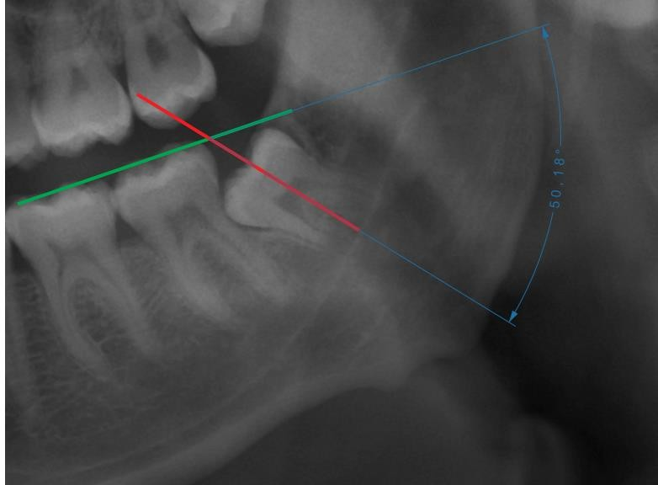

Fig. 1. Mesioangular third molar classified according to Winter’s criteria (adapted from Pell and Gregory, 1933) using CorelDRAW® software (Graphics Suite 2020) (personal archive)

Fig. 2. Vertical third molar classified according to Winter’s criteria (adapted from Pell and Gregory, 1933) using 3D SLICER software (personal archive).
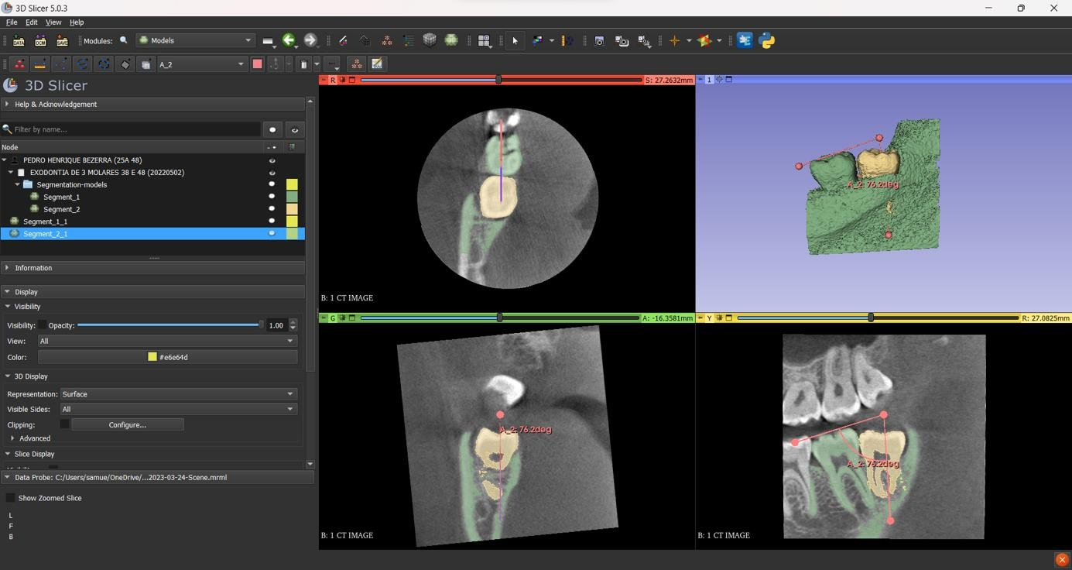

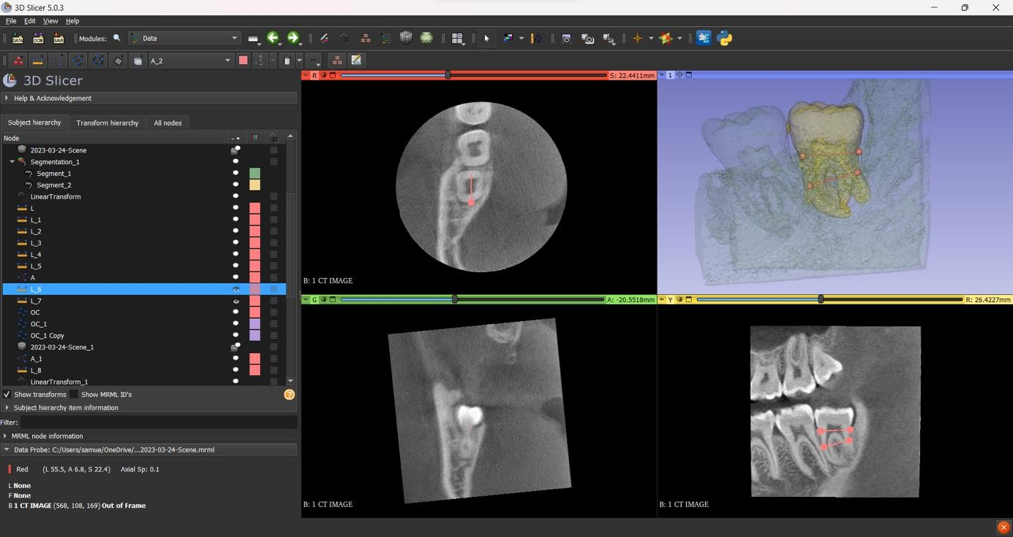
Fig. 3. Bulbous tooth of the third molar classified according to the criteria of Yuasa, Kawai, and Sugiura (2002) using CorelDRAW® software (Graphics Suite 2020) (personal archive).

Fig. 4. Bulbous tooth of the third molar classified according to the criteria of Yuasa, Kawai, and Sugiura (2002) using 3D SLICER software (personal archive).
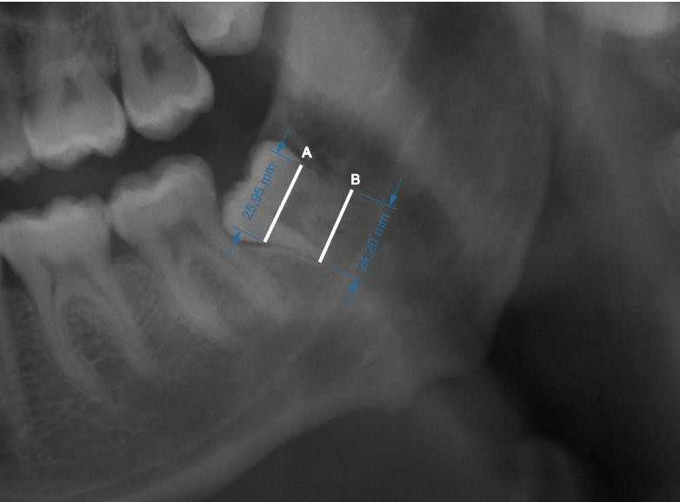

Fig. 5. Proximity of the third molar to the inferior alveolar nerve canal classified according to the criteria of Juodzbalys and Daugela (2013) using CorelDRAW® software (Graphics Suite 2020) (personal archive).
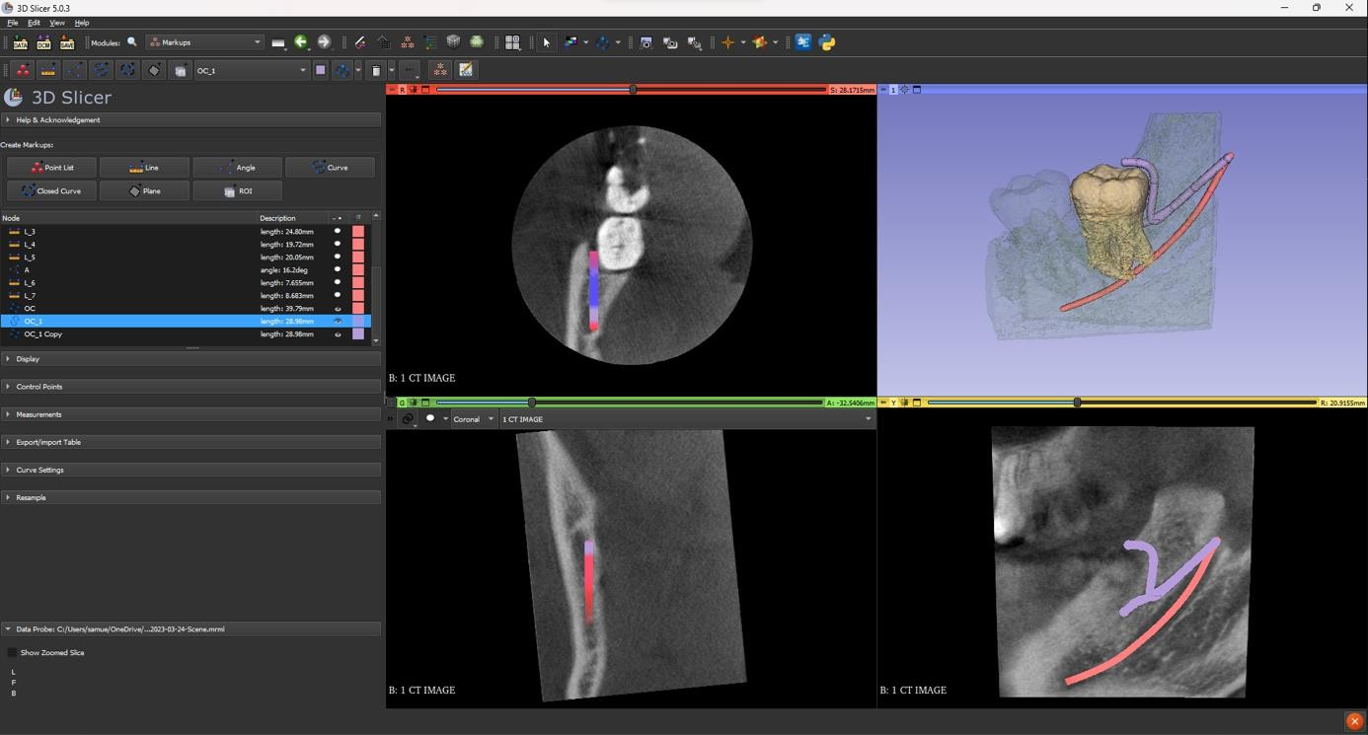

Fig. 6. Proximity of the third molar to the inferior alveolar nerve canal (pink) classified according to the criteria of Juodzbalys and Daugela (2013), and presence of the retromolar canal (purple), using 3D SLICER software (personal archive).
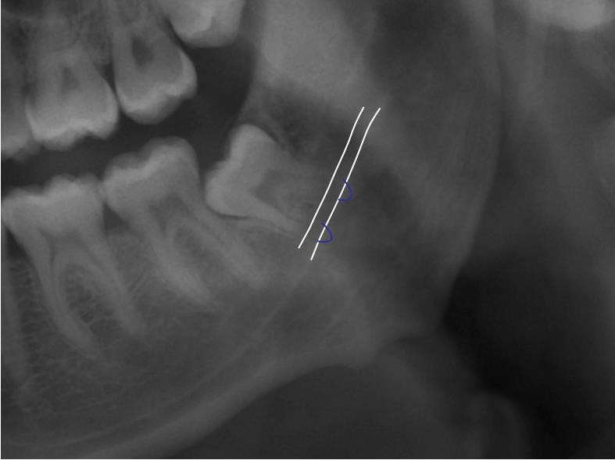

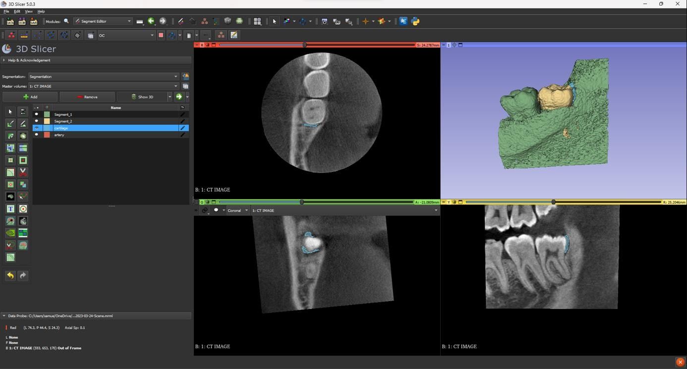
Fig. 7. Marginal bone loss classified according to the criteria of Lainez (2017) using CorelDRAW® software (Graphics Suite 2020) (personal archive).

Fig. 8. Marginal bone loss classified according to the adapted criteria of Lainez (2017) using 3D SLICER software (personal archive).
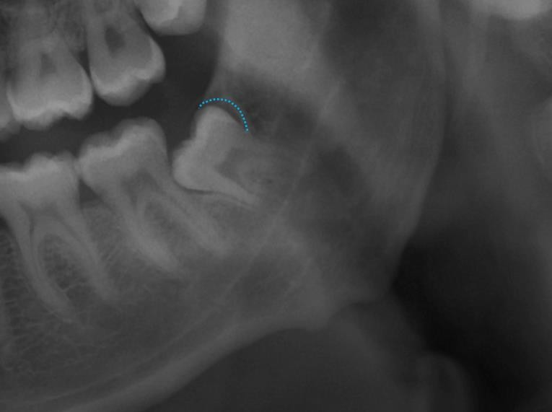
Table 1. Inter-observer Agreement

 |  | 2D |  |  |  | 3D
Classification | T1 | T2 | P | Kappa | T1 | T2 | p | Kappa
Pell e Gregory A B C
A | 27  51.9% | 28  53.8% |  |  | 16  30.8% | 16  30.8%
 | 27  51.9% | 28  53.8% | 1,000 | 0,961 | 16  30.8% | 16  30.8% | 1,000 | 1,000
B | 25  48,1% | 24  46,2% |  |  | 36  69,2% | 36  69,2%
Pell e Gregory I II III
I | 29  55,8% | 29  55,8% |  |  | 14  26,9% | 14  26,9%
II | 23  44,2% | 23  44,2% | 1,000 | 1,000 | 38  73,1% | 38  73,1% | 1,000 | 1,000
Winter
Horizontal | 14  26,9% | 15  28,8% |  |  | 16  30,8% | 15  28,8%
Mesioangulado | 14  26,9% | 13  25% |  |  | 12  23,1% | 13  25%
 | 14  26,9% | 13  25% | 0,368 | 0,949 | 12  23,1% | 13  25% | 1,000 | 0,937
Vertical | 13  25% | 12  23,1% |  |  | 18  34,6% | 18  34,6%
Distoangulado | 11  21,2% | 12  23,1% |  |  | 6  11,5% | 6  11,5%
Dental bulbosity
Yes | 43  82,7% | 43  82,7% |  |  | 36  69,2% | 35  67,3%
 | 43  82,7% | 43  82,7% | 1,000 | 1,000 | 36  69,2% | 35  67,3% | 1,000 | 0,956
No | 9  17,3% | 9  17,3% |  |  | 16  30,8% | 17  32,7% | 1,000 | 0,956
Proximity to the IANC
Yes | 2  3,8% | 3  5,8% |  |  | 4  7,7% | 3  5,8%
 | 2  3,8% | 3  5,8% | 1,000 | 0,371 | 4  7,7% | 3  5,8% | 1,000 | 0,847
No | 50  96,2% | 49  94,2% |  |  | 48  92,3% | 49  94,2% | 1,000 | 0,847
Marginal bone loss
Yes | 36  69,2% | 37  71,2% |  |  | 41  78,8% | 41  78,8%
 | 36  69,2% | 37  71,2% | 1,000 | 0,964 | 41  78,8% | 41  78,8% | 1,000 | 1,000
No | 16  30,8% | 15  28,8% |  |  | 11  21,2% | 11  21,2% | 1,000 | 1,000

McNemar significance test (p<0.05) demonstrated a statistically significant difference in the 2D measurements between the two observers regarding the classification of proximity to the Inferior Alveolar Nerve Canal (IANC).

Table 2. Measurements According to Pell and Gregory.
3D
Classification |  | A | B | Sensivity (A/I) | Specificity (B/II) | PPV (A/I) | NPV (B/II) | Accuracy | P | Kappa
Pell e Gregory
A B C
 | A | 14 | 14
2D | B | 2 | 22 | 87,5% | 61,1% | 50% | 91,7% | 69,2% | 0,004 | 0,402
 | Pell e Gregory I II III
 | I | 12 | 17 | 85,7% | 55,3% | 41,4% | 91,3% | 63,5% | 0,001 | 0,306
 | II | 2 | 21
McNemar significance test (p<0.05) revealed differing values between sensitivity (A/I) and specificity (B/II) in the Pell and Gregory classification.

Table 3. Measurements According to Winter Classification (2D)
Classification | No | 3D  Yes | Sensivity | Specificity | PPV | NPV | Accuracy | p | Kappa
Winter Horizontal
No | 36 | 1 | 93,3 | 97,3 | 93,3 | 91,7 | 96,2
Yes | 1 | 14 | % | % | % | % | % | <0,001 | 0,691
Winter Mesioangulated
No | 37 | 2 | 84,6 | 94,9 | 84,6 | 94,9 | 92,3 | <0,001 | 0,691
Yes | 2 | 11 | % | % | % | % | %
Winter Vertical
No | 32 | 8 | 55,6% | 94,1% | 83,3 | 80 | 80,8 | <0,001 | 0,691
Yes | 2 | 10 |  |  | % | % | %
Winter Distoangulado
No | 39 | 1 | 83,3 | 84,8 | 41,7 | 97,5 | 84,6 | <0,001 | 0,691
Yes | 7 | 5 | % | % | % | % | %
McNemar significance test (p<0.05) revealed greater discrepancies between sensitivity and specificity in vertically positioned third molars according to Winter’s classification.

Table 4 – Measurements According to Other Classifications

Classification | No | 2D  Yes | Sensivity | Specificity | PPV | NPV | Accuracy | p | Kappa
Dental bulbosity
No | 34 | 9 | 47,1 | 97,1 | 88,9 | 79,1 | 80,8
Yes | 1 | 8 | % | % | % | % | % | 0,021 | 0,503
Proximity to the IANC
No | 0 | 3 | 93,9 | 0 | 93,9 | 0 | 88,5 | 1,00 | 0,691
Yes | 3 | 46 | % | % | % | % | %
Marginal boné loss
No | 31 | 6 | 45,5  % | 75,6  % | 33,3  % | 83,8  % | 69,2  % | 0,454 | 0,186
Yes | 10 | 5
McNemar significance test (p<0.05) revealed greater discrepancies between sensitivity and specificity in the classification of Proximity to the inferior.

