Effect of three endodontic sealers and ultrasonic agitation on tooth discoloration

.
ABSTRACT

Aims: Evaluate the color change (ΔE) provided by Endofill (EF), Sealer 26 (S26) and MTA Fillapex (MTAF) endodontic sealers; also, to evaluate the influence of ultrasonic agitation (UA) in this discoloration.
Methodology: Sixty blocks of bovine incisors were prepared and had circular cavities performed on their palatine faces in order to maintain a remnant of 2.0 mm thickness. They were divided into 6 groups according to the sealer/treatment. When used, UA was performed with a smooth ultrasonic insert coupled to a piezoelectric device. The color parameters were measured by means of a Vita Easyshade spectrophotometer after materials insertion and restoration achievement at the periods: immediately (T0), at 7 (T1), 30 (T2), 60 (T3), 90 (T4) and 180 days (T5). During the period the specimens were maintained immersed in containers filled with 2 mL of saline solution kept in an oven at 37 ºC. Statistical analysis was performed by Kruskal-Wallis and Dunn tests with significance set at 5%.
Results: It was observed at 7 and 30 days that just the EF group without UA presented ΔE>3.7, a reference for clinically perceptible alterations. At 60 days all materials presented perceptible ΔE. Significant differences were observed throughout the experimental period in all groups (P<0.05).
Conclusion: In this study conditions could be concluded that, although initially only the EF showed a noticeable color variation, at the end of the experimental period all materials under test produced darkening. Furthermore, UA did not significantly interfere in ΔE effects of tested materials.

Keywords: Endodontics; Tooth Discoloration; Root Canal Filling Materials; Ultrasonics

1. INTRODUCTION

When the pulp becomes non-viable, endodontic treatment aims to achieve its objective through debridement and disinfection, removing microorganisms, and obturation, in order to fill the root canal system (Chen, et al., 2017). However, incomplete filling by obturation materials can lead to endodontic failure, even with meticulous biomechanical preparation (Kalantar et al., 2021).
An important aspect of endodontic treatment is the patient’s quality of life, as oral problems can significantly affect physical and psychological well-being (Avancini et al., 2025). Among the associated issues, dental discoloration -often caused by materials used in obturation- is a significant aesthetic concern.
Dentin discoloration induced by endodontic sealers occurs due to the interaction between radiopacifying agents and dentin collagen fibers, compromising the aesthetic outcome of the treatment (Savaris et al., 2024; Luna-Cruz et al., 2024; Assmann et al., 2012). This effect can directly impact patient satisfaction and emotional well-being.
Various types of endodontic sealers are currently available on the market. Among the most traditional are zinc oxide and eugenol-based sealers, which are widely used worldwide (Assmann et al., 2012; Komabayashi et al., 2020). Endofill cement (Dentsply Brasil, Petrópolis, RJ, Brazil) belongs to this category, comprising a powder component (zinc oxide, hydrogenated resin, bismuth subcarbonate, barium sulfate, and sodium borate) and a liquid component (eugenol and sweet almond oil). This sealer exhibits exceptional flowability and meets appropriate standards for radiopacity and plasticity, as required by ISO 6876/2012 (Torabinejad, Pariokh and Dummer 2018).
In addition to zinc oxide and eugenol-based sealers, there are those formulated with plastic resins as the main component (Alcalde et al., 2017; Camilleri 2015), providing greater mechanical strength compared to conventional materials (Eramo et al., 2018; Cintra et al., 2017; Tomás-Catalá et al., 2017). An example of this group is Sealer 26 (Dentsply Brasil), which consists of a powder (composed of bismuth oxide, calcium hydroxide, hexamethylenetetramine, and titanium dioxide) bound to an epoxy-bisphenol resin (Bernabé et al., 2013; Guimarães et al., 2014).
Another relevant category includes bioceramic sealers, which consist of ceramic or metallic oxides with sufficient biocompatibility to interact with human tissues, stimulate regeneration, and promote tissue resorption (Marciano et al., 2017; Al-Fouzan et al., 2012; Lenherr et al., 2012). A well-known example is mineral trioxide aggregate (MTA)-based sealers (Marciano et al., 2014; Dettwiler et al., 2016). These materials exhibit excellent sealing ability, biocompatibility, and bioactivity, making them widely indicated for endodontic therapy, including pulp capping, pulpotomy, root perforation sealing, apexification, and retrograde obturation (Marciano, Duarte and Camilleri 2015). However, MTA has some drawbacks, such as handling difficulties, prolonged setting time, and potential color alteration (Camilleri, Sorrentino and Damidot 2013; Richman 1957). Among the most accessible materials in this category, MTA Fillapex stands out as a sealer composed of salicylate resin, diluent resin, natural resin, bismuth oxide, radiopacifying agents, silica nanoparticles, MTA, and pigments (Dettwiler et al., 2016; Camilleri, Sorrentino and Damidot 2013). Its distinctive feature lies in its radiopacifier: calcium tungstate.
Studies have shown that ultrasound-assisted obturation results in a denser and more homogeneous filling compared to the more commonly used lateral compaction technique (Alcalde et al., 2017; Bernabé et al., 2013; Yoldaş et al., 2016). Ultrasonically assisted active lateral condensation has been employed to soften gutta-percha, improving its adaptation to canal walls (Alcalde et al., 2017; Bernabé et al., 2013). Some in vitro studies report that this technique provides better sealing ability and higher gutta-percha density than manual lateral compaction (Alcalde et al., 2017). However, the influence of ultrasound agitation on sealer distribution and its impact on the discoloration potential of these materials still require further investigation (Bernabé et al., 2013; Aguiar et al., 2019).
With the ongoing development of new endodontic sealers and the potential positive interactions associated with ultrasonic agitation, a more detailed assessment of the possible discoloration effects of Endofill, Sealer 26, and MTA Fillapex is warranted. The null hypothesis will assume no significant differences among the tested endodontic sealers regarding dentin discoloration induction and that ultrasonic agitation will not influence the darkening effect.

2. material and methods

For the present study, 60 bovine anterior single-rooted teeth were collected. These were cleaned, and their roots were sectioned horizontally at the cementoenamel junction using a diamond disc (7011; KG Sorensen, Cotia, SP, Brazil). After this step, 10 × 10 mm blocks were extracted from the buccal portion of the crowns. The thickness of each block was standardized at 3.5 ± 0.3 mm by removing the palatal surface. Cavities with a diameter of 5.0 mm and approximately 1.5 mm in depth were prepared in the center of the lingual portion of each specimen using a #1057 diamond bur (KG Sorensen), leaving a residual dentin and enamel thickness of 2.0 mm, which was verified with a caliper. The specimens were then immersed in 2.5% sodium hypochlorite for 15 minutes, distilled water for 1 minute, 17% EDTA (Biodinâmica Química e Farmacêutica Ltda., Ibiporã, PR, Brazil) for 3 minutes, and again in distilled water for another 1 minute to remove the smear layer. Finally, they were dried with filter paper.

The blocks were then randomly divided into experimental groups according to Table 1.

Table 1. Division of Experimental Groups
SEALER | TREATMENT
Endofill | With ultrasonic agitation (EF/UA)  Without ultrasonic agitation (EF)
Sealer 26 | With ultrasonic agitation (S26/UA)  Without ultrasonic agitation (S26)
MTA Fillapex | With ultrasonic agitation (MTAF/UA)  Without ultrasonic agitation (MTAF)
Source: author's own

The cavities were completely filled with the sealers, mixed according to the manufacturers’ instructions. In the groups that received ultrasonic agitation, a piezoelectric ultrasonic device (Piezon Master 200; EMS, Nyon, Geneva, Switzerland) was used, set to power level 3 (approximately 30%), with a smooth solid conical tip (E8; Helse Ultrasonic, Santa Rosa do Viterbo, SP, Brazil). After gently condensing the sealer into the cavity, the tip was inserted to a depth of 1 mm. Then, two agitation cycles of 20 seconds each were performed: one in the mesiodistal direction and another in the buccolingual direction (Guimarães et al., 2014).

At the end, the cavities were sealed with Opallis Enamel A3 composite resin (FGM Produtos Odontológicos Ltda., Joinville, SC, Brazil) and light-cured with an LED light (Optilight LD Max; Gnatus, Ribeirão Preto, SP, Brazil) for 60 seconds. Finally, the samples were immersed in individual containers containing 2 mL of distilled water, where they remained immersed until the end of the experiment, indirectly exposed to sunlight at room temperature.

Color determination was performed according to the protocol described by Lenherr et al. (2012) in a dark room using a digital spectrophotometer (VITA Easyshade compact; VITA Zahnfabrik AG, Bad Sachington, Germany). This allowed standardized measurements for each sample throughout the observation periods. The spectrophotometer was calibrated before measurements were taken for each group. Measurements were obtained immediately after material placement (T0 = reference color), after 1 week (T1), after 30 days (T2), after 60 days (T3), after 90 days (T4), and after 180 days (T5). Color parameters were recorded according to the International Commission on Illumination (CIE, 1978), considering L, a, and b values, where "L" represents the brightness of the color, "a" corresponds to the red-green axis measurement, and "b" corresponds to the yellow-blue axis measurement. Color change (ΔE) over time intervals was calculated using the following formula:

ΔE = [(L1-L0)2 + (a1-a0)2 + (b1-b0)2]1/2

The data from both evaluations were tabulated and tested using the Shapiro-Wilk test, which indicated a parametric distribution for the dentin discoloration data analysis. Therefore, the Kruskal-Wallis and Dunn tests, as well as ANOVA and Tukey tests, were used for the discoloration analyses, with statistical significance set at P > 0.05.

.
3. results and discussion

The data regarding color change (ΔE) observed throughout the experimental periods are presented in Table 2.
Table 2. Median, Minimum, and Maximum Values of Discoloration in the Tested Endodontic Sealers With and Without Ultrasonic Agitation

Material | Agitation | 7 Days |  | 30 Days |  |  | 60 Days |  |  |  | 90 Days |  |  | 180 Days
Material | Agitation | Median | Min. - Max. |  | Median | Min. - Max. |  | Median | Min. - Max. | Median |  | Min. - Max. | Median |  | Min. - Max.
Endofill | Without | 4.15^{b,A} | 2.20 – 10.70 |  | 3.88^{a,A} | 1.61 – 6.95 |  | 4.40^{a,A} | 1.31 – 9.67 | 3.30^{a,A} |  | 2.88 -11.08 | 4.54^{a,A} |  | 3.38 -12.36
Endofill | With | 3.04^{ab,A} | 1.36 – 14.45 |  | 2.68^{a,A} | 1.03 – 16.85 |  | 4.39^{a,A} | 2.71 – 15.05 | 2.96^{a,A} |  | 0.92 – 18.54 | 6.53^{a,A} |  | 3.05 – 16.34
Sealer 26 | Without | 0.82^{a,A} | 0.14 – 8.86 |  | 2.74^{a,AB} | 0.73 – 8.25 |  | 3.88^{a,AB} | 1.31 – 12.44 | 3.47^{a,AB} |  | 1.39 – 15.36 | 5.49^{a,B} |  | 3.05 -25.03
Sealer 26 | With | 1.58^{ab,A} | 0.72 – 3.16 |  | 3.49^{a,B} | 2.10 – 5.27 |  | 3.45^{a,AB} | 1.43 – 6.24 | 3.00^{a,AB} |  | 0.91 -5.75 | 4.69^{a,B} |  | 3.05 – 8.74
MTA Fillapex | Without | 2.65^{ab,A} | 0.95 – 3.36 |  | 3.08^{a,AB} | 0.58 – 5.86 |  | 7.05^{a,B} | 2.76 -11.68 | 4.93^{a,AB} |  | 0.91 – 14.99 | 6.09^{a,B} |  | 3.06 -19.66
MTA Fillapex | With | 2.21^{ab,A} | 0.31 – 3.97 |  | 2.40^{a,AB} | 1.06 – 4.40 |  | 5.00^{a,AB} | 1.80 – 8.29 | 5.27^{a,B} |  | 1.80 – 15.71 | 4.04^{a,AB} |  | 3.081 – 8.433
^{a,b} Different lowercase letters indicate statistically significant differences within each time period, according to the Kruskal-Wallis and Dunn tests (P < 0.05).
^{A,B} Different uppercase letters represent significant differences within the same material over time according to the Kruskal-Wallis and Dunn tests (P < 0.05).

Source: author's own

From the analysis of the 7-day period (T1), all analyzed groups exhibited color variation, indicating dentin darkening. However, only the EF group presented discoloration values above the reference threshold of 3.7, a value that represents a clinically perceptible change (Fig. 1).

Figure 1. Graphical representation of the color variation presented by the endodontic sealers over time and with or without the use of UA.
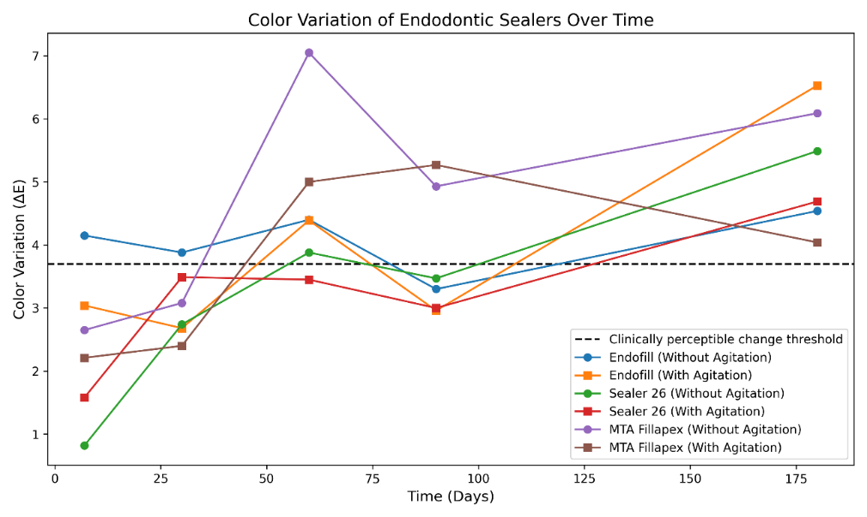
Source: author's own

At 30 days (T2), ΔE values remained stable or showed only slight variations in all experimental groups. At 60 days (T3), all root canal sealers, regardless of the use of ultrasonic agitation (UA), exceeded the 3.7 reference threshold, demonstrating a greater impact on dentin color alteration.
Considering the 180-day period (T5), it is noteworthy that the MTAF sealer without UA reached its highest discoloration value over the study periods (Fig. 2).

Figure 2. Representation of bovine tooth samples filled with Endofill, Sealer 26, and MTA Fillapex after ultrasonic agitation at 180 days.

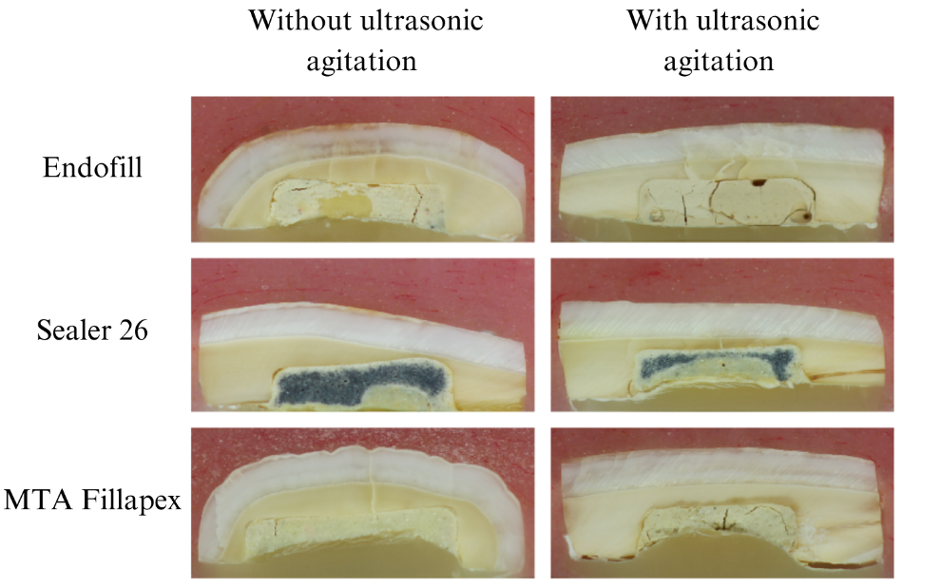

Source: author's own

The S26 sealer showed no significant differences when comparing groups with and without UA, unlike what was observed in the groups of the other tested sealers (Fig. 1). By the T5 period, all experimental groups exhibited values confirming dentin discoloration levels (Fig. 1).

Considering the obtained results, the null hypothesis was partially rejected, as all experimental groups presented clinically significant discoloration values over the study period. However, ultrasonic agitation did not exert a considerable influence on the final findings.
To approximate the employed methods to clinical conditions, all efforts were made to follow the protocol suggested in previous studies (Marciano et al., 2014; Dettwiler et al., 2016), which obtained results with high scientific reliability. The choice of bovine teeth aimed to reduce morphological variability compared to human teeth, as their tubular density does not present significant differences for dental discoloration studies (Marciano et al., 2014). Additionally, for discoloration assessment, enamel-dentin blocks were used to standardize dentin thickness in contact with the material, as well as the cavity size and the amount of material employed (Marciano et al., 2014).
Ultrasound is widely used in endodontics due to its ability to transmit micrometric acoustic energy. This mechanical vibration propagated by the tip can favor greater penetration of the material into dentinal tubules, in addition to improving the adaptation of the cement/dentin interface (Lenherr et al., 2012; Marciano et al., 2014). Thus, in the discoloration analysis, its inclusion aimed to verify possible changes in dentin discoloration caused by endodontic sealers due to this agitation.
Color determination in dentistry can be performed using visual techniques or devices such as spectrophotometers and colorimeters. Although visual assessment is widely used in clinical practice, it has limitations due to subjectivity and individual variation in color perception (Tabatabaian et al., 2021). For this reason, the Vita Easyshade device was chosen, as it is recognized for its high data stability and excellent repeatability (Alcalde et al., 2017; Al-Fouzan et al., 2012).
The results of the present study indicated significant differences in the color change caused by endodontic sealers as early as 7 days, with Endofill showing the highest absolute values, significantly differing from Sealer 26 without agitation (P < 0.05). The values presented by Endofill without agitation positioned it as the only material to exhibit clinically significant color variation as early as the 7-day evaluation.
Overall, all groups demonstrated variation in the intensity of discoloration observed throughout the study, with the highest color variation values most frequently observed at 180 days. The only exception was MTA Fillapex, which, regardless of ultrasonic agitation, exhibited the most significant discoloration at 60 days. By the end of the experimental period (180 days), all tested sealers had exceeded the clinically acceptable limit for color variation. When comparing values throughout the experiment, the Endofill sealer groups were the only ones that did not show significant differences between the 7- and 180-day evaluations (P > 0.05), possibly due to their already high values at 7 days. All other sealers showed a statistically significant increase in discoloration over time (P < 0.05). There are still no studies in the literature that serve as direct benchmarks for comparison with the values found in this study.
Considering that the discoloration caused by endodontic sealers has been attributed to radiopacifying agents present in these materials, it is relevant to observe the behavior of the tested materials, particularly given their different radiopacifying components (Richman 1957). Endofill contains three substances capable of providing radiopacity: zinc oxide, barium sulfate, and bismuth subcarbonate. Sealer 26 exclusively uses bismuth trioxide, while MTA Fillapex employs calcium tungstate.
Bismuth has been identified as responsible for the discoloration of endodontic repair materials (Al-Fouzan et al., 2012). Authors have discussed the instability of this chemical element and its possible interaction with moisture and collagen in dentin (Luna-Cruz et al., 2024; Marciano et al., 2017). This information may explain the discoloration observed in both Endofill and Sealer 26. On the other hand, previous studies have also indicated the occurrence of dental discoloration in repair materials that use calcium tungstate as a radiopacifier (Luna-Cruz et al., 2024; Marques et al., 2021). Additionally, the presence of other components in MTA Fillapex, such as salicylate resin and mineral trioxide aggregate, may lead to reactions that alter the element or cause discoloration themselves (Gonçalves et al., 2021).
Thus, considering the existing literature indicating that ultrasonic agitation can enhance penetration into dentinal tubules and marginal adaptation (Carneiro et al., 2023) as well as antimicrobial capacity (Alcalde et al., 2017), the present study supports that, regarding dental discoloration, the use of ultrasonic agitation is safe.

4. Conclusion

Based on the obtained results and considering the limitations of this study, it is concluded that all tested endodontic sealers promoted clinically perceptible discoloration over time. Additionally, ultrasonic agitation did not significantly influence the degree of discoloration, indicating that its use does not compromise the aesthetics of endodontic treatment.

DISCLAIMER (ARTIFICIAL INTELLIGENCE)

Authors hereby declare that no generative AI technologies such as Large Language Models (ChatGPT, COPILOT, etc.) and text-to-image generators have been used during the writing or editing of this manuscript.

References

- Aguiar, B. A., Frota, L. M., Taguatinga, D. T., Vivan, R. R., Camilleri, J., Duarte, M. A., & de Vasconcelos, B. C. (2019). Influence of ultrasonic agitation on bond strength, marginal adaptation, and tooth discoloration provided by three coronary barrier endodontic materials. Clinical oral investigations, 23(11), 4113-4122.
- Al-Fouzan, K., Al-Garawi, Z., Al-Hezaimi, K., Javed, F., Al-Shalan, T., & Rotstein, I. (2012). Effect of acid etching on marginal adaptation of mineral trioxide aggregate to apical dentin: microcomputed tomography and scanning electron microscopy analysis. International Journal of Oral Science, 4(4), 202-207.
- Alcalde, M. P., Bramante, C. M., Vivan, R. R., Amorso-Silva, P. A., Andrade, F. B. D., & Duarte, M. A. H. (2017). Intradentinal antimicrobial action and filling quality promoted by ultrasonic agitation of epoxy resin-based sealer in endodontic obturation. Journal of applied oral science, 25(6), 641-649.
- Assmann, E., Scarparo, R. K., Böttcher, D. E., & Grecca, F. S. (2012). Dentin bond strength of two mineral trioxide aggregate–based and one epoxy resin–based sealers. Journal of endodontics, 38(2), 219-221.
- Avancini, B. S., Maria, L. C., Botacin, W. G., Santos, P. B. D., & Miotto, M. H. M. D. B. (2025). Demand for Endodontic Treatment and its Impact on Quality of Life. Pesquisa Brasileira em Odontopediatria e Clínica Integrada, 25, e240020.
- Bernabé, P. F. E., Gomes-Filho, J. E., Bernabé, D. G., Nery, M. J., Otoboni-Filho, J. A., Dezan-Jr, E., & Cintra, L. T. A. (2013). Sealing ability of MTA used as a root end filling material: effect of the sonic and ultrasonic condensation. Brazilian Dental Journal, 24, 107-110.
- Camilleri, J. (2015). Staining potential of Neo MTA Plus, MTA Plus, and Biodentine used for pulpotomy procedures. Journal of endodontics, 41(7), 1139-1145.
- Camilleri, J., Sorrentino, F., & Damidot, D. (2013). Investigation of the hydration and bioactivity of radiopacified tricalcium silicate cement, Biodentine and MTA Angelus. Dental materials, 29(5), 580-593.
- Carneiro, V. F., Alcalde, M. P., do Vale, M. S., Vivan, R. R., Duarte, M. A. H., & Vasconcelos, B. C. D. (2023). Effect of ultrasonic agitation on marginal adaptation, intratubular penetration and bonding strength of calcium‐silicate‐based endodontic sealers: A laboratory study. Australian Endodontic Journal, 49(3), 690-699.
- Chen, H., Zhao, X., Qiu, Y., Xu, D., Cui, L., & Wu, B. (2017). The tubular penetration depth and adaption of four sealers: a scanning electron microscopic study. BioMed research international, 2017(1), 2946524.
- Cintra, L. T. A., Benetti, F., de Azevedo Queiroz, Í. O., de Araújo Lopes, J. M., de Oliveira, S. H. P., Araújo, G. S., & Gomes-Filho, J. E. (2017). Cytotoxicity, biocompatibility, and biomineralization of the new high-plasticity MTA material. Journal of endodontics, 43(5), 774-778.
- Dettwiler, C. A., Walter, M., Zaugg, L. K., Lenherr, P., Weiger, R., & Krastl, G. (2016). In vitro assessment of the tooth staining potential of endodontic materials in a bovine tooth model. Dental Traumatology, 32(6), 480-487.
- Eramo, S., Natali, A., Pinna, R., & Milia, E. (2018). Dental pulp regeneration via cell homing. International endodontic journal, 51(4), 405-419.
- Gonçalves, N. B., Luna-Cruz, S. M., Pinheiro Jr, E. C., Gomes, N. V., & De Vasconcelos, B. C. (2021). Evaluation of dentin discoloration caused by endodontic root canal sealers due to ultrasonic agitat. Dental Press Endodont, 11, 46-51.
- Guimarães, B. M., Amoroso-Silva, P. A., Alcalde, M. P., Marciano, M. A., de Andrade, F. B., & Duarte, M. A. H. (2014). Influence of ultrasonic activation of 4 root canal sealers on the filling quality. Journal of endodontics, 40(7), 964-968.
- Kalantar Motamedi, M. R., Mortaheb, A., Zare Jahromi, M., & Gilbert, B. E. (2021). Micro‐CT evaluation of four root canal obturation techniques. Scanning, 2021(1), 6632822.
- Komabayashi, T., Colmenar, D., Cvach, N., Bhat, A., Primus, C., & Imai, Y. (2020). Comprehensive review of current endodontic sealers. Dental materials journal, 39(5), 703-720.
- Lenherr, P., Allgayer, N., Weiger, R., Filippi, A., Attin, T., & Krastl, G. (2012). Tooth discoloration induced by endodontic materials: a laboratory study. International endodontic journal, 45(10), 942-949.
- Luna-Cruz, S. M., Aguiar, B. A., Limoeiro, A. G., Duarte, M. A. H., de VASCONCELOS, B. C., & Mendonça, J. S. (2024). Ex vivo tooth discoloration induced by calcium silicate-based materials: analysis of an experimental cement. Brazilian Dental Science, 27(2).
- Marciano, M. A., Camilleri, J., Costa, R. M., Matsumoto, M. A., Guimaraes, B. M., & Duarte, M. A. H. (2017). Zinc oxide inhibits dental discoloration caused by white mineral trioxide aggregate angelus. Journal of endodontics, 43(6), 1001-1007.
- Marciano, M. A., Duarte, M. A. H., & Camilleri, J. (2015). Dental discoloration caused by bismuth oxide in MTA in the presence of sodium hypochlorite. Clinical oral investigations, 19(9), 2201-2209.
- Marciano, M. A., Costa, R. M., Camilleri, J., Mondelli, R. F. L., Guimarães, B. M., & Duarte, M. A. H. (2014). Assessment of color stability of white mineral trioxide aggregate angelus and bismuth oxide in contact with tooth structure. Journal of Endodontics, 40(8), 1235-1240.
- Marques, R. B., Baroudi, K., Santos, A. F. C. D., Pontes, D., & Amaral, M. (2021). Tooth discoloration using calcium silicate-based cements for simulated revascularization in vitro. Brazilian Dental Journal, 32(1), 53-58.
- Richman, MJ. (1957). The use of ultrasonics in root canal therapy and root resection. J Dent Med, 12, 12-18.
- Savaris, J. M., Czornobay, L. F. M., Dotto, M. E. P., Santos, P. S., Garcia, L. D. F. R., Vitali, F. C., & Teixeira, C. D. S. (2024). Tooth discoloration induced by endodontic sealers of different chemical bases: A systematic review. Brazilian Dental Journal, 35, e24-6021.
- Tabatabaian, F., Beyabanaki, E., Alirezaei, P., & Epakchi, S. (2021). Visual and digital tooth shade selection methods, related effective factors and conditions, and their accuracy and precision: A literature review. Journal of Esthetic and Restorative Dentistry, 33(8), 1084-1104.
- Tomás‐Catalá, C. J., Collado‐González, M., García‐Bernal, D., Oñate‐Sánchez, R. E., Forner, L., Llena, C., ... & Rodríguez‐Lozano, F. J. (2017). Comparative analysis of the biological effects of the endodontic bioactive cements MTA‐Angelus, MTA Repair HP and NeoMTA Plus on human dental pulp stem cells. International endodontic journal, 50, e63-e72.
- Torabinejad, M., Parirokh, M., & Dummer, P. M. (2018). Mineral trioxide aggregate and other bioactive endodontic cements: an updated overview–part II: other clinical applications and complications. International endodontic journal, 51(3), 284-317.
- Yoldaş, S. E., Bani, M., Atabek, D., & Bodur, H. (2016). Comparison of the potential discoloration effect of bioaggregate, biodentine, and white mineral trioxide aggregate on bovine teeth: in vitro research. Journal of endodontics, 42(12), 1815-1818.

