Original Research Article

A Comparative Analysis of Eye Tracking and 2-Alternative Forced Choice Method for Assessing Colour Preferences in Young Children

.
ABSTRACT

Colour preference research has traditionally relied on subjective methods, which can be challenging to apply accurately in young children. This study investigates the effectiveness of eye tracking as an objective method for assessing colour preferences in children aged 6–8 years, in comparison with the two-alternative forced-choice (2-AFC) method. Six colours were considered, three primary (red, blue, yellow) and three secondary (purple, green, orange) were evaluated by 20 participants. Results showed that purple produced significantly higher fixation counts and durations, suggesting a strong visual preference. A positive correlation was observed between eye movement parameters and the choices made in the 2-AFC method, with both methods yielding similar preference sequences. These findings indicate that eye tracking may serve as a reliable standalone tool for measuring colour preferences in young children, offering an objective alternative to subjective methods in the context of educational and design applications.

Keywords: Colour preference, children, eye tracking, research methods

1. INTRODUCTION

Colour is a powerful tool as it can grab individuals’ attention. Several studies suggested that colour can enhance cognitive performance (Brooker and Franklin, 2016; Elliot and Maier, 2014). Individual colour preference pertains to the colours that people prefer (Mikellides, 2012) Individual colour preferences differ from person to person, despite some common trends, such as the tendency for people to detest bright colours like yellow and orange and prefer cold colours like blue (Grieve, 1991). Additionally, some research indicates that individual colour preferences may be influenced by gender (Ling et al, 2006; Fortmann, 2013; Zhang et al, 2019) among other factors such as age, culture (Jonauskaite et al, 2016).
Considering the preference of colour hues, warm colours like orange and yellow are typically disliked in favour of cool colours like blue and green, with blue being the colour most desired and yellow green the least (Ling et al, 2006; Guilford and Smith, 1959; Eysenck, 1941; Hogg, 1969; Dorcus, 1926). A number of studies have suggested that there is a universal individual colour preference across cultures, (Eysenck, 1941; Saito, 1996) genders (Mikellides, 2012; Mohebbi, 2014; Ditmar, 2001) and age levels (Franklin et al, 2010; Teller et al, 2004). Mohebbi carried out a gender based study considering the young children of aged 7-9 years by using Luscher test. The paper stated that a significant difference exists between boys and girls tendencies towards four colours including blue, green, pink and black. Eysenck (1941), discovered that the individual colour preference ranking for white people and those of other races is the same: blue, red, green, and purple. Saito, (1996) found that white and blue were the most preferred colours in Japan and Korea. Blue is the most favourite colour for both sexes, whereas yellow is the least popular colour, according to Mikellides's analysis of previous research on individual colour preference (Mikellides, 2012). Children (infants) of all ages have a tendency for warmer hues; there is no gender-specific preference (Franklin et al, 2010; Teller et al, 2004). However, some studies concluded that different cultural backgrounds lead to different individual colour preferences. Child and Iwao, (1969) found there were colour saturation and brightness preference difference between Japan and United States. Through the analysis of colour emotion data, Ou and Luo discovered that the Chinese prefer "clean," "fresh," and "modern" colours, while the UK preferred "cool" colours (Pitchford et al, 2009). Between genders, for children, according to Burkitt et al, (2003) boys considerably liked pale blue, while girls preferred pink. Males prefer more bluish colours than females, and females prefer more reddish colours than males, according to Hurlbert and Ling's research on adults (Ling et al, 2006). Another study suggested that younger people like light colours, while older people choose dark ones. According to Dittmar, (2001), people's colour preferences tend to remain consistent as they get older, but as they get older, their taste for blue begins to wane and eventually shifts to green and red (Strauss et al, 2013).
In terms of experimental methods, many studies have collected data by using subjective methodologies to identify the colour preferences in different age groups (Pitchford et al, 2009; Jonauskaite et al, 2016; Zentner, 2001; Mohebbi, 2014; Annamary et al, 2016) and using eye tracking in adults (Song E. S., et al, 2021; Lee, T. R. et al, 2005). Over the years, a variety of methodologies have been developed and employed to study colour preferences, reflecting the diverse approaches taken by researchers across disciplines (Guilford and Smith, 1959). There are varieties of survey methods to study colour preferences, but most of them use subjective approaches (Lee, T. R. et al, 2005). Yu et al, (2021), analyse experiments for preference which were subjective approaches and focuses on online experiments for convenience. Finding an effective methodology to identify the colour preference in young children is crucial and very effective for researchers and designers. This article compares two methodologies of identifying colour preference in young children, 2-Alternative Forced-Choice (2AFC) and Eye Tracking. It explores the colour preferences in children aged 6-8 years.
The benefits of the N-AFC approach include minimal response bias effects, no memory load, and a straightforward response to indicate choices. The 2-AFC, commonly known as "Paired-Comparison," is a unique N-AFC (Ling et al, 2006; Ou et al, 2012). One benefit of the 2-AFC task is that it only requires two samples to indicate the choice. The main disadvantage is that, when a high number (N[N-1]/2) of paired comparisons are made with N stimuli, the necessary to complete the entire matrix of comparisons becomes prohibitive (David, 1987). As a result, the researchers are more inclined to use a large number of stimuli in an incomplete comparison experiment (Ling et al, 2006).
The other method is eye tracking as some of the studies showed that colour preference could collect objective data via eye tracking technique (Adams, 1987; Shimojo et al, 2003; Hess and Polt, 1960). Eye tracking involves determining the point of gaze of a person’s eyes on a visual scene (Goldberg and Helfman, 2013). Hess and Polt (1960) had found that colour preference seems to be related to one’s pupils dilation and another study had stated that fixation counts and fixation duration to be associated with colour preference ranking order (Lee, T. R. et al, 2005). A person’s level of preference may be seen in their visual behaviour. These visual clues are more objective and cannot be easily falsified (Lee, T. R. et al, 2005). It has been reported that people look more or pay more visual attention on their area of interest in a scene/ frame of viewing (Wedel and Pieters, 2008; Wedel and Pieters, 2007). This study would identify participants’ colour preference through eye tracking parameters such as Fixation count and Fixation duration.
This study focuses on comparing subjective and objective approaches for assessing colour preferences in young children, to identify an effective research strategy to understand and evaluate individual colour preferences. The aims of this study were: a) To compare colour preference outcomes obtained through two experimental methods- eye tracking and the two-alternative forced-choice (2-AFC) task. b) To evaluate whether eye tracking can serve as a reliable standalone method for determining colour preferences in young children, compared to subjective methods like the 2-AFC task.

2. material and methods

2.1 Participants

The participants were 24 young children aged 6- 8 years, who did not have colour blindness were selected. The presence of colour blindness was assessed through the Ishihara colour blindness test, ensuring the participants have normal colour vision. The colour blindness test was conducted by using Ishihara Colour Blind test developed by Shinobu Ishihara (Ishihara, 1917). The series of plates in the test is designed to provide a test which gives a quick and accurate assessment of colour vision deficiency of congenital origin. Data from a total of 20 participants were analysed, as data from four participants contained errors. The same group of 20 participants was then included in both experiments.

2.2 Apparatus

The pair of colours for 2-AFC experiment was displayed in a laptop screen. The eye tracking experiment was conducted by using SMI Eye Tracking Glasses 2 wireless analysis pro. The stimuli were presented on a 22inch monitor and the configuration of the screen was set at a resolution of 1024 by 768 pixels. The SMI Eye Tracking Glasses 2 wireless analysis pro was used for the experiment. The eye tracking data were recorded at a sampling frequency of 60 Hz using iView ETG software and SMI BeGaze 3.7 software was used for data acquisition. Both experiments were carried out in a laboratory setting.

2.3 Stimulus

The colours used in this study were 6 colour patches selected from standard RGB colour value system. The 6 colours were Red: RGB (255,0,0), Blue: RGB (0,0,255), Yellow: RGB (255,255,0), Green: RGB (0,204,0), Orange: RGB (255,140,0) and Purple: RGB (255,0,255). For 2-AFC, the number of pairs obtained are 6(6-1)/2 i.e, 15 pairs which were displayed in a screen. The stimuli for eye tracking were prepared in PowerPoint slides, three stimuli were prepared for three trials. In each trial, the position of the items in the stimuli were shuffled to eliminate position bias.

2.4 Procedure

In 2-Alternative Forced Choice, the participants were asked to indicate which colour patch they prefer most. Since, there are 15 pairs of colours for six colours, same way the participants were asked to select one mostly preferred colour. To eliminate response bias, both the colours in each pair and the pairs themselves, are randomly arranged. In the eye tracking experiment the participants were presented with 6 colours in a laptop screen in three trials. Each participant was tested alone in a quiet room, seated approximately 60 cm from the monitor. The participants were given no specific, task-related instructions prior to the experiment, except that they needed to watch the images appearing on the computer screen and to look freely wherever they felt like. The 3-point calibration was conducted to obtain good accuracy and precision. The data were rejected for the participants where an error was found in the calibration. At first, each participant was asked to fix their eyes at a small white ‘+’ symbol positioned in the middle of a blank (black) slide presented on the computer screen for 2sec. Next, the first stimulus was presented for 5secs followed by a blank slide with a ‘+’ at the centre of the screen to eliminate the colour after effect. Thus, the stimuli were presented continuously for 21 secs.

2.5 Data Analysis

The data recorded from 2-AFC method of colour preferences were presented in a z-matrix table. According to the Z values, ranking was done for each colour. The data for the eye tracking method were collected in three trials. Some previous researchers indicate that during onscreen presentations, people typically gaze in the center.(Gibbs and Bernas, 2009) Therefore, in this study three trials were conducted in order to prevent position bias in the experimental data. The colour patches positions were altered in every trial. Eye tracking variables considered are fixation count and fixation duration. In order to identify the relationship between colour preference and eye movement, this study analysed the specific indicators, that is, fixation count and fixation duration. Fixation Count refers to how many times the user fixates on the Area of Interest (AOI) in total and fixation duration is the time taken for the eyes to look at a particular AOI. All statistical analyses were performed using SPSS and JASP. Two parameters of gazing behaviour were collected: 1. Fixation count, number of times the participant fixates on an AOI (count), 2. Fixation duration, duration of each individual fixation within an AOI (seconds). The AOI (area of interest) are the six colour patches. The data recorded in the eye tracking system mainly collected eye-movement data while participants viewed the stimulus in the screen. Four participants’ eye-movement data were eliminated because of drifting of eye movement. Twenty young children’s eye tracking parameters were further analysed and the same twenty participants participated in the 2-AFC method experiment. The data from each trial were separately analysed and presented. In this way this study assessed the effectiveness of eye tracking data in identifying colour preference in young children.

3. results and discussion

3.1 Colour preference response by 2-AFC method

The colour preference responses from the 20 participants were recorded, analysed and presented in a rank order after taking out the Z values. The results of the test are presented in Table 1. The findings from the 2-AFC method showed the colour preference sequence for z values/scores to be Purple > Blue > Red > Orange > Green > Yellow.
.
Table 1. Analysis of individual colour preference of 2-AFC method arranged in rank order

Colours | Yellow | Blue | Green | Purple | Red | Orange
Yellow | 0 | 0.253 | 0.126 | 0.385 | 0.126 | 0.253
Blue | -0.253 | 0 | 0.45 | 0.253 | -0.385 | -0.253
Green | -0.126 | 0.126 | 0 | 0.9 | 0.126 | -0.253
Purple | -0.385 | -0.253 | -2.326 | 0 | 0.253 | -0.524
Red | -0.126 | 0.385 | -0.126 | 0.4 | 0 | 0
Orange | -0.253 | 0.253 | 0.253 | 0.7 | 0 | 0
MEAN | -0.1905 | 0.127333 | -0.2705 | 0.439667 | 0.02 | -0.1295
Scale Value | 0.08 | 0.397833 | 0 | 0.710167 | 0.2905 | 0.141
RANKING | 6 | 2 | 5 | 1 | 3 | 4

3.2 Analysis of colour preference response by Eye Tracking method

The mean fixation counts and mean fixation duration of each individual colour variations in each trial were compared. The results showed that the fixation count and duration were higher for purple compared to other colours across the trials. The sequence of mean fixation count and duration (fig.1) across all the trials are – Purple > Blue > Red > Orange > Green > Yellow and Purple > Blue > Red, Orange > Green > Yellow respectively.

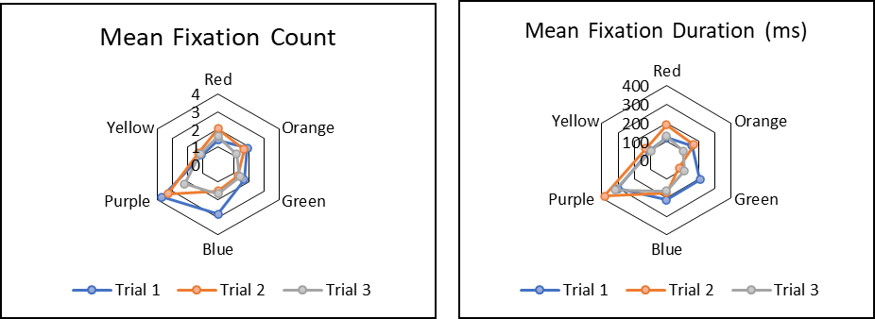

Figure 1: Mean Fixation Count and mean fixation duration of the individual colours

ANOVA was adopted to check significant variation among different colour fixation count and fixation duration. Observation from statistical analysis (ANOVA) has been presented in Table 2 where p<.001 was considered as level of significance. It was clear from the table 2, that there was significant difference among different colour regarding fixation count and fixation duration.

Furthermore, post hoc analysis Tukey HSD pair-wise comparisons were conducted to identify the significant difference between mean values of fixation count and fixation duration of different colour. It was revealed that only purple has a significant higher mean fixation count and duration in comparison to other colours (Table 3). It inferred that most participants significantly preferred purple than the other set of colours.

Table 2 Analysis of variance for fixation count and fixation duration for different colours

Dependent Variables | Between Group | df | F-value | Level of significance
Fixation Count | Between Group | 5 | 17.680 | 0.001
Fixation Duration | Between Group | 5 | 28.249 | 0.001

Table 3 Analysis to identify significant differences between the mean values of fixation count and duration of different colours

Dependent Variable | Colour |  | M±SE | Level of Significance | 95% Confidence interval
 |  |  |  |  | Lower Bound | Upper Bound
Fixation Count | Purple | Blue | 1.083±.2209 | .001 | .450 | 1.716
Fixation Count | Purple | Green | 1.600±.2209 | .001 | .967 | 2.233
Fixation Count | Purple | Orange | 1.467±.2209 | .001 | .834 | 2.100
Fixation Count | Purple | Red | 1.383±.2209 | .001 | .750 | 2.016
Fixation Count | Purple | Yellow | 1.867±.2209 | .001 | 1.234 | 2.500
Fixation Duration | Purple | Blue | 150.240±21.714 | .001 | 88.007 | 212.473
Fixation Duration | Purple | Green | 202.437±21.714 | .001 | 140.203 | 264.670
Fixation Duration | Purple | Orange | 192.157±21.714 | .001 | 129.923 | 254.390
Fixation Duration | Purple | Red | 186.678±21.714 | .001 | 124.445 | 248.912
Fixation Duration | Purple | Yellow | 223.738±21.714 | .001 | 161.505 | 285.972

3.3 Correlation for colour preference between 2 Alternative Forced Choice and Eye tracking parameters (Fixation count and Fixation duration)

A comparison of the two methods was conducted to examine whether colour preference influences eye movements. In the graphs (fig. 2 & 3), the vertical axis represents mean fixations (both count and duration), while the horizontal axis denotes the scale value based on rank order. Each data point corresponds to a specific colour. The strong correlation (r = 0.9) indicates a clear relationship between the results obtained from the two methods. Specifically, the eye-tracking data—measured in terms of fixation count and duration—was found to be associated with individual colour preferences. It can be inferred that young children tended to look longer and more frequently at colours they ranked more highly.

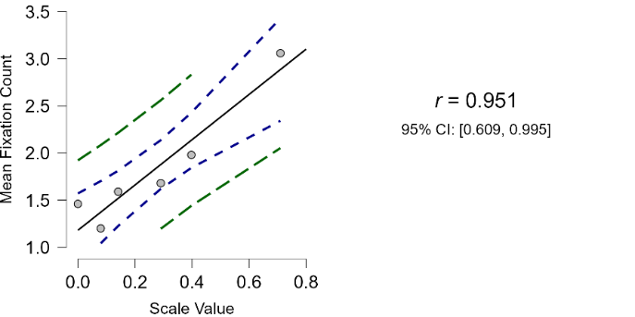
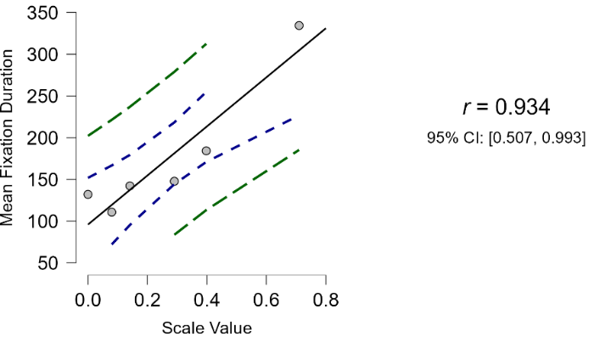

Figure 2: Correlation of colour preference between eye fixations (count and duration) and scale values of the individual colours

The results of this study indicate that eye-tracking data can serve as a valid and objective tool for identifying colour preferences in young children. The strong similarity in outcomes between the eye-tracking and two-alternative forced choice (2-AFC) methods provides preliminary validation for the use of eye-tracking in preference research. In addition to offering an objective measure, eye-tracking allows for data collection from a larger number of participants within a shorter timeframe, making it a practical alternative to traditional subjective methods. Both methods yielded highly similar rank orderings of individual colour preferences: Purple > Blue > Red > Orange > Green > Yellow. This consistency suggests that children tended to look more frequently and for longer durations at colours they subsequently ranked higher, reinforcing the link between visual attention and preference. Purple emerged as the most preferred hue, while green and yellow were least preferred in both approaches.

4. Conclusion

Understanding colour preferences in young children holds significant value in the design and development of products intended for this age group, such as toys, learning materials, clothing, and interior spaces. By aligning product aesthetics with children’s perceptual and emotional responses to colour, designers can create more engaging and developmentally appropriate environments. Therefore, identifying effective and reliable methodologies for determining colour preference in children is crucial.
The present study sought to compare different methods for assessing children’s colour preferences and to examine whether eye-tracking technology could serve as an effective, objective tool for this purpose. Eye-tracking offers a non-invasive means of measuring visual attention, which may provide deeper insights into children’s spontaneous reactions to colour stimuli—particularly valuable when verbal or cognitive responses are limited due to age.
It is also important to acknowledge that this study specifically focused on the hue dimension of colour, without taking into account other influential attributes such as lightness and chroma (saturation). These additional dimensions can significantly affect perceptual appeal and preference. Consequently, future research should aim to incorporate a more comprehensive range of colour attributes to obtain a holistic understanding of children’s colour preferences. Such investigations would help refine and validate objective assessment tools, ensuring that the measures used truly capture the complex nature of colour perception and preference in early childhood.

Ethical approval

All authors hereby declare that all experiments have been examined and approved by the appropriate ethics committee and have therefore been performed in accordance with the ethical standards laid down by the Institutional Ethics Committee for Human Studies. A copy of the ethical approval was attached. NOTE: The title mentioned in the ethical approval form was the broad PhD title of the project. This paper is a small part of that project.

COMPETING INTERESTS DISCLAIMER:
Authors have declared that they have no known competing financial interests OR non-financial interests OR personal relationships that could have appeared to influence the work reported in this paper.

References

- Brooker, A., and Franklin, A. The effect of colour on children's cognitive performance. British Journal of Educational Psychology 2016; 86(2): 241-255.
- Elliot, A. J., & Maier, M. A. Color psychology: Effects of perceiving color on psychological functioning in humans. Annual review of psychology 2014; 65(1): 95-120.
- Mikellides B. Colour psychology: the emotional effects of colour on our perception. Colour Design. Woodhead Publishing 2012;105-128.
- Ou LC, Luo MR, Woodcock A, Wright A. A study of colour emotion and colour preference. Part I: colour emotions for sin gle colours. Color Res Appl. 2004;29(3):232-240.
- Grieve KW. Traditional beliefs and colour perception. Perceptual Motor Skills. 1991;72(3_suppl):1319-1323.
- Ling Y.; Hurlbert A.; Robinson L. Sex differences in colour preference. Prog Colour Studies. 2006;2:173-188.
- Fortmann-Roe S. Effects of hue, saturation, and brightness on color preference in social networks: gender-based color prefer ence on the social networking site twitter. Color Res Appl. 2013;38(3):196-202.
- Zhang Y.; Liu P.; Han B.; Xiang Y. and Li L. Hue, chroma, and light ness preference in Chinese adults: age and gender differences. Color Res Appl. 2019; 44:967-980.
- Jonauskaite D.; Mohr C. and Antonietti JP. Most and least preferred colours differ according to object context: new insights from an unrestricted colour range. PloS One. 2016;11 (3):e0152194.
- Guilford JP, Smith PC. A system of color-preferences. AmJPsychol. 1959;72(4):487-502.
- Eysenck HJ. A critical and experimental study of colour preferences. Am J Psychol. 1941;54(3):385-394.
- Pitchford, N. J., Davis, E. E., & Scerif, G. Does colour preference have a role in colour term acquisition?. British journal of developmental psychology. 2009;27(4), 993-1012.
- Jonauskaite, D., Dael, N., Chèvre, L., Althaus, B., Tremea, A., Charalambides, L., & Mohr, C. Pink for girls, red for boys, and blue for both genders: Colour preferences in children and adults. Sex Roles, 2019;80, 630-642.
- Zentner, M. R. Preferences for colours and colour‐‐emotion combinations in early childhood. Developmental Science, 2001; 4(4), 389-398.
- Song, E. S., Kim, W. H., Lee, B. H., Han, D. W., Lee, J. H., & Kim, B. Assessment of color perception and preference with eye-tracking analysis in a dental treatment environment. International Journal of Environmental Research and Public Health, 2021;18(15), 7981.
- Lee, T. R., Tang, D. L., & Tsai, C. M. Exploring color preference through eye tracking. AIC colour, 2005;3(5), 333-336.
- Hogg J. A principal components analysis of semantic differential judgements of single colors and color pairs. J General Psychol. 1969;80(1):129-140.
- Dorcus RM. Color preferences and color associations. Pedagogical Seminary J Genetic Psychol. 1926;33(3):399-434.
- Saito M. Comparative studies on color preference in Japan and other Asian regions, with special emphasis on the preference for white. Color Res Appl. 1996;21(1):35-49.
- Mohebbi M. Investigating the gender-based colour preference in children. Procedia Soc Behav Sci. 2014;112:827-831.
- Dittmar MJG. Changing colour preferences with ageing: a comparative study on younger and older native Germans aged 19–90 years. Gerontology. 2001;47(4):219-226.
- Franklin A, Bevis L, Ling Y, Hurlbert A. Biological components of colour preference in infancy. Dev Sci. 2010;13(2):346-354.
- Teller DY, Civan A, Bronson-Castain K. Infants' spontaneous color preferences are not due to adult-like brightness variations. Visual Neurosci. 2004;21(3):397-401.
- Child IL, Iwao S. Comparison of color preferences in college students of Japan and the United States. Proceedings of the Annual Convention of the American Psychological Associa tion. American Psychological Association; 1969.
- Ou LC, Ronnier Luo M, Sun PL, et al. A cross-cultural com parison of colour emotion for two-colour combinations. Color Res Appl. 2012;37(1):23-43.
- Burkitt E, Barrett M, Davis A. Children's colour choices for completing drawings of affectively characterised topics. J Child Psychol Psychiatry. 2003;44(3):445-455.
- Lee WY, Gong SM, Leung CY. Is color preference affected by age difference. IASDR 2009; 2009.
- Strauss ED, Schloss KB, Palmer SE. Color preferences change after experience with liked/disliked colored objects. Psycho nomic Bull Rev. 2013;20(5):935-943.
- Annamary, K., Prathima, G. S., Sajeev, R., Kayalvizhi, G., Ramesh, V., & Ezhumalai, G. Colour preference to emotions in relation to the anxiety level among school children in Puducherry–A cross-sectional study. Journal of clinical and diagnostic research: JCDR, 2016;10(7), ZC26.
- Guilford, J. P. and Smith, P. C. A system of color-preferences. The American Journal of Psychology, 1959;72(4), 487-502.
- David HA. Ranking from unbalanced paired-comparison data. Biometrika. 1987;74(2):432-436.
- Adams RJ. An evaluation of color preference in early infancy. Infant Behav Dev. 1987;10(2):143-150.
- Shimojo, S., Simion, C., Shimojo, E., & Scheier, C., “Gaze bias both reflects and influences preference,” Nature Neuroscience, 2003;6(12), 1317-1322.
- Hess, E. H., & Polt, J. M., “Pupil size as related to interest value of visual stimuli,” Science, 1960;132(3423), 349-350.
- Goldberg, J. H. and Helfman, J. I. Eye tracking on visualizations: Progressive extraction of scanning strategies. In Handbook of Human Centric Visualization 2013; 337-372. New York, NY: Springer New York
- Ishihara S., Tests for Colour-Blindness, Handaya - Tokyo, Hongo Harukicho. 1917
- Yu L, Westland S, Li Z. Analysis of experiments to determine individual colour preference. Color Res Appl. 2021;46:155–167.
- Wedel, M. and Pieters, R. Eye tracking for visual marketing. Foundations and Trends in Marketing, 2008;1(4), 231-320.
- Wedel, M. and Pieters, R. Introduction to visual marketing. In Visual Marketing 2007;13-20. Psychology Press.
- Gibbs, w. J. And Bernas, r. S. Visual attention in newspaper versus tv-oriented news websites. Journal of usability studies, 2009;4(4), 147-16.

