Review Article
Soil Carbon Sequestration Strategies for Mitigating Climate Change: A Review of Recent Developments

Abstract
Soil carbon sequestration represents a critical natural climate solution for mitigating atmospheric CO₂ concentrations while simultaneously enhancing soil health and agricultural productivity. This comprehensive review examines recent developments in soil carbon sequestration strategies, analyzing mechanisms, quantification methods, and implementation approaches across diverse ecosystems. Recent studies demonstrate that optimized agricultural practices can increase soil organic carbon stocks by 0.4-1.2 Mg C ha⁻¹ yr⁻¹, contributing significantly to climate mitigation goals. Key strategies include conservation agriculture, cover cropping, biochar application, agroforestry systems, and enhanced weathering techniques. However, permanence challenges, measurement uncertainties, and socioeconomic barriers remain significant constraints. Advanced monitoring technologies, including remote sensing and machine learning approaches, show promise for improving carbon stock assessments. Policy frameworks incorporating carbon credits and incentive mechanisms are emerging globally to promote adoption. This review synthesizes current knowledge on sequestration potential across different soil types and climatic zones, evaluates technological innovations, and identifies research priorities. Future directions emphasize integrated landscape management, precision agriculture technologies, and nature-based solutions. Achieving substantial climate mitigation through soil carbon sequestration requires coordinated efforts combining scientific advancement, policy support, and stakeholder engagement to realize the full potential of soils as carbon sinks.
Keywords: Soil Carbon, Climate Mitigation, Sequestration Strategies, Agricultural Practices, Carbon Stocks

Introduction
The escalating climate crisis demands urgent implementation of carbon dioxide removal strategies to complement emission reduction efforts. Among natural climate solutions, soil carbon sequestration emerges as a particularly promising approach, offering the potential to remove substantial atmospheric CO₂ while delivering co-benefits for agricultural productivity, biodiversity conservation, and ecosystem resilience. Global soils contain approximately 2,500 Pg of carbon in the top meter, representing three times the atmospheric carbon pool and four times the biotic carbon pool. This vast reservoir positions soils as critical components in global carbon cycling and climate regulation.
Historical agricultural practices have depleted soil organic carbon (SOC) stocks by 50-70% in cultivated lands, releasing 133 Pg C to the atmosphere since the advent of agriculture. However, this depletion creates opportunities for carbon restoration through improved management practices. Recent assessments suggest global agricultural soils could sequester 0.9-1.85 Pg C yr⁻¹, offsetting 10-20% of annual anthropogenic emissions. India, with 142 million hectares of agricultural land experiencing severe SOC depletion, presents substantial sequestration potential through targeted interventions.
The mechanisms underlying soil carbon sequestration involve complex interactions between biological, chemical, and physical processes. Plant photosynthesis captures atmospheric CO₂, transferring carbon to soils through root exudates, biomass decomposition, and microbial transformations. Stabilization mechanisms include physical protection within aggregates, chemical association with mineral surfaces, and biochemical recalcitrance of organic compounds. Understanding these mechanisms enables development of management strategies that enhance carbon inputs while minimizing losses through decomposition and erosion.
This review synthesizes recent advances in soil carbon sequestration science, evaluating strategies across agricultural, grassland, and forest ecosystems. We examine technological innovations in measurement and monitoring, analyze policy frameworks and economic incentives, and identify barriers to large-scale implementation. By integrating multidisciplinary perspectives, this review aims to provide comprehensive guidance for researchers, policymakers, and practitioners working to harness soil carbon sequestration for climate mitigation while advancing sustainable land management objectives.
Table 1: Global Soil Carbon Stocks and Sequestration Potential
Ecosystem Type | Area (Mha) | Current SOC Stock (Pg C) | Depletion Level (%) | Sequestration Potential (Pg C yr⁻¹) | Time Frame (years) | Confidence Level
Croplands | 1,550 | 160 | 50-70 | 0.4-0.8 | 20-50 | High
Grasslands | 3,400 | 470 | 10-30 | 0.2-0.5 | 30-60 | Medium
Degraded lands | 2,000 | 120 | 60-80 | 0.3-0.6 | 25-40 | Medium
Paddy soils | 160 | 35 | 40-60 | 0.05-0.15 | 20-30 | High
Peatlands | 400 | 550 | 20-40 | 0.1-0.3 | 50-100 | Low
Forest soils | 4,000 | 780 | 10-25 | 0.2-0.4 | 40-80 | Medium
Urban soils | 250 | 15 | 70-90 | 0.02-0.05 | 15-25 | Low

Figure 1: Soil Carbon Stabilization Mechanisms
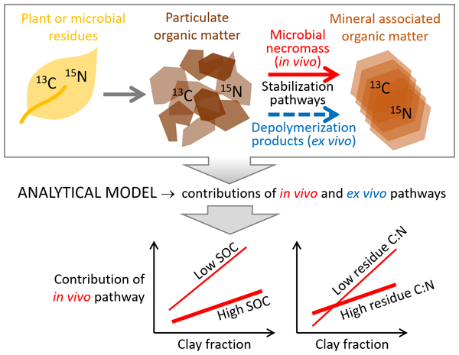
Mechanisms of Soil Carbon Sequestration
Carbon Input Pathways
Soil carbon accumulation fundamentally depends on the balance between carbon inputs and outputs. Primary input pathways include above-ground plant residues, root biomass and exudates, microbial necromass, and organic amendments. Recent isotopic studies reveal that root-derived carbon contributes 2-3 times more to stable SOC formation than shoot residues, highlighting the importance of deep-rooting species and perennial vegetation. Mycorrhizal fungi, particularly arbuscular mycorrhizae, contribute significantly through hyphal biomass and glomalin production, accounting for 15-20% of total SOC in agricultural systems.
Stabilization Mechanisms
Modern understanding of SOC stabilization has shifted from recalcitrance-based models to emphasize organo-mineral interactions and physical protection. Mineral-associated organic matter (MAOM) represents 50-80% of total SOC in agricultural soils, formed through adsorption of dissolved organic compounds onto clay minerals and metal oxides. Fe and Al oxides demonstrate particularly strong stabilization capacity, protecting organic matter from microbial decomposition for decades to centuries. Aggregate formation creates physical barriers limiting enzyme and microbial access, with microaggregates (<250 μm) providing greatest protection. Recent research identifies pyrogenic carbon from incomplete combustion as highly stable, persisting for centuries to millennia.

Table 2: Carbon Stabilization Mechanisms and Residence Times
Stabilization Mechanism | Carbon Pool | Typical Size | Residence Time | Controlling Factors
Mineral association | MAOM | <53 μm | 50-1000 years | Clay content, pH
Aggregate occlusion | iPOM | 53-250 μm | 10-100 years | Aggregate stability
Biochemical recalcitrance | Plant polymers | Variable | 5-50 years | Chemical composition
Pyrogenic carbon | Biochar | >250 μm | 100-1000 years | Pyrolysis temperature
Deep soil burial | Subsoil SOC | Variable | 100-500 years | Soil depth
Anaerobic preservation | Wetland SOC | Variable | 50-200 years | Water saturation
Cryogenic protection | Permafrost C | Variable | 1000+ years | Temperature
Soil Carbon Sequestration Strategies
Conservation Agriculture Practices
Conservation agriculture, encompassing minimal soil disturbance, permanent soil cover, and crop diversification, demonstrates substantial carbon sequestration potential. No-till systems reduce SOC mineralization by maintaining aggregate structure and limiting oxygen exposure. Meta-analyses indicate no-till practices sequester 0.3-0.6 Mg C ha⁻¹ yr⁻¹ compared to conventional tillage, with greatest benefits in humid climates. However, carbon accumulation often concentrates in surface layers (0-10 cm), with limited changes at depth. Combining no-till with cover crops enhances sequestration to 0.5-1.0 Mg C ha⁻¹ yr⁻¹ through increased carbon inputs and year-round soil coverage.
Cover Cropping and Green Manures
Integration of cover crops provides multiple carbon sequestration pathways through biomass inputs, enhanced root production, and nitrogen fixation by leguminous species. Winter cover crops in temperate systems contribute 1-4 Mg C ha⁻¹ yr⁻¹ of biomass carbon, with 10-20% retained as SOC after decomposition. Legume-grass mixtures optimize carbon-nitrogen dynamics, promoting microbial biomass and aggregate formation. Crotalaria juncea, Sesbania aculeata, and Vigna radiata demonstrate particular effectiveness in tropical systems, contributing 2-5 Mg biomass ha⁻¹ while fixing 50-150 kg N ha⁻¹.

"Figure 2: Cover Crop Carbon Sequestration Pathways
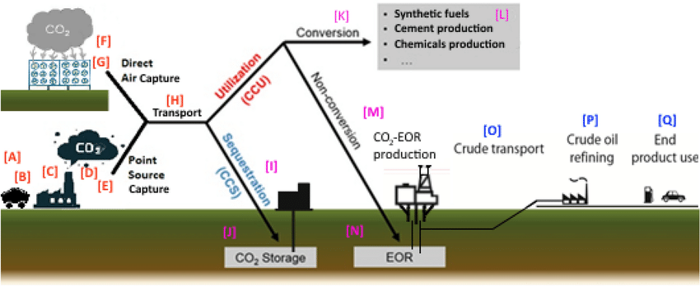
Biochar Application
Biochar represents a targeted approach for introducing recalcitrant carbon into soils while improving fertility and water retention. Pyrolysis temperatures of 400-700°C optimize carbon stability and surface functionality. Application rates of 10-30 Mg ha⁻¹ increase SOC stocks by 10-30%, with 70-90% of added carbon persisting beyond 100 years. Co-benefits include enhanced cation exchange capacity, improved water holding capacity, and reduced greenhouse gas emissions. Economic constraints currently limit large-scale adoption, though integrated biochar-bioenergy systems show promise for improving feasibility.
Table 3: Biochar Properties and Carbon Sequestration Potential
Feedstock Type | Pyrolysis Temperature | Carbon Content | Stability Factor | Application Rate | SOC Increase | Co-benefits
Wood residues | 500-700°C | 75-85% | 0.85-0.95 | 20-40 Mg ha⁻¹ | 15-25% | High porosity
Crop residues | 400-600°C | 60-75% | 0.70-0.85 | 10-30 Mg ha⁻¹ | 10-20% | Nutrient retention
Manure | 350-500°C | 40-60% | 0.60-0.75 | 15-25 Mg ha⁻¹ | 8-15% | P availability
Rice husk | 450-650°C | 65-80% | 0.75-0.90 | 10-20 Mg ha⁻¹ | 12-22% | Si supplement
Bamboo | 550-750°C | 80-90% | 0.90-0.98 | 25-45 Mg ha⁻¹ | 20-30% | High stability
Municipal waste | 400-550°C | 45-65% | 0.65-0.80 | 20-35 Mg ha⁻¹ | 10-18% | Waste management
Sewage sludge | 300-450°C | 35-55% | 0.55-0.70 | 15-30 Mg ha⁻¹ | 7-12% | Heavy metal fixation
Agroforestry Systems
Agroforestry integrates trees with crops or livestock, substantially enhancing carbon storage above and below ground. Systems sequester 0.5-3.0 Mg C ha⁻¹ yr⁻¹ in soils, with additional biomass carbon in woody vegetation. Deep tree roots access subsoil layers, depositing carbon beyond typical crop rooting zones. Leaf litter provides continuous organic inputs while modifying microclimate conditions favorable for SOC accumulation. Leucaena leucocephala, Gliricidia sepium, and Acacia mangium demonstrate exceptional performance in tropical agroforestry, fixing nitrogen while contributing high-quality organic matter.
Figure 3: Agroforestry Carbon Pools Distribution
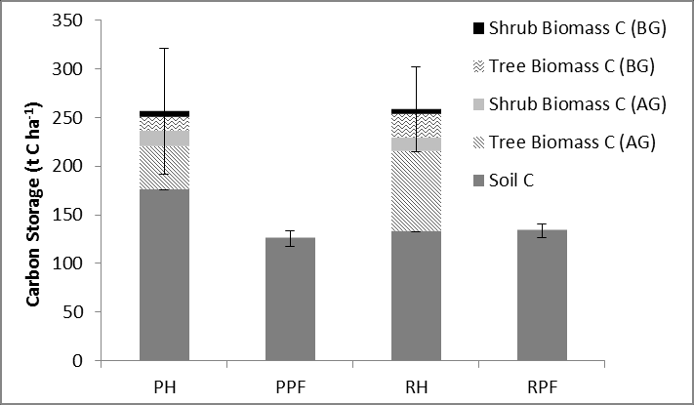
Integrated Nutrient Management
Balanced nutrient management optimizes plant productivity and carbon inputs while minimizing losses through enhanced decomposition. Combining organic and inorganic fertilizers promotes microbial activity and aggregate formation. Farmyard manure applications of 10-15 Mg ha⁻¹ yr⁻¹ increase SOC by 0.3-0.7 Mg C ha⁻¹ yr⁻¹ while improving soil structure. Precision nutrient management using soil testing and variable rate technology reduces over-fertilization that accelerates SOC mineralization. Silicon and calcium amendments enhance carbon stabilization through organo-mineral complex formation.
Table 4: Nutrient Management Effects on Soil Carbon
Management Practice | Application Rate | SOC Change | Mechanism | Duration | Cost-effectiveness
FYM application | 10-15 Mg ha⁻¹ yr⁻¹ | +0.4-0.8% yr⁻¹ | Direct C input | Long-term | High
Compost addition | 5-10 Mg ha⁻¹ yr⁻¹ | +0.3-0.6% yr⁻¹ | Stable C input | Long-term | Medium
Green manuring | 20-30 Mg ha⁻¹ | +0.2-0.5% yr⁻¹ | Fresh biomass | Seasonal | High
Biosolids | 10-20 Mg ha⁻¹ yr⁻¹ | +0.5-0.9% yr⁻¹ | Organic matter | Medium-term | Medium
Integrated NPK+OM | Balanced doses | +0.3-0.7% yr⁻¹ | Enhanced productivity | Long-term | High
Biofertilizers | 20-30 kg ha⁻¹ | +0.1-0.3% yr⁻¹ | Microbial activity | Short-term | Very high
Crop residue retention | 5-8 Mg ha⁻¹ yr⁻¹ | +0.2-0.4% yr⁻¹ | Surface mulch | Continuous | Very high
Measurement and Monitoring Technologies
Traditional and Advanced Sampling Methods
Accurate quantification of SOC stocks requires representative sampling accounting for spatial heterogeneity and depth distribution. Traditional grid sampling with 20-50 points per hectare provides baseline accuracy, though labor costs limit frequency. Stratified random sampling based on soil maps and terrain attributes improves efficiency. Recent advances in electromagnetic induction and ground-penetrating radar enable rapid field-scale carbon mapping. Portable spectrometers using visible near-infrared reflectance (VNIR) provide real-time SOC estimates with 85-95% accuracy compared to laboratory analysis.
Figure 4: Soil Carbon Monitoring Technologies

Remote Sensing Applications
Satellite and aerial remote sensing increasingly support large-scale SOC monitoring. Multispectral indices correlate with surface SOC content, particularly in bare soil conditions. Machine learning algorithms integrating Sentinel-2 imagery, digital elevation models, and climate data predict SOC stocks with R² values of 0.65-0.85. Hyperspectral sensors demonstrate enhanced capability for SOC mapping, though costs remain prohibitive for routine monitoring. Unmanned aerial vehicles equipped with multispectral cameras enable field-scale assessment with centimeter-level resolution.
Modeling Approaches
Process-based models simulate SOC dynamics under different management scenarios, supporting decision-making and carbon credit verification. RothC, CENTURY, and DayCent models represent established tools, though parameter uncertainty limits accuracy. Machine learning approaches using random forests and neural networks show promise for improving predictions by capturing non-linear relationships. Integration of remote sensing data with process models through data assimilation techniques reduces uncertainty in regional carbon assessments.
Table 5: Comparison of SOC Measurement Methods
Method | Spatial Scale | Accuracy | Cost per Sample | Time Required | Advantages | Limitations
Dry combustion | Point | ±2-5% | $15-30 | 2-4 hours | Gold standard | Destructive
Wet oxidation | Point | ±5-10% | $5-15 | 1-2 hours | Low cost | Incomplete oxidation
VNIR spectroscopy | Point/Field | ±10-15% | $2-10 | Minutes | Rapid, portable | Calibration needed
Eddy covariance | Ecosystem | ±15-20% | $50,000+ setup | Continuous | Net flux measurement | High cost
Remote sensing | Landscape | ±20-30% | $0.1-1/ha | Days | Large area coverage | Surface only
Modeling | Regional | ±25-40% | $0.01-0.1/ha | Hours-days | Scenario testing | Parameter uncertainty
Isotopic analysis | Point | ±3-5% | $50-100 | 1-2 weeks | Source partitioning | Expensive
Figure 5: Global Soil Carbon Monitoring Network
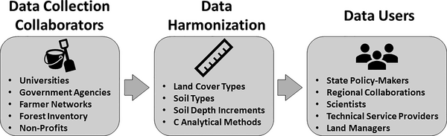
Figure 6: Global Carbon Credit Projects
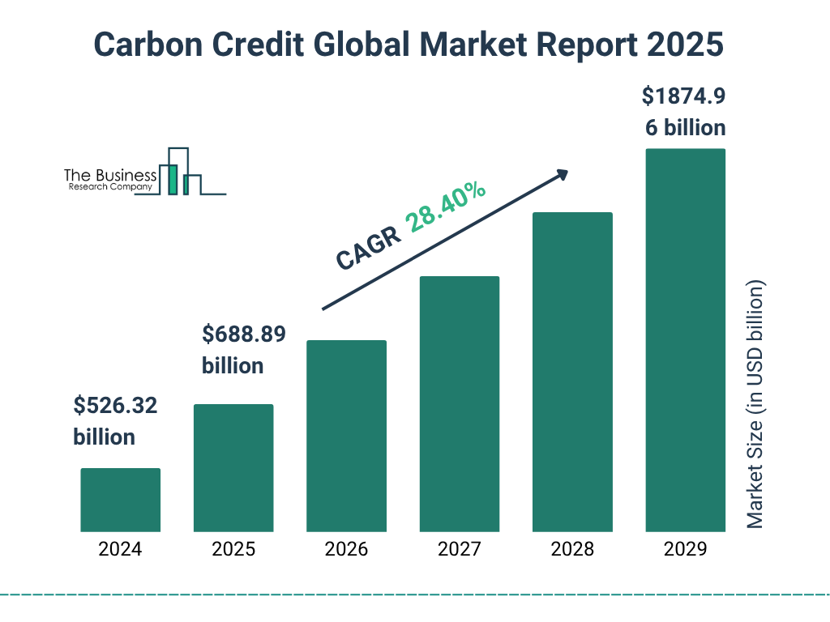
Economic and Policy Dimensions
Carbon Credit Markets
Emerging carbon markets create financial incentives for soil carbon sequestration, with voluntary markets currently dominating transactions. Carbon credit prices range from $5-50 per Mg CO₂, depending on verification standards and co-benefits. However, high transaction costs and measurement uncertainties limit smallholder participation. Blockchain technology shows promise for reducing verification costs and improving transparency. Aggregation models enabling collective participation of small farmers demonstrate success in Kenya and India.
Policy Frameworks and Incentives
National and international policies increasingly recognize soil carbon's mitigation potential. The "4 per 1000" initiative targets annual SOC increases of 0.4% to offset anthropogenic emissions. India's National Mission for Sustainable Agriculture promotes soil health cards and organic farming to enhance carbon stocks. Payment for ecosystem services schemes in Costa Rica and Mexico include soil carbon in benefit calculations. However, policy coherence remains challenging, with agricultural subsidies often favoring intensive practices that deplete SOC.
Table 6: Economic Analysis of Carbon Sequestration Practices
Practice | Implementation Cost | Annual Maintenance | Carbon Price Needed | Break-even Time | Co-benefit Value | Risk Level
No-till adoption | $50-150/ha | $20-40/ha | $15-25/Mg CO₂ | 3-5 years | High | Low
Cover cropping | $80-200/ha | $60-120/ha | $20-35/Mg CO₂ | 4-7 years | Medium | Medium
Biochar application | $500-1500/ha | $50-100/ha | $40-80/Mg CO₂ | 8-15 years | High | Low
Agroforestry | $300-800/ha | $50-150/ha | $10-20/Mg CO₂ | 5-10 years | Very high | Medium
Rotational grazing | $100-300/ha | $30-80/ha | $12-22/Mg CO₂ | 3-6 years | High | Low
Wetland restoration | $1000-5000/ha | $100-300/ha | $25-50/Mg CO₂ | 10-20 years | Very high | High
Precision agriculture | $200-500/ha | $50-150/ha | $18-30/Mg CO₂ | 4-8 years | Medium | Medium
Challenges and Limitations
Permanence and Reversibility
Soil carbon sequestration faces inherent permanence challenges, as stored carbon remains vulnerable to release through land-use change, climate extremes, or management shifts. Drought and warming accelerate decomposition, potentially converting soils from sinks to sources. Contracts ensuring 20-100 year permanence struggle with enforcement and farmer commitment. Insurance mechanisms and buffer pools provide partial solutions, though costs reduce economic viability.
Saturation and Sink Capacity
Soils exhibit finite capacity for carbon storage, reaching new equilibria after 20-50 years of improved management. Saturation levels depend on clay content, climate, and management intensity. Fine-textured soils approach saturation at 50-80 Mg C ha⁻¹, while sandy soils saturate at 20-40 Mg C ha⁻¹. Continued carbon inputs maintain stocks but don't increase sequestration rates, limiting long-term mitigation potential.
Figure 7: Soil Carbon Saturation Curves
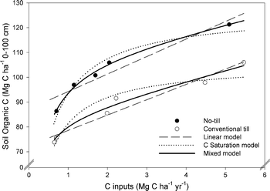
Socioeconomic Barriers
Adoption barriers include high initial costs, technical knowledge requirements, and cultural resistance to practice changes. Smallholder farmers, managing 80% of global farms, face particular constraints accessing capital and information. Gender disparities in land tenure and decision-making authority limit women's participation despite their dominant role in agricultural labor. Extension services often lack capacity to support soil carbon management, requiring substantial investment in training and infrastructure.
Table 7: Barriers to Soil Carbon Sequestration Adoption
Barrier Type | Affected Stakeholders | Severity | Geographic Variation | Potential Solutions | Implementation Timeline
Economic costs | Smallholder farmers | High | Higher in developing nations | Subsidies, carbon credits | 2-5 years
Technical knowledge | All farmers | Medium | Variable | Extension services | 1-3 years
Land tenure | Tenant farmers | Very high | Critical in Asia, Africa | Policy reform | 5-10 years
Market access | Remote communities | High | Severe in isolated regions | Infrastructure, cooperatives | 3-7 years
Cultural practices | Traditional farmers | Medium | Strong in indigenous areas | Participatory approaches | 2-4 years
Policy support | Large-scale farmers | Low | Limited in some regions | Advocacy, lobbying | 1-2 years
Climate risks | All farmers | Increasing | Higher in vulnerable zones | Insurance, adaptation | Ongoing
Figure 8: Adoption Barriers and Solutions
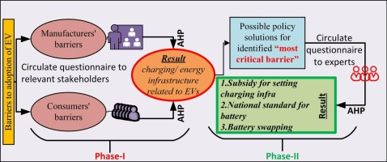
Future Perspectives and Research Priorities
Emerging Technologies
Artificial intelligence and Internet of Things (IoT) technologies promise to revolutionize soil carbon management. Smart sensors continuously monitor soil conditions, enabling precision interventions. Gene editing techniques develop crops with enhanced root biomass and exudate production. Microbial inoculants engineered for carbon stabilization show early promise. Blockchain-based measurement, reporting, and verification systems reduce transaction costs while ensuring transparency.
Integrated Landscape Approaches
Future strategies emphasize landscape-scale management recognizing interconnections between agricultural lands, forests, wetlands, and urban areas. Watershed-based planning optimizes carbon sequestration while managing water resources and biodiversity. Circular economy principles integrate urban organic waste into agricultural carbon cycles. Climate-smart agriculture bundles adaptation and mitigation practices, building resilience while sequestering carbon.
Research Priorities
Critical knowledge gaps require targeted research investment. Understanding deep soil carbon dynamics below 30 cm remains limited despite representing 50-70% of total stocks. Microbial mechanisms governing carbon stabilization need elucidation to optimize management. Developing region-specific sequestration factors improves carbon credit accuracy. Social science research on adoption behaviors and policy effectiveness guides implementation strategies. Long-term experiments tracking carbon permanence under climate change provide essential data for model validation.
Figure 9: Future Research Framework
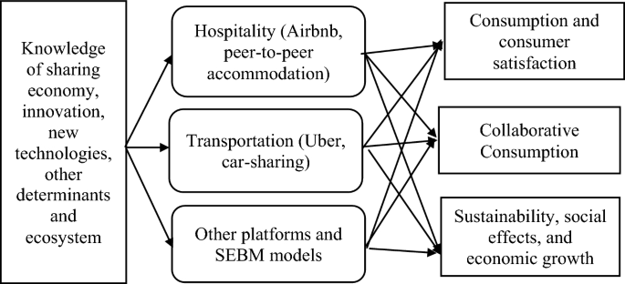
Figure 10: Integrated Landscape Carbon Management
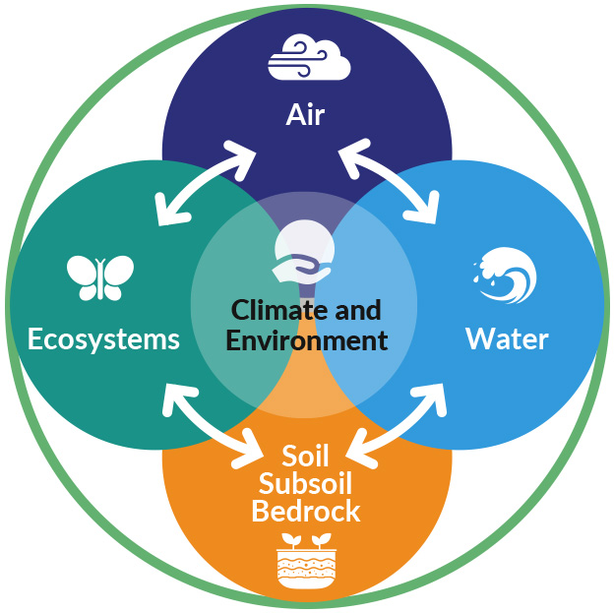
Conclusion
Soil carbon sequestration represents a critical yet underutilized strategy for climate change mitigation, offering substantial potential while delivering multiple co-benefits. This review demonstrates that implementing optimal management practices across global agricultural lands could sequester 0.9-1.85 Pg C annually, significantly contributing to climate targets. However, realizing this potential requires overcoming technical, economic, and social barriers through integrated approaches combining scientific innovation, supportive policies, and stakeholder engagement. Future success depends on developing robust monitoring systems, creating viable economic incentives, and building capacity among land managers. As climate urgency intensifies, soil carbon sequestration must transition from promising concept to widespread practice, recognizing soils as essential natural infrastructure for planetary health.
References
- Amelung, W., Bossio, D., de Vries, W., Kögel-Knabner, I., Lehmann, J., Amundson, R., ... & Chabbi, A. (2020). Towards a global-scale soil climate mitigation strategy. Nature Communications, 11(1), 5427.
- Baveye, P. C., Berthelin, J., Tessier, D., & Lemaire, G. (2018). The "4 per 1000" initiative: A credibility issue for the soil science community? Geoderma, 309, 118-123.
- Chen, S., Martin, M. P., Saby, N. P., Walter, C., Angers, D. A., & Arrouays, D. (2018). Fine resolution map of top-and subsoil carbon sequestration potential in France. Science of the Total Environment, 630, 389-400.
- Dignac, M. F., Derrien, D., Barré, P., Barot, S., Cécillon, L., Chenu, C., ... & Basile-Doelsch, I. (2017). Increasing soil carbon storage: mechanisms, effects of agricultural practices and proxies. A review. Agronomy for Sustainable Development, 37(2), 14.
- Fuss, S., Lamb, W. F., Callaghan, M. W., Hilaire, J., Creutzig, F., Amann, T., ... & Minx, J. C. (2018). Negative emissions—Part 2: Costs, potentials and side effects. Environmental Research Letters, 13(6), 063002.
- Gogoi, B., Nath, T., Deka, B., Kalita, S., Gajurel, S., Borah, D., ... & Das, K. (2021). Soil carbon sequestration potential of different land use systems in India: A review. Environmental Monitoring and Assessment, 193(12), 1-25.
- IPCC. (2022). Climate Change 2022: Mitigation of Climate Change. Contribution of Working Group III to the Sixth Assessment Report of the Intergovernmental Panel on Climate Change. Cambridge University Press.
- Lal, R. (2018). Digging deeper: A holistic perspective of factors affecting soil organic carbon sequestration in agroecosystems. Global Change Biology, 24(8), 3285-3301.
- Lehmann, J., Cowie, A., Masiello, C. A., Kammann, C., Woolf, D., Amonette, J. E., ... & Whitman, T. (2021). Biochar in climate change mitigation. Nature Geoscience, 14(12), 883-892.
- Minasny, B., Malone, B. P., McBratney, A. B., Angers, D. A., Arrouays, D., Chambers, A., ... & Winowiecki, L. (2017). Soil carbon 4 per mille. Geoderma, 292, 59-86.
- Paustian, K., Lehmann, J., Ogle, S., Reay, D., Robertson, G. P., & Smith, P. (2016). Climate-smart soils. Nature, 532(7597), 49-57.
- Poulton, P., Johnston, J., Macdonald, A., White, R., & Powlson, D. (2018). Major limitations to achieving "4 per 1000" increases in soil organic carbon stock in temperate regions: Evidence from long‐term experiments at Rothamsted Research, UK. Global Change Biology, 24(6), 2563-2584.
- Rumpel, C., Amiraslani, F., Koutika, L. S., Smith, P., Whitehead, D., & Wollenberg, E. (2018). Put more carbon in soils to meet Paris climate pledges. Nature, 564(7734), 32-34.
- Smith, P., Adams, J., Beerling, D. J., Beringer, T., Calvin, K. V., Fuss, S., ... & Keesstra, S. (2019). Land-management options for greenhouse gas removal and their impacts on ecosystem services and the sustainable development goals. Annual Review of Environment and Resources, 44, 255-286.
- Sokol, N. W., Sanderman, J., & Bradford, M. A. (2019). Pathways of mineral‐associated soil organic matter formation: Integrating the role of plant carbon source, chemistry, and point of entry. Global Change Biology, 25(1), 12-24.
- Sykes, A. J., Macleod, M., Eory, V., Rees, R. M., Payen, F., Myrgiotis, V., ... & Smith, P. (2020). Characterising the biophysical, economic and social impacts of soil carbon sequestration as a greenhouse gas removal technology. Global Change Biology, 26(3), 1085-1108.
- Tao, F., Palosuo, T., Valkama, E., & Mäkipää, R. (2019). Cropland soils in China have a large potential for carbon sequestration based on literature survey. Soil and Tillage Research, 186, 70-78.
- Vermeulen, S., Bossio, D., Lehmann, J., Luu, P., Paustian, K., Webb, C., ... & Wollenberg, E. (2019). A global agenda for collective action on soil carbon. Nature Sustainability, 2(1), 2-4.
- Zomer, R. J., Bossio, D. A., Sommer, R., & Verchot, L. V. (2017). Global sequestration potential of increased organic carbon in cropland soils. Scientific Reports, 7(1), 15554.

