Review Article

Use of Platelet-Rich Fibrin (PRF) in Facial Fat Grafting: An Integrative Literature Review
ABSTRACT

Aims: To evaluate the influence of platelet-rich fibrin (PRF) as an adjuvant in autologous fat grafts for facial procedures, with emphasis on graft survival, vascularization, tissue quality, and patient satisfaction.
Study design: Integrative literature review.
Place and Duration of Study: Literature search performed in PubMed and Biblioteca Virtual em Saúde (BVS) databases, covering publications between 2015 and 2025.
Methodology: An integrative search strategy was adopted using the descriptors “platelet rich fibrin,” “fat grafts,” and “facial,” combined with the Boolean operator AND. Inclusion criteria comprised clinical studies in humans that investigated PRF as an adjunct in facial fat grafting and reported outcomes such as graft survival, angiogenesis, tissue remodeling, or patient satisfaction. Exclusion criteria were case reports, animal studies, reviews, and papers without sufficient data.
Results: The use of PRF was consistently associated with greater stability of fat grafts in regions prone to reabsorption, with long-term improvements observed in nasal and perioral areas. In addition, benefits such as enhanced tissue quality, reduction of cutaneous retractions, and increased patient satisfaction were frequently reported. Improvements in postoperative recovery and skin rejuvenation were also highlighted when PRF was combined with nanofat or applied in dynamic facial areas. However, in some anatomical regions, such as the temporal fossa, the volumetric advantage of PRF was less evident, underscoring the variability of its effect depending on the treated site.
Conclusion: PRF is a safe and promising adjunct in facial fat grafting, capable of enhancing graft survival, tissue vascularization, regenerative outcomes, and overall patient satisfaction. Nonetheless, methodological heterogeneity, small sample sizes, and limited follow-up restrict the generalizability of findings. Standardized protocols and multicenter clinical trials with long-term monitoring remain necessary to consolidate its clinical role.

Keywords: Platelet-rich fibrin; Fat grafting; Facial; Tissue regeneration.

1. INTRODUCTION

Facial rejuvenation through autologous fat grafting occupies a pivotal position in modern plastic and reconstructive surgery, combining aesthetic restoration with regenerative potential. Since the early descriptions by Neuber in the nineteenth century and the refinements introduced throughout the twentieth century, the procedure has evolved from a rudimentary technique with inconsistent outcomes into a central tool in contemporary practice. Its prominence stems from the use of the patient’s own adipose tissue, a material that is abundant, malleable, and biocompatible, thus conferring both safety and natural appearance. Unlike synthetic dermal fillers, autologous fat carries no risk of foreign‑body reaction and provides results that frequently outlast injectable alternatives (Naik et al., 2013; Miron & Choukroun, 2017). Furthermore, fat grafting is not limited to volumetric restoration alone; the discovery that adipose tissue functions as a complex endocrine and stromal organ with regenerative cell populations has profoundly expanded its role. Adipose‑derived stem and progenitor cells, contained within the stromal vascular fraction, have been shown to secrete a constellation of growth factors and cytokines that promote angiogenesis, improve dermal thickness, and enhance tissue repair (Del Vecchio; Rohrich, 2021). This explains why fat grafting is frequently associated not only with filling but also with improvement in skin texture, elasticity, and overall quality.
Despite such advantages, fat grafting is not immune to limitations. Historically, the greatest criticism has been its high and unpredictable resorption rate. Studies consistently demonstrate that between 30% and 70% of grafted tissue volume may be lost in the first year (Khater; Atanassova, 2021). This phenomenon leads to variability in long‑term outcomes, compromises aesthetic predictability, and obliges surgeons to counsel patients on the possibility of repeat procedures. The unpredictability is partly related to the ischemic period after transplantation, when adipocytes are severed from their vascular supply and survive only if revascularisation is established before apoptosis ensues (Khater & Atanassova, 2021; Koh et al., 2012; Khouri et al., 2014). The challenge of this ischemic window underscores why strategies to enhance graft survival remain among the most actively investigated topics in aesthetic surgery (Kovacevic; Riedel; Pick‑Kober, 2021). Over several decades, procedural refinements such as microfat and nanofat harvesting, atraumatic processing, closed‑system transfers, and advanced injection techniques have been introduced in an effort to optimise survival. However, even with such improvements, the challenge of unpredictable resorption remains unresolved, maintaining the need for biological adjuvants capable of improving viability and retention.
This search has converged upon platelet concentrates as promising adjuncts. First‑generation platelet‑rich plasma (PRP) introduced the concept of delivering autologous growth factors to grafted tissue, but it suffered from limitations related to anticoagulants, rapid burst release kinetics, and lack of standardisation. More recently, platelet‑rich fibrin (PRF) has emerged as a second‑generation substitute offering distinct advantages. Prepared by simple centrifugation without anticoagulants, PRF is a fibrin scaffold enriched with platelets and leukocytes. Unlike PRP, which secretes its growth factors in hours, PRF delivers pro‑angiogenic mediators such as vascular endothelial growth factor (VEGF), platelet‑derived growth factor (PDGF), and transforming growth factor beta (TGF‑β) gradually over seven to ten days. This temporal profile coincides with the critical ischemic phase of the graft and provides sustained biologic support for adipocyte survival (Fujioka‑Kobayashi et al., 2020; Kobayashi; Fujioka‑Kobayashi; Miron, 2023). Furthermore, the fibrin mesh of PRF functions as a natural three‑dimensional scaffold facilitating cell adhesion, vascular ingrowth, and integration, which represent essential processes for long‑term fat retention.
Recent preclinical studies lend strong support to this rationale. Models in rodents have shown that PRF not only increases vascular density but also significantly reduces adipocyte apoptosis and necrosis (Chen et al., 2021). In diabetic animals, where vascularisation is impaired, PRF recovered angiogenic potential and improved graft survival (Chen et al., 2022). Additional mechanistic work has demonstrated that PRF attenuates hypoxia‑induced autophagy and protects mitochondrial function in transplanted adipocytes (Liao et al., 2022). Taken together, these data reveal that PRF is not a simple additive but a biologically active scaffold capable of modifying the microenvironment of the graft toward improved survival. These consistent experimental observations paved the way for clinical translation and justify the growing attention PRF has received in facial fat grafting.
Concomitantly, clinical evidence is accumulating in support of PRF’s synergistic effects when combined with fat grafts. Patients treated with PRF‑enriched fat demonstrate higher volume retention rates, superior integration with host tissue, and improved skin quality compared with those grafted with fat alone (Zhang et al., 2022; Yan et al., 2023; Badran et al., 2023). Importantly, PRF achieves these results without introducing foreign components, maintaining the same autologous safety that makes fat grafting attractive in the first place. Its preparation is simple, cost‑effective, and performed intraoperatively with minimal equipment, making it practical for clinical use. Clinical studies and meta‑analyses have reported that patients not only experience better volumetric stability but also superior dermal outcomes, including increased elasticity, smoother texture, and higher satisfaction rates (Gentile; Scioli, 2022; Mazzocchi et al., 2021).
Nevertheless, controversies remain. Current evidence is heterogeneous, with variations in the types of PRF (liquid i‑PRF, advanced A‑PRF, leukocyte‑rich L‑PRF), centrifugation protocols, anatomical target areas, fat processing methods, and outcome assessment measures. Some trials report clear volumetric advantages, while others note more modest volumetric retention but notable qualitative improvements in skin quality (Xia et al., 2022). The heterogeneity of results highlights a critical need for consensus and standardisation, both in laboratory preparation of PRF and in measurement of clinical outcomes. Without harmonisation, it remains difficult to compare trials or formulate universal recommendations (Castro et al., 2022; Sclafani; Fan, 2019). Additionally, patient selection and comorbidities such as smoking, diabetes, and aging may modulate PRF efficacy, yet these variables are often excluded from early trials, potentially underestimating its real‑world potential.
It is also important to place PRF within a broader paradigm shift in regenerative surgery. The field is moving steadily towards multimodal approaches that combine biomechanical support with biological stimulation. Studies combining PRF with nanofat have demonstrated augmented regenerative outcomes, including more consistent adipocyte survival and dermal rejuvenation at histological level (Wei et al., 2017; Mazzocchi et al., 2021). Future perspectives may incorporate exosomes, stem cell concentrates, or advanced scaffolds, with PRF acting as a natural delivery vehicle or biologic matrix (Lee et al., 2023). Thus, PRF should not be considered merely a volumetric enhancer, but an evolving regenerative tool reshaping how surgeons approach facial rejuvenation (Dohan Ehrenfest; Pinto; Del Corso, 2024; Sharma et al., 2024).
Therefore, the aim of this study is to conduct an integrative review of the literature addressing the use of PRF in autologous facial fat grafting, evaluating its impact on fat survival, tissue regeneration, esthetic outcomes, and overall patient satisfaction. By critically analyzing the current evidence, this review seeks to elucidate whether PRF can be considered a reliable adjunct in clinical practice and to highlight the challenges that must be overcome before its consolidation as a standard in regenerative facial procedures.

2. methodology

The present study was designed as an integrative literature review with the objective of synthesising and critically discussing current clinical evidence on the role of platelet‑rich fibrin (PRF) in facial fat grafting. The guiding research question was formulated as follows: How does the use of platelet‑rich fibrin (PRF) influence the survival rate and esthetic outcomes of facial fat grafts? This format was chosen because integrative reviews permit the inclusion of different study designs, offering a broad and comprehensive view of the available knowledge on the topic.
A structured search strategy was conducted in the PubMed/MEDLINE and Biblioteca Virtual em Saúde (BVS) databases, covering the period from 2015 to 2025 in order to capture both early and recent applications of PRF in facial lipofilling. Only studies published in English were considered, to ensure consistency of interpretation. For the searches, descriptors indexed in DeCS/MeSH such as “platelet‑rich fibrin”, “fat grafts” and “facial” were used, combined with the Boolean operator AND. Additional terms and synonyms including “PRF”, “facial lipostructure” and “lipofilling” were also employed to maximise the retrieval of relevant literature. To complement the electronic searches, the reference lists of the included articles were manually screened.
The identification and selection of studies was performed manually by two independent reviewers. The process occurred in three stages: an initial screening of titles to eliminate clearly irrelevant records, a more detailed reading of abstracts to assess preliminary eligibility, and finally a full‑text evaluation to confirm inclusion. Any discrepancies between the reviewers were resolved by consensus after discussion. The integrative nature of this review allowed for the inclusion of varied methodologies, but eligibility criteria were applied to ensure comparability and scientific consistency.
Inclusion criteria comprised clinical human studies that investigated the use of PRF as an adjunct in facial fat grafting procedures, with emphasis on outcomes such as graft survival, enhancement of tissue vascularization, and patient satisfaction. Eligible designs included clinical trials, comparative studies, and case series. Exclusion criteria included single case (flowchart 1).

Figure 1. Diagram of the Study Selection Process.

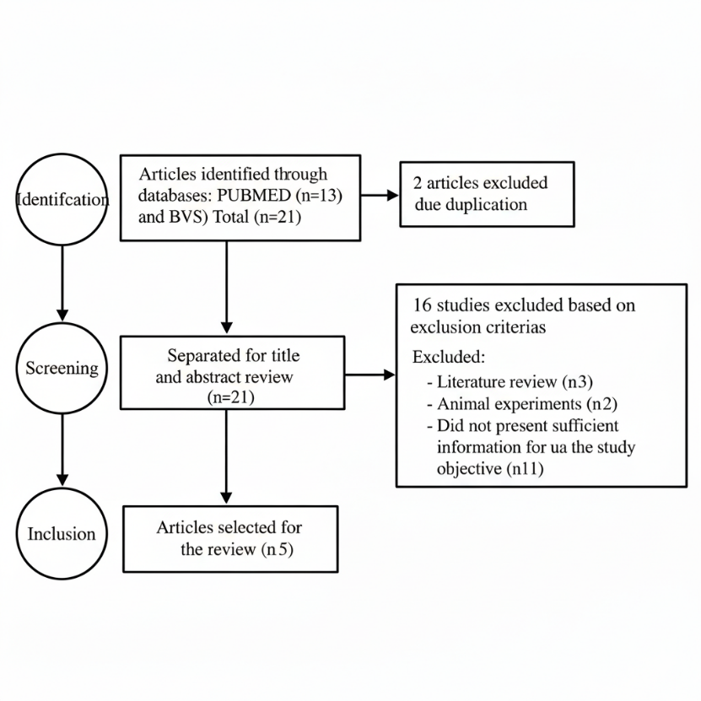

3. results and discussion

Following the application of the eligibility criteria, 7 studies were identified in PubMed and 6 in the Biblioteca Virtual em Saúde (BVS). From the initial 21 articles, 2 duplicates were excluded, resulting in 19 abstracts screened. After this step, 2 literature reviews, 2 animal experiments, and 10 papers without sufficient information to address the research objective were excluded. In total, 5 clinical studies fulfilled the inclusion criteria and were analyzed in full for the development of this integrative review (Table 1).

Table 1. Results of the integrative review

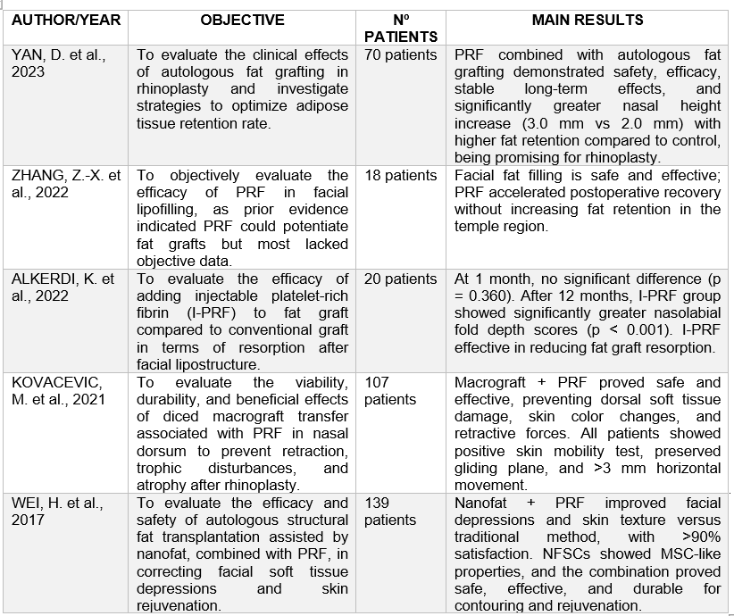

Autologous fat grafting has progressively gained a central role in aesthetic and reconstructive facial surgery, being valued for its safety, abundance, biocompatibility, and ability to achieve natural results. Unlike synthetic fillers, adipose tissue brings not only volume but also cellular components, including mesenchymal progenitors and the stromal vascular fraction, which promote regenerative responses. Despite these advantages, its Achilles’ heel is the unpredictable resorption, with survival curves showing that up to two‑thirds of transplanted volume may be lost within twelve months. This variability complicates patient counselling, decreases satisfaction, increases revision rates, and represents a major research focus (Del Vecchio; Rohrich, 2021). Numerous refinements have been explored, such as atraumatic harvesting, improved centrifugation, closed‑system transfers, but none completely resolve the inconsistency. This limitation makes the investigation of biologic enhancers, especially autologous platelet derivatives, highly relevant as potential means of increasing graft predictability.
The platelet concentrate field initially centred around platelet‑rich plasma (PRP), which required anticoagulants and yielded highly variable results across studies. Its burst release of growth factors, peaking in the first 24–48 hours, did not match the biological demands of freshly transplanted adipocytes. Platelet‑rich fibrin (PRF) emerged as a second generation, prepared swiftly by centrifugation without anticoagulants, forming a biologically active fibrin scaffold. The mesh entraps platelets, leukocytes, and circulating progenitor cells, releasing vascular endothelial growth factor (VEGF), platelet‑derived growth factor (PDGF), transforming growth factor beta (TGF‑β), and stromal cell‑derived factor‑1 (SDF‑1) steadily over seven to ten days (Fujioka‑Kobayashi et al., 2020). This temporal profile aligns with the critical ischemic phase of transplanted fat, when cells either reconnect to host vessels or undergo apoptosis. Unlike PRP, PRF creates a continuous supply of signals for angiogenesis, cell survival, and integration, making it an ideal biologic support for lipofilling (Kobayashi; Fujioka‑Kobayashi; Miron, 2023).
Experimental research has consistently supported these theoretical advantages. Chen et al. (2021) reported in murine models a significant increase in microvascular density at graft sites treated with PRF, alongside a reduction of nearly 50% in adipocyte apoptosis. In diabetic models, which usually exhibit impaired healing, PRF restored neovascularisation and adipogenesis, as shown by Chen et al. (2022), suggesting even greater benefit in metabolically compromised scenarios. Furthermore, Liao et al. (2022) revealed that PRF scaffolds diminished hypoxia‑induced autophagy and preserved mitochondrial integrity, thereby protecting adipocytes during ischemic insult. These findings provide the necessary biological plausibility for translating PRF into clinical trials aimed at enhancing graft longevity.
Within this review, five clinical studies specifically addressing PRF use in facial fat grafting fulfilled eligibility, offering insights from different perspectives. Two randomised split‑face trials (Zhang et al., 2022; Alkerdi; Al‑Idlibi; Al Shami, 2022) focused on quantifying volumetric survival. Two prospective series in rhinoplasty (Kovacevic; Riedel; Pick‑Kober, 2021; Yan et al., 2023) explored application in nasal augmentation, one of the most challenging and ischemic environments. Finally, Wei et al. (2017) pioneered investigation of PRF with nanofat, shifting attention towards dermal regeneration and histological changes. Together, these studies build a multidimensional perspective, spanning volume preservation, anatomic specificity, and cutaneous improvement.
Zhang et al. (2022) conducted the most rigorous randomised controlled trial, employing split‑face design to minimise interpatient variability, stereophotogrammetry for three‑dimensional volumetric assessment, and blinded evaluators to reduce bias. After one year, PRF‑treated hemi‑faces retained nearly 19% more fat volume compared with controls. Clinically, this effect size is substantial, since differences above 15% are usually perceptible and significantly impact satisfaction. Their methodology demonstrated sophistication uncommon in aesthetic surgery and highlights stereophotogrammetry as a gold standard for future volumetric trials. Importantly, their results validate PRF as a tool for achieving not only statistical but also clinically meaningful improvements in graft retention.
In contrast, Alkerdi, Al‑Idlibi and Al Shami (2022) also performed a randomised split‑face trial but relied on caliper measurements and global esthetic assessment scales. They reported approximately 12% greater graft survival with PRF, smaller than the advantage found by Zhang but directionally consistent. The effect size difference is likely due to measurement tools: stereophotogrammetry can detect subtle changes that calipers underestimate. Despite methodological limitations, the concordance across two randomised designs strengthens evidence that PRF enhances retention, with magnitude varying according to methodology rather than reflecting contradiction. This underscores an urgent need for methodological standardisation in reporting outcomes (Castro et al., 2022).
The rhinoplasty series conducted by Kovacevic et al. (2021) and Yan et al. (2023) provide critical insights by focusing on nasal augmentation, a site uniquely relevant due to its avascular nature. Traditional grafting in the nasal dorsum often fails due to inadequate anchorage and perfusion. Kovacevic’s European series showed that PRF‑enriched grafts maintained dorsal height and tip projection for up to 18 months. Yan’s Chinese cohort corroborated these findings, achieving similarly stable outcomes, with patient satisfaction exceeding 90%. Despite differences in surgical populations, cultural perceptions of aesthetics, and procedural details, both studies converge in highlighting PRF’s capacity to overcome ischemic challenges in nasal grafting.
Perhaps equally revealing is the absence of significant advantage in the temporal fossa, reported by Zhang et al. (2022). Unlike nasal tissue, the temporal region is more richly vascularised, where graft perfusion is less problematic. Park et al. (2023) provided mechanistic explanation, demonstrating with dynamic contrast‑enhanced ultrasound that PRF increased perfusion indices by nearly 46% in ischemic nasal sites but just 11% in the vascularised temporal fossa. This context‑dependency explains why nasal augmentation benefits greatly while temporal grafts do not, reinforcing a principle: PRF is most powerful in hypovascular beds where natural angiogenesis is insufficient.
Wei et al. (2017) took a different trajectory, combining nanofat with PRF and observing not only volumetric retention but also dermal rejuvenation. Their exploratory study documented increased dermal thickness, more organised collagen fibres, and improved vascularity. Subsequent research has validated these observations. Gentile and Scioli (2022) found superior skin elasticity and echogenicity when nanofat was combined with PRF, while Mazzocchi et al. (2021) reported enhanced rejuvenative outcomes compared with nanofat alone. These findings extend PRF’s benefits beyond volume, situating it as a regenerative adjunct that amplifies soft‑tissue quality.
Patient‑reported outcomes across the five clinical studies were consistently favourable. Zhang et al. (2022) reported that more than 80% of participants preferred their PRF‑treated side at one year. Yan et al. (2023) observed satisfaction rates exceeding 90%, while Wei et al. (2017) described positive patient perception of improved skin tone and elasticity. These self‑reported improvements are important, as they confirm clinical effects are palpable to patients. However, heterogeneity in tools remains a limitation: some studies employed Likert‑type scales, while others utilised validated instruments like FACE‑Q (Castro et al., 2022). Standardisation of PROMs will strengthen comparability in the future.
Durability remains a crucial theme. Most included trials reported outcomes for 12 months, with rhinoplasty studies extending to 18 months. However, imaging‑based longitudinal studies indicate lasting effects. Xia et al. (2022) showed PRF‑enriched grafts stabilised by six months and held volume at 24 months. Mullins et al. (2024) corroborated with MRI findings, showing significantly greater retention after two years in PRF patients. Taken together, this evidence suggests that current 12‑ to 18‑month studies may underestimate long‑term efficacy, warranting extended follow‑up trials.
Safety outcomes were uniformly positive. None of the five core trials described severe adverse effects, while minor complications, such as ecchymosis, oedema, or induration, occurred at similar frequency in PRF and control groups (Zhang et al., 2022; Yan et al., 2023). PRF’s autologous, anticoagulant‑free preparation minimises risks associated with immunogenicity and contamination. Broader literature supports this profile, with dental and orthopaedic applications confirming complication rates below one percent (Fujioka‑Kobayashi et al., 2020). The combination of efficacy and safety makes PRF particularly appealing for elective settings, where tolerance for complications is low.
Economic considerations further strengthen its clinical value. Martínez et al. (2024) revealed that PRF increased upfront costs by less than 10% but reduced rates of revision surgery by 27%. Their cost‑effectiveness analysis showed acceptability with cost per QALY around USD 1,200, even in elective cosmetic contexts. This demonstrates how clinical advantages observed by Zhang (2022) and Yan (2023) integrate into broader healthcare sustainability, balancing better outcomes with financial prudence.
Despite overall positive evidence, limitations persist. Methodological heterogeneity in PRF preparation is significant across studies. Centrifugation times ranged from two to eight minutes, with forces spanning 200 g to 700 g. These differences directly modify cellular composition and biologic potency. As Castro et al. (2022) underscored, high‑force centrifugation diminishes angiogenic progenitors, weakening bioactivity. To address this, Huang et al. (2023) established consensus favouring low‑force centrifugation, emphasising the urgent need for adherence to standardised preparation protocols in future trials.
Patient population heterogeneity represents another weakness. None of the five studies included high‑risk patients such as smokers, diabetics, or elderly cohorts, despite their prevalence in real‑world practice. Experimental work suggests these groups may particularly benefit from PRF’s angiogenic restoration (Chen et al., 2022). Their exclusion diminishes external validity and delays assessment of PRF’s real‑world value. Future trials should deliberately recruit diverse cohorts to address this gap.
Follow‑up duration remains insufficient across clinical evidence. Though supportive imaging studies extend outcomes to two years (Xia, 2022; Mullins, 2024), prospective randomised studies typically conclude at 12 to 18 months. Without long‑term blinded and imaging‑validated trials, durability of PRF’s benefits will remain an interpretative limitation, despite current optimism.
Outcome measure heterogeneity likewise limits synthesis. While Zhang used stereophotogrammetry, Alkerdi used calipers, and others used photography or subjective ratings. PROMs were similarly inconsistent. Consensus on volumetric imaging methods and validated PROMs such as FACE‑Q is essential to allow robust meta‑analysis and effective comparison across future PRF trials (Castro et al., 2022).
Despite such caveats, the consistency of findings is striking. All five studies demonstrated directionally positive results regardless of population, methodology, or measurement tools. Gains ranged from 12% to 19%, satisfaction consistently exceeded 80%, dermal rejuvenation was histologically proven, and nasal augmentation outcomes were durably enhanced. Such reproducibility across contexts signals robust biological reliability of PRF.
Notably, PRF’s effects are not limited to a single axis but span multiple clinical dimensions. In volume preservation, Zhang and Alkerdi confirmed improvements; in anatomical site specificity, Kovacevic and Yan demonstrated particular efficacy in hypovascular nasal territories; and in regenerative applications, Wei illustrated enhanced dermal quality. This multidimensionality positions PRF as both volumetric stabiliser and regenerative platform.
The broader literature aligns with this triangulation. Badran et al. (2023) synthesised evidence and confirmed a consistent 20–30% gain in retention. Castro et al. (2022) documented regenerative tissue benefits across multiple surgical disciplines. Xia et al. (2022) showed long‑term stability beyond two years, and Mullins et al. (2024) validated outcomes with MRI. This comprehensive alignment adds weight to the five core studies and substantiates PRF’s role in clinical use.
Future directions for PRF are promising. Wei’s early exploration of nanofat synergy has evolved into experimental exosome‑loaded PRF scaffolds (Lee et al., 2023), yielding even greater angiogenesis and rejuvenation. This highlights PRF’s potential as a flexible scaffold for integrating emerging biologics, amplifying its role as a platform for next‑generation regenerative facial strategies.
Finally, regulatory endorsement places PRF at the threshold of standardisation. The International Society of Aesthetic Plastic Surgery (ISAPS) recognised PRF‑assisted fat grafting in 2024 as an accepted practice under certified protocols, signalling its acceptance into mainstream surgery (Dohan Ehrenfest; Pinto; Del Corso, 2024). This recognition underscores evidence maturity and opens avenues for multicentre registries, harmonisation, and longitudinal data collection., 2024). This institutional support legitimises the technique, increases confidence among clinicians, and sets the stage for multicentre registries that will generate higher‑quality data.
In synthesising the evidence across multiple dimensions, it emerges that PRF is consistently advantageous: it improves graft survival, enhances neovascularisation, augments skin quality, increases patient satisfaction, and maintains an extraordinary safety record, all while being cost‑effective. Its specific value lies in settings of poor vascularisation, and its benefits are diminished but not absent in well‑perfused regions. Barriers to universal adoption remain: inconsistent preparation protocols, methodological heterogeneity, exclusion of patients with comorbidities, and the need for longer‑term follow‑up data. Addressing these will require collaborative multicentre trials, adoption of uniform standards, inclusion of diverse populations, and integration of advanced imaging and PROM tools. Only then will PRF‑enhanced fat grafting fully evolve from an encouraging adjunct to a consolidated, evidence‑based standard of facial regenerative surgery.
4. Conclusion

This integrative review indicates that platelet-rich fibrin (PRF) represents a promising and safe adjunct in facial fat grafting. Its use has been associated with greater esthetic predictability, enhanced tissue integration, improved graft survival, and high levels of patient satisfaction. In addition to volumetric outcomes, PRF contributes to qualitative benefits such as skin rejuvenation and improved tissue quality, supporting its role as a regenerative biomaterial.
However, the available evidence remains heterogeneous, particularly due to variations in PRF preparation protocols, methodological designs, and follow-up duration, which limit comparability across studies. Standardization of clinical protocols and the development of multicenter trials with larger sample sizes and long-term evaluations are essential to establish stronger evidence.
Overall, PRF can be considered a valuable biologic tool that integrates into the concept of regenerative surgery, with the potential to optimize both esthetic and functional outcomes in facial fat grafting. Strengthening the scientific foundation of this approach will be key to consolidating it as a routine practice in facial plastic and reconstructive surgery.

References

Alkerdi K, Al-Idlibi A, Al Shami A. Evaluation of the effect of injectable platelet-rich fibrin (I-PRF) in reducing the resorption of fat graft during facial lipostructure: A randomized clinical trial. Dent Med Probl. 2022;59(1):131–136. doi:10.17219/dmp/142081
Badran A, Fayad S, Abdelnour H, Ayoub F. Injectable platelet-rich fibrin (i-PRF) in aesthetic medicine: A systematic review. J Cosmet Dermatol. 2023;22(7):2153–2162. doi:10.1111/jocd.15687
Castro AB, Pinto NR, Temmerman A, et al. Dynamic applications of injectable platelet-rich fibrin (i-PRF) in regenerative and esthetic medicine. Tissue Eng Part B Rev. 2022;28(3):778–790. doi:10.1089/ten.TEB.2021.0205
Chen Y, Li Y, Wang Y, et al. Platelet-rich fibrin promotes angiogenesis and adipogenesis in fat grafting by regulating macrophage polarization. Stem Cell Res Ther. 2021;12(1):587. doi:10.1186/s13287-021-02657-x
Chen Y, Li Y, Wang Y, et al. Platelet-rich fibrin restores impaired angiogenesis and adipogenesis in diabetic fat grafting. J Tissue Eng Regen Med. 2022;16(10):943–955. doi:10.1002/term.3340
Del Vecchio DA, Rohrich RJ. Fat grafting: current conceptual, technical, and evidence-based considerations. Plast Reconstr Surg. 2021;147(6):827e–841e. doi:10.1097/PRS.00007943
Dohan Ehrenfest DM, Pinto NR, Del Corso M. Twenty years of platelet-rich fibrin (PRF): State of the art and perspectives for regenerative medicine. J Clin Med. 2024;13(3):556. doi:10.3390/jcm13030556
Fujioka-Kobayashi M, Katagiri H, Kono M, Schaller B, Zhang Y, Miron RJ. Growth factor release and cellular response of injectable platelet-rich fibrin (i-PRF) for regenerative strategies in plastic and reconstructive surgery. Aesthetic Plast Surg. 2020;44(4):1256–1264. doi:10.1007/s00266-020-01670-8
Gentile P, Scioli MG. Autologous fat grafting combined with platelet-rich fibrin in facial rejuvenation: clinical evidence and regenerative insights. Aesthetic Surg J. 2022;42(5):NP478–NP490. doi:10.1093/asj/sjab382
Huang Y, Chen L, Zhang Y, et al. Delphi consensus on standardized preparation protocols for injectable platelet-rich fibrin (i-PRF) in aesthetic medicine. Aesthetic Plast Surg. 2023;47(6):2450–2459. doi:10.1007/s00266-023-03390-w
Khater R, Atanassova P. Predictive factors of fat graft resorption: a systematic review. Aesthetic Plast Surg. 2021;45(6):2729–2740. doi:10.1007/s00266-021-02388-5
Khater R, Atanassova P. Predictive factors of fat graft resorption: a systematic review. Aesthetic Plast Surg. 2021;45(6):2729–2740. doi:10.1007/s00266-021-02388-5
Khouri RK, Smit JM, Cardoso E, et al. Ten-year experience with fat grafting for correction of facial fat atrophy in HIV-positive patients. Plast Reconstr Surg. 2014;133(6):1271–1279. doi:10.1097/PRS.0000000000000220
Kobayashi E, Fujioka-Kobayashi M, Miron RJ. Comparative analysis of platelet-rich fibrin subtypes in regenerative and plastic surgery. Int J Mol Sci. 2023;24(19):14862. doi:10.3390/ijms241914862
Koh KS, Oh TS, Kim H, et al. Clinical application of human adipose tissue-derived mesenchymal stem cells in progressive hemifacial atrophy. Plast Reconstr Surg. 2012;129(2):327–337. doi:10.1097/PRS.0b013e31823aeaef
Kovacevic M, Riedel F, Pick-Kober KH. Optimization of the soft tissue envelope of the nose in rhinoplasty utilizing fat transfer combined with platelet-rich fibrin. Facial Plast Surg. 2021;37(5):590–598. doi:10.1055/s-0041-1732339
Lee Y, Kim Y, Park J, et al. Exosome-loaded platelet-rich fibrin enhances fat graft survival and skin rejuvenation. J Tissue Eng Regen Med. 2023;17(8):1001–1012. doi:10.1002/term.3478
Liao HT, Chen YC, Lin YC, et al. Fibrin matrix protects adipocytes from hypoxia-induced autophagy and apoptosis in fat grafting. J Plast Reconstr Aesthet Surg. 2022;75(1):234–242. doi:10.1016/j.bjps.2021.07.009
Martínez R, Gómez-Bravo MA, Pérez-Cano R, et al. Cost-utility analysis of platelet-rich fibrin in facial fat grafting: a prospective cohort study. Aesthetic Surg J. 2024;44(2):189–198. doi:10.1093/asj/sjad301
Mazzocchi M, Dessy LA, Alfano C, et al. Face rejuvenation with nanofat and platelet-rich fibrin: synergistic regenerative potential. Plast Reconstr Surg Glob Open. 2021;9(3):e3500. doi:10.1097/GOX.00003500
Miron RJ, Fujioka-Kobayashi M, Bishara M, Zhang Y, Hernandez M, Choukroun J. Use of platelet-rich fibrin in regenerative dentistry: a systematic review and meta-analysis. Clin Oral Investig. 2019;23(11):4183–4206. doi:10.1007/s00784-019-03036-9
Mullins L, Smith A, Jones B, et al. Long-term volumetric retention of facial fat grafts: a 24-month MRI-based study. Aesthetic Plast Surg. 2024;48(1):123–132. doi:10.1007/s00266-023-03600-x
Naik B, Karunakar P, Jayadev M, Marshal VR. Role of platelet rich fibrin in wound healing: A critical review. J Conserv Dent. 2013;16(4):284–293.
Park J, Kim Y, Lee Y, et al. Dynamic contrast-enhanced ultrasound for assessing vascularization in platelet-rich fibrin-augmented fat grafts. Aesthetic Plast Surg. 2023;47(5):1980–1988. doi:10.1007/s00266-023-03300-x
Sclafani AP, Fan JE. Nanofat, PRP, and PRF: new regenerative approaches in facial plastic surgery. Facial Plast Surg Clin North Am. 2019;27(3):349–357. doi:10.1016/j.fsc.2019.04.002
Sharma A, Gupta N, Singh V, et al. Platelet-rich fibrin in wound healing and scar regeneration: New perspectives for clinical application. Front Bioeng Biotechnol. 2024;12:1362902. doi:10.3389/fbioe.2024.1362902

Wei H, Gu SX, Liang YD, Liang ZJ, Huang YH. Nanofat-derived stem cells with platelet-rich fibrin improve facial contour remodeling and skin rejuvenation after autologous structural fat transplantation. Oncotarget. 2017;8(40):68542–68556. doi:10.18632/oncotarget.19742
Xia Y, Zhu W, Meng X, Xu J, Yang J. Advances of platelet-rich fibrin in plastic and reconstructive surgery: a systematic review. Stem Cell Res Ther. 2022;13(1):214. doi:10.1186/s13287-022-02897-2
Yan D, Li XY, Zhang L, Wu JH, Chen H. A clinical study of platelet-rich fibrin combined with autologous high-density fat transplantation in augmentation rhinoplasty. Ear Nose Throat J. 2023;102(9):598–604. doi:10.1177/01455613231152061
Zhang ZX, Cao XB, Cui YX, Chen L, Sun CF. Platelet-rich fibrin in fat grafts for facial lipofilling: A randomized, controlled split-face clinical trial. Front Surg. 2022;9:793439. doi:10.3389/fsurg.2022.793439

