Original Research Article

Valorization of Spent Mushroom Substrate from Pleurotus spp. : Nutrient Profiling and Biocontrol Potential Against Plant Pathogens

.
ABSTRACT

Spent mushroom substrate (SMS), the primary by-product of mushroom cultivation, is often considered as an agricultural waste despite of its potential value. The study presents a comprehensive analysis of the nutrient composition of various SMS samples to assess their suitability as sustainable soil amendments, along with their effectiveness in controlling plant pathogens under in vitro conditions. A combination of analytical techniques was employed, including Kjeldahl digestion for nitrogen determination, di-acid digestion for macro- and micronutrient analysis, and hot water extraction for boron estimation. The nutrients analyzed included nitrogen (N), phosphorus (P), potassium (K), calcium (Ca), magnesium (Mg), sulfur (S), iron (Fe), zinc (Zn), copper (Cu), and boron (B). Three species of oyster mushroom viz. Pleurotus florida, P. ostreatus and P. sajor-caju were used in the present study. The results revealed that all SMS samples were rich in essential plant nutrients, with significant variability observed across different treatments. specifically, the SMS from P. ostreatus (T2) demonstrated significantly higher levels of nitrogen, potassium, calcium and sulphur, while the SMS from P. florida (T1) had the highest levels of phosphorus and magnesium. in contrast, micronutrient levels varied less significantly, though P. ostreatus (T2) still showed the highest levels of boron, iron, and copper. Additionally, an antagonistic bacterium isolated from SMS of P. ostreatus was identified and confirmed as Burkholderia gladioli through 16s rRNA sequencing. In vitro dual culture assays demonstrated that this bacterium produced inhibition against the plant pathogens Rhizoctonia solani (62.2%) and Colletotrichum gloeosporioides (76.6%), highlighting its potential for biological control. The study confirmed that SMS to be promising alternative to traditional fertilizers, offering a sustainable solution for waste valorization.

Keywords: Mushrooms, SMS, Pleurotus, nutrients, antagonistic bacteria

1. INTRODUCTION

The global mushroom industry has undergone a period of significant expansion, driven by increasing consumer demand for mushrooms as a nutritious, protein-rich food source. Recently, Food and Agriculture Organization (FAO) listed mushrooms as a vital protein source, particularly for developing nations, which in turn resulted in a spike in production of mushroom, approximately 44 million tonnes by 2022 (FAOSTAT, 2023). Despite this economic and nutritional success, the rapid growth of the mushroom industry has created a bigger and escalating environmental challenge, i.e., the management of spent mushroom substrate (SMS) (Bijla and Sharma, 2023). Spent mushroom substrate (SMS) refers to the leftover biomass after the completion of mushroom cultivation cycles. For every kilogram of fresh mushrooms produced, around five kilograms of SMS are usually generated (Ma et al., 2014; Economou et al., 2017). As a significant agricultural waste stream, traditional disposal of SMS through landfilling contributes to greenhouse gas emissions and environmental harm. Leaching from such agro-wastes can lead to groundwater contamination, oxygen depletion in aquatic ecosystems, and release of harmful gases.
However, within the framework of a circular economy, this waste is not considered as a liability but as a valuable resource with significant potential for valorisation. Recent research has positioned SMS as a promising feedstock for biochar production, and a sustainable solution for waste disposal, offering numerous agricultural and environmental benefits. By transforming this waste into a usable product, the mushroom industry can align with sustainable practices, reduce its environmental footprint, and contribute to a more resilient food system. SMS possess numerous benefits which includes as a source of renewable energy, substrate for next cycle of milky mushroom production, animal feed, bio-fertilizer, bioremediation and plant disease management (Martin et al., 2023). Additionally, SMS also has the potential to supplement the nutritional demand of the crop and protection from pest and diseases. SMS mainly aids in plant growth and development by directly providing essential nutrients. It functions as a slow-release fertilizer, which, gradually releases the macronutrients like nitrogen, phosphorus, and potassium, as well as vital micronutrients, making them available to plants over an extended period. This slow-release mechanism is advantageous as it minimizes nutrient loss through leaching and ensures a persistent supply of nutrients throughout the growth period. (Ravlikovsky et al., 2024)
The physical, chemical and biological properties of SMS have shown beyond doubt about their ability to suppress plant disease causing pathogens (Ahlawat et al., 2022). SMS harbours a variety of microorganisms which has the antagonistic properties against many plant pathogens, revealing their antifungal, antibacterial and antiviral properties (Bushra et al. 2018). Similarly, a wide array of bioactive compounds has been identified in SMS, originating from residual fungal metabolites, breakdown products of lignocellulosic substrates, and secondary metabolites produced during the mushroom growth cycle. (Martin et al., 2023). Numerous microorganisms having antagonistic potential against plant pathogens have been isolated from SMS of oyster mushrooms such as Trichoderma hamatum and Bacillus subtilis, exhibiting antagonism against Phytophthora capsici (Roshna, 2013)
The bacterial population dominated over the fungal population in the enumeration of SMS from P. ostreatus. These microbial population were found to be antagonistic to plant pathogens, which support the notion that bioagents from SMS can potentially act as growth enhancers and in disease management (Bushra et al., 2018). The primary objective of this study was to conduct a detailed chemical analysis of the macro and micronutrient status of SMS from Pleurotus spp. Also, the secondary objective is to interpret these findings in the context of their agricultural implications and to propose a framework for the tailored valorization of SMS based on its specific nutrient profile. This approach aims to provide a data-driven basis for its most effective and sustainable use.

2. material and methods

2.1 Bed preparation and harvest of SMS
Beds of oyster mushrooms viz. Pleurotus florida, P. ostreatus and P. sajor-caju were prepared during November-December as per the procedure given by Bhaskaran et al. (1987). The beds were kept under dark conditions for two weeks for spawn run and later transferred to cropping rooms. The mushrooms beds were maintained in cropping room about 45 days and until three consecutive harvests were taken from the beds. After three harvests of mushroom the SMS generated was taken, dried and powdered for further nutrient analysis. Nutrient analysis of 4 different samples was done and designated as T1 (SMS of P. florida), T2 (SMS of P. ostreatus), T3 (SMS of P. sajor-caju) and T4 representing paddy straw (control).
The SMS was extracted in sterile water. Hundred grams of the powdered SMS was mixed with 300 ml of sterile distilled water and shaken for two hours at 150 rpm in a shaker cum incubator. The mixture was then filtered using Whatmann No. 2 filter paper. The filtrate was centrifuged at 10000 rpm for 10 to 15 minutes and the supernatant obtained was used as the water extract of SMS. (Kwak et al., 2015)
2.2 Estimation of the nutrient status of SMS
2.2.1. Macronutrient Analysis
Nitrogen in the SMS as well as the raw paddy straw was estimated by the Micro Kjeldahl digestion and distillation method given by Jackson (1973). Nitrogen was converted to ammonium sulphate by digestion with sulphuric acid. Air dried, finely powdered SMS sample (0.5 g) was taken into a 100 mL conical flask, 10 mL conc. H₂SO₄ and 1 g catalyst mixture (100:10:1 ratio of Na₂SO₄, CuSO₄ and Selenium powder) were added. The sample digestion was carried out in a digestion chamber with constant heating until the sample was charred and the content in the flask turned clear. After cooling, the volume of the digest was made upto to 100 mL in a volumetric flask. 10 mL of the made-up digest was pipetted out to a micro Kjeldhal assembly and 10 mL 40 per cent NaOH solution was added and distilled until the production of ammonia ceased. The released ammonia was trapped in 4 per cent solution of boric acid containing mixed indicator. With a standard acid, the mixture was back titrated, till the vine red colour retained.
Di-acid digestion was carried out for the estimation of P, K, Ca, Mg, S. One gram of the ground SMS was taken in a 100mL conical flask and 10mL of acid mixture (9: 4 mixture of HNO₃ and HClO₄) was added and swirled well. The flask was placed on the hot plate at low heat in the digestion chamber and heated at high temperature until the production of red fumes ceased . The contents were further evaporated until the volume was reduced to about 3– 5mL. The completion of digestion was confirmed by the formation of the colourless liquid. After cooling contents, 20mL distilled water was added made up to 100mL in a volumetric flask The solution was then filtered and aliquots were taken for estimation of P, K, Ca, Mg, and S.
Phosphorus levels were estimated calorimetrically following the method described by Jackson (1973). For the analysis, a 5 mL aliquot of the digested material was pipetted into a 50 mL volumetric flask, and 10 mL of the vanado molybdate (Barton's) reagent was added. After thorough mixing, the mixture was kept for 10 minutes for full color development. The intensity of yellow colour as absorbance was measured using a spectrophotometer at 470 nm. A standard curve was prepared from known concentrations prepared from a stock solution (0.2195 g KH₂​PO_{4​} dissolved in 1 litre water) and prepared standards from 1.0 to 4.0 ppm. The phosphorus concentration in the sample was subsequently estimated by comparing the colorimeter reading with this standard curve.
Potassium (K) levels were determined using the flame photometry method, also according to the procedure given by Jackson (1973). Ten millilitre aliquots of the digested SMS was diluted to 100 mL and standards were prepared from a 1000 ppm stock solution (1.907 g of KCl in distilled water and made the volume up to 1 litre). From this, an intermediate stock was created, and working standards of 5 ppm and 10 ppm were prepared. The flame photometer was calibrated using these working standards, after which the diluted SMS samples were aspirated, and the respective readings were noted to determine the K concentration.
Calcium (Ca) in the Spent Mushroom Substrate (SMS) samples was determined by the EDTA titration method (Hesse, 1971). Five millilitre aliquot of the SMS extract was pipetted into a conical flask, to which 5 mL of distilled water, 10 drops of hydroxyl amine hydrochloride, triethanol amine, 2.5 mL of NaOH, and 1 mL of Calcon solution were sequentially added. This mixture was then titrated with a standard EDTA solution to a distinct blue end-point to quantify the calcium concentration. Ca and Mg levels together was determined by adding a 5 mL aliquot of the SMS digest and titrated with EDTA after adding 5 mL distilled water, 15 mL buffer solution, 10 drops of hydroxyl amine hydrochloride, triethanol amine and potassium hexacyano ferrate (II), and 10 drops of Eriochrome Black T solution (resulting in a vine red color). Titration with EDTA was continued until the appearance of a blue color, which marked the end-point for the combined (Ca+Mg) concentration. The concentration of Magnesium alone was then calculated by subtracting the Ca concentration from the total (Ca+Mg) concentration.
The estimation of Sulfur (S) levels in the spent mushroom substrate was carried out by the turbidometric method (Chesnin and Yien, 1951). Ten millilitre of the sample aliquot was transferred into a 100 mL volumetric flask, added of 1 g of sieved BaCl2​ and Shaked for a minute. One millilitre of gum acacia acetic acid solution was added, the volume made up to 100 mL, and followed by shaking for one minute. A blank was also prepared identically. The turbidity of the solution was measured at 440 nm, 25 to 30 minutes after precipitation. The S content in the sample was then determined by reading against a standard curve prepared from similar absorbance readings.

2.2.2. Micronutrient analysis
The estimation of micronutrients (Fe, Zn, and Cu) was conducted using Atomic Absorption Spectrophotometry (AAS), which is based on the principle of flame absorption. A standard curve was prepared for each element by measuring the absorbance of working standards (derived from1000 ppm stock solution prepared by dissolving 1.0 g of pure metal in HCl in the ratio of 1:1). The SMS samples were digested by diacid digestion method. The prepared digest containing the unknown concentration of the element, was atomized in the AAS flame. The degree of absorption by the free metal was observed. The concentration of the element in the unknown SMS sample was determined by comparing its measured absorbance signal against the established standard curve. (Jackson, 1973).
Available boron was estimated by using the hot water extraction method given by Roig et al. (1988). Twenty grams of the SMS sample was taken in a boron free container and 40 mL of distilled water was added along with 0.5 g activated charcoal. The mixture was then boiled for 5 minutes and then filtered. After cooling, 2 ml of the buffer solution and 2 mL of azomethine- H reagent was added. The boron content was estimated as absorbance at 420 nm using a spectrophotometer.

2.3 Antagonism of SMS against plant pathogens under in vitro conditions

2.3.1 Isolation, cultural, morphological and molecular characterization of antagonistic bacteria from SMS
A series of ten-fold dilutions of the SMS extracts were prepared in sterile water. Aliquots of these dilutions were then spread-plated onto various general and selective agar media, including nutrient agar (NA) and potato dextrose agar (PDA), and incubated at 28°C for 24 to 48 hours. After incubation, individual colonies exhibiting distinct morphological characteristics were sub cultured to obtain pure isolates. The morphological and cultural characteristics were studied.

Molecular characterization
Genomic DNA was isolated from the bacterial cultures using the NucleoSpin Tissue Kit (Macherey-Nagel) according to the manufacturer's protocol. A portion of the culture was lysed using T1 buffer and Proteinase K at 56 °C. Following lysis, RNase A (100 mg/mL) was added to degrade RNA. B3 buffer was then applied, and the mixture was incubated at 70 °C. After the addition of 100per cent ethanol, the sample was applied to a NucleoSpin Tissue column, centrifuged, and washed sequentially with BW and B5 buffers. The purified DNA was then eluted using BE buffer into a clean 1.5 mL microcentrifuge tube. The quality and quantity of the isolated DNA were assessed using 0.8per cent agarose gel electrophoresis in 0.5X TBE buffer containing 0.5 µL ethidium bromide. Electrophoresis was conducted at 75 V, and gels were visualized and documented using a UV transilluminator (Genei) and a Gel Documentation System (Bio-Rad).
PCR Amplification of the 16S rRNA Gene: The 16S rRNA gene was amplified using Polymerase Chain Reaction (PCR) with 16S-RS-F (5′ CAGGCCTAACACATGCAAGTC 3′) and 16S-RS-R (5′ GGGCGGWGTGTACAAGGC 3′) primers.
Each PCR reaction mixture consisted of 5 µL of 2X Phire Master Mix, 4 µL of deionized water (D/W), 0.25 µL each of the forward and reverse primers, and 1 µL of the isolated DNA template. The amplification was performed in a GeneAmp PCR System 9700 (Applied Biosystems) using the following thermal profile: Initial denaturation at 98°C for 1 min, 40 cycles of: denaturation at 98°C for 5 sec, annealing at 60∘C for 10 sec, and extension at 72∘C for 15 sec, final extension at 72°C for 2 min and hold at 4°C. The PCR products were subsequently confirmed by running 4 µL of the product on a 1.2per cent agarose gel in 0.5X TBE buffer containing 0.5 µL ethidium bromide. A 2-log DNA ladder (NEB) was used as the molecular standard. The purified PCR products were sequenced using Sanger sequencing method. NCBI BLAST analysis was performed.
2.3.2 In vitro antagonism of B. gladioli against plant pathogens
Pure cultures of pathogens Rhizoctonia solani, and Colletotrichum gloeosporioides were obtained from Department of Plant Pathology, College of Agriculture, Vellayani. Dual culture assay was performed in order to test the antagonistic ability of the bacteria isolated from SMS. PDA plates were prepared and inoculated with a single fungal mycelial bit (5mm) at the centre of the plate. The bacteria were streaked parallelly on both the sides of the petri plates. A control with pathogen only was also maintained. The zone of inhibition (cm) was observed from the dual culture assay.

3. RESULTS AND DISCUSSION
3.1. Bed preparation and harvest of SMS
The mushroom beds of P. florida, P. ostreatus and P. sajor-caju were maintained for 45 days, after 14 days of spawn run and 21 days of cropping period. A week after the pinhead initiation, first harvest was taken, and subsequently, second and third harvest were taken at 7 and 14 days after first harvest, respectively. The SMS was obtained after shade drying and grinding it in a mixer under sterile conditions. All the powdered SMS samples had dark brownish colour.

3.2. Estimation of the nutrient status of SMS
The chemical analysis of the three spent mushroom substrate samples (T1-SMS of P. florida, T2- SMS of P. ostreatus, T3-SMS of P. sajor-caju) with the control (T4) revealed significant variability in their nutrient profiles.

3.2.1 Macronutrient analysis
The results for all analyzed macronutrients are shown in Table 1.

Table 1: Macronutrient status of SMS from different treatments
Treatment | N (per cent) | P (per cent) | K (ppm) | Ca (per cent) | Mg (per cent) | S (per cent)
T1 | 1.45 ± 0.17^{b} | 0.16 ± 0.02ª | 1.15 ± 0.04^{bc} | 1.14 ± 0.05^{c} | 1.26 ± 0.04ª | 0.42 ± 0.07^{b}
T2 | 1.77 ± 0.08ª | 0.02 ± 0.00^{c} | 1.40 ± 0.10ª | 2.10 ± 0.11ª | 1.02 ± 0.03^{c} | 0.59 ± 0.03ª
T3 | 1.50 ± 0.10^{b} | 0.14 ± 0.02^{ab} | 1.25 ± 0.05^{b} | 1.52 ± 0.05^{b} | 1.14 ± 0.06^{b} | 0.51 ± 0.02^{ab}
T4 | 1.35 ± 0.03^{b} | 0.13 ± 0.01^{b} | 1.05 ± 0.05^{c} | 1.20 ± 0.09^{c} | 0.66 ± 0.07^{d} | 0.61 ± 0.03ª
CD (0.05) | 0.204 | 0.024 | 0.120 | 0.148 | 0.098 | 0.105
SE (m) | 0.063 | 0.007 | 0.045 | 0.045 | 0.032 | 0.032
Values are mean of 4 replications ± standard deviation; SE - Standard Error; C.D - Critical difference at 0.05 level of significance

FIG. 1 Macronutrient status of SMS after cultivation of Pleurotus spp.

The analysis of macronutrients demonstrated an array of concentrations across the samples. The macronutrients were found to be higher in the SMS samples compared to the control. Nitrogen content was 1.35 per cent in control. The high percentage of nitrogen (1.77 %) was observed in T2 (SMS of P. ostreatus) and was significantly different from all other treatments. Treatments T1, T3, and T4 were not significantly different. Phosphorus (P) was found to be the highest in T1 (SMS of P. florida) (0.16 %), which was significantly different from T2 and T4. T2 had the lowest P content (0.02 %). T3 (0.14 %). Treatment T2 had the highest K content (1.40 ppm) followed by T3, T1 and T4.
Treatment T2 had the highest Ca content (2.10 ± 0.11 %), which was significantly different from all the other treatments. The next highest was T3 (1.52 %), followed by T4 (1.20 %) and T1 (1.14 %). In case of Magnesium (Mg), T1 had the highest Mg content (1.26 %) and is significantly different from T2, T3, and T4. The lowest Mg content is found in T4 (0.66 %), which is significantly different from all other treatments. Treatments T4 (0.61 %) and T2 (0.59 %) had the highest S content followed by T1.
The relatively high N in T2 suggested that substrate composition and mushroom species influence nutrient retention after harvesting similar to the studies carried out by Li and Wang (2023). Total nitrogen (TN) was significantly higher in the spent substrate than in the original substrate, reflecting the contribution of residual fungal biomass which is nitrogen-rich. Phosphorus content declined in SMS compared with the substrate, indicating that mushrooms actively assimilate phosphorus into their fruiting bodies. (Li and Wang, 2023). The Ca content often remains abundant in SMS due to the presence of lime during substrate preparation. (Roy et al., 2023). Sulphur (S) content ranged from 0.42–0.61%, consistent with earlier studies reporting SMS as a moderate S source (Ahlawat and Sagar, 2007). During mushroom growth, the mycelium actively absorbs sulphur-containing compounds from the substrate for synthesizing essential amino acids (like cysteine and methionine), vitamins, and enzymes. These compounds are critical for protein synthesis and metabolism in fungal cells. As a result, a portion of the sulphur originally present in the substrate is taken up by the mushroom biomass, reducing its concentration in the leftover substrate.

3.2.2 Micronutrient analysis

Table 2: Micronutrient status of SMS from different treatments
Values are mean of 4 replications ± standard deviation; SE - Standard Error; C.D - Critical difference at 0.05 level of significance

Sample | B (ppm) | Fe (ppm) | Zn (ppm) | Cu (ppm)
T1 | 59.00 ± 1.00^{d} | 106.50 ± 1.80 | 15.00 ± 1.00 | 10.49 ± 1.71
T2 | 82.00 ± 3.00 ª | 117.00 ± 8.76 | 18.00 ± 5.00 | 14.50 ± 3.28
T3 | 75.00 ± 1.00^{b} | 115.00 ± 5.57 | 15.00 ± 3.00 | 11.00 ± 2.00
T4 | 70.00 ± 1.00^{c} | 112.50 ± 6.54 | 21.00 ± 6.00 | 9.50 ± 1.00
CD (0.05) | 3.261 | NS | NS | NS
SE (m) | 1.00 | 3.579 | 2.432 | 1.247

FIG. 2 Micronutrient status of SMS obtained after cultivation of Pleurotus spp.

The micronutrient analysis revealed notable trends as shown in Table 2. The sample T2 consistently displayed the highest concentrations of all measured micronutrients, with 82.00 ppm of boron, 117.00 ppm of iron, 18.00 ppm of zinc, and 14.5 ppm of copper. The T4-Control sample, while having the highest zinc concentration at 21 ppm, was found to have the lowest levels of manganese and copper among the samples. Boron content also showed considerable variation, with T2 having the highest concentration at 82 ppm and T1 having the lowest at 59 ppm.
The boron content was found to be highest in T2, which was significantly different from all the other treatments, followed by T3. The control treatment had more boron content than the treatment T1. For the micronutrients Iron (Fe), Zinc (Zn), and Copper (Cu), the statistical analysis indicates that any observed differences in the mean values between treatments (T1, T2, T3, and T4) were not statistically significant. These values agree with studies by Medina et al. (2012), who highlighted the suitability of SMS as a supplier of trace elements The microelement composition of SMS also shifted compared to the original substrate, with trends depending on the mushroom species cultivated (Li and Wang, 2023). The micronutrients manganese (Mn) and copper (Cu) were markedly enriched in SMS of P. eryngii and SMS of P. citrinopileatus, while zinc (Zn) declined in all SMS compared with the substrate. Iron (Fe) content was higher in SMS of P. citrinopileatus and the raw substrate, but lower in SMS of P. ostreatus and SMS of P. eryngii.
The macronutrient and micronutrient analysis of SMS from Pleurotus spp. shows that the residual biomass from the mushroom cultivation still acts as a reservoir of all the essential nutrients. When the SMS is applied either as compost or as extract can enhance the growth and development of the plants as it slowly releases the nutrients upon weathering. Even though there was no significant difference in some of the micronutrients, all the macronutrients exhibited significant difference from the raw paddy straw.

3.3.1 Isolation, cultural, morphological and molecular characterization of antagonistic bacteria from SMS
About six different bacteria were isolated from the spent mushroom substrate of Pleurotus spp. All the bacterial isolates were tested against Rhizoctonia solani, and Colletotrichum sp. of which one bacterium from SMS of Po exhibited antagonistic activity.
Among the 6 different bacteria isolated, Burkholderia gladioli exhibited antagonistic activity against the plant pathogens, R. solani and C. gloeosporioides
The bacterium B. gladioli produced pale yellow colonies on the NA media after 24 h of incubation. The colonies were found to be smooth, circular and convex with entire margins. The colony colour of B. gladioli was observed to be in accordance to the study conducted by Keith et al. (2005) in which the colour was off- white to pale yellow in colour. The bacterium was Gram negative with flagellated non fluorescent colonies. The bacterium was sequenced through 16s rRNA sequencing and was submitted in NCBI GenBank. The NCBI results and phylogenetic tree (Maximum Parsimonius tree) confirmed the bacterium as Burkholderia gladioli (Accession no. PX426320).

3.3.2 In vitro antagonism of B. gladioli against plant pathogens

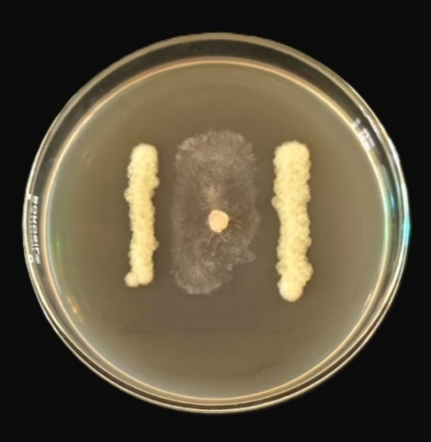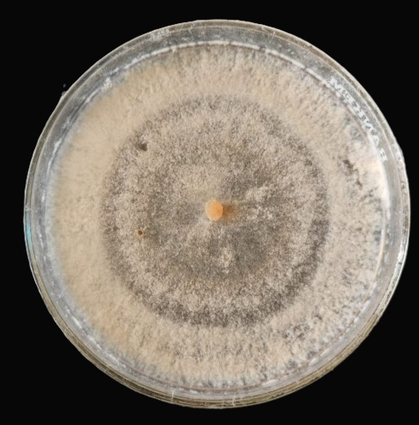
(a) (b)
Plate 1: In vitro antagonism of B. gladioli on R. solani (a) Treatment (b) Control plate (7th day after inoculation)

Table 3: Inhibition of R. solani by Burkholderia gladioli

Treatment | Inhibition zone (cm) | Per cent inhibition  (7 DAI)
T1 (R. solani ×Burkholderia gladioli) | 0.64 ± 0.18ª  (1.07) | 62.22
T2 (Control) | 0.00 ± 0.00^{b}  (0.71) | 62.22
CD (0.05) | 0.07 | 62.22
SE(m) | 0.02 | 62.22
CV (%) | 6.52 | 62.22

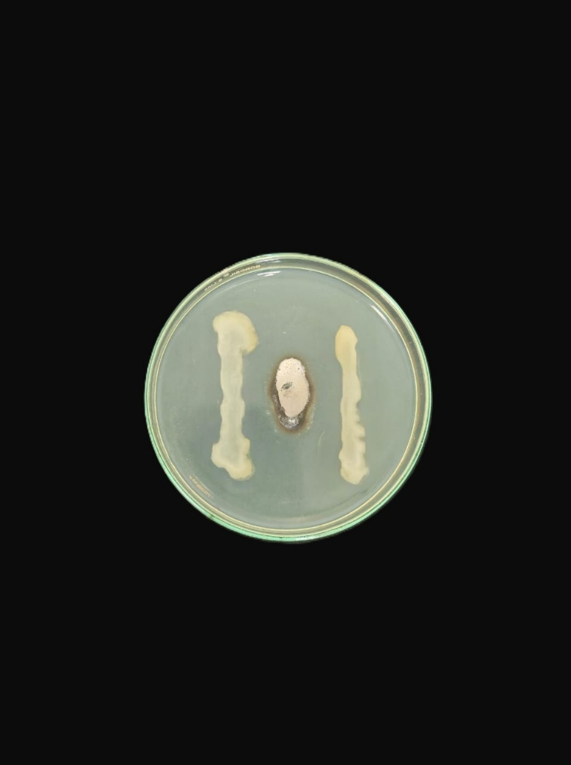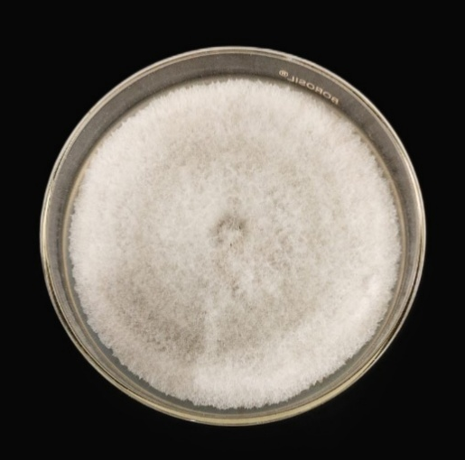
(a) (b)
Plate 2: In vitro antagonism of B. gladioli on C. gloeosporioides (a) Treatment (b) control plate

Table 4: Inhibition of C. gloeosporioides by Burkholderia gladioli
Treatment | Inhibition zone | Per cent inhibition  (7 DAI)
T1 (C. gloeosporioides ×Burkholderia gladioli) | 1.05 ± 0.20ª  (1.24) | 76.66
T2 (Control) | 0.00 ± 0.00^{b}  (0.71) | 76.66
CD (0.05) | 0.06 | 76.66
SE(m) | 0.02 | 76.66
CV (per cent) | 5.59 | 76.66

Dual culture assay exhibited a significant inhibition of R. solani and C. gloeosporioides compared to the control. R. solani was inhibited upto 62.2 % as against the control. Whereas, in case of C. gloeosporioides an inhibition zone of 1.05 cm was observed. The inhibition obtained may be attributed to the production of volatile organic compounds (VOCs) by Burkholderia gladioli pv agaricicola, that suppressed Fusarium oxysporum and Rhizoctonia solani. (Elshafie et al., 2012). B. gladioli strains produced diffusible metabolites and extracellular hydrolytic enzymes, which correlated with their antifungal activity. Wang et al. (2023) isolated a bacterium KRS027 from the soil rhizosphere of a healthy cotton plant in an infected field, which was later identified as B. gladioli. This bacterium exhibited antifungal activity against Botrytis cinerea causing gray mold disease tobacco and table grapes.

4. Conclusion

Spent mushroom substrate or SMS is the residual biomass left after the mushroom cultivation. SMS is a valuable byproduct of the mushroom industry, rich in both macronutrients and micronutrients that are essential for plant growth and soil health. The nutrient analysis confirmed that SMS retains a considerable amount of essential nutrients even after the growth of mushrooms in the substrate. These findings establish SMS as a potentially rich nutrient reservoir. Consistent amounts of macronutrients were observed in the SMS from various oyster mushroom species compared to the control (paddy straw). It was found that considerable amounts of micronutrients are also present in the SMS.
The essential nutrients are released in a slow manner and aids in the growth and development of the plants. These findings indicate that SMS serve as a good soil amendment enhancing soil fertility and promoting plant growth, thereby reducing the dependence on synthetic fertilizers. Moreover, its recycling contributes to waste management and supports a circular economy. Further, field-based evaluations are needed for the standardization of application rates and to find out its long- term impacts on soil health and crop productivity.
SMS harbours a wide range of microflora and many of them are having immense antagonistic potential against plant pathogens. The bacteria, B. gladioli isolated from SMS of oyster mushroom was found to be inhibiting two plant pathogens, R. solani and C. gloeosporioides. This proves the biocontrol activity of SMS against plant pathogens.
These findings establish SMS as a potentially rich nutrient reservoir as well as a natural substance for biological control of plant diseases.

References

Ahlawat, O. P., Kumar, S., and Kumar, P. (2022). Spent mushroom substrate (SMS)- a potential source of bio-agents for plant diseases management. In: Thakur, M.P., Singh, R. P., Singh, H. P., Mishra, K. K. Compendium of mushroom diseases. Indian Phytopathological Society. New Delhi, pp 108-124.

Ahlawat OP & Sagar MP. (2007). Management of Spent Mushroom Substrate [Technical Bulletin]. Chambaghat, Solan: National Research Centre for Mushroom (ICAR).

Bhaskaran, T. L., Sivaprakasham, K., & Kandaswamy, T. K. (1978). Compact bag method-a new method of increasing the yield of Pleurotus sajor-caju. Indian J. Mushrooms 4, 10-12.

Bijla, S., & Sharma, V. P. (2023). Status of mushroom production: Global and national scenario. Mushroom Res. 32 (2), 91-98.

Bushra, S. A., Jamela, D. S., Kareema, T. A., and Al-Sadaawyb, A. K. 2018. Effects Of Spent Mushroom Substrate (SMS) On Cucumber Damping -Off and Root Rot caused by Pythium aphanidermatum in greenhouse. Asian J. Microbiol. Biotech. Env. Sci. 20(2): 1-5.

Chesnin, L. & Yien, C.H. (1951) Turbidimetric Determination of Available Sulphur. Proceedings of Soil Science Society of America, 15, 149-151.

Economou, C. N., Diamantopoulou, P. A., & Philippoussis, A. N. (2017). Valorization of spent oyster mushroom substrate and laccase recovery through successive solid-state cultivation of Pleurotus, Ganoderma and Lentinula strains. Appl. Microbiol. Biotechnol. 101(12), 5213–5222.

Elshafie, H. S., Camele, I., Racioppi, R., Scrano, L., Iacobellis, N. S., & Bufo, S. A. (2012). In vitro antifungal activity of Burkholderia gladioli pv. agaricicola against some phytopathogenic fungi. Int. J. Mol. Sci. 3(12), 16291-302.

Food and Agriculture Organization. (2023). FAOSTAT Statistics database 2023. Food and Agriculture Organization of the United Nations.

Hesse, P. R. (1971). Textbook of Soil Chemical Analysis. John Murray, London. 520 pp.

Jackson, M. L. (1973). Soil chemical analysis. Prentice hall of India Pvt. Ltd., NewDelhi.

Keith, L. M., Sewake, K. T., & Zee, F. T. (2005). Isolation and Characterization of Burkholderia gladioli from Orchids in Hawaii. Plant Disease, 89(12).

Kwak, A. M., Min, K. J., Lee, S. Y., & Kang, H. W. (2015). Water extract from spent mushroom substrate of Hericium erinaceus suppresses bacterial wilt disease of tomato. Mycobiol. 43(3), 311–318.

Li, X. & Wang, M. (2023) Chemical Characteristics Analysis and Quality Assessment of Reed-Based Spent Mushroom Substrate. Agronomy, 13, 898.

Ma, Y., Wang, Q., Sun, X., Wang, X., Su, W., & Song, N. (2014) A study on recycling of spent mushroom substrate to prepare chars and activated carbon. Bioresour. 9(3):3939–3954.

Martin, M. C., Georgios, Z., Xiong, S., Georgios, K., & Strætkvern, K. (2023). Spent substrate from mushroom cultivation: exploitation potential toward various applications and value-added products, Bioeng. 14(1), 2252138.

Medina, E., Paredes, C., Bustamante, M. A., Moral, R., & Moreno-Caselles, J. (2012). Relationships between soil physico-chemical, chemical and biological properties in a soil amended with spent mushroom substrate, Geoderma, 173, 152-161.

Ravlikovsky, A., Pinheiro, M. N. C., Dinca, L., Crisan, V., & Symochko, L. (2024). Valorization of Spent Mushroom Substrate: Establishing the Foundation for Waste-Free Production. Recycling, 9(3), 44.

Roig A., Lax, A., Ceggara, J., Costa, P., & Hernandez, M. T. (1988). Cation exchange capacity as a parameter for measuring the humification degree of manures. Soil Sci. 146(5), 331-316.

Roshna, S. 2013. Potential of spent mushroom substrate for the management of nursery disease of black pepper. MSc. (Ag) thesis, Kerala Agriculture University, Thrissur. 215p.

Roy, S., Barman, S., Chakraborty, U., & Chakraborty, B. (2015). Evaluation of Spent Mushroom Substrate as biofertilizer for growth improvement of Capsicum annuum L. J. Appl. Biol & Biotechnol. 3(3), 22-27.

Wang, D., Luo, W.-Z., Zhang, D.-D., Li, R., Kong, Z., Song, J.-Q., Dai, X., Alkan, N., & Chen, J. (2023). Insights into the Biocontrol Function of a Burkholderia gladioli Strain against Botrytis cinerea. Microbiology Spectrum, 11(2). https://doi.org/10.1128/spectrum.04805-22

