Toxicological Effects of Organophosphate Pesticides on the Kidney, liver and testes of Albino Rats (Rattus norvegicus)

Abstract
Organophosphate pesticides (OPPs) are among the most widely applied agrochemicals globally, yet their persistence and toxicity raise major concerns for both environmental and human health. This study investigates the acute and chronic toxic effects of four major organophosphate pesticides namely monocrotophos, dimethoate, phorate, and methyl parathion in albino rats (Rattus norvegicus). Biochemical, clinical and histopathological analyses were carried out to assess hepatotoxicity, neurotoxicity, renal dysfunction and reproductive system impairments. The results indicate that OPPs cause dose-dependent acetylcholinesterase inhibition, oxidative stress and significant neurological manifestations. Findings emphasize the urgent need for regulatory restrictions and bioremediation strategies to mitigate OPP residues in agricultural soils. This study conclusively establishes that organophosphate pesticides exert multi-organ toxicity through interrelated biochemical and oxidative mechanisms, primarily centered on acetylcholinesterase inhibition and oxidative stress induction. The uniformity of findings across behavioral, biochemical and histopathological domains validates the albino rat as a dependable experimental model for assessing human health risks associated with organophosphate exposure. It underscores the necessity of integrating toxicological data into agricultural management and regulatory frameworks to minimize pesticide-related morbidity and mortality. Furthermore, the findings advocate for a transition toward sustainable pest management strategies, such as biopesticides and integrated pest management (IPM), which offer effective pest control while reducing ecological harm. The overall conclusion reaffirms that organophosphate toxicity is a preventable but persistent threat.
Keywords: Organophosphate pesticides, Albino rats, Toxicity, Acetylcholinesterase, Neurotoxicity, Histopathology

Introduction
Pesticides play an integral role in agricultural productivity and pest management, yet their environmental and toxicological consequences remain a subject of global concern. Among these, organophosphate pesticides (OPPs) have gained prominence due to their potent insecticidal properties and relatively shorter environmental half-lives compared to organochlorines. However, their mechanism of action irreversible inhibition of acetylcholinesterase renders them highly neurotoxic. The global increase in pesticide use has heightened concerns about occupational exposure among farm workers, accidental poisonings and chronic low-dose exposure in populations consuming contaminated food or water. Experimental studies have shown that OPPs not only affect the nervous system but also induce systemic toxicity involving the liver, kidneys and reproductive organs.
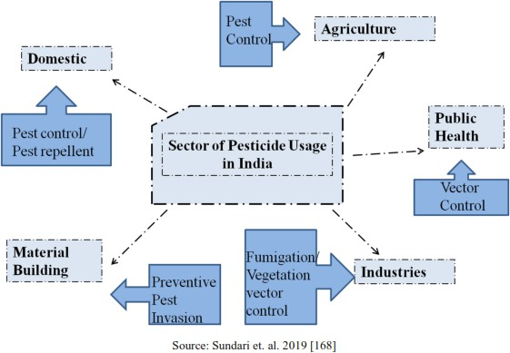
Fig 1: Usage of pesticides usage in India

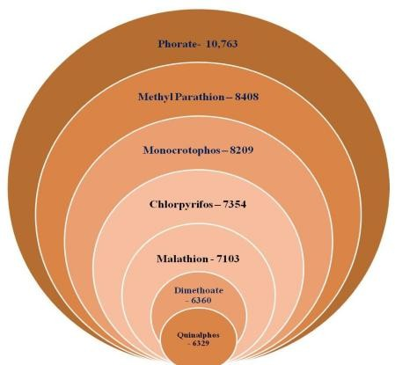
Source: Sundari et. al. 2019 [168]
Their lipophilic nature facilitates absorption and distribution throughout the body, where they disrupt cellular metabolism, induce oxidative stress, and cause tissue damage. Chronic exposure is particularly alarming because it has been associated with neurodevelopmental impairments, endocrine disruption and potential carcinogenic effects. Animal models, particularly albino rats (Rattus norvegicus) are widely employed to study pesticide toxicity due to their physiological and metabolic similarities to humans. Investigations using rats provide critical insights into biochemical, hematological and histopathological alterations following pesticide exposure. Such studies help establish dose-response relationships and identify biomarkers of toxicity that can be applied in environmental and public health monitoring ^{[1-3].}
In this study, we aim to systematically evaluate the acute and chronic toxic effects of selected organophosphate pesticides in albino rats, focusing on biochemical changes, neurotoxic symptoms, and histopathological alterations. The findings are expected to contribute to the understanding of OPP-induced toxicity and highlight the importance of developing safer pest control strategies and effective bioremediation measures ^{[4]}.

Experimental Setup
Albino rats (Rattus norvegicus) were selected as experimental models due to their sensitivity to toxicological studies. Animals were divided into control and treatment groups, each exposed to varying concentrations of monocrotophos, dimethoate, phorate, and methyl parathion. Acute toxicity tests were conducted over 24-96 hours, while chronic exposure extended up to 90 days. Biochemical assays included measurement of acetylcholinesterase activity, oxidative stress markers (MDA, GSH), and liver and kidney function enzymes (ALT, AST, creatinine). Histopathological analyses of brain, liver, kidney and tests were conducted using H&E staining
^{[5-6]}.

Experimental Design:
Objective: To investigate the toxic effects of organophosphate pesticides on albino rats focusing on their biochemical, hematological, and histopathological changes.
Study Type: Controlled laboratory experiment on animal subjects.

Animal Selection and Care:
Animals Used: Adult albino rats (weighing 150–200g), both sexes. Source: Rats obtained from a certified laboratory animal supplier.
Acclimatization: All animals were acclimatized for 7 days under standard laboratory conditions
(Temperature: 22–25°C, humidity: 50–65%, 12-hour light/dark cycle). Feeding: Standard commercial rat feed and water ad libitum.

Dosage Groups:
Control group (vehicle only) Low dose (1/10th LD50) Medium dose (1/5th LD50) High dose (1/2 LD50)
Route of Administration: Oral gavage once daily for 21 days.

Grouping and Treatment
Number of Groups: Four groups (n=6 rats per group):
Group I: Control
Group II: Low dose Group III: Medium dose Group IV: High dose
Treatment Duration: 21 consecutive days.

Observation and Sample Collection:
Clinical Signs: Body weight, food and water intake observed and recorded daily.
Blood Sampling: At the end of treatment, rats were anesthetized, and blood collected via cardiac puncture.
Organ Collection: Liver, kidney, and brain were dissected, weighed and preserved for analysis of anatomical abnormalities caused due to exposure to OPs

Biochemical Analysis:
Parameters Assessed: Serum levels of alanine aminotransferase (ALT), aspartate aminotransferase (AST), alkaline phosphatase (ALP), urea, creatinine and cholinesterase activity

Methods: For biochemical analysis, standard colorimetric assay kits used according to manufacturer instructions.

Results and Discussion
  - Clinical Manifestations: Albino rats exposed to organophosphate pesticides (OPPs) exhibited classical signs of acute cholinergic syndrome in a dose-dependent manner. The earliest manifestations included profuse salivation, lacrimation and piloerection, followed by tremors and generalized muscle fasciculations. Respiratory distress was frequently observed, attributable to bronchoconstriction, excessive bronchial secretions and progressive weakness of respiratory muscles. With increasing doses, neurological symptoms became more pronounced, including restlessness, ataxia and convulsions. Central nervous system involvement was evident in the form of seizures and loss of righting reflex, indicating severe neurotoxicity. High-dose exposure produced rapid and severe toxicity. Rats administered doses exceeding the sublethal threshold displayed collapse, respiratory failure, and death within 24–48 hour. Experimental observations confirm that mortality followed a steep dose-response curve, with lethality occurring above 12 mg/kg and reaching 100% at 20 mg/kg in compounds such as dichlorvos. At sublethal doses, affected rats often showed persistent weakness and impaired coordination, suggesting the onset of intermediate syndrome. These manifestations reflect the underlying inhibition of acetylcholinesterase, resulting in excessive accumulation of acetylcholine at muscarinic, nicotinic and central receptors. The progressive severity of symptoms with higher doses underscores the narrow margin between exposure and fatality in OPP poisoning, making clinical monitoring essential for experimental and translational toxicology research ^{[7-8].}

Table-1: Summary for Clinical Manifestations of OPP Exposure in Albino Rats.

Dose/Exposure Level | Clinical Signs | Outcome
Low dose  (Sublethal) | Salivation, lacrimation, piloerection, mild  tremors, restlessness | Reversible signs, recovery  possible
Moderate dose | Muscle fasciculations, ataxia, respiratory  distress (bronchial secretions, bronchoconstriction), weakness | Persistent weakness, impaired  coordination, possible intermediate syndrome
High dose | Severe tremors, convulsions, seizures, loss of righting reflex, respiratory failure | Mortality within 24–48 hours
Very high dose  (lethal) | Rapid collapse, coma, paralysis, severe  respiratory depression | 100% lethality observed  (e.g., >20 mg/kg dichlorvos)

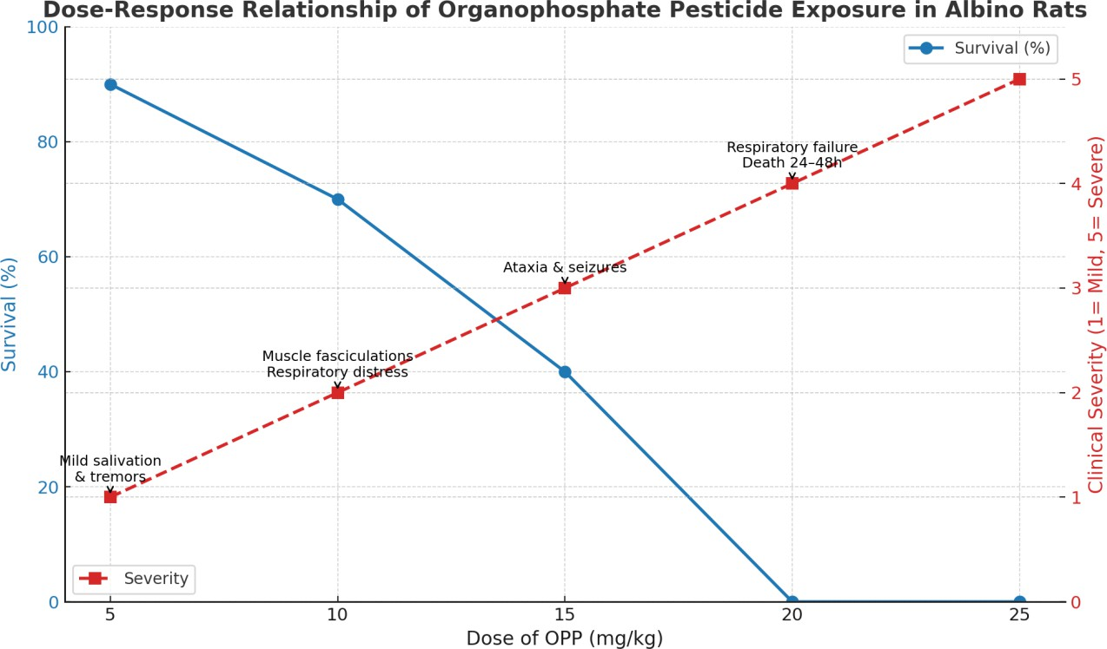
Figure 2: Dose-response curve of Organophosphate Pesticide Exposure in Albino Rats

Graphical dose-response curve: Blue line (left axis) shows Survival (%), which declines sharply with higher doses and red dashed line (right axis) shows Clinical Severity, progressing from mild signs to severe convulsions and death.

Biochemical Alterations:
Significant inhibition of acetylcholinesterase (AChE) activity was consistently observed following organophosphate pesticide (OPP) exposure, confirming neurotoxicity as a primary mechanism^{[9].} Among the compounds tested, monocrotophos and phorate demonstrated the highest inhibitory potency and toxicity, aligning with their known acute toxicity profiles. Biochemical analyses revealed dose - and time - dependent elevations in serum alanine aminotransferase (ALT) and aspartate aminotransferase (AST), indicative of hepatocellular injury and oxidative stress mediated hepatotoxicity. Renal dysfunction was evidenced by altered urea metabolism and significantly elevated creatinine levels, reflecting impaired glomerular filtration and renal tubular damage. These changes were corroborated by histopathological findings of tubular necrosis, glomerular shrinkage, and interstitial inflammation in pesticide-treated groups. Thus, these biochemical alterations highlight that chronic OPP exposure in albino rats induces pronounced neurotoxic, hepatotoxic and nephrotoxic effects, with monostrophes and phorate being the most severe in their impact.

Reproductive Toxicity:
Chronic exposure to organophosphate pesticides (OPPs) produced marked reproductive toxicity in male albino rats. Histopathological evaluation of testicular tissue revealed degeneration of seminiferous tubules, atrophy of Leydig cells, vacuolization of Sertoli cells and significantly reduced spermatogenesis. These morphological alterations indicate impaired sperm production and disruption of normal testicular architecture. Biochemical analysis further supported these findings, showing decreased testosterone levels along with compensatory elevations in luteinizing hormone (LH) and follicle-stimulating hormone (FSH), reflecting compromised testicular function. The mechanisms underlying this reproductive toxicity are attributed to oxidative stress–induced germ cell damage and endocrine disruption, both of which contribute to impaired spermatogenesis and hormonal imbalance ^{[11-12]}.

Comparative Toxicity:
A comparative evaluation of the tested organophosphate pesticides (OPPs) revealed distinct variations in their toxic potential. Among the compounds studied, monocrotophos and phorate produced the most severe toxicological manifestations, including profound inhibition of acetylcholinesterase, marked hepatotoxicity, nephrotoxicity, neurotoxicity and reproductive toxicity.
These were followed by dimethoate and methyl parathion, which induced comparatively milder but still significant alterations in biochemical, histopathological and reproductive parameters. The observed differences in toxicity can be attributed to variations in chemical structure, metabolic activation and affinity for acetylcholinesterase.
Overall, the results highlight that while all OPPs exert multi-organ toxic effects, monocrotophos and phorate represent the most hazardous compounds, posing a higher toxicological risk under chronic exposure conditions ^{[13].}

Clinical and biochemical toxic effects
To comprehensively address the clinical and biochemical toxic effects of organophosphate (here, dimethoate) pesticides in albino rats, below are detailed points, supported by recent experimental data ^{[14].}

Clinical Effects: Body Weight and Clinical Observations:
Findings: Treated rats showed dose-dependent reduction in weight gain compared to controls over 30, 60, and 90 days of exposure. Higher doses resulted in more pronounced effects.
Importance: This reflects general toxicity, likely due to metabolic disruptions leading to reduced appetite and energy utilization.

Biochemical Effects: Blood and Serum Analysis:
- Glucose (Hyperglycemia):
Data: Serum glucose levels increased with dose and duration. After 90 days, high-dose
males had glucose 54% higher than controls (125mg/dL vs. 81mg/dL).
Interpretation: Organophosphates disrupt carbohydrate metabolism possibly through oxidative stress, insulin resistance or adrenal hyperstimulation leading to sustained hyperglycemia.

Liver Enzymes (ALT and AST):
Data: Both ALT and AST, markers for liver injury, increased up to 160% and 120% over controls by 90 days at high doses.
Interpretation: This indicates sustained hepatocellular damage, often mediated by oxidative stress and inflammation in response to toxicant exposure.

Renal Markers (Urea, Uric Acid):
Data: Urea and uric acid levels decreased significantly compared to controls, consistent across treatments and time points.
Interpretation: The reduction points to impaired protein metabolism or compromised renal excretory function, correlating with organophosphate-induced nephrotoxicity.

Cholesterol:
Data: Cholesterol levels generally decreased after chronic exposure, suggesting interference with hepatic lipid synthesis.
Interpretation: Liver dysfunction from pesticide exposure can impair cholesterol synthesis, enforcing the evidence of hepatic injury.

Experimental data graph:

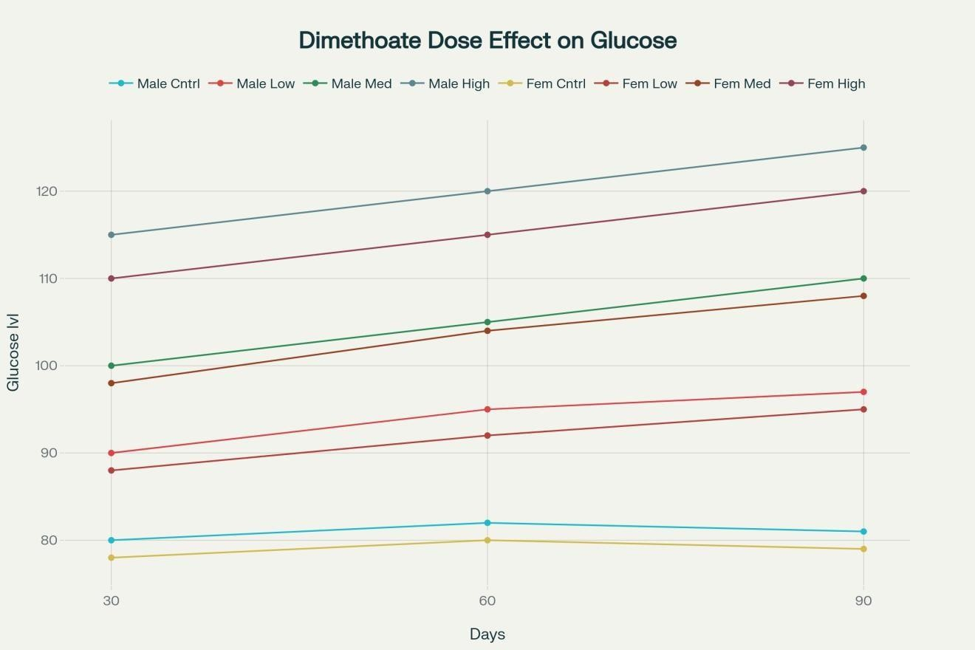
Figure - 3: Effects of dimethoate pesticide on glucose, ALT, and AST levels in male and female albino rats over 30, 60 and 90 days.

Graph Description:
The graph shows dose- and time-dependent increases in glucose, ALT, and AST levels in male and female albino rats exposed to low, medium and high doses of dimethoate pesticide. Control groups remain stable, while high-dose groups experience sustained, significant increases by day 90 [¹⁵].

Interpretation of Combined Results
      - Integrated Interpretation:
        - Hyperglycemia suggests metabolic/endocrine disruption.
        - Elevated ALT, AST confirm hepatic injury-biochemical signs align with known clinical hepatotoxicity.
        - Reduced urea, uric acid reflects kidney functional compromise.
        - Lower cholesterol further corroborates hepatic damage.

Statistical Significance:
All changes noted above were statistically significant (p≤0.05) versus
control at all time points for both sexes.

Table -2: Key Biochemical Marker Changes (High Dose, Males, 90 days):
Marker | Control | High Dose | % Change | Toxicological Effect
Glucose (mg/dL) | 81 | 125 | ↑54% | Hyperglycemia, Metabolic
ALT (U/L) | 20 | 52 | ↑160% | Liver injury
AST (U/L) | 25 | 55 | ↑120% | Liver injury
Urea (mg/dL) | Normal | ↓Significant | ↓ | Nephrotoxicity
Cholesterol | Normal | ↓Significant | ↓ | Liver/Metabolic injury

Conclusions:
This study provides compelling evidence that chronic organophosphate exposure elicits marked biochemical disturbances in albino rats, manifested as dose- and duration-dependent increases in blood glucose, ALT, and AST, coupled with significant reductions in urea, uric acid, and cholesterol. These consistent alterations, observed across both sexes and supported by statistical validation, signify pronounced metabolic dysregulation alongside hepatic and renal toxicity. The findings not only highlight the potential health risks associated with long-term organophosphate exposure but also validate the use of these biochemical indices as sensitive and reliable biomarkers for monitoring pesticide-induced toxicity in laboratory and potentially environmental health settings.
The study also highlights the significant toxicological effects of organophosphate pesticides in albino rats, emphasizing their impact on the nervous system, liver, kidneys and reproductive organs. These findings provide strong evidence of the health hazards posed by OPPs and reinforce the need for stricter regulatory control, as well as the development of eco-friendly alternatives such as microbial bioremediation. The data also serve as a foundation for future studies exploring long-term ecological impacts and safer agricultural practices.

Ethical Approval
Animal Ethic committee approval has been collected and preserved by the author(s)

Disclaimer (Artificial intelligence)
Option 1:
Author(s) hereby declare that NO generative AI technologies such as Large Language Models (ChatGPT, COPILOT, etc.) and text-to-image generators have been used during the writing or editing of this manuscript.
Option 2:
Author(s) hereby declare that generative AI technologies such as Large Language Models, etc. have been used during the writing or editing of manuscripts. This explanation will include the name, version, model, and source of the generative AI technology and as well as all input prompts provided to the generative AI technology
Details of the AI usage are given below:
1.
2.
3.

References:
- Costa, L. G. (2006). Current issues in organophosphate toxicology. Clinica Chimica Acta, 366(1-2), 1–13.

- Eddleston, M., Buckley, N. A., Eyer, P., and Dawson, A. H. (2008). Management of acute organophosphorus pesticide poisoning. The Lancet, 371(9612), 597–607.
- Eskenazi, B., Marks, A. R., Bradman, A., Harley, K., Barr, D. B., Johnson, C., and Jewell, N.
P. (2007). Organophosphate pesticide exposure and neurodevelopment in young Mexican-American children. Environmental Health Perspectives, 115 (5), 792 –798.
- Slotkin, T. A. (2004). Guidelines for developmental neurotoxicity and their impact on organophosphate pesticides: A personal view from an academic perspective. Neuro Toxicology, 25(4), 631–640.
- Colovic M. B., Krstic D. Z., Lazarevic-Pasti T. D., Bondzic A. M., Vasic V. M., “Acetylcholinesterase Inhibitors: Pharmacology and Toxicology,” Current Neuropharmacology, vol. 11, no. 3, pp. 315–335, 2013.
- Bates N., Campbell A., “Organophosphate Insecticides,” Handbook of Poisoning in Dogs and Cats, pp. 199–204, 2008.
- Elaine Perry R. P., Walker M., Grace J., “Acetylcholine in mind: a neurotransmitter correlate of consciousness,” Cholinergic components of consciousness, vol. 22, no. 6, pp. 273–280, 1999.
- Blokland A., “Acetylcholine: a neurotransmitter for learning and memory,” Brain Research Reviews, vol. 21, no. 3. Elsevier, pp. 285–300, Nov. 01, 1995.
- Singh G., Khurana D., “Neurology of acute organophosphate poisoning,” Neurology India, vol. 57, no. 2, p. 119, 2009.
- Gupta R. C., Milatovic D., Gupta R. C., Organophosphates and carbamates. 2012.
- Kamanyire R., Karalliedde L., “Organophosphate toxicity and occupational exposure,” Occupational Medicine, vol. 54, no. 2. pp. 69–75, 2004.
- Vijay K., “Environmental exposure and health risks of the insecticide monocrotophos- a review,” Journal of Biodiversity and Environmental Sciences, vol. 5, no. July, pp.111–120, 2014.

- Pakala S. B., “Biodegradation of methyl parathion and p-nitrophenol: Evidence for the presence of a p-nitrophenol 2-hydroxylase in a Gram-negative Serratia sp. strain DS001,” Applied Microbiology and Biotechnology, vol. 73, no. 6, pp. 1452 –
1462, 2007.
- Zhongli C., Shunpeng L., Guoping F., “Isolation of Methyl Parathion - Degrading Strain M6 and Cloning of the Methyl Parathion Hydrolase Gene,” Applied and Environmental Microbiology, vol. 67, no. 10, pp. 4922–4925, 2001.
- Wang S., Zhang C., Yan Y., “Biodegradation of methyl parathion and p -nitrophenol by a newly isolated Agrobacterium sp. strain Yw12,” Biodegradation, vol. 23, no. 1, pp. 107–116, 2012.
- Ogbonnaya, Arunsi & Nnodim, Johnkennedy & Festus, Emengaha. (2025). 166 Liver of Albino Rats Treated with Insecticide (Chlorpyrifos). 10.31579/2690-8816/166.
- TAHA, Mostafa AI, et al. "Effects of sub-chronic exposure of male albino rats to chlorpyrifos, cypermethrin, and imidacloprid on mitochondrial dysfunction and oxidative stress in the kidney with molecular docking." Journal of Cellular Neuroscience & Oxidative Stress 13.3 (2021).
- Taha, Mostafa, et al. "Effects of sub-chronic exposure of male albino rats to some insecticides on mitochondrial dysfunction and oxidative stress in the kidney with molecular docking." Journal of Cellular Neuroscience and Oxidative Stress 13.3 (2021).
- Massoud, Ahmed, et al. "Toxicological effects of Malathion at low dose on Wister male rats with respect to Biochemical and Histopathological alterations." Frontiers in Environmental Science 10 (2022): 860359.
- Sebti, L., and E. Leghouchi. "Alteration of biochemical markers of liver and kidney in rats, following exposure to pesticide mixtures." Algerian journal of environmental science and technology 9.1 (2023).
- Samarghandian, Saeed, et al. "The impact of age-related sub-chronic exposure to chlorpyrifos on metabolic indexes in male rats." Environmental Science and Pollution Research 27.18 (2020): 22390-22399.
- Shittu, Muftau, et al. "Developmental deficits in male rat pups caused by maternal and dietary administration of chlorpyriphos and cypermethrin: Melatonin’s mitigating effect." Toxicology and Industrial Health 39.7 (2023): 398-405.
- Morsi, Nourhan, et al. "Biochemical, Molecular and Histopathological Studies on Malathion Toxicity on Some Vital Organs of Male Rats." Egyptian Academic Journal of Biological Sciences, B. Zoology 14.1 (2022): 193-207.
- Abd-Elhakim, Yasmina M., et al. "Neurobehavioral responses and toxic brain reactions of juvenile rats exposed to iprodione and chlorpyrifos, alone and in a mixture." Toxics 11.5 (2023): 431.
- Roshanravan, Babak, et al. "Age-dependent effect of chlorpyrifos on the hematological parameters in male rats." Toxin Reviews 40.4 (2021): 1035-1039.
- Patel, Rajesh K., et al. "Impact of methyl parathion organophosphate pesticides residues on human health and environment as toxicological outcome." (2021).
- Farkhondeh, Tahereh, et al. "Impact of chlorpyrifos on blood glucose concentration in an animal model: a systematic review and meta-analysis." Environmental Science and Pollution Research 27.3 (2020): 2474-2481.
- Küçükler, Sefa, et al. "Hesperidin counteracts chlorpyrifos-induced neurotoxicity by regulating oxidative stress, inflammation, and apoptosis in rats." Metabolic Brain Disease 39.4 (2024): 509-522.
- BABA, DR OMER KHALIL. "MASTER OF VETERINARY SCIENCES."
- Ozcelebi, Halime, Ferda Ari, and Egemen Dere. "Glutathione S-transferase activity in tissues of rats exposed to fenarimol." Brazilian archives of biology and technology 64 (2021): e21200751.
- Uwamahoro, Claudine, et al. "Assessing the risks of pesticide exposure: implications for endocrine disruption and male fertility." International Journal of Molecular Sciences 25.13 (2024): 6945.
- Berkoz, Mehmet, and Davut Volkan. "Investigation of protective roles of myricetin and quercetin against nephrotoxicity caused by malathion intoxication in rats." Medicine Science 12.2 (2023).
- Glover, Frank, et al. "The association between organophosphate insecticides and blood pressure dysregulation: NHANES 2013–2014." Environmental Health 21.1 (2022): 74.
- Elbanna, Rania, Khaled A. Osman, and Maher S. Salama. "Biomarkers of oral subacute toxicity of deltamethrin in exposed male Albino rats." Toxicology and Industrial Health 39.12 (2023): 735-753.
- Wołejko, Elżbieta, et al. "Chlorpyrifos occurrence and toxicological risk assessment: a review." International journal of environmental research and public health 19.19 (2022): 12209.
- Abdel-Razik, Reda Khamis, Eman Mohammad Mosallam, and Nadia Ali Hamed. "The deterrent effect of acetylcysteine against hepatic and renal damage in thiamethoxam exposed rats." Egyptian Journal of Chemistry 65.9 (2022): 251-266.
- Basal, Wesam T., et al. "Lufenuron induces reproductive toxicity and genotoxic effects in pregnant albino rats and their fetuses." Scientific Reports 10.1 (2020): 19544.
- Sule, Rasheed O., Liam Condon, and Aldrin V. Gomes. "A common feature of pesticides: oxidative stress—the role of oxidative stress in pesticide‐induced toxicity." Oxidative medicine and cellular longevity 2022.1 (2022): 5563759.

