Original Research Article

MORPHOMETRIC CHARACTERIZATION AND FILLET YIELD OF TWO COMMERCIAL FISH SPECIES FROM PANYAM FISH FARM PLATEAU STATE

ABSTRACT
What is the objective of current research?
A total of 50 individual samples of Parachanna obscura and Clarias gariepinus were collected fresh from Panyam fish farm with the aid of crush ice for preservation until assessment was carried out. The whole fresh fish samples were taken to the department of Fisheries and Aquaculture laboratory of the Federal University, of Agriculture, Makurdi for assessment. Their Total and Standard Lengths were recorded (in cm) using a Measuring Rule, while Total Body Weights were recorded (in grams) using an electronic weighing balance. Data were collected on: the Total Weight (g), Total Length (cm), Standard Length (cm), Visceral Weight (g), Head Length (cm), Weight of Bones (g), Weight of Fins (g) and Weight of Fillet (g) in comparism between the two fish species. Descriptive statistics for morphometric data were determined using Minitab 18® (Minitab 2017). Regression and correlation of variables was carried out in R (R Core Team 2020). Results of the mean measured parameters of Parachana obscura and Clarias gariepinus from Panyam Fish Farm Jos, showed that Total Length (42.66 ± 0.58cm), Standard Length (38.56 ± 0.29cm), Fin Weight (15.51 ± 0.37g), Visceral Weight (11.04 ± 0.17g), Head Weight (1.49 ± 4.01g), Bone weight (39.84 ± 0.80g) and Weight of fillet (89.02 ± 2.38g) of Parachana obscura were higher than the mean measured parameters of Clarias gariepinus. There was a significant difference (p= .05) among the measured parameters between P. obscura and C. gariepinus . The higher fillet percentage per body weight of P. obscura in comparism to C. gariepinus is a pointer to a relatively higher economic value for commercial purposes of this species. This assessment also provides information for further studies on this species to be built on, as there is obvious need for Nigeria’s aquaculture system to diversify from the prevalent catfish culture.

Keywords: Filleting Assessment, Morphometric, Descriptive, Nutrition, Research,
1.0 INTRODUCTION
Background of Study

As the human population inevitably increases, the demand for fish as source of protein also grows [1]. Fish is important to human population in trade and economy and also in the diet of different countries especially in the tropics and subtropics where malnutrition is a major problem [2]. Studying the characteristics of fish quality requirement and assessment indices are basic trade processes in deciding prosperity of commercial fisheries products. To facilitate the saturation of fish for consumption as a source of animal protein, the availability of vital relevant information on the edibility of various fish species should be abundantfor consumer preferences through informed choice and this can effectively be possible by research and documentation. According to [3], most commercially important fish species have not been successfully cultivated on a commercial scale due to lack of deep knowledge of their biology. For a successful culture of any fish species, a good knowledge of its biology (particularly its growth characteristics) is important as it helps in planning and imposing proper management practice to ensure large scale commercial production [4]. The length-weight relationship of fish is generally an index used in fisheries studies to estimate the mean weight of a fish species sample based on a known length.

The fish industry is dynamic and in the last two decades, the utilization and processing of fish have diversified significantly, particularly, into high valued fresh and processed products. This is also coupled with the changes in consumer’s tastes and advances in technology, packaging, logistics and transport. Value addition mainly-focused on increased convenience foods and wider variety of high value added products. Improved processing technology enables higher yield and results in a more lucrative product being demanded from available raw material of fish for human consumption. Fish flesh is basically the edible portion with the most economic value in the fish body.

Flesh yield or fillet yield refers to the edible portion that can be derived from a particular fish species. Fins, viscera, scales, and the vertebra column are not usually regarded as edible parts [5]. Also, filleting reduce the bulky transportation of fresh fish products from point of production to the retail shop, this saves consumers the drudgery of cleaning and processing of raw fish before cooking [5].

The increasing cost of producing fish means that it is important to recover as much valuable flesh as possible, and this has encouraged greater attention to improving the yield of edible portions. Many species are filleted to satisfy consumer and market demands. Filleting is also important for logistics, economics, the edition of value along the marketing chain, and for the separation for edible parts from inedible ones. Filleting can be performed either by machine or by hand [6].

Parachanna obscura, an edible fish species is the most prevalent African Channidae, and various studies are being conducted on its biology and ecology (e.g. ….). It lives in fresh water in quiet and muddy areas. It is a medium sized carnivorous fish that has an elongated shape tapered on both ends and is covered in medium circular scales (cycloid). The head, resembling a snake, is long and depressed anteriorly, and covered with cycloid scales slightly larger than those scales on the body. It is a hardy species that supports stressful conditions. This fish species is one of the edible fish species obtained in Nigeria’s fresh waters though not much research work has been done on it, to avail researchers, nutritionists, farmers, and the public with necessary data as a pointer to the significance of this species. Processors, nutritionists and consumers have direct interest in the physical and chemical composition of fish, and the general condition of fishes such as body weight, body length and filleting yield indices are important in assessing the actual amount of fish tissue consumed, while the inedible parts are discarded.

Clarias gariepinus
gariepinus is an indigenous species to inland waters of Africa. It has an average adult length of 1–1.5 m (3 ft 3 in–4 ft 11 in) [7]. It reaches a maximum length of 1.7 m (5 ft 7 in) TL and can weigh up to 60 kg (130 lb). These fish have slender bodies, flat bony heads, notably flatter than in the genus Silurus, and broad, terminal mouths with four pairs of barbels. They also have large accessory breathing organs composed of modified gill arches.

Morphometric characterisation and filleting of Clarias gariepinus and Paranchana obscura as a study provides information on dress percentage of these species, and it would provide information on the relevance of this fish to purchase in order to get maximum benefit from the purchase of fish. The aim of this study is to determine the fillet yield and the morphometric characteristics of the selected fish species from Panyam fish farm plateau state, Nigeria.

2.0 MATERIALS AND METHODS
2.1 Sampling Site

The fish samples were collected from Panyam fish farm Mangu Local Government Area Plateau State, Nigeria.

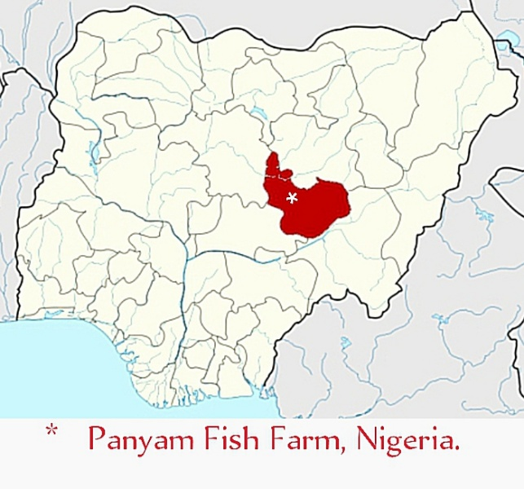
Plate 1: Map of Panyam Mangu Local Government Area, Plateau State Nigeria

2.2 Experimental Fish Species

A total of 50 individuals, belonging to two families, were sampled for this study. Fresh fish were collected and crush ice added for preservation during assessment. The whole fresh fish samples were taken to the Department of Fisheries and Aquaculture Laboratory, University of Agriculture Makurdi (Joseph Sarwuan Tarka University, Makurdi) where their total and standard length were recorded (in cm) using measuring rule (ruler) and total body weights were recorded in grams using an electronic weighing balance. The fishes were then filleted, eviscerated, beheaded using a sharp knife. The weight of viscera, fillets, heads, and skeletons (bones) were weighed separately using weighing balance.
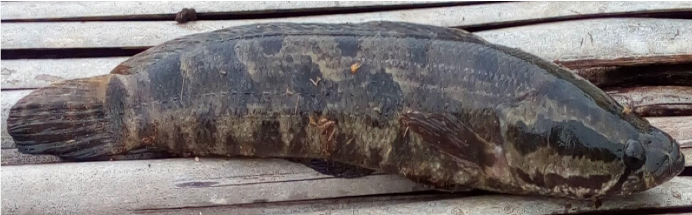

Plate 2: Parachanna obscura from Panyam Fish Farm (photo author)?

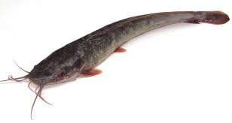

Plate 3: Clarias gariepinus from Panyam Fish Farm(photo author)?

2.3 Filleting Procedure
The fins of the fish were removed and weighted. The fish were then degutted (Removal of internal organs). Thereafter, the fish were beheaded, and the bones removed.

2.4 Data Collection
Data were collected were: Total Weight (g), Total Length (cm), Standard Length (cm), Visceral Weight (g), Head Length (cm), Weight of Bones (g), Weight of Fins (g) and Weight of Fillet (g) from the two fish species.

2.5 Statistical Analysis
Descriptive statistics for morphometric data were determined using Minitab 18® [8]. In order to avoid autocorrelation, total weight (TW) and fillet weight (FW) were removed from the data before analysis since they are used to calculate fillet yield.

Correlation between morphometric characteristics and fillet weight was determined using the corrplot package [9], in R (R Core Team 2020).
Fillet yield (FY) was determined using fillet weight (FW) and Total weight (TW) in the formula as introduced by [10].
$$FY= \left({FW}/{TW}\right)×100$$

RESULTS

Results of the mean measured parameters of Parachana obscura and Clarias gariepinus from Panyam Fish Farms, Jos are presented in Table 1. Mean total weight (543.61 ± 10.59g), Total length (42.66 ± 0.58cm), Standard Length (38.56 ± 0.29cm), Fin Weight (15.51 ± 0.37g), Visceral Weight (11.04 ± 0.17g), Head Weight (1.49 ± 4.01g), Bone weight (39.84 ± 0.80g) and Weight of fillet (89.02 ± 2.38g) of Parachana obscura were higher than the mean measured parameters of Clarias gariepinus with Mean total weight (g), Total length (cm), Standard Length (cm), Fin Weight (g), Visceral Weight (g), Head Weight (g), Bone weight (g) and Weight of fillet(g) of 180.25 ± 4.64, 27.19 ± 0.22, 23.78 ± 0.19, 5.56 ± 0.39, 6.10 ± 0.19, 1.28 ± 1.25, 9.11 ± 0.33 and 83.84 ± 6.05, respectively. There was significant difference (p<0.05) among the measured parameters between P. obscura and C. gariepinus.

Table 1: Mean measurement of parameters of Parachanna obscura and Clarias gariepinus fish species

Parameter | Total  Count | Parachanna  Obscura  Mean ± SD | Clarias gariepinus  Mean ± SD | P-  Value
Total Weight(g) | 50 | 180.25 ± 4.64 | 543.61 ± 10.59 | 0.00
Total length (cm) | 50 | 27.19 ± 0.22 | 42.66 ± 0.58 | 0.00
Standard Length (cm) | 50 | 23.78 ± 0.19 | 38.56 ± 0.29 | 0.00
Fin Weight (g) | 50 | 5.56 ± 0.39 | 15.51 ± 0.37 | 0.00
Visceral Weight (g) | 50 | 6.10 ± 0.19 | 51.04 ± 0.17 | 0.00
Head Weight (g) | 50 | 1.28 ± 1.25 | 1.49 ± 4.01 | 0.00
Bone weight(g) | 50 | 9.11 ± 0.33 | 39.84 ± 0.80 | 0.00
Weight of fillet(g) | 50 | 83.84 ± 6.05^{b} | 89.02 ± 2.38 | 0.00
Means on the same row with different superscript are statistically significant (p = .05)
KEYS: Tw= Total weight, Tl= total length, Sl= standard length, Wfin=weight of fin,Wvis= visceral weight, Hdw=Head weight, Bonw= Bone weight, Wfill=Weight of fillet.

Results of the length-weight relation, condition factor and slope “b” values of Parachana obscura and Clarias gariepinus from Panyam Fish Farms, Jos are presented in Table 2. A higher mean condition factor (K) of 0.94 ± 0.38 was recorded for C. gariepinus compared to the lower (0.85 ± 0.26) recorded for P. obscura. On the other hand, higher slope (b value) of 3.18 was recorded for P. obscura than the lower slope of 2.72 recorded for C. gariepinus.

Table 2. Length-weight relationship, condition factor and slope “b” values of Parachana obscura and Clarias gariepinus from Panyam Fish Farms, Jos

Fish species | Mean K±SD | Intercept (a) | Slope (b) | Regression coefficient (R²)
P.obscura | 0.85 ± 0.26 | -2.10 | 3.18 | 0.92
C. gariepinus | 0.94 ± 0.38 | -1.44 | 2.72 | 0.76
Pvalue | 0.17

Where is the Fillet yield (FY)

DISCUSSION
During this study, variations in the sizes of the sampled fishes were observed. The observed variations in these sizes with respect to the length and weight could be due to the interplay of certain factors such as nutritional, physiological, biotic and climatic factors affecting the growth of the fish. A similar observation was made by [11], who reported different variations in length and weight of moonfish from the Makoko fish market in Lagos and attributed these variations to the interplay of factors (nutritional, physiological, biotic and climatic factors) affecting growth.

Variations in the fillet yield indices of the studied fishes in this study are in line with the previous works of [12].

The frames, fins and viscera of fish are usually inedible parts. Fish flesh is the edible portion thus, flesh yield (filleting yield), as implied in this study, shows the edible portion that can be obtained from a particular fish species [5]. Variations in the fillet yields of the studied fishes in this present study could be attributed to the anatomical features of the fish species. This agrees with the reported work of [5], who reported higher flesh yields in flat fishes than the deep bodied fish and attributed it to their anatomical features, characterized by smaller head and smaller fin bones. When fish are manually filleted, flesh attached to the bones is usually discarded as waste which accounts for between 40-60% of the total weight of fish depending on the fish species [13].

In general, variations in the filleting yield of the studied fish species in the present work could be a reflection of their anatomy.

The present study results revealed that both P. obscura and C. gariepinus exhibited negative and positive allometric growth pattern with regression analysis exponent b values less than and greater than 3. The ‘b’ values in length-weight relationships determine the growth pattern of the fish species. Though the b values for both fish species were not significantly different, the result conforms to the observations of [14]. This result also corroborated the findings of Obasohan et al. (2012), who reported a negative allometric growth pattern in five diﬀerent fish species including P. obscura from Ibiekuma stream, Ekpoma, Edo state, Nigeria. [15] also reported a negative pattern of allometric growth in the research conducted on four fish species including Tilapia zilli, Oreochromis nilotcus and others from Wassai Reservoir in Kano. However, [16] reported isometric growth pattern for Malapterurus electricus from the Lower Benue River and similar findings on Ethmalosa fimbriata and Ilisha africana from the Nkoro River [17].
The study showed the condition factor of P. obscura and C. gariepinus from the Panyam Fish Farm ranged between 0.94 and 0.85, respectively. Condition factor is an index used for monitoring feeding intensity, age and growth rate in fish. It is strongly inﬂuenced by both abiotic and biotic environmental conditions and can be used to assess the status of the aquatic ecosystem in which fish live [18]. It was reported by [19] that the results of the condition factor were less than 1 and are in tandem with the findings of [20], who recorded values less than 0.5 and 0.9 for Papyrocranus afer and P. obscura, respectively. These results may be attributed to different factors such as sex, age, state of maturity, size, state of stomach fullness and environmental factors affecting fish in water bodies [21]. [22] reported that fish living in favourable environment in terms of food availability and suitable environmental conditions grow faster with K ≥ 1. However, most of the
documented condition factor results of P. obscura from Nigeria’s freshwater environment have reported values less than 1. [20] recorded values less than 0.5 and 0.9 for Papyrocranus afer and P. obscura, respectvely, from the Ibiekuma stream, Ekpoma, Edo state, Nigeria. [23] also documented condition factors ranging between 0.63 and 0.79 for pond cultured P. obscura given different feed types in Calabar, Nigeria, while [24] recorded a value of 0.80 for P. obscura from Ibadan, Southwest Nigeria. Therefore, results from the present work are within the ranges that have been documented for captured and cultured P. obscura in Nigeria. These patterns of obtained results might be owed to the fact that the species is highly streamlined and not a robust fish or round. [25] and [26] concluded that different body forms of fish such as elongated, fusiform and short or deep body significantly have effect on condition factors.

CONCLUSION
The edible content from body characteristics and yield indices of Parachana obscura is more than that of Clarias gariepinus. The fillet percentage (84%) from the total body weight of Parachana obscura from Panyam

RECOMMENDATION
Since fish fillet yield helps track the skill level of filleters and also indicates how different sized fish have different yields and how that impacts the food cost, it is recommended that culturing and filleting of Parachana obscura be encouraged as well as it is done on Clarias gariepinus. Thus the culturing of Parachana obscura is as a result of this encouraged.

COMPETING INTERESTS DISCLAIMER
Authors have declared that no competing interests exist. The products used for this research are commonly and predominantly use products in our area of research and country. There is absolutely no conflict of interest between the authors and producers of the products because we do not intend to use these products as an avenue for any litigation but for the advancement of knowledge. Also, the research was not funded by the producing company rather it was funded by personal efforts of the authors.

REFERENCES

- Ikongbeh, O.A.1, Ogbe, F.G. and Solomon, S.G. (2013)Length-Weight Relationship and Condition Factor of Auchenoglanisoccidentalis from LakeAkata, Benue State, Nigeria. Department of Fisheries and Aquaculture,University of Agriculture,BenueState, Makurdi. Pp 11.

- Fawole,O. O., Ogundiran M.A, Ayandiran T.A, Olagunju O. F. (2007). Proximate and Mineral Composition in somr selected Fresh Water species in Nigeria. Internet Journal of Food Safety 9, 52-55, 2007

- Okafor, A.I., Egonmwan, R.I., and Chukwu, L.O. (2012). Behavioral Ecology of African Lungfish, Proptopterus annectens (Owen, 1839) of Anambra River, Nigeria. International Journal of Environmental Biology 2(4):208-2014.

- Meye, J. A. (2012). Lenght-Weight Relationship and Condition Factor of Tilapia zillii (Gervais, 1848) from River Orogodo, Delta State, Nigeria. Journal of Aquatic Sciences 27(2):149-158.

- Solomon, S.G. and Akogu, C.C. (2005). Filleting yields, carcass and nutritional Composition of ten freshwater fish species from River Benue, Nigeria. Journal of Agric Science and Technology.15 (1 and 2): 41-45pp.

- Rora, A.M.B, Morkore, T., Einen, O. (2001) primary processing (evisceration and Filleting). In: Kestin,S.C. and warris, P.D. (Eds).Farmed fish quality, Blackwell, UK, P 249-260. Institute of aquaculture Research (AKvaforsk), N-1432AS, Norway. P1-6

- Daniel Olorunfemi, John Olomukoro, Anani Anthony (2014). Acute toxicity of produced water on Clarias gariepinus juveniles. Studia Universitatis Vasile Goldis Arad, Seria Stiintele Vietii 24(3):299-303

- Minitab 18 Statistical Software (2017). [Computer software]. State College, PA: Minitab, Inc. (www.minitab.com)

- Taiyun Wei and Viliam Simko (2017). R package “corrplot”: Visualization of a Correlation Matrix (Version 0.84). Available from https://github.com/taiyun/corrplot

- Yenmak, S., Joerakate, W. And Poompuang, S. (2018). Prediction of fillet yield in Hatcherypopulations of Asian sea bass, Latescalcarifer (Bloch, 1790) using body weight and measurements.International Aquatic Research 10, 253–261

- Adeyemo, A.O. (2013). Estimation of fillet yield for four tropical freshwater fish species. Merit Research Journal of Environmental Science and Toxicology. Vol. 1(2) pp

- Adam Sulieman1, H.M., Ali, M.T. and Tibin, M.I. ( 2011). Filleting yield and physical attributes of some fish from lake nubia. Online Journal of Animal and Feed Research. Volume 1, Issue 6:412-416.

- Eyo A.A. (2001) Fish Processing Technology in the Tropics.

- Osho, E. F., Ajani, E. K., Omitoyin. B. O., Aniebo, V. (2014): Physical masculinizaton and growth performance of Oreochromis nilotcus placed on 17α-methyltestosterone treated diet. Journal of Environmental Extension, 12, 41-45.

- Imam, T. S., Bala, U., Balarabe, M. L., Oyeyi, T.I. (2010). Length-weight relationship and condition factor of four fish species from Wasai Reservoir in Kano, Nigeria. African Journal of General Agriculture, 6, 3, 101-136.
- Garba, O. F., Arome, A. G. (2006): Growth, reproduction and feeding biology of Malapterurus electricus (Gmelin, 1789) in Lower Benue River, Nigeria. In: Proceedings of the 21st Annual Conference of the Fisheries Society of Nigeria, Calabar, 117 – 128.
- Abowei, F. N., Hart,. I. (2009): Some morphometric parameters of 10 fnfsh species from the lower Nun River, Niger Delay, Nigeria. Research Journal of Biological Sciences.4, 3, 282-288.
- Anene, A. (2005): Condition Factors of Cichlid Species of Man-made Lake in Imo State, Southeast, Nigeria. Journal of Fish and Aquatic Science, 5, 43-47.
- Odo G. E., Inyang N M., Ezenwaji H. M., and Nwani C. D (2007). Macroinvertebrate fauna of a Nigerian freshwater ecosystem . Animal Research International 4(2). DOI: 10.4314/ari.v4i2.40822
- Obasohan, E. E., Obasohan, E. E., Imasuen, J. A., Isidahome, C. E. (2012): Preliminary studies of the length-weight relationships and condition factor of five fish species from Ibiekuma Stream, Ekpoma, Edo State, Nigeria. Journal of Agricultural Research and Development, 2, 3, 61-69.
- Adeyemi, S.O., Bankole N.O., Adikwu I. A., Akombo P. M. (2009): Age, growth mortality of some commercially important fish species in Gbadikere Lake, Kogi State, Nigeria. International Journal of Lakes and Rivers Resources, 2, 1, 63 – 69.
- Kareem, O. K., Olanrewaju, A. N., Osho, E. F., Orisasona, O., Akintunde, M. A. (2016): Growth patterns and condition factor of Hepsetus odoe (Bloch, 1794) captured in Eleyele Lake, Southwest Nigeria. Fisheries and Aquaculture Journal 7: 178 – 185. Leveque, C.amnd J. Deget, 1984. Cyprinidae. In: checklist of the frsh water fisheries
- Bassey, A. U., Ajah, P. O. (2010): Eﬀect of three feeding regimes on growth, condition factor and food conversion tate of pond cultured Parachanna obscura (Gunther, 1861) (Channidae) in Calabar, Nigeria. Turkish Journal of Fisheries and Aquatic Sciences 10, 195-202.
- Oyelese, O. A. (2006): Implications of carcass quality and condition factor to the processing of some selected freshwater fish families. Journal of Fisheries International, 1, 132-138.
- Froese, R. (2006): Cube law, condition factor and weight– length relationships: history, meta-analysis and recommendations. Journal of Applied Ichthyology, 22, 241–253
- Treer, T., Piria, M., Šprem, N. 2009: The relationship between condition and form factors of freshwater fishes of Croata. Journal of Applied Ichthyology, 25, 608–610

