GC-MS and HPLC Profiling of Bioactive Constituents in the Ethyl Acetate Leaf Extract of Ageratum conyzoides and their Pharmacological Activities
Original Research Article
ABSTRACT
Medicinal plants remain a valuable source of bioactive molecules with diverse pharmacological properties. This study investigated the phytochemical composition of the ethyl acetate leaf extract of Ageratum conyzoides using Gas Chromatography-Mass Spectrometry (GC-MS) and High-Performance Liquid Chromatography (HPLC) techniques. GC-MS profiling revealed forty-one compounds, with Precocene I (12.40%), 3-isobutylidene-6,7-dimethyl-3H-isobenzofuran-1-one (9.76%), caryophyllene (10.91%), ethanone, 1-(7-hydroxy-5-methoxy-2,2-dimethyl-2H-1-benzopyran-6-yl) (12.20%), n-Hexadecanoic acid (7.72%) and squalene (6.89%) occurring in relatively high proportions. These compounds are known to possess antimicrobial, antioxidant, insecticidal, anti-inflammatory, and anticancer properties, indicating the therapeutic potential of the extract. HPLC analysis further confirmed the presence of phenolic and flavonoid constituents, with ferulic acid (249.36 mg/L), gallic acid (178.75 mg/L), tannic acid (152.52 mg/L), and caffeic acid (52.00 mg/L) being the most abundant, while minor flavonoids such as quercetin, kaempferol, apigenin, and rutin hydrate were detected in trace concentrations. The predominance of phenolic acids suggests a strong antioxidant potential, while the terpenoids and flavonoids contribute to the anti-inflammatory and antimicrobial properties attributed to the plant in traditional medicine. In conclusion, the combined GC–MS and HPLC fingerprinting provides a comprehensive insight into the phytochemical profile of A. conyzoides, supporting its ethnopharmacological applications and highlighting its promise as a source of therapeutic agents.
Keywords: Ageratum conyzoides, GC-MS, HPLC, bioactive compounds, phenolic acids, flavonoids
- INTRODUCTION
Medicinal plants are invaluable sources of bioactive compounds that play a vital role in the prevention and management of various diseases, many of which exhibit antibacterial, antiviral, antifungal, and anti-inflammatory properties. About 80% of the population in industrially emerging nations, continue to depend on plant resources such as medicinal plants for healthcare (Amos-Tautua et al., 2025).
Among such plants, Ageratum conyzoides Linn. (Asteraceae), commonly known as billy goat weed has been widely utilized in traditional medicine across tropical and subtropical regions. It is native to Central America and is invasive in Southeast Asia, West Africa, South China and India (Puro et al., 2018). The plant occurs abundantly in cultivated lands, along roadsides, in neglected areas, and on disturbed or ruined sites. Across Nigeria, Ageratum conyzoides is known by different names among various ethnic groups, with the Igedes of the Middle Belt calling it “Ufuopioko,” the Yorubas of the Southwest referring to it as “Imiesu,” and the Igbos of the Southeast naming it “Nriewu.” In Onicha Igbeze, Ebonyi State, it is locally referred to as “Nsiigube.” (Aja et al., 2016). Ageratum conyzoides has long been recognized for its curative properties and has been traditionally employed in the management of numerous ailments, including typhoid, anaemia, malaria, headache, burns and wounds, pain and inflammation, asthma, spasmodic arthrosis, dyspnea, pneumonia, gastrointestinal disorders, gynecological conditions, leprosy, and various skin diseases (Ahuchaogu et al., 2018). Phytochemical investigations have revealed that A. conyzoides contains alkaloids, flavonoids, terpenoids, chromenes, essential oils and some triterpenes that contribute to its diverse pharmacological activities (Mihigo et al., 2015).
Analytical techniques such as Gas Chromatography–Mass Spectrometry (GC–MS) and High-Performance Liquid Chromatography (HPLC) are indispensable tools for the separation, identification, and characterization of phytochemicals in medicinal plants. Gas Chromatography-Mass Spectrometry (GC-MS) is a systematic analytical technique widely used for the identification of bioactive compounds. Unknown bioactive molecules in an organic mixture are identified by comparing their mass spectra with the reference spectra stored in the National Institute of Standards and Technology (NIST) database (Nuhu et al., 2024)
Previous studies have employed GC-MS to analyze different extracts of Ageratum conyzoides, identifying several bioactive compounds (Mihigo et al., 2015; Aja et al., 2016; Mary & Giri, 2018; Ahuchaogu et al., 2018; Ferdosi et al., 2021). However, HPLC profiling of the ethyl acetate extract is limited, there is also limited evidence of studies that combine GC-MS and HPLC for this solvent fraction.
The present study therefore investigates the chemical composition of the ethyl acetate leaf extract of A. conyzoides using GC-MS and HPLC, and further evaluates its pharmacological activities, with the aim of providing new insights that may enhance its phytopharmaceutical potential.
- MATERIALS AND METHODS
2.1 Collection of Plant Material
Fresh leaves of Ageratum conyzoides were collected from a farmland within Rivers State, Nigeria. The plant was identified authenticated in the Department of Plant Science and Biotechnology, Rivers State University, Port Harcourt, Nigeria. The leaves were spread under shade at room temperature and allowed to dry and were pulverized into fine powder using an electric grinder and stored in airtight containers until extraction.
2.2 Extraction procedure
About 200 g of the powdered leaf material was extracted by cold maceration in I L ethyl acetate for 72 hours with intermittent shaking. The extract was filtered through Whatman No. 1 filter paper, and the filtrate was concentrated to dryness under reduced pressure at 40 °C using a rotary evaporator (Buchi Rotavapor, Switzerland). The dried extract was stored in airtight containers at 4 °C until further analysis.
2.3 HPLC Analysis of Bioactive Compounds
The HPLC analysis of the ethyl acetate leaf extract of A. conyzoides was carried out at the Department of Pharmaceutical Chemistry, Faculty of Pharmacy, College of Medicine, Idi-Araba Campus, University of Lagos. It was analysed using a NIMR 1260LC HPLC system (Agilent Technologies) equipped with a diode array detector (DAD). Separation was performed on a Poroshell 120 EC C18 column (150 × 4.6 mm, 4 µm) using a gradient mobile phase of 0.1% formic acid in water (A) and 0.2% formic acid in methanol (B). 20 µL of samples and standards were injected at ambient temperature, and detection was monitored at 210 nm. Chemstation acquisition software was used to process data obtained from the instrument.
2.4 Gas Chromatography Mass Spectro-metry (GC-MS) Analysis
The GC-MS examination of ethyl acetate leaf extract of A. conyzoides was done using a GC-MS instrument; Model, QP 2010 PLUS, Shimadzu, Japan. The interpretation of the mass spectrum was done using the National Institute of Standards and Technology (NIST) database, which contains over 62,000 patterns. The spectra of the unknown compounds were compared with those of known compounds stored in the NIST library. This comparison enabled the determination of the compounds detected in the samples, including their names, molecular formulas, molar masses, and chemical structures.
3. RESULTS AND DISCUSSION
3.1 HPLC Analysis of Bioactive Compounds
The HPLC fingerprinting of the ethyl acetate leaf extract of A. conyzoides (Table 1 and figure 1) revealed the presence of several phenolic acids, tannins, flavonoids, and saponins, with variations in their concentrations. Among the identified compounds, ferulic acid (249.37 mg/L), gallic acid (178.75 mg/L), tannic acid (152.52 mg/L), and caffeic acid (52.00 mg/L) were detected in relatively high amounts, while salicylic acid (20.59 mg/L) occurred in moderate concentration. On the other hand, flavonoids such as apigenin, rutin hydrate, naringin, kaempferol, and quercetin were present only in trace quantities. The abundance of ferulic acid in the extract suggests that it may play a dominant role in the pharmacological potential of A. conyzoides. Ferulic acid is a hydroxycinnamic acid with well-documented antioxidant, anti-inflammatory, and anti-diabetic properties, and it is known to enhance glucose metabolism and protect against oxidative stress–related diseases (Srinivasan et al., 2007). Similarly, gallic acid, which was detected in high concentration, has been reported to exhibit strong antioxidant and antimicrobial activities in addition to anticancer and hepatoprotective effects (Faried et al., 2007). The high level of tannic acid in the extract is also significant, as tannins are polyphenolic compounds associated with antimicrobial, astringent, and gastroprotective properties, which may explain some of the ethnomedicinal uses of the plant for treating gastrointestinal disorders (Scalbert, 1991). Caffeic acid, although less abundant than the others, is also biologically important, with antioxidant and immunomodulatory effects that help in the prevention of oxidative damage and inflammation (Gülçin, 2006). The presence of these major compounds in relatively high concentrations indicates that A. conyzoides is a rich source of natural antioxidants and therapeutic metabolites. Although flavonoids such as apigenin, rutin, naringin, kaempferol, and quercetin were detected in only trace quantities, their pharmacological relevance is well established in the literature, especially for anti-inflammatory, vasoprotective, and cardiometabolic activities (Calderón-Montaño et al., 2011; Li et al., 2016; Ajoko et al., 2023). Thus, the combined effects of both abundant and minor constituents may contribute synergistically to the bioactivity of the extract.
Table 1: HPLC Fingerprint of Bioactive Compounds in the Ethyl Acetate Leaf Extract of Ageratum conyzoides
S/N | Retention Time(Min) | Concentration (mg/L) | Bioactive Compounds
1 | 1.247 | 52.00443 | Caffeic Acid
2 | 1.646 | 249.36556 | Ferulic Acid
3 | 2.340 | 178.74867 | Gallic Acid
4 | 3.641 | 20.58913 | Salicylic Acid
5 | 4.347 | 152.52287 | Tannic Acid
6 | 5.106 | 4.92862 | Saponins
7 | 6.516 | 1.33389e-4 | Apigenin
8 | 6.582 | 2.20177e-4 | Rutin Hydrate
9 | 7.109 | 2.11121e-3 | Nairingin
10 | 10.429 | 2.25423e-3 | Kaempferol
11 | 12.236 | 2.92462e-2 | Quercetin

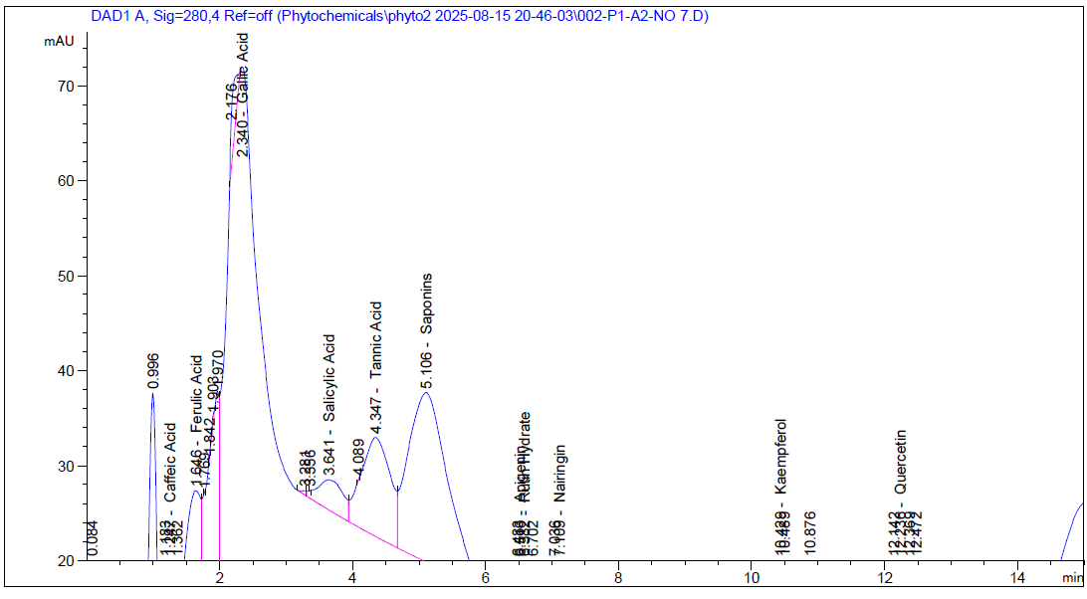
Figure 1: HPLC Chromatogram of Some Bioactive Compounds in Ethyl Acetate Leaf Extract of Ageratum conyzoides
3.2 GC-MS Analysis of Bioactive Compounds
Gas Chromatography-Mass Spectrometry (GC-MS) is a vital preliminary step in phytochemical investigations, as it aids in unveiling the nature of active principles in medicinal plants and clarifies whether a plant species possesses individual compounds or groups of related constituents (Kavitha et al., 2021). The interpretation of the GC-MS mass spectra was carried out using the National Institute of Standards and Technology (NIST) database. The spectra of the unknown compounds were compared with reference spectra of known compounds stored in the NIST library for identification. The GC-MS spectrum of the extract revealed the presence of major phytochemicals, with retention times serving as important indicators of compound separation. The GC-MS analysis of the ethyl acetate leaf extract of A. conyzoides identified 41 bioactive compounds with varying peak area percentages as presented in Table 2. The GC–MS chromatogram of the ethyl acetate leaf extract of A. conyzoides is presented in Figure 2, while the structures of selected bioactive compounds identified are illustrated in Figure 3. Among these, precocene I (12.40%), ethanone, 1-(7-hydroxy-5-methoxy-2,2-dimethyl-2H-1-benzopyran-8-yl) (12.20%), caryophyllene (10.91%), and 3-isobutylidene-6,7-dimethyl-3H-indene (9.76%) were the most abundant constituents. Other notable compounds detected in significant amounts included n-hexadecanoic acid (7.72%), squalene (6.89%), and 9,12,15-octadecatrienoic acid (4.81%). In contrast, compounds such as octanoic acid methyl ester (0.38%), (E)-β-farnesene (0.37%), 1-hexadecyne (0.53%), and bis(2-ethylhexyl) phthalate (0.64%) occurred in only trace concentrations.
A number of the identified phytochemicals have been widely described in scientific literature for their significant biological relevance. n-Hexadecanoic acid has been associated with antioxidant, anti-inflammatory, pesticidal, nematicidal, and enzyme inhibitory properties, as well as and hemolytic effects (Idu et al., 2021; Gopu et al., 2021). Phytol, a major diterpene alcohol detected in the extract, is widely reported for its antioxidant, anti-inflammatory, antinociceptive, antimicrobial, antischistosomal, and anticancer activities (de Moraes et al., 2014; Orlu et al., 2025). Among the identified phytochemicals, Hexadecanoic acid, ethyl ester has the has been reported to have antioxidant, anaemia, hypocholesterol activities, as well as antioxidant, hypocholesterolemic, nematicide, pesticide, antiandrogenic flavor, Hemolytic, Alphareductase inhibitor effects (Sudha et al., 2013; Idu et al., 2021). Caryophyllene, another abundant sesquiterpene, possesses anti-inflammatory, antibiotic, antioxidant, anticarcinogenic, and local anesthetic activities (Mary & Giri, 2018), while its oxidized derivative, caryophyllene oxide, is noted for its anticancer, antioxidant, immunomodulatory, cytoprotective, and trypanocidal properties (Hasan et al., 2019). Precocene I, one of the dominant constituents, is reported to exhibit antifeedant, juvenile hormone-disrupting, and pesticidal activities (Mary and Giri, 2018). Squalene, an important triterpenoid, has demonstrated broad-spectrum bioactivities including antimicrobial, antioxidant, anticancer, antitumor, hypocholesterolemic, hepatoprotective, vasodilatory, and antidiabetic properties, as well as roles in dermatological and antiaging applications (Mary and Giri, 2018; Sudha et al., 2013). Collectively, the GC-MS analysis highlights the presence of diverse bioactive metabolites in A. conyzoides, supporting its traditional medicinal applications and reinforcing its potential as a valuable source of therapeutic compounds.
Table 2: GC-MS profiling of Bioactive Compounds in Ethyl Acetate Leaf Extract of Ageratum conyzoides
S/N | Retention Time (Min) | Name of Compound | Peak Area %
1 | 4.929 | Octanoic acid, methyl ester | 0.38
2 | 7.413 | 2-Methoxy-4-vinylphenol | 1.21
3 | 8.580 | Caryophyllene | 10.91
4 | 8.832 | Silanamine, N,N'-methanetetraylb | 0.43
5 | 8.878 | (E)-.beta.-Famesene | 0.37
6 | 8.946 | Humulene | 0.86
7 | 9.044 | Precocene I | 12.40
8 | 9.232 | (S,1Z,6Z)-8-Isopropyl-1-methyl-5... | 1.01
9 | 9.358 | (+)-epi-Bicyclosesquiphellandrene | 0.39
10 | 9.627 | Cyclohexene, 3-(1,5-dimethyl-4-h... | 1.56
11 | 9.765 | Bicyclo[4.4.0]dec-1-ene, 2-isopr | 0.95
12 | 9.793 | Benzo[b]thiophene, 2-ethyl-7-met... | 1.40
13 | 10.068 | 5,8-Dimethoxycumarin | 0.62
14 | 10.274 | 1H-Cycloprop[e]azulen-7-ol, deca | 0.92
15 | 10.325 | Caryophyllene oxide | 2.80
16 | 10.520 | 6-(1'-Hydroxyethyl)-2,2-dimethyl | 0.47
17 | 10.823 | 10,10-Dimethyl-2,6-dimethylenebi | 0.48
18 | 10.852 | Caryophylla-4(12),8(13)-dien-5.a | 1.00
19 | 10.978 | 1(2H)-Naphthalenone, 7-(1,1-dime | 3.76
20 | 11.046 | benzenesulfonamide, 4-hydrazinyl- | 0.70
21 | 11.195 | 3-Isobutylidene-6,7-dimethyl-3H | 9.76
22 | 11.327 | (1R,7S,E)-7-Isopropyl-4,10-dimet | 0.48
23 | 11.590 | Ethanone, 1-(7-hydroxy-5-methoxy-2,2-dimethyl-2H-1-benzopyran-6-yl) | 12.20
24 | 11.910 | 2,3-Dimethyl-cyclohexa-1,3-diene | 0.60
25 | 12.368 | (S,E)-4-Hydroxy-3,5,5-trimethyl | 0.54
26 | 12.517 | Neophytadiene | 1.28
27 | 12.729 | 1-Hexadecyne | 0.53
28 | 12.889 | Bicyclo[3.1.1]heptane, 2,6,6-tri | 1.07
29 | 13.266 | Hexadecanoic acid, methyl ester | 1.20
30 | 13.673 | n-Hexadecanoic acid | 7.72
31 | 13.816 | Hexadecanoic acid, ethyl ester | 0.43
32 | 14.634 | 9,12-Octadecadienoic acid (Z,Z)-... | 0.44
33 | 14.691 | 9,12,15-Octadecatrienoic acid, m... | 0.74
34 | 14.789 | Phytol | 2.24
35 | 15.017 | Linoelaidic acid | 2.57
36 | 15.080 | 9,12,15-Octadecatrienoic acid, (... | 4.81
37 | 15.195 | Octadecanoic acid | 0.91
38 | 16.299 | Benzenepropanoic acid, 3,5-bis(1... | 0.48
39 | 16.597 | Squalene | 6.89
40 | 17.495 | 3-(3,4-Dimethoxycinnamoyl)-4-hyd. | 1.86
41 | 19.275 | Bis(2-ethylhexyl) phthalate | 0.64

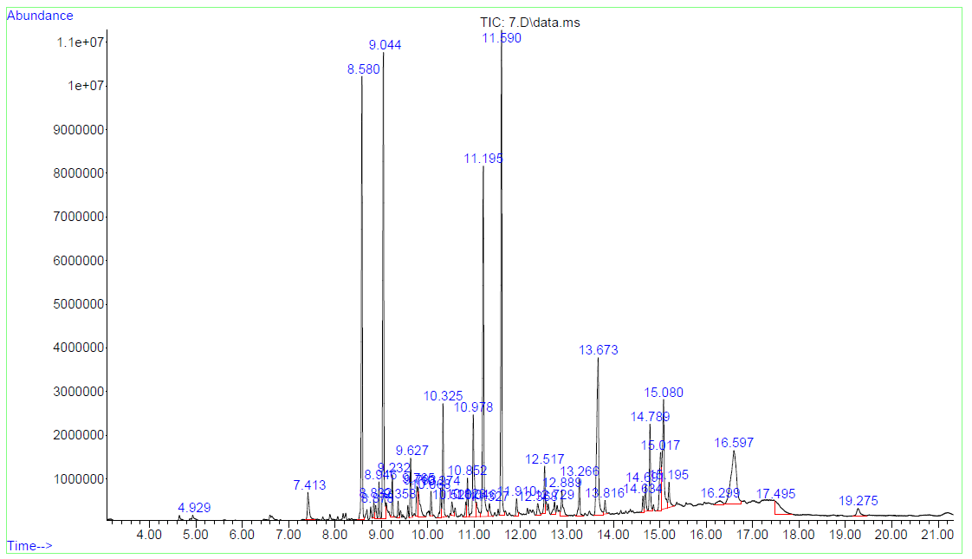
Figure 2: GC-MS chromatogram of Bioactive Compounds in Ethyl Acetate Leaf Extract of Ageratum conyzoides
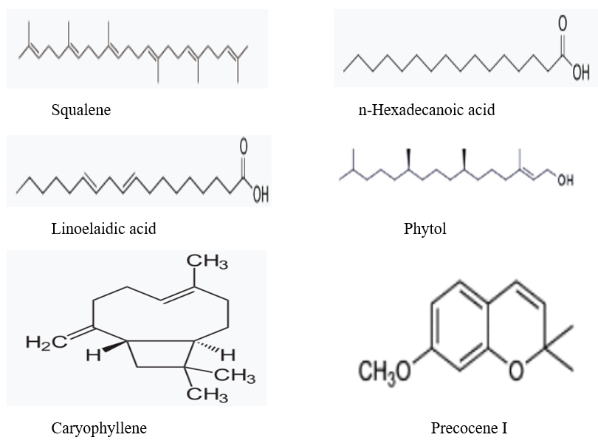
Figure 3: Structure of Some Bioactive Compounds Identified
CONCLUSION
The present study established the phytochemical composition of Ageratum conyzoides leaves using GC-MS and HPLC techniques. The GC-MS analysis identified major metabolites such as precocene I, caryophyllene, n-hexadecanoic acid, squalene, and phytol, which are linked to diverse pharmacological properties including antimicrobial, antioxidant, insecticidal, and anti-inflammatory effects. HPLC further revealed substantial concentrations of phenolic acids, notably ferulic, gallic, tannic, and caffeic acids, known for their potent bioactivities. The combined presence of these bioactive compounds affirms the therapeutic potential of A. conyzoides and validates its ethnomedicinal applications. The findings provide a scientific framework for the plant’s traditional uses and suggest its promise as a reservoir of natural compounds for future drug discovery and bioactivity-guided studies.
Disclaimer (Artificial intelligence)
Author(s) hereby declare that NO generative AI technologies such as Large Language Models (ChatGPT, COPILOT, etc.) and text-to-image generators have been used during the writing or editing of this manuscript.

REFERENCES
- Ahuchaogu, A. A., Ogbuehi, G. I., Obike, A. I., Egedeuzu, C. S., Chukwu, O. J., & Echeme, J. B. O. (2018). GC-MS analysis of bioactive compounds from whole plant chloroform extract of Ageratum conyzoides. IJMPNP, 4, 13-24.
- Aja, P. M., Enechi, O. C., Ozougwu, V. E., Onya-Mmaghiri, E. A., Agu, K. A., Ali-Ikechukwu, A., & Nweke, O. L. (2016). Phytochemical Composition, Gas Chromatography-Mass Spectrometric (GC-MS) Analysis and Anti-Bacterial Activity of Ethanol Leaf–Extract of Ageratum conyzoides. African Journal of Basic and Applied Sciences, 8(1), 34-40.
- Ajoko, I. T., Amos-Tautua, B. M., & Bamgbade, E. O. (2023). HPLC analysis and anti-inflammatory effect of methanol extract of the leaves of triumfetta cordifolia A. Rich. (Malvaceae) Available in Bayelsa State, Nigeria. Scholars International Journal of Chemistry and Material Sciences, 6(06), 115-125.
- Amos-Tautua, B. M., Ajoko, I. T., & Ebong, C. U. (2025). Phytocompounds profiling and assessment of the antioxidant and anti-inflammatory efficacies of Spondias mombin (Linn) leaf extracts. South Asian Res J Nat Prod, 8(1), 1-20.
- Calderon-Montano, J., Burgos-Moron, E., Pérez-Guerrero, C., & Lopez-Lazaro, M. (2011). A review on the dietary flavonoid kaempferol. Mini Reviews in Medicinal Chemistry, 11(4), 298-344.
- De Moraes, J., de Oliveira, R. N., Costa, J. P., Junior, A. L., de Sousa, D. P., Freitas, R. M., & Pinto, P. L. (2014). Phytol, a diterpene alcohol from chlorophyll, as a drug against neglected tropical disease Schistosomiasis mansoni. PLoS Negl Trop Dis, 8(1), e2617.
- Faried, A., Kurnia, D., Faried, L. S., Usman, N., Miyazaki, T., Kato, H., & Kuwano, H. (2007). Anticancer effects of gallic acid isolated from Indonesian herbal medicine, Phaleria macrocarpa (Scheff.) Boerl, on human cancer cell lines. International Journal of Oncology, 30(3), 605-613.
- Ferdosi, M. F., Javaid, A., Khan, I. H., Fardosi, M. F., & Munir, A. (2021). Bioactive components in methanolic flower extract of Ageratum conyzoides. Pakistan Journal of Weed Science Research, 27(2), 181.
- Gopu, C., Chirumamilla, P., Daravath, S. B., Vankudoth, S., & Taduri, S. (2021). GC-MS analysis of bioactive compounds in the plant parts of methanolic extracts of Momordica cymbalaria Fenzl. J. Med. Plants Stud, 9(3), 209-218.
- Gülçin, İ. (2006). Antioxidant activity of caffeic acid (3, 4-dihydroxycinnamic acid). Toxicology, 217(2-3), 213-220.
- Hasan, M. M., Al Mahmud, M. R., & Islam, M. G. (2019). GC-MS analysis of bio-active compounds in ethanol extract of Putranjiva roxburghii Wall. fruit peel. Pharmacognosy Journal, 11(1).
- Idu, M., Aihiokhai, M. O., Imoni, C. A., Akokigho, C. E., & Olali, N. C. (2021). Gas chromatography-mass spectrometry (GC-MS) analysis and phytochemical screening of polyherbal aqueous leaves extract (PALE). Journal of Complementary and Alternative Medical Research, 14(2), 10-18.
- Kavitha, R., & Nadu, T. (2021). Phytochemical screening and GC-MS analysis of bioactive compounds present in ethanolic extracts of leaf and fruit of Trichosanthesis dioica roxb. Int. J. Pharm. Sci. Res, 12(5), 2755-2764.
- Li, Y., Yao, J., Han, C., Yang, J., Chaudhry, M. T., Wang, S., ... & Yin, Y. (2016). Quercetin, inflammation and immunity. Nutrients, 8(3), 167.
- Mary, P. A., & Giri, R. S. (2017). GC-MS Analysis of Bioactive Compounds of Acryranthes aspera. World Journal of Pharmaceutical Research, 7(1), 1015-1056.
- Mihigo, S. O., Ndombele, L., Masesane, I. B., & Sichilongo, K. (2015). Preliminary GC-MS profiling and anti-bacterial activity investigation of Ageratum conyzoides Linn. (Asteraceae). Int J Chem Aquat Sci, 1, 20-29.
- Nuhu, I., Githua, M., Moodley, R., Guo, M. Q., Adamu, H. M., & Kareru, P. G. (2024). Gas chromatography mass spectroscopy [GC-MS] analysis of bio-active compoundsfrom Albizia gumifera leaf extract: A sacred indigenous medicinal plant among the Akamba people of lower eastern Kenya. Journal of Advanced Scientific Research, 15(04), 16-27.
- Orlu, H. A., Ajoko, I. T., Obunwo, C., Overe R., & Ebong, C. U. (2025). Comparative GC-MS Profiling of Essential Oils from Different Plant Parts of Datura stramonium. Asian Journal of Applied Chemistry Research, 16(3), 95-106.
- Puro, K. N., Mazumder, M. U., Khazeo, P., Jyrwa, R., Jamir, N., & Sailo, L. (2018, December). Qualitative and quantitative analysis of phytochemicals of crude extracts of Ageratum conyzoides L. leaves. In Mizoram Science Congress 2018 (MSC 2018) (pp. 164-168). Atlantis Press.
- Scalbert, A. (1991). Antimicrobial properties of tannins. Phytochemistry, 30(12), 3875-3883.
- Srinivasan, M., Sudheer, A. R., & Menon, V. P. (2007). Ferulic acid: therapeutic potential through its antioxidant property. Journal of Clinical Biochemistry and Nutrition, 40(2), 92-100.
- Sudha, T., Chidambarampillai, S., & Mohan, V. R. (2013). GC-MS analysis of bioactive components of aerial parts of Fluggea leucopyrus Willd. (Euphorbiaceae). Journal of Applied Pharmaceutical Science, 3(5), 126-130.

