Original Research Article

The Gig Economy and Women: Participation Factors and Reproductive Health Impacts

ABSTRACT
Aims: The study aims to analyze the socio-demographic and occupational profile of women engaged in gig work and to assess the impact of gig work conditions on their reproductive health outcomes.
Study Design: Descriptive and analytical cross-sectional study.
Place and Duration of Study: Conducted in urban Tripura and selected Indian states between June to July 2025.
Methodology: A purposive sampling method was used to select 50 women gig workers aged 18–45 years engaged in platform-based, freelance, and informal service work. Primary data were collected through a structured questionnaire covering socio-demographic variables, occupational factors, and reproductive health indicators. Linear regression and Chi-square tests were applied using SPSS to determine associations between gig work conditions, barriers to healthcare, and reproductive health outcomes.
Results: Findings reveal significant effects of healthcare access barriers on women’s reproductive health (p < 0.05). Barriers were strongly correlated with menstrual irregularities, reproductive tract infections, and pregnancy-related complications. Stress and inadequate rest showed significant associations with physical strain and reproductive tract infections.
Conclusion: The gig economy offers flexible employment but exposes women to serious health vulnerabilities. Lack of formal labor protections, healthcare access, and social security significantly impact women’s reproductive well-being. Policy intervention is crucial to improve healthcare accessibility and labor rights for women gig workers.
Keywords: Gig Economy, Women’s Reproductive Health, Platform-based Work, Urban Informal Employment.

- INTRODUCTION
The gig economy has rapidly transformed India’s labor market, providing flexible income opportunities, particularly for women seeking work-life balance. However, this flexibility often comes at the expense of job security, fair wages, and healthcare benefits. Women’s participation in the gig economy is largely shaped by access to technology, digital literacy, social norms, and safety conditions.
In India, the COVID-19 pandemic accelerated this shift, with approximately 122 million job losses reported in April 2020 (CMIE, 2020). Many displaced workers turned to gig work through platforms like Swiggy, Uber, and Amazon Mechanical Turk. According to NITI Aayog (2022), India had 7.7 million gig workers in 2021, projected to rise to 23.5 million by 2030. Despite this growth, women in gig work remain underrepresented and underserved in policy frameworks.
In North-East India, including Tripura and Assam, platform-based work is emerging as an alternative livelihood, yet barriers such as digital illiteracy, lack of infrastructure, and absence of labor regulation persist. The intersection of gender, informal work, and health challenges forms the core of this study, focusing specifically on reproductive health implications among women gig workers.
1.1 Review of Related Studies
Several researchers have explored aspects of the gig economy and its gendered impacts. Agrawal and Bhukya (2022) examined the Indian gig economy and noted that while flexibility and digital platforms create opportunities, women often face insecurity and limited access to social protections. Kshatriya and Kurien (2023) highlighted the growing post-pandemic shift toward gig-based work, emphasizing the potential for women but underscoring the absence of health and reproductive protections. David et al. (2024) explored India’s digital work transformation and identified challenges such as income instability and lack of maternity benefits. Dokuka et al. (2022) studied gender workload disparities in online gig teaching and found that women worked fewer evening hours due to caregiving roles, pointing to time-related barriers.
Further, Karunakaran (2025) noted the gig economy’s expansion in India but emphasized structural inequalities affecting women’s occupational well-being. Despite these valuable contributions, there remains a significant research gap regarding the reproductive health outcomes of women engaged in gig work—especially in regions like North-East India, where the gig economy is still developing. The current study seeks to fill this empirical gap.
Research Objectives
The study aims to:
- Examine the socio-demographic and occupational profile of women engaged in gig work.
- Assess the impact of barriers to healthcare services on reproductive health outcomes.
- Analyze the association between gig work conditions and women’s reproductive health indicators.

- MATERIALS & METHODOLOGY
2.1 Sampling and Participants
A purposive sampling method was adopted to select 50 women engaged in gig work (freelance, online retail, personal care, transportation, and delivery). Participants were aged 18–45 and represented diverse educational and income backgrounds.
2.2 Data Collection Tools and Procedure
Primary data were collected using a structured questionnaire including:
- Socio-demographic variables (age, education, marital status, income)
- Occupational factors (type of gig work, work hours, income stability)
- Reproductive health indicators (menstrual issues, RTIs, pregnancy complications, frequency of health check-ups)
2.3 Data Analysis
Descriptive statistics summarized demographic data. Linear regression examined the impact of healthcare barriers on reproductive health, while Chi-square tests evaluated associations between gig work conditions and health outcomes. Statistical significance was set at p < 0.05.

- RESULTS & DISCUSSION
3.1 FOR OBJECTIVE 1
Objective 1: To study about the socio-demographic and occupational profile of women engaged in gig work.
The analysis indicates that women from diverse educational and marital backgrounds are participating in gig work. Most respondents belong to the 26–30 age group, reflecting the growing inclination of younger women toward elastic, technology-based employment. The majority hold at least a bachelor’s degree, signifying that digital literacy and education facilitate participation in online and platform-based work. The occupational data show that women are primarily involved in transportation, delivery, and home-based services. These findings align with NITI Aayog (2022), which reported that women’s participation in India’s gig economy is expanding, but concentrated in low-entry, service-oriented roles.
Income distribution reveals that most respondents earn between ₹30,000–₹50,000 per month, with income stability positively associated with longer working hours and longer duration in gig work. Similar observations were made by UN Women (2023), which found that digital labor platforms often provide supplementary rather than primary income for women in South Asia.
- Socio-Demographic Profile :
Fig. 1: Education Level of Women Gig Workers- The diagram shows that out of the 50 respondents 20 of them are having Bachelor’s Degree, 11 of them Master’s degree & very least that is 4 respondents were there who did not even complete their secondary level education.

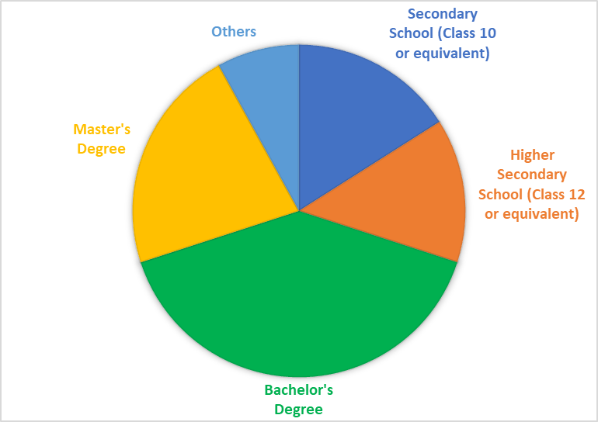

Fig. 2: Marital Status of Women Gig Workers- This figure shows that out of 50 respondents the majority 26 respondents are married and 20 of them are single. The rest of the respondents are divorced, separated and widowed.
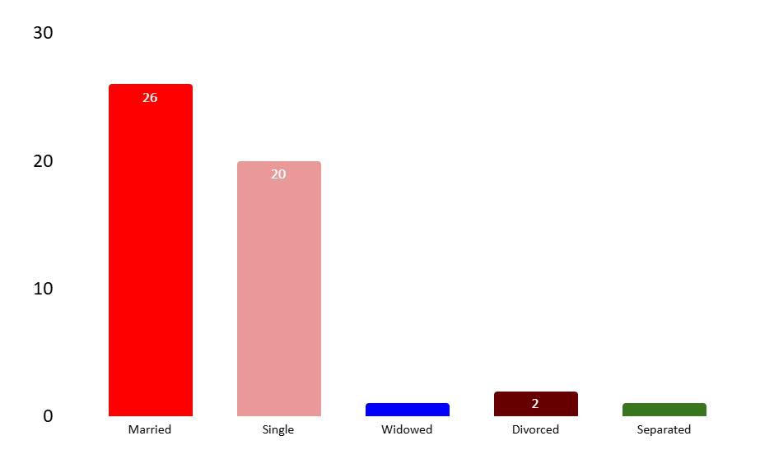

Fig. 3: Age Group of Women Gig Workers - This figure shows that out of 50 respondents 21 of them which is 42% of my sample are from the age group 26-30 years who are engaged in the gig work and 3 of the respondents are from the age group of 18-20 which is 6% of my sample.

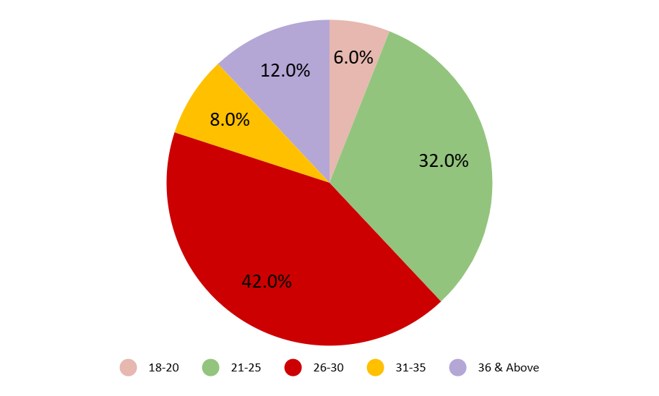

Fig. 4: Type of Gig Work Women are engaged in- This figure shows that out of 50 respondents 22 of them are engaged in Transportation and Digital work, 12 of them in Home-based services and the rest of the respondents are into Event and creative services, Online selling and retail & Others like Baking, Content making, Jewellery making etc.

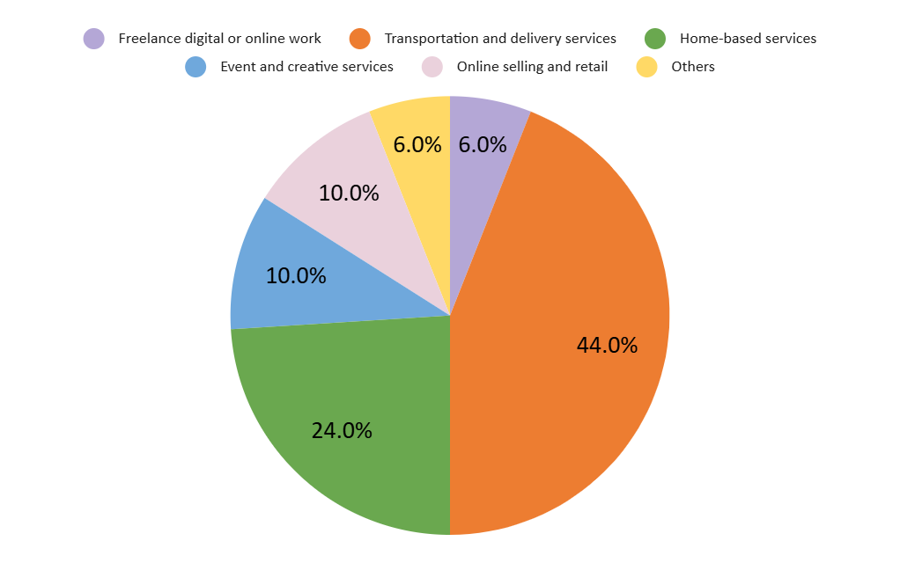

Fig. 5: Monthly Household Income of Women Gig Workers- In this figure it is observed that out of 50 respondents 20 of the respondents are having monthly household income of Rs. 30000 to Rs. 50000 followed by 15 are having less than 30000, 8 respondents are having monthly household income within Rs. 50001-75000 & 2 of them are having Rs. 75001-100000 & 5 respondents are having more than Rs. 100000 of monthly income.

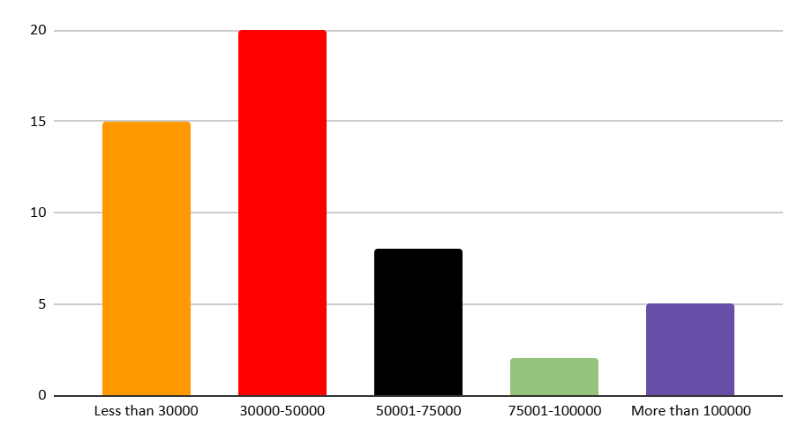
The above data revealed that women of different age groups with varying educational backgrounds are engaged in different types of gig work, and income levels tend to vary with education and marital status.
- Occupational Profile:
Fig. 6: Average Working Hours of Women Gig Workers - This figure shows that out of 50 respondents 20 respondents which is the maximum of respondents are having an average 4 to 6 working hours followed by 15 are having 6-8 hours and 10 respondents have more than 8 hours of average working hours.

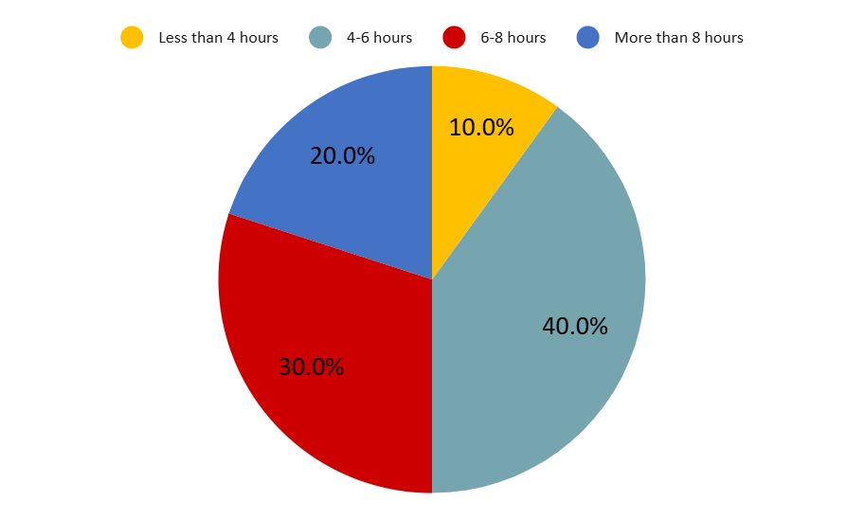
Fig. 7: Duration of Engagement in Gig Work- This below figure shows that maximum respondents are engaged in the gig work for 2 to 5 years followed by 13 respondents are engaged in this profession for 1 to 2 years and least respondents that is 4 are working for 6 months to 1 year.

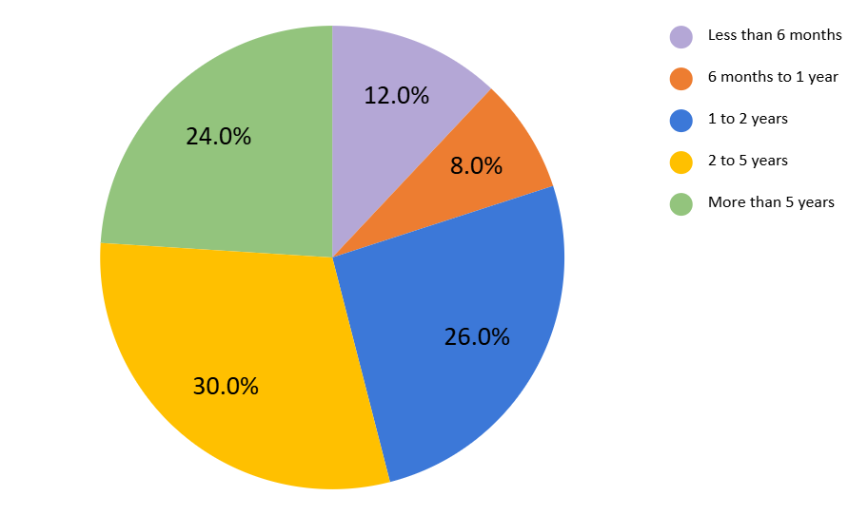

Fig. 8: Work Travel Time of Women Gig Workers- This figure shows that out of the 50 respondents 20 respondents are not required to travel and following that 12 respondents selected the option that they need less than 1 hour to travel, 11 respondents require 1 to 2 hours & least that is 3 respondents require more than 4 hours to travel to reach their workplace.

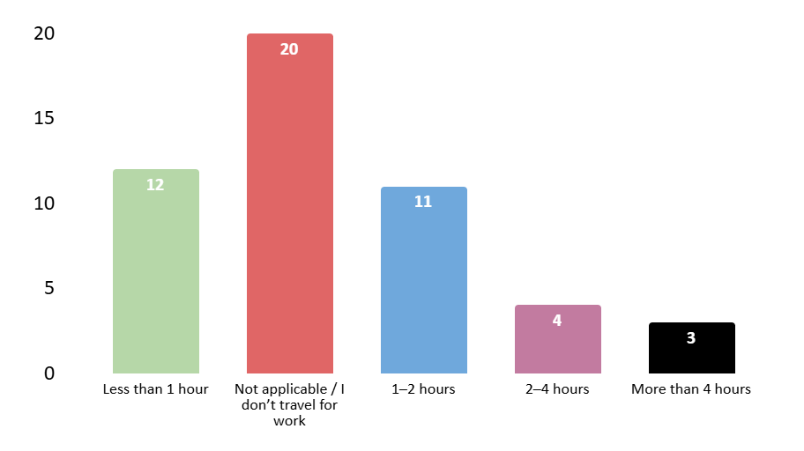

Fig. 9: Perceived Income Stability- This figure shows that the majority of respondents, 20 of them have agreed that there is a perceived income stability in their gig work they are engaged in and 12 of the respondents had been neutral on this statement. 4 of each have been strongly agreed as well as strongly disagreed on this statement.

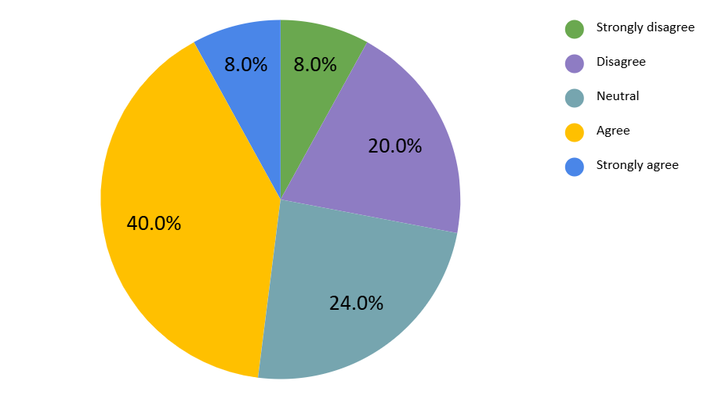
It was found that longer engagement and more working hours were often linked with higher perceived income stability. Travel time also had an impact on income satisfaction.

3.2 FOR OBJECTIVE 2
Objective 2: To study the impact of barriers to healthcare services on access to reproductive health care services.
The regression analysis demonstrates that barriers to healthcare access have a statistically significant effect on several reproductive health outcomes among women gig workers (p < 0.05). To assess the impact of barriers to healthcare services (independent variable) on reproductive health status (dependent variable), a linear regression analysis was performed. Higher healthcare barriers are associated with increased physical strain, menstrual irregularities, reproductive tract infections (RTIs), and pregnancy-related complications. Furthermore, barriers such as financial constraints, irregular working hours, and lack of insurance are negatively correlated with the frequency of reproductive health check-ups.
These results reveal how precarious employment structures affect women’s well-being. The findings corroborate those of the International Labour Organization (ILO, 2022), which emphasized that the absence of formal health protections and social security mechanisms intensifies gendered health vulnerabilities among informal and gig workers. Similarly, a study by Kshatriya and Kurien (2023) identified that women in India’s platform economy face multiple constraints in accessing affordable healthcare, particularly reproductive and maternal services.
The evidence suggests that while gig work offers independence and flexibility, it simultaneously increases physical and emotional stress. Limited maternity benefits and healthcare coverage heighten women’s risk of untreated reproductive health issues, reinforcing existing inequalities within the informal labor market.
Table 1 Summary of Regression
Model |  | Unstandardized Coefficients |  | Standardized Coefficients | t | Sig. | Adjusted R Square
 |  | B | Std. Error | Beta | t | Sig. | Adjusted R Square
Physical strain from gig work affecting reproductive health | (Constant) | 1.353 | 0.429 |  | 3.152 | 0.003 | 0.227**
Physical strain from gig work affecting reproductive health | Barriers | 0.572 | 0.146 | 0.493 | 3.922 | 0 | 0.227**
Experience of menstrual irregularities since starting gig work | (Constant) | 0.997 | 0.36 |  | 2.769 | 0.008 | 0.379**
 | Barriers | 0.68 | 0.122 | 0.626 | 5.559 | 0 | 0.379**
Pregnancy during gig work | (Constant) | -0.209 | 0.145 |  | -1.441 | 0.156 | 0.143**
Pregnancy during gig work | Barriers | 0.149 | 0.049 | 0.401 | 3.029 | 0.004 | 0.143**
Pregnancy-related health complications | (Constant) | -0.312 | 0.132 |  | -2.37 | 0.022 | 0.236**
Pregnancy-related health complications | Barriers | 0.179 | 0.045 | 0.501 | 4.015 | 0 | 0.236**
History of reproductive tract infections (RTIs) in past 12 months | (Constant) | 0.701 | 0.33 |  | 2.129 | 0.038 | 0.394**
 | Barriers | 0.642 | 0.112 | 0.637 | 5.731 | 0 | 0.394**
Frequency of reproductive health check-ups | (Constant) | 4.017 | 0.47 |  | 8.543 | 0 | 0.121**
Frequency of reproductive health check-ups | Barriers | -0.444 | 0.16 | -0.372 | -2.78 | 0.008 | 0.121**
p < 0.05 is considered statistically significant and p** < 0.01.
Interpretation
The regression analysis reveals a strong and statistically significant effect of barriers to healthcare services on multiple reproductive health outcomes among women engaged in gig work. All models showed significance at p < 0.01, indicating a reliable relationship.
- For physical strain, the Beta coefficient is 0.493, meaning a one-unit increase in barriers leads to a 0.493-unit increase in physical strain levels.
- For menstrual irregularities, the Beta is 0.626, suggesting that a one-unit rise in barriers increases menstrual irregularities by 0.626 units.
- For reproductive tract infections (RTIs), the Beta is 0.637, showing a strong positive effect where each unit increase in barriers raises RTI incidence by 0.637 units.
- For pregnancy-related health complications, the Beta is 0.501, implying a 0.501-unit increase in complications per unit increase in healthcare barriers.
- For pregnancy during gig work, the Beta is 0.401, indicating a 0.401-unit increase in likelihood with each unit increase in barriers.
- Notably, the frequency of reproductive health check-ups shows a negative Beta of -0.372, meaning as barriers increase, the frequency of check-ups significantly decreases by 0.372 units.
The adjusted R-squared values, ranging from 0.121 to 0.394, show that a moderate to substantial proportion of the variance in reproductive health outcomes is explained by barriers to healthcare access.
In general, the analysis indicates that increased barriers to healthcare significantly worsen reproductive health outcomes among women gig workers, leading to higher instances of physical strain, menstrual issues, infections, and pregnancy-related complications. These barriers also reduce the frequency of reproductive health check-ups, as challenges like financial constraints, long work hours, lack of health insurance, limited awareness, and social stigma make it difficult for women to access routine care. This results in underdiagnosed and untreated health conditions, highlighting the urgent need to improve healthcare accessibility for women working in the gig economy.
These results underscore the urgent need to address physical, financial, and systemic barriers in healthcare accessibility for women gig workers, as they have a measurable and detrimental impact on their reproductive health.

3.3 FOR OBJECTIVE 3
Objective 3: To know the association of gig work conditions with access to reproductive health care services.
The chi-square analysis identifies significant associations between selected gig work conditions and reproductive health indicators. To examine the connotation between gig work conditions and reproductive health, a Chi-square test of independence was applied. This test is suitable for evaluating whether significant associations exist between categorical independent variables and selected dependent reproductive health indicators. Stress due to gig work and inadequate rest between work shifts show strong correlations with physical strain (p = 0.016) and RTIs (p = 0.025). Adequacy of rest is also significantly related to menstrual irregularities and pregnancy during gig work (p < 0.05). These associations demonstrate that irregular schedules, long working hours, and lack of rest breaks contribute directly to adverse health outcomes.
The findings are consistent with recent evidence by UN Women (2023) and ILO (2021), which link excessive workload and absence of labor protection with physical exhaustion, poor reproductive outcomes, and reduced well-being among women in flexible work arrangements. This underscores that occupational stress and insufficient rest periods are major determinants of reproductive health risks in platform-based labor.
Table 2 Summary of Result

Dependent Variable | Independent Variable | Value | Asymp.Sig. (2-sided) | Whether Significant or not
Physical Strain from Gig Work | Workplace Safety | 9.642 | 0.647 | Not Significant
Physical Strain from Gig Work | Stress due to Gig Work | 30.452 | 0.016 | Significant
Physical Strain from Gig Work | Adequacy of Rest between Work Shift | 40.797 | 0.001 | Significant
Experience of Menstrual Irregularities | Workplace Safety | 15.283 | 0.226 | Not Significant
Experience of Menstrual Irregularities | Stress due to Gig Work | 25.028 | 0.069 | Not Significant
Experience of Menstrual Irregularities | Adequacy of Rest between Work Shift | 32.835 | 0.008 | Significant
Pregnancy during Gig Work | Workplace Safety | 6.822 | 0.078 | Not Significant
Pregnancy during Gig Work | Stress due to Gig Work | 8.111 | 0.088 | Not Significant
Pregnancy during Gig Work | Adequacy of Rest between Work Shift | 10.278 | 0.036 | Significant
Pregnancy-related Health Complications | Workplace Safety | 4.041 | 0.257 | Not Significant
Pregnancy-related Health Complications | Stress due to Gig Work | 5.634 | 0.228 | Not Significant
Pregnancy-related Health Complications | Adequacy of Rest between Work Shift | 6.333 | 0.176 | Not Significant
Reproductive Tract Infections (RTIs) in the last 12 months | Workplace Safety | 21.544 | 0.043 | Significant
Reproductive Tract Infections (RTIs) in the last 12 months | Stress due to Gig Work | 28.868 | 0.025 | Significant
Reproductive Tract Infections (RTIs) in the last 12 months | Adequacy of Rest between Work Shift | 27.26 | 0.039 | Significant
Frequency of Reproductive Health Check-ups | Workplace Safety | 13.289 | 0.348 | Not Significant
Frequency of Reproductive Health Check-ups | Stress due to Gig Work | 20.235 | 0.21 | Not Significant
Frequency of Reproductive Health Check-ups | Adequacy of Rest between Work Shift | 26.856 | 0.043 | Significant

Interpretation
A significant relation has been observed between several dependent reproductive health status and independent gig work conditions variables such as;
- Stress due to gig work (p= 0.016) & Adequacy of rest (p= 0.001) has a significant association with Physical strain from gig work affecting reproductive health.
- Adequacy of rest (p= 0.008) has association with Experience of menstrual irregularities since starting gig work.
- Adequacy of rest (p= 0.036) significantly associated with Pregnancy during gig work.
- Workplace safety perceptions (p= 0.043), Stress due to gig work (p= 0.025), Adequacy of rest between work shifts (p= 0.039) significantly associated with History of reproductive tract infections (RTIs) in the past 12 months.
- Adequacy of rest between work shifts (p= 0.043) has a significant association with Frequency of reproductive health check-ups.
These findings indicate that gig work conditions significantly affect several aspects of women’s reproductive health.
On the other hand, the analysis shows that no significant relationship exists with Workplace safety perceptions and physical strain, menstrual irregularities, pregnancy during gig work, pregnancy-related complications, and frequency of health check-ups.
  - Limitations
The study’s relatively small sample size (n = 50) restricts generalization to a wider population. The cross-sectional design captures associations but not causality. Nonetheless, the statistically significant relationships identified offer important preliminary insights that can guide larger regional or national studies.
  - Policy Implications and Future Research
The results call for targeted interventions to protect women gig workers’ health and well-being. Policymakers should integrate reproductive and occupational health within labor frameworks, ensuring access to affordable healthcare, rest breaks, maternity benefits, and insurance coverage. Digital labor platforms must be encouraged or mandated to provide minimum social protection. Future research should expand to multi-state samples and include longitudinal analysis to understand the long-term effects of gig work on women’s reproductive and mental health.

- CONCLUSION
The study concludes that while gig work provides income and autonomy to women, it also exposes them to health and economic insecurity. Barriers to healthcare access, inadequate rest, and occupational stress contribute significantly to poor reproductive health outcomes. To address these challenges, policymakers and gig platforms must collaborate on gender-sensitive labor policies. Policy formulation should establish a legal framework recognizing women gig workers as a formal labor category entitled to social security, healthcare benefits, and workplace rights. Platform accountability must ensure minimum health insurance coverage, maternity benefits, mandated rest breaks, and safety measures. Skill and health integration programs should combine digital and occupational skill development with reproductive and general health awareness. Finally, a regional focus is needed, prioritizing underrepresented areas like North-East India, where gig work is emerging but institutional and infrastructural support remains limited.

- ETHICAL APPROVAL AND CONSENT
All authors declare that ethical approval was obtained from the Institutional Ethics Committee of ICFAI University Tripura. Written informed consent was obtained from all participants prior to data collection.

Disclaimer (Artificial intelligence)
Option 1:
Author(s) hereby declare that NO generative AI technologies such as Large Language Models (ChatGPT, COPILOT, etc.) and text-to-image generators have been used during the writing or editing of this manuscript.

- REFERENCES
Agrawal, D., & Bhukya, R. (2022). Effects of the gig economy on the workplace: A contemporary Indian perspective study. International Journal of Health Sciences, 6(S3), 2701–2718.
Business Today. (2020). India’s unemployment hits record high amid COVID-19. Retrieved from https://www.businesstoday.in/
Centre for Monitoring Indian Economy (CMIE). (2020). Unemployment in India: CMIE Report. Retrieved from https://www.cmie.com/
David, S., Rajkumar, M., & Joseph, J. (2024). A study on gig economy in India and redefining the work in the digital era. International Journal of Creative Research Thoughts, 12(4), 790–795.
Dokuka, S., Kapuza, A., Sverdlov, M., & Yalov, T. (2022). Women in gig economy work less in the evenings. Scientific Reports, 12(8502), 1–10. https://doi.org/10.1038/s41598-022-12547-3
International Labour Organization (ILO). (2021). Women and Men in the Informal Economy: A Statistical Brief. Geneva: ILO. Retrieved from https://www.ilo.org/
International Labour Organization (ILO). (2022). Digital Labour Platforms and the Future of Work in Asia and the Pacific. Geneva: ILO. Retrieved from https://www.ilo.org/
Karunakaran, N. (2025). The gig economy in India. International Journal of Multidisciplinary Educational Research, 14(2), 25–34.
Kshatriya, R., & Kurien, A. (2023). Women in the Indian gig economy: Health, safety, and inclusion challenges. Open Access Journal of Labour Studies, 8(2), 45–56.
Ministry of Labour and Employment, Government of India. (2022). Code on Social Security, 2020: Rules and Implementation Report. Retrieved from https://labour.gov.in/
NITI Aayog. (2022). India’s Booming Gig and Platform Economy: Perspectives and Recommendations on the Future of Work. New Delhi: Government of India. Retrieved from https://www.niti.gov.in/
Oster, E., & Thornton, R. (2011). Menstruation, sanitary products, and school attendance: Evidence from a randomized evaluation. American Economic Journal: Applied Economics, 3(1), 91–100.
The Shillong Times. (2023). Gig workers in NE face high commission and job insecurity. Retrieved from https://www.theshillongtimes.com/

UNDP. (2022). Advancing gender equality in the digital labour market. New York: United Nations Development Programme. Retrieved from https://www.undp.org/
UN Women. (2023). Gender equality in the platform economy in South Asia. Bangkok: UN Women. Retrieved from https://asiapacific.unwomen.org/
World Bank. (2023). Empowering women in the digital economy: Policy priorities for inclusive growth. Washington, DC: World Bank Group. Retrieved from https://www.worldbank.org/
World Health Organization (WHO). (2023). Women’s health and the future of work. Geneva: WHO. Retrieved from https://www.who.int/
Zhao, L., & Chen, Y. (2024). Platform labour, gender, and wellbeing: A comparative study from Asia. Open Access Journal of Gender and Work Studies, 5(1), 55–70.

