Circular Economy and Green Innovation as Drivers of Social Sustainability in Balinese MSMEs

ABSTRACT
Micro, Small, and Medium Enterprises (MSMEs) play a pivotal role in sustaining Bali’s economy, particularly within the tourism and creative industries. However, global challenges, such as climate change and evolving consumer preferences, necessitate new models of business sustainability. This study examines how Balinese MSMEs transform through adopting circular economy (CE) practices and green innovation (GI) strategies, and the resulting impacts on social sustainability (SS). A quantitative approach involving purposive sampling of 90 MSMEs in Bali, both owners and employees, was conducted between January and August 2025, using structured questionnaires. Data reliability and validity were tested using Cronbach’s Alpha and AVE, while hypotheses were examined through SEM-PLS bootstrapping with 5000 subsamples. The findings indicate that both CE and GI exert significant positive effects on MSME social sustainability. Despite a strong commitment to product quality and community benefits, capacity-building activities for local communities remain limited. Theoretically, this research extends CE and GI frameworks to social sustainability in MSMEs. Policy implications are provided for supporting MSME capacity-building and alignment with Sustainable Development Goals (SDGs), notably SDG 8 (Decent Work and Economic Growth), SDG 9 (Industry, Innovation, and Infrastructure), and SDG 12 (Responsible Consumption and Production).

Keywords: MSMEs; circular economy; green innovation; social sustainability; Bali; SDGs

1. Introduction
Micro, Small, and Medium Enterprises (MSMEs) have long been recognized as the backbone of Indonesia’s economy, contributing significantly to gross domestic product (GDP), employment, and community welfare. In Bali, MSMEs are particularly vital due to the island’s dependence on tourism and its complementary creative industries. Beyond their economic role, MSMEs are embedded in local cultural and social fabrics, making them strategic agents in promoting inclusive and sustainable development (Yuniarta & Purnamawati, 2024). Yet, MSMEs in Bali face unprecedented challenges. The COVID-19 pandemic revealed the fragility of tourism-dependent enterprises, while global megatrends such as environmental degradation, climate change, and resource scarcity have placed additional pressures on small businesses. These dynamics underscore the need for MSMEs to adopt sustainable business models that go beyond profit maximization, integrating ecological stewardship and social responsibility.
Two strategic responses have emerged as central to this transition: the circular economy (CE) and green innovation (GI). CE promotes resource efficiency through reuse, recycling, and waste minimization which the framework fundamentally promotes a shift from the traditional linear 'take-make-dispose' model to one centered on resource longevity and optimization. At its core, CE emphasizes achieving resource efficiency across all stages of the value chain. This is primarily accomplished through strategic initiatives such as product reuse, which extends the useful life of goods; enhanced recycling processes, which ensure materials re-enter the production cycle; and rigorous programs for waste minimization, preventing the generation of discards in the first place. Collectively, these principles aim to decouple economic growth from the consumption of finite resources, thereby enhancing environmental performance and operational sustainability (Virmani et al., 2022). Meanwhile GI emphasizes the development of eco-friendly products, processes, and technologies (Ellen MacArthur Foundation, 2013; Jun et al., 2019). These paradigms align with Indonesia’s policy agenda for sustainable development and with global frameworks such as the United Nations Sustainable Development Goals (SDGs).
This study focuses on the interplay between CE, GI, and social sustainability (SS) in MSMEs. Unlike conventional sustainability research that often prioritizes environmental or economic dimensions, this research highlights the social sustainability dimension, which encompasses job creation, community engagement, skill development, and equitable value distribution (Rodrigues & Franco, 2023). Understanding this linkage is particularly urgent in Bali, where MSMEs’ survival depends on both market competitiveness and community legitimacy.
The study addresses the following research questions:
- Does the adoption of Circular Economy practices significantly influence the Social Sustainability of MSMEs in Bali?
- Does Green Innovation have a significant effect on the Social Sustainability of MSMEs in Bali?
- Do the adoption of Circular Economy practices and Green Innovation, when considered together, have a significant influence on the Social Sustainability of MSMEs in Bali?
By empirically testing these relationships using SEM-PLS, this research contributes to both theory and practice. Theoretically, it integrates CE and GI into a coherent framework for social sustainability in MSMEs. Practically, it offers evidence-based recommendations for entrepreneurs, policymakers, and stakeholders to accelerate MSME transformation in line with the SDGs.

2. Literature Review and Conceptual Framework

2.1 Micro, Small, and Medium Enterprises (MSMEs) in Bali
The role of Micro, Small, and Medium Enterprises (MSMEs) is institutionally central to the Indonesian economy, representing more than 97% of all business units and employing the majority of the national workforce. This dominance is particularly pronounced in regional economies like Bali, where MSMEs form the backbone of key local sectors, including handicrafts, culinary arts, fashion, and various services (Limanseto, 2023). Despite this widespread significance, the inherent small scale of these enterprises often translates into significant structural constraints, notably limiting their access to crucial financing, advanced technology, and expansive global markets. These fundamental challenges are further compounded by contemporary sustainability pressures, such as resource scarcity and climate change impacts. Consequently, there is a growing consensus among scholars that to maintain long-term viability and resilience against increasingly volatile external environments, MSMEs must fundamentally embrace transformative, strategic approaches that move beyond conventional business models (Trisnantari et al., 2023). This imperative necessitates exploring innovative mechanisms to enhance both their economic performance and their commitment to environmental and social stewardship.

2.2 Circular Economy (CE)
The circular economy represents a systemic shift from linear "take-make-dispose" models toward restorative and regenerative systems. CE principles include designing out waste, keeping materials in use, and regenerating natural systems (Ellen MacArthur Foundation, 2013). For MSMEs, CE practices include recycling materials, adopting eco-friendly technologies, collaborating with waste banks, and integrating supply chain sustainability (Permata et al., 2022). Research indicates that CE enhances both environmental performance and cost efficiency by reducing operational expenses (Siregar et al., 2025).

2.3 Green Innovation (GI)
Green Innovation (GI) is fundamentally defined as the design, development, and subsequent implementation of new or significantly improved products, processes, or organizational practices specifically aimed at reducing detrimental environmental impacts (Baeshen et al., 2021). This broad concept encompasses several dimensions, including eco-product design, the adoption of energy-efficient processes within operations, and the establishment of sustainable service models. Prior studies consistently position GI as a potent driver of competitive advantage. By successfully differentiating market offerings and actively meeting the demands of an increasingly environmentally conscious consumer base, firms that embrace GI strategies can enhance their market presence, foster customer trust, and ultimately generate greater resources (Tjahjadi et al., 2020; Rodrigues & Franco, 2023).
This strategic importance holds particular relevance within Bali’s core creative and tourism-related industries. In this regional context, the sustained viability of Micro, Small, and Medium Enterprises (MSMEs) is increasingly tied to evolving customer preferences, which now strongly favor businesses committed to eco-conscious practices and environmental stewardship. Therefore, GI serves not only as an environmental necessity but also as a critical mechanism for market differentiation and long-term economic resilience.

2.4 Social Sustainability (SS) in MSMEs
Social sustainability emphasizes long-term community well-being, encompassing employment, equity, and social cohesion (Rodrigues & Franco, 2023). For MSMEs, SS manifests through hiring local workers, offering training, providing social programs, and producing goods that benefit society. Prior studies in Indonesia highlight both progress and gaps in MSMEs’ social contributions, with many enterprises excelling in local employment but underperforming in structured community capacity-building (Setyaningrum et al., 2024).

2.5 Linking CE, GI, and SS
Existing academic literature strongly suggests a potential synergistic relationship between Circular Economy (CE) practices and Green Innovation (GI) strategies in driving enhanced social sustainability. From a resource perspective, the adoption of CE principles, such as minimizing waste, increasing resource efficiency, and extending product life cycles, effectively reduces operational costs for businesses. This financial advantage creates a margin that can then be strategically reinvested in social initiatives, such as improved employee welfare, capacity building, or local community development programs. Simultaneously, GI, which involves the creation of environmentally friendly products, processes, or technologies, significantly enhances market competitiveness and cultivates stronger customer trust and loyalty. As noted by Ullah et al. (2021), this elevated market position generates increased and stable revenue, providing the necessary resources for sustained investment in social sustainability efforts and broader community engagement. Despite this compelling theoretical and foundational evidence, a significant empirical gap persists. Specifically, there is a distinct scarcity of empirical studies that rigorously test this synergistic model within the specific context of Micro, Small, and Medium Enterprises (MSMEs), particularly those operating in developing economies and unique cultural hubs such as Bali. This research aims to fill that crucial gap.

2.6 Conceptual Framework and Hypotheses
Based on the reviewed literature, the following hypotheses are formulated:
- H1: Circular economy practices positively influence MSME social sustainability.
- H2: Green innovation positively influences MSME social sustainability.
The conceptual model (Figure 1) posits CE and GI as independent variables, with SS as the dependent variable, tested through SEM-PLS.
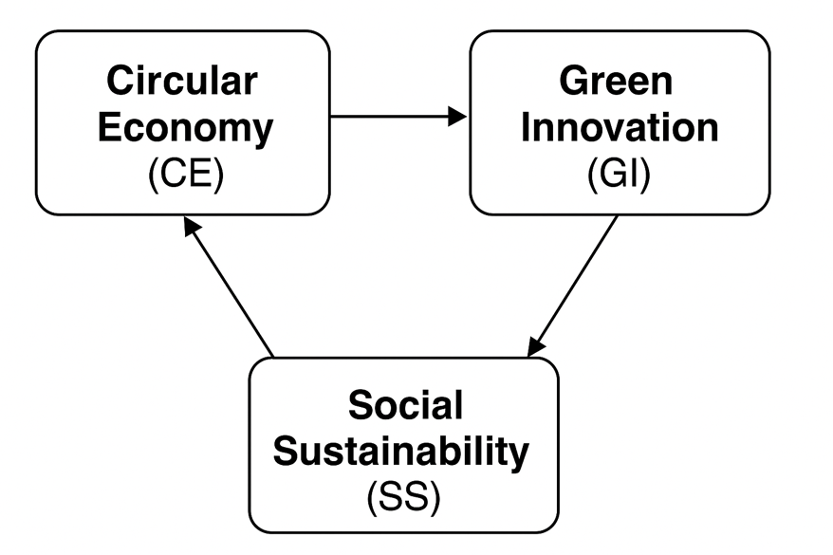
Figure 1. Conceptual Framework

3. Methodology

3.1 Research Design
This investigation is anchored in a quantitative, explanatory research design. This specific approach was deliberately chosen because it offers the systematic rigor necessary for investigating and modeling the causal relationships hypothesized to exist among the core variables: Circular Economy (CE) practices, Green Innovation (GI) strategies, and Social Sustainability (SS) outcomes. The methodology is particularly well-suited for testing the predictive power of established theoretical frameworks and assessing their practical applicability. By focusing on explanatory modeling, the study can move beyond simple correlation to offer insights into the sustainability factors function within the inherently complex and often resource-constrained operational environment of Micro, Small, and Medium Enterprises (MSMEs). This ensures the results are not only statistically sound but also highly relevant to management and policy development in this crucial sector.

3.2 Population and Sampling
The sampling frame for this investigation was defined by the Micro, Small, and Medium Enterprises (MSMEs) located in Bali, specifically targeting those active in key local industries such as handicrafts, culinary arts, fashion, services, and trade. To ensure the data directly addressed the core research questions—which focused on the adoption of sustainability practices—a purposive sampling technique was utilized. This systematic selection process yielded a sample of 90 MSMEs that had already demonstrated active implementation of both Circular Economy (CE) and Green Innovation (GI) practices. Furthermore, to enrich the perspective and capture a balanced view of the operational realities, the survey respondents were deliberately structured to include both MSME owners (comprising 74% of the sample) and employees (26% of the sample). This approach was vital for integrating diverse, yet complementary, viewpoints on how these sustainability practices influence the enterprises.

3.3 Data Collection
Primary data were collected through structured questionnaires, using a 10-point Likert scale. Instruments measured:
- Circular Economy (X1): 9 items (e.g., material reuse, waste management, eco-technology adoption).
- Green Innovation (X2): 8 items (e.g., eco-product development, technology adoption, customer-focused innovation).
- Social Sustainability (Y): 6 items (e.g., local employment, social programs, product societal benefits).

3.4 Data Analysis
Data analysis was performed using Structural Equation Modeling-Partial Least Squares (SEM-PLS), with calculations executed through the SmartPLS 3 software. The measurement model's quality was first evaluated. We confirmed internal consistency reliability as the Cronbach’s Alpha values for all constructs exceeded 0.7. Furthermore, convergent validity was established since the Average Variance Extracted (AVE) values for all constructs were above the recommended 0.5 threshold. For hypothesis testing within the structural model, we utilized the bootstrapping procedure involving 5,000 subsamples. This technique was essential for estimating the significance of the path coefficients, providing a robust statistical test for our hypothesized relationships.
Table 1. Validity and Reliability Test Results
Variabel | Cronbach's Alpha | Composite Reliability
Circular Economy | 0.987 | 0.989
Green Innovation | 0.993 | 0.993
Keberlanjutan Sosial UMKM | 0.989 | 0.990

4. Results

4.1 Descriptive Analysis
Circular Economy (CE): Average score 5.94 (moderately good). Strongest dimension: active waste management (6.68). Weakest: routine reuse of materials (5.16).
Green Innovation (GI): Average score 6.41 (good). Strongest: importance of continuous innovation (7.08). Weakest: prioritization of investment in efficient technology (5.60).
Social Sustainability (SS): Average score 5.99 (moderately good). Strongest: creating high-quality, useful products (8.11). Weakest: providing training/workshops for local communities (3.79).

4.2 Reliability and Validity
For reliability, we relied on Cronbach's Alpha (α). The α values for all latent constructs consistently exceeded the 0.98 threshold, which provides strong evidence of excellent internal consistency among the indicators. Concurrently, construct validity was confirmed using the Average Variance Extracted (AVE) metric. The AVE values for all constructs surpassed the requisite 0.5 criterion, ensuring that the constructs captured sufficient variance from their respective measurement items. Collectively, these results confirm the robust reliability and validity of our instruments for subsequent hypothesis testing.

4.3 Hypothesis Testing
Hypothesis testing in this study was conducted using the t-test (p-value) for each path of influence between variables within the Partial Least Squares (PLS) model. In the context of PLS, the statistical significance of each hypothesized relationship was determined through bootstrapping simulation. This bootstrapping method was also employed to mitigate the impact of data non-normality, thereby ensuring the validity of the hypothesis test results, which are based on the p-values derived from the simulation.
Based on the data processing results presented in Table 1, it is concluded that several variable relationships demonstrate a positive and significant influence. Specifically, the Circular Economy (X1​) and Green Innovation (X2​) variables yielded p-values <0.05. This statistically confirms that both Circular Economy and Green Innovation positively and significantly impact MSME Social Sustainability (Y). Consequently, these findings indicate that a better perception of the circular economy and a higher level of implemented green innovation are associated with stronger social sustainability outcomes within the MSMEs.
Besides that, the findings provide empirical support for the hypothesized relationships within the conceptual framework. The resulting path coefficients and corresponding p-values indicate that certain latent variables exhibit a statistically significant influence on the target construct. Specifically, the data suggests a positive and meaningful association between the tested antecedents and Social Sustainability. This outcome offers a nuanced perspective on how these factors contribute to the social dimension of sustainability within the context of the study.
Table 2. PLS Model Testing and Result
Direct Effect | Original Sample (O) | Standard Deviation (STDEV) | T Statistics (|O/STDEV|) | P Values
Circular Economy -> Sustainability Sosial UMKM | 0.448 | 0.120 | 3.736 | 0.000
Green Innovation -> Sustainability Sosial UMKM | 0.547 | 0.120 | 4.553 | 0.000

Both hypotheses are supported, indicating significant positive effects of CE and GI on MSME social sustainability. To clearly illustrate the influence of the tested variables, the research model design is presented in Figure 1.

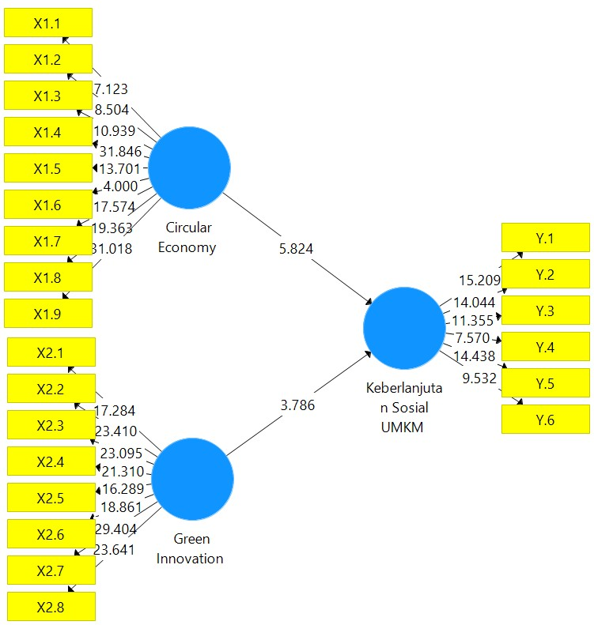
Figure 2 PLS Model Testing and Result

5. Discussion

5.1 The Role of Circular Economy
Findings confirm that CE enhances MSME social sustainability. Practices such as waste management and collaboration with waste banks not only reduce costs but also generate community benefits. However, routine reuse of materials remains underdeveloped, signaling the need for greater awareness and investment in closed-loop processes. This aligns with prior studies highlighting CE’s dual benefits of environmental preservation and cost efficiency (Kurniawan et al., 2023).

5.2 The Role of Green Innovation
GI demonstrates even stronger influence than CE, underscoring the strategic importance of innovation in maintaining competitiveness. MSMEs that innovate sustainably are more likely to deliver customer satisfaction and societal value. This supports Tjahjadi et al. (2020), who argued that green innovation mediates the link between market orientation and business performance. Yet, the relatively low prioritization of technological investment suggests financial and knowledge barriers, consistent with Ullah et al. (2021).
5.3 Social Sustainability Gaps
While MSMEs show strong commitment to producing quality products and employing locals, gaps in training and structured social programs remain. Limited involvement in capacity-building suggests that MSMEs prioritize immediate economic survival over long-term community development. Addressing this requires multi-stakeholder partnerships, as advocated by SDG 17 (Partnerships for the Goals).

5.4 Theoretical Implications
This study extends CE and GI literature by empirically demonstrating their combined influence on social sustainability in MSMEs. It provides a conceptual bridge between sustainability theories and practice in resource-constrained, tourism-dependent regions.

5.5 Managerial and Policy Implications
For entrepreneurs, findings highlight the importance of integrating CE and GI into business strategies not only for environmental gains but also for social legitimacy. For policymakers, results underscore the need to provide financial incentives, training, and infrastructure to accelerate CE and GI adoption.

6. Conclusion
This research demonstrates that circular economy and green innovation significantly enhance MSME social sustainability in Bali. While CE strengthens resource efficiency and waste management, GI drives competitiveness through eco-oriented innovation. Together, they create pathways for MSMEs to balance economic viability with community welfare.
However, gaps remain in structured community engagement, particularly in providing training and workshops for local capacity-building. Bridging these gaps requires collaborative action involving MSMEs, government, academia, and communities.
The study contributes to literature by empirically linking CE and GI to social sustainability within a developing economy context. It also supports policy frameworks aligned with the SDGs. Limitations include the focus on a single region and reliance on self-reported data, suggesting future research could adopt longitudinal and comparative designs.
By embedding sustainability into their core strategies, MSMEs in Bali can not only survive global challenges but also lead the transition toward inclusive, resilient, and environmentally responsible economies.

Disclaimer (Artificial intelligence)
Author(s) hereby declare that NO generative AI technologies such as Large Language Models (ChatGPT, COPILOT, etc.) and text-to-image generators have been used during the writing or editing of this manuscript.

References
Alfarizi, M., & Arifian, R. (2024). Determination of Green Knowledge Economy on Sustainable Performance of Indonesian SMEs. Applied Research and Policy Publication, 7(1), 26-43.
Baeshen, Y., Soomro, Y.A., & Bhutto, M.Y. (2021). Determinants of Green Innovation to Achieve Sustainable Business Performance: Evidence From SMEs. Frontiers in Psychology, 12.
Dahlan, R. (2022). Circular Economy and Sustainable Development. Library Trail.
Ellen MacArthur Foundation. (2013). Towards the Circular Economy: Economic and Business Rationale for an Accelerated Transition. - Schumpeter, J. A. (1934). The Theory of Economic Development: An Inquiry into Profits, Capital, Credit, Interest, and the Business Cycle. Journal of Industrial Ecology, 2(1), 23-44.
Hutajulu, H., Runtunuwu, P. C. H., Judijanto, L., Ilma, A. F. N., Ermanda, A. P., Fitriyana, F., ... & Wardhana, D. H. A. (2024). Sustainable Economic Development: Theory and Foundations of Multi-Sector Sustainable Economic Development in Indonesia. PT. Sonpedia Publishing Indonesia.
Jun, W., Ali, W., Bhutto, M.Y., Hussain, H., & Khan, N.A. (2019). Examining the determinants of green innovation adoption in SMEs: a PLS-SEM approach. European Journal of Innovation Management.
Kasih, D.A.P.N., Supriadi, M., & Yoga, I.P.A.S. (2024). IMPLEMENTATION OF THE GREEN INDUSTRY CONCEPT IN MICRO, SMALL, AND MEDIUM ENTERPRISES (MSMEs) IN DENPASAR CITY. Jurnal Ilmiah Vastuwidya, 7(2), 64-72.
Kim, Y. (2024). Place-based Transition Towards a Circular Economy: Proximity Relations, Entrepreneurial Agencies, and Knowledge Intermediation in Making Fashion Circular. (Doctoral Dissertation). Columbia University. Retrieved from https://doi.org/10.7916/emvh-rn39
Kurniawan, A., et al. (2023). Determination of Circular Economy Adoption, Innovative Business Models, and State Budget Support: A PLS-SEM-Based Investigation of Indonesian MSMEs.
Maharani, P., & Hidayat, A. M. (2024). The Influence of Brand Ambassador Lee Min Ho, Electronic Word of Mouth, and Price on Purchase Decisions for Local Sunscreen Products, Azarine. Journal of Administration and Management, 14(1), 36-45.
Mulyana, R. A. (2023). A Critique of J.A. Schumpeter's Innovation-Entrepreneurship View. Journal of Economic Education (JUPE), 11(3), 243-253.
Nainggolan, H., Nuraini, R., Sepriano, S., Aryasa, I. W. T., Meilin, A., Adhicandra, I., ...& Prayitno, H. (2023). Green technology innovation: Transformation of environmentally friendly technology in various sectors. PT. Sonpedia Publishing Indonesia.
Oktavilia, S., Putri, P. I., Wahyuningrum, I. F. S., & Kistanti, N. R. (2024). The Economic Potential of Waste. NEM Publisher.
Pasek, I. K., Lina, N. P. M., Siwantara, I. W., Sumetri, N. W., & Sukarta, I. W. (2022). Application of Green Human Resource Management (GHRM) in Creating Product and Process Innovation in Small and Medium Coffee Industries in Indonesia. Journal of Business and Entrepreneurship, 18(3), 271-282.
Pawitri, N. N. H. M., & Trimurti, C. P. (2025, January). Innovative Solutions for Garment Waste Utilization for Cost Efficiency in Inainabali: Implementation of a Circular Economy Strategy. In National Scientific Seminar on Technology, Science, and Social Humanities (SINTESA) (Vol. 7, pp. 111-120).
Permata, D. I., Arum, S., Tanuwidjaja, K. D., Evan, V., Wicaksono, A., & Mardikanto, A. (2022). The Future is Circular: Concrete Steps for Circular Economy Initiatives in Indonesia. Ministry of National Development Planning/BAPPENAS.
Pratama, R.A. (2023). Development of the SDGs Green Innovation Platform for MSMEs in Indonesia. Dewantara Management.
Ratnasari, Y., & Aschemann, R. (2024). Study on Monitoring Indonesia's Circular Economy: An Indicator System Proposal. AAS-in-Asia 2024.
Rifal, G. R., Dispindra, R. R., Arifin, A. L., & Azmy, A. (2024). Plastic Waste Recycling Business Ecosystem by MSMEs Towards Improving the Green Economy. Journal of Economics and Information Systems Management (JEMSI), 6(2).
Rodrigues, M., & Franco, M. (2023). Green Innovation in Small and Medium Enterprises Small-Sized Enterprises (SMEs): A Qualitative Approach. Sustainability.
Saputra, D. H., Masdani, M., Asdin, A., & Triaji, B. (2024). Activities to Encourage Economic Independence of Productive Communities Through Environmentally Friendly Businesses with the Fina Foundation. Madaniya, 5(2), 466-472.
Sari, D. P., et al. (2023). Green MSMEs: Business Transformation in an Effort to Maintain Environmental Sustainability. :contentReference[oaicite:6]{index=6} - UI Vocational Community Service Team. (2022). UI Vocational School Develops Tourism Villages in Bali with a Circular Economy Concept. Research & Accounting Journal
Setyaningrum, R. P., Putra, H. M. M., Goestjahjanti, F. S., Muafi, M., & Annaufal, A. I. (2024). Consumer behavior and circular economy in MSMEs. In Achieving Sustainable Business Through AI, Technology Education and Computer Science: Volume 2: Teaching Technology and Business Sustainability (pp. 151-158). Cham: Springer Nature Switzerland.
Siregar, Mufti Al Mumtaz, Robby Adriano Karo Karo, Reza Restu Ardiansyah, and Yenni Samri Juliati Nasution. "Analysis of Circular Economy Implementation in F&B MSMEs Around Medan." Journal of Economics, Business, and Management 4, no. 1 (2025): 14-24.
Siswanto, F. R. (2024, November). Analysis of the Impact of Sustainable Business Implementation by Micro-Enterprises Participating in the MSME Training and Mentoring Program "Transformation Towards Sustainable Business." In National Seminar on Applied Sciences (Vol. 8, No. 1, pp. E23-E23).
Soewarno, N., Tjahjadi, B., & Fithrianti, F. (2019). Green Innovation Strategy and Green Innovation. Management Decision.
Syaiful, A. (2024). The Influence of Accounting Understanding, Financial Literacy, and Social Media Utilization on the Sustainability of MSMEs in Baubau City. Entries, 6(2), 121-131.
Tjahjadi, B., Soewarno, N., Hariyati, H., Nafidah, L. N., Kustiningsih, N., & Nadyaningrum, V. (2020). The role of green innovation between green market orientation and business performance: Its implications for open innovation. Journal of Open Innovation: Technology, Market, and Complexity, 6(4), 173.
Trisnantari, S. A., Susilastuti, D. H., & Putri, T. W. S. (2023). Collaborative Governance Process in MSMEs Empowerment through the Desa-Preneur Program in Sidoarum Village, Yogyakarta. Population, 31(2), 90-111.
Uhai, S., Mahmudin, T., & Dewi, I. C. (2024). Sustainable Tourism: Strategies for Managing Environmentally Friendly and Profitable Tourist Destinations.
Ullah, R., Ahmad, H., Rehman, F., & Fawad, A. (2021). Green innovation and Sustainable Development Goals in SMEs: the moderating role of government incentives. Journal of Economic and Administrative Sciences.

Virmani, N., Saxena, P., & Raut, R. D. (2022). Examining the roadblocks of circular economy adoption in micro, small, and medium enterprises (MSME) through sustainable development goals. Business Strategy and the Environment, 31(7), 2908-2930.

Yuniarta, G. A., & Purnamawati, I. G. A. (2024). Encouraging Sustainable MSME Performance in Bali Province Through Circular Economy and Innovation. Journal of Media Informatics, 6(2), 565-572.
Yamawati, N. K. S., Dewi, R. P. D., Pertama, I. G. A. W. Perceptions of Green Economy and Environmental Issues On Green Entrepreneurship Practices by Homestay Owners as A Form of Social Responsibility in Relation to The Tri Hita. Asian Journal of Social Science and Management Technology, 6(1), 253-267
Yamawati, N. K. S., Pertama, I. G. A. W., & Indiani, N. L. P. Encouraging Expats Purchase Interest in Bali Through Green Economy Perception and Green Entrepreneurship Practices in the Tourism Sector. Asian Journal of Social Science and Management Technology. 6(5), 182-191
Yamawati, N. K. S., Rini, I. G. I. S., & Pratama, I. G. A. W. (2023). The Role of Environmental Knowledge and Green Economy Perceptions On Green Entrepreneurship Interests in Entrepreneurs in the Food and Beverage (F&B) Sector in Bali. International Journal of Social Science, 3(3), 397-402.

