Original Research Article

Epidemiology and Molecular Identification of Intestinal Parasites Among Pupils in Port Harcourt, Rivers State, Nigeria

.
ABSTRACT

Aims: This study assessed prevalence, risk factors and species diversity of intestinal parasites among primary-school pupils in Port Harcourt.
Study design: A cross-sectional study.
Methodology: Stool specimens from 208 pupils were examined by direct wet mount and formol-ether concentration; DNA was extracted and parasite genes amplified on an ABI 9700 thermal cycler. Sociodemographic and behavioural data were obtained with a structured questionnaire. Data analyses were performed in GraphPad Prism 9 using Chi square tests; significance was set at p < 0.05.
Results: Prevalence of intestinal parasite infection was 24.5 %. Age (p = 0.0184), mother’s occupation (p = 0.0013), hand-washing (p = 0.0057), nutrition type (p = 0.0007), raw-produce consumption (p = 0.0104) and contact with domestic animals (p = 0.0126) were significantly associated with infection. Entamoeba histolytica was the leading parasite (13.0 %), followed by Ascaris lumbricoides (5.3 %) and mixed A. lumbricoides + E. histolytica infection (3.4 %). Highest risk occurred in pupils aged 5–7 years and in children of unemployed or privately employed mothers. Regular hand-washing and homemade meals were protective, whereas fast food, raw fruit or vegetable intake and animal contact increased risk. Molecular screening confirmed E. histolytica, E. dispar, E. moshkovskii and A. lumbricoides, demonstrating considerable species diversity.
Conclusion: These findings underline the continuing burden of intestinal parasites in urban Nigerian schools and highlight modifiable behaviours that can be addressed through hygiene promotion, food-safety education and targeted deworming to protect vulnerable pupils. Implementation of routine stool surveillance is recommended to monitor intervention success and emerging species in the area. Molecular diagnostic methods offer higher sensitivity and specificity but they have limitations due to high costs and technical demands. Therefore, they may be considered as complementary tools to microscopy and conventional diagnostic methods, especially in research settings.

Keywords: Intestinal parasitic infections; Prevalence; Primary school pupils; Port Harcourt; Nigeria; Entamoeba histolytica; Ascaris lumbricoides; Molecular diagnosis; Risk factors; Hygiene behaviour

1. INTRODUCTION

Human infection with gastrointestinal parasites is widespread globally (Wong et al., 2020) but their impact is far heavier in low- and middle-income countries, where limited access to adequate sanitation and clean water sustains transmission and leads to higher morbidity and mortality, particularly among children (Ahmed et al., 2023; Atabati et al., 2020). Although infections may be asymptomatic in many individuals, acute or chronic gastroenteritis is common and is frequently attributable to protozoan agents such as Cryptosporidium, Blastocystis, Entamoeba spp., Giardia duodenalis and Dientamoeba fragilis (Vaisusuk & Saijuntha, 2021). Diarrhoeal disease ranks as the second leading cause of death after pneumonia in children under five years (Manetu et al., 2021), carries long-term consequences for survivors, including malnutrition, anaemia, impaired growth, cognitive delay, and increased susceptibility to other infections (Veesenmeyer, 2022; Isah et al., 2020; Girma & Genet, 2024; Gabain et al., 2023; Guerrant et al., 2021; Fauziah et al., 2022). Three protozoa namely, Cryptosporidium parvum, Giardia intestinalis and Entamoeba histolytica are principal aetiological agents of paediatric diarrhoea (Rossi et al., 2024; Das et al., 2024; Siwila, 2023). Their pathogenic effects include chronic diarrhoea, malabsorption and poor weight gain (C. parvum) (Balendran et al., 2024; Robertson et al., 2020; Prabakaran et al., 2023), disruption of epithelial integrity and digestive enzyme activity (G. intestinalis) (Allain & Buret, 2020; Solaymani-Mohammadi et al., 2022), and anaemia with growth impairment (E. histolytica) (Tharmaratnam et al., 2020; Usuda et al., 2022; Ahmed, 2023).
Conventional diagnosis in many resource-limited laboratories relies on microscopic examination of faecal material because of its low reagent cost; however, microscopy is time-consuming, requires skilled personnel and often insufficient for species- or genotype-level identification. In contrast, molecular methods, though costlier, offer superior sensitivity and specificity and have facilitated the recognition of extensive genetic heterogeneity among intestinal protozoa, delineating genotypes and subtypes with differing host ranges, zoonotic potential and clinical relevance (Ryan et al., 2021; Fitri et al., 2022; Midala et al., 2024). Understanding this diversity is essential for accurate epidemiological assessment and targeted control.
Intestinal parasitic infections also function as indicators of socioeconomic deprivation, shaped by sanitation, education and household conditions. High prevalence has been documented in settings characterised by poverty, inadequate water supply and poor hygiene, contributing to malnutrition, reduced school attendance and diminished educational attainment (Wattano et al., 2023; Assemie et al., 2021; Opara et al., 2020). These effects perpetuate intergenerational cycles of poverty and pose challenges to national development. Diagnostic limitations further exacerbate under-recognition: microscopy may have sensitivities as low as 38% for some protozoa, whereas PCR can detect pathogens missed microscopically and simultaneously identify multiple enteropathogens (Kebede et al., 2014; Stensvold & Nielsen, 2012). Although improvements in water and sanitation infrastructure reduce diarrhoeal disease, their effectiveness varies contextually, necessitating localised investigations (Merid et al., 2023).
Given the public health importance of paediatric intestinal protozoan infections and the paucity of local molecular data, this study was designed to determine the prevalence and genetic diversity of intestinal protozoa among pupils in selected primary schools in Port Harcourt, Nigeria. The findings are expected to enhance epidemiological understanding, inform clinical management and guide school- and community-level interventions and policies aimed at mitigating risk factors in this vulnerable population.

2. material and methods

2.1 Study design

A cross-sectional study design was employed to determine the prevalence and genetic diversity of intestinal parasites and to assess associated sociodemographic, behavioural, and environmental risk factors among primary school pupils in Port Harcourt, Rivers State. Data were collected at a single point in time through stool sample analysis and administration of a structured questionnaire. This design provided a snapshot of infection status and exposure characteristics within the study population, enabling the exploration of associations between parasitic infection and potential predictors without manipulating study variables.

2.2 Study area

The study was conducted in Port Harcourt, the capital of Rivers State in southern Nigeria (Figure 1). The city lies within the Niger Delta region at approximately 4.85°N latitude and 7.01°E longitude (Akukwe & Ogbodo, 2015). Port Harcourt experiences a tropical monsoon climate characterised by substantial rainfall, high humidity, and persistently warm temperatures. In 2023, the average annual temperature was 27.0°C, with mean maximum and minimum temperatures of 32.1°C and 23.3°C, respectively, and an average relative humidity of 82.1% (TuTiempo.net, 2023).
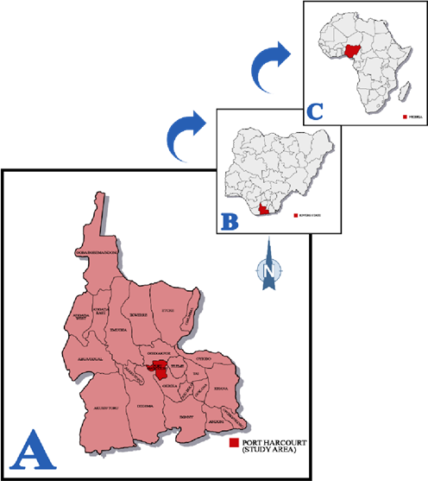

Figure 1: A: Map of Rivers State highlighting Port Harcourt (Study Area); B: Map of Nigeria highlighting Rivers State;
C: Map of Africa highlighting Nigeria (Mike-Ogburia et al., 2023

2.3 Study population, sample size and sample technique

The study population comprised primary school pupils of both sexes enrolled in selected public and private primary schools in Port Harcourt, Rivers State, Nigeria. The minimum sample size was determined using a sample size calculator for prevalence studies (Naing et al., 2022). This calculation was based on a previously reported prevalence of 16.1% for intestinal parasites among primary school children in Rivers State (Ama-Okachi et al., 2020). A multistage sampling technique was employed: first, the six schools were purposively selected to reflect both public and private ownership; thereafter, within each school, eligible pupils were recruited using simple random sampling until the proportional allocation to each school contributed to the overall sample size. Inclusion criteria were enrolment in one of the selected primary schools, absence of antiprotozoal or anthelminthic drug use within two weeks prior to sampling, and provision of at least oral parental/guardian consent.

2.4 Data Collection

Data collection involved the concurrent acquisition of biological and questionnaire-based information to assess the prevalence and determinants of intestinal parasitic infections among primary school pupils in Port Harcourt. Stool samples were obtained from participating pupils using sterile, pre-labelled containers distributed with the assistance of teachers. Pupils and their guardians received verbal instructions to collect a fresh morning stool specimen directly into the container, avoiding contamination with water, soil or other materials. Each specimen was assigned a unique identifier to facilitate accurate linkage with corresponding questionnaire data. Samples were transported promptly under cool, secure conditions to the laboratory for analysis, thereby preserving parasitic elements for microscopy and subsequent molecular identification.
In parallel, a structured questionnaire (Figure 2) was administered to collect sociodemographic and behavioural data. Information captured included age, sex, type and location of school, household size, mother’s educational level and occupation. Potential risk factors were also documented, comprising regular handwashing, type of nutrition, source of drinking water, consumption and washing of raw vegetables or fruits, walking barefoot, contact with domestic animals, bathing location and type of toilet facility.

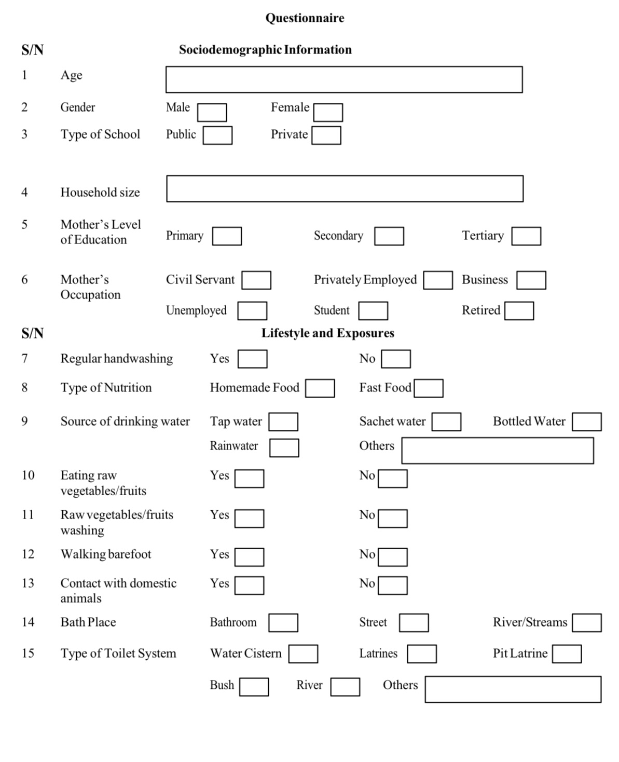
Figure 2: Structured questionnaire for sociodemographic and behavioural data collection

2.5 Stool analysis

Each stool specimen underwent conventional parasitological examination following the procedures described by Cheesbrough (2000). Macroscopic inspection recorded colour, consistency, and any visible blood, mucus, or pus. A direct wet mount was then prepared by emulsifying a small portion of well-mixed stool in physiological saline on a grease-free slide, which was examined under light microscopy at ×100 and ×400 magnifications to detect motile trophozoites, cysts, or helminth eggs. To enhance diagnostic yield, every sample was further processed with the formol-ether concentration technique: one millilitre of stool was fixed in 10 % formalin, sieved, mixed with diethyl ether, vigorously shaken, and centrifuged. After decanting, the concentrated deposit was resuspended and re-examined microscopically at ×100 and ×400 for ova and cysts. This combined direct and concentration approach maximised sensitivity for detecting intestinal parasites.

2.6 Molecular analyses

Genomic DNA was extracted from 150 mg of each stool sample using the ZR Quick-DNA Fecal/Soil Microbe MicroPrep Kit (Inqaba Biotec, South Africa) according to the manufacturer’s protocol, and quantified with a NanoDrop 1000 spectrophotometer. PCR amplification of Entamoeba spp. was performed in 40 µL reactions using DreamTaq Master Mix with primers ENTAF/HER/EDR/EMR, yielding species-specific products of 166 bp (E. histolytica), 580 bp (E. moshkovskii), and 752 bp (E. dispar) on 2% agarose gels. Ascaris lumbricoides DNA was amplified in 30 µL reactions using primers XZ5F/XZ1R to produce a 750 bp fragment, while Trichuris trichiura was targeted with ITS2F/ITS2R primers (expected 325 bp product) (Table 1). All amplicons were electrophoresed at 200 V and visualized under bluelight transillumination.

Table 1: Primers sequences and base pairs

Primer Sequences

(
5
′
–
3
′
)

Amplicon

Size

Reference

166

Target organism

Entamoeba Forward (ENTAF): ATGCACGAGAGCGAAAGCAT (Inqaba Biotec, 2018)
histolytica Reverse (HER): GATCTAGAAACAATGCTTCTCT

Entamoeba moshkovskii | Forward (ENTAF): ATGCACGAGAGCGAAAGCAT Reverse (EMR): TGACCGGAGCCAGAGACAT | 580
Entamoeba dispar | Forward (ENTAF): ATGCACGAGAGCGAAAGCAT Reverse (EDR): CACCACTTACTATCCCTACC | 752
Ascaris lumbricoides | Forward (XZ5F): TGATGTAATAGCAGTCGGCG Reverse (XZ1R): GGAATGAACCCGATGGCGCAAT | 750
Trichuris Forward (ITS2 F): GCTCGTAGGTCGTTGAAG 325
trichiura Reverse (ITS2 R): TAGCCAAGTCGGGTAGT

2.7 Data analysis

All questionnaire responses and laboratory results were first entered into Microsoft Excel (Office 365) and checked for completeness and transcription accuracy. The cleaned dataset was then imported into GraphPad Prism version 9.0 for statistical evaluation. Descriptive statistics including frequencies, proportions, means, and standard deviations, were generated to summarise pupils’ sociodemographic characteristics, behavioural exposures, and the overall prevalence of intestinal parasitic infections detected by microscopy and PCR. Inferential analysis examined relationships between categorical variables such as infection status and age group, sex, school type, hand‑washing practice, dietary habits, and other risk factors using Chi‑square (χ²) tests. Statistical significance was set at P ≤ 0. 05.

3. results and discussion

3.1 Results

Among the 208 pupils studied (mean age = 10.03 years), 45.7 % were ≥ 11 years, 41.8 % were 8–10 years, and 12.5 % were 5–7 years; females constituted 53.4 % of the sample. Most pupils attended public schools (88.9 %), and the mean household size was 5.92, with nearly two-thirds living in households of more than five members. Mothers’ education centred on the secondary level (51.9 %), while 29.8 % had primary and 18.3 % tertiary education. Maternal occupation was dominated by business activities (77.9 %), followed by private employment (13.5 %), civil service (5.3 %), and unemployment (3.4 %).
Of the 208 pupils examined, 51 (24.5 %) were infected with at least one intestinal parasite, while 157 (75.5 %) showed no infection (Figure 3). Microscopic examination of the samples from the infected students revealed that Entamoeba histolytica was most prominent, occurring alone in 27 cases (13.0 %) and in mixed infections with Taenia spp. or Trichuris trichiura in a further 6 cases (2.8 %). Ascaris lumbricoides appeared alone in 11 pupils (5.3 %) and together with E. histolytica in 7 pupils (3.4 %) (Figure 4). Age and mother’s occupation were the only sociodemographic variables significantly associated with infection. Children aged 5–7 years had the highest prevalence (38.5 %) and those ≥ 11 years the lowest (15.8 %) (P = 0.0184), while pupils whose mothers were unemployed (71.4 %) or privately employed (42.9 %) were markedly more often infected than those whose mothers were in business (19.8 %) or civil service (18.2 %) (P = 0.0013). Sex, school type, household size and maternal education showed no significant influence (P > 0.05) (Table 1). In contrast, several behavioural factors were strongly linked to infection: lack of regular hand-washing (P = 0.0057), frequent consumption of fast food (P = 0.0007), eating raw vegetables or fruits (P = 0.0104), and contact with domestic animals (P = 0.0126) all heightened risk. Water source, walking barefoot, bathing location and toilet type were not statistically significant (p > 0.05) (Table 2).
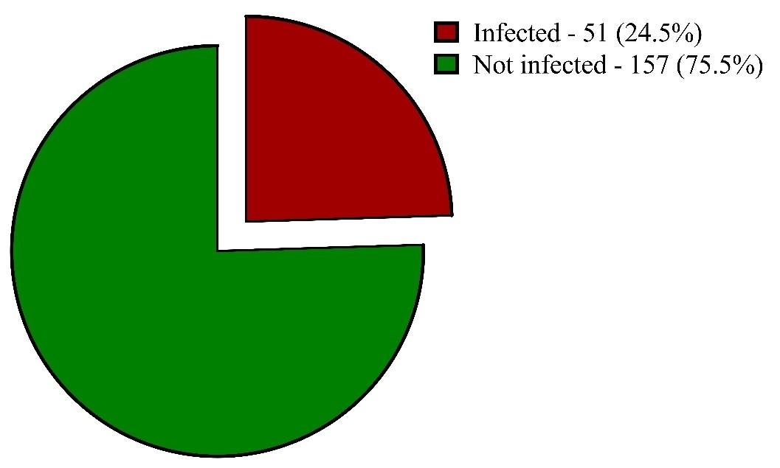
Figure 3: Prevalence of intestinal parasite among subjects

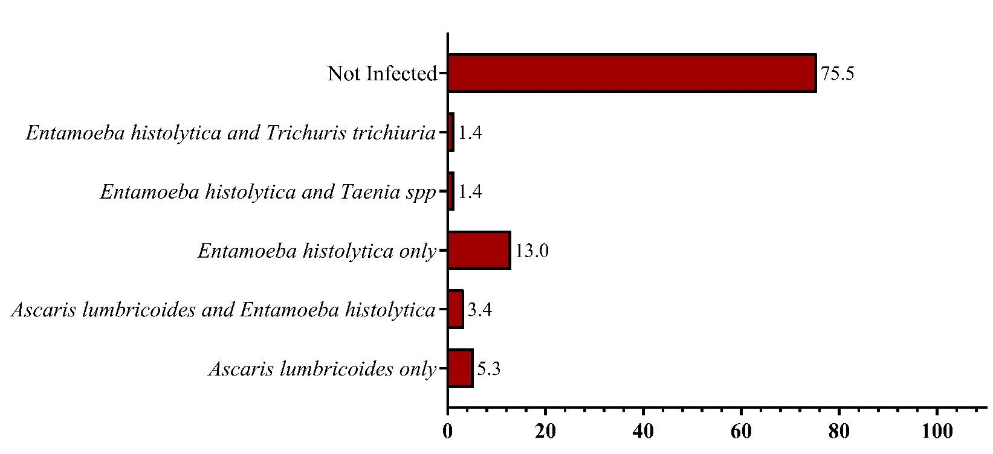
Figure 4: Distribution of intestinal parasite infections among subjects

Table 2: Association between the prevalence of an intestinal parasite and sociodemographic characteristics
Variable | N | Positive (%) | Negative (%) | χ2, df | p-value
Age  5 - 7 | 26 | 10 (38.5) | 16 (61.5) | 7.996, 2 | 0.0184*
8 - 10 | 87 | 26 (29.9) | 61 (70.1)
≥11 | 95 | 15 (15.8) | 80 (84.2)
Total | 208 | 51 (24.5) | 157 (75.5)
Sex  Female | 111 | 23 (20.7) | 88 (79.3) | 1.856, 1 | 0.1731
Male | 97 | 28 (28.9) | 69 (71.1)
Total | 208 | 51 (24.5) | 157 (75.5)
Type of School  Public | 185 | 46 (24.9) | 139 (75.1) | 0.1080, 1 | 0.7424
Private | 23 | 5 (21.7) | 18 (78.3)
Total | 208 | 51 (24.5) | 157 (75.5)
Household Size  ≤5 | 74 | 18 (24.3) | 56 (75.7) | 0.002358, 1 | 0.9613
>5 | 134 | 33 (24.6) | 101 (75.4)
Total | 208 | 51 (24.5) | 157 (75.5)
Mother’s Level of Education  Primary | 62 | 15 (24.2) | 47 (75.8) | 0.3658, 2 | 0.8329
Secondary | 108 | 28 (25.9) | 80 (74.1)
Tertiary | 38 | 8 (21.1) | 30 (78.9)
Total | 208 | 51 (24.5) | 157 (75.5)
Mother’s Occupation  Business | 162 | 32 (19.8) | 130 (80.2) | 15.64, 3 | 0.0013*
Civil Servant | 11 | 2 (18.2) | 9 (81.8)
Privately Employed | 28 | 12 (42.9) | 16 (57.1)
Unemployed | 7 | 5 (71.4) | 2 (28.6)
Total | 208 | 51 (24.5) | 157 (75.5)
* Statistical significance P < 0.05

Table 3: Association between the prevalence of an intestinal parasite and the lifestyle and exposure of the subjects
Variable | N | Positive (%) | Negative (%) | χ2, df | p-value
Regular handwashing  Yes | 173 | 36 (20.8) | 137 (79.2) | 7.646, 1 | 0.0057*
No | 35 | 15 (42.9) | 20 (57.1)
Total | 208 | 51 (24.5) | 157 (75.5)
Type of Nutrition  Homemade Food | 200 | 45 (22.5) | 155 (77.5) | 11.46, 1 | 0.0007*
Fast Food | 8 | 6 (75.0) | 2 (25.0)
Total | 208 | 51 (24.5) | 157 (75.5)
Source of drinking water  Boiled water | 3 | 0 (0.0) | 3 (100.0) | 3.935, 3 | 0.2685
Bottled water | 29 | 9 (31.0) | 20 (69.0)
Sachet water | 45 | 7 (15.6) | 38 (84.4)
Tap water | 131 | 35 (26.7) | 96 (73.3)
Total | 208 | 51 (24.5) | 157 (75.5)
Eating raw vegetables/fruits  Yes | 141 | 42 (29.8) | 99 (70.2) | 6.564, 1 | 0.0104*
No | 67 | 9 (13.4) | 58 (86.6)
Total | 208 | 51 (24.5) | 157 (75.5)
Walking barefoot  Yes | 54 | 9 (16.7) | 45 (83.3) | 2.430, 1 | 0.1190
No | 154 | 42 (27.3) | 112 (72.7)
Total | 208 | 51 (24.5) | 157 (75.5)
Contact with domestic animals  Yes | 61 | 22 (36) | 39 (63.9) | 6.218, 1 | 0.0126*
No | 147 | 29 (19.7) | 118 (80.3)
Total | 208 | 51 (24.5) | 157 (75.5)
Bath Place  Bathroom | 195 | 45 (23.1) | 150 (76.9) | 3.507, 1 | 0.0611
Street | 13 | 6 (46.2) | 7 (53.8)
Total | 208 | 51 (24.5) | 157 (75.5)
Type of toilet system  Latrines | 12 | 0 (0.0) | 12 (100.0) | 5.069, 3 | 0.1668
Pit Latrine | 14 | 3 (21.4) | 11 (78.6)
River | 2 | 0 (0.0) | 2 (100.0)
Water Cistern | 180 | 48 (26.7) | 132 (73.3)
Total | 208 | 51 (24.5) | 157 (75.5)
* Statistical significance P < 0.05

The higher sensitivity and specificity of molecular identification of intestinal parasites revealed the presence of several species which were not detected using routine microsopy among the samples analyzed. Specifically, the amplification of respective genes identified Ascaris lumbricoides in 2 instances. Among Entamoeba species, Entamoeba moshkosvii was detected in 2 samples, while Entamoeba dispar and Entamoeba histolytica were each identified in 1 sample.
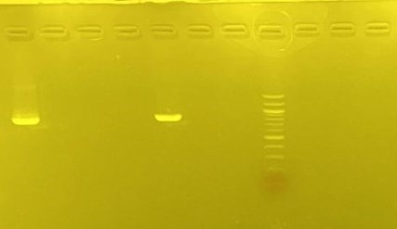
1

2

3

4

5

6

7

M

8

9

10

75

0

bp

500

bp

Figure 5: Agarose gel electrophoresis of Ascaris lumbricoides. Lanes 1 and 5 represent Ascaris lumbricoides gene
band at (750bp). Lane M represents the 100bp Molecular ladder shown at 500bp.

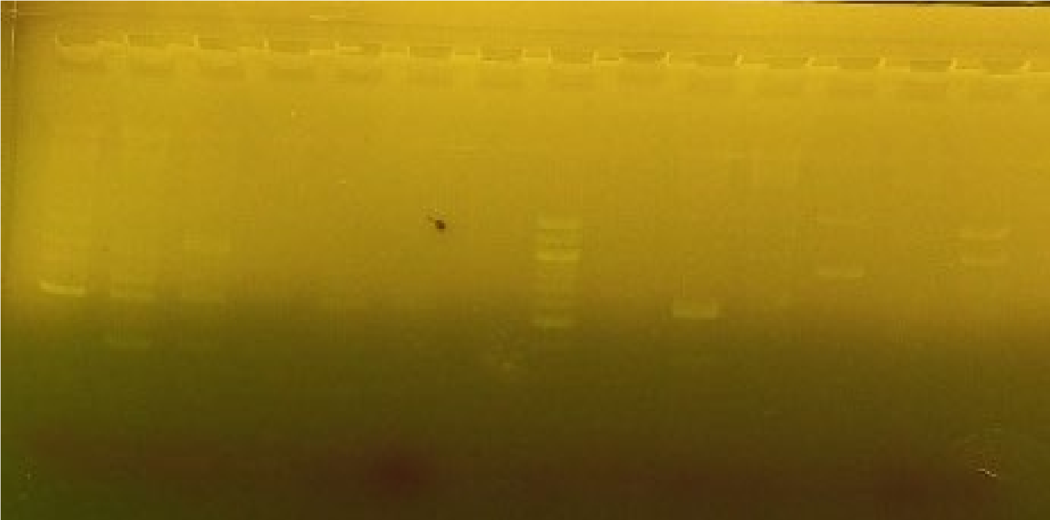

752

bp

582

bp

166

bp

1500

bp

Figure 6: Agarose gel electrophoresis of Entamoeba species. Lane 1 and 9 represent Entamoeba moshkosvii gene bands (582bp), lane 11 represents Entamoeba dispar gene (752bp), Lane 7 represents Entamoeba histolytica gene band (166bp) and Lane M represents the 100bp Molecular ladder of 1500bp.

3.1 Discussion

The overall parasite prevalence of 24.5 % in Port Harcourt pupils mirrors the moderate but persistent burden reported from other southern-Nigerian cohorts (Gbonhinbor et al., 2022; Eboh et al., 2022) and highlight the fact that intestinal protozoa and helminths remain entrenched in school environments despite repeated control campaigns. Entamoeba histolytica dominated the spectrum of infections either alone or in co-infections, reflecting observations from IDP camps in Benin City (Evbuomwan et al., 2022) and urban slums in Lagos (Gyang et al., 2019); its predominance is clinically important because even asymptomatic carriage can impair growth and cognition (Michael et al., 2017). Ascaris lumbricoides was next in frequency, consistent with its recognised endemicity in south-eastern Nigeria (Ugochi et al., 2015).
Age proved the clearest demographic factor with children 5–7 years being more than twice as likely to be infected as those ≥ 11 years, a gradient echoing age-related susceptibilities as also found in a study by Gbonhinbor et al. (2022). This pattern probably reflects immature hygiene behaviour and still-developing immunity in younger pupils. In contrast, sex, school ownership, household size and maternal education showed no statistical influence, a neutrality that agrees with findings from Port Harcourt city schools (Michael et al., 2017) yet diverges from reports that link parental education to lower risk thus, local transmission appears to cut across these social strata.
Maternal occupation emerged as a significant socioeconomic factor. Children of unemployed or privately employed mothers had significantly higher infection prevalence than those whose mothers were business owners or civil servants. Similar occupation-linked gradients have been noted in Lagos slums (Gyang et al., 2019) and suggest that time constraints, income instability or reduced access to health information among certain maternal groups may shape exposure.
Some behavioural variables were also found to be significantly associated with the prevalence of intestinal parasite infection. Regular hand-washing significantly reduced infection prevalence by half, corroborating school-based studies in Osun State (Adefioye et al., 2011). Diet was also found to be significant as pupils reliant on fast food were three times more likely to be infected than those eating home-prepared meals, an association that aligns with Abah and Arene’s (2015) assertion that food-handling hygiene is critical in the Niger Delta. Raw produce consumption and contact with domestic animals each significantly increased the prevalence of the infection, supporting evidence that poor produce washing and peri-domestic zoonotic reservoirs sustain transmission cycles (Gbonhinbor et al., 2022).
The warm, moist conditions, together with heavy seasonal rainfall in the study area, create ecological niches favourable for the survival and transmission of intestinal parasites. Previous regional evidence has documented a prevalence of 23.95% for intestinal parasitic infections among primary school-aged children in southern Nigeria (Gbonhinbor et al., 2022), underscoring the public health relevance of investigating these infections in this setting. Accordingly, Port Harcourt provides an appropriate context for assessing the burden, risk factors, and molecular characteristics of intestinal parasites to inform targeted control strategies.

The findings from this study portray intestinal parasitism in Port Harcourt as a multifactorial problem driven less by school type or household crowding than by young age, maternal socioeconomic position and modifiable behaviours related to food hygiene, hand-washing and animal contact. Interventions that prioritise early-grade pupils; intensify hygiene education for mothers with unstable employment; and integrate hand-washing stations, food-safety messaging and pet-deworming within school-health programmes are therefore likely to yield the greatest gains, complementing periodic anthelminthic distribution recommended by national guidelines (Abah & Arene, 2015).
4. Conclusion

This survey involving 208 primary‑school pupils in Port Harcourt shows that intestinal parasitism remains a considerable public‑health problem: one in four children was infected, most often with Entamoeba histolytica alone or in mixed forms, followed by Ascaris lumbricoides. Infection clustered in the youngest age group (5–7 years) and among children of unemployed mothers. Behavioural factors were found to be significant; regular hand‑washing and home‑prepared meals were protective, whereas fast‑food consumption, raw produce intake and contact with domestic animals increased risk. These findings call for age‑focused hygiene education, promotion of safe food practices, and integrated school‑based deworming and pet‑health programmes to curb transmission and improve child health in this urban setting.

Given the potential for associated anemia as a clinical implication of these infections, we recommend that further studies on infected students should include full assessment of their hematological status. A notable limitation of this study is the absence of Cryptosporidium spp. which is recognized as a significant cause of diarrhoeal disease in children. The findings of this study did not provide data on its prevalence in the sampled population. Molecular analysis confirmed a diverse parasite spectrum, highlighting the value of sensitive diagnostics.

Consent

Written informed consent was sought from the parents or guardians of eligible pupils after briefing them on the study’s objectives and assuring confidentiality. They were also informed that the participation of their children or wards was entirely voluntary, and they could withdraw at any point without any repercussions.

Ethical approval

Ethical approval was obtained from the Rivers State Health Research Ethics Committee (RSHMB/RSHREC/2023/022). All methods employed in this study were carried out in strict accordance with relevant guidelines and regulations, including the Declaration of Helsinki and local ethical standards.

Disclaimer (Artificial intelligence)
Option 1:
Author(s) hereby declare that NO generative AI technologies such as Large Language Models (ChatGPT, COPILOT, etc.) and text-to-image generators have been used during the writing or editing of this manuscript.

References

- Wong, L. W., Ong, K. S., Khoo, J. R., Goh, C. B. S., Hor, J. W. & Lee, S. M. (2020). Human intestinal parasitic infection: A narrative review on global prevalence and epidemiological insights on preventive, therapeutic and diagnostic strategies for future perspectives. Expert Review of Gastroenterology & Hepatology, 14(11), 1093-1105.
- Ahmed, S. A., Kotepui, M., Masangkay, F. R., Milanez, G. D., Karanis, P. (2023). Gastrointestinal parasites in Africa: a review. Advances in parasitology, 1(119), 1-64.
- Atabati, H., Kassiri, H., Shamloo, E., Akbari, M., Atamaleki, A., Sahlabadi, F., et al. (2020). The association between the lack of safe drinking water and sanitation facilities with intestinal Entamoeba spp infection risk: A systematic review and meta-analysis. PloS one, 15(11):e0237102.
- Vaisusuk, K., Saijuntha, W. (2021). Intestinal protozoa: Their role as human pathogens and zoonoses. In: Biodiversity of Southeast Asian Parasites and Vectors causing Human Disease, 35-61.
- Manetu, W. M., M’masi, S., Recha, C. W. (2021). Diarrhea disease among children under 5 years of age: a global systematic review. Open Journal of Epidemiology, 11(3), 207-221.
- Veesenmeyer, A. F. (2022). Important nematodes in children. Pediatric Clinic of North America, 69(1), 129-139.
- Isah, A. U., Ekwunife, O. I., Ejie, I. L., Mandrik, O. (2020). Effects of nutritional supplements on the re-infection rate of soil-transmitted helminths in school-age children: A systematic review and meta-analysis. PLoS One, 15(8):e0237112.
- Girma, A., Genet, A. (2024). Prevalence and factors associated with intestinal parasitic infections among preschool-aged children in Ethiopia: a systematic review and meta-analysis. Parasite Epidemiology and Control, 26:e00368.
- Guerrant, R. L., Bolick, D. T., Swann, J. R. (2021). Modeling enteropathy or diarrhea with the top bacterial and protozoal pathogens: differential determinants of outcomes. ACS Infectious Diseases, 7(5), 1020-1031.
- Gabain, I. L., Ramsteijn, A. S., Webster. J. P. (2023). Parasites and childhood stunting–a mechanistic interplay with nutrition, anaemia, gut health, microbiota, and epigenetics. Trends in Parasitology, 39(3), 167-180.
- Fauziah, N., Aviani, J. K., Agrianfanny, Y. N., Fatimah, S. N. (2022). Intestinal parasitic infection and nutritional status in children under five years old: a systematic review. Tropical medicine and infectious disease, 7(11), 371.
- Rossi, F., Santonicola, S., Amadoro, C., Marino, L., Colavita, G. (2024). Food and drinking water as sources of pathogenic protozoans: An update. Applied Sciences, 14(12):5339.
- Das, S., Neupane, R., Beard, J., Solomon, H., Das, M., Errickson, N., et al. (2024). Aetiology of diarrhoea in children aged zero to nine years in low-and middle-income countries: A systematic review. Journal of Global Health, 14:04168.
- Siwila, J. (2023). The triple food-borne protozoan parasites: Cryptosporidium spp., Giardia duodenalis, Cyclospora cayetanensis—Hope in transmission reduction. Current Clinical Microbiology Reports, 10(3), 99-107.
- Balendran, T., Iddawela, D., Lenadora, S. (2024). Cryptosporidiosis in a zoonotic gastrointestinal disorder perspective: present status, risk factors, pathophysiology, and treatment, particularly in immunocompromised patients. Journal of Tropical Medicine, (1):6439375.
- Robertson, L. J., Johansen, O. H., Kifleyohannes, T., Efunshile, A. M., Terefe, G. (2020). Cryptosporidium infections in Africa—how important is zoonotic transmission? A review of the evidence. Frontiers in Veterinary Science, 7:575881.
- Prabakaran, M., Weible, L. J., Champlain, J. D., Jiang, R. Y., Biondi, K., Weil, A. A., et al. (2023). The gut-wrenching effects of cryptosporidiosis and giardiasis in children. Microorganisms, 11(9), 2323.
- Allain, T., Buret, A. G. (2020). Pathogenesis and post-infectious complications in giardiasis. Advances in parasitology, 107:173-199.
- Solaymani-Mohammadi, S. (2022). Mucosal defense against Giardia at the intestinal epithelial cell interface. Frontiers in Immunology, 13:817468.
- Tharmaratnam, T., Kumanan, T., Iskandar, M. A., D’Urzo, K., Gopee-Ramanan, P., Loganathan, M., et al. (2020). Entamoeba histolytica and amoebic liver abscess in northern Sri Lanka: A public health problem. Tropical Medicine and Health, 48:1-13.
- Usuda, D., Tsuge, S., Sakurai, R., Kawai, K., Matsubara, S., Tanaka, R., et al. (2022). Amebic liver abscess by Entamoeba histolytica. World Journal of Clinical Cases, 10(36):13157.
- Ahmed, M. (2023). Intestinal parasitic infections in 2023. Gastroenterology Research, 16(3), 127-140.
- Ryan, U., Zahedi, A., Feng, Y., Xiao, L. (2021). An update on zoonotic Cryptosporidium species and genotypes in humans. Animals (Basel), 11(11):3307.
- Fitri, L. E., Candradikusuma, D., Setia, Y. D., Wibawa, P. A., Iskandar, A., Winaris, N., et al. (2022). Diagnostic methods of common intestinal protozoa: current and future immunological and molecular methods. Tropical Medicine and Infectious Disease, 7(10), 253.
- Midala, C. A., Kyari, F., Onyiche, T. E. (2024). Genetic diversity of Cryptosporidium species in different hosts in Africa: A systematic review. Parasitologia, 4(4), 405-424.
- Wattano, S., Kerdpunya, K., Keawphanuk, P., Hunnangkul, S., Loimak, S., Tungtrongchitra, A., et al. (2023). An epidemiological survey of intestinal parasitic infection and the socioeconomic status of the ethnic minority people of Moken and Orang Laut. Tropical Medicine and Infectious Disease, 8(3), 161. doi:10.3390/tropicalmed8030161
- Assemie, M. A., Shitu., Getahun, D., Hune, Y., Petrucka, P., Abebe, A. M., et al. (2021). Prevalence of intestinal parasitic infection and its associated factors among primary school students in Ethiopia: A systematic review and meta-analysis. PLoS Neglected Tropical Diseases, 15(4):e0009379. https://doi.org/10.1371/journal.pntd.0009379
- Opara, M. N., Okafor, F. O., Okafor, C. I. (2020). Intestinal parasitic infection among primary school children in Port Harcourt City Local Government Area of Nigeria: A review for school-based intervention. International Journal of Tropical Disease & Health, 41(1), 1-9.
- Kebede, A., Verweij, J. J., Petros, B., Polderman, A. M. (2014). Comparison of microscopy and real-time PCR for the detection of intestinal parasites in Ethiopian children. Acta Tropica, 134, 77–81. https://doi.org/10.1016/j.actatropica.2014.03.017
- Stensvold, C. R., Nielsen, H. V. (2012). Comparison of microscopy and PCR for detection of intestinal parasites in Danish patients supports an incentive for molecular screening platforms. Journal of Clinical Microbiology, 50(2), 540-541. doi:10.1128/JCM.06012-11
- Merid, M. W., Alem, A. Z., Chilot, D., Belay, D. G., Kibret, A. A., Asratie, M. H., et al. (2023). Impact of access to improved water and sanitation on diarrhea reduction among rural under-five children in low and middle-income countries: A propensity score matched analysis. Tropical Medicine & Health, 51(1), 36. doi:10.1186/s41182-023-00525-9
- Akukwe, T. I., & Ogbodo, C. (2015). Spatial analysis of vulnerability to flooding in Port Harcourt metropolis, Nigeria. Sage Open, 5(1), 1-19.TuTiempo.net, 2023).
- Gbonhinbor, J., Abah, A. E., Awi-Waadu, G. (2022). Prevalence of intestinal parasitic infection and associated risk factors among primary school-aged children (5-15 years) in Southern Nigeria. International Journal of Infection, 9(3):e123721.
- Mike-Ogburia, M. I., Dio, A., Nwogu, V. C., Vito-Peter, B., Hart, G. M., Ideozu, N. O., et al. (2023). Prevalence and Associated Risk Factors of COVID-19 in an Incarcerated Population Burdened with HIV Infections in Port Harcourt. World Journal of AIDS, 13(2), 28-46.
- Naing, L., Nordin, R. B., Abdul Rahman, H., Naing, Y. T. (2022). Sample size calculation for prevalence studies using Scalex and ScalaR calculators. BMC Medical Research Methodology, 22(1), 209.
- Ama-Okachi, B. C., Wokem, G. N., Obioma, A. (2020). Comparative Evaluation of Intestinal Parasitic Burden among Some Pupils in Public and Private School in Nkpolu-Oroworukwo Community, Port Harcourt, Rivers State. EC Nursing and Healthcare, 2, 92-102
- Cheesbrough, M. (2000). District laboratory practice in tropical countries: Cambridge University Press. Part 2, 200-205
- Eboh, D. O., Bamaiyi, P. H., Akenroye, O. O., Esumobi, V. U. (2022). Prevalence and pattern of intestinal parasites among primary school pupils in Delta State, Nigeria. Journal of Parasitology and Vector Biology, 14(1), 1-8.
- Evbuomwan, I. O., Edosomwan, E. U., Idubor, V., Bazuaye, C., Abhulimhen-Iyoha, B. I., Adeyemi, O. S., et al. (2022). Survey of intestinal parasitism among school children in internally displaced persons camp, Benin City, Nigeria. Scientific African, 17:e01373.
- Gyang, V. P., Chuang, T. W., Liao, C. W., Lee, Y. L., Akinwale, O. P., Orok, A., et al. (2019). Intestinal parasitic infections: current status and associated risk factors among school aged children in an archetypal African urban slum in Nigeria. Journal of Microbiology, Immunology and Infection, 52(1), 106-13.
- Michael, M. E., Abah, M. G., Utuk, A. E. (2017). Intestinal parasites among school children in Port Harcourt, Nigeria. Journal of Bacteriology and Parasitology, 8(1), 323.
- Ugochi, U. J., Ijeoma, E. N., Godson, U. M., Nwaku, A. I. (2015). Prevalence of intestinal parasites among primary school children in three geopolitical zones of Imo State, Nigeria. Science Journal of Public Health, 12(2), 25-28.
- Adefioye, O. A., Efunshile, A. M., Ojurongbe, O., Akindele, A. A., Adewuyi, I. K., Bolaji, O. S., et al. (2011). Intestinal helminthiasis among school children in Ilie, Osun state, Southwest, Nigeria. Sierra Leone Journal of Biomedical Research, 3(1), 43-48.
- Abah, A. E., Arene, F. O. (2015). Status of intestinal parasitic infections among primary school children in Rivers State, Nigeria. Journal of Parasitology Research, (1):937096.

