Seasonal Dynamics of Solar Radiation and Meteorological Parameters in A Tropical Nigerian Station
ABSTRACT
Temporal variation of solar radiation with prevailing meteorological parameters focused on a specific location in the south-west Nigeria to provide detailed information required for climate studies and agricultural activities. Hourly and monthly solar radiation trends were analyzed using the variations in the temperature, relative humidity and wind speed from 2010 to 2013. This was with the purpose of determining the correction in the monthly trends of the solar radiation and meteorological parameters in Akure, south-west, Nigeria. Statistical analysis using Open Air project for R-statistics and the multiple linear regression (MLR) were carried out to establish correlation between solar radiation and prevailing meteorological parameters. Solar radiation has more significant impact on other meteorological parameter in the wet season at Akure while it drags other parameters with 1 – 2 months lag in the dry season. In the month August, which was characterized by the peak wet season, the station experiences rainfall break, extremely cloudy overcast and dominance of southwesterly wind. The cloudy atmosphere interrupts the incoming solar radiation with consequent effect of extremely humid and cold air temperature. This was why the low solar radiation aligned with high relative humidity and high wind speed in August while the temperature was the lowest. However, in dry season, the lag was as a result of onset of rainfall characterized by withdrawal of dry and cold northeasterly wind which interfered with response of boundary later to incoming radiation due to irregular heavy rainfall and rapid evaporation at this period. The results clearly aligned with predominant weather patterns in the tropical station influenced by back-and-forth movement of inter-tropical discontinuity during transition from dry to wet season.

Keywords: Global solar radiation, meteorological parameters, tropical climate, temporal variation

1.0 INTRODUCTION
The sun's energy derives from nuclear fusion, a process in its core where extreme pressure and temperature cause hydrogen atoms to fuse together, forming helium. “This reaction releases a massive amount of energy in the form of light and heat, which travels to earth and sustains life” [17]. “Little quantities, not surpassing one percent, of total energy is available from other sources including geothermal energy, tidal energy, and cosmic radiation” [4]. “The physical, chemical and biological processes taking place in the earth atmosphere system are driven by the energy from the sun and also determine the earth’s climate” [7] which in turn allows sustainability of organic life on the earth [18]. The energy source for plants is sunlight, which they convert into chemical energy through photosynthesis to produce their own food. Using the energy from light, plants combine water and carbon dioxide to create sugars (glucose) and release oxygen. “This stored chemical energy, in the form of organic compounds, fuels the plant's growth and other metabolic processes” [11]. The visible portion of solar radiation plays a significant role in plant growth due to the photosynthesis activities [6]. Most importantly, periodic event in the plant cycle is caused by the seasonal variation of the day length, incoming solar radiation, air temperature and precipitation of the agricultural crops [8].
“The amount of solar radiation determines the upper productivity limit” [16]. Adequate knowledge about the spatial distribution and temporal variation of solar radiation reaching the earth surface is needed for monitoring the crop growth monitoring and forecasting the crop yields. Bojanowski [3] reported that “22 % (76 Wm⁻²) of the solar radiation which is part of the Earth’s energy budgets that reach the top of the earth’s atmosphere is reflected back to space” [13]. Also, 23 % (79 Wm²) is absorbed by the clouds, gases and aerosols in the atmosphere while 54 % (185 Wm⁻²) of solar radiation reaches the earth’s surface. The solar energy reaching that gets the earth surface is regarded as surface solar radiation and it depends on the geographic location, orientation of the surface, time of the day, time of the year, and atmospheric composition [3]. Therefore, “solar radiation varies significantly in time and space. The day cycle is caused by the earth's rotation around its own axis which changes the angle at which solar radiation hits the surface” [19]. “The displacement of the earth in its orbit around the Sun and its axial tilt is relative to the orbital plane. Periodic variation in the length of the day and the elevation of the sun” [5]. “The length of the day and the elevation of the sun at a given location also depend on the latitude of that location. For any place and at any time, the solar irradiance that reaches the top of the atmosphere can be obtained by considering the frequent variation of the earth’s shape with other factors” [23]. This radiation from the external part of the atmosphere is also known as extraterrestrial radiation. In the absence of atmosphere, slope and soil exposures are only factors that alter solar radiation [22]. However, “the atmosphere has a strong impact on the solar radiation received on the earth's surface, which can cause additional variation” [15]. “Clouds are the major causes of the high variability of transmission in the atmosphere, as they can reflect a significant portion of incident solar radiation. Estimating the transmission through the atmosphere and thus solar radiation reaches the surface is difficult” [3]. Time series of precise, location-specific solar irradiance data are important to many scientific fields and applications which includes; meteorology and climate. Solar irradiance is also an essential input parameter for the design, prediction of performances and monitoring of solar-powered devices [10]. However, they help to quantify the environmental limits of site-specific agricultural production [2}. Finally, running crop growth with future weather scenarios as input can help assess the impact of projected climate changes on future crop production, [1]. Solar radiation was reported by [9] and “identified as the major limitation to plant growth in Europe and other regions of the world, thus demonstrating the aim to improve the accuracy of estimates. of solar radiation”.
“Solar irradiance data provides information about the amount of solar energy hitting a surface at a location on earth over a given period of time. Availability of solar irradiance data is essential for the design and simulation of all solar applications” [10]. Currently, Direct measurement of solar irradiance is also done in two basic ways – values are measured using ground-based instruments collectively known as pyranometers and through satellite telemetry. These methods are often used in combination for mutual validation [4]. “Solar radiation affects the earth's meteorological processes that determine the natural environment, this is necessary for the food supply to mankind” [14]. Therefore, “it is important to be able to understand the physics of solar radiation, and in particular to determine how much energy is intercepted by the earth's surface at different locations”. [12]. “The amount of solar radiation that reaches the earth's surface varies with changes in atmospheric conditions as well as changes in the position of the Sun during the day. Accurate data on global solar irradiance is an essential energy” [21]. Studies on solar radiation have shown significant progress which have improved significantly in recent years.
Previous studies examined “the distribution and characteristics of Surface Solar Radiation Downward (SSRD), sunshine duration, cloudiness index, relative humidity, temperature, and wind speed from the archive of the NASA Power project between the years 2010 and 2020 over Nigeria using 37 stations” [14]. The datasets were subjected to monthly and seasonal analysis over three climatic zones in Nigeria. The results show that “the SSRD of the Sahel is generally higher than that of the Savannah and Guinea Coast. Sunshine duration was found to increase seasonally and from south to north. From the extreme edge of the coastal region in the southern part of Nigeria to its far northern region, the mean sunshine duration hour increases northward from about 2075 hours over the coastal region of the south to about 3525 hours in the north. Relative humidity fluctuates between 70-90%, which peaks in August and declined back to its minimum (70%) in December. Observed over all seasons, relative humidity decreases northward from the far south near the Atlantic Ocean to the far north of Nigeria” [26].
In another study on “the analysis of solar radiation and meteorological variables measured in Ankara province in Türkiye from 2017 to 2018, an empirical model of global solar radiation was developed” [13]. “The global solar radiation at the ground and at the top of the atmosphere (TOA) was calculated and in good agreement with the observations. This model was applied to compute the losses of global solar radiation in the atmosphere and the contributions by atmospheric absorbing and scattering substances. The loss of global solar radiation in the atmosphere was dominated by the absorbing substances. The sensitivity test showed that global solar radiation was more sensitive to changes in scattering (described by a scattering factor S and G which are diffuse and global solar radiation respectively. This empirical model was applied to calculate the albedos at the TOA and the surface. In 2017, 2018, and 2019, the computed albedos were 28.8%, 27.8%, and 28.2% at the TOA and 21.6%, 22.1%, and 21.9% at the surface, which were in reasonable agreement with satellite retrievals. The empirical model was a useful tool for studying global solar radiation and the multiple interactions between solar energy and atmospheric substances. The comparisons of global solar radiation and its loss in the atmosphere, as well as meteorological parameters, were made at some representative sites on the earth. Some internal relationships (between G and the absorbing and scattering substances, air temperature and atmospheric substances, air temperature increase and latitude, etc.) were found” [20]. Thus, it is suggested to thoroughly study solar radiation, atmospheric substances, and climate change as a whole system and reduce the direct emissions of all atmospheric substances and, subsequently, secondary products (e.g., CO₂ and non-CO₂) in the atmosphere for the achievement of slowing down climate warming.
Temporal variation of solar radiation with prevailing meteorological parameters focused on a specific location in the south-west Nigeria to provide detailed information required for climate studies and agricultural activities. Hourly and monthly solar radiation trends were analyzed using the variations in the temperature, relative humidity and wind speed from 2010 to 2013. This was with the purpose of determining the correction in the monthly trends of the solar radiation and meteorological parameters in Akure, south-west, Nigeria, statistical analysis using Open Air project for R-statistics and the multiple linear regression (MLR) were carried out to establish correlation between solar radiation and prevailing meteorological parameters.

2.0 MATERIALS AND METHODS
2.1 Description of the Study Area
The study area is Akure, the capital city of Ondo State in the South-Western geopolitical region of Nigeria. Akure lies between longitude 4.944055°E to 5.82864°E and latitude 7.491780°N to 6.96375°N. Akure city had a population of 556,300 as at the 2015 population census [12]. Climatologically, the study location is in no other way different from other Southwestern part of Nigeria because the climate is greatly influenced by the rain-bearing southwesterly monsoonal winds from Atlantic Ocean and the dry northwesterly winds from the Sahara Desert [20]. Akure is specifically in a tropical climate with two prevailing seasons, namely, wet and dry season. The wet season usually lasts seven months spanning from April to October while the dry season is usually hot, muggy and partly cloudy which is from November to March. The average annual rainfall amount of the study area ranges between 1300 mm and 1650 mm with the high relative humidity [19]. Akure temperatures are generally high during the daytime mostly in the transition months of March and April. The daily mean temperature ranges between 22 and 39 °C annually and the wind flow is relatively weak at the surface. The land is generally with a low average elevation range between 100–270 m and gently undulating with occasional land rising to about 1500 m in the Northern part. Figure 1 presents the map of Nigeria and Ondo State showing the study location.

2.2 Sampling and Analysis of Solar Radiation and Meteorological Parameters
In this study, the solar radiation and the meteorological data were collected from Campbell scientific automatic weather station of Tropospheric Data Acquisition Network (TRODAN), operated and managed by the National Space Research and Development Agency (NASRDA) which covered the period of four years (from May 1st, 2010 to July 31st, 2013). The data collected were sampled at 5 s interval and the dataset were reduced to 1 hour average for each day. The 1-hour average dataset were used in this study for data analysis on hourly, weekly and monthly variations of the solar radiation and the meteorological parameters. Also, the statistical analyses were performed using Open Air project for R-statistics [5, 6] and the multiple linear regression (MLR) were performed in this work using Micro Cal Origin software.
2.3 Quality Control and Uncertainty
This study employed a comprehensive quality control (QC) protocol to guarantee the accuracy and dependability of the TRODAN dataset. Routine maintenance of sensors was carried out to avoid malfunctions and identify raw data issues. The QC process involved detecting and flagging errors and anomalies resulting from instrument faults, human error, transmission problems and environmental influences (WMO, 2008, NASA, 2010). Additional validation also included performing range and consistency checks, as well as verifying temperature readings against acceptable limits outlined in the instrument manufacturer’s guidelines. The dataset was also cross-checked with established standards and reference datasets values to confirm strong correlations between solar radiation and meteorological variables (WMO, 2008, NASA, 2010). Finally, uncertainty assessments were conducted to identify and eliminate spurious data affected by extreme weather conditions before proceeding with analysis.

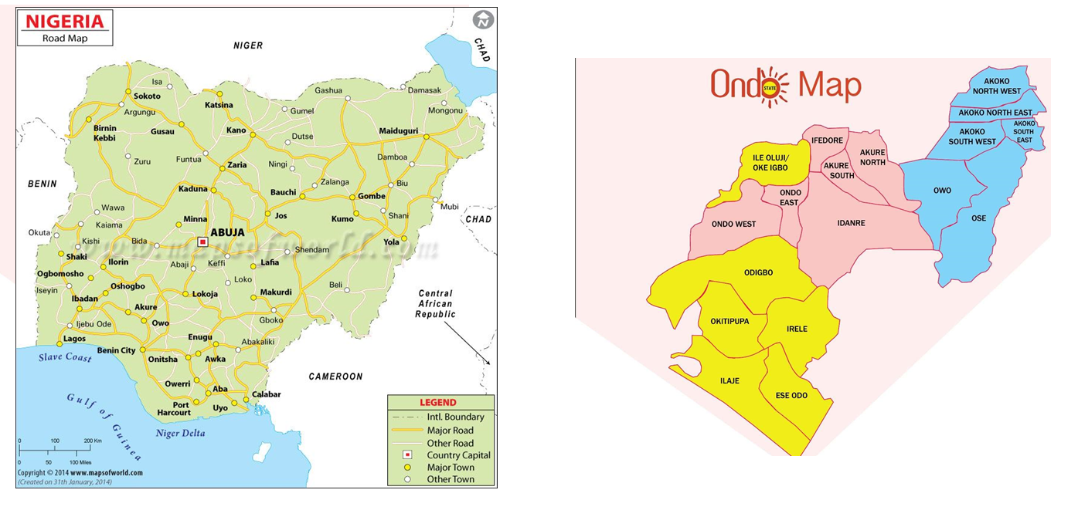
Figure 1 Map of Nigeria and Ondo State showing the Study Area

3.0 RESULTS AND DISCUSSIONS
3.1 Variations of the Solar Radiation with the Prevailing Meteorological Parameters
The monthly mean daily hours of global solar radiation and the meteorological parameters for four years (2010-2013) at the study location are presented in Tables 1 to 4. In Table 1, the maximum values of 187.26, 172.80 and 189.95 w/m² were observed for the global solar radiation in May (2010), May (2011), April (2012) and March (2013), respectively at the study area. Also, the minimum values are in August expected for year 2013 that had its minimum in month of July. The annual average for solar radiation in 2010 was 161.59 w/m², in 2011, it was 147.84 w/m², in 2012 it was 147.03 w/m² and in 2013, it was 161.94 w/m² (Tables 1 – 4). On the other hand, the values of the solar radiation in year 2010 and 2013 were higher than those recorded in year 2011 and 2012. This is attributed to the fact that year 2010 and 2013 were dry and less cloudy compared to the other two years (2011 and 2012).
The monthly mean values for the temperature were observed to be within the range of 23.5 – 26.1ºC, 20.2 – 27.1, 22.7 – 27.3 and 21.9 – 26.8ºC in year 2010, 2011, 2012 and 2013, respectively. The annual average for temperature recorded at the study location were 24.84, 24.42, 25.02 and 25.26ºC in year 2010, 2011, 2012 and 2013, respectively. As observed for relative humidity in Tables 1 to 4, the annual mean values of 80.96, 75.72, 77.66 and 76.97% were recorded in 2010, 2011, 2012, and 2013 respectively. The most humid year was found to be 2010. It was observed in all years than the month of July and August had the highest relative humidity value and thus was attributed to the fact that the period was characterized by rainstorm events. Also, the lowest values for the year are all in the month of December which is indication that the weather conditions were hot and partly cloudy because the period is in the dry season.
For the wind speed in Tables 1 to 4, the monthly mean values varied from 0.60 – 1.30, 0.70 – 1.40, 0.8 – 1.60, and 0.80 – 1.40 mi/s in year 2010, 2011, 2012 and 2013, respectively. The month of July recorded the highest wind speed expect year 2011 and this is because the period was characterized by rainstorm events. In figure 2, the weekdays variations for the solar radiation, temperature and wind speed increased in value from 06:00hrs to reached its peak around 15:00hrs but the relative humidity was noticed to the opposite in trend as it dropped in value to attained its trough around 15:00hrs the increase in values of solar radiation, temperature and wind speed is as a result of response to solar heating (figure 2).
In figure 3, the plots of the hourly trend for solar radiation, temperature, relative humidity and wind speed were observed to have similar trend with what were noticed for the weekdays. The monthly trend showed that the values of solar radiation increased around the month of January and it was maximum in April, but the value decrease appreciably to reach its minimum value in August and again increase in value from September upward. For the temperature and relative humidity, it was noticed that the value in around January to reached its peak in July and drop in value up to December. The wind speed however was observed to have two peaks. The wind speed increased in value from January to March, dropped in value till around May and rose to attained the second peak in the month of August.

Table 1: Year 2010 Monthly mean daily hours of Air temperature (T), relative humidity (rh), wind speed (ws) and global solar radiation (G) at Akure station.
Month | Year | $$T(℃)$$ | $$rh(\%)$$ | $$Ws (m/s)$$ | $$Solar Radiation (w/m2)$$
May | 2010 | 26.08 | 81.54 | 1.02 | 187.26
Jun | 2010 | 25.13 | 82.63 | 1.00 | 171.91
Jul | 2010 | 23.84 | 84.40 | 1.27 | 147.20
Aug | 2010 | 23.56 | 85.97 | 1.26 | 133.36
Sep | 2010 | 24.15 | 84.07 | 1.03 | 156.91
Oct | 2010 | 24.91 | 82.02 | 0.89 | 159.61
Nov | 2010 | 25.69 | 79.12 | 0.67 | 169.69
Dec | 2010 | 25.36 | 67.90 | 0.75 | 166.79

Table 2: Year 2011 Monthly mean daily hours of Air temperature (T), relative humidity (rh), wind speed (ws) and global solar radiation (G) at Akure station.
Month | Year | $$T(℃)$$ | $$rh(\%)$$ | $$Ws (m/s)$$ | $$Solar Radiation(w/m2)$$
Jan | 2011 | 24.71 | 54.57 | 0.78 | 151.71
Feb | 2011 | 26.44 | 70.88 | 1.18 | 161.50
Mar | 2011 | 27.10 | 75.09 | 1.33 | 163.57
Apr | 2011 | - | - | - | -
May | 2011 | 25.68 | 80.70 | 1.07 | 172.80
Jun | 2011 | 24.85 | 82.63 | 1.10 | 160.73
Jul | 2011 | 23.68 | 84.57 | 1.34 | 137.29
Aug | 2011 | 16.61 | 85.57 | 1.39 | 115.07
Sep | 2011 | 10.22 | 84.13 | 1.19 | 133.11
Oct | 2011 | 24.66 | 82.33 | 0.84 | 134.01
Nov | 2011 | 25.97 | 74.30 | 0.90 | 155.94
Dec | 2011 | 24.75 | 58.14 | 0.77 | 140.51

Table 3: Year 2012 Monthly mean daily hours of Air temperature (T), relative humidity (rh), wind speed (ws) and global solar radiation (G) at Akure station.
Month | Year | $$T(℃)$$ | $$rh(\%)$$ | $$Ws (m/s)$$ | $$Solar Radiation(w/m2)$$
Jan | 2012 | 24.75 | 59.14 | 0.89 | 122.06
Feb | 2012 | 26.35 | 73.33 | 1.35 | 137.95
Mar | 2012 | 27.21 | 71.12 | 1.28 | 171.63
Apr | 2012 | 26.37 | 77.17 | 1.29 | 183.52
May | 2012 | 25.36 | 80.27 | 1.07 | 168.32
Jun | 2012 | 24.43 | 82.77 | 1.14 | 164.32
Jul | 2012 | 23.34 | 86.15 | 1.44 | 126.09
Aug | 2012 | 22.75 | 86.65 | 1.54 | 102.73
Sep | 2012 | 23.70 | 85.49 | 1.19 | 110.94
Oct | 2012 | 24.70 | 82.12 | 0.88 | 133.66
Nov | 2012 | 25.77 | 79.19 | 0.91 | 170.51
Dec | 2012 | 25.48 | 68.57 | 0.85 | 172.60

Table 4: Year 2013 Monthly mean daily hours of Air temperature (T), relative humidity (rh), wind speed (ws) and global solar radiation (G) at Akure station.
Month | Year | $$T(℃)$$ | $$rh(\%)$$ | $$Ws (m/s)$$ | $$Solar Radiation(w/m2)$$
Jan | 2013 | 25.89 | 63.05 | 0.88 | 151.35
Feb | 2013 | 26.62 | 69.44 | 1.11 | 162.60
Mar | 2013 | 26.71 | 77.93 | 1.33 | 189.95
Apr | 2013 | 26.14 | 79.69 | 1.05 | 182.27
May | 2013 | 25.62 | 81.64 | 1.01 | 170.76
Jun | 2013 | 23.90 | 82.95 | 1.20 | 151.51
Jul | 2013 | 21.93 | 84.06 | 1.35 | 125.17

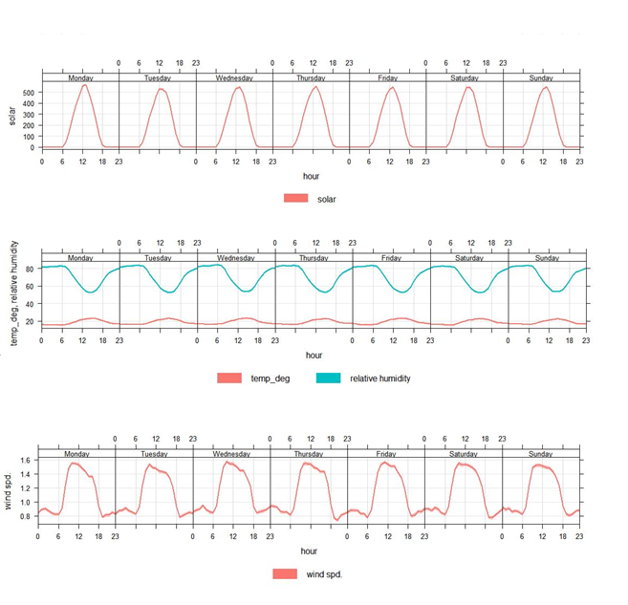
Figure 2: Weekdays Variations of Solar Radiation with Meteorological Parameters

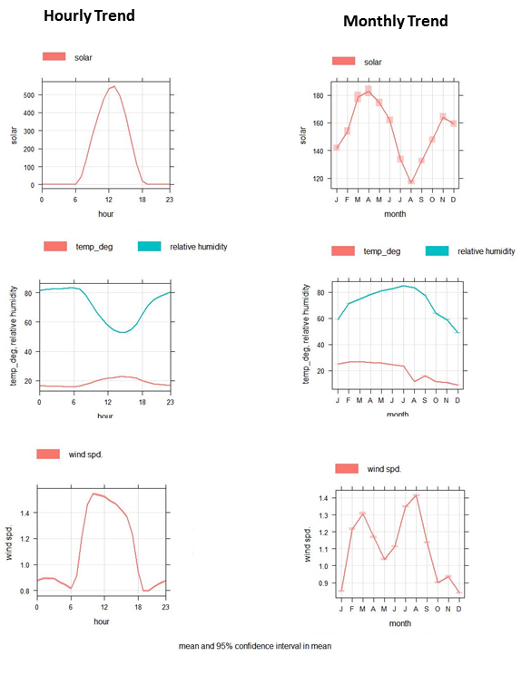
Figure 3: Hourly and Monthly Variations of Solar Radiation with Meteorological Parameters

3.2 CORRELATION BETWEEN SOLAR RADIATION AND METEOROLOGICAL PARAMETERS
Figure 4 showed the correlation matrix which gave the relationship between the solar radiation and the meteorological parameters at the study location in Akure. The result from figure 4 showed that the temperature and relative humidity had a good positive correlation which is significant (r= 80, p> 0.001). This is an indication that an increase in temperature directly increases the relative humidity. It was also observed that the correlation between temperature and wind speed had a weak negative correlation (r = -2) while relative humidity and wind speed gave a positive correlation of r=29. Also, solar radiation was positively correlated with temperature and had a correlation coefficient value of 0.12 while relative humidity and wind speed had a negative correlation value of -0.12 and -0.36, respectively. However, the correlations of any of these parameters with the wind direction were not discussed because wind direction was not included in the earlier discussion.

3.3 MULTIPLE LINEAR REGRESSION (MLR) RELATIONSHIP
The MLR analysis using two and three redirector variables was analyzed and presented in Table 5. It was observed that the solar radiation had a coefficient of determination R² of 0.27 when the temperature and relative humidity were used as predictor variables. With the other two predictor variable relative humidity and wind, temperature and wind speed, the solar radiation recorded a coefficient of determined (R²) of 0.25 and 0.15, respectively. There was a significant increase in the coefficient of determination R² (0.37) when the three predictor variables were used to predict the solar radiation. It was however observed that was little difference between the measured variable and the predicted value from -0.23 to 0.37.
As observed in Table 5, in model 1, R² of 0.27 and a p-value of 0.02 (at a 0.05 significant level) were observed, indicating that 27 % of the variability in factors such as temperature and relative humidity is explained by the multiple linear regression (MLR) model 1. This demonstrated a statistically significant relationship at the 95 % confidence level. Model 2 on the other hand showed a slightly lower R² of 0.25 and a more significant p-value of 0.002, suggesting a statistically relationship between predictors and the outcome, despite a relatively weak model fit. Model 3 in Table 5 had the lowest R² (0.15) but a highly significant p-value of 0.001. this implies that while the model fit is weak, the relationship between predictors and the outcome is still statistically significant. In addition, model 4 gave the highest R² of 0.37 and a p-value of 0.02, the model demonstrated stronger explanatory power and a statistically significant relationship despite a weak correlation.

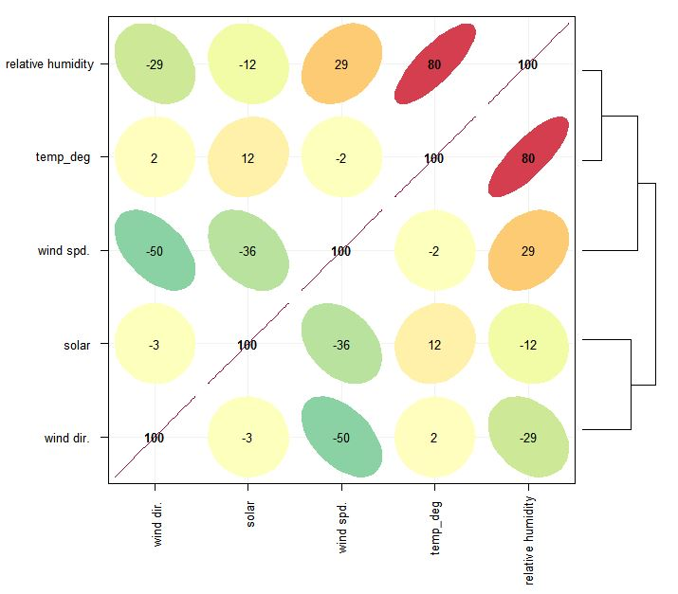
Figure 4: Correlation Matrix for the Solar radiation and the Meteorological parameters.

Table 5: Multiple Linear Regression (MLR) Relationship for two and three Predictor Variables
Parameters |  |  | Multiple Regression Equations | $$R^{2}$$ | $$p-value$$ | Significant level | $$RMSE$$ | Measured value | Predicted Value
Solar Rad. | Model 1 | T, rh | $$solar=5.56 T-5.25rh+424.43$$ | 0.27 | 0.02 | 0.05 | 197.0 | 151.37 | 151.74
Solar Rad. | Model 2 | Rh, ws | $$solar=121.88 ws-2.93rh+227.67$$ | 0.25 | 0.002 | 0.05 | 199.70 | 151.37 | 151.51
Solar Rad. | Model 3 | T, ws | $$solar=1.23 T+125.63ws-9.58$$ | 0.15 | 0.001 | 0.05 | 213.22 | 151.37 | 151.38
Solar Rad. | Model 4 | T, rh, ws | $$solar=5.15 T-4.97 rh+111.3 ws+289.11$$ | 0.37 | 0.02 | 0.05 | 182.69 | 151.37 | 151.14

4.0 CONCLUSION
The monthly mean daily hours of global solar radiation and the meteorological parameters for four years (2010-2013) at Akure, the capital city of Ondo State in the South-Western geopolitical region of Nigeria. Akure lies between longitude 4.944055°E to 5.82864°E and latitude 7.491780°N to 6.96375°N. The results showed a strong relationship between solar radiation, temperature, relative humidity and wind speed in wet season while a lag of one month was observed in the dry season. In 2010, minimum solar radiation of 133.36 w/m² coincided with minimum temperature of 23.56 ºC, maximum relative humidity of 85.97 % and maximum wind speed of 1.26 m/s in the month of August. Maximum solar radiation of 187.26 w/m² and maximum temperature 26.08 ºC were recorded in March.
In 2011, minimum solar radiation 115.07 w/m² matched with minimum temperature 10.2 ºC, maximum relative humidity 85.57 % and maximum wind speed 1.39 m/s in the month of August and September. In 2012, minimum solar radiation of 102.73 w/m² harmonized with minimum temperature of 22.75 ºC, maximum relative humidity 86.65 % and maximum wind speed 1.54 m/s in the month of August. In 2013, minimum solar radiation of 125.17 w/m² was consistent with minimum temperature of 21.93 ºC, maximum relative humidity of 84.06 % and maximum 1.35 m/s in the month of July. Solar radiation has more significant impact on other meteorological parameter in the wet season at Akure while it drags other parameters with 1 – 2 months lag in the dry season.
In the month August, which was characterized by the peak wet season, the station experiences rainfall break, extremely cloudy overcast and dominance of southwesterly wind. The cloudy atmosphere interrupts the incoming solar radiation with consequent effect of extremely humid and cold air temperature. This was why the low solar radiation aligned with high relative humidity and high wind speed in August while the temperature was the lowest. However, in dry season, the lag was as a result of onset of rainfall characterized by withdrawal of dry and cold northeasterly wind which interfered with response of boundary later to incoming radiation due to irregular heavy rainfall and rapid evaporation at this period. The results clearly aligned with predominant weather patterns in the tropical station influenced by back-and-forth movement of inter-tropical discontinuity during transition from dry to wet season.

Disclaimer (Artificial intelligence)
Author(s) hereby declares that NO generative AI technologies such as Large Language Models (ChatGPT, COPILOT, etc.) and text-to-image generators have been used during the writing or editing of this manuscript.

5.0 REFERENCES
- Assi, A. and Jama. M., (2018). “Estimating Global Solar Radiation on Horizontal from Sunshine, Journal of Meteorology. Vol 32 (12): pp 200-211
- Bechini, L., Ducco, G., Donatelli, M., and Stein, A. (2010). “Modelling, Interpolation and
Stochastic Simulation in Space and Time of Global Solar Radiation”. Agriculture, Ecosystems & Environment, Vol 81(1): pp 29–42.
- Bojanowski, J, Donatelli, M, Skidmore, T and Vrieling, A. (2013). An auto-calibration procedure for empirical solar radiation models. Environmental Modelling and Software. Vol 49. pp 118-128.
- Brisson, A., Borgne, P, and Marsouin, A. (2019). “Development of Algorithms for Surface Solar Irradiance retrieval at O&SI SAF Low and Mid Latitudes”. Meteorology in France. Vol 22(9): pp 25-34.
- Carslaw, D.C. (2015). The open-air manual–open-source tools for analyzing air pollution data. Journal of Meteorology. Vol 1: pp 1–4.
- Carslaw, D.C. and Ropkins, K. (2012). Open air — an R package for air quality data analysis. Environment Modelling Software. Pp 27–28.
- Ertekin, C. and Evrendilek, F. (2017). “Spatio-Temporal Modeling of Global Solar Radiation Dynamics as a Function of sunshine Duration for Turkey. Journal of Agricultural and Forest Meteorology”, Vol 145: pp 36–47.
- Esomchi, et al., (2025): Performance of Generated Models with Statistical Tools for Estimation of Solar Radiation in Umudike, Abia State, Nigeria. Communication in Physical Sciences, 2024, 12(3): pp. 1094-1108
- Frank, J. S., (2013). “Predicting Solar Radiation Based on Available weather Indicators". Masters Theses. https://scholarsmine.mst.edu/masters_theses/7361
- Gautam, D., Neupane, B. R., Khadka, N., Koirala, M. P., Baniya, S., and Baniya, H. B. (2024). Impact of Meteorological Parameters on Global Solar Radiation (GSR) at Nepalgunj Airport, Nepal. Amrit Journal, 4(1), 28–39. https://doi.org/10.3126/amritj.v4i1.73750
- Hunt, L. A., Kuchar, L., and Swanton, C. J. (2018). “Estimation of Solar Radiation for Use in Crop Modelling. Agricultural and Forest Meteorology”, Vol 91(3–4): pp 293 –300.
- Idumu, A. M, Ishaya, K. S., Bello, E., Ifeka, A., (2020). Evaluation of Onset and Cessation of Rainfall and Temperature on Maize Yield in Akure, Ondo State, Nigeria. Atmospheric and Climate Sciences. Vol 10; pp 125-145.
- Jianhui Bai, Xiaowei Wan, Erhan Arslan, and Xuemei Zong (2024): Global Solar Radiation and Its Interactions with Atmospheric Substances and Their Effects on Air Temperature Change in Ankara Province. Climate 2024, 12(3), 35; https://doi.org/10.3390/cli12030035
- Kehinde A. J and Richard A. B (2022): Characteristics and Distribution of Some Radiation
Parameters over Nigeria. European Journal of Environment and Earth Sciences. DOI: http://dx.doi.org/10.24018/ejgeo Vol 3, Issue 4, July 2022, pp. 32-40
- Laszlo, I., Ciren, P., Liu, H., Kondragunta, S., Tarpley, J. D., and Goldberg, M. D. (2018). “Remote Sensing of Aerosol and Radiation from Geostationary Satellites”. Advances in Space Research, Vol 41: pp 1882–1893.
- Liu, G., Rasul, M. G., Amanullah, M. T. O., and. Khan, M. M. K., (2012). "Techno-Economic Simulation and Optimization of Residential Grid-Connected PV System for the Queensland Climate." Renewable Energy Vol 45: pp 146-155.
- Mavi, H. S. and Tupper, G. J., (2014). Principles and Applications of Climate Studies in Agriculture, Research on Agrometerology. pp 10-447 https://doi.org/10.1201/9781482277999
- NASA, (2010). Measuring and Test Equipment Specifications. NASA Measurement Quality Assurance Handbook. NASA-HDBK-8739-19-2
- Nwokolo, S.C., Ogbulezie, J.C., Toge, C.K., John-Jaja, S.A., (2017). Photosynthetically Active Radiation Estimation and Modeling over Different Climatic Zones in Nigeria. Journal of Agric Ecological Research. http://sciencedomain.org/journal/37/ articles-press.
- Olabode, A.D, (2015). Urban Extreme Weather: A Challenge for a Healthy Living Environment in Akure, Ondo State, Nigeria. Journal of Climatology. Vol 3: pp 775-791.
- Olujumoke, A. O, Folorunso, M. A, Valerie, G and Christia, B. (2016). Descriptive analysis of rainfall and temperature trends over Akure, Nigeria. Journal of Geography and Regional Planning, Vol. 9(11), pp. 195-202, DOI:10.5897/JGRP2016.0583
- Paulescu, F. M and Tulcan, P, E. (2016). "Models for Obtaining Daily Global Solar Radiation from Air Temperature Data." Journal of Atmospheric Research. Vol 79 (3-4): pp 227-240. Prieto, J. I., Martínez-García, J. C., and García, D., (2019). "Correlation between Global Solar Radiation and Air Temperature in Asturias, Spain." Solar Energy. Vol 83 (7): pp 1076-1085.
- Şen, Z. (2017). "Simple Nonlinear Solar Radiation Estimation Model." Renewable Energy Vol 32 (2): pp 342-350.
- Şahin, A. D. 2017. "A New Formulation for Solar Radiation and Sunshine Duration Estimation."International Journal of Energy Research. Vol 31 (2): pp 109-118
- World Meteorology Organization (WMO), (2008). Guide to Meteorological Instruments and Methods of Observation. Seventh edition. Chairperson Publication Board. ISBN 978-92-63-100085
- Osinowo, A. A., & Okogbue, E. C. (2014). Correlation of global solar irradiance with some meteorological parameters and validation of some existing solar radiation models with measured data over selected climatic zones in Nigeria. Int. J. Innov. Educ. Res, 2(1924), 41-56.

