Comparative Analysis of Rainfall Heights Over Geo-Climatic Zones for Satellite Communication at Ku-Band in Nigeria

ABSTRACT
Nigeria's diverse geo-climatic zones present varying challenges for satellite communications, particularly at Ku-band frequencies (12-18 GHz). Rainfall height is a critical parameter that directly influences signal propagation and the link margin, as such, must be taken into account when designing Ku-band satellite communication systems to ensure reliable and efficient communication. This study presents a comparative analysis of rainfall heights over Nigeria geo-climatic zones, the impact on Ku-band satellite communication system and a monthly zero degree isotherm height (km) across the selected locations. Data collected over three years from four locations, each representing a major geo-climatic zone of Nigeria, were analyzed using a purposeful sampling technique. The result shows seasonal variations of the Zero Degree Isotherm Height (ZDH) over Nigeria geo-climatic zones with lower heights occurring in January (4.1 to 4.15km) and December (4.18 to 4.2km) while peak heights occur during the middle months of the year (July-August), reaching approximately 4.42-4.43km. ESUT (Enugu) and FUTA (Akure) shows slightly higher values than PJAA (Abuja) and FUGUS (Gusau) most times of the year, particularly in August where it reaches about 4.43km. The distribution of measured ZDIH across the zones varies (4.109km – 4.431km) as against 4.5km predicted by the International Telecommunication Union-Radio (ITU-R). The measured rain height ranges from 4.46km to 4.79km across the zones as against 4.86km predicted by ITU-R for the same zones. ITU-R model maintains a constant height throughout the period, showing no seasonal variation. The study reveals that the ITU-R model overestimates the ZDIH by approximately 4.4-5.6% and the rain height by about 4.1-5.2% across Nigerian zones. Therefore, this substantial difference must be put into consideration as an important parameter in Meteorology and for estimating rain attenuation in satellite communication systems in Nigeria to avoid the overestimation of rain attenuation and subsequent over-engineering of satellite link budgets.
Keywords: Rainfall height, Ku-band, satellite communications, geo-climatic zones, zero isothermal height

1. INTRODUCTION
Rainfall presents a significant challenge for satellite communications, particularly in the Ku-band frequency range (Ojo & Rotimi, 2015). In tropical region like Nigeria, understanding the variations in rainfall heights across different geo-climatic zones is crucial for designing reliable satellite communication systems (Ojo et al., 2022; Pelton, 2012). The understanding of rainfall pattern and the impact on satellite communication is a global concern for both scientist and engineers. The application of Satellite communication systems operating at frequencies (12-18 GHz), include telecommunications, broadcasting, and navigation (Panagopoulos et al., 2004; Shriram et al. 2015). However, one of the major challenges facing Ku-band satellite communications is the impact of rain attenuation on signal quality and reliability. Rain attenuation is the loss of signal power due to absorption and scattering by raindrops, and it is a serious problem for Ku-band systems, particularly in tropical regions with high rainfall rates (Ojo et al., 2022; Kodheli et al., 2020; Semire et al., 2019; Crane, 1984). Rain height, which is the vertical extent of precipitation from the surface, is crucial in determining the extent of rain attenuation. Increase in rain height, increases the signal attenuation, leading to a decrease in signal quality and reliability (Ippolito, 2008; Stigsson, 2024; Shih, 2008). Hence, understanding the impact of rain height on rain attenuation at Ku-band satellite communications is very important for designing and operating reliable and efficient satellite communication systems (Acharya, 2017; Adetan & Obiyemi, 2016). A higher rain height results in a longer path length and increasing attenuation. It is used to calculate the effective path length, which is then used to estimate rain attenuation. Inaccurate rain height estimation can lead to underestimation or overestimation of attenuation. Rain height affects the link budget, which determines the signal-to-noise ratio and overall system performance (Orji et al., 2024; Crane, 2002).

Figure 1: Schematic diagram of Earth-Space path showing input parameters
For ITU-R rain attenuation prediction model (ITU-R, 2021). (A - Frozen height; B - Rain height; C: Liquid precipitation; D: Earth-space path)
In the case of Nigeria, the different geo-climatic zones suggest that there will be variations in key factors like rainfall, temperature, elevation, and latitude. However, ITU-R model did not take into consideration the variations that may come as a result of the differences in each climatic zone. Therefore, the objective of this study is to carry out analysis of rainfall heights over Nigeria geo-climatic zones for satellite communication at Ku-band and to compare ITU-R model with the measured data of the selected locations in Nigeria. The findings of this study will be useful for the development of more accurate rain attenuation prediction models and improve satellite communication system design especially in Nigeria.
2. Location and Geology of Study Area
Nigeria is located on latitude 9.0820° N and longitude of 8.6753° E. These coordinates place Nigeria in both the northern and the eastern hemispheres (World Population Review, 2025). Nigeria is primarily divided into four geo-climatic zones which includes Tropical Monsoon/Rainforest in the south (characterized by year-round high rainfall typically over 2,000 mm, warm and humid. There's a double maxima peak in rainfall, with a short "August break"), Tropical Continental/Savannah in the central regions (has distinct wet season April to September and dry season December to March, with temperatures generally above 18°C), Sahel/Hot Semi-Arid in the far north (hot, dry with a short rainy season from June to September. Annual rainfall is typically low, ranging from 500 mm to 750 mm), and Alpine or Montane in highland areas (typically above 1,520 meters like the Jos Plateau with cooler temperatures) (Edokpa et al., 2024; Ogolo & Mathew, 2022; World Bank Group, 2020). To obtain a representative sample of the entire population, a purposeful sampling technique was adopted to select one location from each of the geo-climatic zones where the Weather Stations are installed. This translates to four locations including Akure (FUTA), Enugu (ESUT), Gusau (FUGUS), and Abuja (PJAA). The map of Nigeria showing the geo-climatic zones and the sites where the weather stations were located is shown in Figure 2 and the location codes with their corresponding GPS locations is presented in Table 1.
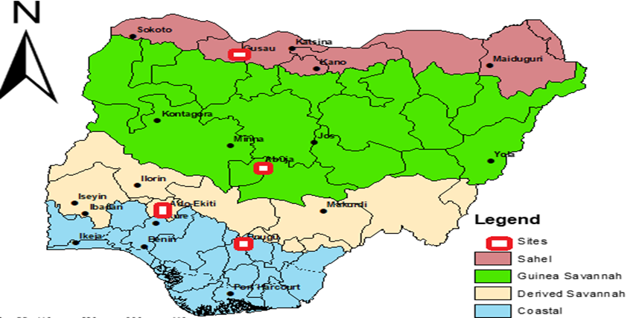
Figure 2. Map of Nigeria showing the geo-climatic zones and the sites where the weather stations are located (Lawal et al 2021)
Table 1: Location codes with their corresponding GPS locations
S/N | GEO-CLIMATIC LOCATION | NAME | STATE CODE | GPS L0CATION
 |  |  |  | LONGITUDE | LATITUDE
1 | SAHEL | GUSAU | FUGUS | 12.10⁰N | 06.15⁰ E
2 | GUINEA SAVANNAH | ABUJA | PJAA | 08.97⁰N | 07.37⁰E
3 | DERIVED SAVANNAH | AKURE | FUTA | 07.31⁰N | 05.14⁰E
4 | COASTAL | ENUGU | ESUT | 07.27⁰N | 06.25⁰E

3. MATERIALS AND METHODS
The TRMM-PR data product used for this work is the PR 2A23 version 7. The algorithm for extraction and processing 2A23 v7 is contained in the product manual (TRMM-PR manual v7, 2011). Rain flag, rain type, bright band height (BBH), bright band status, Intensity, Freezing Height Levels (FHL) also known as Zero Degree Isotherm Heights (ZDIH) h₀ and other rain-related parameters were extracted from TRMM-PR. Algorithm 2A23 helps to identify rain type, provides information on freezing height level such as detection of presence of bright band in rain echoes and also the bright band height when it exists.
The study analyzed rainfall height data collected across thirty-six months from four strategic locations in Nigeria. The measurements were recorded in kilometers (km) with tracked seasonal variations throughout the period. The satellite signal was received by the 90 cm offset parabolic dish, at an elevation angle of 42º to the down converter and the beacon receiver. The precipitate measurement was made up of the Davis Vantage Vue weather station, which logs rain rate and other meteorological parameters at the required one-minute integration time. Both satellite signal and precipitation measurement were done concurrently. The Davis station has an Integrated Sensor Suit (ISS), which is collocated with the outdoor unit of the beacon signal measurement setup i.e. the offset parabolic antenna. Data was collected from January, 2019 to December 2021 in all the locations. Within the experimental period, attenuation data were collected for 80% of the time, while rainfall data were collected for about 85% of the time from all study locations except at FUGUS where measurements are for a period of 70% of the time, while rainfall data were collected for about 75% of the time for attenuation and rain rate measurement, respectively. Figures 3 and 4 show the experimental set-up used to concurrently measure and record rain rate, rain attenuation, signal loss and noise threshold in FUTA and PJAA.
On TRMM-PR, the data from the TRMM was used to validate the data from the weather stations used for the research. During the validation, the spatial and temporal alignment was checked: TRMM data was used as footprint-based dataset and weather station provide point data, using interpolation. Root-mean-square error was used as the validation matric.
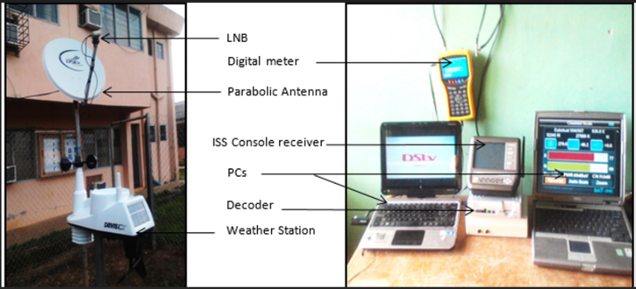
Figure 3. FUTA site weather station’s outdoor and indoor facility
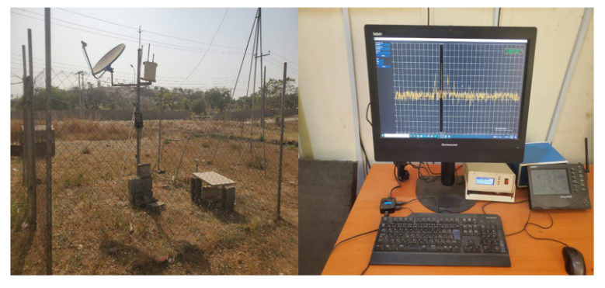
Figure 4. PJAA site weather station’s outdoor and indoor facility

3.1 Measurement of Rain Height
The rain height affects the path length through the rainfall as shown in Figure 1. The rain height is determined from the 0°C isotherm height, which is the height above the Earth’s surface where the temperature is 0°C. The ZDIH depends on the season and weather conditions. The height associated with the 0°C isotherm is the threshold between the air layers with temperatures above 0°C at lower altitudes and those with temperatures below freezing at higher altitudes. According to ITU-R (2013), ZDIH is related to rain height as follows

$h_{R }= h_{o}+0.36km$ (1)
where $h_{R }$ is the rain height and $h_{o}$ is the zero isotherm height

4. RESULTS AND DISCUSSION
The results of this study show the monthly average zero isothermal heights and the monthly mean rain heights for the various geo-climatic zones in the study locations as presented in Tables 2 and 3 while Figure 5 is a histogram showing the average rainfall accumulation for the period of 36 months of study.
Table 2: Monthly Average ZDIH over the Study Locations
MONTHS | FUTA (km) | ESUT (km) | FUGUS (km) | PJAA (km) | ITU-R (km)
JAN | 4.10 | 4.15 | 4.10 | 4.15 | 4.50
FEB. | 4.16 | 4.20 | 4.20 | 4.20 | 4.50
MAR. | 4.20 | 4.25 | 4.25 | 4.25 | 4.50
APR. | 4.25 | 4.30 | 4.25 | 4.25 | 4.50
MAY. | 4.30 | 4.30 | 4.30 | 4.30 | 4.50
JUN. | 4.35 | 4.40 | 4.35 | 4.30 | 4.50
JUL. | 4.42 | 4.43 | 4.35 | 4.35 | 4.50
AUG. | 4.42 | 4.43 | 4.35 | 4.35 | 4.50
SEP. | 4.30 | 4.40 | 4.40 | 4.35 | 4.50
OCT. | 4.25 | 4.35 | 4.40 | 4.30 | 4.50
NOV. | 4.20 | 4.30 | 4.25 | 4.25 | 4.50
DEC. | 4.18 | 4.20 | 4.20 | 4.20 | 4.50
Mean | 4.26 | 4.31 | 4.28 | 4.27 | 4.50

Table 3: Monthly mean rain height over the study locations
MONTHS | FUTA (km) | ESUT (km) | FUGUS (km) | PJAA (km) | ITU-R (km)
JAN | 4.46 | 4.51 | 4.46 | 4.51 | 4.86
FEB. | 4.52 | 4.56 | 4.56 | 4.56 | 4.86
MAR. | 4.56 | 4.61 | 4.61 | 4.61 | 4.86
APR. | 4.61 | 4.66 | 4.61 | 4.61 | 4.86
MAY. | 4.66 | 4.66 | 4.66 | 4.66 | 4.86
JUN. | 4.71 | 4.76 | 4.71 | 4.66 | 4.86
JUL. | 4.78 | 4.79 | 4.71 | 4.71 | 4.86
AUG. | 4.78 | 4.79 | 4.71 | 4.71 | 4.86
SEP. | 4.66 | 4.76 | 4.76 | 4.71 | 4.86
OCT. | 4.61 | 4.71 | 4.76 | 4.66 | 4.86
NOV. | 4.56 | 4.66 | 4.61 | 4.61 | 4.86
DEC. | 4.54 | 4.56 | 4.56 | 4.56 | 4.86
Mean | 4.62 | 4.67 | 4.64 | 4.63 | 4.86

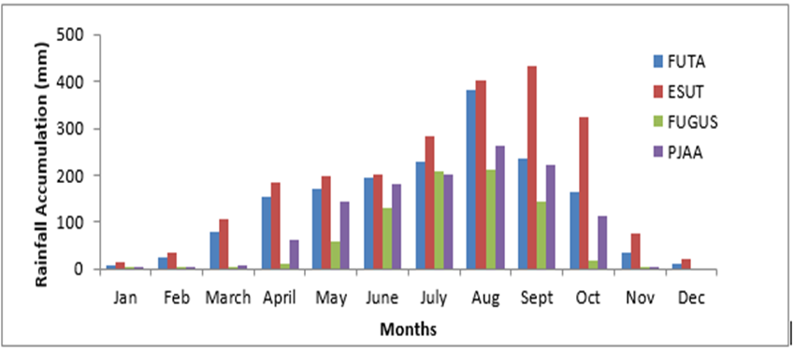
Figure 5. Average rainfall accumulation for the period of 36 months of study

Figure 6. Distribution of 0º C isotherm height over the study locations

Figure 7. The mean ZIDH over the geo-climatic zones vs ITU-R prediction

Figure 8. Distribution of rain height over the study locations

Figure 9. Mean rain height over the geo-climatic zones vs ITU-R prediction

“The information on the vertical structure and extent of precipitation events is an important factor in the prediction of attenuation due to rain on a satellite to earth slant link. It is assumed that rain is uniform from the ground to the rain height according to the simple vertical structure and the rain height is quoted to be that level up to which rain drops present have a diameter of 0.1 mm or more” (Ajayi & Odunewu, 1990). From Figure 5, the average rain period is between March and November. There is moderate rainfall experienced throughout the period with peak values in July and August. Figure 6, presents the distribution of the ZDIH for Nigeria showing variation within the different geo-climatic zones with FUTA, ESUT and PJAA showing similar trends throughout the year while and FUGUS trends were slightly different in pattern especially towards end of the year with peak values in September and October. From Table 2, the lowest height was 4.10 km experienced in FUTA and FUGUS in January, while the highest was 4.43 km experienced in ESUT between July and August. Mean ZDIH for the different geo-climatic zones as shown in Figure 7 are 4.26 km, 4.31 km, 4.28 km and 4.27 km for FUTA, ESUT, FUGUS and PJAA respectively as against 4.50 km predicted by ITU-R model. Figure 8 is the distribution of rain height over the study locations showing variation within the different geo-climatic zones with similar pattern with the ZDIH. From Table 3 the lowest rain height is 4.46 km while the highest rain height was 4.79 km. The mean rain height for each geo-climatic zones as shown in Figure 9 are 4.62 km, 4.67 km, 4.64 km and 4.63 km for FUTA, ESUT, FUGUS and PJAA respectively as against 4.86 km predicted by ITU-R model.
The rainfall accumulation for 36 months from the selected locations reveals that ESUT has the highest rainfall and that was recorded in July and August. Based on the information, Enugu State is characterized with heavy rainfall except for the relatively dry period between December and February. For the period of observation, the mean annual rainfall is about 1800 mm with the peak amount of rainfall of about 440 mm. Akure station followed Enugu relatively with an annual mean precipitation of about 1750 mm and peak amount of about 382 mm occurring in July and August and Abuja site with an annual mean rainfall of about 1400 mm. “Gusau station continue to receive minimum rainfall all through the period of study with no rainfall throughout the dry season. Generally, the period of intense rainy months including June to October; these months are needed to be subjected to further analysis in order to select the worst months in the studied locations” (Iroka et al., 2022).
Findings from this studies have revealed that the 0°C isotherm heights are higher during the wet months of the year (April – October) than the rest of the calendar month (dry months- November- March). This is in agreement with the observation made by Mandeep (2011) that during the period of enhanced shower activities, 0°C isotherm heights is higher than during the dry months due to the convective heating. In overall, the mean 0°C isotherm heights vary from 4.26 km, 4.31 km, 4.28 km and 4.27 km, over FUTA, ESUT, FUGUS and PJAA, respectively. However, ITU-R model predicted an annual average value of 4.5 km for this region corresponds to location based percentage error of 5.63%, 4.41%, 5.14% and 5.39% respectively for FUTA, ESUT, FUGUS and PJAA. The implication is that, rain attenuation estimated using the value predicted by the ITU will be overestimated in this region due to the annual average estimated value of the 0°C isotherm height used.
The mean values of rain heights 4.62 km, 4.67 km, 4.64 km and 4.63 km, for FUTA, ESUT, FUGUS and PJAA respectively using the measured 0°C isotherm height puts the average h_{r} over Nigeria at 4.64 km above mean sea level. The percentage error based on each of the locations is 5.19%, 4.07%, 4.74% and 4.97% respectively for FUTA, ESUT, FUGUS and PJAA. This variation is Significant during peak rainfall months in all regions which suggests a need for region-specific model for accurate rain attenuation prediction in Nigeria. With highest value of 4.79 km recorded at ESUT, findings of this study have shown that h_{r} does not depend very much on latitude of the stations as earlier observed by Ajayi and Odunewu (1990). Furthermore, the rainfall height directly influences signal attenuation at Ku-band frequencies in the form of lower, moderate and high attenuation across the zones. Other impacts are short, longer and extended duration of significant attenuation events across the locations. The result implies that maximum signal attenuation is likely to occur between July and September while more stable satellite communication conditions are likely to occur between January and February.

5. CONCLUSION
The different geo-climatic regions of Nigeria show marked variations in rainfall height patterns, which significantly impact Ku-band satellite communications’ performance. This study reveals some crucial insights for optimizing system design across the country. The highest rainfall heights occur in the coastal region, resulting in a high level signal attenuation. In contrast, lower rainfall heights occur in the Sahel region resulting in more reliable service and operating with reduced fade margins. This regional disparity underscores the need for location-specific design approaches rather than implementing a standardized solution across Nigeria. Notable discrepancies between measured rainfall data and ITU-R predictions highlight the necessity for continued local measurements and development of region-specific models tailored to tropical environments. Future Ku-band satellite communication systems in Nigeria should incorporate these regional rainfall height variations to optimize overall system performance, maximize service availability and minimize costs by avoiding unnecessary over-engineering in less challenging climatic zone by using ITU-R model alone. These findings contribute valuable data for developing more effective satellite communication infrastructure that accounts for Nigeria's diverse climate conditions, ultimately improving service reliability and cost-efficiency.

Disclaimer (Artificial intelligence)
Option 1:
Author(s) hereby declare that NO generative AI technologies such as Large Language Models (ChatGPT, COPILOT, etc.) and text-to-image generators have been used during the writing or editing of this manuscript.

REFERENCES
Acharya, R. (2017). Satellite Signal Propagation , Impairments and Mitigation. Elsevier Ltd. https://doi.org/10.1016/B978-0-12-809732-8.00001-6
Adetan, O., & Obiyemi, O. O. (2016). A Analysis of Raindrop Diameters for Rainfall Attenuation in Southern Africa. International Journal of Electrical & Computer Engineering (2088-8708), 6(1).
Crane, R. K. (2002). Analysis of the effects of water on the ACTS propagation terminal antenna, Antennas and Propagation, IEEE Trans., 50, 954–965.
Crane R. K. (1984). A comparative evaluation for several rain attenuation prediction models. Final Rep., NASW-3645N, ASA,
Edokpa, D. O., Ede, P. N., Brown, J., Adeyemi, A. J., & Pukiche, I. U. (2024).The Nigeria climate zones: Variability, trends and analysis from era-interim data (2010-2015). International Journal of Climate Research, 8(1), 1-24. DOI: 10.18488/112.v8i1.3804.
Ippolito, L. J. (2008). Propagation Effects Handbook for Satellite Systems Design. Online Journal of Space Communication, 1(2), 15.
ITU-R (2021). Acquisition, presentation and analysis of data in studies of radiowave propagation. ITU Radio-communication Bureau, Geneva. P.311-18.
ITU-R (2013). “Propagation data and prediction methods required for the design of Earth-Space telecommunication systems,” Recommendation, Geneva. P. 618-11.
Kodheli, O., Lagunas, E., Maturo, N., Sharma, S. K., Shankar, B., Montoya, J. F. M., & Goussetis, G. (2020). Satellite communications in the new space era: A survey and future challenges. IEEE Communications Surveys & Tutorials, 23(1), 70-109.
Lawal, Y. B., Ojo, J. S., Falodun, S. E., & Olurotimi, E. O. (2021). Geoclimatic characterization and latitudinal dependence of rain heights over Nigeria. In Journal of Physics: Conference Series (Vol. 2034, No. 1, p. 012010). IOP Publishing.
Mandeep, J. S. (2011). Comparison of rain rate models for equatorial climate in South East Asia. Geofizika, 28(2), 265-274.
Ogolo, E. O., & Matthew, O. J. (2022). Spatial and temporal analysis of observed trends in extreme precipitation events in different climatic zones of Nigeria. Theoretical and Applied Climatology, 148(2), 1335–1351. DOI: 10.1007/s00704-022-04006-7.
Ojo, J. S., Ijomah, C. K., & Akinpelu, S. B. (2022). YOJNA neural networks for earth-space link applications: a prediction approach and inter-comparison of rain-influenced attenuation models. Int. J. Intell. Syst. Appl. (IJISA), 14(5), 47-58.
Ojo, J. S., & Rotimi, O. C. (2015). Diurnal and seasonal variations of rain rate and rain attenuation on Ku-band satellite systems in a tropical region: A synthetic storm techniques approach. Journal of computer and communications, 3(4), 1-10.
Orji, O. P., Chukwuebuka, O. D., Chidinma, O. E., Josephine, U. O., Chinedu, O. P., Uzochukwu, I. E., ... & Chiemeka, I. U. (2024). Rain Attenuation Prediction at Different Time Percentages for Ku, K, and Ka Bands Satellite Communication Systems over Nigeria. Journal of Astronomy and Space Sciences, 41(1), 25-33.
Panagopoulos, A. D., Arapoglou, P. D. M., & Cottis, P. G. (2004). Satellite communications at Ku, Ka, and V bands: Propagation impairments and mitigation techniques. IEEE communications surveys & tutorials, 6(3), 2-14.
Pelton J. N. (2012). Introduction to Satellite Communications (pp. 1–3). https://doi.org/10.1007/978-1-4614-1994-5_1
Semire, F. A, Adekunle, A. J., & Abolade, R. A. (2019). A Study on Rain Rate Prediction of Southwestern Nigeria. Physical Science International Journal, 23 (4), 1-12
Shih, S. P. (2008). A study of precipitation effect on tropospheric electromagnetic wave propagation at frequency 19.5 GHz. Terrestrial, Atmospheric and Oceanic Sciences, 19(3), 309–319. https://doi.org/10.3319/TAO.2008.19.3.309(AA)
Shriram, R., Imthiyaz, A. S., & Kumar, L. S. K. (2015). Calculation of cloud attenuation at Ku and Ka band frequencies over Indian region. Conference: 2015 IEEE Applied Electromagnetics Conference (AEMC), DOI: 10.1109/AEMC.2015.7509233.
Stigsson, A. (2024). Satellite signal attenuation due to atmospheric influences in northern Sweden.
TRMM-PR Team (2011). Tropical Rainfall Measuring Mission (TRMM) precipitation radar algorithm 2A23 Instruction Manual for Version 7. JAXA-NASA, 170 pp. Accessed on 12th Jnuary, 2019. [Available online at http://www.eorc.jaxa.jp/TRMM/documents/PR_algorithmroduct_information/pr_manual/PR_Instruction_manual7_L1.pdf.].
World Bank Group (2020). Observed Climatology of Average Mean Surface Air Temperature 1991-2020. Climate Change Knowledge Portal for Development Practitioners and Policy Makers.
World Population Review (2025). Where is Nigeria in the World? Accessed on 08 October, 2025 from https://worldpopulationreview.com/countries/nigeria/location.
Iroka, C. J., Adeleke, O. A., & Sanusi, Y. K. (2022). Comparative Analysis of Rain–Induced Attenuation Models Over Some Selected Nigerian Cities. UNIOSUN Journal of Engineering and Environmental Sciences, 4(1), 11-12.

