Passive optimization of indoor thermal comfort using bio-based materials: An experimental study in a classroom in Burkina Faso

.
ABSTRACT

In the Sahel region, which is characterized by extreme temperatures and energy insecurity, improving thermal comfort in school buildings is a major challenge. This study evaluates the effectiveness of a bio-based construction solution integrated into the envelope of a typical school building in Burkina Faso. This solution is a bio-based eco-material made from plant aggregates (rice husks) and plant fibers (kapok) used as a false ceiling and wall coating. A dual approach was adopted: experimental measurements in situ during the hot season and dynamic thermal modeling using Python. The results show a reduction in maximum indoor temperature of up to 8°C, a thermal phase shift of approximately 5 hours, and a decrease of more than 57% in the intensity of thermal discomfort (>32°C) when the eco-material is used in combination with a false ceiling and wall coating. In addition, the theoretical cooling energy demand is reduced by 30%, highlighting the energy benefits of these materials in terms of energy efficiency. These performances, combined with the accessibility of local resources and ease of implementation, position these solutions as credible alternatives for the design of bioclimatic schools adapted to the Sahelian climate. The study also highlights limitations related to hygrothermal sustainability and calls for further work to assess the impact perceived by users and reproducibility on a large scale.

Keywords: Thermal comfort; bio-based materials; passive architecture; Sahelian climate; energy simulation; green false ceiling; wall coating

1. INTRODUCTION

Energy management in the building sector is now central to strategies for climate resilience and reducing greenhouse gas (GHG) emissions (International Labour Organization, 2019). In the Sahelian region, the building sector accounts for a significant proportion of energy consumption due to designs that are unsuited to local climatic conditions (ADEME and al., 2021; Magniont, 2010; Dejeant and al., 2021). The thermal envelope (roof, walls, joinery, and flooring) is the main vector for unwanted heat transfer: the roof contributes to approximately 25-30% of heat gain, walls to 25%, windows to 10-15%, and floors to 7-10% (ADEME, 2022; Umurigirwa-Vasseur, 2014). The thermal comfort of students in classrooms in these areas is a crucial issue: high temperatures combined with often inadequate natural ventilation can affect health, cognitive performance and overall comfort. In addition, active equipment (air conditioning, controlled mechanical ventilation) is rarely viable in rural and peri-urban contexts in the Sahel due to high investment and operating costs. In Burkina Faso, most school buildings are constructed from cement blocks and covered with metal roofs without insulation or effective ventilation systems. This configuration leads to extreme overheating during the hot season, when indoor temperatures can exceed 35°C, compromising students' concentration (Bar-Or, 1983). To avoid health problems (fatigue, illness) and a decline in students' concentration, the temperature in a classroom should not fall below 18°C (WHO, 2018), with the ideal range being between 20°C and 26°C. In addition, children's high body surface area to mass ratio and less efficient sweating reduce their ability to dissipate heat, increasing their thermal vulnerability (Deoux, 2019). A meta-analysis conducted in a temperate climate identified an indoor neutral temperature of around 22°C as favorable for cognitive performance (Deoux, 2019). In hot countries such as Nigeria, India, and Malaysia, residents are accustomed to higher temperatures. Studies show that in naturally ventilated buildings (without air conditioning), people still feel comfortable at temperatures around 29°C (Peuportier and al., 2023). The literature focuses mainly on the energy efficiency of residential and commercial buildings (Kabore, 2020; Cycle Terre, 2020), while schools, healthcare facilities and other recreational facilities (community centers) are not included in the study. in hot and dry tropical climates remain understudied. In light of these shortcomings, passive comfort solutions based on bio-based materials with low environmental impact - such as stabilized raw earth plasters or plant fiber panels - offer significant potential for improving thermal comfort thanks to their thermal inertia and hygrometric properties (Ouedraogo and al., 2023; Steyn and al., 2025; Gbadeyan and al., 2023; Compaore and al., 2022). Numerous recent studies highlight the growing interest in bio-based materials (plant fibers, agricultural waste, mycelium, improved raw earth, etc.) in the African context, both for their thermal and environmental potential and their socio-economic benefits (Ouedraogo and al., 2025a; A. L. S.-N. Ouedraogo and al., 2024; Kiki and al., 2025; Mushtaha and al., 2021). In Cameroon, Ganou Koungang et al. evaluated a system based on compressed earth blocks incorporating bio-based aggregates (coconut and Canarium). Compared to a cinder block construction (44% comfort), a house built with compressed earth blocks offers much better thermal comfort (96%), while saving around 100 kWh per year and reducing its carbon footprint. In South Africa, Ganou Koungang and al., (2023), used bagasse ash from sugar cane, palm trees, and rice husks to partially replace cement, resulting in a reduction in density (-25%) and an increase in strength (up to +65%) for bricks, concrete, and paving stones (Gbadeyan and al., 2023). In Burkina Faso, Sandwidi et al. conducted a hygrothermal test on a prototype house built from earth mixed with Hibiscus cannabinus fibers, demonstrating a reduction in indoor temperature variations and improved thermal inertia (Sandwidi and al., 2023). In addition, a study in this country models bio-based (straw, hemp, reed) and recycled materials for the insulation of office buildings, advocating their adoption in simple, circular improvements. Our research focuses on evaluating two bio-based solutions integrated into the envelope of schools in the Sudano-Sahelian climate: a plaster-stabilized rice husk wall coating and a false ceiling made of plant-based panels. To this end, we conducted an in-situ experiment on a school building and performed dynamic simulations using a Python-transcribed numerical code to quantify the impact of these two systems on thermal and energy performance. This article is divided into four main sections. The first section introduces the context and research questions. The second section presents details of the pilot site and the experimental methodology followed by a description of the modeling carried out in Python and the various simulation scenarios considered. The third section analyzes results obtained, offering a critical analysis, concrete implications, and practical recommendations. Finally, the fourth section concludes the study by summarizing the main contributions and opening up future perspectives.

2. material and methods

2.1 Study site and climatic characteristics

Ouahigouya (13.58°N, -2.42°E; altitude ≈ 335 m) city is located in the Sahelian region of northern Burkina Faso. The city has a semi-arid climate, marked by a prolonged dry season (November to May) and a short but intense wet season (June to September). The average annual temperature is around 29.5°C. Monthly extremes range from 17.7°C in January to 40.8°C in April. Annual rainfall is around 735 mm, concentrated mainly in July, August, and September. Annual sunshine exceeds 3,100 hours with average radiation of 5.4 to 6.7 kWh/m²/day. The city experiences significant daily temperature variations of over 15°C, which is favorable for passive thermal adaptation strategies. The following graph (Fig. 1) shows the main monthly average climate indicators for the period 1991-2020.

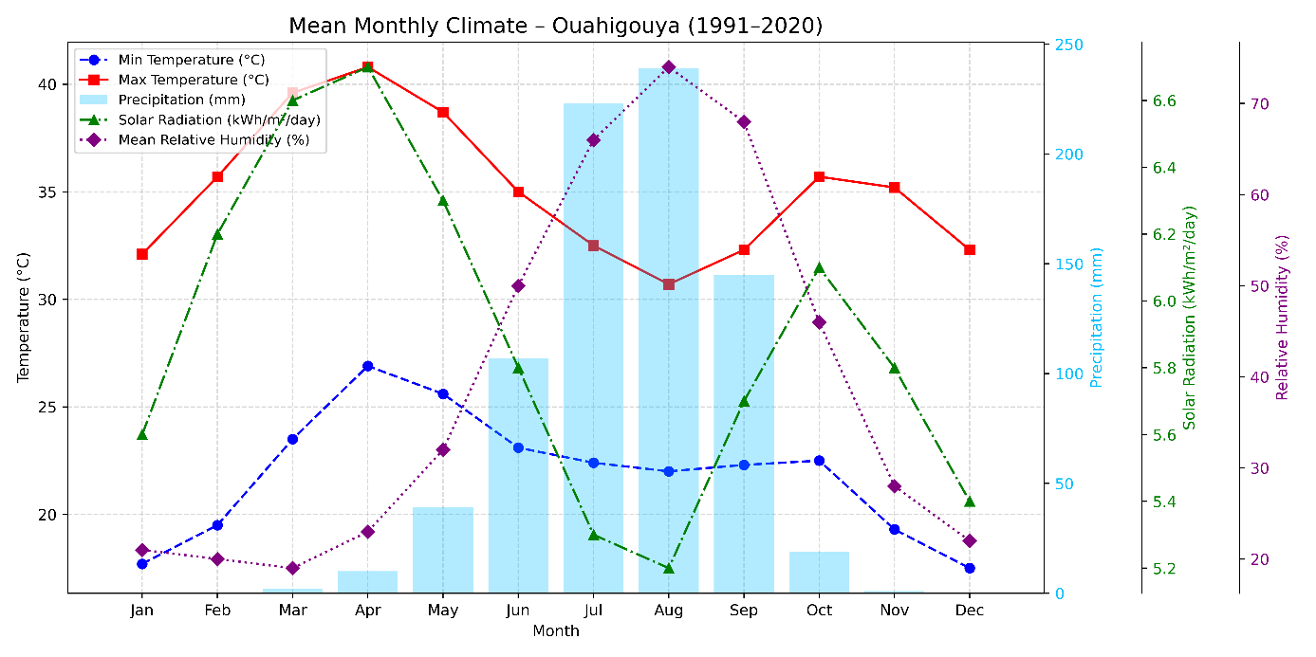

Fig.1. Climatic Factors and Variation over the Year in Ouahigouya
Sources: National Meteorological Agency (NAMA-BF), Climate to Travel, Weather Spark (based on NASA POWER/MERRA 2) and ERA5 (ECMWF)

These data highlight the extreme nature of the Sahelian climate in Ouahigouya, particularly in terms of temperature and sunshine hours. They justify the importance of an appropriate bioclimatic approach for studying thermal comfort in this area.

2.2 Description of the typical school building

2.2.1 Building geometry
The reference school building, representative of most primary schools in Burkina Faso, is parallelepiped in shape. It measures approximately 31 m long, 9 m wide, and 4 m high, with a floor area of 288 m² and an interior volume of approximately 1000 m³. The building rests directly on the ground (earthwork) and is generally located in an open environment, with no vegetation or obstacles nearby. It is correctly oriented along a north-south axis, with the main facades facing north and south (Fig. 2). It consists of three classrooms, an office, a storage room, and a hall (Fig. 3). Each room, designed to accommodate 65 students, is 7 m wide by 9 m long, with an average ceiling height of 3.5 m, a surface area of 63 m², and a volume of 221 m³. The openings include a 1.20 m × 2.20 m door and five 1.20 m × 1.20 m windows.
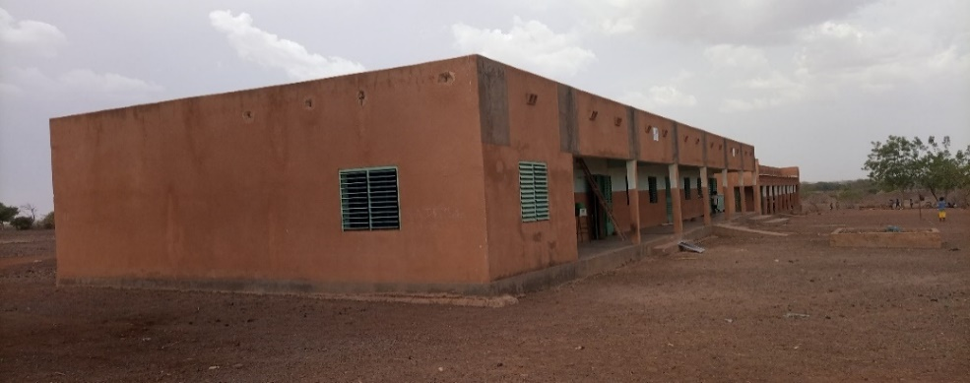

Fig. 2. Photo of a school building (Bourbo A School in Ouahigouya)
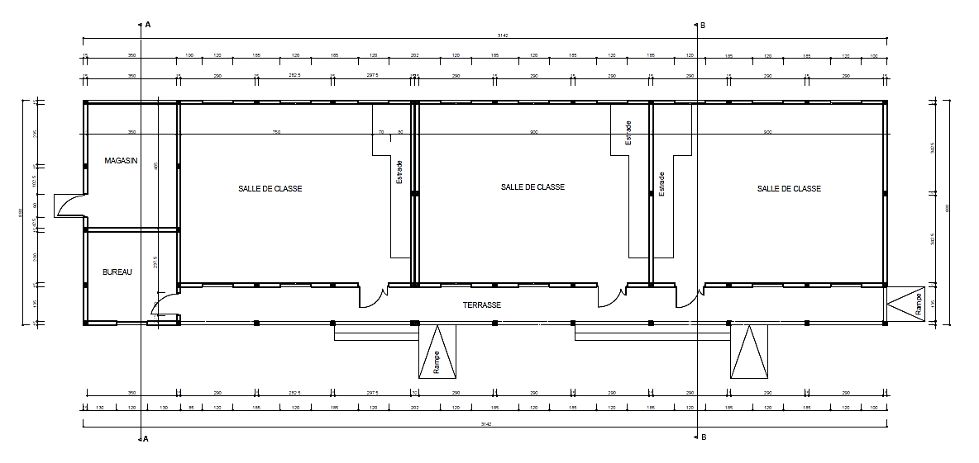

Fig. 3. Floor plan of a typical school building

2.2.2 Composition of the building envelope
The building envelope consists of cement block walls, a reinforced concrete floor, a pre-coated metal sheet roof, and metal louvered doors and windows. The building has no glazing whatsoever. The thermophysical properties of the materials used are summarized in Table 1, based on our experimental tests and the literature (Ouedraogo and al, 2025b).

Table 1. Thermophysical properties of the various materials used in the standard solar building

Materials | e (m) | λ (W.m⁻¹.K⁻¹) | ρ (kg.m³) | cp (J.kg⁻¹.K⁻¹)
Walls (cement blocks) | 0,200 | 1,1 | 930 | 840
Coating (cement) | 0,015 | 1,4 | 892 | 1672
Roof (sheet metal) | 0,0005 | 50.0 | 7800 | 480
Floor (concrete screed) | 0,100 | 2.0 | 2450 | 920
Openings (iron shutters) | 0,001 | 45.0 | 7824 | 1090

e: thickness, λ: thermal conductivity, ρ: density, cp: specific heat

2.3 Description of bio-based materials

The solution implemented is based on a bio-based agro-composite eco-material made from kapok wool and rice husk granules, with plaster used as a hydraulic binder. This choice was motivated by the local availability of raw materials and their thermo-hygrometric properties, particularly in terms of insulation and moisture regulation. This material was incorporated into the building envelope on two levels: as insulating false ceiling panels and as a thin layer of thermoregulatory interior wall coating.

- Insulating false ceiling
The false ceiling consists of 2 cm thick agro-composite panels, with standard dimensions of 120 × 80 × 2 cm, suspended 50 cm below the metal roof to form a continuous air gap. This configuration offers several thermal and technical advantages:
- reduction of direct solar gain, thanks to the combined insulating effect of the material and the air gap;
- attenuation of radiative exchanges, made possible by the low emissivity of the panels and the intermediate air barrier;
- easier installation, thanks to an interlocking system that does not require specialized tools, reducing technical constraints on site.

- Thermoregulatory wall coating
An interior wall coating based on the same agro-composite was applied to the vertical walls in a uniform 2 cm layer. This coating aims to reinforce the thermal inertia of the walls, while ensuring hygrothermal continuity conducive to interior comfort.

- Stabilized compressed earth blocks (BTC)
In addition, and in order to compare the performance of local materials with that of the reference Portland cement, stabilized compressed earth blocks were manufactured and tested. These blocks, measuring 20 × 22 × 11 cm, were stabilized using 1% rice husk ash and 4% Portland cement, with a view to making use of local resources while improving mechanical strength.

All of the thermophysical and mechanical characteristics of these bio-based and geo-based materials were tested in a series of laboratory experiments, the results of which are summarized in Table 2 below.

Table 2. Thermophysical and mechanical properties of bio-based and geo-based materials

Matériau | ρ (kg.m³) | λ (W.m⁻¹.K⁻¹) | cp (J.kg⁻¹.K⁻¹) | Rc (MPa)
Agro-composite false ceiling | 936 ± 4 | 0,135 ± 0,010 | 723 ± 10 | 3,6 ± 0,4
Stabilized BTC (walls) | 1839 ± 5 | 0,720 ± 0,068 | 1994 ± 45 | 6,8 ± 0,4
Agro-composite coating | 650 ± 4 | 0,110 ± 0,010 | 1400 ± 44 | 1,1 ± 0,4

Rc: Mechanical resistance to compression

2.4 Experimental measurements

A series of measurements was taken before and after the bio-based solution was implemented, during the hot season. The parameters measured included the ambient temperature and relative humidity of indoor and outdoor, as well as the temperature of inner and outer surfaces (walls, ceiling), using calibrated sensors (Fig. 4). The data was recorded every 10 minutes. The equipment used was:
- MSR145 S sensors for ambient temperature and relative humidity.
- WBGT meter 87786 Logger, incorporating: a black globe thermometer (average radiant temperature), an anemometer (air velocity according to EN 13779), and an air thermometer, a hygrometer. To take a measurement with the WBGT meter, the device is placed at the height of the head, torso, and legs of a seated individual. If this is not possible, the device is placed 1.5 m above the ground to take the measurement.
- Two Graphtec GL240 recorders, each equipped with 10 type J thermocouples (range: - 100°C to + 100°C, accuracy ± 0.5°C) to measure the internal and external temperatures of the walls.

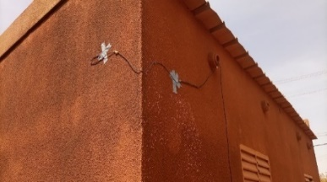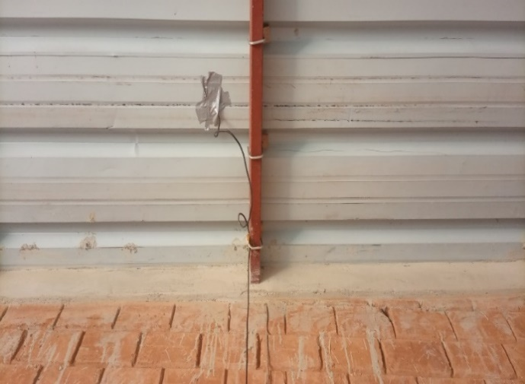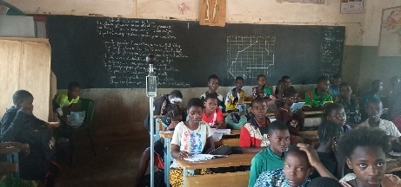
(c)
(b)
(a)

Fig. 4. Measuring instruments: (a) Measurement of the temperature of the wall facades, (b) Roof temperature measurement (internal face), and (c) WBGT-meter

2.5 Thermal modeling

A digital model of the building was developed using Python and validated by comparison with in situ measurements. Five configurations were simulated: reference (no intervention), plaster only, false ceiling only, combination of plaster + ceiling and combination of plaster + ceiling + stabilized BTC.
The thermophysical properties of materials are derived from experimental data. The weather data used for the simulation are those from the reference year (Typical Meteorological Year) representing the median climatic conditions of the site over a period of 30 years (1991-2020). The simulation covers a representative period of three months (March to May) with hourly intervals. It is based on a nodal approach, assuming:
- materials with constant thermophysical properties,
- homogeneous temperatures of the walls and indoor air,
- walls treated as gray bodies,
- the sky as a black body.
Heat balances are established for each surface (wall, roof, floor) interacting with the exterior or interior, as well as for the interior air volume. The system of equations (equations 1 to 8) is then discretized using the implicit finite difference method and formulated in matrix form for numerical resolution.

a) Heat balance of a surface of the envelope in contact with the external environment
The heat balance of the external facades of the walls (east, west, north, south) and the roof is given by equation 1:
$C_{pse}\frac{dT_{se}}{dt}=Φ_{cve}+Φ_{rc}+Φ_{rs}+Φ_{cd}+α_{se}G$ (1)
Where $T_{se}, C_{pse}, Φ_{ce}, Φ_{rc}, Φ_{rs}, Φ_{cd}, α_{se}, G$ are respectively : temperatures of the external wall and roof (°C), wall heat capacity (J/K), convective heat flow with the outside air (W), radiative heat flow with the sky (W), radiative heat flow with the ground (W), conductive heat flow between the inner and outer walls (W), absorptivity for an external wall, and global solar radiation (W/m²).

b) Temperature in the walls (roof, wall, floor)
One-dimensional conduction model:
$ρ{ c}_{p}\frac{∂T(x,t)}{∂t}= \frac{∂^{2}T(x,t)}{∂^{2}x}$ (2)
Where $ρ$, ${ c}_{p}$, , $T(x,t)$ are respectively: density, specific heat (J/kg.K), thermal conductivity (W/m.K) and temperature of the wall (°C).
c) Heat balance of a surface of the envelope in contact with indoor air
The heat balance of the interior surfaces of the walls (east, west, north, south), roof, ceiling, and floor is given by equation 3:
$C_{psi}\frac{dT_{si}}{dt}=Φ_{cd}+Φ_{cvi}+Φ_{rm}$ (3)
Where $T_{si}, C_{psi}, Φ_{cd}, Φ_{cvi}, Φ_{rm}$ are respectively : temperatures of the internal wall (°C), wall heat capacity (J/K), conductive heat flow between the inner and outer walls (W), convective heat flow with the inside air (W) and radiative heat flow with all walls (W).

d) Thermal convective balance of the indoor air node
$C_{pai} \frac{dT_{ai}}{dt}=\sum_{p=1}^{N_{pi}}{ h_{ci,p} S_{si,p} \left(T_{ai}-T_{si,p}\right)}+ρ_{ai}{ c}_{ai} {\dot{Q}}_{v} \left(T_{ae}- T_{ai}\right)+Φ_{int}$ (4)
Where $T_{ai}, C_{pai}, h_{ci,p}, S_{si,p}, T_{si,p}, {\dot{Q}}_{v}, T_{ae}, Φ_{int}$ are respectively : temperatures of air (°C), air heat capacity (J/K), convection coefficient with the inner wall (W/m.K), wall surface (m²), wall temperature (°C), air exchange rate (vol/h) and internal heat gains (W).

e) Indoor air humidity balance
In the building's humidity model, we take into account moisture transfers related to vapor diffusion and condensation on wall surfaces, exchanges through air renewal with the outside, and moisture production due to occupants. Moisture production is 0.18 kg/h for an average person (Compaoré, 2018). The relative humidity balance for the air zone is given by equation 5.
$ρ_{ai} V_{ai} \frac{∂w_{ai}}{∂t} = \sum_{p=1}^{N_{p}}{h_{m,p}{ S}_{si,p} (P_{v,p}- P_{v,ai})} + {\sum_{z=1}^{N_{z}}{m_{z} \left(w_{z}-w_{ai}\right)}+ ρ}_{ai} V_{ai} {\dot{Q}}_{v}.\left(w_{ae}- w_{ai}\right)+ m_{int}$ (5)
$ϕ_{a}= \frac{P_{v,a}}{P_{vs}}=\frac{w_{a}}{w_{s}}$ (6)
$P_{vs}=140974×{10}^{5} ×exp\left( \frac{-3928,5}{T_{ai} + 231,667} \right)$ (7)
$w_{s}=\frac{1}{ρ R T_{ai}}× exp\left(23,7093- \frac{4111}{T_{ai} + 35,45} \right)$ (8)
$h_{m,p}=7,4×{10}^{-5} h_{ci,p}$
With $w_{ai}$, $w_{ae}$, $w_{s}$, $m_{int}$ representing the moisture content of the indoor air, the moisture content of the outdoor air, and the rate of indoor moisture production. $P_{vs}$, $P_{v,ai}$ are the vapor pressure of the air near the wall and that of the indoor air. $h_{m,p}$, $h_{ci,p}$ represent the mass transfer coefficient of water vapor and the convective heat transfer coefficient with the wall (p).

2.6 Analysis and criteria

The indicators analyzed are:
- average and maximum indoor temperature during occupancy hours (7:00 a.m.to 5:00 p.m.), school days being Monday to Friday and from October to June;
- number of hours exceeding the thermal comfort threshold (32°C). This takes into account acclimatization and the fact that in hot, dry climates, people can tolerate temperatures of 31°C more easily.;
- theoretical energy requirement for cooling (kWh/day);
- basic statistical analysis (averages, standard deviations) of time series;
- critical discussion of the hygrothermal durability of materials and limitations of the model.

2.6.1. Comfort range (restraint) in natural ventilation:
20°C ≤ Indoor temperature ≤ 32°C,
Wind speed ≤ 0.2 m/s
40% ≤ Relative humidity of indoor air ≤ 60%

2.6.2. Adaptive comfort temperature
In accordance with standard NF EN 15251, the adaptive indoor comfort temperature ($T_{c}$) is linked to the 7-day rolling average outdoor temperature ($T_{RM7}$) according to the following relationships:
$T_{c}= 0,33 T_{RM7}+18,8$ (9)
$T_{RM7}= \frac{T_{-1} + 0,8 T_{-2} + 0,6 T_{-3} + 0,5 T_{-4} + 0,4 T_{-5} + 0,3 T_{-6} + 0,2 T_{-7}}{3,8}$ (10)
$T_{c}$ : Optimal indoor comfort temperature [°C]
$T_{RM7}$ : Daily rolling average outdoor temperature over 7 days [°C]
$T_{-1}$ to $T_{-7}$: Average daily temperatures for days J₋₁ to J₋₇ [°C]

2.6.3. Degrees of discomfort (DH)
DH is defined as the sum of the hourly differences between the indoor air temperature and the maximum comfort temperature during periods of occupancy.
${Si T}_{op}\left(t\right)>T_{C}+3$ $DH=\int_{t0}^{t}{\left[T_{op}\left(t\right)-{(T}_{C}+3)\right]}.dt$ (11)
According to RE2020:
- If DH < 350°C.h, comfortable building;
- 350 ≤ DI < 600°C.h, borderline comfort;
- 600 ≤ DI < 1250°C.h, cooling system recommended;
- DI > 1250°C.h, uncomfortable building.

3. results and discussion

3.1. Main sources of thermal discomfort

Thermograms obtained on the roof (Fig. 5a) and windows (Fig. 5b) reveal surface temperatures exceeding 55°C during hot periods. The walls, particularly the roof and exposed walls, thus contribute significantly to the rise in indoor temperature.

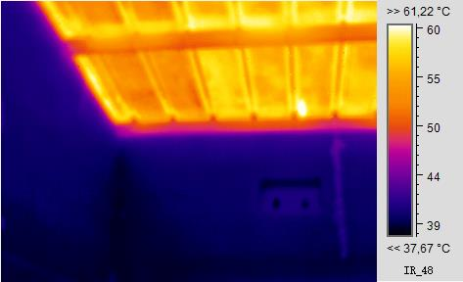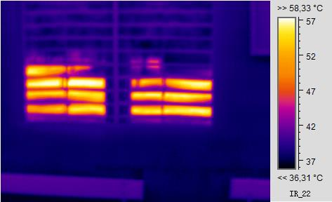
(b)
(a)

Fig. 5. Thermograms of a school building on March 23, 2023, at 11:20 a.m.: (a) Roof, (b) Windows

The internal temperatures of the walls (Fig. 6a) regularly exceed 40°C during the day, while the indoor air (Fig. 6b) varies between 25°C and 43°C. This confirms the critical role of the building envelope in heat transfer.

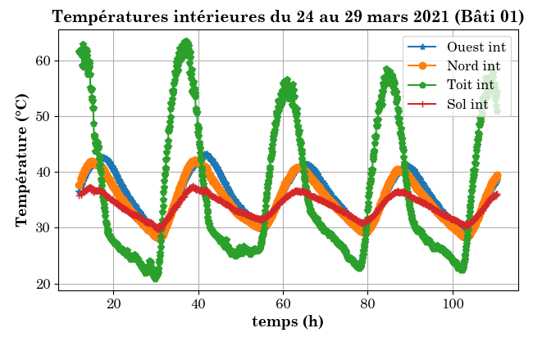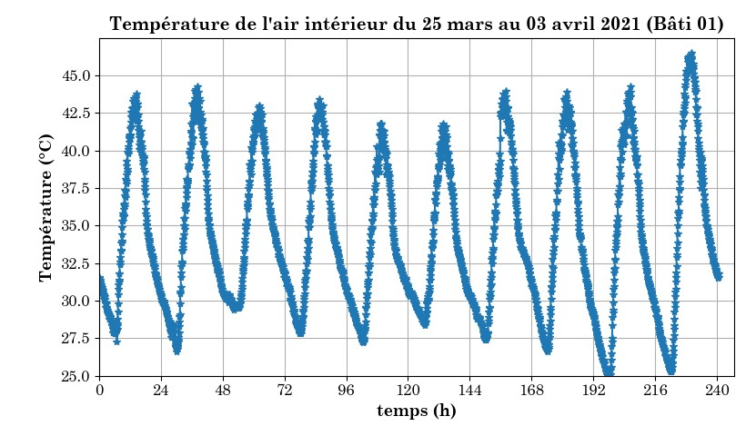
(b)
(a)

Fig. 6. Temperature profiles inside the school building: (a) Temperatures of interior walls, and (b) Indoor air temperature

3.2 Impact of bio-based materials on indoor temperature

The improved standard school building combines compressed earth brick (CEB) walls with a metal roof, insulated by a false ceiling made of a thermo-corrective eco-material composed of rice husks and kapok wool bound with plaster. The same material is also applied as a coating on the CEB walls. This combination enhances the building's insulation and thermal inertia, significantly improving its interior comfort by slowing down and reducing heat transfer.

Experimental measurements show a significant reduction in maximum indoor temperature, up to 7°C when the two bio-based solutions are combined. The average annual damping is 6.5°C during the school year (Fig. 7). Thermal modeling confirms these results, with a notable drop in temperatures during peak heat periods (2 p.m. to 5 p.m.). The coating acts as a thermal buffer, dampening fluctuations, while the false ceiling limits direct radiation.

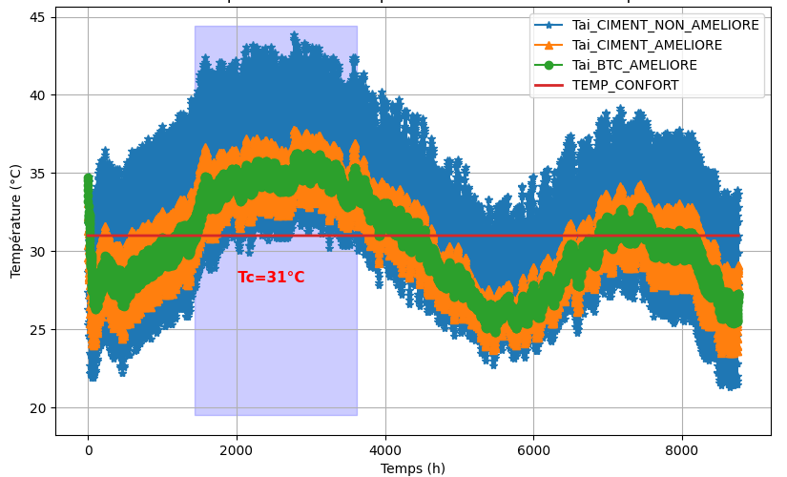

Fig. 7. Evolution of depreciation during the year

The installation of a false ceiling made of rice husk-based panels results in during the hottest day a reduction of 8,2°C (Fig. 8) and a thermal phase shift of 5 hours (Fig. 9), compared to the uninsulated building. The maximum indoor temperature thus drops from 44°C to 36°C.

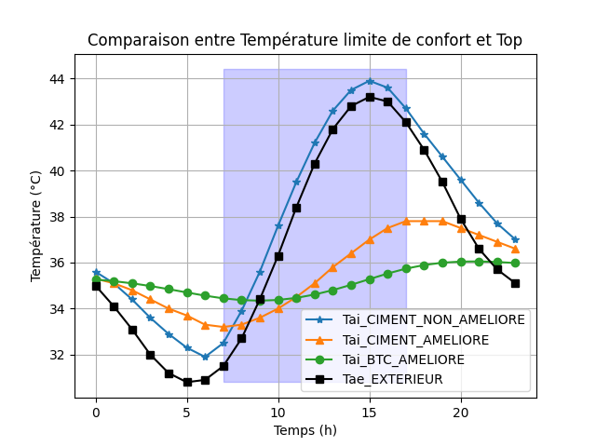
$$∆T=8,2°C$$

Fig. 8. Thermal amplitude damping during the hottest day of year

$$=5 h$$

Fig. 9: Thermal phase shift during the hottest day of the year

3.3 Improved thermal comfort thanks to bio-based materials

The number of hours of discomfort (temperature > 32°C) is substantially reduced, from 9 hours to 3.2 hours per day on average. This reduction is particularly noticeable in the afternoon, a critical period for occupants.
The discomfort rate calculated (Fig. 10) according to EN 15251 standard falls from 71% (uninsulated building, Fig. 10a) to 32% (optimized building, Fig. 10a), a reduction of 39%.

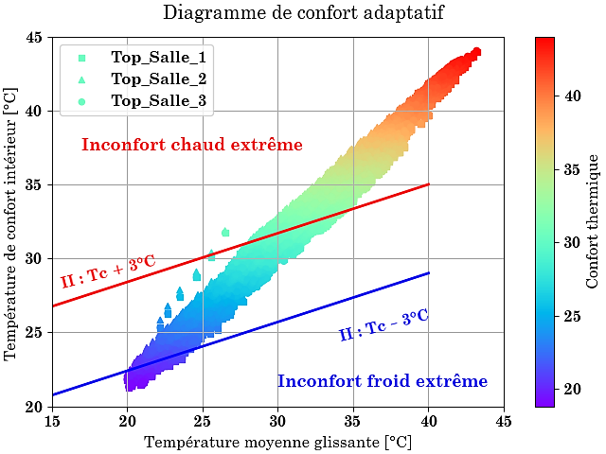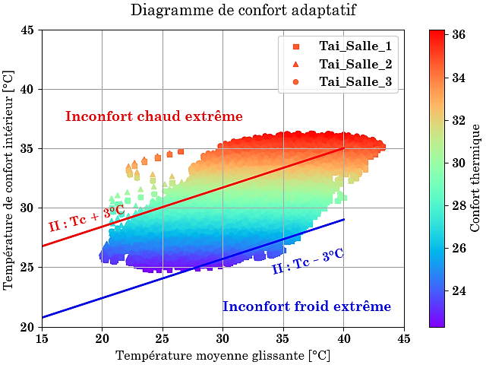
(a)
(b)

Fig. 10. Adaptive comfort diagram for a typical school building: (a) Unimproved building, and (b) Improved building

The high inertia of the building improved with local materials considerably reduces the intensity of discomfort in the school building, which goes from 9600°C.h to 2481°C.h, a reduction of 74% over the entire school year. In the hot season (Fig. 11a), the intensity of discomfort drops from 5184°C.h to 2198°C.h (a reduction of 57%), demonstrating the thermal inertia effect of bio-based materials. Regardless of the month, there is a reduction in discomfort (Fig. 11b).

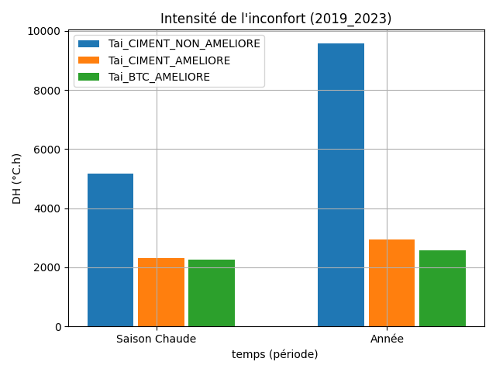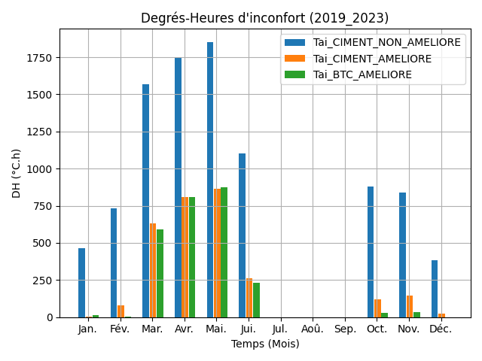
(b)
(a)

Fig. 11. Intensity of discomfort in the upgraded school building: (a) Hot season and school year, and (b) By month

The results obtained highlight the effectiveness of bio-based materials in improving the hygrothermal comfort of school buildings in the Sahelian climate. The false ceiling and rice husk-based plaster work in synergy to reduce thermal amplitude and delay temperature peaks. However, the application of European standards such as EN 15251, RE2020, or the adaptive models of Brager or Givoni poses certain limitations in the Sahelian context. For example, the EN 15251 standard is based on maximum outdoor temperatures of 32°C, whereas local peaks frequently exceed 40°C. Similarly, the comfort thresholds set by RE2020 (26-28°C) do not take into account the acclimatization of occupants in naturally ventilated buildings. An adjustment to 31°C, as proposed in this study, therefore appears more realistic and consistent with field observations. These adjustments reinforce the need for thermal regulations adapted to the specificities of the Sahelian climate, particularly for highly exposed school buildings.

3.4 Reduction in cooling requirements

The simulation estimates energy savings of around 53% in cooling requirements, thus validating the energy benefits of the proposed passive solutions. These gains are significant in a context where air conditioning is often inaccessible and even costly.

While the results are encouraging, the sensitivity of bio-based materials to humidity raises a major question about their long-term durability and performance. The simulations do not yet incorporate dynamic hygrothermal effects or complete seasonal variation. Furthermore, the study does not take into account perceived comfort (PMV/PPD indices) or the socio-economic aspects of large-scale implementation. However, rice husks are widely available.

4. Conclusion

This study demonstrated the effectiveness of bio-based materials in improving thermal comfort in school buildings in the Sahel. The combination of a coating and a false ceiling made of rice husk and kapok panels reduced the maximum indoor temperature by up to 8°C and the hours of thermal discomfort by more than 57%. Dynamic simulations indicate a decrease of approximately 53% in air conditioning demand. The optimized model, combining BTC walls and bio-based elements, has a thermal phase shift of 5 hours, an attenuation of 8°C, and a 74% reduction in the intensity of discomfort and a 30% reduction in its duration. These results confirm the relevance of passive, local, and ecological solutions in the Sahelian context. However, the hygrothermal durability of the materials and the lack of assessment of perceived comfort call for further research. The development of local standards for thermal comfort in schools also appears to be a priority in order to promote the widespread adoption of these solutions.

DISCLAIMER (ARTIFICIAL INTELLIGENCE)
Wehereby declare that NO generative AI technologies such as Large Language Models (ChatGPT, COPILOT, etc) and text-to-image generators have been used during writing or editing of this manuscript.

References

ADEME, (2022). Renovating and insulating your home. www.agirpourlatransition.ademe.fr/particuliers
ADEME, Dorémi, & Enertech. (2021). Step-by-step energy-efficient renovation-Study of the conditions necessary to achieve BBC renovation performance or equivalent in individual housing (Expertise, pp. 1-20) www.ademe.fr/mediatheque
Bar-Or, O. (1983). Pediatric sports medicine for the practitioner (complete manual in pediatrics). New York: Springer-Verlag.
Climates and Travel (2025). Climat - Ouahigouya (Burkina Faso). Accessed September 20, 2025. https://www.climatsetvoyages.com/climat/burkina-faso/ouahigouya
Compaore, A., Sawadogo, G. L., Ouédraogo, D., & Ouédraogo, O. (2022). Thermal study and formulation of briquettes based on kapok-plaster wool for the insulation of local ovens suitable for grilling meat. International Journal of Current Research, 14(08), Article 08. https://doi.org/10.24941/ijcr.43864.08.2022
Dejeant, F., Garnier, P., & Joffroy, T. (2021). Local materials, materials of the future: Local resources for sustainable cities and territories in Africa (CRAterre Éditions). CRAterre.
Deoux, S. (2019). Thermal comfort study in schools (p. 57) [Report]. enviroBAT-Reunion. https://cdn.s-pass.org/SPASSDATA/attachments/2019_12/16/5f7f4c60322f0-d77710.pdf
Earth Cycle. (2020). BTC/S stabilized compressed earth block (p. 2) [Report]. Earth Cycle. www.cycle-terre.eu
ERA5 (ECMWF), via Climate Change Knowledge Portal (2025). Accessed September 20, 2025. https://climateknowledgeportal.worldbank.org/country/burkina-faso
Ganou Koungang, B. M., Courard, L., Tatchum Defo, U., Ndapeu, D., Njeugna, E., & Attia, S. (2023). Evaluating Thermal Performance and Environmental Impact of Compressed Earth Blocks with Cocos and Canarium Aggregates: A Study in Douala, Cameroon. International Journal of Engineering Research in Africa, 67, 49-66. https://doi.org/10.4028/p-71UmdZ
Gbadeyan, O. J., Sibiya, L., Mpongwana, N., Linganiso, L. Z., Linganiso, E. C., & Deenadayalu, N. (2023). Manufacturing of building materials using agricultural waste (sugarcane bagasse ash) for sustainable construction: Towards a low carbon economy. A review. International Journal of Sustainable Engineering, 16(1), 368-382. https://doi.org/10.1080/19397038.2023.2283545
International Labour Organization. (2019). Working on a hotter planet : The impact of heat stress on labor productivity and decent work. International Labour Organization. www.ilo.org/publns
Kabore, A. (2020). Hygrothermal modeling of building envelopes using hemp (pp. 1-252) [Master's thesis]. University of Quebec.
Kiki, G., Remond, R., Ouertani, S., Houngan, & Andre, P. (2025). Hygrothermal performance of compressed earth blocks incorporating quackgrass straw. Construction and Building Materials, 482(141495). https://doi.org/10.1016/j.conbuildmat.2025.141495
Magniont, C. (2010). Contribution to the formulation and characterization of an eco-friendly building material based on agricultural resources [Doctoral thesis]. University of Toulouse III - Paul Sabatier.
Mushtaha, E., Salameh, T., Kharrufa, S., Mori, T., Aldawoud, A., Hamad, R., & Nemer, T. (2021). The impact of passive design strategies on cooling loads of buildings in temperate climate. Case Studies in Thermal Engineering, 28(101588), 1-14. https://doi.org/10.1016/j.csite.2021.101588
NAMA-BF : National Meteorological Agency - Burkina Faso (2025). The climate of our cities. Accessed September 20, 2025. https://meteoburkina.bf/le-climat-de-nos-villes/
Ouedraogo, A. L. S.-N., Hema, C., N’guiro, S. M., Nshimiyimana, P., and Messan, A. (2024). Optimizing the thermal comfort of buildings in a hot and dry tropical climate: A comparative approach between compressed earth/concrete block shells. Journal of Minerals and Materials Characterization and Engineering, 12(1), 1–16. https://doi.org/10.4236/jmmce.2024.121001
Ouedraogo, O., Compaore, A., Namoano, D., Igo, S.W. and Dissa, A.O. (2023) Development and Characterization of Thermal Insulation Panels Based on Rice Husks and Kapok Fibers Stabilized with Plaster. International Journal of Engineering, Science and Mathematics, 12(4), 19‑27. https://ijesm.co.in/uploads/68/14526_pdf.pdf
Ouedraogo, O., Igo, W. S., Ouedraogo, R. W., & Compaore, A. (2025a). Thermal study of a prototype of a Sahel-type humanitarian emergency shelter, semi-permanent, degradable, and made from biological materials. Open Journal of Applied Science, 15(5), 1391–1407. https://doi.org/10.4236/ojapps.2025.155098
Ouedraogo, O., (2025b). Valorisation des Résidus Agricoles par la formulation de Nouveaux Matériaux Isolants Biosourcés : Application à l'amélioration du Confort Thermique de Bâtiments Scolaires au Burkina Faso [Thèse de Doctorat Unique]. Université Joseph KI-ZERBO? pp 205
Peuportier, B., Monnier, R., Schalbart, P., Armines, Lemonsu, A., LEROY, B., CNRM, François, E., Wurtz, E., Ouvrier-Bonnz, O., CEA-INES, & Ziv, N. (2023). Resilience: Adapting buildings to climate change – Final report (p. 375). https://librairie.ademe.fr/
Sandwidi, S., Compaore, A., Haro, K., Tere, D., Sinon, S., Sanogo, O., & Bere, A. (2023). Hygrothermal investigation of a house made of local bio-based clay building materials: Experimental study. Open Journal of Applied Sciences, 13(1), 60–75. https://doi.org/10.4236/ojapps.2023.131006
Steyn, K., de Williers, W., & Babafemi, A. J. (2025). A comprehensive review of hempcrete as a sustainable building material. innovative Infrastructure Solutions, 10(97), 1‑45. https://doi.org/10.1007/s41062-025-01906-1
Umurigirwa-Vasseur, B. S. (2014). Development and characterization of a hemp-starch agromaterial for construction [Doctoral thesis]. University of Reims Champagne-Ardenne.
Weather Spark, based on NASA POWER/MERRA 2 (2025). Climate and average weather throughout the year in Burkina Faso. Accessed September 20, 2025. https://weatherspark.com/countries/BF#Figures-Temperature
WHO Housing and health guidelines. Geneva: World Health Organization; 2018. License: CC BY-NC-SA 3.0 IGO. https://iris.who.int/server/api/core/bitstreams/be014865-921a-482c-89e4-9191c7476e13/content

