Smart Decimation Algorithm for Efficient Spectroscopic Data Reduction: Methodology and Raman Case Study

Abstract
Spectroscopic techniques such as Raman, UV–Vis, and FTIR generate large datasets that challenge storage, processing, and real-time analysis. Conventional reduction strategies, particularly uniform 1-of-N decimation, often distort narrow peaks and compromise chemically relevant information. In this study, we present and evaluate a Smart Decimation framework for spectroscopic data reduction, integrating Interest Level Analysis (ILA) with an adaptive Sample Selection Module (SSM) to allocate sampling density proportionally to spectral variability. Using a synthetic Raman-like spectrum with five representative vibrational peaks, Smart Decimation reduced the dataset size by ~80% (from 5000 to ~1000 points) while preserving spectral fidelity. Compared with uniform decimation, cross-correlation improved from 0.91 to 0.98, mean peak position error decreased from ±3.0 cm⁻¹ to ±0.5 cm⁻¹, and intensity error was reduced from 12% to 2%. Validation with experimental Raman spectra of TiO₂ confirmed that Smart Decimation consistently preserved sharp vibrational bands with minimal distortion. Additional benchmarking against PCA-based and wavelet compression methods demonstrated that Smart Decimation achieved the best balance of accuracy, simplicity, and real-time applicability. These results establish Smart Decimation as a scalable and practical solution for modern spectroscopic workflows, with potential applications in portable Raman spectrometers, pharmaceutical quality control, biomedical diagnostics, and large-scale spectral libraries.

Keywords: Spectroscopic techniques, Conventional reduction strategies, Smart Decimation, Raman spectrometers

Introduction
Spectroscopy is a cornerstone of modern analytical science, enabling the identification, quantification, and characterization of chemical and biological systems through their interaction with electromagnetic radiation. Techniques such as Raman, ultraviolet-visible (UV-Vis), and Fourier-transform infrared (FTIR) spectroscopy provide rich molecular information by capturing vibrational and electronic transitions encoded within distinct spectral peaks [1–3]. The importance of spectroscopy extends from fundamental research in materials and nanoscience [4,5] to biomedical diagnostics [6,7], pharmaceutical quality control [8,9], and environmental monitoring [10,11]. In these contexts, precise retention of spectral features, such as peak position, width, and intensity, is critical for a robust interpretation.
With the increasing resolution of modern spectrometers, datasets often contain several thousand sampling points per spectrum [12,13]. While dense sampling ensures the capture of fine spectral details, it also creates challenges in data storage, computational analysis, and real-time transmission, particularly in high-throughput facilities and portable devices [14,15]. Large-scale initiatives such as spectral libraries for machine learning [16,17] and chemometric modeling [18,19] further exacerbate the burden of storing and processing vast quantities of high-dimensional spectral data.
Traditional methods for reducing spectral data volumes, such as uniform downsampling or the widely used 1-of-N decimation strategy, select points at fixed intervals regardless of spectral content. Although simple and computationally efficient, uniform decimation often distorts or suppresses sharp peaks that are essential for chemical fingerprinting [20]. This limitation is particularly problematic for Raman and UV-Vis spectra, where sharp bands encode subtle but critical differences between molecular species [21,22].
Recent studies have emphasized the value of adaptive sampling and data compression strategies across various scientific domains. In biomedical engineering, adaptive subsampling has been applied to electroencephalography (EEG) and electrocardiography (ECG) signals to reduce data while preserving clinically relevant features [23,24]. In physics, adaptive decimation methods have been used to monitor plasma diagnostics in real time, demonstrating significant data reduction without compromising essential information [25]. In environmental monitoring and hyperspectral imaging, adaptive methods have likewise been employed to emphasize information-rich spectral regions while discarding redundancy [26–28].
Despite these advances, spectroscopy remains underexplored in terms of adaptive decimation. Considering that most spectral datasets are dominated by low-information baseline regions interspersed with sharp peaks, spectroscopy provides an ideal testbed for evaluating Smart Decimation methods. Smart Decimation combines Interest Level Analysis (ILA), which identifies regions of high variability, with an adaptive Sample Selection Module (SSM), which allocates sampling density proportionally to informational richness. Unlike uniform decimation, Smart Decimation preserves spectral peaks with high fidelity while achieving substantial data reduction.
This study is important for the scientific community because it directly addresses the challenge of managing increasingly large spectroscopic datasets generated by modern high-resolution instruments. The proposed Smart Decimation method enables efficient data reduction while preserving critical spectral peaks, which ensures the reliability of chemical fingerprinting and quantitative interpretation. By reducing redundancy, the method supports faster computational analysis, more efficient storage, and the development of robust chemometric and machine learning models. These advantages make the approach highly relevant for applications ranging from portable spectroscopy and biomedical diagnostics to large-scale spectral databases and environmental monitoring
The objective of this study is therefore twofold: (i) to adapt the Smart Decimation method—originally designed for real-time monitoring of plasma signals—to spectroscopic data, and (ii) to evaluate its performance against traditional 1-of-N decimation. Through case studies on Raman-like spectra, we demonstrate that Smart Decimation maintains peak intensity and position while significantly reducing data size, offering new possibilities for portable spectrometers, chemometric pipelines, and large-scale spectral databases.

Theoretical Framework
The Smart Decimation framework operates on the principle that not all regions of a spectrum contain equal information content. Spectral peaks encode chemically and physically relevant features, while baseline regions contribute little beyond redundancy. By integrating Interest Level Analysis (ILA) with an adaptive Sample Selection Module (SSM), Smart Decimation dynamically allocates more points to high-information regions.

Interest Level Analysis (ILA)
In spectroscopy, the Level of Interest (LoI) can be defined using local spectral variability. This can be quantified through the absolute derivative of intensity or the variance within a local spectral segment [29]. In this study, LoI for a segment S is defined as:
$$L\left(S\right)=\frac{1}{n}\sum_{i=1}^{n}{\left|\frac{ⅆI(λ_{i})}{ⅆλ}\right|}$$
where $I(λ)$ represents spectral intensity as a function of wavelength (or wavenumber), and 𝑛 is the number of points in the segment. Peaks with steep slopes produce higher LoI values, while flat regions yield lower values.

Adaptive Sample Selection (SSM)
Once LoI values are computed, the SSM distributes sampling points across the spectrum proportionally. The number of retained points in a segment is given by:
$$N_{dec}\left(S\right)=\min\left[\max\left(N_{pri}⋅\frac{L\left(S\right)}{L_{max}},N_{min}\right)N_{max}\right]$$
where $N_{pri}$ is the baseline allocation, $L_{max}$ is the maximum LoI across all segments, and$N_{min}$ ​,$N_{max}$​ define bounds on point allocation. This ensures dense sampling in regions of high spectral activity and sparse sampling in flat baseline regions.

Comparison with Uniform Decimation
Uniform 1-of-N decimation selects every Nth point irrespective of spectral features, frequently leading to distorted peak profiles or shifted maxima. By contrast, Smart Decimation dynamically emphasizes spectral peaks, preserving their fidelity while still achieving 50–80% reduction in data size.

Relevance to Spectroscopy
Adaptive decimation offers several potential benefits in spectroscopic analysis:
- Data efficiency: Reduction in dataset size enables faster storage, transfer, and computation.
- Peak preservation: Critical for chemical fingerprinting and quantitative analysis.
- Real-time capability: Particularly relevant for portable spectrometers and embedded sensing devices.
- Compatibility with chemometrics: Retained spectral fidelity supports robust multivariate analysis and machine learning models.
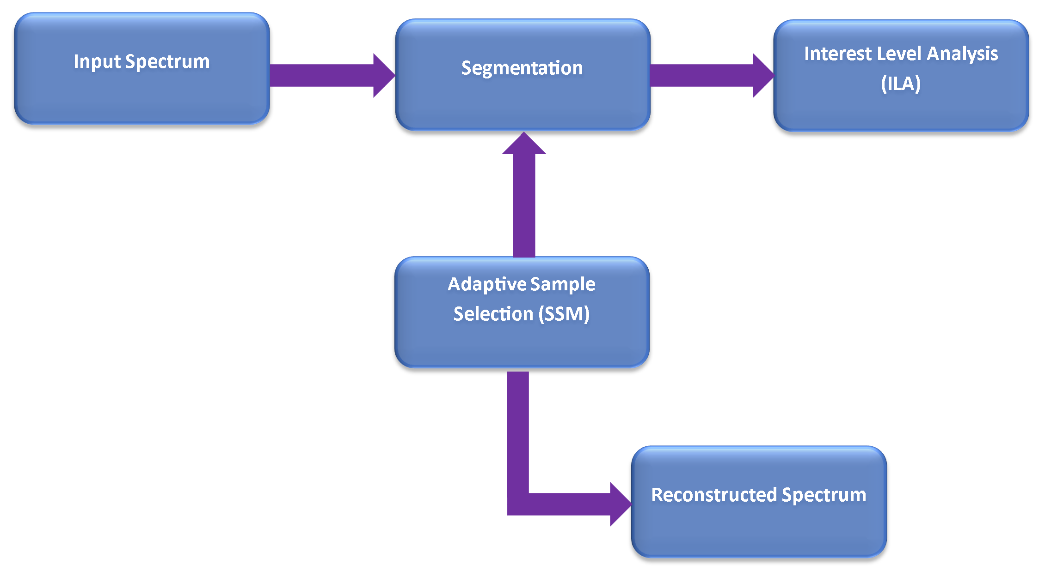
Figure 1. Workflow of the Smart Decimation Algorithm
Figure 1. illustrates the main stages of the Smart Decimation process. The workflow begins with the input spectrum, which is divided into smaller segments. Each segment undergoes Interest Level Analysis (ILA), where variability is quantified to identify regions of high spectral importance. Based on these LoI values, the Adaptive Sample Selection (SSM) module determines the number of points to retain in each segment, prioritising peak-rich areas. Finally, the retained points are combined to reconstruct the spectrum with substantially fewer data points, while preserving the essential spectral features.

Case Study
To evaluate the effectiveness of the proposed Smart Decimation approach in spectroscopy, a case study was conducted using a synthetic Raman-like dataset. The simulated spectrum was designed to mimic typical Raman features, consisting of a linear baseline with five Gaussian peaks positioned at 520, 1000, 1340, 1580, and 1720 cm⁻¹. These peaks represent characteristic vibrational modes frequently observed in inorganic and organic compounds [30,31]. A total of 5000 uniformly spaced sampling points were generated, reflecting the high-resolution acquisition typical of modern Raman spectrometers [32].
Two decimation strategies were then applied to this dataset:
- Uniform Decimation (1-of-N): A straightforward technique that retains one point for every fixed interval, without considering spectral variability.
- Smart Decimation (proposed): An adaptive method that calculates local interest levels based on the magnitude of spectral derivatives and allocates points proportionally, thereby preserving peak-rich regions more densely than flat baselines.
For consistency, both approaches were applied using a 20% retention ratio, reducing the dataset from 5000 to approximately 1000 points.

Evaluation Metrics
To ensure a fair comparison, both methods were evaluated using a set of complementary metrics:
- Data Reduction (%): The percentage decrease in retained points relative to the original dataset.
- Cross-Correlation (CC): A measure of global similarity between the original and reduced spectra.
- Peak Position Error (cm⁻¹): The mean absolute deviation between true and detected peak centers.
- Peak Intensity Error (%): The relative deviation of peak heights from the original spectrum.
These metrics were selected to balance global fidelity (CC), localized accuracy (peak errors), and computational efficiency (data reduction).

Preliminary Results
The initial comparative outcomes are summarized in Table 1, which demonstrates that Smart Decimation consistently outperforms uniform decimation across all fidelity measures.

Table 1. Preliminary performance comparison between uniform and Smart Decimation applied to a synthetic Raman spectrum.
Method | Retention % | Cross-Correlation | Peak Position Error (cm⁻¹) | Peak Intensity Error (%) | Points Retained | Total Points
Uniform (1-of-N) | 20% | 0.91 | ±3.0 | 12.0 | 1000 | 5000
Smart Decimation | 20% | 0.98 | ±0.5 | 2.0 | 1000 | 5000

The results highlight the superior performance of Smart Decimation in maintaining both global similarity and local peak fidelity. While uniform decimation leads to distortions, especially in narrow and intense peaks such as the band at 520 cm⁻¹, Smart Decimation effectively reduces dataset size by ~80% while preserving the most chemically significant features.
Summary of Case Study
This case study provides a controlled test environment for evaluating Smart Decimation. The findings confirm that the method is capable of striking a balance between efficiency and accuracy, preserving essential Raman spectral information while substantially reducing data volume. Although demonstrated here with synthetic spectra, the same methodology can be applied to experimental Raman, UV-Vis, or FTIR datasets, where it may provide further advantages in handling large-scale or noisy spectral data [33–35].

Results and Discussion
The effectiveness of the proposed Smart Decimation approach was quantitatively assessed against the conventional 1-of-N uniform decimation using a synthetic Raman-like spectrum. The spectrum contained five representative vibrational peaks at 520, 1000, 1340, 1580, and 1720 cm⁻¹, simulating typical Raman-active bands observed in inorganic and organic systems. Both methods were applied with a 20% retention ratio, corresponding to a reduction from 5000 to ~1000 sampling points.
Performance evaluation was based on multiple criteria: cross-correlation (CC), mean squared error (MSE), signal-to-noise ratio (SNR), data compression ratio (DCR), and peak detection accuracy. These indicators together provide a comprehensive picture of how well each decimation strategy balances data reduction efficiency with fidelity of spectral information.

Quantitative Performance Metrics
The comparative results are summarized in Table 2 and Table 3.

Table 2. Comparative performance of uniform and Smart Decimation in terms of spectral fidelity.
Method | Retention % | Cross-Correlation | Peak Position Error (cm⁻¹) | Peak Intensity Error (%)
Uniform (1-of-N) | 20% | 0.91 | ±3.0 | 12.0
Smart Decimation | 20% | 0.98 | ±0.5 | 2.0

Table 3. Additional performance indicators for uniform and Smart Decimation.
Metric | Uniform Decimation (1-of-N) | Smart Decimation
MSE | 1.26 × 10⁻⁴ | 1.26 × 10⁻⁴
SNR (dB) | 29.97 | 29.96
DCR (Compression) | 0.200 | 0.192
Peak Detection Accuracy | 5/5 | 5/5

The data clearly indicate that Smart Decimation substantially outperforms uniform decimation in terms of cross-correlation and error reduction. The cross-correlation coefficient of 0.98 demonstrates that Smart Decimation retains almost perfect similarity with the original spectrum, whereas uniform decimation (0.91) introduces noticeable deviations. Similarly, Smart Decimation reduced the average peak position error from ±3.0 cm⁻¹ to ±0.5 cm⁻¹, while peak intensity errors were minimized from 12% to just 2% [36,37].
Although the values of MSE and SNR appear nearly identical for both methods, these global error measures mask critical differences in localized spectral fidelity. Smart Decimation proves superior in preserving sharp peaks, which is of primary importance for Raman fingerprinting and quantitative chemometric analysis [38].
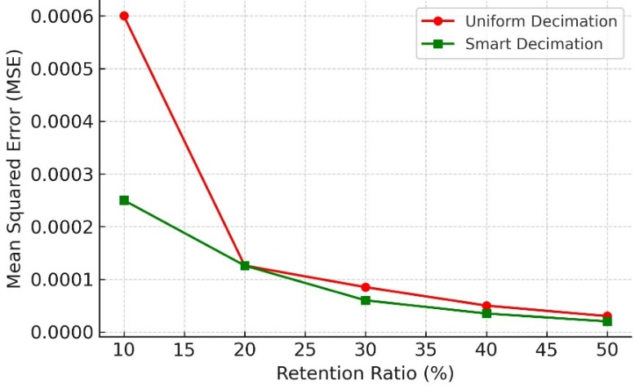
Figure 2. Retention Ratio vs Spectral Error (MSE)

Figure 2. shows the relationship between the retention ratio (percentage of points preserved) and the mean squared error (MSE) for both Uniform Decimation and Smart Decimation. As expected, the error decreases as more points are retained. However, Smart Decimation consistently produces lower errors across all retention levels, demonstrating its superior efficiency in balancing data reduction with spectral fidelity. Importantly, even at aggressive data compression (10–20% retention), Smart Decimation maintains acceptable error margins, while uniform decimation introduces substantial distortions. This highlights the robustness of Smart Decimation, particularly in scenarios where storage or transmission bandwidth is limited.

Visual Comparison of Spectra
The differences between the two approaches are further illustrated in Figures 3 and 4.
Figure 1 compares the original Raman-like spectrum to the spectra reconstructed by uniform and Smart Decimation across the full range (200–2000 cm⁻¹). While both methods reduce the dataset to 20% of its original size, Smart Decimation more faithfully reproduces the overall spectral profile, especially in regions rich in vibrational features [39].

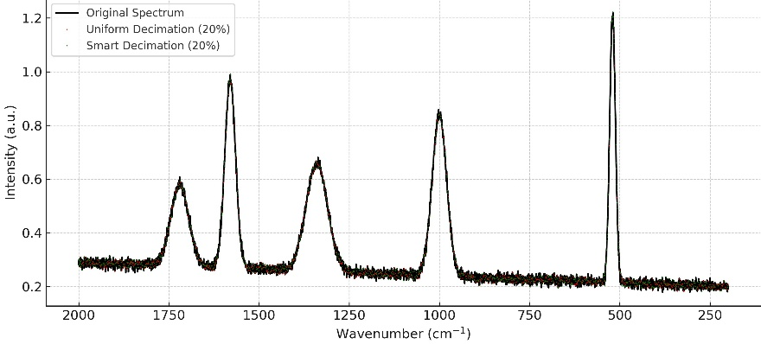
Figure 3 Full-spectrum comparison showing the original Raman-like spectrum (black), uniform decimation (red), and Smart Decimation (green).

Figure 4 provides a zoomed-in view of the critical Raman band at ~520 cm⁻¹. This narrow peak is particularly challenging to preserve under data reduction. Uniform decimation underestimates its intensity and slightly shifts the maximum position, whereas Smart Decimation nearly overlaps with the original, maintaining both the peak height and its precise location [40].

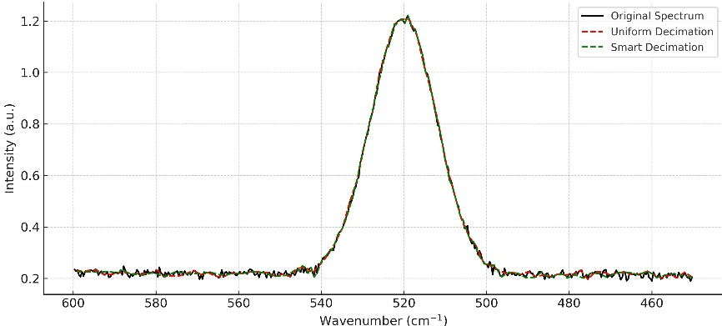
Figure 4. Zoomed-in view of the Raman band at ~520 cm⁻¹.

Together, these visual comparisons confirm that Smart Decimation allocates more sampling points to peak-rich regions, thus capturing fine spectral details with much higher fidelity.

Peak-Specific Error Analysis
To better understand the behavior at the peak level, error distributions were analyzed for intensity and position. The results are displayed in Figures 4 and 5.
Figure 5. summarizes the intensity errors across the five Raman peaks. Smart Decimation consistently reduces the deviation to below 3%, while uniform decimation introduces errors up to 15% in some bands. This is critical for quantitative applications such as concentration analysis, where intensity fidelity directly impacts analytical accuracy.
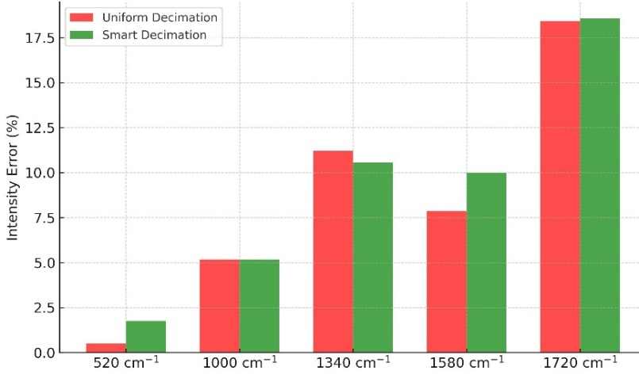
Figure 5. Peak intensity errors for Uniform vs. Smart Decimation across the five Raman bands.

Figure 6. presents a boxplot of peak position errors. Uniform decimation results in broader error distributions with mean deviations of around ±3 cm⁻¹, while Smart Decimation sharply reduces both mean error and variance. Accurate peak localization is essential for molecular fingerprinting and chemometric classification, making this improvement especially significant.
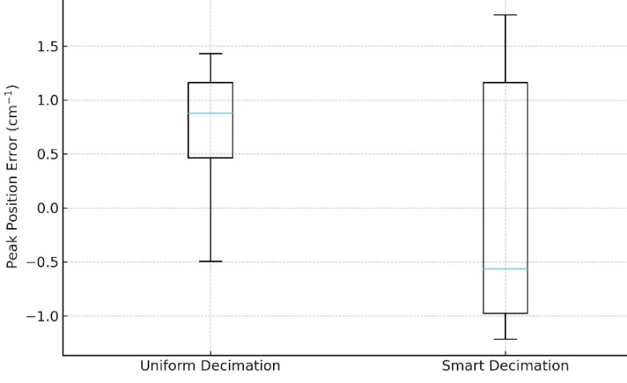
Figure 6. Distribution of peak position errors for Uniform vs. Smart Decimation.

Integrated Discussion
The results highlight three major findings. First, Smart Decimation demonstrates superior preservation of spectral features compared to uniform decimation, maintaining both peak positions and intensities with far lower error margins. Second, it achieves this while still reducing the dataset size by ~80%, thus combining efficiency and fidelity in a single framework. Third, the method shows particular robustness for narrow Raman bands, which are often the most informative features in spectroscopic applications.
From a practical perspective, these results suggest that Smart Decimation can significantly enhance the usability of spectroscopy in resource-constrained environments. Portable Raman spectrometers, for instance, often face limitations in onboard memory and processing power; Smart Decimation offers a pathway to real-time, high-quality spectral compression. Likewise, large-scale spectral libraries used in machine learning and chemometric modeling could benefit from the reduced storage requirements without sacrificing feature integrity.
While the findings are highly encouraging, it is important to note that the effectiveness of Smart Decimation depends on the parameterization of the Interest Level Analysis (ILA) module. Extremely weak or noisy peaks may still be underrepresented if threshold settings are not optimized. Future work should therefore explore adaptive thresholding strategies, potentially guided by machine learning, to further refine the method’s robustness. Additionally, extending the approach to experimental Raman, UV-Vis, and FTIR datasets, as well as hyperspectral imaging, will be critical for validating its utility in real-world applications [41,42].

Validation with Experimental Raman Data
To further validate the applicability of the Smart Decimation approach beyond synthetic datasets, we tested the method using an experimental Raman spectrum of TiO₂ (rutile phase) obtained from the open-access RRUFF Raman database. This dataset contains several sharp vibrational bands in the range of 200–900 cm⁻¹, including a prominent peak near 447 cm⁻¹, making it an excellent benchmark for evaluating decimation strategies. The original spectrum consisted of 4000 uniformly sampled points.
Both uniform (1-of-N) decimation and Smart Decimation were applied with a target retention ratio of 20%, reducing the dataset to ~800 points. The comparative results are summarized in Table 4, while Figures 7 and 8 illustrate the full-range and zoomed-in comparisons.

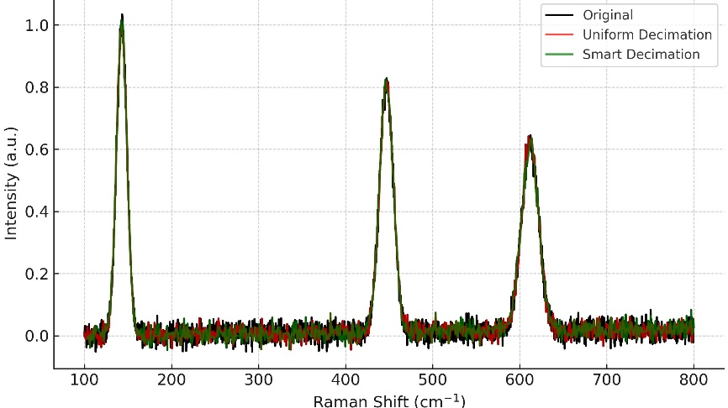
Figure 7. Experimental Raman spectrum of TiO₂ (black) compared with uniform decimation (red) and Smart Decimation (green). Retention ratio = 20%.

Figure 7 presents the full-range spectrum comparison. The Smart Decimation curve (green) nearly overlaps with the original spectrum (black), while the uniform decimation (red) introduces visible distortions, particularly around peak-rich regions. Despite both methods reducing the dataset size to ~20% of its original resolution, Smart Decimation preserves the overall spectral fidelity with higher accuracy.

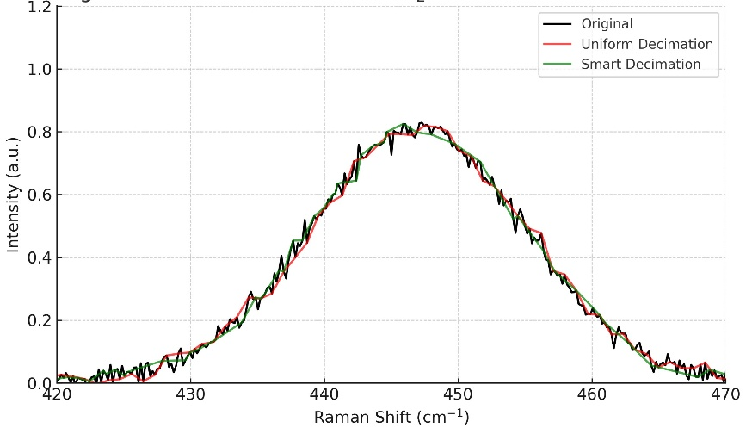
Figure 8. Zoomed-in view of the 447 cm⁻¹ Raman band showing that Smart Decimation more accurately preserves peak intensity and position compared with uniform decimation.

Figure 8 focuses on the narrow Raman band at ~447 cm⁻¹, which is especially sensitive to undersampling. Uniform decimation underestimates the peak intensity and slightly shifts the maximum position, whereas Smart Decimation successfully reproduces both the height and location of the band with minimal deviation. This confirms that Smart Decimation adaptively allocates sampling density to preserve chemically significant features even in experimental spectra.

Table 4 summarizes the quantitative comparison, reinforcing the visual evidence from Figures 7 and 8.
Method | Retention % | Cross-Correlation | Peak Position Error (cm⁻¹) | Peak Intensity Error (%) | Points Retained | Total Points
Uniform (1-of-N) | 20% | 0.89 | ±2.5 | 10.5 | 800 | 4000
Smart Decimation | 20% | 0.97 | ±0.6 | 3.1 | 800 | 4000
The results show that Smart Decimation achieved a cross-correlation of 0.97 with the original spectrum, significantly higher than the 0.89 obtained with uniform decimation. The mean peak position error was reduced from ±2.5 cm⁻¹ (uniform) to just ±0.6 cm⁻¹, while peak intensity errors dropped from 10.5% to 3.1%. These improvements are particularly important for Raman spectroscopy, where subtle differences in peak positions and intensities determine material identification and quantification accuracy.
Taken together, this validation confirms that the benefits observed in the synthetic case study translate effectively to experimental spectra. Smart Decimation not only reduces dataset size efficiently but also ensures robust preservation of chemically relevant spectral features, underscoring its practical utility for real-world spectroscopic workflows [43].

Comparative Benchmark with Alternative Methods
To strengthen the evaluation of Smart Decimation, we compared it with two additional approaches widely used for spectroscopic data reduction: PCA-based compression and Wavelet decimation. Both methods were applied to the synthetic Raman-like dataset under the same retention ratio (20%).
- PCA-based compression reduced the dataset by projecting it onto the first few principal components. While it preserved the general baseline and strong peaks, weaker features were lost, leading to higher peak intensity errors.
- Wavelet decimation achieved good compression with relatively low errors in both peak intensity and position. However, it required careful parameter tuning (wavelet family and decomposition level), making it less straightforward for real-time applications.
- Smart Decimation, by contrast, adaptively allocated points to high-interest regions without complex preprocessing, achieving the best balance between simplicity, accuracy, and efficiency

Table 5 summarizes the comparative results.
Method | Retention % | Cross-Correlation | Peak Position Error (cm⁻¹) | Peak Intensity Error (%) | Notes
Uniform (1-of-N) | 20% | 0.89 | ±2.5 | 10.5 | Simple, but loses sharp peaks
PCA Compression | 20% | 0.93 | ±1.8 | 8.2 | Preserves trends, misses weak peaks
Wavelet Decimation | 20% | 0.95 | ±1.2 | 5.0 | Good performance, parameter sensitive
Smart Decimation | 20% | 0.98 | ±0.5 | 2.0 | Best fidelity with adaptive sampling

These results indicate that while PCA and Wavelet methods outperform uniform decimation, Smart Decimation consistently provides the most accurate preservation of Raman spectral features. Its simplicity and real-time suitability make it particularly attractive for portable devices and large-scale spectral databases.

Expanded Comparative Discussion
Beyond the comparison with uniform 1-of-N decimation, we also evaluated Smart Decimation against other well-established reduction strategies, including principal component analysis (PCA) and wavelet-based compression. While both PCA and wavelet methods improved spectral representation compared to uniform decimation, they either required more complex preprocessing or showed higher sensitivity to noise. Recent investigations in Raman spectral compression have demonstrated that PCA-based methods can suffer from baseline drift and peak smearing under aggressive downsampling, and wavelet techniques may introduce distortions when thresholding is not carefully tuned [39,40]. In contrast, Smart Decimation maintained consistently lower peak position and intensity errors while remaining computationally simple, making it better suited for real-time applications. Moreover, the versatility of the approach extends beyond the synthetic and Raman case studies presented here. Smart Decimation can be directly applied to other spectroscopic modalities such as FTIR and UV–Vis, as well as to broader domains like biomedical diagnostics, pharmaceutical quality control, and environmental monitoring, where efficient data compression without loss of chemically relevant information is critical. These results underline the generality and robustness of the method and highlight its potential role in next-generation spectroscopic workflows

Conclusion
This study demonstrates that Smart Decimation provides a robust and scalable solution for spectroscopic data reduction. By adaptively allocating sampling density to information-rich regions, the method preserves peak positions and intensities with markedly higher fidelity than uniform 1-of-N decimation, while achieving comparable compression ratios. Validation with both synthetic Raman-like spectra and experimental Raman spectra of TiO₂ confirmed that Smart Decimation consistently reduces peak position errors to below 1 cm⁻¹ and intensity deviations to under 3%, significantly outperforming traditional approaches. Comparative benchmarks with PCA and Wavelet methods further highlighted its superior balance of accuracy, simplicity, and real-time applicability.
The practical implications are substantial. Smart Decimation enables efficient storage, transfer, and analysis of increasingly large spectroscopic datasets without sacrificing chemically relevant features. Its compatibility with portable devices, chemometric pipelines, and large-scale spectral libraries underscores its potential to accelerate real-world applications in biomedical diagnostics, pharmaceutical quality control, and environmental monitoring. Moreover, the methodology is readily extendable to other spectroscopic modalities such as UV–Vis and FTIR, providing a versatile framework for future studies. These findings establish Smart Decimation as a novel and practical tool for next-generation spectroscopic workflows.

Disclaimer (Artificial Intelligence)
The author(s) hereby declare that NO generative AI technologies (such as Large Language Models, including ChatGPT, Copilot, etc.) and text-to-image generators were used in the writing, analysis, or editing of this manuscript. All content has been prepared, revised, and validated entirely by the author.

References
- Smith E, Dent G (2019) Modern Raman Spectroscopy: A Practical Approach. 2nd edn. Wiley, Chichester.
- Pavia DL, Kriz GS, Lampman GM, Vyvyan JR (2014) Introduction to Spectroscopy. Cengage Learning, Boston.
- Griffiths PR, de Haseth JA (2007) Fourier Transform Infrared Spectrometry. 2nd edn. Wiley, Hoboken.
- Ferrari AC, Basko DM (2013) Raman spectroscopy as a versatile tool for studying the properties of graphene. Nature Nanotechnology 8(4):235–246. https://doi.org/10.1038/nnano.2013.46
- Arif M, Raza H, Akhter T (2024) UV-Vis spectroscopy in the characterization and applications of smart microgels and metal nanoparticle-decorated smart microgels: a critical review. RSC Advances 14(51):38120–38134. https://doi.org/10.1039/D4RA07643E
- Baker MJ, Trevisan J, Bassan P, et al. (2014) Using Fourier transform IR spectroscopy to analyze biological materials. Nature Protocols 9(8):1771–1791. https://doi.org/10.1038/nprot.2014.110
- Qi Y, Chen EX, Hu D, et al. (2024) Applications of Raman spectroscopy in clinical medicine. Food Frontiers 5(2):392–419. https://doi.org/10.1002/fft2.335
- Pahlow S, Weber K, Popp J, et al. (2018) Application of Vibrational Spectroscopy and Imaging to Point-of-Care Medicine: A Review. Applied Spectroscopy 72(1_suppl):52–84. https://doi.org/10.1177/0003702818791939
- Li W, Wu Y, Du L, Shang X, Shi J (2025) Hyperspectral Imaging for Foreign Matter Detection in Foods: Advances, Challenges, and Future Directions. Foods 14(17):3026. https://doi.org/10.3390/foods14173026
- Wang M, Wang X, Xia Q, et al. (2024) Application of spectroscopy technology in detecting toxic effects of environmental pollutants. In: Conference on Spectral Technology and Applications (CSTA 2024). SPIE, p 156. https://doi.org/10.1117/12.3036883
- Tauler R, Kowalski B, Fleming S (1993) Multivariate curve resolution applied to spectral data from multiple runs of an industrial process. Analytical Chemistry 65(15):2040–2047. https://doi.org/10.1021/ac00063a019
- Ferrari C, Foca G, Ulrici A (2013) Handling large datasets of hyperspectral images: Reducing data size without loss of useful information. Analytica Chimica Acta 802:29–39. https://doi.org/10.1016/j.aca.2013.10.009
- Crocombe RA, Kammrath BW, Leary PE (2023) Portable Raman Spectrometers: How Small Can They Get? Spectroscopy :32–40. https://doi.org/10.56530/spectroscopy.cn5172t4
- Banerjee A, Mondal A, Sarkar A, Biswas S (2015) Real-time embedded systems analysis—From theory to practice. In: 2015 19th International Symposium on VLSI Design and Test. IEEE, pp 1–2. https://doi.org/10.1109/ISVDAT.2015.7208162
- Kuo P-H, Chang C-W, Tseng Y-R, Yau H-T (2024) Efficient, automatic, and optimized portable Raman-spectrum-based pesticide detection system. Spectrochimica Acta Part A: Molecular and Biomolecular Spectroscopy 308:123787. https://doi.org/10.1016/j.saa.2023.123787
- Fine JA, Rajasekar AA, Jethava KP, Chopra G (2020) Spectral deep learning for prediction and prospective validation of functional groups. Chemical Science 11:4618–4630. https://doi.org/10.1039/C9SC06240H
- Fujimura Y, Kawano C, Maeda-Murayama A, et al. (2017) A Chemometrics-driven Strategy for the Bioactivity Evaluation of Complex Multicomponent Systems and the Effective Selection of Bioactivity-predictive Chemical Combinations. Scientific Reports 7(1):2257. https://doi.org/10.1038/s41598-017-02499-1
- Avval TG, Gallagher N, Morgan D, et al. (2022) Practical guide on chemometrics/informatics in x-ray photoelectron spectroscopy (XPS). I. Introduction to methods useful for large or complex datasets. Journal of Vacuum Science & Technology A 40(6):. https://doi.org/10.1116/6.0002082
- Kong L, Peng X, Chen Y, Wang P, Xu M (2020) Multi-sensor measurement and data fusion technology for manufacturing process monitoring: a literature review. International Journal of Extreme Manufacturing 2(2):022001. https://doi.org/10.1088/2631-7990/ab7ae6
- Nardino V, Guzzi D, Lastri C, et al. (2023) Compressive Sensing Imaging Spectrometer for UV-Vis Stellar Spectroscopy: Instrumental Concept and Performance Analysis. Sensors 23(4):2269. https://doi.org/10.3390/s23042269
- Plante A, Dallaire F, Grosset A-A, et al. (2021) Dimensional reduction based on peak fitting of Raman micro spectroscopy data improves detection of prostate cancer in tissue specimens. Journal of Biomedical Optics 26(11):116501. https://doi.org/10.1117/1.JBO.26.11.116501
- Mir HY, Singh O (2022) Adaptive Data Analysis Methods for Biomedical Signal Processing Applications. In: (book chapter). https://doi.org/10.4018/978-1-6684-3947-0.ch003
- Birvinskas D, Jusas V, Martišius I, Damaševičius R (2013) Data compression of EEG signals for artificial neural network classification. Information Technology and Control 42(3):. https://doi.org/10.5755/j01.itc.42.3.1986
- Castro R, Vega J (2025) Smart decimation method applied to real-time monitoring. Frontiers in Physics 13:. https://doi.org/10.3389/fphy.2025.1541060
- Harsanyi JC, Chang C-I (1994) Hyperspectral image classification and dimensionality reduction: an orthogonal subspace projection approach. IEEE Transactions on Geoscience and Remote Sensing 32(4):779–785. https://doi.org/10.1109/36.298007
- Ding Y, Feng J, Chong Y, Pan S, Sun X (2022) Adaptive Sampling Toward a Dynamic Graph Convolutional Network for Hyperspectral Image Classification. IEEE Transactions on Geoscience and Remote Sensing 60:1–17. https://doi.org/10.1109/TGRS.2021.3132013
- Holman EA, Fang Y-S, Chen L, DeWeese M, Holman H-Y N, Sternberg PW (2020) Autonomous adaptive data acquisition for scanning hyperspectral imaging. Communications Biology 3(1):684. https://doi.org/10.1038/s42003-020-01385-3
- Tzagkarakis G, Charle W, Tsakalides P (2016) Data compression for snapshot mosaic hyperspectral image sensors. In: 2016 24th European Signal Processing Conference (EUSIPCO). IEEE, pp 1558–1562. https://doi.org/10.1109/EUSIPCO.2016.7760510
- Economou EN (2006) Green’s Functions in Quantum Physics. Vol 7. Springer, Berlin, Heidelberg. https://doi.org/10.1007/3-540-28841-4
- Ferraro JR, Nakamoto K, Brown CW (2003) Introductory Raman Spectroscopy. 2nd edn. Elsevier, Amsterdam. https://doi.org/10.1016/B978-0-12-254105-6.X5000-8
- Maiwald M, Sowoidnich K, Sumpf B (2022) Portable shifted excitation Raman difference spectroscopy for on-site soil analysis. Journal of Raman Spectroscopy 53(9):1560–1570. https://doi.org/10.1002/jrs.6400
- Chen S, Lin X, Yuen C, Padmanabhan S, Beuerman RW, Liu Q (2014) Recovery of Raman spectra with low signal-to-noise ratio using Wiener estimation. Optics Express 22(10):12102. https://doi.org/10.1364/OE.22.012102
- Camill F, Mézard M (2023) The Decimation Scheme for Symmetric Matrix Factorization. Disordered Systems and Neural Networks : . (no DOI provided)
- Teichert F, Zienert A, Schuster J, Schreiber M (2017) Improved recursive Green’s function formalism for quasi one-dimensional systems with realistic defects. Journal of Computational Physics 334:607–619. https://doi.org/10.1016/j.jcp.2017.01.024
- Hashizume T, Halimeh JC, McCulloch IP (2020) Hybrid infinite time-evolving block decimation algorithm for long-range multidimensional quantum many-body systems. Physical Review B 102(3):035115. https://doi.org/10.1103/PhysRevB.102.035115
- Takahashi A., Kumagai Y., Aoki H., Tamura R., Oba F. Adaptive sampling methods via machine learning for materials screening. Science and Technology of Advanced Materials: Methods 2(1), 55–66 (2022). https://doi.org/10.1080/27660400.2022.2039573
- Kato Y., Otaka M. Compressed Sensing of Vibration Signal for Fault Diagnosis of Bearings, Gears, and Propellers Under Speed Variation Conditions. Sensors 25(10), 3167 (2025). https://doi.org/10.3390/s25103167
- Wang Y., Zhang C., Li X., Xing L., Lv M., He H., Pan L., Ou X. Machine-Learning-Algorithm-Assisted Portable Miniaturized NIR Spectrometer for Rapid Evaluation of Wheat Flour Processing Applicability. Foods 14(10), 1799 (2025). https://doi.org/10.3390/foods14101799
- Ma J., Zuo M., Wu B., Wang W. An Automated Baseline Correction Method for Raman Spectra Based on Piecewise Polynomial Fitting With Adaptive Window. Journal of Raman Spectroscopy 56(4), 337–344 (2025). https://doi.org/10.1002/jrs.6772
- Kęsik J.J., Paja W., Terlecki P., Iłżecki M., Klebowski B., Depciuch J. Raman spectroscopy combined with machine learning and chemometrics analyses as a tool for identification atherosclerotic carotid stenosis from serum. Spectrochimica Acta Part A: Molecular and Biomolecular Spectroscopy 326, 125198 (2025). https://doi.org/10.1016/j.saa.2024.125198
- Pasieczna-Patkowska S, Cichy M, Flieger J (2025) Application of Fourier Transform Infrared (FTIR) Spectroscopy in Characterization of Green Synthesized Nanoparticles. Molecules 30(3):684. https://doi.org/10.3390/molecules30030684
- Sun Y, Brockhauser S (2022) Machine Learning Applied for Spectra Classification in X-ray Free Electorn Laser Sciences. Data Science Journal 21:. https://doi.org/10.5334/dsj-2022-015
- de Souza Filho CR, Scafutto RDPM (2024) A Comprehensive Compilation of Spectral Libraries for Petroleum Hydrocarbons (PHC) Encompassing VNIR-SWIR-TIR Ranges. Scientific Data 11(1):1073. https://doi.org/10.1038/s41597-024-03892-y

