Heat Transfer Analysis in a Square Cavity:
Effects of Nusselt,Reynolds, and Prandtl Numbers

ABSTRACT
This work focuses on a theoretical and numerical and numerical study of the thermal behavior of certain physical parameters of air.
The aim is to show the importance of natural convection in heat transfer, based on the contribution of parameters such as Nusselt, Prandt and Reynolds, which often influence heat transfer. These parameters in a thermal cavity show the extent to which an engineer can design a cooling system based on solar energy.
The prototype studied and built is exposed to the sun's rays, and one of its sides is covered with a transparent pane to transmit heat by conduction inside the device. The trapped air creates a greenhouse effect, promoting heat exchange by convection.
The study was carried out at the Carnot Energy Laboratory in Bangui (CAR).
The equations governing the operation of the device presented in fluid mechanics in the case of conservation of mass, momentum and energy were written and solved numerically by the finite volume method, implemented in MATLAB.
In order to take into account temperature-dependent density variations, so that the physical so that the physical properties of the fluid can be considered constant at low temperatures, the Boussinesq approximation is necessary for two-dimensional steady-state flow conditions.
Numerical results for the distribution of different temperatures were presented, along with targeted correlations highlighting the influence of these thermal parameters. These results reveal the influence of the Nusselt number on heat transfer.

Key words: Flow, Air, Nusselt, Reynolds, Prandtl
- INTRODUCTION
Technological advances and the optimization of thermal performance are major challenges in many fields of science and engineering.
The study of convection is a very important subject, because of its presence in various industrial applications such as the cooling of processors, electronic components, heat loss in solar collectors such as solar dryers, solar cookers and others. Heat transfer involves the exchange of heat between a surface and a moving fluid in contact with it, or the displacement of heat within a fluid by the overall movement of its molecules from one point to another.
As mentioned above, natural convection is an important phenomenon in many industrial processes. For this type of convection, the movements are due to density variations in a fluid subjected to the field of gravity.
The latter has been the subject of much numerical and experimental work.
Numerical work has been carried out using several methods and calculation codes [1-17].The authors focused their studies on convective flow in a space between concentric spheres with isothermal walls, then on the movement of a fluid in an annular cavity closed by two concentric vertical cylinders and two horizontal planes, and finally on non-Newtonian fluids, leading to a comparison between experimental results for a Newtonian fluid in a cubic cavity on the one hand, and local and global heat transfer between concentric and eccentric horizontal cylinders on the other. Parameters considered include Rayleigh number (based on space width) up to 2.105, Prandtl number from 0.5 to 5, radius ratio from 1 to 4 and aspect ratio (cavity height/space) from 1 to 20. The equations of motion and energy were solved numerically. Finite element and finite volume difference methods coupled with the implicit method were used for simulation. The radial function enhanced domain-free discretization (DFD) method is based on Lagrange interpolation and the polynomial-based differential quadrature (PDQ) method. The SIMPLER algorithm facilitated the calculation, and the FDS (Fire Dynamic Simulator) and FLUENT calculation codes were used. Results were obtained for stationary and transient heat transfer in vertical eccentric spheres at a Prandtl number of 0.7, with a modified Rayleigh number varying from 103 to 5.105, for a radius ratio of 2 and eccentricities varying from -0.625 to +0.625. Comparisons have been made between the isothermal edge condition and current calculations for the heat flow edge condition.
They prove that positioning the rod at the top of the channel and a few centimeters from the wall proves to be the best option for efficient cooling. They have also justified that the results obtained from the scaling arguments and the numerical model are in qualitative and quantitative agreement. These results are presented in terms of theoretical streamlines and isotherms, average Nusselt number on the hot wall, horizontal velocity at the vertical midpoint, vertical velocity at the horizontal midpoint, and temperature distribution at the horizontal and vertical midpoints. It emerges that the use of the radial basis function can effectively improve the DFD method in terms of numerical stability and convergence speed. And the computational results show excellent agreement with previous experimental data. Good agreement was also found for most Newtonian cases. A comparison between Newtonian and non-Newtonian results reveals an increase in heat flux with increasing model non-linearity. They observed that the non-Newtonian case also exhibits periodic behavior in the diagonal orientation, in contrast to the Newtonian cases.
II.PHYSICAL, MATHEMATICAL AND NUMERICAL MODELING OF THE PROTOTYPE
II.1-Description of the proposed physical model
The model proposed in this work consists of a square enclosure filled with air, circulating inside. The walls of the enclosure, with the exception of the glass wall facing the sun, are made of wood measuring 100 x 100 cm, 5 cm thick, with a layer of glass wool 3 cm thick for insulation. A 4mm-thick pane of glass, located inside the enclosure, transmits part of the radiated solar flux. Access to the interior of the enclosure is provided by one of the vertical walls adjacent to the opposite wall, designed as a door. Figure 1 shows the different parts of the enclosure and the various heat exchanges taking place within them.
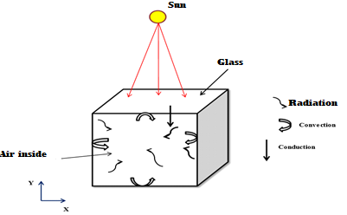
Figure1 : schematic of the chosen prototype
The diagram below shows one of the walls subjected to a horizontal temperature gradient (hot wall). With the exception of the glass pane, the walls are assumed to be adiabatic. This physical model is represented by the geometry (diagram 2) below:
II.2- How it works
The solar flux is transmitted to the interior of the enclosure through the glass, resulting in a heat flow by conduction. his transmitted flux is trapped by the greenhouse effect in the enclosure, resulting in a heat input by diffusion to the fluid qualifying as air inside the box.
II.3 Mathematical modeling
II.3.1- Flow governing equations
The three fundamental physical principles of conservation of mass, momentum and energy are generally used as mathematical models to govern natural convection

II.3.2 Continuity equation
This law states that as a fluid moves, its mass remains constant. This translates into:
$\frac{∂ρ}{∂t}+div\left(ρ\vec{V}\right)=0 (1)$
With: ρ the density of the fluid and the velocity vector.
II.3.3- Equation of conservation of momentum
This law states that the rate of change of momentum in a control volume is equal to the sum of all external forces applied to it. This translates into:
$$\frac{D}{Dt}\left(ρV\right)=ρF-grad\left(p\right)+μ∆V+\frac{1}{3}μgrad\left(div\left(V\right)\right) (2)$$
With: F force per unit volume, p pressure and dynamic viscosity.

II.3.4- Energy equation
This law states that the total energy of an isolated system is invariant with time, which translates
into:
$$\frac{D}{Dt}\left(ρC_{p}T\right)=∆\left(KT\right)+q+βT\frac{Dp}{DT}+μ ϕ (3)$$
II.4-Boussinesq approximation
According to BOUSSINESQ, this approximation is valid when the temperature difference is so small that the physical properties of the fluid can be considered constant.
From the outset, density variations within the fluid are small and the equation of state for density ρ using Taylor expansion varies linearly with temperature and is written:
$$ρ=ρ_{0}\left[1-\frac{{T-T}_{0}}{T_{0}}\right] (4)$$
Restricting ourselves to a development of the first order, we have:
$$ρ=ρ_{0}\left[1-β(T-T_{0})\right] (5)$$
Natural convection occurs by generating a volumetric driving force that opposes, in particular, the viscous friction force when faced with a variation in fluid density. The Boussinesq approximation consists in neglecting variations in this density (in the conservation equations), except when they are applied as a driving force in the term of the conservation equation for momentum. Thus, the volumetric force responsible for natural convection is expressed by:
II.5- Dimensional equations
The following equations describe the phenomenon of natural convection in the square cavity in dimensional form, based on the assumptions described above.
II.5.1- Continuity equation
This is expressed by the following equation
:$\frac{∂u}{∂x}+\frac{∂v}{∂y}=0 (6)$
II.5.2- Equations for the conservation of momentum
These equations are written along the waxes:
The (x) axis,
$$u\frac{∂u}{∂x}+v\frac{∂u}{∂y}=-\frac{1}{ρ}\frac{∂p}{∂x}+ϑ\left(\frac{∂^{2}u}{{∂x}^{2}}+\frac{∂^{2}u}{{∂y}^{2}}\right) (7)$$
The (y) axis,
$$u\frac{∂v}{∂x}+v\frac{∂v}{∂y}=-\frac{1}{ρ}\frac{∂p}{∂y}+gβ(T-T_{0})+ϑ\left(\frac{∂^{2}v}{{∂x}^{2}}+\frac{∂^{2}v}{{∂y}^{2}}\right) (8)$$
Where g is the acceleration of gravity and is the pressure gradient.
II.3.3- Energy equation
The energy equation is as follows:
$u\frac{∂T}{∂x}+v\frac{∂T}{∂y}=α\left(\frac{∂^{2}T}{{∂x}^{2}}+\frac{∂^{2}T}{{∂y}^{2}}\right) (9)$
II.3.4 Dimensional equations of the problem
These parameters enable us to better control the problem under study. Their values are more significant than those of the physical quantities themselves. To achieve this adimensional formatting, it is important to define the following changes in variables:
$X=\frac{x}{L}; Y=\frac{y}{L} (10)$
$$U=\frac{u}{Vo};V=\frac{v}{Vo} avec Vo=\left(α/L\right) (11)$$
$P=\frac{P}{ρ{\left(Vo\right)}^{2}}; θ=\frac{T-T_{ph}}{T_{vi}-T_{ph}} (12)$

By introducing these dimensionless variables into the governing equations, we obtain the dimensionless equations written as follows:
$$\frac{∂U}{∂X}+\frac{∂V}{∂Y}=0 (13)$$
$$U\frac{∂U}{∂X}+V\frac{∂U}{∂Y}=-\frac{∂P}{∂X}+\frac{1}{Re}\left(\frac{∂^{2}U}{{∂X}^{2}}+\frac{∂^{2}U}{{∂Y}^{2}}\right) (14)$$
$$U\frac{∂V}{∂X}+V\frac{∂V}{∂Y}=-\frac{∂P}{∂Y}+\frac{1}{Re}\left(\frac{∂^{2}V}{{∂X}^{2}}+\frac{∂^{2}V}{{∂Y}^{2}}\right)+Ri.θ (15)$$
$$U\frac{∂θ}{∂X}+V\frac{∂θ}{∂Y}=\frac{1}{RePr}\left(\frac{∂^{2}θ}{{∂X}^{2}}+\frac{∂^{2}θ}{{∂Y}^{2}}\right) \left(16\right)$$
II.4- Boundary conditions
It is necessary to incorporate the thermal boundary conditions shown in the diagram below (Fig. 3) to solve the system of equations previously obtained for each dependent variable.
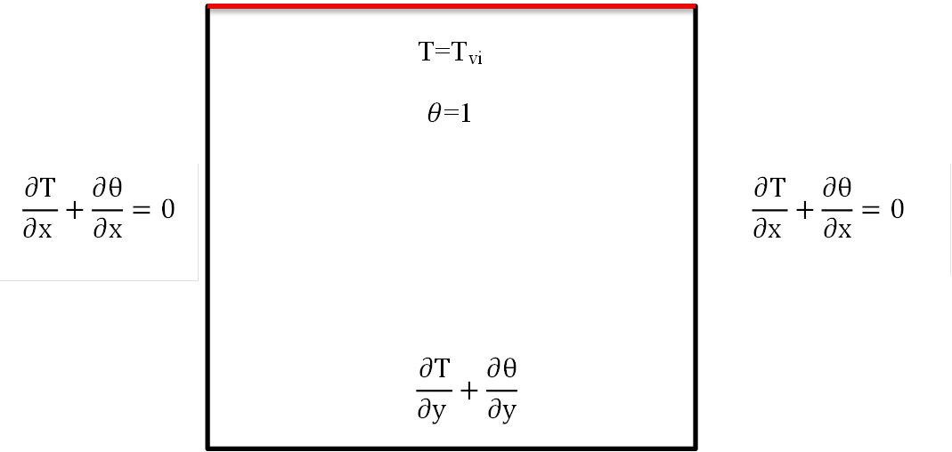
Figure 2: Diagram showing boundary conditions

The table below summarizes the various boundary conditions in dimensional and dimensionless form.
Table 1: Summary of boundary conditions
Limits | Hydrodynamic conditions |  | Thermal conditions
Left sidewall :  X=0; 0<y<L | Dimensional | dimensionless | Dimensional | dimensionless
Left sidewall :  X=0; 0<y<L | u=0  v=0 | U=0  V=0
Right side wall:  X=L ; 0<y<L | u=0  v=0 | U=0  V=0
Glass inner wall :y=L ; 0<x<L | u=0  v=0 | U=0  V=0 | T=Tvi | =1
Horizontal floor wall  y=0 ; 0<x<L | u=0  v=0 | U=0  V=0
II.5 - Numerical modeling of equations
Due to their complexity, partial differential equations cannot be solved analytically. The main methods used are the finite element method, the finite difference method and the finite volume method. In the present work, the finite volume method is appropriate for our study.III- Résultats et discussions
III -RESULTS AND DISCUSSION
III.1 - Influence of temperature on the glass pane
Figure 3 shows the evolution of temperatures as a function of time on the upper horizontal wall, more precisely on the outer and inner sides of the pane. Both temperatures increase with exposure time, and evolve linearly. However, as exposure time increases, the temperature of the inner pane rises more rapidly than that of the outer pane, reaching a temperature of 800°K (526.86°C) after 1h40min. This difference can be explained by the fact that the outer pane was subjected to wind convection, which lowered its temperature over time.
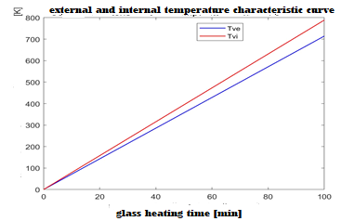
Figure 3: External and internal glass temperature curves
III.2-Temperature distribution in the box
Figure 4 illustrates the evolution of temperature distribution in the enclosure as a function of height. We can see that this temperature is distributed along the X and Y axes for a dimension of 100cm100cm. It can be seen that the temperature is high close to the hot upper wall, and decreases as we move away from the hot wall. Already from 0.3 to the bottom horizontal wall, it is completely low and maintained at the temperature of the three adiabatic walls alone. The results also show that the temperature evolves with the size of the box, reaching its maximum value of 70°C at the next upper wall when the box dimensions are at their extremes (X=1m and Y=1m), and is distributed throughout the enclosure.
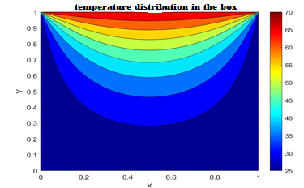
Figure 4 : Temperature distribution
III.3-Effect of the Nusselt Numbers
Figure 5 shows the variation of the Nusselt number in the enclosure as a function of height, depending on the dimension set. Note that the Nusselt number characterizes the type of heat transfer between a fluid and a wall. The result shows that at the level of the upper wall at a height of h=0.7cm, the Nusselt number is very high, with a sharp increase in heat and a decrease up to h=0.35cm, followed by a sharp decrease from 0.35 up to the horizontal adiabatic wall at ground level. From the above, we can say that the increase in the Nusselt number leads to an increase in heat transfer. So, the higher the ambient temperature within the device, the higher the Nusselt number, which justifies the predominance of convection over conduction in relation to the Rayleigh number.
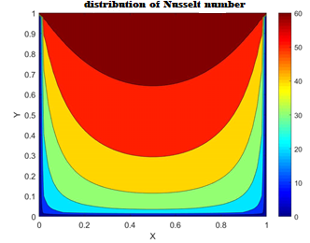
Figure 5 : Distribution of the number of Nusselt

III.4-Effect of the Rayleigh number on the Nusselt number in the enclosure
Figure 6 shows the evolution of the Rayleigh number effect on the dimensionless Nusselt number. The Nusselt graph is plotted as a function of Rayleigh. The Rayleigh number Ra varies from 103 to 107 for an elongation of 10.We note that our flow structure is two-dimensional (2D) in the convective regime, leading to increased diffusion of the transverse wall shear effect (along the y-axis).
The Nusselt number increases as the Rayleigh number increases. Heat transfer is therefore more efficient only around the 0 point, corresponding to 103, where heat is transferred by conduction. Above 103, heat transfer is entirely by natural convection. For this purpose, the Nusselt varies from 2.5 to 10.5. Heat transfer by natural convection is predominant.
Thus, the Nusselt number depends on the evolution of the Rayleigh number. This increase in Nusselt number is due to the positive effect of convection at the hot wall.
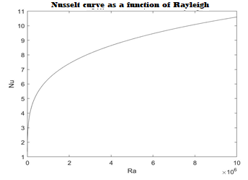
Figure 6: Nusselt curve as a function of Rayleigh (A=10)
The Nusselt number values found numerically are compared with the correlation results found in the literature for the same cavity elongation of 10.Thus, for an elongation of 10, our result is in qualitative agreement with a trend in the allure that is close to the curves found by Zhao [Zhao,1997] and Yin [Yin,1978].

III.5- Effect of Reynolds number on air flow in the enclosure
Figure 7 shows a Reynolds curve as a function of enclosure length.The air movement is ordered and the Reynolds number is low, ranging from 630 to 810. This represents natural laminar convection.
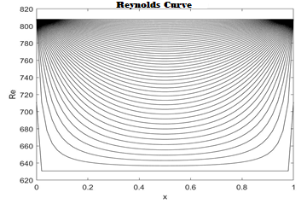
Figure 7: Reynolds curve
Thus, for the evolution of the Reynolds number, which is a function of the dimensions of the device, we note that its maximum value reached is of which shows that we are in the case of a laminar flow regime although the Reynolds number is not a satisfactory condition, since the density of the fluid can never be considered as constant.
III.6- Effect of Reynolds number on Nusselt in the enclosure
Figure 8 shows a plot of the Nusselt number as a function of Reynolds. The Reynolds number Re varies from 5.103 to 3.104. And different values of Prandtl have been used to highlight the effect of Reynolds on the flow. As the Prandtl number and Reynolds number increase, the Nusselt number also increases proportionally and in an orderly fashion. This is laminar convection. We can say that the increase in the Reynolds number is the cause of the increase in the convective heat transfer coefficient. The results found are in good agreement with other works in the literature.
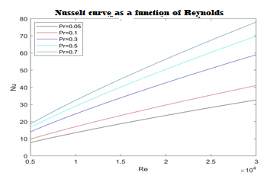
Figure 8: Nusselt curve as a function of Reynolds (for Pr=0.05 ;Pr=0.1 ;Pr=0.3 ;Pr=0.5 ;Pr=0.7)
III.7- Effect of Prandtl number on the Nusselt number in the enclosure
Figure 9 illustrates the effect of the Prandtl number on the Nuselt number. This dimensionless Prandtl number ranges from 0.05 to 0.7. Under the influence of low Reynolds numbers (Re=5.103, Re=9.103, Re=104), the curves vary little (Nu goes from 0 to 19, 0 to 30 and 0 to 33 respectively). On the other hand, as Reynolds increases (Re=3.104), the curve grows enormously (Nu increases from 0 to 78). In this case, the flow is turbulent.
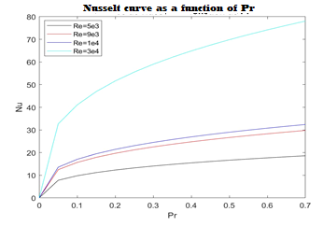
Figure 9 Nusselt curve as a function of Prandtl (for Re=5.103, Re=9.103, Re=104, Re=3.104)

III.8- Effect of the Richardson number on the Nusselt number in the enclosure
Figure 10 shows the Nusselt number versus Richardson number curve. The results show that all curves have a decreasing trend, as we observe a sharp drop in the Nusselt number. Thus, for low Grashof (Gr=2.104, Gr=3.106) and Prandtl (Pr=0.2) values, the curves are almost horizontal until they stabilize and remain constant throughout the evolution of the Richardson number. We're witnessing virtually inefficient heat transfer, with forced convection dominating.
For high values of Grashof (Gr=3.106) and Prandtl (Pr=0.7), the curves decrease significantly and we see thermal diffusion justifying the efficiency of the heat transfer rate.
In both cases, we note that the Nusselt number starts to decrease from Ri>> 1. Consequently, natural convection dominates over forced convection.
In view of the above, we conclude that heat transfer efficiency is a function of air flow, when the latter is directed along the hottest wall. This result is corroborated by the work of S. BOUABDALLAH [15].
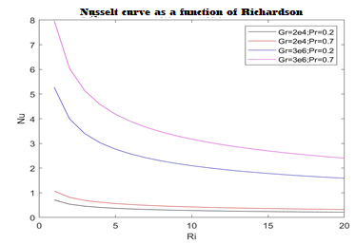

Figure 10 : Nusselt curve as a function of Richards
IV- CONCLUSION
The main results of the targeted parameters were presented, the simulation carried out showed that these correlations have a significant influence in the case of heat transfer phenomena. The results obtained for the Nusselt curve made it possible to highlight the heat transfer behavior as a function of other thermal parameters of the air. The Reynolds curves made it possible to highlight the air flow regime in the enclosure. The Prandtl curves characterizing the relationship between the heat transfer coefficients and the air mass highlighted the heat diffusion of the air in the enclosure of the box.
They are responsible for the rise and fall of temperature in a thermal device, for example, and help determine the nature of convection (natural, forced, mixed, laminar or turbulent).
AI disclaimer
Author(s) hereby declare that NO generative AI technologies such as Large Language Models (ChatGPT, COPILOT, etc.) and text-to-image generators have been used during the writing or editing of this manuscript.

REFERENCE
[1] V.K. Garg, Natural convection between concentric spheres, Int. J. Heat & Mass Transfer, 35, 1992, pp. 1935–1945.
[2] G.de Vahl Davis, R.W. Thomas, Natural convection between concentric vertical cylinders, High Speed Computing in Fluid Dynamics, Physics of Fluids, 12, 1969, pp.198-207.
[3] W.R. Chen, Numerical study of thermal wall boundary effects for transient natural convection between concentric and vertically eccentric spheres, Numer. Heat Transfer A, 44, 2003, pp. 443–449.
[4] C. Shu, K.S. Yeo, Q. Yao, An efficient approach to simulate natural convection in arbitrarily eccentric annuli by vorticity-stream function formulation, Numer. Heat Transfer A, 38, 2000, pp. 739–756.
[5] Y.L. Wu, C. Shu, H.Q. Chen, N. Zhao, Radial basis function-enhanced domain-free
[6] Mohamed A. Medebber, N. Retiel, Numerical Study of Natural Convection in a Vertical Cylindrical Partially Annular, Mechanics and Mechanical Engineering 22, 2018, pp. 77-92.
[7] C.C. Cho, C.L. Chen C.K. Chen, Natural convection heat transfer performance in complex-wavy-wall enclosed cavity filled with nanofluid, Int. J. Ther Sci, 60, 2012, pp. 255- 263.
[8] J. Dale, A. Emery, The free convection of heat from a vertical plate to several nonNewtonian pseudoplastic fluids, ASME J. Heat Transfer 94, 1972, pp. 64–72.
[9]Getachew, W. Mincowycz, D. Poulikakos, Natural convection in a porous cavity saturated with a non-Newtonian fluid, J. Thermophys. Heat Transfer 10, 1996, pp. 640–651.
[10] M. Ohta, M. Akiyoshi, E. Obata, A numerical study on natural convective heat transfer of pseudo-plastic fluids in a square cavity, Numer. Heat Transfer A, 41, 2002, pp. 357–372.
[11] L. Khezzar, D. Signiner, I. Vinogradov, Natural convection of power law fluids in inclined cavities, Int. J. Ther Sci, 53, 2011, pp. 8-17.
[12] W.L. Barth, G.F. Carey, On a natural-convection benchmark problem in non-Newtonian fluids, Numer. Heat Transfer B, 50, 2006, pp. 193–216.
[13] W.H. Leung, K.G.T. Hollands, A.P. Brunger, On a physically-realizable Benchmark problem in internal natural convection, Int. J. Heat & Mass Transfer, 41, 1998, pp. 3817–3828.
[14] A. Prhashanna, R.P. Chhabra, Free convection in power-law fluids from a heated sphere, Chemical Engineering Science, 65, 2010, pp. 6190-6205.
[15] S. Bouabdallah, A. Medjelled, A. Benchatti & A. Hamini, Convection Mixte dans une Cavité Carrée Contenant des Portes d’entrée et de Sortie d’air, Revue des Sciences et Science de l’Ingénieur. RSSI, Vol l. No.02, Décembre (2011)01-09

[16] Farah Zemani-Kaci, Amina Sabeur-Bendhina, Numerical Study of Natural Convective Heat Transfer in an Air Filled Square Cavity Heated from Below and Symmetrically Cooled from the Sides with a Partition in the Hot Wall Fluid Dynamics and Materials Processing
Volume 19, Issue 2, 25 August 2022, Pages 513-539
[17] Sardar Bilal and al, Numerical Study of Natural Convection of Power Law Fluid in a Square Cavity Fitted with a Uniformly Heated T-Fin, Mathematics 2022, 10(3), 342; https://doi.org/10.3390/math10030342 Submission received: 22 September 2021 / Revised: 4 December 2021 / Accepted: 16 December 2021 / Published: 24 January 2022

[18] Farah Zemani-Kaci, Amina Sabeur-Bendhina, Numerical Study of Natural Convective Heat Transfer in an Air Filled Square Cavity Heated from Below and Symmetrically Cooled from the Sides with a Partition in the Hot Wall Fluid Dynamics and Materials Processing
Volume 19, Issue 2, 25 August 2022, Pages 513-539
[19] Sardar Bilal and al, Numerical Study of Natural Convection of Power Law Fluid in a Square Cavity Fitted with a Uniformly Heated T-Fin, Mathematics 2022, 10(3), 342; https://doi.org/10.3390/math10030342
Submission received: 22 September 2021 / Revised: 4 December 2021 / Accepted: 16 December 2021 / Published: 24 January 2022
[20] Hamza Daghab and al, Numerical study of natural convection heat transfer for second-grade fluids confined in square cavity subjected to horizontal heat flux ,AIP Conf. Proc. 2345, 020035 (2021) https://doi.org/10.1063/5.0049421
[21] A. Bendaraa, M. M. Charafi, A. Hasnaoui, Numerical study of natural convection in a differentially heated square cavity filled with nanofluid in the presence of fins attached to walls in different locations, Published in The Physics of Fluids 1 May 2019, Physics, Engineering, Materials Science

