Trauma to Transplant: Paediatric Pythium Keratitis Advancing to Anterior Staphyloma
Abstract
Pythium keratitis, an aggressive vision-threatening infection that rarely affects children. We present the case of an 11-year-old boy who, three years after ocular trauma with a cow horn, experienced progressive corneal opacity and protrusion with vision loss in the right eye. He had a clinical diagnosis of Pythium keratitis, which progressed to anterior staphyloma after healing with scarring and ectasia. Histopathology confirmed the patient's healed Pythium keratitis sequelae after therapeutic penetrating keratoplasty. With better vision and cosmesis after surgery, the graft remained clear. This instance emphasises the importance of prompt keratoplasty in visual and cosmetic rehabilitation by highlighting an uncommon consequence of paediatric Pythium keratitis that progresses to anterior staphyloma.
Keywords: Pythium keratitis, corneal ectasia, cataract, anterior staphyloma, penetrating keratoplasty

Introduction
Pythium insidiosum is an aquatic oomycete that primarily affects tropical and subtropical areas and causes severe, quickly progressing keratitis. It frequently delays diagnosis and effective treatment because of its clinical characteristics, which closely resemble fungal keratitis and include feathery stromal infiltrates, tentacle-like borders, linear expansions, and peripheral guttering ^{[1,2]}. Medical therapy often fails to stop the course of Pythium, which is unresponsive to typical antifungal medications, unlike fungal keratitis ^{[3]}. One significant risk factor, especially in youngsters, is exposure to animals or vegetative materials after trauma ^{[3,4]}. The possibility of amblyopia from extended corneal opacity, delayed reporting, and examination difficulties make paediatric cases more complex.
Anterior staphyloma, an ectatic protrusion of a thin, scarred cornea lined by uveal tissue, is an uncommon but serious complication of untreated infectious keratitis or trauma, resulting in substantial sight loss and cosmetic disfigurement. In advanced situations, therapeutic penetrating keratoplasty (TPK) is frequently required for anatomical restoration, visual rehabilitation, and cosmetic correction ^{[5]}. Paediatric Pythium keratitis leading to anterior staphyloma is extremely rare. Here, we report on an 11-year-old child with post-traumatic Pythium keratitis who developed anterior staphyloma over three years and was successfully treated with TPK.
Case Report
An 11-year-old male presented to our tertiary care ophthalmology department with complaints of developing whitish opacity and protrusion of the right eye, along with poor vision, during the previous three years. At the age of eight, the right eye was traumatised with a cow horn, resulting in pain, redness, watering, and rapid corneal ulceration. At the time, the infant was clinically diagnosed with Pythium keratitis due to a history of trauma, vegetative matter, quickly progressing stromal infiltrates, and feathery edges with surrounding tentacle-like extensions. Despite intensive medical treatment, the infection did not completely resolve, and the cornea developed scarring, thinning, and ectasia. Over the years, the damaged cornea gradually protruded, resulting in the development of an anterior staphyloma. The parents noted that the protrusion and milky opacity gradually grew in size, and the child's vision decreased dramatically. There was no history of previous ocular surgery, systemic sickness, or similar problems among family members.
On examination, uncorrected visual acuity (VA) in the right eye (RE) was HM+, PL+, PR4+ not improving further. The left eye (LE) had unaided 6/6 vision. Ocular motility was full in both eyes. Torchlight examination of (RE) showed an ectatic, irregularly contoured cornea with whitish opacity. Slit-lamp examination revealed a protruding anterior staphyloma with extensive corneal neovascularization, hypertrophic epithelium, and diffuse stromal opacity. (Figure 1.) The anterior chamber's details were not visible. The fundus view was obscured, but B-scan ultrasonography revealed cataract formation in the normal posterior segment. The (LE) anterior segment, adnexa, and fundus were all within normal ranges.
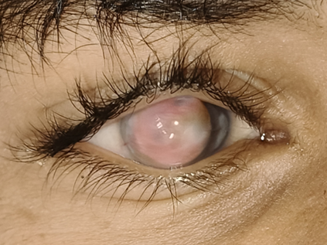
(Figure 1: Torchlight photograph of the right eye showing anterior staphyloma with whitish corneal opacity, ectasia, and surface neovascularization.)
Given the patient's poor vision and disfiguring anterior staphyloma, therapeutic penetrating keratoplasty (PKP) was recommended. Under general anaesthesia, a 10.0 mm recipient bed was trephined, and a 10.5 mm donor corneal button was secured with interrupted 10-0 nylon sutures. The excised corneal tissue was submitted for histopathological examination (HPE). HPE revealed stratified squamous epithelium overlying Bowman's layer, as well as disorganised stromal collagen bundles, fibrovascular proliferation, and neovascularisation foci, all of which were consistent with the presence of long-standing staphyloma following healed infectious keratitis (Pythium). No viable fungal elements were detected. (Figure 2A and 2B)
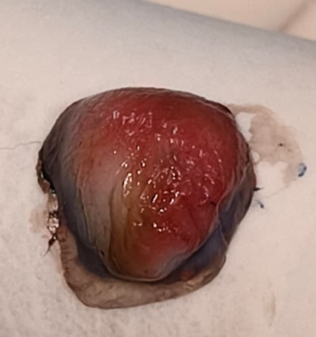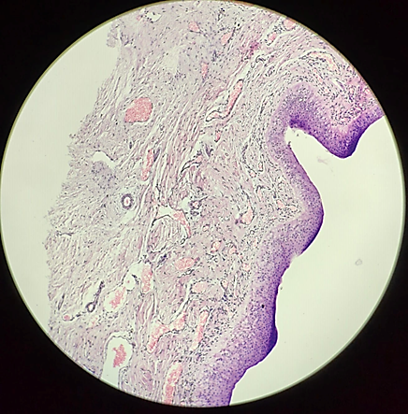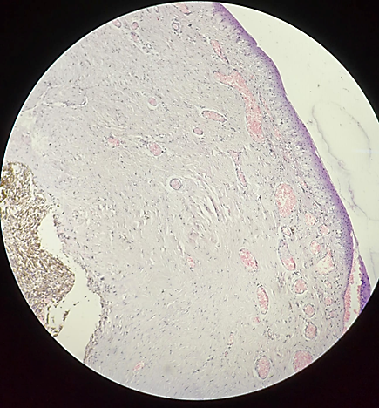
(Figure 2A: Gross photograph of the excised corneal button. showing an opaque, ectatic specimen consistent with anterior staphyloma. Figure 2B: Histopathology of the corneal button demonstrating disorganized stromal collagen with fibrovascular proliferation and neovascularization (H&E, x40))
Postoperatively, the graft was well-attached and clear, with no symptoms of rejection. (Figure 3). At the 4-week follow-up, the best corrected visual acuity (BCVA) in RE had improved to counting fingers at 3 meters (CF3). The cosmetic look was greatly improved, and both the patient and his parents ‘expressed happiness with the results.
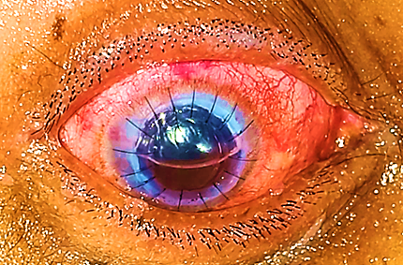
(Figure 3: Postoperative photograph showing a clear, well- attached penetrating keratoplasty graft with restored corneal curvature)

Discussion
Pythium insidiosum keratitis is a rare and aggressive corneal infection often misdiagnosed as fungal keratitis due to overlapping clinical features, which can delay diagnosis and worsen prognosis ^{[1,2]}. Unlike fungal keratitis, Pythium is refractory to conventional antifungal therapy, and therapeutic penetrating keratoplasty (TPK) is often the only definitive management for advanced or non-resolving cases ^{[3,4]}. Recent studies emphasize that early microbiological confirmation and initiation of targeted antimicrobial therapy, particularly with linezolid and azithromycin, can improve outcomes ^{[1,3,5]}.
Paediatric presentations are particularly challenging, as children tend to present late, are difficult to examine, and face the risk of amblyopia due to prolonged corneal opacity and visual deprivation ^{[3,6]}. Our patient developed keratitis following cow horn trauma, which progressed over three years to anterior staphyloma—a rare chronic outcome in paediatric cases. Most reported paediatric Pythium cases either heal with scarring or progress rapidly to perforation, making this prolonged ectatic sequela unusual ^{[6,7]}.
Recent literature from Indian centres has further defined the clinical spectrum of Pythium keratitis. Vishwakarma et al. described detailed clinical, microbiological, and post-treatment histopathological findings, noting that fibrovascular proliferation and loss of normal stromal architecture often indicate healed infection ^{[11]}. Their findings align with our histopathological observation of disorganized stromal collagen and fibrovascular tissue without viable organisms. Kate et al. reported favourable anatomical outcomes after TPK when managed with a combination of topical and systemic antibiotics, highlighting the evolving role of non-antifungal regimens in perioperative management ^{[12]}.
Paediatric outcomes remain variable. Gurnani et al. reported successful medical management in a 9-year-old child using linezolid, azithromycin, and cyanoacrylate glue, achieving BCVA of 6/12 ^{[8]}. In contrast, Ranasinghe et al. described a Sri Lankan adolescent requiring multiple keratoplasties with poor visual outcomes ^{[9]}. Large Indian cohorts demonstrate that over 80% of Pythium keratitis cases ultimately require TPK, with recurrence being common and globe loss occurring in up to 25% of eyes ^{[10,12]}.
In our case, the large-diameter TPK (10.5 mm) successfully restored globe integrity, improved cosmesis, and yielded modest visual recovery. Given the paediatric context, cosmetic rehabilitation holds special significance for psychosocial well-being and confidence. Early recognition, microbiological confirmation, and aggressive surgical management remain key to improving anatomical and visual outcomes in Pythium keratitis.
Conclusion
Paediatric Pythium insidiosum keratitis is an uncommon and aggressive infection that can lead to serious complications such as anterior staphyloma, especially after ocular trauma. Early detection and timely action are critical, as traditional antifungal medication is frequently ineffective. Therapeutic penetrating keratoplasty is still the primary treatment for anatomical restoration, visual rehabilitation, and cosmetic improvement in advanced paediatric cases.
Informed Consent
Informed consent was obtained from the patient for the publication of this case report, including any accompanying images and details.
Disclaimer (Artificial intelligence)
Option 1:
Author(s) hereby declare that NO generative AI technologies such as Large Language Models (ChatGPT, COPILOT, etc.) and text-to-image generators have been used during the writing or editing of this manuscript.
Option 2:
Author(s) hereby declare that generative AI technologies such as Large Language Models, etc. have been used during the writing or editing of manuscripts. This explanation will include the name, version, model, and source of the generative AI technology and as well as all input prompts provided to the generative AI technology
Details of the AI usage are given below:
1.
2.
3.

References
1.Sood DR, Sood DR. Assessment of cases of Pythium insidiosum keratitis- A clinical study. Int J Med Ophthalmol [Internet]. 2020;2(2):81–3. Available from: https://www.ophthalmoljournal.com/articles/45/2-2-3-564.pdf
2.Thomas PA, Kaliamurthy J. Mycotic keratitis: epidemiology, diagnosis and management. Clin Microbiol Infect. 2013 Mar;19(3):210-20. doi: 10.1111/1469-0691.12126. Epub 2013 Feb 9. PMID: 23398543.
3. Pratima Vishwakarma & Bhupesh Bagga (2022): Pythium insidiosum keratitis: Review of literature of 5 years’ clinical experience at a tertiary eye care center, Seminars in Ophthalmology, DOI: 10.1080/08820538.2022.2116287
4. Bajracharya L, Gurung R. Outcome of therapeutic penetrating keratoplasty in a tertiary eye care center in Nepal. Clin Ophthalmol. 2015 Dec 7; 9:2299-304. doi: 10.2147/OPTH.S92176. PMID: 26673279; PMCID: PMC4676621.
5. Gurnani, Bharat; Kaur, Kirandeep¹; Venugopal, Anitha²; Srinivasan, Bhaskar³; Bagga, Bhupesh⁴; Iyer, Geetha⁵; Christy, Josephine⁶; Prajna, Lalitha⁷; Vanathi, Murugesan⁸; Garg, Prashant⁹; Narayana, Shivanand¹⁰; Agarwal, Shweta¹¹; Sahu, Srikant¹². Pythium insidiosum keratitis - A review. Indian Journal of Ophthalmology 70(4): p 1107-1120, April 2022. | DOI: 10.4103/ijo.IJO_1534_21
6. Krajaejun T, Sathapatayavongs B, Pracharktam R, Nitiyanant P, Leelachaikul P, Wanachiwanawin W, Chaiprasert A, Assanasen P, Saipetch M, Mootsikapun P, Chetchotisakd P, Lekhakula A, Mitarnun W, Kalnauwakul S, Supparatpinyo K, Chaiwarith R, Chiewchanvit S, Tananuvat N, Srisiri S, Suankratay C, Kulwichit W, Wongsaisuwan M, Somkaew S. Clinical and epidemiological analyses of human pythiosis in Thailand. Clin Infect Dis. 2006 Sep 1;43(5):569-76. doi: 10.1086/506353. Epub 2006 Jul 13. PMID: 16886148.
7. Gurnani B, Kaur K, Agarwal S, Lalgudi VG, Shekhawat NS, Venugopal A, et al. Pythium insidiosum Keratitis: Past, Present, and Future. Ophthalmol Ther. 2022;11(5):1629–53. Available from: https://d-nb.info/1266282742/34
8. Researchgate.net. Available from: https://www.researchgate.net/publication/389070239_A_case_of_Pythium_keratitis_from_Sri_Lanka
9. Gurnani B, Kaur K, Venugopal A, Srinivasan B, Bagga B, Iyer G, Christy J, Prajna L, Vanathi M, Garg P, Narayana S, Agarwal S, Sahu S. Pythium insidiosum keratitis - A review. Indian J Ophthalmol. 2022 Apr;70(4):1107-1120. doi: 10.4103/ijo.IJO_1534_21. PMID: 35325996; PMCID: PMC9240499.
10. Cao B, Gonugunta VT, Radhakrishnan N, Lalitha P, Gurnani B, Kaur K, Iyer G, Agarwal S, Srinivasan B, Keenan JD, Prajna NV. Outcomes of Pythium keratitis: a meta-analysis of individual patient data. Curr Ophthalmol Rep. 2022 Dec;10(4):198-208. doi: 10.1007/s40135-022-00302-7. Epub 2022 Nov 10. PMID: 37250102; PMCID: PMC10211475.
11. Vishwakarma P, Mohanty A, Kaur A, Das S, Priyadarshini SR, Mitra S, et al. Pythium keratitis: clinical profile, laboratory diagnosis, treatment, and histopathology feature post-treatment at a tertiary eye care center in Eastern India. Indian J Ophthalmol. 2021;69(6):1544–52. doi: 10.4103/ijo.IJO_2356_20.
12. Kate A, Thigale U, Ponnapati LP, Chaudhary S, Vishwakarma P, Sharma S, Bagga B, et al. Outcomes of therapeutic penetrating keratoplasty in Pythium insidiosum keratitis managed with a combination of antibiotics. Indian J Ophthalmol. 2023;71(5):1868–74. doi: 10.4103/IJO.IJO_2862_22.

