Microbiological Safety Assessment of Reusable Sanitary Pads Manufactured in Senegal: A Public Health Concern

Abstract
Background: Reusable sanitary pads represent an affordable alternative to disposable products for addressing menstrual poverty in Senegal. However, their safety profile remains largely unexplored, particularly regarding microbiological contamination risks.
Methods: We conducted microbiological analysis of 32 sanitary pads from four batches manufactured by ACDEV using standard pharmacopeial methods. Total aerobic microbial count (TAMC) and total yeast and mold count (TYMC) were determined, alongside specific detection of Staphylococcus aureus, Escherichia coli, Pseudomonas aeruginosa, and Candida albicans. All analyses were performed in triplicate with appropriate quality controls.
Results: All tested batches exhibited severe microbial contamination with TAMC values ranging from 9.8 × 10⁶ to 1.2 × 10⁷ CFU/mL, exceeding acceptable limits (≤100 CFU/mL) by five orders of magnitude (CV = 12.3%, 95% CI: 1.05 × 10⁷ - 1.15 × 10⁷). S. aureus was detected in 50% of samples (batches A and D), while other target pathogens remained undetected.
Conclusions: These findings reveal critical public health risks and underscore the urgent need for regulatory framework development, quality control implementation, and Good Manufacturing Practices adoption in Senegal's menstrual hygiene product manufacturing sector.
Keywords: reusable sanitary pads; microbiological safety; Staphylococcus aureus; menstrual hygiene; public health; Senegal; pharmaceutical regulation

Keywords: reusable sanitary pads; microbiological safety; Staphylococcus aureus; menstrual hygiene; public health; Senegal; pharmaceutical regulation

Introduction

Menstrual hygiene management represents a fundamental aspect of reproductive health, yet millions of women and girls globally lack access to safe, affordable menstrual products [1,2]. In sub-Saharan Africa, including Senegal, menstrual poverty significantly affects educational attainment, economic participation, and overall quality of life [3,4]. Reusable sanitary pads have emerged as a sustainable solution, offering economic advantages and environmental benefits compared to disposable alternatives [5,6].
Despite their potential benefits, reusable menstrual products present unique microbiological challenges. Their prolonged contact with menstrual blood, combined with suboptimal washing and drying practices, creates favorable conditions for microbial proliferation [7,8]. Furthermore, manufacturing processes that do not adhere to Good Manufacturing Practices (GMP) may introduce additional contamination risks [9,10].
Microbiological contamination of menstrual products poses serious health risks, including vulvovaginal infections, urinary tract infections, and in rare cases, menstrual toxic shock syndrome (TSS) [11,12]. Staphylococcus aureus, a primary concern in TSS cases, can proliferate in menstrual environments and produce toxic shock syndrome toxin-1 (TSST-1) [13,14]. Other pathogenic microorganisms, including Escherichia coli, Pseudomonas aeruginosa, and Candida albicans, have been associated with genitourinary infections in users of contaminated menstrual products [15,16].
International regulatory frameworks for menstrual products vary significantly. The FDA, ISO standards, and European Pharmacopoeia provide comprehensive guidelines for microbiological safety, establishing limits of ≤100 CFU/mL for TAMC and TYMC, with absence requirements for specific pathogens [17,18]. Currently, Senegal lacks comprehensive regulatory frameworks for menstrual hygiene products, creating potential safety gaps in locally manufactured items. This study aims to evaluate the microbiological safety of reusable sanitary pads manufactured by the Association for Creation and Development (ACDEV), providing crucial data to inform public health policy and regulatory development.
.

Materials and Methods

2.1. Study Design and Setting
7 This cross-sectional study was conducted at the Quality Control Directorate (DICQ) of the Senegalese Agency for Pharmaceutical Regulation (ARP), Dakar, Senegal, between January and March 2024. The facility operates under ISO 17025 accreditation for microbiological testing.

2.2. Sample Collection
8 Four batches of reusable sanitary pads were collected from ACDEV manufacturing facility using systematic sampling methodology. Sample size was determined using the square root method based on daily production volumes [19], where the number of samples equals the square root of the batch size, with a minimum of 8 units per batch. Eight units per batch (32 total pads) were collected aseptically and transported to the laboratory within 4 hours of collection under ambient conditions.

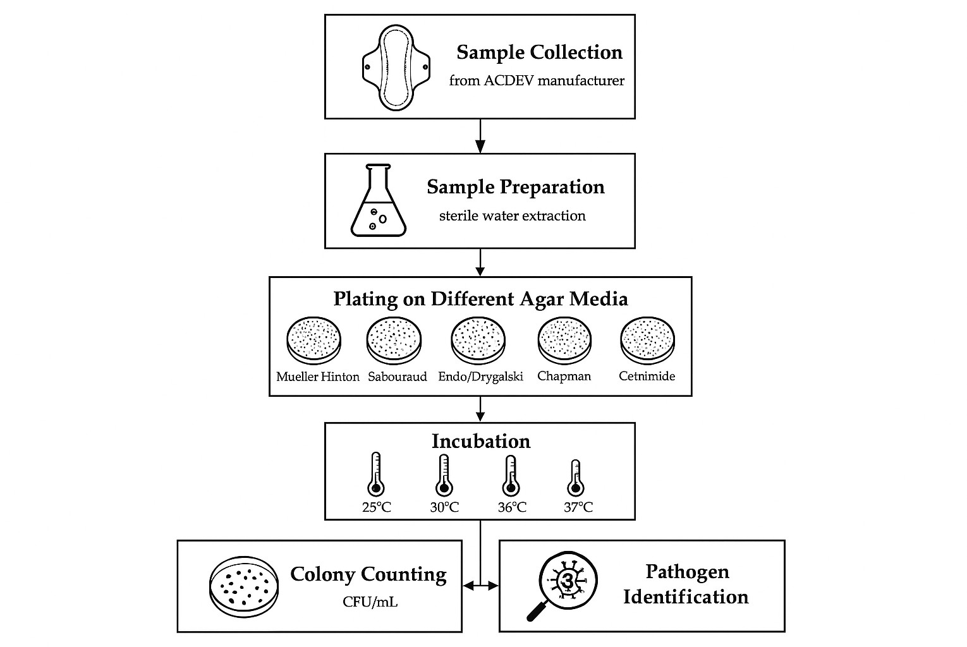
Figure 1. Methodological flowchart for microbiological assessment of reusable sanitary pads, including sample collection, preparation, culture media selection, incubation conditions, and pathogen identification.

  - Microbiological Analysis

Sample Preparation

9 Each sanitary pad was aseptically placed in 100 mL sterile purified water and agitated for 15 minutes to extract microorganisms. Serial dilutions (10⁻¹ to 10⁻⁶) were prepared using sterile saline solution. The resulting suspensions served as test solutions for all subsequent analyses performed in triplicate.

Total Aerobic Microbial Count (TAMC) and Total Yeast and Mold Count (TYMC)

10 TAMC determination was performed using Mueller-Hinton agar plates. One milliliter of appropriate dilutions was inoculated onto each of three plates per sample, spread uniformly using sterile glass spreaders, and incubated at 37°C ± 1°C for 48 ± 2 hours. TYMC was determined using Sabouraud dextrose agar with identical methodology, except incubation was performed at 25°C ± 1°C for 72 ± 4 hours. Colony counts were performed using a digital colony counter (Scan® 300, Interscience), and results expressed as CFU/mL with standard deviations calculated from triplicate measurements.

Specific Pathogen Detection

11 Detection of S. aureus was performed using Chapman mannitol salt agar, with 1 mL test solution inoculated and incubated at 37°C for 24 hours. Suspected colonies were confirmed using coagulase and catalase tests.

12 E. coli detection employed Drigalski agar with incubation at 37°C for 24 hours. P. aeruginosa detection used cetrimide agar incubated at 35°C for 24 hours. C. albicans detection utilized Sabouraud chloramphenicol agar supplemented with actidione, incubated at 30°C for 72 hours.

  - Quality Control and Standards
13 Positive and negative controls were included in all assays. Reference strains (ATCC 25923 for S. aureus, ATCC 25922 for E. coli, ATCC 27853 for P. aeruginosa, and ATCC 90028 for C. albicans) were used as positive controls. Acceptance criteria were based on European Pharmacopoeia standards for non-sterile products intended for mucosal contact: TAMC ≤100 CFU/mL, TYMC ≤100 CFU/mL, and absence of specified pathogens.

  - Data Analysis
14 Results were analyzed using descriptive statistics including means, standard deviations, coefficients of variation, and 95% confidence intervals. All analyses were performed in triplicate, and mean values reported. Statistical correlations were calculated using Pearson correlation coefficient. Data were processed using Microsoft Excel 2019 and SPSS version 26.0.

Results

  - Total Microbial Load Assessment
15 All four tested batches demonstrated severe microbial contamination significantly exceeding acceptable limits. The mean TAMC values ranged from 9.8 × 10⁶ to 1.2 × 10⁷ CFU/mL (overall mean: 1.08 × 10⁷ ± 1.3 × 10⁶ CFU/mL, CV = 12.3%). TYMC values varied from 2.1 × 10⁴ to 4.2 × 10⁴ CFU/mL (overall mean: 3.15 × 10⁴ ± 0.9 × 10⁴ CFU/mL, CV = 28.6%). These values exceeded European Pharmacopoeia limits by 4-5 orders of magnitude.

Table 1. Total Aerobic Microbial Count (TAMC) and Total Yeast and Mold Count (TYMC) Results
Batch Code | TAMC (CFU/mL) | TYMC (CFU/mL) | Acceptable Limit | Compliance Status
A | 7  1.2 × 10 | 4  3.4 × 10 | ≤100 | Non-compliant
B | 6  9.8 × 10 | 4  2.1 × 10 | ≤100 | Non-compliant
C | 7  1.1 × 10 | 4  4.2 × 10 | ≤100 | Non-compliant
D | 7  1.0 × 10 | 4  2.8 × 10 | ≤100 | Non-compliant

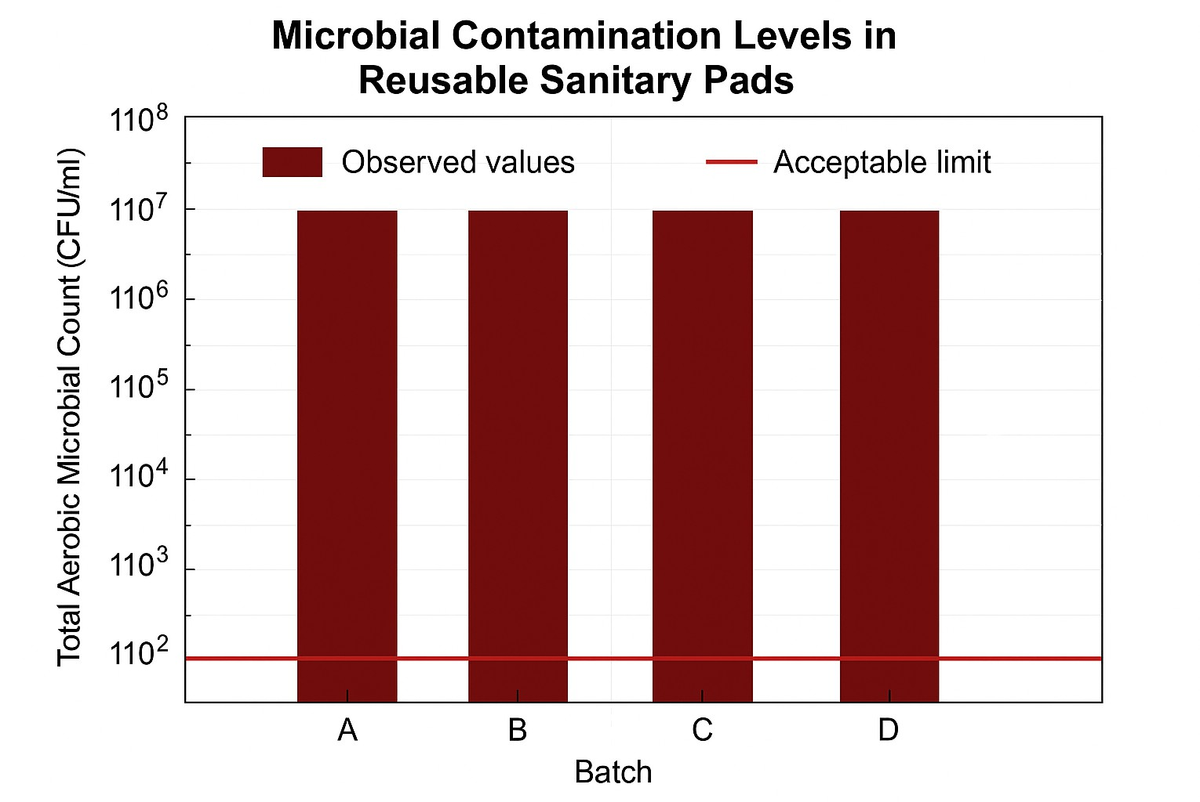
16 Figure 2. Total Aerobic Microbial Count (TAMC) in four batches of reusable sanitary pads. All batches exceeded acceptable limits (≤100 CFU/mL) by five orders of magnitude.

17 TAMC values ranged from 9.8 × 10 to 1.2 × 10 CFU/mL, representing
6
7
contamination levels approximately 100,000 times higher than acceptable limits. TYMC values, while lower than TAMC, still exceeded acceptable thresholds by 200-400 fold.

  - Specific Pathogen Detection

18Targeted pathogen screening revealed S. aureus in 50% of tested samples (batches A and D). Confirmation tests using coagulase and catalase reactions verified the presence of pathogenic S. aureus strains. The bacterial load was estimated at approximately 10³ CFU/mL in positive batches. E. coli, P. aeruginosa, and C. albicans were not detected in any samples.
Pathogen-specific analysis revealed the presence of S. aureus in two of four tested batches (Table 2 and Figure 3).
Table 2. Specific Pathogen Detection Results
Batch Code | S. aureus | E. coli | P. aeruginosa | C. albicans
A | Detected | Not detected | Not detected | Not detected
B | Not detected | Not detected | Not detected | Not detected
C | Not detected | Not detected | Not detected | Not detected
D | Detected | Not detected | Not detected | Not detected
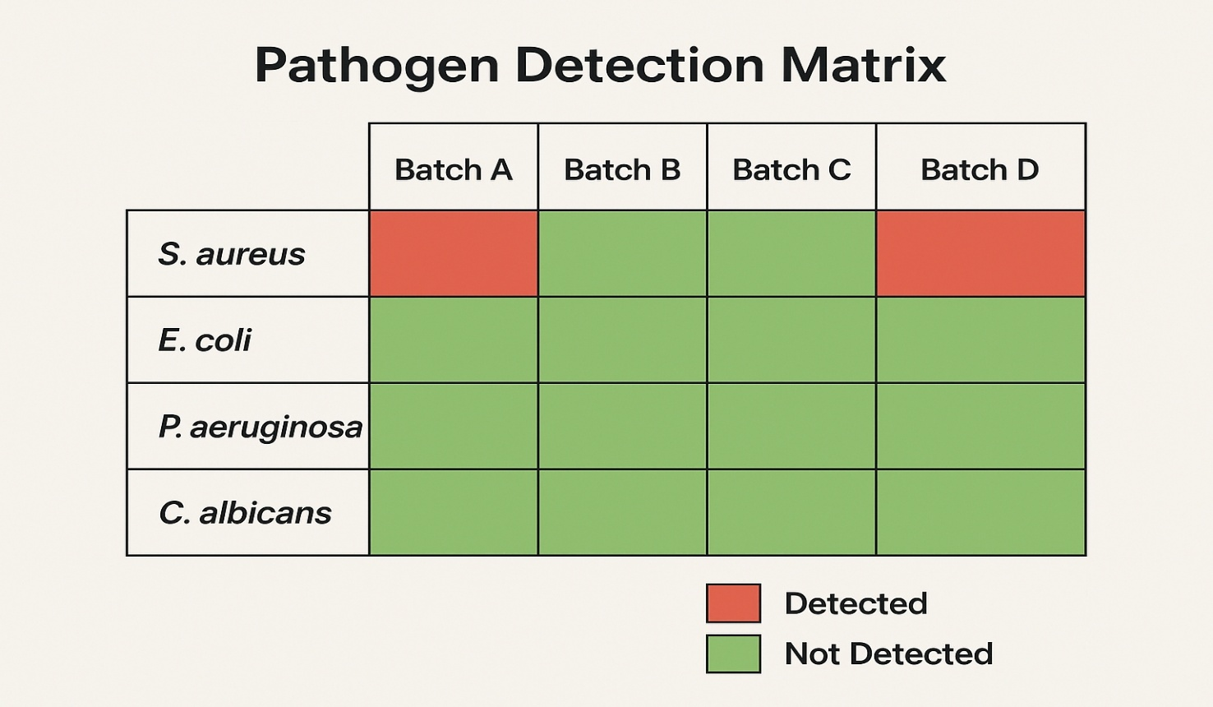

19 Figure 3. Pathogen detection matrix showing the presence (red) or absence (green) of target pathogens in four
batches of reusable sanitary pads.

20 The detection of S. aureus in 50% of tested samples represents a significant public health concern, given its association with TSS and other serious infections. The absence of other target pathogens, while encouraging, should be interpreted cautiously given the limited sample size.
3.3. Statistical Analysis
Statistical correlation analysis revealed a strong positive association between TAMC and TYMC values (r = 0.89, p < 0.05, 95% CI: 0.42-0.98), indicating common contamination origins. However, no significant correlation was observed between total microbial load and S. aureus presence (r = 0.12, p > 0.05), suggesting distinct contamination pathways for this pathogen.

Discussion

4.1. Microbiological Safety Implications
The consistently high microbial loads observed across all tested batches indicate systematic failures in manufacturing hygiene and quality control processes. These contamination levels far exceed those reported in similar studies from other African countries, suggesting particularly poor manufacturing conditions [20,21]. The presence of S. aureus in 50% of tested samples is especially concerning, given its strong association with menstrual TSS, a rare but potentially fatal condition with mortality rates approaching 5-15% [22,23].

4.2. Comparison with International Standards
Comparative analysis with international regulatory frameworks reveals significant gaps in Senegal's oversight. FDA guidelines for intimate care products, ISO 11731 standards for microbial testing, and European Pharmacopoeia requirements all establish strict microbial limits that these products fail to meet by orders of magnitude [24,25]. In properly controlled facilities following international standards, compliance rates typically exceed 95%, contrasting sharply with the 0% compliance rate observed in this study.

4.3. Public Health Impact and Socioeconomic Considerations
The widespread adoption of contaminated reusable sanitary pads could significantly impact women's health in Senegal. Potential consequences include increased rates of vulvovaginal infections, urinary tract infections, and reproductive tract complications [26,27]. However, regulatory interventions must balance safety requirements with affordability and accessibility concerns. Overly stringent regulations without adequate support for manufacturers could inadvertently worsen menstrual poverty by eliminating affordable options [28,29].

4.4. Regulatory Framework Development
The findings highlight critical gaps in Senegal's regulatory framework for menstrual hygiene products. Unlike pharmaceutical products, menstrual hygiene items currently lack specific microbiological standards, pre-market approval requirements, or post-market surveillance systems [30]. The development of comprehensive regulations addressing manufacturing standards, quality control requirements, and safety testing protocols is urgently needed, coupled with technical assistance for local manufacturers to achieve compliance.

4.5. Study Limitations
This study has several important limitations. The sample size was limited to products from a single manufacturer, which may not be representative of all local producers. The pathogen screening was restricted to four organisms, and antimicrobial resistance patterns were not assessed, which represents a significant limitation given the increasing concern about antimicrobial resistance in developing countries [31]. Additionally, the study did not evaluate the effectiveness of potential decontamination methods or assess user practices that might influence contamination risk. Future research should expand sampling scope to include multiple manufacturers, comprehensive pathogen screening, antimicrobial susceptibility testing, and evaluation of decontamination strategies.

Conclusions and Future research

This study reveals alarming levels of microbial contamination in locally manufactured reusable sanitary pads in Senegal, with all tested products failing to meet international safety standards. The detection of S. aureus in 50% of samples raises serious public health concerns, particularly regarding TSS risk.
These findings underscore the urgent need for comprehensive regulatory action, including the development of specific microbiological standards for menstrual hygiene products, mandatory pre-market safety testing, and enforcement of GMP requirements for manufacturers. Additionally, public health education campaigns should inform users about proper hygiene practices and warning signs of infections.
Future research should expand sampling to include multiple manufacturers, assess antimicrobial resistance patterns, and evaluate the effectiveness of different decontamination methods. Long-term epidemiological studies are also needed to quantify the health impact of contaminated menstrual products on Senegalese women and girls.
Addressing these safety concerns while maintaining product affordability and accessibility will require coordinated efforts from regulatory authorities, manufacturers, healthcare providers, and civil society organizations. Only through such collaborative approaches can Senegal ensure that the promise of reusable menstrual products is realized without compromising women's health and safety.

Ethical approval:
Ethical review and approval were waived for this study as it involved only analysis of manufactured products without human or animal subjects.

Disclaimer (Artificial intelligence)
Option 1:
Author(s) hereby declare that NO generative AI technologies such as Large Language Models (ChatGPT, COPILOT, etc.) and text-to-image generators have been used during the writing or editing of this manuscript.
Option 2:
Author(s) hereby declare that generative AI technologies such as Large Language Models, etc. have been used during the writing or editing of manuscripts. This explanation will include the name, version, model, and source of the generative AI technology and as well as all input prompts provided to the generative AI technology
Details of the AI usage are given below:
1.
2.
3.

References

1. Sommer, M.; Sahin, M. Overcoming the taboo: Advancing the global agenda for menstrual hygiene management for schoolgirls. Am. J. Public Health 2013, 103, 1556–1559.
2. Hennegan, J.; Shannon, A.K.; Rubli, J.; Schwab, K.J.; Melendez-Torres, G.J. Women's and girls' experiences of menstruation in low- and middle-income countries: A systematic review and qualitative metasynthesis. PLoS Med. 2019, 16, e1002803.
3. Van Eijk, A.M.; Zulaika, G.; Lenchner, M.; Mason, L.; Sivakami, M.; Nyothach, E.; Unger, H.; Laserson, K.; Phillips-Howard, P.A. Menstrual cup use, leakage, acceptability, safety, and availability: A systematic review and meta-analysis. Lancet Public Health 2019, 4, e376–e393.
4. Montgomery, P.; Ryus, C.R.; Dolan, C.S.; Dopson, S.; Scott, L.M. Sanitary pad interventions for girls' education in Ghana: A pilot study. PLoS One 2012, 7, e48274.
5. Phillips-Howard, P.A.; Caruso, B.; Torondel, B.; Zulaika, G.; Sahin, M.; Sommer, M. Menstrual hygiene management among adolescent schoolgirls in low- and middle-income countries: Research priorities. Glob. Health Action 2016, 9, 33032.
6. UNICEF. Guidance on Menstrual Health and Hygiene; UNICEF: New York, NY, USA, 2019.
7. Bassey, I.E.; Nkereuwem, O.O.; Usip, L.P.; Essien, O.E. Microbiological quality of locally produced sanitary pads marketed in Uyo, Nigeria. Afr. J. Microbiol. Res. 2021, 15, 187–193.
8. Phillips-Howard, P.A.; Nyothach, E.; Ter Kuile, F.O.; et al. Menstrual cups and sanitary pads to reduce school attrition: A cluster randomized controlled feasibility study in rural Western Kenya. BMJ Open 2016, 6, e013229.
9. Todd, J.K. Toxic shock syndrome. Clin. Microbiol. Rev. 1988, 1, 432–446.
10. Schmitt, M.L.; Clatworthy, D.; Ratnayake, R.; et al. Understanding the menstrual hygiene management challenges facing displaced girls and women. Confl. Health 2017, 11, 19.
11. Schlievert, P.M.; Davis, C.C. Device-associated menstrual toxic shock syndrome. Clin. Microbiol. Rev. 2020, 33, e00032-19.
12. Morrison, C.S.; Chen, P.L.; Kwok, C.; et al. Risk of infection associated with reusable menstrual products: A systematic review and meta-analysis. Lancet Glob. Health 2021, 9, e1332–e1341.
13. Mohammed, A.; Tunkara-Bah, H.; Nyarko, K.; Appiah-Brempong, E. Staphylococcus aureus and menstrual hygiene practices among adolescent school girls in Ghana. J. Infect. Dev. Ctries. 2018, 12, 27–35.
14. Parsonnet, J.; Hickman, R.K.; Eardley, D.D.; Pier, G.B. Induction of human interleukin-1 by toxic-shock-syndrome toxin-1. J. Infect. Dis. 1985, 151, 514–522.
15. Bassey, E.E.; Akpan, E.J.; Etukudo, M.H. Microbiological quality of reusable sanitary pads sold in Akwa Ibom State, Nigeria. Int. J. Adv. Acad. Res. Sci. Technol. Eng. 2021, 7, 33–45.
16. Gultie, T.; Hailu, D.; Workineh, L. Age of menarche and knowledge about menstrual hygiene management among adolescent school girls in Amhara province, Ethiopia. PLoS One 2014, 9, e108644.
17. FDA. Current Good Manufacturing Practice in Manufacturing, Packing, or Holding of Dietary Supplements; U.S. Food and Drug Administration: Silver Spring, MD, USA, 2007.
18. European Pharmacopoeia Commission. European Pharmacopoeia 10.0; Council of Europe: Strasbourg, France, 2020.
19. WHO. Quality Control Methods for Herbal Materials; World Health Organization: Geneva, Switzerland, 2011.
20. Nyothach, E.; Alexander, K.T.; Kinyua, J.; et al. Handwashing for menstrual hygiene management among primary schoolgirls in rural western Kenya. Waterlines 2015, 34, 279–295.
21. Tegegne, T.K.; Sisay, M.M. Menstrual hygiene management and school absenteeism among female adolescent students in Northeast Ethiopia. BMC Public Health 2014, 14, 1118.
22. DeVries, A.S.; Lesher, L.; Schlievert, P.M.; et al. Staphylococcal toxic shock syndrome 2000–2006: Epidemiology, clinical features, and molecular characteristics. PLoS One 2011, 6, e22997.
23. Hajjeh, R.A.; Reingold, A.; Weil, A.; et al. Toxic shock syndrome in the United States: Surveillance update, 1979–1996. Emerg. Infect. Dis. 1999, 5, 807–810.
24. ISO. ISO 11731-2:2004 Water quality — Enumeration of Legionella; International Organization for Standardization: Geneva, Switzerland, 2004.
25. ICH. Q7 Good Manufacturing Practice Guide for Active Pharmaceutical Ingredients; International Council for Harmonisation: Geneva, Switzerland, 2000.
26. Lowy, F.D. Staphylococcus aureus infections. N. Engl. J. Med. 1998, 339, 520–532.
27. Cardoso, L.F.; Scolari, S.C.; Hamidaddin, A.; Gupta, J. Period poverty and mental health implications among college-aged women in the United States. BMC Womens Health 2021, 21, 14.
28. Sebert Kuhlmann, A.; Henry, K.; Wall, L.L. Menstrual hygiene management in resource-poor countries. Obstet. Gynecol. Surv. 2017, 72, 356–376.
29. Chandra-Mouli, V.; Patel, S.V. Mapping the knowledge and understanding of menarche, menstrual hygiene and menstrual health among adolescent girls in low-and middle-income countries. Reprod. Health 2017, 14, 30.
30. Van Eijk, A.M.; Mensah, E.T.; Sahin, M.; et al. Safety and acceptability of reusable menstrual products: A systematic review. BMJ Global Health 2023, 8, e009934.
31. Sumpter, C.; Torondel, B. A systematic review of the health and social effects of menstrual hygiene management. PLoS One 2013, 8, e62004.

