Original Research Article

Quantifying Inter-Annual Seasonal Drift in Tomato Prices Using Dynamic Time Warping: Evidence from Kolar Market

.
ABSTRACT

Tomato prices in Kolar market exhibit high volatility alongside recurring seasonal patterns, but the consistency of these patterns across years remains unclear. This study analysed weekly tomato prices and arrivals from 2010–2024 to quantify inter-annual variability using descriptive statistics, seasonal indices, and Dynamic Time Warping (DTW). Descriptive analysis confirmed extreme fluctuations (CV = 77% for prices, 102% for arrivals) with positive skewness and heavy tails, indicating frequent extreme events. Seasonal indices revealed recurring intra-year cycles, but year-to-year alignment varied substantially. DTW analysis for 2021–2024 quantified pattern similarity, showing that 2022–2023 had the highest alignment (DTW distance: 23,258) despite extreme price spikes (max: ₹7,429), whereas 2021–2022 exhibited the weakest alignment (distance: 39,049), reflecting structural shifts in market dynamics. Path length metrics indicated minimal temporal warping in 2022–2023 (71 points) versus extensive alignment in 2021–2022 (83 points). These results demonstrate that while seasonal patterns recur, their temporal consistency is not fixed, highlighting the need for forecasting models that adapt to both magnitude volatility and temporal shifts. The study also illustrates the utility of DTW for agricultural price analysis and the limitations of relying solely on fixed seasonal patterns in volatile commodity markets.

Keywords: Tomato prices, Price volatility, Inter-annual variability, Seasonal index, Dynamic Time Warping (DTW), Pattern similarity, Forecasting accuracy

1. INTRODUCTION

Tomato is India’s most important vegetable crop, yet its market is notorious for intra-year price swings that often exceed 200 per cent (Rediff Money 2024; PIB 2024; The Hindu 2024; NITI Ayog 2024). Perishability, concentrated harvest windows and thin cold-chain capacity expose smallholders to large income risk (Roy et al. 2024; Mittal, 2007). Forecasting models from SARIMA to LSTM capture mean seasonality but lose accuracy during volatile spells, with errors above 20 per cent (Manogna et al., 2025). A neglected issue is whether the calendar of seasonality itself changes. Classical seasonal indices assume identical timing each year; if peaks slide by several weeks, fixed-dummy forecasts fail. Dynamic Time Warping (DTW) allows elastic alignment of two series and has been used in energy and equity research; applications to perishable food prices remain rare.
This study examines weekly tomato prices and arrivals at Kolar APMC (2010-2024) to (i) profile volatility, (ii) extract seasonal indices, and (iii) quantify year-to-year calendar drift with DTW over 2021-2024. Kolar is South India’s dominant tomato supply hub, so its price discovery influences neighbouring states.
The study contributes: (a) a DTW-based diagnostic for inter-annual pattern consistency, (b) empirical evidence that tomato seasonal timing is recurrent but temporally unstable, and (c) guidance for adaptive forecasting that tolerates both magnitude and calendar shocks.
2. methodology
2.1 Study area and data
This study used secondary time-series data on tomato arrivals and modal prices from the Kolar Agricultural Produce Market Committee (APMC), Karnataka, India. Weekly tomato arrivals (quintals) and modal prices (₹/quintal) for January 2010 to December 2024 (792 observations) were obtained from Krishimaratavahini and Agmarknet. Modal price represents the value at which the largest quantity is traded on a given day, aggregated to the week-ending date. This measure is commonly used in agricultural market analysis, as it more accurately reflects typical transaction prices than minimum or maximum values.
2.2 Data cleaning
Missing weekly observations (<2%) were interpolated using cubic splines. Outliers, defined as values beyond $Q_{1}-3×\text{IQR}$or $Q_{3}+3×\text{IQR}$, were cross-checked against market bulletins and retained if verified as genuine price or arrival spikes. Stationarity of the series was assessed using the Augmented Dickey-Fuller (ADF) test, which rejected the unit-root hypothesis for log-price differences ($p<0.01$).
2.3 Descriptive Statistical
Comprehensive descriptive statistics were computed to characterize the central tendency, dispersion, and distributional properties of weekly tomato arrivals and modal prices. The metrics calculated included the mean, median, standard deviation, coefficient of variation (CV), skewness, kurtosis, and the Jarque-Bera test for normality. These measures provided insights into the typical values, variability, asymmetry, and tail behaviour of the series, helping to assess volatility and the prevalence of extreme events in the market.
2.4 Seasonal Indices
Seasonal indices were calculated to identify recurring intra-year price and arrival patterns. The analysis used ISO week numbering (weeks 1-52/53) to align observations across different years (Kendall and Stuart, 1983). This approach assumes that a time series can be decomposed into trend, seasonal, cyclical, and irregular components (Makridakis et. al, 1998) The seasonal indices were computed separately for tomato arrivals and modal prices to examine whether supply and price seasonality patterns align or diverge.

2.5 Dynamic Time Warping (DTW)
Dynamic Time Warping (DTW) was applied to align tomato price trajectories across different years. DTW measures the similarity between two temporal sequences that may vary in timing, allowing detection of interannual irregularities and structural shifts in price patterns. Price data from each year were aligned against a reference year for analysis. Unlike correlation-based measures that require point-to-point temporal alignment, DTW allows flexible matching of time series with temporal shifts, compressions, or expansions (Sakoe and Chiba, 2003; Berndt and Clifford, 1994). This makes DTW particularly suitable for capturing seasonal deviations and timing differences in market price dynamics.
2.5.1 DTW Algorithm
Let two time series be defined as
$X=\left\{x_{1},x_{2},…,x_{n}\right\}$ and $Y=\left\{y_{1},y_{2},…,y_{m}\right\}$.
The DTW algorithm finds an optimal warping path between $X$ and $Y$ that minimizes the cumulative distance between aligned elements.
Step 1: Distance Matrix
A local distance matrix $D$ of size $n×m$ is computed as:
$$d(i,j)=\left|x_{i}-y_{j}\right|.$$
For multivariate series, the Euclidean distance is used:
$$d(i,j)=\sqrt{\sum_{k=1}^{p}{ } {\left(x_{i,k}-y_{j,k}\right)}^{2}}.$$
Step 2: Cumulative Cost Matrix
A cumulative cost matrix $γ$ is computed recursively:
$$γ(i,j)=d(i,j)+min\left\{\begin{matrix}γ(i-1,j-1) & \text{ (diagonal) } \\ γ(i-1,j) & \text{ (vertical) } \\ γ(i,j-1) & \text{ (horizontal) }\end{matrix}\right.$$
with boundary conditions$\begin{matrix} & γ(1,1)=d(1,1), \\ & γ(i,1)=\sum_{k=1}^{i}{ } d(k,1),\text{ and } \\ & γ(1,j)=\sum_{k=1}^{j}{ } d(1,k).\end{matrix}$
Step 3: Optimal Warping Path
The optimal warping path $W=\left\{w_{1},w_{2},…,w_{K}\right\}$ with $w_{k}=\left(i_{k},j_{k}\right)$ is obtained by backtracking from $γ(n,m)$ to $γ(1,1)$, always following the predecessor with the minimum cost.
Step 4: DTW Distance
The DTW distance between $X$ and $Y$ is defined as:
$$DTW(X,Y)=\frac{γ(n,m)}{K}$$
where $K$ is the length of the warping path. A lower DTW distance indicates higher similarity between the temporal patterns of the two series.
2.5.2 Implementation Details
Pair-wise alignments of weekly modal prices were run for consecutive years 2021-2024 with the Python darts library. A full warping window (no Sakoe-Chiba band) and Euclidean local cost were used first; robustness was checked with ±4-week bands year-pair rankings did not change, so unrestricted results are reported. Metrics extracted: DTW distance, mean point-wise distance, path length, and warped series.
2.6 Software and Statistical Tools
All analyses were performed in Python 3.10 using pandas, NumPy, SciPy, statsmodels, darts, Plotly, matplotlib and seaborn; significance level α = 0.05.
3. results and discussion
3.1 Descriptive Statistics and Distributional Analysis
Table 1. Descriptive statistics of Tomato arrivals and prices in Kolar Market (2010-2025)

Metric | Arrivals (qtl) | Modal Price (₹/qtl)
Count | 792 | 792
Mean | 6772 | 1140
Std | 6899 | 880
CV (%) | 101.89 | 77.13
Skewness | 2.02 | 2.70
Kurtosis | 4.38 | 11.33
Min | 361 | 153
25% | 2016 | 588
50% (Median) | 4634 | 864
75% | 8569 | 1424
Max | 38277 | 7429
JB p-value | <0.001 | <0.001

Table 1 summarizes the weekly tomato arrivals and modal prices in Kolar Market from 2010 to 2025. Weekly tomato arrivals and modal prices in Kolar Market (2010–2025) exhibited substantial variability, with coefficients of variation of 101.9 per cent for arrivals and 77.1 per cent for prices, far exceeding levels typically observed in stable commodity markets (Reddy and Reddy, 2018; Chand and Tewari, 2017) (Table 1). Positive skewness (2.02 for arrivals, 2.70 for prices) and high kurtosis (4.38 for arrivals, 11.33 for prices), along with Jarque-Bera p-values < 0.001, indicate frequent extreme values and heavy-tailed distributions, consistent with findings from other perishable commodity markets (Ali et al., 2023; Miljkovic et al., 2023; Cont, 2001).
These characteristics suggest that extreme price movements occur more frequently than would be expected under normal assumptions, making classical models such as standard ARIMA inadequate for capturing full market dynamics (Box et al., 2015; Makridakis et al., 1998). Robust modelling approaches or appropriate transformations, including logarithmic or Box–Cox, are recommended (Box and Cox, 1964; Taylor and Letham, 2018). Modern forecasting frameworks - SARIMA, Prophet, XGBoost, and LSTM demonstrated superior performance in capturing non-linear and volatile patterns in agricultural markets (Chen and Guestrin, 2016; Hochreiter and Schmidhuber, 1997; RL and Mishra, 2021; Manogna et al., 2025).
The heavy-tailed distributions also imply that prediction intervals should be wider than those based on normality, which is crucial for forecasting and risk management in volatile markets (Gilbert and Morgan, 2010; Miljkovic et al., 2023). These insights provided guidance for storage planning, market interventions, and price stabilization strategies, helping to mitigate income risks for farmers and traders.
3.2 Seasonal Pattern Analysis
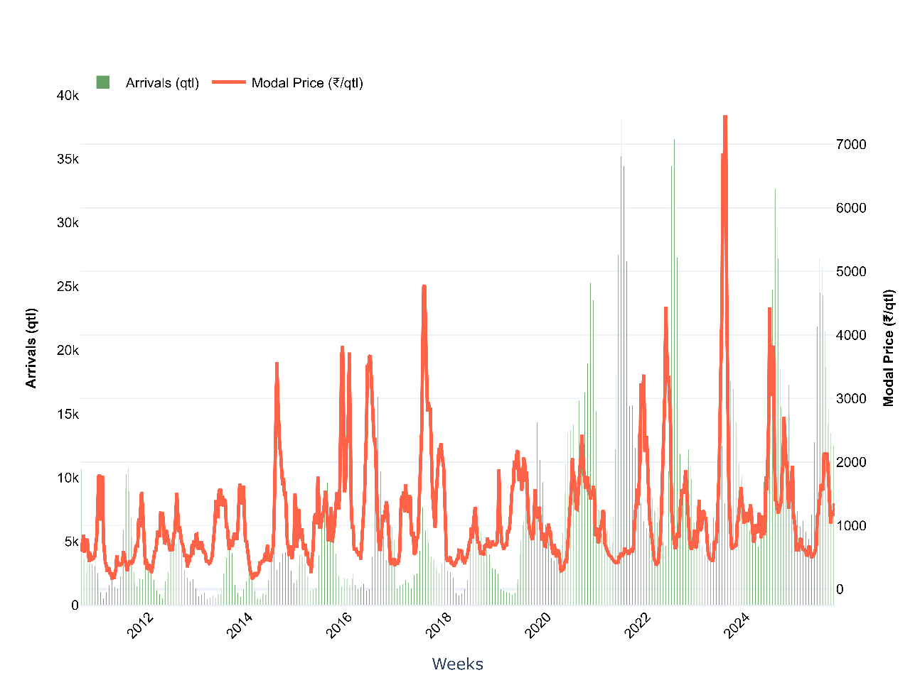

Fig. 1. Weekly trends of Tomato arrivals and prices in Kolar market (2010-2025)

Fig. 1 showed weekly arrivals and modal prices (2010–2025), revealing the expected inverse relationship: large influxes were usually followed by price troughs (weeks 18-22 and 40-48). Deviations from this pattern, high arrivals coupled with high prices or low arrivals with low prices were common, underscoring that factors such as quality heterogeneity, festival demand, weather shocks, or inter-market arbitrage also influenced prices (Acharya et al., 2012; Miljković et al., 2024). The coexistence of multiple arrival-price combinations confirmed the non-linear nature of price formation in perishable produce markets, as documented earlier for Indian tomatoes by Ali et al. (2023).
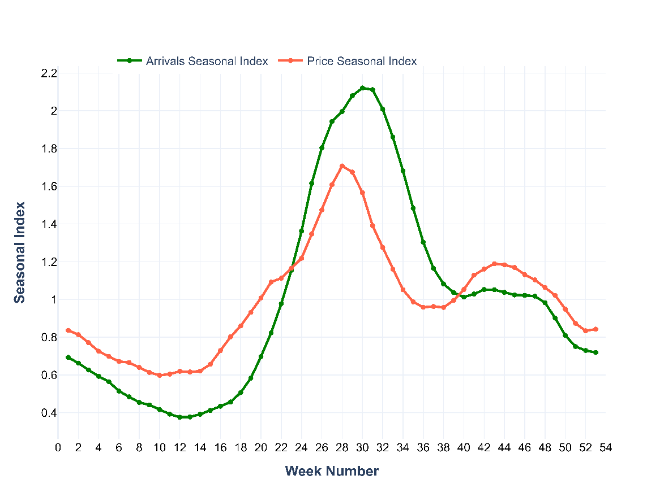
Fig. 2. Weekly Seasonal Index of Tomato arrivals and Modal prices in Kolar market (2010-2025)

Fig. 2 showed weekly seasonal indices (2010-2025), indicating a bi-modal arrival cycle with an early peak in weeks 5-15 and a larger one in weeks 40-48, reflecting Kolar’s two main harvest windows. Prices moved inversely, troughing during supply surges and rebounding once arrivals tapered off, consistent with standard supply-price dynamics (Murthy et al., 2009). A secondary price spike appeared in the post-peak weeks when residual supply met festival demand.
However, identical index values across years masked calendar drift: weather shocks, seedling advancement, or policy bans shifted peaks by several weeks (Chand, 2010). Static seasonal dummies therefore risked mis-timing forecasts; the next section used Dynamic Time Warping to quantify how much the seasonal calendar slid from year to year.
3.3 Inter-annual pattern stability: Dynamic Time Warping (2021-2024)
3.3.1 Modal prices
Dynamic Time Warping (DTW) analysis of weekly tomato prices from 2021 to 2024 revealed notable inter-annual differences in pattern similarity. This method was chosen to capture post-pandemic shifts in market behaviour while maintaining statistical robustness. Consistent with prior studies demonstrating DTW’s ability to detect structural similarity despite temporal misalignment (Berndt and Clifford, 1994; Sakoe and Chiba, 1978), the analysis successfully aligned seasonal peaks and troughs even when their timing varied across years (Table 2; Fig. 3).
The comparison showed the strongest alignment during 2022-2023 (DTW distance: 23,258; mean distance: 327.58), indicating that despite sharply higher prices in 2023 (maximum ₹7,429 vs. ₹4,447 in 2022), seasonal patterns remained consistent. This decoupling of magnitude and timing was observed in other volatile agricultural markets, where seasonal timing persists despite extreme price shocks (Miljkovic et al., 2023). In contrast, 2021-2022 exhibited the weakest similarity (DTW distance: 39,049; mean distance: 470.47), reflecting a structural break in price behaviour during post-pandemic recovery, characterized by supply chain disruptions and altered production cycles.
Path length analysis supported these observations: 2022-2023 required only 71 alignment points versus 83 for 2021-2022, indicating tighter temporal correspondence (Han et al., 2020). Moderate similarity in 2023-2024 (DTW distance: 29,092; path length: 80) suggested post-shock stabilization, with a higher price floor (₹734 vs. ₹429) and reduced volatility consistent with typical market adjustments (Gilbert and Morgan, 2010).
Overall, these results confirmed that seasonal timing in tomato prices was recurrent but not fixed. Variation in DTW distances (23,258-39,049) highlighted the need for forecasting models that are robust to both magnitude shocks, as in 2023, and structural breaks, as in 2021-2022 (Makridakis et al., 1998; Hamilton, 1989). Practically, DTW can inform training data selection, allowing greater weight to years with higher temporal similarity (e.g., using 2023 data to forecast 2024), and can be operationalized through DTW-weighted ensemble learning or adaptive neural network training (Manogna et al., 2025).
Table 2. Dynamic Time Warping Analysis summary for Modal prices (2021-2024)
Years | Data Points (Y1/Y2) | Price Range Y1 | Price Range Y2 | DTW Distance | Mean Distance | Path Length | Similarity Rank
2021 vs 2022 | 52 / 52 | 401 - 3,377 | 371 - 4,447 | 39,049 | 470.47 | 83 | 3
2022 vs 2023 | 52 / 53 | 371 - 4,447 | 429 - 7,429 | 23,258 | 327.58 | 71 | 1
2023 vs 2024 | 53 / 52 | 429 - 7,429 | 734 - 4,434 | 29,092 | 363.65 | 80 | 2
Note: DTW Distance- Total cumulative distance between aligned patterns (lower = more similar); Mean Distance- Average per-point distance after alignment; Path Length-Number of alignment points needed (indicates degree of time warping)

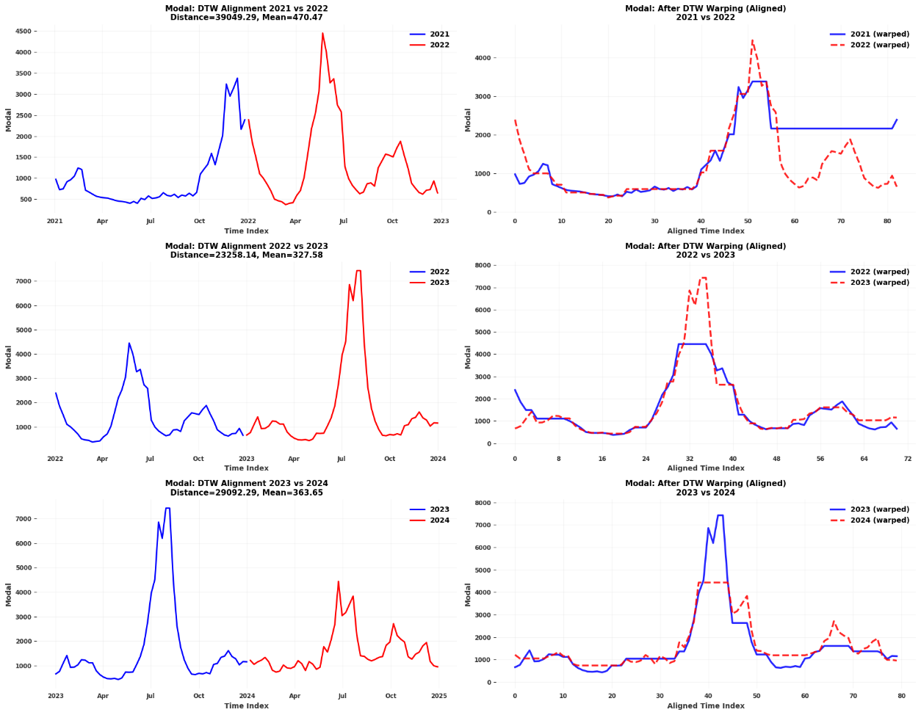

Fig. 3. DTW Analysis of Modal Price Patterns (2021-2024).
Note: Left panels: DTW alignment paths; Right panels: warped (time-aligned) price series. Lower DTW distances indicate higher inter-annual pattern similarity.
3.3.2 Arrivals
Dynamic Time Warping (DTW) analysis of weekly tomato arrivals (Table 3, Fig. 4) revealed that the patterns contrasting with price dynamics. The 2021-2022 comparison showed the highest similarity (DTW distance: 102,597; mean distance: 1,386.45), indicating that weekly supply timing and magnitude were highly consistent. This suggests stable production and harvesting trajectories despite the structural break observed in prices during the same period. Similar stability in arrivals during post-pandemic recovery has been reported for other perishable commodities (Ali et al., 2023).
In contrast, 2022-2023 exhibited the weakest alignment (DTW distance: 188,074; mean distance: 2,507.66), reflecting substantial shifts in arrival patterns, likely due to supply shocks, production decisions influenced by prior year prices, or climatic variability. Interestingly, while prices remained temporally aligned in this period, arrivals diverged, a phenomenon previously attributed to storage and inventory management strategies, where traders adjust release patterns to stabilize prices (Acharya et al., 2012). Inter-regional imports or market channel substitutions may also have contributed to maintaining price stability.
During 2023-2024 comparison showed intermediate similarity (DTW distance: 143,025; path length: 80), suggesting partial recovery of typical supply patterns. Path length variability (74–80 alignment points) was less pronounced than for prices, indicating that weekly arrivals are generally more stable than price trajectories, though both exhibit meaningful inter-annual variability.
Table 3. Dynamic Time Warping Analysis summary for weekly Arrivals (2021-2024)
Years | Data Points (Y1 / Y2) | Arrivals Range Y1 | Arrivals Range Y2 | DTW Distance | Mean Distance | Path Length | Similarity Rank
2021 vs 2022 | 52 / 52 | 4,171–38,277 | 4,634–6,572 | 102,597 | 1,386.45 | 74 | 1
2022 vs 2023 | 52 / 53 | 4,634–36,572 | 3,437–19,249 | 188,074 | 2,507.66 | 75 | 3
2023 vs 2024 | 53 / 52 | 3,437–19,249 | 4,619–32,653 | 143,025 | 1,787.82 | 80 | 2

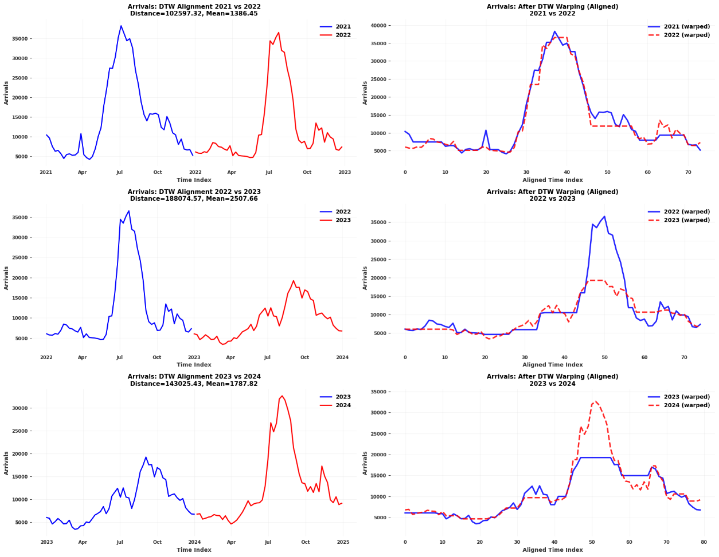
Fig .4. Dynamic Time Warping Analysis of Arrivals Patterns (2021-2024).
Overall, these results highlighted the complex, non-linear relationship between supply arrivals and price formation. Divergent DTW patterns indicated that price dynamics were influenced not only by immediate supply but also by storage behaviour, demand fluctuations, and market expectations (Miljkovic et al., 2024). Forecasting models should therefore incorporate both supply-side indicators and market behaviour variables to capture the full range of factors shaping price movements.

4. Conclusion
Dynamic Time Warping showed that seasonal patterns in Kolar tomato prices and arrivals recur but rarely line up on the calendar. Price trajectories aligned best in 2022-23 even while recording the highest absolute volatility, whereas arrival timings were most stable in 2021-22. This mismatch confirms that price formation was driven by more than immediate supply; storage behaviour, inter-regional flows and market expectations regularly shift the calendar. The study demonstrated that DTW can quantify inter-annual pattern drift and separate calendar shocks from pure magnitude spikes an information that seasonal indices alone cannot provide. Farmers can use early-season DTW alerts to adjust planting or staggered harvesting; traders and cold-store managers can time inventory release; policymakers can replace rigid calendar-based interventions with adaptive triggers that activate when the current year diverges beyond a DTW-distance threshold. Given that tomato markets experience intra-year price swings exceeding 200 per cent, public action is essential. Government agencies should link DTW-based alerts to procurement and subsidy schemes, activate buffer-stock operations when patterns diverge beyond critical thresholds, and expand cold-storage infrastructure to stabilize supply during lean periods. These adaptive interventions would address extreme volatility more effectively than fixed-calendar policies.
Limitations are the short four-year window, single-market focus and absence of a formal bootstrap significance test or an out-of-sample forecast horse-race using DTW-weighted training sets. Extending the series and embedding DTW distances into transformer architectures (PatchTST, Informer, etc.) as patch-weighting or adaptive-window features is an obvious next step. Combining DTW diagnostics with modern deep-learning forecasts offers a practical route to more resilient decision-support in volatile perishable value chains.
Disclaimer (Artificial intelligence)

Author(s) hereby declare that generative AI technologies such as Large Language Models, etc. have been used during the writing or editing of manuscripts. This explanation will include the name, version, model, and source of the generative AI technology and as well as all input prompts provided to the generative AI technology

Details of the AI usage are given below:
1.Claude (Anthropic), Sonnet 4.5 model via claude.ai was used for language editing and improving clarity of expression through prompts requesting text refinement and readability improvements.
2. Claude (Anthropic), Sonnet 4.5 model via claude.ai was used for sentence restructuring and word choice suggestions through prompts requesting simplification of complex sentences.
3. Claude (Anthropic), Sonnet 4.5 model via claude.ai was used for grammar checking and conciseness improvements through prompts requesting more precise writing while retaining technical accuracy.
Note: All intellectual content, data analysis, methodology, interpretations, and conclusions remain entirely the work of the authors. AI was used solely as a writing assistance tool.

References

- Rediff Money. (2024). Tomato price volatility exposes gaps in India’s agriculture supply chain. Rediff.com. https://www.rediff.com/money/report/tomato-price-volatility-exposes-gaps-in-indias-agriculture-supply-chain/20241026.htm
- Press Information Bureau. (2024). Price of tomato falls over 22 percent in a month due to better supply. PIB Release 2074016. https://www.pib.gov.in/PressReleasePage.aspx?PRID=2074016
- The Hindu. (2024). Retail tomato prices drop 22.4 % on improved supplies: Govt. The Hindu. https://www.thehindu.com/business/retail-tomato-prices-drop-224-on-improved-supplies-govt/article68878920.ece
- NITI Aayog. (2024). Year-end review 2024. PIB Release 2088051. https://www.pib.gov.in/PressReleasePage.aspx?PRID=2088051
- Roy, R., Gupta, S., Wardhan, H., Sarkar, S., Tewari, S., Bansal, R., Bhatia, S., & Gulati, A. (2024). Vegetables inflation in India: A study of tomato, onion and potato (TOP). Reserve Bank of India Working Paper Series.
- Mittal, S. (2007). Strengthening backward and forward linkages in horticulture: some successful initiatives. Agricultural Economics Research Review, 20, 457-469.
- Manogna, R. L., Dharmaji, V., & Sarang, S. (2025). A novel hybrid neural network-based volatility forecasting of agricultural commodity prices: empirical evidence from India. Journal of Big Data, 12(1), 85. https://doi.org/10.1186/s40537-025-01131-8
- Kendall, M. G., & Stuart, A. (1983). The Advanced Theory of Statistics, Vol. 3: Design and Analysis, and Time-Series (4th ed.). Griffin, London. https://www.cabidigitallibrary.org/doi/full/10.5555/19471601829
- Makridakis, S., Wheelwright, S. C., & Hyndman, R. J. (1998). Forecasting: Methods and Applications (3rd ed.). John Wiley & Sons, New York. https://doi.org/10.2307/2287014
- Sakoe, H., & Chiba, S. (2003). Dynamic programming algorithm optimization for spoken word recognition. IEEE Transactions on Acoustics, Speech, and Signal Processing, 26(1), 43-49. https://jeffe.cs.illinois.edu/teaching/compgeom/refs/Sakoe-Chiba-DTW.pdf
- Berndt, D. J., & Clifford, J. (1994). Using dynamic time warping to find patterns in time series. Proceedings of the 3rd International Conference on Knowledge Discovery and Data Mining, AAAI Press, 359-370. https://dl.acm.org/doi/abs/10.5555/3000850.3000887
- Ali, M. A., Kamraju, M., & Sonaji, D. B. (2023). Unraveling the factors behind the soaring tomato prices: A comprehensive analysis. ASEAN Journal of Agriculture and Food Engineering, 2(2), 85-104. https://ejournal.bumipublikasinusantara.id/index.php/ajafe/article/download/372/302
- Miljkovic, D., & Vatsa, P. (2023). On the linkages between energy and agricultural commodity prices: A dynamic time warping analysis. International Review of Financial Analysis, 90, 102834. https://doi.org/10.1016/j.irfa.2023.102834
- Cont, R. (2001). Empirical properties of asset returns: stylized facts and statistical issues. Quantitative Finance, 1(2), 223-236. https://doi.org/10.1080/713665670
- Box, G. E. P., Jenkins, G. M., Reinsel, G. C., & Ljung, G. M. (2015). Time Series Analysis: Forecasting and Control (5th ed.). John Wiley & Sons, Hoboken, New Jersey. https://elib.vku.udn.vn/bitstream/123456789/2536/1/1994.%20Time%20Series%20Analysis-Forecasting%20and%20Control.pdf
- Box, G. E. P., & Cox, D. R. (1964). An analysis of transformations. Journal of the Royal Statistical Society: Series B (Methodological), 26(2), 211-252. http://links.jstor.org/sici?sici=0035-9246%281964%2926%3A2%3C211%3AAAOT%3E2.0.CO%3B2-6
- Taylor, S. J., & Letham, B. (2018). Forecasting at scale. The American Statistician, 72(1), 37-45. https://doi.org/10.1080/00031305.2017.1380080
- Chen, T., & Guestrin, C. (2016). XGBoost: A scalable tree boosting system. In Proceedings of the 22nd ACM SIGKDD International Conference on Knowledge Discovery and Data Mining (pp. 785-794). ACM, San Francisco, CA. http://dx.doi.org/10.1145/2939672.2939785
- Hochreiter, S., & Schmidhuber, J. (1997). Long short-term memory. Neural Computation, 9(8), 1735-1780. https://doi.org/10.1162/neco.1997.9.8.1735
- RL, M. and Mishra, A.K. (2021). Forecasting spot prices of agricultural commodities in India: Application of deep-learning models. Intelligent Systems in Accounting, Finance and Management, 28(1), 72-83. https://doi.org/10.1002/isaf.1487
- Manogna, R. L., Dharmaji, V., & Sarang, S. (2025). Enhancing agricultural commodity price forecasting with deep learning. Scientific Reports, 15(1), 20903. https://doi.org/10.1038/s41598-025-05103-z
- Gilbert, C. L., & Morgan, C. W. (2010). Food price volatility. Philosophical Transactions of the Royal Society B: Biological Sciences, 365(1554), 3023-3034. https://doi.org/10.1098/rstb.2010.0139
- Acharya, S. S., Chand, R., Birthal, P. S., Kumar, S., & Negi, D. S. (2012). Market Integration and Price Transmission in India: A Case of Rice and Wheat with Special Reference to the World Food Crisis of 2007/08. FAO, Rome. http://prod-qt-images.s3.amazonaws.com/indiawaterportal/import/sites/default/files/iwp2/an034e00.pdf
- Miljkovic, D., Vatsa, P., & Olson, F. An investigation of the price discovery role of futures markets: A dynamic time warping analysis of the United States corn markets. Agribusiness. https://doi.org/10.1002/agr.21939
- Murthy, D. S., Gajanana, T. M., & Sudha, M. (2009). Marketing and post-harvest losses in fruits: Its implications on availability and economy. Indian Journal of Agricultural Economics, 64(2), 259-275.
- Chand, R. (2010). Understanding the nature and causes of food inflation. Economic and Political Weekly, 45(9), 10-13. https://www.jstor.org/stable/25664159
- Han, T., Peng, Q., Zhu, Z., Shen, Y., Huang, H., & Abid, N. N. (2020). A pattern representation of stock time series based on DTW. Physica A: Statistical Mechanics and its Applications, 550, 124161. https://doi.org/10.1016/j.physa.2020.124161
- Hamilton, J. D. (1989). A new approach to the economic analysis of nonstationary time series and the business cycle. Econometrica, 57(2), 357-384. https://www.jstor.org/stable/1912559

