Review Article

Advances in Chemical Protection for Plant Disease Management in Agriculture: From Traditional Practices to Modern Innovations

ABSTRACT
Chemical protection in agriculture has played a pivotal role in safeguarding crops from pests, pathogens, and weeds, thereby sustaining global food production and ensuring food security. This review aims to provide a comprehensive understanding of the evolution, advancements, and future perspectives of chemical crop protection strategies. It traces the progression from traditional practices such as the use of botanical extracts, sulfur, and copper compounds to the modern era of synthetic pesticides, systemic fungicides, and targeted molecular formulations. Advances in agrochemical chemistry and formulation technology have significantly enhanced efficacy, persistence, and selectivity while minimizing phytotoxicity and non-target effects. The review emphasizes the increasing integration of chemical protection within the framework of integrated pest management (IPM), precision agriculture, and sustainable production systems. Furthermore, emerging innovations such as nanotechnology-based delivery systems, RNA interference (RNAi) technology, CRISPR-mediated resistance, and pheromone-based pest control represent a paradigm shift from curative to preventive crop protection. Despite these advances, challenges persist regarding pesticide resistance, environmental contamination, and evolving regulatory frameworks. Therefore, future strategies should focus on developing eco-compatible molecules, optimizing dose dynamics, and integrating chemical and biological approaches to achieve resilient and sustainable agroecosystems.
Keywords: Chemical protection, agrochemicals, crop chemotherapy, sustainable agriculture, pesticide innovation, integrated pest management (IPM)
- INTRODUCTION
Plant diseases remain one of the most critical challenges confronting global agriculture, threatening food security, ecosystem health, and the economic viability of farming systems (Jeger et al., 2021). These diseases are caused by a diverse range of pathogens, including fungi, bacteria, viruses, nematodes, and mycoplasma-like organisms, each capable of inflicting severe damage at different crop growth stages. Their impact is influenced by various factors such as climatic conditions, pathogen virulence, vector populations, and the genetic susceptibility of host plants. In many regions, yield losses due to plant diseases can range from 10% to as high as 40%, representing billions of dollars in lost agricultural productivity each year (Mueller et al., 2020). This persistent threat underscores the need for effective and integrated disease management strategies to ensure sustainable food production and to safeguard farmer livelihoods.
Among the various disease management approaches such as cultural, biological, genetic, and physical control chemical protection and plant chemotherapy have played a pivotal role in modern agriculture. Chemical protection broadly encompasses the use of pesticides, fungicides, bactericides, and nematicides to either prevent or cure plant infections (Beyari, 2025). These compounds act through multiple mechanisms: as protectants, they form a barrier on plant surfaces to block pathogen entry, and as systemic or curative agents, they penetrate plant tissues to inhibit or eliminate pathogens already present within. The evolution of agricultural chemistry over the past century has transformed chemical protection from crude, broad-spectrum toxicants to highly refined, target-specific molecules that offer improved efficacy and safety (Souto et al., 2021).
The concept of plant chemotherapy, first introduced in the mid-20th century, represents the therapeutic use of chemicals to treat established infections in plants, much like chemotherapy in medical science (Banik et al., 2023). Unlike preventive fungicidal sprays, plant chemotherapeutic agents act internally by disrupting pathogen metabolism or replication within the host plant. Modern examples include systemic fungicides such as triazoles, strobilurins, and succinate dehydrogenase inhibitors (SDHIs), which have revolutionized disease control by offering long-lasting protection, curative action, and lower environmental persistence compared to older chemistries (Gawande et al., 2025). These innovations have significantly reduced yield losses in key crops such as wheat, rice, apple, and soybean, thereby supporting global food and nutritional security.
The growing demand for food due to the expanding global population has led to intensified agricultural practices characterized by monocropping, high-yield varieties, and extensive input use. While these advancements have boosted productivity, they have simultaneously heightened the vulnerability of crops to diseases. Genetically uniform crop systems are more prone to epidemics, as seen in cases such as rice blast, late blight in potatoes, or rusts in cereals (Singh et al., 2016). In such high-risk systems, chemical protection becomes an indispensable component of integrated disease management. It not only mitigates yield losses but also ensures the consistent quality of produce, which is crucial for global supply chains and market competitiveness.
In recent decades, the development of next-generation agrochemicals has reflected a shift toward precision agriculture and environmental stewardship (McLeod et al., 2024; Nath, 2024). Innovations in formulation technology such as nanoemulsions, controlled-release systems, and bio-based adjuvants have enhanced pesticide efficacy while minimizing off-target effects and chemical residues. The integration of chemosensors and AI-based predictive models allows for optimized spray timing and dosage, thereby reducing chemical footprints (Chowdhury & Oehlschlaeger, 2025). Moreover, the discovery of molecules that target specific enzymatic pathways in pathogens has improved selectivity, reducing harm to beneficial organisms and mitigating the emergence of resistance.
Despite these advancements, the overreliance on synthetic chemicals has raised ecological and health concerns, including pesticide resistance, soil degradation, and non-target toxicity. As a result, there is a growing emphasis on developing eco-compatible chemistries, combining traditional protection with biopesticides, natural extracts, and resistance inducers. This fusion represents a sustainable transition from purely chemical control to chemical-biological hybrid strategies, aligning with global efforts to achieve safe, sustainable, and climate-resilient agriculture (Salakinkop et al., 2024).
In conclusion, chemical protection and chemotherapy in agriculture have evolved from simple disease prevention tools to sophisticated technologies underpinning modern plant health management (Rizzo et al., 2021; Harman et al., 2021). Their continued refinement through innovation, regulation, and integration with other sustainable practices will remain central to ensuring global food and nutritional security. The future of plant disease management lies not in eliminating chemical tools but in enhancing their precision, safety, and synergy with ecological principles, thus bridging traditional practices with modern innovations in agricultural science.

ROLE OF CHEMICAL PROTECTION IN MODERN AGRICULTURE
Chemical protection remains one of the most widely adopted strategies in plant disease management due to its rapid and broad-spectrum effectiveness. While cultural, biological, and genetic methods are valuable components of integrated disease management, they often require longer timeframes for implementation and may not provide immediate solutions. Chemical protection, on the other hand, offers a quick response to emerging disease threats, especially under epidemic conditions.
In modern agriculture, fungicides and bactericides are routinely used to protect staple crops such as rice, wheat, maize, and vegetables from devastating fungal and bacterial diseases (Mehmood et al., 2025). For example, powdery mildew, rust, and blight diseases, which can cause severe yield losses, are effectively controlled through systemic and contact fungicides. Similarly, antibiotics and bactericides are employed to manage bacterial infections such as fire blight in apples and bacterial wilt in solanaceous crops (Nguyen et al., 2025).
However, the indiscriminate and excessive use of chemical pesticides has raised concerns regarding environmental pollution, pesticide resistance, and non-target effects on beneficial organisms. To address these challenges, recent advancements in chemical protection have focused on developing eco-friendly and biodegradable compounds with improved target specificity and reduced toxicity. Additionally, integrated disease management approaches advocate for the judicious use of chemical control methods in combination with other sustainable practices. Claasification of pesticides shown n Fig. 1.
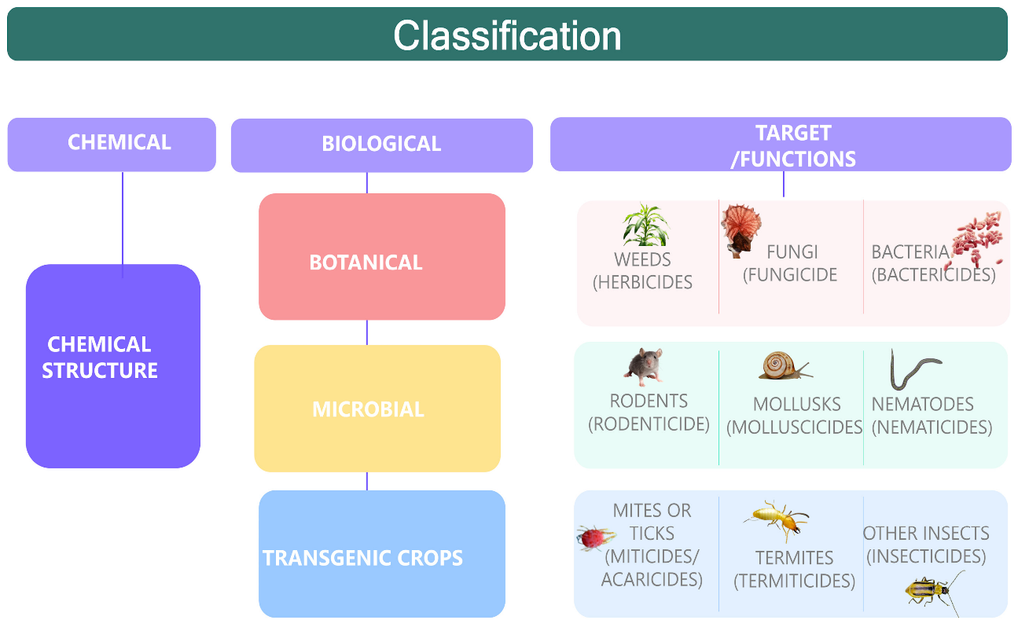
Fig.1: Classification of pesticide (Chemical, Biological and functions)

2.1 Chemotherapy: A Curative Approach to Plant Disease Management
While chemical protection primarily focuses on preventing disease establishment, chemotherapy refers to the use of chemical agents to cure infected plants by suppressing or eliminating the pathogens within plant tissues. This approach is particularly relevant for systemic infections caused by vascular pathogens, such as bacterial wilt, viral diseases, and certain fungal infections that spread internally within the plant system.
Chemotherapeutic agents include systemic fungicides, antibiotics, and antiviral compounds that can penetrate plant tissues and inhibit pathogen multiplication (Stan et al., 2021). For instance, systemic fungicides such as benzimidazoles and triazoles have been successfully used to manage soil-borne and vascular fungal diseases. Similarly, antibiotics like streptomycin and oxytetracycline have been employed to treat bacterial infections in high-value crops like citrus, apples, and pears (Batuman et al., 2024). Despite its potential, chemotherapy in plant pathology faces limitations, including the emergence of resistant pathogen strains, the high cost of treatment, and regulatory restrictions on certain chemical agents. Therefore, it is often integrated with other disease management practices to enhance its efficacy and sustainability.

3. Chemical Protection in Plant Pathology

3.1 Definition and Importance
Chemical protection in plant pathology refers to the application of synthetic or natural chemicals to prevent, suppress, or eliminate plant diseases caused by fungal, bacterial, viral, or nematode pathogens (Ul Haq et al., 2020). It is a fundamental component of plant disease management strategies, playing a critical role in maintaining agricultural productivity and ensuring food security. Chemical protection methods help in reducing crop losses, improving yield quality, and enhancing resistance against destructive plant diseases.
The importance of chemical protection arises from the increasing threats posed by plant diseases, which can lead to severe economic losses for farmers and disrupt global food supply chains. Climate change, monoculture farming, and evolving pathogen populations have intensified disease outbreaks, necessitating the use of chemical agents as a rapid and effective means of disease control (Singh et al., 2023). Furthermore, chemical protection is often integrated with other management practices, such as biological control, cultural practices, and resistant crop varieties, to form a comprehensive Integrated Disease Management (IDM) approach.
Advancements in chemical formulations have led to the development of safer, more efficient, and environmentally friendly fungicides, bactericides, and other protective agents. However, the excessive and indiscriminate use of chemical protectants has raised concerns regarding environmental pollution, human health risks, and the development of resistant pathogen strains (Pathak et al., 2022). Therefore, proper application techniques, adherence to recommended dosages, and the use of alternative eco-friendly options are essential for sustainable disease management.

3.2 Types of Chemical Protection
Chemical protection in plant pathology can be categorized into two major types based on the timing and purpose of chemical application:

3.2.1 Preventive Protection
Preventive protection involves applying chemicals before the onset of disease to create a protective barrier against pathogens. This method aims to prevent infection by inhibiting spore germination, disrupting pathogen life cycles, or altering the host surface to make it unsuitable for pathogen colonization.
- Contact fungicides, such as copper-based fungicides (e.g., Bordeaux mixture, copper oxychloride), are commonly used as preventive agents. These chemicals form a protective layer on plant surfaces and inhibit the germination of fungal spores.
- Seed treatments with fungicidal coatings (e.g., thiram, captan) protect seedlings from soil-borne and seed-borne pathogens, reducing early-stage infections.
- Soil fumigants such as methyl bromide and chloropicrin are used to sterilize soil and eliminate harmful pathogens before planting.
Preventive protection is particularly effective for crops that are highly susceptible to foliar diseases, such as vegetables, fruits, and cereals. It is widely used in large-scale commercial farming to ensure consistent crop health.

3.2.2 Curative Protection
Curative protection involves applying chemicals after an infection has already occurred to control disease progression and minimize damage. These chemicals are often systemic fungicides or bactericides that can penetrate plant tissues and target pathogens within the plant.
- Systemic fungicides, such as benzimidazoles (e.g., carbendazim) and triazoles (e.g., propiconazole), move through the plant’s vascular system and inhibit fungal growth even after infection has begun.
- Antibiotics, such as streptomycin and tetracycline, are used to manage bacterial diseases by inhibiting bacterial protein synthesis.
- Curative sprays are applied when disease symptoms first appear, preventing further pathogen multiplication and spread.
Curative chemical protection is particularly useful for managing systemic diseases, such as rusts, powdery mildew, and bacterial blights, where infections spread internally and cannot be controlled by contact fungicides alone.

3.3 Modes of Action
The effectiveness of chemical protection depends on the mode of action of the chemical agents used. Chemical protectants can be classified into three main categories based on how they interact with plant tissues and pathogens:

3.3.1 Contact Fungicides
Contact fungicides, also known as protectant fungicides, remain on the surface of plant tissues and act as a physical barrier against pathogen infection. They do not penetrate plant cells but instead prevent spore germination and fungal establishment.
- Example: Copper-based fungicides (e.g., Bordeaux mixture, copper hydroxide) and mancozeb are widely used contact fungicides.
- They are effective against foliar pathogens such as downy mildew, leaf spot, and anthracnose.
- Since they do not enter plant tissues, they must be applied repeatedly to ensure continuous protection, especially after rainfall.

3.3.2 Systemic Fungicides
Systemic fungicides are absorbed by the plant and translocated through the vascular system, providing internal protection against pathogens. These fungicides have curative properties and can stop disease progression even after infection has occurred.
- Example: Benzimidazoles (e.g., carbendazim), triazoles (e.g., propiconazole), and strobilurins (e.g., azoxystrobin).
- Systemic fungicides are widely used in cereals, fruits, and vegetables for controlling rusts, smuts, powdery mildew, and vascular wilt diseases.
- They provide longer-lasting protection compared to contact fungicides but may contribute to the development of resistant pathogen strains if overused.

3.3.3 Translaminar Fungicides
Translaminar fungicides move across the leaf surface and penetrate only a few cell layers but do not travel through the entire plant system. They offer localized protection against pathogens attacking leaf tissues.
- Example: Fluopyram and spiroxamine are translaminar fungicides used against powdery mildew and botrytis.
- They provide better protection than contact fungicides and reduce the risk of wash-off by rain.
- These fungicides are effective for foliar diseases but do not protect other parts of the plant, such as stems and roots.

3.3.4 Multi-Site and Single-Site Fungicides
Fungicides can also be categorized based on whether they target multiple metabolic pathways or a single specific site in the pathogen’s biochemical processes.
- Multi-site fungicides (e.g., mancozeb, captan) act on multiple biochemical pathways, making it harder for pathogens to develop resistance.
- Single-site fungicides (e.g., benzimidazoles, triazoles) target a specific enzyme or pathway, offering high efficacy but posing a higher risk of resistance development.

4. Chemotherapy in Plant Pathology

2.1 Concept and Definition
Chemotherapy in plant pathology refers to the use of chemicals for the therapeutic treatment of plants already infected by pathogens. Unlike protective chemical treatments, which aim to prevent infection, chemotherapy involves the direct eradication or suppression of pathogens that have already established themselves within the plant tissues.
Chemotherapeutic agents primarily function by interfering with the metabolic pathways of pathogens, inhibiting their growth, reproduction, or survival. These agents can be applied through foliar sprays, seed treatments, soil drenches, or systemic injections, depending on the nature of the disease and the affected crop.
The importance of chemotherapy lies in its ability to salvage infected crops, particularly in cases where cultural and preventive chemical methods fail to prevent disease outbreaks. Chemotherapy plays a significant role in managing systemic infections caused by fungi, bacteria, and viruses that spread internally within the plant. Some of the most widely used chemotherapeutic agents include systemic fungicides, bactericides, and antiviral compounds.
While chemotherapy provides an effective disease control measure, it must be used judiciously to minimize risks such as pathogen resistance, environmental contamination, and toxicity to non-target organisms. Integrated disease management (IDM) strategies often combine chemotherapy with biological control, crop rotation, and resistant crop varieties to achieve sustainable plant disease management.

2.2 History and Development
The concept of chemotherapy in plant pathology emerged in the early 20th century, when researchers first began experimenting with mercury-based compounds to control fungal and bacterial diseases in plants. These early compounds, such as ethyl mercury chloride and phenylmercuric acetate, were widely used due to their broad-spectrum activity. However, concerns regarding toxicity, environmental persistence, and bioaccumulation led to their eventual ban or restricted use in most countries.

Early Developments (1900s–1950s):
- The first chemotherapeutic agents included copper-based fungicides (e.g., Bordeaux mixture), which were initially used as preventive measures but later showed some therapeutic properties.
- Organic mercury compounds became popular as seed treatments and foliar sprays to control various plant diseases.
- Sulfur-based compounds and dithiocarbamates (e.g., zineb, mancozeb) were introduced as effective alternatives to mercury-based chemicals.

Advancements in the Mid-20th Century (1950s–1980s):
- The discovery of systemic fungicides revolutionized plant disease management. These fungicides, such as benomyl (a benzimidazole fungicide) and carboxin (an oxathiin fungicide), provided internal protection by moving through the plant’s vascular system.
- The development of antibiotics for plant disease control, such as streptomycin and tetracycline, enabled effective management of bacterial infections like fire blight in apples and pears.
- The introduction of phenylamide fungicides (e.g., metalaxyl) marked a major breakthrough in controlling oomycete pathogens such as Phytophthora and Pythium.

Modern Chemotherapy (1990s–Present):
- Research in molecular plant pathology has led to the identification of highly specific and environmentally safe fungicides, including strobilurins and triazoles, which target fungal respiration and sterol biosynthesis, respectively.
- The development of plant defense activators, such as salicylic acid analogs and jasmonic acid derivatives, has provided alternative approaches to chemotherapy by enhancing plant immunity.
- RNA-based therapies, including RNA interference (RNAi) and CRISPR-mediated pathogen control, have emerged as potential futuristic tools in chemotherapy for viral and fungal diseases.

3. 1Classification of Chemicals Used in Plant Protection
The use of chemicals in plant protection is a fundamental approach to controlling plant diseases caused by various pathogens, including fungi, bacteria, nematodes, and viruses. These chemicals are classified based on their target pathogens, chemical composition, and mode of action. Proper classification and understanding of these chemicals ensure their effective application, reducing crop losses and enhancing global food security.

3.2 Fungicides

Definition and Importance
Fungicides are chemical substances used to inhibit or eliminate fungal pathogens that cause plant diseases such as powdery mildew, rusts, leaf spots, and root rots. They work by preventing spore germination, inhibiting fungal growth, or destroying fungal cells. Fungicides play a key role in integrated disease management (IDM) by providing both preventive and curative protection.

Classification of Fungicides
Fungicides can be classified based on their chemical composition and mode of action:

A. Organic Sulfur Compounds
These fungicides contain sulfur-based active ingredients, which interfere with fungal metabolism and inhibit fungal spore germination. They are widely used against leaf spots, downy mildew, and other fungal infections.
- Examples:
  - Mancozeb: A broad-spectrum fungicide used in controlling fungal diseases in vegetables, fruits, and cereals.
  - Ziram: Effective against blights, anthracnose, and damping-off diseases.
  - Thiram: Used primarily as a seed treatment fungicide to prevent seedling diseases.

B. Copper-based Fungicides
Copper-based fungicides disrupt fungal enzyme activity and are effective in managing both fungal and bacterial plant diseases.
- Examples:
  - Bordeaux mixture: A traditional fungicide made from copper sulfate and lime, used for controlling downy mildew and blights.
  - Copper oxychloride: A widely used fungicide for controlling leaf spots, blights, and rusts in field crops and horticultural plants.

C. Benzimidazoles
These fungicides inhibit fungal mitosis (cell division) and provide systemic protection to plants.
- Examples:
  - Benomyl: A systemic fungicide used to control leaf spot diseases, powdery mildew, and fruit rots.
  - Thiabendazole: Primarily used as a post-harvest treatment for fruits to prevent fungal decay.

3.3 Bactericides

Definition and Importance
Bactericides are chemicals used to suppress or eliminate bacterial infections in plants. Since bacterial diseases are often difficult to manage, bactericides are frequently used in combination with other control methods such as crop rotation, resistant varieties, and biocontrol agents.

Classification of Bactericides

A. Copper Compounds
Copper compounds act as multi-site inhibitors, disrupting bacterial enzymes and proteins.
- Examples:
  - Copper sulfate: Used to manage bacterial blights, leaf spots, and citrus canker.
  - Copper hydroxide: Commonly applied as a foliar spray against bacterial leaf spots and soft rots.

B. Antibiotics
Antibiotics are used to inhibit bacterial growth by targeting protein synthesis or DNA replication. They are applied as foliar sprays, seed treatments, or trunk injections.
- Examples:
  - Streptomycin: Used against fire blight in apples and pears.
  - Tetracycline: Effective against bacterial wilt and phytoplasma diseases in crops like citrus and rice.

3.4 Nematicides

Definition and Importance
Nematicides are chemicals that control plant-parasitic nematodes, microscopic worms that damage plant roots, causing yield loss and stunted growth. These chemicals work by either fumigating the soil or disrupting nematode nervous systems.

Classification of Nematicides

A. Fumigants
Fumigant nematicides volatilize into gas, penetrating soil pores and killing nematodes.
- Examples:
  - Methyl bromide: A highly effective but restricted fumigant due to environmental concerns.
  - 1,3-Dichloropropene: Used for pre-plant soil fumigation to control root-knot nematodes.

B. Non-fumigant Nematicides
These are liquid or granular formulations applied to soil or roots to disrupt nematode metabolism.
- Examples:
  - Carbofuran: A systemic nematicide that provides long-term root protection.
  - Aldicarb: A highly toxic nematicide used for controlling nematodes in citrus, potatoes, and vegetables.

3.5 Viricides

Definition and Importance

Viricides are chemicals that target plant viruses, though their effectiveness is often limited due to the nature of viral infections. Unlike fungicides and bactericides, very few chemical treatments can directly kill plant viruses. Instead, most viricidal compounds work by suppressing viral replication or enhancing plant resistance. Classification of Viricides shown in Fig. 2.

Classification of Viricides

A. Synthetic Antiviral Compounds
- Ribavirin: A broad-spectrum antiviral agent that inhibits viral RNA replication.
- Acibenzolar-S-methyl: Induces systemic acquired resistance (SAR) in plants, helping them fight viral infections.

B. Plant-derived Compounds
- Essential oils: Certain plant oils (e.g., neem oil, tea tree oil) have been found to reduce viral transmission by interfering with insect vectors.
- Plant extracts: Extracts from medicinal plants such as garlic and turmeric have shown antiviral properties against some plant viruses.
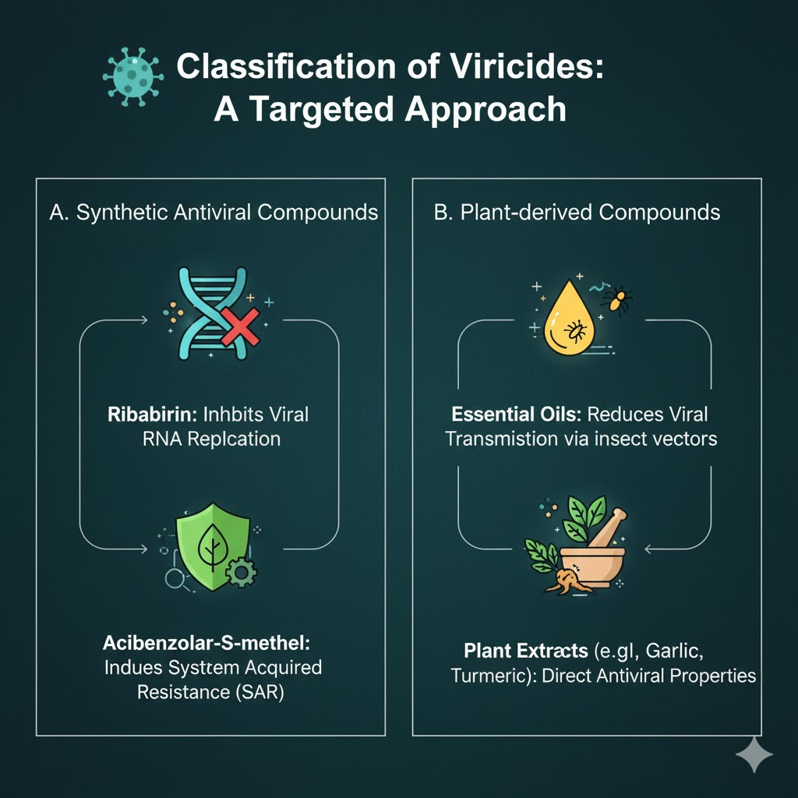
Fig. 2: Classification of Viricides

Table 1: Chemical and Physical Characteristics, Dosage and Target Diseases of Common Agrochemicals
Chemical Name/Common Name | Chemical and Physical Properties | Dose and Diseases for Which Used | References
I. Organic Sulphur (Carbamates)
Antracol (Bayer, Germany) | Zinc propylene bisdithiocarbamate (70%) / Propineb; Odourless, low toxicity, easily soluble in water, compatible with many insecticides. | 2 lbs/100 gallons of water; Used against leaf spots and downy mildews. | Parihar et al. (2011)
Dithane M-45 (Rohm and Haas, USA) | Mancozeb (Zn 2% + 78% Maneb) / Manganese ethylene bisdithiocarbamate; Yellow-colored, slightly soluble in water, compatible with most pesticide sprays. | 1.5-2 lbs/100 gallons of water; For leaf spots and downy mildews of vegetables. | Thind et al. (2018)
Zerlate (Dupont, USA) | Ziram (75%) / Zinc dimethyldithiocarbamate; White powder, partially soluble in water but completely in alcohol, toxic to mammals if consumed orally. | 1.5-2 lbs/100 gallons of water; For blights and anthracnoses of vegetables. | Bhagat and Choudhary (2024)
Dithane Z-78 (Dupont, USA) | Zineb / Zinc ethylene bisdithiocarbamate; Yellowish powder, unstable in light and moisture. | 2 lbs/100 gallons of water (0.2%); For leaf spots of vegetables and ornamental plants. | Brandes (1953)
Thiram (Dupont, USA) | Tetramethyl thiuram disulphide / Arasan; White-colored, unstable in acids, insoluble in water, mostly compatible with other pesticides. | Seed treatment (0.15-0.2%); For seedling diseases. | Maude et al. (1969)
II. Copper (Organic)
Cupravit (Bayer, Germany) | Copper oxychloride (50% Cu); Soluble in water, low phytotoxicity. | 1.5-2 lbs/100 gallons of water (0.15-0.2%); For downy mildews and leaf spots of vegetables. | Alkolaly et al. (2017)
Perenox | Cuprous oxide; Brown powder, fine particle size, soluble in water giving good suspension. | 2-2.5 lbs (0.2-0.25%); For leaf spots, downy and powdery mildews of field crops and vegetables. | Mohamed et al. (2016)
Bordeaux Mixture | Copper sulfate + lime | 3:3:50, 4:4:50; For leaf spots, downy mildews, and blights. | Roberts (1936)
Vitigran Blue (Hoechst, Germany) | Copper oxychloride (35% Cu); Bluish powder, soluble in water. | General-purpose fungicide (2.0-3.0 lbs/100 gallons of water) for many fungal diseases. | Pethybridge et al. (2020)
III. Oxathiins
Vitavax-200 (Uniroyal, USA) | Carboxin / Dihydro-methyl-oxathiin carboxanilide (DMOC); Crystalline compound, often combined with other seed and soil fungicides. | 85g/45 kg of seed; Effective seed dressing fungicide for seedling diseases. | Mohamed et al. (2016)
Vitavax-Thiram (Uniroyal, USA) | Carboxin/DMOC + Thiram; Crystalline, soluble in acetone, compatible with common fungicides and insecticides. | 200 g/100 kg; Used as seed protectant against seedling diseases. | Roberts (1936)
Plantavax (Uniroyal, USA) | Oxycarboxin / DMOC; Available in granule, liquid, and dust form, compatible with some common fungicides and insecticides. | ½ to 1 lbs/acre; Used against rusts of field crops and ornamentals. | Pethybridge et al. (2020)

Table 1: Chemical and Physical Characteristics, Dosage and Target Diseases of Common Agrochemicals (Contd..)
Chemical Name/Common Name | Chemical and Physical Properties | Dose and Diseases for Which Used
IV. Benzimidazole
Benlate (Dupont, USA) | Benomyl / Methyl-N-butyl-carbamoyl-benzimidazole carbamate; White powder, non-volatile, insoluble in water. | 56.7 g/bushel post-harvest dip for fruits (400 ppt).
Thiabendazole (Tecto) | Thiazolyl benzimidazole; Stable, creamy white, non-phytotoxic at recommended doses. | Foliar, bulb (corm and tuber), seed, and soil application; Controls same diseases as Benomyl.
Topsin-M (Nippon Soda Co., Japan) | Cercobin-M / Bismethoxycarbonyl-thioureidobenzene; Colorless crystalline solid, protective, curative, systemic activities, broad-spectrum fungitoxic. | Used against Cercospora leaf spot, powdery mildew, apple and pear scab, rice blight, Sclerotinia, and Botrytis rots.
V. Heterocyclic Nitrogenous Compounds
Captan (Chemagro, USA) | Orthocide or Vancide / N-trichloromethyl-thiocyclohexene-dicarboximide; Incompatible with lime sulfur and Bordeaux mixture. | 2 lbs/400 liters as spray; For leaf spots, mildews, and smuts of field crops.
Brassicol (Hoechst, Germany) | PCNB or Quintoxene (20%) / Pentachloro-nitrobenzene; Yellowish brown crystalline, insoluble in water, characteristic odor, stable at normal conditions. | Soil drenching (0.5 lbs/1 ft soil drenching, 60/100 liters); For soil-borne diseases like damping-off, root rots.
Brestan-60 (Hoechst, Germany) | Fentin acetate (60%) / Triphenyl tin-acetate; White crystalline, odorless, less soluble in water. | 200 g/100 liters.
Morestan (Hoechst, Germany) | Oxythioquinox (25%) / Methyl quinoxaline-dithiolocarbonate; Insoluble in water, unstable in alkaline medium. | 50 g/100 liters; For powdery mildews of vegetables.
VI. Mercury (Organic)
Ceresan | Ethyl mercury chloride; Reddish fine powder. | 2 ounces/30 kg of seeds; Used as seed protectant for cereals and vegetables.
Semesan | Hydroxy mercuric chlorophenol. | Seed (bulb) treatment of vegetables and ornamentals (0.25-0.30%).
Agallol | Methoxyethyl Mercury chloride / Aretan. | Used as dip for sugarcane or tubers (0.5% of 6% Hg).
VII. Quinones
Spergon (Uniroyal, USA) | Chloranil / Tetrachloro-benzoquinone; Golden yellow, insoluble in water, stable at acidic pH, unstable in sunlight. | 0.2% dry seed protectant; Against certain smuts and downy mildew of field crops.
Phygon (Uniroyal, USA) | Dichlone / Dichloronaphthoquinone; Yellow crystalline, odorless, insoluble in water, stable to sunlight. | Seed protectant (0.2%) for certain smuts and blight diseases of field crops.

Methods of Chemical Application
The effectiveness of chemical protection in plant pathology depends on the method of application, ensuring maximum coverage, absorption, and disease control while minimizing environmental impact. Different application techniques are used based on pathogen type, plant growth stage, and target area. The primary methods include seed treatment, foliar sprays, soil treatment, and systemic application.

4.1 Seed Treatment

Definition and Importance
Seed treatment involves coating, soaking, or dusting seeds with fungicides, bactericides, or insecticides to prevent early-stage infections caused by soil-borne and seed-borne pathogens. This method enhances seed germination, protects seedlings, and promotes healthy crop establishment.

Types of Seed Treatment
- Protective seed treatment: Prevents infection from pathogens present in soil or on seed surfaces.
- Therapeutic seed treatment: Eradicates existing infections in seeds.

Examples of Seed Treatment Chemicals
- Thiram: A broad-spectrum fungicidal seed treatment that prevents damping-off diseases caused by Rhizoctonia solani and Pythium spp.
- Captan: A systemic fungicide used to prevent seed rot, seedling blight, and collar rot in crops such as cereals, vegetables, and legumes.
- Carbendazim: Controls seed-borne fungal infections in pulses, oilseeds, and cereals.

4.2 Foliar Sprays

Definition and Importance
Foliar application involves spraying chemical solutions directly on plant leaves to control air-borne pathogens, insect pests, and nutrient deficiencies. This method ensures rapid disease control by providing immediate contact or systemic action.

Examples of Foliar Spray Chemicals
- Mancozeb: A contact fungicide used to control leaf spots, rusts, and blights in crops like potatoes, tomatoes, and wheat.
- Copper oxychloride: Effectively manages downy mildew, bacterial leaf blight, and citrus canker by acting as a multi-site inhibitor.
- Streptomycin: A bactericide used to control fire blight in apple and bacterial wilt in vegetables.

Application Techniques
- High-volume spraying: Covers entire plant surfaces, commonly used in orchards.
- Low-volume and ultra-low-volume spraying: Uses minimal water, suitable for large-scale field applications.
- Mist and fogging systems: Used in greenhouses to deliver fine chemical droplets for even coverage.

4.3 Soil Treatment

Definition and Importance
Soil treatment methods help manage soil-borne pathogens, nematodes, and weeds by sterilizing, fumigating, or drenching the soil with protective chemicals. This ensures healthy root development and strong plant establishment.

Types of Soil Treatment

A. Soil Fumigation
Fumigants are volatile chemicals that penetrate the soil and eliminate pathogens, nematodes, and insect pests.
- Examples:
  - Methyl bromide: A broad-spectrum fumigant used for nematode and soil-borne fungal control, though its use is restricted due to ozone depletion concerns.
  - Chloropicrin: Controls Fusarium wilt and Verticillium wilt in vegetables and field crops.

B. Soil Drenching
Drenching involves applying liquid fungicides or bactericides to soil to kill pathogens near plant roots.
- Examples:
  - PCNB (Pentachloronitrobenzene): Controls root rot and damping-off diseases in vegetables, ornamentals, and cereals.
  - Metalaxyl: A systemic fungicide effective against oomycete pathogens like Phytophthora and Pythium.

4.4 Systemic Application

Definition and Importance
Systemic application involves using chemicals that enter the plant system and move through xylem or phloem, offering long-term protection against fungal, bacterial, and viral diseases. Unlike contact chemicals, systemic agents reach internal plant tissues, making them highly effective.

Types of Systemic Chemicals

A. Systemic Fungicides
Systemic fungicides are absorbed by the plant and inhibit fungal growth from within.
- Carbendazim: A broad-spectrum systemic fungicide used to control powdery mildew, rusts, and anthracnose in multiple crops.
- Metalaxyl: Used for oomycete diseases like late blight in potatoes and damping-off in seedlings.

B. Systemic Bactericides
Systemic bactericides are absorbed by plant tissues and suppress bacterial growth internally.
- Streptomycin: A widely used antibiotic bactericide effective against fire blight, bacterial wilt, and citrus greening.
- Kasugamycin: An antibiotic used in rice bacterial blight control.

C. Systemic Insecticides (for vector control)
Systemic insecticides indirectly help control viral diseases by targeting insect vectors such as aphids and whiteflies.
- Imidacloprid: Controls sap-sucking insects, reducing virus transmission in crops like cotton and tomatoes.
- Thiamethoxam: Used for aphid and leafhopper management, preventing viral infections in rice and vegetables.

5. Advantages and Disadvantages of Chemical Protection and Chemotherapy

5.1 Advantages
- Effective and Quick: Provides rapid disease control.
- Broad-Spectrum Activity: Many chemicals target multiple pathogens.
- Enhances Crop Yield: Reduces losses and improves productivity.
- Easily Accessible: Available for large-scale agricultural use.

5.2 Disadvantages
- Development of Resistance: Repeated use may lead to resistant pathogens.
- Environmental Impact: Chemical residues may pollute soil and water.
- Health Concerns: Some chemicals are toxic to humans and animals.
- High Costs: Continuous application can be expensive for farmers.

6. Future Perspectives in Chemical Protection and Chemotherapy

6.1 Development of Eco-Friendly Fungicides
Research is focused on developing biofungicides and organic compounds that are less harmful to the environment.

6.2 Integrated Disease Management (IDM)
Combining chemical control with biological, cultural, and genetic approaches can enhance disease management and sustainability.

6.3 Advancements in Molecular Research
Genetic engineering and molecular breeding techniques are being explored to develop disease-resistant crop varieties, reducing dependence on chemicals.

7. Conclusion
Chemical protection remains a cornerstone of modern plant pathology, providing effective tools for preventing and managing a wide range of crop diseases caused by fungi, bacteria, and other pathogens. These chemical interventions have been instrumental in ensuring global food security by minimizing yield losses and maintaining crop quality. However, excessive or indiscriminate use of agrochemicals has led to challenges such as pathogen resistance, environmental contamination, and potential risks to human and ecosystem health. Therefore, the future of plant disease management lies not in the abandonment of chemical methods, but in their intelligent integration with sustainable agricultural practices. Advancements in precision agriculture, nanotechnology-based formulations, and targeted delivery systems offer promising pathways for reducing chemical loads while enhancing efficiency. Similarly, combining chemical protection with biological control agents, resistant crop varieties, and cultural practices can create synergistic and eco-friendly solutions. Chemical protection and related innovations thus continue to be vital components of integrated disease management strategies. A balanced approach focusing on efficacy, safety, and sustainability is essential to ensure that these technologies remain effective tools for resilient and environmentally responsible agricultural production systems.

DISCLAIMER (ARTIFICIAL INTELLIGENCE)
Author(s) hereby declare that NO generative AI technologies such as Large Language Models (ChatGPT, COPILOT, etc.) and text-to-image generators have been used during the writing or editing of this manuscript.

Reference
Alkolaly, A. M., El-nahas, Shereen., & abdel-rahman, T. A. (2017). Residual effect of certain copper fungicides used in controlling downy mildew of lettuce. Egyptian Journal of Agricultural Research, 95(1), 65-71.
Banik, S., Pramanik, M., Roy, S., Ghosh, P. K., Duary, S., Bachaspati, S., ... & Mondal, B. P. (2023). Green Chemo-Prevention: An Integrated Review Between Agriculture and Medicine. Journal of Advanced Zoology, 44.
Batuman, O., Britt-Ugartemendia, K., Kunwar, S., Yilmaz, S., Fessler, L., Redondo, A., ... & Wade, T. (2024). The use and impact of antibiotics in plant agriculture: A review. Phytopathology®, 114(5), 885-909.
Beyari, E. A. (2025). Alternatives to chemical pesticides: the role of microbial biocontrol agents in phytopathogen management: a comprehensive review. Journal of Plant Pathology, 107(1), 291-314.
Bhagat, S., & Choudhary, S. (2024). Chemical control of plant diseases. Plant pathology and plant diseases, 306
Brandes, G. A. (1953). The history and development of the ethylene bisdithiocarbamate fungicides. American Potato Journal, 30(6), 137-140.
Chowdhury, M. A. Z., & Oehlschlaeger, M. A. (2025). Artificial Intelligence in Gas Sensing: A Review. ACS sensors, 10(3), 1538-1563.
Gawande, P., Jana, S., Kumar, A., Biswas, J., Bharti, D., Jyoti, S., ... & Roy, P. P. (2025). Fungicidal SDH Inhibitors in Agriculture: Regulation and Future Perspectives. In Deciphering The Role of Succinate Dehydrogenase in Drug Discovery: SDH in Drug Discovery (pp. 227-268). Singapore: Springer Nature Singapore.
Harman, G., Khadka, R., Doni, F., & Uphoff, N. (2021). Benefits to plant health and productivity from enhancing plant microbial symbionts. Frontiers in plant science, 11, 610065.
Jeger, M., Beresford, R., Bock, C., Brown, N., Fox, A., Newton, A., ... & Yuen, J. (2021). Global challenges facing plant pathology: multidisciplinary approaches to meet the food security and environmental challenges in the mid-twenty-first century. CABI Agriculture and Bioscience, 2(1), 1-18.
Maude, R. B., Vizor, A. S., & Shuring, C. G. (1969). The control of fungal seed–borne diseases by means of a thiram seed soak. Annals of Applied Biology, 64(2), 245-257.
McLeod, L. J., Kitson, J. C., Dorner, Z., Tassell-Matamua, N. A., Stahlmann-Brown, P., Milfont, T. L., & Hine, D. W. (2024). Environmental stewardship: A systematic scoping review. PLoS One, 19(5), e0284255.
Mehmood, M. A., Iqbal, M. M., Ashfaq, M., Raza, N., Wang, J., Hafeez, A., ... & Ali, Q. (2025). Impact of Antibacterial Agents in Horticulture: Risks to Non-Target Organisms and Sustainable Alternatives. Horticulturae, 11(7), 753.
Mohamed, A., Hamza, A., & Derbalah, A. (2016). Recent approaches for controlling downy mildew of cucumber under greenhouse conditions. Plant Protection Science, 52(1), 1.
Mueller, D. S., Wise, K. A., Sisson, A. J., Allen, T. W., Bergstrom, G. C., Bissonnette, K. M., ... & Wiebold, W. J. (2020). Corn yield loss estimates due to diseases in the United States and Ontario, Canada, from 2016 to 2019. Plant Health Progress, 21(4), 238-247.
Nath, S. (2024). A vision of precision agriculture: Balance between agricultural sustainability and environmental stewardship. Agronomy Journal, 116(3), 1126-1143.
Nguyen, L. T. T., Park, A. R., Im, H. W., Le, V. V., Nguyen, H. T., Le Dang, Q., ... & Kim, J. C. (2025). Biological control of tomato bacterial wilt and apple fire blight through the induced resistance of azomycin derived from Streptomyces sp. JCK. Frontiers in Plant Science, 16, 1654826.
Parihar, N. S., & Sharma, B. N. (2011). Persistence of propineb (polymeric zinc 1, 2-propylene bisdithiocarbamate) fungicide in onion and cropped soil. Bulletin of environmental contamination and toxicology, 86(5), 545-547.
Pathak, V. M., Verma, V. K., Rawat, B. S., Kaur, B., Babu, N., Sharma, A., ... & Cunill, J. M. (2022). Current status of pesticide effects on environment, human health and it’s eco-friendly management as bioremediation: A comprehensive review. Frontiers in microbiology, 13, 962619.
Pethybridge, S. J., Sharma, S., Hansen, Z., Kikkert, J. R., Olmstead, D. L., & Hanson, L. E. (2020). Optimizing Cercospora leaf spot control in table beet using action thresholds and disease forecasting. Plant Disease, 104(6), 1831-1840.a
Rizzo, D. M., Lichtveld, M., Mazet, J. A., Togami, E., & Miller, S. A. (2021). Plant health and its effects on food safety and security in a One Health framework: four case studies. One health outlook, 3(1), 6.
Roberts, J. W. (1936). Recent developments in fungicides: Spray materials. The Botanical Review, 2(12), 586-600.
Salakinkop, S. R., Talekar, S. C., Patil, C. R., Patil, S. B., Jat, S. L., Iliger, K. S., ... & Kachapur, R. M. (2024). Sustainable intensification of climate-resilient maize–chickpea system in semi-arid tropics through assessing factor productivity. Scientific Reports, 14(1), 3958.
Singh, B. K., Delgado-Baquerizo, M., Egidi, E., Guirado, E., Leach, J. E., Liu, H., & Trivedi, P. (2023). Climate change impacts on plant pathogens, food security and paths forward. Nature Reviews Microbiology, 21(10), 640-656.
Singh, R. P., Singh, P. K., Rutkoski, J., Hodson, D. P., He, X., Jørgensen, L. N., ... & Huerta-Espino, J. (2016). Disease impact on wheat yield potential and prospects of genetic control. Annual review of phytopathology, 54(1), 303-322.
Souto, A. L., Sylvestre, M., Tölke, E. D., Tavares, J. F., Barbosa-Filho, J. M., & Cebrián-Torrejón, G. (2021). Plant-derived pesticides as an alternative to pest management and sustainable agricultural production: Prospects, applications and challenges. Molecules, 26(16), 4835.
Stan, D., Enciu, A. M., Mateescu, A. L., Ion, A. C., Brezeanu, A. C., Stan, D., & Tanase, C. (2021). Natural compounds with antimicrobial and antiviral effect and nanocarriers used for their transportation. Frontiers in pharmacology, 12, 723233.
Thind, T. S., & Hollomon, D. W. (2018). Thiocarbamate fungicides: reliable tools in resistance management and future outlook. Pest Management Science, 74(7), 1547-1551.
Ul Haq, I., Sarwar, M. K., Faraz, A., & Latif, M. Z. (2020). Synthetic chemicals: Major component of plant disease management. In Plant disease management strategies for sustainable agriculture through traditional and modern approaches (pp. 53-81). Cham: Springer International Publishing.

