Geology and Mineral Deposits of Ondo State, Southwestern Nigeria: Assessment of Potential Benefits of Resource Exploitation

Abstract
Ondo State, located in southwestern Nigeria within the Nigerian basement complex and the East Dahomey Basin, hosts a diverse range of geologic units and mineral deposits. The state’s geology is characterized mainly by ancient Precambrian crystalline rocks, including grey gneisses, which are considered the oldest rocks in the Nigerian basement complex; granite gneisses of supposedly Liberian age (>2.5 Ga); pelitic gneisses, quartzites, schists (ancient metasediments); a 2nd generation of granite gneisses of Eburnean age (ca. 2.0 Ga), Proterozoic Schist Belts and Pan-African (ca. 600 Ma) granites and charnockite, overlain by Cretaceous to Recent sedimentary sequences. These rocks provide the framework for the formation of a variety of solid mineral deposits, including gold, limestone, glass sand, tar sand, bitumen, coal, kaolin, lateritic iron ore, dimension stones, and construction materials, as well as hydrocarbons in the onshore-offshore East Dahomey Basin. This paper reviews and presents a novel interpretation of the geological history and localization of mineral deposits in Ondo State, highlighting their economic potential and the benefits of exploiting these resources. Furthermore, the paper assesses the opportunities and challenges associated with sustainable resource utilization, such as environmental degradation and community dislocation. The findings demonstrate that responsible and sustainable development of these resources could significantly enhance the state’s economic landscape, stimulate industrial growth, bolster energy supply, promote job creation, advance infrastructure development, support community uplift, and generate substantial revenue for both the state and national economies. However, it is critical to consider environmental impacts, technological requirements, and practical policy frameworks to maximize the benefits. This paper contributes to a deeper understanding of the geology, age relationships, and mineral deposits of Ondo State, underscoring the necessity for further geological research and integrated resource management strategies that harmonize economic advancement with environmental conservation and community welfare.

Keywords: Geology, Mineral deposits, Exploitation, Ondo State, Nigeria, Economic benefits, Sustainable development

INTRODUCTION
Mineral resources are hypothetical concentrations of earth materials of economic value that can be used for human benefit. In contrast, mineral deposits are actual physical accumulations of economic minerals and rocks in a defined location where they can be extracted at a profit (Olade, 2021). Since time immemorial, mineral deposits have been extracted and utilized as raw materials for industrial production or exported to generate revenue for the state or national economy. While geographic boundaries do not control the distribution of mineral deposits, most state and national governments often consider the geographical extent of their mineral deposits and plan how they can be best developed for the benefit of their people. Ondo State is in southwestern Nigeria and shares borders with multiple other states (Fig. 1). It is mainly an agrarian state with significant energy resources. It is ranked 7th among Nigerian states in terms of its Gross Domestic Product (GDP) (Nigeria Bureau of Statistics). There are 18 local government areas (LGAs), which are grouped into three geographic regions: the northern, central, and southern regions (Fig. 1).
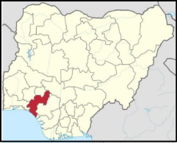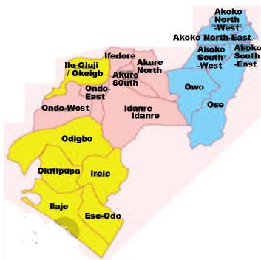
Figure 1: Map of Nigeria showing Ondo State and local governments

Mineral deposits are usually classified into four different types based on their composition and characteristics (Olade, 2021). (1) Metallic minerals, e.g., gold, copper, silver, and other metals:; (b) mineral fuels, e.g., oil and gas, coal and bitumen; (c) industrial minerals and rocks, e.g., feldspar, gypsum, kaolin, limestone, marble, etc; and (d) gemstones, e.g., diamonds, rubies, and emeralds. On the basis of current knowledge, Ondo State is blessed with significant deposits of mineral fuels, some industrial minerals and rocks, but few or unknown metallic minerals and gemstones. The systematic exploration and exploitation of mineral deposits in Ondo State could become a significant vehicle for economic growth, transforming the state into a major hub for industrialization and energy independence. This would create opportunities for global investment and trade, leveraging its extensive coastline for direct access to the Atlantic Ocean through a proposed deep seaport. This paper provides an overview of the geology and mode of occurrence of mineral deposits, assessing the potential for mineral discoveries and prospects for industrial and economic development through resource exploitation.
GEOLOGICAL SETTING
Nigeria lies within the Trans-Saharan Mobile Belt of West Africa, sandwiched between the West African Craton to the west, the Trans-Saharan Craton to the east, and the Tuareg Shield to the north (Black, 1980) (Fig. 2). Approximately half of Nigeria is underlain by Precambrian crystalline rocks, whereas the other half is covered by sedimentary and volcanic rocks (Fig. 3) (Oyawoye, 1970; Rahaman, 1976). Approximately 60% of Ondo State is underlain by rocks of the Precambrian basement complex, which occupies most of the northern and central regions, whereas sedimentary rocks of the Cretaceous cover the remaining 40% in the southern region to recent ages (Fig. 4). The basement complex is composed of three major rock groups (Oyawoye, 1970; Rahaman, 1983):
(1) Archean Migmatite-Gneiss Complex (MGC)
(2) Proterozoic Schist Belts (PSB)
(3) Pan-African Granitoids and Pegmatites (PGP)
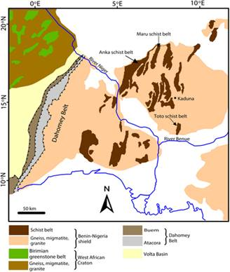
Figure 2: Tectonic setting of Nigeria in the Trans-Saharan Belt
The Migmatite-Gneiss Complex is a heterogeneous assemblage of metaigneous and metasedimentary rocks containing ancient relics that have been reworked by several orogenic events (Kroner et al., 2001; Okonkwo and Ganev, 2012). The lithologic units of the MGC in Ondo State include a variety of orthogneisses, paragneises, and migmatites with intercalated bands of metasedimentary rocks and rare amphibolite (Oyawoye, 1970; Oyinloye, 2011). The Archean to Early Proterozoic basement rocks include grey gneiss, charnockitic gneiss, granite gneiss, pelitic gneiss, migmatite- gneiss, and biotite gneiss. (Oyawale and Ocan, 2020; Oyeshomo, 2025). The grey gneisses are presumably the oldest rocks in Nigeria’s Precambrian basement complex (Rahman et al., 1983) and are tonalite-trondjhemite-granodiorite (TTG) in composition. They contain amphibolite fragments and mostly occur as relics or patches within vast areas of granite gneiss in the areas around Ikare, north of Akungba, Arigidi-Akoko, and Oka-Akoko (Oyewale and Ocan, 2020; Adegbuyi and Ogunyele, 2018) (Fig. 6). Both rock types are intruded by extensive bodies of light-colored and weakly foliated granite gneiss found mainly around the Akoko region (Fig. 5). Pelitic (garnet) gneisses, sometimes with leucosomes and commonly mapped as “banded gneiss” or “migmatite”, are the most widespread basement rocks outside of the upland Akoko region. They are younger than the grey and granite gneisses (Oyawale and Ocan, 2020; Oziegbe et al., 2021) and are commonly associated with intercalated or infolded bands of quartzites (Fig. 5). These metapelites (Oziegbe et al., 2021) may belong to the so-called “Older or Ancient Metasediments” of Oyawoye (1970) (Rahaman, 1976; Jones and Hockey, 1983).
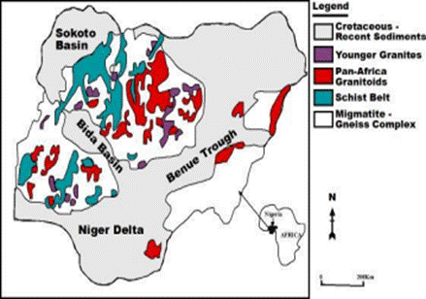
Figure 3: Simplified geological map of Nigeria
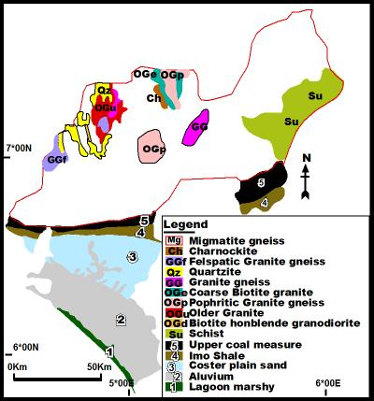
Figure 4: Generalized geological map of Ondo State
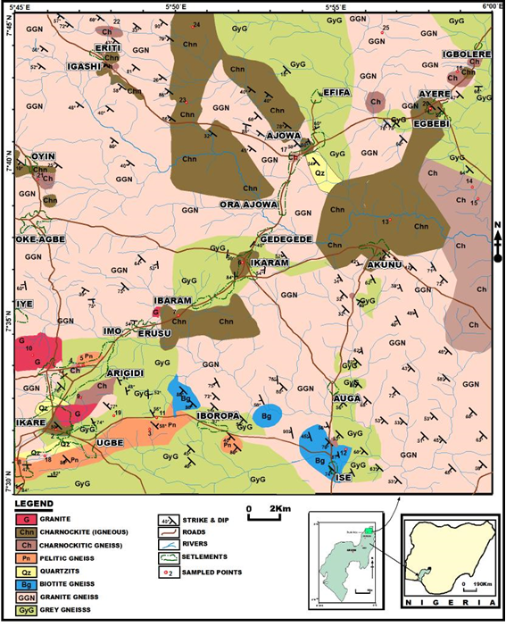

Figure 5: Geology of the Akoko NW Local Government Area (After Oyeshomo et al., 2025)
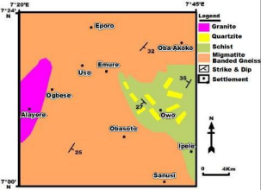
FIGURE 6:Geological map of Owo-Idoani Schist Belt

A second generation of granite gneiss and biotite gneiss intruded the pelitic and migmatite gneisses at various locations within the basement complex, where they occur as isolated intrusions or plutons. At Oba-Ile near Akure, and nearby Ogbese village, granite gneiss bodies contain large fragments of the surrounding migmatite gneiss (Ademeso, 2010) (Fig. 6). The MGC is overlain by schistose rocks and quartzites of the Neoproterozoic supracrustal Schist Belts that are exposed in two areas of Ondo State: 1) in the east, extending from Owo to Idoani-Idogun, and 2) in the far west, along the border with Osun State, from Odigbo through Ondo West to Ile-Oluji LGA (see Fig. 4). In the Owo-Idoani Schist Belt, which is a southern extension of the Igarra Schist Belt (Odeyemi, 1976), the dominant rocks are quartz-mica schist, and massive quartzites (Fig. 6), which pass into phyllite, flaggy quartzite, muscovite-quartz schist and calc-gneiss in the area north of Idoani-Idogun area (Ogunyele et al., 2017). In the west, along the Osun State border, the metasedimentary rocks are mostly massive quartzites feldspathic quartzites and paragneisses (Okunlola and Okoroafor, 2009). Porphyritic granites and associated charnockite bodies of Pan-African age (650--500 Ma) occur as isolated plutons in many areas of Ondo State's basement complex, where they form prominent hills and inselbergs, notably around Akure, Idanre, Ifedore, Ile-Oluji, Irele, and Odigbo LGAs (Ademeso, 2010).
Cretaceous and Tertiary sediments cover the southern and coastal regions of Ondo State in the East Dahomey Basin (Fig. 7). These rocks are highly economically important for the occurrence of mineral deposits, including petroleum, tar sand, bitumen, kaolin, bentonite, phosphate, silica sand, limestone, and coal. The oldest sediments belong to the Abeokuta Group, which in Ondo State is composed of the basal sandstones of the Abeokuta Formation (Ise/Afowo Formations) and the overlying shales and siltstone of the Late Cretaceous Araromi Formation, with interbeds of coal and limestone, as exposed at the Ute and Arimogija-Okeluse areas respectively (Eninola et al., 2012). Overlying the Araromi Formation are the Tertiary Ewekoro, Akinbo, and Oshoshun Formations, which are composed of marine shales. The sands of the Benin Formation overlie the Oshshun Formation and occur extensively in the Okitipupa, Irele, and Odigbo LGAs (Fig. 7). In coastal regions, alluvium is the dominant lithology in most of the Ese-Odo and Ilaje LGAs.

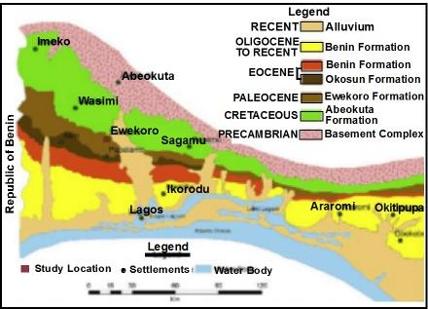
Figure 7: Geology of southern Ondo State, East Dahomey Basin
Table 1: Brief Geological History of Ondo State
 | PERIOD | AGE | ROCKS/FORMATIONS | PROCESSES | LOCALITIES
10 | Quaternary | 2Ma -  Present | Alluvium  Benin Formation | Sands and gravel,  clays, and silty clays | Ese-Odo, Ilaje  Irele, Okitipupa,
9 | Tertiary | 65 - 2Ma | Ososhun/Ilaro  Akinbo  Ewekoro Formation | Shales, mar, siltstone, | Okitipupa, Irele, Odigbo
8 | Cretaceous | 145 - 65  Ma | Araromi Formation  Abeokuta/ Formation | Coarse sediments,  siltstone, shale,  limestone, and coal | Okitipupa  Irele  Okeluse
7 | Triassic/Jurassic Paleozoic | HIATUS Period of Regional Uplift and Non-Deposition
6 | Pan-African  Orogeny | 700-450  Ma | Pegmatite  Porphyritic granite,  Charnockite, Syenite | Tectonic,  metamorphic &  magmatic processes | Akure, Idanre  Akoko SW, NE Ifetedo, Owo
5 | Neoproterozoic | 1000 - 700 Ma | Marble /Calc-silicate gneiss; Quartzites  Quartz muscovite schist | Deposits of pelites, limestone, and sandstone | Owo-Ose  Odigbo  Ile-Oluji
4 | Eburnean  Orogeny | 2200- 2000 Ma | Granite Gneiss (GG2)  and Biotite Gneiss  Emplacement | Tectonic,  metamorphic and magmatic processes | Owo  Ondo  Irele
3 | Paleoproterozoic | 2500 -2200 Ma | Quartzites & Schist  Pelitic Gneiss & Migmatite (Banded Gneiss) | Deposits of pelites, sandstone, limestone, | Akoko NW  Akoko NE, Ose Gdigbo, OndoW,
2 | Liberian  Orogeny | 2700 -  2500 Ma | Granite Gneiss (GG1) Emplacement | Tectonic and  magmatic processes | Akoko SE  Akoko NW
1 | Archean  (Neoarchean)  (Mesoarchean) | 2500 -  3500 Ma | Grey Gneiss  (Tonalitic-Graodiorite TTG) Amphibolite | Formation from  igneous protoliths | Akoko NW  Akoko NE  Akoko SW
The geological history of Ondo State is summarized in Table 1. A novel interpretation is proposed based on the new lithologic units identified and their field relationships (Oyeshomo, 2025). Crustal evolution in southwestern Nigeria probably began in the Mid– to Late Archean (3.2 -2.5 Ga), with the emplacement of the grey gneisses believed to be the oldest rocks in the Nigerian Basement Complex (Rahman, 1983). They originated from the upper mantle by partial melting of basaltic rocks (Oyinloye, 2011; Adegbuyi and Ogunyele, 2018). These ancient rocks carry amphibolite xenoliths presumably picked up from the upper mantle (Oyawale and Ocan, 2020). The grey gneisses are intruded by a massive suite of granite gneisses probably emplaced during the Liberian Orogeny (2.7--2.5 Ga), similar in age to the Ilesha granite gneiss, which produced a Pb‒Pb age of 2725 Ga (Oyinloye, 2011). The grey gneisses, charnockitic gneisses, and granite gneisses were overlain by the widespread pelitic gneisses and migmatite with intercalated quartzites and schist. These ancient metasedimentary rocks were probably deformed, metamorphosed, and intruded by the second generation of granite gneisses during the Eburnean Orogeny (ca. 2.0 Ga). They are similar in age to the Ibadan Granite Gneiss, dated by the Rb/Sr isochron as 2207 Ma (Grant, 1070). During the Late Proterozoic (1000--700 Ma), low-grade metasedimentary rocks were deposited as supracrustal cover rocks in the Owo-Idoani area and deformed during the Pan-African Orogeny (ca. 600 my), when the Pan-African granites and charnockite invaded all the existing rocks. U-Pb zircon age determinations are in progress to determine the absolute and relative ages of the ancient gneisses. During the Paleozoic and early Mesozoic, there was a long hiatus of nondeposition until the commencement of doming and rifting in the Triassic to Jurassic period, which led to the opening of the Atlantic Ocean in the Early Cretaceous (Olade, 1975). This was accompanied by marine transgression that led to the deposition of the Cretaceous formations, followed by the Tertiary deposition of the marine Ewekoro, Akinbo, Oshoshun, and Benin Formations.
MINERAL DEPOSITS
Ondo State is blessed with abundant energy fuels: oil and gas (petroleum), bitumen and coal; several industrial minerals and rocks, including silica sand, limestone, kaolin, ball clay, dimension stones, and marble; and metallic gold and lateritic iron ore (Fig. 8).
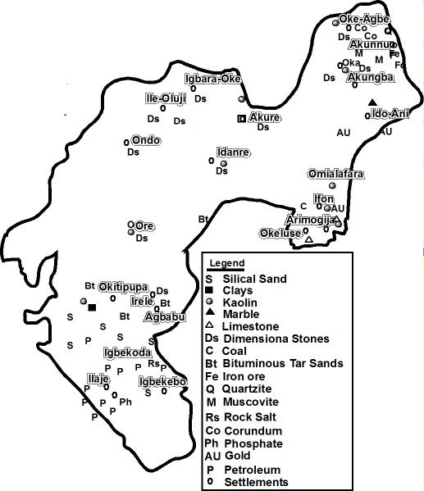
Figure 8: Map showing mineral deposits of Ondo State
Oil and Gas deposits
The first oil discovery in Nigeria was made in Araromi, Ondo State, in 1908. While the discovery was not in commercial quantities, it stimulated further oil exploration in the region. This was followed by the discovery of bitumen in Agbabu, Odigbo LGA, in 1910 by a German firm, the Nigerian Bitumen Corporation (NBC). The oil and gas deposits in Ondo State are located within the Eastern Dahomey Basin (Fig. 9), a major sedimentary depocenter situated west of the Niger Delta Basin, comprising a series of microbasins formed by Cretaceous crustal subsidence and block faulting (Omatsola and Adegoke, 1981). In addition to the Niger Delta, the Eastern Dahomey Basin is the most significant source of oil and gas deposits in Nigeria with substantial reserves, particularly in Ondo State and Lagos State (Coker et al., 1983). Ondo State is currently the 6th largest producer of crude oil in Nigeria, with a daily production of approximately 60,000 barrels, 3.74% of Nigeria's total crude oil output (Fig. 10). Crude oil reserves, both onshore and offshore deposits, are estimated to be 4 billion barrels, representing about 12% of Nigeria’s crude oil reserves. (Ondo State Investment Corp, 2024). The state also possesses large quantities of natural gas deposits that can generate up to 20 million tons of natural gas per year if harnessed as LNG (liquefied natural gas).
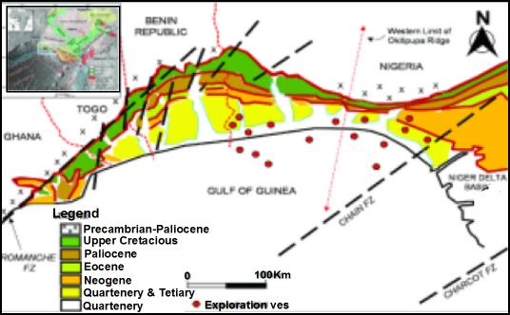 Figure 10: Hydrocarbon occurrences in the East Dahomey Basin
The oil-bearing sands and sandstones are found within the Afowo Formation (Abeokuta Formation) in the basal section of the transgressive Abeokuta Group. The Afowo Formation is a key unit that contains both source rocks (shales) and reservoirs (sands) for hydrocarbons (Falufosi and Osinowo, 2021). Oil has accumulated in sandstone reservoirs that are overlain or surrounded by impermeable shales and clays. The source rocks of petroleum are believed to be shale sequences within the Abeokuta Group, particularly the Afawo Formation, from which petroleum migrated into structural and stratigraphic traps. Organic geochemical studies have shown that the shale facies in the Afawo Formation reached maturity and could have generated hydrocarbons in the subsurface (Coker et al., 2002; Ogala et al., 2019), whereas the shales of the overlying Araromi Formation are considered to be immature to marginally mature source rocks, but possibly the deeper offshore areas may show more promise (Njoku et al., 2021; Adekeye et al., 2019).
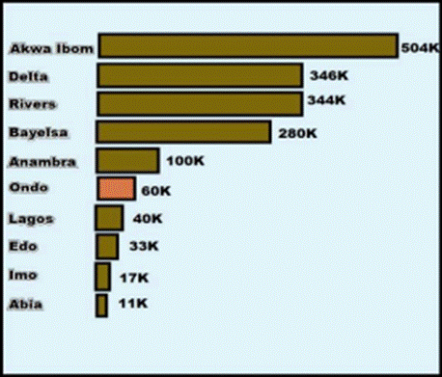
Figure 10: Oil production by leading states in Nigeria
Most of the new offshore production wells are distributed along the coastline off the Ilaje and Ese Odo LGAs, mostly in shallow waters and riverine estuaries. The Okitipopa LGA has a few onshore wells. Nevertheless, the Ilaje LGA contains most of the oil production wells onshore and offshore, and is now the “hotspot” for oil exploration activities and home to a potential oil refinery project. The hydrocarbon potential of Ondo State's offshore area is vast and has attracted recent attention as exploration companies continue to obtain a better understanding of the oil traps in the offshore area.

Bitumen deposits

Bitumen is a sticky, black, thick, and highly viscous liquid, a semiliquid to semisolid form of petroleum that fills the pore spaces in host sediments such as sandstones, referred to as “tar sands” (Cornelius, 1987). Since 1901, bitumen and tar sands have been known to occur along the coastline of southwestern Nigeria, where they extend for a total distance of more than 120 km over a 6 km wide belt in Ondo, Ogun, Lagos, and Edo States, known as “Nigeria's Bitumen Belt” (Fig. 11). Bitumen deposits in Ondo State are the most significant in Nigeria, constituting 90% of known Nigerian resources, estimated to be approximately 16 billion barrels, with valued reserves of 42 billion barrels of combined tar sands and heavy oils, ranking as the largest in Africa and 2nd in the world to Venezuela.. The Ondo State “bitumen belt” stretches across several LGAs, including Okitipupa, Irele, Odigbo, Ese Odo, and Ilaje LGAs. Bitumen deposits in Ondo State are localized within the Cretaceous sediments of the Abeokuta Group, mainly in the Abeokuta (Afowo) Formation, with lesser amounts in the Araromi Formation. The tar sands are fine- to medium-grained, moderately to well -sorted, and composed mainly of quartz (90%), with subordinate amounts of clay minerals (Ogala et. al., 2019). The average bitumen content is about 20% which is considered good (Alhassan et al., 2020). Bitumen occurs in two forms: (1) as surface seepages and outcrops of tar-impregnated sands (Fig. 12), and (2) as subsurface deposits. The areas with major bitumen seepages are shown in Figure 13 (Jekayinfa, 2023).

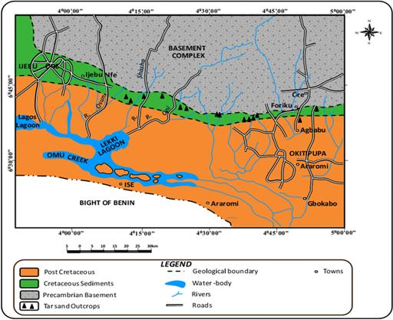
Figure 11: Bitumen distribution along the coast of southwestern Nigeria
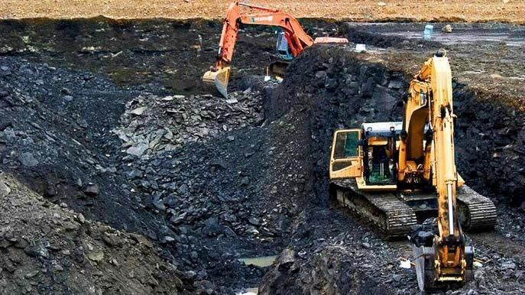
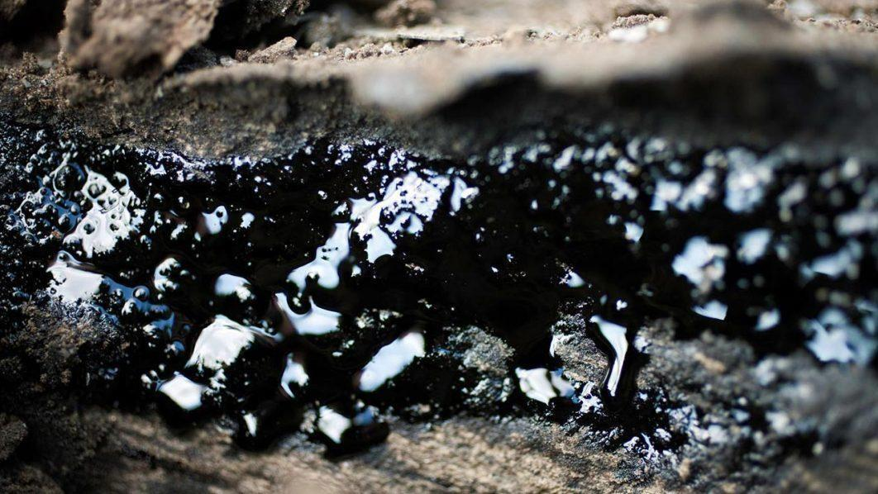
Figure 12: Bitumen seepage and surface deposit in Ondo State

The subsurface bitumen and tar sands only intersect in subsurface wells in onshore, coastal, and offshore areas. The stratigraphy includes two horizons of bituminous sands: the upper horizon (Horizon X), which is approximately 5–22 m thick, and the lower horizon (Horizon Y), which is less than 50 m from the surface, and approximately 3–23 m thick (Enu, 1985). The upper horizon can be exploited by open-cast mining, whereas the lower layer can be exploited by steam-assisted gravity drainage. The communities with significant bitumen deposits include (i) Agbabu and Ilubirin in Odigbo LGA; (ii) Ode-Irele, Loda, and Gbeleju in Irele LGA; and (iii) Ode Erinje at the center of the bitumen belt in the Okitipupa LGA. Bitumen seepages contribute to soil, surface water, and groundwater contamination (Jekayinfa, 2023).

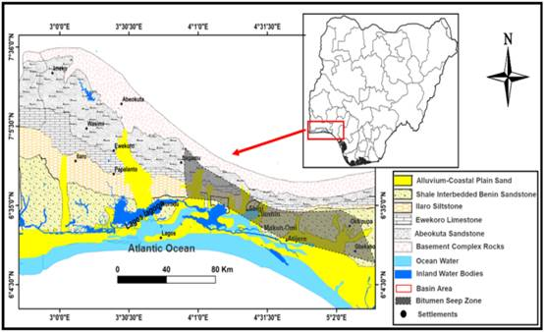
Figure 13: Distribution of Bitumen seeps in Ondo State (Jekayinfa et al., 2023)

Coal deposit

Coal is a black or brownish-black sedimentary rock composed chiefly of combustible carbon, formed by the accumulation and subsequent compaction and decomposition of plant material or organic matter. Coal is a significant energy resource used worldwide for generating electricity and providing energy for industrial applications. Ondo State has a coal deposit in Ute, Ose LGA, although it is a low-rank lignite. The deposit is made up of several coal seams that occur at intervals as intercalated units within siltstones and shales of the Araromi Formation (Fig. 14). Geophysical studies (Ehinola et al., 2012; Egunjobi and Muslim, 2018) have identified several seams that range from 0.6 to --2 m in thickness, near the surface and at depths of up to 30 m in the Ute area (Fig. 13). A calculated mineral reserve of 10 million tons (1.02 × 10^7) was obtained in a specific area southwest of Ute (Ehlinola et al., 2012). The Ute coal deposit is sufficient in quantity and can be exploited and used to generate electricity or mold into briquettes for cooking domestic fuel.

Limestone deposits
Limestone is a common sedimentary rock composed mainly of calcite (or aragonite), a carbonate of calcium (CaCO3), and sometimes with minor dolomite (MgCaCO3). Limestones are used in a variety of industrial applications, including cement manufacturing, pulverized limestone powder used as a soil conditioner, lime or quicklime(calcium oxide), and slaked lime (calcium hydroxide) production (Ola, 1977; Olade, 1988). In Nigeria, 80% of more than a dozen cement factories use limestone as a raw material.
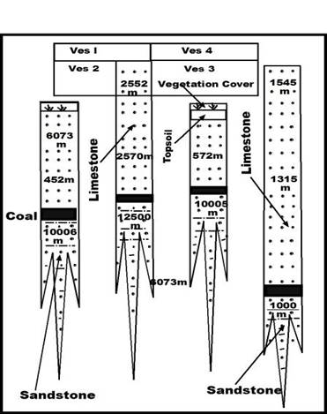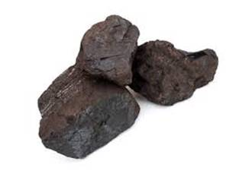
Figure 14: Geoelectric vertical profile of lignite coal seams at Ute, Ose LGA
Limestone occurrences in Ondo State are found as relatively thin layers (1–3 m) within the Araromi Formation. Outcrops of Upper Cretaceous limestone beds have been observed at various locations stretching from the Ogbese River in the west through Okeluse, North Omolege, Arimogija, and Ijagba to Sobe in the east, Ose LGA. The most extensive outcrops of the limestone occur in the area southwest of Okeluse (Omi Alayo and Okeluse Forest Reserve) (Fig. 15) and south of Arimogija town, where the limestone occurs as a discontinuous band with an average thickness of approximately 2 m in Arimogija to 3 m at Okeluse. As shown in the geological map (Fig. 16), the limestone bed appears to be situated near the top of the Araromi Formation, toward the base of the Ewekoro Formation. Chemical analysis of the limestone samples from Arimogija and Okeluse (Table 2 shows that the CaO (calcium oxide) content ranges from 47% to 52%, with an average MgO (magnesian) content of 1.52%. The high CaO content and relatively low MgO (<2%) indicate their suitability for cement production (Olade, 1988; Edema et al., 2016; Ogunribido and Ogunjemila, 2022; Oyeshomo, 2024). The reserve estimate for the two deposits is approximately 12 million tons (Ehinola et al., 2012). Nevertheless, the limestone deposit at Okelusse contains more reserves and is of better quality (lower MgO) than the Arimogija deposit. The prospects of finding a more extensive limestone deposit at depth are very encouraging on the basis of its lateral persistence over an area spanning several kilometers. However, a more detailed geological investigation involving subsurface core drilling is needed.
Table 2: Chemical Composition of Arimogija-Okeluse Limestones
Arimogija Limestone Samples
 | SiO2 | Al2O3 | Fe2O3 | MgO | CaO | Na2O | K2O | TiO2 | MnO | LOI
ARS1 | 4.52 | 1.79 | 2.08 | 1.76 | 48.60 | 0.02 | 0.07 | – | 0.01 | 39.5
ARS2 | 5.24 | 1.62 | 22.54 | 1.84 | 47.00 | 0.02 | 0.06 | 0.07 | 0.01 | 38.9
ARS3 | 3.89 | 0.97 | 1.89 | 1.80 | 49.20 | 0.02 | 0.06 | 0.06 | 0.01 | 40.2
ARS4 | 4.58 | 1.57 | 2.41 | 1.58 | 48.67 | 0.02 | 0.06 | 0.06 | 0.01 | 39.5
ARS5 | 4.78 | 1.66 | 2.03 | 1.39 | 47.89 | 0.02 | 0.07 | 0.07 | 0.01 | 39.8
Okeluse Limestone Samples
OKL1 | 1.94 | 0.61 | 1.20 | 1.40 | 52.31 | 0.02 | 0.04 | 0.43 | 0.01 | 41.8
OKL2 | 1.96 | 0.61 | 1.22 | 1.40 | 51.98 | 0.02 | 0.04 | 0.47 | 0.01 | 41.2
OKL3 | 2.54 | 0.61 | 1.22 | 1.42 | 50.06 | 0.02 | 0.04 | 0.51 | 0.01 | 40.9
OKL4 | 1.99 | 0.61 | 1.28 | 1.40 | 51.22 | 0.02 | 0.05 | 0.48 | 0.01 | 41.3
OKL5 | 2.16 | 0.61 | 1.20 | 1.40 | 52.04 | 0.02 | 0.05 | 0.47 | 0.01 | 41.2
MEAN | 3.36 | 1.09 | 1.70 | 1.52 | 50.06 | 0.02 | 0.05 | 0.07 | 0.01 | 40.4
(Source: Edema et al., 2016)
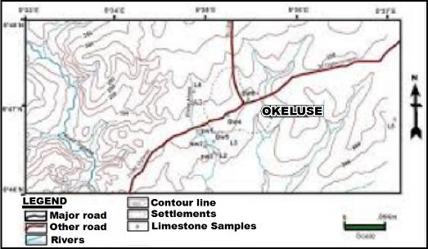
Figure 15: Topographic map of Okeluse and Limestone locations

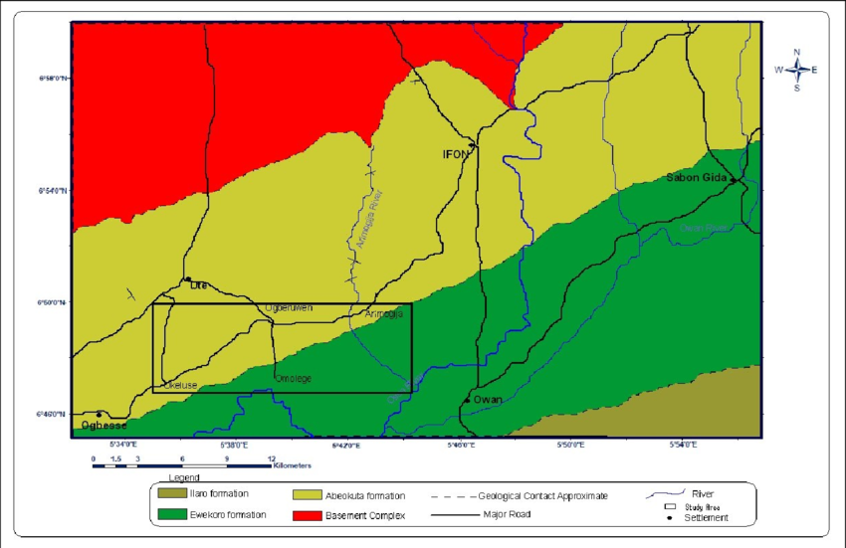
Figure 16a: Geological map of Ute and the surrounding areas of Okeluse and Arimogija

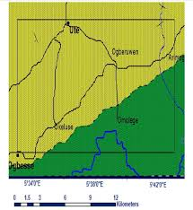
Figure 16b: Enlarged map of the area in Fig. 16 showing Okeluse and Arimogija

Silica Sand deposits
Silica sand is pure sand composed predominantly of silica (SiO2) as quartz grains. Silica sand occurs naturally and is usually produced by wind or water action, particularly along beaches and dunes. River deposits of sand can also produce silica sand if it is free of clay and other impurities. Silica sand is used primarily in the manufacture of glass products, including sheet glass and glass containers. It is also applied as an additive in cement and ceramics. Industrial-grade glass sands must meet certain textural and chemical specifications.
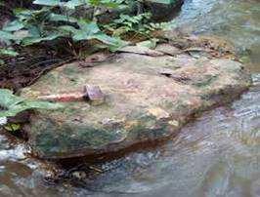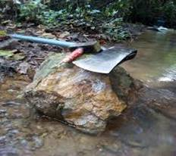
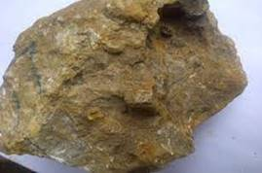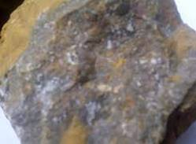
Figure 17: Okeluse limestone at Omi Alayo (After Bolawale,2018 Limestone samples (after Oyeshomo, 2024)
Ondo State is fortunate to have the best top-quality silica sand deposits in Nigeria (Olade, 2020), which are found along its coastal and riverine areas in the Ilaje LGA. The most notable of these deposits is at Igbokoda, which was the site of the moribund Oluwa Glass Company, created in 1982. The company manufactured sheet glass for several years but faced financial problems and was liquidated in 2006. The glass sands at Igbokoda (Fig. 18) are extensive and cover an area of over 40 km², with reserves of over 74 million metric tons. Other surrounding areas contain similar sands to those to the north and east of Igbokoda, covering an additional area of approximately 42 km² over the alluvial plains of the Oluwa and Igbokoda rivers. Notable localities include Atijere, Zion-Pepe, Akata-Agbala, and Agerige, Orereara, Ipare, Ode Etikan, and Aboto (Ondo State Government, 2012).
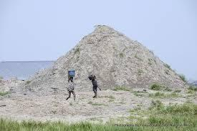
Figure 18: Stockpile of Igbokoda Silica Sand
These silica sand deposits all have similar characteristics and are essentially high-quality, white or nearly white in color, medium- to fine-grained (passing a 20 to 50-mesh sieve) sand. The chemical composition, as shown in Table 3, indicates that the silica content exceeds 94% with minor impurities. The moribund Oluwa Glass factory was unique, being the first in Nigeria to produce sheet glass that supplied windshields to the first Peugeot vehicle assembly in Kaduna. The state has raw materials for the production of all types of glass for sheets and containers. The Nigerian Raw Materials Research Agency is conducting further studies of variability in the quality of the deposits.

Table 3: Chemical Composition of Ignokoda Glass Sand |  | Chetland Glass Sand (Standard)
Chemical  Constituent | Concentration (%)
SiO2 | 94.24 | 97.91
Fe2O3 | 0.87 | 0.50
Al2O3 | 1.47 | 1.13
TiO2 | 0.48 | –
Cao | 0.90 | –
K2) | 0.82 | 0.25
Na2O | 0.75 | –
MnO | 0.47 | –

Kaolin deposits
Kaolin is a unique type of clay in which the predominant mineral is kaolinite, with minor amounts of residual quartz, feldspar, and muscovite. Kaolinite is soft and whitish in color and is widely used in various industries because of its unique properties, including chemical inertness, non-swelling characteristics, and ability to be processed into a fine powder. Kaolinitic clays are not as pure as kaolin, but have similar industrial properties. Pure kaolin has numerous industrial applications, including in ceramics, paint, paper, steel, rubber, glass, filler, and pharmaceuticals. Kaolin deposits are usually of two types: (i) residual kaolin, formed by chemical weathering (residual clay), and (ii) sedimentary kaolin, which is reworked residual clay transported or washed during sedimentary deposition, and plastic fire clays.
Ondo State contains significant kaolin deposits at Omialafara (Ose LGA), Ile-Oluji (Ile-Oluji LGA), Akure, Erushu, and Ishua (Akoko LGA). The Omialafara kaolin is mostly residual in origin and located along the basement-sedimentary contact, with some minor sedimentary reworking. Some plastic kaolinitic fire clays are found in various locations, such as the Isua-Akoko, Akure, Lafe, Ayadi, and Ifon areas. These deposits are suitable for industrial use, including ceramics and refractory bricks. The kaolin deposits in Okitipupa and Irele LGAs are sedimentary kaolin deposits with the ability to swell and burn white, at Abusoro (Okitipupa LGA), Ewi Camp (Okitipupa LGA), Ode Aye (Okitipupa LGA), and Omifun (Irele LGA). (Ondo State Government, 2012). Kaolin deposits, in general, are raw materials used for the manufacture of all kinds of ceramics and refractories, such as at the moribund Ifon Golden Ceramics Factory at Ifon.
Dimension Stones (Granite and Gneiss)

Dimension stones are made of crystalline rocks that can be cut and shaped for use in building construction and decorations, and other applications. They are characterized by their adequate strength and fracture density, size, shape, color, texture, pattern, and surface finish, and are made from various rock types, particularly igneous and metamorphic rocks. The state features many outcrops of igneous and metamorphic rocks that can be used as dimension stones, including granites, charnockite, banded gneiss, and granite gneiss, which form prominent inselbergs and ridges in many parts of the central region, particularly in Akure (Ademeso, 2010), Idanre, Ondo, Akoko NW, and Owo LGAs, whereas gray gneiss and granite gneiss are prominent in Akoko SW, Owo, and Ose LGAs. It is estimated that over 100 million tons of dimension stone are available in Ondo State, with a fast-growing dimension stone industry using granites and gneisses. At least two prominent dimension stone factories involved in rock cutting and slabbing operate in Supare, Akoko SW, owned by Crushed Rock Industries (Fig. 19), and the other, at Afo in Ose LGA (Fig. 20), owned by a Chinese company, Xiamen Win Stone and Marble Company. Both companies are in production with a combined production estimate of 2 million square meters of dimension stone annually (Ibitoye and Ajibade, 2017; Ayeni et al., 2015).

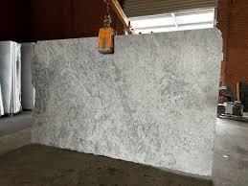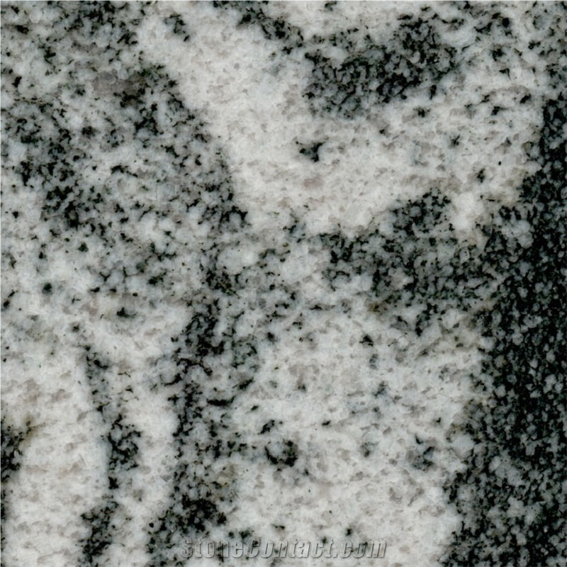
Figure 19: Supare Ivory White and Supare White Granite Dimension Stones

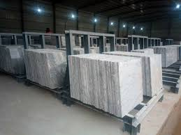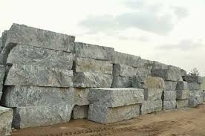
Figure 20: Dimension stone production, Afo, Ose LGA, Ondo State
Marble Occurrences
Occurrences of marble have been reported near both the Idoani and Idogun areas in Ose LGA, extending to the Ifira area in Akoko SE LGA. These occurrences are calc-silicate and dolomitic marble lenses within the Owo-Idoani Schist Belt, which is a southern extension of the Igarra Schist Belt in nearby Owan and Akoko-Edo LGAs. Marble deposits are numerous in the Igarra area, such as at Ukpella, Ubo, Igwe, and Ekpeshi. Dolomitic marble is used as a dimension stone for flooring, wall coverings, kitchen countertops, and bathroom surfaces, as well as in the production of magnesium, as a flux in steel manufacturing, and as a raw material for glass and ceramics.
Construction Materials
Construction materials are unconsolidated or loose earth materials used in building and road construction. They also form the foundational components of concrete, asphalt, and mortar for buildings, roads, and other structures. The mining and production of these geomaterials, although small in value, support significant economic activity and employ many people. In 2023, Nigeria produced approximately 95 million tons of geomaterials (sand, gravel, and crushed stone) and 5 million tons of laterite, generating more than 9 billion naira, which is shared with the states (NEITI, 2024).
Ondo State has significant sand and gravel deposits that occur along the riverbeds and terraces of the Rivers Ose, Ogbese, Owena, and Oluwa river systems, and along the coastal areas of Ilaje and Ese Odo LGAs. They are a key resource for the local construction industry and for local revenue generation. Crushed stone is an artificial aggregate composed of rock fragments produced by the crushing of crystalline rocks such as granite or basalt. Ondo State has abundant outcrops of granite and granite gneisses used for crushed stone at several quarries in the northern and central parts of the state.
METALLIC MINERALS
Ondo State is not rich in metallic minerals, mainly because the rocks that host such minerals, e.g., amphibolites, schists, and granitic pegmatites, are not abundant in the state. The few metallic minerals that are known to occur are gold, lateritic iron ore, and tantalite, which are usually present in small quantities.
Gold
Gold deposits in Nigeria (orogenic gold) are associated with structural features in the Proterozoic “Schist Belts”, where gold occurs in two forms: as primary auriferous quartz veins of hydrothermal origin and as alluvial (and regolith) deposits a (Olade, 2020). In Ondo State, the mode of occurrence has not been thoroughly investigated. However, rocks of the Schist Belts are found in the Odigbo LGA and the Owo-Idoani Schist Belt (Fig. 4). These are the potential areas for orogenic gold mineralization. The most recent report of the Nigerian Extractive Industries Transparency Initiative (NEITI, 2024) indicated that the Ondo State is a gold producer.
Reports indicate illegal gold mining and the apprehension of offenders by law enforcement agents in two areas considered favorable for gold mineralization: Odigbo and Owo/Ose LGAs. In September 2024, the Nigerian Security and Civil Defense Corps (NSCDC) raided an illegal gold mining site at Ogunlepa, Oluwa Forest Reserve, near Ore in Odigbo LGA, near the border with Osun State. Photographs show that gold mining from alluvial deposits, weathered host rocks, and surficial regolith is in progress in this area (Fig. 21). In May 2025, the Ondo State Security Network (also known as “Amotekun”) also arrested illegal gold miners in Owo Forest Reserve between Ipele-Owo and Ute in Owo-Ose LGAs. Further geological exploration in these areas is needed to determine the nature and extent of gold mineralization.
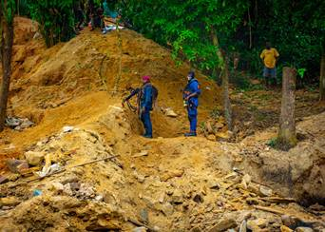
Figure 21: Illegal gold mining sites at Ogunlepa, Oluwa Forest Reserve, Odigbo LGA (Apprehension by Mining Marshals) (Source: NSCDC, 2024)
Lateritic Iron Ore
Occurrences of lateritic iron ore have been reported for several decades from the area around Akunnu in Akoko Northeast LGA. Local blacksmiths utilize lateritic iron ore as a raw material for metal casting. Floats of the iron ore fragments have been observed along stream beds, where they appear as dark ferruginous samples with metallic luster that show strong magnetism. An aerial geomagnetic survey of the entire region has identified three anomalies with peaks at Boropa, Ase Auga, and Akunnu, suggesting the presence of iron-rich rocks suspected to be ferruginous quartzites beneath the overburden. Occurrences of ferruginous quartzites are also common in the areas adjoining Kogi State near Okene (Olade 1979). These iron-rich anomalies represent small ferruginous quartzite lenses that contain mostly hematite.
DISCUSSION
Ondo State is blessed with substantial economic minerals, including oil and gas, bitumen, silica sand, limestone, granite, coal, kaolin, gold, and iron ore, many of which are currently underdeveloped or underutilized. Exploitation of these mineral deposits can significantly impact the state's economy in several ways, including revenue generation, job creation, industrial development, infrastructure development, and potential benefits to local communities. Table 4 presents a list of industrial projects that can be derived from the exploitation of mineral resources in Ondo State.
With respect to oil and gas, Ondo State currently produces approximately 60,000 barrels per day of crude oil, mostly from offshore wells along the Ilaje coastal areas. Although crude oil production in Ondo State began only in 1981, the state has grown significantly to become one of the nation’s top six leading producers, with prospects of even greater crude oil output in the future. Several exploration wells are active in offshore areas and are most likely to lead to the discovery of new oil fields. The number of drilling rigs explored for oil has doubled in the past 5 years, and Sahara Energy, owned by Dr. Funsho Kupolokun, an Ondo State-born engineer and a former Managing Director of the NNPC, has been licensed to manage two new oil fields, PPL 270 and PPL 271, in the riverine communities of Ilaje LGA. The Odu'a, an investment conglomerate, has also begun oil drilling and exploration in the coastal communities of Ilaje through its technical partner, Bita Exploration and Production Limited. The state’s revenue from its share of crude oil taxes and royalties has grown from approximately 22.5 billion naira in 2022 to approximately 25 billion in 2024. Currently, approximately 60% of the state's revenue comes from oil production, and 30% comes from agriculture. In evaluating the potential for new oil discoveries, advanced techniques for integrating exploration data and statistical methods to evaluate complex reservoir rocks in the East Dahomey Basin (Eftekhari, et al., 2024).
In addition to the establishment of refineries, the potential production of petrochemicals, plastics, and fertilizer industries using raw materials from crude oil will benefit the economic growth of Ondo State. A Nigerian company, Backbone Infrastructure Nigeria Limited (BIN), in partnership with the Ondo State Government, is in the process of building a $15 billion oil refinery with a planned production capacity of 500,000 barrels per day at Ogboti-Eruuna, located in the Sunshine Industrial Park, a part of the Sunshine Free Trade Zone in the Ilaje LGA,. This project, when completed, will boost the job creation and industrial development of the riverine areas of the State. The exact quantity of natural gas produced in Ondo State is not available; estimates suggest that the natural gas reserves of the State can make approximately 20 million tons of natural gas per year. The Ondo State government has attracted investors to establish a 2000 metric ton inland liquefied petroleum gas (LPG) storage terminal under development by Alles Charis Gas Limited. Overall, plans are in place to attract over 10,000 metric tons of LPG storage within the Ore Corridor, near the Lagos-Escravos pipeline, ensuring an adequate supply of liquefied LPG under pressure for easy storage and transportation. The state government has also obtained approval for the acquisition of over 200 hectares of land within the Ore Industrial Park for the development of a $300 million gas by-product industry in partnership with the Ondo Linyi Industrial Hub, which was created in 2020 and has attracted several industries and created jobs.
Nigeria currently suffers from a significant power shortage with an installed capacity of 12,500 MW, but a peak production of only 4,300 MW daily (80% from natural gas as of September 2025). The state's location presents a market opportunity for investors to leverage its natural gas resources for power generation projects, as it hosts 64 km of the Lagos-Escravos gas pipeline, from which power-generating companies can source gas for thermal generating plants for electricity distribution to Ondo State or feed into the national grid as needed. A notable example is the Pacific Energy 1250 MW gas-fired power plant, owned by Dr. Jide Adeleke, which is situated in Ajebamidele, near Ore in Ondo State. It is nearing completion and awaits connection to the national gas grid to begin operations. It is expected to significantly increase Nigeria's power generation capacity and is estimated to employ over 2,000 engineers and other workers.
Bitumen deposits in Ondo State are estimated to be approximately 16 billion barrels, with reserves of tar sands and heavy oils valued at approximately 42 billion barrels. The exploitation of these reserves holds excellent potential for Ondo State and Nigeria's infrastructure development and industrial growth, creating economic opportunities and jobs. After several years of attempting to attract viable investment for developing the bitumen deposits, the Ondo State Government is starting to make progress in developing the bitumen industry by partnering with private firms to explore and exploit the mineral deposits. A Nigerian company named Southwest Bitumen (SWB) has commenced modular exploitation of surface bitumen deposits (Fig. 20a) at Lamidifa in Irele LGA, with a target production capacity of 50,000 metric tons per month. Another indigenous company, Owena Bitumen Exploration Nigeria Limited, has commenced excavation of tar sand deposits at Agbabu, Odigbo LGA (Fig. 20b), which is expected to be processed using German processing technology at a plant described as the largest bitumen processing plant in the world, under construction at Ijebu Ode.
The Federal Government has expressed support for Ondo State's efforts in exploring and exploiting bitumen. In June 2025, the Senate passed a bill establishing the Bitumen Development Commission to boost the exploitation of the vast resources. The Ondo State government has also held meetings with host communities to ensure smooth operations. If all these proposed projects come to reality, the Ondo State will be at the forefront of economic renaissance in Nigeria’s mining sector. Bitumen is primarily used for producing asphalt for road and highway paving, and for the production of binders and other accessory products.
The Ondo State bitumen project is expected to generate massive employment opportunities, suggesting over 30,000 direct jobs. Industrialization is expected to experience considerable growth with the establishment of ancillary companies that produce asphalt, synthetic crude, fertilizer, and other related products. The project could also boost the state's economy and contribute significantly to Nigeria's revenue. A proposed deep-sea port known as Port Ondo is located in Ilaje LGA, two kilometers off the coast, with an adjacent free trade zone development that houses a refinery. Both the free trade zone and seaport can provide a massive opportunity for global trading and serve as a gateway for exports of manufactured goods, petroleum, and ancillary products to and from West African countries.
Vast deposits of untapped industrial minerals and rocks exist in Ondo State. Among them is silica sand, a valuable raw material containing more than 90% SiO2 that is used in the production of several types of glass to meet the needs of the construction industry, automobile and solar panel manufacturers, particularly sheet glass for windows, doors, vehicle windshields, and container glass for a variety of bottles. The sands are of sufficient quantity and adequate quality to support several glass-making factories for local consumption and for export to neighboring countries. In addition, silica sand can be used in the manufacturing of insulating fibers and as additives in the ceramic, refractory, and abrasive industries. The moribund Oluwa Glass Factory at Igbokoda operated for more than a decade before it was liquidated for indebtedness. There have been recent attempts to build a new glass factory rather than resuscitating the moribund factory because of its high debt profile. The exploitation of silica sands in Ondo State will create jobs, increase state revenue, and diversify the economy by reducing the state's dependence on oil. However, the vast resources of silica sand require further geological characterization to identify variations in quantity and quality.
Limestone is a primary raw material for the production of cement in Nigeria. Cement is a product in high demand in Nigeria for building and road construction. The state has sufficient reserves of high-grade limestone suitable for cement production at Okeluse and Arimogija in Ose LGA.
Establishing a cement factory initially in a small-scale modular cement factory in the Okeluse area will increase economic activity, create jobs, and generate revenue for the state. Coal is another valuable resource near Oeluse that can be utilized for energy generation, domestic heating, and cooking. Kaolin and kaolinitic clay deposits of high purity have been identified at several localities in Ondo State, particularly in Owo-Ose and Okitipupa LGAs. These deposits are of adequate quantity when combined with ball clays for use in the ceramic, pharmaceutical, and cosmetic industries. The moribund Golden Ceramics Factory at Ifon, Ose LGA, which was established in 1991, produced floor tiles, culinary ware, and other ceramic products for over a decade before it was liquidated, mainly due to a lack of adequate power from the grid to fire the kilns. Currently, factories are being planned for resuscitation.
Resource exploitation often involves significant environmental consequences, including soil contamination, surface water and drinking water pollution, and heavy metal pollution. Other environmental impacts include habitat destruction, which impacts waterways and fisheries, in riverine areas; population dislocation; dust and particulate matter pollution; air quality degradation; and the destruction of forests and economic trees, reducing agricultural yields and biodiversity. All these aspects need to be taken into consideration to maintain a sustainable mineral resource development (Akinyosoye and Ebhuoma, 2024). A significant target for attaining sustainable development is the maintenance of a “healthy environment” for all stakeholders within the dynamics of natural resource development (Akinsulore and Akinsulore, 2021). Therefore, to mitigate environmental impacts, Ondo State and Federal regulators must ensure that comprehensive environmental impact assessments are prepared (and implemented) to truly predict and mitigate damage before and during resource exploitation projects. Moreover, the Ondo State government and mineral-producing companies must implement precautionary or mitigation measures and remedial actions, such as waste minimization, recycling, effective waste management, and compensation to individuals and communities for damage, which will ameliorate the adverse effects of mineral resource extraction. Community involvement should be a key component of resource development, ensuring that host communities feel like partners in the process and benefit from mineral resource projects through rapid economic growth, infrastructural development, and increased local employment opportunities.

Table 4: Potential Mineral Resource-Based Industries in Ondo State
 | Resource | Potential Industries | Estimated  Reserves | Locality  LGAs
 | CRUDE OIL | 1 Oil Refinery  2. Petrochemicals  3. Fertilizers  4 Plastics | 42 billion barrels | Ilaje  Ese Odo
 | NATURAL GAS | 1 Liquefied Petroleum Gas 2 Liquefied Natural Gas 3. Power Generation, Fertilizer  4 Petrochemicals | 124 billion cu ft | Ilaje  Ese Odo
 | BITUMEN | 1 Asphalt Production  2 Synthetic Crude  3 Petrochemicals | 42 billion barrels (equivalent) | Okitipupa  Irele  Odigbo
 | LIMESTONE | 1 Cement Factory  2 Hydrated Lime | 12 million tons | Ose
 | GLASS SAND | 1 Sheet glass  2 Container glass | 300 million tons | Ilaje
 | COAL | 1 Coal briquettes | (?) | Ose
 | KAOLIN | 1 Ceramics  2 Pharmaceutical  3 Cosmetics | 100 billion tons | Ose, Irele  Okitipupa
 | BALL CLAY | Electro-ceramics  Chinaware  Bricks | 40 million tons | Ose  Akoko NE  Okitipupa
 | GRANITE &  GNEISS | Dimension Stone  Crushed Stone | 100 million tons | Akoko SE, SW Ose, Idanre Akure,
 | DOLOMITIC  MARBLE | Dimension Stone  Magnesian Lime | (?) | Ose
 | GOLD | Gold Mining | (?) | Owo, Ose,  Odigbo
CONCLUSIONS
Ondo State possesses substantial deposits of economic minerals, including oil and gas, bitumen, silica sand, limestone, coal, kaolin, granite, potential for gold, iron ore, and marble. Further exploration and exploitation of these deposits can significantly impact the state's economy in various ways, including increased revenue generation, economic diversification, job creation, technological advancement, industrial development, infrastructure development, and community growth. The state should proceed with the establishment of major industrial centers or industrial hubs to attract investors who could establish manufacturing enterprises using mineral-based raw materials in the following locations: (i) Ilaje LGA (for modular refineries, petrochemicals, plastics, and fertilizer manufacturing industries):; (ii) Irele LGA (for modular bitumen production and asphalt concrete mix, heavy oils, petrochemicals, etc,.); (iii) Ore, Odigbo LGA (for LPG, LNG, and CNG and gas byproducts industries & power generation); and (iv) Ifon-Okeluse in Ose LGA (for modular cement manufacture, ceramics, lime production, electro-ceramics, coal briquetting plants, lignite dust, etc.). .The Ondo State Government is already establishing some of these industrial parks. To create mineral-based industrial complexes and achieve the lofty goals of economic development, several challenges must be addressed, including inadequate infrastructure and limited accessibility to remote locations such as Ese-Odo and Ose LGAs. Insecurity remains a concern for mineral exploitation, despite Ondo State being regarded as one of the nation's safest states. Illegal gold mining must be curtailed through the vigilance of law enforcement agencies.

Disclaimer (Artificial intelligence)
Option 1:
Author(s) hereby declare that NO generative AI technologies such as Large Language Models (ChatGPT, COPILOT, etc.) and text-to-image generators have been used during the writing or editing of this manuscript.
Option 2:
Author(s) hereby declare that generative AI technologies such as Large Language Models, etc. have been used during the writing or editing of manuscripts. This explanation will include the name, version, model, and source of the generative AI technology and as well as all input prompts provided to the generative AI technology
Details of the AI usage are given below:
1.
2.
3.
REFERENCES
Adegbuyi, O. and Ogunyele, A. C. (2018). Petrology and geochemistry of basement gneissic rocks around Oka-Akoko, southwestern Nigeria. Malaysian Journal of Geosciences (MJG) Vol. 2 (2), pp. 11-16.
Adekeye, O.A. (2019). Olabisi A. Adekeye, Samuel O. Akande, James A. Adeoye, The assessment of potential source rocks of Maastrichtian Araromi formation in Araromi and Gbekebo wells, Dahomey Basin, southwestern Nigeria, Heliyon, Vol. 5, Issue 5, 2019,
Ademeso, O.A. (2010). Field and petrographic relationships between Charnockitic and associated Granitic rocks, Akure, Ondo State. Int. Journ. Env. Chem. Geol. Geophys. Eng. Vol. 4. No. 11, 2010.
Akinsulore, A. O.,& Akinsulore, O. M. (2021). Sustainable Development and the Exploitation of Bitumen in Nigeria: Assessing the Environmental Laws Faultlines. Beijing Law Review, Vol. 12, pp.113-138.
Akinyosoye, O.O. and Ebhuoma, E. E. (2024). The paradox of sustainable futures in Nigeria: the case of bitumen exploitation. Sustainability: Science, Practice and Policy, Vol. 21, No. 4,
Alhassan, M., Asmau, M.S. et al. (2020). Characterization of Nigerian Bitumen Extract Fractions. Journal of Ecology and Natural Resources, Vol. 4, Issue 6,
Ayeni, J. K. Ogunbajo, I.M., Amadi, A.N., and C.M. Okobi (2015). Evaluation of the Suitability of Rocks Using Volumetric Joint Count for Dimension Stone Quarry in Supare, Ondo State, Southwestern Nigeria. Academia.edu.
Black, R. (1980). Precambrian of West Africa. Episodes, Vol. 4, pp. 3-8.
Boluwade, E. A., Menuwa O.B., and Ogunleye O. (2018). Petrographical studies of Okeluse Limestone. Intern. Journ. Sci & Tech. Res. vol. 7, Issue 6, June 2018.
Coker, S.L., Ejedawe, J.E., and Oshiorienua, J.A. (1983) Hydrocarbon Source Potential of Cretaceous Rock of Okitipupa Uplift. Nigerian Journal of Mining and Geology, 2, 163-169.
Coker S.J.L. (2002). Field excursion guide to tar sand outcrops in Benin Basin. Nigerian Association of Petroleum Explorationists, Mini-Conference, pp. 32.
Cornelius, C.D. (1987). Classification of Natural Bitumen: A Physical and Chemical Approach. In: Exploration for Heavy Crude Oil and Natural Bitumen Editor(s) Richard F. Meyer. American Association of Petroleum Geologists.
Edema, A. and Owonipa, O.D. (2015). Geochemical Evaluation of Arimogija-Okeluse Limestones, Eastern Dahomey Basin, Southwestern Nigeria. International Letters of Natural Sciences Vol. 56, pp 57-64
Eftekhari, S.H., Memariani, M., Maleki, Z., Aleali, M., Kianoush, P., Shirazy, A., Shirazi, A. & Pour, A.B. (2024). Employing Statistical Algorithms and Clustering Techniques to Assess Lithological Facies for Identifying Optimal Reservoir Rocks: A Case Study of the Mansouri Oilfields, SW Iran. Minerals 14 (3), 233
Egunjobi, T. and Muslim, A. M. (2018). The Detectability of Ute Coal Seam Using Geo-Electric Method, Ondo State, Nigeria. Journal of Geology & Geophysics Vol. 7, Issue 3, pp. 337-340.
Ehinola, O. A, Oluwajana A, Adekoya AT (2012) Geophysical investigation and reserve estimation of a coal seam in Ute area, South-western Nigeria. Petrol & Coal 54: 252-259.
Ehinola, O.A., Oluwajana, A., and C.O. Nwabueze (2012). Depositional Environment Geophysical Mapping and Reserve Estimation of Limestone Deposit, ,in Arimogija-Okeluse Area, Southwestern Nigeria. Research Journal in Engineering and Applied Sciences, Vol. 1, Issue 1, pp. 7-11.
Enu, E.I. (1985). Textural characteristics of the Nigerian tar sands. Sed. Geol. vol. 44, pp. 61-86
Falufosi, M.O. Osinowo, O.O. (2021).Geology and hydrocarbon potential of the Nigerian sector of the Dahomey Basin. Journal of Sedimentary Environments, Vol. 6, pp. 335-358.
Fitches, W.R. Ajibade, A. C. Egbuniwe, I.G. Holt, R.W. and J. B. Wright, “Late Proterozoic Schist Belts and Plutonism in NW Nigeria,” Journal of the Geological Society of London, Vol. 142, No. 2, 1985, pp. 312-337.
Grant, N. K. (1970). The geochronology of Precambrian Basement Rocks from Ibadan, Southwestern Nigeria,” Earth and Planetary Science Letters, Vol. 10, No. 1, pp. 28-38.
Ibitoye, T.A. and Ajibade, Z.F. (2017). Determination of Supare Granite Suitability for Dimension Stone Production. Akoko-Edo, Ondo-State, Nigeria. Int. Journ.Sci. Basic and App. Res. Vol. 34 No. 3, 2017.
Jekayinfa, S/M., Oladunjoye, M.A., and Doro, K.O. (2021). A review of the occurrence, distribution, and impact of bitumen seeps on soil and groundwater in parts of southwestern Nigeria. Environmental Monitoring and Assessment, Vol. 195, 2023.
Jones, H.A. and Hockey, R.D. (1964). The Geology of Part of Southwestern Nigeria. Geological Survey of Nigeria Bulletin 31: 101.
Kröner, A., Ekwueme, B. N., and Pidgeon, R. T. (2001). The Oldest Rocks in West Africa: SHRIMP Zircon Age for Early Archean Migmatitic Orthogneiss at Kaduna, Northern Nigeria. The Journal of Geology, Vol. 109, Issue 3, pp. 399–406.
Njoku, J.O., Okeke, O.C., Opara, K.D., Okeke, H.M., Okonkwo, S.I. (2021). A Review of the Geology and Hydrocarbon Potential of the Dahomey Basin International Journal of Innovative Environmental Studies Research Vol. 9, No. 2, pp.:58-71.
Odeyemi, I.B. (1976). Preliminary Report on the Field Relationship of the Basement Complex around Igarra, Midwest Nigeria. In: Kogbe, C.A., Ed., Geology of Nigeria, Elizabethan Press, Lagos, pp. 365-369.
Ogala, J.E. et al. (2019) Jude Etunimonuwa Ogala, Stavros Kalaitzidis, Kimo Christanis, Omoleomo Olutoyin Omo-Irabor, Adewale Akinmosin, Caleb Ugbede Yusuf, Nikos Pasadakis, Miltiadis Constantinopoulos, Helen Papaefthymiou, Geochemical and organic petrological study of bituminous sediments from Dahomey Basin, SW Nigeria, Marine and Petroleum Geology, Vol. 99, 2019,
Ogala, J.E. et al. (2025) J.E. Ogala, K. Perleros, E. Kyriazaki, M. Angelopoulos, O.I. Ejeh, M. Wojtaszek-Kalaitzidi, S. Kalaitzidis, K. Christanis, Paleoenvironmental reconstruction of the coal-forming conditions during the Oligocene in Niger Delta, Southern Nigeria: Implications for organic matter preservation and hydrocarbon potential, Intern. Journal of Coal Geology, Vol. 306, 2025,
Ogunribido, T.H.T. and Ogungbamila, M.M. (2022). Geochemical and Hydrogeochemical Characterization of Limestone Deposits of Okeluse Area, Southwestern Nigeria. SSRG International Journal of Geo-informatics and Geological Science, Vol. 9, Issue 1, pp.13-20, Jan-April 2022.
Ogunyele, A. C., Adegbuyi, O., Odindu, M., & Erinfolami, T. (2017). Geochemical characteristics and petrogenesis of basement rocks in Idoani area, Ondo state, southwestern Nigeria. International Journal of Advanced Geosciences, Vol. 5, Issue 2, pp. 102-112.
Okonkwo, C.T. and Ganev, V.Y. (2012). U‒-Pb Geochronology of the Jebba Granitic Gneiss and Its Implications for the Paleoproterozoic Evolution of the Jebba Area, Southwestern Nigeria. International Journal of Geosciences > Vol 3 No.5, November 2012.
Okunlola, A.O. and Okoroafor, R.E. (2009). Geochemical and petrogenetic features of Schistose rocks of the Okemesi fold belt, Southwestern Nigeria. Geoenviron, Vol 56, No. 2, pp. 148-162.
Ola S. A (1977). Limestone deposits and small production of lime in Nigeria. Engineering Geology Vol. 11, pp. 127-137.
Olade. M.A.,(1975). Evolution of Nigeria's Benue Trough (Aulacogen): a tectonic model. Geol. Mag. Vol. 112. No. 2, pp. 10-15.
Olade, M.A. (1979). General features of a Precambrian iron deposit and its environment at Itakpe ridge, Okene, Nigeria. Trans. Inst.. Mining Metall. London, Vol. 87, pp. 1-9.
Olade, M.A. (1988). Raw Materials for Cement Production after the Year 2000: Availability, Suitability and Accessibility”. National Workshop on Cement and Allied Products. Abeokuta, Nigeria. (1988).
Olade M.A. (2020). Mineral Deposits and Exploration Potential of Nigeria. Prescott Publishers. 386 pp.
Olade, M.A. (2021). Basics of Economic Geology and Mining Practices. Prescott Publishers. 520 pp.
Omatsola M.E. and Adegoke O.S. (1981) Tectonic evolution and Cretaceous stratigraphy of the Dahomey Basin. J Mining Geol, Vol. 18, pp. 130-137.
Ondo State Government (1992). Investment Opportunities in Mineral-Based Industries in Ondo State. Published by the Ondo State Published by the Ondo State Ministry of Commerce and Industry.
Ondo State Government (2012). An Investment Manual on the Mineral Resources In Ondo State, 32pp. Published by the Ondo State Ministry of Commerce and Industry.
Oyawale, A.A. and Ocan, O.O. (2020). Migmatization process and the nature of transition from amphibolite- to granulite -facies metamorphism in Ikare area, southwestern Nigeria. Geology and Mining Research, Vol 12, No. 2, pp. 45-64.
Oyawoye, M. O. (1970). The Basement Complex of Nigeria. In Dessauvagie, T. F. J., & Whiteman, A. J. (Eds), African Geology, pp. 67-99. University of Ibadan Press.
Oyeshomo, A. V. A. (2024). Geochemical Assessment Of Limestone Deposits Around Omi Alayo–Okeluse, Southwestern Nigeria. Earth Sciences Malaysia, 8(1), 27–31.
Oyeshomo et al., 2025. Anthony Victor Oyeshomo, Cyril Chibueze Okpoli, Uwe Altenberger, Adedibu, Sunny Akingboye, Daniel Harlov, Anthony Temidayo Bolarinwa (2025) Retrograde equilibration conditions of garnet-sillimanite -cordierite migmatitic metapelites around Ikare-Akoko, southwestern Nigeria: Insights from petrology and mineral chemistry, Journal of African Earth Sciences, Vol. 231, 2025.
Ozeigbe et al. (2021) Ehitua Julius Oziegbe, Onesmus Ojok Ocan, Gelu Costin, Péter Horváth (2021) Geochemistry and mineral chemistry of pelitic gneiss of Ikare area, southwestern Nigeria. Heliyon, Vol. 7, Issue 12, 2021.
Rahaman, M.A. (1976) Review of the Basement Geology of South-Western Nigeria. In: Kogbe, C.A., Ed., Geology of Nigeria, 2nd Edition, Elizabethan Publishers, Lagos, pp. 41-58.
Rahaman, M. A., Emofureta, W. O., & Vachette, M. (1983). The potassic - grades of the Igbeti area: Further evaluation of the polycyclic evolution of the Pan-African belt in south-Western Nigeria. Precambrian Research, 22, 75-92.
Rahaman, M.A. (1988). Recent Advances in the Study of the Basement Complex of Nigeria,” In: P. O. Oluyide, W. C. Mbonu, A. E. Ogezi, I. G. Egbuniwe, A. C. Ajibade and A. C. Umeji, Eds., Precambrian Geology of Nigeria, Geological Survey of Nigeria, Kaduna, 1988, pp. 11-41.
Turner, D.C. (1983). Upper Proterozoic Schist Belt in the Nigerian Sector of Pan African Province of West Africa. In: Kogbe, C.A., Ed., Geology of Nigeria, 2nd Revised Edition, Rock-view Limited, Jos, Nigeria.

