Geospatial Assessment of Soil Fertility Status and Management Strategies in Tribal Blocks of Bharuch District, Gujarat, India

ABSTRACT
Soil fertility is a key determinant of crop productivity, particularly in tribal regions where resource limitations constrain sustainable agriculture. This study, conducted by Krishi Vigyan Kendra, Bharuch assessed the fertility status of surface (0–22.5 cm) and sub-surface (22.5–45 cm) soils in Jhagadia, Netrang and Valia blocks of Bharuch district using 217 geo-referenced soil samples and geospatial techniques. Soil pH ranged from 5.5 to 8.68, with Netrang soils being largely acidic (54% of the total geographical area), while Jhagadia and Valia soils were predominantly slightly alkaline (72% and 46%, respectively). Soil organic carbon was low over 104,968 ha (mean 0.43% in surface soils), whereas available nitrogen was moderate in 88% of the study area (mean 311 kg ha⁻¹). Available phosphorus and potassium were high in 61% and 77% of the area, respectively. Micronutrient analysis revealed widespread deficiencies of iron (Fe) and zinc (Zn), affecting 67% (83,917 ha) and 62% (78,133 ha) of the area, respectively, while manganese (Mn) and copper (Cu) levels were generally adequate Thematic soil fertility maps highlighted spatial variability, enabling precise identification of nutrient-deficient zones. Site-specific remedial measures—including organic amendments, biofertilizers, lime/gypsum application, green manuring and legume-based crop rotations—are recommended to improve soil health, enhance crop productivity and promote sustainable agriculture in these tribal blocks.
Key Words: soil fertility, GIS mapping, spatial variability, soil management, Bharuch
INTRODUCTION
Soil fertility is a foundational factor for sustaining agricultural productivity and ecological balance. Adequate and balanced nutrient availability underpins healthy plant growth, improved yields and long‐term maintenance of soil structure and function. Conversely, nutrient deficiencies or imbalances can severely constrain crop performance and progressively degrade soil quality. In India, mounting concerns about soil health stem from excessive cropping, overuse or imbalance of chemical fertilizers and underutilization of organic amendments, all contributing to declining soil organic carbon levels and nutrient depletion (Gorain et al., 2024).
Soil fertility mapping, which integrates soil analysis with geospatial techniques, provides a scientific basis for understanding the spatial variability of nutrients across regions. Thematic soil fertility maps serve as powerful tools for identifying nutrient-rich and nutrient-deficient zones, enabling farmers, planners and policymakers to adopt appropriate management interventions. The use of Geographic Information System (GIS) and Global Positioning System (GPS) techniques allows precise mapping of soil properties, facilitating efficient monitoring and resource management at regional and local levels (Mishra et al., 2013; Hussain et al., 2024)
Bharuch district of Gujarat is characterized by diverse physiographic and agro-climatic conditions. The tribal-dominated talukas of Jhagadia, Netrang and Valia largely depend on agriculture for their livelihood. However, the productivity of this region is often constrained by uneven soil fertility status, inadequate use of organic amendments and limited awareness among farmers regarding balanced nutrient management. A recent evaluation of tribal talukas in Bharuch by Patil et al. (2024) showed that a substantial area falls under land capability class II, but significant zones in Netrang (Class IV) face severe limitations due to soil quality, erosion and wetness. A systematic assessment of soil fertility in these tribal blocks is essential for identifying nutrient gaps and formulating appropriate soil health improvement strategies.
In this context, the present study was undertaken to assess the fertility status of surface soils of tribal talukas of Bharuch district and to generate thematic soil fertility maps using geospatial techniques.
2. MATERIALS & METHODS
2.1 Geographical Setting
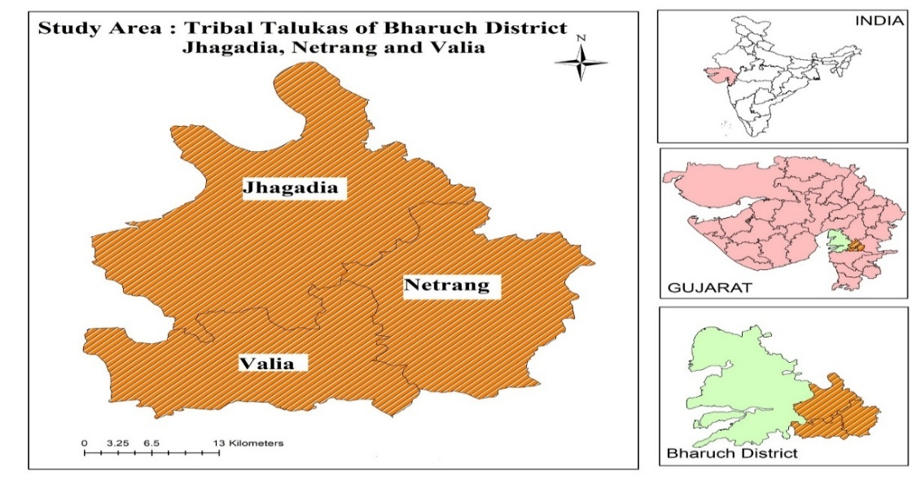
The study focuses on soil fertility mapping in the tribal blocks of Bharuch district, namely Jhagadia, Netrang and Valia. These areas fall under the South Gujarat region, classified as Agro-climatic Zone II. Geographically, the study area lies between 21°29′05″ to 21°55′21″ N latitude and 73°03′40″ to 73°29′51″ E longitude in Bharuch district, Gujarat (Fig. 1), with an elevation of up to 414 m above mean sea level. The total area covers 1.32 lakh ha, representing 20.23% of the district’s geographical

Fig. 1. Location map of Jhagadia, Netrang and Valia block
area and includes 264 villages with a population of 3.30 lakh (Census, 2011). Notably, over 73% of the population comprises scheduled tribes, predominantly the Bhil Vasava community.
2.2 Development of Base Maps Using Geospatial Techniques
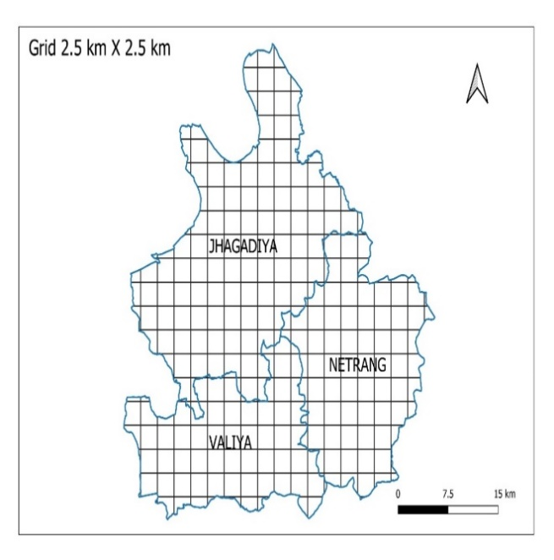
The block maps of Jhagadia, Netrang, and Valia were digitized and converted into Google Earth compatible format (KML) for overlay analysis. Based on these maps, the study area was demarcated and subdivided into approximately 240 grids. From each grid cell, geo-referenced surface and sub-surface soil samples were collected following standard procedures. The latitude and longitude of each sampling point were also recorded using a portable GPS device (Garmin).

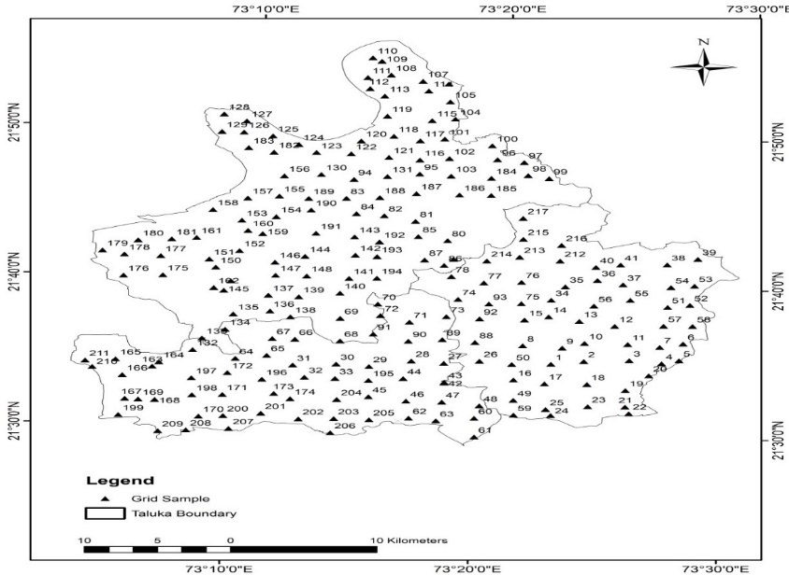

Fig.2 Grid map of tribal blocks of Bharuch district for surface and subsurface soil sampling

2.3 Collection and Analysis of Soil Samples
To assess the fertility properties of soils in the tribal blocks of Bharuch district, 217 fields were selected—101 from Jhagadia, 65 from Netrang and 51 from Valia. From each grid, soil samples were randomly collected from five fields adequately spaced apart, at two depths (0–22.5 cm and 22.5–45 cm), following standard procedures. Dense forest areas and grids occupied by residential or industrial establishments were excluded due to inaccessibility. The collected samples were air-dried, sieved and ground before laboratory analysis. Soil pH was measured using a glass electrode in a 1:2.5 soil–water suspension and organic carbon was estimated by the Walkley and Black (1934) method. Available nitrogen was determined by Subbiah and Asija (1956), phosphorus by the Bray P-1 method (Bray and Kurtz, 1945) and potassium by extraction with 1 M ammonium acetate and estimation using a flame photometer. Micronutrients were analyzed following Lindsay and Norvell (1978) with the help of an atomic absorption spectrophotometer.
The analytical results of each soil sample were classified following established critical limits. Soil reaction (pH 1:2.5) was rated as slightly acidic (5.5–6.5), normal (6.5–7.5) and slightly alkaline (7.5–8.5) (Jackson, 1967). According to Gundalia and Savalia (2000), soils were classified based on CaCO₃ content as non-calcareous (<5%), moderately calcareous (5–10%) and calcareous (>10%). Similarly, based on exchangeable sodium percentage (ESP), soils were categorized as non-sodic (<5% ESP), slightly sodic (5–15%) and sodic (>15%) following Sharma and Singh (2018). Organic carbon and macronutrients were rated as low, medium, or high, whereas micronutrients (Fe, Mn, Zn, Cu) were categorized as deficient, marginal, or sufficient according to the critical limits for Gujarat soils
2.4 Preparation of Soil Fertility Maps Using Geospatial Techniques:
In the present study, both deterministic and geostatistical interpolation techniques were employed to analyze soil nutrient distribution. The geographic coordinates of each soil sample were recorded using a Garmin GPS device and imported into a base map prepared in ArcGIS 10.8.2. Data interpolation was performed using the Arc Toolbox to generate soil fertility maps.

3. RESULTS AND DISCUSSION

3.1 Soil Chemical Properties

The soil chemical properties (pH, CaCO₃ and ESP) of the study area are summarized in Table 1 and their findings are discussed below.

Soil pH in the study area ranged from 5.50 to 8.68, with mean values of 7.67, 6.37 and 7.60 in the surface soils of Jhagadia, Netrang and Valia talukas, respectively. Jhagadia soils were predominantly slightly alkaline (69%), Netrang soils were largely acidic (54%) and over 52% of Valia soils were slightly alkaline. A consistent increase in pH with depth was observed across all talukas, reflecting enrichment with soluble salts or basic cations through alluvial deposition and irrigation.

Calcium carbonate (CaCO₃) content varied from 0.10 to 10.10% (mean 3.96%) in surface soils and 0.21 to 14.00% (mean 7.06%) in sub-surface soils, with values increasing with depth. Overall, 72.2% of surface soils were non-calcareous, 20.3% moderately calcareous and 7.5% calcareous, while sub-surface soils showed 45.7%, 20.8% and 33.6% in respective categories. Pansoli (Valia) soils were dominantly calcareous (>10% CaCO₃) (Gowthamchand et al., 2023).

Most soils were non-sodic (ESP <5%), except for Pansoli (Valia), where both surface and sub-surface soils were slightly sodic. Sub-surface sodicity (ESP 5–10%) was also observed in Jhagadia and Valia 22.22 % and 41.82% samples, respectively; whereas Netrang soils remained non-sodic. ESP generally increased with depth, likely due to irrigation with borewell/tubewell water and leaching of CaCO₃ under semi-arid conditions, which may promote sub-soil sodicity (Chinchmalatpure et al., 2008).

3.2 Soil Organic Carbon and Macro Nutrients

The depth-wise status of soil organic carbon and available NPK are presented in Table 2.

Soil organic carbon (SOC) varied from 0.04–1.05% in surface soils (mean 0.43%) and 0.05–0.94% in sub-surface soils (mean 0.36%), with 64.2% and 76.1% of samples, respectively, in the low category. Netrang and Valia soils showed higher SOC than Jhagadia, reflecting greater organic residue input at the surface, while declines with depth were due to reduced organic matter incorporation. Higher SOC in Valia was attributed to sugarcane cultivation, consistent with findings by Bhalawe et al. (2024).

Available nitrogen ranged from 85.3–630.9 kg ha⁻¹ (mean 311.3) in surface soils and 309.7 kg ha⁻¹ in sub-surface soils, with 94–95% of samples in low to medium categories. Mean N content ranked Netrang < Jhagadia < Valia in surface soils, while in sub-surface soils Jhagadia < Valia < Netrang. Nitrogen decreased with depth, reflecting lower SOC and management-induced losses, as reported by Choudhary et al. (2019) and Patil et al. (2016).

Available phosphorus (P₂O₅) ranged from 11.6–166.8 kg ha⁻¹ in surface and 1.7–227.1 kg ha⁻¹ in sub-surface soils. In surface layers, 22.5% of samples were low, 21.5% medium, and 55.6% high; corresponding sub-surface values were 23.5%, 26.3% and 50.1%. Soils of Jhagadia and Valia were predominantly high in P₂O₅, which can be attributed to intensive cropping patterns resulting in high phosphorus fertilizer application, along with slightly alkaline pH and the presence of CaCO₃, whereas Netrang had more low-P soils due to lower fertilizer use and slightly acidic pH. Declines with depth reflected P fixation, in line with Choudhary et al. (2019) and Negash & Mohammed (2014).

Available potassium (K₂O) was present with mean value of 362.0 kgha⁻¹ in surface and 328.5 kg ha⁻¹ in sub-surface soils. Most samples were medium to high, with 63.2% surface and 56.7% sub-surface soils in the high category. Jhagadia soils showed the highest proportion of high-K samples, attributed to K-bearing minerals (feldspar, mica) and organic matter–clay interactions. These results indicate no additional K management is required, supporting the findings of Paramasivan & Jawahar (2014) and Sharma et al. (2020).

3.3 Micronutrient (DTPA-Fe, Mn, Zn, Cu)
The available micronutrients (DTPA-extractable Fe, Mn, Zn, and Cu) in the study area exhibited considerable spatial variability (Table 3). Iron (Fe) concentrations ranged from 0.72 to 14.10 ppm in surface soils (mean 4.79 ppm) and from 0.80 to 15.25 ppm in sub-surface soils (mean 5.86 ppm). More than 75% of the samples were deficient in Fe, except in Netrang, where over 50% of the samples showed moderate levels. The mean Fe concentration followed the order Jhagadia < Valia < Netrang for both surface and sub-surface soils, indicating a strong association of low Fe availability with low SOC, high pH, and elevated CaCO₃ content (Rengel, 2007). Manganese (Mn) levels varied from 1.19 to 27.13 ppm in surface soils (mean 9.79 ppm) and from 1.55 to 24.35 ppm in sub-surface soils (mean 10.43 ppm). Soils from Jhagadia and Netrang were generally moderate to sufficient in Mn, whereas those from Valia exhibited greater deficiency (<5 ppm), likely due to lower cation exchange capacity (CEC) and its influence on Mn retention (AbdelRahman et al., 2016). Zinc (Zn) varied 0.07–1.52 ppm in surface and 0.07–1.79 ppm in sub-surface. >70% of Jhagadia and Valia soils were deficient, whereas Netrang soils were relatively higher, likely due to slightly lower pH (Arunachalam et al., 2013). Copper (Cu) was sufficient across all soils (>0.20 ppm), ranging 0.26–6.91 ppm (surface, mean 1.66 ppm) and 0.31–5.88 ppm (sub-surface, mean 1.80 ppm), with mean values following Valia < Jhagadia < Netrang. Consistently adequate Cu suggests no additional management is required (Shirgire et al., 2015; Choudhary et al., 2019).
 |  | 0 – 22.5 cm |  |  |  |  |  |  | 22.5 – 45.0 cm
Parameter | Block | Range | Mean | S. Acidic | Normal | S. Alkaline |  |  |  | Range | Mean | S. Acidic | Normal | S. Alkaline
pH | Jhagadia | 6.46- 8.45 | 7.67 | 1.11 | 30.02 | 68.87 |  |  |  | 6.39-8.48 | 7.74 | 1.11 | 31.19 | 67.7
pH | Netrang | 5.53-7.46 | 6.37 | 54.34 | 45.66 | 0.00 |  |  |  | 5.50-7.92 | 6.47 | 51.69 | 45.23 | 3.08
pH | Valia | 6.14-8.65 | 7.6 | 0.00 | 42.05 | 57.95 |  |  |  | 6.02-8.68 | 7.58 | 9.32 | 33.41 | 57.27
pH | Mean of 3 blocks | 5.53-8.65 | 7.21 | 18.48 | 39.24 | 42.28 |  |  |  | 5.50-8.68 | 7.26 | 20.71 | 36.61 | 42.68
CaCO3 |  | Range | Mean | Non-Calcareous | M. Calcareous | Calcareous |  |  |  | Range | Mean | Non-Calcareous | M. Calcareous | Calcareous
CaCO3 | Jhagadia | 0.21-9.00 | 4.29 | 63.23 | 36.77 | 0.00 |  |  |  | 0.14-14.00 | 8.01 | 28.84 | 28.53 | 42.64
CaCO3 | Netrang | 0.10-6.00 | 2.72 | 98.33 | 1.67 | 0.00 |  |  |  | 0.19-12.80 | 5.02 | 70.40 | 20.85 | 8.74
CaCO3 | Valia | 0.10-10.10 | 4.87 | 55.00 | 22.50 | 22.50 |  |  |  | 0.21-13.70 | 8.15 | 37.73 | 12.95 | 49.32
CaCO3 | Mean of 3 blocks | 0.10-10.10 | 3.96 | 72.19 | 20.31 | 7.50 |  |  |  | 0.21-14.00 | 7.06 | 45.66 | 20.78 | 33.57
ESP (%) |  | Range | Mean | Non-Sodic | S. Sodic | Sodic |  |  |  | Range | Mean | Non-Sodic | S. Sodic | Sodic
ESP (%) | Jhagadia | 1.33-9.72 | 3.31 | 82.29 | 17.71 | 0.00 |  |  |  | 1.05-14.78 | 3.62 | 77.78 | 22.22 | 0.00
ESP (%) | Netrang | 1.16-5.41 | 2.36 | 96.00 | 4.00 | 0.00 |  |  |  | 1.58-5.57 | 3.03 | 96.00 | 4.00 | 0.00
ESP (%) | Valia | 1.12-15.25 | 4.99 | 62.50 | 35.00 | 2.50 |  |  |  | 1.10-11.87 | 5.54 | 58.18 | 41.82 | 0.00
ESP (%) | Mean of 3 blocks | 1.12-15.25 | 3.55 | 80.26 | 18.90 | 0.83 |  |  |  | 1.05-14.78 | 4.06 | 77.32 | 22.68 | 0.00
Table 1. Depth-wise range, mean and distribution (%) of soil chemical properties
Table 2. Depth-wise range, mean and distribution (%) of soil organic carbon and macronutrients
 |  | 0 – 22.5 cm |  |  |  |  |  | 22.5 – 45.0 cm
Nutrient | Block | Range | Mean | Low | Medium | High |  | Range | Mean | Low | Medium | High
Organic Carbon (%) | Jhagadia | 0.04-0.65 | 0.34 | 83.44 | 16.56 | 0.00 |  | 0.05-0.57 | 0.28 | 94.44 | 5.56 | 0.00
Organic Carbon (%) | Netrang | 0.13-0.71 | 0.43 | 57.81 | 40.52 | 1.67 |  | 0.07-0.78 | 0.34 | 73.91 | 24.43 | 1.67
Organic Carbon (%) | Valia | 0.09-1.05 | 0.52 | 51.36 | 26.82 | 21.82 |  | 0.10-0.94 | 0.45 | 60.00 | 27.5 | 12.5
Organic Carbon (%) | Mean of 3 blocks | 0.04-1.05 | 0.43 | 64.2 | 27.97 | 7.83 |  | 0.05-0.94 | 0.36 | 76.11 | 19.16 | 4.72
Available N (kgha⁻¹) | Jhagadia | 179.38-577.65 | 327.76 | 20.96 | 74.53 | 4.51 |  | 163.70- 512.42 | 306.15 | 28.32 | 68.34 | 3.33
Available N (kgha⁻¹) | Netrang | 85.30- 630.96 | 276.83 | 36.32 | 62.01 | 1.67 |  | 112.27- 588.94 | 314.78 | 29.6 | 64.74 | 5.67
Available N (kgha⁻¹) | Valia | 163.70- 511.17 | 329.35 | 22.95 | 67.73 | 9.32 |  | 156.17- 509.29 | 308.02 | 13.64 | 81.36 | 5.00
Available N (kgha⁻¹) | Mean of 3 blocks | 85.30- 630.96 | 311.32 | 26.75 | 68.09 | 5.16 |  | 112.27- 588.94 | 309.65 | 23.85 | 71.48 | 4.67
Available P₂O₅  (kgha⁻¹) | Jhagadia | 23.27 - 138.64 | 62.65 | 5.50 | 30.98 | 63.52 |  | 18.42 - 170.63 | 62.83 | 7.79 | 31.79 | 60.42
Available P₂O₅  (kgha⁻¹) | Netrang | 11.56 - 142.05 | 46.48 | 38.04 | 26.69 | 35.26 |  | 1.65- 227.11 | 42.87 | 38.04 | 34.9 | 27.06
Available P₂O₅  (kgha⁻¹) | Valia | 14.96 - 166.75 | 83.75 | 24.09 | 6.82 | 69.09 |  | 4.13 - 172.57 | 77.18 | 24.77 | 12.27 | 62.95
Available P₂O₅  (kgha⁻¹) | Mean of 3 blocks | 11.56 - 166.75 | 64.29 | 22.54 | 21.5 | 55.96 |  | 1.65- 227.11 | 60.96 | 23.54 | 26.32 | 50.14
Available K₂O  (kgha⁻¹) | Jhagadia | 115.58-971.71 | 406.54 | 6.49 | 22.87 | 70.64 |  | 75.94-894.43 | 385.4 | 9.89 | 20.72 | 69.39
Available K₂O  (kgha⁻¹) | Netrang | 143.81-705.60 | 327.42 | 0.00 | 36.19 | 63.81 |  | 120.96-899.81 | 298.75 | 10.97 | 33.06 | 55.97
Available K₂O  (kgha⁻¹) | Valia | 73.92-960.28 | 351.93 | 20.0 | 24.77 | 55.23 |  | 61.15-860.16 | 328.95 | 19.32 | 35.91 | 44.77
Available K₂O  (kgha⁻¹) | Mean of 3 blocks | 73.92-971.71 | 361.96 | 8.83 | 27.94 | 63.23 |  | 61.15-899.81 | 337.7 | 13.39 | 29.89 | 56.71

Table 3. Depth-wise range, mean and distribution (%) of soil micronutrients
 |  | 0 – 22.5 cm |  |  |  |  |  | 22.5 – 45.0 cm
Nutrient | Block | Range | Mean | Low | Medium | High |  | Range | Mean | Low | Medium | High
Available Fe (ppm) | Jhagadia | 0.72-11.87 | 3.18 | 88 | 8.84 | 3.16 |  | 0.80-13.28 | 3.96 | 80.46 | 14.28 | 5.26
Available Fe (ppm) | Netrang | 3.33-14.10 | 7.66 | 18.91 | 61.09 | 20.00 |  | 2.72-15.25 | 9.55 | 3.08 | 52.2 | 44.73
Available Fe (ppm) | Valia | 1.10-8.77 | 3.54 | 83.86 | 16.14 | 0.00 |  | 1.95-9.34 | 4.07 | 75.23 | 24.77 | 0.00
Available Fe (ppm) | Mean of 3 blocks | 0.72-14.10 | 4.79 | 63.59 | 28.69 | 7.72 |  | 0.80-15.25 | 5.86 | 52.92 | 30.42 | 16.66
Available Mn (ppm) | Jhagadia | 1.19-27.13 | 13.96 | 23.22 | 18.3 | 58.48 |  | 2.87-24.35 | 9.5 | 9.71 | 50.49 | 39.79
Available Mn (ppm) | Netrang | 2.47-20.56 | 10.10 | 4.74 | 40.38 | 54.88 |  | 9.44-15.13 | 13.96 | 0.00 | 5.54 | 94.46
Available Mn (ppm) | Valia | 1.55-23.01 | 5.33 | 62.27 | 25.91 | 11.82 |  | 1.55-14.84 | 7.83 | 40.00 | 17.95 | 42.05
Available Mn (ppm) | Mean of 3 blocks | 1.19-27.13 | 9.79 | 30.08 | 28.2 | 41.73 |  | 1.55-24.35 | 10.43 | 16.57 | 24.66 | 58.77
Available Zn (ppm) | Jhagadia | 0.07-1.18 | 0.41 | 73.66 | 22.94 | 3.40 |  | 0.10-1.79 | 0.32 | 89.3 | 9.65 | 1.05
Available Zn (ppm) | Netrang | 0.30-0.95 | 0.56 | 40.69 | 59.31 | 0.00 |  | 0.11-1.00 | 0.48 | 62.2 | 36.26 | 1.54
Available Zn (ppm) | Valia | 0.07-1.52 | 0.47 | 70.23 | 24.77 | 5.00 |  | 0.07-0.96 | 0.36 | 90.68 | 9.32 | 0.00
Available Zn (ppm) | Mean of 3 blocks | 0.07-1.52 | 0.48 | 61.53 | 35.67 | 2.80 |  | 0.07-1.79 | 0.39 | 80.73 | 18.41 | 0.86
Available Cu (ppm) | Jhagadia | 0.26-6.91 | 1.59 | 0.00 | 2.11 | 97.89 |  | 0.35-3.61 | 1.43 | 0.00 | 1.18 | 98.82
Available Cu (ppm) | Netrang | 0.48-4.59 | 1.95 | 0.00 | 0.00 | 100.00 |  | 0.50-5.88 | 2.36 | 0.00 | 0.00 | 100.00
Available Cu (ppm) | Valia | 0.44-2.88 | 1.46 | 0.00 | 7.95 | 92.05 |  | 0.31-3.65 | 1.59 | 0.00 | 2.50 | 97.50
Available Cu (ppm) | Mean of 3 blocks | 0.26-6.91 | 1.66 | 0.00 | 3.35 | 96.65 |  | 0.31-5.88 | 1.80 | 0.00 | 1.23 | 98.77

3.4 Thematic Soil Fertility Maps
The Thematic Soil Fertility Maps provide comprehensive information on physiography, landforms, geology, vegetation, drainage and soil fertility, serving as vital tools for planners, administrators and stakeholders. In this study, thematic soil fertility maps of surface soils from Jhagadia, Netrang and Valia blocks in Bharuch district were generated using geospatial techniques based on sampling point data. The geospatial area under each category, derived from these maps, is presented in Tables 4, 5 and 6. Block-wise analysis revealed that the distribution of soil chemical properties across the three talukas, detailing both the area and percentage of the total geographical area. Regarding soil reaction (pH), Jhagadia and Valia predominantly have slightly alkaline soils, covering areas of 42264 ha and 14427 ha, respectively. In contrast, Netrang features a significant portion of slightly acidic soils, totalling 19769 ha.
The majority of the study area falls into the low category for Soil Organic Carbon, covering 83.49 per cent of the total area with 104968 ha. For Available Nitrogen (N), the medium category is predominant, accounting for 87.98 per cent. In contrast, Available Phosphorus (P) is predominantly in the high category, covering 61.37 per cent of the area with 77151 hectares. Available Potassium (K) also shows a strong presence in the high category at 77.49 per cent with medium and low categories contributing 22.24 per cent and 0.27 per cent, respectively.
The data on soil micronutrients shows a varied distribution across different categories. For DTPA-Fe, the majority of samples fall into the deficit category, covering 66.75 per cent of the area with 83917 ha. Similarly, For DTPA-Zn, the deficit category is predominant, encompassing 62.15 percent of the area with 78133 ha. In contrast, DTPA-Cu shows near-total sufficiency, with 99.93 percent of samples categorized as sufficient. This indicates that while deficiencies in Fe and Zn are widespread, Mn levels are more balanced, and Cu is generally sufficient.

Table 4. Taluka-wise geospatial area under different soil chemical properties
 | Taluka
Ratings | Jhagadia |  | Netrang |  | Valia |  | Total
 | Area (ha) | % of TGA of Jhagadia | Area (ha) | % of TGA of Netrang | Area (ha) | % of TGA of Valia | Area (ha) | % of TGA of 3 talukas
Soil Reaction (pH)
S. Acidic | 8 | 0.01 | 19769 | 54.85 | 0 | 0.00 | 19777 | 15.73
Normal | 16213 | 27.25 | 15932 | 43.57 | 16714 | 52.66 | 48859 | 38.86
Slightly Alkaline | 42264 | 72.26 | 340 | 0.94 | 14427 | 46.25 | 57031 | 45.36
Free CaCO₃
Non-Calcareous | 32753 | 56.00 | 35830 | 99.42 | 18987 | 60.87 | 87570 | 69.65
Moderately Calcareous | 25733 | 44.00 | 211 | 0.59 | 12202 | 39.12 | 38145 | 30.34
Calcareous | 0 | 0.00 | 0 | 0.00 | 4 | 0.01 | 4 | 0.00
Exchangeable Sodium Percentage (ESP)
Non-Sodic | 53468 | 91.42 | 35955 | 99.76 | 20872 | 66.91 | 110295 | 87.73
Slightly Sodic | 5017 | 8.58 | 86 | 0.24 | 10313 | 33.06 | 15416 | 12.26
Sodic | 0 | 0.00 | 0 | 0.00 | 8 | 0.03 | 8 | 0.01
*TGA excludes area under built-up and water bodies
Table 5. Block-wise geospatial area under soil organic carbon and macro-nutrients content
Ratings | Jhagadia |  | Netrang |  | Valia |  | Total
 | Area (ha) | % of TGA of Jhagadia | Area (ha) | % of TGA of Netrang | Area (ha) | % of TGA of Valia | Area (ha) | % of TGA of 3 blocks
Soil Organic Carbon
Low | 55779 | 95.37 | 27117 | 75.24 | 22072 | 70.76 | 104968 | 83.49
Medium | 2608 | 4.46 | 8924 | 24.76 | 8502 | 27.26 | 20035 | 15.94
High | 98 | 0.17 | 0 | 0.00 | 618 | 1.98 | 716 | 0.57
Available N
Low | 2346 | 4.01 | 10911 | 30.27 | 1439 | 4.61 | 14697 | 11.69
Medium | 55889 | 95.56 | 24982 | 69.32 | 29733 | 95.32 | 110604 | 87.98
High | 250 | 0.43 | 149 | 0.41 | 20 | 0.06 | 418 | 0.33
Available P
Low | 66 | 0.11 | 3406 | 9.45 | 2065 | 6.62 | 5538 | 4.40
Medium | 12432 | 21.26 | 22127 | 61.39 | 8471 | 27.16 | 43030 | 34.23
High | 45987 | 78.63 | 10508 | 29.16 | 20657 | 66.22 | 77151 | 61.37
Available K
Low | 98 | 0.17 | 0 | 0.00 | 231 | 0.74 | 329 | 0.26
Medium | 12643 | 21.62 | 9370 | 26.00 | 5952 | 19.08 | 27966 | 22.24
High | 45744 | 78.22 | 26671 | 74.00 | 25009 | 80.18 | 97425 | 77.49
*TGA excludes area under built-up and water bodies
Table 6. Block-wise geospatial area under soil micro-nutrients content
 | Block
Ratings | Jhagadia |  | Netrang |  | Valia |  | Total
 | Area (ha) | % of TGA of Jhagadia | Area (ha) | % of TGA of Netrang | Area (ha) | % of TGA of Valia | Area (ha) | % of TGA of 3 blocks
 | DTPA-Fe
Deficit | 53444 | 91.38 | 5088 | 14.12 | 25385 | 81.38 | 83917 | 66.75
Marginal | 4885 | 8.35 | 28615 | 79.40 | 5807 | 18.62 | 39307 | 31.27
Sufficient | 156 | 0.27 | 2339 | 6.49 | 0 | 0.00 | 2495 | 1.98
 | DTPA-Mn
Deficit | 3797 | 6.49 | 747 | 2.07 | 14040 | 45.01 | 18584 | 14.78
Marginal | 17876 | 30.57 | 21642 | 60.05 | 14716 | 47.18 | 54234 | 43.14
Sufficient | 36812 | 62.94 | 13652 | 37.88 | 2436 | 7.81 | 52901 | 42.08
 | DTPA-Zn
Deficit | 43089 | 73.67 | 10719 | 29.74 | 24325 | 77.98 | 78133 | 62.15
Marginal | 15025 | 25.69 | 25322 | 70.26 | 6464 | 20.72 | 46812 | 37.24
Sufficient | 372 | 0.64 | 0 | 0.00 | 403 | 1.29 | 774 | 0.62
 | DTPA-Cu
Deficit | 4 | 0.01 | 0 | 0.00 | 0 | 0.00 | 4 | 0.00
Marginal | 82 | 0.14 | 0 | 0.00 | 0 | 0.00 | 82 | 0.07
Sufficient | 58399 | 99.85 | 36041 | 100.00 | 31192 | 100.00 | 125633 | 99.93
*TGA excludes area under built-up and water bodies
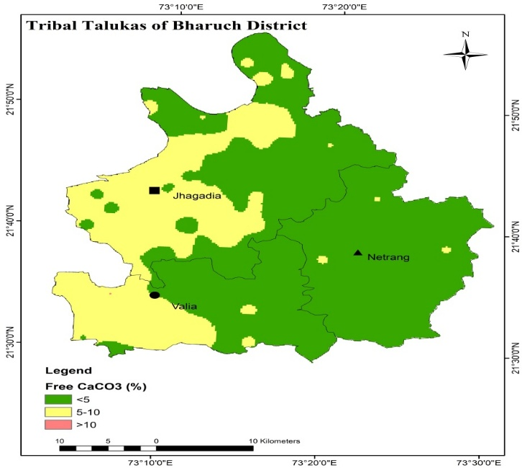
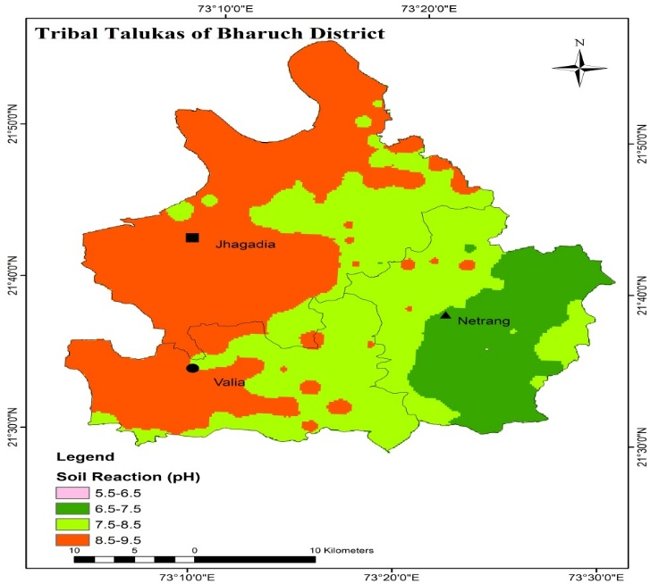
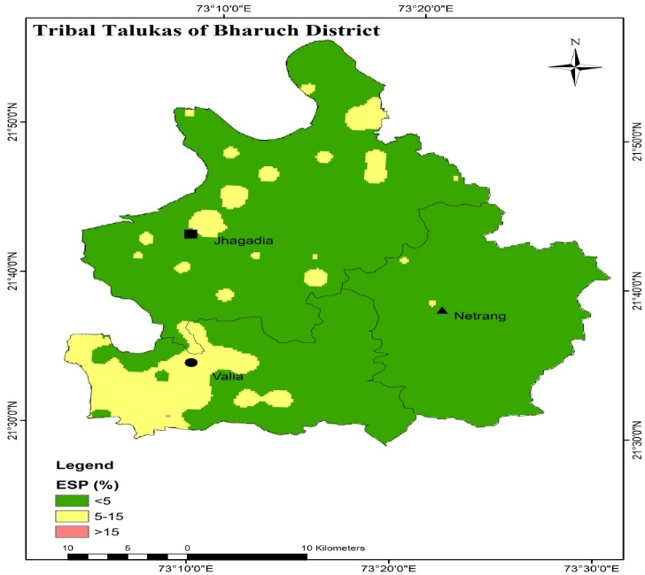
Fig.3: Spatial distribution of soil pH Fig.4: Spatial distribution of CaCO3

Fig. 5: Spatial distribution of soil ESP
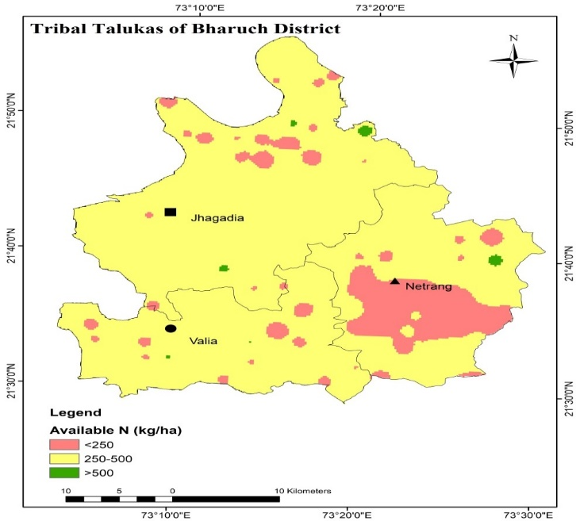
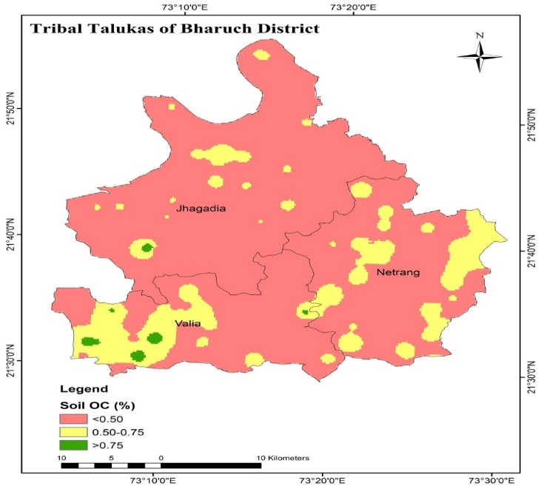

Fig.6: Spatial distribution of Organic Carbon Fig.7: Spatial distribution of Available N
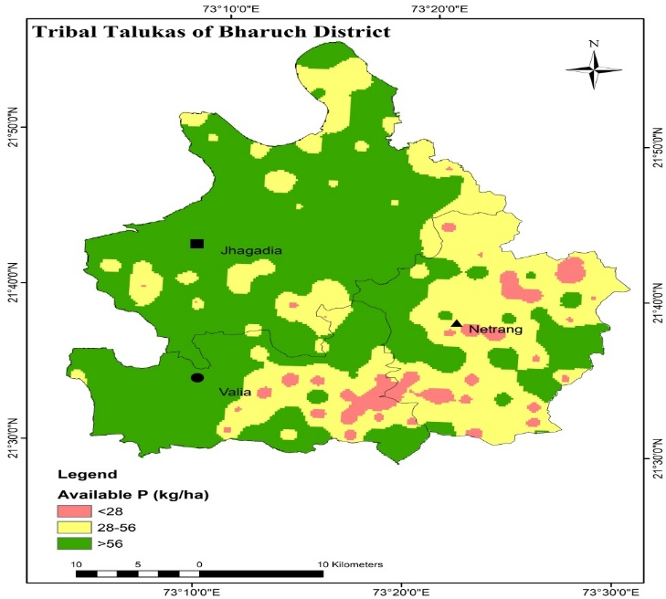
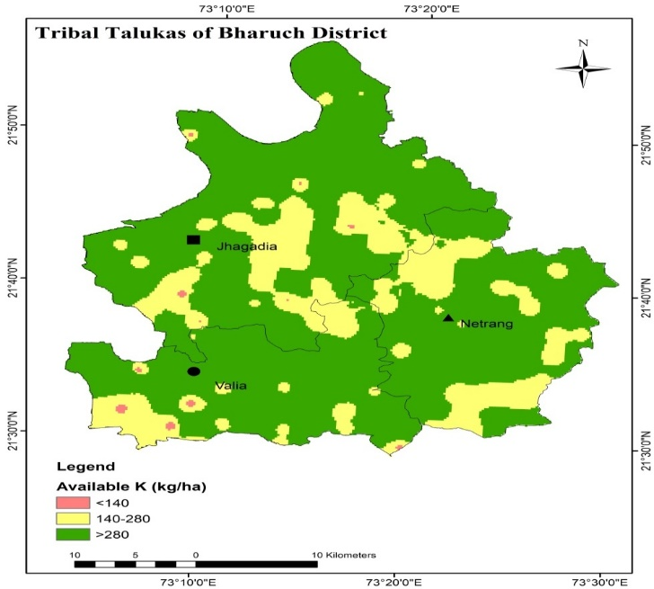
Fig.8: Spatial distribution of Available P Fig.9: Spatial distribution of Available K

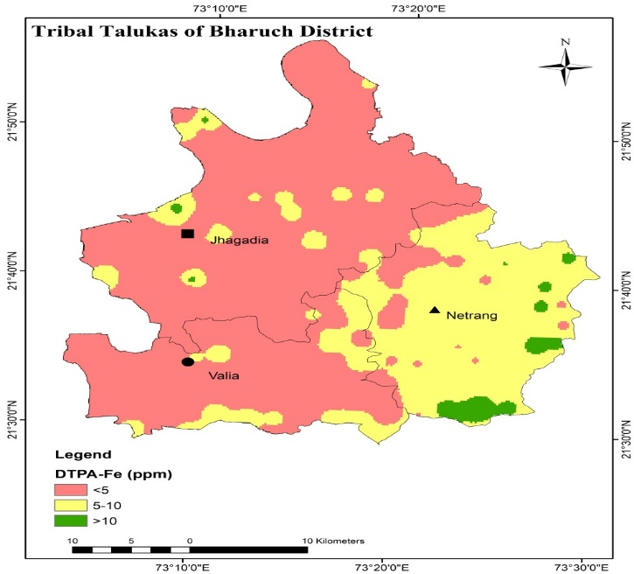
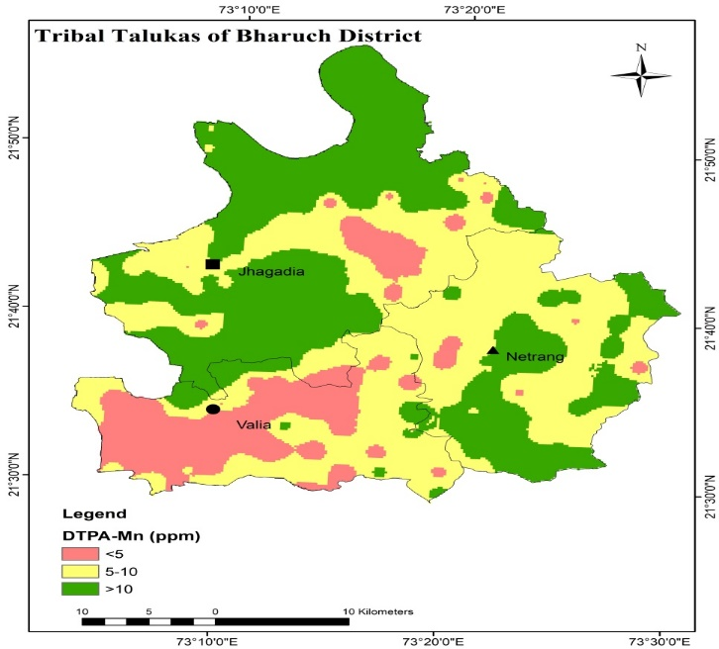
Fig.10: Spatial distribution of Available Fe Fig.11: Spatial distribution of Available Mn
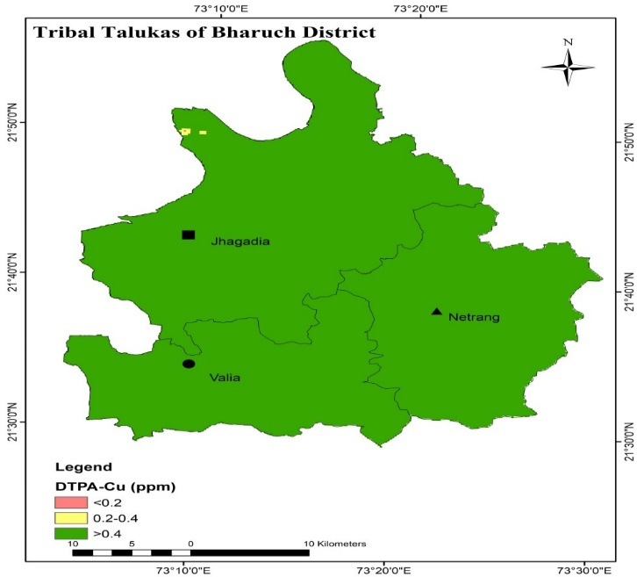
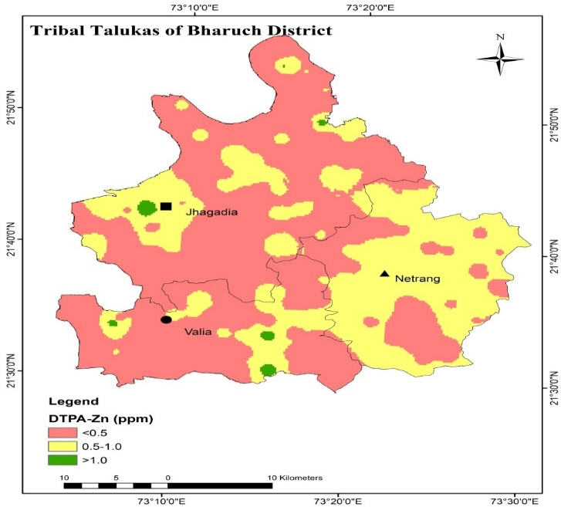
Fig.12: Spatial distribution of Available Zn Fig.13: Spatial distribution of Available Cu

Table 7. Soil fertility constraints and remedial measures in tribal blocks of Bharuch district
Key Soil fertility constraints | Block | Recommended Remedial Measures
Slightly Acidic Soils | Netrang | - Select acid-tolerant crops (rice, finger millet, millets, pulses, wheat, chili, beans, mango, citrus).  - Incorporate organic manures (FYM, vermicompost, poultry manure) + crop residues + biofertilizers.  - Apply lime @ 2–3 t ha⁻¹ + Class-C fly ash @ 3% (w/w).
Slightly Alkaline Soils | Valia | - Apply soil test-based gypsum.  - Adopt drip irrigation and mulching to restrict upward movement of soluble salts
Subsurface Sodicity | Valia and Jhagadia | - Sodicity-tolerant crops include cotton, chickpea, soybean, mustard, and sorghum, along with specific rice varieties (CSR 105, CSR 23, CSR 27) and wheat varieties (KRL 19, KRL 210, KRL 213).  - Apply gypsum as per soil test.
Low Soil Organic Carbon status | Jhagadia, Netrang and Valia | - Apply FYM (10 t ha⁻¹) or vermicompost (5 t ha⁻¹), or city compost (10 t ha⁻¹) during land preparation.  - Promote in-situ crop residue decomposition and incorporation, enriched with Trichoderma viride (@ 5 g kg⁻¹ residue) to enhance microbial activity and organic matter breakdown.  - Practice green manuring with crops like dhaincha, sunhemp, or cowpea.  - Incorporate legume-based crop rotations and intercropping systems  - Apply biochar (2–5 t ha⁻¹ depending on soil type)
Low N status | Some parts in Netrang | - Practice cereal–legume rotations or intercropping for atmospheric N fixation.  - Apply Rhizobium, Azotobacter, Azospirillum, and BGA to enhance biological N fixation.  - Use Neem Coated Urea for slow release and reduced N losses.  - Apply N fertilizer in 2–3 splits as per crop growth stages.  - Incorporate cereal stubbles and legume residues to recycle nutrients.
Fe- deficient | Jhagadia and Valia | - Foliar sprays of FeSO₄ (0.5%) or crop-specific FeSO₄ soil application with FYM for chelation. (e.g., Sugarcane – 50 kg ha⁻¹).
Zn - deficient | Jhagadia, Valia and some areas of Netrang | - Application of ZnSO₄ (25 kg ha⁻¹ once in 2–3 years) along with organics; foliar sprays of 0.5% ZnSO₄ + 0.25% lime for standing crops.

4. CONCLUSION
The geospatial assessment revealed substantial spatial variability in soil chemical properties, SOC, macronutrients, and micronutrients across the tribal blocks of Bharuch district. Netrang soils were slightly acidic, while Jhagadia and Valia were slightly alkaline; subsurface sodicity affected Valia and Jhagadia. Low SOC was widespread, indicating the need for organic matter enhancement. Available nitrogen was moderate, phosphorus and potassium largely adequate, but Fe and Zn deficiencies were prevalent. The study provides targeted management strategies—such as organic amendments, biofertilizers, lime and gypsum application, green manuring, and legume-based crop rotations—can effectively address nutrient constraints. Thematic soil fertility maps provide a spatial framework to guide site-specific interventions, enabling improved soil health, enhanced crop productivity, and sustainable agricultural practices in tribal regions. The integration of geospatial mapping with soil analysis offers a precise, science-based framework for precision nutrient management and long-term soil sustainability.
DISCLAIMER (ARTIFICIAL INTELLIGENCE)
Author(s) hereby declares that NO generative AI technologies such as Large Language Models (ChatGPT, COPILOT, etc) and text-to-image generators have been used during writing or editing of manuscripts.
COMPETING INTERESTS
Authors have declared that no competing interests exist.
REFERENCES
AbdelRahman Mohamed A.E.; Natarajan A. and Hegde R. (2016) Assessment of land suitability and capability by integrating remote sensing and GIS for agriculture in Chamarajanagar district, Karnataka, India. The Egyptian Journal of Remote Sensing and Space Sciences, 19: 125-141.
Arunachalam, P.; Kannan P.; Prabukumar G and Govindaraj M. (2013). Zinc deficiency in Indian soils with special focus to enrich zinc in peanut. Afr. J. Agric. Res., 8(50): 6681-6688.
Bhalawe, S.; Nayak, D.; Lodhi, A. S.; Thakur, R. K.; Rai, S. K. and Shrivastava, A. (2024) Soil Dynamics for Carbon Buildup in Different Land Use Systems in the South Region of Gujarat, India. Journal of Experimental Agriculture International, 46(1): 77-86.
Bray, R. H., & Kurtz, L. T. (1945). Determination of total, organic, and available forms of phosphorus in soils. Soil Science, 59, 39-45.
Chinchmalatpure, A. R.; Khandelwal, M. K. and Rao, G. G. (2008). Characterization and classification of salt affected soils of Samni farm, Bharuch district, Gujarat. Agropedology 18: 71-75.
Choudhary, S.; Patel, J. M.; Gavit, C. S.; Gadhavi, B. K. and Saxena, M. (2019).Vertical distribution of available nutrients in soils of paddy and sugarcane growing areas of Navsari district in Gujarat. Int. J. Chemical Studies, 7(6): 810-814
Directorate of Census Operations, Gujarat (DCOG) (2011). District Census Handbook- Bharuch district, Series-25, Part XII-A and XII-B. Village and town directory.
Gorain, S., Kuriachen, P., Kumar, C.V., Suresh, A., 2024. Land degradation and its impact on agricultural productivity: the case of India. Land Degrad. Dev. 35 (1), 196–212.
Gowthamchand; Dhaliwal, S.S.; Sharma, V.; Verma, G.; Singh, J. and Kaur, M. (2023). Variation of Physico-Chemical Properties among Different Soil Orders under Different Land Use Systems of the Majha Region in North-Western India. Sustainability, 15: 4779.
Gundalia, J. D. and Savalia, S. G. (2000). In proceedings of national symposium on Balanced Nutrition of Groundnut and Other Field Crops Grown in Calcareous Soils of India pp33-42.
Hussain, S. S., Ganie, A., Dar, W. A., Wani, T., Hadayatullah, M., Baba, J., Parrey, G., Mugloo, J., & Dar, R. (2024). The role of digital soil mapping in soil survey and agricultural planning. International Journal of Plant and Soil Science, 36(9), 438-449.
Lindsay, W. L. and Norvell, W. A. (1978). Development of a DTPA soil test for zinc, iron, manganese and copper. Soil Sci. Society American J., 42: 421-428.
Mishra, A., Das, D., & Saren, S. (2013). Preparation of GPS and GIS based soil fertility maps for Khurda district, Odisha. Indian Agriculturist, 57(1), 11-20.
Negash, H. and Mohammed, M. (2014). Soil fertility in Kokanagawo area of Lumme district in East shoa zone of Oromia region, Ethiopia. East African J. Sci., 8(1): 1-12.
Paramasivan, M. and Jawahar, D. (2014). Characterization, classification and crop suitability of some black cotton soils of southern Tamil Nadu. Agropedology, 24 (1): 111-118.
Patil L. M.; Patel K. G.; Naik, V. R. and Pampaniya N. K. (2024). Land Evaluation of Tribal Talukas of Bharuch District in South Gujarat, India. International Journal of Environment and Climate Change 14(9), 296-306,
Patil, P. L.; Kuligod, V. B.; Gundlur, S. S.; Katti, J.; Nagaral, I. N.; Shikrashetti, P.; Geetanjali, H. M. and Dasog, G. S. (2016). Soil fertility mapping in Dindur sub-watershed of Karnataka for site specific recommendations. J. Indian Soc. Soil Sci., 64(4): 381-390.
Rengel, Z. (2007). Cycling of micro-nutrients in terrestrial ecosystems. In: “Nutrient Cycling in Terrestrial Ecosystem”. Springer-Verlag, Berlin, Heidelberg, pp. 93-121.
Sharma P.C. and Singh, A. (2018). Advances in Salinity and Sodicity Management under Different Agro-Climatic Regions for Enhancing Farmers’ Income. ICAR-Central Soil Salinity Research Institute, Karnal, India
Sharma, R. P.; Jangir, A.; Tiwari, G.; Dash, B.; Naitam, R. K.; Kumar, N.; Singh, R. S.; Singh, S. K.; Chandran, P. and B. S. Dwivedi (2020). “Land Resource Inventory of Jhagadia Taluka, Bharuch District, Gujarat on 1:10,000 Scale for Optimal Agricultural Land Use Planning, Using Geo-Spatial Techniques”NBSS Publ. No. 1138, NBSS&LUP, Nagpur, pp.1-150.
Shirgire, S.T.; Savalia, S. G.; Misal, N. B. and Singh, N. (2015). Evaluation of soil constraints and soil-site suitability for sesame in the soils of coastal area of Jamnagar district of Gujarat. Res. Environ. Life Sci., 8(3):501-506.
Subbiah, B. V. and Asija, G. L. (1956). A rapid procedure for the estimation of available nitrogen in soil. J. Current Sci., 25: 259-260.
Walkley, A., & Black, I.A. (1934). An examination of the digestion method for determining soil organic matter, and a proposed modification of the chromic acid titration method. Soil Science, 37, 29-38.

