KINEMATIC ANALYSIS OF TRANSPLANTING MECHANISM FOR ROOTWASHED PADDY SEEDLINGS USING SOLIDWORKS

ABSTRACT
The kinematic analysis of a planting mechanism is essential for understanding its operational behavior, as it enables the prediction of the mechanism’s motion at any point in its cycle and provides a basis for further design improvements. By using computer-assisted analytical methods, a complete rotation analysis can be performed quickly and accurately, avoiding the time-consuming steps required in traditional graphical approaches. SolidWorks motion analysis was used to simulate the mechanism’s full operating cycle, providing results comparable to theoretical predictions. The displacement trends of the crank–rocker mechanism closely matched analytical results, validating the accuracy of the model. However, the theoretical angular velocity and acceleration were higher due to idealized assumptions such as negligible link mass and friction, whereas SolidWorks considered the actual mass and inertial effects of the components, resulting in more realistic values. At 90 rpm, one complete crank revolution occurred in 0.68 s, with 0–0.32 s as the forward stroke and 0.32–0.68 s as the return stroke. The fingertip achieved the optimal pickup position at X = 320 mm and Y = 182 mm, with a maximum lift of 335 mm and a planting depth of 49.5 mm. The follower’s angular velocity ranged from 58.9 to 443 deg/s, indicating non-uniform motion due to changing mechanical advantage. The validated model confirmed that the mechanism provided smooth and synchronized motion suitable for simultaneous seedling pickup and planting, and the consistent fingertip trajectory supports integration with sensor-based conveying systems for precise, automated operation.
Keywords: crank rocker mechanism, kinematic analysis, paddy seedlings, SolidWorks
1. Introduction
Kinematic analysis is fundamental for gaining insight into the functional characteristics and overall performance of a mechanism. It provides detailed insights into the motion characteristics of individual components throughout the working cycle, enabling designers to identify inefficiencies, optimize motion transmission, and improve overall mechanism performance. Such analysis can be conducted using analytical, graphical, or numerical methods (Wang et al., 2022; Avilés et al., 2008; Gallardo-Alvarado & Gallardo-Razo, 2022; Shete et al., 2017; Vareed Thomas, 2002; Guo & Zhang, 2001). Analytical methods involve deriving equations of motion based on kinematic relations, while graphical methods rely on scaled diagrams to visualize the movement of links. Numerical methods, on the other hand, employ iterative techniques and computer simulations to handle complex geometries and motions that are difficult to solve analytically. Among these, computer-assisted analytical methods are particularly advantageous, as they allow complete cycle analysis to be performed efficiently, eliminating the time-consuming steps associated with traditional graphical methods. Modern CAD software such as SolidWorks offers powerful motion analysis tools to simulate and analyze mechanisms in real time, providing precise values for kinematic parameters such as linear displacement, angular velocities, and accelerations of different components. These parameters are essential for evaluating the functional efficiency, ensuring proper timing between components, and avoiding undesirable vibrations or shocks during operation. Similar approaches have been adopted in many studies involving agricultural automation and precision seeding systems (Sahoo et al., 2022; Pradhan et al., 2021; 2023; 2024; T N et al., 2025). In this study, kinematic analysis is carried out for a planting mechanism designed for transplanting root-washed paddy seedlings. This analysis aims to predict the motion behavior of the mechanism throughout its cycle, thereby supporting design refinement and ensuring reliable and synchronized transplanting operations in field conditions.

2. METHODOLOGY
2.1 Design of the transplanting mechanism
The transplanting unit used a crank rocker mechanism for picking and planting as shown in Fig. 1. It is a four bar mechanism where the fixed link AB is inclined at an angle $θ$ from the horizontal. When the disc (AB) rotates, the coupler (BC) which is eccentrically connected to the disc, reciprocates the follower (CD), which in turn moves the planting finger in the desired path. The dimensions of the link satisfied the Grashof’s law (Soriano-Heras et al., 2025). The length of the transplanting finger was designed to provide an appropriate lift to pick seedlings effectively from a tray positioned at 160 mm above the ground. Also the finger should move 50 mm deep into the soil for proper planting. Considering the requirements, a planting mechanism with a disc (diameter -140 mm, length of coupler-250 mm, eccentricity of coupler – 55 mm), length of follower - 68 mm, finger arm (length-250 mm, radius of curvature- 95 mm from center) and finger was designed using SolidWorks premium software-2023.
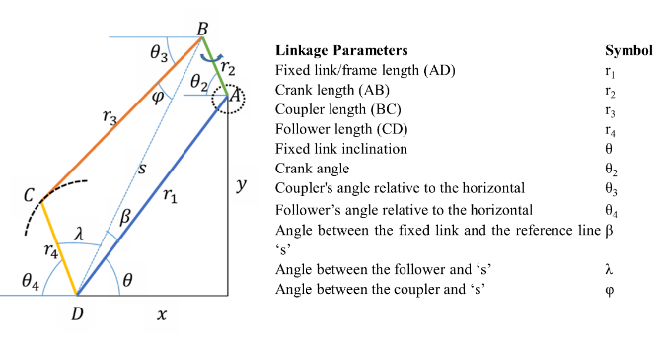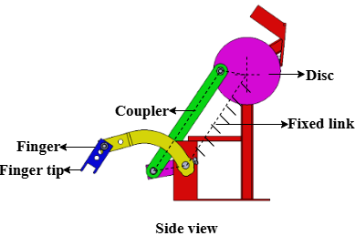
Fig.1 Crank rocker mechanism
2.2 Kinematic Analysis
The analytical method uses Eqn.1-10 for kinematic analysis of four bar mechanism in 2D plane (Marzuki et al., 2019). But it is a time consuming process. In this study, motion analysis was done in SolidWorks to obtain linear displacement, velocity and acceleration of the fingertip in 3D plane. Although SolidWorks does not directly apply the analytical equations (Eq. 1–10) used for 2D kinematic analysis of four-bar mechanisms, it is based on the same fundamental kinematic and dynamic principles. The software employs numerical solvers to handle vector loop and constraint equations in three dimensions, using multibody dynamics formulations derived from Newton–Euler equations and D’Alembert’s principle. This allows it to compute displacement, velocity, and acceleration parameters efficiently for complex geometries without the need for explicit manual calculations. In simple planar cases, the results obtained from SolidWorks closely match those derived analytically, while for spatial mechanisms, the numerical approach provides a more practical and comprehensive solution. In the designed model, the follower’s upper and lower trajectory limits defined the maximum lift height and planting depth. At the upper limit, the finger initiated seedling pickup, while at the lower limit, it became perpendicular for seedling release. Considering a desired plant spacing of 15 cm, motion analysis was conducted at 90 rpm (Gaikwad et al., 2018) in SolidWorks to validate the mechanism’s linear displacement ,angular velocity and acceleration, and the corresponding steps are shown in Fig. 2.
Displacement analysis
$$s=\sqrt{r_{1}^{2}+r_{2}^{2}-2r_{1}r_{2}\cos{{(θ}_{2}+θ)}}$$ | (1)
$$β= \sin^{-1}{\frac{r_{2}sin({θ_{2}+θ)}}{s}}$$ | (2)
$$φ=\cos^{-1}({\frac{s^{2}+r_{3}^{2}-r_{4}^{2}}{2sr_{3}})}$$ | (3)
$$λ=\cos^{-1}{(\frac{s^{2}+r_{4}^{2}-r_{3}^{2}}{2sr_{4}}})$$ | (4)
$$θ_{3}=β+θ-φ$$ | (5)
$${ θ}_{4}=π-(θ+β+λ)$$ | (6)

Angular velocity analysis ($ω$)
$$Angular velocity of coupler, ω_{3}=\frac{ω_{2}r_{2}\sin{{(θ}_{4}-θ_{2})}}{r_{3}\sin{{(θ}_{3}-θ_{4})}}$$ | (7)
$${Angular velocity of follower, ω}_{4}=\frac{ω_{2}r_{2}\sin{{(θ}_{3}-θ_{2})}}{r_{4}\sin{{(θ}_{3}-θ_{4})}}$$ | (8)
Angular acceleration analysis ($α$)
$${Angular acceleration of coupler, α}_{3}$$  $$=\frac{r_{2}α_{2}\sin{{(θ}_{4}-θ_{2})-r_{2}ω_{2}^{2 }\cos{{(θ}_{4}-θ_{2})+r_{4}ω_{4}^{2 }-r_{3}ω_{3}^{2 }\cos{{(θ}_{4}-θ_{3})}}}}{r_{3}\sin{{(θ}_{3}-θ_{4})}}$$ | (9)
$${Angular acceleration of follwer,α}_{4}=\frac{r_{2}α_{2}\sin{{(θ}_{3}-θ_{2})-r_{2}ω_{2}^{2 }\cos{{(θ}_{3}-θ_{2})-r_{3}ω_{2}^{2 }+r_{4}ω_{4}^{2 }\cos{{(θ}_{3}-θ_{4})}}}}{r_{4}\sin{{(θ}_{3}-θ_{4})}}$$ | (10)

2.2 Stepwise procedure for motion analysis of transplanting mechanism in SolidWorks
1. Model preparation
The 3D model of the transplanting mechanism was created in SolidWorks consisting of the crank, coupler, rocker, and finger assembly. All components were dimensioned according to the design specifications. Material properties such as density and mass were assigned to each part to ensure accurate dynamic response during simulation.
2. Defining joints and boundary conditions
Revolute mates were applied at all pin joints to allow rotational motion between the links. Concentric and coincident mates were used to maintain proper geometric alignment. Boundary constraints were defined so that the planting finger remained perpendicular to the soil surface when it reached the lower limit position, ensuring proper vertical placement of seedlings.
3. Motor input definition
A rotary motor was assigned to the crank link as the primary input. The motor speed was set to 90 rpm, equivalent to 540° s⁻¹ (9.42 rad s⁻¹), representing the actual operational speed of the mechanism. The rotation direction was chosen to match the intended movement sequence of the prototype.
4. Setting analysis parameters
The Motion Analysis (Dynamic) type was selected to include the effects of mass and inertia. Gravity was enabled in the vertical direction (–Y axis). The total simulation time was fixed at 2 seconds, corresponding to nearly three complete crank revolutions, with a time step of 0.001 s to capture fine variations in acceleration and contact response.
5. Output configuration and motion tracking
The motion results and plots available within SolidWorks were utilized for output analysis. Angular displacement, velocity, and acceleration of the crank, coupler, and rocker were extracted directly from the simulation results. The fingertip trajectory was obtained using the trace path feature, and the vertical position of the finger was visually analyzed to ensure accurate planting movement.
6. Simulation execution
A preliminary kinematic simulation was first conducted to verify the correctness of mates and ensure smooth mechanism motion. After confirming proper constraints and motion direction, a full dynamic simulation was executed with the defined motor input and gravity effects. The mechanism was animated and observed throughout the cycle to ensure smooth transitions between upper and lower limits.
7. Post-processing and data extraction
Following the simulation, graphs for displacement, angular velocity, and angular acceleration were generated using the Motion Study results tool. The magnitude and direction of motion parameters were analyzed to assess mechanical performance.
8. Validation of results
The simulated kinematic results were compared with theoretical values obtained from analytical equations of the four-bar linkage.
3. Results and Discussion
3.1 Kinematic Analysis
From motion analysis of the planting mechanism the crank angle at the upper limit of follower was determined as 126.6ᵒ (Fig.3a) and at the lower limit was 53.39ᵒ (Fig.3b). The values of different kinematic parameters at the upper and lower limit of the fingertip is given in Table. 1. It provided idea regarding the connection between the links to achieve the desired finger lift, planting depth, the total space requirement, and position of tray placement.
Table.1 kinematic parameters of developed planting mechanism at extreme limits of fingertip
Fingertip position | $$θ_{2}$$ | $$s$$ | $$β$$ | $$φ$$ | $$λ$$ | $$θ_{3}$$ | $$θ_{4}$$
Start (upper limit) | 126.6 | 298.37 | -0.93 | 10.04 | 39.86 | 47.45 | 82.59
End (lower limit) | -53.39 | 188.8 | -1.47 | 7.83 | 149.94 | 52 | -29.92

*angles measured below the horizontal line are considered as negative
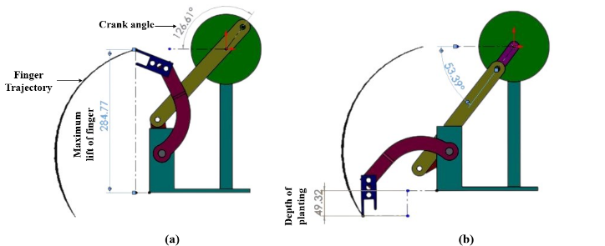
Fig.3 Motion analysis of designed mechanism using SolidWorks (a) upper limit of fingertip, (b) lower limit of fingertip
a. Linear displacement
The linear displacement analysis showed that, at 90 rpm, the crank required 0.68 seconds to complete one revolution (Fig. 4a). The time interval from 0 to 0.32 s corresponded to the forward stroke, while the interval from 0.32 to 0.68 s represented the return stroke. The finger was able to pick the seedlings from the tray at a linear displacement X equals to 320 mm which indicated that the horizontal distance of picking area in the tray should be at this position. The corresponding Y component 182 mm indicated the vertical position of the picking area from the center of disc. The upper limit of Y component (335 mm) at the end of return stroke indicated a sufficient lift of fingertip above the tray and a proper planting depth of 49.5 mm as shown in Fig. 4b. Similar study was conducted by (Marzuki et al., 2019) in SolidWorks software to optimize the dimension of a four bar mechanism for transplanting paddy seedlings.
b. Angular velocity
The angular velocity of the follower increased from 58.9 – 443 deg s⁻¹ as the finger moved from its initial point to halfway of the forward stroke and decreased towards the end of forward stroke (133.7 deg s⁻¹) (Fig.4b). This behavior occurred because the follower started from a position where the mechanical advantage allowed it to rotate faster. As the follower links moved towards the end of the forward stroke, the distance between the links decreased leading a reduction in the angular velocity due to changes in relative velocity of the links. The finger exhibited same trend during the return stroke though the magnitude of angular velocity was high compared to the forward stroke. This was likely due to more power requirement for lifting the finger during the return stroke. The non-uniform velocity profile of the follower due to the constrained link lengths caused continuous shifting of the instantaneous center of rotation and relative angular velocities throughout the stroke (Khurmi & Gupta, 2005). Although the motion of the follower link was directly driven by the input link, the motion of coupler was influenced by the relative movement of both input and follower link. The angular velocity of the coupler decelerated when the follower velocity accelerated as the motion of input and output link no longer provided sufficient mechanical advantage to the coupler in that position.
c. Angular Acceleration
The angular acceleration of the follower decreased when the angular velocity was high (Fig.4c). This may have occurred because the system velocity was approaching a constant value due to inertia, requiring less acceleration to maintain that high speed. Since the couplers motion was influenced by both the follower and driver, the combined forces from these links could lead to increase in angular acceleration with increase in angular velocity (Khurmi & Gupta, 2005). At higher angular velocity, the system demanded a greater change in angular velocity for the coupler to continue its motion.
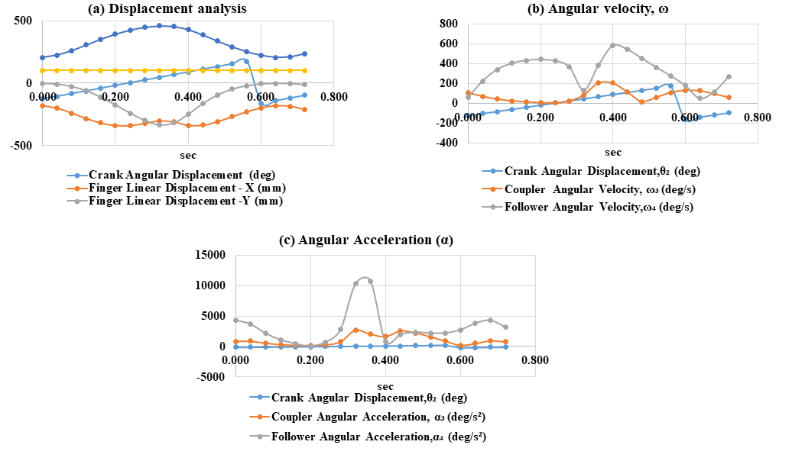
Fig. 4 Kinematic analysis of planting mechanism using SolidWorks premium Software-2023, (a) Displacement analysis, (b) Angular velocity, (c) Angular acceleration
3.2 Validation of results
The values of the kinematic parameters obtained from the motion analysis were compared with the calculated values in Microsoft Excel to verify the adequacy of the model (Table.1).The displacement analysis of the crank-rocker mechanism conducted theoretically closely matched the results obtained from SolidWorks motion analysis, confirming the accuracy of the kinematic modeling. However, theoretical angular velocity and angular acceleration values are significantly higher and are expressed with a ± sign to indicate the direction of motion, representing both clockwise and counterclockwise rotations of the links (Table.2). In contrast, SolidWorks reports only the magnitude of motion, with all values positive, as the software focuses on realistic motion behavior rather than directional convention. The discrepancy between theoretical and SolidWorks results arises from idealized assumptions in theory, such as rigid links, no friction, and instantaneous motion, which can exaggerate peaks, particularly near toggle or reversal positions. SolidWorks motion analysis, on the other hand, accounts for mass, inertia, friction, and constraints of the links, along with numerical damping and smoother interpolation, yielding more realistic angular velocity and acceleration values. Several research studies also report angular velocities and accelerations within ranges similar to those obtained from SolidWorks, confirming that simulation-based results better represent the actual physical behavior of the mechanism than purely theoretical predictions (Marzuki et al., 2019; Arman, 2020; Figueroa-Díaz et al., 2024).
Table.2 Kinematic analysis of mechanism calculated using Eqn. 1-10 in Microsoft excel for one complete rotation of crank
$θ_{2}$ (degree) | $$θ$$  (degree) | S (mm) | $$β$$  (degree) | $$φ$$  (degree) | $$λ$$  (degree) | $$θ_{3}$$  (degree) | $$θ_{4}$$  (degree) | ω₃ (deg/s) | ω₄ (deg/s) | α₃ (deg/s²) | α₄ (deg/s²)
-126.60 | 58.43 | 228.82 | -12.89 | 15.53 | 100.22 | 30.01 | 34.25 | -527.11 | -2345.19 | -1.73 × 10⁷ | -1.19 × 10⁷
-105.00 | 58.43 | 209.53 | -10.99 | 13.71 | 119.36 | 33.73 | 13.20 | 298.54 | 821.49 | 3.72 × 10⁵ | 2.90 × 10⁵
-83.41 | 58.43 | 195.03 | -6.84 | 10.40 | 138.41 | 41.19 | -10.00 | 146.11 | 461.38 | 3.35 × 10⁴ | 2.50 × 10⁴
-61.81 | 58.43 | 188.62 | -0.98 | 7.73 | 150.37 | 49.72 | -27.81 | 68.04 | 416.11 | -7.36 × 10³ | -6.00 × 10³
-40.21 | 58.43 | 192.03 | 5.14 | 9.31 | 143.53 | 54.26 | -27.09 | 27.28 | 440.45 | -9.90 × 10³ | -8.50 × 10³
-18.61 | 58.43 | 204.32 | 9.93 | 12.80 | 125.49 | 55.56 | -13.84 | 10.55 | 448.90 | -9.72 × 10³ | -8.20 × 10³
2.99 | 58.43 | 222.50 | 12.54 | 15.15 | 106.06 | 55.82 | 2.97 | -0.05 | 436.65 | -3.00 × 10³ | -2.80 × 10³
24.59 | 58.43 | 243.03 | 12.98 | 15.77 | 87.94 | 55.64 | 20.65 | -14.24 | 392.86 | -1.50 × 10⁴ | -1.30 × 10⁴
46.19 | 58.43 | 262.83 | 11.68 | 14.97 | 71.73 | 55.14 | 38.15 | -56.86 | 232.54 | -5.00 × 10⁴ | -4.50 × 10⁴
67.79 | 58.43 | 279.54 | 9.13 | 13.30 | 57.78 | 54.26 | 54.66 | 3865.60 | 14636.76 | 1.20 × 10⁶ | 1.05 × 10⁶
89.39 | 58.43 | 291.53 | 5.77 | 11.45 | 46.86 | 52.75 | 68.95 | 148.71 | 934.28 | 2.30 × 10⁴ | 2.00 × 10⁴
110.99 | 58.43 | 297.74 | 1.94 | 10.18 | 40.54 | 50.19 | 79.08 | 129.98 | 789.15 | 1.50 × 10⁴ | 1.25 × 10⁴
132.59 | 58.43 | 297.67 | -2.02 | 10.20 | 40.61 | 46.21 | 82.98 | 151.16 | 728.18 | 1.00 × 10⁴ | 9.00 × 10³
154.19 | 58.43 | 291.34 | -5.84 | 11.48 | 47.04 | 41.11 | 80.37 | 180.29 | 634.92 | 7.00 × 10³ | 6.50 × 10³
175.79 | 58.43 | 279.24 | -9.19 | 13.34 | 58.04 | 35.89 | 72.72 | 193.05 | 469.32 | 5.00 × 10³ | 4.50 × 10³
-162.61 | 58.43 | 262.45 | -11.72 | 15.00 | 72.05 | 31.71 | 61.25 | 166.96 | 219.11 | 3.50 × 10³ | 3.00 × 10³
-141.01 | 58.43 | 242.61 | -12.99 | 15.78 | 88.30 | 29.66 | 46.27 | 52.66 | -247.71 | -1.00 × 10⁴ | -8.00 × 10³
-119.41 | 58.43 | 222.09 | -12.51 | 15.12 | 106.45 | 30.80 | 27.63 | 1168.81 | 3924.04 | 1.00 × 10⁶ | 9.50 × 10⁵
-97.81 | 58.43 | 203.99 | -9.85 | 12.73 | 125.89 | 35.85 | 5.53 | 228.98 | 625.91 | 3.50 × 10⁴ | 3.00 × 10⁴

Table.3 Comparative evaluation of theoretical and SolidWorks-derived kinematic parameters of the planting mechanism
Quantity | Theoretical | SolidWorks | Findings
ω₃ | Up to ±3865 deg/s | 3–206 deg/s | Theoretical peaks are highly exaggerated due to small denominator near toggle positions. SolidWorks shows realistic link motion.
ω₄ | Up to ±14636 deg/s | 26–10800 deg/s | Similar data. Software caps realistic motion.
α₃ | Up to 1×10⁶ deg/s² | 214–2662 deg/s² | Theoretical α₃ is orders of magnitude higher. SolidWorks shows moderate accelerations.
α₄ | Up to 9.5×10⁵ deg/s² | 26–10787 deg/s² | Theory overestimates spikes; software reflects physical limits.

4. Conclusion
The kinematic analysis of the developed planting mechanism confirmed that the designed link dimensions and motion characteristics are suitable for precise and synchronized seedling picking, lifting, and placement. SolidWorks motion analysis enabled comprehensive evaluation of displacement, velocity, and acceleration, providing more realistic results than manual calculations by accounting for actual physical parameters such as link mass and inertia. The mechanism exhibited an appropriate fingertip trajectory, sufficient planting depth, and smooth motion throughout the operating cycle. These validated results form a strong basis for prototype development and further optimization to enhance the efficiency and precision of mechanical paddy transplanting for root washed seedlings.
Disclaimer (Artificial intelligence)
Author(s) hereby declare that generative AI technologies such as Large Language Models, etc. have been used during the writing or editing of manuscripts. This explanation will include the name, version, model, and source of the generative AI technology and as well as all input prompts provided to the generative AI technology
Details of the AI usage are given below:
1. ChatGPT (OpenAI) was used to assist in paraphrasing and rephrasing sentences for better readability and academic presentation of the research content.
Reference
Arman, R. (2020). Kinematic analysis on four-bar mechanism model using PID Controller. IOP Conference Series: Materials Science and Engineering, 990(1). https://doi.org/10.1088/1757-899X/990/1/012029
Avilés, R., Hernández, A., Amezua, E., & Altuzarra, O. (2008). Kinematic analysis of linkages based in finite elements and the geometric stiffness matrix. Mechanism and Machine Theory, 43(8), 964–983. https://doi.org/10.1016/J.MECHMACHTHEORY.2007.07.007
Figueroa-Díaz, R. A., Urías, F. G., Moreno-Romero, R., Ruiz-Ibarra, É. C., & De la Cruz-Soto, J. (2024). Kinematic Analysis of 4 Bar Mechanisms Applying for Solar Tracking. https://doi.org/10.20944/preprints202407.0165.v1
Gaikwad, P. B., Shahare, P. U., & Pathak, S. V. (2018). Performance of Four Row Self Propelled. 36(1), 72–75.
Gallardo-Alvarado, J., & Gallardo-Razo, J. (2022). Analytical method. Mechanisms, 279–309. https://doi.org/10.1016/B978-0-32-395348-1.00027-2
Guo, L. S., & Zhang, W. J. (2001). Kinematic analysis of a rice transplanting mechanism with eccentric planetary gear trains. Mechanism and Machine Theory, 36(11–12), 1175–1188. https://doi.org/10.1016/S0094-114X(01)00052-0
Khurmi, R. S., & Gupta, J. K. (2005). Theory of machines. S. Chand Publishing. https://books.google.co.in/books?id=RWWgwVoSBWwC&lpg=PA3&ots=yfQTwHBLOy&dq=khurmi book theory of machines&lr&pg=PA15#v=onepage&q=khurmi book theory of machines&f=false
Marzuki, Syukran, & Azwinur. (2019). Design and Development of Four Link Bar Mechanism for Transplanting Wet Rice Seedlings. IOP Conference Series: Materials Science and Engineering, 536(1). https://doi.org/10.1088/1757-899X/536/1/012027
Pradhan, N. C., Sahoo, P. K., Kushwaha, D. K., Bhalekar, D. G., Mani, I., Kumar, K., Singh, A. K., Kumar, M., Makwana, Y., Soumya Krishnan, V., & Aruna, T. N. (2024). ANN-PID based automatic braking control system for small agricultural tractors. Journal of Field Robotics, 41(8), 2805–2831. https://doi.org/10.1002/rob.22393
Pradhan, N. C., Sahoo, P. K., Kushwaha, D. K., Makwana, Y., Mani, I., Kumar, M., Aruna, T. N., & Soumya Krishnan, V. (2023). A finite element modeling-based approach to predict vibrations transmitted through different body segments of the operator within the workspace of a small tractor. Journal of Field Robotics, 40(6), 1543–1561. https://doi.org/https://doi.org/10.1002/rob.22191
Pradhan, N. C., Sahoo, P. K., Kushwaha, D. K., Mani, I., Srivastava, A., Sagar, A., Kumari, N., Sarkar, S. K., & Makwana, Y. (2021). A novel approach for development and evaluation of lidar navigated electronic maize seeding system using check row quality index. Sensors, 21(17). https://doi.org/10.3390/s21175934
Sahoo, P. K., Kushwaha, D. K., Pradhan, N. C., Makwana, Y., Kumar, M., Jatoliya, M., & Mani, I. (2022). Robotics application in agriculture. In 55th Annual Convention of the Indian Society of Agricultural Engineers and International Symposium, 60–76.
Shete, S., Kumar, N., Nalawade, P., & Tripathi, P. (2017). Review of Synthesis of Four BAR Mechanism. International Research Journal of Engineering and Technology(IRJET), 4(5), 1521–1524. https://www.irjet.net/archives/V4/i5/IRJET-V4I5297.pdf
Soriano-Heras, E., Pérez-Carrera, C., & Rubio, H. (2025). Mathematical Dimensional Synthesis of Four-Bar Linkages Based on Cognate Mechanisms. Mathematics, 13(1), 1–24. https://doi.org/10.3390/math13010011
T N, A., Sahoo, P. K., Kushwaha, D. K., Pradhan, N. C., Kumar, K., V, S. K., B S, M., Gaddamwar, R. B., Pandey, A., Singh, A. K., Orban, Z., & Salem, A. (2025). Static and dynamic cutting forces in coriander crop harvesting: Engineering insights for harvester optimization. Smart Agricultural Technology, 10(November 2024), 100772. https://doi.org/10.1016/j.atech.2025.100772
Vareed Thomas, E. (2002). Development of a mechanism for transplanting rice seedlings. Mechanism and Machine Theory, 37(4), 395–410. https://doi.org/10.1016/S0094-114X(01)00071-4
Wang, Y., Zhang, Q., Zhang, X., Cai, J., Jiang, C., Xu, Y., & Feng, J. (2022). Analytical and numerical analysis of mobility and kinematic bifurcation of planar linkages. International Journal of Non-Linear Mechanics, 145, 104110. https://doi.org/10.1016/J.IJNONLINMEC.2022.104110

