1
2 Constraints Faced by the Self-Help Group
3 (SHG) Members in Effective Management of
4 Income Generating Activities: A Case Study in
5 Cuttack District of Odisha
6
7
8
9
10
11
12

Authors’ contributions
- This work was carried out in collaboration among all authors. All authors read and approved
- the final manuscript.

17
189
20 .
21 ABSTRACT
22
The study examined the constraints faced by Self-Help Group (SHG) members under Mission Shakti in managing income-generating activities, focusing on social, economic, and technical dimensions. An ex- post- facto designed study has been carried out in the Cuttack district of Odisha. Different statistical tools like mean, median, mode have been used for better representation of the data. Total number of 120 respondents have been taken for the study . The results revealed that major constraints faced by members of Self-Help Groups (SHGs) across three dimensions: economic, technical, and social. Data collected from 120 respondents were evaluated using mean scores to rank the severity of each constraint. Among the economic constraints, the most critical issues were the high rate of interest (1.61), non-availability of finance (1.53), and high transaction costs (1.47), indicating systemic financial barriers and limited access to affordable credit. In terms of technical constraints, the leading challenges included a lack of direction and encouragement (1.46), lack of training (1.44), and lack of regular meetings (1.40), highlighting the need for structured guidance, skill development, and consistent group coordination. The analysis of social constraints revealed lack of education (2.26) and lack of family support (1.94) as the most severe issues, suggesting that socio-cultural factors significantly hinder participation and empowerment. Overall, the findings underscore the multifaceted nature of the difficulties SHG members face and point to the need for integrated interventions that address financial access, technical capacity building, and social support systems.
23
24 Keywords: SHG, Mission Shakti, empowerment, constraints, social, economical
25
26
27

28 1. INTRODUCTION
29
- Women have always had a submissive role in the house. Inequality against women has been ingrained in society since
- birth. In every community, women play a vital role (Behera et al., 2025). Slowly and steadily SHGs has becoming the back
- bone of Indian economy. Now a days ,almost in every village of India Women are coming together to form Self Help
- Groups to face their economical constraints and to establish small and medium scale business.India is regarded as one
- of the fast growing economy of the world. At the beginning of 21st century, the annual average growth rate of GDP has
- remained steady between 6% to 7%. During the period 2014 to 2018 India was the fastest growing economy and
- surpassed China. However, in India the fruit of this development is unequally distributed among the populace. There are
- still a large number of population who live in poverty and impoverishment where as the top 1% of the country holds the
- 73% of the wealth. According to the United Nations report of Millennium developmental goals program 270 million people
- of India which comes around 21.9% of Indian population lived below poverty line in 2011-12. Since Independence,
- eradication of poverty is the toughest challenge faced by the economist and the law makers and with a significant
- population living in poverty the state of India needs a strong commitment from the government, political class and the
- common populace. Most of the poverty alleviation programmes in India are designed through community development
- Programmes and the activities of Self Help Groups are one of them.

- SHG members involved in Mission Shakti face several key challenges in running their groups.The most
- significant issues include a lack of knowledge and proper guidance needed to start suitable and profitable income-
- generating activities.This situation limits their ability to transition from micro-credit to sustainable micro-entrepreneurship
- .Concerns about the sustainability and quality of SHG operations are ongoing.This consists of maintaining regular savings
- and timely loan repayment.Many SHGs rely heavily on support agencies, such as Anganwadi workers and community
- resource persons, which makes them vulnerable if external assistance is withdrawn.This dependency can threaten group
- unity and ongoing operations.Furthermore, only a small number of SHGs manage to create strong market connections for
- their products.There is also a need for improved access to training in bookkeeping, digital financial services, and
- entrepreneurial skills.Tackling these challenges is important for enhancing the long-term effect and viability of SHGs
- under Mission Shakti. The Government of India tried to expedite the process of establishing small Self-Help Groups
- (SHGs) based on data from rural areas where women have begun to form small groups with modest contributions from
- each member to establish saving habits and accumulate the funds for starting micro-enterprises both collectively and
- individually by taking out loans from the common fund (Swetadipta et al., 2024).

- After 14 years of the inception of the Mission Shakti in Odisha, issue of sustainability of the development
- of poor rural household through WSHGS is still a debatable issue. Scholars like Sahoo (2012), Dash (2011), Sahu (2013)
- says that the Mission Shakti has significantly improved the economic condition of poor household but scholars like
- Pradhan (2012) comment on the role of mission in eliminating poverty through empowering women by SHGs. Few
- Scholars like Rath (2007) and Panda (2008) say although women SHG is creating opportunities for rural poor, it is
- becoming difficult to convert these opportunities to reality as a result poverty prevails. WSHGs are usually informal
- groups whose members i.e. the women have a common perception of the need and importance towards collective action.
- These groups promote savings among themselves and use the pooled resources to meet the urgent needs. They rotate
- this common pooled resource within the members with a very small rate of interest. The number of members in a WSHG
- normally ranges from 10 to 20( Amrita M Patel 2011). A multiple regression equation focused on identifying the
- contributing factors toward explaining SHG income. Results indicated that income generation for all the blocks together
- was significantly influenced by factors like loan amount, amount of saving, years of existence of SHG, education level of
- the group leader, and availability of the training facility( S.K Datta 2014).

- The impact of SHGs has gone beyond facilitating income generation for women, and the transformation
- can be observed in the overall rural population. A culture of entrepreneurship (Small and Medium Enterprises) has
- emerged. It has fostered a sense of community among the SHG group members, building a solid network of financially
- empowered women. There have been many studies on SHG schemes exploring their implementation, effectiveness,
- success, and non-performance, along with evidence to quantify each factor. However, besides the measure of success
- and failure of these schemes, the SHGs have notably also created spaces and scope of inclusion and participation for
- women in socio-economic and political spaces in their communities. The social impact of the system on women’s
- empowerment has been far-reaching.

- The concept of WSHG turns women into responsible citizen of the country achieving socio-economic
- growth. Involvement of women in all stages of both family and community affairs have been an added significance to
- them. Women escorted the SHGs in several areas of the country have accomplished triumph in conveying the women to
- the conventional of the decision making (Oka, 2000). They are empowered in so extent that they are being consulted in all
- the decision making like-education and marriage of their children, owning property, expenditure, taking loans etc. The

- research work has shown that, in many cases the women have proved themselves to be as active agent in the community
- development (Selvam, 2005).

85
86
87
88
89
90
91
92
93
94
95
96
97
98
99
100
101
102
103
104
105
106
107
108
109
110
111
112
113
114
115
116

117
118
119
120
121
122
123
In 1976, Prof. Mohammed Yunus of Bangladesh stared women’s groups in Bangladesh and developed thrift and savings among the poorest. Gradually, it has developed into Bangladesh Grameen Bank (BGB). With the success of BGB and similar organization somewhere else, the concept of micro credit has gained momentum in India. Cumulatively, WSHGs came to existence in Odisha in term of Mission Shakti supported by the state regime.

METHODOLOGY

In social research, selecting an appropriate research problem is of utmost importance. A study must begin with the formulation of a problem that is realistic, clear, and unambiguous, as defining the problem is often more important than finding its solution. With this perspective, the present research problem was identified and undertaken to provide relevant suggestions and recommendations for future applications and reference. Prior to the actual investigation, an extensive survey was carried out to examine all aspects related to e-agriculture within the scope of the study. The study adopts a survey research design, primarily ―ex post facto‖ in nature. In this study, an ex-post facto research design was employed. Ex post facto studies, also known as after-the-fact research, are a type of research design in which the researcher has no control over the fact that the investigation begins after it has happened (Behera & Modak, 2021). Based on the objectives and scope, appropriate decisions were made regarding the techniques of investigation, research methods, and statistical tools for data analysis and interpretation. The research was performed within the Cuttack district of Odisha during the time frame of 2024-25. Odisha, a state with 30 districts, within it the purposive selection of Cuttack district was done for the present study. Cuttack district encompasses 15 blocks, and for this study, the blocks of Athagarh, Banki and Salepur were selected. From three blocks five gram panchayats were selected. From Athagarh block two gram panchayats were selected. From Banki two gram panchayats were selected and from Salepur one gram panchayat was selected. Those are Totapada and Dorada of Athagarh block, Subarnapur and Kusupangi of Banki and Gopinathpur of Salepur block respectively, from each of the 3 purposively selected blocks, respondents were selected randomly. The block office of Athagarh, Banki and Salepur contacted and made a list of SHGs members from the selected gram panchayat. 120 respondents were selected randomly by lottery method. Appropriate statistical tools like mean, median, mode, percentage, coorelation and regression etc. have been taken for proper analysis of the collected data.

RESULTS AND DISCUSSION

Economic constraints
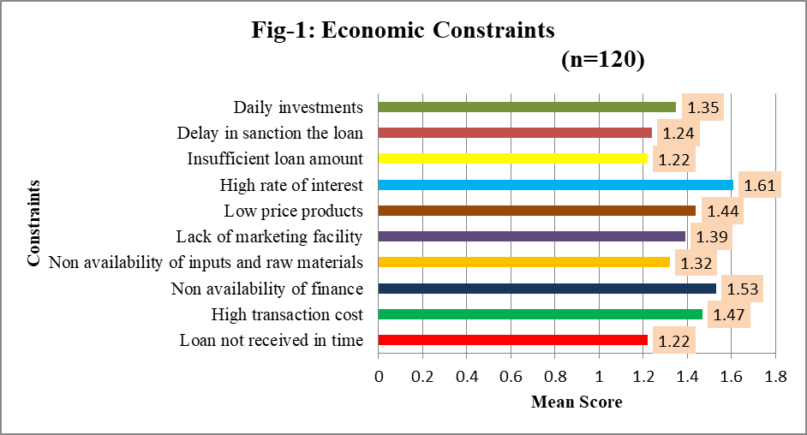

In fig-1 , The scores shown in the bar chart represent the mean scores of various economic constraints, indicating the average severity or impact of each constraint as experienced by the respondents. A higher mean score reflects a more significant or frequently encountered challenge. The high rate of interest received the highest mean score of 1.61, suggesting that expensive credit is a major barrier—possibly due to dependence on informal lenders or limited access to subsidized loans. This is followed by non-availability of finance (1.53), likely stemming from strict eligibility criteria, lack of

124
125
126
127
128
129
130
131
132
133

134
135
136
137
138
139
140
141
142
143
144
145
146
147
148
149
150
151
152
153
154
155
156
157
158
159
160
161
162
163
collateral or inadequate financial infrastructure in rural or underdeveloped areas. The high transaction cost (1.47) also ranks high, which could be due to excessive processing fees, transportation costs, or bureaucratic delays. Meanwhile, low price for products (1.44) points to poor market linkages and weak bargaining power of producers. Constraints like insufficient loan amount and loan not received in time, both with mean scores of 1.22, though less severe in comparison, still reflect inefficiencies in the credit delivery system. Overall, these constraints underline the need for better access to affordable credit, improved market facilities, and streamlined financial services to support economic development and sustainability.

Technical constrains
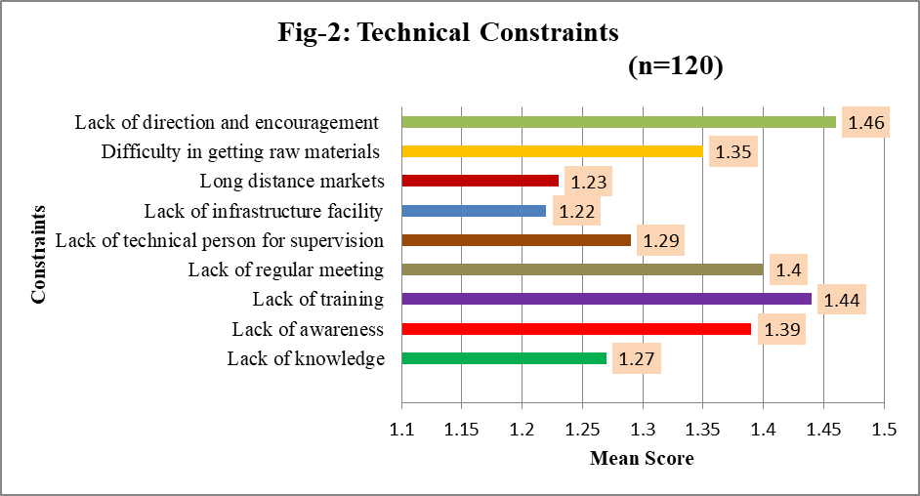

In fig-2, The bar chart titled "Technical Constraints" (n=120) presents the mean scores of various technical challenges faced by respondents, with each constraint evaluated on its average severity. The highest mean score is for lack of direction and encouragement (1.46), indicating that a significant number of individuals feel unsupported or unguided in their technical pursuits—likely due to the absence of mentors, extension services, or institutional backing. This is followed closely by lack of training (1.44) and lack of regular meetings (1.40), which highlight gaps in capacity-building efforts and communication, limiting opportunities for skill enhancement and knowledge sharing. Other prominent issues include lack of awareness (1.39) and difficulty in getting raw materials (1.35), which may stem from inadequate exposure to new technologies and poor logistical support. Lower-scoring constraints like lack of infrastructure (1.22) and long-distance markets (1.23), although still relevant, appear to be less severe. Overall, the chart underscores the need for improved technical guidance, structured training programs, regular stakeholder engagement, and better access to information to address these technical barriers effectively.

164
165
166
167
168

169
170
171
172
173
174
175
176
177
178
179
180
181
182
183
184
185
186
187
188
189
190
191
192
193
194
195
196
197
198
199
200
201
202
203

Social constraints
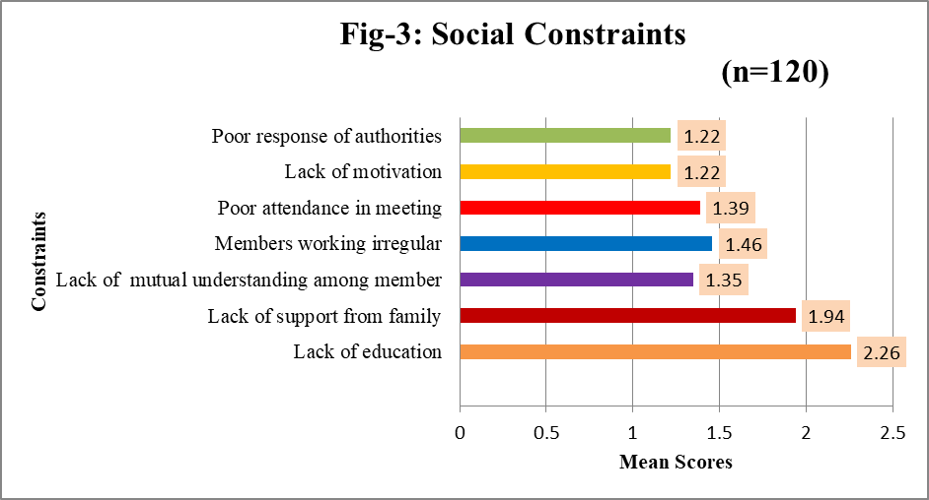

In fig-3 , The bar chart titled "Social Constraints" (n=120) illustrates the mean scores of various social challenges faced by respondents, with higher scores indicating more severe or commonly experienced issues. The most critical constraint identified is lack of education, with the highest mean score of 2.26, suggesting that limited literacy or awareness significantly affects social participation, decision-making, and the ability to engage in development activities. Following this is lack of support from family (1.94), which may indicate that social or cultural pressures discourage individuals— especially women or youth—from actively participating in community or group-based initiatives. Another prominent issue is members working irregularly (1.46), likely due to lack of commitment, time constraints, or inadequate motivation. Poor attendance in meetings (1.39) and lack of mutual understanding among members (1.35) reflect weak group cohesion and communication barriers. On the lower end, poor response of authorities and lack of motivation, both scoring 1.22, are still noteworthy but comparatively less severe. Overall, the chart emphasizes that low educational levels, lack of familial and peer support, and weak group dynamics are key social constraints that need to be addressed through awareness campaigns, community engagement, and inclusive educational efforts.

CONCLUSION

Mission Shakti, Odisha's flagship program for women's empowerment, has been the subject of various research studies. This specific research study explores the program's impact on women's social and economic standing, particularly within Self-Help Groups (SHGs) in the Cuttack District. Research findings indicate younger respondents tend to have higher education, more land, greater income, and farming experience. Caste influences education and livestock ownership but is negatively associated with family type and income. Larger family size and joint family structures correlate with increased assets and income. Land holding plays a central role, strongly connected to family size, income, and farming experience. Annual income is closely tied to expenditure and asset ownership. Marketing behaviour positively affects employment generation. The ability to face problems has shown considerable improvement across different areas. For health related problems as well as in financial matters, significant improvement has been seen. In conclusion, this thesis seeks to contribute to the broader discourse on socio-economic empowerment of women by providing empirical evidence on the role of targeted women empowerment initiatives through Mission Shakti. By focusing on the specific case of the Cuttack district, the research will offer localized insights that can inform policy adjustments and improve the overall efficacy of Mission Shakti programs aimed at empowering women in social, economic, political, . Ultimately, the findings from this study will help shape strategies for financial literacy and access to banking services, skill development, impact of specific Mission Shakti initiatives like the Millet Mission and its associated cafes, showcasing their role in promoting sustainable

204 livelihoods and community development and research collaborations, such as the one with UNFPA, highlight the
205 importance of digital and financial literacy in empowering women within the Mission Shakti framework.
206

207 DISCLAIMER (ARTIFICIAL INTELLIGENCE)
208
209 Author(s) hereby declare that generative AI technologies such as Large Language Models, etc. have been used during
210 the writing or editing of manuscripts. This explanation will include the name, version, model, and source of the generative
211 AI technology and as well as all input prompts provided to the generative AI technology
212

213 Details of the AI usage are given below:
214
215 1. Co-Pilot is used for grammar error correction and sentence improvement.
216

217 ACKNOWLEDGEMENTS
218
219 All the authors have significantly contributed to the research paper, and the staffs of the Mission Shakti office and all the
220 beneficiaries are acknowledged for their help and cooperation in providing the information. 221

222 COMPETING INTERESTS
223
224 Authors have declared that they have no known competing financial interests or non-financial interests or personal
225 relationships that could have appeared to influence the work reported in this paper. 226
227 REFERENCES
228
- Behera, D., & Modak, S. (2021). Attitude and opinion of the farmers towards regulated market: A case of Balasore
- District. Indian Research Journal of Extension Education, 22(2), 169–172.
231
- Behera, D., Kanungo, A. P., Prangya, S., Swetadipta, S., & Paik, S. (2025). Social interaction pattern within the self-help
- groups (SHGs) in Rayagada District of Odisha, India. Journal of Scientific Research and Reports, 31(1), 300–
- 308. https://doi.org/10.9734/jsrr/2025/v31i12769
235
- Datta, S. K., & Singh, K. (2014). Determinants of income generation and financial performance through self-help groups.
- Journal of Social Service Research, 40(1), 97-110.https://www.tandfonline.com/doi/abs/10.1080/01488376.2013.845129

- Department of Mission Shakti. (2019). Report. https://missionshakti.odisha.gov.in
239
- Goyal, G., & Kaur, R. (2001). Loan associated constraints of integrated rural development programme women
- beneficiaries. Journal of Research, Punjab Agricultural University, 38(3/4), 301–307.
242
243
- Mankar, D. M. (2009). Sustainable rural livelihood security in disadvantaged districts of Maharashtra. Research review
- committee report, 10–15.
246
247 Mission Shakti. (n.d.). Activity. https://missionshakti.odisha.gov.in
248
- Nayak, A. K., Panigrahi, P. K., & Swain, B. (2020). Self-help groups in India: Challenges and a roadmap for
- sustainability. Social Responsibility Journal, 16(7), 1013–1033. https://doi.org/10.1108/SRJ-01-2019-0017
251
- Patel, A. M. (2011). Women self-help groups in Orissa: Challenges and opportunities. Orissa Review, 67(7-8), 50–53.
- Rajpal, N. K. (2019). SHG federations in Odisha: Management, challenges and opportunities. Research Journal of
- Humanities and Social Sciences, 10(1), 170–176. https://doi.org/10.5958/2321-5828.2019.00029.9
255
- Swain, S. R., Rudraraju, V., & Nayak, S. (2024). Empowering women through millet entrepreneurship: Cultivating success
- and sustainability. International Journal of Research–GRANTHAALAYAH, 12(5), 43–
- 59. https://doi.org/10.29121/granthaalayah.v12.i5.2024.5616
259

- Swetadipta, S., Samal, A. R., Prangya, S., Behera, D., & Jena, A. K. (2024). Examining the transformative impact:
- Entrepreneurial activities of self-help groups and their influence on socio-economic status. International Journal for
- Multidisciplinary Research. https://www.semanticscholar.org/paper/7213de2227d9602249a886e4d95fe925d76d3657
263
264

