Revised Research Article
Development and Evaluation of Solar Powered IoT Controlled Poultry Egg Incubator
ABSTRACT

A prototype of a solar-powered IoT-enabled automatic egg incubator with LED lights was developed at the Farm Machinery Testing Centre, Regional Agricultural Research Station, Vijayapura, and evaluated for feasibility and performance. The incubator has a micro-controller for temperature, humidity, and egg turning setup, which accommodates the best conditions for farmyard poultry hatching. This device was developed to control and monitor from a mobile application; hence, it's a user friendly remote location suitable gadget. The research was carried out for 8 replicates of a 21-day incubation time for each replica and kept the chamber busy maintaining an optimal temperature range within 36-39 °C and relative humidity of 60-65 percent to prevent embryo dehydration per moistening. The data showed conventional incubation was represented by a temperature set at 37.5 °C and humidity at 62 percent, and the performance was comparable to the traditional incubators. The implemented incubator showed a hatchability rate of 78 percent and chick survival of 79.7 percent. Moreover, the developed incubator offers the advantage of turning the eggs automatically at an interval of 6 hours, unlike that of the manual method, to support the embryo development. Furthermore, solar PV system integration, which targets remote locations where conventional electricity supply is inadequate, and to cut down energy costs turn in as an equally appreciable approach for the incubator’s efficient and cost effective alternative solution with a promising techno economic analysis for 10 years revealed that the incubator is practical and profitable, offering a sustainable approach to rural poultry farming.
Keywords: Solar, IoT, LED, incubation, temperature, relative humidity, hatchability, techno economic analysis.
GRAPHICAL ABSTRACT

1. INTRODUCTION

1.1 Background

In view of the world's rapidly expanding population, there is a growing demand for high-quality food products that are high in protein. The world's population is expected to reach 9.7 billion people by 2050 (Gu et al., 2021), which means that in order to guarantee food security and adequate nutrition, quality food production must increase by 25 per cent to 70 per cent as per food security and nutrition in the word, 2022. Commercial electric incubators, which offer automation, accuracy, and reliable hatchability, are extensively utilized in urban and semi-urban areas for poultry farming in developing nations like India. However, farmers are still compelled to take on conventional incubation techniques like brooding under hens in rural areas, particularly those with inadequate or no electrical power supply (Hunter et al., 2017 and Gulati & Juneja, 2023). These techniques are frequently labour-intensive, unreliable, and produce low hatchability rates.The challenges are compounded by the high cost of operating diesel generators and frequent power outages, which hinder consistent incubation(Wu et al., 2022).

The development of technologically inclusive and sustainable solutions is desperately needed to close this gap. A promising substitute for electricity in off-grid areas is solar energy, which is plentiful and renewable. Egg incubators that run on solar power have the potential to provide dependable incubation while lowering operating expenses and reliance on fossil fuels (Peprah et al., 2022). Ikpeseni et al. (2022) developed a locally produced solar-powered incubator for low-income contexts, with a focus on cost-effectiveness and operational ease. Following these developments, the current study attempts to design and develop a solar-powered, IoT-based automatic egg incubator with LED lighting, including remote monitoring and accurate environmental management, and assess its performance, hatchability, and techno-economical feasibility under field conditions. The poultry industry has experienced a dramatic change in recent years, evolving from domestic chicken farming to a sophisticated, profit-driven business. Large-capacity egg hatcheries have made it possible for farmers to generate steady income, increase productivity, and ensure a steady supply of chicks. Even in rural areas, this evolution signals a move towards commercialization, necessitating creative incubation solutions that address scale and energy issues while also taking into account the economics of contemporary poultry production (Pandey et al., 2023 and Bi et al., 2024).

The Significance of Egg Incubation: Incubation is essential to bird reproduction and conservation efforts in a larger context. Effective and dependable incubation procedures are essential to hatcheries because they have a direct impact on the health and survival of the hatched chicks (Mesquita et al., 2021). The incorporation of automated technologies presents a viable option for improving hatchery success rates, a goal that environmentalists and poultry producers alike are constantly pursuing (Kolog, 2023). Processes can be streamlined, and a degree of control and accuracy that is difficult to attain with manual techniques can be enabled through automation through IoT (Liang & Shah, 2023). This study is situated at the intersection of this evolving landscape, seeking to explore the potential benefits of an LED-equipped IoT enabled egg incubator in enhancing the efficiency and outcomes of avian breeding and conservation efforts in remote rural areas of India for small-scale poultry production.

Automation Technology in Hatcheries: The incorporation of automated technologies into hatcheries marks a paradigm change in chicken production (Jacob et al., 2025). As worldwide demand for chicken products is growing (Mottet & Tempio, 2017), there is a growing need for scalable and efficient production techniques. Automation technology meets this demand by providing solutions that not only increase production but also contribute to the economic viability of poultry farming operations (Neetirajan, 2022). The emphasis on automation is especially relevant to egg incubation, a vital step in the chicken farming process. The capacity to accurately manage environmental parameters including as temperature, humidity, and egg flipping using automated methods has the potential to dramatically improve hatchery success rates (Aldiar et al., 2018).

Research Context and Objectives:This study unfolds within the context of the Farm Machinery Testing Centre at the Regional Agricultural Research Station, Vijayapura. The study team has set out to develop and test a solar-powered and IoT enabledpoultry incubator. The goals were twofold: first, to address the uninterrupted power supply and energy consumption issues associated with standard incubators; and second, to improve the mobility of the incubation process with automation technology. These aims were more than just technical obstacles; they were part of a larger purpose of making chicken farming more sustainable, economically feasible, and adaptable to different production sizes.

Energy-Efficient and Portable Incubation:Traditional incubator energy usage has long been a problem (Kapen et al., 2020). It is critical to solve this issue as poultry farming expands, for both environmental and financial reason (Abutu et al., 2025)s. Through the use of solar PV assistance and the energy-efficient features of LED lighting technology, the suggested incubator attempts to mitigate this difficulty. LED lights are perfect for preserving a steady and regulated incubation environment since they use less energy and produce optimum heat (Li et al., 2022). In order to augment the incubator's sustainability and efficiency, the incorporation of a photovoltaic system is executed and suggested.

2. MATERIALS AND METHODS

- Development of incubator

The incubator's design and construction took into account with several criteria, including simplicity, low cost, material availability, aesthetics, sustainability and ergonomics aspects. The study also took into account the fact that current egg incubators should be capable of incubating and hatching eggs of diverse sizes (Olorunnisola, 2021). figure 1 shows the fabrication of the incubator.
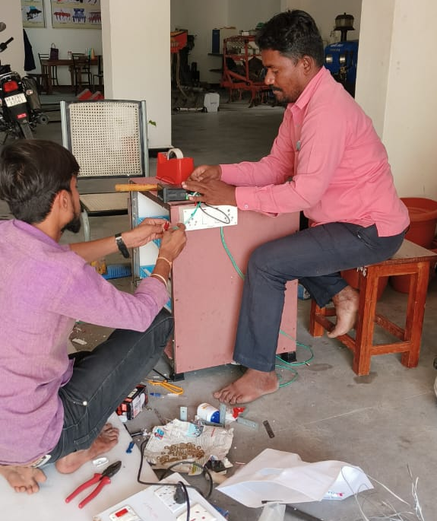

Fig. 1.Fabrication of solar powered IoT controlled poultry egg incubator

- Incubator overview

The developed incubator (figure 2.) has an incubation (heating) chamber comprised of 3 numbers of LED bulbs of 15W each that creates heat and a forced-convective 5V DC fan that assists in the uniform distribution of the heat generated to the incubator's interior. The Relative Humidity (RH) and uniform temperature conditions in the incubation chamber were monitored using sensors and a microprocessor. The incubator features an LCD panel that displays the incubator's status and operational conditions.
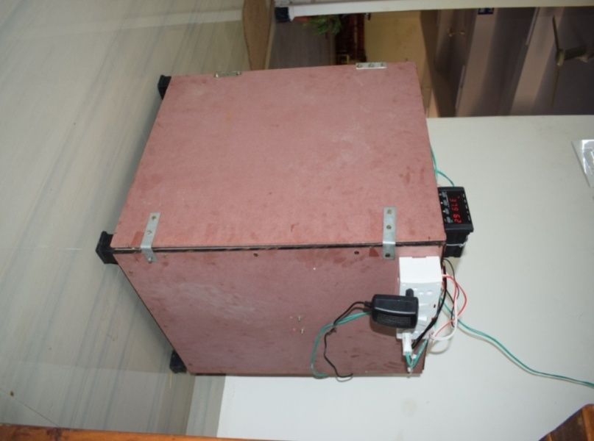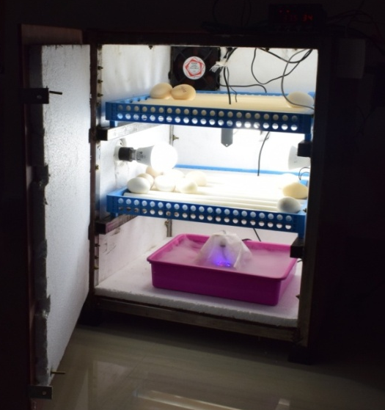

Fig. 2. Newly developed solar powered IoT controlled poultry egg incubator

The chamber was built with 6 mm thick water proof cardboard, which is known for its strength, light weight and durability. The incubator's inside wall was lined with 20 mm thick thermocol to avoid heat loss and to improve thermal insulation. The combination of use of cardboard and thermocol is to come out with a light weight and economical incubator. The incubator chamber measures 620mm × 500mm × 500mm (l × w × h) and can hold around 110 eggs.

Two egg turning trays which can accommodate 55 eggs each were placed inside the chamber on the slots provided. These trays are specially designed for proper and periodic turning of eggs during the incubation period, an essential requirement for embryo development.

Three LED bulbs of 15W each were provided inside the chamber. The optimum heat required can be achieved i.e. 36 to 38 ºC with these bulbs and are efficient enough to conserve the electricity consumption resulting in reduced cost of operation.

A 5V DC fan was used for uniform supply of heat generated by the LED bulbs throughout the chamber, ensuring adequate temperature and RH levels of the incubator.

An Ultrasonic mist maker operating on a standard 110-240V AC supplywas used to create humidity inside the incubation chamber. It converts water into fine mist using ultrasonic vibrations and typically connects to a 24-volt power source, which is standard in many heating and cooling systems. This type of humidifier is often used to maintain comfortable humidity levels.

The ESP32 is a versatile microcontroller with integrated Wi-Fi and Bluetooth 4.2 capabilities. Its dual-core processor and rich set of GPIOs make it ideal for embedded applications requiring wireless communication, real-time processing, and peripheral control with 520 KB of SRAM.The ESP32 is a series of low-cost, low-power system-on-chip (SoC) microcontrollers developed by Espressif Systems which supports multiple general purpose I/O interfaces including Adc, DAC, PWM, and UART, making it suitable for real time monitoring.

The DHT11 is a basic, low-cost digital temperature and humidity sensor. The DHT11 uses a thermistor for temperature and a capacitive humidity sensor. It sends a calibrated digital signal using a proprietary single-wire protocol. This sensor operates in a temperature range of 0 to 50 °C with ±2 °C accuracy and measures humidity between 20 per cent to 80 per cent with ±5 per cent accuracy.

A 4-channel relay module was used to control the workingn of humidifier, egg turning motor and LED bulbs.The relay module offers electrical isolation between the high-voltage loads and the low-voltage microcontroller and is compatible with both 3.3V and 5V control signals. Every relay has an LED indicator to show its operational status and an optocoupler for protection.

- Integration of IoT with Incubator

The main criteria in incubation system are to maintain the temperature and humidity level stable. To do this a continuous monitoring and a closed loop system should be maintained. The data coming from the sensor may not be correct due to noise from the environment, to overcome this problem Kalman filter is proposed (Lim et al., 2016). By using the Kalman filter algorithm it can screen out the unwanted signals resulting which the data with respect to humidity and temperature to be more precise (figure 3).
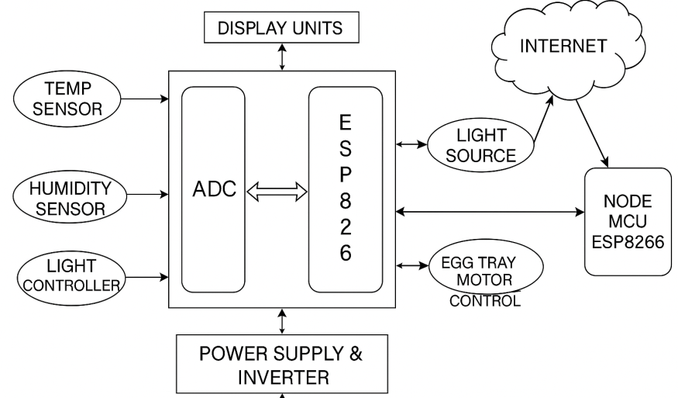

Fig.3. Block digram of incubator integrated with IoT

In the block diagram (figure 3):The IoT device serves as the main control unit for the incubator, integrating various components and enabling connectivity to the internet. Temperature and humidity sensors measure and provide data on the incubator's internal environment.A Synchronous motor is employed for egg turning, ensuring consistent embryo development. IoT connectivity allows the device to communicate with external systems, such as a cloud platform.

- Design and Integration of Solar PV System

Installation of solar PV system involves consideration of following data:

  - Power consumption demand:Total electric power consumption by all electrical utilities used per day was 1.68 kWh.
  - Sizing of pv panel: To size the solar panels was calculated using equation 1 as given by (Shrama et al., 2022).Considering the location the average solar insolation (sunlight received per day) assumed as 6 hours per day.

$Solar panel capacity= \frac{Total energy consumption}{Average insolation per day}$ (1)

  - Inverter sizing: Inverter was used to convert the fluctuating direct current (DC) into alternative current (AC). The charge controller is essential to regulate the voltage and current from the solar panels to the battery to prevent overcharging. Choose a 12V charge controller suitable for the solar panel capacity (Leonics, Accessed on December 2023).
  - Battery sizing: Battery is used to store the power in order to use it during the cloudy days. Considering 50 per cent of dept of discharge (Sharma et al., 2022), the capacity of battery can be calculated from equation 2.

$Batterycapacity=\frac{Total energy consumption }{Battery efficiency × Depth of discharge}$ (2)

Where, battery loss is assumed to be 0.80, 0.5 as depth of discharge and nominal voltage of battery to be 12v(Leonics, Accessed on December 2023).

- Methodology

- Incubation process followed

Incubation period per batch was conducted for the period of 21 days. A total number of 100 eggs per batch with age of 1 to 4 days were selected for incubation. The incubation chamber with three 15W LED bulbs were used as the source of heat to maintain temperature range of 36 – 39 ºC throughout the incubation period. With the help of ultrasonic mist maker relative humidity was maintained at 60 per cent for first 18 days and 65 per cent for last 3 days which is ideal for embryonic development and hatching of eggs by softening the egg shell respectively. Ventilation was provided with 5v DC fan to maintain and distribute the uniform environmental conditions inside the incubator. An automatic egg turning mechanism used to rotate eggs at every 6 hrs of interval for first 18 days of incubation which is essential to prevent the yolk from sticking to the shell.

- Performance evaluation

- No load test

The incubator was tested for a whole day without eggs prior to the start of incubation test to manage the environment and measure RH and temperature within the chamber. The atmospheric humidity and temperature, as well as those monitored in the incubator, were recorded at an interval of every 2 hours.

- Incubation

The incubation test was done with 8 batches based on the age of eggs and incubating temperature as referred in Table 1.

Table 1. Parameter adopted for incubation test

Independent parameters | Dependent parameters
Age of eggs (0, 4 days) | Egg fertility
Temperature (36, 37, 38, & 39 ºC) | Egg hatchability

Hatchability refers to the proportion of viable eggs that hatch throughout each incubation cycle. The incubator was filled to capacity with eggs from local poultry. Eggs were flipped every 6 hours from the second to the 18th day of assessment. The Candling test was performed to assess egg fertility and hatchability on the tenth day. Equations 3 and 4(Kabaradin, 2023) were used to calculate the ratio of fertility and hatchability.

$\text{Fertility rate, (\%)=}\frac{\text{Number of fertile eggs}}{\text{Number of total eggs }}\text{×100}$ (3)

$\text{Hatchability rate, (\%)=}\frac{\text{Number of hatched eggs}}{\text{Number of fertile eggs }}\text{×100}$ (4)
- Techno-economical evaluation

In order to assess the economic feasibility of the developed egg incubator at the industrial level(Panwar et al., 2014) proposed four economic indicators: net present worth (NPW), internal rate of return (IRR), benefit cost ratio (B/C ratio), and payback period.

The following assumptions were made to assess the viability of the developed egg incubator:

- Life span of working incubator: 10 years
- Initial cost of developed incubator: Rs. 6800
- Cost of solar PV system (Panel + Battery + Inverter + Miscellaneous): Rs. 39000 (8000+20000+8000+3000)
- The mist maker is replacement frequency: after every 7-8 incubation batches
- Repair and maintenance per year: Rs. 1300
- Discount rate: 10%
- Number of working days per batch of incubation: 21
- Number of working days per year: 315
- Number of eggs kept per batch: 100
- Cost of incubation egg: Rs. 2.5 per egg
- Average number of chicks produced per batch: 55
- Market value per chick: Rs. 22
The NPW can be computed by using the equation 5.

$\text{NPW=}\sum_{\text{t=1}}^{\text{n}}{\frac{{\text{B}}_{\text{t}}\text{-}{\text{C}}_{\text{t}}}{{\text{(1+i)}}^{\text{t}}}}$ (5)

Mathematical expression of the benefit cost ratio is given as in equation 6.

$\text{cost benefit ratio=}\frac{\sum_{\text{t=1}}^{\text{n}}{{\text{B}}_{\text{t}}}}{\sum_{\text{t=1}}^{\text{n}}{{\text{C}}_{\text{t}}}}$ (6)

IRR is the measure of rate at which return of the investment is achieved. It is a useful indicator of value of the system and provides the maximum interest to recover the investment and cost of operations and it can be computed from the equation 7.

$\sum_{\text{t=1}}^{\text{n}}{\frac{{\text{B}}_{\text{t}}\text{-}{\text{C}}_{\text{t}}}{{\text{(1+i)}}^{\text{t}}}}=0$ (7)

3. RESULTS AND DISCUSSION

- Incubator Design and Construction

The development and fabrication of the incubator was designed according to the focus on its simplicity, cost-effectiveness, material availability, and sustainability. It was also engineered to accommodate eggs of various sizes, ensuring versatility in its application.

- Incubation Chamber

The incubation chamber constructed with 6 mm thick waterproof cardboard and lined with 20 mm thick thermocol, exhibited robustness and insulation properties, respectively. This combination ensured both durability and heat retention while keeping the incubator lightweight and economical.

- Heating System

The incubator utilized three 15W LED bulbs to provide optimal heat ranging from 36 to 39°C, promoting uniform heating within the chamber. The low energy consumption of LED bulbs contributed to cost efficiency without compromising performance as compared to other heating sources employed in existing incubators.

- Ventilation and HumidityControl

A 5V DC fan was provided to facilitate the uniform distribution of heat generated by the LED bulbs across the chamber, ensuring consistent temperature conditions. Additionally, an ultrasonic mist maker was employed to regulate humidity levels inside the incubation chamber, essential for successful egg incubation.

- Microcontroller and Sensors

The incubator was equipped with aESP32 microcontroller, humidity, and temperature sensors, enabling precise control over the environment. The controller's multifunctionality allowed for temperature regulation within the range of 36-39°C and humidity maintenance between 60 to 65 per cent, optimizing conditions for egg incubation. Furthermore, the microcontroller controlled the automatic turning of eggs at 6-hour intervals, mimicking natural incubation conditions.

- Solar PV System

The incubator was supplied with the solar power using battery assisted PV system for uninterrupted power supply. The Solar system was designed based on the daily power consumption of the incubator which was summed up to 1.68 kW per day. To meet the calculated power consumption the a 300 W solar PV panel accommodated with 12 V 350 A-h battery with a 1kW inverter with integrated charge controller was installed. The set up of the incubator with solar assistance was as shown in the figure 4.
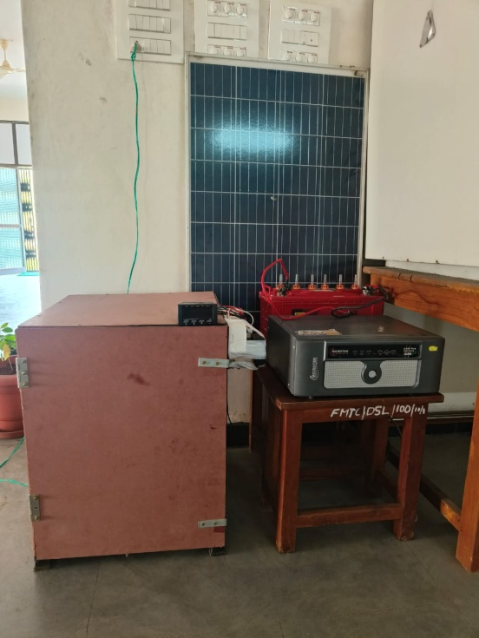

Fig.4. Components of solar powered IoT controlled poultry egg incubator

- Performance Evaluation

The incubator underwent rigorous testing, including a no-load test to assess environmental control capabilities. Subsequent incubation tests with eight batches of eggs varying in age and temperature revealed satisfactory results in terms of egg fertility and hatchability rates. Candling tests performed on the tenth day allowed for the evaluation of egg viability as shown in the figure 5.
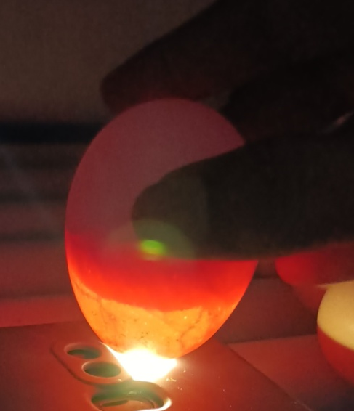

Fig.5. Performing the candling process

      - No-load test

During no-load test the incubator temperature and RH were set at 38.5 ºC and 62.5 per cent respectively. Table 2.and Figure 6.shows the variations in temperature and RH maintained by incubator and change in ambient temperature and RH at that time.

Table 2. Temperature and RH during No-load

Sl. No. | Time interval of 2 h | Incubator |  | Ambient
Sl. No. | Time interval of 2 h | Temperature | RH | Temperature | RH
1 | 10.00 | 37.3 | 59.5 | 33 | 35
2 | 12.00 | 38.1 | 61.3 | 35 | 30
3 | 14.00 | 39.1 | 62.4 | 36 | 25
4 | 16.00 | 38.5 | 62.9 | 36 | 24
5 | 18.00 | 38.6 | 62.6 | 35 | 29
6 | 20.00 | 38.3 | 63.2 | 32 | 31
7 | 22.00 | 38.4 | 62.4 | 30 | 34
8 | 00.00 | 38.5 | 61.9 | 28 | 42
9 | 02.00 | 38.6 | 63.0 | 27 | 38
10 | 04.00 | 38.4 | 62.1 | 26 | 36
11 | 06.00 | 38.3 | 62.8 | 26 | 37
12 | 08.00 | 38.6 | 62.4 | 28 | 32

Fig.6. Graphical representation of incubator performance during no load test

      - Incubation

The incubator utilizes a pre-programmed controller for temperature, relative humidity, and egg turning mechanisms, ensuring optimal environmental conditions for poultry egg development (figure 7). Throughout the 21-day incubation period, the chamber maintains a temperature range of 36–39 °C using LED lighting, while relative humidity was maintained at 60–65 per cent with the assistance of a 5V DC fan and an open water trough. Table 3.And Figure 8. Show the performance of incubator at different temperatures i.e., Egg fertility rates ranged from 84 per cent to 88 per cent, with slightly higher rates observed for eggs aged 1 day compared to those aged 4 days. Hatchability rates varied depending on both egg age and incubation temperature, with the highest hatchability observed at 38°C across both age groups.
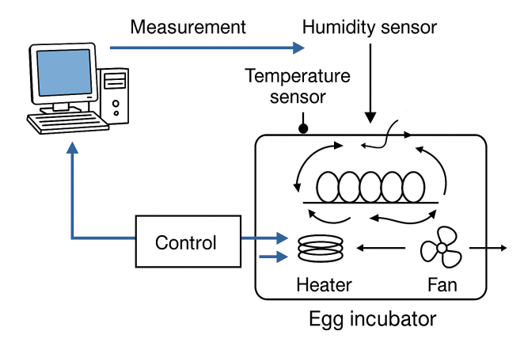
Fig.7. Working of Incubator

Impact of Incubation Temperature:

Incubation temperature had a significant effect on egg hatchability. Optimal rates of 80 per cent and 74 per cent were observed at 38 °C for 1-day-old and 4-day-old eggs, respectively, while higher temperatures (39 °C) reduced hatchability to 78 per cent and 70 per cent, particularly for older eggs. This indicates that precise temperature control is critical for maximizing hatchability. Overall, the incubator achieved average hatchability of 78 per cent and 72.5 per cent for 1-day-old and 4-day-old eggs, respectively.

Survival of Hatched Chicks:

Survival rates of hatched chicks ranged from 49 per cent to 64 per cent, with higher rates generally observed at lower incubation temperatures (36-37°C) compared to higher temperatures (38-39°C).Chicks hatched from eggs incubated at 38°C exhibited the highest survival rates i.e. 64 per cent and 53 per cent across both 1 and 4 days age groups respectively.Overall on an average the incubator performance leads to achieve 61 and 50.75 per cent of survival rate for the 1 and 4 days old eggs.

Table 3. Overall performance of the solar powered IoT controlled poultry egg incubator
Age of eggs, days | Temperature, ºC | Egg fertility, (out of 100 eggs) | Egg hatchability, (out of 100 eggs) | Survived chicks, (out of hatched eggs)
1 | 36 | 86 | 76 | 57
1 | 37 | 88 | 78 | 63
1 | 38 | 88 | 80 | 64
1 | 39 | 86 | 78 | 60
4 | 36 | 84 | 72 | 50
4 | 37 | 86 | 74 | 51
4 | 38 | 84 | 74 | 53
4 | 39 | 84 | 70 | 49

Fig.8. Graphical representation of performance of Solar powered IoT controlled egg incubator

Performance evaluation of the developed incubator showed average operational temperature and relative humidity of 37.5 °C and 62 per cent, respectively, closely matching the optimal conditions of traditional incubators. The prototype achieved 78 per cent hatchability and 79.7 per cent survival for day-old chicks, demonstrating that precise control of temperature, humidity, and egg turning directly contributes to successful incubation. These results highlight the incubator’s effectiveness in replicating conventional incubation outcomes while providing the additional advantages of automated monitoring and remote control.

- Techno-Economical Evaluation

The viability of the incubator was assessed using economic indicators proposed by Panwaret al, 2014. These included net present worth (NPW), internal rate of return (IRR), benefit-cost ratio (B/C ratio), and payback period. Assumptions regarding the lifespan of the incubator, replacement of components, and operational parameters were made to compute these indicators. The parameters and assumptions made to assess the economic evaluation of the incubator were as follows
- Net Present Worth (NPW): The NPW of the egg incubator over a 10-year period is approximately Rs. 35948.10, indicating that the investment in the incubator is financially beneficial.
- Internal Rate of Return (IRR): The IRR of the egg incubator is approximately 103.122 per cent, which exceeds the discount rate of 10 per cent. This suggests that the investment is profitable.
- Cost-Benefit Ratio: The cost-benefit ratio of the egg incubator is approximately 1.38, indicating that for every 100 unit of cost, the incubator generates over 138 units of revenue. This demonstrates the economic viability of the investment in the egg incubator.

4. CONCLUSION

The development and performance evaluation of the solar powered IoT controlled poultry incubator offer valuable insights into the potential benefits of integrating automation technology and sustainable energy conservation practices into poultry farming practices. The incubator's robust, economical, efficient, sustainable, and user-friendly design; precise environmental control mechanisms for maintaining optimal temperature and humidity conditions; coupled with the incorporation of automated features; and satisfactory performance in hatchability trials underscore its potential to enhance hatchery success rates and streamline egg incubation processes. Also, the integration of the solar PV system directly and indirectly helped by reducing energy costs and environmental impact; the combined system contributes to the economic viability and environmental sustainability of poultry farming practices. Moreover, the positive results of the techno-economic evaluation highlight the financial viability of investing in the developed incubator, making it an attractive option for poultry farmers seeking to improve efficiency and profitability. Moving forward, further research and refinement of the incubator design and operation could lead to even greater advancements in hatchery technology, ultimately benefiting both farmers and consumers by ensuring a consistent and sustainable supply of poultry products.

Disclaimer (Artificial intelligence)
Option 1:
Author(s) hereby declare that NO generative AI technologies such as Large Language Models (ChatGPT, COPILOT, etc.) and text-to-image generators have been used during the writing or editing of this manuscript.

REFERENCES

Aldair, A. A., Rashid, A. T., & Mokayef, M. (2018, November). Design and implementation of intelligent control system for egg incubator based on IoT technology. In 2018 4th International Conference on Electrical, Electronics and System Engineering. IEEE, 49-54. https://doi.org/10.1109/ICEESE.2018.8703539
Abutu, J., Umar, M., Midala, J. W., Odeh, A. M., Haruna, G., Ike, C., & Lawal, S. A. (2025). Development of a Solar-Powered Incubator for Poultry Eggs. International Journal of Engineering Materials and Manufacture, 10(1), 1-9. https://orcid.org/0000-0003-1494-9201
Bi, B. E. B., Koffi, E. P. M., & Gbaha, P. (2024). Experimental study of a solar thermal incubator using a phase-change material for off-grid use. Open Journal of Applied Sciences, 14(9), 2471-2481. https://doi.org/10.4236/ojapps.2024.149163
FOOD, R., & AFFORDABLE, H. D. M. (2022). Food security and nutrition in the World.
Gulati, A., & Juneja, R. (2023). Poultry Revolution in India: Lessons for smallholder production systems (No. 225). ZEF working paper series. https://hdl.handle.net/10419/278686
Gu, D., Andreev, K., & Dupre, M. E. (2021). Major trends in population growth around the world. China CDC weekly, 3(28), 604.
Hunter, M. C., Smith, R. G., Schipanski, M. E., Atwood, L. W., & Mortensen, D. A. (2017). Agriculture in 2050: recalibrating targets for sustainable intensification. Bioscience, 67(4), 386-391. https://doi.org/10.1093/biosci/bix010
Ikpeseni, S. C., Owebor, K., Owamah, H. I., Sada, S. O., Dibie, E. C., & Odeh, O. E. (2022). Design and fabrication of a local solar-powered poultry egg incubator for a low-income country. Journal of The Institution of Engineers (India): Series B, 103(3), 779-790. https://link.springer.com/article/10.1007/s40031-021-00701-7
Jacob, P. M., Moni, J., Simon, S., Beegam, S., & Sasidharan, S. (2025, February). An Automated Smart Incubator System for Poultry Farms and Hatcheries. In 2025 Emerging Technologies for Intelligent Systems. IEEE, 1-5. https://doi.org/10.1109/ETIS64005.2025.10961849
Kabaradin, A. (2023). Development and Performance Evaluation of Home-Made Electric and Kerosene Lump Egg Incubator. International Journal of Precision Farming, 1(1), 31-41. https://doi.org/10.54536/ijpf.v1i1.2176
Kapen, P. T., Youssoufa, M., Foutse, M., Manfouo, H., & Mbakop, F. O. N. (2020). Design and prototyping of a low-cost, energy efficient eggs incubator in developing countries: A case study of Cameroon. Scientific African, 10, e00618. https://doi.org/10.1016/j.sciaf.2020.e00618
Kolog, E. (2023). Enhancing innovative ideas implementation: a study of Finland’s poultry industry. https://urn.fi/URN:NBN:fi-fe2023080493079
Leonics. How to Design Solar PV System [Internet].Leonics; c2023 [cited 12 December 2023] Available from: http://www.leonics.com/support/article2_12j/articles2_12j_en.php
Liang, C., & Shah, T. (2023). IoT in agriculture: The future of precision monitoring and data-driven farming. Eigenpub Review of Science and Technology, 7(1), 85-104.https://studies.eigenpub.com/index.php/erst
Lim, K., Bastawrous, H. A., Duong, V. H., See, K. W., Zhang, P., & Dou, S. X. (2016). Fading Kalman filter-based real-time state of charge estimation in LiFePO4 battery-powered electric vehicles. Applied Energy, 169, 40-48. https://doi.org/10.1016/j.apenergy.2016.01.096
Li, H., Diederich, S., & Cai, H. (2022). A new LED luminaire system architecture for energy saving. Indoor and Built Environment, 31(6), 1654-1674. https://doi.org/10.1177/1420326X211052529
Mesquita, M. A., Araújo, I. C., Café, M. B., Arnhold, E., Mascarenhas, A. G., Carvalho, F. B., ... & Gonzales, E. (2021). Results of hatching and rearing broiler chickens in different incubation systems. Poultry Science, 100(1), 94-102..https://doi.org/10.1016/j.psj.2020.09.028
Mottet, A., & Tempio, G. (2017). Global poultry production: current state and future outlook and challenges. World's poultry science journal, 73(2), 245-256. https://doi.org/10.1017/S0043933917000071
Neethirajan, S. (2022). Automated tracking systems for the assessment of farmed poultry. Animals, 12(3), 232. https://doi.org/10.3390/ani12030232
Olorunnisola, A. O. (2021). Potentials of wood, bamboo and natural fibre-reinforced composite products as substitute materials for fabricating affordable agricultural equipment and processing machines in Africa. In Technology in Agriculture. IntechOpen. DOI: 10.5772/intechopen.98265
Pandey, R., Sinha, A., & Sharma, A. K. (2023, September). Design and development of smart hybrid solar PV driven automatic electric egg incubator. In AIP Conference Proceedings (Vol. 2863, No. 1, p. 020029). AIP Publishing LLC. https://doi.org/10.1063/5.0158005
Panwar, N. L., Kothari, S., & Kaushik, S. C. (2014). Cost-benefit and systems analysis of passively ventilated solar greenhouses for food production in arid and semi-arid regions. Environment systems and decisions, 34(1), 160-167. https://doi.org/10.1007/s10669-013-9438-5
Peprah, F., Gyamfi, S., Amo-Boateng, M., Buadi, E., & Obeng, M. (2022). Design and construction of smart solar powered egg incubator based on GSM/IoT. Scientific African, 17, e01326.https://doi.org/10.1016/j.sciaf.2022.e01326
Sharma, K., Kothari, S., Panwar, N. L., & Rathore, N. (2022). Design and development of solar energy powered maize milling machine. International Journal of Ambient Energy, 43(1), 1671-1676. https://doi.org/10.1080/01430750.2020.1712241
Wu, D., Cui, D., Zhou, M., & Ying, Y. (2022). Information perception in modern poultry farming: A review. Computers and Electronics in Agriculture, 199, 107131.https://doi.org/10.1016/j.compag.2022.107131

Symbols and units
per cent - Percentage
W – Watt
V – Voltage
mm – millimeter
ºC – Degree Celsius
Rs. – Rupees
C_{t} - Cost in each year
B_{t} - Benefit in each year
t – number of years (1, 2, 3………….n)
i - Discount rate, %
Abbreviations
AC – Alternating current
ADC - Analog to digital converter
B/C ratio – benefit cost ratio
DAC - Digital to analog converter
DC – Direct current
et. al. – And others
I2C - Inter Integrated Circuit
IRR – Internal rate of return
LCD – Liquid crystal display
LED – Light emitting diode
lwh – length width height
NPW – Net present worth
PWM - Pulse Width Modulation
RH – Relative humidity
SOC - System on chip
SPI - Serial Peripheral Interface
UART - Universal Asynchronous Receiver Transmitter

