Eosinophilic Esophagitis During Milk Oral Immunotherapy in a Child With Severe IgE-Mediated CMPA: Case Report
Abstract
Background: Oral immunotherapy (OIT) for persistent cow’s milk protein allergy (CMPA) can improve protection against accidental exposures, but gastrointestinal adverse events, including eosinophilic esophagitis (EoE), are increasingly recognized.
Case: A 4.5-year-old boy with severe IgE-mediated CMPA and atopy began milk OIT. After 6 weeks he developed odynophagia, dysphagia, vomiting, anorexia, and weight stagnation.
Diagnosis & Treatment: Upper endoscopy showed EoE with peak 78 eosinophils/high-power field (eos/HPF). A strict milk-free diet, proton-pump inhibitor, and swallowed topical budesonide were initiated.
Outcome: Symptoms resolved with weight catch-up; follow-up biopsies at 3 months showed remission (3 eos/HPF).
Conclusion: In high-risk, highly atopic children, OIT warrants close clinical and endoscopic monitoring. When EoE is suspected, guideline-based evaluation (EREFS, ≥6 biopsies from ≥2 levels) and early anti-inflammatory therapy are recommended.
Keywords: cow’s milk protein allergy; oral immunotherapy; eosinophilic esophagitis; child; atopy

Introduction
Food allergies represent a growing public health concern, affecting approximately 6–8% of children in industrialized countries, with a significant impact on quality of life and risk of severe reactions.
Among them, cow’s milk protein allergy (CMPA) is one of the most common, with an estimated prevalence of 2–3% in infants. It manifests with a wide clinical spectrum ranging from mild cutaneous or digestive symptoms to potentially life-threatening anaphylaxis.
The standard management relies on strict avoidance of the allergen, an effective yet restrictive approach, exposing patients to nutritional and psychosocial risks. Oral immunotherapy (OIT), also known as oral tolerance induction (OTI), is gradually emerging as a therapeutic alternative. It consists of the progressive and controlled administration of the allergen with the aim of inducing immune tolerance.
Several clinical trials have demonstrated promising efficacy, with an increased reactivity threshold and reduced risk of accidental reactions. However, OIT is not without adverse effects. In addition to immediate allergic reactions, delayed gastrointestinal manifestations may occur, among which eosinophilic esophagitis (EoE) has attracted particular attention.
EoE is a chronic inflammatory disorder of the esophagus characterized by significant eosinophilic infiltration and dysphagia. Its association with OIT is increasingly recognized, particularly in patients with a strong atopic background.
We report a case of EoE occurring during OIT for severe CMPA in a child and provide a review of the literature on mechanisms, risk factors, and clinical implications of this complication.
Methods :
We searched PubMed, Embase, and Cochrane from Jan 2013 to Oct 2025 using (‘eosinophilic esophagitis’ AND (‘oral immunotherapy’ OR ‘OIT’) AND (‘milk’ OR ‘cow’s milk protein allergy’)). We included guidelines, systematic reviews, cohort studies, and case series addressing EoE during/after OIT in children. Key guidance documents informing diagnostic standards, biopsy protocols, and pediatric management were ACG 2025 and ESPGHAN 2024

Clinical Case Report
We report the case of a 4.5-year-old boy, born by cesarean section, breastfed until 18 months of age, with food diversification starting at 5 months. Family history was notable for maternal asthma. The child had a personal history of atopy, including severe CMPA, allergic rhinitis, and well-controlled asthma since the age of 2 years.
The diagnosis of CMPA was established at 5 months, following ingestion of dairy products (yogurt, cheese) that led to persistent vomiting and lethargy within 20 minutes.
The initial allergy workup revealed positive skin tests to milk, meat, and fish, confirmed by elevated specific IgE levels: alpha-lactalbumin 4.8 kU/L, beta-lactoglobulin 6.16 kU/L, and casein 3.95 kU/L. The child also presented contact urticaria to meat. At 18 months, repeated testing confirmed strong sensitization, with milk-specific IgE levels exceeding 100 kU/L.
At 3 years, an oral food challenge (OFC) was performed to determine the reactive dose and initiate OIT. The reaction occurred at a very low dose (3 mL), with cyanosis, angioedema, and respiratory distress. Despite this high reactivity profile, OIT was initiated at parental request to reduce the risk of accidental anaphylaxis.
Doses were increased very gradually, with frequent adjustments due to transient digestive symptoms. After 6 weeks, the child developed odynophagia, dysphagia, vomiting, anorexia, and weight stagnation.
Esophagogastroduodenoscopy revealed an inflamed esophageal mucosa with marked eosinophilic infiltration (78 eosinophils/high-power field), confirming the diagnosis of EoE.
A strict cow’s milk exclusion diet was implemented, combined with proton pump inhibitors and topical viscous budesonide. Evolution was favorable, with weight gain recovery, symptom resolution, and endoscopic/histological improvement after 3 months (3 eosinophils/HPF).
Table 1. Patient Demographics and Clinical Characteristics
Characteristic | Value
Age at presentation (years) | 4.5
Family history of Atopy | Maternal Asthma
Personal Atopy | Severe IgE-mediated CMPA, allergic rhinitis
Initial sensitization tests (SPT) | Positive to milk, meat, fish
Specific IgE (initial) | α‑lactalbumin 4.8 kU/L; β‑lactoglobulin 6.16 kU/L; casein 3.95 kU/L
Specific IgE (repeat at 18 months) | Milk‑specific IgE > 100 kU/L

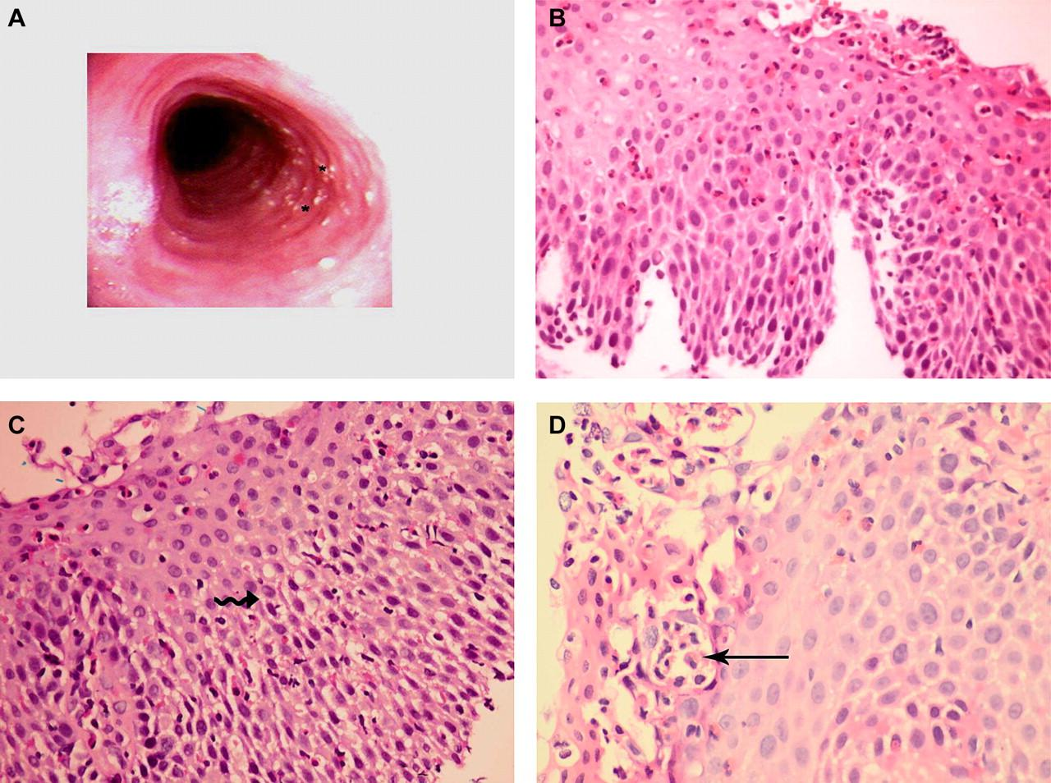
Figure 1. Endoscopic and histopathologic features of eosinophilic esophagitis during milk oral immunotherapy

A: Upper endoscopy showing concentric mucosal rings (“trachealization”; asterisks) with scattered punctate white exudates—EREFS features compatible with eosinophilic esophagitis. B–D: Hematoxylin–eosin–stained esophageal biopsies demonstrating basal cell hyperplasia and papillary elongation (B), dense intraepithelial eosinophilic infiltration with degranulation (C; wavy arrow), and an intraepithelial eosinophilic microabscess (D; straight arrow).

Discussion
1. Context and epidemiological data
CMPA is the most frequent food allergy in infants, affecting about 2–3% of children in industrialized countries. Most cases resolve before school age, but a significant proportion persists into adolescence, particularly in severe IgE-mediated forms.
OIT has emerged as a promising approach to induce tolerance and reduce the risk of accidental reactions, with variable success rates depending on protocols. However, OIT may cause adverse effects, ranging from immediate allergic reactions to delayed gastrointestinal complications. Among these, EoE has attracted growing interest, as its association with OIT in CMPA and other food allergies is now well documented.
2. Pathophysiological link between OIT and EoE
EoE is a chronic inflammatory disease of the esophagus, defined by eosinophilic infiltration ≥15 cells/HPF in the absence of other causes. It is often triggered by food allergens, cow’s milk being among the most frequent.
Proposed mechanisms for post-OIT EoE include:
- Th2 pathway activation: repeated allergen exposure stimulates pro-inflammatory cytokine production (IL-5, IL-13), promoting eosinophilic infiltration.
- Epithelial barrier dysfunction: favored by gastroesophageal reflux or genetic predisposition, increasing mucosal permeability and allergen access.
- Esophageal dysbiosis: alterations of local microbiota may modulate the immune response.
3. Identified risk factors
Several factors appear to increase the likelihood of developing EoE during OIT:
- Atopic background (asthma, allergic rhinitis, atopic dermatitis)
- High IgE sensitization (very elevated milk-specific IgE and fractions)
- Frequent and prolonged allergen exposure in persistent hypersensitivity
- Family history of atopy and genetic variations affecting mucosal barrier regulation and inflammatory response
Our patient presented multiple risk factors: strong atopic background, milk-specific IgE >100 kU/L, family history of atopy, and high reactivity at OFC.
4. Clinical implications
This case highlights the need for careful selection of OIT candidates, along with close clinical monitoring, especially in high-risk patients.
Persistent or progressive digestive symptoms (dysphagia, odynophagia, vomiting, weight stagnation) should prompt early endoscopic evaluation to rule out EoE.
Preventive strategies may include:
- Slower dose escalation protocols
- Immunological and possibly genetic evaluation before OIT
- Multidisciplinary management involving allergists and pediatric gastroenterologists
Early recognition of EoE enables effective management based on the three therapeutic pillars: elimination diet, pharmacologic treatment (PPIs, topical corticosteroids), and, rarely, esophageal dilation.
5. Perspectives
Personalized medicine paves the way for individualized OIT protocols. Genetic and immunological testing could help identify children at high risk of developing EoE, allowing tailored dosing and monitoring.
Targeted biologics addressing Th2 pathways are under evaluation and may provide alternative treatment options for refractory EoE.

Conclusion
Oral immunotherapy represents an innovative therapeutic option for persistent and severe cow’s milk protein allergy.
However, the onset of eosinophilic esophagitis during this treatment, though rare, constitutes a potentially severe complication that may compromise success.
Our case highlights the importance of identifying at-risk patients, particularly those with a strong atopic background and high IgE sensitization.
Close clinical surveillance and early endoscopic evaluation in case of digestive symptoms are crucial for timely diagnosis and effective management.
In the future, the development of personalized approaches integrating immunological and genetic data could optimize the risk–benefit balance of OIT while reducing the incidence of inflammatory complications such as eosinophilic esophagitis.
Declarations :

Ethics & reporting statements
- Patient consent: Written informed consent for publication of clinical details and images was obtained from the patient’s legal guardians.
- Ethics approval: According to our institution’s policy, single-patient case reports do not require IRB approval; no identifying details are published.
- Reporting guideline: This case was prepared in accordance with the CARE checklist (attached as Supplement)
Disclaimer
Author(s) hereby declare that NO generative AI technologies such as Large Language Models (ChatGPT, COPILOT, etc.) and text-to-image generators have been used during the writing or editing of this manuscript.

References:
1.Schoemaker AA, Sprikkelman AB, Grimshaw KE, Roberts G, Grabenhenrich L, Rosenfeld L, et al. Incidence and natural history of challenge-proven cow’s milk allergy in European children — EuroPrevall birth cohort. Allergy. 2015;70(8):963-72. doi:10.1111/all.12630.
2. Allen KJ, Heine RG. Eosinophilic oesophagitis: a pediatric update. J Paediatr Child Health. 2015 ;54(9):974-80. doi:10.1111/jpc.12757 .
3. Papadopoulou A, Koletzko S, Heuschkel R, Dias JA, Allen KJ, Murch SH, et al. Management guidelines of eosinophilic esophagitis in childhood: ESPGHAN expert recommendations. J Pediatr Gastroenterol Nutr. 2014;58(1):107-18
4. Liacouras CA, Furuta GT, Hirano I, Atkins D, Attwood SE, Bonis PA, et al. Eosinophilic esophagitis: updated consensus recommendations for children and adults. J Allergy Clin Immunol. 2011;128(1):3–20.e6.
5. Fahad I Alsohaibani , , Musthafa C Peedikayil . Eosinophilesophagitis: current insights on diagnosis and treatment. The Saudy journal of gastroenterology. 2024;50(1).
6. Burk CM, Shreffler WG. Triggers for Eosinophilic Esophagitis (EoE): The Intersection of Food Allergy and EoE. J Allergy Clin Immunol. 2024;153:1500–1509.
7.Dellon ES, Liacouras CA, Molina-Infante J, Furuta GT, Spergel JM, Zevit N, et al. Updated international consensus diagnostic criteria for eosinophilic esophagitis: proceedings of the AGREE conference. Gastroenterology. 2018;155(4):1022-33. doi:10.1053/j.gastro.2018.07.009.
8. Muir AB, Falk GW. Eosinophilic esophagitis — A review. JAMA. 2021;326(13):1310-8. doi:10.1001/jama.2021.14920.
9. Amil-Dias J, Levy EI, Papadopoulou A, Bindels LB, Chong-Neto HJ, Díaz JJ, et al. Diagnosis, treatment and follow-up of paediatric eosinophilic oesophagitis: ESPGHAN position paper. J Pediatr Gastroenterol Nutr. 2024;78(1):141-57. doi:10.1002/jpn3.12188.
10. Dellon ES, Muir AB, Katzka DA, Aceves SS, Alexander JA, Atkins D, et al. ACG Clinical Guideline: Diagnosis and Management of Eosinophilic Esophagitis. Am J Gastroenterol. 2025;120(1):31-59. doi:10.14309/ajg.0000000000003194.
11 . O’Shea KM, Aceves SS, Dellon ES, Gupta SK, Spergel JM, Furuta GT, et al. Pathophysiology of eosinophilic esophagitis. Gastroenterology. 2018;154(2):333-45. doi:10.1053/j.gastro.2017.06.065.
12 . Biedermann L, Straumann A. Eosinophilic oesophagitis: pathogenesis, diagnosis and therapy. Nat Rev Gastroenterol Hepatol. 2022;19(10):615-29. doi:10.1038/s41575-022-00679-3.
13 . Lucendo AJ, Arias Á, Tenias JM. Relation between eosinophilic esophagitis and oral immunotherapy for food allergy: a systematic review with meta-analysis. Ann Allergy Asthma Immunol. 2014;113(6):624-9. doi:10.1016/j.anai.2014.08.004.
14 . Cianferoni A. Eosinophilic esophagitis as a side effect of food oral immunotherapy. Curr Opin Allergy Clin Immunol. 2020;20(6):616-22. doi:10.1097/ACI.0000000000000702.
15. Frangiosa C, Safroneeva E, Wang Q, Schoepfer AM, Katzka DA, Dellon ES. Risk of eosinophilic esophagitis in pediatric patients undergoing oral immunotherapy for food allergy: a real-world cohort study. J Allergy Clin Immunol. 2024;153(2):AB241. (Abstract, meeting data).
16. Byrne NW, Chan ES, Abrams EM, Vander Leek TK, Ellis AK. Monitoring for eosinophilic esophagitis in individuals receiving peanut oral immunotherapy: a consensus document. Ann Allergy Asthma Immunol. 2024;132(6):685-92. doi:10.1016/j.anai.2024.03.015.
17 . Fiocchi A, Brożek J, Schünemann H, Bahna SL, von Berg A, Beyer K, et al. World Allergy Organization (WAO) Diagnosis and Rationale for Action against Cow’s Milk Allergy (DRACMA) Guideline update – XIII. World Allergy Organ J. 2022;15(7):100690. doi:10.1016/j.waojou.2022.100690.
18. Reed, C. C., &amp; Dellon, E. S. (2019). Eosinophilic esophagitis. Evidence‐based Gastroenterology and Hepatology 4e, 50-67.
19. ACG Clinical Guideline: Diagnosis and Management of EoE (2025; Am J Gastroenterol; doi:10.14309/ajg.0000000000003194).
20. ESPGHAN pediatric update on EoE (2024; JPGN; doi:10.1002/jpn3.12188).
21. Wilson BE et al. The relationship between EoE and immunotherapy (2024 review).
22. Wechsler JB et al. Validation of the EREFS system (2018).

