Evaluation of Engineering Properties of Groundnut Plants and Pods for Efficient Pod Stripper Design

Abstract
Efficient mechanization of groundnut stripping necessitates a detailed understanding of the crop’s physical and mechanical properties to support the design and optimization of threshing and stripping equipment. This study evaluated the key engineering characteristics of groundnut plants and pods to aid in developing an efficient pod stripper. The number of pods per plant ranged from 18 to 40 (mean 28.91), with an average of 10.67 branches and 912.98 g plant weight with pods. The mean pod dimensions—length, width, thickness, and geometric mean diameter—were 33.04 mm, 12.39 mm, 11.01 mm, and 16.47 mm, respectively. Bulk and true densities were 279.84 kg/m³ and 574.60 kg/m³, corresponding to a porosity of 50.72%. At 20% moisture content, the sphericity, aspect ratio, surface area, and volume averaged 0.59, 2.70, 855.84 mm², and 755.86 mm³, respectively. Mechanical parameters included an angle of repose of 25.9°, terminal velocity of 9.08 m/s, and coefficients of static friction of 0.36, 0.44, and 0.39 on glass, steel, and plywood surfaces, respectively. Rupture forces were highest in the lateral direction (240.23 N), followed by longitudinal (64.36 N) and vertical (32.74 N) orientations.
The findings indicate that pod geometry, density, and frictional behaviour critically influence the design of stripping and cleaning units, such as concave clearance, drum configuration, and blower velocity. Overall, the evaluated properties establish a reliable database for optimizing pod stripper design, enhancing operational efficiency, minimizing pod breakage, and promoting cost-effective, energy-efficient, and farmer-friendly mechanized solutions for sustainable groundnut production.
Keywords: Groundnut pod stripper; Engineering properties; Physical and mechanical characteristics; Post-harvest mechanization; Rupture force; Coefficient of friction; Bulk and true density; Design optimization

- INTRODUCTION
Groundnut (Arachis hypogaea L.) is a leguminous crop cultivated extensively across tropical and subtropical regions. It is highly valued for its oil-rich edible seeds, ranking as the world’s fourth-largest source of edible oil and the third-largest source of vegetable protein. Beyond its role as an oilseed crop, groundnut seeds are widely utilized in confectioneries, snack mixtures, breakfast items, and processed products such as peanut butter, which serves as a substitute for dairy butter. Due to its high nutritional and economic value, groundnut is considered one of the most important oilseed crops in India and a major agricultural commodity in international trade.
Globally, groundnut is cultivated on approximately 29.5 million hectares, producing about 48.7 million tonnes at an average yield of 1647 kg ha⁻¹. India accounts for the largest acreage under groundnut cultivation and is the second-largest producer, with an annual production of 101 lakh tonnes from 55.6 lakh hectares across all seasons (Anonymous, 2021). Cultivation occurs during kharif, rabi, and summer seasons, although nearly 80% of the crop is produced during the kharif season (June–October). Among Indian states, Gujarat leads in area (1.83 m ha), followed by Andhra Pradesh (1.38 m ha), Karnataka (0.65 m ha), Tamil Nadu (0.33 m ha), and Maharashtra (0.31 m ha). In terms of productivity, Tamil Nadu ranks first (2382 kg ha⁻¹), followed by Gujarat (1603 kg ha⁻¹), Maharashtra (1247 kg ha⁻¹), Karnataka (705 kg ha⁻¹), and Andhra Pradesh (650 kg ha⁻¹) (Kaushikbhai et al., 2021).
In Chhattisgarh, groundnut covers a total area of 67.7 thousand hectares, producing 70.2 thousand tonnes with an average productivity of 1036 kg ha⁻¹ (Anonymous, 2018). Among its 27 districts, Raigarh contributes significantly, accounting for 24.33% of the total groundnut acreage and 23.30% of state production. The soils of Chhattisgarh, primarily Entisols in districts such as Raipur, Durg, Rajnandgaon, and Bilaspur, and Vertisols in Surguja and Raigarh, provide a favorable environment for the expansion of groundnut cultivation. Over time, improvements in irrigation infrastructure and the promotion of low-cost input technologies have further encouraged its adoption. Consequently, the cultivated area under groundnut in Chhattisgarh is showing a steady and significant upward trend.
Despite its potential, the cultivation and post-harvest handling of groundnut face several challenges. One of the most labor-intensive operations is pod stripping, which involves separating pods from harvested plants. Traditional stripping methods rely heavily on manual labor, requiring continuous knee bending and hand-picking. This not only causes drudgery and musculoskeletal strain among farm workers, particularly women, but also leads to injuries to fingers during repetitive operations. Damaged pods resulting from manual stripping are downgraded and used primarily for oil extraction rather than for higher-value food purposes, thereby reducing farmer income. Furthermore, continuous hand-picking exposes laborers to insect bites and, in some reported cases in Chhattisgarh, scorpion stings.
The average cost of groundnut cultivation in Chhattisgarh is estimated at ₹18,276.43 per hectare, with stripping and cleaning operations accounting for nearly 78% of the labor costs (Rathiya, 2015). This underscores the urgent need for research and development of mechanized stripping solutions to minimize labor requirements, reduce post-harvest losses, and enhance economic returns for farmers. A better understanding of the physical and mechanical properties of groundnut plants and pods is critical for the design of efficient machinery suited to local agro-climatic conditions. Such advancements would not only improve productivity but also alleviate the drudgery associated with traditional post-harvest practices, ensuring sustainable groundnut cultivation in regions like Chhattisgarh.
While some studies have reported on the properties of groundnut kernels, there is a lack of comprehensive data on the physical and mechanical properties of the entire plant and pods for varieties commonly grown in the central Indian region of Chhattisgarh. This study, therefore, aims to fill this gap by conducting a detailed evaluation of the key engineering properties of groundnut plants and pods. The specific objectives were to determine: (1) the physical properties (dimensions, mass, density, porosity) of the pods; (2) the mechanical properties (rupture force, angle of repose, coefficient of friction, terminal velocity) of the pods; and (3) the physical characteristics of the groundnut plant. The resulting database is intended to provide critical inputs for the rational design and optimization of efficient and damage-minimizing pod stripping machinery under local conditions.
Materials and Methods
The groundnut variety Chhattisgarh Mungfali-1 (CGM-1) was used for this study. Mature and well-developed pods were randomly collected from the experimental fields of the Department of Agronomy, Indira Gandhi Krishi Vishwavidyalaya (IGKV), Raipur, Chhattisgarh, India. The collected pods were manually cleaned to remove foreign materials such as dust, dirt, broken, and immature pods to ensure sample uniformity and accuracy of measurements.
The initial moisture content of the pods was determined using the standard hot air oven method (AACC, 2000), expressed on a wet basis, by applying the following formula:
$$MC\left(\%\right)=\frac{W_{2} – W_{3}}{W_{3}-W_{1}}×100$$
Where,
MC = Moisture content on a dry basis, in percentage; W₁= The bowl's initial weight, g; W₂= The sample's weight upon drying; and W₃ = Bowl weight, g, plus sample weight upon drying.
- Linear dimension of pods
To determine the size and shape of groundnut pods, length, breadth and thickness of randomly selected 10 pods for measurement by using digital Vernier caliper with least count reading 0.01 mm and its average was recorded.
$$GMD ={(LBT)}^{\frac{1}{3 } }$$
- Surface area
The surface area (S) was calculated by using the following formula by (Moses & Zibokere 2011).
$${ S=π(GMD)}^{2}$$
- Sphericity
Sphericity is defined as the ratio of the surface area of the sphere having the same volume as that of the pods to the surface area of the pod and it was determined using following formula (Muhammad et al.2015).
$$Φ =\frac{{(LBT)}_{3}^{1}}{L}$$
Where, L=Length of pod, mm; B= Breadth of pod, mm; and T= Thickness of pod, mm.
- Volume
By measuring the grain along its three axes of length, breadth, and thickness, the volume of the pod was calculated then used the following relationship to estimate the pod's volume (Muhammad et al.2015).
$$V =\frac{πLBT}{6}$$
Where, V = Volume, mm³; L = Length of pod, mm; B = Breadth of pod, mm; T = Thickness of pod, mm; and π = constant (22/7).
- Thousand Pod Mass
Using a precise electronic balance with 0.01g accuracy, the mass of 1000 units was calculated. 100 randomly chosen samples were weighed in order to test the 1000 unit mass, and the mean results were given (Chukwu et al., 2018).
- Bulk Density
The method reported by (Muhammad et al.2015) was adopted for bulk density determination. A 75 × 75 × 90 mm box was filled with groundnut pods and weighed using an electronic balance of 0.01g accuracy. The trials were repeated five times using different sets of pods for each variety and the bulk density was calculated from the following equation.
$$BD =\frac{W_{S}}{V_{S}}$$
Where, BD = Bulk density in kg/m³; W_{s} = Weight of the sample in kg; and V_{s}= Volume occupied by the sample, m³.
- True Density
The toluene (C₇H₈) displacement technique was used to calculate the real density, which is defined as the sample's mass to its true volume. Water was substituted with toluene because seedlings may absorb it more slowly. 5 g of pods were dissolved in 50 milliliters of toluene in a 100 milliliter graduated measuring cylinder. The graduated scale of the cylinder was used to measure the amount of toluene that had been displaced. The real density was determined by dividing the weight of the pods by the volume of toluene displaced.
True volume of pods (ml) = (initial toluene level in measuring jar) – (final moisture level in measuring jar).
$$TD= \frac{W_{S}}{T_{VS}}$$
Where, TD = True density, kg/m³; Ws = Weight of seed, kg; and${ T}_{vs}$ = True volume of seed, m³.
- Porosity
The percentage of the bulk pod's volume that is empty space of pods is known as the porosity. Using the values of true density and bulk density, the porosity of the bulk pod was calculated:
$$ϵ =\frac{TD-BD}{TD}×100$$
Where, ε = Porosity; TD = True density, kg/m³; and BD = Bulk density, kg/m³.
- Aspect Ratio
The following relationship was used to compute the aspect ratio (R). (Davies, 2009).
$$R =\frac{W}{L}$$
Where, W = Width, mm; L = Length, mm.
- Coefficient of Friction
The static friction may be defined as the friction forces acting between surface of contact at rest with respect to each other. The coefficient of friction apparatus (Plate 1) consists of a horizontal plane and a bottomless open container and a pan. Known weights of pods were taken in the container. The weights were added in the pan and at the instant at which the pan weight exceeds the pods weight and friction; the container starts to slide on selected surface. The static coefficient of friction for groundnut pod was determined with respect to three test surfaces viz., plywood, MS sheet and wood by inclined surface method. The static coefficient of friction was calculated using the equation.
$$µ= \frac{F}{N}$$
Where,  = Coefficient of friction, F = Frictional force (force applied), N = Normal force (weight of the pods).

- Terminal Velocity
The terminal velocity of the particle may be defined as the air velocity at which a particle remains in suspended state in a vertical pipe. When air stream is used for separation of a product such as pods from its associated foreign materials, the knowledge of terminal velocity of all the particles involved would define the range of air velocities affecting good separation of the pods from foreign materials. For these reasons, terminal velocity has been used as important aerodynamic properties of materials in such applications as conveying and separation from foreign materials (Muhammad et al.2015).).
- Angle of Repose
The angle of repose is the angle between the base and the slope of the cone formed on a free vertical fall of the granular material to a horizontal plane. A tapering hopper (Plate 2) made of sheet metal with the top and bottom having a dimension of 300 × 300 mm and 100 × 100 mm, respectively and a height of 300 mm was used to measure the angle of repose. At 200 mm from the top, a circular disc of 100 mm diameter was fixed so that enough gap was left between the hopper wall and disc which allows the pods to flow through during the test. A horizontal sliding gate was provided right below the disc for sudden release of the pods during the test. Similar method was used by (Barai, 2020). While testing, pod was filled in the hopper and the horizontal sliding gate was suddenly opened. The height of seed piled on the circular disc was measured and used to calculate the angle of repose by using the formula;
$${Ɵ =tan}^{-1}{\frac{\left(2H\right)}{D} }$$
Where, H = Height of the cone, cm; and D = Diameter of cone, cm.
- Rupture Force
The rupture force test was conducted using a texture analyzer (Lutron FG-5020) equipped with a force gauge having a reading accuracy of 0.01 N. Preliminary trials were performed at loading rates of 10 and 15 mm min⁻¹, which showed no significant variation in rupture force values. Therefore, a constant loading rate of 25 mm min⁻¹ was selected for all experiments to ensure uniformity and reliable results.
The texture analyzer consisted of three main components: a platform, a driving unit with adjustable loading speeds, and electronic circuits to control and record the applied force. Each groundnut pod was positioned on a fixed seat at the base of the platform and compressed vertically by a motion probe with a 27.5 mm stroke length at the specified speed. The applied force was recorded automatically by the force dynamometer at the point of initial rupture, after which the motion mechanism was stopped.
A total of 60 pods of approximately uniform size and shape were selected for the tests. These were divided into three sets of 20 pods each, representing three principal loading orientations corresponding to the natural geometry of the pod. A system of orthogonal axes was used as a reference:
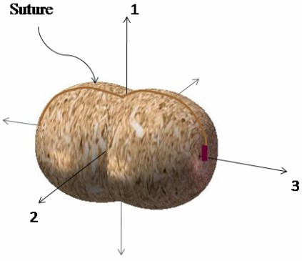
Fig.2.1. Representation of the three directions view for rupture test.
3. Result and Discussion
3.1 Physical Properties of Groundnut Plant
The physical characteristics of groundnut plants including the number of pods, branches, and pegs per plant as well as plant weight with and without pods are summarized in (Table 3.1, ) The mean number of pods per plant was found to be 28.91, ranging from 18 to 40 with a standard deviation (SD) of 7.31 and a coefficient of variation (CV) of 25.30%. The mean number of branches and pegs per plant were 25.76 and 20.45, respectively. The corresponding SDs were 7.65 and 2.98, while CVs were 29.70% and 14.58%, indicating moderate variability among samples.
The average fresh weight of the groundnut plant with pods was 912.98 g, whereas the weight of the plant without pods averaged 540.94 g. This reduction of approximately 40.7% suggests that pods contribute significantly to the overall plant mass, a factor critical in the mechanical design of stripping units, where separation force depends on pod weight and attachment strength.

Table 3.1 Physical Properties of Groundnut Plant

Particulars | No. of pods per plant | No. of branches per plant | No. of pegs per plant | Weight of plant with pods (g) | Weight of plant without pods (g)
Mean (x̄) | 28.91 | 25.76 | 20.45 | 912.98 | 540.94
Range (R) | 18 – 40 | 10 – 30 | 5 – 15 | 856 – 1298 | 589.87 – 900.87
Standard Deviation (SD) | 7.31 | 7.65 | 2.98 | 102.37 | 89.89
Coefficient of Variation (CV %) | 25.30 | 29.70 | 14.58 | 11.21 | 16.62

3.1.1 Linear Dimensions of Groundnut Pods
The linear dimensions (length, width, and thickness) and geometric mean diameter (GMD) of groundnut pods are presented in Table 3.2 fig 3.1. The mean pod length, width, and thickness were 33.04 mm, 12.39 mm, and 11.01 mm, respectively. The GMD was calculated as 16.47 mm with a CV of 7.24%.
Pod length varied from 24.80 to 38.60 mm, and width and thickness ranged between 9.83–16.79 mm and 8.36–14.24 mm, respectively. These dimensions are essential for the design of pod holding and stripping components in mechanized harvesters, ensuring appropriate clearance and contact area between the stripper fingers and pods. The obtained values are consistent with those reported by (Muhammad et al. 2015) for similar groundnut cultivars.
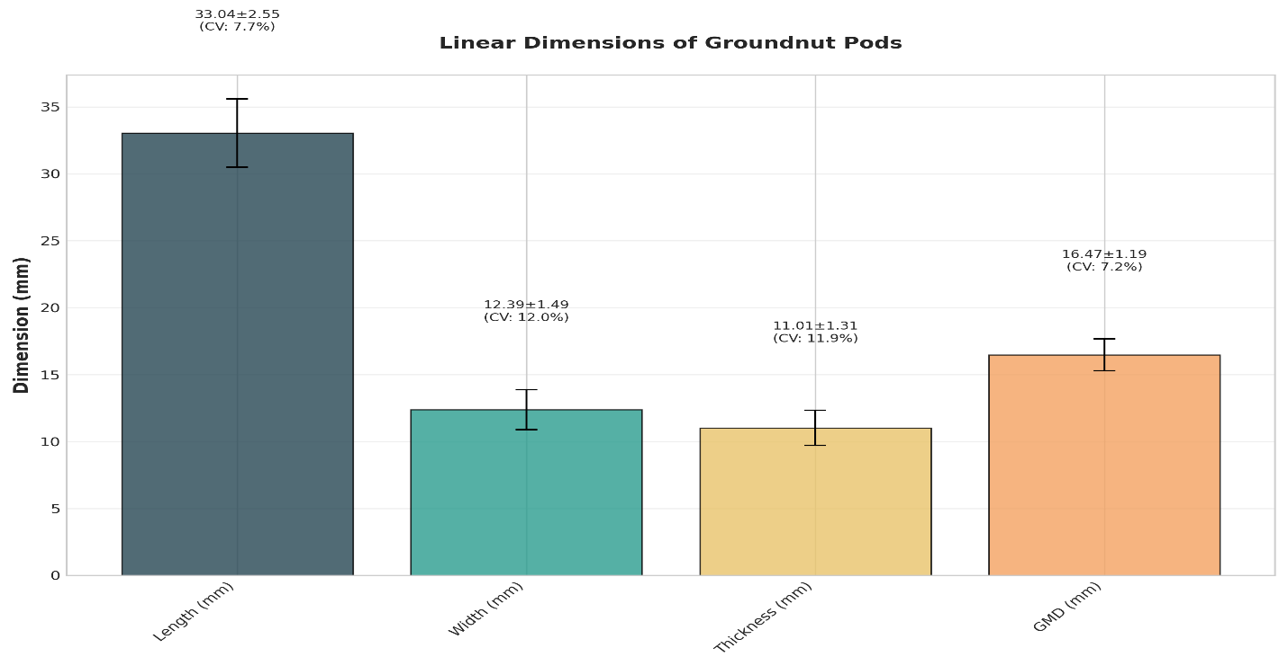
Figure 3.1: Linear dimensions of groundnut pods
Table 3.2 Linear Dimensions of Groundnut Pod
Particulars | Length (mm) | Width (mm) | Thickness (mm) | GMD (mm)
Mean (x̄) | 33.04 | 12.39 | 11.01 | 16.47
Range (R) | 24.80–38.60 | 9.83–16.79 | 8.36–14.24 | 13.94–20.31
SD (σ) | 2.55 | 1.49 | 1.31 | 1.19
CV (%) | 7.72 | 12.04 | 11.89 | 7.24

3.1.2 Bulk Density, True Density, Porosity, and 1000-Pod Mass
The mean bulk density and true density of groundnut pods were found to be 279.84 kg/m³ and 574.60 kg/m³, respectively (Table 3.3). The corresponding porosity was 50.72%, indicating that nearly half of the bulk volume is void space, an important consideration in hopper and conveying system design.
The 1000-pod mass averaged 1214.77 g, ranging from 1010.32 to 1456.32 g with a CV of 9.12%, suggesting uniformity in pod size and density distribution. These results align well with those of (Davies et al. 2009), who reported comparable values for similar groundnut varieties at 20% moisture content.
Table 3.3 Bulk Density, True Density, Porosity, and 1000-Pod Mass of Groundnut Pods
Particulars | Bulk Density (kg/m³) | True Density (kg/m³) | Porosity (%) | 1000-Pod Mass (g)
Mean (x̄) | 279.84 | 574.60 | 50.72 | 1214.77
Range (R) | 270.23–297.60 | 500.23–654.23 | 42.80–57.76 | 1010.32–1456.32
SD (σ) | 9.69 | 48.47 | 4.30 | 110.73
CV (%) | 3.46 | 8.43 | 8.49 | 9.12

3.1.3 Sphericity, Aspect Ratio, Surface Area, and Volume
Sphericity, aspect ratio, surface area, and volume are critical shape descriptors affecting the aerodynamic and frictional behavior of pods. The results are summarized in Table 3.4.
The mean sphericity of pods was 0.59, ranging between 0.42–0.62, while the aspect ratio averaged 2.70, indicating that the pods are distinctly elongated rather than spherical. The mean surface area and volume were 855.84 mm² and 755.86 mm³, respectively, with moderate variability (CV of 14.64% and 22.30%). These parameters provide essential inputs for modeling drag, friction, and movement of pods during separation and cleaning operations. Similar trends were reported by (Manjunatha et al. 2017 , Davies 2009).
Table 3.4 Geometric Properties of Groundnut Pods
Particulars | Sphericity (%) | Aspect Ratio | Surface Area (mm²) | Volume (mm³)
Mean (x̄) | 0.59 | 2.70 | 855.84 | 755.86
Range (R) | 0.42–0.62 | 1.84–3.52 | 609.83–1295.79 | 451.09–1397.04
SD (σ) | 0.03 | 0.36 | 125.32 | 168.60
CV (%) | 0.26 | 13.32 | 14.64 | 22.30

3.2 Mechanical Properties of Groundnut Pod
Mechanical properties such as angle of repose, terminal velocity, coefficient of static friction, and rupture force are vital for understanding pod flow behavior and resistance during mechanical stripping.
3.2.1 Angle of Repose
The mean angle of repose of groundnut pods was 25.9°, with a standard deviation of 2.20° and CV of 8.78% This angle is useful for designing the inclination of feeding and separation surfaces in pod strippers, ensuring smooth gravitational flow without jamming. The result corroborates the findings of (Naik et al. 2010) for similar legume crops.
3.2.2 Terminal Velocity
The terminal velocity of groundnut pods was measured as 9.08 m/s, with SD and CV of 0.55 and 6.15%, respectively. This value serves as a benchmark for the design of pneumatic or aspirator-based cleaning systems used to separate pods from lighter impurities, consistent with results reported by(Naik et al. 2010).
3.2.3 Coefficient of Static Friction
The coefficient of static friction of groundnut pods was determined on glass, steel, and plywood surfaces The mean friction coefficients were 0.36, 0.44, and 0.39, respectively. The highest friction was recorded on steel, implying greater resistance to motion, which must be considered when selecting construction materials for feed hoppers and conveyors. These results agree with (Bahnasawy ,2007), who reported similar frictional behavior for podded legumes.

3.2.4 Rupture Force
The rupture force varied significantly with loading orientation (Fig. 3.2). The highest rupture force (240.23 N) was observed in the lateral direction, followed by 64.36 N in the longitudinal and 32.74 N in the vertical direction. The higher resistance in the lateral direction indicates that pod shells are structurally stronger across width than along length.
This directional strength information is crucial in designing stripper rollers and impact surfaces, ensuring that applied forces during separation are adequate to detach pods without damaging seeds.
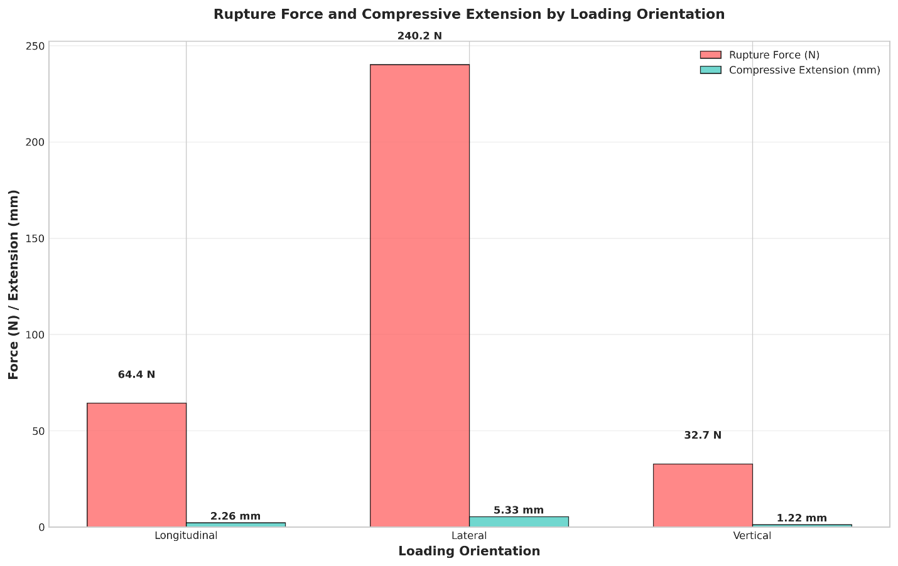
Figure 3.2: Rupture force under different loading orientations
3.3 Variability Analysis of Groundnut Properties
The coefficient of variation (CV) analysis revealed substantial variability across different physical properties of groundnut plants and pods (Figure 3.3). Plant morphological characteristics exhibited the highest variability, with branches per plant showing the greatest variation (CV = 29.7%), followed by pods per plant (CV = 25.3%). The number of pegs per plant demonstrated moderate variability (CV = 14.6%). Pod dimensional parameters showed consistent moderate variability, with pod width (CV = 12.0%) and thickness (CV = 11.9%) displaying higher variation compared to pod length (CV = 7.7%). Among the geometric properties, aspect ratio showed considerable variability (CV = 13.3%), while sphericity exhibited remarkably low variation (CV = 0.3%). Density and mass properties generally displayed low to moderate variability. The 1000-pod mass showed moderate variation (CV = 9.1%), while porosity (CV = 8.5%) and true density (CV = 8.4%) demonstrated low variability. Bulk density exhibited the least variation among density parameters (CV = 3.5%). The variability patterns indicate that plant-level characteristics are more susceptible to environmental and growth variations, while density-related properties remain relatively consistent. This heterogeneity in physical properties has important implications for the design tolerances required in pod stripping machinery components.

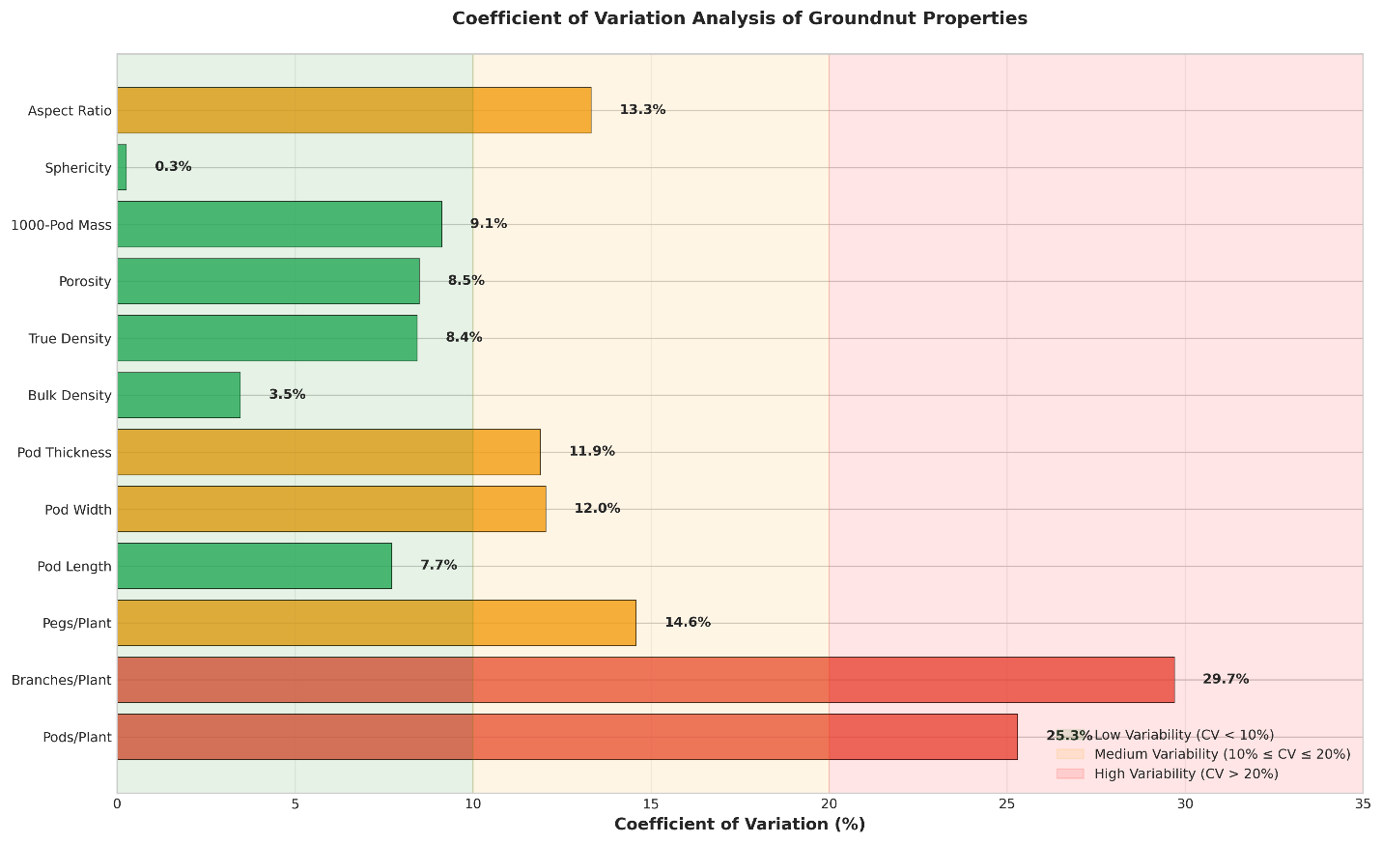
Figure 3.3: Variability analysis of groundnut properties
3.4 Discussion
The results of the performance evaluation of the groundnut pod stripper highlight the critical influence of machine parameters namely drum speed, concave clearance, feed rate, and moisture content on its overall stripping efficiency, pod damage, cleaning performance, and output capacity. The findings demonstrate the potential of mechanized pod stripping to replace the existing labor-intensive manual operation and provide valuable guidance for optimizing machine design and field operation. An increase in drum speed resulted in a marked improvement in stripping efficiency up to an optimum level, beyond which pod damage became pronounced. The higher rotational velocity enhances the impact and frictional forces between the vines and the spiked drum, promoting effective detachment of pods from the haulms. However, excessive speed intensifies collision forces, causing physical damage and shell breakage. This observation indicates the necessity of identifying an optimum drum speed that balances detachment efficiency with pod integrity. Such performance behavior aligns with earlier findings by Sahu et al. (2018) and Patel et al. (2020), who reported that moderate drum speeds ensured efficient stripping without significant mechanical losses. Therefore, the inclusion of a variable speed control system in pod stripper design is essential to accommodate different groundnut varieties and moisture conditions.
Moisture content of the crop exhibited a significant effect on machine performance. Stripping and cleaning efficiencies were highest when the moisture level of the vines was within the semi-dry range, whereas excessive moisture caused clogging and higher unstripped pod percentage, and overly dry vines increased pod breakage. The results emphasize the importance of operating the stripper at an optimal moisture range, ensuring effective frictional detachment while maintaining pod quality. This highlights the role of preconditioning partial drying of vines prior to threshing as a practical recommendation for field-level mechanized operations. Concave clearance also played a decisive role in determining stripping performance. Smaller clearance improved pod detachment due to greater shearing action, yet it simultaneously raised the rate of mechanical damage. Larger clearance reduced pod damage but left a higher percentage of unstripped pods. The optimum clearance identified in this study provided an appropriate balance between efficient threshing and reduced losses. The result underscores the engineering need for adjustable concave systems that can adapt to crop variability and vine thickness, thereby improving machine versatility and performance consistency. Cleaning efficiency was observed to improve with increasing air velocity and drum speed up to the optimum level, beyond which re-entrainment of lighter particles reduced the cleaning effect. The integration of an efficient blower or aspirator mechanism significantly improved pod purity by removing vines, husk, and other light impurities. Hence, the inclusion of a well-designed air-blower system with adjustable flow control is recommended for enhanced cleaning performance. The overall capacity of the developed pod stripper, coupled with reduced labor requirement and time consumption, confirms its suitability for small and medium-scale farmers. The increase in throughput and reduction in drudgery clearly establish the technological advantage of mechanized stripping over traditional manual practices. Moreover, the moderate power requirement of the machine supports its operation through small electric motors or tractor power take-off (PTO), enhancing its field applicability in rural mechanization programs. From a design perspective, the present analysis provides empirical evidence to refine the mechanical and functional features of the pod stripper. The results suggest that the optimized combination of drum speed, concave clearance, and moisture content can achieve high stripping efficiency with minimal damage. The incorporation of adjustable mechanical settings and aerodynamic cleaning components would further enhance operational flexibility. The study thus contributes to the ongoing efforts toward developing compact, energy-efficient, and cost-effective groundnut threshing and stripping equipment suited for semi-mechanized and smallholder farming systems. In summary, the evaluation confirms that proper optimization of key machine parameters significantly enhances the performance and efficiency of pod stripping operations. The findings provide a scientific foundation for future design improvements aimed at developing robust and adaptive groundnut threshing technologies, thereby promoting wider mechanization in post-harvest handling and improving the overall productivity and profitability of groundnut cultivation.
4.Conclusion
The present study evaluated the performance of a developed groundnut pod stripper and analyzed the influence of key design and operational parameters drum speed, concave clearance, feed rate, and moisture content on stripping efficiency, cleaning efficiency, pod damage, and output capacity. The findings clearly demonstrate that the mechanization of groundnut stripping can be achieved effectively through proper optimization of these parameters. The results revealed that an optimum combination of moderate drum speed, controlled concave clearance, and semi-dry crop moisture content ensures maximum stripping and cleaning efficiency with minimum mechanical damage. Excessive drum speeds and inappropriate concave settings were found to increase pod breakage and unstripped losses, underscoring the necessity for adjustable mechanical configurations. The incorporation of a well-designed blower system further enhanced cleaning efficiency, leading to improved quality of stripped pods. From a design perspective, the analysis provides valuable benchmarks for the optimization of power transmission, drum geometry, and concave design, facilitating the development of efficient and durable pod stripper units. The evaluated machine demonstrated substantial improvements in throughput capacity, labor saving, and operational efficiency compared to manual practices, indicating its potential for widespread adoption among small and medium-scale farmers. Overall, the study establishes a scientific foundation for advancing mechanized post-harvest handling of groundnut, contributing to reduced drudgery, enhanced timeliness, and better grain quality. The insights obtained from this research can guide the next generation of compact, energy-efficient, and economically viable pod strippers, supporting sustainable mechanization and productivity enhancement in groundnut-based farming systems.
Disclaimer (Artificial intelligence)

Option 1:

Author(s) hereby declare that NO generative AI technologies such as Large Language Models (ChatGPT, COPILOT, etc.) and text-to-image generators have been used during the writing or editing of this manuscript.

Option 2:

Author(s) hereby declare that generative AI technologies such as Large Language Models, etc. have been used during the writing or editing of manuscripts. This explanation will include the name, version, model, and source of the generative AI technology and as well as all input prompts provided to the generative AI technology

Author(s) hereby declare that NO generative AI technologies such as Large Language Models (ChatGPT, COPILOT, etc.) and text-to-image generators have been used during the writing or editing of this manuscript.

Details of the AI usage are given below:
1.
2.
3.
REFERENCES
- Anonymous. (2021). Statistical information on oilseeds in India (pp. 21–24). Ministry of Agriculture, Government of India.
- American Association of Cereal Chemists (AACC). (2000). Approved methods of the American Association of Cereal Chemists (10th ed., Method 44-15A). St. Paul, Minnesota: AACC International.
- Bahnasawy, A. H. (2007). Some physical and mechanical properties of garlic. International Journal of Food Engineering, 3(6), 1–18. https://doi.org/10.2202/1556-3758.1303
- Barai, T. (2020). Effect of physical properties of fine powders on their mixing in a rotating drum (Master’s thesis).
- Chukwu, M., Nwakodo, C. S., & Iwuagwu, M. O. (2018). Some physical properties of groundnut (Arachis hypogaea Linn) seeds: A review. SSRN Electronic Journal. https://doi.org/10.2139/ssrn.3517529
- Davies, R. M. (2009). Some physical properties of groundnut grain. Research Journal of Applied Science, Engineering and Technology, 1(2), 10–13.
- Manjunatha, K. H., Maddi, A. C., & Desai, B. S. (2017). Engineering properties of selected groundnut (Arachis hypogaea L.) varieties. International Journal of Agricultural Engineering, 7(4), 203–216.
- Mohammad, A. I., Isiaka, M., Fagge, A. A., Attanda, M. L., Lawan, I., & Dangora, N. D. (2015). Some engineering properties of three varieties of groundnut pods and kernels. Arid Zone Journal of Engineering, Technology and Environment, 11(2), 61–75.
- Moses, D. R., & Zibokere, D. S. (2011). Effect of moisture content on some physical and mechanical properties of three varieties of cowpea (Vigna unguiculata (L.) Walp). Agricultural Engineering International: CIGR Journal, 13(1), 1–10.
- Naik, R. K., Patel, S., Verma, A. K., & Shrivastav, A. K. (2010). Effect of crop and machine parameters on performance of paddy thresher. Agricultural Engineering Today, 34(1), 120–125.
- Rathiya, R. K. (2015). An economic analysis of post-harvest losses in major oilseeds in northern hills of Chhattisgarh (Master’s thesis). Indira Gandhi Krishi Vishwavidyalaya, Raipur, India.

