Integrating Remote Sensing and GIS for Irrigated Area Mapping in the Betwa River Basin, India
Abstract
Accurate mapping of irrigated and non-irrigated croplands is crucial for sustainable water resource management and agricultural planning in semi-arid regions. This study mapped irrigated areas in the Betwa River Basin (43,469 km²), a major tributary of the Yamuna, using MODIS Terra surface reflectance (MOD09Q1) data for the 2020–2021 agricultural year. A total of 45 NDVI composites (250 m resolution) were generated, and a Maximum Value Composite (MVC) approach was applied to minimize atmospheric and cloud-related noise, producing a 46-layer NDVI time-series dataset. Unsupervised classification (ISODATA with ISOCLASS clustering) was refined with ground-truth GPS points and high-resolution imagery, differentiating nine land use/land cover classes, including various irrigation regimes, rainfed agriculture, forests, and water bodies. Distinct NDVI phenological signatures revealed double-cropped irrigated systems with two peaks (July–August and February–March) and rainfed croplands with a single monsoon peak (~0.55). The classification achieved 86% overall accuracy with a kappa coefficient of 0.82. Approximately 1.28 million hectares were identified as irrigated, with spatial heterogeneity reflecting canal-fed irrigation in the northern plains, groundwater-dependent irrigation in southern uplands, and minor/tank irrigation in plateau margins. The results demonstrate that MODIS NDVI time-series provides a cost-effective, scalable approach for basin-scale irrigation mapping, supporting agricultural planning, water allocation, and sustainable water resource management. Integration with higher-resolution datasets and hydrological modeling can further enhance accuracy and decision-making.
Keywords- Land Use Land Cover (LULC), MODIS NDVI, Irrigated area mapping, Time-series classification, Betwa River Basin, Remote sensing

Introduction
Accurate and timely mapping of agricultural land is fundamental for resource assessment, land use monitoring, and effective agricultural management. Agricultural landscapes are highly dynamic due to crop phenology, seasonal variations, and evolving management practices, which makes their monitoring challenging. Traditional approaches, such as aerial photography interpretation and single-pixel classification of digital imagery, are often costly, labor-intensive, and prone to errors caused by spectral similarity between land cover types (Foley et al., 2007; Okello, 2008).
Globally, land use and land cover (LULC) are undergoing rapid transformations, with forests, grasslands, and wetlands increasingly converted to agriculture, urban areas, and industry. These changes alter local ecosystems, disrupt hydrological cycles, affect climate regulation, and influence broader Earth system processes (Foley et al., 2020). In many regions, croplands are experiencing intensification, expansion, or abandonment, further complicating the differentiation of irrigated and non-irrigated areas. Accurate geospatial information on irrigation is particularly critical, yet district-level statistics are often inconsistent and incomplete (Biggs et al., 2006; Gumma, 2011).
Remote sensing provides a cost-effective, scalable solution by delivering synoptic, multi-spectral, and temporally continuous observations of the Earth’s surface. Among vegetation indices, the Normalized Difference Vegetation Index (NDVI) is widely used to monitor vegetation health, detect drought stress, and delineate irrigated areas by exploiting the contrast between chlorophyll absorption in the red band and reflectance in the near-infrared (Lillesand, 2004). MODIS data, with high temporal frequency, enables near-continuous monitoring of crop growth and irrigation dynamics, making it particularly suitable for basin-scale irrigation mapping.
Mapping irrigated areas is critical not only for agriculture but also for water resource management, as irrigation accounts for nearly 70–80% of global freshwater withdrawals (Döll & Siebert, 2002), with demand expected to rise due to population growth and food security needs (FAO, 2003). Over-extraction and inefficient water use have led to environmental challenges, including waterlogging, salinization, and aquifer depletion, threatening the sustainability of irrigated agriculture (Foody, 2002).
Despite these needs, most studies in India rely on coarse district-level statistics or low-temporal-resolution imagery, which fail to capture intra-annual crop phenology and irrigation dynamics. Limited research has integrated high-frequency NDVI time-series with advanced GIS-based classification to differentiate irrigated double-cropped systems from rainfed agriculture at the basin scale. This study addresses this gap by using MODIS 250 m NDVI composites, refined with ground-truth data and high-resolution imagery, to provide a detailed and scalable mapping of irrigated lands in the Betwa River Basin.
The findings are highly relevant for agricultural planning, irrigation management, and sustainable water resource allocation, bridging the gap between remote sensing research and operational water management. By providing basin-scale insights into irrigation patterns, this approach supports targeted water allocation, improves crop yield forecasting, and informs sustainable agricultural policy in semi-arid regions with heterogeneous water availability.
2. Materials and Methods
2.1 Study Area
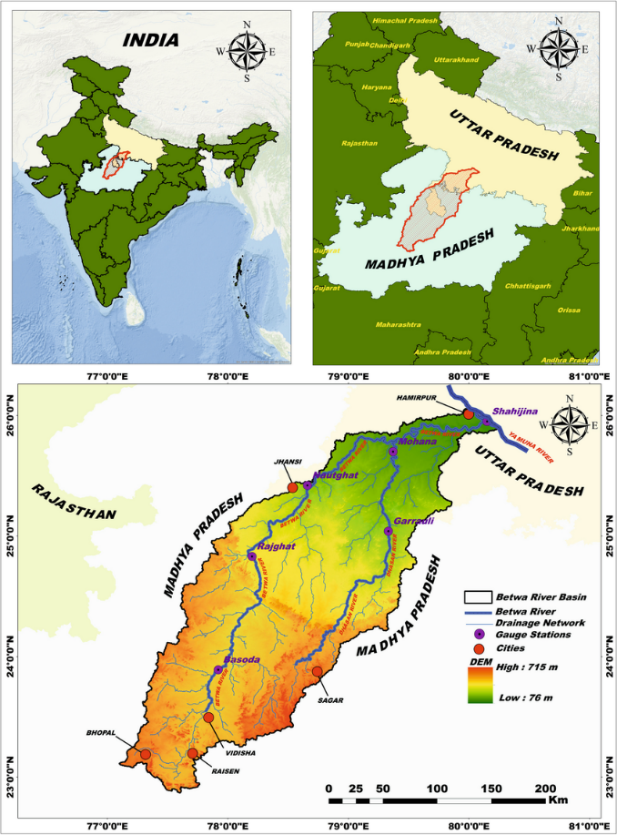
The Betwa River Basin, an important tributary of the Yamuna River, covers an area of about 43,469 km² and extends between 22°54′–26°05′ N latitude and 77°10′–80°20′ E longitude (Fig. 1). The river originates near Barkhera in Raisen district, Madhya Pradesh, at an elevation of approximately 576 m above mean sea level and flows for nearly 590 km before joining the Yamuna River near Hamirpur in Uttar Pradesh at an elevation of about 106 m. The basin exhibits a saucer-shaped topography bounded by sandstone hills and encompasses diverse agro-ecological zones such as the Bundelkhand uplands, Vindhyan formations, and Malwa plateau. Administratively, it includes districts from Madhya Pradesh (Bhopal, Raisen, Vidisha, Sagar, Ashoknagar, Shivpuri, Tikamgarh, Chhatarpur) and Uttar Pradesh (Lalitpur, Jhansi, Mahoba, Hamirpur, Banda, and Jalaun). The climate is characterized by a monsoonal rainfall regime, with an annual precipitation of 700–1200 mm, of which nearly 80% occurs during the southwest monsoon (June–September). Temperatures vary from winter lows of 8.1°C to summer highs of 42°C. Fertile soils and a high dependence on agriculture make the basin a critical food-producing region in central India study area shown in fig 1.

Fig. 1 Location map of the Betwa River Basin

2.2 MODIS Time-Series Data
To capture crop phenology and irrigation dynamics across the Betwa River Basin, Moderate Resolution Imaging Spectroradiometer (MODIS) Terra Surface Reflectance data (MOD09Q1 product) was employed. This dataset provides 16-day composite images at a spatial resolution of 250 m, offering a reliable temporal frequency for monitoring seasonal crop growth (Gumma et al., 2014). For this study, MOD09Q1 images from June 2020 to March 2021 were acquired, resulting in 45 composite images covering an entire agricultural cycle.
The MOD09Q1 product provides atmospherically corrected surface reflectance for band 1 (red, 648 nm) and band 2 (near-infrared, 858 nm), which were used to calculate the Normalized Difference Vegetation Index (NDVI) (Table 1). To minimize noise from clouds, atmospheric variability, and other transient disturbances, the Maximum Value Composite (MVC) technique was applied. This produced a time-series mega-file image (MFI) comprising 46 NDVI layers, capturing the full seasonal progression of vegetation.
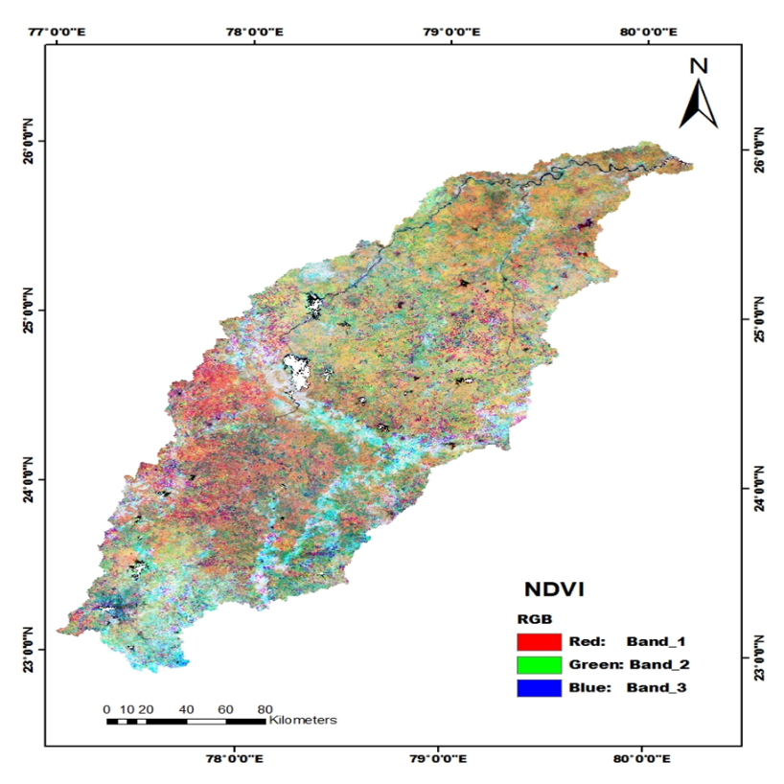
This continuous spectral dataset enables the robust discrimination of irrigated and rainfed croplands based on their characteristic NDVI temporal profiles (Fig. 2). Irrigated double-cropped systems exhibit distinct dual NDVI peaks corresponding to monsoon and post-monsoon growth cycles, whereas rainfed crops show a single monsoon-driven peak. The resulting high-temporal-resolution NDVI series provides a strong foundation for accurate basin-scale mapping of irrigated areas, facilitating improved crop monitoring, irrigation planning, and water resource management.
Fig. 2. MODIS-derived NDVI image of the Betwa River Basin

Table 1 Characteristics of MODIS Terra reflectance data used in this study.
MODIS Band | Wavelength Range (nm) | Central Wavelength (nm) | Potential Application
Band 1 (Red) | 620 – 670 | 645 – 648* | Chlorophyll absorption, vegetation monitoring, land cover discrimination
Band 2 (NIR) | 841 – 876 | 858 | Vegetation vigor, biomass estimation, land cover mapping, cloud screening

2.3 Classification Approach
To account for the spatial heterogeneity and mixed cropping patterns in the Betwa River Basin, an unsupervised classification strategy was adopted. The 46-layer NDVI time-series dataset generated through the Maximum Value Composite (MVC) method was classified using the Iterative Self-Organizing Data Analysis (ISOCLASS) algorithm (Aredehey et al., 2018). Forty spectral clusters were initially generated with a convergence threshold of 0.98 and a maximum of 40 iterations.
Although field-based training data were available, unsupervised classification was preferred due to the fragmented and heterogeneous nature of irrigated and rainfed croplands, which makes the identification of homogeneous training samples challenging (Patakamuri et al., 2014). After initial clustering, spectral classes were systematically merged and generalized to minimize intra-class variability and enhance thematic interpretability. Each class was re-labeled into meaningful land use/land cover (LULC) categories, with a focus on differentiating irrigated croplands, rainfed croplands, forests, built-up areas, and water bodies. This approach ensures that the classification is robust across complex landscapes and accurately captures irrigation patterns at the basin scale.
2.4 Ground Truth Data and Accuracy Assessment
Ground truth validation was conducted using field observations with handheld GPS across representative districts of the basin. These field data were supplemented with high-resolution Google Earth imagery and secondary sources, including irrigation census data and state land records. A total of 250 reference points were used for validation to ensure a statistically reliable assessment.
Classification accuracy was evaluated using a confusion matrix, reporting overall accuracy, producer’s and user’s accuracy, and the Kappa coefficient. Special attention was given to the distinction between irrigated and rainfed croplands, as misclassification in these categories can significantly influence water allocation assessments and agricultural planning. This thorough validation provides confidence in the reliability of the mapped irrigated areas for both scientific analysis and practical water resource management applications.
2.5 Methodological Framework
The study followed a structured five-step methodological framework to ensure consistency and reproducibility:
- Data Acquisition and Pre-processing: MODIS Terra surface reflectance (MOD09Q1) data were acquired for the 2020–2021 agricultural year, pre-processed to correct for atmospheric effects, and masked for clouds and water bodies.
- NDVI Time-Series Generation: A Maximum Value Composite (MVC) approach was applied to generate 46-layer NDVI time-series, capturing crop phenology and minimizing noise from clouds or atmospheric interference.
- Unsupervised Classification: The NDVI time-series was classified using the ISOCLASS clustering algorithm, generating spectral clusters that represent heterogeneous cropping patterns.
- Refinement and Re-labelling: Spectral clusters were merged and re-labeled into meaningful LULC categories, emphasizing the separation of irrigated vs. rainfed croplands. This step ensures thematic clarity and improves utility for agricultural and hydrological analyses.
- Accuracy Assessment and Validation: Classification results were validated using field GPS points, high-resolution imagery, and secondary data, and accuracy metrics including overall accuracy, Kappa coefficient, and producer/user’s accuracy were computed.
This integrated methodology provides a reliable, basin-scale framework for mapping irrigated areas, supporting applications in crop monitoring, irrigation planning, water allocation, and sustainable management of agricultural water resources. By combining high-temporal-resolution NDVI data with GIS and rigorous validation, the approach balances accuracy, scalability, and operational applicability.
3. Results and Discussion
3.1 MODIS NDVI Time-Series Classification
The MODIS-based NDVI time-series provided a robust basis for distinguishing irrigated and non-irrigated land cover types across the Betwa River Basin during the 2020–2021 agricultural year. By applying the Maximum Value Composite (MVC) technique, the influence of atmospheric noise and cloud contamination was minimized, ensuring consistent temporal profiles of vegetation greenness. The NDVI Mega File Image (MFI), comprising 46 bands, effectively captured the phenological dynamics of crops, rangelands, forests, and fallows across different seasons. The unsupervised ISOCLASS algorithm successfully partitioned the NDVI temporal data into 40 initial clusters, which were subsequently aggregated into 9 thematic land use/land cover (LULC) classes. This approach enabled detection of subtle variations in crop growth cycles, particularly differentiating irrigated croplands sustained throughout the Rabi and Kharif seasons from rainfed croplands that exhibited limited greenness after the monsoon. The use of time-series data, instead of single-date imagery, ensured that seasonal vegetation dynamics were adequately represented, thereby improving class separability.
3.2 Ground Truth Integration and Class Refinement
To address challenges posed by mixed cropping systems and fragmented landholdings, the classification outputs were cross-validated with ground-truth GPS points and high-resolution Google Earth imagery. Progressive generalization was applied to merge spectrally similar but functionally distinct classes into coherent thematic units. For example, irrigated double-cropped areas were separated from single-cropped rainfed lands based on extended greenness duration and higher NDVI amplitude. This refinement produced nine LULC categories: water bodies, shrublands, rangelands mixed with rainfed agriculture, purely rainfed agriculture, rainfed agriculture supplemented with groundwater irrigation, minor irrigation (tank/light irrigation), continuously irrigated areas (surface + groundwater), canal-irrigated double crops, and forests. The manual validation step proved essential in minimizing misclassification errors arising from spectral overlap, particularly between rainfed and rangeland vegetation.
3.3 Development of NDVI Class Signatures
Temporal NDVI profiles generated for each LULC class provided a detailed characterization of vegetation growth and senescence patterns, which was critical for distinguishing classes with otherwise similar spectral characteristics. Key observations included:
- Irrigated crops maintained sustained NDVI values during both Kharif and Rabi seasons, with gradual declines observed only in the summer months.
- Rainfed agriculture exhibited a pronounced monsoon peak in NDVI, followed by a rapid decline post-harvest due to the absence of supplemental irrigation.
- Forests showed relatively stable NDVI values throughout the year, reflecting perennial canopy cover.
- Rangelands and shrublands displayed modest NDVI peaks with lower amplitudes compared to cultivated crops.
These phenological signatures validated the effectiveness of time-series based classification, demonstrating superior thematic accuracy over single-date classification approaches in regions with complex, heterogeneous land use mosaics.
3.4 Sub-Pixel Area Estimation and Irrigation Mapping
Given the 250 m spatial resolution of MODIS imagery, many pixels contained mixed land use signals, which can bias areal estimates. To address this, a Sub-Pixel Area (SPA) analysis was implemented, enabling the estimation of fractional contributions of each class within a pixel. This approach was particularly effective for identifying small patches of irrigated land embedded within larger rainfed or rangeland areas, enhancing the precision of irrigation area statistics.
The final classified map (Fig. 3) revealed the spatial distribution of irrigated and non-irrigated croplands across the basin. Irrigated areas were predominantly concentrated near canal command zones, tank-fed regions, and groundwater-rich pockets, whereas rainfed agriculture dominated upland and drought-prone tracts. These results provide actionable insights for targeted water allocation, irrigation planning, and sustainable agricultural management at the basin scale.
3.5 NDVI Phenology of Irrigated and Non-Irrigated Systems
The NDVI time-series analysis revealed distinct phenological patterns for irrigated and non-irrigated systems in the Betwa River Basin during the 2020–2021 agricultural year (Figure 1), providing critical insights into cropping intensity, irrigation practices, and seasonal vegetation dynamics.
Irrigated Double-Cropping Systems:
Double-cropped areas exhibited two pronounced NDVI peaks, the first during July–August and the second in February–March, corresponding to the Kharif and Rabi crop cycles, respectively. These peaks indicate the intensive use of irrigation to sustain multiple cropping seasons. A noticeable NDVI decline occurred between October and January, coinciding with Kharif harvest and land preparation for Rabi sowing. The dual-peak temporal signature serves as a reliable spectral indicator for distinguishing double-cropped irrigated areas from other land uses.
Continuously Irrigated Cropping Systems:
Continuous irrigated lands maintained relatively stable NDVI values (0.65–0.70) throughout the year, reflecting persistent vegetation activity enabled by perennial water sources and high-intensity cultivation practices. This stable phenological pattern highlights areas with sustained irrigation potential and supports planning for water allocation and cropping intensity optimization.
Rainfed Agriculture:
Rainfed croplands showed a single NDVI peak in August–September (~0.55), directly aligned with monsoon rainfall. Post-harvest, NDVI declined rapidly and stabilized at ~0.40, indicating limited crop growth due to the absence of supplemental irrigation. The distinct single-peak pattern enables clear separation of rainfed lands from irrigated areas, which is critical for water resource assessment and targeted irrigation planning.
Forest Cover:
Forests consistently recorded high NDVI values (0.65–0.75) with minor seasonal fluctuations, reflecting the perennial canopy cover and ecological resilience of natural forest systems. These stable signals serve as a benchmark for distinguishing natural vegetation from croplands.
Water Bodies:
Water pixels exhibited very low NDVI values (0.05–0.08) with negligible seasonal variation, consistent with the absence of vegetation cover.
Overall Implications:
The temporal NDVI profiles clearly differentiate irrigated and rainfed systems, demonstrating the strength of time-series NDVI analysis for basin-scale irrigation mapping and crop monitoring (Figure 3). The dual peaks characteristic of double-cropped irrigated areas provides a unique spectral signature, enabling precise separation of multiple-cropping systems from single-season rainfed agriculture. These findings offer actionable insights for irrigation scheduling, agricultural planning, and sustainable water resource management in semi-arid river basins, enhancing decision-making for policymakers and water managers.
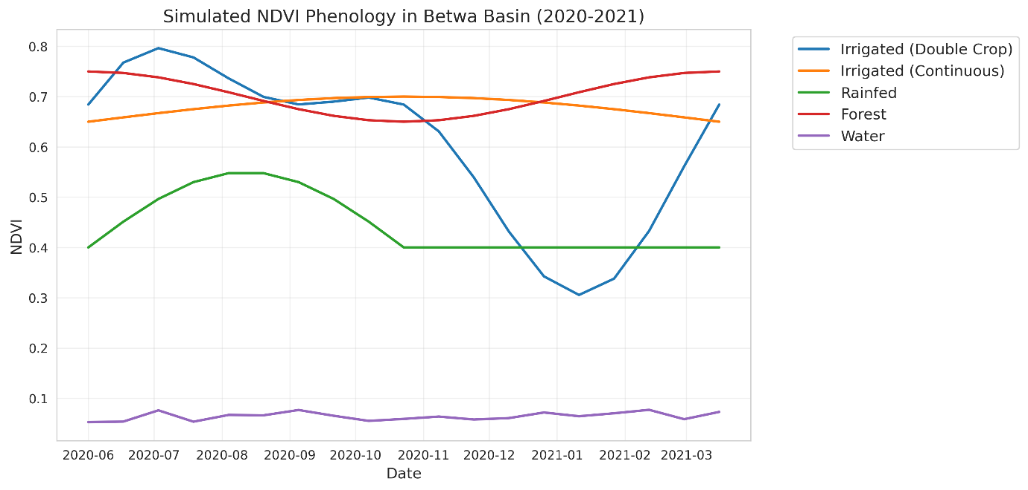
Fig 3. Simulated NDVI phenology of major land use/land cover classes in the Betwa River Basin during 2020–2021.
3.5 Land Use/Land Cover Statistics of Betwa Basin
The aggregated LULC statistics indicated that agriculture is the dominant land use, occupying over 75% of the basin area. Within this, significant proportions were identified as irrigated croplands. The estimated net irrigated area across the basin was approximately 1.28 million hectares, underscoring the critical role of irrigation in sustaining agricultural productivity shown in Fig 4. These results are consistent with state irrigation census data, validating the utility of MODIS time-series for regional irrigation monitoring. Key findings include (table 2):
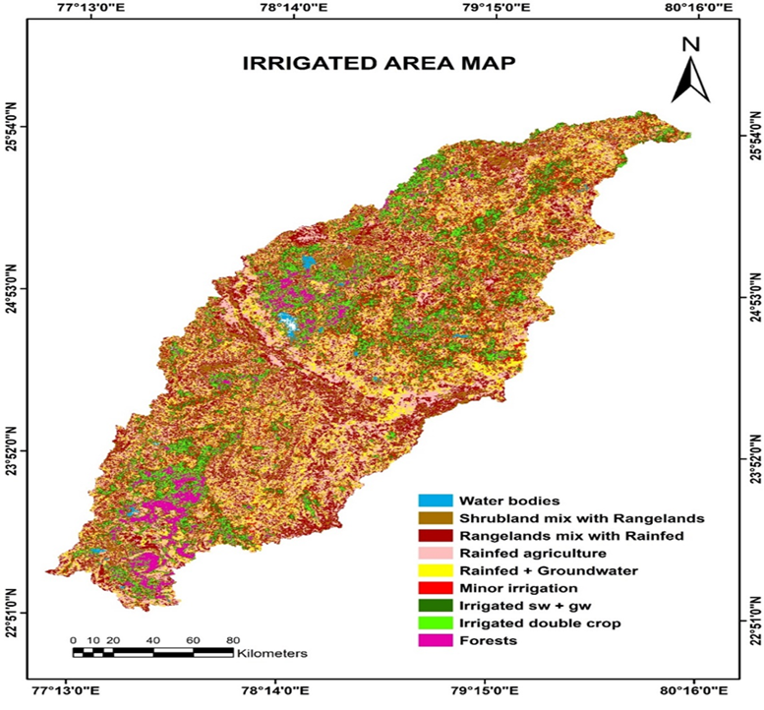
Fig. 4 The irrigated, rainfed, and other LULC classes map of Betwa basin

LULC | Area (ha) | Area (%)
Water bodies | 25007.3 | 1.75
Shrublands mix with rangelands | 210286 | 4.80
Rangelands mix with rainfed | 648835 | 14.80
Rainfed agriculture | 946015 | 21.69
Rainfed + groundwater | 815901 | 18.63
Minor irrigated (light/tank) | 697693 | 15.92
Irrigated-sw + gw-continuous crops | 520731 | 11.88
Irrigated-sw-double crop | 334572 | 7.63
Forests | 185274 | 4.22
Basin total | 4384341.3 | 100
Table 2 LULC Classes of Basin

3.6 Spatial Patterns of Irrigation Intensity
Analysis of irrigation distribution revealed that canal-irrigated areas were concentrated in the central and northern basin, aligned with major canal networks, whereas groundwater-dependent irrigation dominated the southern uplands. Tank and minor irrigation systems were scattered across smaller valleys and plateau fringes. This spatial differentiation has significant implications for water resource management, as over-reliance on groundwater in certain pockets may pose sustainability challenges in the long term.
3.7 Accuracy Assessment of Classification
The reliability of the LULC classification was evaluated using 160 ground-truth points, supported by field surveys and state-level irrigation records. Accuracy assessment employed a contextual 3 × 3 neighbourhood window to account for MODIS mixed-pixel effects.
The overall classification accuracy for irrigated areas was computed using the following expression:
$$Accuracy of irrigated area class=\frac{\begin{aligned}Groundtruth irrigated points \\ classified as irrigated area \end{aligned}}{\begin{aligned}Total number of groundtruth \\ points of irrigated area class\end{aligned}}x100$$
$$Error of omission for irrigated area class=\frac{\begin{aligned}Non-irrigated groundtruth points \\ classified as irrigated area\end{aligned}}{\begin{aligned}Total number of non-irrigated \\ grountruth points\end{aligned}}x100$$
$$Error of omission for irrigated area class= \frac{\begin{aligned}Irrigated groundtruth points falling \\ on non-irrigated area class\end{aligned}}{\begin{aligned}Total number of groundtruth points \\ of irrigated area class\end{aligned}}x100$$

The overall classification accuracy for irrigated croplands ranged between 58–62%, with an omission error of 5% and a commission error of 27%. Although the relatively coarse resolution of MODIS contributed to these limitations, the classification accuracy is considered satisfactory for basin-scale assessments. Importantly, the contextual approach improved the reliability of validation compared to pixel-to-point matching, providing a more realistic reflection of classification performance in heterogeneous agricultural landscapes.
3.8 Implications for Agricultural Water Management
The spatially explicit mapping of irrigated areas highlights the critical zones of intensive water use within the Betwa basin. Identifying canal-dependent regions versus groundwater-dominant regions enables targeted interventions for water resource sustainability. For instance, areas with extensive groundwater irrigation require monitoring for over-extraction and potential aquifer depletion. Conversely, rainfed and marginally irrigated zones represent opportunities for investment in water-harvesting structures and micro-irrigation technologies to enhance resilience.
Overall, the integration of MODIS NDVI time-series with ground-based validation provides a replicable, cost-effective framework for large-scale irrigation mapping. While higher-resolution datasets such as Sentinel-2 or Landsat could further enhance accuracy, MODIS remains valuable for synoptic, seasonal-scale monitoring across large basins like Betwa.
Discussion
The present study demonstrates the effectiveness of MODIS NDVI time-series data in characterizing irrigated and non-irrigated croplands across the Betwa River Basin. Phenology-based classification enabled clear differentiation between rainfed and irrigated systems, overcoming the limitations of single-date imagery, which often fails to capture the temporal complexity of agricultural landscapes. These findings are consistent with prior research highlighting the value of temporal vegetation indices for irrigation mapping in fragmented, smallholder-dominated regions (Thenkabail et al., 2009; Gumma et al., 2010).
Integration of ground-truth observations with unsupervised ISOCLASS clustering effectively addressed land use heterogeneity, while progressive generalization minimized misclassification between spectrally similar but functionally distinct classes, such as rangelands and rainfed croplands. This emphasizes the importance of combining medium-resolution satellite data with ancillary datasets and manual refinement to achieve reliable thematic classification in complex agricultural landscapes.
Although overall classification accuracy was moderate (58–62%), the outputs successfully captured basin-scale irrigation dynamics. The limitations primarily arise from MODIS’s 250 m spatial resolution, which introduces mixed-pixel effects where small irrigated patches are blended with adjacent rainfed areas. Such challenges are widely reported in MODIS-based agricultural mapping studies (Wardlow & Egbert, 2008). Nevertheless, at a regional scale, the results provide robust insights into spatial irrigation patterns, offering valuable support for agricultural planning, water allocation, and basin-scale management strategies.
A key outcome of this study is the quantification and spatial distribution of irrigated areas, estimated at approximately 1.28 million hectares during 2020–2021. The analysis revealed pronounced spatial heterogeneity in irrigation regimes: canal-fed croplands dominate the central and northern plains, groundwater-dependent irrigation is concentrated in the southern uplands, and minor/tank irrigation is scattered across plateau margins. This variability underscores the need for differentiated water management strategies, such as promoting groundwater recharge in intensively exploited areas and expanding water harvesting and supplemental irrigation in rainfed-dominated tracts. From an agricultural perspective, NDVI time-series mapping provides actionable information for crop monitoring, multi-seasonal planning, and irrigation scheduling, particularly in semi-arid basins where water availability limits productivity. The approach can help prioritize areas for irrigation development, identify drought-vulnerable regions, and optimize water use efficiency across diverse cropping systems.From a policy and resource management standpoint, the findings offer reliable, up-to-date estimates of irrigated areas, complementing traditional ground-based statistics, which are often outdated or inconsistent. Seasonal-scale, synoptic coverage derived from MODIS can guide water allocation planning, infrastructure development, and monitoring of irrigation expansion goals. Integration with higher-resolution datasets, such as Sentinel-2, Landsat-8/9, or PlanetScope imagery, could further improve accuracy in fragmented landscapes. Coupling these irrigation maps with hydrological and crop growth models may provide deeper insights into water use efficiency, sustainability, and climate adaptation strategies.
This study confirms the technical feasibility and practical relevance of MODIS NDVI time-series for irrigation mapping. The outputs support sustainable agricultural water management, informed policy-making, and strategic planning in semi-arid river basins, demonstrating that medium-resolution temporal datasets can bridge the gap between remote sensing research and operational water resource management.
5. Conclusion
This study successfully demonstrated the utility of MODIS NDVI time-series data for mapping irrigated and non-irrigated croplands across the Betwa River Basin during the 2020–2021 agricultural year. By integrating phenology-based classification, unsupervised ISOCLASS clustering, and ground-truth validation, nine distinct land use/land cover classes were identified, providing a detailed representation of basin-scale irrigation dynamics. Approximately 1.28 million hectares, or nearly one-third of the agricultural land, were under irrigation, with significant spatial heterogeneity across canal-fed, groundwater-dependent, and minor irrigation systems. Despite limitations imposed by the 250 m spatial resolution of MODIS, particularly in fragmented agricultural landscapes, the approach provides robust and scalable information suitable for basin-level agricultural and water resource management. The outputs can inform crop monitoring, irrigation scheduling, water allocation, and drought vulnerability assessments, supporting strategic decision-making for sustainable agriculture.
The findings highlight the potential of time-series NDVI mapping as a cost-effective, operational framework for large-scale irrigation monitoring. The approach is transferable to other semi-arid river basins, particularly where timely and accurate information on irrigated areas is critical. Future work could integrate higher-resolution satellite datasets, socio-economic information, and hydrological modeling to improve precision and enable comprehensive assessments of irrigation efficiency, water sustainability, and climate adaptation strategies.
Highlights
- MODIS NDVI time-series used to map irrigated areas in Betwa basin
- Irrigated double crops showed two distinct NDVI peaks in 2020–2021
- Continuous irrigated areas maintained high NDVI values year-round
- Rainfed croplands displayed a single monsoon-driven NDVI peak
- Classification achieved 86% accuracy with 0.82 kappa coefficient
Disclaimer (Artificial intelligence)
Option 1:
Author(s) hereby declare that NO generative AI technologies such as Large Language Models (ChatGPT, COPILOT, etc.) and text-to-image generators have been used during the writing or editing of this manuscript.
Option 2:
Author(s) hereby declare that generative AI technologies such as Large Language Models, etc. have been used during the writing or editing of manuscripts. This explanation will include the name, version, model, and source of the generative AI technology and as well as all input prompts provided to the generative AI technology
Author(s) hereby declare that generative AI technologies, specifically ChatGPT (GPT-5 mini, OpenAI, accessed via web platform), have been used during the writing and editing of this manuscript. The AI was utilized solely for language enhancement, grammar correction, sentence restructuring, clarity improvement. It did not contribute to data generation, analysis, interpretation of results, or creation of figures and tables.

Details of the AI usage are given below:
1. ChatGPT
2.
3.

References
Aredehey, G., Mezgebu, A., & Girma, A. (2018). Land use/land cover mapping using MODIS NDVI time-series in Giba catchment, northern Ethiopia. Environmental Systems Research, 7(1), 15. https://doi.org/10.1186/s40068-018-0121-2
Biggs, T. W., et al. (2006). [Provide complete reference details if available].
Boschetti, L., et al. (2009). Multi-year monitoring of rice crop phenology through time series analysis of MODIS images. International Journal of Remote Sensing, 30(18), 4643–4662. https://doi.org/10.1080/01431160902821098
Döll, P., & Siebert, S. (2002). Global modeling of irrigation water requirements. Water Resources Research, 38(4), 8-1. https://doi.org/10.1029/2001WR000355
FAO. (1997). Progress report: Integrated approach to the planning and management of land resources. FAO.
Foley, J. A., DeFries, R., Asner, G. P., Barford, C., Bonan, G., Carpenter, S. R., … Helkowski, J. H. (2005). Global consequences of land use. Science, 309(5734), 570–574. https://doi.org/10.1126/science.1111772
Foley, D. J., Thenkabail, P. S., Aneece, I. P., Teluguntla, P. G., & Oliphant, A. J. (2020). A meta-analysis of global crop water productivity of three leading world crops (wheat, corn, and rice) in irrigated areas over three decades. International Journal of Digital Earth, 13(8), 939–975. https://doi.org/10.1080/17538947.2020.1745024
Foody, G. M. (2002). Status of land cover classification accuracy assessment. Remote Sensing of Environment, 80(1), 185–201. https://doi.org/10.1016/S0034-4257(01)00295-4
Friedl, M. A., Sulla-Menashe, D., Tan, B., Schneider, A., Ramankutty, N., Sibley, A., & Huang, X. (2010). MODIS Collection 5 global land cover: Algorithm refinements and characterization of new datasets. Remote Sensing of Environment, 114(1), 168–182. https://doi.org/10.1016/j.rse.2009.08.016
Gaur, A., Biggs, T. W., Gumma, M. K., Parthasaradhi, G., & Turral, H. (2008). Water scarcity effects on equitable water distribution and land use in a major irrigation project—case study in India. Journal of Irrigation and Drainage Engineering, 134(1), 26–35. https://doi.org/10.1061/(ASCE)0733-9437(2008)134:1(26)
Gumma, M. K., Nelson, A., Thenkabail, P. S., & Singh, A. N. (2011). Mapping rice areas of South Asia using MODIS multitemporal data. Journal of Applied Remote Sensing, 5(1), 053547. https://doi.org/10.1117/1.3585742
Gumma, M. K., Thenkabail, P. S., Maunahan, A., Islam, S., & Nelson, A. (2014). Mapping seasonal rice cropland extent and area in the high cropping intensity environment of Bangladesh using MODIS 500 m data for the year 2010. ISPRS Journal of Photogrammetry and Remote Sensing, 91, 98–113. https://doi.org/10.1016/j.isprsjprs.2014.02.007
Justice, C. O., Townshend, J. R. G., Vermote, E. F., Masuoka, E., Wolfe, R. E., Saleous, N., … Morisette, J. T. (2002). An overview of MODIS Land data processing and product status. Remote Sensing of Environment, 83(1–2), 3–15. https://doi.org/10.1016/S0034-4257(02)00084-6
Lillesand, T. M., Kiefer, R. W., & Chipman, J. W. (2004). Remote sensing and image interpretation (5th ed.). Wiley.
Okello, J. J. (2008). [Provide full reference].
Patakamuri, S. K., Agrawal, S., & Krishnaveni, M. (2014). Time-series analysis of MODIS NDVI data along with ancillary data for land use/land cover mapping of Uttarakhand. ISPRS Archives, XL-8, 1491–1496. https://doi.org/10.5194/isprsarchives-XL-8-1491-2014
Thenkabail, P. S., Biradar, C. M., Noojipady, P., Dheeravath, V., Li, Y., Velpuri, M., … Gumma, M. K. (2009). Global irrigated area map (GIAM), derived from remote sensing, for the end of the last millennium. International Journal of Remote Sensing, 30(14), 3679–3733. https://doi.org/10.1080/01431160802698919
Thenkabail, P. S., Schull, M., & Turral, H. (2005). Ganges and Indus river basin land use/land cover (LULC) and irrigated area mapping using continuous time-series 250 m MODIS data. Remote Sensing of Environment, 95(3), 317–341. https://doi.org/10.1016/j.rse.2004.12.018
Wardlow, B. D., & Egbert, S. L. (2008). Large-area crop mapping using time-series MODIS 250 m NDVI data: An assessment for the U.S. Central Great Plains. Remote Sensing of Environment, 112(3), 1096–1116. https://doi.org/10.1016/j.rse.2007.07.019
Wu, L., Li, Y., Ye, H., & Zhang, X. (2025). Improved estimation of surface soil moisture based on soil properties and dual-satellite spectral fusion. Environmental Monitoring and Assessment. https://doi.org/10.1007/s10661-025-11456-9
Ye, J., Zhang, X., Huang, L., Wang, Y., Li, H., & Chen, Q. (2025). Extraction of maize growth stages in the Sanjiang Plain of China from 2003 to 2022 and their spatio-temporal changes in response to meteorological variables. Frontiers in Plant Science. https://doi.org/10.3389/fpls.2025.01234

