Effect of culture media on cultural and morphological charecteristics of sclerotium rolfsii.

ABSTRACT

The present study was undertaken to assess the influence of different culture media on the mycelial growth and cultural characteristics of Sclerotium rolfsii, an important soil-borne pathogen responsible for collar rot in several crops. Eight culture media, namely Potato Dextrose Agar (PDA), Sabouraud Maltose Agar, Oat Meal Agar, Coon’s Agar, Corn Meal Agar, Ashby’s Mannitol Agar, Czapek’s Dox Agar, and Richard’s Agar were evaluated under in vitro conditions. Significant variation in radial growth, colony morphology and pigmentation was recorded among the tested media. Maximum mycelial growth was observed on Potato Dextrose Agar (90.00 mm), which was statistically at par with Sabouraud Maltose Agar (89.68 mm) and Oat Meal Agar (89.65 mm). Minimum growth was recorded on Czapek’s Dox Agar (67.86 mm). The colony characters ranged from cottony, fluffy, irregular to compact mycelium, while pigmentation varied from pure white to creamy and yellowish white depending on the medium. These results clearly indicate that PDA, Sabouraud Maltose Agar and Oat Meal Agar are the most suitable media for luxuriant growth and sporulation of S. rolfsii, and can be recommended for cultural variability studies, pathogenicity assays and further research on this pathogen.

Introduction
Groundnut (Arachis hypogaea L.) is one of the most important oilseed as well as leguminous crops belonging to the family Fabaceae. It is commonly known as peanut, earthnut, monkey nut, and goobers. Groundnut is believed to have originated in South America, from where it spread to Asia and Africa. In India, it is grown both in kharif and rabi seasons under a wide range of agro-climatic conditions, mainly as a rainfed crop in semi-arid regions. It is a short- duration crop with moderate drought tolerance, wider adaptability, and fits well in different cropping systems. Groundnut seeds are rich in oil (40–50%), protein (20–30%), carbohydrates, vitamins, and minerals, making it an important food as well as industrial crop. Being a legume,

it enriches soil fertility through biological nitrogen fixation and also contributes organic matter to the soil. In addition to its edible oil, groundnut haulms serve as nutritious fodder for livestock.
“Groundnut is one of the most important legume crops and is a rich source of proteins and edible oil in the human diet. It is considered as an excellent food for both children and adults. Groundnut seeds contain Protein (25–30%), Oil (44–56%), Carbohydrates (18%) and Minerals (4–5%). It is also a good source of essential amino acids such as arginine, lysine and histidine, and provides vitamins like niacin, thiamine, riboflavin and vitamin E. Groundnut oil is rich in monounsaturated (oleic acid) and polyunsaturated fatty acids (linoleic acid), which help in reducing cholesterol levels. Besides, groundnut also contains important bioactive compounds such as resveratrol and phytosterols, which contribute to its antioxidant and cardioprotective properties” (Gopalan et al., 1995, Kris-Etherton et al., 1999).
In India, groundnut is mainly grown in the states of Gujarat, Andhra Pradesh, Tamil Nadu, Karnataka, Maharashtra, Rajasthan and Madhya Pradesh. The area, production, and productivity of groundnut in the country during the year 2023-24 were about 47.16 lakh ha, 101.80 lakh tonnes and 2,160 kg/ha, respectively. In Maharashtra, the area, production and productivity of groundnut during the year 2023-24 were 1.45 lakh ha, 3.14 lakh tonnes and 2,162 kg/ha, respectively. In the Marathwada region of Maharashtra, the area, production and productivity of groundnut during the year 2023-24 were 0.42 lakh ha, 0.86 lakh tonnes and 2,047 kg/ha, respectively. (As per the Final Advance Estimates 2023-24, Department of Agriculture, Government of Maharashtra).
Groundnut is affected by several fungal, bacterial and viral diseases (Ghewande et al., 2002). The major fungal diseases include stem rot, collar rot, dry root rot, leaf spot (early and late), rust, seedling blight and wilt. The important viral diseases reported are peanut bud necrosis, peanut mottle, peanut clump and rosette. Among these, stem rot or southern blight incited by Sclerotium rolfsii is one of the most destructive diseases causing severe damage to groundnut crop and leading to heavy yield losses (Mehan et al., 1994; Mayee and Datar, 1988; Subrahmanyam et al., 1992; Ghewande et al., 2002; Mahato et al., )
In Maharashtra, stem rot of groundnut has been reported as one of the most destructive diseases causing severe economic losses to farmers. Sclerotium rolfsii infects the stem near the soil line and spreads rapidly under warm and humid conditions. The fungus produces white mycelial growth on the stem surface, eventually forming small, round, mustard-seed-like sclerotia. The infected stem becomes soft and water-soaked, leading to wilting and death of the plant. The disease also affects pegging and pod formation, resulting in significant reduction in yield (Haari et al.,1991 Mahato et al., 2017).

Materials and Methods

The effect of culture media on cultural and morphological characteristics of Sclerotium rolfsii

The isolates of Sclerotium rolfsii used in this study were obtained from naturally infected groundnut (Arachis hypogaea L.) plants showing typical symptoms of southern blight, such as wilting, stem rot at the collar region, and white cottony mycelial growth with sclerotia formation. Infected plant samples were collected from farmer fields in [Badnapur , Jalna district Maharashtra, India]. Small pieces of infected tissue along with sclerotia were surface-sterilized using 0.1% sodium hypochlorite for 1–2 minutes, followed by rinsing in sterile distilled water. The tissue pieces were then placed on Potato Dextrose Agar (PDA) plates and incubated at 28 ± 2°C for 5–7 days to allow fungal growth. Pure cultures were obtained by the hyphal tip method and maintained on PDA slants at 4°C for further studies. All culture media used for growth and characterization were prepared following standard protocols (Karnati et al., 2020; Paul et al., 2023; Daami-Remadi et al., 2018).
To evaluate the influence on growth and sporulation, eight media were used Potato Dextrose Agar (PDA), Richards' agar, Oat Meal agar, Coon's agar, Corn meal medium, Ashby's mannitol agar, Czapek's dox agar and Sabouraud maltose agar. Except of Potato dextrose agar (PDA), all media were pre-made (make: Hi Media). Sterilize all media in an autoclave at 15 Ibs/inch pressure for 20 minutes. (Prajapati et al., 2023, Ayed et al., 2018).
Sterilized Petri plates with a 90 mm diameter were filled with autoclaved and cooled media (20 ml/plate) and allowed to solidify at room temperature. (Vaniya et al., 2022) Petri plates of each culture medium (three plates/medium/replication) were infected after the media and solidified by inoculating a 5 mm mycelial disc of a pure culture, that was actively developing seven days after, it was cultured. Three replications of each culture media were made. After that, plates were kept in a BOD incubator at 27 + 2 °C. After seven days of incubation, observations on mycelial development, colony colour and sporulation were noted. Media giving best radial growth of mycelium were used for further studies.

Details of experiment Design : CRD
Replications : Three

Treatments : Eight (culture media)

Treatment details

M1 | : Potato dextrose agar | M2 : Sabouraud maltose agar
M3 | : Oat meal agar | M4 : Coon’s agar
M5 | : Corn meal medium | M6 : Ashby’s mannitol agar
M7 | : Czapek’s dox agar | M8 : Richard’s agar

Visual and microscopic observations were made about the morphological and cultural characteristics of the pathogen, including Sclerotial mycelial development, colony colour, diameter and sporulation.

Results and discussion

Effect of culture media
Cultural characteristics viz., colony diameter and mycelial growth of Sclerotium rolfsii were studied in vitro using eight different culture media and the results obtained are presented in Table I and depicted in Fig. I and PLATE I.

Mycelial growth
The results (Table -I, Fig I, and Plate I) revealed that, all of the eight culture media tested encouraged better growth of Sclerotium rolfsiii. The mean colony diameter mycelial growth recorded with all the test media was ranged from 67.86 mm (Czapek's dox agar) to 90.00 mm (Potato dextrose agar). However, significantly highest mean mycelial growth was recorded on Potato dextrose agar (90.00 mm) followed by Sabouraud's dextrose agar (89.68 mm), Oat meal agar (89.65 mm) Coon's agar (88.28 mm), Corn meal agar (86.00 mm), Richard's agar (85.63 mm) and Ashyby’s mannitol agar (78.33 mm), which were at par with each other. These were followed by the media viz., Richard's agar (85.63 mm), Ashyby’s mannitol agar (78.33 mm) media which were at par with each other Comparatively minimum mean mycelial growth of the test pathogen was found on Czapek's dox agar (67.86).

Colony colour

The data presented in ( Table I ) also revealed that colony colour varied from white, dull white, pale white, creamy white, yellowish white in colour. The colour of the mycelial growth on PDA, Sabouraud maltose Agar, Oat meal Agar, Coon’s Agar, Corn meal Agar,Ashby’s mannitol Agar Czapek’s dox Agar, Richard’s Agar was yellowish white, Sabouraud maltose Agar was white to dull white and Czapek’s Dox Agar was creamy white.

Colony character

The data presented in ( Table I) revealed that there was significant variation in colony character of Sclerotium rolfsii depending on the medium . On Potato Dextrose Agar (PDA), the fungus exhibited cottony white mycelium growth. Sabouraud Maltose Agar resulted dull white mycelium, Oat Meal Agar produced white colony of mycelium. Corn Meal Agar exhibited whitish fluffy cottony growth. Ashby’s Mannitol Agar leads to white colour mycelium and smooth margin. Czapek’s Dox Agar showed colonies with compact creamy white mycelium. On Rechard’s Agar were initially white but later turned to yellowish colour.
The results of the present study on the cultural variability Sclerotium rolfsii on different media are in similar line with those reported earlier by several workers viz., Archana et al., (2019), who reported that Sclerotium rolfsii exhibited optimal growth on PDA with variations in colony morphology across different media. Paparu et al., (2020) also observed morphological and pathogenic diversity in S. rolfsii, emphasizing its adaptability to different culture conditions. Kumar et al., (2017) demonstrated that the choice of culture medium significantly affects mycelial growth and sclerotial formation of S. rolfsii. Furthermore, Singh and Verma (2021) highlighted that nutrient composition of media influences both the growth rate and colony characteristics of this pathogen. Lastly, Sharma et al., (2018) reported differences in colony color and texture of S. rolfsii on various agar media, supporting the observations of the current study.

Table .1 Effect of different culture media on mycelial growth of Sclerotium rolfsii
Tr No | Media used | Colony diameter (mm) | Colony character | pigmentation
M1 | Potato dextrose agar (PDA) | 90.00 | Cottony white mycelium grow | White
M2 | Sabouraud maltose Agar | 89.68 | White to dull white mycelium | White to dull
M3 | Oat meal Agar | 89.65 | White colony colour of mycelium | White
M4 | Coon’s Agar | 88.28 | White irregular growth of mycelium | White
M5 | Corn Meal Agar | 86.00 | White fluffy cottony growth | Pale White
M6 | Ashby’s  Mannitol Agar | 78.33 | White colour mycelium | White
M7 | Czapek’s Dox Agar | 67.86 | Aerial with compact creamy white  Mycelium | Creamy White
M8 | Ricahard’s Agar | 85.63 | Initially white and then turn to yellowish colony colour | Yellowish white
 | SE(m) | 1.93 | - | -
 | C.D. @ 1% | 0.63 % | - | -
*- Mean of three replications; Figure in parenthesis are arc sine transformed value.

PLATE I

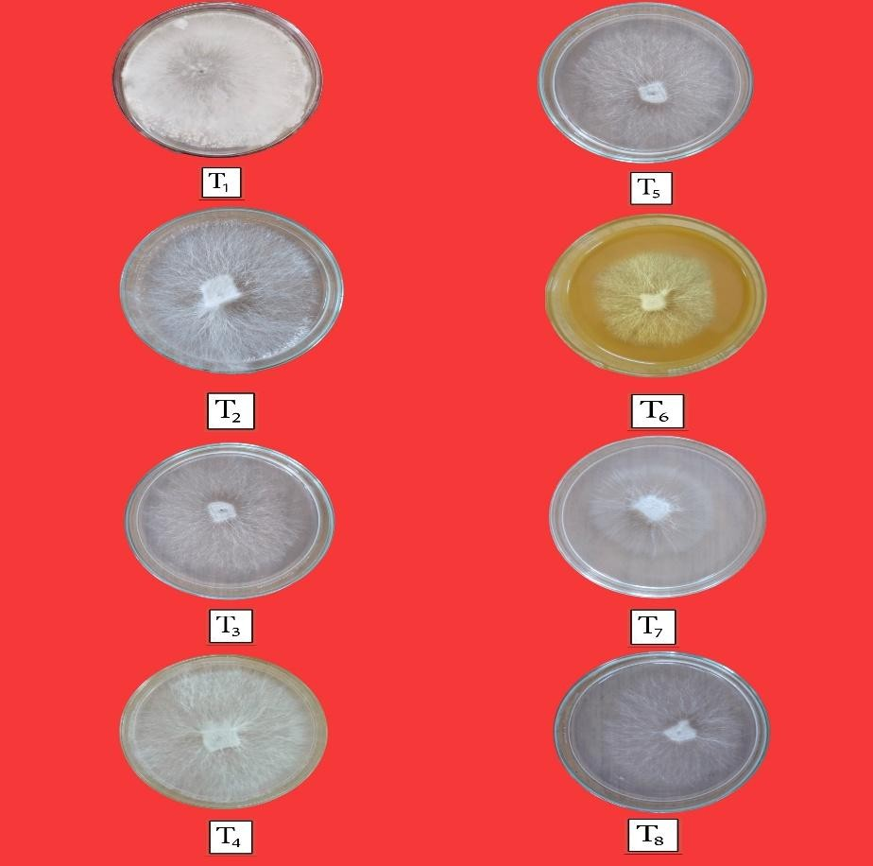

Plate 1. Cultural characteristics viz., colony diameter and mycelial growth of
Sclerotium rolfsii

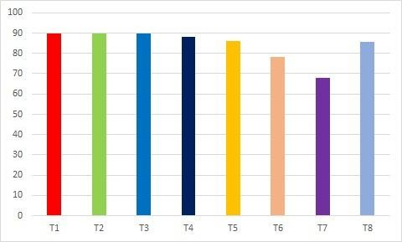

T1 – Potato dextrose agar T5 – Corn meal agar
T2 - Sabouraud maltose agar T6 – Ashby’s mannitol agar T3 – Oat meal agar T7 – Czapek’s dox agar
T4 – Coon’s agar T8 – Rechard’s agar
Fig.1 In vitro effect of different culture media on growth of Sclerotium rolfsii

Conclusion :

This research paper bring deals with the effects of different culture media and morphological charecteristics of Sclerotium rolfsii. To evaluate the influence on growth and sporulation, eight media were used Potato Dextrose Agar (PDA), Richards' agar, Oat Meal agar, Coon's agar, Corn meal medium, Ashby's mannitol agar, Czapek's dox agar and Sabouraud maltose agar. Plates were incubated at 27 + 2 °C.
Among the different culture media tested, Potato Dextrose Agar (90 mm) and Sabouraud Maltose Agar (89.68 mm) were found to be the most effective in supporting maximum colony diameter with profuse cottony white mycelial growth. These results indicate that PDA and Sabouraud Maltose Agar provide favorable nutrient composition for vigorous mycelial development and can be considered as the most suitable media for maintaining and studying the fungus.
The present study provides useful information on the most effective growth media for cultural and morphological characterization of Sclerotium rolfsii isolates from diseased plant samples. These findings will help in selecting suitable media for future pathogenicity studies and identifying the most virulent isolates. Such knowledge can contribute to the development of better management strategies against S. rolfsii.
Disclaimer (Artificial intelligence)
Option 1:
Author(s) hereby declare that NO generative AI technologies such as Large Language Models (ChatGPT, COPILOT, etc.) and text-to-image generators have been used during the writing or editing of this manuscript.
Option 2:
Author(s) hereby declare that generative AI technologies such as Large Language Models, etc. have been used during the writing or editing of manuscripts. This explanation will include the name, version, model, and source of the generative AI technology and as well as all input prompts provided to the generative AI technology
Details of the AI usage are given below:
1.
2.
3.

References

Archana, T. S., Pankaj, B., Jagtap, S. D., and Patil, B. S. (2019). Effect of Different Cultural Media on Growth of Sclerotium rolfsii Sacc. Causing Root Rot of Chilli. International Journal of Current Microbiology and Applied Sciences, 8(2): 3019-3024.

Ayed, F., Jabnoun-Khiareddine, H., Aydi Ben Abdallah, R., and Daami-Remadi, M. (2018). Effect of temperatures and culture media on Sclerotium rolfsii mycelial growth, sclerotial formation, and germination. Journal of Plant Pathology & Microbiology, 9(8), 446.

Daami-Remadi, M., Jabnoun-Khiareddine, H., and Aydi Ben Abdallah, R. (2018). Effect of temperatures and culture media on Sclerotium rolfsii mycelial growth, sclerotial formation and germination. Journal of Plant Pathology & Microbiology, 9, 446.

Gopalan C, Rama Sastri B.V., Balasubramanian S.C. (1995). Nutritive value of Indian foods. Hyderabad (India): National Institute of Nutrition, Indian Council of Medical Research. 156 p.

Ghewande, M. P., Desai, S., and Basu, M. S. (2002). Diagnosis and management of major diseases of groundnut. NRCG Technical Bulletin, National Research Centre for Groundnut, Junagadh, India.

Haari, K. N., Reddy, P. M., and Reddy, D. V. R. (1991). Occurrence and management of major diseases of groundnut in India. Indian Phytopathology, 44(2), 220–225.

Kris-Etherton P.M, Yu S. (1997). Individual fatty acid effects on plasma lipids and lipoproteins: human studies. American Journal of Clinical Nutrition. 65(5 Suppl):1628S–1644S. doi:10.1093/ajcn/65.5.1628S.

Karnati, D., Sinha, B., and Savani, A. K. (2024). Morphological variability and mycelial compatibility of Sclerotium rolfsii. Journal of Plant Pathology & Microbiology, 15(1), 1–6.

Kumar, S., Singh, A., and Meena, P. D. (2020). Effect of different culture media and temperature on the growth and sclerotial formation of Sclerotium rolfsii causing collar rot of chickpea. Journal of Pharmacognosy and Phytochemistry, 9(4), 1578–1582.

Subrahmanyam, P., M. C. Donald, D., Waliyar, F., Reddy, L. J., Nigam, S. N., Gibbons, R. W., Singh, A. K. (1992). Screening methods and sources of resistance to rust and late leaf spot of groundnut. Information Bulletin No. 34, ICRISAT, Patancheru, India.

Sharma, P., and Sharma, S. (2018). Genetic diversity studies based on morphological and molecular markers in Sclerotium rolfsii isolates from chickpea. Journal of Plant Pathology, 100(2), 379–386.

Singh, R., and Verma, P. (2021). Effect of different cultural media on growth of Sclerotium rolfsii causing collar rot of lentil. The Pharma Innovation Journal, 12(5), 1592–1596.

Mahato, A., Meena, P. D., and Kumar, A. (2017). Management of major diseases of oilseed crops. Journal of Oilseed Research, 34(2), 87–98.

Mehan, V. K., M.C. Donald, D., Subrahmanyam, P., and Rao, V. R. (1994). Resistance in groundnut to stem rot caused by Sclerotium rolfsii. Plant Disease, 78(9), 897–900.

Mayee, C. D., and Datar, V. V. (1986). Phytopathometry (Technical Bulletin No. 1; Special Bulletin No. 3). Parbhani, Maharashtra Marathwada Agricultural University.

Paparu, P., and Okonya, J. S. (2020). Morphological and pathogenic characterization of Sclerotium rolfsii Sacc., the causal agent of southern blight disease on common bean in Uganda. Plant Disease, 104(10), 2717–2725.

Prajapati, S., Singh, R., Fatehpuria, P. K., and Payasi, D. K. (2023). Effect of different cultural media on growth of Sclerotium rolfsii Sacc. incited by collar rot of lentil. Pharma Innovation Journal, 12(5), 1592–1596.

Paul, S. K., et al., (2023). Morpho-molecular, cultural and pathological characterization of Sclerotium rolfsii causing southern blight of common bean in Bangladesh. Microorganisms, 11(3), 143.

Vaniya, R. G., Singh, P., and Deshmukh, A. J. (2022). Effect of different cultural media on growth of different isolates of Sclerotium rolfsii Sacc. causing stem rot of Indian bean. Pharma Innovation Journal, 11(4), 14–19.

