Geostatistical Assessment of Soil Fertility and Spatial Variability in Kota District, Rajasthan, India

Abstract
In India, several regional studies have used geostatistics and GIS to map soil properties and identify nutrient-deficient zones, but most analyses focus on broad agroecological units rather than on detailed, district-level assessments that farmers and local extension services can directly implement. Soil fertility variability is a critical constraint to sustainable crop production in semi-arid regions, where uniform management often leads to inefficient nutrient use. This study was conducted to assess the spatial variability of soil physico-chemical properties in Kota district, Rajasthan, India, using GPS-based sampling and GIS mapping. A total of 200 surface soil samples (0–15 cm) were collected from five blocks of the district and analyzed for pH, electrical conductivity (EC), organic carbon (OC), available nitrogen (N), phosphorus (P), potassium (K), sulphur (S), and micronutrients (Zn, Fe, Mn, Cu) using standard protocols. Results showed that soils were neutral to moderately alkaline (pH 6.2–8.9) and non-saline (EC <1 dS m⁻¹). Organic carbon and nitrogen levels were predominantly low to medium, with mean values of 0.42% and 252 kg ha⁻¹, respectively. Available phosphorus ranged between 7.4 and 41.5 kg ha⁻¹ (low to medium), while potassium was medium to high (135–712 kg ha⁻¹). Sulphur deficiency (<10 mg kg⁻¹) was observed in one-third of samples, particularly in Itawa and Sangod blocks. Among micronutrients, zinc deficiency was widespread, with 45% of soils testing below the critical level, whereas Fe, Mn, and Cu were generally adequate. GIS-based maps effectively captured the block-level variability of each nutrient, highlighting fertility hotspots and deficient zones. The novelty of this study lies in generating the district-scale GIS-based soil fertility maps for Kota, providing a scientific basis for site-specific nutrient management. These findings offer valuable guidance for improving fertiliser-use efficiency, planning nutrient interventions, and promoting sustainable land use in the region. Future research should focus on field validation of GIS-based nutrient management recommendations and on integrating long-term monitoring to capture the effects of management practices on soil health and crop productivity.

Keywords: Soil fertility, spatial variability, Kota district, Rajasthan, nutrient mapping
Introduction
Soil degradation and declining soil fertility are major constraints to sustainable crop production worldwide, especially in semi-arid regions where fragile soils, erratic rainfall and intensive land use amplify vulnerability (Ramzan et al., 2017; Yadav et al., 2018). Soil degradation processes are mainly associated with the combined action of parent material, climate, physical, chemical and biological processes operating in soil along with human and animal activities. Besides, soil degradation can have an impact on the ability of the soil to continue to perform its crop cultivation functions (Chen et al., 2020). Spatial heterogeneity in soil physical and chemical properties leads to inefficient input use and yield gaps when management treats fields as homogeneous units. Geo-spatial tools, combined with multivariate statistics, allow researchers and practitioners to quantify this heterogeneity and to design site-specific nutrient management strategies that improve fertiliser use efficiency and reduce environmental risks (Boafo et al., 2019; Mandal et al., 2011).
Geostatistics techniques estimate the spatial variability using variogram models, which predict the values of soil properties at unsampled locations. These methods are widely used to assess spatial correlation in soils and ascertain the spatial variability in soil properties (Kingsley et al., 2019; Selmy et al., 2022). In India, several regional studies have used geostatistics and GIS to map soil properties and identify nutrient-deficient zones, but most analyses focus on broad agroecological units rather than on detailed, district-level assessments that farmers and local extension services can directly implement (Ramzan et al., 2017; Yadav et al., 2018). Kota district (Rajasthan) supports diverse cropping systems under semi-arid conditions, yet comprehensive, high-resolution soil quality assessments for the district are limited. Lack of localised soil quality maps constrains the adoption of precision nutrient recommendations and targeted soil restoration at the block–village scale.
This study addresses that gap by integrating GPS-referenced field sampling, laboratory analyses, geostatistical interpolation, and Principal Component Analysis (PCA) to (i) quantify the spatial variability of key physico-chemical soil properties across Kota district and (ii) develop a PCA-based Soil Quality Index (SQI) and block-level soil quality maps to support site-specific nutrient management. The novelty of this work lies in producing the first district-scale, GIS-integrated SQI map for Kota (based on 200 surface samples, 0–15 cm), combining objective PCA indicator selection with kriging-based spatial prediction to deliver actionable, field-level guidance for farmers and planners
Materials and Methods
Study area
The study was carried out in Kota district, Rajasthan, India (25.21° N, 75.86° E), which is characterised by a semi-arid climate with mean annual rainfall of ~850 mm, hot summers (up to 46 °C), and mild winters. The district supports major crops such as soybean, wheat, mustard, and rice under irrigated and rainfed systems. Soils are predominantly alluvial with considerable variability in texture, fertility status, and nutrient management history.
Soil sampling and preparation
A total of 200 surface soil samples (0–15 cm depth) were collected from five blocks of the district (Ladpura, Sultanpur, Itawa, Khairabad, and Sangod), with 40 samples per block. Each sample represented a composite of five subsamples collected in a zig-zag pattern within a 20 m radius using a stainless-steel auger. Samples (~1 kg each) were geo-referenced with a handheld GPS, air-dried, gently crushed, and passed through a 2 mm sieve for analysis.
Village-wise Sampling Locations
Detailed coordinates of villages from each block (Ladpura, Sultanpur, Itawa, Khairabad, and Sangod) are presented in Tables 1 to 5
Table 1. Ladpura Block
Village | Latitude | Longitude
Mandana | 24.946014 | 75.94111
 | 24.939975 | 75.942664
 | 24.938548 | 75.936179
 | 24.941378 | 75.934193
Tathed | 25.179748 | 75.979416
 | 25.187041 | 75.976858
 | 25.172176 | 75.977748
 | 25.185214 | 75.996656
Bargaon | 25.236286 | 75.788167
 | 25.237433 | 75.784519
 | 25.242082 | 75.787466
 | 25.240178 | 75.790143
Borabas | 25.02002 | 75.696549
 | 25.026443 | 75.698669
 | 25.020652 | 75.692244
 | 25.025829 | 75.695471
Bhimpura | 25.118657 | 75.949324
 | 25.12071 | 75.937595
 | 25.112347 | 75.936976
 | 25.127896 | 75.945903
Arandkhera | 25.035192 | 76.04471
 | 25.050702 | 76.043819
 | 25.025515 | 76.03346
 | 25.039815 | 76.026186
Shambhoopura | 25.169773 | 75.748473
 | 25.172385 | 75.747305
 | 25.172947 | 75.744203
 | 25.177125 | 75.745122
Mawasa | 25.07271 | 75.969643
 | 25.07745 | 75.970234
 | 25.076245 | 75.967961
 | 25.070765 | 75.969117
Arampura | 25.139895 | 75.941267
 | 25.142384 | 75.930952
 | 25.144953 | 75.930923
 | 25.139808 | 75.928391
Kethun | 25.123357 | 75.978133
 | 25.120997 | 75.970026
 | 25.126256 | 75.964297
 | 25.122831 | 75.964822
Table 2. Sultanpur Block
Village | Latitude | Longitude
Barod | 25.389304 | 76.308905
 | 25.375879 | 76.306825
 | 25.383984 | 76.305445
 | 25.373874 | 76.300871
Doongarjya | 25.254864 | 76.094481
 | 25.262666 | 76.106558
 | 25.252425 | 76.114707
 | 25.246585 | 76.089164
Zalimpura | 25.27559 | 76.143456
 | 25.273926 | 76.136135
 | 25.276726 | 76.136174
 | 25.273117 | 76.145349
Seemalya | 25.170362 | 76.104738
 | 25.16801 | 76.114611
 | 25.178157 | 76.109604
 | 25.181465 | 76.10513
Mundala | 25.249352 | 76.406423
 | 25.241278 | 76.411569
 | 25.238046 | 76.396373
 | 25.243186 | 76.400914
Fatehpur | 25.247005 | 76.056644
 | 25.244103 | 76.060346
 | 25.248182 | 76.073159
 | 25.243412 | 76.079422
Digod | 25.212122 | 76.084725
 | 25.209406 | 76.071882
 | 25.21904 | 76.072059
 | 25.226267 | 76.085592
Bamori | 25.190062 | 76.185475
 | 25.184845 | 76.197698
 | 25.183584 | 76.183309
 | 25.181487 | 76.190935
Kotsuwan | 25.254795 | 76.026575
 | 25.249204 | 76.038944
 | 25.260899 | 76.021721
 | 25.269853 | 76.032035
Polai kalan | 25.171969 | 76.0517
 | 25.148814 | 76.032932
 | 25.169683 | 76.033316
 | 25.170022 | 76.041189
Table 3. Itawa Block
Village | Latitude | Longitude
Binayaka | 25.442365 | 76.352856
 | 25.450712 | 76.363681
 | 25.439767 | 76.343501
 | 25.44448 | 76.358288
Dhanwa | 25.317116 | 76.225335
 | 25.330682 | 76.240661
 | 25.325804 | 76.237964
 | 25.325568 | 76.226996
Dheepri | 25.397569 | 76.336829
 | 25.394412 | 76.34387
 | 25.398074 | 76.34378
 | 25.396381 | 76.339827
Pipalda kalan | 25.272924 | 76.632425
 | 25.279075 | 76.604635
 | 25.276564 | 76.612936
 | 25.275417 | 76.616596
Ayana | 25.444675 | 76.44595
 | 25.440315 | 76.441403
 | 25.447852 | 76.44258
 | 25.445329 | 76.433407
Nimola | 26.155572 | 75.870883
 | 26.15582 | 75.880302
 | 26.162058 | 75.889188
 | 26.150492 | 75.888307
Talav | 25.647391 | 76.430264
 | 25.657752 | 76.438723
 | 25.662313 | 76.442469
 | 25.654348 | 76.442348
Balupa | 25.740805 | 76.501085
 | 25.746179 | 76.511457
 | 25.747877 | 76.513894
 | 25.734429 | 76.502824
Haripura | 25.577038 | 74.473903
 | 25.57895 | 74.480553
 | 25.582616 | 74.482654
 | 25.580254 | 74.474853
Itawa | 25.54739 | 76.376317
 | 25.542522 | 76.386376
 | 25.542414 | 76.388541
 | 25.546012 | 76.385958
Table 4. Khairabad Block
Village | Latitude | Longitude
Chechat | 24.762956 | 75.905352
 | 24.777075 | 75.878365
 | 24.752323 | 75.891145
 | 24.762927 | 75.912008
Madanpura | 24.71556 | 75.846881
 | 24.711974 | 75.842378
 | 24.714785 | 75.838878
 | 24.715421 | 75.847882
Udpura | 24.722675 | 75.974636
 | 24.731643 | 75.978519
 | 24.723448 | 75.98667
 | 24.731508 | 75.986446
Suket | 24.653654 | 76.038094
 | 24.647332 | 76.051433
 | 24.641013 | 76.035199
 | 24.653849 | 76.046539
Khairabad | 25.224145 | 74.589614
 | 25.23759 | 74.593519
 | 25.235523 | 74.582261
 | 25.228772 | 74.603551
Julmi | 24.590509 | 75.989436
 | 24.586133 | 75.987967
 | 24.585967 | 75.984964
 | 24.589441 | 75.986751
Kudayala | 24.660167 | 75.973103
 | 24.651224 | 75.966877
 | 24.648991 | 75.972092
 | 24.658183 | 75.962627
Manpura | 25.185383 | 75.883768
 | 25.185712 | 75.888564
 | 25.189124 | 75.885117
 | 25.183083 | 75.888217
Ramganjmandi | 24.653279 | 75.946666
 | 24.640381 | 75.948908
 | 24.630385 | 75.953994
 | 24.645207 | 75.960236
Undwa | 24.579441 | 75.90854
 | 24.594222 | 75.890873
 | 24.608216 | 75.893106
 | 24.590208 | 75.89726
Table 5. Sangod Block
Village | Latitude | Longitude
Bapawar | 24.930356 | 76.432118
 | 24.926293 | 76.427925
 | 24.926564 | 76.436979
 | 24.920699 | 76.435792
Raigarh | 24.250165 | 75.885719
 | 24.248885 | 75.883085
 | 24.247308 | 75.883886
 | 24.249690 | 75.885938
Sangod | 24.920362 | 76.292751
 | 24.926844 | 76.293416
 | 24.929953 | 76.282892
 | 24.922959 | 76.269719
Khemaj | 24.716956 | 76.000847
 | 24.721880 | 75.996705
 | 24.714877 | 75.995914
 | 24.713342 | 75.996127
Moi Kalan | 24.877683 | 76.414893
 | 24.875071 | 76.414119
 | 24.871354 | 76.413828
 | 24.878600 | 76.414392
Awan | 24.931572 | 76.094860
 | 24.927890 | 76.096953
 | 24.932678 | 76.102900
 | 24.935806 | 76.101808
Dhoolet | 24.802459 | 76.211827
 | 24.804361 | 76.212558
 | 24.806841 | 76.211290
 | 24.809337 | 76.211569
Haripura | 25.280768 | 76.082846
 | 25.284811 | 76.087596
 | 25.288500 | 76.098096
 | 25.293058 | 76.101711
Amrit Kua | 24.848336 | 76.276480
 | 24.850636 | 76.278755
 | 24.845217 | 76.275250
 | 24.841431 | 76.275913
Kanwas | 24.869409 | 76.130882
 | 24.870594 | 76.131027
 | 24.866434 | 76.129589
 | 24.863653 | 76.127210
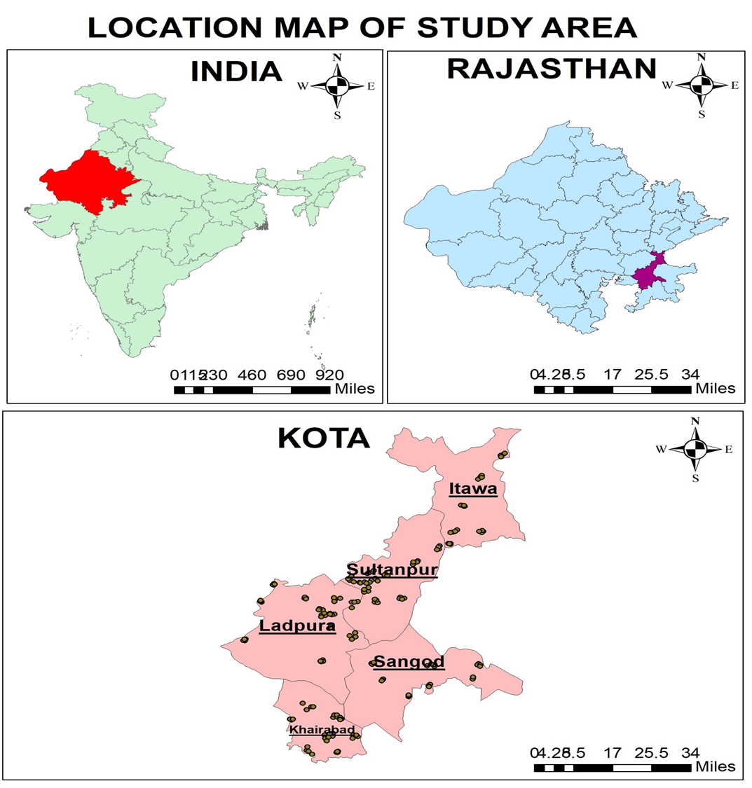
Fig.1 Location map of study area.

Laboratory analysis:
Physico-chemical parameters included pH and electrical conductivity (1:2 soil: water suspension; Jackson, 1973), organic carbon (Walkley & Black, 1934), available nitrogen (alkaline KMnO₄ method; Subbiah & Asija, 1956), available phosphorus (Olsen et al., 1954), available potassium (NH₄OAc extraction; Hanway & Heidel, 1952), and available sulphur (turbidimetric method; Williams & Steinbergs, 1959). Micronutrients (Zn, Cu, Fe, Mn) were extracted using DTPA (Lindsay & Norvell, 1978) and quantified on an Atomic Absorption Spectrophotometer. Standard quality control procedures, including blanks, duplicates, and certified reference samples, were used for accuracy assurance. Full analytical protocols are provided in the Supplementary Information.
Geo-statistical and GIS analysis
Descriptive statistics (mean, standard deviation, coefficient of variation) were calculated for each soil parameter. Ordinary kriging was used to interpolate soil properties and generate spatial distribution maps at 250 m resolution in ArcGIS 10.8.
Results and Discussion
Soil Reaction (pH)
The soil pH in Kota district varied from 6.2 to 8.9, with a mean of 7.6, indicating that the soils are generally neutral to moderately alkaline in nature (Fig. 2). Block-wise, pH values were highest in Sangod (mean 8.3) and lowest in Itawa (mean 7.1). Such variation can be attributed to differences in parent material, irrigation water quality, and land use intensity. Similar trends of neutral to alkaline soil reaction in semi-arid districts of Rajasthan were also reported by Yadav et al. (2018).
Electrical Conductivity (EC)
The electrical conductivity ranged between 0.12 and 0.85 dS m⁻¹, with an average of 0.38 dS m⁻¹ across the district (Fig. 3). All values were below the critical limit of 1.0 dS m⁻¹, suggesting that salinity is not a constraint to crop production in the area. Slightly elevated EC was observed in the Khairabad block, which could be linked to localised irrigation with marginal quality water. Comparable EC levels were reported in adjacent districts under irrigated conditions (Dilliwar et al., 2014).
Organic Carbon (OC)
Organic carbon content of the soils varied from 0.18 to 0.92%, with a mean of 0.42% (Fig. 4). Most soils fell in the low to medium fertility class (<0.75%), reflecting intensive cropping, low residue retention, and limited organic matter application. Higher OC was recorded in the Ladpura block, possibly due to higher biomass return from soybean–wheat rotations. Low organic carbon in semi-arid soils has been widely documented (Mandal et al., 2011), and improving organic matter input remains a key challenge.
Available Nitrogen
Available nitrogen ranged from 182 to 345 kg ha⁻¹, with a mean of 252 kg ha⁻¹ (Fig. 5). The majority of soils tested low to medium in available N. The low nitrogen status can be attributed to high mineralisation losses and insufficient organic inputs, consistent with earlier findings from Rajasthan soils (Talib & Verma, 1990). Block-wise, Itawa soils recorded relatively higher nitrogen, while Sangod soils were lowest, reflecting differences in cropping intensity and fertiliser practices.
Available Phosphorus
Available phosphorus content varied widely between 7.4 and 41.5 kg ha⁻¹, with a mean of 22.6 kg ha⁻¹ (Fig. 6). Soils were generally low to medium in P availability. Higher values were observed in the Khairabad block, which may be due to the regular application of phosphatic fertilisers in irrigated crops. The spatial variability of P is likely linked to fixation in calcareous soils, as noted by Todmal et al. (2008).
Available Potassium
Available potassium status ranged from 135 to 712 kg ha⁻¹, with a mean of 384 kg ha⁻¹ (Fig. 7). Most soils fell in the medium to high category, indicating sufficient reserves of K in the parent material. The highest mean K was observed in the Ladpura block, whereas the Sultanpur soils showed comparatively lower levels. Similar medium to high potassium status has been reported in alluvial soils of northern India (Prasad & Rokima, 1991).
Available Sulphur
Available sulphur varied from 6.2 to 28.7 mg kg⁻¹, with a mean of 14.5 mg kg⁻¹ (Fig. 8). Approximately one-third of samples were below the critical limit of 10 mg kg⁻¹, particularly in Itawa and Sangod blocks. Sulphur deficiency is increasingly common in intensively cropped areas due to the omission of sulphur fertilisers (Tiwari et al., 2011).
Micronutrients
- Zinc (Zn): Available Zn ranged between 0.28 and 1.65 mg kg⁻¹, with a mean of 0.64 mg kg⁻¹ (Fig. 9). Nearly 45% of soils were deficient (<0.6 mg kg⁻¹), especially in Sangod and Sultanpur. Zinc deficiency in Rajasthan soils has been widely reported and is linked to high pH and low organic matter (Singh et al., 2017).
- Iron (Fe): Available Fe ranged from 2.3 to 8.5 mg kg⁻¹, with a mean of 4.6 mg kg⁻¹ (Fig. 10). Most soils were adequate, though localised deficiencies occurred in alkaline zones.
- Copper (Cu): Available Cu ranged from 0.28 to 2.1 mg kg⁻¹, with a mean of 0.82 mg kg⁻¹ (Fig. 11). All soils were sufficient in Cu, in agreement with earlier reports from semi-arid regions (Dilliwar et al., 2014).
- Manganese (Mn): Available Mn varied from 3.1 to 11.2 mg kg⁻¹, with an average of 6.8 mg kg⁻¹ (Fig. 12). All samples exceeded the critical limit, suggesting Mn is not a limiting nutrient.
Table 6: Descriptive statistics (min, max, mean, SD, CV) of soil properties in Kota district.
Block |  | pH | EC | OC | N | P | K | S | Cu | Zn | Fe | Mn
 |  |  | (dS/m1 ) | % | (Kg/ha) |  |  |  | mg kg⁻¹,
Ladpura | MIN | 7.15 | 0.39 | 0.30 | 142.50 | 18.00 | 161.00 | 20.00 | 0.22 | 0.30 | 2.01 | 1.31
 | MAX | 7.99 | 1.40 | 0.93 | 325.50 | 46.00 | 833.00 | 31.00 | 1.19 | 1.12 | 9.12 | 8.33
 | MEAN | 7.71 | 0.76 | 0.51 | 207.33 | 30.03 | 363.95 | 25.93 | 0.74 | 0.76 | 6.07 | 4.51
 | SD | 0.17 | 0.21 | 0.12 | 35.13 | 8.26 | 124.68 | 2.96 | 0.29 | 0.22 | 1.97 | 2.02
 | CV | 2.24 | 27.02 | 23.21 | 16.95 | 27.52 | 34.26 | 11.44 | 38.89 | 29.52 | 32.40 | 44.81
Sultanpur | MIN | 7.34 | 0.45 | 0.33 | 156.75 | 18.00 | 202.00 | 16.00 | 0.23 | 0.32 | 2.03 | 1.34
 | MAX | 7.95 | 1.29 | 0.68 | 255.00 | 55.00 | 645.00 | 31.00 | 1.46 | 1.42 | 8.65 | 9.98
 | MEAN | 7.71 | 0.83 | 0.51 | 207.29 | 33.88 | 405.60 | 25.33 | 0.80 | 0.89 | 5.43 | 5.59
 | SD | 0.14 | 0.26 | 0.09 | 24.84 | 9.98 | 108.57 | 3.89 | 0.36 | 0.31 | 1.93 | 2.67
 | CV | 1.82 | 31.89 | 18.49 | 11.99 | 29.47 | 26.77 | 15.37 | 45.02 | 34.98 | 35.55 | 47.71
Itawa | MIN | 7.30 | 0.39 | 0.18 | 85.50 | 18.00 | 148.00 | 16.00 | 0.20 | 0.29 | 2.05 | 1.60
 | MAX | 8.24 | 1.28 | 0.68 | 255.00 | 42.00 | 511.00 | 33.00 | 1.66 | 1.56 | 8.68 | 9.26
 | MEAN | 7.72 | 0.80 | 0.44 | 186.68 | 28.08 | 357.90 | 25.80 | 0.79 | 0.86 | 5.42 | 5.64
 | SD | 0.27 | 0.19 | 0.11 | 36.92 | 7.08 | 90.28 | 3.61 | 0.36 | 0.30 | 2.19 | 2.30
 | CV | 3.43 | 23.44 | 25.69 | 19.78 | 25.22 | 25.22 | 13.99 | 45.50 | 34.54 | 40.41 | 40.79
Khairabad | MIN | 7.20 | 0.40 | 0.23 | 109.25 | 22.00 | 228.00 | 15.00 | 0.15 | 0.33 | 2.17 | 0.58
 | MAX | 8.27 | 1.26 | 0.78 | 273.00 | 59.00 | 645.00 | 31.00 | 1.66 | 1.32 | 8.73 | 11.15
 | MEAN | 7.71 | 0.73 | 0.46 | 192.95 | 38.00 | 364.83 | 24.00 | 0.93 | 0.71 | 5.03 | 5.92
 | SD | 0.28 | 0.22 | 0.12 | 35.28 | 9.91 | 102.29 | 4.53 | 0.45 | 0.28 | 1.91 | 3.38
 | CV | 3.69 | 30.20 | 26.72 | 18.29 | 26.08 | 28.04 | 18.87 | 48.29 | 39.65 | 37.95 | 57.19
Sangod | MIN | 7.41 | 0.13 | 0.30 | 142.50 | 20.00 | 269.00 | 19.00 | 0.21 | 0.23 | 1.05 | 2.04
 | MAX | 8.27 | 1.39 | 0.72 | 270.00 | 46.00 | 753.00 | 30.00 | 2.85 | 2.22 | 19.42 | 20.74
 | MEAN | 7.82 | 0.70 | 0.48 | 200.56 | 35.73 | 427.53 | 24.73 | 1.19 | 1.14 | 8.98 | 9.35
 | SD | 0.2051 | 0.256 | 0.1084 | 32.847 | 6.7139 | 107.16 | 2.6505 | 0.6898 | 0.6102 | 6.1624 | 3.8764
 | CV | 2.6239 | 36.785 | 22.543 | 16.378 | 18.793 | 25.066 | 10.72 | 57.774 | 53.699 | 68.635 | 41.467

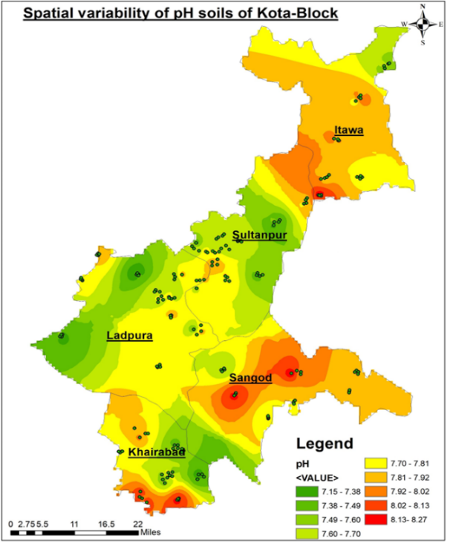 | 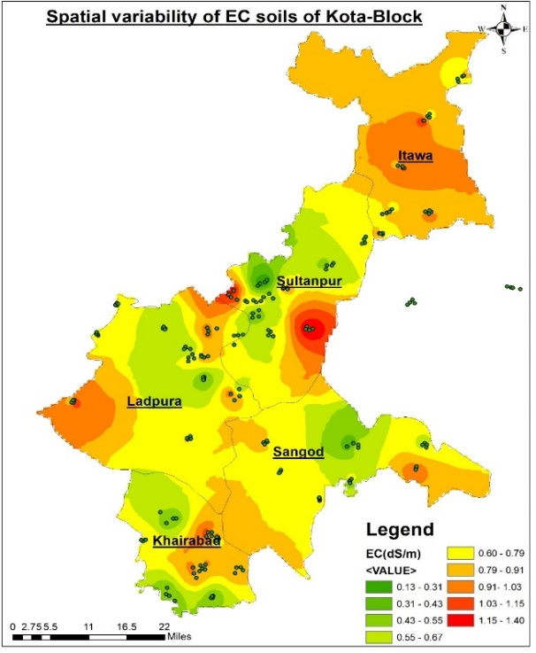
Fig. 2 Spatial variability of pH soils of Kota-Block | Fig. 3 Spatial variability of EC soils of Kota-Block
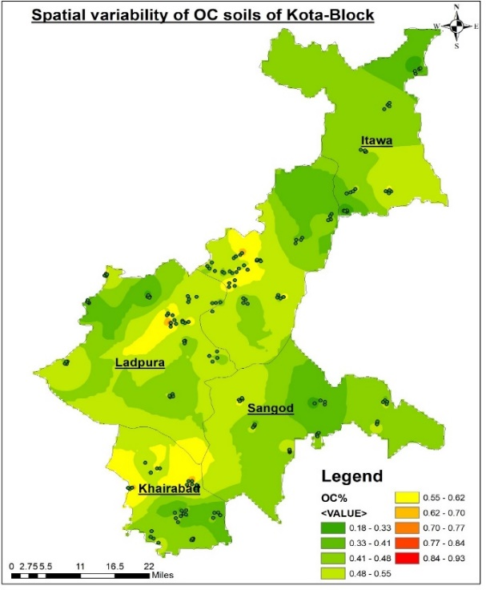 | 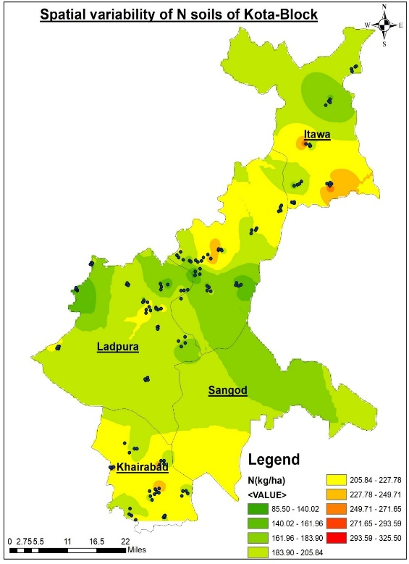
Fig. 4 Spatial variability of OC soils of Kota-Block | Fig. 5 Spatial variability of N soils of Kota-Block
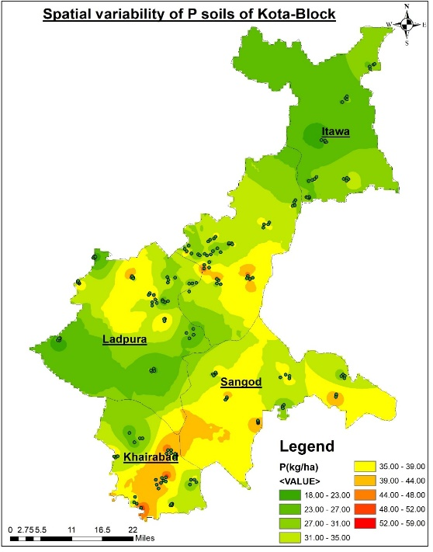 | 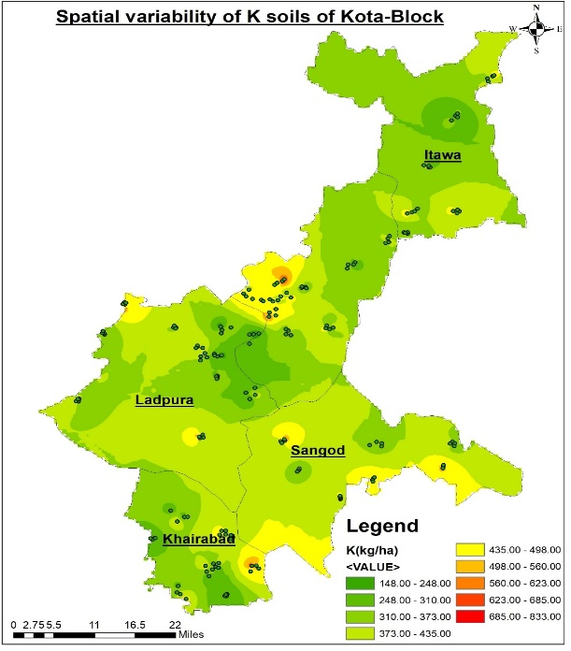
Fig. 6 Spatial Variability of P soils of Kota-Block | Fig. 7 Spatial variability of K soils of Kota-Block
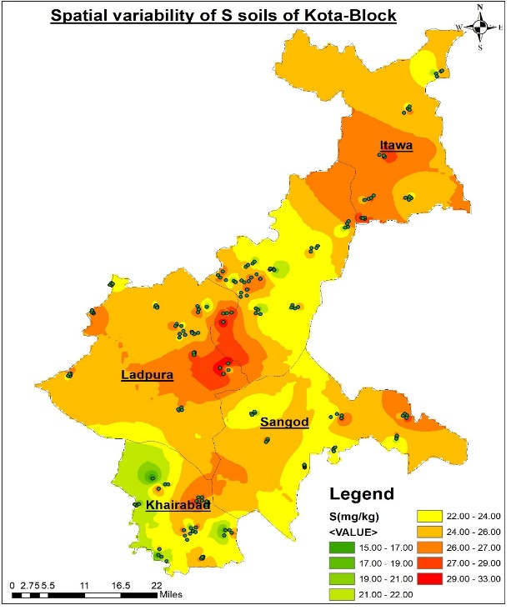 | 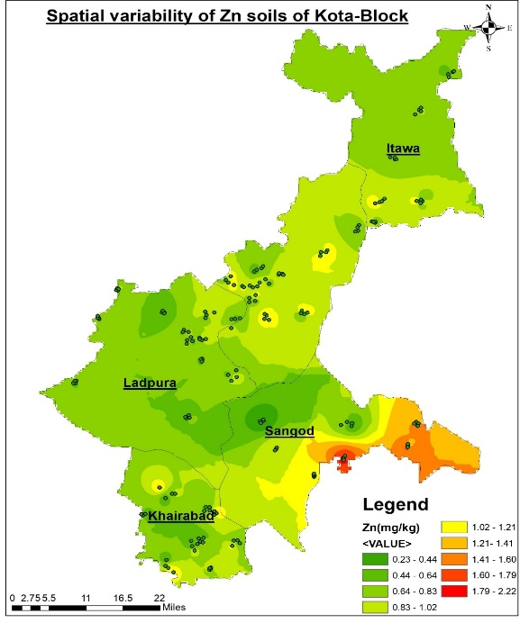
Fig. 8 Spatial Variability of S soils of Kota-Block | Fig. 9 Spatial variability of Zn soils of Kota-Block
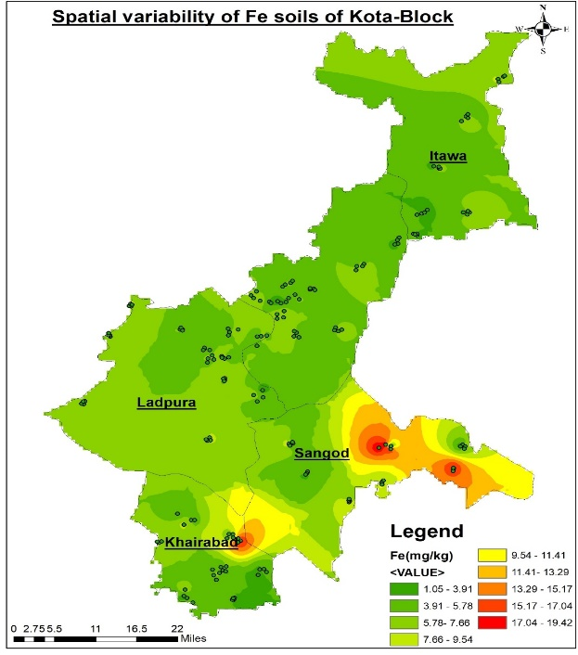 | 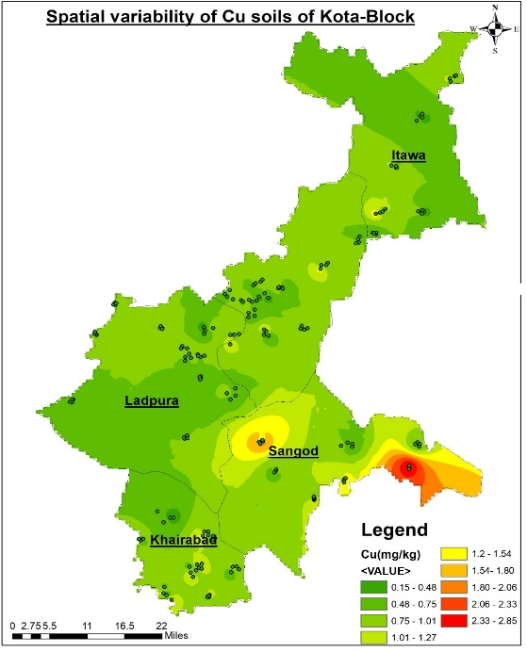
Fig. 10 Spatial variability of Fe soils of Kota-Block | Fig. 11 Spatial variability of Cu soils of Kota-Block
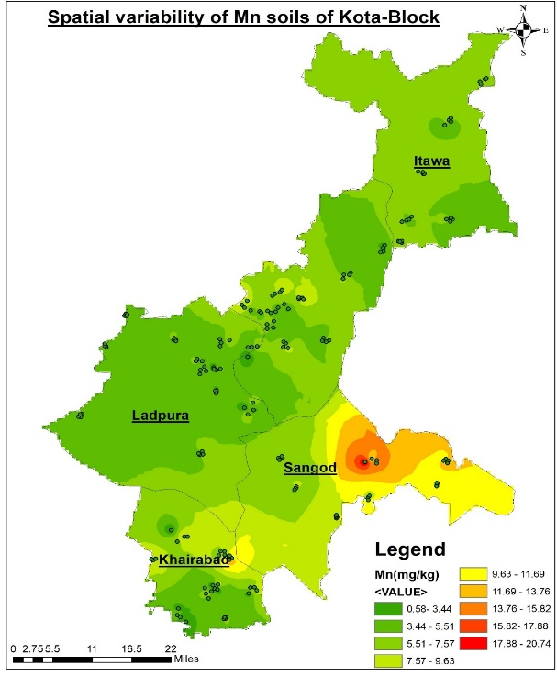
Fig. 12 Spatial variability of Mn soils of Kota-Block
The analysis of 200 geo-referenced samples revealed that the soils of Kota district are generally neutral to moderately alkaline, non-saline, and medium to high in potassium, but consistently low in organic carbon, nitrogen, and phosphorus, with emerging sulphur and zinc deficiencies. Such nutrient imbalances directly affect crop productivity and highlight the need for site-specific nutrient management rather than blanket recommendations. GIS-based maps clearly delineated fertility hotspots and deficient zones, offering actionable guidance for extension services and farmers. These results are consistent with earlier reports from semi-arid regions of India (Mandal et al., 2011; Yadav et al., 2018; Singh et al., 2017), but the present study provides a district-scale spatial framework that is more locally relevant. By integrating conventional soil analysis with GPS and GIS tools, this study demonstrates the practical utility of spatial mapping in identifying soil fertility constraints and prioritising interventions for sustainable land use planning.

Conclusion
The soils of Kota district were found to be neutral to moderately alkaline and non-saline, with adequate levels of potassium, manganese, and copper, but with low to medium organic carbon, nitrogen, and phosphorus. Sulphur deficiency was observed in nearly one-third of the samples, while zinc emerged as the most widespread micronutrient constraint, particularly in Sangod and Sultanpur blocks. GIS-based spatial maps clearly depicted the variability of soil properties, enabling the identification of fertility hotspots and nutrient-deficient areas. The findings underscore the urgent need for site-specific nutrient management strategies, emphasising organic carbon enhancement and balanced fertilisation with nitrogen, phosphorus, sulphur, and zinc. The generated maps provide a valuable baseline dataset for local planners, extension workers, and policymakers to improve fertiliser-use efficiency and guide sustainable land management in the district. Future research should focus on field validation of GIS-based nutrient management recommendations and on integrating long-term monitoring to capture the effects of management practices on soil health and crop productivity.

Disclaimer (Artificial intelligence)

Option 1:

Author(s) hereby declare that NO generative AI technologies such as Large Language Models (ChatGPT, COPILOT, etc.) and text-to-image generators have been used during the writing or editing of this manuscript.

Option 2:

Author(s) hereby declare that generative AI technologies such as Large Language Models, etc. have been used during the writing or editing of manuscripts. This explanation will include the name, version, model, and source of the generative AI technology and as well as all input prompts provided to the generative AI technology

Details of the AI usage are given below:
1.
2.
3.

References
Andrews, S. S., Mitchell, J. P., Mancinelli, R., Larlen, D. L., Hartz, T. K., Horwarth, W. R., Pettygrove, G. S., Scow, K. M., & Munk, D. S. (2002). On-farm assessment of soil quality in California’s Central Valley. Agronomy Journal, 94(1), 12–23. https://doi.org/10.2134/agronj2002.1200
Boafo, D. K., Kraisornpornson, B., Panphon, S., Owusu, B. E., & Amaniampong, P. N. (2019). Assessment of soil quality using principal component analysis and soil quality index in Thailand. Applied Ecology and Environmental Research, 17(2), 2585–2600.
Dilliwar, P., Singh, R. P., & Mishra, S. K. (2014). Available macro nutrients (N, P, K and S) in the soils of Chiraigaon block of district Varanasi (UP) in relation to soil characteristics. Indian Journal of Scientific Research, 5(2), 97–101.
Goovaerts, P. (1997). Geostatistics for natural resources evaluation. Oxford University Press.
Hanway, J. J., & Heidel, H. (1952). Soil analysis methods as used in Iowa State College Soil Testing Laboratory. Iowa Agriculture, 57, 1–31.
Isaaks, E. H., & Srivastava, R. M. (1989). An introduction to applied geostatistics. Oxford University Press.
Jackson, M. L. (1973). Soil chemical analysis. Prentice Hall of India.
Lindsay, W. L., & Norvell, W. A. (1978). Development of a DTPA soil test for zinc, iron, manganese and copper. Soil Science Society of America Journal, 42(3), 421–428. https://doi.org/10.2136/sssaj1978.03615995004200030009x
Mandal, B., Majumder, B., Adhya, T. K., Bandyopadhyay, P. K., Gangopadhyay, A., Sarkar, D., ... & Mishra, A. K. (2011). The potential of cropping systems and soil amendments for carbon sequestration in soils of the Indo-Gangetic Plains. Soil and Tillage Research, 111(1), 1–7.
Olsen, S. R., Cole, C. V., Watanabe, F. S., & Dean, L. A. (1954). Estimation of available phosphorus in soils by extraction with sodium bicarbonate. USDA Circular No. 939. U.S. Government Printing Office.
Prasad, R., & Rokima, A. (1991). Potassium in Indian agriculture. Potash Review, 5(1), 1–16.
Ramzan, S., Wani, M. A., & Bhat, M. A. (2017). Assessment of spatial variability of soil fertility parameters using geostatistical techniques in temperate Himalayas. International Journal of Geosciences, 8(10), 1251–1263.
Singh, M., Yadav, R. L., & Meena, R. L. (2017). Status of macro- and micronutrients in soils of Madhya Pradesh. Journal of the Indian Society of Soil Science, 65(3), 307–313.
Singh, R. P., Mishra, P. K., & Rai, P. K. (2014). Spatial variability of available micronutrients in soils of the Indo-Gangetic Plains. Environment Conservation Journal, 15(3), 93–99.
Subbiah, B. V., & Asija, G. L. (1956). A rapid procedure for estimation of available nitrogen in soils. Current Science, 25(8), 259–260.
Talib, A. R., & Verma, K. S. (1990). Available nitrogen status of soils of Chambal command area. Journal of the Indian Society of Soil Science, 38(3), 445–449.
Tiwari, K. N., Gupta, B. R., & Malewar, G. U. (2011). Sulphur for sustainable high yield agriculture in Madhya Pradesh. Indian Journal of Fertilisers, 7(4), 24–36.
Todmal, S. M., Patil, V. D., & Patil, S. G. (2008). Phosphorus availability in soils of semi-arid regions of Maharashtra. Journal of the Indian Society of Soil Science, 56(2), 195–199.
Walkley, A., & Black, I. A. (1934). An examination of the Degtjareff method for determining soil organic matter and a proposed modification of the chromic acid titration method. Soil Science, 37(1), 29–38. https://doi.org/10.1097/00010694-193401000-00003
Williams, C. H., & Steinbergs, A. (1959). Soil sulphur fractions as chemical indices of available sulphur in some Australian soils. Australian Journal of Agricultural Research, 10(3), 340–352. https://doi.org/10.1071/AR9590340
Yadav, K. K., Mali, N. L., Kumar, S., Surya, J. N., Moharana, P. C., Nogiya, M., & Meena, R. L. (2018). Assessment of soil quality and spatial variability of soil properties using geo-spatial techniques in sub-humid Southern Plain of Rajasthan, India. Journal of the Indian Society of Soil Science, 70(1), 69–85.

Chen, S., Lin, B., Li, Y., & Zhou, S. (2020). Spatial and temporal changes of soil properties and soil fertility evaluation in a large grain-production area of subtropical plain, China. Geoderma, 357, 113937.
Kingsley, J., Lawani, S. O., Esther, A. O., Ndiye, K. M., Sunday, O. J., & Penížek, V. (2019). Predictive mapping of soil properties for precision agriculture using geographic information system (GIS) based geostatistics models. Modern Applied Science, 13(10), 60-77.

Selmy, S., Abd El-Aziz, S., El-Desoky, A., & El-Sayed, M. (2022). Characterizing, predicting, and mapping of soil spatial variability in Gharb El-Mawhoub area of Dakhla Oasis using geostatistics and GIS approaches. Journal of the Saudi Society of Agricultural Sciences, 21(6), 383-396.

