Review Article

E-NOSE technology: An eminent tool for early detection of plant diseases

Abstract
Plant pathogens and pests pose a critical threat to global food security, necessitating early, accurate and cost-effective diagnostic tools. Conventional methods such as visual inspection, microscopy and molecular assays, while accurate, are often labor-intensive, expensive and unsuitable for large-scale field deployment. Recent advances in volatile organic compound (VOC) profiling have enabled the development of electronic nose (E-Nose) technology, which replicates the mammalian olfactory system through arrays of chemical sensors and pattern recognition algorithms. E-Noses offer rapid, non-invasive and non-destructive detection of plant stress and disease at pre-symptomatic stages, providing an essential advantage for timely intervention. Beyond disease diagnostics, E-Noses are increasingly applied in pest detection, crop quality monitoring, fertilizer and pesticide management and environmental surveillance, aligning closely with the objectives of precision agriculture. The integration of artificial intelligence, nanotechnology and machine learning has enhanced system accuracy and robustness, while challenges such as sensor drift, standardization and field-level validation remain. Overall, E-Nose technology holds significant promise as a practical and sustainable tool for advancing plant health management, promoting environmental sustainability and strengthening the resilience of modern agricultural systems.
Keywords: Deep learning, Electronic nose, Plant disease detection, Precision agriculture, Sensor arrays, VOCs

1.Introduction

The progressive decline in biodiversity within agricultural systems increases the vulnerability of crops to pests, diseases and yield reductions. Plant pathogens, in particular, represent a considerable threat to agricultural productivity and global food security. Consequently, the implementation of effective disease management strategies is imperative to mitigate these risks. Promoting sustainable agricultural practices, coupled with accurate and timely disease detection, is crucial for minimizing economic losses (Gaya & Gursoy, 2023). Conventional disease assessment primarily relies on visual inspection, a method that, while diagnostic, is often labor-intensive and time-consuming (Palma et al., 2022). Alternatively, advanced diagnostic approaches such as light and transmission electron microscopy, virus bioassays and polymerase chain reaction (PCR) techniques provide greater accuracy; however, these methods are costly, laborious and dependent upon specialized expertise (Dastgir et al., 2022; Vunsh, Rosner, & Stein, 2010). When a plant becomes infected, both the composition and concentration of volatile organic compounds (VOCs) are altered (Jansen et al., 2011). This shift has led to advancements in gas monitoring technologies, enabling the detection of plant stress and disease through VOC profiling.

The development of sensor technologies has marked a significant advancement in the early diagnosis of plant diseases (Maiolo & Polese, 2021). Differentiation of specific chemical signatures requires consideration of the plant’s physiological state as well as its interactions with pests and pathogens. These volatile signatures frequently include compounds such as terpenoids, essential oils, ethylene, jasmonic acid, insect pheromones and metabolites associated with cellular stress or damage (Dudareva et al., 2006). For diagnostic applications to be feasible in field conditions, however, a balance must be achieved between sensitivity, target specificity, timeliness, operational simplicity and cost-effectiveness.

The emergence of electronic nose (e-nose) sensor technology has significantly contributed to agriculture and forestry by enabling the rapid detection of volatile organic compounds (VOCs) released by infected plants. This capability facilitates accurate monitoring of disease progression and supports the development of effective control strategies to limit further spread. Over the past few decades, progress in e-nose and sensor technologies has been driven by the miniaturization of sensing devices, advancements in materials science and the integration of sophisticated information processing techniques, including pattern recognition. Collectively, these innovations have enhanced the efficiency and resilience of agricultural systems through improved plant health monitoring.

2. Volatile Organic Compounds (VOC) Based Plant Disease Detection

Plant-derived volatile organic compounds (VOCs) are low molecular weight biomolecules and metabolites characterized by high volatility and low boiling points. These compounds are continuously emitted by plants and play essential roles in growth, defense, survival and inter-organismal signaling (Baldwin et al., 2006). Structurally, VOCs encompass diverse classes, including hydrocarbons, alcohols, aldehydes and organic acids. Beyond their internal regulatory functions, VOCs also act as mediators of ecological interactions at higher trophic levels, influencing herbivores, pollinators and natural enemies.

The emission of volatile organic compounds (VOCs) reflects underlying biochemical and metabolic processes governed by hundreds of genes, thereby serving as indicators of a plant’s physiological state. Within complex signaling networks, VOCs act as primary mediators through which plants and their neighbors perceive and respond to potential threats. These volatiles include green leaf volatiles (GLVs), diverse terpenes, methanol and key signaling phytohormones such as ethylene, methyl jasmonate (MeJA) and methyl salicylate (MeSA), all of which are integral to inter and intra-plant communication (Hazaika et al., 2020). Under conditions of stress, whether from pathogen infection or physical injury, plants emit distinct VOC profiles that differ significantly from those of healthy individuals (Sharifi et al., 2018). Such stress-induced alterations hold promise as biomarkers for early disease detection, allowing diagnosis at stages much earlier than conventional methods typically permit (Cellini et al., 2016).

3. E-NOSE

The concept of the electronic nose (E-Nose) was first introduced by Persaud and Dodd in 1982, who described it as “an invention which replicates the sense of smell through the use of an integrated system of chemical sensors and a pattern recognition system.” This pioneering definition marked the initial step in the development of artificial olfaction technologies, demonstrating the feasibility of replicating the biological function of smell through technological means. Building upon this foundation, Gardner and Bartlett (1994) provided a more comprehensive characterization, defining the E-Nose as “a system that implements several chemical sensors of varying degrees of specificity and applies sophisticated pattern recognition techniques to analyze a spectrum of olfactory stimuli ranging from simple to multi-layered.” These early contributions laid the groundwork for subsequent research and technological advancements that continue to shape the field of artificial olfaction.

Contemporary electronic noses (e-noses) are engineered to detect, classify and identify complex mixtures that often pose challenges for conventional analytical techniques. In contrast to traditional chemical analyses, which emphasize the separation and identification of individual compounds, the e-nose is designed to capture the overall essence of an odor by analyzing the collective response patterns of multiple sensors. This approach employs an array of broadly responsive, non-specific sensors that operate in concert to generate distinctive “fingerprints” for different volatile organic compound (VOC) mixtures (Jiarpinijnun et al., 2020; Santos et al., 2019). The resulting sensor data are subsequently processed using computational algorithms that integrate statistical methods and machine learning techniques to interpret responses and classify odors. This principle closely parallels the biological olfactory system (Figure 1), wherein odor discrimination arises from the combined activity of numerous receptors, producing a composite pattern of chemical information rather than a signal from a single receptor (Sun et al., 2019; Zhong, 2019).

Electronic noses (E-Noses) provide considerable advantages by saving time and resources while enabling the real-time identification and classification of odors an ability not afforded by most conventional techniques. Although methods such as gas chromatography and mass spectrometry (GC-MS) deliver high analytical accuracy, they are costly, time-consuming and require specialized expertise. In contrast, E-Noses represent a more cost-effective, rapid and user-friendly approach, particularly in non-destructive applications. Their efficiency in analyzing volatile organic compound (VOC) emissions plays a crucial role in agriculture, where they facilitate the detection of plant infections, stress and other physiological disturbances before visible symptoms appear. By supporting early and affordable disease management. E-Noses contribute to improved crop health and a reduction in economic losses. Moreover, recent advancements in artificial intelligence (AI) and nanotechnology have further enhanced the reliability, sensitivity and accuracy of E-Nose systems, reinforcing their potential for widespread use in agricultural monitoring and management.

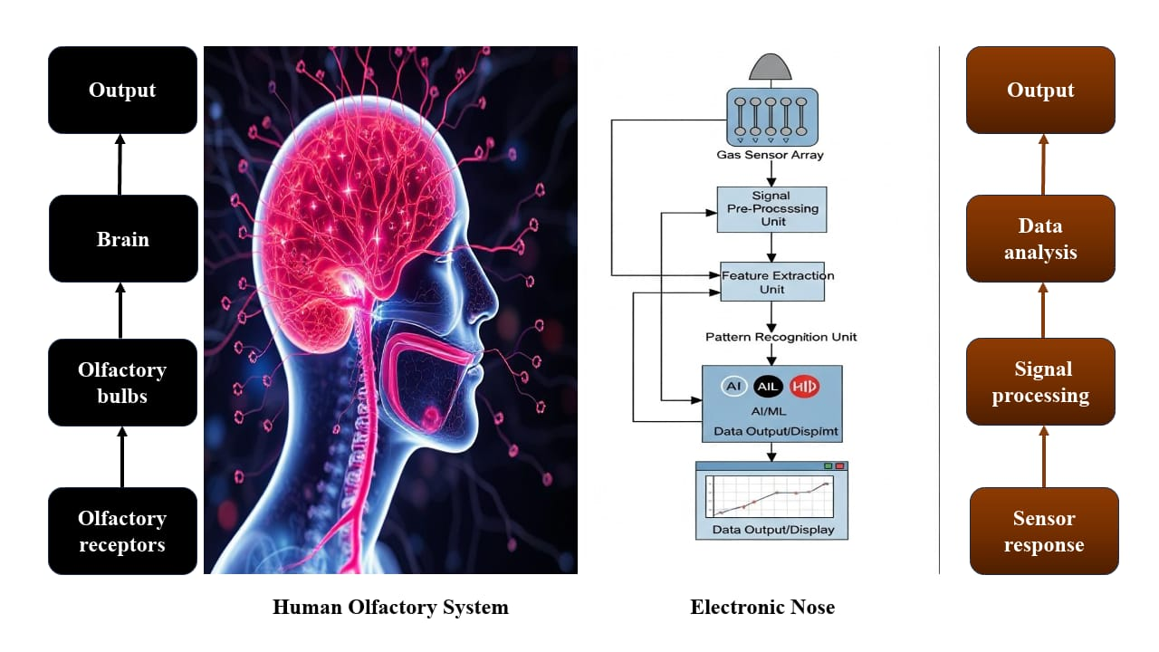

Figure 1. A schematic illustration showing the comparison between the human olfactory system and an electronic nose (E-NOSE)

4. Working principle of E-NOSE

The fundamental principle of an electronic nose (EN) system lies in the use of a sensor array to mimic the mammalian olfactory process by detecting changes in odor and aroma caused by volatile metabolites (Suchorab et al., 2019). An EN system typically comprises multiple sensors, each designed with varying sensitivities to different volatile compounds released from a sample. For instance, the PAN 3 electronic nose developed by Pan et al. (2014) incorporated ten sensors (S1–S10), each exhibiting distinct specificity. Sensor S1 was responsive to aromatic gases, while S2 detected nitrogen oxides. Sensor S3 exhibited sensitivity to both ammonia and aromatic gases, whereas S4 specifically detected hydrogen. Sensor S5 responded to alkenes and aromatic volatiles, and S6 was selective for methane. Sensor S7 demonstrated sensitivity to sulfur-containing compounds, alcohols and certain aromatic volatiles, while S8 was responsive to both aromatic and sulfur-organic volatiles. Sensor S9 detected nitrogen oxides and sulfides and S10 was sensitive to alkanes. In environmental monitoring, EN systems frequently employ sealed vials containing measured quantities of liquid or solid samples. The volatile compounds present in the headspace—sometimes enhanced through incubation interact with the sensors, inducing changes in their physical or chemical properties, such as electrical resistance or optical characteristics. These changes are then transduced into electrical signals. When analyzed collectively, the outputs from all sensors form a multidimensional dataset that characterizes the sample’s odor profile (Licen et al., 2018; Yakubu et al., 2021), as illustrated in Figure 2.

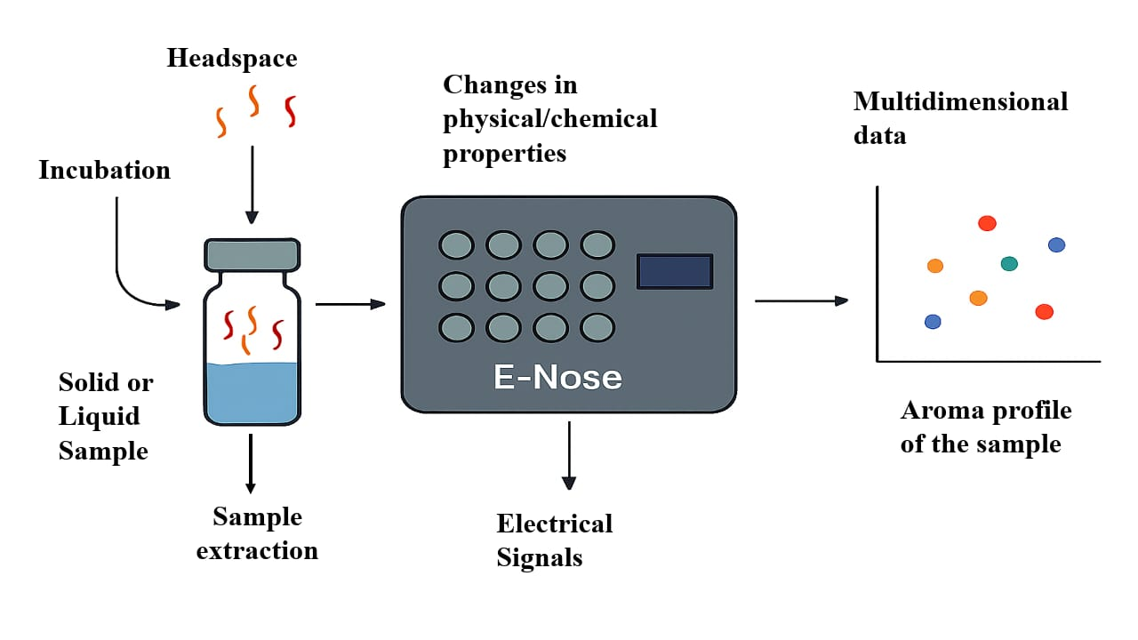

Figure 2. Schematic representation of the working principle of E-NOSE

These sensors exhibit high sensitivity to subtle variations in volatile metabolites, making them well suited for applications in early and highly sensitive detection processes (Lou et al., 2018). The ability of electronic nose (EN) technology to discriminate among complex odors relies on arrays of gas sensors with varying selectivity (Ali et al., 2020; Lioutas et al., 2021). By employing sensors with different response profiles, EN systems can differentiate and separate volatile fingerprints, thereby enhancing identification accuracy (Ali et al., 2020). Depending on the analytical objective, EN configurations may consist of a single sensor unit or a cluster of multiple sensing units, calibrated to detect the specific volatiles of interest. Both the type and number of sensors are critical determinants of detection efficacy, with larger sensor arrays generally improving analytical performance. Consequently, most research has focused on multi-sensor configurations to maximize effectiveness. This approach enables real-time detection by distinguishing unique volatile fingerprints with high precision (Shi et al., 2019).

The typical workflow of electronic nose (E-NOSE) technology comprises sampling, sensing, data acquisition, pattern recognition, and analyte detection as described in Figure 3.

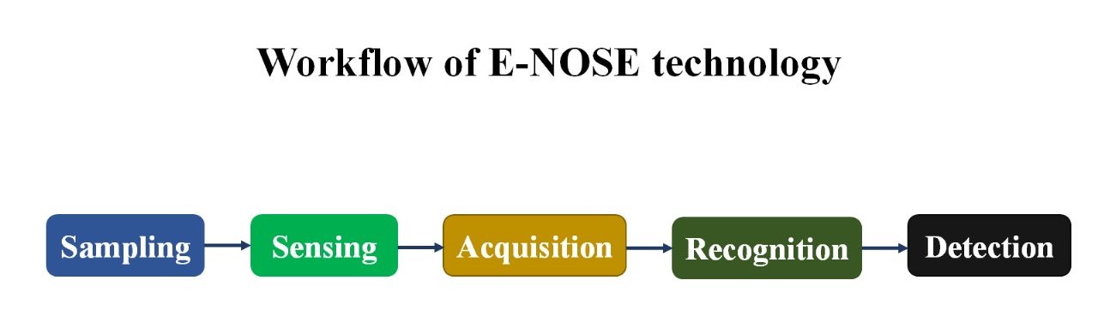

Figure 3. Schematic representation of the workflow of E-NOSE technology

5. Components of E-NOSE
Electronic noses consist of a sample dispersion system, sensing system and processing system (Karami et al., 2020)(Figure 4). The characterization of volatile metabolite profiling is a three-step process: (1) sampling of odours, (2) identification of disease based upon analysis of sensory array, and (3) capturing of data together with recognition of patterns (Ali et al., 2023).
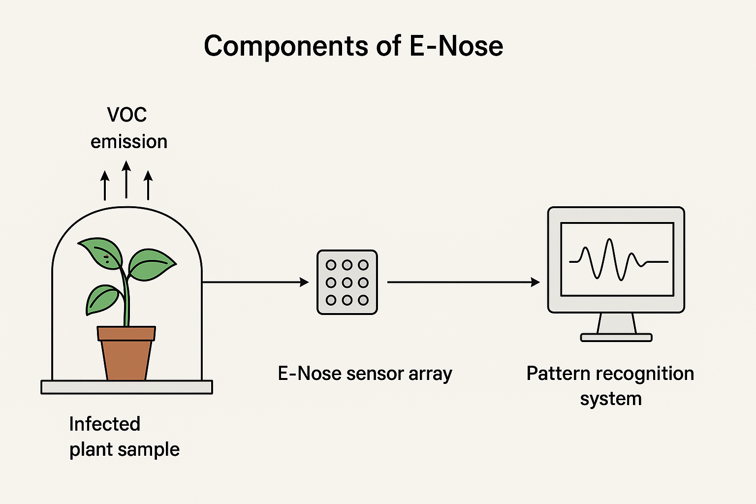

Figure 4. Schematic illustration showing the main components of an electronic nose (E-NOSE)

5.1. Odour sampling

In analytical applications involving diseased samples, efficient sampling procedures (Figure 5) are essential to ensure that volatile metabolites are accurately directed to the sensor array. The use of rapid sampling techniques that cause minimal or no mechanical damage during testing is particularly important, as it helps preserve product quality and maintain consumer acceptance (Adedeji et al., 2020). Classical methods employed in such applications include static headspace analysis, pre-concentration techniques and solid-phase microextraction (SPME), each of which is designed to enable precise and reliable detection of volatile compounds (Dong et al., 2019).

The static headspace technique requires that samples be securely sealed in vials, allowing equilibrium to be established prior to analysis of the volatiles by the sensor array, as illustrated in Figure 6 (Pascale et al., 2018). To ensure reproducibility, parameters such as equilibration time, temperature, and sample volume must be carefully optimized. Another widely employed approach, the pre-concentrator or “purge and trap” method, involves transferring volatile metabolites toward the detector via an inert gas stream, as shown in Figure 7. While effective, this technique is limited by the substantial loss of certain volatile compounds during the purging stage, which represents a significant drawback (Bruno & Harries, 2019).
Solid-phase microextraction (SPME) has gained widespread use in volatile metabolite research due to its simplicity and efficiency. The technique employs an adsorbent-coated fiber capable of selectively capturing volatile molecules, which are subsequently released into a detection system through thermal desorption (Peris & Escuder-Gilabert, 2009). Owing to its reliability and efficiency in isolating odorants from fresh produce, SPME is considered one of the most suitable methods for analytical applications.

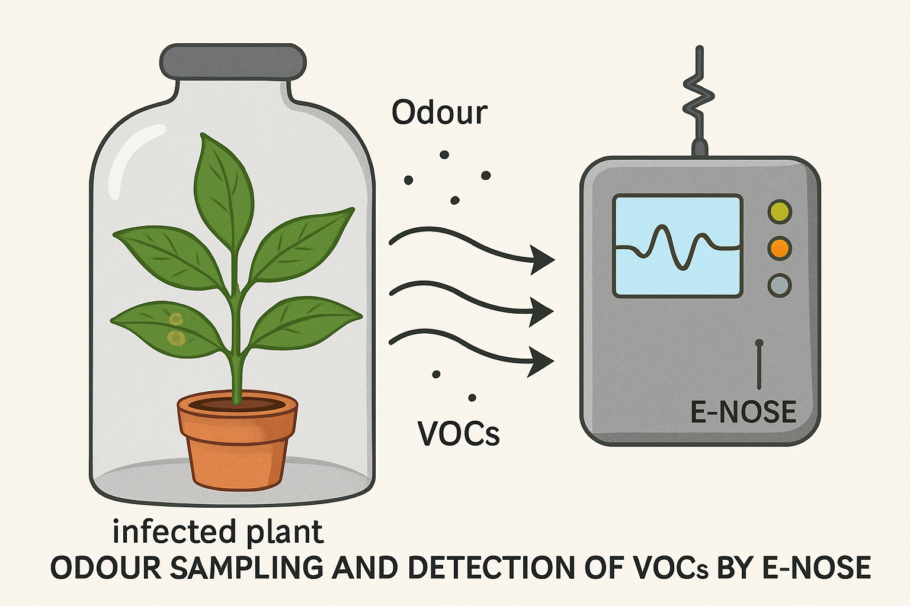

Figure 5. Diagrammatic illustration of odour sampling for the collection of volatile organic compounds (VOCs) from a diseased sample

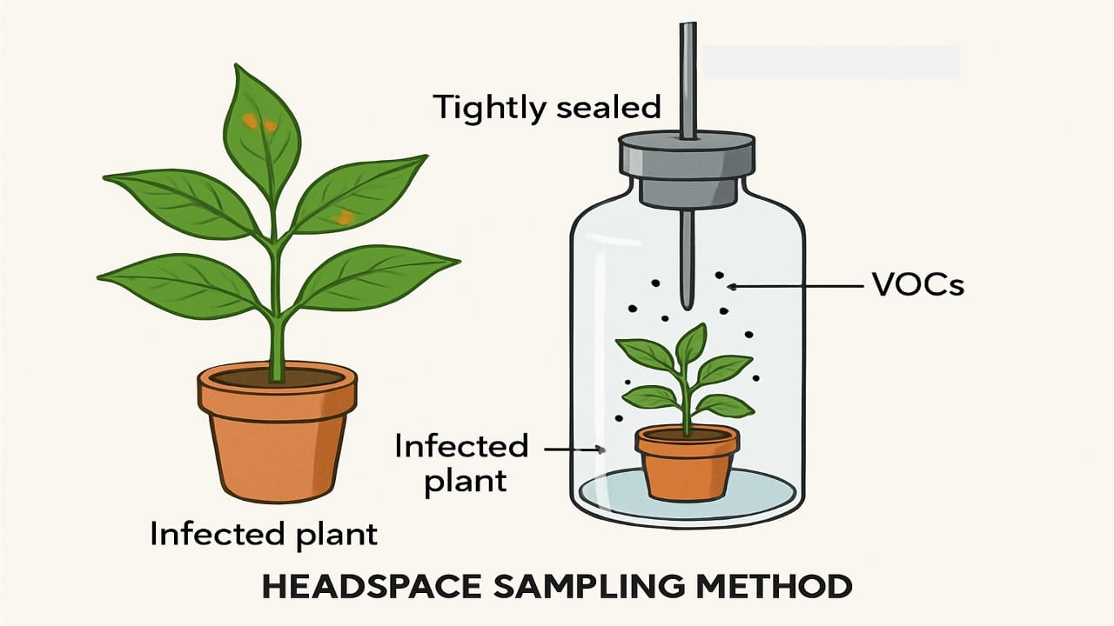
Figure 6. Schematic illustration of the static headspace method used for extracting samples from a diseased specimen
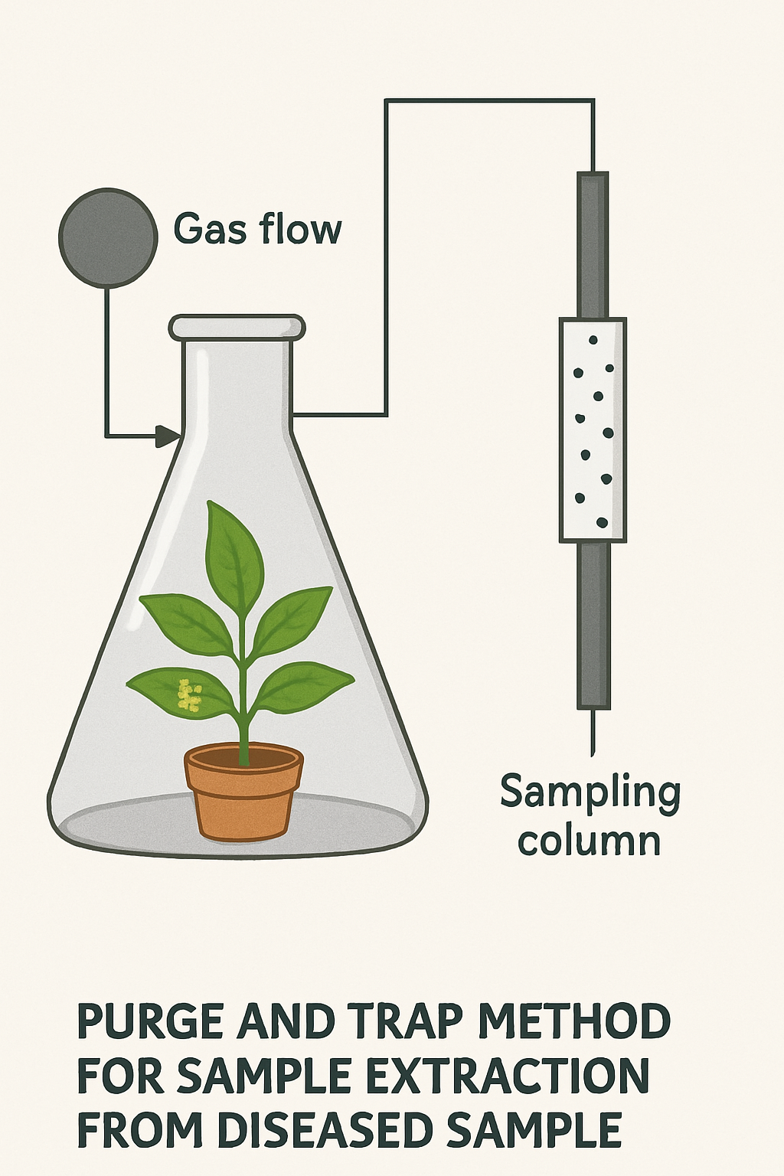
Figure 7. Schematic illustration of the purge-and-trap method for extracting samples from a diseased specimen

5.2. Sensor array/detection system
The detection system, typically composed of several sensors, functions as the reactive component of the electronic nose (Figure 8). Upon exposure to volatile compounds, these sensors undergo measurable changes in their electrical properties. Although each sensor is responsive to a range of volatile molecules, their distinct response patterns enable effective differentiation. Most electronic nose devices employ sensor arrays in which the adsorption of volatile molecules onto the sensor surface induces a physical change that is subsequently transduced into a quantifiable signal. This signal is processed through the electronic interface, converted into digital values and analyzed to generate an interpretable odor profile.
Electronic nose (EN) systems use various sensor technologies, including MOS, MOSFET, PC, QCM, electrochemical and SAW sensors (Table 1). Among these, MOS sensors are widely used in postharvest monitoring for early detection and quality control. They operate by detecting resistance changes in a metal oxide layer caused by gas surface interactions that affect electron availability. MOS sensors are favored for being low-cost, durable, sensitive and able to detect diverse gases.
Certain sensor types provide unique benefits. In plant disease detection, QCM biosensors use pathogen-specific antibodies on quartz crystals, where mass changes shift resonance frequency via the piezoelectric effect. SAW sensors function similarly but differ in acoustic wave propagation (Kus et al., 2021). Both offer high sensitivity for diverse volatiles but are limited by cost and power demands.
Metal-oxide semiconductor (MOS), quartz crystal microbalance (QCM) and surface acoustic wave (SAW) sensors have been tested for plant disease detection, but their field suitability differs. MOS sensors are inexpensive, portable and scalable, though affected by humidity and temperature. QCM sensors are highly sensitive but fragile and vibration-prone, while SAW sensors combine sensitivity with miniaturization yet require strict environmental control. Overall, MOS arrays currently offer the most practical field solution, whereas QCM and SAW need further refinement for outdoor use.
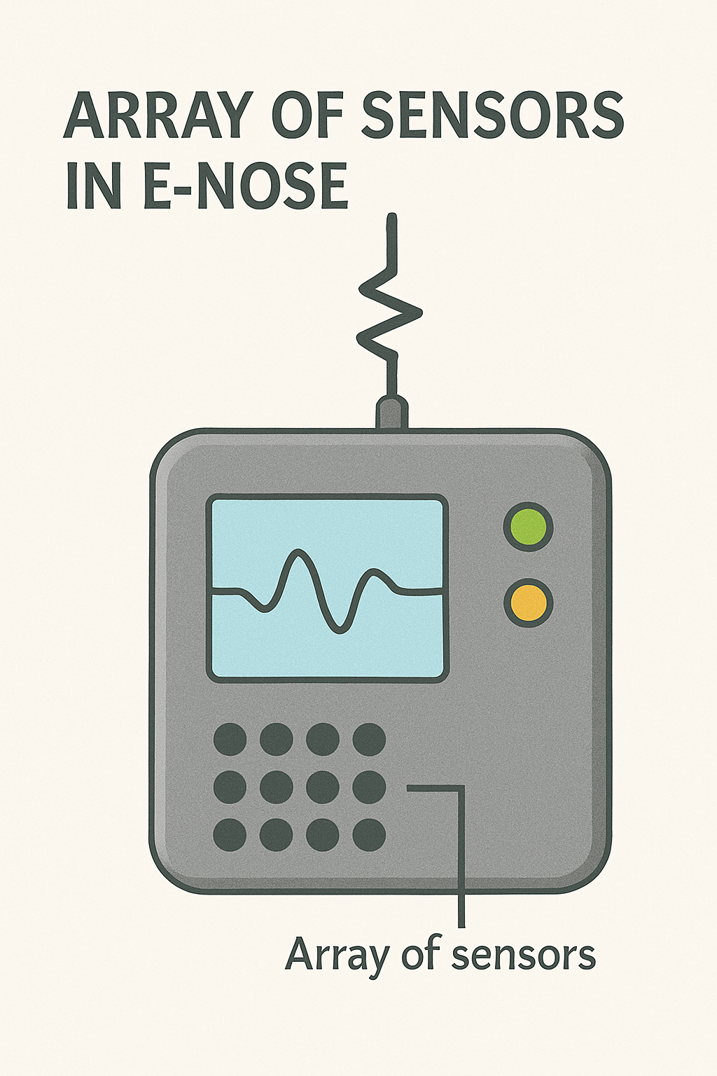

Figure 8. Diagrammatic illustration of the sensor array, functioning as the reactive component of the electronic nose (E-NOSE) system
Table 1. Overview of common sensor types employed in electronic nose (E-NOSE) systems for the detection of odors and volatile compounds. [Source: Ali et al., 2023]

Sensor type | Measurement | Advantages | Disadvantages | References
Metal oxide semiconductor (MOS) | Conductivity | The capability of detecting a greater range of chemicals, coupled with high reproducibility and rapid response times, represents a lower-cost, more convenient alternative. | High operating temperatures, high power consumption, susceptibility to sulfur poisoning and humidity, and a limited selection of available coatings are main concerns. | Nunes et al. (2019)
Metal oxide semiconductor field-effect transistors (MOSFET) | Threshold voltage change | Small, inexpensive sensors have a very fast response time and are very selective. | Baseline drift, high power consumption, controlled environmental conditions, and reduced sensitivity to ammonia and carbon dioxide | Loutfi et al. (2015)
Piezoelectric crystal (PC) | Piezoelectricity | High sensitivity, prompt time of response, capability to work at room temperature, easy synthesis, and low cost are impressive. | High sensor drift, unsatisfactory durability, sensitive to temperature and moisture, hard to produce | Pohanka (2018)
Quartz crystal microbalance(QCM) | Piezoelectricity | Wide range of coatings, batch-to-batch reproducibility, and enhanced sensitivity. | High cost, temperature- and moisture-sensitive, poor signal-to-noise ratio | Wang (2020)
Surface acoustic wave (SAW) | Piezoelectricity | The system has a rapid response time and is extremely sensitive, along with a broad selection of various coatings specifically created for a full range of detection analysis of gases. | The connected expenses are expensive, and there is a sensitivity of materials to variations in moisture and temperature, such that there is a suboptimal signal-to-noise ratio | Kus et al. (2021)
Electrochemical sensor | Conductivity | The fast processing, reduced cost, excellent chemical stability, and large ratio of surface to noise are of particular importance. | The product has a very limited shelf life, and it is cross-sensitive to other gases. Further, it is temperature- as well as moisture-sensitive | Xiao et al., 2020
Optical based | Intensity/spectrum | The sensor is highly sensitive, offers a high signal-to-noise ratio, and is immune to electromagnetic interference. Additionally, it is fast in its response, inexpensive, lightweight, as well as possessing a higher operational lifetime | High-cost, complex construction with advanced devices, experience photo-bleaching, advanced interface circuitry, few light sources, and poor portability | Ruan et al. (2018)
MS based | Chromatogram/ spectrum | This is a very sensitive, fast-response system, able to provide qualitative as well as quantitative results. The system is a universal detector, usable in a wide variety of different applications. | The factors concerning higher costs, heavy power consumption, and poor portability are significant points of consideration. | Zhang et al. (2018)

5.3. Data acquisition and Pattern recognition
Algorithm-driven data analysis is crucial for both qualitative classification and quantitative prediction in E-Nose applications, with most methods falling into three categories: graphical techniques, multivariate statistical analysis and machine learning as mentioned in Figure 9 . Simple graphical techniques such as Sammon mapping, bar charts, polar plots and hierarchical cluster analysis (HCA) reduce data dimensionality for easier sample and VOC comparison, but can be ambiguous with highly complex datasets. Multivariate statistical methods like principal component analysis (PCA), linear discriminant analysis (LDA) and cluster analysis (CA) condense high-dimensional data into interpretable two or three-dimensional forms, making them especially valuable for analysis involving many variables.
In electronic nose (E-Nose) systems, pattern recognition is classified as supervised or unsupervised. Supervised methods, such as artificial neural networks (ANNs), use training data to classify unknown features, while unsupervised methods, like cluster analysis, group data based on feature similarities (Wu et al., 2016). Principal component analysis (PCA), also known as the Karhunen–Loève transform, is a widely used unsupervised technique that reduces dimensionality while preserving key information, making it effective for clustering.
Artificial neural networks (ANNs) effectively analyze complex data for chemical vapor recognition. Integrated with sensor arrays, they can identify multiple compounds (Hoffheins et al., 1989) while allowing the use of inexpensive sensors. Once trained, ANNs quickly classify vapors, with feed-forward networks and backpropagation commonly applied in E-Nose studies. Shakaff et al. (2014) demonstrated the effectiveness of an ANN-based E-Nose for detecting basal stem rot in oil palm plantations, achieving 100% classification accuracy with multilayer perceptron and probabilistic neural networks, and 97.5% accuracy with the radial basis function (RBF) model.
Random Forest (RF) is another widely applied supervised learning method, commonly used for both classification and regression tasks. Due to its strong performance in analyzing E-Nose data, RF has gained prominence across a variety of analytical domains. The method operates by constructing an ensemble of decision trees, where each tree’s prediction is based on randomly selected variables, and the collective output of the ensemble determines the final result. For instance, RF was successfully employed to distinguish between healthy maize plants and those showing early symptoms of Phaeosphaeria leaf spot, achieving 88% accuracy with a kappa coefficient of 0.75 (Adam et al., 2017). Likewise, Knauer et al. (2017) applied an RF model to predict the severity of powdery mildew in Chardonnay grape clusters, reporting a classification accuracy of 0.87 in differentiating healthy, infected, and severely infected samples.
Principal Component Analysis (PCA) is a powerful tool for dimensionality reduction; however, it relies on linear assumptions and may fail to capture subtle nonlinear relationships (Jolliffe & Cadima, 2016). Artificial Neural Networks (ANNs), on the other hand, can effectively model complex nonlinear patterns but demand large datasets, high computational power, and are vulnerable to overfitting, in addition to offering limited interpretability (Goodfellow, Bengio, & Courville, 2016). Random Forests provide robustness and can manage diverse data types effectively, yet their performance may decline when dealing with highly correlated or very high-dimensional features, and their transparency is only moderate (Breiman, 2001). Acknowledging these trade-offs allows researchers to make more informed choices about analytical approaches and highlights opportunities for refining current methodologies.

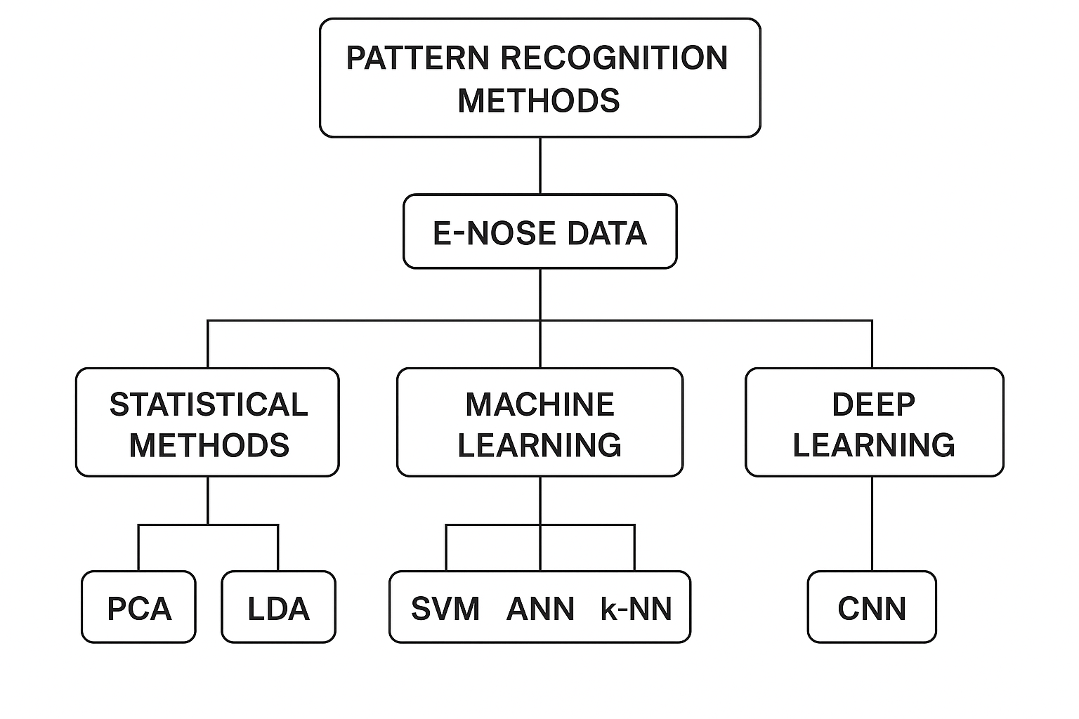
Figure 9. Common pattern recognition methods applied in electronic nose (E-NOSE) system

6. E-NOSE in plant disease detection

Electronic noses (E-Noses) have emerged as valuable tools for the early detection of plant diseases, offering rapid, non-destructive and highly sensitive diagnostics even before visible symptoms appear. Unlike conventional diagnostic methods that rely on morphological, molecular, or serological analyses, E-Noses function by detecting volatile organic compounds (VOCs) emitted by plants under stress or infection. This capability highlights their potential for early intervention, reduction of crop losses, and promotion of sustainable disease management practices.

For example, the Cyranose 320 E-Nose, using nitrogen as the reference gas, successfully differentiated Fulvifomes siamensis cultures, fruiting bodies and decayed wood from control samples (Tan et al., 2023). In another study, Wang et al. (2023) examined changes in VOCs associated with kiwifruit soft rot infection and storage conditions. By combining E-Nose measurements with chemometric analyses, they were able to clearly distinguish between medium- and late-rot stages, although differentiating latent infections from healthy samples proved more difficult. Their results further demonstrated that a multilayer perceptron neural network (MLPNN) provided the best performance for early detection of soft rot.

In a related study, Borowik et al. (2021) utilized a cost-effective E-Nose to detect odors produced by the forest pathogens Pythium intermedium and Phytophthora plurivora. Their results confirmed that E-Noses can successfully differentiate pathogen-derived odors under in vitro conditions. Among the sensors tested, TGS 2602 demonstrated particularly high sensitivity to VOCs, ammonia and hydrogen sulfide (H₂S), achieving the highest classification accuracy when used within a minimized sensor array.

Oates et al. (2020) employed a low-cost E-Nose system equipped with eight Taguchi-type (MQ) sensors (MQ135, MQ2, MQ3, MQ4, MQ5, MQ9, MQ7, and MQ8) to detect fatal bronzing disease in cabbage. More recently, Ratnayake et al. (2024) compared the diagnostic performance of three commercially available E-Nose devices, Cyranose 320, PEN 3 and MSEM 160 for identifying mango twig tip dieback (MTTD) and banana Panama disease (TR4). The Cyranose 320 achieved 54% accuracy in distinguishing healthy leaves from those infected with MTTD, and 75% accuracy in differentiating healthy pseudostems from TR4-infected ones. PEN 3 performed more effectively, with 86.06% accuracy for MTTD classification and 84.96% for TR4 detection. Among the three, MSEM 160, the most advanced system, demonstrated the highest capability in accurately separating samples into their respective disease categories.

Laboratory-developed systems have also demonstrated strong diagnostic capabilities. For instance, a custom-built E-Nose incorporating eight MOS gas sensors (Taguchi TGS series) combined with Support Vector Machine (SVM) analysis achieved 99.64% accuracy in differentiating Ganoderma boninense CSB, Ganoderma boninense “Rejosari” and Ganoderma lucidum in oil palm, with a clear distinction between infected and healthy samples. In another comparative study, Borowik et al. (2021) evaluated two low-cost systems, PW4 and PW6, against Fusarium oxysporum and Rhizoctonia solani. The PW4 system, equipped with six TGS sensors, exhibited a broad response spectrum, while PW6, which incorporated only two carefully chosen sensors, achieved higher classification accuracy highlighting the importance of strategic sensor selection in optimizing system performance.

The integration of machine learning has significantly improved the performance of E-Nose systems. Wu et al. (2022) demonstrated that combining E-Nose data with the K-nearest neighbors (KNN) algorithm enabled early detection of Ceratocystis fimbriata in sweet potatoes, even during the asymptomatic phase. Similarly, Haghbin et al. (2022) utilized an E-Nose equipped with thirteen MOS gas sensors to identify Botrytis cinerea-infected kiwifruits. By applying correlation-based feature selection (CFS) alongside a multilayer perceptron neural network (MLPNN), they achieved classification accuracies of 99.9% in training and 100% in testing. In another application, the gas feature neural network (GFNN) model reached 98.76% accuracy in assessing wheat bunt severity, effectively detecting trimethylamine (TMA) as a key VOC biomarker.

Finally, Wang et al. (2020) developed a bioelectronic nose incorporating single-stranded DNA and single-walled carbon nanotubes to detect VOCs released by strawberries infected with Phytophthora cactorum, further expanding the technological frontier of plant disease diagnostics.

7. Applications of E-NOSE technology in agriculture

The electronic nose (E-Nose) has found wide-ranging applications in agriculture as described in Figure 10, which includes spanning disease detection, crop quality management and environmental monitoring. Among its most critical functions is the early detection of plant diseases through the analysis of volatile organic compounds (VOCs) emitted by plants before the onset of visible symptoms. This rapid and non-destructive diagnostic capability also extends to food safety, where E-Noses are employed to monitor pesticide residues in crops. Additionally, they assist in fertilizer management by estimating nutrient residues in fruits and vegetables, based on VOC emissions linked to soil fertilizer applications. E-Noses are equally valuable for crop quality assessment, providing insights into freshness, ripeness, and post-harvest conditions. Beyond crop-focused applications, they also serve an important role in environmental surveillance by detecting soil and air pollutants, thereby supporting safer and more sustainable agricultural practices.

In plant health diagnostics, electronic noses (E-Noses) are typically applied through two main strategies: the direct method, which detects VOCs released by isolated microbial pathogens, and the indirect method, which analyzes plant-emitted VOC changes following pathogen inoculation. Together, these approaches provide a comprehensive assessment of infection status and plant stress responses. Notable examples include the successful early detection of fire blight (Erwinia amylovora) and blossom blight (Pseudomonas syringae pv. syringae) in apple orchards, demonstrated under both laboratory and field conditions (Fuentes et al., 2018; Spinelli et al., 2010).

Electronic noses (E-Noses) have also shown strong potential in detecting insect infestations and monitoring pest population dynamics. For example, tomato plants infested with spider mites (Tetranychus urticae), a significant greenhouse pest, produce distinct VOC profiles that can be accurately identified through E-Nose analysis (Zhang et al., 2011). Likewise, research has demonstrated that mechanical damage triggers defense-related alterations in plant VOC emissions, with the specific composition varying according to the type of stress or injury (Ghaffari et al., 2011).

Beyond their role in pathogen and pest detection, electronic noses (E-Noses) also contribute to resource management and food safety. For instance, VOC analysis of cucumber fruits has been employed to predict NPK fertilizer residues using statistical modeling, providing a rapid and non-destructive approach to fertilizer monitoring while helping to minimize excessive agrochemical use (Tatli et al., 2022). Similarly, E-Nose technology has shown strong potential in monitoring pesticide contamination in vegetables, offering a fast and effective tool for safeguarding food safety (Meng et al., 2025).

Electronic noses have also been applied in broader botanical research, such as detecting and monitoring floral scents and volatile biogenic gas emissions. These applications make it possible to analyze seasonal variations in plant VOC release, thereby enhancing our understanding of plant–environment interactions (Fujioka et al., 2012).
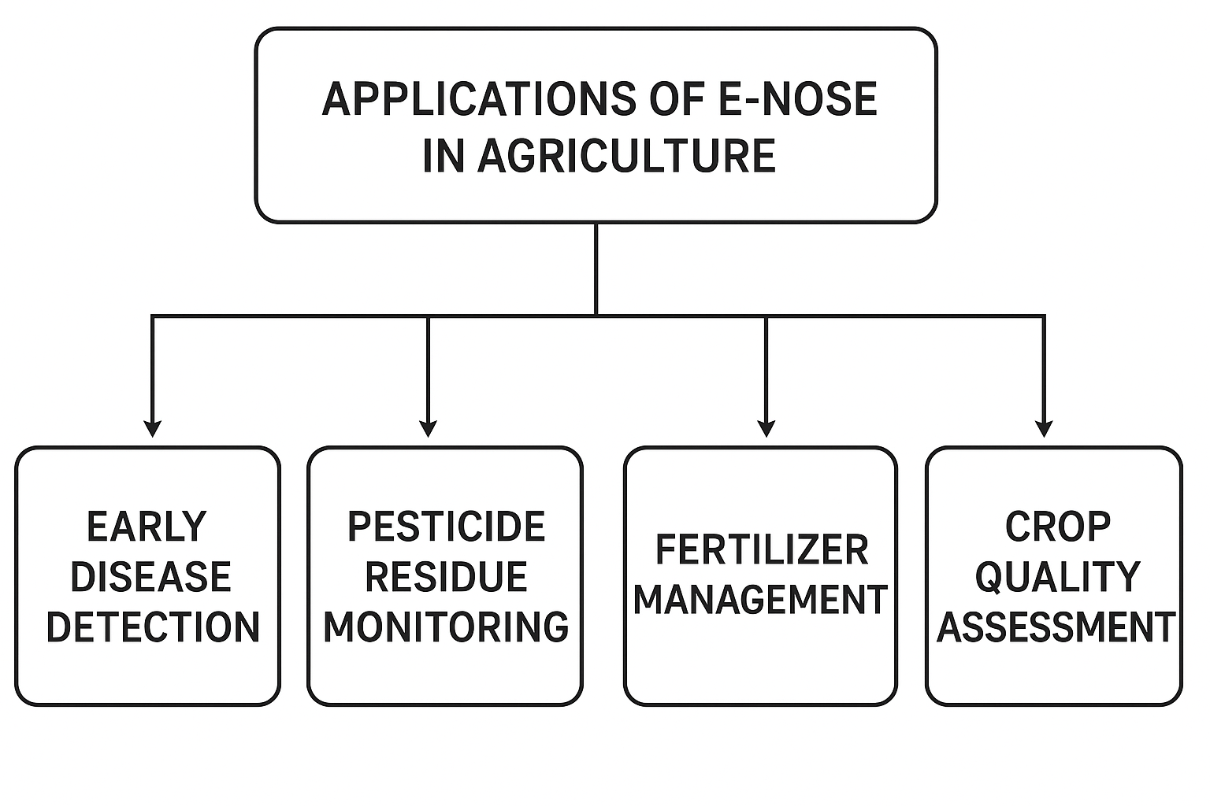

Figure 10. Applications of electronic nose (E-NOSE) technology in agriculture

8. Advantages of E-NOSE technology

The use of electronic nose (E-Nose) systems in plant disease diagnostics presents several notable advantages. These include: (1) non-invasive and non-destructive sampling, (2) the ability to detect infections within bulk host samples, (3) simultaneous identification of multiple diseases, (4) adjustable detection thresholds through customized training and discrimination settings, (5) sensor arrays that can be designed to target specific groups of disease-associated volatile organic compounds (VOCs), and (6) the capability to detect diverse pathogen classes using distinct reference databases while operating on a single device (Cellini et al., 2017).

Beyond these functional advantages, E-Nose devices are also valued for their portability, cost-effectiveness and ease of use, requiring only minimal operator training. Notably, they can detect, identify and classify complex mixtures of VOCs emitted from biological tissues without the need to isolate or characterize individual chemical compounds (Wilson, 2018). This capacity to transform chemical complexity into recognizable digital patterns highlights their practicality and efficiency as diagnostic tools in agriculture.

9. Practical challenges in field deployment

Although electronic noses (E-Noses) hold considerable potential for detecting plant diseases and supporting agricultural monitoring, their widespread application in real-world field conditions faces several practical barriers. Environmental variables such as temperature shifts, humidity and dust can undermine sensor reliability and stability. For example, metal oxide semiconductor (MOS) sensors—commonly employed in affordable E-Nose systems are particularly vulnerable to fluctuations in moisture and surrounding conditions, often resulting in inconsistent outputs (Nunes et al., 2019; Cellini et al., 2017). Another major concern is sensor drift, which refers to the gradual decline in sensitivity or baseline stability over time. This issue demands frequent recalibration, limiting accuracy and long-term usability in outdoor environments (Romain & Nicolas, 2010; Osborne et al., 2016).

Portability also remains a limitation. While recent technological progress has produced smaller, handheld E-Nose prototypes (Pereira et al., 2019), many devices continue to be bulky or consume significant energy, making them less practical for deployment in remote agricultural sites. Cost further constrains adoption, especially for smallholder farmers in low-resource regions. Although inexpensive sensor arrays such as Taguchi-type devices have shown promising results (Oates et al., 2020; Borowik et al., 2021), achieving an optimal balance between low cost, durability, and analytical performance remains a challenge.

To overcome these hurdles, research is focusing on innovations in sensor design, miniaturization, and advanced data-processing techniques. The incorporation of artificial intelligence and machine learning has already enhanced accuracy and mitigated the impact of drift (Ranjan et al., 2020), while developments in nanomaterials and portable platforms are anticipated to strengthen resilience under variable field conditions (Ali et al., 2023). Addressing these challenges will be crucial to transforming E-Nose technology from experimental laboratory systems into dependable tools for practical agricultural use.

10. Conclusion

The electronic nose (E-Nose) represents a significant advancement in agricultural diagnostics, providing a rapid, non-invasive and cost-effective approach to detecting plant diseases at early stages. By analyzing volatile organic compounds (VOCs) released by plants, E-Noses bridge the gap between conventional laboratory-based methods and real-time field applications, allowing the detection of stress factors before visible symptoms emerge. The integration of advanced sensor technologies with machine learning and deep learning algorithms has further improved their sensitivity, specificity and predictive capabilities.

Beyond plant disease detection, electronic noses (E-Noses) have demonstrated broad applicability in agriculture, including crop quality assessment, fertilizer and pesticide monitoring, post-harvest management, and environmental surveillance. These functions align closely with the objectives of precision agriculture, where efficient resource use and timely interventions help reduce crop losses, limit excessive chemical application and enhance overall sustainability. However, challenges such as device standardization, sensor drift, miniaturization and field-level validation continue to hinder large-scale adoption. Overcoming these barriers through sustained research, technological innovation and interdisciplinary collaboration will be essential for realizing the full potential of E-Nose systems in modern agriculture.

In summary, E-Nose technology holds great promise as an indispensable tool in modern agriculture, contributing to food security, advancing environmental sustainability and strengthening the resilience of farming systems in response to growing global challenges.

Disclaimer (Artificial intelligence)

Author(s) hereby declare that generative AI technologies such as Large Language Models, etc. have been used during the writing or editing of manuscripts. This explanation will include the name, version, model, and source of the generative AI technology and as well as all input prompts provided to the generative AI technology

Details of the AI usage are given below:
1. Grammarly for paraphrasing
2.Chatgpt for text to image generation.

References:
Abdullah, A.H., A.Y.M. Shakaff, A. Zakaria, F.S.A. Saad, S.A.A. Shukor & A. Mat (2014). Application specific electronic nose (ASEN) for Ganoderma boninense detection using artificial neural network. Proc. 2nd Int. Conf. on Electronic Design (ICED), Kuala Lumpur, Malaysia, pp. 19–21 August. IEEE.
Adam, E., H. Deng, J. Odindi, E.M.A. Rahman & O. Mutanga (2017). Detecting the early stage of Phaeosphaeria leaf spot infestations in maize crop using in situ hyperspectral data and guided regularized random forest algorithm. J. Spectrosc., 2017: 1–8.
Adedeji, A.A., N. Ekramirad, A. Rady, A. Hamidisepehr, K.D. Donohue, R.T. Villanueva & M. Li (2020). Non-destructive technologies for detecting insect infestation in fruit and vegetables under postharvest conditions. Crit. Rev. Food Sci. Nutr., 60(15): 927–945.
Ali, A., A.S. Mansol, A.A. Khan, K. Muthoosamy & Y. Siddiqui (2023). Electronic nose as a tool for early detection of diseases and quality monitoring in fresh postharvest produce: A comprehensive review. Compr. Rev. Food Sci. Food Saf., 22(3): 2408–2432.
Ali, M.M., N. Hashim, S.A. Aziz & O. Lasekan (2020). Principles and recent advances in electronic nose for quality inspection of agricultural and food products. Trends Food Sci. Technol., 99: 1–10.
Baldwin, I., R. Halitschke, A. Paschold, C. Dahl & C. Preston (2006). Volatile signaling in plant–plant interactions: “Talking trees” in the genomics era. Science, 311(5762): 812–815.
Borowik, P., L. Adamowicz, R. Tarakowski, P. Walclawik, T. Oszako, S. Ślusarski & M. Tkaczyk (2021). Development of a low-cost electronic nose for detection of pathogenic fungi and applying it to Pythium intermedium and Phytophthora plurivora. Sensors, 21(17): 5868.
Breiman, L. (2001). Random forests. Machine Learning, 45(1): 5–32.
Bruno, T.J. & M.E. Harries (2019). Encyclopedia of Analytical Science (3rd ed.). Elsevier, Amsterdam.
Cellini, A., S. Blasioli, E. Biondi, A. Bertaccini, I. Braschi & F. Spinelli (2017). Potential applications and limitations of electronic nose devices for plant disease diagnosis. Sensors, 17(11): 2596.
Cellini, A., E. Biondi, S. Blasioli, L. Rocchi, B. Farneti, I. Braschi, S. Savioli, M.T. Rodriguez-Estrada, F. Biasioli & F. Spinelli (2016). Early detection of bacterial diseases in apple plants by analysis of volatile organic compounds profiles and use of an electronic nose. Ann. Appl. Biol., 168(3): 409–420.
Chen, Y., Q. Liu & H. Wang (2017). Application of quartz crystal microbalance sensors for VOCs detection in plant disease diagnostics. Analytical Methods, 9(25): 3660–3667.
Dastgir, G., M.I. Majeed, H. Nawaz, N. Rashid, A. Raza, M.Z. Ali … A. Abdultaheem (2022). Surface-enhanced Raman spectroscopy of PCR products of rifampin resistant and susceptible tuberculosis patients. Photodiagn. Photodyn. Ther., 38: 102758.
Dong, W., R. Hu, Y. Long, H. Li, Y. Zhang, K. Zhu & Z. Chu (2019). Comparative evaluation of volatile profiles and taste properties of roasted coffee beans as affected by drying method and detected by electronic nose, electronic tongue, and HS-SPME-GC-MS. Food Chem., 272: 723–731.
Dudareva, N., F. Negre, D.A. Nagegowda & I. Orlova (2006). Plant volatiles: Recent advances and future perspectives. Crit. Rev. Plant Sci., 25(5): 417–440.
Fuentes, M.T., A. Lenardis & E.B. de la Fuente (2018). Insect assemblies related to volatile signals emitted by different soybean–weeds–herbivory combinations. Agric. Ecosyst. Environ., 255: 20–26.
Fujioka, K., M. Shirasu, Y. Manome, N. Ito, S. Kakishima, T. Minami, T. Tominaga, F. Shimozono, T. Iwamoto, K. Ikeda, et al. (2012). Objective display and discrimination of floral odors from Amorphophallus titanum using an electronic nose. Sensors, 12(2): 2152–2167.
Gardner, J.W., & Bartlett, P.N. (1994). A brief history of electronic noses. Sens Actuators B Chem, 18(3): 210-211.
Gaya, Z., & Gursoy, D. (2023). Discriminative detection of different cigarette brands using a fast-response electronic nose system based on porous ceramic substrate. ACS Omega, 8(47), 43425–43433
Ghaffari, R., F. Zhang, D.D. Iliescu, E.L. Hines, M.S. Leeson & R. Napier (2011). Intelligent systems for machine olfaction: Tools and methodologies. In: Detection of Diseases by Volatile Discrimination in Plants (Eds.: D. Olivares, A.Y. Zain & K. Kamel). IGI Global, USA, pp. 145–166.
Goodfellow, I., Y. Bengio and A. Courville (2016). Deep Learning. MIT Press, Cambridge, MA, USA.
Gupta, V. & A. Agarwal (2011). Quartz crystal microbalance: A tool for characterization of materials and biosensing. J. Sci. Ind. Res., 70(1): 1–15.
Haghbin, M., R. Mirzaei, H. Ghanbari, M. Khodayar and F. Rashidi (2022). Electronic nose technology for plant disease detection: Progress and challenges. Sens. Actuators B: Chem., 359: 131604.
Hazaika, B., R. Shavit, A. Zaidman & M. Shachak (2020). Plant volatiles as mediators of plant–insect and plant–plant interactions: Prospects for sustainable agriculture. Agron. , 10(9): 1345.
Huang, X., Y. Wang, H. Liang, Y. Xu, Y. Li & H. Zhang (2019). Discrimination of fungal infection in postharvest fruits using electronic nose and multivariate statistical analysis. Postharvest Biol. Technol., 150: 108–114.
Iseki, K., K. Ohnishi, J. Takabayashi & K. Takahashi (2007). Detection of cucumber green mottle mosaic virus infection in cucumber plants by gas chromatography-mass spectrometry and electronic nose. J. Agric. Food Chem., 55(21): 8579–8584.
Jain, S., S. Sharma & R. Kulshreshtha (2020). Electronic nose: A non-destructive tool for quality evaluation of food products. Food Anal. Methods, 13: 2221–2234.
Jansen, R.M.C., M. Hofstee, J. Bouwmeester, W. van der Voort, H.J. Jalink, H.J. van Loon & M.C.M. De Kogel (2011). Induced plant volatiles allow sensitive monitoring of plant health status in greenhouses. Plant Signal. Behav. 6(6): 882–888.
Jiarpinijnun, O., P. Sookpeng, T. Wongchoosuk & A. Kerdcharoen (2020). Development of an electronic nose for detecting fungal contamination in stored maize. IEEE Access, 8: 210355–210364.
Jolliffe, I.T. & J. Cadima (2016). Principal component analysis: a review and recent developments. Philosophical Transactions of the Royal Society A: Mathematical, Physical and Engineering Sciences, 374(2065): 20150202.
Karami, A., R. Amini, H. Alimardani & S. Khoshtaghaza (2020). Application of electronic nose coupled with chemometrics for non-destructive evaluation of plant disease: A review. Chemometr. Intell. Lab. Syst., 196: 103913.
Keshri, G., S. Voyron & R. Balestrini (2018). Potential of e-nose technology for monitoring plant–microbe interactions. Sens. Actuators B: Chem., 263: 76–84.
Knauer, U., K. Matros, S. Peterek, S. Zörb, T. Möller, A. Reimer, M. Schikora, R. van Dongen, T. Niehaus, R. Kraska and H.P. Mock (2017). Improved classification accuracy of maize leaf diseases using hyperspectral imaging in combination with machine learning and data preprocessing. BMC Plant Biol., 17: 184.
Kus, S., A. Koseoglu-Imer, O. Caglayan, A. Oztoprak, E. Karaca & O. Yilmaz (2021). Electronic nose system for plant disease diagnosis: A review. Chemosensors, 9(5): 111.
Licen, S., M. Barbieri, L. Fabbris, D. Cavalli, E. Barbi, A. Pillon, A. Vestri, G. Miani & D. Marchiol (2018). Chemical characterization and olfactometric evaluation of emissions from a composting plant: Assessing the performance of an electronic nose. Atmos. Environ. , 175: 192–201.
Lioutas, T.S., A. Charatsari & G. La Rocca (2021). Toward smart farming: The adoption of electronic nose technology in agriculture. Sensors, 21(4): 1144.
López, R., M. García & C. Orellana (2021). Recent advances in volatile analysis for disease detection in crops. Plant Sci. Today, 8(3): 547–555.
Loutfi, A., S. Coradeschi, G.K. Mani, P. Shankar & J. B. B. Rayappan (2015). Electronic noses for food quality: A review. J. Food Engineer. , 144: 103–111.
Maiolo, L., & Polese, D. (2021). Advances in Sensing Technologies for Smart Monitoring in Precise Agriculture. In Proceedings of the 10th International Conference on Sensor Networks (SENSORNETS 2021), pp. 151-158.
Martínez-García, H., M.C. Rodríguez-Molina & J. González (2017). Monitoring of tomato bacterial wilt through volatile organic compounds using electronic nose technology. Crop Prot., 100: 28–35.
Meng, X., L. Zhao, H. Wang, S. Li and Z. Zhang (2025). Integration of electronic nose and artificial intelligence for rapid on-site crop disease diagnosis: A futuristic approach. Artif. Intell. Agric., 9: 50–63.
Muthusamy, K., K. Kandasamy & S. Kim (2018). Surface acoustic wave sensors for chemical and biological detection. Sensors, 18(11): 3564.
Ncube, B., J.F. Finnie & J. Van Staden (2011). Quality from the field: The impact of environmental factors as quality determinants in medicinal plants. S. Afr. J. Bot., 77(3): 654–664.
Nunes, N., N. Rodrigues, J. Góis & A. Veloso (2019). Recent advances in electronic nose technologies for the detection of plant diseases. Sensors, 19(2): 404.
Oates, M.J., S. Chatterjee & M. Gheorghiu (2020). Low-cost electronic nose system for cabbage disease detection. Biosensors, 10(8): 78.
Osborne, J., A. Turner & R. Clark (2016). Advances in artificial olfaction: E-nose development and application to agriculture. Biosyst. Eng., 151: 120–131.
Pan, L., Y. Zhang, Z. Wang, H. Sun, H. Li & Y. Zhang (2014). Detection of early stage wheat powdery mildew based on electronic nose. Sensors, 14(5): 9806–9817.
Palma, G., et al. (2022). Ensemble Learning-Based Approach for Gas Detection Using a Mobile Robot Equipped with an Electronic Nose. Front. Chem. 10, 863838.
Pascale, S., L. Lemoine, M. Maupin, C. Dufossé & G. Bertin (2018). Application of electronic nose technology for monitoring plant health and early disease detection. Sensors, 18(11): 3776.
Pereira, D.A., R. Silva & J. Costa (2019). Portable electronic nose for plant disease detection in the field. Comput. Electron. Agric., 162: 931–939.
Peris, M. & L. Escuder-Gilabert (2009). A 21st century technique for food control: Electronic noses. Analytica Chimica Acta, 638(1): 1–15.
Pohanka, M. (2018). Electronic nose: Principles and advance. Crit. Rev. Anal. Chem., 48(5): 417–430.
Ponzoni, A., C. Baratto, N. Cattabiani, M. Falasconi, V. Galstyan, E. Nunez-Carmona, … G. Sberveglieri (2012). Metal oxide gas sensors, a survey of selectivity issues addressed at the SENSOR Lab, Brescia (Italy). Sens Actuators B Chem., 179: 3–20.
Qiu, Z., Y. Zhao & Y. He (2015). Discrimination of fungal diseases in rice by electronic nose combined with feature selection and classifier. Sensors, 15(4): 8647–8660.
Ranjan, R., N. Verma & B. Gupta (2020). Application of machine learning in e-nose for detection of crop diseases: A review. Artif. Intell. Agric., 4: 81–90.
Ratnayake, H.M.S., J. Torres-Giner and R. Lagaron (2024). Advances in machine learning-assisted electronic noses for real-time monitoring of agricultural pathogens. Sensors, 24(6): 2265.
Romain, A.C. & J. Nicolas (2010). Long term stability of metal oxide-based gas sensors for e-nose environmental applications: An overview. Sens Actuators B Chem., 146(2): 502–506.
Ruan, Q., L. Li, H. Li, J. Wang, H. Liu & Y. Li (2018). Detection of rice blast disease using an electronic nose combined with feature selection and classifier methods. Sensors, 18(2): 441.
Santos, J.P., M. Lozano, J. Aleixandre & M.C. Horrillo (2019). Electronic noses applications in food analysis. Sensors, 19(3): 459.
Shakaff, A.Y.M., A.H. Abdullah, A. Zakaria, F.S.A. Saad, S.A.A. Shukor and A. Mat (2014). Application specific electronic nose (ASEN) for Ganoderma boninense detection using artificial neural network. Proc. 2nd Int. Conf. on Electronic Design (ICED), Kuala Lumpur, Malaysia, pp. 19–21 August. IEEE.
Sharifi, R., & Ryu, C. M. (2018). Microbe-induced plant volatiles. New Phytol., 220(3), 684-691.
Sharma, R., D. Singh & R. Kaushik (2018). Early detection of plant pathogens using volatile profiling and electronic nose. Front. Plant Sci., 9: 1036.
Shi, Y., L. Guo, X. Chen, Y. Sun, H. Wang & J. Xu (2019). Early detection of postharvest peach spoilage using electronic nose technology. Postharvest Biol. Technol, 151: 68–75.
Si, P., J. Mortensen, A.S. Komolov, A. Denisenko & K. Haenen (2020). Advances in SAW-based gas sensors for field applications. Sens Actuators B Chem., 320: 128345.
Spinelli, F., A. Cellini, L. Marchetti, K. Mudigere & A. Bertaccini (2020). Emerging trends in electronic noses for plant disease detection. Phytopathol. Res., 2(1): 23.
Suchorab, Z., A. Kowalski, M. Błaszczak, J. Łagód, M. Guz, A. Łukasiewicz & J. Sobczuk (2019). A review of electronic nose technologies and their applications to detect biological hazards. Environ. Monit. Assess., 191(3): 167.
Sun, X., Y. Du, Y. Wang, J. Li & Z. Yang (2019). Application of electronic nose for early detection of tobacco bacterial wilt caused by Ralstonia solanacearum. Plant Dis., 103(12): 3158–3164.
Tan, J., C. Xu, H. Li, J. Wu, Y. Yang and S. Zhang (2023). Development of an electronic nose system for early detection of tomato bacterial wilt disease in greenhouse conditions. Comput. Electron. Agric., 205: 107620.
Tatli, F., G. Altuntas and M. Cimen (2022). Early detection of powdery mildew in cucumber leaves using electronic nose combined with chemometric techniques. Sci. Hortic., 292: 110625.
Tóth, B., D. Virág & L. Kiss (2017). Volatile organic compounds in plant–pathogen interactions: Past, present, and future. J. Plant Pathol., 99: 11–18.
Usha, B., S. Meenakshi & C. Reddy (2019). Role of artificial olfaction in sustainable agriculture: A review. Curr. Sci., 116(9): 1515–1523.
Varma, A. & A. Dubey (2018). Plant–microbe interactions and volatile emissions: Diagnostic potential of e-nose. Appl. Microbiol. Biotechnol., 102(6): 2613–2624.
Vunsh, R., A. Rosner & A. Stein (2010). PCR techniques for detection of plant pathogens. Methods Mol. Biol., 630: 107–118.
Wang, Y., H. Li, Y. Zhang & X. Chen (2020). Electronic nose detection of wheat fusarium head blight based on volatile fingerprints. Biosens. Bioelectron., 147: 111752.
Wilson, A.D. & M. Baietto (2019). Applications and advances in electronic-nose technologies. Sensors, 19(1): 45.
Wu, Y., Y. Liang, H. Sun & Q. Xu (2016). Pattern recognition methods in electronic nose systems for agricultural applications: A review. Sensors, 16(12): 1958.
Xiao, Z., Y. Liu, J. Wang, F. Zhang, L. Wu & L. Wang (2020). Rapid detection of fungal diseases in postharvest strawberries by electronic nose and gas chromatography–mass spectrometry. Postharvest Biol. Technol, 168: 111271.
Yakubu, A., R. Li, Y. Li, H. Alhassan, L. Li & X. Bai (2021). Electronic nose for the detection of maize weevil infestation in stored maize grains. Postharvest Biol. Technol., 175: 111456.
Zhang, Q., J. Liu & Y. Xu (2016). Identification of rice blast disease using electronic nose and pattern recognition. Comput. Electron. Agric., 127: 760–768.
Zhong, C. (2019). Electronic nose and its applications in food quality evaluation. J. Food Qual., 2019: 1–11.

