Income distribution of dry farming households in the Kurnool district Andhra Pradesh, India

ABSTRACT:
Reliance on monsoons and rainfed cultivation makes it highly susceptible to risks and uncertainties. Around 56% of the nation’s cultivated land is under dryland farming, which sustains a large share of rural households. In Andhra Pradesh, where dry farming is widespread, recurring environmental instability and economic vulnerability significantly impact farming families. This study analyses income distribution and inequality among dry farming households in Kurnool district using the Lorenz curve and Gini coefficient. Findings indicate that livestock serves as the primary income source for all categories, while larger landholders have greater access to non-farm income opportunities. Expanding access to technology, promoting diversification, and creating non-farm income avenues are essential for building resilience and ensuring greater equity among dryland farming households.
KEYWORDS: Income distribution, farmer, households, dry farming, resilience, population.
INTRODUCTION:
India is an enormous country with 15 agroclimatic zones, distinct seasons, crops, and farming practices (Kapa & Henuk, 2018). Approximately 58% of the population mostly relies on agriculture for their livelihood. Agriculture and allied activities contribute almost 25% of India's GDP and provide employment opportunities to two-thirds of the population (Annual Report 2021). Agriculture in India has traditionally been a high-risky endeavour due to the unpredictable nature of monsoons and the interaction of various abiotic and biotic components (Bjornlund et al., 2019). Almost 56 % of the total cultivated area in India falls under rainfed agriculture (Suresh, et al.,2014). The majority of households in India depend upon dryland farming as their primary source of income. Therefore, enhancing these smallholders' resilience is crucial to their survival (Ahearn et al., 1985; Emran et al., 2021). Andhra Pradesh's agricultural landscape is characterized by a large proportion of dry agricultural regions struggling with persistent environmental instability and economic fragility (Sahara et al., 2023). These farming villages, which rely primarily on rainfall patterns and have inadequate

irrigation infrastructure, are an important part of the state's agricultural economy, but they are disproportionately affected by climatic unpredictability and market volatility.
MATERIALS AND METHODS:
To analyse the distribution of income of dry land households Lorenz curve was used. Further, to construct the income distribution table, the number of income classes were decided by Yule’s formula i.e., 2.5 X n1/4 where n is the total number of observations. The class interval (CI) was then formed out by using the following formula:
CI= $\frac{Maximum income value in data-Minimum value of data}{Number of classes }$
Lorenz curve: According to (Martin 2023) Lorenz curve is the most important graphical representation of the distribution of income. It shows how much proportion of total wealth is distributed among cumulative percentage of population covering the all sections from poorest to richest in the society. Lorenz curve indicates inequality (Pandey et al., 2010). The Lorenz curve used in the study was constructed by plotting the cumulative percentage share of income against the corresponding cumulative percentage share of farmers and then after joining the points by a smooth curve. The area between the egalitarian line or line of equality and the Lorenz curve formed represents the degree of inequality or we can say that wider the area, larger the inequality in the distribution of income among sample farmers (Antriyandarti et al., 2023).
Gini Ratio: It is also known as the Gini Coefficient, is a numerical measure of inequality within a distribution, commonly used to assess income or wealth inequality in a population. It is derived from the Lorenz Curve and it ranges from 0 to 1: 0 represents perfect equality, where everyone has the same income or wealth and 1 shows perfect inequality, where one person owns everything, and others have nothing. The Gini coefficient is calculated as:
G= $\frac{A}{A+B }$
Where;
A: The area between the line of equality and the Lorenz Curve.
B: The area under the Lorenz Curve.

G = 1- $\sum_{i=1}^{n}{(Xi-Xi-1)(Yi+Yi-1)}$

Where;
Xi​: Cumulative proportion of the population up to group iii.
Yi​: Cumulative proportion of income or wealth up to group iii.
n: Total number of population groups.

Results and Discussion:
Income distribution of dry farming households
Income distribution of dry farming households from the district were studied based on the different income generating activities undertaken by the farmers practicing dry farming in the region and income distribution of the farmers were classified based on their land holding size and the major findings in the household were given.
Kurnool district
The average annual income of Kurnool farmers practicing dry farming from various income generating activities can be observed from Table.1 and Fig.1. under three different sizes of farms as small, medium, large farmers.
Table.1. Average annual income of Kurnool farmers practicing dry farming
S. No. | Income generating activity | Income from different size of farms |  |  | Average annual income (Rs.)
S. No. | Income generating activity | Small Farm | Medium Farm | Large Farm | Average annual income (Rs.)
1 | Crops | 46200.42  (28.00) | 74432.75  (39.68) | 105409.10  (33.82) | 75347.42  (34.03)
2 | Livestock | 107130  (64.93) | 100557.90  (53.60) | 194753.20  (62.48) | 134147.03  (60.58)
3 | Agricultural wages | 11675  (7.08) | 12606.06  (6.72) | 11543.08  (3.70) | 11941.38  (5.39)
A | Total farm income (1+2+3) | 165005.42  (93.88) | 187596.70  (88.79) | 311705.40  (85.28) | 221435.84  (88.28)
4 | Non-farm employment | 10750  (100.00) | 13612.12  (57.48) | 17176.92  (31.93) | 13846.35  (47.08)
5 | Leasing out of land | 0  (0.00) | 3787.88  (16.00) | 14738.46  (27.39) | 6175.45  (21.00)
6 | Leasing out of machinery | 0  (0.00) | 2121.21  (8.96) | 10000  (18.59) | 4040.40  (13.74)
7 | Sale of irrigation water | 0  (0.00) | 106.06  (0.45) | 1815.39  (3.37) | 640.48  (2.18)
8 | Business | 0  (0.00) | 2272.73  (9.60) | 6923.08  (12.87) | 3065.27  (10.42)
9 | Salaries | 0  (0.00) | 0  (0.00) | 0  (0.00) | 0  (0.00)
10 | Services | 0  (0.00) | 1780.30  (7.52) | 3146.15  (5.85) | 1642.15  (5.58)
B | Total non-farm income (4+5+6+7+8+9+10) | 10750  (6.12) | 23680.30  (11.21) | 53800  (14.72) | 29410.10  (11.72)
C | Total income (A+B) | 175755.40  (100.00) | 211277  (100.00) | 365505.40  (100.00) | 250845.93  (100.00)
Note: Figures in parentheses denote percentage to the source of income
On an average, the small farmers who possess less than 1 ha of land earn Rs.46200.42 from crops (28.00%), Rs.1,07,130 from livestock (64.93%) and Rs.11,675 from agricultural wages (7.08%); thus, contributing to a total of Rs.1,65,005.42 (93.88%). In addition, the farmers earn Rs.10,750 from non-farm employment (100%); thus, contributing to a total non-farm income of Rs.10,750 (6.12%) and total income of Rs.1,75,755.40.
Regarding the small farmers who possess 1-2 ha of land on an average earn Rs.57201.86 from crops (32.56%), Rs.107695.80 from livestock (61.30%) and Rs.10776.45 from agricultural wages (6.13%); thus, contributing to a total of Rs.175674.10 (91.73%). In addition, the farmers earn Rs.10745.16 from non-farm employment (67.83%), Rs.3548.39 from leasing out of machinery (22.40%), Rs.419.35 from selling of irrigation water (2.65%), and Rs.1129.03 from services (7.13%); thus, contributing to a total non-farm income of Rs.15841.94 (8.27%) and a total income of Rs.191516.10.
Whereas the farmers who possess more than 2 ha of land on an average earn Rs.102084 from crops (35.15%), Rs.177928 from livestock (61.26%) and Rs.10439.20 from agricultural wages (3.59%); thus, contributing to a total of Rs.290451 (83.52%). In addition, the farmers earn Rs.17766.70 (31.00%) from non-farm employment, Rs.17708.30 (30.90%) from leasing out of land, Rs.9916.67 (17.30%) from leasing out of machinery, Rs.2083.33 (3.64%) from selling of irrigation water, Rs.7916.67 (13.81%) from business and Rs.1916.67 (3.34%) from services; thus contributing to a total non-farm income of Rs.57308.30 (16.48%) and a total income of Rs.347759.
Eventually, on an average Nandyal farmers earn Rs.69241.35 from crops (34.68%), Rs.119910.20 from livestock (60.05%) and Rs.10519.02 from agricultural wages (5.27%); thus, contributing to a total of Rs.199670.40 (87.71%). In addition, the farmers earn Rs.13905.92 (46.81%) from non-farm employment, Rs.5902.77 (21.10%) from leasing out of land, Rs.4488.35 (16.04%) from leasing out of machinery, Rs.834.23 (2.98%) from selling of irrigation water, Rs.2638.89 (9.43%) from business and Rs.1015.23 (3.63%) from services; thus contributing to a total non-farm income of Rs.27975.38 (12.29%) and a total income of Rs.227645.70.
Limited land availability and lack of hi-tech machineries restricts the farmers with less than 1 ha to start a business or service oriented income generating activity. Whereas, the farmers with 1 to 2 ha and more than 2 ha of land can lease out their land and machinery, initiate a business and service oriented income generating activites; that enables them to earn more than the farmer with less than 1 ha. While, comparing the farmers with different size of farm, it could be understand that, higher land holding increases the barginaing power of the farmers due to larger quantities of yield.
Fig.1. Average annual income of Kurnool farmers practicing dry farming

Income distribution of Kurnool farmers who possess less than 1 ha size of farm was analysed under five categories and the major findings were presented in Table.2 and Fig.2.

Table.2. Income distribution of total household income of small farmers less than 1 ha size of farms
S. No. | Income group | Households  (Numbers) | Average income (Rs, /farm) | Percentage of total |  | Cumulative percentage
 |  |  |  | Households | Income | Households | Income
1 | Less than Rs.50,000 | 2 | 46812 | 9.09 | 5.53 | 9.09 | 5.53
2 | Rs.50,000 – Rs.1,00,000 | 5 | 92211 | 22.73 | 10.90 | 31.82 | 16.44
3 | Rs.1,00,000 – Rs.2,00,000 | 9 | 141481 | 40.91 | 16.73 | 72.73 | 33.17
4 | Rs.2,00,000 – Rs.3,00,000 | 5 | 221160 | 22.73 | 26.15 | 95.45 | 59.32
5 | More than Rs.3,00,000 | 1 | 344092 | 4.55 | 40.68 | 100.00 | 100.00
Total |  | 22 | 845756 | 100.00 | 100.00

The findings in Table.2 revealed the average income distribution of small farmers with less than 1 ha size of farms. It could be observed that 22 farmers under study in Kurnool region had less than 1 ha of land, in which, 2 farmers (9.09%) on an average earns Rs.46812 under the category of less than Rs.50000; 5 farmers (22.73%) earns on an average of Rs.92211 under the category of between Rs.50,000 to Rs.1,00,000; 9 farmers (40.91%) on an average earn Rs.141481 under the category of between Rs.1,00,000 to Rs.2,00,000; 5 farmers (22.73%) earn on an average of Rs.221160 under the category of between Rs.2,00,000 to Rs.3,00,000 and 1 farmer (4.55%) earns an average of Rs.344092 under the category of more than Rs.3,00,000.
Small and fragmented land holdings restrict the choice for crop rotation and crop diversification as it could affect the yield of main crop. But, few of the farmers with less 1 ha revealed that, they had adopted poultry as it serves as a daily source of income and helps to minimize risk from crop failure. These findings emphasize that, farmers those who possess livestock along with farming earns well than the other farmers.

Fig.2. Pie-chart showing the income distribution of total household income of small farmers in less than 1 ha size of farms in Kurnool district

Income distribution of Kurnool farmers who possess 1-2 ha size of farm was analysed under five categories and the major findings were presented in Table.3 and Fig.3.
Table.3. Income distribution of total household income of medium farmers 1-2 ha size of farms
S. No. | Income group | Households | Average income (Rs, /farm) | Percentage of total |  | Cumulative percentage
 |  |  |  | Households | Income | Households | Income
1 | Less than Rs.1,00,000 | 5 | 98345.55 | 15.15 | 14.46 | 15.15 | 14.46
2 | Rs.1,00,000 – Rs.2,00,000 | 18 | 157008.06 | 54.55 | 11.44 | 69.70 | 25.90
3 | Rs.2,00,000 – Rs.3,00,000 | 2 | 277092.28 | 6.06 | 20.20 | 75.76 | 46.10
4 | Rs.3,00,000 – Rs.4,00,000 | 2 | 330390.76 | 6.06 | 24.08 | 81.82 | 70.18
5 | More than Rs.4,00,000 | 6 | 409162.58 | 18.18 | 29.82 | 100.00 | 100.00
Total |  | 33 | 1371999.22 | 100 | 100

The average income distribution of farmers of medium farmers with 1-2 ha size of farms could be observed from Table.3. It revealed that 33 farmers under study in Kurnool region had 1- 2 ha of land, in which, 5 farmers (15.15%) on an average earns Rs.98345.55 under the category of less than Rs.100000; 18 farmers (54.55%) earns on an average of Rs.157008.06 under the category of between Rs.100000 to Rs.2,00,000; 2 farmers (6.06%) on an average earn Rs.277092.28 under the category of between Rs.2,00,000 to Rs.3,00,000; 2 farmers (6.06%) earn on an average of Rs.330390.76 under the category of between Rs.3,00,000 to Rs.4,00,000 and 6 farmers (18.18%) earns an average of Rs.409162.58 under the category of more than Rs.4,00,000.
It is a well-known fact that, inputs like seeds, fertilizers and pesticides usually costs higher when purchased in small quantities. In this regard, increased land holding increases the profit of the farmers by improving the bargaining ability of the farmer at reduced cost of cultivation. In addition, it was well understood that, increases land holding and updated machineries enables them to lease out their land and machinery and earn higher than the farmer with less than 1 ha.
Fig.3. Pie-chart showing the income distribution of total household income of medium farmers 1-2 ha size of farms in Kurnool district

Income distribution of Kurnool farmers who possess more than 2 ha size of farm was analysed under five categories and the major findings were presented in Table.4 and Fig.4.
Table.4. Income distribution of total household income of large farmers 2 ha size of farms
S. No. | Income group | Households | Average income (Rs, /farm) | Percentage of total |  | Cumulative percentage
 |  |  |  | Households | Income | Households | Income
1 | Rs.1,00,000 – Rs.2,00,000 | 6 | 186475 | 9.23 | 11.04 | 9.23 | 11.04
2 | Rs.2,00,000 – Rs.3,00,000 | 12 | 220063.45 | 18.46 | 13.03 | 27.69 | 24.06
3 | Rs.3,00,000 – Rs.4,00,000 | 8 | 344917.28 | 12.31 | 20.42 | 40.00 | 44.48
4 | Rs.4,00,000 – Rs.5,00,000 | 29 | 413399.80 | 44.62 | 24.47 | 84.62 | 68.95
5 | More than Rs.5,00,000 | 10 | 524496 | 15.38 | 31.05 | 100.00 | 100.00
Total |  | 65 | 1689351.53 | 100.00 | 100.00

From Table.5, the average income distribution of Kurnool farmers with more than 2 ha size of farms can be understood. It could be observed that 65 farmers under study in Kurnool region had more than 2 ha of land, in which, 6 farmers (9.23%) on an average earns Rs.186475 under the category of Rs.100000 to Rs.200000; 12 farmers (18.46%) earns on an average of Rs.220063.45 under the category of between Rs.200,000 to Rs.3,00,000; 8 farmers (12.31%) on an average earn Rs.344917.28 under the category of between Rs.3,00,000 to Rs.4,00,000; 29 farmers (44.62%) earn on an average of Rs.413399.80 under the category of between Rs.4,00,000 to Rs.5,00,000 and 10 farmer (15.38%) earns an average of Rs.524496 under the category of more than Rs.5,00,000.
Due to larger land availability, the farmers with more than 2 ha of land were able to plan and cultivate crops according to market demand and this helps them to earn more than other farmers. Meanwhile, cultivation of fast growing and high value crops along with processing enterprise and service enterprise like renting their own machinery like paddy harvester, thresher for rent, enables them to earn more.
Fig.4. Pie-chart showing the income distribution of total household income in more than 2 ha size of farms in Kurnool district

As a measure of income inequality, Gini ratio was analysed for the farmers practicing dry farming in Kurnool region based on different size farms and presented in Table.5 and Fig.5.
Table.5. Gini ratio of Kurnool farmers practicing dry farming in different farm sizes
S. No. | Particulars | Gini ratio
1 | Total income in <1 ha | 0.342
2 | Total income 1-2 ha | 0.173
3 | Total income >2 ha | 0.206

Based on the Table.5, it was revealed that the income inequality was higher among the income earned by farmers with farm size of less than 1 (0.342) followed by farm size with more than 2 ha of land (0.206) and farm size of 1-2 ha (0.173).
Limited access to infrastructure and technology restricts their opportunities to participate in the demand driven market, reduce their bargaining power and leads to higher income inequality among the farmers with less than 1 ha and more than 2 ha. Simultaneously, it could be observed that, farmers with 1-2 ha utilize the agricultural land efficiently through crop rotation and crop diversification for increased yield. In addition, the excess produce was value added through agro-processing units of their own or others and sold. These activities enable to reduce the income inequality among the farmers with 1-2 ha of land.

Fig.5.Lorenz Curve for Kurnool dry farming households by farm size using Gini Ratio
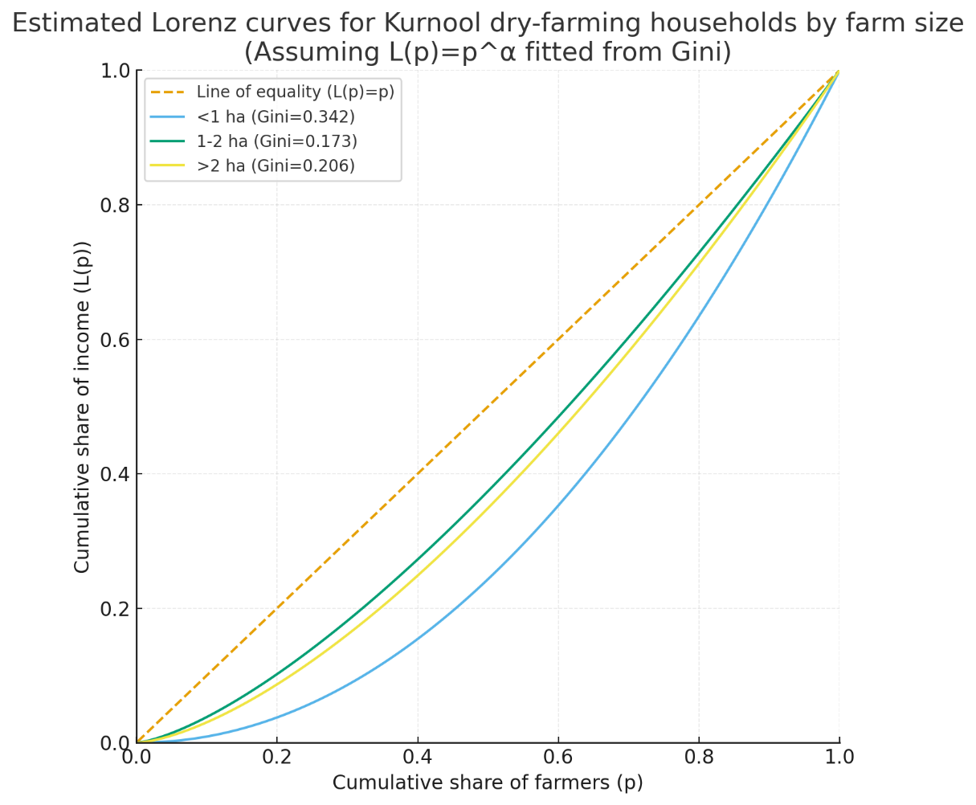

Fig :5 The Lorenz curves depict the level of income inequality among various farm size groups. The closer a Lorenz curve is to the line of equality, the more equitably income is distributed between household in that category Households with <1 hectare had the highest Gini value (0.342) among all groups. The Lorenz curve slopes further away from the equality line, indicating that smaller farmers experience higher income disparity. A tiny fraction of households receives a disproportionately large amount of total income. Households with 1-2 hectares have the lowest Gini (0.173). The Lorenz curve is closest to the equality line, showing the most equitable income distribution for this group. Medium farmers appear to distribute agricultural profits more equitably. Households with more than 2 hectares have a Gini coefficient of (0.206), indicating moderate inequality. Inequality is apparent, but less severe compared to farmers with less than one hectare. Larger farms show some income distribution, but not to the same extent as the smallest landlords.

CONCLUSION:
The study on income distribution among dry farming households in Kurnool district reveals clear disparities linked to landholding size and resource access. Farmers cultivating less than 1 ha encounter severe constraints due to limited land, lack of technology, and restricted scope for diversification, resulting in greater vulnerability and pronounced income inequality. In contrast, medium farmers (1–2 ha) utilize their resources more efficiently, engage in both farm and non-farm activities, and record the lowest level of inequality, as reflected by the Gini index. Large farmers (over 2 ha) benefit from scale advantages, stronger bargaining capacity, and the ability to invest in value-added enterprises and leasing activities, though internal disparities remain evident. The findings suggest that improving equity and resilience in dryland farming requires expanded access to irrigation, modern technology, and value-addition avenues, particularly for smallholders. Encouraging crop diversification, livestock-based farming, agro-processing, and non-farm income sources can mitigate risks and reduce inequality. Institutional support, better market integration, and farmer collectives will be crucial for enabling small and marginal farmers to secure sustainable livelihoods despite environmental and economic challenges.
Disclaimer (Artificial intelligence)
Option 1:
Author(s) hereby declare that NO generative AI technologies such as Large Language Models (ChatGPT, COPILOT, etc.) and text-to-image generators have been used during the writing or editing of this manuscript.
Option 2:
Author(s) hereby declare that generative AI technologies such as Large Language Models, etc. have been used during the writing or editing of manuscripts. This explanation will include the name, version, model, and source of the generative AI technology and as well as all input prompts provided to the generative AI technology
Details of the AI usage are given below:
1.
2.
3.
REFERENCES:
- Annual Report 2021 Department of Agriculture, cooperation and farmer’s welfare Ministry of Agriculture & Farmers’ Welfare Government of India Krishi Bhawan, New Delhi-110 001 www.agricoop.nic.in.2-298.
- Antriyandarti, E., Barokah, U., Rahayu, W., Laia, D. H., & Asami, A. (2023). Factors associated with food security of dryland farm households in the karst mountains of Gunungkidul Indonesia. Sustainability, 15(11), 8782.
- Ahearn, M., Johnson, J., & Strickland, R. (1985). The distribution of income and wealth of farm operator households. American journal of agricultural economics, 67(5), 1087-1094
- Bjornlund, H., Zuo, A., Wheeler, S. A., Parry, K., Pittock, J., Mdemu, M., & Moyo, M. (2019). The dynamics of the relationship between household decision-making and farm household income in small-scale irrigation schemes in southern Africa. Agricultural water management, 213, 135-145.
- Emran, S. A., Krupnik, T. J., Aravindakshan, S., Kumar, V., & Pittelkow, C. M. (2021). Factors contributing to farm-level productivity and household income generation in coastal Bangladesh’s rice-based farming systems. PloS one, 16(9), e0256694.
- Kapa, M. M. J., & Henuk, Y. L. (2018, February). Contribution of local beef cattle production on farmer’s income in the dryland farming of Kupang Regency, Indonesia. In IOP Conference Series: Earth and Environmental Science (Vol. 122, No. 1, p. 012118). IOP Publishing.
- Martin, N. 2023. Income Inequality and Economic Growth: An Analysis. University of Arkansas. Undergraduate Honors Theses.
- Pandey, S., Paris, T., & Bhandari, H. (2010). Household income dynamics and changes in gender roles in rice farming. Rice in the global economy: Strategic research and policy issues for food security, 93-111.
- Suresh, A., Raju S.S., Chauhan, S., and Chaudhary, K.K. 2014. Rainfed agriculture in India: An analysis of performance and implications. Indian Journal of Agricultural Sciences. 84 (11): 1415–22.
- Sahara, D., Triastono, J., Praptana, R. H., Romdon, A. S., Arianti, F. D., Widodo, S., ... & Nurwahyuni, E. (2023). Sorghum Contribution to Increased Income and Welfare of Dryland Farmer Households in Wonogiri, Indonesia. Agriculture, 13(8), 1609.
- Worku, A., Pretzsch, J., Kassa, H., & Auch, E. (2014). The significance of dry forest income for livelihood resilience: The case of the pastoralists and agro-pastoralists in the drylands of southeastern Ethiopia. Forest Policy and Economics, 41, 51-59.

