Effect of Liquid Biofertilizer Seed Treatments on Growth and Development of Wheat (Triticum aestivum L.)

Abstract
This study evaluates the impact of various liquid biofertilizer seed treatments, including single and combined applications of Azospirillum, KSB (Potassium Solubilizing Bacteria), PSB (Phosphate Solubilizing Bacteria), Pseudomonas, and Thiram on wheat growth parameters and phenological stages. Field emergence, plant establishment, chlorophyll content, leaf area index (LAI), spike emergence, heading, plant height, and crop maturity days were assessed. Results reveal significant improvements in emergence, growth, and accelerated phenology with biofertilizer treatments, especially combinations of Azospirillum with KSB and PSB, compared to the control and Thiram-treated seeds. Combined biofertilizer application yielded the highest emergence (93.33%), leaf area (5.16), and shortest crop maturity duration (118.83 days). These findings indicate that strategic biofertilizer co-inoculations promote early establishment, robust growth, and enable faster crop maturity in wheat.
Keywords-Co-inoculations, Phonological stage, Emergence, Growth
Introduction
Wheat (Triticum aestivum L.), a major staple crop, demands optimized nutrient management for high productivity. Wheat production has increased significantly since the Green Revolution of the 1970s and 1980s. The primary wheat-cultivating states are located in the plains, including Uttar Pradesh, Punjab, and Haryana, which account for nearly 70% of the country's wheat cultivation. India now has surplus production and exports wheat to international markets, earning foreign exchange. Conventional chemical seed treatments, such as Thiram, primarily serve disease management but offer limited physiological benefits. Bio fertilizers offer an efficient alternative for restoring soil fertility in certain situations. These preparations contain living microorganisms that can improve soil fertility and promote growth by converting unavailable nutrients (nitrogen, phosphorus) into available forms through biological nitrogen fixation and phosphorus solubilisation (Rokhzadi et al., 2008).Biofertilizers, including Azospirillum, PSB, KSB, and Pseudomonas, are increasingly adopted for their multifaceted roles in nitrogen-fixation, phosphorus and potassium solubilization, and plant growth promotion. The integration of bio fertilizers as seed treatments is known to improve emergence, growth dynamics, and nutrient uptake. However, quantifying the comparative effects of single and combined liquid biofertilizer treatments against conventional chemical fungicides has received limited long-term field validation in wheat. This experiment was conducted to explore the pooled effects (2023–2025) of various liquid bio fertilizer treatments on emergence, plant establishment, vegetative growth, and maturation traits in wheat under field conditions.

Materials and Methods
For conducting an experiment wheat variety K1317 seeds were treated with required quantity of liquid bio fertilizers viz., Em culture, Pseudomonas, Azospirillum, PSB, KSB alone and in combination. The treated seeds were kept for shade drying for 30 minutes. For conducting a field trial randomized block design was applied. The field investigation was carried out at the research farm of Chandra Shekhar Azad University of Agriculture and Technology (CSAU&T), Kanpur, India. The experimental site is geographically situated at 26.4912° N latitude and 80.3071° E longitude, with an elevation of approximately 126 meters above mean sea level (MSL). This location falls within the subtropical Indo-Gangetic Plains, characterized by hot summers, cool winters, and moderate rainfall, thereby making it a representative site for wheat cultivation under rabi season conditions. The study was conducted for two consecutive rabi cropping seasons, extending from 2023 to 2025. Certified wheat seeds were used for sowing during each season under standard agronomic management practices. This temporal framework ensured the evaluation of seed performance and treatment effects under varying seasonal environments and agro-climatic conditions, thereby increasing the reliability and robustness of the experimental observations.
The experimental material consisted of ten distinct seed treatment protocols designed to evaluate the influence of microbial inoculants and chemical protectants on wheat seed performance under field conditions. The treatments were imposed on wheat seeds prior to sowing, with specific dosages optimized according to standard recommendations for microbial cultures and fungicides. The details of the treatments are T1: Control (untreated seeds) – Seeds were sown without any microbial or chemical treatment to serve as the baseline for comparison. T2: Effective Microorganisms (EM) culture @ 10 ml/kg seed – Seeds were treated with a consortium of beneficial microbes (lactic acid bacteria, photosynthetic bacteria, actinomycetes, and yeasts) aimed at enhancing microbial colonization around the rhizosphere. T3: Potassium-solubilizing bacteria (KSB) @ 20 ml/kg seed – Application of KSB culture intended to facilitate mineral potassium solubilization and improve nutrient availability during germination and seedling growth. T4: Phosphate-solubilizing bacteria (PSB) @ 20 ml/kg seed – A microbial bio-inoculant applied to promote dissolution of insoluble phosphates, thereby improving phosphorus uptake efficiency in early seedling stages. T5: Pseudomonas fluorescens @ 20 ml/kg seed – A plant growth-promoting rhizobacterium (PGPR) treatment, well known for its antagonistic activity against seed- and soil-borne pathogens, as well as for stimulating root development. T6: Azospirillum @ 20 ml/kg seed – Seeds treated with Azospirillum, a well-documented nitrogen-fixing bacterium that enhances root proliferation, nutrient uptake, and overall seedling vigor. T7: Azospirillum + KSB @ 20 ml/kg seed – A dual inoculation treatment combining nitrogen-fixing and potassium-solubilizing microbial populations to provide synergistic effects on nutrient availability. T8: Azospirillum + PSB @ 20 ml/kg seed – A combination treatment involving Azospirillum and phosphate-solubilizing microorganisms to promote both nitrogen fixation and phosphorus solubilization. T9: Azospirillum + KSB + PSB @ 30 ml/kg seed – A consortium inoculation where all three beneficial microbial groups were simultaneously applied, hypothesized to maximize nutrient availability (N, P, and K mobilization) and enhance seedling vigor. T10: Thiram @ 1.3 g/kg seed – Seeds treated with Thiram, a synthetic dimethyl-dithiocarbamate fungicide, applied as a standard chemical seed protectant against seed- and soil-borne fungal diseases, to serve as a chemical check.
Data Collection
Emergence & Plant Establishment includes Percentage emergence and final plants/m² counted at early seedling stage. Field emergence data were taken by sowing hundred seeds at 5 cm depth in three replications. After 21 days numbers of seeds germinated were counted on hundred plant basis. Final plant stand was recorded 20 days after sowing using a 1 m² quadrat placed randomly at two locations within each net plot. All established seedlings within the quadrat were counted and expressed as plants m⁻². Growth Metrics include Plant heights measured at 30 days after sowing (DAS) and at harvest were taken for randomly selected plants and measured using scale from base to tip. Physiological Traits includes Chlorophyll content (SPAD units) at first bloom, Leaf Area Index (LAI). The chlorophyll content was recorded for flag leaves of randomly tagged ten plants by using SPAD meter. For the same selected plants LAI were taken by measuring length and breadth of the leaves and calculated using formula given below:
LAI = Total Leaf Area/Ground Area
Phenological Parameters observed were days to spike emergence, 50% heading, and maturity days. The number of days from the planting date until the first spike appeared above the flag leaf sheath in 50% of the plants in each plot was recorded as days to spike emergence. The days from planting until roughly half of the plants in each plot had fully erupted spikes from the flag leaf sheath were taken as days to 50% heading. When 90% of the spikes in each plot turned golden yellow and the grains hardened and stopped producing a milky exudate when pressed, the number of days to maturity was noted.

Statistical Analysis
Results were analyzed via pooled mean comparisons with calculation of the standard error (SE), critical difference (CD), and coefficient of variation (CV) for each parameter. Treatments showing differences greater than the CD were considered significantly different.
Results
Field Emergence and Plant Establishment
The treatment Azospirillum + PSB differed significantly with the control for both field emergence and final plant stand establishment/m². The highest field emergence achieved in Azospirillum + PSB (T8, 93.33%) and Azospirillum + KSB (T7, 93.00%) treatments, with increased final plant establishment/m² (46.17 and 45.83, respectively) over control (87.67%, 40.5/m²) (Table 1 & Fig.1). All biofertilizer treatments surpassed Thiram and control in emergence and establishment, indicating improved seed vigor and microbial synergy. The similar findings were observed by Pathak et al., (2016) in wheat, Singh et al., (2010) in soyabean.
Table 1: Pooled Effect of Liquid Bio fertilizers on Field Emergence and Final Plant Establishment/m²
TREATMENTS | Field Emergence | Final plant Establishment/m²
Control | 88.83 | 40.50
Em Culture @ 10 ml/kg of Seed | 90.00 | 42.33
KSB @ 20 ml/kg of Seed | 90.17 | 42.83
PSB @ 20 ml/kg of Seed | 92.00 | 46.00
Pseudomonas @ 20 ml/kg of Seed | 91.33 | 45.33
Azospirillum @ 20 ml/kg of Seed | 90.67 | 43.33
Azospirillum + KSB @ 20 ml/kg seed | 93.00 | 45.83
Azospirillum + PSB @ 20 ml/kg seed | 93.33 | 46.17
Azospirillum + KSB + PSB @ 30 ml/kg seed | 90.00 | 42.17
Thiram @ 1.3 g/kg seed | 89.33 | 42.50
SE (m±) | 0.55 | 0.89
CD (P=0.05) | 1.63 | 2.65
CV (%) | 1.04 | 3.51

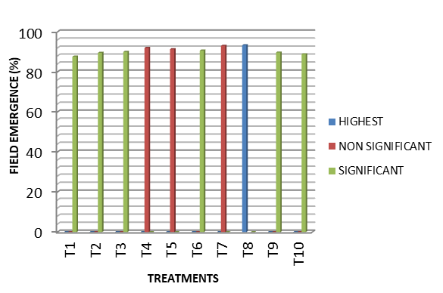
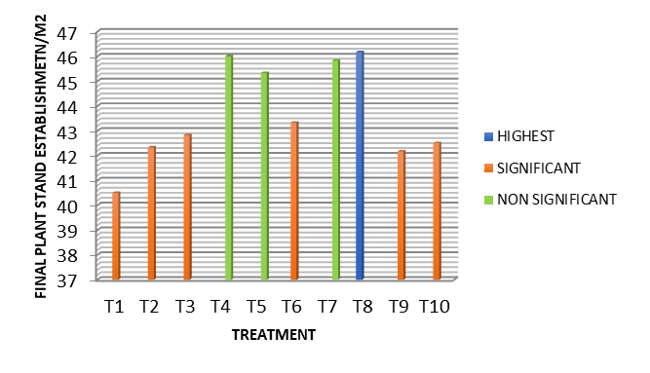
Fig. 1.Effect of different liquid bio fertilizers on Field Emergence and Final Plant Stand Establishment/m²
Plant Height
Plant height at 30 DAS peaked in T7 (43.08 cm) and T8 (42.48 cm), compared to control (36.51 cm). At harvest, maximum height recorded in Azospirillum + PSB (T8, 117.55 cm) and Azospirillum + KSB (T7, 116.82 cm), signifying sustained growth promotion (Table 2 & Fig.2). At 30 DAS after sowing the treatment T8 and T7 has showed significant difference for plant height with the control whereas there was no significant difference were observed at the time of harvest, sowing transfer of energy from vegetative to reproductive part. The results are in agreement with the findings of Me carty et al., (2017) in wheat, Mahapatra et al., (2018) in maize, Game et al., (2020) in wheat, Sai and debbarama (2022) in wheat, Baghel and Singh (2024) in paddy.
Table 2: Pooled Effect of Liquid Bio fertilizers on Plant Height at 30 DAS and Plant Height at Harvest
TREATMENTS | Plant Height at 30 DAS | Plant Height at Harvest
Control | 36.51 | 105.62
Em Culture @ 10 ml/kg of Seed | 38.48 | 110.47
KSB @ 20 ml/kg of Seed | 39.48 | 112.83
PSB @ 20 ml/kg of Seed | 41.46 | 113.27
Pseudomonas @ 20 ml/kg of Seed | 42.18 | 114.25
Azospirillum @ 20 ml/kg of Seed | 37.94 | 112.70
Azospirillum + KSB @ 20 ml/kg seed | 42.48 | 116.84
Azospirillum + PSB @ 20 ml/kg seed | 43.08 | 117.33
Azospirillum + KSB + PSB @ 30 ml/kg seed | 40.18 | 113.33
Thiram @ 1.3 g/kg seed | 37.48 | 108.29
SE (m±) | 0.83 | 2.54
CD (P=0.05) | 2.49 | NS
CV (%) | 3.60 | 3.90

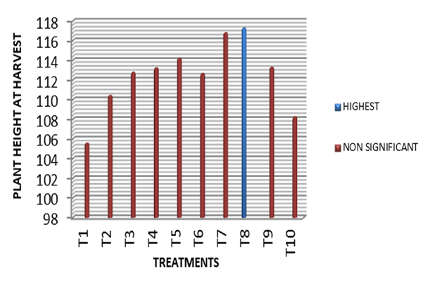
Fig. 2.Effect of different liquid bio fertilizers on Plant Height at 30 DAS and Plant Height at Harvest
Leaf Chlorophyll and LAI
Chlorophyll content highest in T₈ (46.95 SPAD) and T7 (46.45 SPAD), LAI highest in T₈ (5.16) and T₇ (4.97), demonstrating enhanced photosynthetic capacity and canopy development (Table 3 & Fig.3). There is also significant difference were observed for both the treatments with respect to control. These results were also observed by Tamilarasu et al., (2022) in maize.
Table 3: Pooled Effect of Liquid Bio fertilizers on Leaf Chlorophyll and LAI
TREATMENTS | Leaf Chlorophyll (SPAD) | LAI
Control | 37.59 | 3.01
Em Culture @ 10 ml/kg of Seed | 39.18 | 3.42
KSB @ 20 ml/kg of Seed | 43.45 | 3.90
PSB @ 20 ml/kg of Seed | 42.91 | 4.35
Pseudomonas @ 20 ml/kg of Seed | 43.91 | 4.30
Azospirillum @ 20 ml/kg of Seed | 45.10 | 4.27
Azospirillum + KSB @ 20 ml/kg seed | 46.45 | 4.97
Azospirillum + PSB @ 20 ml/kg seed | 46.95 | 5.16
Azospirillum + KSB + PSB @ 30 ml/kg seed | 44.56 | 3.81
Thiram @ 1.3 g/kg seed | 38.53 | 3.27
SE (m±) | 1.56 | 0.20
CD (P=0.05) | 4.68 | 0.60
CV (%) | 6.32 | 8.69

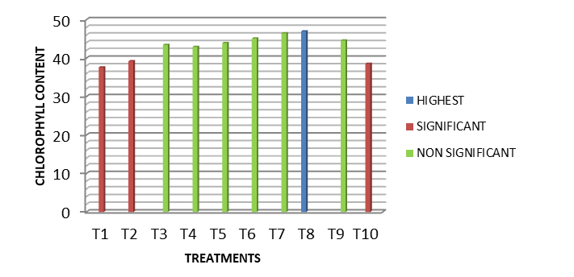
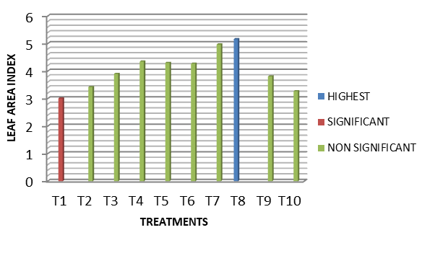
Fig. 3.Effect of different liquid bio fertilizers on Chlorophyll content and LAI
Phenology: Ear Emergence, Heading, and Maturity
Combined biofertilizer treatments led to earliest spike and heading (T8: 77.33 days, 89.33 days for 50% heading) and earliest maturity (T7: 118 days, T8: 118.83 days), compared to the control (131.83 days). Significant difference with the control was observed in these two treatments T₈ and T₇ (Table 4 & Fig.4). Thiram-treated seeds showed only modest improvements over control, confirming limited physiological benefit versus microbial treatments. Soleymanifard et al.,(2013) in maize has observed similar results.
TREATMENTS | Days to Spike Emergence | Days to 50 % Heading | Days to Maturity
Control | 87.83 | 96.00 | 132.33
Em Culture @ 10 ml/kg of Seed | 84.67 | 92.50 | 126.83
KSB @ 20 ml/kg of Seed | 82.83 | 90.50 | 125.33
PSB @ 20 ml/kg of Seed | 79.83 | 89.33 | 122.67
Pseudomonas @ 20 ml/kg of Seed | 79.50 | 88.17 | 121.50
Azospirillum @ 20 ml/kg of Seed | 82.67 | 89.67 | 121.17
Azospirillum + KSB @ 20 ml/kg seed | 78.33 | 88.00 | 119.67
Azospirillum + PSB @ 20 ml/kg seed | 77.33 | 89.33 | 119.50
Azospirillum + KSB + PSB @ 30 ml/kg seed | 84.33 | 92.83 | 125.33
Thiram @ 1.3 g/kg seed | 86.33 | 94.33 | 129.67
SE (m±) | 1.22 | 1.25 | 3.60
CD (P=0.05) | 3.67 | 3.75 | NS
CV (%) | 2.58 | 2.38 | 5.01
Table 4: Pooled Effect of Liquid Bio fertilizers on Days to Spike Emergence, Days to 50 % Heading and Days to Maturity

Fig.4.Effect of different liquid bio fertilizers on Days to Spike Emergence, Days to 50 % Heading and Days to Maturity
Discussion
Field Emergence and Plant Establishment
All biological seed treatments particularly combinations involving Azospirillum and other functional microbes exceeded both the control and the chemical fungicide Thiram treatment in improving early seedling vigor and field establishment. This enhancement is attributable to improved nutrient mobilization (nitrogen and phosphorus) and symbiotic microbial synergy, which collectively foster a more favorable rhizosphere environment for wheat seedlings. Similar positive impacts have been substantiated in previous studies, such as Pathak et al. (2016) for wheat and Singh et al. (2010) for soybean, indicating the reproducibility and reliability of biofertilizer-mediated increases in germination and stand establishment across crops. These results affirm that microbial seed priming strategies incorporating Azospirillum and PSB represent a scientifically validated approach to enhancing wheat seed vigor and securing robust crop stands under field conditions.

Plant Height
The observed increase in plant height at 30 days after sowing (DAS) in the Azospirillum + KSB (T7) and Azospirillum + PSB (T8) treatments indicates enhanced early vegetative growth compared to the untreated control, which recorded a lower height (36.51 cm). This early vigor is likely due to the synergistic effects of Azospirillum, known for its nitrogen-fixing ability and phytohormone (e.g., auxin) production that stimulates root and shoot elongation, combined with potassium- or phosphate-solubilizing bacteria that improve nutrient availability critical for cell expansion and biomass accumulation during initial growth stages (Bashan et al., 2013; Verma et al., 2016).
At harvest, although the maximum plant height was still observed in T7 and T8 treatments (117.55 cm and 116.82 cm, respectively), the differences were not statistically significant compared to the control. This suggests that while biofertilizer treatments accelerate early growth, subsequent plant development may equilibrate as plants transition from vegetative to reproductive stages. Nutrient and energy partitioning during this phase often shift towards grain filling and reproductive organs rather than further vegetative elongation, potentially reducing height differences accumulated in early stages (Kumar et al., 2018). Similar trends have been documented in wheat and other cereals where Azospirillum inoculation enhanced seedling growth and early biomass but showed diminishing differences at maturity, implying that early growth stimulation does not always translate to proportionally taller plants at harvest (Pathak et al., 2016; Singh et al., 2010). The sustained growth promotion during early stages, however, is critical for establishing robust plants capable of supporting later yield components.Thus, this data highlights the effectiveness of Azospirillum combined with KSB or PSB in promoting early vegetative growth in wheat, with implications for improved nutrient use efficiency and crop establishment, even though ultimate final plant height may stabilize irrespective of treatment due to physiological growth transitions.
Leaf Chlorophyll and LAI
The significantly higher chlorophyll content measured by SPAD values in treatments T8 (Azospirillum + PSB, 46.95 SPAD) and T7 (Azospirillum + KSB, 46.45 SPAD) relative to the control indicates enhanced photosynthetic pigment accumulation. This increase in chlorophyll concentration is a direct indicator of improved photosynthetic capacity, which is further supported by the greater leaf area index (LAI) values observed in these treatments (5.16 for T8 and 4.97 for T7). Elevated LAI signifies more developed canopy architecture, contributing to greater light interception and higher potential biomass production. The collaborative action of Azospirillum, known for producing phytohormones that stimulate leaf expansion and chlorophyll biosynthesis, combined with potassium- and phosphate-solubilizing bacteria that improve nutrient availability, particularly macronutrients critical for photosynthesis, likely underpin these physiological improvements (Verma et al., 2016; Bashan et al., 2013). Enhanced nutrient uptake through biofertilization improves nitrogen and magnesium availability key elements for chlorophyll synthesis and leaf development—thus directly boosting plant photosynthetic efficiency and yield potential. These findings are consistent with Tamilarasu et al. (2022), who reported similar increases in chlorophyll content and LAI in maize following seed treatments combining Azospirillum and phosphate-solubilizing bacteria, emphasizing the positive role of microbial inoculants in enhancing photosynthetic capacity and canopy formation across crop species. Such physiological enhancements are crucial for improved crop growth and productivity by optimizing energy capture and assimilation during the growing season.
Ear Emergence, Heading, and Maturity
The reported result that combined biofertilizer treatments (T7 and T8) led to earlier ear emergence, heading, and maturity compared to the control aligns well with existing knowledge on the beneficial impacts of biofertilizers on crop phenology and growth. Biofertilizers enhance plant growth by natural mechanisms such as nitrogen fixation, phosphorus solubilization, and the production of growth-promoting phytohormones (auxins, gibberellins), which collectively accelerate developmental stages like ear emergence and heading. Their use often results in earlier maturity due to improved nutrient availability and uptake, which supports faster physiological development in plants compared to uninoculated controls. Specifically, seed inoculation with biofertilizers has demonstrated positive influences on phenological characteristics including spike initiation and heading time, potentially due to enhanced nitrogen and other nutrient content in the plants during critical growth phases. This can lead to significant advancement in flowering and maturity dates, consistent with the observations for treatments T7 (118 days) and T8 (118.83 days) versus the control (131.83 days). In contrast, the modest benefits observed with Thiram-treated seeds can be explained by its fungicidal mode of action primarily targeting seed-borne pathogens without directly promoting plant physiological processes. Thiram is effective as a contact fungicide but does not provide nutrient or growth hormone benefits that biofertilizers do. Moreover, fungicides like Thiram may have limited or even negative effects on beneficial soil and rhizosphere microorganisms, including nitrogen-fixing bacteria essential for early plant development. Studies report that Thiram can inhibit some microbial symbioses and nitrogen fixation activities, which may explain the limited improvement in phenological traits compared to microbial biofertilizers. In summary, combined biofertilizer treatments significantly advance phenological stages such as ear emergence, heading, and maturity by enhancing nutrient availability and promoting plant growth hormones, while Thiram seed treatment shows limited physiological benefits beyond pathogen control. This underscores the advantage of microbial inoculants in stimulating earlier crop development stages over conventional chemical seed treatments.

Treatment Code | Seed Treatment & Dose | Active Ingredient/Organism(s) | Mode of Action | Reference
T1 | Control (untreated) | None | No treatment; baseline for comparison | https://agritech.tnau.ac.in/org_farm/orgfarm_faq's_bioferti.html
T2 | EM culture @ 10 ml/kg seed | Consortium of beneficial microbes | Enhances rhizospheric microbial activity, accelerates organic matter turnover, releases plant growth-promoting substances | https://yadda.icm.edu.pl/baztech/element/bwmeta1.element.baztech-b2565513-13d5-440a-88ee 8280cde6d576/c/48_piotrowska_analysis_ROS_2021.pdf
T3 | KSB @ 20 ml/kg seed | Potassium-solubilizing bacteria | Solubilizes mineral potassium, increases K availability in rhizosphere | https://agritech.tnau.ac.in/org_farm/orgfarm_faq's_bioferti.html
T4 | PSB @ 20 ml/kg seed | Phosphate-solubilizing bacteria | Releases insoluble soil phosphates through production of organic acids | Dasila, et al., (2023).
T5 | Pseudomonas @ 20 ml/kg seed | Pseudomonas fluorescens | Suppresses seed/soil-borne pathogens, produces phytohormones, induces systemic resistance | Dasila, et al., (2023).
T6 | Azospirillum @ 20 ml/kg seed | Azospirillum spp. | Biological nitrogen fixation, stimulates root growth and development | https://agritech.tnau.ac.in/org_farm/orgfarm_faq's_bioferti.html
T7 | Azospirillm + KSB @ 20 ml/kg seed | Azospirillum + potassium-solubilizer | Synergistic action: N-fixation and K-solubilization | Optimizes N and K supply for balanced seedling nutrition
T8 | Azospirillum + PSB @ 20 ml/kg seed | Azospirillum + phosphate-solubilizer | Synergistic: N-fixation and P-solubilization | Dasila, et al., (2023).
T9 | Azospirillum + KSB + PSB @ 30 ml/kg | Azospirillum + KSB + PSB | Multiplex nutrient mobilization: N-fixation, P- and K-solubilization | Dasila, et al., (2023).
T10 | Thiram @ 1.3 g/kg seed | Thiram (fungicide) | Broad-spectrum contact action against seed- and soil-borne fungi via enzyme inhibition and protective coating | FAO/WHO. (1996).
Table 5- Seed treatments, active ingredients, modes of action, and references
Conclusion
The co-inoculation of wheat seeds with Azospirillum and PSB or KSB resulted in pronounced improvements across all measured traits, outperforming both single-strain and chemical (Thiram) treatments. The synergistic effects of nitrogen-fixing Azospirillum and phosphate/potassium solubilizers enhanced root development, nutrient uptake, and early vigor, reflected by the highest emergence, establishment, and photosynthetic parameters. These treatments also promoted faster heading and significantly shortened crop maturity period, thereby offering greater flexibility in cropping systems. Thiram, although effective for disease control, did not support physiological or phenological advancement to the extent of biofertilizer applications. The increase in leaf area and chlorophyll content indicates improved translocation and assimilation, which could contribute to better resource-use efficiency and yield sustainability. Liquid biofertilizer seed treatments, especially combinations of Azospirillum with PSB or KSB, provide substantial agronomic benefits for wheat cultivation. These include improved emergence, early vigor, robust vegetative growth, and accelerated crop maturity, far exceeding the effects of traditional chemical seed treatments. The results strongly advocate integrating liquid biofertilizer co-inoculations into wheat seed management practices for higher productivity and resource-use efficiency in modern agriculture.

Disclaimer (Artificial intelligence)
Author(s) hereby declare that NO generative AI technologies such as Large Language Models (ChatGPT, COPILOT, etc.) and text-to-image generators have been used during the writing or editing of this manuscript.

References
- Baghel, S., & Singh, A. K. (2025). Effect of Different Bio-Fertilizer on Plant and Soil in Different Stages of Rice in Vertisol of Chhattisgarh Plain, India. International Journal of Plant & Soil Science, 37(5), 10-9734.
- Bashan, Y., de-Bashan, L. E., Prabhu, S. R., & Hernandez, J.-P. (2013). Advances in plant growth-promoting bacterial inoculant technology: formulations and practical perspectives (1998–2013). Plant and Soil, 378(1-2), 1–33.
- Dasila, H., Sah, V.K., Jaggi, V., Kumar, A., Tewari, L., Taj, G., Chaturvedi, S., Perveen, K., Bukhari, N.A., Siang, T.C. and Sahgal, M. (2023). Cold-tolerant phosphate-solubilizing Pseudomonas strains promote wheat growth and yield by improving soil phosphorous (P) nutrition status. Frontiers in Microbiology, 14: 1135693
- FAO/WHO. (1996). Thiram. Pesticide residues in food – 1996: Evaluations, Part II – Toxicological and environmental, Joint FAO/WHO Meeting on Pesticide Residues (JMPR), FAO, Rome, pp. 319–364.
- Game, B. C., Ilhe, B. M., Pawar, V. S., & Khandagale, P. P. (2020). Effect of Azotobacter, phosphate solubilising bacteria and potash mobilising bacteria inoculants on productivity of wheat (Triticum aestivum L.). Intern. J. Curr. Microbiol. Appl. Sci, 9(3), 2800-2807.
- Kumar, S., Singh, R., & Pandey, A. (2018). Growth and yield attributes of wheat as influenced by biofertilizers and nutrient management. Journal of Plant Nutrition, 41(2), 255-265.
- Kushwaha, P., Kashyap, P. L., Pandiyan, K., & Bhardwaj, A. K. (2020). Zinc-solubilizing microbes for sustainable crop production: Current understanding, opportunities, and challenges. Phytobiomes, 281–298. https://doi.org/10.1007/978-981-15-3151-4_11
- Mahapatra, A., Barik, A. K., & Mishra, G. C. (2018). Effect of integrated nutrient management (INM) on growth and yield of baby corn (Zea mays L.). Environment and Ecology, 36(1A), 338-342.
- Me Carty, S. C., Chauhan, D. S., MeCarty, A. D., Tripathi, K. M., Selvan, T., & Dubey, S. K. (2017). Effect of Azotobacter and phosphobacteria on yield of wheat (Triticum aestivum). Vegetos-An International journal of plant research, 30(2).
- Pathak, A., Chakrabarti, S. K., Das, R., & Mandal, M. K. (2016). Response of different wheat varieties towards Azospirillum and phosphate solubilizing bacteria (PSB) seed inoculation. Journal of Applied and Natural Science, 8(1), 213.
- Pathak, D., Singh, R., & Sangeeta. (2016). Response of different wheat varieties towards Azospirillum and phosphate-solubilizing bacteria (PSB) as seed inoculation for enhancing seed storability and seedling growth. Journal of Applied and Natural Science, 8(1), 408–412.
- Pathak, D., Singh, R., & Sangeeta. (2016). Response of different wheat varieties towards Azospirillum and phosphate-solubilizing bacteria (PSB) as seed inoculation for enhancing seed storability and seedling growth. Journal of Applied and Natural Science, 8(1), 408–412.
- Rajani, K., Parihar, S. S., Lal, S. K., Kumar, R. R., & Kumar, A. Enhancement of Seed Quality of Black Cumin (Nigella sativa L.) through Seed Priming. Int. J. Curr. Microbiol, special, (2018), 7.
- Rokhzadi, A., Asgharzadeh, A., Darvish, F., Nour-Mohammadi, G., & Majidi, E. (2008). Influence of plant growth-promoting rhizobacteria on dry matter accumulation and yield of chickpea (Cicer arietinum L.) under field conditions
- Sai, G. D., & Debbarma, V. (2022). Effect of Zinc and Bio-fertilizers on Growth and Yield of Wheat (Triticum aestivum L.). International Journal of Plant & Soil Science, 34(22), 1624-1632.
- Singh, A. V., Shah, S., & Prasad, B. (2010). Effect of phosphate solubilizing bacteria on plant growth promotion and nodulation in soybean (Glycine max (L.) Merr.). Journal of Hill agriculture, 1(1), 35-39.
- Singh, A., Kumar, V., & Sharma, P. (2010). Effect of Azospirillum and phosphate solubilizing bacteria inoculation on growth and yield of soybean (Glycine max L.). Journal of Agricultural Science, 5(3), 245–250.
- Singh, A., Kumar, V., & Sharma, P. (2010). Effect of Azospirillum and phosphate solubilizing bacteria inoculation on growth and yield of soybean (Glycine max L.). Journal of Agricultural Science, 5(3), 245–250.
- Tamilarasu, S., Thamizhiniyan, P., & Manikandan, S. Biofertilizers effects on the germination and photosynthetic pigments of maize (Zea mays L.). https://www.researchgate.net/publication/384287446.
- Verma, J. P., Yadav, J., Tiwari, S., & Singh, D. P. (2016). Plant growth-promoting rhizobacteria (PGPR): Current and future prospects for development of sustainable agriculture. Journal of Microbial & Biochemical Technology, 8(3), 207-217.
- Soleymanifard, A., Piri, I., & Naseri, R. (2013). The Effect of Plant Growth Promoting Bacteria on physiological and Phenological traits of maize (Zea mays L.) at different levels of Nitrogen Fertilizer. Bull. Env. Pharmacol. Life Sci, 2(9), 55-64. http://www.bepls.com.

