Original Research Article
Original Research Article
Influence of Plant Growth Regulators on In Vitro Morphogenesis of Moringa oleifera L. Using Nodal Segment Cultures
Abstract
Moringa oleifera is a multi-purpose tree that is gaining popularity as an economic crop because of increasing recognition of its nutritional and medicinal properties. Conventionally, seeds have been employed to propagate Moringa oleifera; the genotypes of trees developed from seedlings often differ from their mother plants, which affecting nutritional value and pod production. Therefore, in the present investigation, a protocol was established to regenerate plantlets through indirect and direct in vitro organogenesis from cultured nodal segments excised from in vitro developed plants. The present study was carried out at the Plant Tissue Culture & Genetic Transformation Laboratory, Department of Plant Molecular Biology & Biotechnology, Rajmata Vijayaraje Scindia Agricultural University, Gwalior M.P., India during the years 2021 to 2023. Nodal segments were inoculated on MS medium amended with different concentrations and combinations of auxins and cytokinins. MS medium containing 1.0 mgl⁻¹ 2,4-D induced callus in higher frequencies with maximum fresh weight (3.70g) after 60 days of inoculation. The best multiple shoot formation (8.00±0.30) with higher shoot length (9.00±0.27cm) were observed on nutrient media fortified with 1.0 mgl⁻¹NAA in combination with 0.5 mgl⁻¹ BAP. Whereas, maximum numbers of roots per micro shoot (11.00±0.28) with greater length (7.20±0.15cm) were obtained on basal MS media amended with 1.0 mgl⁻¹ IBA. Among different potting mixture combinations, maximum survival (85%) with maximum plant height (12.95±0.17cm) achieved in a cocopeat: vermiculite in 1:1 ratio. The in vitro regenerated plantlets were successfully acclimatized and established under field conditions. Although the characters were not scored quantitatively, regenerated plantlets appeared phenotypically normal and true- to-type.
Keywords: Moringa oleifera Lam, direct and indirect organogenesis, massive in vitro propagation, nodal segment culture, plantlet regeneration.

1. Introduction
Moringa belonging to Moringaceae family is also known as the "drumstick tree" and "Miracle Tree" originated in South and East Asia then proliferated in the Himalayas (Northwest India), from where it dispersed throughout the entire globe (Devendra et al., 2012; Fatima et al., 2016; Gopalakrishnan et al., 2016) owing to the shape of its pods or the "horseradish tree" referring to the flavor of its roots (Stohs & Hartman, 2015). It is a significant plant for pharmaceuticals with a wide range of pharmacological, nutritional and medical uses (Bajwa et al., 2023; Ewhayid et al., 2023; Singh et al., 2023). According to Arif et al. (2023) the extract derived from Moringa oliefera is an inexpensive, environment friendly, unique biostimulator and bio-enhancer that promotes crop productivity and sustainable agricultural practices. Nearly every part of the plant, including the roots, shoots, leaves, flowers, and fruits, is widely consumed in India and around the world due to its high nutritional content and medicinal potential (Gopalakrishnan et al., 2016; Dar, 2017). According to the Ayurvedic Scripts, moringa leaves can prevent 300 common diseases that people encounter on a daily basis. One of the best nutritional supplements, it has about 20 different types of amino acids, 46 antioxidants, 36 anti-inflammatory chemicals and more than 90 minerals (Mittal et al., 2017; Moustafa & Mansour, 2020; Khajeh et al., 2025). It is a great source of macronutrients, trace minerals, phytonutrients, and minerals like iron, calcium and vitamins A, B, B₁, B₂, B₃, B₆, C, and E (Oriabi, 2016; Sekhar et al., 2017; Senthilkumar et al., 2018; Saravanakumaran et al., 2019; Sivakumar, 2024). Besides that, it is a good source of dietary fiber and high-quality protein (Suresh et al., 2020). These vibrant green leaves are the superfood of nature (Yadav et al., 2022). Malnutrition can be cured worldwide with its power (Sekhar et al., 2019). Numerous medical uses for the plant exist, including those related to hepatoprotection, wound healing, analgesia, anticancer, antiasthmetic, antiallergic, antipyretic, antidiabetic, and antiasthmatic properties (Saini et al., 2016; Palada, 2017; Saravanakumaran et al., 2019).
M. oleifera is steadily gaining popularity as an economic crop, with market demand for moringa products increasing annually. The global moringa products market size was estimated at USD 8,152.2 million in 2023 and is projected to reach USD 15,428.5 million by 2030, growing at a CAGR of 9.5% from 2024 to 2030 (Moringa Products Market 2024 - 2030). The growth is attributed to various factors, including increasing consumers awareness of its health and well-being. To attain moringa industrialization, commercial farms are needed to be established (Dar, 2017; Palada, 2017). Consequently, this will require a large number of planting materials for its rapid mass propagation.
Moringa is a slow-growing plant that is often propagated by seeds. As a result, these findings make it hard to meet the species expanding needs for a variety of domestic, dietary, commercial and medical applications. Traditionally, seeds have been used to cultivate Moringa oleifera. In three–fourteen days, each seed yields one seedling. The genotypes of trees developed from seedlings differed, which affects the nutritional value and pod production of the trees (Riyathong et al., 2010). This plant can also be propagated by stem cuttings; however, this may slow the mother plant's growth, alter yields and occasionally result in the mother plant's mortality (Riyathong et al., 2010). Tissue culture is an excellent substitute to address these issues by producing uniform planting materials without endangering the mother plants (Tripathi et al., 2019; Tripathi et al., 2021a; Tripathi et al., 2022a; Tripathi et al., 2022b; Sharma et al., 2025).
Plant Biotechnology, which is based on a set of techniques called plant tissue culture (PTC) that enables the establishment, maintenance, and development of any part of the plant, from an individual cell to a complete plant, under artificial and axenic conditions, is one way to solve this kind of problem (Tripathi et al., 2022c; Tripathi et al., 2023a; Tripathi et al., 2023b). Tissue culture has substantially expanded the possibilities and potential of micropropagation by harnessing the inherent regenerative abilities of selected horticultural and medicinal plants, including those of medicinal significance (Ahuja et al., 2016; Jhankare et al., 2011; Uikey et al., 2016; Tiwari et al., 2021; Tripathi et al., 2023c). As a result, creating an in vitro tissue culture has several benefits over using traditional propagation techniques.
The tissue culture technique offers a promising opportunity to regenerate numerous plantlets of Moringa oleifera efficiently and rapidly, ensuring a year-round availability of this essential medicinal plant. In vitro propagation methods hold the promise of increasing the availability of plant resources for commercial utilization. In Moringa oleifera, plant regeneration has been reported earlier by various researchers applying diverse explants viz., seedling (Alkateeb et al., 2013), cotyledon (Shittu et al., 2017), nodal segment (Saini et al., 2012; Abbas, 2014; Mathur et al., 2014; Saini et al., 2016; Salem et al., 2016; Hassanein et al., 2018; Chand et al., 2019; Ravi et al., 2019; Gupta et al., 2020; Harshitha et al., 2020; Ridzuan et al., 2020; Marfori, 2024;), shoot apex (Avila-Trevino et al., 2017; Adugna et al., 2020), callus culture (Bajwa et al., 2023), Zygotic embryo (Devendra et al., 2012) and leaf (Junjib et al., 2017) with varying degree of accomplishment.
In vitro morphogenesis, however, seems to be reliant on the genotype, explant source and culture medium, and thus, it is necessary to develop specific regeneration protocols for each explant (Tiwari et al., 2004; Tripathi et al., 2021b; Tripathi et al.,2022a; Tripathi et al., 2022b). Hence, the current investigation aimed to establish a comprehensive system for the extensive propagation of Moringa oleifera variety-PKM-1 employing nodal segments as an explant as it is available throughout the year by computing optimum concentrations and combinations of plant growth regulators to be supplemented in a nutrient medium exhibiting higher in vitro morphogenesis followed by an efficient plantlet regeneration.
2. Material & Methods
2.1 Explant material
The present study was carried out at the Plant Tissue Culture & Genetic Transformation Laboratory, Department of Plant Molecular Biology & Biotechnology, Rajmata Vijayaraje Scindia Agricultural University, Gwalior M.P., India during the years 2021 to 2023. Healthy uniform seeds of Moringa oleifera, variety: PKM-1 were obtained from Krishi Vigyan Kendra, Rajmata Vijayaraje Scindia Agricultural University, Gwalior (26°13’5.8332” N 78°10’58.1916” E), Madhya Pradesh, India that were shifted from the local nursery in the year 2020.
2.2 Culture media
To commence with an initial experiment, two diverse fortifications of basal media viz., MS (Murashige and Skoog, 1962) and B₅ (Gamborg et al., 1968) were adored to search out better in vitro response. In preliminary investigation, MS basal medium was found more responsive than B₅ media (data not presented); henceforth, for an advance experimentations basal MS medium was employed throughout experiment. All initial nutrient media were prepared utilizing readymade basal MS medium (HiMidiaTM) and supplemented with three different sets of plant growth regulators to fortify MS basal media. In first set: auxin 2, 4-D and a cytokinin TDZ (alone) for callus induction, in second set: a cytokinin BAP and an auxin NAA as sole in varying concentrations and in third set: a cytokinin BAP and an auxin NAA in varying concentrations and combinations for initiation of shootlets. Apart from MS basal macro and micro salts, vitamins, all initial media was amended with 30.0 gl⁻¹ sucrose and the final volume was made to 1000 ml and pH was adjusted to 5.8 ± 0.1 with 1N KOH solution. After adjusting the pH, agar @ 7.5 gl⁻¹ was added to the media as a semi-solidifying agent. Warm culture media, still in liquid state was poured into baby food bottles (50-60 ml / bottle) and culture tubes (15-20 ml/ tube) followed by autoclaving at 121ºC under 15 psi pressures for 25 minutes. Readymade basal media, plant growth regulators and other ingredients were procured from Hi-media Laboratories, Mumbai, India.
2.3 Surface sterilization of donor plant
The seeds were cleaned gently employing 3.0 ml^{l-1} tween 20 with double distilled water by mild agitation. The seeds were then washed with double distilled water and again dipped in 1.5 to 3.0 % w/v solution of bavistin® (BASF, Germany) a fungicide along with the antibiotic streptomycin sulphate in different concentration and combinations and kept in a rotatory shaker for 15-35 min with initial vacuum of 100 psi and then thoroughly washed with double distilled water. Further steps of surface sterilization were carried out on the Laminar Airflow Cabinet where they were surface sterilized with 20% aqueous solution of NaOCl and 0.1% (w/v) mercuric chloride (HgCl₂) for different durations and washed with double distilled water four to five times after removal of the seed coat. The seeds were again treated with 70% (v/v) ethanol for 30 seconds and then washed with autoclaved sterilized double distilled water four to five times. The surface sterilized seeds were then inoculated aseptically on MS basal medium.
2.4 Nodal segment excision and plating technique
Germinated seedlings consisting of 3–4 nodes (4-5 weeks after initial inoculation) were used for the excision of nodal segments.
2.5 Culture conditions
Baby food bottles/culture tubes encompassing cultures sealed with Lab film (Parafilm®) were incubated under complete darkness at 25±2°C for one week. Later in vitro inoculated nodal segments were subjected to photoperiod regime of 16 hours light/8 hours dark cycle at an intensity of 2000-lux luminance provided by combinations of fluorescent tubes and Photosynthetically Active Radiation lamps at 25±2 ⁰C and 70% relative humidity.
2.6 Subculture
The responding explants were transferred routinely every 15 days into fresh media with the similar composition of the initial medium.
2.7 Regeneration of plantlets
After 4-5 weeks of initial culturing, nodal segments followed either direct plant regeneration i.e., via auxiliary bud proliferation or indirect organogenesis via callus formation. Shootlets obtained from direct proliferation were transferred to MS elongation medium supplemented with 1.0 mgl⁻¹ GA₃, 20.0 gl⁻¹ sucrose and 7.5 gl⁻¹ agar. For regeneration, reduced level of sucrose was applied on the basis of work conducted by different researchers as well as prior experiences of our laboratory (Tiwari & Tripathi 2005; Tiwari et al., 2007; Baghel et al., 2008; Mishra et al., 2021; Shyam et al., 2021). However, calli obtained from indirect organogenesis were subcultured again on the initial medium after four weeks of inoculation. Cultures were subjected to 25±2ºC temperature and photoperiod regimes of 60 μmolm²s⁻¹ luminance provided by cool fluorescent tubes for 16 hours light/8d hours dark cycle.
2.8 In vitro rooting of regenerants
When root formation was not attained on regeneration medium, plantlets were then transferred to full strength MS medium supplemented with different concentrations of IBA and NAA, 15.0 gl⁻¹ sucrose and 7.5 gl⁻¹ agar. For rooting, reduced level of sucrose was employed on the basis of work conducted by different researchers as well as preliminary experiences of this laboratory (Bhatt et al., 2022; Tripathi et al., 2022a; Sharde et al., 2023; Tripathi et al., 2023a; Tripathi et al., 2024a).
2.9 Acclimatization of regenerants
After differentiation and regeneration of plantlets through succeeding culturing phases, the rooted vigorous regenerants were carefully detached from the culture vessels and systematically washed with distilled water to eradicate traces of agar. Before being planted in plastic pro-trays filled with different potting mixtures including sand, soil, vermiculite, FYM, cocopeat and vermicompost in different ratios and combinations, the plantlets underwent fungicide treatment by submerging them in 0.25 percent bavistin for 2 minutes. Root trainers with transplanted plants were transferred under 30±2ºC and 60 ± 5% relative humidity for 40-45 days in greenhouse/polyhouse for hardening. Later these regenerants were transferred under field conditions.
2.10 Experimental design and analysis of data
All experiments were conducted in a Completely Randomized Design (CRD) with two replications. Each treatment and each replication contained 80-100 nodal segments. Visual observations of the cultures were made every week and data related to callus induction %, callus weight, texture, colour, shoot proliferating competence, numbers of shootlets, root proliferating efficiency, numbers of roots and root length were recorded at different time intervals. Data were analyzed using Duncan’s Multiple 35-Range Test (DMRT). Mean with different letters in the same column differed significantly at p = 0.05. The programme employed was SPSS version 23.0. Whereas the survival and contamination percentages were analyzed by employing arc-sine transformation since data were in percentage. The data were analyzed for means and standard error in accordance with Snedecor and Cochran's (1997) guidelines. Following the value transformation for the number of shoot and root inductions from explants, the standard error was computed.
3. Results and Discussion
3.1 Establishment of Aseptic Culture
Explants excised from greenhouse grown mother plants harbor various microorganisms that must be eliminated before inoculation into the culture media. Contamination may spread from an explant to the cultures even if most of the bacteria are eliminated (Tripathi et al., 2022d; Tripathi et al., 2023d). Therefore, one of the most critical actions in the development of an aseptic culture is standardizing the explant surface sterilization method. In current study, seeds were employed to raise plants which were subsequently used for excision of nodal segments. Thus, proper surface sterilization of seeds is essential for establishing aseptic cultures. The most commonly used surface sterilant in plant tissue culture are streptomycin sulphate, bavistin (fungicide), sodium hypochlorite, mercuric chloride (HgCl₂) and 70% (v/v) ethyl alcohol (Tripathi et al., 2023e; Tripathi et al., 2024b). Different surface sterilants, their concentrations and exposure times are well reported to affect the in vitro culture establishment up to a great extent (Vibhute et al., 2022).
The process for surface sterilization of Moringa oleifera has been described by several researchers in the past, including, Sivakumar et al. (2024) and Pandey & Bajpai (2024). However, different sterilization methods have been standardized for seeds. In the current study, there were highly significant (p<0.05) differences were evident among the responses to different surface sterilizing, anti-bacterial and antifungal agents. The data presented in Table 1 and Fig.1 showed that for seeds a noteworthy decrease in microbial contamination was observed when seeds were treated with a combination of (Bavistin + Streptomycin) + HgCl₂ + NaOCl + Ethanol at the concentrations/ magnitude of (3.0+0.3) +0.1+ 20% + 70% for 15+15+2+5+0.5 minutes, respectively, resulting in survival rate (65%) with the least contamination (35%). Aseptic culture establishment has previously been demonstrated by Pandey & Bajpai (2024) who have achieved the efficacy of 0.1% HgCl₂ for 5 minutes in the case of nodal section.
Furthermore, nodal segment excised from the top 1-10 nodes could not induce higher bud break, possibly due to the tender nature of buds (Kurmi et al., 2011). The exposure of explants to sterilants/antioxidants may damage these soft buds (Sharma et al., 2010). Maximum bud break was recorded from 10-20 nodes, probably due to juvenile status and ability to resist the toxic effect of surface sterilizing agents (Tripathi et al., 2022d). These findings are in accordance to the results of Tripathi et al. (2025a) and Tripathi et al. (2025b) who also attained higher morphogenic response tracked by plantlet regeneration that seems to be highly dependent on position of explant in different horticultural and medicinal plants. Investigations have also revealed that lower or mid portion of the branch are easier to establish in vitro than upper portion (Vibhute et al., 2022).
3.2 In Vitro Morphogenesis
To acquire nodal segment seeds were first inoculated on MS medium devoid of plant growth regulators. Plants were obtained from seed (Fig.2 A-E). Nodal segments were then excised from these in vitro developed plants. In the present study, three different sets of plant growth regulators were added to fortify MS basal media for culturing nodal segments. Depending on the type, concentration, and combination of plant growth regulators, inoculated nodal segments followed either a direct or an indirect pathway of plantlet regeneration. In direct approach, plantlets were regenerated on explant surface directly without intervening callus formation (via auxiliary bud proliferation); whereas in the indirect mode, plantlets originated via callus formation (indirect organogenesis). In direct mode of regeneration, shootlets were developed directly from the meristematic zones of cultured nodal segments (Fig.2: F). Shoot formation were started approximately 7-15 days after initial culturing and proliferated 1-15 shoots (Fig. 2: G). In the indirect pathway, plantlets were regenerated via organogenesis on the callus surface (Fig. 2: H-M). The first response of cultured explants appeared after 4-7 days and was mostly independent of culture media. All explants became swollen and no callus proliferation was evident during first few days. Callus proliferation generally started from the portion in contact with the medium and spread upward after a week of inoculation (Fig. 2: H-I). Initiated callus tissue developed distinct phenotypes. These pheno-variants were rough, hard, dense and glossy reflecting different developmental potentials (Fig. 2: H-I). Plantlet regeneration occurred routinely (Fig. 2: J-M) after sub culturing of these organogenic calli. Root initiation started after 15- 20 days of transferring shootlets to the rooting medium (Fig. 2: N). Regenerated plantlets (Fig. 2: O) were subjected to green house conditions for hardening before being transferred to field conditions.
3.3 Standardization of Plant Growth Regulators for In Vitro Callus Induction
Auxins, an external source of plant growth regulators, were employed to initiate callus from various explants. In the current investigation, explant nodal section failed to begin callus or bud break when grown in a media devoid of plant growth regulators (Table 2). After addition of plant growth regulators in to basal MS medium, depending upon the concentration of plant growth regulators like auxin 2,4-D and cytokinin (TDZ), callus induction may take place and varied significantly (Table 2).
When 2,4-D added in to MS basal medium as sole at the concentration of 1.0 mgl⁻¹, 100% callus proliferation was achieved with fresh weight of 3.70g after 60 days of inoculation. In contrast, an intermediate callusing observed at 2.0 mgl⁻¹2,4-D, while higher concentration (>3.0 mgl⁻¹) resulted in a progressive decline in callus induction efficiency.The lowest response was recorded at 5.0 mgl⁻¹ 2,4-D, producing only 1.60 g fresh weight (Table 2). Calli obtained with 2,4-D alone were generally friable and semi-compact, varying in colour from light brown to brown. The callus initiation was observed within 15–20 days of culture, typically beginning at the cut surface of the explants. Similar response has also been obtained by Sharma et al. (2025).
A 100% frequency of callus initiation with fresh weight (3.25g) was observed upon application of 0.2 mgl⁻¹TDZ after 60 days of inoculation. On average 8.15±0.44 days were required to initiate callus. Increasing levels of TDZ, above 0.5 mgl⁻¹ subsequently decreased callus proliferation efficiency. Addition of TDZ as the sole supplement in the medium produced a friable and semi-compact callus that ranged in colour from green, light brown to yellow (Table 2). Although, callus proliferation occurred with the application of both 2,4-D and TDZ, the best results were obtained with 2,4-D. Yadav et al. (2022) reported that calluses grew more rapidly on MS medium amended with 0.4 mgl⁻¹ TDZ as compared to the same medium supplemented with either a lower (0.2 mgl⁻¹⁾ or higher (1.0 mgl⁻¹).
3.4 Standardization of Plant Growth Regulators for In Vitro Shoot Initiation
Auxins and cytokinins are commonly added to tissue culture media to promote the initiation of axillary or adventitious shoots. The function of cytokinin in tissue culture is well understood, and the synergistic action of appropriate cytokinin and their combination can result in the greatest morphogenetic response (Tripathi et al., 2023a; Tripathi et al., 2023b). The effects of an auxin (NAA) and a cytokinin (BAP), either alone in combination, on shoot initiation and proliferation were investigated in the present investigation.
Enrichment of MS medium with different levels of BAP and NAA significantly increased the average number of shoots and shoot length over the control. The nodal section explants started to grow within 12-15 days of inoculation. After 24-26 days of inoculation, multiple shooting and new leaves were observed with addition of different levels of BAP. The best multiple shoot formation (4.35±0.13) with higher shoot length (6.25±0.30cm) were attained on media supplemented with 0.5 mgl⁻¹ BAP after 60 days of inoculation (Table 3). Saini et al. (2012) and by Pandey & Bajpai (2024) have also been previously demonstrated that cytokinins positively influence the axillary bud bursting, multiple shoot development and the initiation of the shoot meristem in moringa. Among different concentrations of NAA, when added solely in the culture medium, the best multiple shoot formation (3.85±0.07) with higher shoot length (5.05±0.16cm) was evident at the concentration of 1.0 mg l⁻¹ (Table 3).
To achieve a higher in vitro response, the basal medium was also fortified with an auxin and a cytokinin in combination. Medium supplemented with 1.0 mgl⁻¹NAA in combination with 0.5 mgl⁻¹ BAP has displayed shoot bud differentiation rather than nutrient media amended with NAA or BAP alone. The best multiple shoot formation (8.00±0.30) with higher shoot length (9.00±0.27) were evident on nutrient media fortified with 0.5 mgl⁻¹ BAP in combination with 1.0 mgl⁻¹NAA after 60 days of inoculation (Table 4) These results are in accordance with earlier findings of Baghel et al. (2008) in teak, Sharma et al. (2010) in Glycyrrhiza glabra L., Jhankare et al. (2011) in Withania somnifera, Uikey et al. (2016) in Rauwolifia serpentina, Gupta et al. (2020) in moringa and Tripathi et al. (2021b) in sandalwood.
3.5 Standardization of Plant Growth Regulators for Root Initiation
The main endogenous plant growth hormones known for promoting the adventitious rooting process is an auxin (Tripathi et al., 2023c; Tripathi et al., 2023d). Auxins help in the mobilization of reserve food resources, the elongation of meristematic cells and the differentiation of cambial initials into root primordia, which may account for the rise in the proportion of rooting on auxin-rich medium (Tripathi et al., 2022c; Tripathi et al., 2023e). In general, a higher rooting efficiency is frequently linked to low auxin concentration during the initial phase of rooting (Tripathi et al., 2022d). It was discovered that moringa shoots can induce the formation of roots by providing an extra plant growth regulator. Furthermore, the presence of auxin induces more root initiation than actual root elongation (Tripathi et al., 2021a; Tripathi et al., 2021b). As a consequence, the application of auxins, particularly IBA and NAA, is critical for the induction of functional and quality rootlets (Tripathi et al., 2024a; Tripathi et al., 2025a; Tripathi et al., 2025b).
In this study, we observed significant improvement rooting with the fortification of rooting media with various levels of auxins viz., IBA and NAA (Table 5). Early induction of good quality roots along with the maximum numbers of roots per micro shoot (11.00±0.28) with higher length (7.20±0.15cm) was evident on basal MS media amended with 1.0 mgl⁻¹ IBA after 60 days of transferring microshoots to rooting media. In comparison to NAA, IBA produced better results when the two auxins were employed to induce consistent, well-shaped roots. IBA was found to be the most effective than any other synthetic auxins in most of the cases, probably because it is not destroyed by IAA oxidase or other enzymes and therefore persists longer (Sharma et al., 2025). The effectiveness of IBA in inducing quality roots has earlier been proved by Mathur et al. (2014), Mittal et al. (2017) and Tripathi et al. (2023e). Mathur et al. (2014) recorded successful multiple rooting in moringa with application of 3.0 mgl⁻¹ IBA in association with 1.0 mgl⁻¹ NAA. Furthermore, Mittal et al. (2017) discovered that half-strength MS medium amended with 0.5 mgl⁻¹IBA in combination with 0.5 mgl⁻¹ NAA produced rootlets of higher length (8.3±0.46 cm) with 89% proliferation competence.
3.6 Standardization of Hardening Competence Employing Different Potting Mixtures
The survival of tissue culture raised plantlets in the greenhouse or under field conditions, determines the eventual success of any profitable tissue culture operation (Bhatt et al., 2022). In the present study, the effectiveness of in vitro hardening in enhancing plant survival and reducing mortality of in vitro regenerated plantlets was standardized.
The high danger of plantlet death is evident when in vitro regenerated regenerants are transplanted to an in vivo environment. This is mainly instigated by weak root systems and the necessity for newly raised regenerants to acclimatize to an array of abnormalities that exist in in vivo condition, including high levels of radiation, low relative humidity, a lack of water, etc. Among different potting mixture combinations, maximum survival (85%) with maximum plant height (12.95±0.17cm) was attained in combination of cocopeat: vermiculite (1:1) followed by vermiculite: soil: FYM (75%) with (9.95±0.09cm) plant height (Table 6). Similar results have also been earlier reported by Suresh et al. (2020), Chaudhary et al. (2024) and Marfori (2024).
Conclusion
The present results corroborate the fact that nodal segments is an excellent explant source and are available throughout the year. The present investigation demonstrated that nodal segment explants of Moringa oleifera possess a high potential for rapid multiple shoot regeneration which could be utilized for subsequent massive in vitro propagation. Employing our regeneration system in moringa could deliver an additional approach for the improvement of elite cultivar along with raising embryogenic cell suspension cultures which may be further used for production of useful secondary metabolites of pharmaceutical importance.

Disclaimer (Artificial Intelligence)
Author(s) hereby declares that no generative AI technologies such as Large Language Models (ChatGPT, COPILOT, etc.) and text-to-image generators have been used during the writing or editing of this manuscript.
Competing Interests
Authors have declared that no competing interests exist.
Abbreviations: B₅-Gamborg’s medium, BA-6-benzylaminopurine; 2,4-D: 2,4-dichlorophenoxyacetic acid; IBA-Indole-3-butyric acid; GA₃: Gibberellic acid; MS-Murashige and Skoog medium; NAA-α-Naphthalene acetic acid; TDZ- Thidiazuron.

References
- Adugna, A.Y., Feyissa T. & Tasew, F. S. (2020). Optimization of growth regulators on in vitro propagation of Moringa stenopetala from shoot explants. BMC Biotechnology 20:60 https://doi.org/10.1186/s12896-020-00651-w
- Abbas, D. (2014). Development of in vitro regeneration and Agrobacterium mediated transformation systems for Moringa oleifera plant. Egyptian Journal of Genetics and Cytology, 43(1): 99-111.
- Ahuja, A., Tripathi, M.K. & Singh, S.P. (2016). Plant cell cultures-an efficient resource for the production of biologically important metabolites: recent developments-a review. Progressive Research, 11(1):1-8.
- Alkateeb, W., Bahar, E., Lahham, J., Schroeder, D.& Hussien, E. (2013). Regeneration and assessment of genetic fidelity of endangered tree Moringa peregrine (Forsk.) Fiori using inert simple sequences repeat (ISSR). Physio Mol Biol Plant. 157–64.
- Arif, Y., Bajguz, A. & Hayat, S. (2023). Moringa oleifera extract as a natural plant biostimulant. J. Plant Growth Regul., 42:1291–1306
- Avila-Trevino, J.A., Munoz-Aleman, J.M., Perez-Molphe-Balch. E., Rodrıguez-Sahagun A. & Morales-Domınguez. J.F. (2017). In vitro propagation from bud and apex explants of Moringa oleifera and evaluation of the genetic stability with RAMP marker. South Afr. J. Bot., 108:149–156. https://doi.org/10.1016/j.sajb.2016.10.003
- Bajwa, M. N., Khanum, M., Zaman, G., Ullah, M.A., Farooq, U., Waqas, M., Ahmad, N., Hano, C. & Abbasi, B.H. (2023). Effect of wide-spectrum monochromatic lights on growth, phytochemistry, nutraceuticals, and antioxidant potential of in vitro callus cultures of Moringa oleifera. Molecules, 28: 1497.
- Baghel RS, Tiwari S, Tripathi MK. (2008). Comparison of morphogenic and plant regeneration ability of some explants of teak (Tectona grandis L inn. F) J. Agric Technol. 4:125-136.
- Bhatt, D., Tripathi, M.K., Vidhya Sankar, M., Tiwari, S., Sharma, M.& Tripathi, N. (2022). Standardization of in vitro regeneration protocol in Gerbera jamesonii Bolus Ex Hooker F. In book: Current Topics in Agricultural Sciences. 7:105-121. DOI: 10.9734/bpi/ctas/v7/2303B
- Chand, S., Pandey, A. &Verma, O. (2019). In vitro regeneration of Moringaoleifera Lam.: A medicinal tree of family Moringaceae. Indian J Genet Plant Breed.,79(3): 606-613.
- Choudhary, R., Gurjar P.K.S., Tripathi, M.K., Kantwa, R.S.,Sharma, A.A., Khandoliya,S. & Ram, G. (2024). Effect of different potting mixtures on acclimatization of in vitro developed plants on survival percentage under glass house condition. International Journal of Environment & Climate Change.14 (3), 445-449.
- Dar, W.D. (2017). Challenges in the industrialization of moringa in the Philippines. Acta Hortic., 1158:15-8.
- Devendra, B.N., Prasad Tuluari, V.S.S.L. & Srinivas T. N. (2012.). Callus induction and somatic embryogenesis of Moringa oleifera Lam an anti-radiation plant. Journal of Agricultural Technology, 8(6): 1953-1963.
- Ewhayid, B. M.., Ibrahim, M. A. & Abdulzahra, E. M. (2023). Chitosan as a growth stimulator of moringa (Moringa oleifera L.) under in vitro conditions. DAS 4, 28-34.
- Fatima, H., Perveen, A. & Quiser, M. (2016). Micropropagation to rescue endangered plant Moringa concanensis nimmo (moringaceae). Park J Bot. 48(1):291–4.
- Gamborg, O.L., Miler, R.A.& Ojima, K. (1968). Nutrient requirement of suspension culture of soyabean root cells. Exp. Cells Res. 50:151-158.
- Gopalakrishnan, L., Doriya, K. & Kumar D.S. (2016). Moringa oleifera: A review on nutritive importance and its medicinal application. Food Science and Human Wellness, 5(2), 49-56.
- Gupta, S., Kachhwaha, S., Kothari, S. L. & Jain, R. (2020). Synergistic effect of cytokinins and auxins enables mass clonal multiplication of drumstick tree (Moringaoleifera Lam.): a wonder. In Vitro Cellular & Developmental Biology-Plant, 1-12.
- Harshitha, J.D., Santhanakrishnan, V.P., Meenakshisundaram, P., Hemaprabha, K., ManikandaBoopathi. N., Raveendran, M. & Gnanam, R. (2020). Micropropagation in Moringa oleifera Lam for high-throughput multiplication. Electronic Journal of Plant Breeding,11(4):1205-1210. https://doi.org/10.37992/2020.1104.194
- Hassanein, A.M., Salem, J.M., Faheed, F.A. & El-Nagish, A. (2018) Effect of anti-ethylene compounds on isoenzyme patterns and genome stability during long term culture of Moringa oleifera. Plant Cell Tissue Organ Cult., 132:201–212. https://doi.org/10.1007/s11240-017-13260
- Jhankare, A., Tiwari, G., Tripathi, M.K., Tiwari, S. & Baghel, B.S. (2011). Plant regeneration from mature cotyledon, embryo and hypocotyl explants of Withania somnifera (L.) Dunal. J Agric Technol. 7:1021-1033.
- Junjib, Z., Yue-sheng, Y., Mengfei, L., Shuqi, L., Yi, T., Han-bin, C. & Xiao-yang, C. (2017). An efficient micropropagation protocol for direct organogenesis from leaf explants of an economically valuable plant, drumstick (Moringa oleifera Lam.). Ind. Crops. Prod., 103:59–63. https://doi.org/10.1016/j.indcrop.2017.03.028
- Khajeh, H., Fazeli-Nasab, B., Salehi Sardoei, A., Fotoohiyan, Z., Hatami, M., Mirzaei, A., Ghorbanpour, M. & Maggi, F. (2025). Characterization of biological components of leaves and flowers in Moringa peregrina and their effect on proliferation of staurogyne repens in tissue culture conditions. Plants. 14(15):2340. https://doi.org/10.3390/plants14152340
- Kurmi, U.S., Sharma, D.K., Tripathi, M.K., Tiwari, R., Baghel, B.S. &Tiwari, S. (2011). Plant regeneration of Vitis vinifera (L.) via direct and indirect organogenesis from cultured nodal segments. J Agric Technol. 7:721-737.
- Mathur, M., Yadav, S., Katariya, P.K. & Kamal, R. (2014). In vitro propagation and biosynthesis of steroidal sapogenins from various morphogenetic stages of Moringa oleifera Lam., and their antioxidant potential. Acta Physiol Plant, DOI 10.1007/s11738-014-1549-1
- Marfori, E.D.C. (2024). Improving micropropagation of Moringa oleifera: The use of semi-solid medium for rooting and sucrose-free liquid medium combined with temporary ventilation for hardening. J App Biol Biotech. 12(3):34-39. DOI: 10.7324/JABB.2024.166818
- Mishra, N., Tripathi, M.K., Tiwari, S., Tripathi, N., Sapre, S., Ahuja, A. & Tiwari, S. (2021). Cell suspension culture and in vitro screening for drought tolerance in soybean using polyethylene glycol. Plants. 10(3):517-536.
- Mittal, A. Sharma, M., David, A., Vishwakarma, P., Saini, M., Goel, M.& Saxena. K. K. (2017). An experimental study to evaluate the anti-inflammatory effect of Moringa oleifera leaves in animal models. International Journal of Basic & Clinical Pharmacology, DOI: http://dx.doi.org/10.18203/2319-2003.ijbcp20170347
- Moringa Products Market (2024 - 2030). Report ID: GVR-2-68038-898-5 Pp, 80
- Moustafa, A. & Mansour, S. (2020). Moringa peregrina a natural medicine for increasing immunity defense against the COVID-19. Med.Aromat. Plants, 9, 358.
- Murashige, T.& Skoog, F. (1962). A revised medium for rapid growth and bioassays with tobacco tissue cultures. Physiol Plant. 15(3): 473–97.
- Oriabi, A. G. (2016). Moringa oleifera in vitro culture and its application as anti-diabetic in alloxan induced diabetic albino mice. Int. J. Curr. Microbiol. App. Sci, 5(2): 43-49.
- Palada, M.C. (2017). The moringa industry in the Philippines: Status, challenges and opportunities. Acta Hortic., 1158:447-54.
- Pandey, M. & Bajpai, M. (2024). Unveiling antiarthritic potential of Moringa oleifera lam. extract: Evaluation and hydroxypropyl methylcellulose-based formulation. Traditional & Intregative Medicine, 9(3), 267-274.
- Ravi, R. D., Siril, E. A. and Nair, B. R. (2019). The effect of silver nitrate on micropropagation of Moringa oleifera Lam. an important vegetable crop of tropics with substantial nutritional value. Physiol Mol Biol Plants, 25(5): 1311-1322.
- Ridzuan, N. I., Abdullah, N., Vun, Y. L. 7 Supramaniam, C. V. (2020). Micropropagation and defence enzymes assessment of Moringa oleifera L. plantlets using nodal segments as explant. S. Afr. J. Bot., 129: 56-61.
- Riyathong, T.S., Dheeranupattana, S., Palee, J. & Shank, L. (2010). Shoot multiplication and plant regeneration from in vitro cultures of Drumstick tree (Moringa oleifera Lam). Proceeding of the 8th International Symposium on Biocontrol and Biotechnology, Pattaya, Thailand, pp154–159.
- Saini, R.K., Shetty, N.P., Giridhar, P. & Ravishankar, G.A. (2012). Rapid in vitro regeneration method for Moringa oleifera and performance evaluation of field grown nutritionally enriched tissue cultured plants. 3 Biotech 2:187–192. doi:10.1007/s13205-012-0045-9
- Saini, R. K., Sivanesan, I. & Keuml, Y. S. (2016). Phytochemicals of Moringa oleifera: a review of their nutritional, therapeutic and industrial significance. 3 Biotech, 6:203 10.1007/s13205-016-0526-3
- Salem, J. M. (2016). In vitro propagation of Moringa oleifera L. under salinity and ventilation conditions. Genet. Plant physiol, 6(1-2): 54-64.
- Saravanakumaran, R., Shekhar, C. & Murugesan, S. (2019). Value addition, nutritional parameters and quality certifications in exportable organic moringa produce. International Journal of Current Microbiology and Applied Sciences 8(1): 813-828.
- Sekhar, C., Venkatesan, N., Vidhyavathi, A. & Murugananthi M. (2017). Post harvest processing of Moringa and socio-economic appraisal of Moringa orchards in Tamil Nadu, International Journal of Horticulture, 7(30): 275-287.doi: 10.5376/ijh.2017.07.0030
- Senthilkumar, A., Karuvantevida, N., Rastrelli, L., Kurup, S.S. & Cheruth, A.J. (2018). Traditional Uses, Pharmacological Efficacy, and Phytochemistry of Moringa peregrina (Forssk.) Fiori. A Review. Front. Pharmacol. 9, 465.
- Sharde, R., Tripathi, M.K., Bhatt, D., Tiwari, S., Sharma, M., Tomar, Y.S. & Tripathi, N. (2023). Influence of plant growth regulators on in vitro morphogenesis in sprout culture of potato (Solanum tuberosum L.) Potato Research, doi: https//doi.org. /10.1007/s11540-023-09640-w
- Sharma, A., Tripathi, M.K. Pandey, A., Payasi, D. K., Sharma, M., Mishra, R., Patel, G., Verma, A., Sharma, S. & Tiwari, S. (2025). Standardization of in vitro propagation protocol for Asparagus racemosus employing nodal segments. Plant Cell Biotechnology & Molecular Biology, 26 (9-10):73–90. https://doi.org/10.56557/pcbmb/2025/v26i9-109693.
- Sharma, P., Tripathi, M.K., Tiwari, G., Tiwari, S. & Baghel, B.S. (2010). Regeneration of liquorice (Glycyrrhiza glabra L.) from cultured nodal segments. Indian J Plant Physiol. 15:1-10.
- Sivakumar T. (2024). A review of Moringa oleifera (Miracle tree) and its potential phytochemistry, traditional, health benefits, pharmacological applications. Letter in Applied NanoBiscieence.14(1) 13. https://doi.org/10.33263/LIANBS141.013
- Shyam, C., Tripathi, M.K., Tiwari, S., Ahuja, A., Tripathi, N. & Gupta, N. (2021). In vitro regeneration from callus and cell suspension cultures in Indian mustard [Brassica juncea (Linn.) Czern & Coss]. International Journal of Agricultural Technology. 17(3):1095-1112.
- Singh, S., Dubey, S. & Rana, N. (2023). Phytochemistry and pharmacological profile of drumstick tree “Moringa oleifera Lam”: An overview. Curr. Nutr. Food Sci., 19(5):529-548.
- Shittu, O. H., Akaluzia, H. C. & Chibuogwu, M. O. (2017). A comparison of callus production from Moringa oleifera Lam. leaf, cotyledon and stem explants using 2, 4-dichlorophenoxyacetic acid and kinetin for media supplementation. SAU Sci-Tech. J, 2(1): 1-6.
- Snedecor, G.W.& Cochran, W. G. (1997). Statistical Methods. 6th ed. Delhi: Oxford and IBH Publishing Co.
- Stohs, S. J., & Hartman, M. J. (2015). Review of the safety and efficacy of Moringa oleifera. Phytotherapy Research, 29(6), 796-804.
- Suresh, S., Chhipa A. S., Gupta, M., Lalotra, S., Sisodia, S.S., Baksi, R. & Nivsarkar, M. (2020). Phytochemical analysis and pharmacological evaluation of methanolic leaf extract of Moringa oleifera Lam. in ovalbumin induced allergic asthma. South African Journal of Boanty,130, 484-493.
- Tiwari, S., Shanker, P.& Tripathi, M. (2004). Effects of genotype and culture medium on in vitro androgenesis in soybean (Glycine max Merr.). Indian Journal of Biotechnology. 3(3):441-444.
- Tiwari, S. &Tripathi, M. K. (2005). Comparison of morphogenic ability of callus types induced from different explants of soybean (Glycine max L. Merrill). Legume Research. 28:115-118.
- Tiwari S, Tripathi MK, Khare UK, Rana R. (2007). Initiation of embryogenic suspension cultures and plant regeneration in onion (Allium cepa L.). Indian J. Biotechnol. 6:100-106.
- Tiwari, G., Tripathi, M.K., Tiwari, S., Tripathi, N., Uikey, D.S. & Patel, R.P. (2021). In vitro production of secondary metabolites reserpine and ajmalicine in Rauvolfia serpentina (L.) Benth. In book: Current Aspects in Pharmaceutical Research and Development. 4:132-152. DOI: 10.9734/bpi/caprd/v4/2136C
- Tripathi, M.K., Mishra, N., Tiwari, S., Singh, S., Shyam, C. & Ahuja, A. (2019). Plant tissue culture technology: Sustainable option for mining high value pharmaceutical compounds. Int J Curr Microbiol Appl Sci. 8(2):102-110.
- Tripathi, M.K., Tiwari, S., Tripathi, N., Tiwari, G., Mishra, N., Bhatt, D. et al. (2021a). Plant tissue culture techniques for conservation of biodiversity of some plants appropriate propagation in degraded and temperate areas. In: book: Current Topics in Agricultural Sciences. 4:30-60. DOI: 10.9734/bpi/ctas/v4/2119C
- Tripathi, M.K., Tripathi, N., Tiwari, S., Tiwari, G., Mishra, N., Bele, D., Patel, R.P., Sapre, S. & Tiwari, S. (2021b). Optimization of different factors for initiation of somatic embryogenesis in suspension cultures in sandalwood (Santalum album L.). Horticulturae. 7(5):118. Available: https://doi.org/10.3390/horticulturae7050118
- Tripathi, M.K., Tiwari, G., Tiwari, S., Tripathi, N., Payasi, D.K. & Tiwari, S. (2022a). In vitro regeneration of sandalwood (Santalum album Linn.) employing different explants. In book: Advances in Agricultural Biotechnology. 6:83-116. DOI: 10.22271/ed.book.2048
- Tripathi, M.K., Tiwari, G., Tiwari, S., Tripathi, N., Mishra, N. & Tomar, Y.S. (2022b). Plant regeneration in Rauvolfia serpentina (L.) Benth via organogenic mode. In book: Research Aspects in Biological Science. 7:124-155. DOI: 10.9734/bpi/rabs/v7/3678A
- Tripathi, M.K., Tiwari, G., Tiwari, S., Tripathi, N., Sharma, M., Bhargav, S. et al. (2022c). Influence of plant growth regulators on in vitro morphogenesis in Plumbago zeylanica Linn. In book: Research Aspects in Biological Science. 7:96-123. DOI: 10.9734/bpi/rabs/v7/3679A
- Tripathi, M.K., Bele, D., Tiwari, S., Mishra, N., Tripathi, N. & Tiwari, G. (2022d). Plantlet regeneration from cultured nodal segments in sandalwood (Santalum album Linn.). In book: Research Developments in Science and Technology. 2:1-21, DOI: 10.9734/bpi/rdst/v2/6011F
- Tripathi, M.K., Tiwari, G., Tiwari, S., Tripathi, N., Sharma, M. & Mishra, N. (2023a). Effect of diverse plant growth regulator concentrations and amalgamations in plantlet regeneration in Rauvolfia serpentina (L.) Benth from cell suspension culture. In book: Research Trends in Multidisciplinary Research. 42:125-153. DOI: 10.22271/ed.book.2087
- Tripathi, M.K., Tiwari, G., Patidar, S.L., Tiwari, S., Tripathi, N. & Tiwari, S. (2023b). Optimization of an effectual and reproducible plantlet regeneration protocol from embryogenic cell suspension culture in Plumbago zeylanica Linn. In Book Advances in Agricultural Biotechnology Volume 8: 105-135.
- Tripathi, M.K., Tripathi, N., Tiwari, S., Malviya, R.K., Tiwari, P.N., Tiwari, S. et al. (2023c). Plant regeneration from cultured cormel explants in gladiolus (Hort.) In book: Recent Advances in Molecular Biology and Plant Physiology, 4:139-167. DOI: 10.22271/ed.book.2230.
- Tripathi, M.K., Tripathi, N., Tiwari, S., Payasi, D.K., Bhatt, D., Tomar, Y.S. et al. (2023d). Effect of plant growth regulators on in vitro morphogenesis and regeneration of Amaryllis belladonna L. In book: Recent Advances in Molecular Biology and Plant Physiology. 4:99-138. DOI: 10.22271/ed.book.2230.
- Tripathi, M.K., Tiwari, S., Tripathi, N., Malviya, R.K., Bhatt, D., Tiwari, P.N.& Tiwari, S. (2023e) In vitro morphogenesis in gladiolus (Gladiolus hybridus Hort.) from corm slice. Advances in Agricultural Biotechnology 8: 73-103.
- Tripathi, M.K., Tripathi, N., Tiwari, P.N. & Tiwari, S. (2024a). Plant regeneration via direct shoot organogenesis from cultured stem disc in tuberose (Polianthes tuberosa Linn.). In book: Advances in Agricultural Biotechnology, 10: 81-111.
- Tripathi, M.K., Patidar, D.K., Tiwari, R., Tripathi, N. & Tiwari, S. (2024b). Massive in vitro propagation of Emblica officinalis from cultured nodal segments. In book: Advances in Agricultural Biotechnology, Volume 10, pp 57-80.
- Tripathi, M.K., Tiwari, R., Mishra, R., Sharma, S., Tripathi, N. and Tiwari, S. (2025a). Regeneration of Vitis vinifera (L) via organogenesis from nodal segments. In Book: Advances in Agricultural Biotechnology, Volume 12, pp 115-152.
- Tripathi, M.K., Tiwari, G., Jhankare, A., Sharma, S., Tripathi, N. and Tiwari, S. (2025b). In vitro regeneration from different explants cultures in Withania somnifera (L.) Dunal. Advances in Biotechnology & Bioscience, Volume 18, pp 43-75.
- Uikey, D.S., Tripathi, M.K., Tiwari, G., Patel, R.P.& Ahuja, A. (2016). Embryogenic cell suspension culture induction and plantlet regeneration of Rauwolfia serpentina (L.) Benth.: influence of different plant growth regulator concentrations and combinations. Med Plants Int J Phytomed Relat Ind. 8(2):153-162.
- Vibhute, M., Tripathi, M.K., Tiwari, R., Tiwari, S., Tripathi, N. & Sharma, M. (2022). Massive in vitro propagation from cultured nodal segment of three Citrus species. In book: Research Aspects in Biological Science. 6:102-127. DOI: 10.9734/bpi/rabs/v6/3508B
- Yadav L.P, Gangadhara, K. & Apparao, V.V. (2022). Evaluation of Moringa oleifera (drumstick) variety Thar Harsha under rainfed semi-arid conditions for growth, yield and quality along with antioxidant potentiality and nutrient content. South African Journal of Botany, 148, 112-122.

Table 1 Effects of different surface sterilizing, antifungal and antibacterial agents on aseptic culture establishment
S. No. | Treatment | Concentra tion  g/l and (%) | Duration (in  min) | Numbers of inoculated  seeds | Numbers of  survived seeds* | Contami nated  seeds* | Survival*  (%) | Contamination* (%)
1 | Bavistin + Ethanol | 1.5+70% | 20+0.5 | 20 | 5 (12.92) | 15 (22.78) | 25e (30.00) | 75ª (60.00)
2 | Bavistin + Ethanol | 2.0+70% | 25+0.5 | 20 | 6 (14.17) | 14 (21.97) | 30^{d} (33.21) | 70 ^{b} (56.78)
3 | (Bavistin +Streptomycin) +Ethanol | (3+0.1) +70% | 15+15+0.5 | 20 | 8 (16.42) | 12 (20.26) | 40^{c} (39.23) | 60^{c} (50.76)
4 | (Bavistin +Streptomycin)  +HgCl₂+Ethanol | (3.0+0.2) +0.1+70% | 15+15+1+0.5 | 20 | 10 (18.43) | 10 (18.43) | 50^{b} (45.00) | 50^{d} (45.00)
5 | (Bavistin+ Streptomycin) + HgCl₂ + NaOCl ₊Ethanol | (3.0+0.3) +0.1+ 20% + 70% | 15+15+2+5+0.5 | 20 | 13 (21.13) | 7 (15.34) | 65ª (53.73) | 35e (36.27)
6 | HgCl₂ + NaOCl | 0.1+20% | 2+5 | 20 | 8 (16.42) | 12 (20.26) | 40^{c} (39.2) | 60^{c} (50.76)
Mean |  |  |  |  | 8.33 | 11.37 | 41.66 | 58.33
CD_{0.05} |  |  |  |  |  |  | 3.45 | 4.26
* Figures in parenthesis are transformed values (Arc-sine transformation)
Mean values within the column followed by the different letters significantly differed by Duncan’s multiple range test (P>0.05)

Table 2 Effect of added TDZ and 2,4-D in varying concentrations on callus formation from cultured nodal segments
Culture media combination | Plant growth regulators  (mgl⁻¹) |  | Days taken for  callus induction | Fresh weight of callus (in grams) |  |  | Colour
Culture media combination | TDZ | 2,4-D | Days taken for  callus induction | 20 days | 40 days | 60 days
MS0 | - | - | - | 0.00^{g}±0.00 | 0.00^{h}±0.00 | 0.00e±0.00 | -
MS.1Td | 0.1 | - | 9 | 1.00^{cdef}±0.03 | 1.50^{ef}±0.05 | 2.50^{bc}±0.10 | Light green
MS.2Td | 0.2 | - | 8 | 1.35^{ab}±0.09 | 2.60^{b}±0.09 | 3.25ª±0.18 | Brown
MS.3Td | 0.3 | - | 11 | 1.25^{bc}±0.07 | 1.25^{bc}±0.07 | 1.25^{bc}±0.07 | Light brown
MS.4Td | 0.4 | - | 13 | 1.15^{bcd}±0.07 | 1.75de±0.08 | 2.35^{bc}±0.11 | Light yellow
MS.5Td | 0.5 | - | 15 | 0.80^{ef}±0.05 | 1.25^{fg}±0.05 | 2.10^{bcd}±0.10 | Yellowish brown
MSTd | 1.0 | - | 16 | 0.80^{ef}±0.03 | 1.20^{fg}±0.04 | 2.25^{bc}±0.11 | Brown
MS.5D | - | 0.5 | 12 | 1.25^{bc}±0.08 | 2.20^{c}±0.10 | 3.50ª±0.15 | Brown
MSD | - | 1.0 | 10 | 1.65ª±0.10 | 3.10ª±0.11 | 3.70ª±0.19 | Brown
MS2D | - | 2.0 | 15 | 1.10^{bcde}±0.04 | 1.35^{fg}±0.04 | 2.05^{bcd}±0.09 | Brown
MS3D | - | 3.0 | 17 | 1.00^{cdef}±0.05 | 2.00^{cd}±0.06 | 2.50^{bc}±0.10 | Light brown
MS4D | - | 4.0 | 19 | 0.90^{def}±0.03 | 1.25^{fg}±0.04 | 2.00^{cd}±0.08 | Brown
MS5D | - | 5.0 | 25 | 0.75^{f}±0.02 | 1.10^{g}±0.02 | 1.60^{d}±0.05 | Brown
CD_{0.05} |  |  |  | 0.311 | 0.342 | 0.575
Mean values within the column followed by the different letters significantly differed by Duncan’s multiple range test (P>0.05)

Table 3 Effect of added alone BAP and NAA in varying concentrations on in vitro response of cultured nodal segments
Culture media combination | Plant growth regulators (mgl⁻¹) |  | Numbers of shoots per explants |  |  | Shoot length (in cm)
Culture media combination | BAP | NAA | 30 days | 40 days | 60 days | 30 days | 40 days | 60 days
MS0 | - | - | 0.00^{g}±0.00 | 0.00^{h}±0.00 | 0.00^{g}±0.00 | 0.00^{j}±0.00 | 0.00e±0.00 | 0.00^{h}±0.00
MS.5B | 0.5 | - | 2.70ª±0.10 | 3.80ª±0.14 | 4.35ª±0.13 | 4.00ª±0.15 | 4.95ª±0.21 | 6.25ª±0.30
MSB | 1.0 | - | 2.05^{b}±0.08 | 2.55e±0.07 | 3.65^{b}±0.10 | 2.30^{def}±0.09 | 2.85^{cd}±0.11 | 5.60^{abc}±0.15
MS2B | 2.0 | - | 1.55^{c}±0.06 | 2.95^{cd}±0.09 | 3.60^{bc}±0.10 | 2.85^{bc}±0.10 | 3.30^{bc}±0.15 | 5.20^{bcd}±0.29
MS3B | 3.0 | - | 1.45^{cd}±0.05 | 3.28de±0.04 | 3.35^{bcd}±0.09 | 2.80^{bcd}±0.10 | 3.15^{bc}±0.14 | 5.05^{cd}±0.17
MS4B | 4.0 | - | 1.25de±0.04 | 1.75^{fg}±0.07 | 3.25de±0.04 | 1.95^{fgh}±0.09 | 2.85^{cd}±0.11 | 4.35^{def}±0.15
MS5B | 5.0 | - | 1.25de±0.04 | 3.15^{bc}±0.11 | 2.95e±0.09 | 2.05^{efg}±0.09 | 3.00^{bcd}±0.13 | 3.95^{efg}±0.16
MS.5N | - | 0.5 | 2.05^{b}± 0.08 | 2.95^{cd}±0.09 | 2.75^{cd}±0.09 | 2.95^{cd}±0.09 | 2.95^{cd}±0.09 | 2.95^{cd}±0.09
MSN | - | 1.0 | 1.85^{b}±0.07 | 3.45^{b}±0.07 | 3.85^{b}±0.07 | 1.15^{i}±0.05 | 2.35^{d}±0.10 | 5.05^{ab}±0.16
MS2N | - | 2.0 | 2.45ª±0.10 | 3.35^{b}±0.13 | 3.65ª±0.15 | 3.10^{b}±0.17 | 3.65^{b}±0.16 | 4.65^{cde}±0.12
MS3N | - | 3.0 | 1.50^{cd}±0.06 | 2.65de±±0.08 | 3.50^{bc}±0.10 | 2.45^{cdef}±0.12 | 2.95^{cd}±0.17 | 4.00^{efg}±0.19
MS4N | - | 4.0 | 1.15^{ef}±0.03 | 1.70^{fg}±0.07 | 3.00de±0.9 | 1.60^{ghi}±0.7 | 2.40^{d}±0.10 | 3.45fg±0.14
MS5N |  | 5.0 | 0.95^{f}±0.01 | 1.55^{g}±0.05 | 2.55^{f}±0.8 | 1.45^{hi}±0.7 | 2.45^{d}±0.11 | 3.15^{g}±0.15
CD_{0.05} |  |  | 0.261 | 0.300 | 0.352 | 0.546 | 0.678 | 0.959
Mean values within column followed by the different letters significantly differed by Duncan’s multiple range test (P>0.05)

Table 4 Combined effect of added BAP and NAA in varying concentrations and combinations on in vitro response of cultured nodal segments
Culture media combination | Plant growth regulators (mgl⁻¹) |  | Numbers of shoots per explant |  |  | Shoot length (in cm)
Culture media combination | NAA | BAP | 30 | 40 | 60 | 30 | 40 | 60
MS0 | 0.0 | 0.0 | 0.00e±0.00 | 0.00^{g}±0.00 | 0.00^{h}±0.00 | 0.00^{f}±0.00 | 0.00^{f}±0.00 | 0.00^{g}±0.00
MS.5N.5B | 0.5 | 0.5 | 1.00^{d}±0.14 | 2.00^{f}±0.16 | 2.00^{g}±0.16 | 3.25^{cd}±0.07 | 4.60^{cd}±0.15 | 6.20^{d}±0.19
MSN.5B | 1.0 | 0.5 | 3.00ª±0.24 | 6.00ª±0.28 | 8.00ª±0.30 | 3.85ª±0.11 | 6.00ª±0.23 | 9.00ª±0.27
MS2N.5B | 2.0 | 0.5 | 2.50^{ab}±0.22 | 2.50^{ef}±0.25 | 5.50^{c}±0.27 | 3.30^{cd}±0.07 | 5.80^{ab}±0.21 | 8.05^{b}±0.23
MS3N.5B | 3.0 | 0.5 | 2.00^{bc}±0.20 | 2.00^{bc}±0.20 | 2.00^{bc}±0.20 | 2.90^{ef}±0.06 | 4.00de±0.13 | 6.55^{d}±0.15
MS4N.5B | 4.0 | 0.5 | 1.50^{cd}±0.18 | 2.50^{ef}±0.25 | 4.50de±0.26 | 3.35^{g}±0.08 | 3.60e±0.12 | 4.95e±0.14
MS5N.5B | 5.0 | 0.5 | 1.50^{cd}±0.15 | 3.00de±0.16 | 4.00e±0.19 | 3.15^{cde}±0.07 | 3.45e±0.11 | 4.05^{f}±0.13
MS.5NB | 0.5 | 1.0 | 1.00^{cd}±0.14 | 2.0^{f}±0.17 | 4.00e±0.18 | 3.10^{def}±0.07 | 3.55^{cd}±0.11 | 7.55^{bc}±0.18
MSNB | 1.0 | 1.0 | 2.00^{bc}±0.20 | 4.00^{c}±0.23 | 4.50de ±0.25 | 3.35^{cd}±0.07 | 5.10^{bc}±0.14 | 7.75^{bc}±0.21
MS2NB | 2.0 | 1.0 | 2.00^{bc}±0.20 | 5.00^{b}±0.30 | 7.00^{b}±0.30 | 3.75^{ab}±0.10 | 5.75^{ab}±0.22 | 8.05^{b}±0.26
MS3NB | 3.0 | 1.0 | 2.50^{ab}±0.25 | 3.50^{cd}±0.26 | 5.50^{c}±0.27 | 3.45^{bc}±0.08 | 5.60^{ab}±0.18 | 7.05^{cd}±0.22
MS4NB | 4.0 | 1.0 | 1.50^{cd}±0.15 | 1.50^{cd}±0.15 | 1.50^{cd}±0.15 | 2.20^{g}±0.04 | 3.40e±0.07 | 4.85^{ef}±0.17
MS5NB | 5.0 | 1.0 | 1.00^{d}±0.14 | 2.00^{f}±0.20 | 2.00^{g}±0.230 | 2.80^{f}±0.06 | 3.85de±0.08 | 4.95e±0.18
CD_{0.05} |  |  | 0.947 | 0.847 | 0.847 | 0.336 | 0.753 | 0.866
Mean values within column followed by the different letters significantly deferred by Duncan’s multiple range test (P>0.05)

Table 5 Effects of auxins IBA and NAA supplemented in full strength MS medium for inducing in vitro rooting
Culture media combination | Plant growth regulators (mgl⁻¹) |  | Numbers of roots initiated |  |  | Root length (cm)
Culture media combination | IBA | NAA | 20 days | 40 days | 60 days | 20 days | 40 days | 60 days
MS0 | 0 | 0 | 0.00^{g}±0.00 | 0.00^{i}±0.00 | 0.00^{g}±0.00 | 0.00^{g}±0.00 | 0.00^{i}±0.00 | 0.00^{i}±0.00
MS.5IB | 0.5 | - | 4.00^{bc}±0.16 | 5.50^{c}±0.17 | 7.00^{c}±0.16 | 2.25^{bc}±0.07 | 3.35^{b}±0.08 | 6.10^{bc}±0.09
MSIB | 1.0 | - | 6.50ª±0.26 | 9.00ª±0.27 | 11.00ª±0.28 | 2.55ª±0.10 | 4.80ª±0.12 | 7.20ª±0.15
MS2IB | 2.0 | - | 3.50^{cd}±0.14 | 5.00^{c}±0.14 | 6.00^{bc}±0.15 | 1.90^{d}±0.03 | 2.65de±0.04 | 5.50^{cd}±0.06
MS3IB | 3.0 | - | 3.00^{d}±0.12 | 4.00^{ef}±0.13 | 6.00^{d}±0.13 | 2.10^{bcd}±0.08 | 2.85^{cd}±0.09 | 4.85de±0.10
MS4IB | 4.0 | - | 2.00e±0.10 | 3.50^{g}±0.11 | 5.50^{d}±0.14 | 1.40e±0.04 | 2.15^{f}±0.5 | 4.60^{ef}±0.05
MS5IB | 5.0 | - | 1.00^{f}±0.09 | 2.00^{h}±0.10 | 3.00^{f}±0.11 | 2.00^{d}±0.2 | 2.90^{cd}±0.3 | 4.25^{efg}±0.04
MS.5N | - | 0.5 | 2.00e±0.10 | 3.00^{g}±0.11 | 5.50^{d}±0.12 | 2.55ª±0.05 | 3.05^{c}±0.7 | 4.20^{efg}±0.07
MSN | - | 1.0 | 3.00^{d}±0.12 | 4.5^{0de}±0.15 | 7.00^{c}±0.16 | 2.05^{cd}±0.06 | 2.75^{d}±0.6 | 3.95^{fg}±0.6
MS2N | - | 2.0 | 4.50^{b}±0.25 | 7.00^{b}±0.26 | 9.00^{b}±0.26 | 2.30^{b}±0.09 | 3.55^{b}±0.09 | 6.45^{ab}±0.11
MS3N | - | 3.0 | 3.00^{d}±0.14 | 3.50^{fg}±0.13 | 6.00^{d}±0.15 | 1.55e±0.07 | 2.45e±0.06 | 3.75^{g}±0.08
MS4N | - | 4.0 | 1.50^{ef}±0.13 | 2.00^{h}±0.16 | 4.00e±0.16 | 1.10^{f}±0.5 | 1.85^{g}±0.05 | 2.80^{h}±0.9
MS5N | - | 5.0 | 1.0^{f}±0.09 | 2.00^{h}±0.12 | 4.00e±0.13 | 0.95^{f}±0.1 | 1.55^{h}±0.01 | 2.50^{h}±0.02
CD_{0.05} |  |  | 0.847 | 0.734 | 0.599 | 0.216 | 0.275 | 0.768
Mean values within column followed by the different letters significantly differed by Duncan’s multiple range test (P>0.05)

Potting mixture | Mixture  ratio | Survival percentage * |  |  | Plant height (in cm)
Potting mixture | Mixture  ratio | 20 days | 30 days | 40 days | 20 days | 30 days | 40 days
Soil: Sand | 01:01 | 36 (36.86) | 35 (36.27) | 34 (35.66) | 3.15^{g}±0.01 | 3.75e±0.03 | 5.05e±0.05
Soil: Sand | 03:01 | 44 (41.55) | 40 (39.23 | 40 (39.23) | 4.05e±0.05 | 6.05^{c}±0.07 | 7.95^{c}±0.09
FYM: Soil | 01:01 | 75 (60.00) | 60 (50.76) | 60 (50.76) | 5.75^{c} ±0.6 | 7.75^{b}±0.08 | 9.30^{b}±0.08
Vermiculite: Soil | 01:01 | 80 (63.43) | 75 (60.00) | 65 (53.72) | 3.50^{f}±0.03 | 4.20^{d}±0.04 | 6.05^{d}±0.06
Cocopeat: Vermiculite | 01:01 | 85 (67.21) | 85 (67.21) | 85 (67.21) | 7.25ª±0.14 | 9.05ª±0.15 | 12.95ª±0.17
Sand: Vermicompost | 01:01 | 80 (63.43) | 75 (60.00) | 70 (56.78) | 6.00^{b}±0.8 | 8.15^{b}±0.09 | 9.95^{b}±0.10
Vermiculite: Soil: FYM | 01:01:01 | 75 (60.00) | 80 (63.43) | 75 (60.00) | 4.40^{d}±0.06 | 5.90^{c}±0.07 | 9.95^{b}±0.09
CD_{0.05} |  |  |  |  | 0.126 | 0.424 | 0.698
Table 6 Effect of different potting mixtures on acclimatization of in vitro developed regenerants

*Values in brackets are arc sign transformation.
Mean values within column followed by the significantly different by Duncan’s multiple range test (P>0.05)

Fig. 1 Bar chart showing different surface sterilizing, antifungal and antibacterial agents on aseptic culture establishment

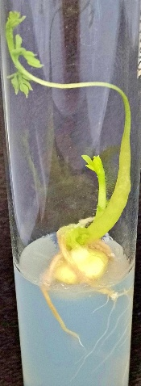
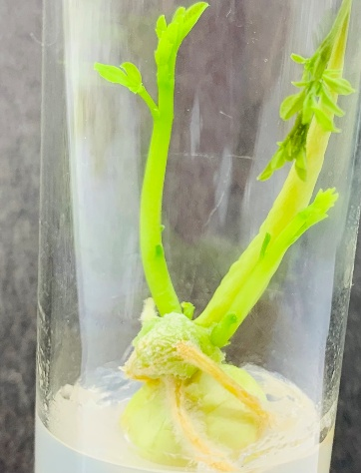
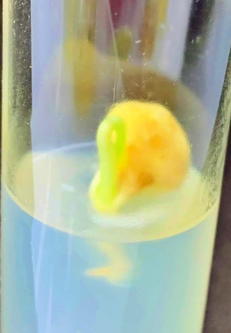
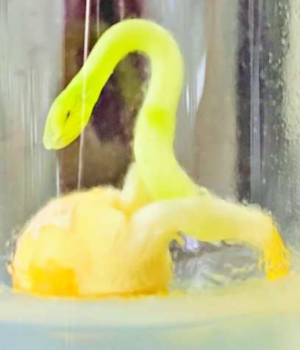
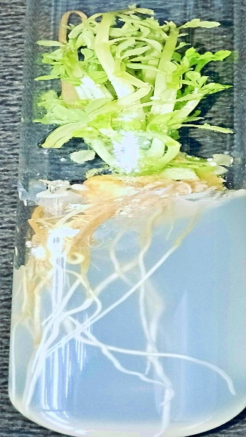
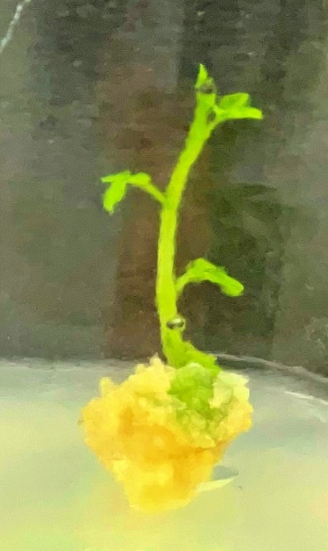
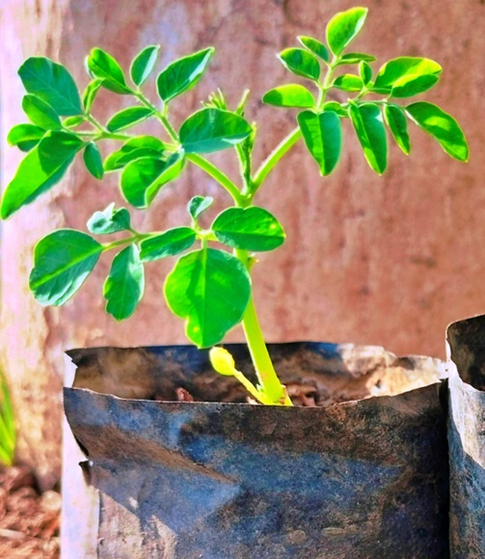
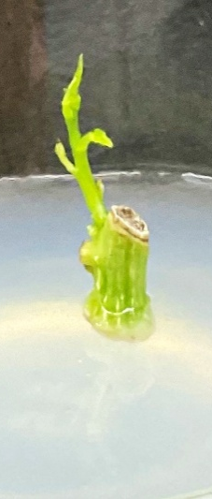
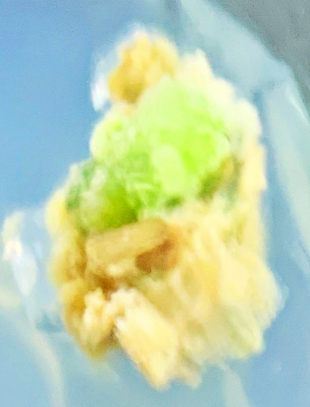
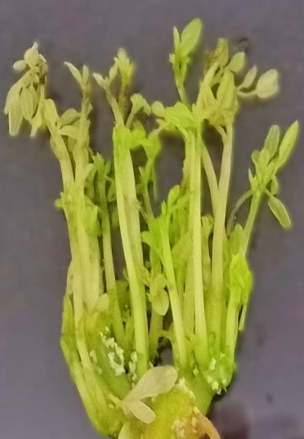
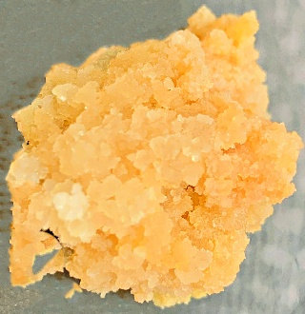
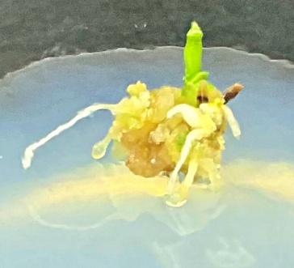
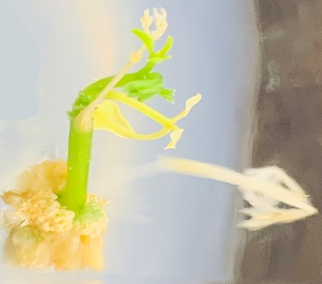
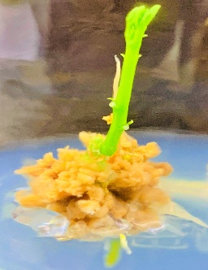
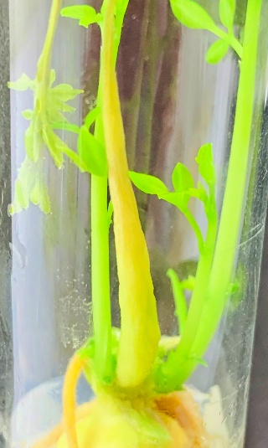
M

D
C
B
A

G
H
F
E

K
J
L
I

O
N
M
Fig. 2. Plantlet regeneration in Moringa oleifera Lam from cultured nodal segments: A. Seed after 4-7 days of inoculation; B. Germinated seed after 10 days of inoculation; C-E. Developed plants after25-30 days of inoculation; F. Cultured nodal segments after 7-10 days in culture; G. Formation of multiple shootlets via direct organogenesis; H. Proliferation of callus after 10-15 days in culture; I. Formation of callus after 20-25 days in culture; J-M. Initiation of single shoot via indirect organogenesis; N. Regenerants with well-developed roots in vitro; O. Regenerants transferred in greenhouse after 45-50 days for hardening.

