Original Research Article

Assessment of Cutch, Katha and Catechin content from heartwood of Senegalia catechu and its variation with storage

ABSTRACT
The investigation was carried out in the laboratory of College of Forestry, O.U.A.T, Bhubaneswar during 2023-24. S.catechu phenotypically superior trees selected from the natural habitat of Subarnapur forest division situated in western part of Odisha from which heart wood saw dust were extracted and then Cutch, Katha, Catechin content (%) and Catechin yield were estimated. The ranges were found to be for Cutch yield (1.310 – 1.648 g), Katha yield (1.197 – 0.440 g), Catechin content in katha (33.640 % – 15.935 %) and Catechin content in saw dust (0.571 % – 1.894 %). For identification of proper storage condition of saw dust of Senegalia catechu to avoid losses in Cutch, Katha and Catechin content (%), Saw dust (15 g) stored under different regime (Light, Dark), condition (Open and Closed) for various durations (0, 30, 60, 90 days) which were then extracted. The Katha and Cutch yield from the stored saw dust after 90 days of storage revealed that saw dust stored in closed light condition had highest yield of Katha (1.605 gm), Cutch (1.395gm) with 28.916% and 27.397% increase respectively from initially stored saw dust. The Catechin content (%) in the extracted Cutch from stored saw dust of S. catechu after 90 days of storage revealed that closed dark condition contain highest Catechin content (31.869 %) with 25.137% increase from Cutch extracted initial stored saw dust. The study also revealed light and open has a greater effect on degradation of Katha and Catechin in saw dust whereas closed and dark condition on degradation of Cutch in stored saw dust of S. catechu.

Key Words: Senegalia catechu, Cutch, Katha, Catechin

INTRODUCTION
Senegalia catechu is commonly called as Cutch tree in English, Khair in a deciduous medium sized tree belonging to the family Fabaceae. It is one of the widely growing trees found up to an altitude of 1200m in the forest in India, Pakistan, Nepal, Bhutan, Thailand and China (Kumari et al. 2022). The tree is found to be widely distributed in drier tracts of most of the states of India like Odisha, Chattishgargh, Uttar Pradesh, Madhya Pradesh, Uttrakhand, Himachal Pradesh, Punjab, Jammu, Assam, Karnataka, Assam and Tamil Nadu in the Tropical moist deciduous, tropical dry deciduous and Tropical thorn forest (Chowdhery & Wadhwa, 1984). The heartwood of the tree is mainly used for extracting Katha and Cutch which are sold in the market. Katha is for curing sore throat and commonly used in ayurvedic preparations. It is applied in mouth and on tongue to cure mouth ulcers. It is also applied externally on ulcers, boils, skin eruptions and on gums as disinfectant. Katha after drying is applied on lemon slice and taken regularly with empty stomach to cure piles. Besides this, it also serves as one of the major components in masticatory i.e. chewing of betel leaf (pan) in India (Singh and Lal, 2006; Hashmat & Hussain, 2013, Pandey,2020). The katha extracted from heartwood contains mostly Catechin and Epicatechin (Awang et al.,1993; Hye et al., 2009 and Amir et al., 2012). Some other major compounds found in heartwood of S.catechu are Epigallocatechin, Epicatechin gallate, Epigallocatechin gallate, Protocatechunic acid, Acacetin, Quercetin, Kaempferol, Lupernone, Lupeol and Taxifolin (Kumari et al. 2022, Karande and More, 2020 and Kayathri et al.,2013). The high amount of Catechin content in Senegalia catechu contributes to many pharmacological activities such as Immunomodulatory, anti-diabetic, anti-bacterial, anti-oxidant, anti-allergic, anti-viral and also as lipid lowering agent (Kumari et al., 2022; Adhikari etal, 2021; Sharma and Lingha ,2021; Cosarca et al., 2019 and Khan et al., 2010). The phytochemicals present in plant part also changes because of genotypic characters, environmental factors and their interaction in khair (Luna et al., 2008; Khawale et al. ,2023). Senegalia catechu is found naturally distributed in dry deciduous forest of western tract of Odisha and the harvested wood are sold at very low rate as the major phytochemical content like cutch, katha, catechin etc has not been evaluated sufficiently. So, it necessitates to evaluate the phytochemical content from different plant sources to identify the high content source and fetch higher market rate for the extracted heart wood. Most of the phytochemicals during drying, storage, and processing because of enzymatic and microbiological interactions in presence of light, heat, air, becomes unstable and decomposes. This initiates to identify appropriate storage conditions for each phytochemical which minimize its degradation. Because of the multifarious uses of Senegalia catechu, its availability as natural population in western part of Odisha, the present study was carried out to evaluate the Cutch, Katha and Catechin content in natural population and its variation with storage of wood.

2. Materials and Methods
  - Estimation of Catechin content from Katha extracted from heartwood of Senegalia catechu.
    - Location and Morphology of Sample trees

The heartwood discs of 5 sample trees of Senegalia catechu were collected from Subarnapur Forest Division of Odisha. The geographical location and morphometric characters of the selected trees are given below:
Table 1. Geographical location of the sample trees of Senegalia catechu

Sample Tree No. | Name of the Range | Name of the  R eserve forest | GPS Coordinate |  | Girth (in  cm) | Height (in ft)
ST-1 | Ullunda | Ghikundi R.F | 20.958053 | 83.967608 | 45 | 20
ST-2 | Ullunda | Harinapali R.F | 20.974608 | 83.953809 | 30 | 14
ST-3 | Ullunda | Chandili R.F | 20.979508 | 83.880711 | 30 | 11
ST-4 | Birmaharajpur | Hatilimunda R.F | 21.00655 | 84.105053 | 38 | 18
ST-5 | Sonepur | Arjunpur R.F | 20.85861 | 83.854444 | 28 | 10

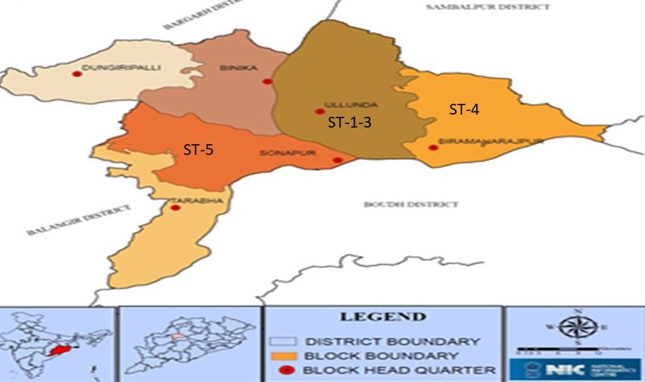

Figure-1 Different blocks of Subarnapur District of Odisha, India

Extraction procedure of Katha and Cutch
The heartwood disc of 5 harvested sample trees were cut to small wood flakes which were ground to fine powder. The heart wood powder were then sieved to get uniform size of grounded wooden dust of which 15gms from each selected sample tree were refluxed using 250 mL distilled water for 4 hours. Then it was filtered using white cotton cloth. The left saw dust was refluxed once again with 250 mL distilled water for another 4 h and then it was filtered by using the white cotton cloth. After the reflux process, the filtrate of each selected was concentrated to 40 ml at 150 °C temperature till attains specific gravity of 1.07. The concentrated filtrate of all samples were then kept in refrigerator for 48 h at temperature 5°C to allow the Katha to get settled down. After the Katha get settled at the bottom of the beaker, the upper layer consisting of Cutch was taken out by using syringe and transferred to another beaker. The Cutch was again kept in freezer at 5°C for 48 h for separation of excess Katha present in the Cutch extracted. The Katha and Cutch thus collected in different beakers were oven dried at temperature 55°C. The well dried Cutch and Katha of each sample were scrapped, collected and weighed to obtained their yield.

2.1.3 Separation and Quantifying Catechin from Katha by TLC
10 mg of Katha extracted from each sample were taken in separate graduated test tubes and dissolved with 2 mL of methanol of which, one drop (0.03 mL) of each samples was applied on TLC Plate GF₂₅₄ by using pipette. One drop of Standard Catechin was also applied on the same plate as reference. The spots on TLC sheets were allowed to dry for 30 minutes at room temperature which was then run with solvent system of Toluene : Ethyl acetate: Formic acid in 10:8:1 ratio up to 11.4 cm. The TLC plate was then dried for 10 minutes and observed under UV light where single spot corresponding to the Catechin Standard was identified at RF= 0.29 (Figure-2). The Catechin corresponding spot was cut and dipped in a beaker containing 5 ml methanol (HPLC Grade) till it gets dissolved which was confirmed by visualizing the cutout TLC sheet under UV-VIS Spectrophotometer. Then the vacuum filtration was carried out for the Catechin dissolved methanol solution sample to filter any impurity (silica gel) if present. After the filtration process, the concentration of Catechin solution was made to 10 ml by adding methanol (HPLC Grade). The absorbance of Catechin solution was finally recorded at wavelength 276.8nm. The Absorbance recorded was then further used to determine the concentration of Catechin using the Standard curve.

2.1.4 Preparation of Standard Curve of Catechin
The Standard Catechin (100 mg) was dissolved in 1000 mL of Methanol (HPLC Grade) which was taken as the Stock solution. From this standard solution 0.2 mL , 0.4 mL, 0.6 mL , 0.8 mL and 1.0 mL were pipette out in separate test tubes to which 9.8 mL. 9.6 mL, 9.4 mL, 9.2mL and 9.0 mL of Methanol (HPLC grade) were added to make the concentration of 0.002 mg/mL, 0.004 mg/mL, 0.006 mg/mL, 0.008 mg/mL and 0.01 mg/mL respectively. Then the Absorbance of each concentration solution of Catechin were recorded on UV-VIS Spectrophotometer at 276.8 nm which was plotted against their concentration for Standard Curve preparation (Figure-3).
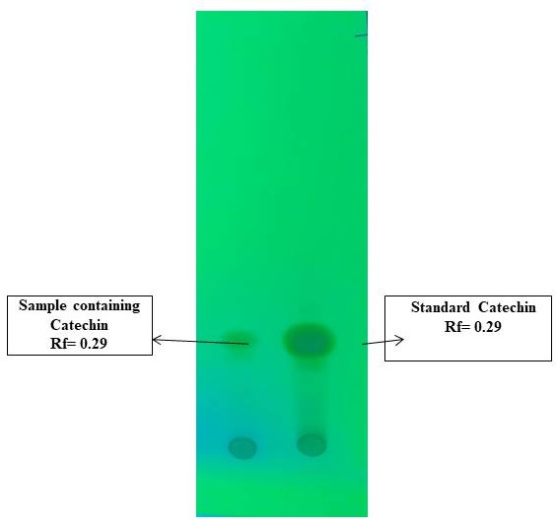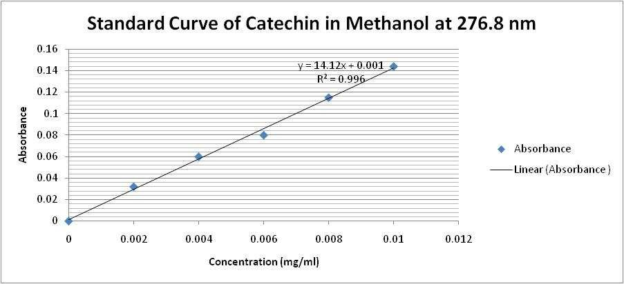
Figure-2 TLC of Standard Catechin and Catechin derived from Katha
Figure-3 Standard Curve of Catechin

2.1.5 Estimation of Catechin Content (%) from Katha and Saw dust
The Catechin concentration (mg/mL) for each sample was found out from the standard curve using the equation y = 14.12x + 0.001. The amount of Catechin was thus obtained by multiplying the dilution factor. The Catechin percentage from Katha and Saw dust were calculated by the given formula:
Amount of Catechin obtained (mg)
Catechin (%) from Katha = x100
Weight of Katha (mg)

Amount of Catechin obtained (mg)
Catechin (%) from Saw dust = x100
Weight of saw dust (mg)

Observations to be recorded
The observations recorded for the above experiment included Cutch yield (g), Katha yield (g), Catechin (%) in Katha, Catechin Yield from Katha (mg) and Catechin (%) in saw dust of heart wood.

2.2 Changes in Cutch, Katha and Catechin Content (%) from stored Senegalia catechu wood dust

Experimental Material
During the study of the present experiment saw dust from heart wood of S. catechu were stored for 90 days in different regimes ( Light, Dark), conditions (Open , closed) and the changes in Katha yield, Cutch yield, Catechin content from Katha and Catechin content from stored saw dust were assessed. The saw dust was prepared from the oven dried flakes of the heart wood of sample tree ST5. Each sample was stored separately and analyzed for each treatment combination after storage durations (0 days, 30 days, 60 days, 90 days). The experiment was carried out on factorial CRD design with 2 regimes, 2 conditions and 4 durations accounting for 16 treatment combination.
    - Extraction procedure of Katha and Cutch
The extraction procedure of Katha and Cutch from the stored saw dust was carried out as per the same methodology mentioned in 2.1.2 .

Isolation and Estimation of Catechin content (%) from Katha and Saw dust
Isolation and estimation of Catechin (%) from Katha and Saw dust was carried out as per the same methodology mentioned in 2.1.3 and 2.1.5.

Observations recorded
The observations to be recorded for the above experiment includes Cutch yield (g) , Katha yield (g) , Catechin (%) in Katha , Catechin Yield from Katha (mg) and Catechin (%) in stored saw dust of heart wood .

3. Results and Discussion

  - Estimation of Cutch, Katha and Catechin from heartwood of Senegalia catechu
The Cutch, Katha and Catechin Content were found significantly different among the sample trees collected from different natural populations which was confirmed from the Tukay (HSD) test. The Cutch, Katha yield, Catechin Content (%) in Katha and Catechin Content (%) from 15 g extracted saw dusts of all 5 sample trees and mean value are given in Table-2. Cutch and Katha yield were found maximum in ST-1 (25.801% and 172.045% higher) than lowest recorded ST-4. Similarly, Catechin yield from Katha and Catechin Content in Saw dust can be considered maximum in ST-1 (as ST-1 and ST-2 are statistically at par) with 224.976% and 224.868% higher than the lowest recorded value of ST-4. However, Catechin content in Katha was found to be highest in ST-2 which was even 44.669% more than that of ST-1.

Table 2 :Cutch, Katha yield and Catechin (%) in Sample trees of Senegalia catechu

Sl.  No. | SampleTree No. | Cutch Yield (g) | Katha Yield (g) | Catechin content(%) in Katha | Catechin yield from Katha (mg) | Catechin Content(%) in Saw dust
1 | ST-1 | 1.648 | 1.197 | 23.253 | 278.307 f | 1.855 g
2 | ST-2 | 1.485 a | 0.845 d | 33.640 | 284.150 f | 1.894 g
3 | ST-3 | 1.421 ab | 0.813 de | 21.836 | 177.470 | 1.183
4 | ST-4 | 1.310 c | 0.440 | 19.476 | 85.639 | 0.571
5 | ST-5 | 1.369 bc | 0.741 e | 15.935 | 117.978 | 0.787
MEAN |  | 1.447 | 0.807 | 22.828 | 188.709 | 1.258
F-statistics |  | 51.0958 | 120.3674 | 3171.9157 | 194.751 | 195.1376
p-value |  | 1.459e-8 | 3.305e-11 | 0.00 | 9.865e-13 | 195.1376
(Letters denoted by a,b,c,d,e,f,g signifies the values are statistically significant)

Higher Cutch and Katha in ST-1 may be because of superior genotype, favorable environment conditions and interaction of both. Similarly, Catechin (%) in Katha is high in ST-2 than ST-1 as the synthesis of Catechin may be more favored by the genetical trait of the tree. However, Catechin yield from Katha and Catechin (%) in sawdust is higher in ST- 2 because of multiplicative effect of Katha yield and Catechin (%) in katha. The mean cutch and Katha content estimated in our experiment found to be 9.646% and 5.38 % (Calculated from Table-2) which is in close agreement with the values estimated by Luna et al. (2009). The Catechin % in Katha found under this investigation varies from 15.935% - 33.640% with average value 22.828 % (Table-2) which is nearly equal to the Catechin (20-25 %) in Katha estimated by Sharma et al. (2021).

  - Changes in Katha, Cutch and Catechin Content (%) from stored Senegalia catechu wood

Plant official parts being collected at the appropriate harvesting stage mainly for trees and plants having important phytochemicals used as medicinal, gums, resins, tannins, phenols etc need to be properly stored and dried under regulated circumstances until the processing stage. As the harvested official part cannot be processed immediately as the processing unit are at large distance from the site of collections and also availability of plenty of raw materials which cannot be used in a single processing, the drying and storage become essential for keeping the raw material for future processing.

The chemical structure of phytochemical or active principles varies which is the main reason each having their own biological, chemical and pharmacological identity. Each active principle has different level of stability which is because of its chemical structure, functional groups attached to it. During drying, storage, and processing because of enzymatic and microbiological interactions in presence of light, heat, air, these unstable compounds decomposes or get converted into other compounds. This initiates to evaluate appropriate storage conditions (light, dark, closed, open), storage container (that act as a barrier between the stored herbs and environment) and storage duration which minimize the degradation of the phytochemicals.

Table-3: Changes in Katha and Cutch Yield from saw dust stored under various regimes and conditions for different duration

Product Yield→ | Changes in Katha Yield (g) |  |  |  | Changes in Cutch Yield(g)
Regimes→ | LIGHT |  | DARK |  | LIGHT |  | DARK
Type→ | Open | Closed | Open | Closed | Open | Closed | Open | Closed
Duration↓
0 DAYS | 1.245 | 1.245 | 1.245 | 1.245 | 1.095 | 1.095 | 1.095 | 1.095
30 DAYS | 0.890 | 1.130 | 0.725 | 1.810 | 0.765 | 1.200 | 1.165 | 1.035
60 DAYS | 0.920 | 0.710 | 1.140 | 1.705 | 1.795 | 1.100 | 1.255 | 0.910
90 DAYS | 1.205 | 1.605 | 1.560 | 1.325 | 1.395 | 1.220 | 1.240 | 1.080
Intraction (Regime X Condition X  Duration) | C.D | SE(d) | SE(m) |  | Intraction (Regime X ConditionX Duration | C.D | SE(d) | SE(m)
Intraction (Regime X Condition X  Duration) | 0.102 | 0.048 | 0.034 |  | Intraction (Regime X ConditionX Duration | 0.144 | 0.068 | 0.048

Table-4: Changes in Catechin content (%) in extracted Katha and stored sawdust under various regimes and conditions for different duration

Product Yield→ | Changes in Catechin Content (%) in Extracted Katha |  |  |  |  |  | Changes in Catechin Content(%) in Stored Saw dust
Regimes→ | LIGHT |  |  |  | DARK |  | LIGHT |  |  | DARK
Type→ | Open |  | Closed | Open |  | Closed | Open | Closed |  | Open | Closed
Duration↓
0 DAYS | 25.496  (30.291) | 25.496  (30.291) |  | 25.496  (30.291) |  | 25.496  (30.291) | 2.126  (2.202) |  | 2.126  (2.202) | 2.126  (2.202) | 2.126  (2.202)
30 DAYS | 52.644  (46.497) | 56.421  (48.670) |  | 58.545  (49.900) |  | 42.729  (40.802) | 3.117  (2.029) |  | 4.251  (2.291) | 2.829  (1.957) | 5.158  (2.482)
60 DAYS | 31.397  (34.065) | 20.066  (26.061) |  | 23.135  (28.738) |  | 36.119  (36.926) | 1.929  (1.711) |  | 0.950  (1.396) | 1.755  (1.660) | 4.105  (2.259)
90 DAYS | 29.037  (32.592) | 13.456  (21.510) |  | 17.941  (25.050) |  | 31.869  (34.355) | 2.330  (1.825) |  | 1.438  (1.561) | 1.868  (1.693) | 2.814  (1.953)
Intraction (Regime X Condition X  Duration | CD | SE(d) |  | SE(m) |  |  | Intraction (Regime X ConditionX Duration |  | CD | SE(d) | SE(m)
Intraction (Regime X Condition X  Duration | 2.361 | 1.114 |  | 0.788 |  |  |  |  | 0.145 | 0.069 | 0.049

During this study, the phytochemicals like Katha, Cutch and Catechin estimated from heartwood dust of S.catechu. The Katha yield, Cutch yield and Catechin Content (%) in saw dust found to be increasing and decreasing in an irregular fashion from time of storage till 90 days of storage (Table-3 and Table-4) which indicates regimes, conditions and their interaction accelerates or decelerates the synthesis of Katha , Cutch over the period of storage. As few works has been carried out on storage of Senegalia catechu for estimation of Cutch, Katha and Catechin, works related to change in Catechin content with storage in tea. Yang et al.(2007) also revealed increasing and decreasing of Catechin content in an irregular fashion. Other compounds like phenols showed increase and decrease in pattern with storage of plant extract of Piper betel till 90 days (Ali et al., 2018). However, Catechin (%) in Katha found to be increasing till 30 days in all storage types and then decreasing continuously till 90 days of storage (Table-4). This may be due to during initial 30 days of storage the phytochemicals present in the stored saw dust when get requisite temperature, humidity promotes higher rate of synthesis or conversion of other compounds to Catechin than its degradation. As very less work has been carried out on storage of Catechin, phenolic compounds however reported to increase in its content from initial storage till one month and then decreases, Gelani et al. (2013).

It was found that irrespective of storage condition and duration , Katha ,Catechin (%) in Katha and Catechin (%) in saw dust was highest in dark than light (Fig.-4,6 and 7) indicating lesser degradation of katha and catechin. Katha and Catechin content (%) were maximum in case saws dust stored in closed container irrespective of storage regime and storage duration (Fig.-4 and Fig.-7). However, Cutch production was found to be maximum in open condition (Fig.-5) which may be due to air favoring oxidation of some chemicals in saw dust and getting it converted to phytochemicals constituting the cutch.

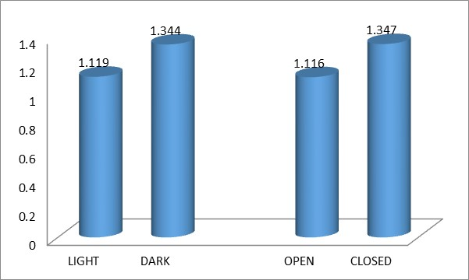
Figure-4. Katha extracted from stored saw dust

Fig 5- Cutch extracted(g) from stored saw dust

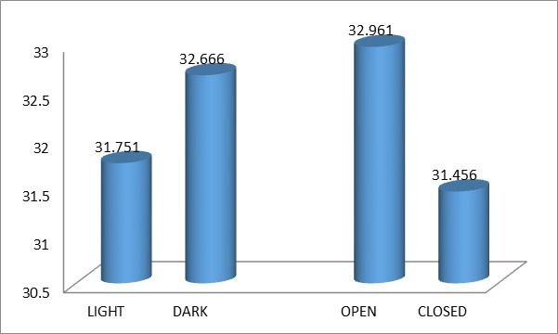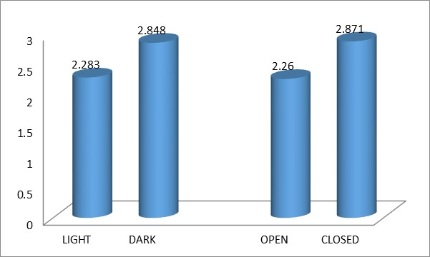
Fig 7- Catechin(%) on basis of stored saw dust

Fig 6-Catechin(%) present in Katha extracted stored saw dust

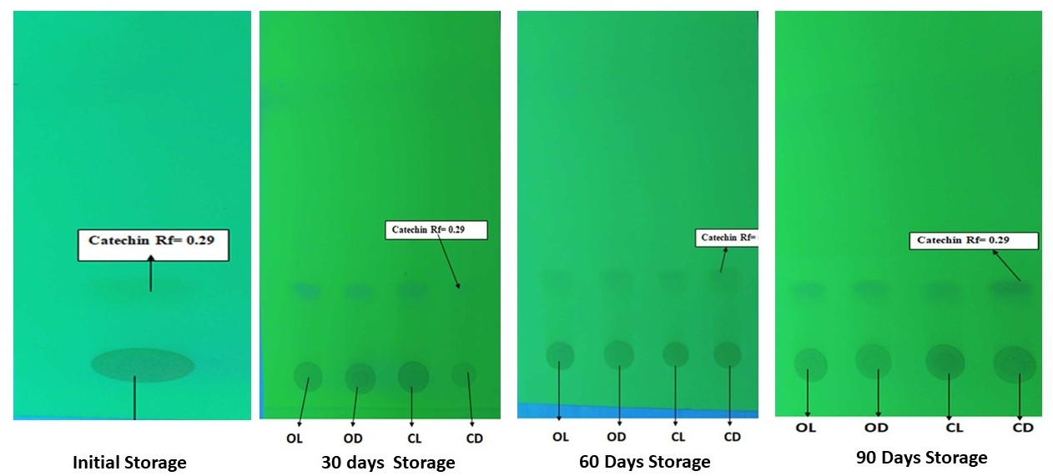6. Conclusion
Fig.8- Separation of Catechin from extracted Katha of stored saw dusts
The heart wood of Senegalia catechu collected from Odisha contains average Cutch content in saw dust (9.646%) , Katha content in saw dust (5.38%), Catechin Content in Katha (22.828 %) and Catechin Content in saw dust (1.258%) which can have a good market value as a raw material for Cutch and Katha industry than fuelwood. In order to obtain higher Katha yield and Catechin (%) from stored saw dust, it should be stored in closed dark condition. The storage period may be increased further for a longer period to observe better trend of degradations of Cutch, Katha and Catechin. Different Storage temperature can also be taken up to study its impact on Cutch, Katha and Catechin degradation.
5. Declarations
Conflicts of interest: The authors declare that they have no conflicts of interest.
6. Disclaimer (Artificial Intelligence)
Author(s) hereby declare that NO generative AI technologies such as Large Language Models (ChatGPT, COPILOT, etc.) and text-to-image generators have been used during the writing or editing of this manuscript.
7. References

1. Adhikari, B., Aryl, B. & Bhattarai,B.R. (2021). A Comprehensive Review on the Chemical Composition and Pharmacological Activities of Acacia catechu (L.f.) Wild. Journal of Chemistry , 1-11.
2. Ali, A., Choong, C.W., Mah, S.H. & Abdullah, L.C. (2018). Impact of Storage Conditions on the Stability of Predominant Phenolic Constituents and Anti-oxidant Activity of Dried Pipper betle Extracts. Molecules, 84(23), 1-15.
3. Amir, M., Mujeeb, M. ,Khan, A., Kamran, A.,Sharma,D. & Aqui, M. (2012). Phytochemical analysis and in vitro antioxidant activity of Uncaria gambir. International Journal Of Green Pharmacy , 6(1),67-72.
4. Awang, K. & Taylor, D. (1993). Acacias for Rural, Industrial and Environmental Development. Biotica Research Today : 1-264.
5. Chowdhery, H.J. & Wadha, B.M. (1984). Orchidaceae. In: Flora of Himachal Pradesh:
Analysis, 3: 680-693.
8. Cosarca, S., Tanase, C. & Muntean, L.( 2019). Therapeutic aspects of Catechin and its derivatives- an update. Acta Biologica Marisiensis, 2(1): 21-29.
9. Gelani, J.H., Acharya, P.P. & Rajbhandari, M.M. (2013). Isolation of Gallic acid and Estimation of Total Phenolic Content in Some Medicinal Plants and Their Antioxidant Activity. Nepal Journal of Science and Technology, 14(1): 95- 102.
10. Hashmat, M. & Hussain, R. (2013). A review on Acacia catechu Wild. Interdisciplinary Journal of contemporary research in business, 5(1): 593-600.
11. Hye, M.A. & Zaman, S. (2009). Isolation of (+)-Catechin from Acacia catechu (Cutch tree ) by a convenient method. Journal of Scientific Research, 1(2): 300- 305.
12. Karande, P. & More, S. (2020). Qualitative and Quantitative Phytochemical Analysis of Acacia catechu Wild. International Journal of Scientific Research in Science and Technology, 7(3): 327-332.
13. Kayathri, B., Kavitha, P. & Panneerselvam, A.(2013). Studies on preliminary phytochemical analysis and antimicrobial effucacy of Acacia catechu (L.) Wild. against poultary pathogens. World Journal of Pharmaceutical research, 3(1): 1-10.
14. Khan, M. & Manzoor, N. (2010). Assessment of antimicrobial activity of Catechu and its dyed substrate. Journal pf Cleaner Production, 19: 1385-1394.
15. Khawale, M.G. , Mhaiske,Y.M., Patil, Y.K., Rane , A.D. & Narkhede,S.S.(2023). Variability study on Katha recovery in Konkan region of Maharashtra state. International journal of farm sciences ,13(1): 77-80.
16. Kumari, M., Kumar, M, Zhang, B. and Puri, S. (2022). Acacia catechu (L.f.) Wild.: Review on bioactive compounds and their health promoting functionalities. Plants, 11: 3091-3100.
17. Luna, R. K., Kamboj, S. K. & Thakur, N.S.(2009). Source variation in Katha and Cutch content in khair (Acacia catechu WILD.) in Shiwalik hills of Punjab. Ann.For.,17(1):89-96
18. Pandey, R. (2020). Evaluation of Catechu Extracts from Acacia catechu Collected from Central India for Antidiabetic activity. Internationsal Journal of Recent Scientific Research, 11(2): 37509-375011.
19. Sharma, P. & Lingha, R. (2021). A Recent Update on the Pharmacognostical as well as pharmacological Profiles of the Acacia catechu Heartwood: A Mini Review. Journal of Ayurvedic and Herbal Medicine, 7(3): 188-192.
20. Sharma, P. & Raju, L. (2021). Investigation of the pharmacognosy as well as the antioxidant, anti-inflammatory potential of the Katha powder. International Journal of Pharmacognosy, 8(5): 205-215.
22. Singh, K.N. & Lal, B. (2006). Notes on Traditional Uses of Khair (Acacia catechu Wild.) Inhabitants of Shivalikrange in western Himalaya. Ethnobotanical leaflets, (10)1: 109-112.
23. Stohs ,S.J. & Bagchi, D.(2015). Antioxidant, Anti‐inflammatory, and Chemoprotective Properties of Acacia catechu Heartwood Extracts. Phytotherapy Research, 29(6):818–824..

24. Yang, J., HwangL.L.C. & Lin,J.T.(2007). Effect of different steeping methods ans storage on caffine, catechins and gallic acids in bag infusions. Journal of ChromatographyA, 1156(1-2):312-320.
25.Vasisth,A., Kaushal,A.N., Guleria,V. & Pandey,S.B.S.(2010). Effect of storage conditions and chip thickness on Katha and Cutch yield. Indian Forester,136(7):929-935..

.

