Original Research Article
Study on Problems Faced by the Dairy Women Entrepreneurs and their Suggestions to Strengthen Dairy Industry
ABSTRACT
Women dairy entrepreneurs play a very important role in Indian dairy industry. These women contribute 70% of work force and earn regular income from dairy industry. This promotes socio economic empowerment of women financially, invest in their children’s education, healthcare, and contribute to household expense. Even though women entrepreneurs facing some problems in this industry, the study planned to identified solutions to those problems. The study was conducted in Bharuch district of Gujarat state with the sample size of 360. The study was planned to make survey for three years (2021 to 2024) by developing a pre tested interview schedule. The schedule was developed by collecting information from review of literature and with experts help. The data was collected and analysed using Garrett ranking technique using excel. From the data it’s revolved that the women dairy entrepreneurs encountered some important challenges in dairy industry like lack of low milk price (83.33%), availability of nutrient feeding (73.33%), cost of nutrient feeding (66.11%) etc. The study reviles that solutions to overcome those problems and sustain women dairy entrepreneurs were women centric training programs, awareness campaigns, timely supply of inputs with affordable prices including veterinary services can strengthen the women dairy entrepreneurs.
Keywords: Dairy; Women; Entrepreneurs; Garrett ranking

- INTRODUCTION
The development of economy of all nations depends primarily on the important role played by entrepreneurs. Entrepreneurs in agriculture can play a pivotal role in uplifting our nation’s economy. Interestingly, progressive farmers cannot always be identified as agricultural entrepreneurs, but those of them who are entrepreneurs, are essentially progressive farmers. This pertains to the quality of agricultural entrepreneurs to generally work in direction of increasing their income by adopting new strategies and innovation. The entrepreneur is an economic person, who strives to maximize his profits through innovations. An entrepreneur’s function is to revolutionize the pattern of production by exploiting an invention or introducing an untried technological possibility for producing a new commodity (Swoboda, 1984). Entrepreneur is the organizer of economic venture, especially one who organizes, owns, manages and assumes the risk of the business. An entrepreneur may also be defined as the economic functionary, who undertakes such responsibilities, which cannot be insured or capitalized or salaried. Dairy farming is one of the important enterprises in agriculture which dominated by the woman in the rural areas of India. India is the world's largest milk producer an average milk production of 17,281 thousand tonnes of milk per year. India's milk production has grown remarkably over the past decade, with a Compound Annual Growth Rate (CAGR) of 6 percent. It contributes 25% of the world's milk production. Increasing demand for milk and milk products in recent years intensifies dairy farming as profitable enterprise for rural woman. FAO Dairy Market Review (2023) milk production of India is reached 236.35 million tonnes in 2023-24 registering a growth of 2.5% over the last year beating the world average growth rate. Gujarat contributes 7.99% to total milk production of India. As per the official figures, last year total milk production in Gujarat was 11,690.57 thousand tones. Gujarat produces daily 32,000 tonnes of milk per day (NDDB, 2024). The notable and sustainable growth in dairy industry is, by the involvement of women. Nationwide 48,000 women cooperatives societies operating at the village level with 35 percent of women participation. This promoting inclusive growth and empowering women in rural areas.
- ROLE OF WOMEN IN DAIRY SECTOR
Women play an important role in a range of dairy activities including harvesting and feeding animals, processing fodder, milking animals, and raising calves. They make significant contribution to household income through dairy industry by maintaining nutritional security of family and livestock, this promotes socio economic empowerment of women. In this context, women assume a prominent position in dairy operations and supervision of livestock. This state not only leads to higher income and also signifies sense of independence, prestige and authority over household resources. This entrepreneur trends enhances women’s self-assurance, self-esteem, and ability to make independent decisions (Shraddha et al, 2024). The dairy farming provides sustainable jobs and makes them to set up their own enterprise in their local communities. In addition to this dairy industry makes significant contributions in increase in income, enhanced nutrition and education specially in girls and ensuring economic stability. Involvement of women in dairy industry extends beyond their economic contribution playing an instrumental role in community development, social empowerment, rural transformation, gender equality and sustainable comprehensive and inclusive agricultural growth.
Research studies also justified women’s efforts in dairy industry. Women have traditionally played crucial roles in livestock rearing and dairy farming activities in India, making the dairy sector predominantly female-dominated (Rajpurohit & Sareen, 2022). Dairy cooperatives are crucial in promoting inclusivity and providing livelihood opportunities for small-scale farmers, especially women (Dohmwirth & Liu, 2020). Even though women’s dominating dairy industry some of the factors that hinders the entrepreneurship behaviour of women like lack of financial support, family ties, lack of exposure, high input and labour cost etc. Sharma and Sah (2022) in his study on entrepreneurial behaviour and their correlates among dairy entrepreneurs in Northern India found that herd size, milk yield, mass media exposure and economic motivation of the respondents had positive contribution on the entrepreneurial behaviour. Various stakeholders including the KMF, Dairy Development Board, Micro Finance Institutions are advised to uplift the socio-economic status of women by encouraging their inbuilt entrepreneurial talent to make them socially and economically self-sufficient and achieve self-esteem in the society to contribute to the sustainable development of the country (Paramashivaiah & Puttaswamy, 2018). In consideration of the above-mentioned research findings, the current study aimed at assessing entrepreneurial behaviour of dairy farm women in South Gujarat
- OBJECTIVES:
To document the problems and suggestions for better development of entrepreneurial behaviour of dairy.
- REVIEW OF LITERATURE:
4.1 Difficulties confronted by women dairy entrepreneurs
Animal husbandry is the one of the primary sources of income for the Indian farmers. Especially small farmers derive 16% of family income from dairy industry. Over 70 million rural families in India rely on livestock as a significant source of additional income (Patel et al., 2021). By review Shraddha et.al 2024 attempts to highlights various difficulties confronted women dairy farmers were limited policy support, lack of infrastructure chain, inadequate developmental schemes, consumer demand for enhanced food safety, increasing wage levels, male-dominated society and raw material shortage. Consequently, despite the increasing demand for feed and fodder due to the rise in livestock, the Kerala state finds itself facing a deficit in both dry and concentrate forms of feed and fodder (Ashraf & Shafeek 2024). Evidences for the studies reviles that, policy making at national and sub-national level for the technical and financial assistance to dairy farmers, because this sector was a labour-intensive activity with low input-output ratio. More emphasis can be put on dissemination of technical knowledge through media and strengthening the research environment in both private and public sector (Annu, 2023). Women's access to training in contemporary dairying and cooperative management was a crucial for their empowerment and economic well-being. The inclusion of women in the workforce serves as an indicator of their economic and social standing within society (Shraddha et.al, 2024). In Gujarat dairy farm women reported that small size of land holdings, restricts them to put more land under fodder crop production as they need to grow food grains and commercial crops. The other major constraints reported were no provision of quality fodder seed in market, high cost of cultivation and low returns on fodder production, non-availability of grazing lands, and non-availability of adequate irrigation water (Kalamkar et.al, 2020).
- RESEARCH METHODOLOGY
5.1 Selection of study area: The study was conducted in 2021-2024 in Gujarat state of Bharuch district. At present Bharuch district is having 600 rural milk co-operatives and more than 59,200 milk producer members affiliated in Bharuch district milk union, among them 55 percent women. The district is having 6 talukas (Amod, Ankleshwar, Bharuch, Hansot, Jambusar, Jhagadia, Valia, and Vagra) among them 3 talukas (Ankleshwar, Bharuch and Hansot) were selected purposely where the milk production is maximum.
5.2 Sample size: Among the three talukas eighteen villages were selected randomly from each village 20 dairy farm women were selected with the simple random sampling method leading to total sample of 360 explained in Fig 1.
5.3 Data collection: The list of problems faced by the dairy farm women was complied with the help of review of literature and the data was collected on the rank order using pre tested interview schedule. The primary data were collected with the help of structured, pre-tested scheduled through personal contact and the data were compiled, tabulated and analysed using Microsoft Excel according to the objectives.
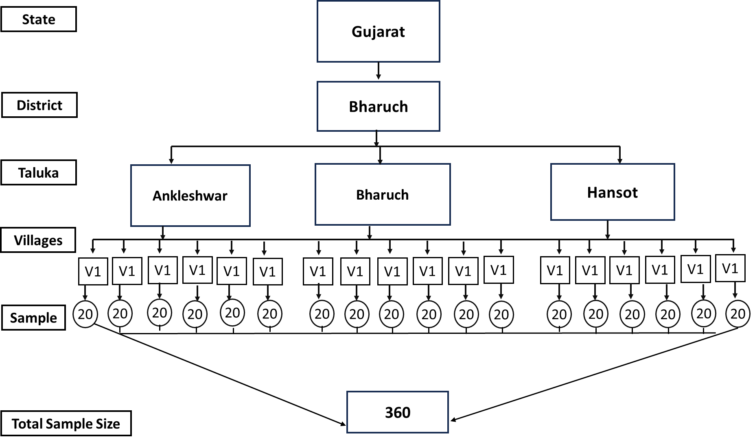
Fig 1: Sample selection process and sample size
5.4 DATA ANALYSIS
5.4.1 Statistical tools used to rank the constraints: To analyse the constraints data Garrett ranking technique was used. The respondents asked to rank the problems on five different categories. These ranks were then converted in to scores values using formula proposed by Garrett (1997). Garrett table is used to find out the present position, which was then converted in to corresponding scores assigned by each individual for each constraint were summed and total mean score was calculated as the method indicated.
$$Percent position=\frac{100(Rij-0.5)}{Nj}$$
Where, R_{ij} = Rank given to the i^{th} attribute by j^{th} respondent.
N_{j} = Number of attributes ranked by the j^{th} respondent.
Garrett’s tables were used to estimate the percent position, which was then covered in to corresponding scores. Subsequently, the scores assigned by each individual for each constraint were summed up, and the total mean scores were calculated. The problems with the highest mean score were identified as the most significant and signed first rank.

5.4.2 Mean scores used to analyse problems:
The mean is the mathematical average of a set of numbers and used to measure a central tendency. It was used to classify the women groups around central value. Further, averages were employed to associate the importance and usefulness of crop insurance in these changed climatic conditions.
- RESULTS AND DISCUSSION
5.1 Problems faced by the women dairy entrepreneurs in dairy enterprise
The problems faced by the respondents regarding dairy farming were studied, analyzed and presented in Table 1. The survey results revealed significant insights into the constraints faced by the women dairy entrepreneurs in study area of dairy industry, that was price of the milk was low ranked 1st with the garret score 83.33 % followed low availability of concentrated and mineral mixture at nearby villages and concentration cost was high ranked 2nd and 3rd with garret score 73.33% and 71.67% respectively. The cost of the milk and the cost of concentrated feed considered as the critical problems by the respondents (Rathod et al, 2011 and Mariammal and Seethalakshmi, 2017). Following, the findings of the study indicated that other major problems reported by women dairy entrepreneurs where treatment charges from private participants were high, shortage of skilled labour for milking and specific breed semen was not available at the required time ranked 4th, 5th and 6th with a garret score of 66.11%, 52.78%, and 50.00% respectively. Unavailability of timely veterinary services, shortage of labour for care and management of animals, lack of veterinary services at the nearest place and least interest shown by youth in dairy industry ranks 7th 8th 9th and 10th with a garret score of 35.56%, 33.33%, 31.56% and 30.78% respectively (Panchbhai, 2017). The least perceived constraints by the women dairy enterprisers were lack of timely technical assistance/extension services (20.78%), unviability of grazing areas in the villages (22.33%), lagging behind for implementation of scientific dairy farming (25.11%), low conception rate in artificial insemination (26.33%) and non-availability of green and dry fodder throughout the year (28.44%) were ranks 15th, 14th, 13^{th,} 12^{th,} and 11th respectively (Manjusha, 2009). The survey indicates that primary activities that directly related to money were ranked first as a major problem. Followed by factors influencing the economic status would give secondary position by the women dairy entrepreneurs. Because these constraints directly related to strengthen dairy industry. Additionally, ensuring the availability of skilled labour for milking and other activities, timely required semen breed, veterinary services, increased involvement of youth in dairy industry would further better motivate respondents in dairy industry.
Table 1. Problems faced by the women dairy entrepreneurs in dairy enterprise (n=360)
Sr. No. | Problems | Garret Score % | Rank
1 | Price of milk was low | 83.33 | I
2 | Low availability of concentrate and mineral mixture at nearby  village | 73.33 | II
3 | Concentration cost was high | 71.67 | III
4 | Treatment charges for private practitioners were high | 66.11 | IV
5 | Shortage of skilled labour for milking | 52.78 | V
6 | Specific breed semen was not available at the required time | 50.00 | VI
7 | Unavailability of timely veterinary services | 35.56 | VII
8 | Shortage of labour for care and management of animals | 33.33 | VIII
9 | Lack of veterinary services at the nearest places | 31.56 | IX
10 | Least interest shown by youth in dairy industry | 30.78 | X
11 | Non availability of green and dry fodder throughout the year | 28.44 | XI
12 | Low conception rate in artificial insemination | 26.33 | XII
13 | Laging behind for implementation of scientific dairy farming  practices | 25.11 | XIII
14 | Unviability of grazing areas in the villages | 22.33 | XIV
15 | Lack of timely technical assistance/extension services | 20.78 | XV
Source: Field survey 2021-24
5.2 Suggestions of the women dairy entrepreneurs to improve the dairy enterprise
The women dairy entrepreneurs were asked to provide the suggestions to strengthen the dairy industry and presented data in Table 2 and Fig 2. The table reveals that majority of the respondents suggested that remunerative price for milk ranks 1st with a mean score of 5.44 followed by the concentrated feed formulations with low-cost feed ingredients ranks 2nd with mean score of 4.78. Obviously lack of remunerative price for the milk in the market and increased cost of nutrient formulations reduce profits of women dairy farmers. Followed by developing drought resistant fodder varieties, frequent revision of milk prices, ways to improve fat and solid not fat (SNF) content in milk ranks 3rd,4th and 5th with the mean score of 4.78,4.33 and 4.16 respectively. Green fodder is important part in the animal nutrition, in summers lesser availability of green fodder directly affects the milk production, drought resistant verities increase the availability of the fodder across the year. Price of the milk, determined based on fat content present in the milk so the scientific efforts should be made to increase the fat content. Calf management, subsidy for Azolla cultivation and periodical training on recent dairy farming technologies ranks 6th, 7th and 8th with a mean score of 3.05, 2.61 and 2.33 respectively. Azolla acts as a supplement in animal nutrition and helps to increases the milk production in mulching animals (Meena, 2017). Proper technical and financial support to Azolla cultivation to women dairy entrepreneurs reduces the dependency on nutrient formulations and green fodder. Regular trainings towards calf management, scientific technologies, processing and marketing of dairy industry benefits the women dairy entrepreneurs (Rathod et al, 2011). Awareness on disease prevention measures and motivate the youth to take up dairy business ranks 9th and 10th with mean score of 2.05 and 2.01 respectively. Migration of population from villages to cities leaving behind agriculture special in youth is the biggest problem, it’s due to diverse problems (Kumar et al, 2019). Increased income and automation of dairy industry can attract youth towards dairy industry.
Table 2. Suggestions of the women dairy entrepreneurs to improve the dairy enterprise
(n=360)
Sl. No. | Suggestions | Mean score | Rank
1 | Remunerative price for milk | 5.44 | I
2 | Concentrate feed formulation with low-cost feed ingredients | 4.78 | II
3 | Developing drought resistant fodder varieties | 4.33 | III
4 | Frequent revision of milk price | 4.16 | IV
5 | Ways to improve FAT and SNF | 3.38 | V
6 | Calf management | 3.05 | VI
7 | Subsidy for azolla cultivation | 2.61 | VII
8 | Periodical training on recent dairy farming technologies | 2.33 | VIII
9 | Awareness on disease prevention measures | 2.05 | IX
10 | Motivate the youth to take up dairy business | 2.01 | X
Source: Field survey 2021-24
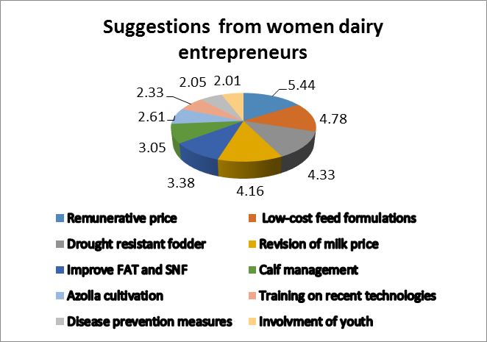
Fig:2 Suggestions of the women dairy entrepreneurs to improve the dairy enterprise
- CONCLUSION:
Indian agriculture sector is one of the major player in worldwide, demonstrated a consistent remarkable growth rate by promoting crop diversification and increased farmers’ income. Currently employs 46% of the workforce and contributes 18% to GDP and has become potential driver of job creation. In agriculture, dairy industry is the global leader by contributes 4% to Indian GDP with world’s largest cattle herd (Gamit et al., 2021). It provides a vital income source and nutritional security for millions of smallholders especially women. According to National Dairy Development Board (NDDB), women contribute 70 % of labor force in dairy sector by involving in different activities such as animal care, feeding, cleaning, milking processing and marketing of dairy products. However, the study relives women dairy entrepreneurs face technical challenges like low price of milk, poor animal feeding, lack of veterinary services, unavailability of green fodder, high cost of inputs, limited access to training regarding modern technologies and marketing information. These challenges hinder their progress and entrepreneurship qualities of women in dairy farming. Additionally, from dairy activities, women can support their families financially by invest in their children’s education and healthcare, and contribute to household expenses, the challenges hinder these activities. In village-level men dominates the membership of Dairy Cooperative Societies (DCS), but slowly the situation is shifting towards women due to their contribution. In support of this in 1995 Women's Dairy Cooperative Leadership Programme (WDCLP) was launched to augment the involvement of women in dairy cooperative societies, unions, and federations as an administrators, members and leaders. Proper technical, economic, financial, social and input support to women dairy entrepreneurs makes them economically self-sufficient, self-reliant and they can contribute indispensable and sustainable way to dairy development. Moreover, dairy industry provides steady income for the women entrepreneurs throughout the year, thereby women-led intervention and women-centric training, awareness programmes, workshops, developmental schemes can help to strengthen the entrepreneurship qualities among the dairy farm women.
Consent
As per international standards or university standards, Participants’ written consent has been collected and preserved by the author(s).

DISCLAIMER (ARTIFICIAL INTELLIGENCE)
Author(s) here by declared that NO generative AI technologies such as Large Language Models (ChatGBT, COPILOT etc) and text-to-image generations have been used during writing or editing of this man script.

- REFERENCES:
- Annu Kumari. (2023). Livestock Income in Rural Households in India: An Empirical Analysis. Indian Economic Service, www.ies.gov.in/pdfs/Annu-Kumari-Seminar-Paper.pdf
- Ashraf, P. and Shafeek, A. (2024). A preliminary analysis and estimation of the status of feed and fodder in Kerala. Heliyon, 10(10), e31200.
- Dohmwirth, C., & Liu, Z. (2020). Does cooperative membership matter for women’s empowerment? Evidence from South Indian dairy producers. J Dev Effectiveness,12(2),133-150.
- Food and Agricultural Organisation of the United States (2023), Dairy market review Emerging trends and outlook, Rome, pp:1-16.
- Gamit, V., Odedra, M., Ahlawat, A., Prajapati, V., Patel, H. & Gamit, K. (2021). Constraint faced by dairy farmers in different state of India: An overview. J Entomology Zoology Stud, 9(1), 1901-1906.
- Garrett, H., E. (1979). Statistics in Psychology and education. Vakils Feffer and Simons Ltd., Bombay, India.
- Kalamkar S. S., Sharma, H. & Makwana, M. (2020). Assessment of Livestock Feed and Fodder in Gujarat. Agro-Economic Research Centre, AERC REPORT 193.
- Manjusha & Jyoti (2016). Productive and reproductive performance of dairy animals in Karnal district of Haryana. Indian Veterinary Journal, 93(6), 38-40.
- Mariammal & Seetha Lakshmi. (2017) Constraints Faced by the Women Dairy Farmers and their Suggestions to Improve the Dairy Enterprise. Academy of Agriculture Journal, 2(7), 8-21.
- Meena, G., S., Dhaka, B., & Singh, B. & Meena, R., K. (2017). Effect of Azolla as Feed Supplement on Milk Yield in Buffaloes. International Journal of Current Microbiology and Applied Sciences, 6(12), 3490-3494.
- National Dairy Development Board. (2024). Annual Report, https://www.nddb.coop
- Panchbhai, G. J. (2017). Constraints faced by co-operative dairy farmers in adoption of recommended dairy management practices. International Journal of Current Microbiology and Applied Sciences, 6(3), 1962-1966.
- Paramashivaiah, P. & Puttaswamy. (2018) Determinants of Entrepreneurial Behaviour of Rural Women Farmers in Dairying: An Empirical Study. OIDA International Journal of Sustainable Development, 11(5),31-40, Available at SSRN: https://ssrn.com/abstract=3282756
- Patel, S. J., Kumar, R., Patel, A. S., Patel, N. R., & Parmar, V. N. (2017). Involvement of Farm Women in Decision making Regarding Dairy Farming in Junagadh District of Gujarat State. Indian Journal of Hill Farming, 30(1), 97–99.
- Rajpurohit, D., Sareen, N. (2022). Time Spent Pattern of Rural Men and Women on Selected Dairy Farming Practices in Bikaner District of Rajasthan, India International Journal of Agriculture Innovations and Research, 10(4), 2319-1473.
- Rathod, P.K., Landge, S., Nikam, T., R & Vajreshwari, S. (2011). Socio-personal profile and constraints of dairy farmers. Karnataka Journal of Agricultural Sciences, 24(4, 619-621.
- Shraddha, P., Sanjay, M., Akhil, K., J. & Hari, O., P. (2024), Women in Indian dairy farming business: Significance, challenges, and way forward. International journal of veterinary sciences and animal husbandry, 9(1), 701-708.
- Swoboda, P. (1984). Schumpeter’s Entrepreneur in Modem Economic Theory. In: Seidl, C. (eds) Lectures on Schumpeterian Economics. Springer, Berlin, Heidelberg. https://doi.org/10.1007/978-3-642-69656-5_2
- Vinaya Kumar H., M., Chauhan, N., B., Patel, D., D. & Patel, J., B. (2019) Predictive factors to avoid farming as a livelihood. Economic Structures, 8. 10.1186/s40008-019-0141-7

