Review Article

Overview of Food Adulteration: Its Definition, Causes, impacts, and Detection

Abstract
A tampered food, Food is any substance made up of carbohydrates, water, fats, and proteins that is consumed by humans and other animals to survive. It holds great significance for us. Nonetheless, it is not uncommon for food products to be tampered with, and dangerous situations can arise from poorly managed supply chains that handle perishable goods. Economic Customers who purchase and serve food are impacted in numerous ways; they might not receive the nutrients they are supposed to, contaminated food may be harmful to their health, and they might also suffer financial losses. So, every responsible individual, organization, and government should complete their role to protect the act of food adulteration and to reveal the recognized acts. Furthermore, there are numerous gaps in the literature that need to be filled by academics and researchers working in various research institutes. These gaps include the assessment of the situation, the identification of foods that are vulnerable to adulteration in the national context, the development and validation of detection methods, and much more. adulteration has long plagued the food business, negatively impacting both food quality and public health. The process of altering food by adding undesirable or dangerous components lowers its safety and quality, a practice known as food adulteration. Inadequate handling of this issue has led to the production of contaminated and dangerous food products, which has raised concerns throughout history. Food adulteration can harm our health and often does so without our knowledge. By addressing these issues, we may proactively work to create a better society. Food adulteration can involve adding, taking away, or replacing expensive food ingredients with less expensive (cheaper) ones in order to get unfair financial advantage. The manufacturer may profit financially from this act of food fraud, but the eventual consumers of the goods suffer losses. A variety of approaches, such as physical, chemical, biological, and other methods, are used to detect food adulteration. However, detecting adulterants can be hard when the adulterants closely mirror the food’s physiochemical properties. The right of consumers to safe and high-quality food is undermined by adulteration, hence it is imperative that people, groups, and governments take action to stop these practices.
Keywords
Adulteration, Fraud, Intention, Incidental, Replacement, Substitution
Introduction
Food is material of either plant or animal origin that, in its raw, processed, or semi- processed form, is consumed to support the body’s biochemical and physiological activities. However, these foods are often susceptible to fraud and adulteration, which can lead to health issues for consumers. Food fraud involves the deliberate substitution, addition, tampering, or misrepresentation of food, food ingredients, or food packaging, as well as making false or misleading statements about a product for economic gain. A specific type of food fraud includes the fraudulent addition of fake substances or the removal or replacement of genuine substances without the purchaser’s knowledge, primarily for the seller’s economic benefit. Even if historically people cooked and consumed meals containing health risks and occurrences at home, a growing number of people in current times regularly eat ready-to-eat meals at restaurants due to changes in lifestyle and increased money [1].
Instead of offering a filling, nutritious meal, the cuisine in many of these establishments may have been prepared with subpar ingredients, but it nevertheless manages to draw in customers and please their palates. However, as the aforementioned writers suggest, the majority of individuals are typically unaware that these items are contaminated to a degree of 25 to 30 percent. This has a significant negative impact on these customers' health.
Within the food supply chain, food quality and safety, along with the variables influencing them, are key growing topics that have drawn attention from researchers, government and regulatory bodies [2]. Among these various cutting-edge scientific fields is food adulteration. One can interpret the term "adulteration" in a variety of ways, such as removing certain valuable ingredients from a particular food product or mixing or substituting inferior components with superior ones [3]. When a food product doesn't fulfil federal or state requirements, it's referred to as adulterated in legal terminology.
Adulteration can also occur accidentally or purposely through the inclusion of a non-food item to increase the amount of food in its raw or prepared state, for preservation, or to improve its look. Added to the list are any harmful or toxic ingredients that could make the dish unhealthy.
Examples include adding water to milk, adding animal carcasses to meat items that aren't intended for human consumption, or adding stones, gravel, sand, insects, or animal hairs to grain goods. Thus, one definition of food adulteration is the deliberate lowering of the standard of food that is being sold. Customers are invariably either victims of fraud at the very least or become ill as a result of food adulteration and ultimately perish. Consequently, it is crucial for consumers to understand common food categories that are contaminated, prevalent adulterants, and the health effects of the various adulterants [4].
In addition, adulterants can be defined as chemicals that belong outside of a particular food or drink but are purposefully added to more costly ingredients to lower manufacturing costs and increase visible quantities, among other dishonest or malicious intentions [4]. Because there were insufficient or no official oversight mechanisms in place, adulteration was more prevalent in societies dating back to very early times when there were little legal restrictions on food quality. At times, adulteration can even involve the use of extremely harmful substances and toxins.
Moreover, adulterants are substances that are not intended for use in a specific food or beverage but are knowingly added to more expensive ingredients in order to reduce production costs and boost visible quantities, among other nefarious or malicious purposes [4]. Toxins and other exceedingly dangerous compounds may occasionally be used in adulteration.
According to a recent article [5], the People's Republic of China (PRC) was the centre of a major public issue around melamine milk, which led to numerous child fatalities and injuries to thousands more. This literature analysis on the subject is crucial since it will help identify research gaps and provide a simple way to understand what has been identified and done thus far in the field. In order to make this review paper a focus point for future research, it was created by analysing several adulteration-related sources and adding potential prospective lines of inquiry.

History of Adulteration
In nations where there are little legal restrictions on food quality, adulterants have long been used, leading to inadequate or non-existent government oversight. In the prehistoric era, people changed the condition of food to increase its shelf life or enhance its flavour [7]. This author claims that early humans utilized fire to preserve and prepare meat as early as 300,000 years ago. Salt was later shown to be an effective way to preserve meat without cooking. Ancient Roman and Greek wine was often sweetened and preserved with a mixture of honey, herbs, spices, chalk, or even lead or saltwater. With time, food adulteration for financial gain became more common. The German scientist Frederick Accum examined adulteration use for the first time in 1820 after finding numerous hazardous metal colonisations in drink and Ford. His efforts caused resentment among food suppliers, and a scandal surrounding his purported disfigurement of the book "The Royal Institution Library" finally led to his downfall.
Early in 1850, the physician-author Hill Hossal carried out in-depth research that was published in the Lancet. This research resulted in the 1860 Food Adulteration Act and other legislation (Ghimire, 2016).

Why food adulteration?
Adulteration has long existed in society, but because of its low impact and limited use, it went unnoticed. However, economic adulteration is currently a persistent issue that has the greatest impact on the food industry.
In one survey, adulteration was found in milk to the extent of 70% with water, 43% with chalk powder, 100% with artificial colouring, 70% with turmeric powder, 37% with chalk powder, etc. According to Afzal et al. (2011), adulteration is primarily drawn to places where the goal is to increase financial income through volume. Although certain self-centred producers, processors, and retailers started adulterating items to increase their profit margins, dishonesty and a lack of inadvertent quality checks on suspected products are the main causes of adulteration [9]. Given the frightening rate at which the world's population is expanding, food is frequently tampered with in order to feed the vast majority of people.
Outsourcing to overseas producers is a catalyst for further fraud and adulteration of goods and services [10]. Due to the relatively low cost of labour in some nations, outsourcing has become possible. This also makes it simple to fake products because the cost of production is much lower than the extraordinary profits that are produced [11]. Because globalization typically facilitates the flow of capital and know-how to new markets, Cofie (2012) contends that counterfeiting benefits from the process as a whole. People in Bangladesh were motivated to adulterate petrol due to the high cost [6], in order to profit excessively from the adulteration. Narayan (2014) states that the following six factors typically lead to food and drink adulteration. They are as follows:
1. In a situation when market demand exceeds supply;
2. To match competitors in the market by reducing manufacturing costs;
3. The need for ever-higher profit margins;
4. The average person cannot buy food items that include all of their original ingredients;
5. A shortage of skilled workers using antiquated food processing methods; and
6. A lack of awareness regarding disease outbreaks brought on by contaminated food goods.

Types of Food Adulteration
Adulteration has been characterized in literature [14] as the debasing of a product with the intention of impersonating a pure or authentic commodity or of exchanging a subpar item for a superior one in order to make an unlawful profit. The writers also provide a list of four methods of adulteration [14]. They are as follows:
- extraneous matter addition, such as adding water to milk or sand to cereal grains;
- combining low-quality with high-quality materials;
- for instance, combining fresh and used tea leaves
using preservatives and dyes that are forbidden, such as colouring spices;
- removal of desirable components, such as the fat from milk or the oils from spices.
Although there are various ways to adulterate food, there are essentially two kinds of adulterants. There are intentional/deliberately/knowingly and unintentional/unknowingly/incidental adulterations [15].

- Intentional adulteration
When a food item is purposefully tainted, it is referred to as intentional adulteration. It is the addition of subpar ingredients with characteristics resembling those of the dishes to which they are introduced. As such, it is challenging to find them. The adulterant may be biological or physical in origin. In order to increase their profit margin, various chemicals such as urea and melamine are used to lower the level of essential nutrients. Additionally, materials like starch, flour, cane sugar, vegetable oils, water, skim milk, sand, chalk powder, molasses, stone, brick powder, ergot, chicory, roasted barley powder, ground papaya seeds, etc. are added to various food items [15]. The most hazardous type of adulteration is when food products are adulterated by adding foreign chemicals and removing nutrients. This is done by business-oriented individuals who have forgotten about humanity in favour of a profit-making mindset [16].
Based on data from the first U.S. public database established to gather information on risk factors for food fraud, [17] states that the seven foods most likely to be the focus of intentional or economically motivated food fraud are olive oil, milk, honey, saffron, orange juice, coffee, and apple juice. The following substances can be considered adulterants if they are not properly disclosed: cheap green colours that contain chemicals like metallic lead applied to bitter gourd and leafy vegetables to give them a fresh colour; excessive use of pesticides and herbicides to grow fruits and vegetables; calcium carbide used in mangoes and bananas; copper sulphate used to ripen fruits faster; oxytocin, a hormone used for faster growth of Pumpkin, watermelon, gourds, cucumber; and wax used to add shine on apples and pears.

- Incidental Adulteration
Lack of facilities to preserve food quality or ignorance led to unintentional (incidental) adulteration. Adulteration results from inadequate hygienic conditions for food and beverages from the production site to the dining area. Pesticide residues, rodent droppings, food containing larvae, etc. are examples of accidental adulterants.
Accidental metallic contamination with lead, arsenic, and mercury can also happen. Unintentional adulterants can also include vermin like mice and insects that heavily infiltrate food, causing impurities including excrement, body fluids, and microbial deterioration. According to Pandit et al. (2002), pesticides, D.D.T., and residues found on plant products are the most often occurring unintentional adulterants.
The 3-ppm maximum allowable limit for D.D.T. is occasionally exceeded (Kannan et al., 1997) [19].
Various foods and the adulterants they contain
There is some degree of adulteration in almost every food item, including grains, vegetables, and milk. Due to inadequate cleaning, some adulterants infiltrate through agricultural pathways. These are obvious adulterants, such as dirt, sand, stones, and leaves, to mention a few. It is less dangerous because the buyer can clean them. Intentionally inserted adulterants are either invisible or cleverly disguised with a different hue or texture to make themselves appear undetectable. They are typically unhealthy, and the majority of them cause major health issues like cancer. According to Alauddin (2012), almost 90% of loose, unbranded kinds of animal feed, including cake used as a protein supplement for breastfeeding animals, are contaminated [20].

Table 1. Table of Various foods and the adulterants they contain
Food and beverage products | Extraneous/adulterant substances | Objective | Type of Adulteration
Ghee | Oleomargarine, anatta, and ghee Vanaspati | To create additional yellow | Conscientious
Milk | Water, skim milk | To boost the volume | Conscientious
Sweetened condensed milk | Paneer and Khoya | To provide rich textural | Conscientious
Butter | vegetable oil, and oleomargarine | to boost output and create a yellowish | Conscientious
Ice cream | Wheat flour, rice powder, or starch | To make cream thicker | Conscientious
Tea leaves | Gram dal husk with color, black/Bengal | To purposefully add color | Conscientious
Red wine | Bilberry juice using lead acetate | to draw in or create a vivid blue precipitate | Conscientious
Mustard grease | Papaya seed | to increase weight and bulk | Conscientious
black pepper | Papaya seed | To increase size | Conscientious
Peas and green chilies | Malachite green | To impart a vivid, luminous green hue | Conscientious
powdered chilies | powdered brick | To put on more weight | Conscientious
Sugar | chalk powder | To raise the quantity | Conscientious
Oils | oxidized oil | To boost the volume | Conscientious
coriander powder | Powdered cow dung | To raise the quantity | Conscientious
Typical salt | White powdered stone, chalk | To raise the quantity | Intentionally
Coffee | Tamarind seeds, roasted barley powder, and chicory | to incorporate color and mass | Intentionally
Honey | to incorporate color and mass | to boost volume | Intentionally
Wheat | Ergot (poisonous fungus) | To increase weight | Intentionally
jiggery powder | chalk residue | to gain weight | Intentionally
more, such as preservatives, etc. | formalin, etc. | to lengthen the shelf life | unIntentionally

- Metallic contamination
Foods may include trace amounts of metallic pollutants, which can enter the food supply chain through environmental pollution or food production processes [21]. Some metallic pollutants that may be regarded as an additional incidental form of adulterants in food are arsenic from pesticides, lead from water, wastewater from chemical companies, and tin from cans [22]. Lead in water, mercury from wastewater, and other comparable pollutants are also included in the category of metallic contaminants that are adulterated [21].

- Natural adulteration
Another type of adulteration that can occur in food is called natural adulteration. This occurs when various chemicals, organic compounds, or radicals that are harmful to health are naturally present in food and are not added, either purposefully or accidentally, to the food [23]. Among the various natural adulterations are poisonous pulse variants, mushrooms, green and other vegetables, fish, and seafood—which in certain situations may even be considered anti-nutrients.
It is recognized that many marine fish species have poisonous variations, even though many of them are edible.

- Adulteration in organic food
If the food is labelled as organic, it must be produced and farmed in accordance with the regulations of the nation in which it is marketed. Synthetic pesticides are not used in the environment when farming is organic. The most widely used insecticides, which most organic standards permit limited usage of, include rotenone, Bt, and pyrethrum. As a result, food that is labelled as organic but does not meet the requirements is contaminated [23].

- Adulteration during irradiating the food
Ionizing radiation, such as radionuclide Cobalt-60, is applied to food during food irradiation in order to inhibit sprouting, postpone ripening, and enhance rehydration in addition to eliminating and preventing the growth of any bacteria, viruses, or insects that may be present in the food [23]. When it comes to food irradiation, dose quantity is crucial. Ionizing radiation causes DNA cleavage, changes to a cell's internal metabolism, and the production of free radicals. Chemical connections may be broken, resistant microbes may emerge, insufficient analytical techniques to identify radiation in food, and public opposition may arise during the process. It is clear that this radiation can be overdosed if it is utilized at a level where it
The names of the foods won't be severing health hazards.

- Adulteration during production of Genetically Modified food
Organisms classified as genetically modified (GMO) are those whose genetic material (DNA) has undergone modifications not found in naturally occurring organisms. It's frequently referred to as gene technology or contemporary technology. Genetic alteration occurs when genes from different organisms are combined. Medication, vaccinations, food and food additives, feeds, and fibers are among the genetically modified items. While the development and marketing of genetically modified foods is motivated by perceived benefits for both the producer and the consumer, there are safety concerns as well, such as the potential for allergies and the transmission of antibiotic resistance markers. Therefore, genetically modified food may be one type of adulteration if users are not informed [23].

Food adulteration and its consequences
- Health problem related to adulteration
Foods that have been tampered with can cause a variety of health issues after eating and are one of the main issues of daily living [23]. For instance, adding argemone seeds to mustard can result in cardiac problems and blindness.
As [24] concluded, adulterations expose society to a wide range of illnesses, from minor to fatal. For instance, eating seafood, fruits, meat, or milk tainted with formalin can lead to asthma, skin conditions, and cancer. Food adulteration can occasionally have immediate negative effects on human health, such as diarrhoea, dysentery, and vomiting. For instance, using tamarind or date seed powder in place of coffee powder can result in diarrhoea [17]. As per [23], a portion of the leafy green veggies available in Chennai is discovered to have hazardous metals that can cause injury to several body parts. It is prevalent in nearly every emerging nation. Their hideous visages manifest as detrimental consequences such as gastrointestinal issues, respiratory disorders, cardiac arrest, glaucoma, paralysis, diarrhoea, giddiness, diarrhoea, liver illness, dropsy, and so on. Thus, it is clear from this analysis that health concerns associated with food adulteration include food poisoning, indigestion, diarrhoea, loose stools, cough, fever, vomiting, or nausea, aphthae in the mouth, infections resulting from contaminated food, and etc.

- Economic impact of adulteration

Adulterant is rampant in poor strata of society due to consumer’s illiteracy and ignorance of their rights and responsibilities towards food adulteration [25]. High incidence of food borne illness is found in families who consume adulterated food. Thus, adulterated foods may be illegal profit for those who are adulterating while it is not only expense of money for consumer but also leads to illness as well. With time, acceptance of foods in the any types of market could decrease due to destruction in originality of adulterated foods and this in turn is economic loss [26].

Table 2. Table for Instances of adulterants' purposes and negative effects.
Adulterants | Purpose | Harmful effects
Water | To make more milk | Water contaminated with hazardous chemicals, germs, and excrement can be dangerous for human health and increase the risk of contracting water-borne illnesses.
cellulose | to raise the overall solids and, in turn, the product quantity. | Food tainted with these goods has a lower digestibility and is less nutritious than the original.
Protein | Affordable non-dairy proteins including those from soy, peas, and wheat | It is not what is paid for and will not yield the anticipated protein.
Boric acid | Stable preservative used | cause acute circulatory system failure, nausea, vomiting, diarrhea, kidney damage, and possibly death.

Only a few instances of adulterants, their intended usage in milk, and any resulting effects on nutrition or health are listed in the above table. But as is the case with other food items, there are various kinds of adulterants in milk in addition to these particular ones.

Food products prone to adulteration
Numerous food items and drinks have been found to be susceptible to adulteration, as reported by numerous writers worldwide. This implies that obtaining dietary items free of adulterants, such as flour, pulses, oil, fruit, vegetables, milk, sweets, spices, tea, coffee, honey, baked goods, chocolate, fruit juice, and the like, may be challenging. Around 90% of unbranded loose forms of animal feed, including cake, which is intended as a protein supplement for nursing animals, are found to be contaminated, according to published research [1].

Impacts of adulteration
Due to inadequate handling brought on by adulteration issues, food items utilized in our daily lives are unsafe to eat and unclean (Asrat et al., 2012). Food adulteration has grown to be one of the major issues in recent decades, and eating food that has been tainted can lead to major illnesses like cancer, ulcers, diarrhoea, and asthma. Generally speaking, food adulteration has a very negative effect on farmers, producers, manufacturers, processors, consumers, and the government.

Detection mechanism of adulterated food
The methods used to detect the presence of adulterants in food products include physical, chemical, biological, and other approaches. The early organoleptic test and other empirical tests have been replaced by all these procedures, which are constantly updated due to the endless nature of food adulteration and the constant emergence of new issues. Most adulteration cases use a variety of analytical techniques, giving the analyst the freedom to select the best one based on factors like the quantity of samples to be examined and the level of sensitivity needed. For instance, lead acetate precipitated in a vivid blue colour when red wine tainted with bilberry or elderberry juice [17]. The authors also state that starch, which is frequently added to cream to thicken it, can be identified by the blue colour that a diluted iodine test solution in aqueous potassium iodide produces.

- Chemical and bio chemical methods
Adulterant detection can be accomplished by a variety of designed chemical and biological techniques, which fall into three main categories: chromatography-based, spectroscopy and
immunology-based, and electrophoresis-based [24]. These authors state that the fundamental analytical procedure consists of several processes, such as extraction using an appropriate solvent, cleanup to get rid of any matrix components that are interfering, chromatographic separation, and selective detection.
You can use these and other techniques to detect adulterants by following the guidelines provided by each technique. Because HPLC can separate different chemical ingredients from mixtures, it can be utilized as a quality control technique. It can also be used to detect adulteration or characterize food goods [24]. That is to say, its ability to separate mixtures of chemicals makes it useful for adulterant identification.
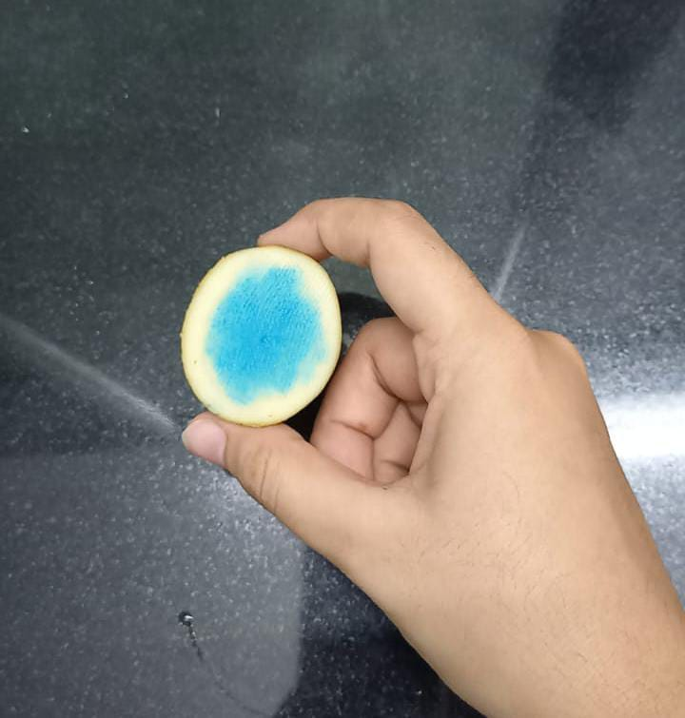
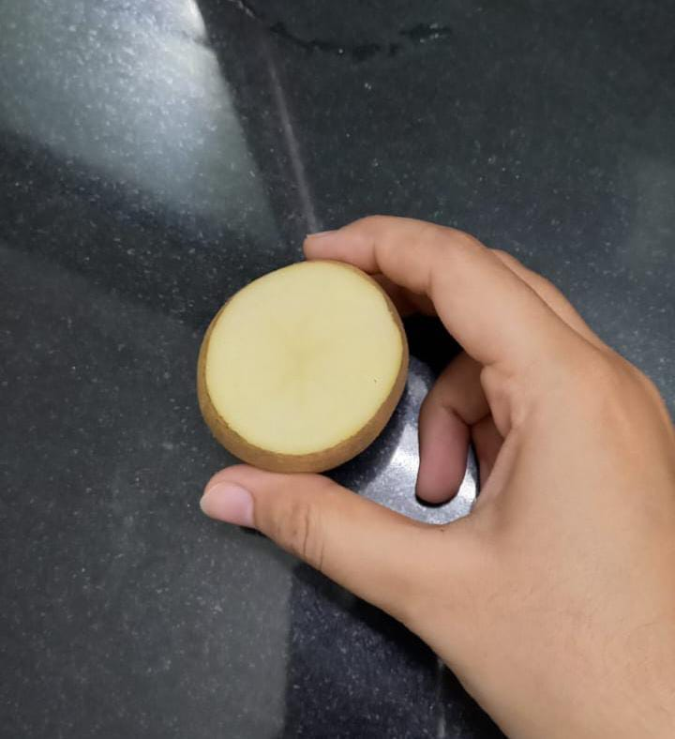

Figure 1: Way to differentiate iodized and common salt

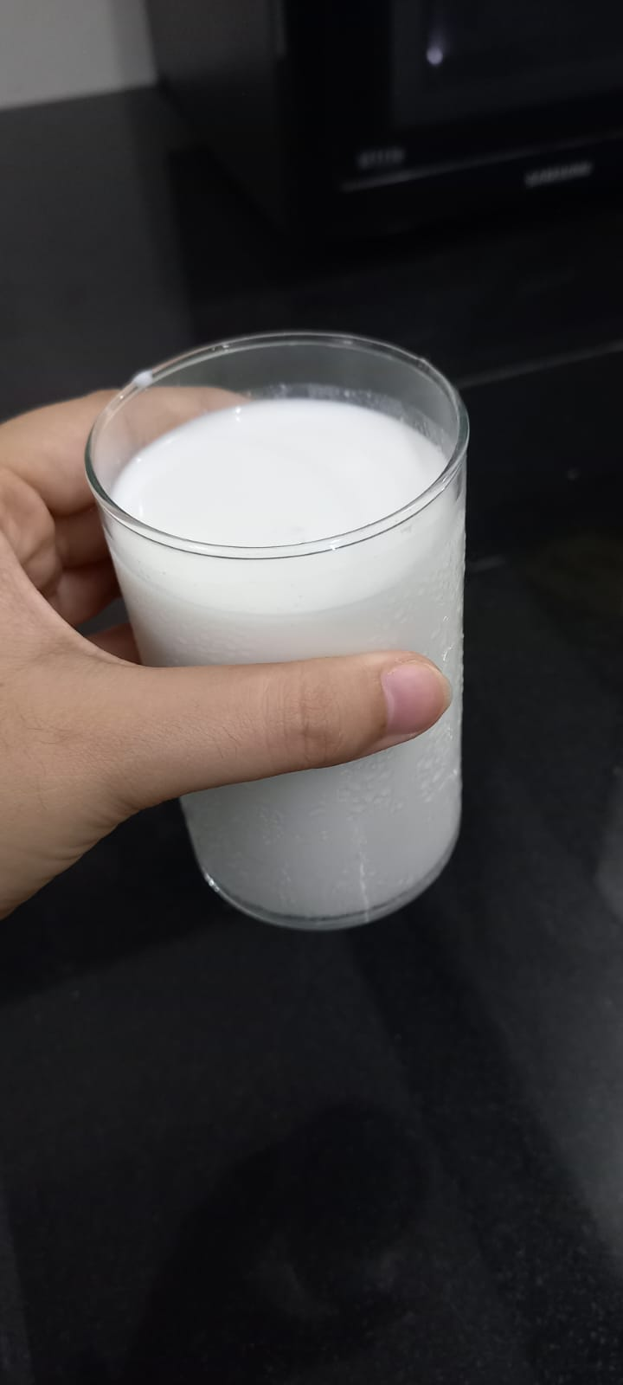
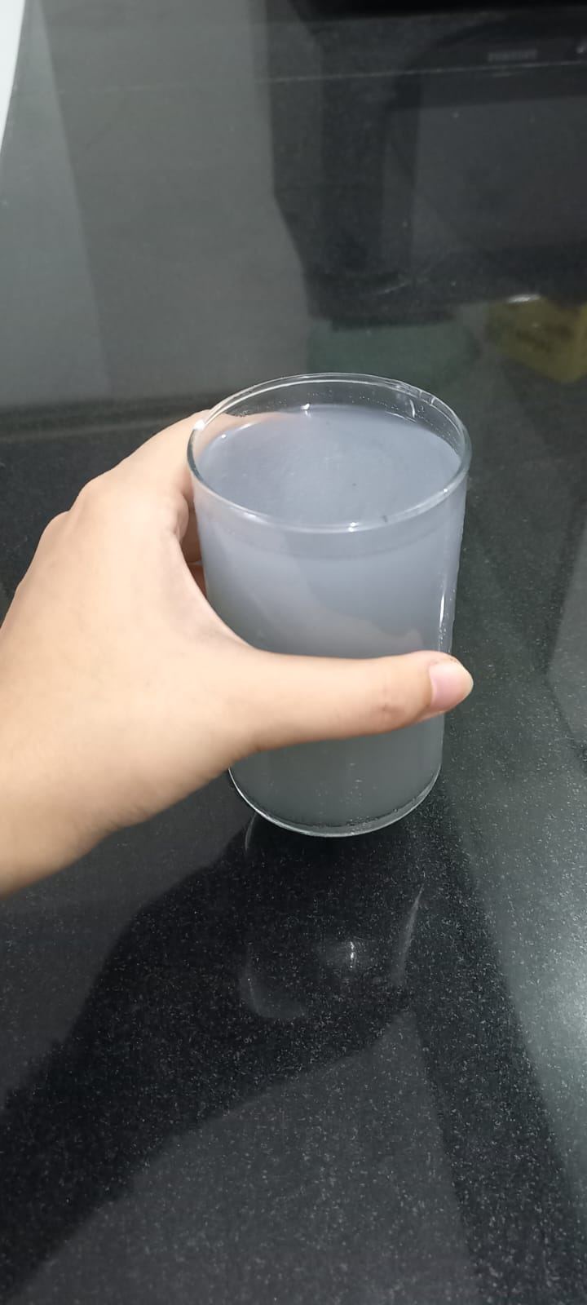
Figure 2; Milk adulteration detection by starch test.

Table 3: Identifies common food adulterants and provides easy-to-follow identification guidelines:
Food products | Adulterants | Detection methods
Mustard | Argemone seeds | The inside of argemone seeds is white upon pressing and has a rough surface. Inside, mustard is yellow.
Ice cream | Washing powder | Add some lemon juice; if there is washing powder, bubbles will appear.
Honey | Water | A matchstick lighted cotton wick dipped in pure honey burns. When there is water present, the honey won't burn and will crack instead of burning.
Red chilli powder | Brick powder,  Red colour dye | While powder settles slowly in water, brick powder settles quickly in chili.  Add a small amount of chilli powder to the water's surface in a glass beaker. The coloured streaks will be artificial colorants.
Using analytical techniques inherited from physical analysis, the other method examines the entire sample to demonstrate how the adulteration affected the sample's physicochemical properties.
As explained below, the various detection techniques can be divided into two categories: physical and chemical procedures. A table including examples of analytical techniques for adulteration detection may be found below.

Table 4: Analytical techniques for finding things.
Products | Common adulterants | Common detection methods
Berry jam | addition of less expensive fruit | HPLC
Fruit juice | Distillation using water | Degree brix
Meat | addition of less expensive meat | Immunoassay and electrophoresis
Vegetable oil | Addition of cheaper seed oil | Mass spectroscopy and chromatography
Natural aroma | Non-natural aroma | Chiral chromatography
Natural vanilla extract | Artificial vanilla added | IRMS and SNF-NMR
Soyabean | Genetic modification | DNA methods

- Physical Methods
Numerous physical techniques, such as microscopic and macroscopic visual structural analysis and food analysis through physical parameter analysis such as bulk density, texture, solubility, and morphology, have been developed for the purpose of detecting adulteration; however, they do not ensure quantitative adulterant detection [24]. For example, the presence of extraneous starch in powdered spices such as cumin, coriander, chiles, and cloves can be easily detected through microscopic analysis [5].
Since pure food grains won't contain any of these impurities, it is possible to detect adulteration in grain by taking a small sample, placing it in a glass plate, and visually examining the impurities (dust, stones, straw, weed seeds, damaged grain, weevil grain, insects, rodent hair and excreta, and so on).
- Sensory Methods
Sensory techniques have historically been used to identify some adulteration. Legislation for the detection of food adulteration has not yet included sensory approaches, despite the fact that regular sample analysis always involves analysing the sample's organoleptic properties.
International organizations that have developed and endorsed sensory procedures for foods in general and specific commodities include the American Society for Testing Materials (ASTM), the International Standards Organization (ISO), and others [27].
These techniques are helpful in resource management and trade (goods grading, for example). Furthermore, the results of sensory panel tests have been acknowledged by the US Food and Drug Administration (FDA) as prima facie proof of product efficacy, and in certain instances, sensory evaluation data has been the only basis for legal decisions made in the USA.
Subjectivity of judgment and the use of multivariate statistical approaches, but with less restrictions, are the difficulties associated with the application of sensory methods for the detection of adulteration ([27] and [28]).
These techniques improve the evaluation of sensory input and enable the drawing of more trustworthy judgments. For instance, the Generalized Procrustes approach can be used to examine the outcomes of Free-choice Profiling tests. The latter then modifies the data to combine terms that seem to measure the same attributes after accounting for various sorts of heterogeneity in how each panellist defines samples. This method has been usefully used to categorize alcoholic beverages, tea, and coffee [27].
Summary and Conclusion
Food fraud refers to the intentional addition, substitution, tampering, or misrepresentation of food, food ingredients, or food packaging, as well as the making of false or deceptive claims about a product in order to profit financially. Various authors have highlighted that almost every food category, such as milk, honey, butter, oil, grains, pulses, and so on, is susceptible to adulteration. The tainted meals are produced in a way that draws customers and allows for greater pricing to be obtained. The problem is that these foods might be tampered with to make them seem more appetizing. Numerous economic and public health ramifications result from these adulterations.
There are several ways to identify adulteration, ranging from sensory techniques to chemical and analytical examination. Various stakeholders need to pay attention to the control of food adulteration.
If we are unaware of it, food adulteration might have a significant negative impact on our health. A few proactive measures on the part of our society can stop it. The government ought to monitor increases in food prices. Food should not be purchased from establishments that do not uphold adequate hygienic standards. Government agencies ought to inspect food stores, including national chains and local ones. We can ensure that the next generation has a healthy and risk-free future if we actively contribute to these reforms.

Disclaimer (Artificial intelligence)
Author(s) hereby declares that NO generative AI technologies such as Large Language Models (ChatGPT, COPILOT, etc.) and text-to-image generators have been used during the writing or editing of this manuscript.

References:
[1] Alauddin S, 2012. Food adulteration and society. Global research analysis international. Vol. 1 (7), pp 3-5.
[2] Ayalew, H., Birhanu, A. and Asrade, B. 2013. Review on food safety system: Ethiopian perspective. Afr. J. Food Sci. 7 (12): 431-440.
[3] Matute, A. I., Soria, A. C., Martínez-Castro, I. and Sanz, M. L., 2007. A new methodology based on GC− MS to detect honey adulteration with commercial syrups. Journal of agricultural and food chemistry, 55 (18), pp. 7264-7269.
[4] Ehsan M, Rahman M, Saadi H. Effect of Fuel Adulteration on Engine Crankcase Dilution. Journal of Mechanical Engineering. 2010; 41(2).
[5] Food safety & standards authority of india (FSSAI), 2010 (ministry of health & family welfare) fda bhavan, kotla road, new delhi – 110 002 website: www.fssai.gov.in
[6] Lakshmi, V., 2012. Food adulteration. International Journal of Science Inventions Today, 1 (2), ppt. 106-113.
[7] Manasha, M. Janani, 2016. Food adulteration and its problems (intentional, accidental and natural food adulteration). International Journal of Research in Finance & Marketing 6 (4): 131-140
[8] Afzal A, Mahmood MS, Hussain L, Akhtar, Masood. Adulteration and Microbiological Quality of Milk (A Review). Pak J Nutrit. 2011; 10(12):1195.
[9] Asrat A, Zelalem Y. Patterns of milk and milk products adulteration in Boditti town and its surrounding, South Ethiopia. Scholarly J Agric. Sci. 2014; 4(10):512-516.
[10] Hamburg MA. Food and Drug Partnership for Safe Medicines Interchange, 2010. http://www.fda.gov/downloads/Drugs/ResourcesForYou/ Consumers/BuyingUsingMedicineSafely/Cou nterfeitMedicine/UCM235240.pdf.
[11] Sicpa. Injury or Death from Fake Drugs, Expired Drugs, Adulterated Drugs, Mislabelled Drugs and Unauthorized Medicinal Products - NGP Pharmaceuticals; GDS Publishing, 2012.
[12] Cofie CA. The Impact of Illicit Trade and Counterfeit Goods on National Development, 27th June, 2012.
[13] Narayan D. Food Adulteration: Types, worldwide laws and futures. Health care, 2014. http://www.biotecharticles.com/Healthcare-Article/Food Adulteration-Types-Worldwide-LawsFuture-3165.html.
[14] Biresaw, A. D., Woldemariam, H. W. and Abera, B. D., 2015. The Extent of Adulteration of Selected Foods at Bahir Dar, Ethiopia.
[15] El-Loly MM, Mansour AIA, Ramadan RO. Evaluation of Raw Milk for Common Commercial Additives and Heat Treatments. International Journal of Food Safety. 2013; 15:7-10.
[16] Awasthi S, Jain K, Das A, Alam R, Surti G, Kishan N. Analysis of Food quality and Food Adulterants from Different Departmental & Local Grocery Stores by Qualitative Analysis for Food Safety. IOSRJESTFT. 2014; 8(2):22-26.
[17] Laura Schumm, 2014 Food Fraud: A Brief History of the Adulteration of Food
[18] Pandit GG, Sharma S, Srivastava PK, Sahu SK. Persistent organochlorine pesticide residues in milk and dairy products in India. Food Additives and Contaminants. 2002; 19(2):153-157.
[19] Kannan K, Tanabe S, Gisey JP, Tasukawa R. Organochlorine pesticides and polychlorinated biphenyls in foodstuffs from Asian and Oceanic countries. Rev. Environ. Contamin. Toxicology. 1997; 152:1-55.
[20] Alauddin S. Food adulteration and society. Global research analysis International. 2012; 1(7):3-5.
[21] Deepti Narayan, 2014, Food adulteration-Types, worldwide lows and future Category: Healthcare Views: 20277
[22] World Health Organization, 2017. Ten chemicals of major public health concern. Available from URL: http://www.who.int/ipcs/assessment/public_health/chemicals_ phc/en/
[23] Mansuri, Z. 2011. Study of adulterants in foods. Delhi, India.
[24] Bansal, S., Apoorva, S., Manisha, M., Anupam, K M. and Sanjiv, K., 2015. Food Adulteration: Sources, Health Risks and Detection Methods. Critical Reviews in Food Science and Nutrition, DOI: 10.1080/10408398.2014.967834
[25] Kohda, Y. and Haque, I., 2017. Knowledge and Perception about Food Adulteration Problem among School Children in BangladeshIffat Haque. European Journal of Public Health, 27 (suppl_3).
[26] Asrat, A. and Ermias, B., E., 2015. Food Adulteration: Its Challenges and Impacts. Food Science and Quality Management, pp. 50-56.
[27] Vasireddi, 2013. Food Adulteration & Control Mechanism; At the Workshop on Food Defense Awareness for Food Business Operators and Exporters February 5, 2013 – Hyderabad
[28] Fiorino, G. M., Garino, C., Arlorio, M., Logrieco, A. F., Losito, I. and Monaci, L., 2018. Overview on untargeted methods to combat food frauds: a focus on fishery products. Journal of food quality, 2018.

