Original Research Article
IN VITRO ANTIVIRAL ACTIVITY OF THE AQUEOUS EXTRACT AND ESSENTIAL OIL OF OCIMUM GRATISSIMUM L. LEAVES AGAINST THE WEST NILE VIRUS

ABSTRACT

Aims: The emergence of viral infections highlights the urgent need to develop new antiviral molecules. This study is part of an effort to explore the antiviral properties of medicinal plants used in traditional pharmacopoeia in Côte d'Ivoire. The main objective was to evaluate the antiviral activity of the essential oil and aqueous extract of Ocimum gratissimum leaves against the West Nile virus.
Study design: An in vitro experimental study carried out to evaluate the cytotoxicity and antiviral activity of the essential oil and aqueous extract of Ocimum gratissimum leaves against West Nile virus using Vero cell cultures.
Place and Duration of Study: The study was conducted at the Epidemic Viruses Department of Institut Pasteur de Côte d’Ivoire and at the Biochemical Pharmacodynamics Unit of Félix Houphouet Boigny University over a period of six months.
Methodology: After determining the safety of the different dilutions of the extracts by a cytotoxicity test on Vero cells, we used non-toxic concentrations of the essential oil and aqueous extract of Ocimum gratissimum to perform tests to inhibit the replication of the West Nile virus.
Results: The cytotoxicity study showed that the essential oil has lower toxicity than the aqueous extract, with respective CC₅₀ values of 500 µg/ml and 250 µg/ml. Ocimum gratissimum essential oil inhibited the growth of West Nile virus, with a minimum inhibitory concentration of 250 μg/ml, while the aqueous extract showed no antiviral effect.
Conclusion: Thus, Ocimum gratissimum essential oil has shown promising antiviral activity against the West Nile virus, probably due to the phytochemical compounds it contains.

Keywords: Ocimum gratissimum, antiviral activity, West Nile virus, Côte d’Ivoire

1. INTRODUCTION

Medicinal plants are the most widely used remedy, especially in rural areas, for treating public health problems. In some Asian and African countries, 80% of the population relies on traditional medicine for primary health care (Nations Unies, 2010). According to the National Programme for the Promotion of Traditional Medicine in Côte d'Ivoire, nearly 1,500 species of medicinal plants used in traditional medicine and for patient care have been identified to date by Ivorian researchers (WHO, 2021).
Furthermore, despite advances in research, viral diseases remain a cause for concern today. However, immunisation and prophylaxis are not sufficient to control all pathogenic viruses. Microorganisms such as bacteria and viruses have developed increased resistance to available antibiotics and antivirals, leading to treatment failures (Opatowski, 2020). The West Nile virus (WNV) is currently considered the most widespread flavivirus after dengue fever. In humans, WNV infections are asymptomatic in 80% of cases, and when symptomatic, they most often manifest as a flu-like syndrome. Neurological complications (meningitis, encephalitis) occur in less than 1% of cases (Medicine of voyages, 2020). Plants synthesize a wide variety of bioactive molecules designed to protect them from predators and infectious agents. However, these same compounds are exploited by humans for medicinal purposes (Talambedu et al., 2014). Ocimum gratissimum L. (Lamiaceae), commonly known as fever leaf, is a species that has been domesticated because it is widely used in traditional medicine to treat coughs, colds, dysentery, etc. (WHO, 2021). It is found in all regions of Côte d'Ivoire. Ethnobotanical surveys, biochemical analyses and field trials conducted as part of the GlobalHort Project have revealed some of the nutritional, medicinal and agronomic values of this plant (Assogba et al., 2015). Essential oils and extracts from Ocimum species contain compounds involved in antiviral activity (Dorothée et al., 2020). Numerous similar studies, such as the work of Lai, have shown that Ocimum gratissimum (Ocimum g.) has antiviral activity against herpes simplex virus 1 and 2 (Lai, 2012). It is in this context that this study was conducted, with the aim of highlighting the importance of phytomedicine against WNV infections. The main objective was to evaluate the antiviral activity of the aqueous extract and essential oil of Ocimum g. leaves.

2. material and methods

2.1 Obtaining plant powder

The plant material used in this study consists of Ocimum g. leaves collected on 13 January 2024 in Anyama, a town in the Agnéby-Tiassa region, located in southern Côte d'Ivoire. The plant was first identified at the National Centre for Floristics at Félix Houphouët-Boigny University, where a herbarium sample was deposited. The Ocimum g. leaves were then carefully cleaned with running water and dried away from light at an ambient temperature of 25 to 30 °C for 14 days. Finally, they were ground into powder using an IKAMAG-RCT electric grinder. The powder obtained was stored in a carefully sealed glass jar and placed in a dry place at a temperature between 25 and 30 °C.

2.2 Preparation of the aqueous extract by decoction

Fifty grams (50 g) of Ocimum g. powder were placed in a water heater containing one litre of distilled water. The mixture was boiled for five minutes. After cooling to room temperature (25 °C), the decoction was strained through a clean square of cloth, then filtered twice using cotton wool and once using Whatman No. 3 filter paper. The filtrate was then concentrated in a rotary vacuum evaporator at 50 °C. The extract was placed in an oven at 46 °C for 24 hours. The powder obtained was weighed using a precision balance and then stored in a sterile, hermetically sealed bottle in a dry place at room temperature (Hanen et al., 2021).

2.3 Production of Ocimum g. essential oil

The technique used to extract essential oils in this study was hydrodistillation. This method was carried out using 500 g of fresh Ocimum g. leaves with a Clevenger-type extractor. The essential oil obtained was separated by decantation after an extraction period of 4 hours. It was then collected in a bottle, carefully wrapped in aluminium foil to protect it from light. Finally, the essential oil was stored in a refrigerator at a temperature of +4 °C (Kouassi, 2022).

2.4 Cell line and culture media

The cell line used in this study consisted of Vero cells, derived from the renal epithelium of African green monkeys. These cells were supplied by specialised laboratories accredited by the WHO. After storage at -70°C, the cells were thawed in a water bath at 37°C and recultured in a suitable growth medium to allow them to proliferate. After culture, the Vero cells were suspended at a concentration of 2.10⁻⁵ cells/ml using trypsin (WHO, 2004). The number of passages was P6+1. The culture medium consisted of ready-to-use Minimum Essential Medium (MEM), enriched with 2% foetal calf serum, L-glutamine and a mixture of penicillin/streptomycin.

2.5 Viral strain

The viral strain consists of lyophilised West Nile virus, supplied by the Centre for Disease Control and Prevention (CDC) in South Africa. It was stored at room temperature at the Biobank of the Pasteur Institute of Côte d'Ivoire for future use. Prior to use, the virus was rehydrated in sterile water, then amplified in Vero cells. After amplification, aliquots were prepared and stored at –70°C.

2.6 Determination of cytotoxicity of Ocimum g. leaves

2.6.1 Preparation of extract dilutions
The stock solution (SS) was prepared by dissolving 10 mg of the aqueous extract in 10 ml of cell culture medium (Minimum Essential Medium 2%), giving an initial concentration of 1 mg/ml. The mixture was homogenised in a shaker at 2,500 rpm for 5 minutes before use. The other concentrations to be tested were obtained by a series of 1/2 cascade dilutions, ranging from 0.5 mg/ml to 2 µg/ml.
For the essential oil, 11 µL of oil (corresponding to 10 mg) was dissolved in 10 mL of cell culture medium. The homogeneous solution was used to prepare dilutions with concentrations ranging from 0.5 mg/mL to 2 µg/ml.
2.6.2 Cytotoxicity test
The cytotoxicity test was performed according to the method described by Bouagnon (Bouagnon et al., 2022). In a 96-well microplate, a volume of 100 µL of the diluted extract was distributed into the first five wells of the first column, then transferred successively from column to column up to the tenth, according to a serial dilution scheme. Next, 100 µL of Vero cells were added to each well. The twelfth column served as a control, containing 200 µL of Vero cells in each well (Fig. 1). The plate was sealed and incubated at 36 °C in an incubator for three days. Observations were made under an inverted microscope after 24, 48, and 72 hours of incubation.

SS 1/2 1/4 1/8 1/16 1/32 1/64 1/128 1/256 1/512 T

Wells used

Empty wells

Fig. 1. Plate layout for the cytotoxicity test of the aqueous extract on Vero cells

2.7 West Nile virus titration

Virus titration was performed according to the method established by the World Health Organisation (WHO, 2004). The viral titre, defined as the final dilution producing a cytopathic effect on 50% of infected cells, was calculated using Kärber's formula:
log CCDI50 = L – d (S – 0,5) :
L = log of the lowest dilution used in the test
d = difference between logarithmic dilution steps
S = sum of ratios
The ratio was determined by dividing the number of wells showing cytopathic effect (CPE) by the number of wells used in the microplate for a given dilution, i.e. 20 wells.
The viral titre was therefore used as a reference for evaluating antiviral activity.

2.8 Evaluation of antiviral activity (Inhibition assay)

A volume of 50 µL of reference viral suspension was deposited in each of the first four wells, ranging from the first to the eighth column of a 96-well microplate. After determining the non-toxic dilutions, 50 µL of each useful dilution was added to these wells, with one dilution per column. The plate was then sealed and incubated at 36°C for one hour to promote contact between the plant extract and the virus.
After this contact period, 50 µL of Vero cells were added. Two controls were established: the first, located in the tenth column, served as a viral control and contained 50 µL of virus and 100 µL of cells, while the second control, in the twelfth column, contained 150 µL of cells. The plate was incubated again for five days, and observations were made under an inverted microscope throughout this period.
Note: The single plate was used to test both plant extracts.

3. results and discussion

3.1 Results

3.1.1 Cytotoxicity of Ocimum gratissimum leaves

The cytotoxic effect of Ocimum g. oil was observed over a period of three days, both for the stock solution and for the ½ dilution. The results revealed significant cytotoxicity at concentrations equal to or greater than 500 µg/ml (CC₅₀ = 500 µg/ml), resulting in the destruction of the Vero cell layer. However, no cytotoxicity was observed at the ¼ dilution and up to the 1/512 dilution, indicating that the oil at concentrations less than or equal to 250 µg/ml is not toxic to these cells.
With regard to the aqueous extract, a cytotoxic effect was also observed over a three-day period, ranging from the stock solution to a dilution of 1/4. No toxicity was observed for dilutions 1/8 to 1/512. The results show that the aqueous extract of Ocimum g., at concentrations equal to or greater than 250 µg/ml (CC₅₀ = 250 µg/ml), causes the destruction of the Vero cell layer after 72 hours. Conversely, concentrations less than or equal to 125 µg/ml show no toxicity (Table 1).

Table 1. Determination of cytotoxicity in the presence of different concentrations of Ocimum g.

Dilutions  (Concentration) | Essential oil of Ocimum gratissimum  Day 1 Day 2 Day 3 | Aqueous extract of Ocimum gratissimum  Day 1 Day 2 Day 3
Stock solution (1 mg/ml) | + + + | + + +
1/2  (500 µg/ml) | + + + | + + +
1/4  (250 µg/ml) | - - - | + + +
1/8  (125 µg/ml) | - - - | - - -
1/16  (62.5 µg/ml) | - - - | - - -
1/32  (31.25 µg/ml) | - - - | - - -
1/64  (15.62 µg/ml) | - - - | - - -
1/128  (7.81 µg/ml) | - - - | - - -
1/512  (2 µg/ml) | - - - | - - -

(+)Toxic; (-) Non-toxic

3.1.2 Virus titer

The mean titer of the West Nile virus is the average of the titers obtained from three experiments carried out on three microplates (Fig. 2). Thus, the mean titer = 10^6.35 CCID₅₀/0.1 ml.

Virus dilutions
CPE
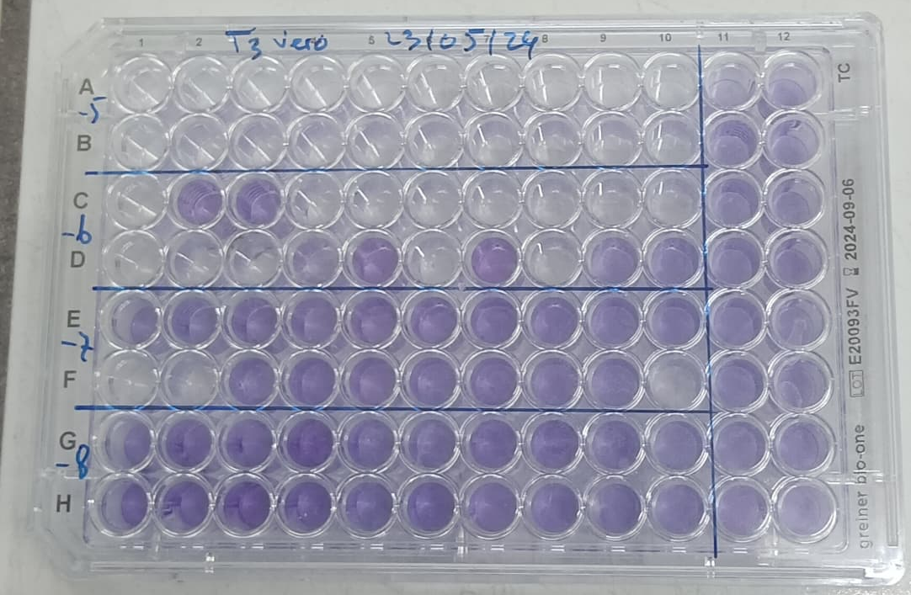
Absence of CPE

Fig. 2. Illustration of a 96-well plate used for the titration assay. Methylene blue staining was performed after five days of microscopic observation, allowing clear distinction between CPE and non-CPE.

3.1.3 Antiviral activity
The antiviral activity assay was carried out taking into account the viral load used. After 48 hours of incubation, no cytopathic effect (CPE) was observed, and the cell monolayer remained intact. However, after 72 hours, a 25% CPE was observed, indicating that a small portion of the cell monolayer had been affected. From the fourth day onward, the CPE reached 100%, meaning that the entire cell monolayer was destroyed by the virus. Regarding the essential oil of Ocimum g., at a 1/4 dilution (C = 250 µg/ml), two out of four cell monolayers were infected, corresponding to 50% inhibition of CPE. In contrast, for dilutions from 1/8 to 1/512, all cell monolayers were destroyed, resulting in 0% CPE inhibition. Concerning the aqueous extract, from 1/8 to 1/512 dilutions, all cell monolayers were also destroyed, indicating 0% CPE inhibition. Therefore, this extract shows no effect on the virus (Fig. 3 and Fig. 4)).
The essential oil of Ocimum g. inhibited viral growth with a minimum inhibitory concentration (MIC) of 250 µg/ml (Fig. 5).

1/4 1/8 1/16 1/32 1/64 1/128 1/256 1/512 TV TN
Absence of CPE

Essential oil of
Ocimum gratissimum
CPE

Empty wells

Aqueous extract
Ocimum gratissimum

Fig. 3. Antiviral effect of the essential oil and aqueous extract of Ocimum gratissimum on West Nile virus
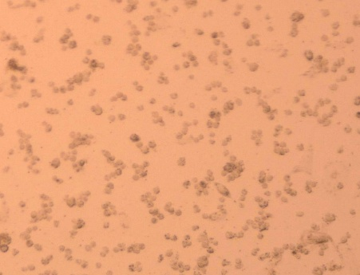
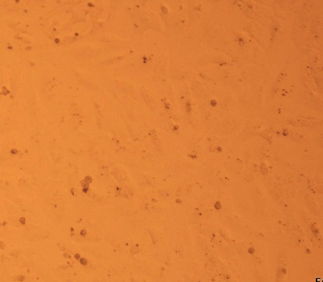
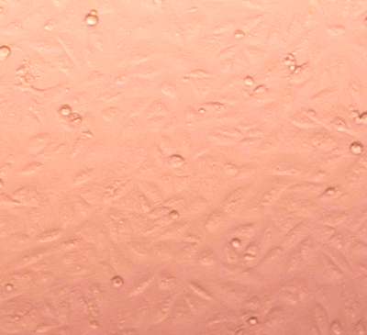

(1) (2) (3)

Fig. 4. Images of the microplate wells: (1) Cell monolayer of the negative control, (2) Observed cytopathic effect (CPE), and (3) Absence of CPE

MIC
Fig. 5. Graphs illustrating the changes in inhibition percentages of various Ocimum g. extract concentrations on West Nile virus (WNV) growth

3.2 Discussion

The toxicity evaluation revealed that Vero cells tolerated Ocimum g. essential oil at concentrations ranging from 2 µg/ml to 250 µg/ml, with no alteration of cell viability observed over a 72-hour period. This indicates that these concentrations are non-toxic to the cells. In contrast, at concentrations of 1 mg/ml and 500 µg/ml, the essential oil exhibited a cytotoxic effect after 24 hours of incubation, suggesting that concentrations equal to or greater than 500 µg/ml are toxic.
Furthermore, the aqueous extract of Ocimum g. showed cytotoxicity on Vero cells starting from a concentration of 250 µg/ml. However, this extract was non-toxic at concentrations ranging from 2 µg/ml to 125 µg/ml. Several similar studies, such as those conducted by Elisée Kouassi (Kouassi et al., 2018), demonstrated that Ocimum g. essential oil exhibits dose-dependent cytotoxic activity on various cell lines, including HCT 116, HeLa, Jurkat, MDA-MB-231, Ramos CRL 1596, and U87 HTB-14, at respective concentrations of 150 µg/ml, 180 µg/ml, 80 µg/ml, 150 µg/ml, 160 µg/ml, and 200 µg/ml. Likewise, the aqueous extract of Ocimum g. showed cytotoxic effects starting at 125 µg/ml on the L20B cell line (Kouadjo, 2022).
Regarding antiviral activity, the essential oil of Ocimum g. demonstrated notable efficacy against West Nile virus, unlike the aqueous extract of the same plant. After one hour of contact with the virus, the essential oil appears to have sufficient time to act on virus-specific processes within the viral replication cycle and in infected cells (Kouadjo, 2022).
This selective inhibition of viral replication may result from the action of phytochemical compounds present in the essential oil. Studies on the phytochemical composition of essential oil extracted from fresh Ocimum g. leaves identified forty-two chemical compounds, with thymol and γ-terpinene being predominant (Koffi et al., 2020).
Indeed, eugenol and thymol have demonstrated inhibitory actions on viral replication and destructive effects on virions, respectively (Bachar et al., 2021; Pushapa et al., 2013). Several pure compounds, isolated and identified from essential oil extracts of the Ocimum genus (such as eugenol, methyleugenol, carvacrol, linalool, 1,8-cineole, apigenin, ursolic acid, oleanolic acid, luteolin, and quercetin) have also shown antiviral activity against certain DNA and RNA viruses (Caamal-Herrera et al., 2016).

4. Conclusion

This study demonstrated, through validated assays, the antiviral activity of the essential oil and aqueous extract of Ocimum g. leaves, a plant widely used in Ivorian traditional medicine. Ocimum g. essential oil exhibited cytotoxic effects at concentrations equal to or greater than 500 µg/ml, resulting in the destruction of Vero cells. In contrast, the aqueous extract was toxic to these cells at concentrations equal to or greater than 250 µg/ml.
Antiviral activity was assessed using non-toxic concentrations of the extracts. In vitro, the essential oil at a concentration of 250 µg/ml inhibited the growth of West Nile virus, with maximal inhibition reaching 50%. Conversely, the aqueous extract showed no inhibitory effect on this virus. Thus, Ocimum g. essential oil could act as a virucidal agent or inhibitor of West Nile virus replication, and its antiviral activity may be attributed to the diversity of chemical compounds it contains. To further this study, work should be undertaken to identify and isolate the bioactive molecules involved in antiviral activity.

Consent AND Ethical approval

It is not applicable.

DISCLAIMER (ARTIFICIAL INTELLIGENCE)
Author(s) hereby declare that generative AI technologies such as Large Language Models (ChatGPT) have been used during the writing or editing of manuscripts.
Details of the AI usage are given below:
1. Translation of texts into English
2. Reformulation of texts
3.

References

Assogba, K. F., N’Danikou S., J. Honfoga, C. Sossa Vihotogbé A. Mensah et S. Simon (2015). Ocimum gratissimum L. (Tchiayo en Fongbé) : Du jardin à la table. Bibliothèque Nationale (BN) du Bénin. Fiche technique. Legal notice N°7697 of 07 January 2015, 1st quarter 2025, Bibliothèque Nationale (BN) du Bénin. ISBN: 978-999190-305-7.
Bachar, S.C., Mazumder, K., Bachar, R., Aktar, A., Al Mahtab, M. A. (2021). Review of Medicinal Plants with Antiviral Activity Available in Bangladesh and Mechanistic Insight Into Their Bioactive Metabolites on SARS-CoV-2, HIV and HBV. Frontier Pharmacology, 8;12: 732891. doi: 10.3389/fphar.2021.732891.
Bouagnon, J. J. R., Bolou, G. E. K., Guédé, K. B., Sanga, D., Koffi, L. R., N’Guessan, C. D. R., 5Konan, Y., Adjogoua, E. V., N'Guessan, J. D., Djaman, A. J., and Dosso, M (2022). Phytochemical study and evaluation of the antiviral activity of aqueous extracts of three medicinal plants; Xylopia aethiopica, Gliricidia sepium and Ocimum gratissimum used in Cote d'Ivoire. African Journal Clinical Experimental Microbiology, 23 (2): 141-14.
Caamal-Herrera, I., Muñoz-Rodríguez, D., Madera-Santana, T.J., Azamar, A (2016). Identification of volatile compounds in essential oil and extracts of Ocimum micranthum Willd leaves using GC/MS. International Journal of Applied Research in Natural Products, 9(1) : 31.
Dorothée, D. T., Etienne, M. N., Carlos, N. K., Aristote, M., Gédéon, N. B., Clément, L. I., Clément, M. M., Benjamin, Z. G., Emmanuel, M. L., Jason, T. K., Domaine, T. M., Giresse, N. K., Damien, S. T. T., Koto-te-Nyiwa, N., & Pius, T. M. (2020). Species of Ocimum as powerful bioresources against COVID-19: a review of their phytochemistry and their antiviral activity. Journal international de recherche sur les agents pathogènes, 5(4), 42-54.
Hanen, F., Chokri, H., Ichrak, M. and Riadh, K (2021). Evaluation of different procedures for the extraction of phenolic compounds from a medicinal plant : Verbena officinalis. Biologie Aujourd’hui, 215 (3-4), 133-142.
Kouassi, E. K., Sitapha, O., Cendrine, S., Sylvie, F., & Benoit, F. (2018). Etude De Quelques proprietes biologiques de Ocimum gratissimum L., une Lamiaceae collected in Daloa (Côte d’Ivoire). European Scientific Journal, 14(3), pp.477.
Kouassi, K.S. (2022). Chemical composition, antioxidant and antimicrobial activity of the essential oils of five aromatic and medicinal plants of the Ivory Coast: comparative study in the cases of hydrodistillation and entry into steam. Thèse de Doctorat Unique. Laboratoire de Chimie Organique et Structurale, UFR SSMT, Université de Cocody-Abidjan, 83 p.
Koffi, F. J., Koff, G. K., Konan, K., Bi Bolou, A., & Daouda K. (2020). Chemical composition of the essential oil extracted from the fresh leaves of Ocimum gratissimum and evaluation of its toxicity on 3 isolates of Fusarium oxysporum lycopersici, telluric parasite in tomato culture. Afrique SCIENCE, 16(1), 226 – 237.
Kouadjo, S. W. (2022). Evaluation of the antiviral activity of the aqueous and hydroethanolique extracts of Ocimum gratissimum L. on the souches of Poliovirus 1 Sabin isolated in Côte d'Ivoire. Mémoire de Biologie santé, Université Jean Lorougnon Guédé de Daloa (Côte d’Ivoire). 33p.
Lai, W.L., Chuang, H.S., Lee, M.H., Wei, C.H., Lin, C.F., Tsai, Y.C. (2012). Inhibition of herpes simplex virus type 1 by thymol-related monoterpenoids. Planta Medica ; 78 (15):1636–1638.
Medicine of voyages. (2020). Premier annual case of infection with the West Nile virus in Florida, aux Etats-Unis Outbreak News Today https://www.vidal.fr/actualites/24914-premier-cas-annuel-d-infection-a-virus-west-nile-en-floride-aux-etats-unis.html
Nations Unies, (2010). The WHO launches itself into a world classification of traditional medicine. https://news.un.org/fr/story/2010/12/203502.
Opatowski, M. (2020). Bacterial resistance to antibiotics, contributes to the national system of health women. Human medicine and pathology. Thèse de doctorat, Université Paris-Saclay, 18p.
Pushapa, R., Nishant, R., Navin, K., & Pankaj, G. (2013). Antiviral potential of medicinal plants: An overview. International. Research Journal of Pharmacy, 4(6), 8-16.
Talambedu, U., Sushil, K. M., Arvind, K. G., Mahesh, K., Da, M., Syed, F., Peyush, G., Hp, P. and Veena, P. (2014). Molecular docking studies of anti-cancerous candidates in Hippophae rhamnoides and Hippophae salicifolia. Journal of Biomedical Research, 28(5) : 406-415.
WHO, (2021). Plants and tools of traditional medicine in the Ivory Coast (https://www.afro.who.int/sites/default/files/202107/HERBIER%282%29_0.pdf
WHO. (2004). Department of Immunization, Vaccines and Biologicals. Polio laboratory manual. 4th edition, 2004.
https://polioeradication.org/wpcontent/uploads/2017/05/Polio_Lab_Manual04.pdf 61p

WHO. (2004). Department of Immunization, Vaccines and Biologicals. Polio laboratory manual. 4th edition, 2004.
https://polioeradication.org/wpcontent/uploads/2017/05/Polio_Lab_Manual04.pdf

