Hydrotherapy as a Complementary Approach in Hypertension Management: A Narrative Review

ABSTRACT
Background: Hypertension remains a leading global risk factor for cardiovascular disease. Complementary non-pharmacological therapies that reduce blood pressure (BP) and improve vascular function are of growing interest. Hydrotherapy including warm or hot-water immersion, aquatic exercise, foot soaks, balneotherapy and local cold applications (e.g., ice massage) is widely used in clinical and traditional settings but its role in hypertension management is not yet standardized.
Objective: To summarize the changes in systolic and diastolic blood pressure through available clinical evidences in hypertensive patients using hydrotherapy modalities such as warm-water immersion ,cold water therapies, ice massage ,steam and sauna bath.
Methods: A literature search was conducted using terms like "hydrotherapy," "hypertension," and "blood pressure", "complimentary" in PubMed, Scopus, Google Scholar, and ScienceDirect to find publications published between 1985 and 2025. Excluded were research involving animals or unrelated topics, and included were peer-reviewed English-language human studies that examined how hydrotherapy affected circulatory or autonomic processes. Key findings were summarized by screening and narratively analyzing pertinent papers. Only publicly available data were used, thus ethical approval was not necessary.
Conclusions: Hydrotherapy shows promise as an adjunctive strategy for managing hypertension by enhancing vascular function and autonomic balance through endothelial and thermoregulatory mechanisms. Further research is needed to standardize protocols and confirm long-term efficacy.

KEYWORDS : Hypertension, hydrotherapy, blood pressure, vascular function

1.Introduction

The hallmark of systemic arterial hypertension, often known as hypertension, is consistently elevated blood pressure (BP) in the systemic arteries. The ratio of the systolic blood pressure (the force the blood applies to the artery walls during heart contraction) to the diastolic blood pressure (the force during heart relaxation) is a typical way to express blood pressure.(1) Hypertension is a major public health problem due to its high prevalence worldwide (2)According to estimates from the Global Burden of Disease 2019 (GBD 2019), high blood pressure is the primary metabolic risk factor worldwide, accounting for 19% of all fatalities.(3) Non-communicable illnesses hypertension cause 41 million deaths annually, or 74% of all deaths worldwide. Almost one-third of all deaths, or 17.9 million deaths annually, are caused by cardiovascular disease.(4) The risk of cardiovascular and all-cause mortality, including heart failure, stroke, and renal insufficiency, is significantly increased by hypertension. It is intimately associated with peripheral arterial disease, atrial fibrillation, and coronary artery disease. A logarithmic scale shows a continuous and linear relationship between normal blood pressure and cardiovascular problems. (5) Its rarely exhibits any symptoms in its early stages until a serious medical emergency, such as a heart attack, stroke, or chronic renal disease, hypertension is a silent killer.(6) Blood pressure must be measured by a medical specialist in order to identify hypertension. Getting your blood pressure checked is quick and easy. While automated devices are available for people to measure their blood pressure, a health professional's assessment is crucial for determining risk and related diseases.(7) Certain major risk factors have been identified for the development of hypertension in young and middle-aged Indian adults, including smoking, drinking, being overweight, having a family history of hypertension, growing older, eating a diet high in salt, developing diabetes, and having a body mass index (BMI) above 30 kg/m2. Waist-to-hip ratio, high cholesterol, central obesity, socioeconomic status, lack of exercise, bad diet, lack of education, and ignorance.(8) Only a tiny percentage of people may encounter symptoms like: Fatigue, nausea, vomiting, headaches, and blurred vision But these symptoms typically don't show up until the blood pressure reaches a potentially fatal level.(9) Myocardial infarction, atherothrombotic brain infarction, heart failure, intracerebral hemorrhage, and renal failure are the main side effects of hypertension.(10) While the other two are actually arteriosclerotic consequences that arise from long-standing, often mild hypertension, the first three are thought to be true hypertensive complications and happen in individuals with severe hypertension.(11) Pharmacological Treatment Antihypertensive drugs target a number of physiological pathways, such as the sympathetic nervous system (SNS), vascular smooth muscle tone, and the renin-angiotensin-aldosterone system (RAAS), that are important in blood pressure management.(12) Angiotensin-converting enzyme (ACE) inhibitors, angiotensin II receptor blockers (ARBs), calcium channel blockers (CCBs), beta-blockers, and diuretics are common groups of antihypertensive medications.(13) When choosing an antihypertensive treatment, considerations such the patient's age, comorbidities, cost, and medication tolerability are taken into account. 18 Reaching desired blood pressure objectives frequently necessitates combination therapy, which uses at least two antihypertensive medications with complimentary modes of action.(14)
The peripheral nervous system includes the autonomic nervous system, which controls involuntary physiological functions like heart rate, respiration, digestion, blood pressure, and sexual desire. The sympathetic, parasympathetic, and enteric nervous systems are the three anatomically separate divisions of the nervous system . Insulin resistance, altered lipid metabolism, and high blood pressure can result from autonomic nervous system dysregulation. Heart rate variability (HRV) is a measure of the different physiological elements influencing the heart's regular rhythm. The autonomic nervous system (ANS), which controls heart activity, is evaluated via HRV analysis.(15)
Naturopathy is a unique form of primary care medicine that combines modern research and technological advancements with traditional healing methods. It is founded on a distinct set of ideas that highlight illness prevention, acknowledge the body's natural ability to heal, and promote personal accountability for achieving optimal health.(16) In ancient cultures such as China, Egypt, India, and others, hydrotherapy was a common naturopathic therapeutic method, The external or internal application of water in any form—ice, steam, or water—for the purpose of promoting health or treating a variety of illnesses at different temperatures, pressures, durations, and locations is known as hydrotherapy.(17) it is a effective non-pharmacological therapeutic approaches that can be used to lower blood pressure. This method is recommended since it is easy to use and does not require certain knowledge or abilities.(18) Various temperature-based hydrotherapy techniques can enhance blood pressure, cardiac autonomic regulation, and parasympathetic dominance.(19) various hydrotherapy techniques are there to reduce blood pressure .

2.Human body and water
When the human body enters water, it confronts a medium for which it is not made and where its ability to move is constrained. Nonetheless, the biological impacts of submersion in water are linked to the basic ideas of hydrodynamics. being aware of these impacts as well as the physical characteristics of water, including buoyancy, density, and hydrostatic pressure.(20) The density (ϱ) is the ratio of a substance's mass (kg) to its volume (m3). When it comes to a fluid, the more dense it is, the more force it applies to items submerged in it or floating in it, the pathophysiology of essential hypertension as a normal response to the elevated gravitational stress brought on by frequent, extended sitting—excessive standing with a high gravitational gradient across the heart(21) Resistance offered by water is greater than that experienced during locomotion on dry land This greater resistance of water compared with that of air is due not only to its density, but also to its dynamic viscosity.(22)
3.Methodology : A literature search was conducted using terms like "hydrotherapy," "hypertension," and "blood pressure", "complimentary" in PubMed, Scopus, Google Scholar, and ScienceDirect to find publications published between 1985 and 2025. Excluded were research involving animals or unrelated topics, and included were peer-reviewed English-language human studies that examined how hydrotherapy affected circulatory or autonomic processes. Total 44 studies Key findings were summarized by screening and narratively analyzing pertinent papers. Only publicly available data were used, thus ethical approval was not necessary.
4.Results
44 studies in all satisfied the requirements for inclusion. The majority reported notable drops in both systolic and diastolic blood pressure after receiving cold therapy, spinal bath and spary, or hot foot immersion,sauna and steam bath, immerssion bath,chest pack .

Table 1 : Literature review showing BP reduction by therapy
Author (Year) | Sample Characteristics | Hydrotherapy treatment | Duration / Frequency | Outcome Measures | BP Reduction (mmHg) | Key Findings
Kihara et al., 2008 | Hypertensive adults (n=30), age 45–65 yrs | Sauna bathing (80–90°C) | 15–20 min/day for 2 weeks | SBP, DBP | ↓SBP 10 ± 3 ↓DBP 6 ± 2 | Improved endothelial function via nitric oxide–mediated vasodilation
Laukkanen et al., 2018 | Middle-aged adults (n=1621) | Finnish sauna | 2–4 sessions/week | BP, cardiovascular mortality | ↓SBP 7 ± 4 | Regular sauna use associated with lower BP and reduced CV risk
Lee et al., 2014 | Mild hypertensives (n=25) | Hot foot immersion (40–42°C) | 15 min/session, 5 days/week | SBP, DBP, HR | ↓SBP 8 ± 2 ↓DBP 5 ± 1 | Increased skin blood flow and reduced vascular resistance
Ahmed Sodha | Hypertensive patients, rural selected area (age 36-60 yrs) | Warm foot soak | Single pre-post intervention | SBP, DBP | SBP ↓ ~16.67 mmHg, DBP ↓ ~6.69 mmHg | Warm foot soak reduced BP substantially in hypertensive patients over short term.
Kim et al., 2019 | Adults with essential hypertension (n=40) | Cold-water immersion (20°C) | 10 min, 2×/week for 4 weeks | BP, HRV | ↓SBP 5 ± 3 | Enhanced parasympathetic tone and improved autonomic balance
Mooventhan & Bharti (2021) | 15 hypertensive subjects, mean age ~49 yrs | Ice massage to head & spine | 1 session, 20 min | SBP, DBP, HRV | SBP ↓ significant, DBP ↓ significant | Ice massage (head & spine) showed immediate BP reduction and improved HRV in hypertensive patients.

5. Hydrotherapy and hypertension
5.1 Steam and sauna bath and hypertension
Steam bath is a type of hydrotherapy bath where the person exposes whole body to moist heat (23)
when exposed to it the body attempts to restore homeostasis through a sequence of processes that cause peripheral vasodilation and decrease in peripheral resistance. (24)one of the previous study on similar treatment sauna bath have shown that effect on adrenal glands through aldosterone system .(25,26) the pathway implicated in the effects of saunabathing on vascular condition and reduction in systemic BP.(27) improves the endothelial function(28,29) reduction in oxidative stress (30) and modulation in the autonomic nervous system (31) both sauna and steam bath increases body temperature which causes increase in skin blood flow leading to increase in cardiac output and decrease in blood flow to internal organs While cardiac stroke volume remains unchanged, cardiac output increases by 60% to 70% in response to an increase in heart rate. Sauna use has varying effects on blood pressure.(32) Previous study found that heat therapy significantly lowered mean arterial blood pressure and diastolic blood pressure for about 4 mmHg in magnitude.(33) Lee et al. found that hypertensive patients with cardiovascular risk factors showed decrease in both systolic and diastolic blood pressure following 30-minute sauna bath, resulted in positive changes in arterial stiffness metrics including pulse wave velocity.(34)
Repeated use of saunas and steam increases nitric oxide release and parasympathetic activation, which improve endothelial function and peripheral vasodilation. The resulting decrease in systemic vascular resistance and slight loss of plasma volume help to lower blood pressure and have long-term cardiovascular advantages.(35)

5.2 Spinal Bath
A spinal bath is Applications of traditional hydrotherapy for the management of cardiovascular diseases like hypertension using spinal bathtub that is cool (26 ±1°C) is provided for 15 minutes.(36) Tubs designed specifically for this purpose were used to administer cold spinal baths. Made of fiber, spinal bath tubs are non-allergic and waterproof. In the investigation, a spinal bath tub from Indian Fibre Company in Bangalore, Karnataka, was used. The spinal bath tub was 3' by 21/2' and stood 10 inches tall.spinal bath increases cardiac output (CO), central venous pressure, stroke volume, and central blood volume by bringing peripheral blood into the thoracic vasculature. It's probable that this rise in central venous pressure will raise arterial pressure and decrease cardiopulmonary pressure. Bradycardia can result from this mechanism, which is known to increase parasympathetic activity and decrease sympathetic activity . Therefore, the reduction of HR may be the primary cause of the drop in blood pressure (BP) variables. Since peripheral resistance and CO both affect blood pressure.(37–39) another mechanism of spinal bath is through Transient receptor potential cation channel subfamily M member 8 (TRPM8), a member of the transient receptor potential family, is responsible for the hypotensive impact of cold spinal baths. Specialized dorsal root ganglion (DRG) neurons in the trunk may receive a signal from the application of cold water in the form of a spinal bath. TRPM8 is activated by the DRG neurons' cell bodies, which are located in the vertebral column next to the spinal cord. Activation of TRPM8 counteracts the sympathetic neurotransmitters' contractile function, which may have a hypotensive impact. Additionally, cold-induced activation of TRPM8, which is located in the sarcoplasmic reticulum membrane, can promote the release of Ca2+ from the sarcoplasmic reticulum, depleting the Ca2+ store and perhaps inhibiting vasoconstriction activity.(40,41)
5.3 Spinal spray
Spinal spray 15°C to 19°C. Over a duration of 20 minutes, a continuous stream of water was sprayed into the spinal area through the perforated tube. reduces SBP, DBP, PP, and MAP in male hypertension patients, significant reductions in LF, LF/HF ratio, and significant improvement in HF.(42) Aortic and carotid sinus baroreceptors may be activated by Cold spinal spray potential to cause instantaneous vasoconstriction, which raises vascular pressure. By activating the vagus nucleus, this lowers sympathetic activity, resulting in vasodilation and a decrease in blood pressure.(43) as the main effect on spinal cord like spinal bath TRPM8 channel mechanism.
5.4 Immersion bath
Immersion bath is the one of the hydrotherapy measure to lower blood , 20 min vs 40 min of water immersion at temperature 36.5°C vs 40°C respectively In patients with hypertension, hot-water immersion resulted in a significant drop in systolic blood pressure.Following the three immersion treatments, the ambulatory systolic blood pressure decreased by 6–7 mm Hg in comparison to the control; the amplitude of this response remained constant throughout the day and night, Similar to the hot-water immersion, the thermoneutral immersion lowered blood pressure throughout a 24-hour period.(44) This hypotensive impact may have numerous and multiple contributing pathways. The core blood volume increases by about 700 mL as soon as the person is submerged in chest-deep water, and the stroke volume increases in tandem with the water's temperature.(45) It is unknown how this reaction varies in hypertensive individuals or older adults, as well as how long these decreases in total peripheral resistance last. Peripheral blood flow and antegrade vascular shear stress increase due to the increased cardiac output and concurrent decrease in sympathetically mediated constrictor tonic activity. This causes endothelium-mediated nitric oxide release, which causes arterial vasodilation akin to that of high-intensity exercise.(46)Other hydrostatic reactions that probably contribute to hypotensive effects include diuresis and natriuresis. Curiously, the atrial natriuretic peptide response may be higher during thermoneutral immersion than during hot-water immersion due to the increased venous return during immersion and prolonged stretch on the right atrium.(47) In addition to increasing prostaglandin E and suppressing fluid regulating hormones like vasopressin and aldosterone, atrial natriuretic peptide also causes an increase in salt and water excretion, which lowers fluid volume during immersion. Additionally, atrial natriuretic peptide exhibits moderate vasodilatory effects. It's possible that a supercompensation in plasma volume, like that seen in the post-exercise hypotensive response, follows these diuretic and natriuretic effects. Water immersion's hypotensive effects are probably caused by a multifactorial cascade that includes the subsequent decrease in resting heart rate, rise in parasympathetic activity, and arterial baroreceptor resetting.(48)

5.5 Chest pack :
The improvement of multiple cardiorespiratory variables was seen with 20 minutes of Hot chest pack When compared to the control session, the results show that 20 minutes of the hydrotherapy procedure (HCP) significantly improved peak expiratory flow rate (PEFR) and significantly decreased cardiovascular variables (such as blood pressure and heart rate). This implies that in addition to improving cardiovascular efficiency, the intervention also improved respiratory function.The improved peripheral blood circulation brought on by hydrotherapy may provide a physiological explanation for the improvement in respiratory indices. Applications of warm or alternating water encourage vasodilation, which reroutes blood toward the body's surface. By reducing excessive blood pooling in the lungs and enhancing pulmonary circulation generally, this procedure helps lessen pulmonary congestion. The results of this study showed the application of a CCP for 20 minutes affects central hemodynamics and heart rate variability; these results may be considered when using CCP therapeutically.(49) A Study shows that cold water immersion induces fast post exercise parasympathetic reactivation. Cold water immersion is a better strategy to increaseparasympathetic activity. At rest, the equilibrium between the two branches of the ANS confers a cardioprotective back ground. The sympathetic accelerates HR parasympathetic acts as brake on heart rate.(50)

5.6 Hot Foot immersion
The blood pressure was significantly reduced after 20 minutes of administering warm water at 40°C and 25 cm of water level to the feet.(51) (52) Warm foot immersion enhances vascular microcirculation, causing vasodilation and stimulating nerves in the feet to activate the parasympathetic nervous system, which helps to alter blood pressure, according to Dwi Uswatun Chasanah et al.(53)(54) efficient way to increase peripheral circulation by foot soaking. The thermal effect of a 10-minute, heated bath at 41°C at the xiphoid process level was comparable to that of Waon therapy.(55) (56) Previous studies have shown that submerging feet in warm water lowers blood pressure by stimulating nerve tissue to produce electricity.(57) Strengthening and dilatation of the ligamentous muscles results in vasodilation of the blood vessels, decreased muscle tension, and increased blood vessel flexibility.(58) Ventricular tension and ventricular muscle vasodilation are affected by warm water, which can lower systolic and diastolic blood pressure by influencing the baroreceptors in the arteries that transmit signals to the brain's nerve fibers..(59) The mechanism involved in the reduction of BP from the intervention HFI at 40°C.(60) HFI may work by increasing venous return, which causes shear stress on the vascular endothelium. This shear stress then triggers the production of nitric oxide through L-arginine, which in turn acts on smooth muscle's cyclic guanosine monophosphate (cGMP) to dilate blood vessels, lowering blood pressure and peripheral vascular resistance.(61,62)The potential effects of lower body heat therapy on endothelial function are far less well understood. In the past, our team showed that whereas young adults showed no change in superficial femoral artery endothelium-dependent vasodilation, older adults showed improvement after acute lower leg heat exposure. Cheng et al. subsequently expanded on these findings by showing that brachial artery endothelium-dependent vasodilation in young people was not improved by lower leg heat therapy. However, limb differences rather than age-related factors may account for these outcomes. However, these investigations along with the findings presented here imply that age and/or the existence of overt endothelial dysfunction may influence the capacity to enhance endothelial function with focused heating of the legs or lower body.(63)

5.7 Ice massage
Ice massage is the one of the hydrotherapy measures where Individual were asked to lie prone on the massage table. Then ice massage was given to the head and spine by continuous longitudinal displacements by the means of a rubber bag filled with ice (1-20C) for 20 minutes . The use of ice bags is to avoid overuse injuries among the patients, After 20 minutes of ice massage to the head and spine, previous research has shown a decrease in heart rate and blood pressure. This is explained by an increase in the R-R interval and sympathetic withdrawal through vagal modulation..(64)(65) This action results from activation of the aortic and carotid artery baroreceptors, which in turn stimulates the solitary tract nucleus, activating the vagal nucleus and suppressing the sympathetic nervous system.(66)(67) According to research, the TRPM8 channel, which is sensitive to cold and is situated over the sarcoplasmic reticulum and golgi apparatus (Figure 2), can be stimulated to activate calmodulin-mediated extracellular calcium influx. This prevents vasoconstriction by generating nitric oxide, which causes vasodilation and lowers blood pressure following an ice massage. (68)
The activation of brown adipose tissue (BAT) in response to thermal stimulation is another potential mechanism (Figure 3).BAT activation increases metabolic activity and encourages the release of prostaglandins and nitric oxide, two chemicals that dilate blood vessels.By assisting in the dilatation of peripheral blood arteries, these vasodilators enhance blood flow to the skin and limbs.The release of norepinephrine from sympathetic nerve terminals is also decreased at this period.The vascular walls' smooth muscles relax as a result of this reduction in sympathetic neurotransmission.Peripheral vascular resistance consequently falls, making it simpler for blood to pass through the veins.Peripheral tissue perfusion is improved when vasodilation and decreased sympathetic tone work together. Systemic blood pressure is significantly lowered as a result of these physiological modifications..(69)(70)

5.8 Strength
The evidence from a variety of hydrotherapy methods, including spinal bath, ice massage, hot foot immersion, and spinal spray, sauna &steam bath,cold immerssion bath is thoroughly compiled in this review, emphasizing their physiological underpinnings and clinical significance in blood pressure regulation. It provides an integrated understanding of autonomic and vascular responses by bridging the gap between contemporary cardiovascular science and traditional naturopathic methods. Clarity and clinical application are improved by the addition of comparative tables and mechanistic explanations.
5.9 Limitations
Since the study is a narrative review, it does not have the statistical rigor and quantitative synthesis of a systematic review or meta-analysis. There may be limited direct comparability among the included studies due to differences in design, sample size, intervention methods, and assessment factors. Furthermore, a large number of the analyzed trials have small populations and short-term results, which makes it challenging to extrapolate results or evaluate long-term safety and effectiveness. In hydrotherapy research, publication bias and a lack of high-quality randomized controlled trials continue to be problems.
5.10 Future direction
Future research should include large-scale randomized controlled trials to confirm the antihypertensive effects of different hydrotherapy techniques. Standardization of temperature, duration, and frequency is needed to ensure reproducibility. Long-term studies should assess safety, sustainability, and integration with conventional hypertension management.
6. Conclusion
Hydrotherapy seems to be a promising adjunctive strategy in the treatment of hypertension, Clinical research indicates that warm-water immersion ,cold water therapies, ice massage ,steam and sauna baths can improve vascular function, autonomic balance, and lower blood pressure. This is most likely due to changes in endothelium and thermoregulatory pathways . The development of standardized and easily available guidelines could improve adherence to non-pharmacological management by incorporating hydrotherapy into regular care. Further large-scale, well-designed randomized controlled trials are needed to establish standardized protocols, long-term efficacy, and optimal frequency and duration of hydrotherapy interventions in hypertensive populations.

Disclaimer (Artificial intelligence)
Option 1:yes
Author(s) hereby declare that NO generative AI technologies such as Large Language Models (ChatGPT, COPILOT, etc.) and text-to-image generators have been used during the writing or editing of this manuscript.

REFERENCE
1. Seravalle G, Grassi G. Essential Hypertension. Primer on the Autonomic Nervous System, Fourth Edition [Internet]. 2023 Jul 20 [cited 2025 Aug 17];467–70. Available from: https://www.ncbi.nlm.nih.gov/books/NBK539859/
2. Abebe SM, Berhane Y, Worku A, Getachew A. Prevalence and Associated Factors of Hypertension: A Crossectional Community Based Study in Northwest Ethiopia. PLoS One [Internet]. 2015 Apr 24 [cited 2025 Aug 17];10(4):e0125210. Available from: https://journals.plos.org/plosone/article?id=10.1371/journal.pone.0125210
3. Global Burden of Disease Study 2019 (GBD 2019) Disease and Injury Burden 1990-2019 | GHDx [Internet]. [cited 2025 Aug 17]. Available from: https://ghdx.healthdata.org/record/ihme-data/gbd-2019-disease-and-injury-burden-1990-2019
4. Noncommunicable diseases [Internet]. [cited 2025 Aug 17]. Available from: https://www.who.int/health-topics/noncommunicable-diseases#tab=tab_1
5. Fagard RH. Exercise Therapy in Hypertensive Cardiovascular Disease. Prog Cardiovasc Dis [Internet]. 2011 May [cited 2025 Oct 26];53(6):404–11. Available from: https://pubmed.ncbi.nlm.nih.gov/21545926/
6. Chobanian A V., Bakris GL, Black HR, Cushman WC, Green LA, Izzo JL, et al. Seventh report of the Joint National Committee on Prevention, Detection, Evaluation, and Treatment of High Blood Pressure. Hypertension [Internet]. 2003 Dec [cited 2025 Aug 17];42(6):1206–52. Available from: https://pubmed.ncbi.nlm.nih.gov/14656957/
7. Al-Makki A, DiPette D, Whelton PK, Murad MH, Mustafa RA, Acharya S, et al. Hypertension pharmacological treatment in adults: A world health organization guideline executive summary. Hypertension [Internet]. 2022 Jan 1 [cited 2025 Aug 17];79(1):293–301. Available from: https://pubmed.ncbi.nlm.nih.gov/34775787/
8. Meher M, Pradhan S, Pradhan SR. Risk Factors Associated With Hypertension in Young Adults: A Systematic Review. Cureus [Internet]. 2023 Apr 12 [cited 2025 Aug 17];15(4):e37467. Available from: https://pmc.ncbi.nlm.nih.gov/articles/PMC10181897/
9. View of Management of Hypertension with Conventional and Herbals Drugs [Internet]. [cited 2025 Aug 17]. Available from: https://jddtonline.info/index.php/jddt/article/view/3998/3135
10. Perry HM, editor. Lifelong Management of Hypertension. 1983 [cited 2025 Aug 17];26. Available from: http://link.springer.com/10.1007/978-94-009-6732-8
11. Perry HM, Neal WH. Complications of hypertension and their relation to therapy. 1983 [cited 2025 Aug 17];150–70. Available from: https://link.springer.com/chapter/10.1007/978-94-009-6732-8_11
12. WHO package of essential noncommunicable (PEN) disease interventions for primary health care [Internet]. [cited 2025 Aug 17]. Available from: https://www.who.int/publications/i/item/9789240009226
13. Elendu C, Amaechi DC, Elendu TC, Amaechi EC, Elendu ID. Dependable approaches to hypertension management: A review. Medicine [Internet]. 2024 Jun 14 [cited 2025 Aug 17];103(24):e38560. Available from: https://pmc.ncbi.nlm.nih.gov/articles/PMC11175961/
14. Rosendorff C, Lackland DT, Allison M, Aronow WS, Black HR, Blumenthal RS, et al. Treatment of Hypertension in Patients With Coronary Artery Disease: A Scientific Statement From the American Heart Association, American College of Cardiology, and American Society of Hypertension. Circulation [Internet]. 2015 May 12 [cited 2025 Aug 17];131(19):e435. Available from: https://pmc.ncbi.nlm.nih.gov/articles/PMC8365343/
15. Straznicky NE, Nestel PJ, Esler MD. Autonomic Nervous System: Metabolic Function. Encyclopedia of Neuroscience. 2009;951–9.
16. Fleming SA, Gutknecht NC. Naturopathy and the Primary Care Practice. Prim Care [Internet]. 2010 Mar [cited 2025 Aug 17];37(1):119. Available from: https://pmc.ncbi.nlm.nih.gov/articles/PMC2883816/
17. Mooventhan A, Nivethitha L. Scientific Evidence-Based Effects of Hydrotherapy on Various Systems of the Body. N Am J Med Sci [Internet]. 2014 [cited 2025 Aug 17];6(5):199. Available from: https://pmc.ncbi.nlm.nih.gov/articles/PMC4049052/
18. View of The Effect of Hydrotherapy on Lowering Blood Pressure among Hypertension [Internet]. [cited 2025 Aug 17]. Available from: https://jurnal.globalhealthsciencegroup.com/index.php/PICNHS/article/view/5752/4094
19. Abinaya S, Vijay A, Nivethitha L, Mooventhan A, Manavalan N. Effects of various hydrotherapeutic procedures on heart rate variability and blood pressure: A systematic review. Adv Integr Med [Internet]. 2025 Sep 1 [cited 2025 Aug 18];12(3):100500. Available from: https://www.sciencedirect.com/science/article/abs/pii/S221295882500059X
20. Becker BE. Aquatic therapy: scientific foundations and clinical rehabilitation applications. PM R [Internet]. 2009 Sep [cited 2025 Sep 17];1(9):859–72. Available from: https://pubmed.ncbi.nlm.nih.gov/19769921/
21. Pekarski SE. A gravitational hypothesis of essential hypertension as a natural adaptation to increased gravitational stress caused by regular, prolonged sitting typical of modern life [Internet]. Available from: http://www.MedSciMonit.com/pub/vol_10/no_6/4238.pdf
22. Dowzer CN. Effects of deep and shallow water running on spinal shrinkage. Br J Sports Med [Internet]. 1998 [cited 2025 Sep 17];32(1):44–8. Available from: https://www.researchgate.net/publication/13718604_Effects_of_deep_and_shallow_water_running_on_spinal_shrinkage
23. Pandiaraja M, Vanitha A, Maheshkumar K, Venugopal V, Poonguzhali S, Radhika L, et al. Effect of the steam bath on resting cardiovascular parameters in healthy volunteers. Adv Integr Med [Internet]. 2021 Sep 1 [cited 2025 Aug 18];8(3):199–202. Available from: https://www.sciencedirect.com/science/article/abs/pii/S221295882030118X
24. Maheshkumar K, Venugopal V, Poonguzhali S, Mangaiarkarasi N, Venkateswaran ST, Manavalan N. Trends in the use of Yoga and Naturopathy based lifestyle clinics for the management of Non-communicable diseases (NCDs) in Tamilnadu, South India. Clin Epidemiol Glob Health [Internet]. 2020 Jun 1 [cited 2025 Sep 9];8(2):647–51. Available from: https://www.sciencedirect.com/science/article/pii/S2213398419303847
25. the principle and prctice of hydrotherapy a guid to the application of water in disease for students and - Google Search [Internet]. [cited 2025 Sep 9]. Available from: https://www.google.com/search?q=the+principle+and+prctice+of+hydrotherapy+a+guid+to+the+application+of+water+in+disease+for+students+and&rlz=1C1RXQR_enIN1087IN1087&oq=the+principle+and+prctice+of+hydrotherapy+a+guid+to+the+application+of+water+in+disease+for+students+and+&gs_lcrp=EgZjaHJvbWUyBggAEEUYOdIBCjU5OTcwajBqMTWoAgiwAgHxBRu3GKSbw81u&sourceid=chrome&ie=UTF-8
26. Sawka MN, Leon LR, Montain SJ, Sonna LA. Integrated physiological mechanisms of exercise performance, adaptation, and maladaptation to heat stress. Compr Physiol [Internet]. 2011 Oct [cited 2025 Sep 9];1(4):1883–928. Available from: https://pubmed.ncbi.nlm.nih.gov/23733692/
27. Zaccardi F, Laukkanen T, Willeit P, Kunutsor SK, Kauhanen J, Laukkanen JA. Sauna Bathing and Incident Hypertension: A Prospective Cohort Study. Am J Hypertens [Internet]. 2017 Nov 1 [cited 2025 Sep 9];30(11):1120–5. Available from: https://pubmed.ncbi.nlm.nih.gov/28633297/
28. Imamura M, Biro S, Kihara T, Yoshifuku S, Takasaki K, Otsuji Y, et al. Repeated thermal therapy improves impaired vascular endothelial function in patients with coronary risk factors. J Am Coll Cardiol [Internet]. 2001 [cited 2025 Sep 9];38(4):1083–8. Available from: https://pubmed.ncbi.nlm.nih.gov/11583886/
29. Ohori T, Nozawa T, Ihori H, Shida T, Sobajima M, Matsuki A, et al. Effect of repeated sauna treatment on exercise tolerance and endothelial function in patients with chronic heart failure. American Journal of Cardiology [Internet]. 2012 Jan 1 [cited 2025 Sep 9];109(1):100–4. Available from: https://pubmed.ncbi.nlm.nih.gov/21944673/
30. Sutkowy P, Woźniak A, Boraczyński T, Mila-Kierzenkowska C, Boraczyński M. The effect of a single Finnish sauna bath after aerobic exercise on the oxidative status in healthy men. Scand J Clin Lab Invest [Internet]. 2014 [cited 2025 Sep 9];74(2):89–94. Available from: https://pubmed.ncbi.nlm.nih.gov/24304490/
31. Radtke T, Poerschke D, Wilhelm M, Trachsel LD, Tschanz H, Matter F, et al. Acute effects of Finnish sauna and cold-water immersion on haemodynamic variables and autonomic nervous system activity in patients with heart failure. Eur J Prev Cardiol [Internet]. 2016 Apr 1 [cited 2025 Sep 9];23(6):593–601. Available from: https://pubmed.ncbi.nlm.nih.gov/26152773/
32. Hannuksela ML, Ellahham S. Benefits and risks of sauna bathing. American Journal of Medicine [Internet]. 2001 Feb 1 [cited 2025 Sep 9];110(2):118–26. Available from: https://pubmed.ncbi.nlm.nih.gov/11165553/
33. Brunt VE, Howard MJ, Francisco MA, Ely BR, Minson CT. Passive heat therapy improves endothelial function, arterial stiffness and blood pressure in sedentary humans. J Physiol [Internet]. 2016 Sep 15 [cited 2025 Oct 26];594(18):5329. Available from: https://pmc.ncbi.nlm.nih.gov/articles/PMC5023696/
34. Laukkanen JA, Laukkanen T, Kunutsor SK. Cardiovascular and Other Health Benefits of Sauna Bathing: A Review of the Evidence. Mayo Clin Proc [Internet]. 2018 Aug 1 [cited 2025 Oct 26];93(8):1111–21. Available from: https://www.mayoclinicproceedings.org/action/showFullText?pii=S0025619618302751
35. Laukkanen T, Kunutsor SK, Khan H, Willeit P, Zaccardi F, Laukkanen JA. Sauna bathing is associated with reduced cardiovascular mortality and improves risk prediction in men and women: A prospective cohort study. BMC Med [Internet]. 2018 Nov 29 [cited 2025 Oct 26];16(1):1–14. Available from: https://bmcmedicine.biomedcentral.com/articles/10.1186/s12916-018-1198-0
36. Rational hydrotherapy : a manual of the physiological and therapeutic effects of hydriatic procedures, and the technique of their application in the treatment of disease : Kellogg, John Harvey, 1852-1943 : Free Download, Borrow, and Streaming : Internet Archive [Internet]. [cited 2025 Sep 10]. Available from: https://archive.org/details/rationalhydrothe00kelluoft
37. Mooventhan A. Immediate effect of ice bag application to head and spine on cardiovascular changes in healthy volunteers. International Journal of Health & Allied Sciences [Internet]. 2016 [cited 2025 Sep 10];5(1):53. Available from: https://www.researchgate.net/publication/292947097_Immediate_effect_of_ice_bag_application_to_head_and_spine_on_cardiovascular_changes_in_healthy_volunteers
38. Šrámek P, Šimečková M, Janský L, Šavlíková J, Vybíral S. Human physiological responses to immersion into water of different temperatures. Eur J Appl Physiol [Internet]. 2000 Mar 11 [cited 2025 Sep 10];81(5):436–42. Available from: https://pubmed.ncbi.nlm.nih.gov/10751106/
39. (PDF) IMMEDIATE EFFECT OF COLD SPINAL BATH ON AUTONOMIC AND RESPIRATORY VARIABLES IN HYPERTENSIVES [Internet]. [cited 2025 Sep 10]. Available from: https://www.researchgate.net/publication/321777191_IMMEDIATE_EFFECT_OF_COLD_SPINAL_BATH_ON_AUTONOMIC_AND_RESPIRATORY_VARIABLES_IN_HYPERTENSIVES
40. Johnson CD, Melanaphy D, Purse A, Stokesberry SA, Dickson P, Zholos A V. Transient receptor potential melastatin 8 channel involvement in the regulation of vascular tone. Am J Physiol Heart Circ Physiol [Internet]. 2009 Jun [cited 2025 Sep 10];296(6):H1868. Available from: https://pmc.ncbi.nlm.nih.gov/articles/PMC2716108/
41. Mourot L, Bouhaddi M, Gandelin E, Cappelle S, Dumoulin G, Wolf JP et al. Cardiovascular autonomic control during short-term thermoneutral and cool head-out immersion. Aviat Space Environ Med., 2008 Jan; 79(1): 14-20. - Google Search [Internet]. [cited 2025 Sep 10]. Available from: https://www.google.com/search?q=Mourot+L%2C+Bouhaddi+M%2C+Gandelin+E%2C+Cappelle+S%2C+Dumoulin+G%2C+Wolf+JP+et+al.+Cardiovascular+autonomic+control+during+short-term+thermoneutral+and+cool+head-out+immersion.+Aviat+Space+Environ+Med.%2C+2008+Jan%3B+79(1)%3A+14-20.&rlz=1C1RXQR_enIN1087IN1087&oq=Mourot++L%2C++Bouhaddi++M%2C++Gandelin++E%2C++Cappelle++S%2C+Dumoulin++G%2C++Wolf++JP++et++al.++Cardiovascular+autonomic++control+during++short-term++thermoneutral+and+cool++head-out+immersion.++Aviat+Space++Environ+Med.%2C+2008+Jan%3B+79(1)%3A+14-20.&gs_lcrp=EgZjaHJvbWUyBggAEEUYOdIBCTI1MjFqMGoxNagCCLACAfEFspg5lAxq463xBbKYOZQMauOt&sourceid=chrome&ie=UTF-8
42. Paily AK, Shetty GB, Shetty P, Sujatha K. Immediate Effect of Cold Spinal Spray on Autonomic Variables in Hypertensive Individuals-A Randomised Control Trial. 2020;
43. View of Effectiveness of Cold Spinal Spray on Blood Pressure and Heart Rate Variability in Patients with Hypertension—A Randomized Controlled Trial [Internet]. [cited 2025 Sep 10]. Available from: https://candjournal.ca/index.php/candj/article/view/140/250
44. Roxburgh BH, Campbell HA, Cotter JD, Williams MJA, Thomas KN. Both hot- and thermoneutral-water immersion reduce 24-h blood pressure in people with hypertension: A randomized crossover study. Temperature: Multidisciplinary Biomedical Journal [Internet]. 2025 [cited 2025 Sep 15];12(2):166. Available from: https://pmc.ncbi.nlm.nih.gov/articles/PMC12051523/
45. Weston CFM, O’Hare JP, Evans JM, Corrall RJM. Haemodynamic changes in man during immersion in water at different temperatures. Clin Sci (Lond) [Internet]. 1987 [cited 2025 Sep 15];73(6):613–6. Available from: https://pubmed.ncbi.nlm.nih.gov/3319357/
46. Amin SB, Hansen AB, Mugele H, Simpson LL, Marume K, Moore JP, et al. High-intensity exercise and passive hot water immersion cause similar postintervention changes in peripheral and cerebral shear. J Appl Physiol (1985) [Internet]. 2022 Aug 1 [cited 2025 Sep 15];133(2):390–402. Available from: https://journals.physiology.org/doi/pdf/10.1152/japplphysiol.00780.2021
47. Kissling LS, Akerman AP, Campbell HA, Prout JR, Gibbons TD, Thomas KN, et al. A crossover control study of three methods of heat acclimation on the magnitude and kinetics of adaptation. Exp Physiol [Internet]. 2022 Apr 1 [cited 2025 Sep 15];107(4):337–49. Available from: https://pubmed.ncbi.nlm.nih.gov/34957632/
48. Dietz JR. Mechanisms of atrial natriuretic peptide secretion from the atrium. Cardiovasc Res [Internet]. 2005 Oct 1 [cited 2025 Sep 15];68(1):8–17. Available from: https://pubmed.ncbi.nlm.nih.gov/15993390/
49. Manjuladevi T, Mooventhan A, Manjunath NK. Immediate effect of hot chest pack on cardio-respiratory functions in healthy volunteers: A randomized cross-over study. Adv Integr Med [Internet]. 2018 Aug 1 [cited 2025 Oct 19];5(2):63–8. Available from: https://www.sciencedirect.com/science/article/abs/pii/S2212958817300575
50. Valsakumar A, Dinesh S, Prasad G, Shetty P. Immediate effect of cold mud pack therapy on autonomic variables in primary hypertensive individuals: a randomized trial. J Complement Integr Med [Internet]. 2021 Sep 1 [cited 2025 Oct 19];19(3):799–806. Available from: https://pubmed.ncbi.nlm.nih.gov/34757704/
51. Murwidi C, Abdullah F. Effectiveness of Warm Water Foot Soak and Benson Relaxation Techniques Combination in Reducing Blood Pressure of Hypertensive Patients. International Journal of Health, Economics, and Social Sciences (IJHESS) [Internet]. 2019;1(1). Available from: https://dx.doi.org/10.31934/ijhess
52. Júnior FADM, Gomes SG, da Silva FF, Souza PM, Oliveira EC, Coelho DB, et al. The effects of aquatic and land exercise on resting blood pressure and post-exercise hypotension response in elderly hypertensives. Cardiovasc J Afr [Internet]. 2020 Jun 1 [cited 2025 Jul 27];31(3):116–22. Available from: https://pubmed.ncbi.nlm.nih.gov/31651927/
53. View of Implementation of Warm Foot Soak Hydrotherapy Reduces the Risk of Indefective Peripheral Perfusion in Hypertension Patients in the Family [Internet]. [cited 2025 Jul 29]. Available from: https://prosiding.arikesi.or.id/index.php/ICHSN/article/view/43/58
54. Pagani M, Lombardi F, Guzzetti S, Rimoldi O, Furlan R, Pizzinelli P, et al. Power spectral analysis of heart rate and arterial pressure variabilities as a marker of sympatho-vagal interaction in man and conscious dog. Circ Res [Internet]. 1986 [cited 2025 Jul 23];59(2):178–93. Available from: https://pubmed.ncbi.nlm.nih.gov/2874900/
55. Pomeranz B, Macaulay JB, Caudill MA. Assessment of autonomic functions in humans by heart rate spectral analysis. Am J Physiol Heart Circ Physiol [Internet]. 1985 [cited 2025 Jul 23];17(1). Available from: https://pubmed.ncbi.nlm.nih.gov/3970172/
56. Saeki Y, Nagai N, Hishinuma M. Effects of footbathing on autonomic nerve and immune function. Complement Ther Clin Pract [Internet]. 2007 Aug [cited 2025 Jul 23];13(3):158–65. Available from: https://pubmed.ncbi.nlm.nih.gov/17631258/
57. Putu Sudiartawan I, Made Dwi Mertha Adnyana I. Science Midwifery Efficacy of Hydrotherapy Soak Feet in Lowering Blood Pressure of Hypertension Sufferers in Dauhwaru Village, Jembrana [Internet]. Vol. 10, Science Midwifery. Online; 2022. Available from: www.midwifery.iocspublisher.orgJournalhomepage:www.midwifery.iocspublisher.org
58. Becker BE. The biologic aspects of hydrotherapy. J Back Musculoskelet Rehabil [Internet]. 1994 [cited 2025 Jul 27];4(4):255–64. Available from: https://www.researchgate.net/publication/260398052_The_Biologic_Aspects_of_Hydrotherapy
59. Brunt VE, Howard MJ, Francisco MA, Ely BR, Minson CT. Passive heat therapy improves endothelial function, arterial stiffness and blood pressure in sedentary humans. Journal of Physiology [Internet]. 2016 Sep 15 [cited 2025 Jul 27];594(18):5329–42. Available from: https://pubmed.ncbi.nlm.nih.gov/27270841/
60. Wang PC, Song QC, Chen CY, Su TC. Cardiovascular physiological effects of balneotherapy: focused on seasonal differences. Hypertension Research [Internet]. 2023 Jul 1 [cited 2025 Jul 6];46(7):1650–61. Available from: https://www.nature.com/articles/s41440-023-01248-4
61. Sartori C, Lepori M, Scherrer U. Interaction between nitric oxide and the cholinergic and sympathetic nervous system in cardiovascular control in humans. Pharmacol Ther [Internet]. 2005 May 1 [cited 2025 Jul 6];106(2):209–20. Available from: https://www.sciencedirect.com/science/article/abs/pii/S0163725804002050?via%3Dihub
62. Tei C, Horikiri Y, Park JC, Jeong JW, Chang KS, Toyama Y, et al. Acute hemodynamic improvement by thermal vasodilation in congestive heart failure. Circulation [Internet]. 1995 May 15 [cited 2025 Jul 6];91(10):2582–90. Available from: https://pubmed.ncbi.nlm.nih.gov/7743620/
63. Ruiz-Pick YI, Cope HL, Richey RE, Moore AM, Garfield TC, Olivencia-Yurvati AH, et al. Home-based heat therapy lowers blood pressure and improves endothelial function in older adults. J Appl Physiol (1985) [Internet]. 2025 Apr 1 [cited 2025 Oct 26];138(4):979. Available from: https://pmc.ncbi.nlm.nih.gov/articles/PMC12053574/
64. (PDF) IMMEDIATE EFFECT OF COLD SPINAL BATH ON AUTONOMIC AND RESPIRATORY VARIABLES IN HYPERTENSIVES [Internet]. [cited 2025 Jun 5]. Available from: https://www.researchgate.net/publication/321777191_IMMEDIATE_EFFECT_OF_COLD_SPINAL_BATH_ON_AUTONOMIC_AND_RESPIRATORY_VARIABLES_IN_HYPERTENSIVES
65. Mooventhan A, Nivethitha L. Effects of ice massage of the head and spine on heart rate variability in healthy volunteers. J Integr Med [Internet]. 2016 Jul 1 [cited 2025 Jun 5];14(4):306–10. Available from: https://pubmed.ncbi.nlm.nih.gov/27417177/
66. Valsakumar A, Dinesh S, Prasad G, Shetty P. Immediate effect of cold mud pack therapy on autonomic variables in primary hypertensive individuals: A randomized trial. J Complement Integr Med [Internet]. 2022 Sep 1 [cited 2025 Jul 29];19(3):799–806. Available from: https://pubmed.ncbi.nlm.nih.gov/34757704/
67. Simon E, Kosaka M. Application of Heat and Cold: Physiological Responses and Therapeutic Implications. Thermotherapy for Neoplasia, Inflammation, and Pain [Internet]. 2001 [cited 2025 Jul 29];12–26. Available from: https://link.springer.com/chapter/10.1007/978-4-431-67035-3_2
68. Silva H. Current Knowledge on the Vascular Effects of Menthol. Front Physiol [Internet]. 2020 Apr 7 [cited 2025 Jul 28];11:523469. Available from: www.frontiersin.org
69. Daanen HAM. Finger cold-induced vasodilation: A review. Eur J Appl Physiol [Internet]. 2003 [cited 2025 Jul 29];89(5):411–26. Available from: https://pubmed.ncbi.nlm.nih.gov/12712346/
70. Lijnen PJ, Petrov V V., Fagard RH. Association between transforming growth factor-β and hypertension. Am J Hypertens [Internet]. 2003 Jul 1 [cited 2025 Jul 29];16(7):604–11. Available from: https://pubmed.ncbi.nlm.nih.gov/12850397/

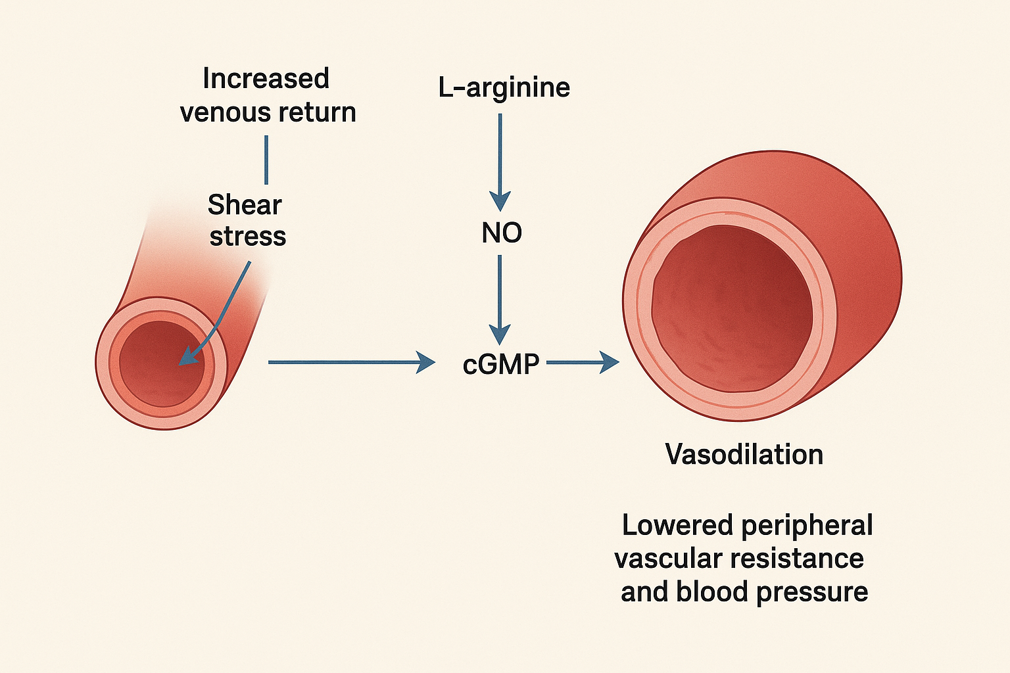
Figure 1: Mechanisam of Hot Foot imerssion

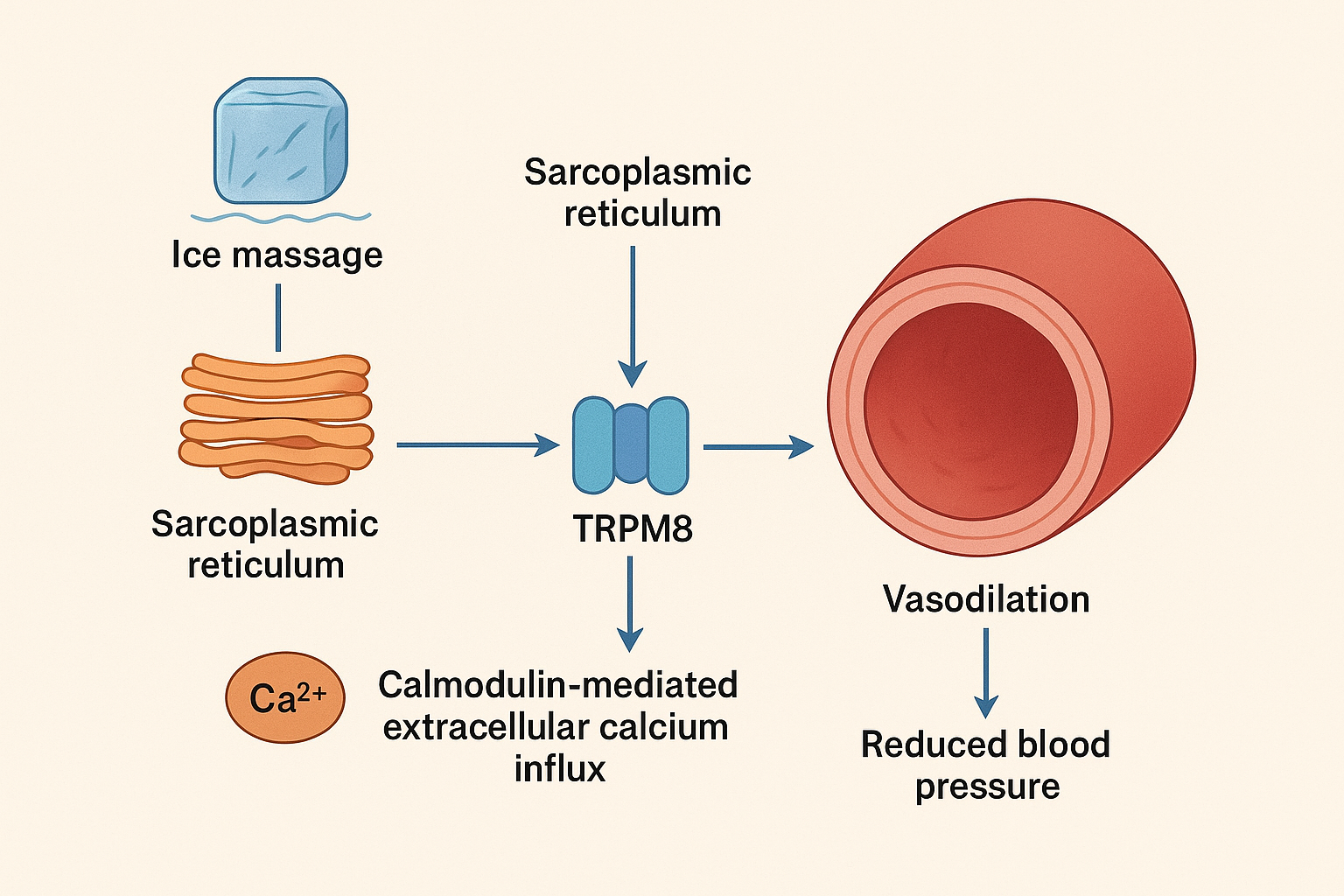
Figure 2: Ice Massage Mechanism

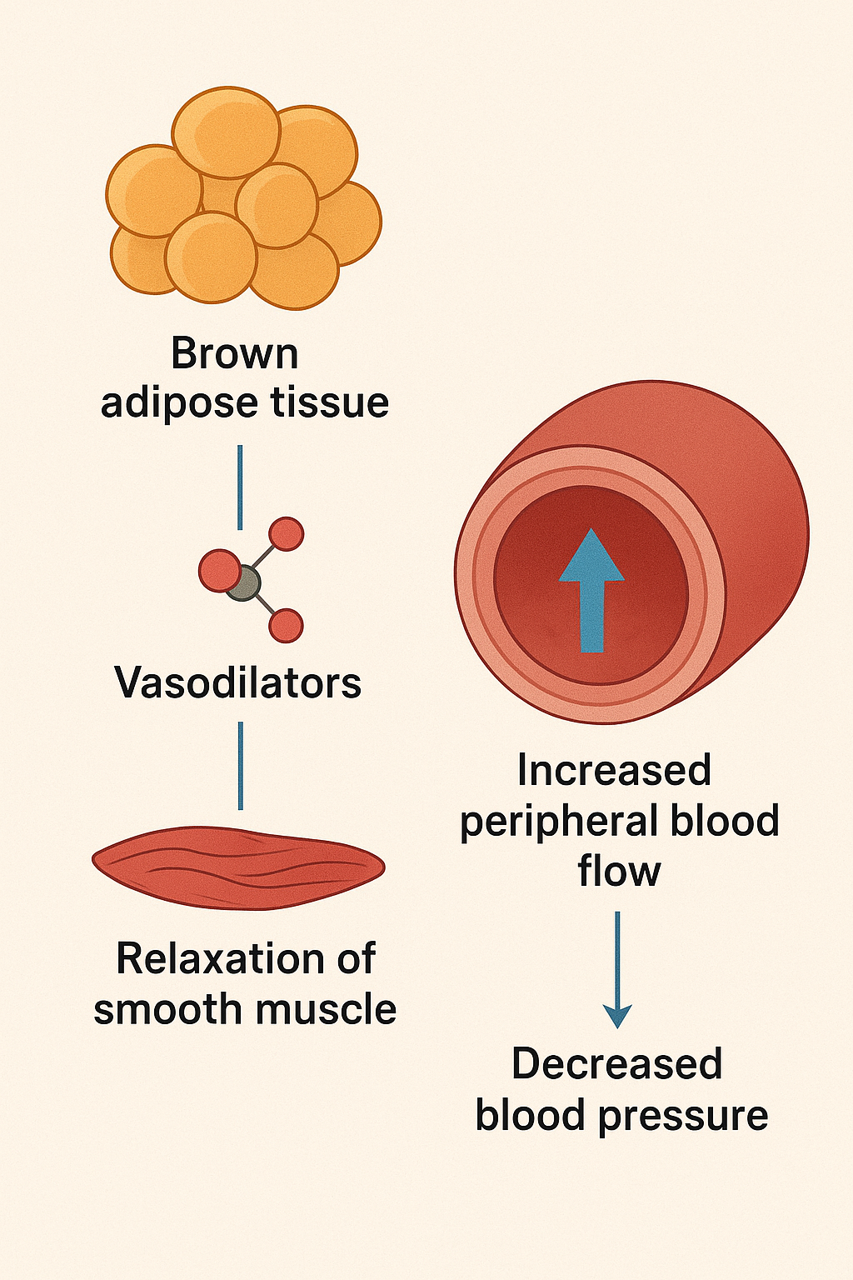
Figure 3: Ice Massage Mechanism Through adipose tissue

