Synthesis, Characterization And Antimicrobial Activities Of Co(II) Complex of The Schiff Base Ligand Derived from 4-Acyl Antipyrine

ABSTRACT
The incidence of drug- resistant microbial infections is a growing concern worldwide, necessitating the development of novel antimicrobial agents that would break barrier of resistance, guarantee safety and potency of pharmaceutical products. This study aimed to synthesize, characterize, and evaluate the antimicrobial activities of a Schiff base ligand derived from acetyl chloride antipyrine (4- acyl antipyrine) and substituted 2- hydroxyl aniline and its Co(II) complex, in order to explore their potential as antimicrobial agents. The ligand was synthesized by condensing 4-acyl antipyrine with 2-hydroxyl aniline in ethanol, while the Co(II) complex was prepared in a 1:2 metal-to-ligand ratio. The synthesized compounds were characterized using FTIR, UV-Vis, GCMS and XRD techniques. Interestingly, all the synthesized compounds were obtained in good yield (78%-86%). The spectroscopic and diffraction studies confirmed successful coordination via nitrogen and oxygen donor atoms, with characteristic shifts indicating complex formation. The Schiff base ligands SLOA (1,700.65cm⁻¹) showed a notable shift to higher wavenumbers indicating increase C=O bond strength due to coordination with metal through its oxygen. metal complex shows C=O stretching shifted back to lower frequency value (1.633.54cm⁻¹) suggesting co-ordination of oxygen to metal. Antimicrobial activity was evaluated using agar diffusion and broth dilution methods against various bacterial and fungal strains. The results revealed that the metal complex, exhibited enhanced antimicrobial efficacy compared to the ligands. Notably, the cobalt complex showed enhanced activity against Salmonella typhi, Escherichia coli, Staphylococcus aureus, Streptococcus pyogenes, and Candida albicans. The findings highlight the significance of metal chelation in improving biological activity and support the potential of Co(II) complex and its Schiff base ligand as an effective antimicrobial agent.
Keywords: 4-Acyl Antipyrine, Co(II) Complex, 2-Hydroxyl aniline, Schiff base ligand, Antimicrobial activities, Octahedral geometry,

1. INTRODUCTION
4-acyl antipyrine have continued to attract research interest in recent years due to their established antimicrobial properties. These compounds are formed by the condensation reaction of 2,3-dimethyl-1-phenylpyrazolone-5 and acetyl chloride [1]. A major Schiff base derivative, 4- acyl antipyrine and substituted aniline, has become a key player in the development of active drugs due to their biological and pharmacological profiles [3]. They exhibit exceptional properties in coordination chemistry due to their ability to coordinate with metals and form stable complexes [2]. The pharmacological actions of are attributed to their unique structural features, which include the presence of the azomethine group (-NH-N-CH), making them an important player in pharmaceutical chemistry [4,5].
Recent reports have indicated that 4-acyl antipyrine and substituted aniline derivatives exhibit significant antimicrobial activity, including antibacterial, antifungal, antimycobacterial, anti-inflammatory, and antiviral effects [6]. The efficacy of their metal complexes against multidrug-resistant pathogens underscores their relevance in addressing global health challenges [7]. The complexation of the Schiff bases with transition metals has led to compounds with enhanced antimicrobial activity compared to their parent ligands [4,7]. The antimicrobial properties of such compounds are influenced by the nature of the metal ion, the ligand structure, and the coordination geometry, which can be elucidated through spectroscopic and crystallographic techniques [8].
Cobalt(II) complexes, in particular, have become of research interest because several Co(II)– 4- acyl antipyrine complexes have demonstrated promising antibacterial and antifungal results in vitro, and in some cases, improved activity against drug-resistant strains.[7] These findings justify exploring Co(II) chelates of new 4- acyl antipyrine ligands as potential antimicrobial agents. This work aims to synthesize, characterize, and evaluate the antimicrobial activities of the titled ligand and its Co(II) complex, contributing to the growing body of knowledge on 4- acyl antipyrine Schiff base chemistry. The scope of this study encompasses a detailed investigation of the ligand's synthesis via condensation reactions, its coordination with Co(II), and an assessment of ligand and complex antimicrobial efficacy against selected bacterial and fungal strains. The findings are expected to provide insights into the structure-activity relationships and validate the potential of these compounds as candidates for further pharmaceutical development.

2. experimentals

All the reagents used in this research were of analytical grade and used without further purification. The reagents were purchased from Sigma–Aldrich Chemie GmbH, Germany, and supplied through their local distributor in Nigeria, Bristol Scientific. Metal salts were obtained from E. Merck, and distilled water was purchased from QualityChem (Nig.). The Molar conductivity, elemental composition, GC-MS, XRD, FTIR, and UV-Vis spectroscopic analyses were performed at the Nanotechnology Research Laboratory of National Research Institute for Chemical Technology, Zaria, Kaduna State Nigeria, Nigeria. While the antimicrobial was carried out at Gomecs-Evergland Limited, Nekede, Owerri, Imo State, Nigeria.
The melting points were determined using a capillary tube in the Melting Point Apparatus (HUNK-4524542). Molar conductivity was measured in deionized water at 25°C with a WTW conductivity meter. Infrared spectra were recorded in the frequency range of 4000 cm⁻¹ to 400 cm⁻¹ using an FT-IR spectrometer (Varian 660 MidIR Dual MCT/DTGS Bundle with ATR), with a detector set at a resolution of 4 cm⁻¹ and 200 scans per sample. Ultraviolet-visible spectra of the ligand and complexes were recorded using a UV-Vis spectrophotometer (2100 Pro) within the range of 200-800 nm. Mass spectra were obtained on a Varian 3800/4000 gas chromatograph-mass spectrometer equipped with an Agilent splitter, with split/splitless options, and a BP5 capillary column (30 m × 0.25 mm × 0.25 microns). The samples were analyzed using an X-ray diffraction diffractometer (XDS 2400H), equipped with a Mini+-9—8yyFlex2+ goniometer and detector.

2.1 Synthesis of 4- acyl antipyrine
The ligand was synthesized according to the method used by Jensen. [1] as follows:

Step 1:
9g (0.05mol) of antipyrine (2,3-dimethyl-1-phenylpyrazolone-5) was dissolved in hot dioxane (70cm³) placed in a round bottom flask equipped with a stirrer, separating funnel and reflux condenser. Calcium hydroxide (7.00g,0.1mol) was added to this solution, followed by acetyl chloride (5ml, 0.07mol) added drop wise. The reaction mixture became thick paste and was refluxed for 2 hrs. and allowed to cool. The mixture was poured into hydrochloric acid (200cm³). The cream-coloured crystals obtained were filtered and then recrystallized from cold ethanol- water acidified with HCl to destroy any undecomposed calcium complex and recrystallized. The cream yellow crystals obtained were filtered and dried over silica gel in a desiccator and it was labelled LOA. (Yield, 80%, M.P.,116°C).IR (KBr, ѵ/cm⁻¹): 1613. v(C=O), 2983 v(C-CH₃), 813 v(C₆H₆), 1436 v(C=C), 2896 v(C-H) XRD (2θ, Å): 21.08, 24.00, 4.19, 4.70 UV–Vis (DMSO, λmax, nm): 250 (LOA,). GC-MS (m/z): cal., 230.00; found, 230.10

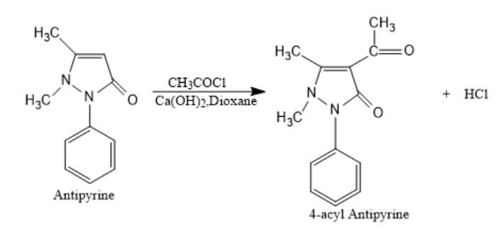
Scheme 1: Synthetic route for 4-acyl antipyrine (LOA)

Step 2: Synthesis of Schiff base ligand from 4-acyl antipyrine and 2- hydroxyl aniline
2.18g, 0.02mol of 2-hydroxylaniline was dissolved with 150ml absolute ethanol in 500ml round bottomed flask, to this solution was added dropwise 2.68g, 0.03mol of LOA in 30cm³ of absolute ethanol over 30minutes while stirring. Stirring continued for another 30minutes and mixture refluxed for 3hrs.The resulting solution was allowed to cool and filtered to remove the solvent and the solid residue was washed with cold ethanol and then recrystallized with a mixed solvent of methanol, ethanol and acetone in the ratio of 1:1:1. The black amorphous powder obtained was filtered, recrystallized and dried over silica gel in a desiccator and the Schiff base was labelled SLOA. (Yield, 86%, M.P., 232°C).IR (KBr, ѵ/cm⁻¹): 3500 v(O–H), 1700 v(C=O) 2998 (C-CH₃/C–H), 800 v(C₆H₆), 1582 (C=N), 1446 (C=C). XRD (2θ, Å ): 21.14, 4.19, 3.86. UV–Vis (DMSO, λmax, nm): 278 (SLOA). GC-MS (m/z): cal., 321.00; found, 321.00
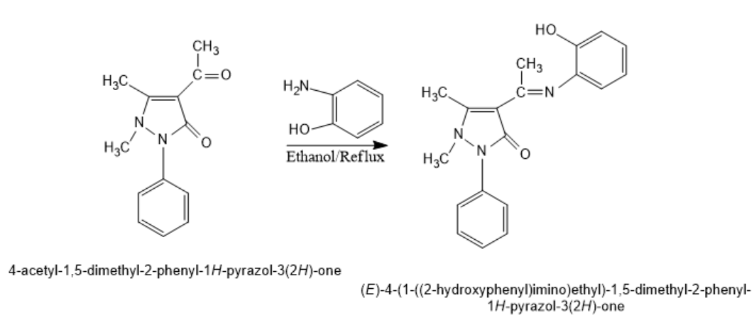
Scheme 2: Synthetic route for the (E)-4-(1-((2-hydroxyphenyl)ethyl)-1-5-dimethyl-2-phenyl-1H-pyrazol-3(2H)-one ligand

2.2 Synthesis of Co(II) Complex of (E)-4-(1-((2-hydroxyphenyl)ethyl)-1-5-dimethyl-2-phenyl-1H-pyrazol-3(2H)-one
The metal complex was prepared by reacting non-aqueous solutions of the metal salt (Co(II)) with ethanol solutions of the ligand in a 1:2 molar ratio.
The ligand (E)-4-(1-((2-hydroxyphenyl)ethyl)-1-5-dimethyl-2-phenyl-1H-pyrazol-3(2H)-one(1.0 g, 0.00312) mol) was dissolved in 10 mL of ethanol in a round-bottom flask and heated for 30 seconds on a heating mantle. The Co(II) acetate (0.390 g, 0.00156 mol) was dissolved in 10 mL of ethanol in a separate round-bottom flask. The ligand was then carefully added, with continuous stirring, to the Co²⁺ solution, and the mixture was refluxed for 4 hours in a 250 mL round-bottom flask on a heating mantle. The solution was left to crystallize for 24 hours. The Brownish grey crystals obtained were filtered and dried over silica gel in a desiccator (Yield, 78%, M.P., >296°C).IR (KBr, ѵ/cm⁻¹): 1633 v(C=O), 2864 v(C-CH₃), 725 v(C₆H₆), 1512 v(C=N), 1485 v(C=C), 2200 v(C-H), 561 v(M-O), 721 v(M-N). XRD (2θ, Å ): 28.00, 37.20, 3.19, 2.43. UV–Vis (DMSO, λmax, nm): 435 (SLOACo, strong band due to coordination and conjugation disruption). GC-MS (m/z): cal., 698.90; found, 698.90
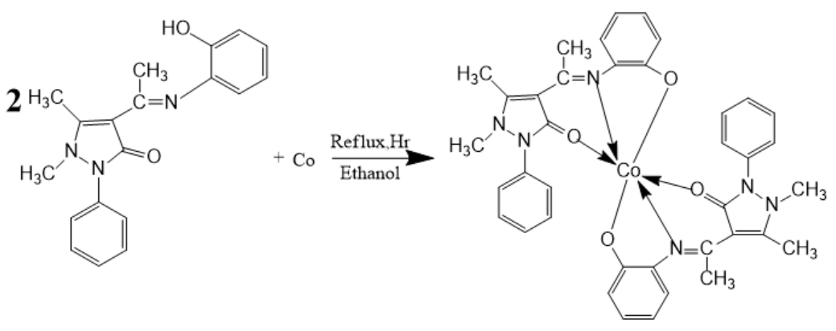
Scheme 3: Synthetic Route for the Co(II) Complex
3. RESULT AND DISCUSSION
The ligand (E)-4-(1-((2-hydroxyphenyl)ethyl)-1-5-dimethyl-2-phenyl-1H-pyrazol-3(2H)-one was prepared by the condensation reaction of equimolar concentrations of 4-acetyl-1,5-dimethyl-2-phenyl-1H-pyrazol-3(2H)-one(4-acyl antipyrine) and 2-hydroxylaniline(Scheme 2), while the Co(II) complex of the ligand was prepared by a 1:2 mole ratio of metal salt and ligand. The synthesized ligands (LOA, SLOA) and its Co(II) complex (SLOACo) were obtained in yields of 80%,86% and 78%, respectively, demonstrating moderate to good synthetic efficiency, with a higher yield observed upon complexation. The ligand (SLOA)was isolated as a black amorphous powder with a melting point of 232°C, whereas SLOACo appeared as purple crystals with a higher melting point of >296°C, indicating improved thermal stability due to cobalt coordination (Table1). The increase in melting point is attributed to the increase in mass of the formed complex and thus provide evidence for complexation. These variations in yield, colour, and melting point are consistent with reported trends for Schiff base metal complexes, where chelation typically enhances stability and alters physicochemical properties [9,10].

Table 1 Characteristic Physical Properties of Synthesized Compound

Compound | Percentage Yield% | Melting Point (⁰C) | Colour
SLOA | 86 | 232 | Black
SLOACo | 78 | >296 | Brownish grey

The characteristic FTIR Spectral data of ligand and complex (Figure 1), the Schiff base ligand SLOA (I,700.65cm⁻¹) showed a notable shift to higher wavenumbers indicating increase C=O bond strength due to coordination with metal through its oxygen [9]. Metal complex show C=O stretching shifted back to lower frequency value (1,633.54 cm⁻¹) suggesting co-ordination of oxygen to metal. The Schiff base SLOA has a frequency value (3,500.06cm⁻¹) assigned to v(OH) in the aromatic ring. The absorption band assigned to C=N Stretching in the Schiff base ligand as seen in SLOA – 1,582.90cm⁻¹ confirming Schiff base formation. In complexes, C=N band shift downward (e.g., SLOACo -1,512.12 cm⁻¹) as seen in table 2 indicate consistent coordination via azomethine nitrogen to the metal [28,32]. The ligand and metal complex show absorption band at 2,998.95cm⁻¹ and 2, 864.30 cm⁻¹ v(C-CH₃), 800.62 cm⁻¹ and 725.80 cm⁻¹ v(C₆H₆), 1,446.38 cm⁻¹ and 1,485.17 cm⁻¹ v(C=C), 2,998.95 cm⁻¹ and 2,200.06 cm⁻¹ (C-H) respectively. SLOACo exhibit absorption band at 561.38 cm⁻¹ and 721.80 cm⁻¹ attributed to v(M-O) and v(M-N) respectively, indicating coordination of both oxygen and nitrogen donor atoms to the metal [10].

Table 2 Comparative FTIR Absorption Bands of the SLOA and its Co(II) Complex

Compounds | (C=O) | (C-CH₃) | (O-H) | (C₆H₆) | (C=N) | (C=C) | (C-H) | (M-O) | (M-N)
SLOA | 1,700.65 | 2,998.95 | 3,500.06 | 800.62 | 1,582.90 | 1,446.38 | 2,998.95 | - | -
SLOACo | 1,633.54 | 2,864.30 | - | 725.80 | 1,512.12 | 1,485.17 | 2,200.06 | 561.38 | 721.80

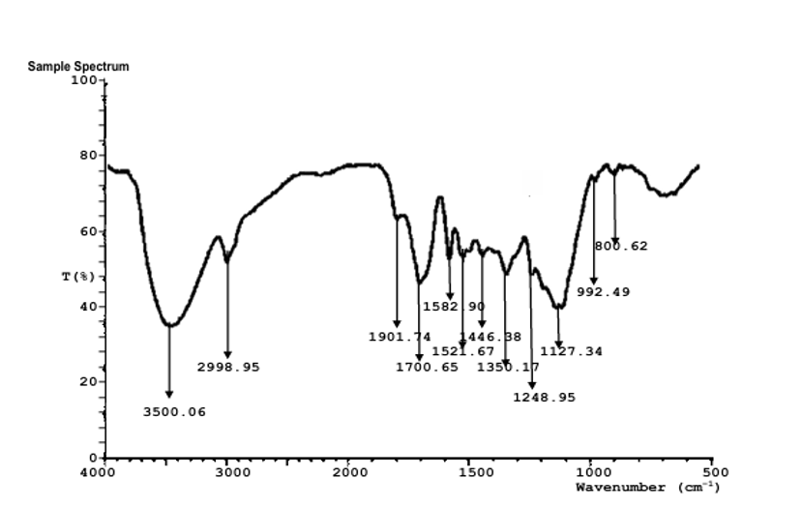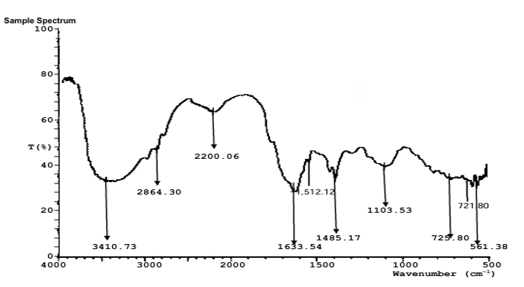
SLOACo
SLOA

Figure 1: Comparative FTIR Absorption Spectra of the Ligand (SLOA)and Its Co(II) Complex (SLOACo)

The GC–MS spectrum of the Schiff base ligand displayed a molecular ion peak at m/z 321.0, consistent with the calculated molecular mass (321.0 g/mol), confirming the successful synthesis of the compound. Fragmentation yielded a characteristic peak of 107.0 m/z and 214.0 m/z, corresponding to acetyl chloride antipyrine and aniline moiety in the Schiff base, which confirms the stability of the fragment ion in the Schiff base. Additional peaks, including a fragment at 223.1 m/z, support the presence of the 4- acyl antipyrine, together providing strong analytical evidence for the proposed molecular structure. The SLOACo Complex showed a molecular ion peak at m/z 698.9 and a fragmentation pattern with peaks at m/z 106.1, 214.1 and 320.0, indicating the presence of multiple structural fragments. The fragment ion with peak 640 m/z showed that the co-ordination of the Schiff base ligand (SLOA) with the metal ion is in the ratio of 2:1

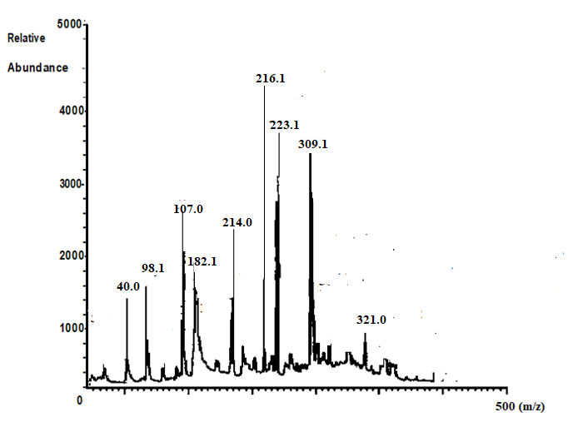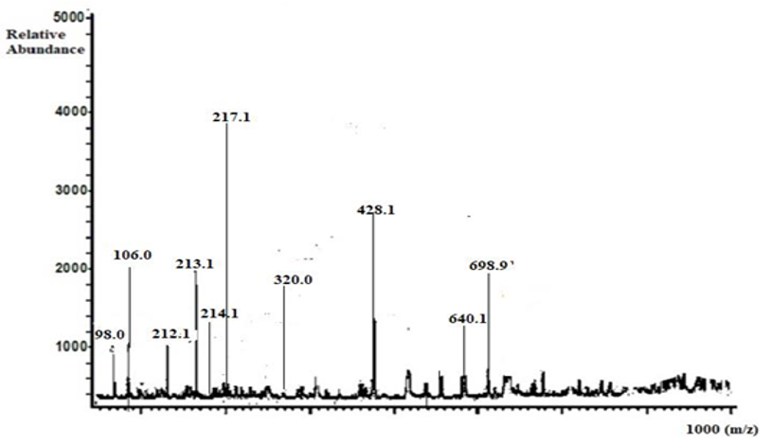
SLOACo
SLOA

Figure 2: Comparative GC-MS Spectra of the Ligand (SLOA)and Its Co(II) Complex (SLOANi)

The XRD pattern of Schiff base ligand SLOA exhibits broad peaks at 21.98, 25.98, 4.04, and 3.43, indicating a partially amorphous structure with quartz and graphite phases, consistent with the absence of metal coordination. In contrast, the SLOACo complex displays sharp, distinct peaks at 28.00, 37.00, 3.19, and 2.43, which are indexed to crystalline cobalt and cobalt oxide phases, confirming successful metal complexation. This shift from amorphous characteristics in the ligand to well-defined crystalline patterns in the complex demonstrates the formation of a stable coordination compound.

Table 3: Comparative Power XRD diffraction Patterns of the SLOA and Its Co(II) Complex
Sample | Main Peak | Main identified phase | Crystalline and Amorphous | Interpretations
SLOA | 21.98, 25.98  4.04, 3.43 | Amorphous, quartz | Partially Amorphous | Schiff8 base formation enhanced crystalline; aromatic stacking observed.
SLOACo | 28.00, 37.00  3.19,2.43 | Cobalt and Cobalt oxide | Crystalline | Sharp peaks confirm Co–Schiff base coordination with good crystallinity

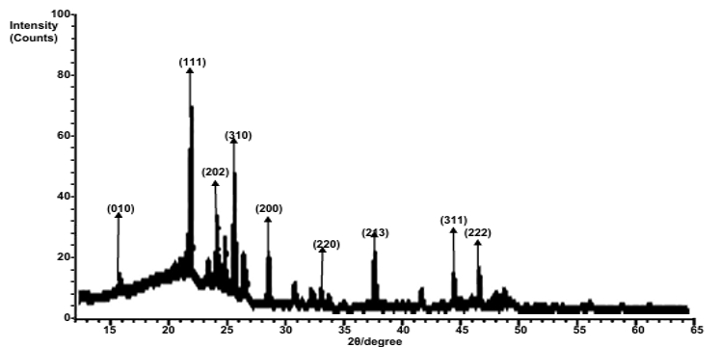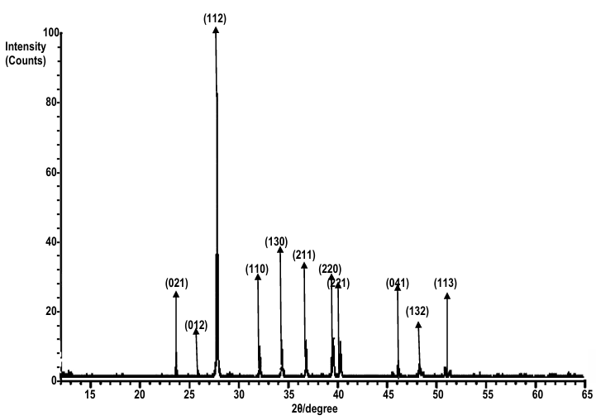
SLOACo
SLOA

Figure 3: Comparative XRD diffraction Peaks of the SLOA and Its Co(II) Complex

The UV-Vis absorption spectrum of the ligand SLOA exhibited a maximum absorption wavelength (λ_max) at 278 nm, ascribed to n π* and attributed to an intramolecular charge transfer (ICT) transition from the 4- acyl antipyrine (donor) to the 2- hydroxyl aniline (acceptor), reflecting its electronic structure in the free state while for the SLOACo complex, the λ max (wavelength) shifted to 435 nm, attributed to dd* which is indicative of strong coordination and disruption of conjugation due to the metal-ligand interaction, altering the electronic environment.
Table 4: UV-Vis Absorption Trends and Structural Correlations for SLOA and SLOACo
Sample | Wavelength Λ(nm) | Elemental Tranistion | Interpretation
SLOA | 278 | n π* | ICT transition: 4-acyl antipyrine (donor) → 2-hydroxyl aniline(acceptor)
SLOACo | 435 | dd* | Strong coordination + conjugation disruption

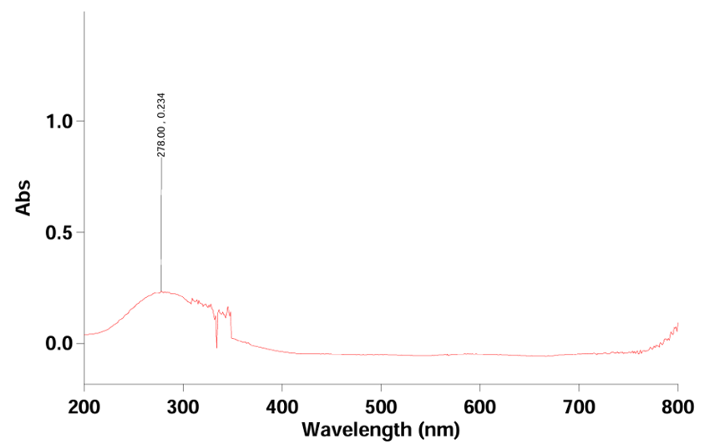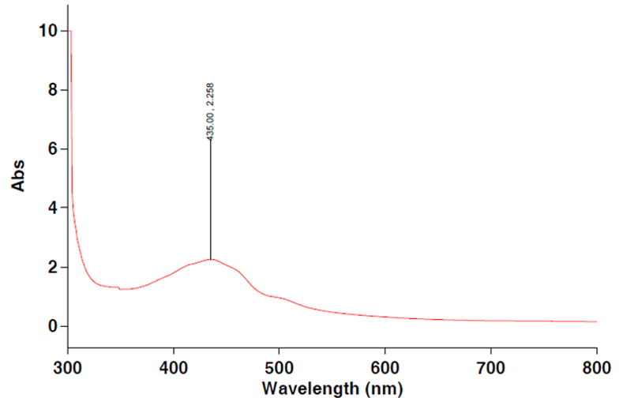
SLOACo
SLOA
Figure 4: UV-Vis Absorption Spectra for SLOA and SLOACo

Antimicrobial Activities of (E)-4-(1-((2-hydroxyphenyl)ethyl)-1-5-dimethyl-2-phenyl-1H-pyrazol-3(2H)-one Schiff base Ligand SLOA and Its Co(II) Complex
The antimicrobial Susceptibility of the synthesized compounds was evaluated against five clinical test organisms, including two Gram-negative bacteria (Escherichia coli and Salmonella typhi), two Gram-positive bacteria (Staphylococcus aureus and Streptococcus pyogenes), and a fungal strain (Candida albicans). The Disc diffusion method [10] revealed varying degrees of inhibition, highlighting the structure–activity relationships between the Schiff base ligand (SLOA) and its metal complex (SLOACo), (Table 5).
The antimicrobial susceptibility testing showed that the Schiff base ligand SLOA exhibited varying zones of inhibition, with susceptibility against Salmonella typhi (18 mm), Staphylococcus aureus (18 mm), and Candida albicans (16 mm), while SLOA shows resistant against Escherichia coli (12mm) and Streptococcus pyogenes (10 mm). The SLOACo complex demonstrated enhanced activity, with susceptibility observed across all tested organisms (E. coli, 24 mm; S. aureus, 22 mm; S. pyogenes, 26 mm; S. typhi, 30 mm; C. albicans, 28 mm), suggesting improved efficacy upon coordination with Co(II). The metal complex showed great inhibition against test microorganisms because of lipophilicity which is the ability of metal complex to dissolve in lipids or soluble in fat, since the cell membrane of microorganisms are made up of lipids. The lipophilic metal complex can penetrate the cell wall of the test organism and inhibit their growth. Compared to the control antibiotics levofloxacin (12–30 mm) and and nystatin (30 mm), both SLOA and SLOACo showed moderate activity, with SLOACo outperforming SLOA.
Table 5: Antimicrobial Susceptibility Testing of the Synthesized Schiff base Ligand (SLOA) and Co(II) (SLOACo) Complex compared to Control Drugs

Test Organisms/Zones of Inhibition (mm)
Compounds | Salmonella typhi | Escherichia coli | Staphylococcus aureus | Streptococcus pyogenes | Candida albicans
SLOA | 18 | 12 | 18 | 10 | 16
SLOACo | 30 | 24 | 22 | 26 | 28
Levofloxacin ( control antibiotics) | 12 | 30 | 30 | 26 | -
Nystatin | - | - | - | - | 26

Key:
- mm = Millimeter
Clinical Laboratory Standard Institute Guideline for Antimicrobial Agents
- R = Resistant (0 – 12 mm)
- S = Susceptible (16 mm and above)
- I = Intermediate (13–15 mm).
- - = No Inhibition

The minimum inhibitory concentration (MIC) results (Table 6) showed that the Schiff base ligand SLOA needed higher concentrations (500 mg/mL for E. coli, 250mg/ml for S. aureus) to inhibit growth, with no activity (ND) against S. pyogenes,C.albicans and S.typhi In comparison, the SLOACo complex exhibited a broader activity profile, with higher MIC values (125 mg/mL for E. coli and S. pyogenes, 250mg/ml for S. aureus, 62.5mg/ml for S.typhi and C. albicans), indicating increased potency and a wider spectrum of effectiveness following metal complexation. The potency of the metal complex suggest that coordinating Co(II) with the ligand may enhance its ability to penetrate bacterial and fungal cell membranes because of its ability to dissolve lipid and inhibit the growth of the micro- organisms.
Table 6: Minimum Inhibitory Concentrations (MIC) of the Synthesized Schiff base Ligand and Co(II) Complex.
Test Organisms/Zones of Inhibition (mm)
Compounds | Escherichia coli | Staphylococcus aureus | Streptococcus pyogenes | Salmonella typhi | Candida albicans
SLOA | 500 | 250 | ND | ND | ND
SLOACo | 125 | 250 | 125 | 62.5 | 62.5

Key:
- mg/ml = Milligram per millilitre
- ND = Not detected
The minimum bactericidal/fungicidal concentration (MBC/MFC) (Table 7) testing revealed no detectable bactericidal or fungicidal activity (ND) for SLOA. In comparison with SLOACo (500 mg/ml E. coli and S. pyogenes, 250 for mg/ml S. typhi, and C. albicans), indicating enhanced ability to penetrate the cell membrane of the microorganisms inhibiting the growth of bacteria and fungi. There is no activity (ND) for the S.aureus. This of bactericidal/fungicidal activity suggests SLOACo act primarily as bacteriostatic or fungistatic agents, inhibiting growth with eradicating the pathogens, which enhance their therapeutic potential as standalone antimicrobial agents expect S.aureus which recorded no activity for bactericidal or fungicidal (ND) .
Table 7: Minimum Bactericidal/Fungicidal Concentrations of the Synthesized Ligand and Complex
Test Organisms/Zones of Inhibition (mm)
Compounds | Escherichia coli | Staphylococcus aureus | Streptococcus pyogenes | Salmonella typhi | Candida albicans
SLOA | ND | ND | ND | ND | ND
SLOACo | 500 | ND | 500 | 250 | 250
Key:
- mg/ml = Milligram per millilitre
- ND = Not detected

4. CONCLUSION
This research achieved the successful synthesis and characterization of a Schiff base ligand (SLOA) using 2-hydroxyaniline with acetyl chloride antipyrine (4-acyl antipyrine) and Co(II) complex. The melting point of the metal complexes was higher than that of the ligands but later melted and decomposed. The increases in melting point are attributed to the increase in mass of the formed complex and thus provide evidence for complexation. Complexation of Co(II) complex was successful using the Schiff base ligand as shown by GCMS, FTIR, UV-VIS Spectrometric spectra interpretation.
The antimicrobial activities revealed that the complex show greater potency than the Schiff base ligand on the test organism due to chelation.
However, the interpretation from GCMS, UV-VIS, and FTIR deduced that the octahedral geometry was proposed for the structure of the metal complex.

Disclaimer (Artificial intelligence)
Option 1:
Author(s) hereby declare that NO generative AI technologies such as Large Language Models (ChatGPT, COPILOT, etc.) and text-to-image generators have been used during the writing or editing of this manuscript.
Option 2:
Author(s) hereby declare that generative AI technologies such as Large Language Models, etc. have been used during the writing or editing of manuscripts. This explanation will include the name, version, model, and source of the generative AI technology and as well as all input prompts provided to the generative AI technology
Details of the AI usage are given below:
1.
2.
3.
REFERENCES
- Jensen, B.S., (1959) Acta chem. Scand 13.1668
- Yousri, A., Hassan, M., El-Faham, A., Barakat, A., Haukka, M., Tatikonda, R., Abu-Youssef, M. A., & Soliman, S. M. (2025). Homoleptic Co(II) and Ni(II) complexes with promising anticancer and antimicrobial activities; Synthesis, X-ray structure, and DFT studies. Journal of Molecular Structure, 1321, 139774. https://doi.org/10.1016/j.molstruc.2024.139774
- Sharma, P., Sharma, D., Sharma, A., Saini, N., Goyal, R., Ola, M., Chawla, R., & Thakur, V. (2020). Hydrazone comprising compounds as promising anti-infective agents: Chemistry and structure-property relationship. Materials Today Chemistry, 18, 100349. https://doi.org/10.1016/j.mtchem.2020.100349
- Silas, C. U., Ezenweke, L. O., Ojiako, E. N., & Ebosie, N. P. (2025). Synthesis, characterization, and study of anti-microbial properties of Fe (III) Schiff base complex derived from hydrazone and benzaldehyde. International Journal of Latest Technology in Engineering, Management & Applied Science (IJLTEMAS), 14(9), 499–505. https://doi.org/10.51583/IJLTEMAS.2025.1409000062 Agili, F. (2024). Novel Hydrazide Hydrazone Derivatives as Antimicrobial Agents: Design, Synthesis, and Molecular Dynamics. Processes, 12(6), 1055. https://doi.org/10.3390/pr12061055
- Paruch, K., Popiołek, L., Biernasiuk, A., Malm, A., Gumieniczek, A., & Wujec, M. (2020). Novel Derivatives of 4-Methyl-1,2,3-Thiadiazole-5-Carboxylic Acid Hydrazide: Synthesis, Lipophilicity, and In Vitro Antimicrobial Activity Screening. Applied Sciences, 11(3), 1180. https://doi.org/10.3390/app11031180
- Wang, C., Wei, X., Zhong, L., Chan, C.-L., Li, H., & Sun, H. (2025). Metal-based approaches for the fight against antimicrobial resistance: Mechanisms, opportunities, and challenges. Journal of the American Chemical Society, 147(15), 12361–12380. https://doi.org/10.1021/jacs.4c16035
- Venkatesh, G., Vennila, P., Kaya, S., Ahmed, S. B., Sumathi, P., Siva, V., Rajendran, P., & Kamal, C. (2024). Synthesis and Spectroscopic Characterization of Schiff Base Metal Complexes, Biological Activity, and Molecular Docking Studies. ACS Omega, 9(7), 8123. https://doi.org/10.1021/acsomega.3c08526
- Matshwele, J. T., Odisitse, S., Mazimba, O., Demissie, T. B., Koobotse, M. O., Mapolelo, D. T., Bati, K., Julius, L. G., Nkwe, D. O., Jongman, M., & Nareetsile, F. M. (2024). Cobalt pyridyl complexes against drug-resistant bacteria: Synthesis, characterization, antibacterial properties, mode of action, and molecular docking studies. Inorganica Chimica Acta, 563, 121911. https://doi.org/10.1016/j.ica.2024.121911
- Okolo, A.J., Ezenweke, L.O., Emmanuel, I.V., Osuagwu, C.C., Usiakpebru, A.E. (2022). Synthesis of Acetyl Resorcinol and Investigation of the Anti-Microbial Potentials of Some of its Metal Complexes. International Journal of Research and Innovation in Applied Science (IJRIAS) 7(6) 59-63.
- Jayarajan, R., Vasuki, G., & Sambasiva Rao, P. (2010). Microwave assisted synthesis of Schiff bases and their antimicrobial studies. International Journal of ChemTech Research, 2(4), 2055–2060.

