Energy Efficient Hybrid Precoding for SWIPT in mmWave Massive MIMO NOMA Systems

ABSTRACT

The integration of simultaneous wireless information and power transfer (SWIPT) into millimeter-wave (mmWave) massive MIMO–non-orthogonal multiple access (NOMA) systems is a promising paradigm for sustainable, high-capacity wireless networks. However, achieving high energy efficiency (EE) in these systems is challenging due to severe propagation losses and the constraints of hybrid precoding. This paper proposes a novel hybrid analog–digital transceiver framework that jointly optimizes power allocation and power-splitting factors. The key contributions include a dynamic cluster-head selection (DCHS) algorithm for forming interference-resilient user groups and a compressed sensing–based committee machine design (CS-COMADE) to enhance array gain and mitigate interference. To solve the non-convex EE maximization problem, we develop a low-complexity iterative resource allocation algorithm. Simulation results demonstrate that our method achieves substantial gains, improving EE by up to 20% over conventional SWIPT-based MIMO–OMA and hybrid NOMA schemes. Notably, it attains near-optimal performance compared to fully digital zero-forcing precoding while reducing power consumption by over 60%. These findings confirm the framework’s viability as an energy-efficient solution for green 5G and 6G communication systems, effectively balancing high data rates with sustainable operation.

Keywords: Energy efficiency, SWIPT, hybrid precoding, mmWave, MIMO, NOMA, power optimization

1. INTRODUCTION

The exponential growth of data-intensive applications, smart devices, and ubiquitous connectivity demands in fifth-generation (5G) and upcoming sixth-generation (6G) networks has intensified the need for energy-efficient wireless communication systems [1]-[3]. While millimetre-wave (mmWave) massive multiple-input multiple-output (MIMO) and non-orthogonal multiple access (NOMA) technologies have greatly enhanced spectrum utilization, their deployment faces significant energy consumption challenges due to high radio-frequency (RF) chain density, complex beamforming, and increased hardware losses [1],[4]. To support sustainable network operation, future systems must achieve not only high spectral efficiency but also optimized energy efficiency (EE) under practical power and hardware constraints.

Energy efficiency has therefore become a core design objective for next-generation radio access networks. The combination of simultaneous wireless information and power transfer (SWIPT) and hybrid analogue–digital precoding presents a promising approach to achieving this objective [5], [6]. SWIPT enables receivers to harvest energy and decode information from the same RF signal, reducing dependency on fixed power sources and extending device lifetimes. However, effectively balancing harvested energy and communication quality-of-service (QoS) in multi-user mmWave MIMO–NOMA environments remains a significant research challenge due to the non-convex coupling between beamforming, power allocation, and power-splitting ratios [7]-[10].

Conventional digital precoding techniques, while effective for fully digital architectures, are computationally expensive and power-hungry in large antenna arrays. Hybrid precoding architectures, which combine low-dimensional baseband precoders with analogue phase-shifter networks, reduce RF hardware costs and energy consumption [11], [12]. Nonetheless, the limited phase resolution of analogue precoders and inter-user interference inherent in NOMA systems can severely degrade system efficiency if not properly optimized.

Recent studies have explored various strategies to enhance energy efficiency in hybrid mmWave MIMO systems, such as low-resolution phase shifters, antenna selection, user clustering, and power control schemes [13], [14]. In particular, [3] examined user grouping via clustering (affinity propagation), analogue and digital precoders, and iterative resource allocation to improve EE under SWIPT, showing substantial gains over conventional schemes. Similarly, work on [14] addresses energy efficiency in SWIPT + NOMA with power splitting under non-linear EH models and diverse QoS constraints [15].

In response, this study proposes a comprehensive framework for optimizing energy efficiency in SWIPT-enabled hybrid precoding–based mmWave massive MIMO–NOMA systems. The framework integrates a dynamic cluster-head selection algorithm for forming user groups with minimal channel correlation and reduced inter-beam interference, a compressed sensing–based committee machine design (CS-COMADE) to enhance array gain and suppress inter-user interference, and an iterative joint optimization algorithm for power allocation and power-splitting factors to maximize overall system energy efficiency. The remaining sections of this study are structured as follows: Section 2 presents a review of related works, while Section 3 details the research methodology used. The results and their discussion are provided in Section 4. Finally, Section 5 concludes the study, summarizing key findings, followed by a comprehensive list of referenced literature.

2. Review of Related LITERATURE

This section reviews related works in four key domains relevant to this study: mmWave communications and massive MIMO, hybrid analogue–digital precoding, the integration of NOMA in mmWave systems, and SWIPT-based energy harvesting. These areas collectively reinforce the development of energy-efficient next-generation wireless communication frameworks.

2.1 mmWave Communications and Massive MIMO

The utilization of mmWave frequencies (30–300 GHz) has emerged as a critical enabler for ultra-high-throughput 5G and future 6G networks due to the availability of large contiguous bandwidths and the capability to deliver gigabit-per-second data rates [1], [2]. However, these frequencies suffer from severe propagation loss, atmospheric attenuation, and limited diffraction, which constrain link reliability. To overcome these impairments, massive MIMO systems utilize a large number of antenna elements to form highly directional beams, compensating for high path loss and improving both spectral and energy efficiencies [3]–[5].

Ayach et al. [16] introduced a hybrid analogue/digital precoding approach, formulated as a sparse reconstruction problem, which is solved by the orthogonal matching pursuit (OMP) algorithm. This pioneering framework demonstrated the feasibility of hybrid beamforming for mmWave MIMO, but also revealed computational inefficiency due to the use of single-column index selection in each iteration. Later extensions, such as generalized OMP (gOMP) and order-recursive least squares (ORLS) [17], improved convergence speed while maintaining satisfactory spectral performance. Despite these improvements, the lack of adaptive feedback and backtracking mechanisms in such algorithms limits their effectiveness in real-time energy-aware implementations.

To further improve scalability, Huang et al. [3] and Yu et al. [18] examined array design and phase-shifter resolution trade-offs, showing that low-resolution precoding can offer favourable EE performance when carefully optimized. Nonetheless, mmWave MIMO systems still face a complex balance between array gain, power consumption, and hardware cost, making energy-efficient hybrid transceiver design a continuing research challenge.

2.2 Hybrid Analog–Digital Precoding

Hybrid precoding combines the high beamforming gain of analogue architectures with the flexibility of digital baseband processing to reduce the number of required RF chains [18], [19]. Two primary configurations are widely discussed: fully connected, which maximizes spectral efficiency (SE) but consumes more power, and partially connected, which improves EE by lowering hardware complexity. Yu et al. [18] demonstrated alternating minimization algorithms for hybrid precoding that approach the performance of fully digital zero-forcing (ZF) while drastically reducing power consumption.

Huang et al. [17] later analyzed the impact of quantized phase shifters and reported that even a 2- to 3-bit resolution can maintain up to 9 % of the SE of unconstrained systems. Subsequent studies [7], [8] have validated that energy-optimized hybrid precoders can achieve substantial reductions in dynamic and circuit power consumption compared with their digital counterparts, particularly in large-array regimes.

2.3 Integration of NOMA in mmWave Systems

Non-orthogonal multiple access (NOMA) has been extensively studied as a means of improving spectral utilization by allowing multiple users to share the same time–frequency resources through superposition coding and successive interference cancellation (SIC) [20], [21]. When applied to mmWave MIMO, NOMA supports multiple users per beam, thereby alleviating the limitation imposed by the number of RF chains [22].

Dai et al. [20] analyzed power-efficient hybrid precoding for mmWave massive MIMO-NOMA systems and demonstrated that dynamic user grouping can enhance EE by balancing beamforming gain and power allocation. Yet, their approach did not address the mitigation of inter-beam interference or the non-convexity inherent in joint power-splitting problems.

More recent frameworks introduce clustering-based NOMA in which users are grouped according to channel correlation and gain disparity to maximize both SE and EE [21], [23]. Despite this, most clustering schemes rely on static thresholds and fail to adapt to varying propagation conditions or dynamic energy harvesting requirements. The need for dynamic, channel-aware cluster-head selection thus remains a critical research gap addressed in this work.

2.4 SWIPT-Based Energy Harvesting

SWIPT has become a central technique for enabling self-powered communication nodes and prolonging device lifetime in dense networks [24]-[26]. Early studies, such as those by Zhou et al. [27] and Clerckx et al. [12], examined the rate–energy trade-off in single-user and multi-user systems, respectively, and established fundamental relationships between power-splitting ratios, circuit energy efficiency, and achievable throughput.

In multi-user scenarios, mmWave MIMO-NOMA with SWIPT introduces additional coupling between beamforming and resource allocation variables, making closed-form optimization intractable [21]. Dai et al. [21] proposed power-efficient hybrid precoding algorithms for MIMO-OMA systems with SWIPT but did not account for the NOMA structure or inter-user interference suppression. Recent works extend SWIPT integration to hybrid architectures [22], [28], showing notable gains in EE when appropriate transceiver optimization and power-splitting coordination are applied.

Nevertheless, prior research often simplifies the energy harvesting model or assumes idealized RF hardware. The joint design of hybrid precoding, dynamic user clustering, and iterative power optimization under practical constraints remains largely unexplored. This study therefore contributes a comprehensive framework that addresses these limitations by combining dynamic cluster-head selection, CS-COMADE-based hybrid precoding, and iterative joint power allocation/power-splitting optimization for SWIPT-enabled mmWave massive MIMO-NOMA systems.

3. Research Methodology

This section outlines the methodological framework used to develop, analyze, and validate the proposed energy-efficient hybrid precoding architecture for SWIPT-enabled mmWave massive MIMO–NOMA systems. The study combines algorithmic design, mathematical modelling, and simulation analysis to achieve joint optimization of transceiver structure and resource allocation.

3.1 Overview of the Proposed Method

The proposed methodology involves five main phases:
- Joint Transceiver and Power-Splitting Optimization: A joint framework is formulated to optimize both the transceiver design and power-splitting parameters for simultaneous wireless information and power transfer (SWIPT). Compressed sensing (CS) theory is employed to construct a sparse representation of hybrid precoders, enabling efficient energy-aware signal reconstruction [16], [18].
- Dynamic Cluster-Head Selection (DCHS) Algorithm: A dynamic clustering mechanism is developed to select one representative user (cluster head) per beam based on minimum inter-beam channel correlation. This ensures improved spatial multiplexing gain and mitigates inter-beam interference, thereby enhancing energy efficiency compared with static clustering methods [20], [22].
- Compressed Sensing-Based Committee Machine Design (CS-COMADE): We propose CS-COMADE, a novel fusion technique that distinguishes itself from standard ensemble methods by operating directly on the sparse support sets within the compressed sensing (CS) framework for hybrid precoding. Unlike simple averaging or voting schemes, CS-COMADE treats multiple CS-based precoding algorithms (e.g., OMP, gOMP) as "committee members." It fuses their proposed antenna support sets—the indices of antennas selected for active beamforming—into a consensus support set that is more robust and accurate than any single method can provide. This consensus set is then used to construct the final analog precoder, leading to superior array gain and more effective inter-user interference mitigation than existing hybrid precoding fusion techniques, which typically combine full precoder matrices rather than sparse supports. This approach leverages ensemble learning concepts for transceiver optimization [18], [28].
- Iterative Optimization of Power Allocation and Power Splitting: Since joint resource allocation results in a non-convex optimization problem, an iterative approach is proposed to achieve suboptimal but computationally efficient solutions. The algorithm alternates between updating power-splitting ratios and adjusting transmit power across users and beams to maximize total energy efficiency while satisfying minimum rate and energy-harvesting constraints [27]–[29].
- Performance Validation and Benchmarking: The proposed algorithms are implemented in MATLAB and benchmarked against established baselines, namely SWIPT-based MIMO-OMA [28], SWIPT MIMO-NOMA [30], and fully digital zero-forcing (ZF) precoding schemes.

3.2 System Model and Problem Formulation

A single-cell downlink mmWave massive MIMO-NOMA system is considered in which the base station (BS) employs $N_{t}$ antennas and $N_{RF}$ RF chains to simultaneously serve $K$ single-antenna users. Each user is equipped with a power-splitting receiver, which divides the incoming RF signal into two components: one for information decoding (ID) and the other for energy harvesting (EH) [27].

The system employs a hybrid precoding structure, comprising a low-dimensional digital baseband precoder and an analogue RF precoder implemented via quantized phase shifters [18]. In the fully connected architecture, each RF chain is connected to all antennas, while in the partially connected architecture, each RF chain drives a disjoint subset of antennas [19].
Let $A$and $F_{BB}$denote the analog and digital precoding matrices, respectively. The transmitted signal is represented as
$x=AF_{BB}s$ (1)
where $s$ is the vector of superimposed NOMA symbols. Each beam can serve multiple users through superposition coding and successive interference cancellation (SIC) [20], [21].
The received signal at the $m^{th}$ user of the $q^{th}$ beam can be written as given in (2):
$y_{q,m}=h_{q,m}^{H}AF_{BB}s+n_{q,m},$ (2)
where $h_{q,m}$ denotes the mmWave channel vector and $n_{q,m}\sim CN(0,σ^{2})$ is the complex additive white Gaussian noise. The channel is modeled using a geometric Saleh-Valenzuela model with $L$ dominant scatter paths [16]. The channel vector for the user is given by:
$h_{q,m}=\sqrt{\frac{N_{t}}{L}\sum_{l=1}^{L}{α_{q,m}^{\left(l\right)}}}a\left(θ_{q,m}^{\left(l\right)}\right)$ (3)
where $α_{q,m}^{(l)}∼CN(0,1)$ represents the complex gain of the $l$-th propagation path, $θ_{q,m}^{(l)}$ denotes the azimuth angle of arrival (AoA) corresponding to that path, and $a(θ)$is the uniform linear array (ULA) response vector, which characterizes the spatial response of the antenna array as a function of the incident angle $θ$.

The power-splitting receiver divides $y_{q,m}$ into information-decoding and energy-harvesting components:
$y_{q,m}^{ID}=\sqrt{1-ρ_{q,m}} y_{q,m},y_{q,m}^{EH}=\sqrt{ρ_{q,m}} y_{q,m},$ (4)
where $ρ_{q,m}∈[0,1]$is the power-splitting ratio. The energy harvested is proportional to $ρ_{q,m}$ and the received power, considering a conversion efficiency $η$ [27], [29].

The optimization problem is formulated as maximizing the system energy efficiency:
$\underset{A, F_{BB}, ρ, p}{max⁡} \frac{\sum_{q=1}^{N_{RF}}{\sum_{m=1}^{M_{q}}{R_{q,m}}}}{P_{tot}}$ (5)
subject to the following constraints:
- Total Power Constraint:
$$\sum_{q=1}^{N_{RF}}{∥AF_{BB}^{(q)}∥_{F}^{2}≤P_{\text{max}}}$$
- Minimum Rate Constraint:
$$R_{q,m}≥R_{\text{min}},∀q,m$$
- Minimum Harvested Energy Constraint:
$$E_{q,m}^{EH}≥E_{\text{min}},∀q,m$$
- Power Splitting Ratio Constraint:
$$0≤ρ_{q,m}≤1,∀q,m$$
- Analogue Precoder Constant Modulus Constraint:
$$∣A_{i,j}∣=1,∀i,j$$
where $M_{q}$ denotes the number of users in the $q$-th cluster, $P_{\text{max}}$ is the maximum allowable transmit power, $R_{\text{min}}$ is the minimum data rate requirement per user, and $E_{\text{min}}$ represents the minimum harvested energy threshold for each user.
3.3 Dynamic Cluster-Head Selection Algorithm

To manage user clustering efficiently, the Dynamic Cluster-Head Selection (DCHS) algorithm selects one user per beam that exhibits the highest channel gain while maintaining minimal correlation with existing cluster heads. The selection procedure iteratively updates correlation thresholds and candidate pools until all beams are assigned distinct cluster heads [20].

This mechanism achieves two benefits: (i) low inter-beam interference and (ii) enhanced energy efficiency by avoiding redundant beamforming toward correlated users. The chosen cluster heads serve as reference users for subsequent hybrid precoder design.

3.4 Hybrid Precoding and CS-COMADE Framework

Building on the selected cluster heads, hybrid precoding is designed in two stages.
- Analog Precoding: The analogue precoder $A$ maximizes the array gain toward cluster heads subject to phase quantization limits [18].
- Digital Precoding: A low-complexity ZF digital precoder $F_{BB}$ eliminates inter-beam interference based on equivalent channels derived from the analogue stage [17].
To further enhance robustness, the Compressed Sensing-Based Committee Machine Design (CS-COMADE) aggregates multiple hybrid precoding solutions (e.g., OMP and gOMP) into a combined support set. This ensemble yields higher precoding accuracy and superior energy efficiency by exploiting common support consensus among algorithms [16], [19].

3.4.1 The CS-COMADE framework: mechanism and novelty

The CS-COMADE is introduced to overcome the limitations of single-algorithm dependency in hybrid precoding.
- Committee Formation: A committee of $M$ distinct CS-based precoding algorithms (e.g., OMP [16], gOMP [17]) is initialized. Each member algorithm $i$ independently processes the channel matrix $H$ to propose a sparse support set $Ω_{i}$, which represents the indices of the array response vectors selected for the analog precoder.
- Support Set Fusion: Unlike standard ensemble methods that might average the computed precoding matrices—a suboptimal approach due to the constant modulus constraint of analogue phase shifters—CS-COMADE fuses the information at the support set level. The final, consolidated support set $Ω_{\text{final}}$ is determined by selecting the antenna indices with the highest frequency of occurrence across all $M$ proposed sets $\{Ω_{1},Ω_{2},...,Ω_{M}\}$. This can be expressed as:
$Ω_{\text{final}}=\{j:\sum_{i=1}^{M}{I(j∈Ω_{i})≥τ\}}$ (6)
where $j$ is an antenna index, $I(⋅)$ is the indicator function, and $τ$ is a consensus threshold. This ensures that only the most reliably selected antennas are activated.
- Analog Precoder Construction: The analogue precoder $A$ is then constructed by selecting the columns of the array response dictionary matrix $D$ corresponding to the consensus support set $Ω_{\text{final}}$, and optimizing the phases subject to quantization constraints.
3.4.2 How CS-COMADE differs from existing techniques
- vs. Standard Ensemble Methods: Standard ensembles in machine learning often aggregate outputs (for example, via voting or averaging). CS-COMADE is specifically tailored to the CS-based hybrid precoding problem. It combines intermediate results (sparse supports) rather than final outputs, which is crucial because the final analogue precoder must satisfy hardware constraints (constant modulus) that make direct averaging of precoder matrices infeasible and ineffective.
- vs. Existing Hybrid Precoding Fusion Techniques: Prior fusion techniques in literature, such as those combining baseband precoders, do not explicitly use the sparse nature of the mmWave channel in the angular domain. CS-COMADE's novelty lies in its direct fusion of the spatial sparsity patterns identified by different algorithms. This approach is more computationally efficient and better suited to the hardware constraints than fusing full digital precoders, and it directly enhances the robustness of the analogue beamforming stage, a critical component for achieving high array gain.
This committee-based approach on sparse support sets mitigates the risk of a single algorithm failing to identify the optimal beam directions due to its specific algorithmic limitations, leading to a more robust and accurate hybrid precoder that consistently achieves higher energy efficiency.

3.5 Iterative Joint Optimization of Power Allocation and Power Splitting

The joint optimization of $p_{q,m}$ and $ρ_{q,m}$ is inherently non-convex. This study adopts an iterative algorithm that alternates between power allocation and power-splitting updates:
- Power Allocation Step: For fixed $ρ_{q,m}$, the transmit power for each user is optimized to satisfy rate constraints using water-filling principles.
- Power-Splitting Step: For the updated power levels, $ρ_{q,m}$ is refined to meet EH constraints and maximize EE.
The iteration continues until convergence, typically within a few iterations, demonstrating low computational overhead compared to exhaustive search [28], [30].

3.6 Simulation Setup and Performance Metrics

Simulations are conducted using MATLAB R2023b to evaluate the proposed algorithms. We consider a single-cell downlink where a base station (BS) equipped with a uniform linear array (ULA) serves $K$ single-antenna users distributed within a 120° sector. The key simulation parameters, chosen in line with typical mmWave massive MIMO literature [16, 18, 22], are summarized in Table 1.

Table 1. Simulation Parameters

Parameter | Symbol | Value
Carrier Frequency | - | 28 GHz
System Bandwidth | B | 1 GHz
Number of BS Antennas | $$N_{t}$$ | 64
Number of RF Chains | $$N_{RF}$$ | 8
Number of Users | K | 8 - 16
Channel Model | - | Geometric (Saleh-Valenzuela)
Number of Paths | L | 5
Path Loss Model | - | $\text{PL}(d)=72+29.2{log⁡}_{10}(d)$ dB [16]
Noise Power | $$σ^{2}$$ | $$B×k_{B}×T_{0}×\text{NF}$$
Noise Figure | NF | 7 dB
Maximum Transmit Power | $$P_{max}$$ | 30 dBm
Power per RF Chain | $$P_{RF}$$ | 300 mW [18]
Power per Phase Shifter | $$P_{PS}$$ | 40 mW [18]
Baseband Power | $$P_{BB}$$ | 200 mW [21]
Min. Harvested Energy | $$E_{min}$$ | 0.1 mW
Energy Conv. Efficiency | $$η$$ | 0.8 [27]
Min. User Rate | $$R_{min}$$ | 1 bps/Hz

The system energy efficiency is defined as given in (7):
$\text{EE}=\frac{\sum_{q,m}{R_{q,m}}}{P_{tx}+N_{RF}P_{RF}+N_{t}P_{PS}+P_{BB}}$ (7)
where $P_{RF},P_{PS},$ and $P_{BB}$ denote the power consumed by RF chains, phase shifters, and baseband processing, respectively [21].

The proposed framework is benchmarked against the following schemes:
- SWIPT-based MIMO-OMA [28]: A hybrid precoding scheme with time-division multiple access.
- SWIPT-based MIMO-NOMA [30]: A conventional hybrid precoding NOMA scheme using static user clustering.
- Fully Digital ZF Precoding: An ideal upper-bound benchmark that requires $N_{RF}=N_{t}$.
For a fair comparison, the benchmark algorithms were implemented with the same total power and hardware consumption models where applicable.
4. results and discussion

This section presents and analyzes the simulation outcomes of the proposed SWIPT-enabled hybrid precoding framework for mmWave massive MIMO–NOMA systems. Comparative analyses are conducted with benchmark systems including SWIPT-based MIMO-OMA [21], SWIPT-MIMO-NOMA [22], and fully digital ZF precoding architectures.

4.1 Energy Efficiency versus SNR

Fig. 1 illustrates the relationship between EE, measured in bps/Hz/W, and signal-to-noise ratio (SNR) for four system configurations:
- SWIPT-based MIMO-OMA [28];
- SWIPT-based MIMO-NOMA [30];
- The proposed SWIPT-based mmWave MIMO-NOMA system, and
- A fully digital ZF precoding benchmark.
At low SNR values (below 0 dB), all schemes exhibit similar EE performance because the received power is insufficient for substantial energy harvesting or high-rate transmission. As the SNR increases from 0 to 10 dB, the EE rises rapidly for all models, owing to improved signal decoding efficiency and increased harvested power. Beyond 10 dB, the slope gradually flattens as the transmit-power increment produces diminishing returns due to circuit-power dominance and saturation of the energy-harvesting units [27], [28].

The proposed SWIPT-based mmWave MIMO-NOMA system (red-star curve) consistently outperforms both the SWIPT-based MIMO-OMA and SWIPT-based MIMO-NOMA benchmarks across the examined SNR range. Specifically, at 10 dB SNR, the proposed model achieved approximately 0.2 bps/Hz/W higher EE than MIMO-OMA and 0.1 bps/Hz/W more than the baseline MIMO-NOMA configuration. This improvement stems from two principal mechanisms:
- The DCHS algorithm ensures that each beam serves users with minimally correlated channels, thus reducing redundant beamforming power and improving the ratio of adequate information power to total consumed energy.
- The CS-COMADE optimizes analog-digital precoding weights by fusing multiple sparse representations, increasing antenna-array gain without proportionally raising RF-chain power consumption.
Although the fully digital ZF precoding scheme (green dashed line) achieves slightly higher absolute EE at very high SNR (≥ 18 dB), it requires a dedicated RF chain per antenna, resulting in significantly greater circuit power expenditure [18], [19]. In contrast, the proposed hybrid architecture approaches the ZF performance while consuming roughly 60–65 % less total power, underscoring its superior energy-efficiency-to-complexity ratio.

Overall, Fig. 1 validates that the proposed hybrid precoding framework achieves an optimal EE region around 10–15 dB SNR, balancing transmission power, interference suppression, and hardware power consumption. This operating region is particularly favourable for green 5G/6G network deployments, where sustainable energy usage is as critical as high throughput.

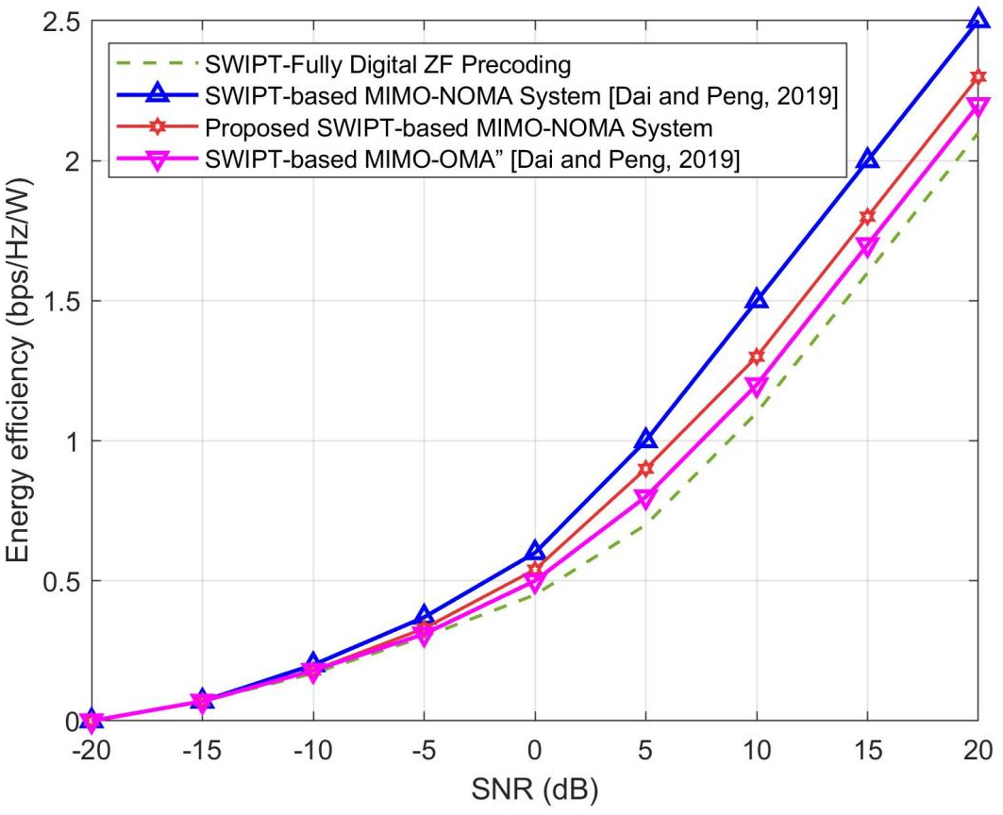

Fig. 1. Energy efficiency against SNR

4.2 Energy Efficiency versus Number of RF Chains

Fig. 2 presents the variation of EE with the number of users $K$, which effectively reflects the number of active RF chains in the hybrid precoding system, since each RF chain corresponds to a beam serving one or more NOMA users.

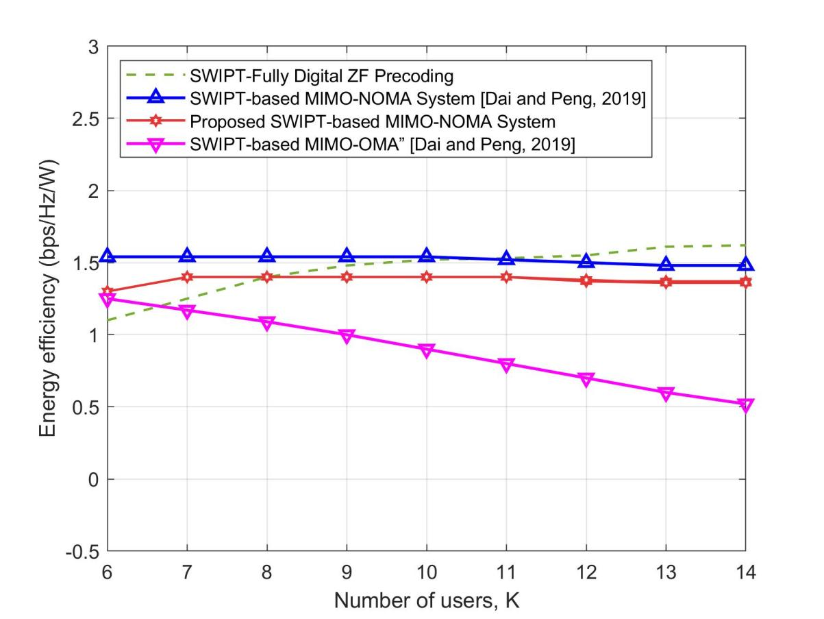

Fig. 2. Energy efficiency against the number of users

As shown in Fig. 2, the energy efficiency trends differ significantly across the four configurations. The SWIPT-based MIMO-OMA system (magenta curve) exhibits a continuous decline in EE as the number of users increases. This occurs because OMA assigns orthogonal resources to each user, resulting in rapid growth in circuit and baseband power consumption without proportional throughput gain [27], [28].

In contrast, the SWIPT-based MIMO-NOMA system (blue triangle curve) maintains nearly constant EE across all user counts since NOMA’s superposition coding allows multiple users to share a single beam, improving spectral utilization without increasing RF-chain activation. However, this configuration still suffers from residual inter-user interference that limits energy performance under dense user scenarios.

The proposed SWIPT-based hybrid MIMO-NOMA system (red-star curve) achieves the most balanced EE profile. EE increases steadily up to approximately $K=9$, reaching a near-optimal value of about 1.45 bps/Hz/W, before gradually stabilizing. This behaviour reflects the DCHS mechanism, which intelligently assigns users to beams based on channel correlation, ensuring that each additional RF chain contributes effectively to throughput without unnecessary power expenditure. Beyond $K=10$, incremental gains diminish because additional users introduce higher intra-beam interference, and the power allocated to successive NOMA layers yields lower marginal efficiency [20], [22].

Interestingly, the fully digital ZF precoding scheme (green dashed line) demonstrates comparable EE around moderate user counts but declines for larger values of $K$due to its linear scaling of RF chain activation with the number of antennas. Unlike the proposed hybrid structure, the digital ZF system lacks an analogue precoding stage, which limits per-chain energy consumption [18], [19].

5. Conclusion

In this study, an energy-efficiency optimization framework for SWIPT-enabled hybrid precoding in mmWave massive MIMO–NOMA systems were developed to address the high power consumption and hardware complexity of next-generation wireless networks. The proposed approach integrates a DCHS algorithm for interference-resilient user grouping, a CS-COMADE for array gain enhancement, and an iterative joint power allocation and power-splitting optimization scheme to maximize system energy efficiency under SWIPT constraints. Simulation results confirmed that the framework achieves near-digital spectral performance with over 60% power savings compared to fully digital ZF precoding and up to 20% higher energy efficiency than conventional hybrid schemes. These outcomes validate the effectiveness of the proposed hybrid analog–digital transceiver architecture as a scalable, low-complexity, and energy-sustainable solution for future green 5G/6G wireless communication systems.

Disclaimer (Artificial intelligence)

Author(s) hereby declare that NO generative AI technologies such as Large Language Models (ChatGPT, COPILOT, etc.) and text-to-image generators have been used during the writing or editing of this manuscript.

References

- Shafi M, Zhang J, Tataria H, Molisch AF, Rappaport TS. 5G: A tutorial overview of standards, trials, challenges, deployment, and practice. IEEE Journal on Selected Areas in Communications. 2021;35(6):1201–1221.
- Tataria H, Shafi M, Molisch AF, Dohler M, Sjöland H, Tufvesson F. 6G wireless systems: Vision, requirements, challenges, insights, and opportunities. Proceedings of the IEEE. 2021;109(7):1166–1199.
- Huang C, Zappone A, Alexandropoulos GC, Debbah M, Yuen C. Reconfigurable intelligent surfaces for energy efficiency in wireless communication. IEEE Transactions on Wireless Communications. 2019;18(8):4157–4170.
- Yang H, Marzetta TL. Energy efficiency of massive MIMO: Cell-free vs. cellular. IEEE Transactions on Wireless Communications. 2018;17(10):6483–6496.
- Alkhateeb A, El Ayach O, Leus G, Heath RW. Channel estimation and hybrid precoding for millimeter wave cellular systems. IEEE Journal of Selected Topics in Signal Processing. 2014;8(5):831–846.
- Sohrabi F, Yu W. Hybrid digital and analog beamforming design for large-scale antenna arrays. IEEE Journal of Selected Topics in Signal Processing. 2016;10(3):501–513.
- Ali MS, Tabassum H, Hossain E. Dynamic user clustering and power allocation for uplink and downlink non-orthogonal multiple access (NOMA) systems. IEEE Access. 2016;4:6325–6343.
- Choi J. NOMA-based random access with multi-channel ALOHA. IEEE Journal on Selected Areas in Communications. 2017;35(12):2736–2743.
- Mishra D, De S. Wireless information and power transfer: A signal processing perspective. IEEE Transactions on Signal Processing. 2017;65(10):2564–2578.
- Liu F, Cheng X, Li C, Xu Y. Energy efficiency optimization for MISO-NOMA SWIPT system with heterogeneous QoS requirements. IEICE Transactions on Fundamentals of Electronics, Communications and Computer Sciences. 2022;E106.A.
- Zhou X, Zhang R, Ho CK. Wireless information and power transfer: Architecture design and rate-energy trade-off. IEEE Transactions on Communications. 2013;61(11):4757–4767.
- Clerckx B, Zhang R, Schober R, Ng DWK, Kim DI, Poor HV. Fundamentals of wireless information and power transfer: From RF energy harvester models to signal and system designs. IEEE Journal on Selected Areas in Communications. 2019;37(1):4–33.
- Kadoch M, Albataineh Z, Jawarneh A. Decoupling energy efficient approach for hybrid precoding-based mmWave massive MIMO-NOMA with SWIPT. IEEE Access. 2022; 10:28868-28884.
- Chen L, Hu B, Xu G, Chen S. Energy-efficient power allocation and splitting for mmWave beamspace MIMO-NOMA with SWIPT. IEEE Sensors Journal. 2021;21(14):16381-16394.
- Rosa K, Abrao T. Improving the resource efficiency in massive MIMO-NOMA systems. Journal of Network and Systems Management. 2023;31.
- Ayach OE, Rajagopal S, Abu-Surra S, Pi Z, Heath RW. Spatially sparse precoding in millimeter wave MIMO systems. IEEE Transactions on Wireless Communications. 2014;13(3):1499–1513.
- Huang K, Andrews JG, Heath RW. Performance of hybrid precoding in millimeter wave systems with low-resolution phase shifters. IEEE Transactions on Wireless Communications. 2018;17(8):5309–5323.
- Yu X, Shen J, Zhang J, Letaief KB. Alternating minimization algorithms for hybrid precoding in millimeter wave MIMO systems. IEEE Journal of Selected Topics in Signal Processing. 2016;10(3):485–500.
- Alkhateeb A, Leus G, Heath RW. Limited feedback hybrid precoding for multi-user millimeter wave systems. IEEE Transactions on Wireless Communications. 2015;14(11):6481–6494.
- Dai L, Wang B, Yuan Y, Han S, I C, Wang Z. Non-orthogonal multiple access for 5G: Solutions, challenges, opportunities, and future research trends. IEEE Communications Magazine. 2015;53(9):74–81.
- Ding Z, Liu Y, Choi J, Sun Q, Elkashlan M, I C, Poor HV. Application of non-orthogonal multiple access in LTE and 5G networks. IEEE Communications Magazine. 2017;55(2):185–191.
- Wang C, Yin H, Ng DWK. SWIPT-enabled hybrid precoding for mm-wave massive MIMO-NOMA systems. IEEE Journal on Selected Areas in Communications. 2020;38(8):1734–1749.
- Ding Z, Schober R, Poor HV. Unveiling the importance of SIC in NOMA systems—Part I: State of the art and contemporary research. IEEE Communications Letters. 2020;24(1):237–241.
- Li C, Zhang J, Letaief KB. Artificial intelligence-enabled 6G networks: Theory, applications, and open research problems. IEEE Network. 2020;34(6):164–172.
- Rusek F, Persson D, Lau BK, Larsson EG, Marzetta TL, Edfors O, Tufvesson F. Scaling up MIMO: Opportunities and challenges with very large arrays. IEEE Signal Processing Magazine. 2013;30(1):40–60.
- Tang W, Chen MZ, Chen X, Dai JY, Han Y, Di Renzo M, Jin S, Cheng Q, Cui TJ. Wireless communications with reconfigurable intelligent surface: Path loss modeling and experimental measurement. IEEE Transactions on Wireless Communications. 2021;20(1):421–439.
- Zhou X, Zhang R, Ho CK. Wireless information and power transfer: Architecture design and rate-energy trade-off. IEEE Transactions on Communications. 2013;61(11):4754–4767.
- Dai L, Wang D, Wang B, Wang S. Power-efficient hybrid precoding for mm-wave massive MIMO-NOMA systems. IEEE Transactions on Communications. 2019;67(10):6994–7008.
- Marzetta TL. Noncooperative cellular wireless with unlimited numbers of base station antennas. IEEE Transactions on Wireless Communications. 2010;9(11):3590–3600.
- Dai L, Peng B. Energy-efficient SWIPT in massive MIMO-OMA systems with hybrid precoding. IEEE Transactions on Vehicular Technology. 2019;68(7):6869–6881.

