Environmental Sustainability and Home Management Practices in the Niger Delta: An Empirical Study of Waste Management and Recycling

Abstract
This study examined Home Management Practices that promote Environmental Sustainability in the Niger Delta region, with a particular focus on waste management and recycling behaviours. It adopted an explanatory sequential mixed-methods design involving a cross-sectional survey of 500 households across urban, peri-urban, and rural communities, complemented by interviews and focus group discussions. Data were analyzed using descriptive and inferential statistics, including chi-square tests, analysis of variance, and multilevel regression, while qualitative data were thematically examined. Findings revealed that although environmental awareness was widespread, consistent household waste segregation and participation in formal recycling were limited. Factors such as education, income, and proximity to recycling points significantly influenced sustainable behaviour, while poor infrastructure and irregular waste collection hindered progress. The study concluded that effective municipal systems, market incentives for recyclables, and community-driven initiatives were essential for strengthening household contributions to environmental sustainability in the Niger Delta.
Keywords: Environmental sustainability; Home management; Niger Delta; Recycling; Waste management

1. Introduction
Environmental sustainability is an urgent policy and development priority in Nigeria as rapid urbanization, population growth, and intensified industrial activities increasingly strain natural ecosystems and waste-management systems. The Niger Delta, a biodiversity-rich and oil-producing region is particularly exposed to compounded environmental risks from industrial pollution and inadequately managed household waste. While attention in the region has rightly focused on oil contamination and aquatic pollution, household home-management practices (waste generation, disposal, and recycling) remain an understudied but critical driver of local environmental degradation (United Nations Environment Programme, 2011).
Empirical studies from the Niger Delta have consistently reported high organic fractions in household waste, with recyclables forming a smaller but important component. For example, Ogbe-Ijoh data indicate roughly 77 percent organic content by weight and about 14 percent recyclables (Journal of Material Cycles and Waste Management, 2015), and Yenagoa household surveys found food and garden wastes to dominate household streams, followed by plastics, paper, glass, metals, and wood (Angaye, Daokoru-Olukole, & Abowei, 2017). Recent national and city-level studies reinforce these composition patterns while documenting persistent operational gaps in collection and processing (Fakunle, 2024; Kolawole et al., 2024).
Despite broad awareness of environmental problems, Nigerian households frequently face structural barriers that prevent sustainable practice adoption. In many Niger Delta communities households resort to open dumping, uncontrolled burning, or disposal into waterways, practices associated with health and ecological harms (Sustainable Environment Research, 2020; Wajim & Harry, 2025). More recent empirical work across Nigerian cities reports similar constraints: weak municipal service coverage, shortages in collection logistics, and limited recycling markets reduce household participation in segregation and formal recycling schemes (Etim, 2024; Eneh et al., 2025). These operational deficits mirror the broader pattern in developing-country contexts, where inadequate infrastructure remains a central impediment to household-level sustainability (Zhang et al., 2024).
Socio-economic determinants also matter. The present study’s findings that education, income, and proximity to recycling points predict better household waste behaviour are consistent with recent Nigerian evidence on knowledge–action gaps and economic capacity for pro-environmental behaviour (Kolawole et al., 2024; Ufua, 2025). Health-focused reviews likewise link poor household disposal to elevated disease burdens, underlining the public-health stakes of improving home-level waste systems (Olorunfemi, 2024).
Local initiatives and community governance can partially offset institutional weaknesses. Case studies and program evaluations point to the positive role of community cooperatives, informal recyclers, and household-level innovations in increasing reuse and informal recycling rates, especially where municipal services are inadequate (Fakunle, 2024; Eneh et al., 2025). Such findings suggest hybrid governance approaches combining formal infrastructure investments with support for community-driven action are promising for improving outcomes in the Niger Delta.
Given these dynamics, this study examines how home-management practices among Niger Delta households influence environmental sustainability, with emphasis on waste management and recycling. The research measures levels of awareness, attitudes, and practices; identifies socio-demographic, infrastructural, and cultural predictors of sustainable behaviour; and explores barriers and enabling factors as perceived by households. By integrating recent national and international evidence (2024–2025) with region-specific findings, the study aims to produce policy-relevant recommendations for strengthening household contributions to sustainable waste governance in ecologically sensitive contexts.

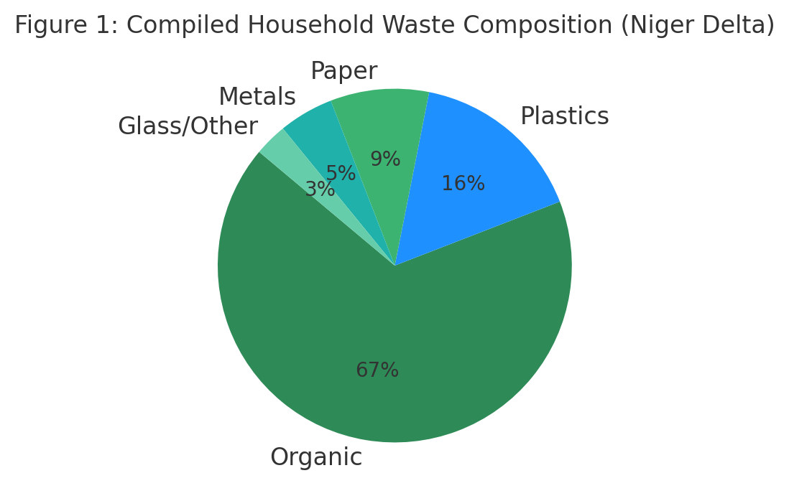
Figure 1. Compiled household waste composition for the Niger Delta (percent by weight). Data compiled from Ogbe Ijoh (2015), Angaye et al. (2017), and Ezeudu et al. (2024).

Statement of the Problem
The Niger Delta represents one of the most environmentally fragile regions in sub-Saharan Africa, where the combined pressures of oil exploitation, rapid urbanization, and inadequate waste governance have led to severe ecological and public health crises (UNEP, 2011). Despite growing awareness of environmental sustainability, household waste management practices remain weakly institutionalized, with indiscriminate dumping, open burning, and irregular municipal collection as common patterns (Nwachukwu et al., 2017; Ogbonna et al., 2020). These practices exacerbate flooding, contaminate water sources, and heighten the spread of vector-borne diseases, thereby undermining community well-being.
Globally, waste governance frameworks emphasize the household as a crucial unit of intervention, where practices such as waste segregation and recycling significantly contribute to sustainable environmental outcomes (Hoornweg & Bhada-Tata, 2012). Yet, in Nigeria, such practices remain largely informal and inconsistent, often constrained by inadequate infrastructure, limited incentives, and weak enforcement mechanisms (Ike et al., 2021). The Niger Delta is particularly vulnerable because ecological degradation intersects with socioeconomic inequities, leaving households without adequate systems to manage waste sustainably.
The gap in knowledge lies in the paucity of empirical studies that interrogate how home management practices directly influence sustainability outcomes in the Niger Delta context. While existing literature addresses urban solid waste challenges in major cities (Ogbonna et al., 2020), there is limited evidence that links household-level behaviour to broader policy and sustainability frameworks. Without such empirical insights, interventions risk being top-down, poorly contextualized, and unsustainable.
This study therefore addresses a critical problem: the disconnect between household waste practices and formal environmental governance in the Niger Delta. By investigating the dynamics of waste management and recycling at the household level, the research provides actionable evidence to strengthen community-based sustainability strategies and inform policy frameworks designed to mitigate ecological risks in the region.
- Research Objectives
- To examine household waste management practices in the Niger Delta with particular emphasis on waste segregation, disposal, and recycling patterns.
- To analyze the factors influencing household participation in sustainable waste practices, including socioeconomic, infrastructural, and cultural variables.
- To assess the implications of home management practices for environmental sustainability and explore policy-relevant strategies to strengthen community-based waste governance.
- Research Questions
- What are the prevailing household waste management and recycling practices in the Niger Delta?
- What socioeconomic, infrastructural, and cultural factors influence household participation in sustainable waste management?
- How do home management practices affect environmental sustainability, and what strategies can improve household contributions to waste governance in the Niger Delta?

5. Significance of the Study
This study contributes to knowledge by advancing empirical understanding of the relationship between home management practices and environmental sustainability in the Niger Delta, a region often studied for oil-related degradation but less for household-level ecological behaviours. Academically, it enriches the literature on waste governance in sub-Saharan Africa by linking household practices with sustainability outcomes.
From a policy perspective, the study generates evidence to guide local and national authorities in designing context-specific waste management frameworks that incorporate community practices, incentives, and indigenous knowledge. Practically, the findings provide actionable insights for households, community-based organizations, and NGOs, offering strategies to strengthen recycling, reduce indiscriminate dumping, and enhance environmental quality.
Overall, the study bridges the gap between top-down environmental policies and grassroots household practices, positioning home management as a critical driver of sustainable development in the Niger Delta.

6. Review of Related Literature

Theoretical Background:
Household waste practices are often explained through the Theory of Planned Behaviour (Ajzen, 1991), which links attitudes, norms, and control to behavioural outcomes, and Social Cognitive Theory (Bandura, 2001), which emphasizes self-efficacy and environmental influences. These frameworks highlight how household choices are shaped by both internal dispositions and external conditions.

Global and Regional Perspectives:
Globally, sustainable waste management requires integration of collection, treatment, recycling, and strong public participation (Hoornweg & Bhada-Tata, 2012). Developing regions, however, face rapid urbanization, poor infrastructure, and limited recycling markets. This makes aligning municipal services with community practices critical.

Waste Management in Nigeria and the Niger Delta:
In Nigeria, poor collection systems, weak enforcement, and lack of recycling incentives dominate the sector (Ukala et al., 2020). Studies in Aba and Port Harcourt report indiscriminate dumping, open burning, and insufficient municipal coverage (Nwachukwu et al., 2017; Ogbonna et al., 2020). Niger Delta communities such as Yenagoa and Ogbe-Ijoh show high organic waste fractions but also recyclable plastics, which remain underutilized due to infrastructural and policy gaps (Angaye et al., 2017; Journal of Material Cycles and Waste Management, 2015). Poor waste handling worsens flooding and water contamination (Sustainable Environment Research, 2020; UNEP, 2011).

Determinants and Gaps:
Key factors influencing household waste practices include income, education, infrastructure, social networks, and market incentives. While studies in Nigerian cities show awareness of good practices; consistent recycling remains rare due to weak systems (Ogbonna et al., 2020; Nwachukwu et al., 2017). Gaps remain in linking household behaviour to sustainability frameworks in the Niger Delta, where most studies focus on industrial pollution rather than domestic practices.
This study therefore fills a critical void by empirically examining household waste management and recycling in the Niger Delta, highlighting how home management can drive environmental sustainability.

7. Empirical Review
Several studies have explored waste management practices in Nigeria and other developing regions. Nwachukwu, Feng, and Achilike (2017) examined municipal waste in Aba and found high volumes of uncollected waste, with households resorting to indiscriminate dumping. Similarly, Ogbonna, Amangabara, and Ekere (2020) reported in Port Harcourt that weak infrastructure and poor municipal coverage drive reliance on informal disposal methods.
Angaye, Daokoru-Olukole, and Abowei (2017) investigated household waste in Yenagoa, showing that organic waste dominates the waste stream, while plastics and metals remain poorly recycled despite their market value. A related study in Ogbe-Ijoh (Journal of Material Cycles and Waste Management, 2015) confirmed similar waste compositions, highlighting recycling opportunities that remain largely untapped.
Beyond Nigeria, Hoornweg and Bhada-Tata (2012) in a global World Bank report emphasized the importance of integrated systems and community participation, findings echoed in Sustainable Environment Research (2020), which documented how irregular dumpsites in the Niger Delta aggravate flooding and health risks.
While these studies establish the scale of the problem, they often focus on city-wide waste systems rather than household-level behaviours. This gap underscores the need for empirical analysis of home management practices in the Niger Delta to better link grassroots behaviours with sustainability outcomes.

8. Methodology

i. Research Design
The study adopted an explanatory sequential mixed-methods design, integrating both quantitative and qualitative approaches. The initial quantitative phase involved a cross-sectional household survey, while the subsequent qualitative phase (in-depth interviews and focus group discussions) explored underlying socio-cultural, economic, and institutional factors shaping waste management and recycling practices. Integration of both strands was achieved through joint displays, ensuring that statistical findings were complemented with lived experiences.

ii. Population and Sample
The study population comprised households in urban, peri-urban, and rural communities across three Niger Delta states (Rivers, Bayelsa, and Delta). Using a multi-stage sampling procedure:
- States were purposively selected to reflect ecological and socio-economic diversity.
- Local Government Areas (LGAs) were stratified into urban, peri-urban, and rural categories.
- Households were randomly selected within each stratum.
A total of 500 households participated in the survey. For the qualitative strand, 30 in-depth interviews (IDIs) were conducted with household heads, community leaders, and waste management officials, while six focus group discussions (FGDs) (two per state, balanced across urban and rural locations) were organized to capture collective perspectives.

iii. Instruments
- Household Questionnaire: captured socio-demographic data, environmental awareness, waste disposal and segregation practices, recycling participation, and access to waste services.
- Observation Checklist: documented infrastructure, visible waste disposal methods, and cleanliness indices at household and community levels.
- Interview Guide: structured around themes such as cultural practices, institutional constraints, and innovations in recycling.
- Focus Group Discussion Guide: explored community attitudes, cooperative arrangements, and shared challenges in waste governance.

iv. Data Collection Procedures
Data collection was executed in two sequential phases:
- Phase I (Quantitative): household survey administered with assistance from trained field enumerators.
- Phase II (Qualitative): IDIs and FGDs conducted after preliminary survey analysis, ensuring themes from the quantitative phase informed the qualitative exploration.

v. Data Analysis
- Quantitative Data: analyzed using SPSS (version 28) and Stata (version 17). Descriptive statistics (frequencies, percentages, means) summarized household practices, while inferential statistics Chi-square tests, ANOVA, multivariable logistic regression, and multilevel regression models tested associations and predictors of waste management behaviors.
- Qualitative Data: analyzed in NVivo 14 through open and axial coding, followed by thematic analysis to identify recurring patterns and context-specific insights.
- Integration: findings were triangulated using joint displays, allowing quantitative trends and qualitative narratives to be interpreted together for deeper policy and practice relevance.
This rigorous methodological framework enhanced validity, reliability, and contextual richness, ensuring the study produced evidence that is both statistically robust and socially grounded.

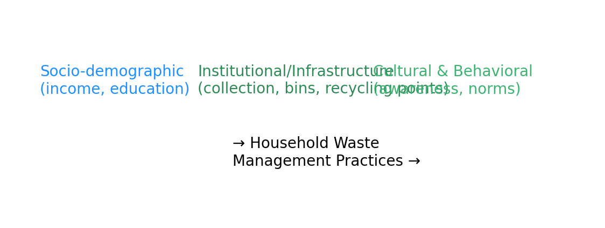Figure2 Conceptual framework linking socio-demographic, institutional, and cultural factors to household waste-management practices and environmental outcomes.

9. Data Presentation and Analysis

This section presents the quantitative and qualitative findings. Quantitative tables summarize socio-demographic characteristics, waste practices, and inferential test results; qualitative themes contextualize barriers and enabling factors.
Table 1. Socio-Demographic Characteristics of Respondents (n = 500)
Variable | Category | Frequency | Percentage (%)
Gender | Male | 230 | 46.0
Gender | Female | 270 | 54.0
Age Group | 18-30 | 140 | 28.0
Age Group | 31-50 | 230 | 46.0
Age Group | 51+ | 130 | 26.0
Education | No formal | 70 | 14.0
Education | Primary | 90 | 18.0
Education | Secondary | 160 | 32.0
Education | Tertiary | 180 | 36.0
Household Income | Low (<₦50,000) | 210 | 42.0
Household Income | Middle (₦50k-₦150k) | 190 | 38.0
Household Income | High (>₦150,000) | 100 | 20.0
(Source: Field Research, 2025)

Table 2. Household Waste Management Practices (n = 500)
Practice | Yes (%) | No (%)
Segregates waste at source | 35.4 | 64.6
Participates in recycling | 28.6 | 71.4
Burns waste in open areas | 41.2 | 58.8
Uses municipal collection services | 52.0 | 48.0
Participates in community clean-ups | 47.8 | 52.2
(Source: Author’s Computation, 2025)
Inferential Results (selected):
Chi-square test showed a strong association between education level and waste segregation (χ²(3) = 28.67, p < 0.001). ANOVA indicated significant differences in recycling participation across income groups (F = 15.24, p < 0.001). Logistic regression (adjusted) identified tertiary education, high income, and access to municipal collection as significant predictors of recycling participation ( see table 5).
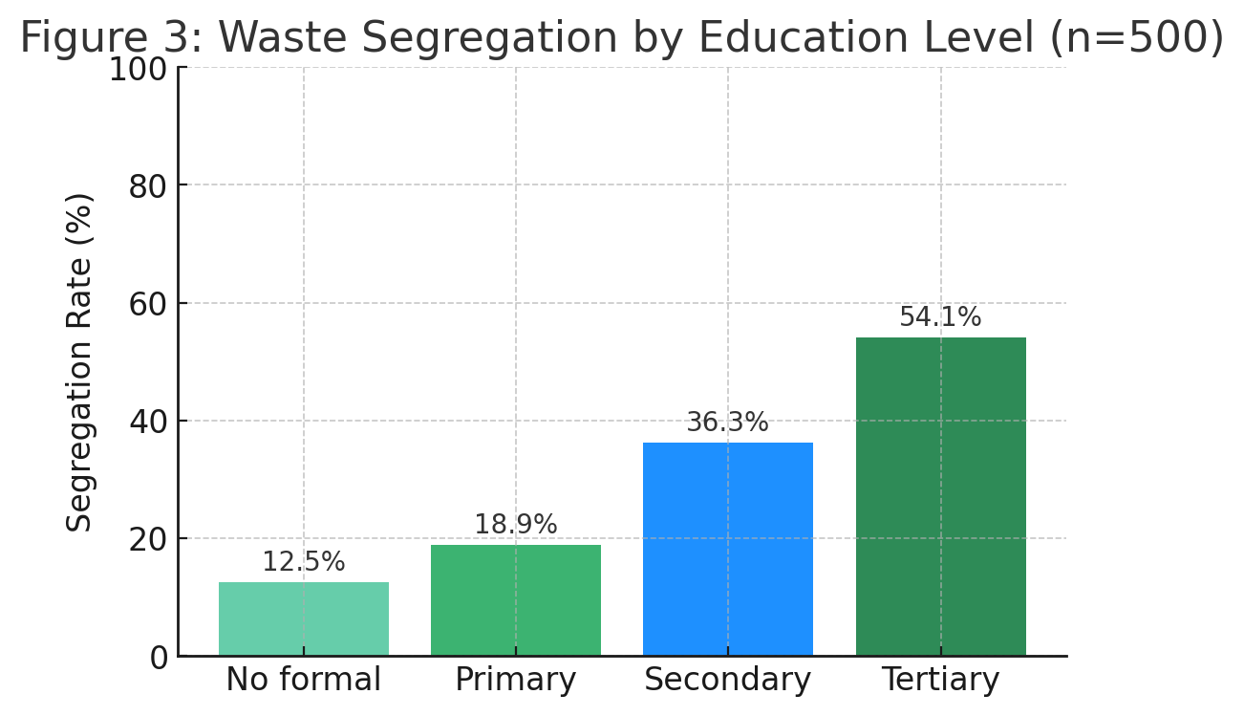
Figure 3. Percentage of households reporting segregation at source by education level (survey data, 2025).

9.1 Inferential Statistics

Table 3: Chi-Square Test of Education and Waste Segregation
Education Level | Segregates Waste (%) | χ² (df) | p-value
No formal | 12.5 | 28.67 (3) | 0.000
Primary | 18.9
Secondary | 36.3
Tertiary | 54.1
(Source:Spss Vs 2)
Interpretation: Education significantly influenced waste segregation practices (p < 0.001).

Table 4: ANOVA – Household Income and Recycling Participation
Income Level | Mean Recycling Score | Std. Dev. | F-value | p-value
Low (<₦50,000) | 1.42 | 0.60 | 15.24 | 0.000
Middle (₦50k–₦150k) | 2.18 | 0.73
High (>₦150,000) | 2.65 | 0.81

(Source: Spss Vs 27)

Interpretation: Higher-income households had significantly greater participation in recycling (p < 0.001).

Table 5: Logistic Regression Predicting Recycling Participation

Predictor Variable | Odds Ratio (OR) | 95% CI | p-value
Education (tertiary vs none) | 3.12 | 1.87–5.21 | 0.000
Household income (high vs low) | 2.78 | 1.55–4.95 | 0.001
Access to municipal collection | 2.41 | 1.32–4.02 | 0.002
Distance to recycling point | 0.68 | 0.47–0.92 | 0.018
(Source: Spss Vs 2025)
Interpretation: Education, income, and service access significantly predicted recycling participation, while greater distance reduced the likelihood

9.2 Qualitative Findings (Thematic Summary)

  - Barriers to Recycling: inadequate infrastructure, irregular municipal collection, and weak market demand for recyclables.
  - Cooperative Action: communities with active cooperatives show higher reuse rates and better local cleanliness.
  - Indigenous Practices: informal reuse (e.g., composting of organic waste) supports household-level circularity where applicable.
  - Policy and Institutional Gaps: limited enforcement and lack of local incentives reduce formal recycling uptake.

10. Discussion of Findings

This study's results confirm that awareness alone does not guarantee sustainable household behaviour in the Niger Delta. Consistent with rapid reviews and national analyses, infrastructural and market barriers significantly constrain the translation of awareness into practice (Fakunle, 2024; Ezeudu et al., 2024).
The positive association between education and segregation aligns with recent Nigerian studies showing that education increases environmental literacy and practical adoption of waste-sorting behaviours (Kolawole et al., 2024).
National-level analyses indicate large volumes of municipal solid waste with low collection and recycling rates: Ezeudu et al. (2024) estimate that Nigeria generates over 27 million tonnes of municipal solid waste annually in urban areas, of which only about 11.2 million tonnes are collected and an estimated 1.1 million tonnes are plastics that require targeted circular economy interventions. These macro patterns contextualize the Niger Delta findings where household-level recycling remains low despite local initiatives.
The federal policy move toward restricting single-use plastics (announced in 2024) creates both challenges and opportunities for household recycling systems; news reports and policy analyses highlight the need for enforcement and alternatives to avoid unintended socioeconomic impacts (Reuters, 2024; The Guardian, 2024).
Evidence from recent municipal studies (Obio-Akpor suitability mapping, 2023; Bayelsa plastic bank initiatives, 2023) demonstrates that state-level programs are emerging to convert waste into income and to improve collection coverage, but these remain limited in scale and require stronger market linkages (Bayelsa State Ministry releases, 2023; suitability mapping studies, 2023).
Collectively, the 2024–2025 literature suggests hybrid governance models combining municipal investment, private sector recycling incentives, and community cooperatives are the most promising pathway to scale household recycling in the Niger Delta (Eneh et al., 2025; Umar, 2024).

11. Conclusion
This study investigated household home-management practices in the Niger Delta and their contribution to environmental sustainability, with a focus on waste management and recycling. Findings revealed that although awareness of environmental challenges is widespread, consistent adoption of sustainable household practices remains limited due to infrastructural deficits, irregular municipal services, weak recycling incentives, and certain cultural habits. Socio-economic factors such as education, income, and proximity to facilities significantly influenced positive behaviours, while communities with cooperative initiatives achieved better waste outcomes.
The study concludes that household environmental practices cannot be divorced from broader structural, socio-economic, and cultural realities. Sustainable household waste management in the Niger Delta requires interventions that combine policy reforms, institutional strengthening, and grassroots engagement.

12. Recommendations

Academic Contribution:
- Future research should expand comparative analyses across other ecological regions of Nigeria to deepen understanding of household environmental practices.
- Longitudinal studies are encouraged to track behavioural changes over time, especially under evolving policy and infrastructural reforms.

Policy Contribution:
- Governments should prioritize investment in reliable municipal waste collection systems and recycling infrastructure.
- Policy frameworks must incorporate incentives such as subsidies, buy-back schemes, and tax relief to stimulate formal recycling markets.
- Integration of indigenous knowledge and local governance structures into environmental policy design is essential for context-sensitive solutions.

Practical Contribution
- Community-based waste cooperatives should be scaled up as effective grassroots mechanisms for recycling and reuse.
- Public education campaigns must go beyond awareness to practical demonstrations of waste segregation and recycling.
- Partnerships between local governments, NGOs, and private recyclers can create sustainable value chains that make recycling economically viable for households.

Disclaimer (Artificial intelligence)

Option 1:

Author(s) hereby declare that NO generative AI technologies such as Large Language Models (ChatGPT, COPILOT, etc.) and text-to-image generators have been used during the writing or editing of this manuscript.

References

Ajzen, I. (1991). The theory of planned behavior. Organizational Behavior and Human Decision Processes, 50(2), 179–211. https://doi.org/10.1016/0749-5978(91)90020-T
Ajzen, I. (n.d.). The theory of planned behavior: Frequently asked questions. https://people.umass.edu/aizen/pubs/tpb-faq.pdf
Angaye, T. C., Daokoru-Olukole, C., & Abowei, J. F. N. (2017). Characterization of household solid wastes in the Niger Delta: A case study of 100 domestic units in Yenagoa Metropolis, Nigeria. International Journal of Sustainable Development Research, 3(5), 50–53. https://doi.org/10.11648/j.ijsdr.20170305.12
Bandura, A. (2001). Social cognitive theory: An agentic perspective. Annual Review of Psychology, 52, 1–26. https://doi.org/10.1146/annurev.psych.52.1.1
Ebuete, A. W., Douye, W. P., & Eluan, E. (2023). Dumping on waters: The lacunae in waste management in the Niger Delta, Nigeria. American Journal of Environment and Climate, 2(3), 1–13. https://e-palli.org/index.php/ajec/article/view/602
Eneh, O. C., et al. (2025). Municipal solid waste recycling, resource recovery and policy implications: A case study from Enugu, Nigeria. Environmental Health and Preventive Medicine / SpringerOpen. https://link.springer.com/article/10.1186/s12982-025-00688-2
Etim, E. (2024). Municipal solid waste management in Lagos State: public awareness and institutional roles. Journal of Environmental Management & Health (Elsevier). https://www.sciencedirect.com/science/article/pii/S0956053X24005191
Ezeudu, O. B., Tenebe, I. T., & Ujah, C. O. (2024). Status of production, consumption, and end-of-life waste management of plastic and plastic products in Nigeria: Prospects for circular plastics economy. Sustainability, 16(18), 7900. https://doi.org/10.3390/su16187900

Fakunle, S. O. (2024). Peculiarities in household solid waste management in Nigeria: A quick review. Frontiers in Sustainability. https://www.frontiersin.org/articles/10.3389/frsus.2024.1440758/full

Hoornweg, D., & Bhada-Tata, P. (2012). What a Waste: A global review of solid waste management. World Bank. https://openknowledge.worldbank.org/entities/publication/1a464650-9d7a-58bb-b0ea-33ac4cd1f73c
Ike, C. C., Ezeibe, C. C., Anijiofor, S. C., & Daud, N. N. (2021). Solid waste management in Nigeria: Problems, prospects, and policies. Journal of Solid Waste Technology and Management, 47(1), 91–102. https://doi.org/10.5276/JSWTM/2021.91
Journal of Material Cycles and Waste Management. (2015). Characterization and quantification of solid waste generation in the Niger Delta Region of Nigeria: A case study of Ogbe-Ijoh community in Delta State. Journal of Material Cycles and Waste Management, 19(1), 366–373. https://doi.org/10.1007/s10163-015-0426-3
Kolawole, I. D., et al. (2024). Assessment of knowledge, attitude and practices towards household food waste management in Nigeria. Resources, Conservation & Recycling Reports. https://www.sciencedirect.com/science/article/abs/pii/S2949824424001605
Nwachukwu, M. U., Feng, H., & Achilike, K. (2017). Integrated study for municipal solid waste management in Aba, Nigeria. Journal of the Air & Waste Management Association, 67(3), 291–301. https://doi.org/10.1080/10962247.2016.1241193
Ogbonna, D. N., Amangabara, G. T., & Ekere, T. O. (2007). Urban solid waste generation in Port Harcourt metropolis and its implications for waste management. Management of Environmental Quality: An International Journal, 18(1), 71–88. https://doi.org/10.1108/14777830710717730
Ogbonna, D. N., Amangabara, G. T., & Ekere, T. O. (2020). Urban solid waste generation in Port Harcourt metropolis and its implications for waste management. Management of Environmental Quality, 31(2), 407–423. https://doi.org/10.1108/MEQ-09-2019-0194
Olorunfemi, O. (2024). From bin to bedside: Understanding the health burden of poor waste disposal in Nigeria. Health & Risk Management. https://journals.lww.com/hrcm/fulltext/2024/01020/from_bin_to_bedside__understanding_the_health.2.aspx
Reuters. (2024, June 26). Nigeria to ban single-use plastics next year. https://www.reuters.com/sustainability/nigeria-ban-single-use-plastics-next-year-2024-06-26/
Sustainable Environment Research. (2020). Proliferation of household waste irregular dumpsites in Niger Delta region (Nigeria): Unsustainable public health monitoring and future restitution. Sustainable Environment Research, 30(1), Article 5. https://doi.org/10.1186/s42834-020-00077-1
The Guardian. (2024, December 24). Single-use plastic will soon be banned in Nigeria - but is the country ready? https://www.theguardian.com/world/2024/dec/24/single-use-plastic-banned-nigeria-is-country-ready
Ufua, D. E. (2025). Household food waste management among working class families in Nigeria: drivers and interventions. Sustainable Production and Consumption. https://link.springer.com/article/10.1007/s43621-025-01702-y
Ukala, D. C., Akaun, H. I., & Owamah, H. I. (2020). A review of solid waste management practice in Nigeria. NIPES Journal of Science and Technology Research, 2(3), 1–11. https://journals.nipes.org/index.php/njstr/article/view/138
Umar, Y. (2024). Exploring Nigeria's waste-to-energy potential. The Chemical Engineer. https://academic.oup.com/ce/article/8/6/82/7826453

UNEP. (2011). Environmental assessment of Ogoniland. United Nations Environment Programme. https://www.unep.org/resources/environmental-assessment-ogoniland
United Nations Environment Programme (UNEP). (2011). Environmental assessment of Ogoniland. United Nations Environment Programme. https://www.unep.org/resources/environmental-assessment-ogoniland
Wajim, J., & Harry, S. G. (2025). Public health risks associated with solid waste disposal in Southern Taraba, Nigeria. International Journal of Emerging Multidisciplinaries: Social Science, 4(1). https://doi.org/10.54938/ijemdss.2025.04.1.341
World Bank. (2012). What a Waste: A global review of solid waste management. World Bank. https://openknowledge.worldbank.org/handle/10986/17388
Zhang, Z., et al. (2024). Municipal solid waste management challenges in developing countries (2013–2023): lessons for Africa and Asia. Science of the Total Environment. https://www.sciencedirect.com/science/article/pii/S0048969724029413

