Original Research Article
A Semi-Automated Geographic Information System Approach for Pre-Census Mapping

Abstract: Accurate and efficient pre-census mapping is crucial for reliable population enumeration, particularly in regions with complex geographic and security constraints. This study presents a semi-automated Geographic Information System (GIS) approach for developing a detailed digital geodatabase to support Mali’s fifth pre-census, with a rigorous validation process ensuring methodological reliability. Using high-resolution satellite imagery and geospatial techniques, Enumeration Sections (ES) were delineated based on estimated population and visible boundaries such as roads and waterways. The method integrates Google Satellite imagery with geospatial data to generate ES polygons aligned with administrative limits and population thresholds. Validation in the cercles of Macina and Niono demonstrated strong accuracy, with correlation coefficients of 0.97 and 0.94, and Root Mean Square Errors (RMSE) of 37.46 and 42.79, respectively. The Mean Absolute Errors (MAE) of 26.63 and 29.58 indicate minimal deviation between estimated and field-measured populations, confirming high model consistency. While the approach enhances mapping accuracy and efficiency, limitations include dependence on satellite image quality and challenges in updating rapidly changing regions. Compared with similar GIS-based census mapping initiatives in Nigeria and Kenya, the proposed method shows comparable performance and adaptability. Beyond Mali, this scalable and cost-effective framework offers a practical solution for pre-census and population mapping in other low- and middle-income countries.
Keywords: GIS; Pre-census; Geospatial data; Semi-automate, Mapping

1. Introduction
Accurate population enumeration is vital for effective policy-making, resource allocation, and sustainable development, particularly in regions with logistical challenges. Traditional census methods often struggle to achieve precise and efficient mapping, especially in low- and middle-income countries where vast and diverse landscapes, limited infrastructure, and security issues complicate data collection. To address these challenges, this study introduces a semi-automated Geographic Information System (GIS) methodology tailored for pre-census mapping, with a specific application to Mali’s fifth census. Census mapping, one of the first efficient parts of the census, divides the country into small areas known as Enumeration Sections (ES) based on population and spatial distribution. It’s a critical component of the subsequent census process [1, 2]. The traditional creation methods of ES have been an expensive task executed by approaches such as physically walking to map ES boundaries, buildings, infrastructure, roads, rivers, and population which can require intensive resources and multiple years to complete [3]. For example, in Zambia, the 2010 census mapping exercise was expected to take about two years to complete at a total cost of US $7 million [4]. Manual digitization of ES is still costly and labor-intensive. It is also prone to human error and can have poor accuracy [5]. In addition, in the manually digitized ES approach, it can be challenging to accommodate population and area constraints.
The previous methods, evident in the 2010 Population and Habitat Census series, have inherent defects, particularly in achieving comprehensive coverage due to challenges like war, civil unrest, and geographical inaccessibility [6]. To address these limitations, there is a growing interest in innovative modeling approaches leveraging satellite imagery, and survey data [7]. Since the advent of Geographic Information Systems (GIS) and high-resolution satellite photography census cartographers in some countries have been able to manually digitize ES boundaries from satellite imagery, leading to better control of ES delineation. The advent of geospatial technologies has revolutionized census mapping, rendering traditional methods of manual digitization and physical boundary walking obsolete [8]. In this context, Geographic Information System (GIS) has emerged as a pivotal tool, demonstrating its efficiency and accuracy in creating detailed census maps through high-resolution satellite imagery, remote sensing, and auxiliary geographic information [9]. Automated approaches employing computer algorithms optimize the creation or digitalization of ES from satellite imagery, resulting in consistent mapping standards, time savings, and reduced costs [10]. This shift from manual to digital mapping has been particularly beneficial, as it has increased accuracy and quality control and reduced costs and time spent on the process. Australia has successfully applied GIS in its Census of Population, Housing, and Plans [11], further validating its capabilities.
Recognizing the need for more resilient and efficient methodologies, the United Nations encourages member countries to embrace geospatial information and communication technologies [12]. The evolution of mapping methods in African censuses during the 1900s underscores the necessity to minimize errors in population counting [13]. However, GIS technology has become integral in worldwide census mapping operations, offering improved accuracy in small-area projections and efficient data dissemination [14]. Nigeria's National Population Commission and Survey model exemplifies GIS incorporation for predicting demographic distribution [15]. Developing countries have established geospatial census frameworks based on GIS, GPS, and satellite imagery, presented by initiatives in Brazil, South Africa, Fiji, and India [16]. The current research focuses on enhancing the accuracy and efficiency of census operations in Mali, aligning with the United Nations' recommendation to leverage GIS capabilities for digital census mapping.
In developing Enumeration Sections (ES) from gridded population estimates several tools are available out of which is the Geo-sampling tool [17, 18]. Wang et al [19] used remote sensing and GIS data to derive homogeneous regions and spatial sample designs. Haynes et al.,[20] used statistical region merging procedures to define zones for different applications like assessing neighborhood impacts on health and publishing census information. Nock and Nielsen [21] for instance categorized the image into regions of channels with similar intensity values. The improved max-p algorithm as explained by Kang et al., [22], enhances the process of growing irregular regions from census enumeration sections by allowing for flexible user-defined constraints. This flexibility enables the algorithm to adapt to the multidimensional characteristics of the regions, making it particularly effective in complex spatial contexts. The max-p algorithm, as presented by Hussah et al., et al., [23] serves as a robust spatial clustering solution aimed at maximizing the number of homogeneous geographical regions while adhering to a specified threshold for spatial spread. On the other hand, Cardona [24] designed a region-merging tool with census data and pre-existing ES as the basic unit to create new reporting units. The merit of this method is that it employs original ES which is assumed to map directly onto known geographical phenomena. However, this approach may not be possible, especially in area merging in developing countries where ES data may be outdated.
Digital ES-level information may not be available in many developing countries; however, new data sources may be helpful in the development of ES. Two essential components are required: Accurate geographical information of the infrastructural and buildings context to define the ES boundaries. There is one Global source namely OpenStreetMap (OSM) which gives road data, where fully mapped street information is presented, containing several in developing countries [25]. More derivatives include rivers, elevation, and buildings added to a landscape adding detail to its features. Then, the population density estimates allow for defining the right ES sizes when enumerators can survey such sizes within a certain amount of time. The population models available at high spatial resolution provide population density under different scenarios and can inform the creation of ES.
This study integrates high-resolution satellite imagery and diverse geographical data within a GIS framework, enabling precise pre-census mapping. It develops algorithms to estimate and extract population data across various areas and delineates ES based on population estimates that align with population distribution and existing administrative boundaries. Through tools like raster calculators and zonal statistics within GIS and Python environments, our approach efficiently estimates the population within each ES polygon, facilitating an accurate, scalable mapping solution. To maintain data relevance and precision, the process involves automated population extraction based on polygons population density, further supported by machine learning techniques that enhance population extraction and ES delineation. In addition, the methodology includes a robust validation process that cross-checks delineated ES against existing census data of a test area choice, ensuring that the digital boundaries are both accurate and practical for on-the-ground census operations.

2. Materials and Methods
This study used a semi-automated ES delineation process to build a national geodatabase for Mali's fifth pre-census and post-census survey sampling database. The methodology outlines our approach and details its application in Mali.

2.1 Study area
Mali, A vast country in the Sahel, is a low-income economy, with little diversification. It is the eighth-largest country in Africa, with an area of over 1,241,238 square kilometers, and had an estimated population of 22,395,489 in 2022[26], and 47.19% of which are estimated to be under the age of 15 in 2024. Its rapid population growth (fertility rate of 5.88 children per woman in 2018). The 2022 census found that 30.3% of the population resided in urban areas. The country lies at the intersection of a region experiencing significant security challenges and a more stable zone. These security conditions make traditional, manual data collection difficult, underscoring the need for an automated approach in pre-census mapping. This study aims to divide the country area into individual ES and build a comprehensive digital geodatabase using GIS capabilities through a semi-automatic method. This geodatabase serves as a sampling frame for post-census surveys, ensuring precise and exhaustive coverage across the region. The automated mapping method leverages GIS tools to efficiently generate accurate geographic data, enhancing the reliability and reach of census-related activities. Mali is divided into 20 administrative regions, as shown in Figure 1, with these regional boundaries serving as the primary divisions for defining major strata.
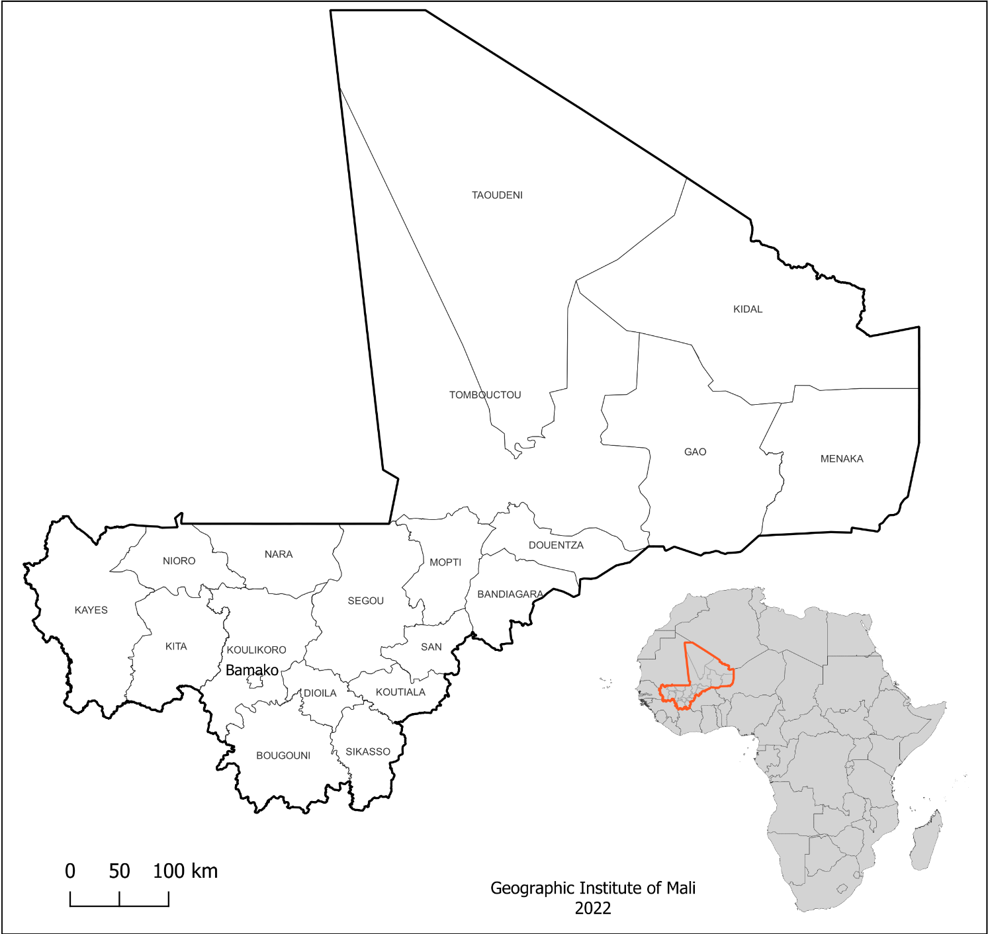
Figure 1. Study area

2.2. General approach
Accurate mapping for census purposes is essential for defining Enumeration Sections (ES), which divide the country into smaller, manageable units for population counting. Each ES, the smallest census unit assigned to enumerators, typically accommodates 500 to 1,100 individuals and is shaped by factors such as workload and geographical accessibility and identifiable. To streamline the creation of new Enumeration Sections (ES) based on the "Emprise" polygons generated during the data digitization process, we developed an automated "split and merge" process inspired by geodata processing techniques, such as the merging algorithm. This method uses vector data to divide the country into small sub-areas, based on visible boundaries such as roads, waterways, and administrative borders. These sub-areas are then merged to form larger regions while adhering to user-defined constraints on area and population size. Administrative boundaries serve as ‘hard’ limits to ensure regions are not merged across certain borders. During Mali’s fifth census mapping in 2020, the National Institute of Statistics (INSTAT-Mali) utilized satellite imagery to create ES based on the population estimated and collect data on buildings, roads, and infrastructure. This process relied on detailed georeferenced data, including information on resolution, scale, and coverage. Similar methodologies, such as those used in India’s 2010 census, helped create comprehensive digital geographic databases through automatic demarcation of satellite imagery. In creating Mali’s census geodatabases, satellite images were used to map buildings, roads, and landmarks, but a digital geodatabase was still required. The establishment of a Geographic Information System (GIS) Laboratory was critical for this purpose. ArcGIS 10.7.1 software was employed to develop a geodatabase, enabling GIS technicians and engineers to extract key features from satellite images. This approach allowed our method to produce accurate population estimates using the population grid method. These estimates were used to delineate ES boundaries and validate our method against recent survey data, confirming its accuracy.

2.3. Data sources
To carry out this work, multiple datasets were compiled and integrated from various sources, Table 1. Most of these datasets were developed by GIS technicians in the GIS laboratory established by INSTAT-Mali during the pre-census mapping process. They were created using Google Satellite imagery and basic shapefiles, such as administrative boundaries, collected from the Geographic Institute of Mali (IGM). During the study, ArcGIS 10.7.1 software was used for accurate data management. These datasets facilitated the updating and refinement of existing data for the study.
Table 1. Dataset used during Enumeration Section creation process.
Dataset | Formats | Sources | Dates | Descriptions
Infrastructure | Point | INSTAT-Mali | 2020 | Reference points
Locality Data | Point | INSTAT-Mali | 2009 | Points of the localities in Mali.
Road data | Line | OSM | 2020 | All roads linking the localities
Rail | Line | IGM-Mali | 2009 | Railway
River | Line | IGM-Mali | 2020 | Water drainage networks
Waterbody | Polygons | OSM | 2020 | Waterbody
Building | Polygons | INSTAT-Mali | 2021
Emprise | Polygons | INSTAT-Mali | 2021 | ES zooms in on the building block for delineation
Administrative boundaries | Polygons | IGM Mali | 2009 | Administrative division
Population data | Statistics | INSTAT-Mali | 2020 | Population collected during the surveys
Satellite imagery | Raster | Google
Survey data | Statistics | INSTAT-Mali | 2020 | Different statistics on households

The data spatial distribution map of Mali shows two areas: regions with building data and regions without. The southern and central parts have extensive building data, indicating more populated areas, especially around the Niger River. The northern region has minimal data, reflecting its sparse population and the challenging Sahara terrain. This division highlights the geographic and demographic contrasts within the country.
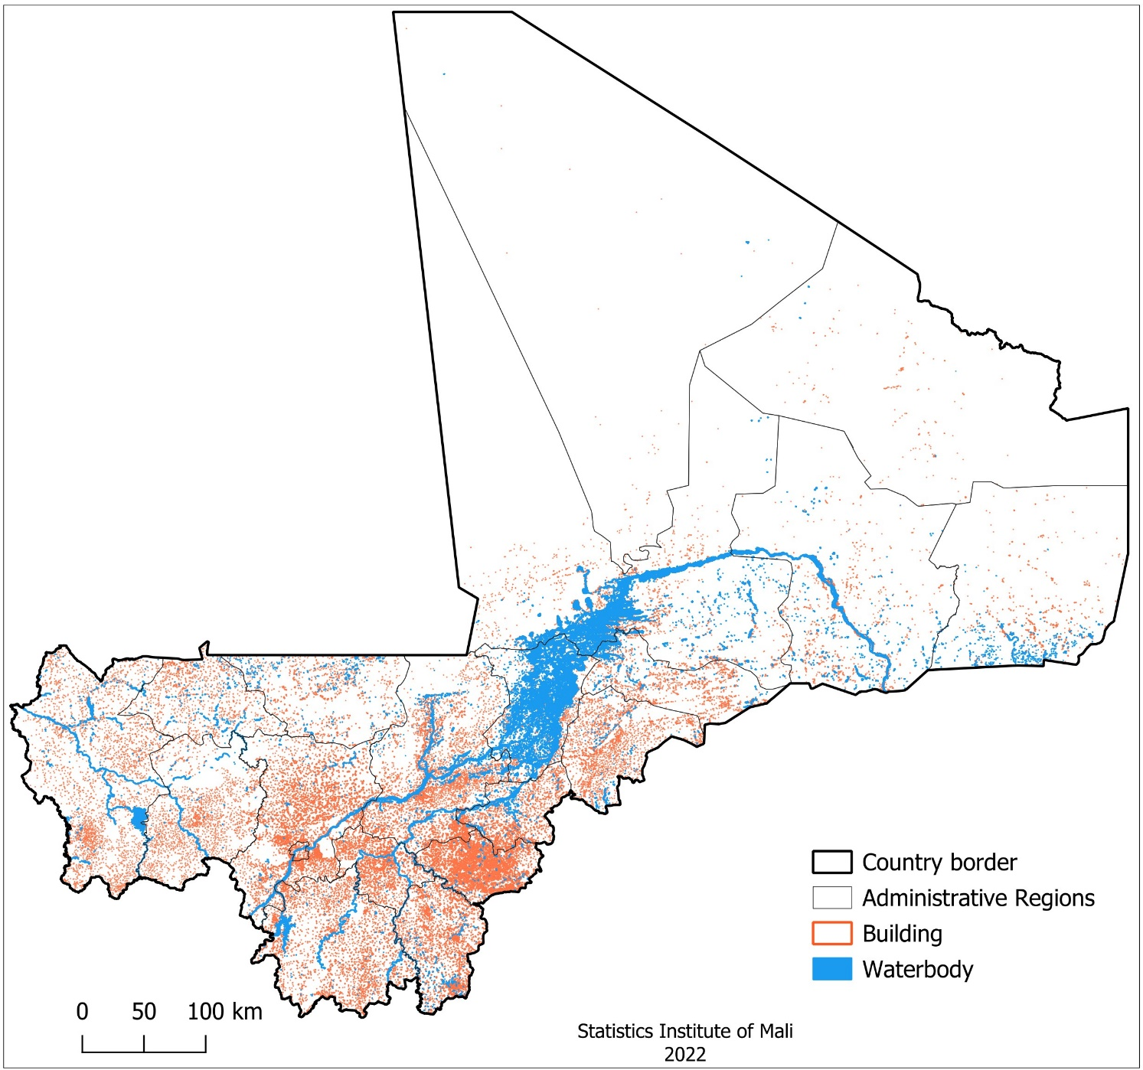
Figure 2. Spatial data distribution

2.4. Data processing

2.4.1. Data digitalization
Previous pre-census mapping in Mali was conducted manually, making it challenging to gather the necessary geographic information. We established a GIS laboratory dedicated to creating a digital database using high-resolution satellite imagery to address these limitations. Technicians in this lab digitized geographic features such as buildings, roads, rivers, and infrastructure. Additionally, OpenStreetMap data were used to validate some datasets, particularly buildings and streets. After creating these data layers, the team divided each commune into smaller units, known as Emprise, based on building density and spatial distribution. In Mali, communes are small administrative units used as strata for the creation of the Enumeration Section (ES). This geographic segmentation was carefully executed to follow specific requirements: the country was divided using road networks, buildings, waterways, rivers, and administrative boundaries. This facilitated a clear delineation of each ES. Finally, a geodatabase was established, providing Mali with a comprehensive digital resource a significant achievement for INSTAT-Mali, such as Figure 3. Using this geodatabase, the population of Mali was estimated with improved accuracy, supporting precise ES creation.
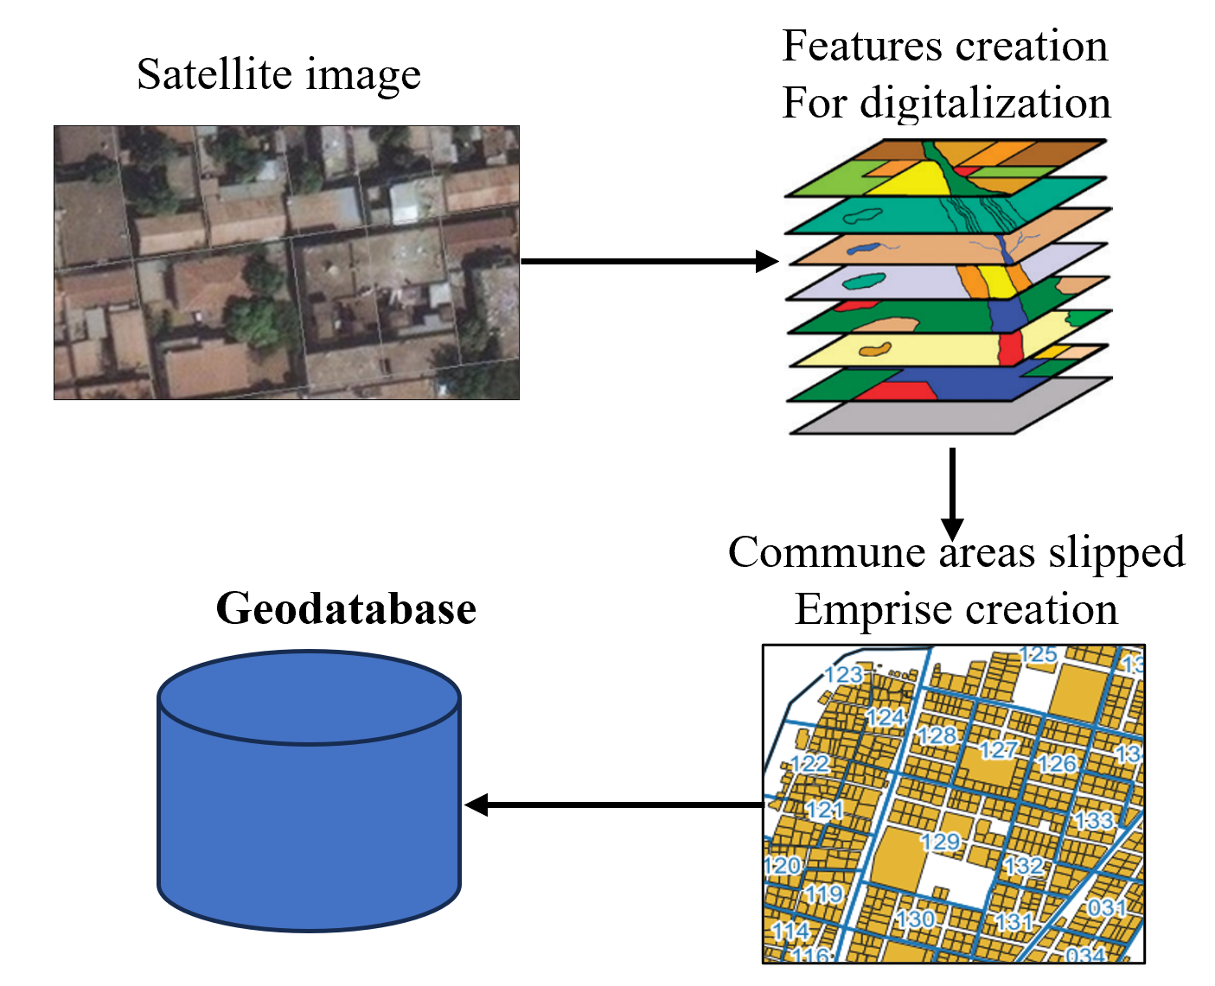
Figure 3. Pre-Enumeration section creation process

2.4.2. Spatial Population Estimation
The method used in this study is Grid Population Estimation. It is a spatial analysis technique used to estimate population distribution within a defined geographic area by overlaying a grid of cells (typically square or rectangular) over the area of interest. Each cell in the grid is assigned a population value based on data from various sources, such as census data, satellite imagery, or other demographic databases. The core idea is to produce a spatially explicit representation of population density that accounts for the distribution and intensity of the population across small, manageable units. The algorithm calculates population estimates within predefined spatial zones by integrating raster-based population data with building footprint information, utilizing Python’s geospatial libraries. The process begins by loading the building footprints, population raster, and spatial zone polygons (referred to as "Emprise polygons"). Metadata and boundaries from the population raster are extracted to align the subsequent data processing steps. Each building’s population estimate is calculated based on its type and number of stories. Thresholds for population per building type such as residential, multi-story, and commercial define minimum and maximum values. The estimated population P_{b} for each building is computed as follows Equation 1.
(1)
where and represent the minimum and maximum population thresholds for the building type, and represents the number of stories.
The number represents a normalization factor for the number of stories. It serves as a way to scale the influence of a building's height (or number of stories) on the population estimate within the given thresholds. Essentially, dividing by moderates the effect of the number of stories, ensuring that population estimates remain within realistic bounds for typical building heights and densities. According to the demographic data are different for types of areas. It is 10 for urban and 10.2 for rural zone.
For each Emprise polygon, population values within its boundaries are extracted from the population raster through zonal statistics, which aggregates raster cell values to provide a sum P_{raster}. This raster-based population estimate is then combined with building-derived estimates using a spatial join. The total population P_{total} for each polygon is calculated as Equation 2.
(2)
where ∑P_{b} represents the sum of estimated populations from building footprints within the polygon.
Finally, the combined population data for each polygon are rasterized to produce a grid, with each cell representing the estimated population within each spatial zone. This rasterized output aligns with the original raster’s specifications, ensuring compatibility with GIS software for further analysis or visualization, such as Figure 4. This structured approach supports applications in census planning, urban management, and resource allocation by providing accessible, grid-based population estimates within defined spatial boundaries.
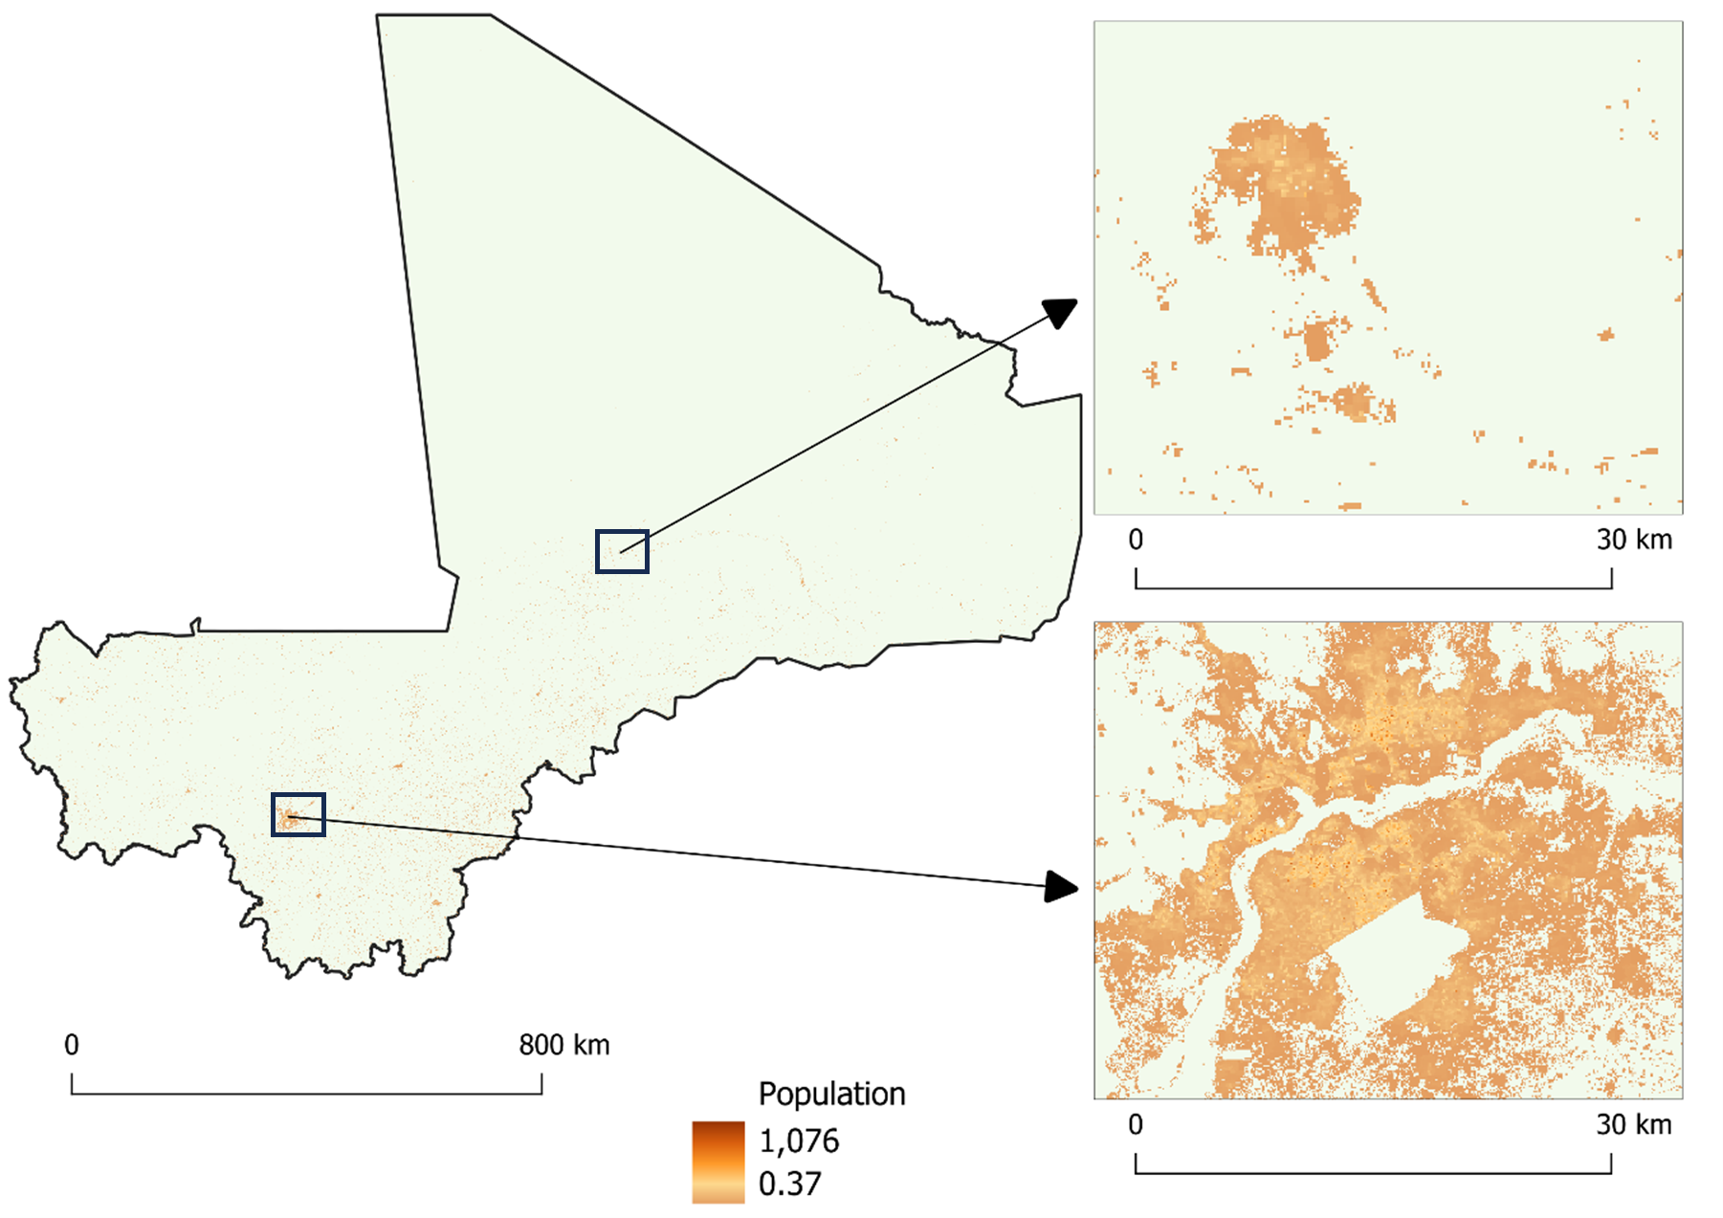
Figure 4. Population estimation using the Grid method
In practice, grid population estimation allows demographers, urban planners, and researchers to better understand population patterns within specific areas and to analyze population density and distribution in regions with diverse geographical and demographic characteristics. This method is particularly effective in low- and middle-income countries (LMICs) or areas with rapidly changing populations, where traditional census data alone may be insufficient.

2.4.3. Raster Population Aggregation Algorithm
The Raster Population Aggregation Algorithm (RPAA) is a specialized method designed to estimate and classify population distributions within predefined spatial zones using raster data. This algorithm leverages Geographic Information Systems (GIS) capabilities for zonal statistical analysis, combining geospatial data processing with conditional classification to support census and demographic research.
The RPAA begins by loading two primary datasets: (i) a vector layer of polygons (referred to here as "Emprise" polygons), representing spatial zones with specific attributes like area type (e.g., rural or urban), and (ii) a population raster containing grid-based population estimates, with each cell representing a population count.
Using the function from the library, population values within each polygon's boundary are aggregated to compute a total population per polygon. For each polygon , the total population is calculated as Equation.
(3)
where represents the population value of each raster cell that falls within the polygon boundary. This computed total is added to the polygon dataset as a new attribute, transforming raster-based estimates into a structured summary suitable for polygon-based analysis.
Following the population aggregation, each polygon is classified based on its area type and population density. The classification criteria are as follows:
For rural areas
If T_{population}<700, the polygon is assigned a classification code of 111.
If T_{population}>1100, it is assigned a classification code of 222.
For urban areas
If T_{population}<500, the polygon is assigned a classification code of 55.
If T_{population}>700T, it is assigned a classification code of 555.
The classification function evaluates each polygon’s population sum, ​, against the area type-specific thresholds, assigning a status code as Table 2
Table 2. Polygon population classification evaluation function
S = | 1 | if type – rural and T_{population < 700}
S = | 2 | if type – rural and T_{population > 1100}
S = | 55 | if type – urban and T_{population < 500}
S = | 555 | if type – urban and T_{population > 700}

This classification is stored as a new attribute in the dataset, allowing a demographic overview based on population density thresholds tailored to rural and urban zones.
Finally, the enriched dataset, which includes both the population totals and classification attributes, is saved as a new shapefile. This output can be visualized or further analyzed in GIS software, providing a robust foundation for population management, urban planning, and socio-economic assessment. This approach efficiently translates raster-based population data into administratively relevant zones and applies meaningful classifications, supporting decisions in resource allocation, regional planning, and urban development.

2.5. Principles of Enumeration Section Creation
The geodatabase created during data digitization was crucial for defining Enumeration Sections (ES) and estimating populations within each area using the Hybrid Population Estimation Model. This process involved creating Emprise polygons (digitized spatial units) that serve as ES boundaries and allow for accurate population estimation.
Leveraging GIS software’s raster calculator and Python, we developed an automated algorithm to extract population data for each Emprise polygon. To enhance accuracy, we incorporated Support Vector Machines (SVM), a supervised machine learning algorithm used for classification and regression. SVM identifies an optimal hyperplane that separates data points of different classes with maximum margin. In our study, SVM was trained on labeled building samples using features such as footprint, height, area, and type. The trained model then classified buildings and estimated occupancy levels, enabling more precise population estimates within each polygon. Integrating SVM into our GIS-based workflow allows the algorithm to generalize predictions to new areas with similar characteristics, improving the accuracy and reliability of the semi-automated pre-census mapping process.
Each Emprise polygon was designated as an ES according to Mali’s official ES creation guidelines, ensuring consistency and precision in population data extraction. To align ES boundaries with actual population distributions, manual refinements were made based on established requirements. For instance, if a polygon’s boundaries did not accurately represent the population density or characteristics of an area, adjustments were made by splitting larger polygons into smaller, more representative units. In cases where polygons were underpopulated according to specified thresholds, a merging method was employed. Underpopulated polygons were combined with adjacent areas to create a more balanced population distribution. This approach enhances demographic accuracy and ensures each ES reflects realistic population densities, supporting reliable demographic and census planning within the study area.
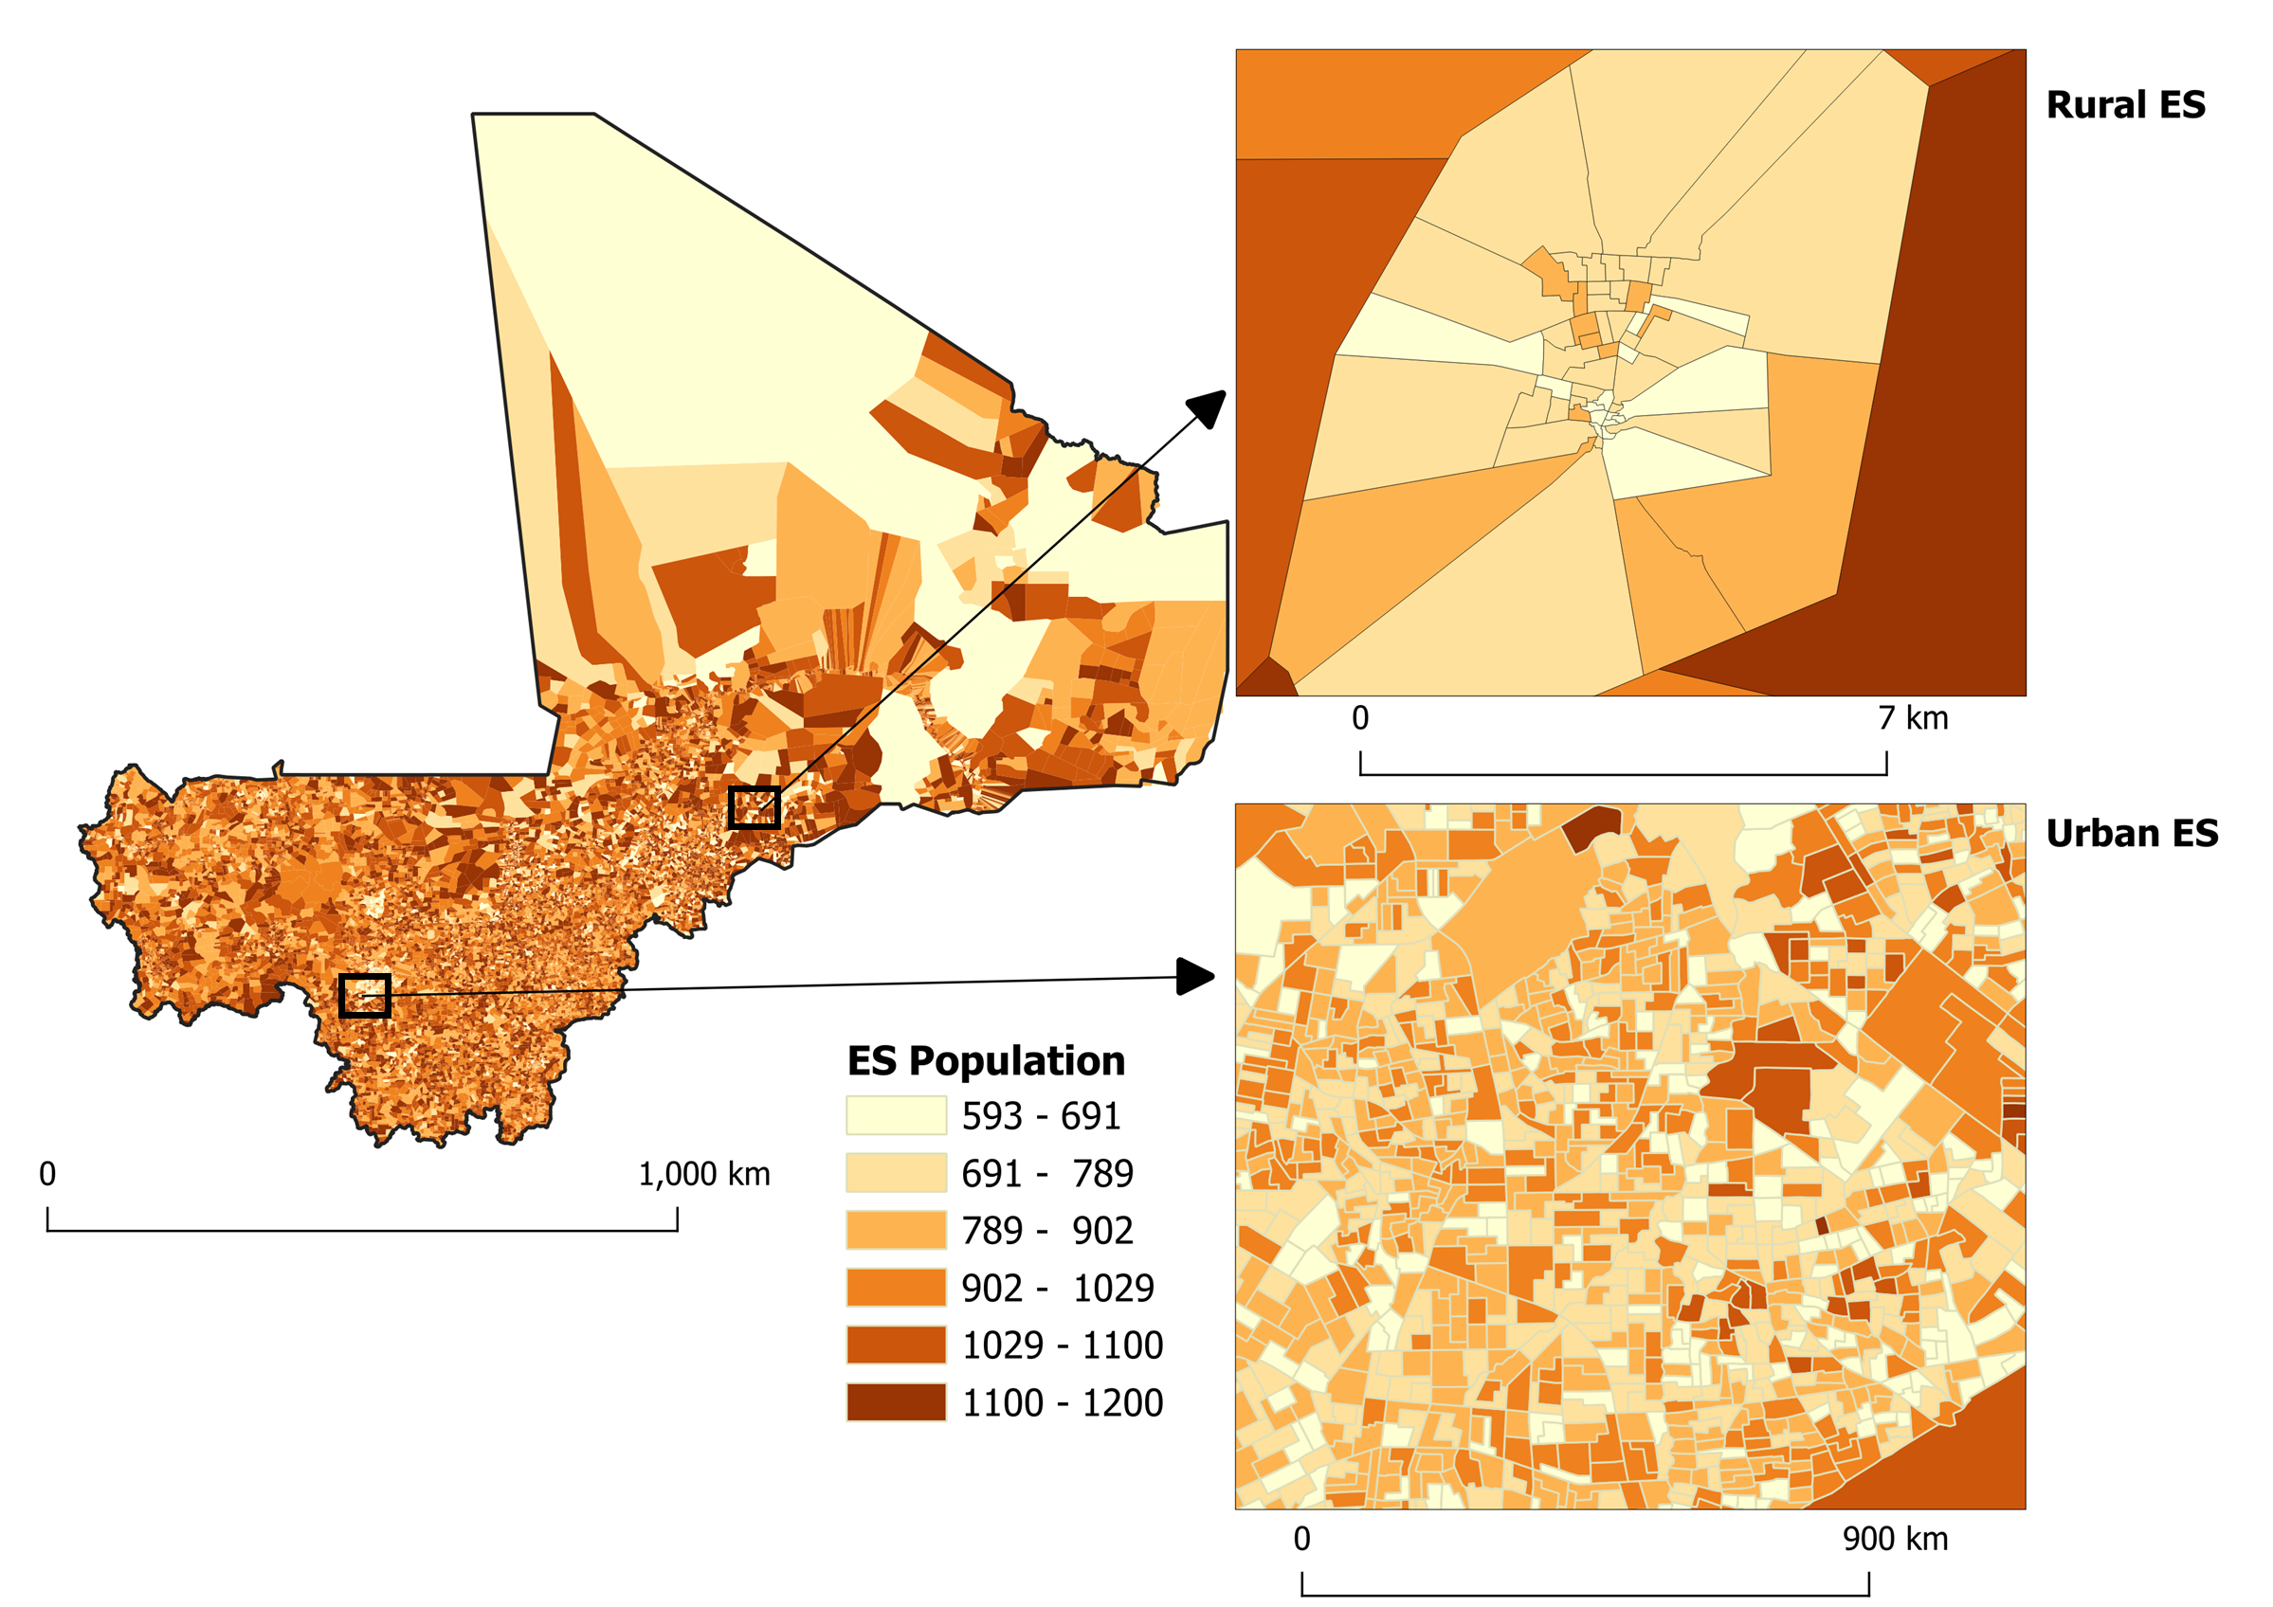
Figure 5. Enumeration Section delineated. Population spatial distribution, urban and rural
A finalized geodatabase was constructed using the updated data and refined Enumeration Sections (ES), tailored specifically for census and survey projects. This geodatabase integrates the latest population estimations and spatial boundaries, providing a comprehensive and reliable foundation for demographic analysis, planning, and resource allocation, as shown in Figure 6. By aligning the geodatabase with precise ES boundaries, it ensures accuracy and usability for a range of applications, including population studies, socioeconomic assessments, and regional development initiatives.
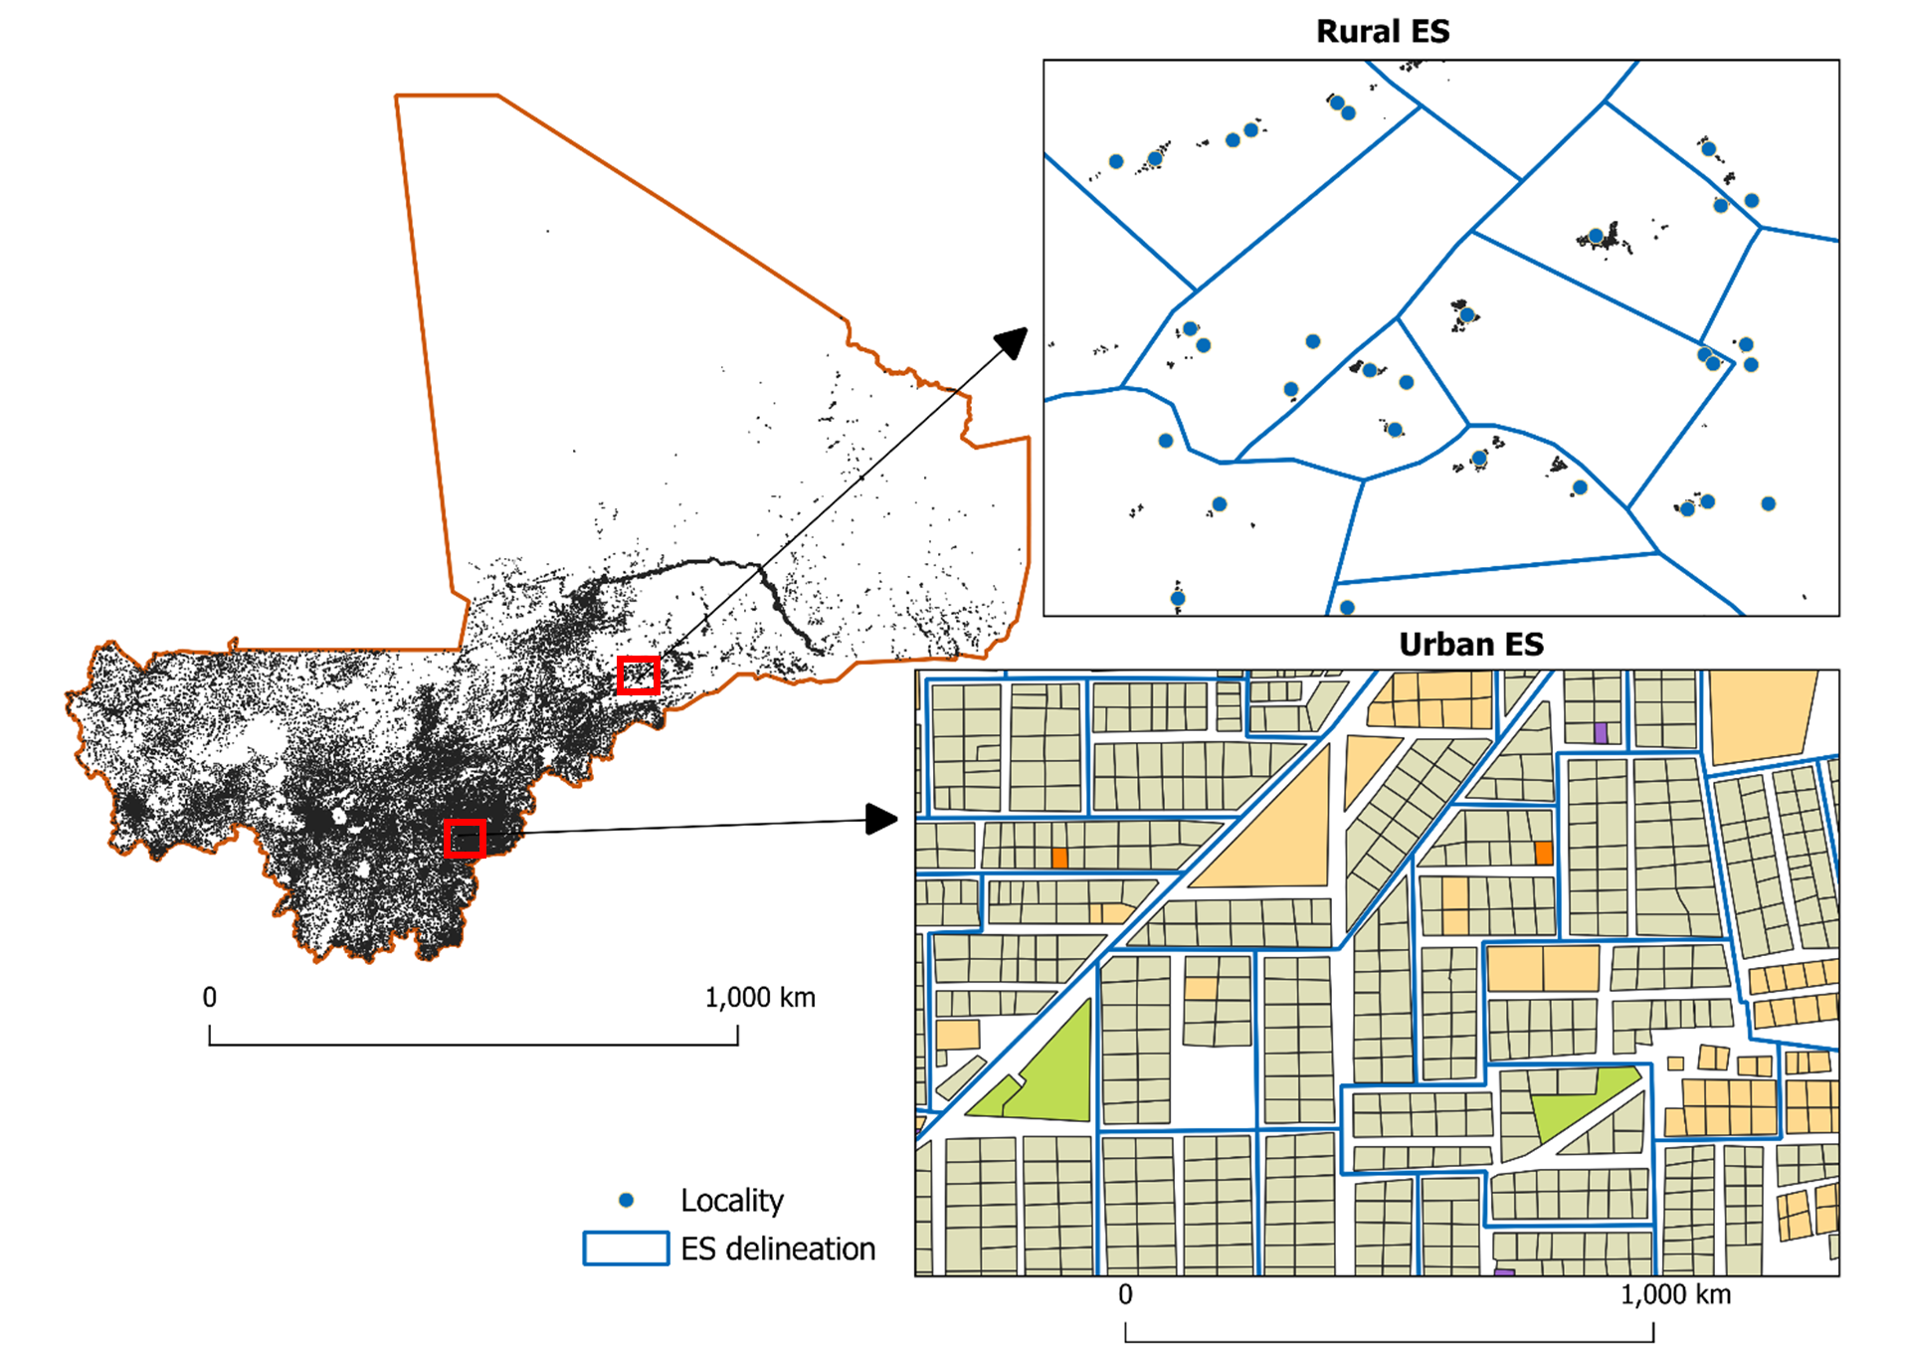
Figure 6. Enumeration Section delineated by type of the zone, urban and rural

3. Method validation
To ensure the practical reliability and adaptability of our semi-automated GIS-based methodology for pre-census mapping, this study includes a validation step using field data collected in two distinct Cercle of Mali, shown in Figure 7. Both regions are characterized by complex geographic features and heightened security challenges, which make on-the-ground census mapping efforts difficult. Validating the accuracy of our Enumeration Section (ES) delineation and population estimates in these areas allows us to critically assess the method’s performance under real-world conditions and its effectiveness in environments where traditional field verification is limited. In this validation phase, the delineated ES boundaries and estimated population data generated from satellite imagery and geospatial integration are compared to field-collected data from these two regions. The field data provides a benchmark to evaluate the accuracy and practical application of our method in capturing population distributions and geographic boundaries effectively in challenging contexts. Additionally, this step enabled the identification of region-specific adjustments that may improve the method’s scalability and reliability across diverse settings. This validation not only highlights the robustness of our approach in regions with limited accessibility but also underscores its potential applicability to other low- and middle-income countries (LMICs) facing similar challenges. The findings from this validation step will contribute to refining the methodology, ensuring that it meets the demands of sustainable population mapping efforts on a broader scale.
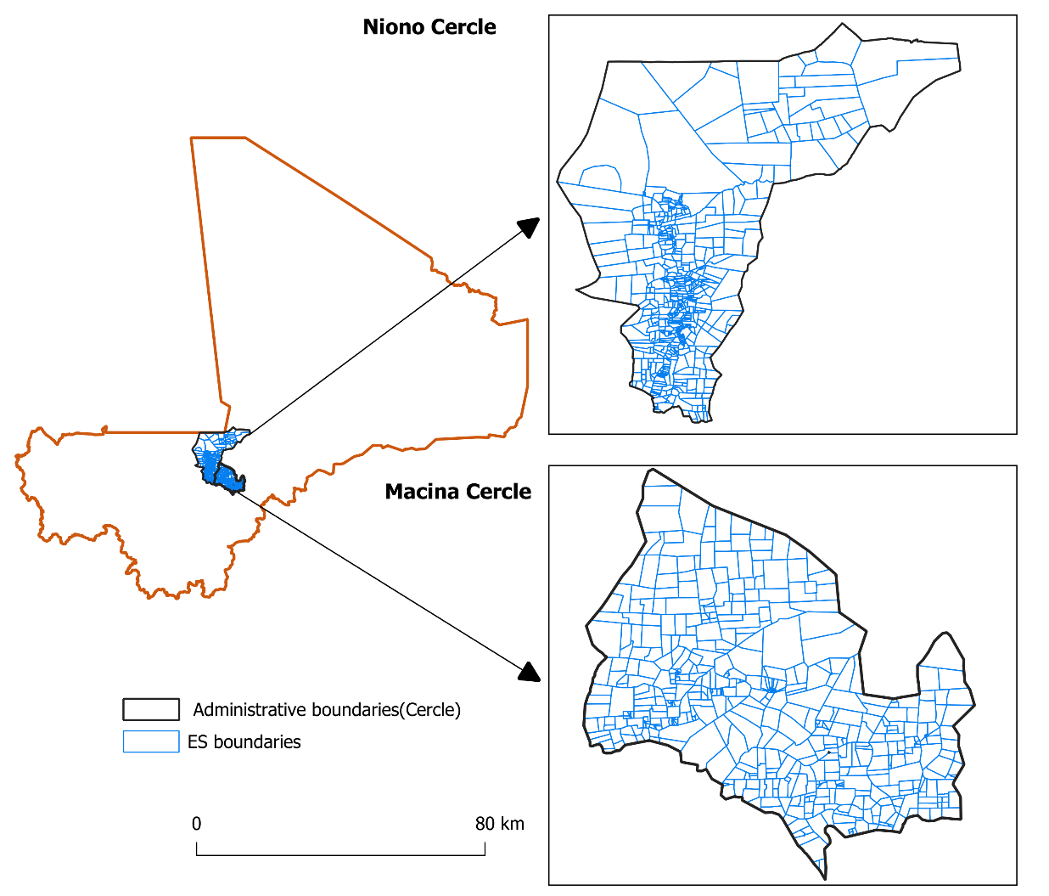
Figure 7. Study method validation areas

3.1. Cercle of Macina
First, Figure 8a demonstrates a strong positive relationship between the field-measured population and the estimated population values, supported by a high correlation coefficient of 0.97. This indicates that the estimation method closely approximates actual population counts, showing reliable consistency. The trend line equation, y=1.00x+3.77, suggests near-perfect scaling of estimated values with the actual counts, with a slope almost exactly equal to 1, meaning there is minimal systematic bias in scaling. The slight positive intercept (3.77) suggests only a minor tendency for overestimation at lower population values. Figure 8b, a line plot of population differences across Enumeration Sections (ES), shows the variation between estimated and field-measured values. The differences fluctuate around zero, indicating that errors are mostly small and centered, though a few sections show larger deviations. Statistical measures provide further insights: the Mean Absolute Error (MAE) of 26.63 suggests that, on average, estimated populations deviate by about 27 people from the actual counts, which is relatively low. The Root Mean Square Error (RMSE) of 37.46, slightly higher than the MAE, reflects some larger errors in a few cases but remains within an acceptable range. The close values of MAE and RMSE indicate a lack of extreme outliers, reinforcing the method’s accuracy and reliability in various population scenarios.
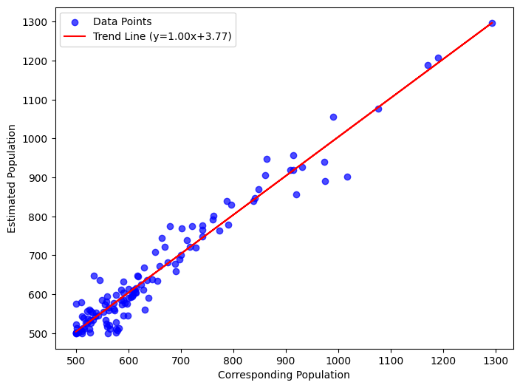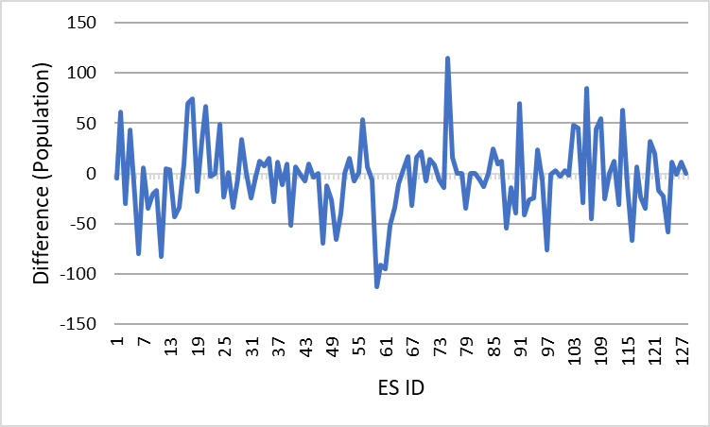
(a)
(b)
Figure 8. Method validation. (a) Correlation between population estimate and field-measured; (b) difference between population estimate and field-measured

3.2. Cercle of Niono
The Figure 9a evaluate the model's accuracy by comparing estimated population values with actual values for each Enumeration Section (ES) in the Niono Cercle. The trend line (y=0.92x+49.30) suggests a strong linear relationship, with a slope of 0.92, indicating that the model generally performs well across various population levels. A correlation coefficient of 0.94 confirms a strong positive correlation, showing that the model's estimates align closely with actual values. The Mean Absolute Error (MAE) of 29.58 indicates an average deviation of about 30 individuals per ES, while the Root Mean Square Error (RMSE) of 42.79 highlights some variability, with larger deviations in certain cases. The intercept of 49.30 hints at a slight overestimation for lower population levels. Figure 9b provides further insight into these deviations by showing the difference between estimated and actual populations across ES. Although the differences fluctuate around zero, certain ES show higher discrepancies, Figure 9b. Overall, while the model demonstrates a high degree of accuracy, adjustments to reduce variability at higher population levels could enhance precision.
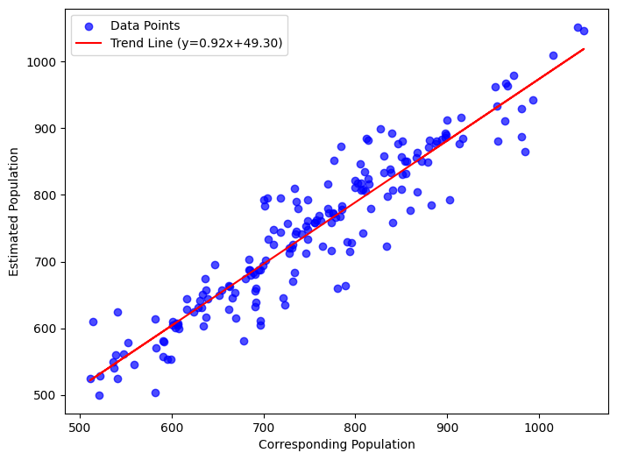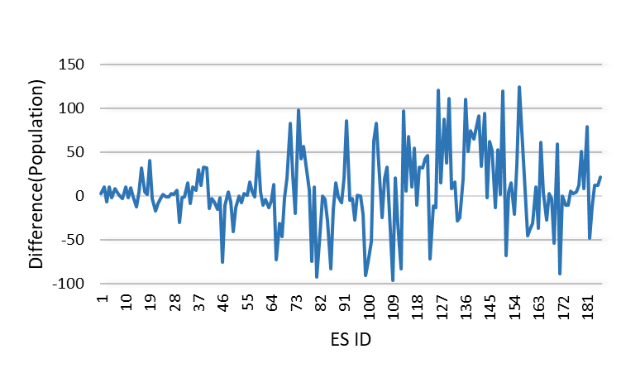
(b)
(a)
Figure 9. Method validation. (a) Correlation between population estimated population values with actual values; (b) difference between estimated population values with actual values

4. Discussion
Automating pre-census Enumeration Section (ES) mapping using satellite imagery and vector-based GIS data represents a substantial advancement in census preparation, particularly in terms of accuracy, efficiency, and operational safety. Very-high-resolution satellite imagery enhances structural detection precision, which is critical for accurate population estimation and resource allocation in national censuses [27]. In many developing countries, logistical constraints and security challenges make traditional, field-intensive census methods difficult. Automated mapping addresses these obstacles by generating reliable data without extensive fieldwork, enabling timely and accurate population mapping even in areas with outdated or incomplete census data [28].
Many gridded population surveys have relied on ad-hoc GIS-based sampling approaches. For example, Galway et al. [29] sampled 1×1 km cells using probability proportional to size (PPS), followed by a random selection of households. Thomson et al. [30] converted 1×1 km population grids into random points and manually delineated clusters for micro-census sampling. Traditional manual ES delineation is time-consuming, error-prone, and dependent on field staff marking boundaries on paper maps [31]. By integrating modern geospatial data with computational algorithms, our semi-automated approach achieves comparable accuracy while significantly reducing labor input. High-resolution data on population distribution, buildings, roads, and rivers allow for precise delineation of ES that are contiguous, compact, and aligned with physical features.
Importantly, our approach incorporates machine learning to refine population estimation and ES delineation. Predictive models adjust for variations in building types, population densities, and local settlement patterns, improving the consistency and accuracy of population estimates. This integration reduces manual intervention, enables adaptive thresholding for different urban and rural contexts, and supports automated detection of under- or over-populated polygons for merging or splitting operations.
Regarding computational efficiency, the methodology processed approximately 10,000 Emprise polygons for Mali within 30–45 minutes on a standard workstation (Intel Core i7, 32 GB RAM) using Python and ArcGIS automation tools. Raster aggregation, population assignment, and ES classification steps were fully automated, which demonstrates the scalability of this approach for national-level applications. Such processing efficiency contrasts sharply with traditional manual methods that may require months or years of fieldwork.
Validation was conducted in two cercles: Macina and Niono representing diverse security and geographic contexts. The strong positive correlations (0.97 in Macina, 0.94 in Niono) and low MAE values (26.63 in Macina, 29.58 in Niono) indicate high reliability of the population estimates. However, we acknowledge that validation in only two regions limits the generalizability of results. Future studies should extend validation across other regions with varied terrains, settlement patterns, and security conditions. Comparable studies in India [33], South Africa [34], and Brazil [35] suggest that semi-automated GIS approaches can maintain accuracy across different geographic and socio-demographic contexts, supporting broader applicability.
Despite its strengths, the methodology has limitations. Its effectiveness depends on the availability of high-quality satellite imagery and accurate ancillary data such as building footprints and population grids [32]. Data preprocessing is intensive, and population models may introduce bias if input data are incomplete or outdated. Further refinement of the ES delineation algorithm, including optimizing the compactness and merging criteria, could improve the geographic coherence of ES and reduce variability in high-density areas.
In conclusion, this study demonstrates the potential of semi-automated, geospatial approaches for pre-census ES mapping. By integrating machine learning, GIS automation, and high-resolution satellite imagery, this method improves accuracy, efficiency, and safety while offering scalable and adaptable solutions for census operations in low- and middle-income countries. Future work should explore broader validation across diverse terrains, enhanced machine learning models for population prediction, and further optimization of computational performance.

5. Conclusion
In developing countries like Mali, basic spatial sampling tools, such as Enumeration Sections (ES) and population estimation, are vital for fostering development and enabling informed decision-making. However, logistical, security, and data limitations pose significant obstacles to traditional census approaches. This study demonstrates that our method for creating predefined census ES can help address these challenges by utilizing freely available, high-resolution gridded population data and settlement maps, making the approach both accessible and adaptable. Future research will focus on applying this method in various regions and enhancing output usability by integrating additional constraints and optimized merging algorithms.

Data Availability Statement: Data will be made available upon a reasonable request.

Disclaimer (Artificial intelligence)
Option 1:
Author(s) hereby declare that NO generative AI technologies such as Large Language Models (ChatGPT, COPILOT, etc.) and text-to-image generators have been used during the writing or editing of this manuscript.
Option 2:
Author(s) hereby declare that generativ AI technologies such as Large Language Models, etc. have been used during the writing or editing of manuscripts. This explanation will include the name, version, model, and source of the generative AI technology and as well as all input prompts provided to the generative AI technology
Details of the AI usage are given below:
1.
2.
3.

References
- United. Nations. Principles and recommendations for population and housing censuses. UN-library. pp 7-22 https://doi.org/10.18356/8b8ce311-en. Acceded 30 October 2024.
- INSTAT-Mali. Strategic document of the mapping of the fifth general census of population and housing (5th rgph), Mali. https://demostaf.web.ined.fr/index.php/catalog/382 Acceded, 31 October 2024
- Joas, J.M. Challenges experienced with the demarcation of Enumeration Areas for Census 2011, https://catalog.ihsn.org/citations/52530. Acceded, 31 October 2024
- Qader, S. ; Lefebvre, V. ; Tatem, A. et al. Semi-automatic mapping of pre-census enumeration areas and population sampling frames. 2021, Humanit Soc Sci Commun 8, 3. https://doi.org/10.1057/s41599-020-00670-0
- Cockings, S.; Harfoot, A; Martin, D; Hornby, D. Maintaining existing zoning systems using automated zone-design techniques: methods for creating the 2011 Census output geographies for England and Wales. Environ Plan A, 2011, 43 (10):2399–2418. https://doi.org/10.1068/a43601
- United Nations. Economic and Social Council. 2010 Population and Housing Census Series in Africa, Conferences on statistical development, Addis Ababa, Ethiopia, 17 – 22 Jan 2010.
- Si, Y.K.; Boukerch, I.; Hocine, I.; Benabdelkader, A. The setting up of a GIS for the general population and housing census. ISPRS. 2021, 313–319, https://doi.org/10.5194/isprs-archives-XLIII-B4-2021-313-2021.
- Wang, Y.; Li, H.; Yu, Z.; Luo, B. Approaches to census mapping: Chinese solution in 2010 rounded census. Chin. Geogr. Sci, 2012, 22, 356–366. https://doi.org/10.1007/s11769-012-0540-2.
- Frederick, R.B.; Leslie G. Partnering for the people: improving the US Census Bureau's MAF/TIGER database. Photogrammetric Engineering & Remote Sensing. 2003, 69, 1119–1123.
- Robert W. M. The TIGER system: Automating the geographic structure of the United States census. G. Pub. Review. 1986, 13, 181–201; https://doi.org/10.10¹⁶/0277-9390(86)90003-8.
- Alister, D. N. Application of GIS in the 2011 Australian census of population and housing and plans for 2016, Geo.C.Science, 2023, http://2013.isiproceedings.org/Files/IPS082-P2-A.pdf.
- UNECE. Conference of European Statisticians Recommendations for the 2020 Censuses of Population and Housing. New York and Geneva, 2015. https://unece.org/statistics/publications/conference-european-statisticians-recommendations-2020-censuses-population.
- Sanga, D.; Dosso, B. The use of geographic information systems in African national statistical institutes/offices, United Nations Regional Workshop on Data Dissemination and Reporting Niamey, African Statistical Journal, 2007, 5. 161-181.
- Srini, V., Adelamar, A. GIS-based Methods for Estimating Missing Poverty Rates & Projecting Future Rates in Census Tracts. Review of Economics and Finance, 2016, 3(6), 1923-8401.
- Okeke, O.; Okonkwo, E. Design and development of a data mining model for census analysis with geographical information system (GIS). Journal of emerging technologies and innovative research, 2017, 4. 388-397.
- Claude, B.; Gilles, R. The mapping of censuses, 1977, 119-198. https://horizon.documentation.ird.fr/exl-doc/pleins_textes/divers10-09/20624.pdf.
- Thomson, D.R.; Stevens, F.R.; Ruktanonchai, N.W.; Tatem, A.J.; Castro, M.C. GridSample: an R package to generate household survey primary sampling units (PSUs) from gridded population data. Int J Health Geogr, 2017, 16. https://doi. org/10.1186/s12942-017-0098-4
- Cajka, J.; Amer, S.; Ridenhour, J.; Allpress, J. Geo-sampling in developing nations. Int J Soc Res Methodol, 2018, 21(6):729–746. https://doi.org/10.1080/ 13645579.2018.1484989
- Wang, Y.J.; Jiang, L.L.; Qi ,Q.W.; Liu, Y.; Wang, J. Remote Sensing-Guided Sampling Design with Both Good Spatial Coverage and Feature Space Coverage for Accurate Farm Field-Level Soil Mapping. Remote Sensing, 2019, 11(16): https:// doi.org/10.3390/rs11161946
- Haynes, R.; Daras, K.; Reading, R.; Jones, A. Modifiable neighbourhood units, zone design and residents perceptions. Health Place, 2007, 13(4):812–825. https:// doi.org/10.1016/j.healthplace.2007.01.002
- Nock R, Nielsen F (2004) Statistical region merging. IEEE Trans Pattern Anal Machine Intelligence 26(11):1452–1458. https://doi.org/10.1109/tpami.2004.110
- Yunfan, K.; Amr, M. EMP: EMP: Max-P Regionalization with Enriched Constraints, 2022 IEEE 38th International Conference on Data Engineering (ICDE), Kuala Lumpur, Malaysia, 2022, pp. 1914-1926, doi: 10.1109/ICDE53745.2022.0018
- Hussah, A.; Yongyi, L.; Amr, M. Proceedings of the 30th International Conference on Advances in Geographic Information Systems, New York, NY, USA, 01-01-2022. doi: 10.1145/3557915.3561011
- Cardona, D.; Carlos, J. Design of Homogenous Territorial Units. A Methodological Proposal and Applications. Report Thsis, Universitat de Barcelona, 2004
- Barrington, L.C., Millard, B.A. The world’s user-generated road map is more than 80% complete. PLoS ONE, 2017 12(8). https://doi.org/10.1371/journal. pone.0180698
- INSTAT-Mali. Preliminary report of the overall result of RGPH5, https://www.instat-mali.org/laravel-filemanager/files/shares/rgph/rapport-resultats-globaux-rgph5_rgph.pdf. accessed on 1 novembre 2024.
- Gafarou, K.; Yacine, B. ; Harolde, C. ; Damien, E. ; Etienne, L.H. ; Mikaël. G. Application of deep-learning techniques to very-high-resolution satellite images supporting population censuses in developing countries. Journal of Applied Remote Sensing, 2023. 2 (17). doi: 10.1117/1.jrs.17.024506
- Stefanos, G.; Sebastian, H.; Monika, K.; Catherine, L.; Yifang, B. A census from heaven: Unraveling the potential of deep learning and Earth Observation for intra-urban population mapping in data scarce environments, International Journal of Applied Earth Observation and Geoinformation, 2022, 103013, 114, 1569-8432, https://doi.org/10.1016/j.jag.2022.103013.
- Galway, L.P.; Bell. N.; Sae, A.S, Hagopian, A.; Burnham, G.; Flaxman, A.; Wiliam, M.W.; Julie, R.; Tim, K.T. A two-stage cluster sampling method using gridded population data, a GIS, and Google Earth imagery in a population-based mortality survey in Iraq. Int J Health Geogr, 2012, 12 (2012) . https://doi.org/10.1186/1476-072X-11-12.
- Thomson, D.R.; Hadley, M.B.; Greenough, P.G., Castro MC. Modelling strategic interventions in a population with a total fertility rate of 8.3: a cross-sectional study of Idjwi Island, DRC. BMC Public Health. 2012. https://doi. org/10.1186/1471-2458-12-959
- Si, Y.K., Boukerch, I.; Hocine, I.; Benabdelkader, A. The setting up of a GIS for the general population and housing census, Int. Arch. Photogramm. Remote Sens. Spatial Inf. Sci., XLIII-B4-2021, 313–319, https://doi.org/10.5194/isprs-archives-XLIII-B4-2021-313-2021, 2021.
- C. Sangeetha; Vishnu Moond; Rajesh G. M.; Jamu Singh Damor; Shivam Kumar Pandey; Pradeep Kumar; Barinderjit Singh. Remote Sensing and Geographic Information Systems for Precision Agriculture: A Review. International Journal of Environment and Climate Change, (2024) 14(2), 287–309. https://doi.org/10.9734/ijecc/2024/v14i23945

