Ecotourism and Socio-Economic Transformation: A Case Study of Native Communities around Khutaghat Dam, Chhattisgarh, India

Abstract
In Chhattisgarh, including places like Khutaghat Dam and Bilaspur, ecotourism has become a popular tactic to support economic growth while protecting the state's natural and cultural resources. With its abundance of species and natural beauty, the area has a great chance of drawing eco-aware tourists. To provide other sources of income for the local rural and tribal populations, efforts have been undertaken in recent years to promote ecotourism around Khutaghat Dam. The socioeconomic status of the local villages around Khutaghat Dam is still mostly undeveloped, nonetheless, in spite of these efforts. Programs for skill development are either inadequate or poorly executed, and women in particular continue to be underrepresented in ecotourism-related activities. Because of this, the expected advantages of ecotourism have not quite materialized into raises in the level of life for the local populace. Although ecotourism has raised awareness of sustainability and conservation, it has not yet succeeded in achieving the more general objectives of sustainable community development, according to an analysis of local government programs, tourist development plans, and scholarly findings. In the majority of nearby communities, the principal goalspoverty reduction, gender parity, better health and education, and food security remain unfulfilled. This circumstance emphasises how urgently integrated development planning and cooperation between the government, tourist authorities, local panchayats, non-governmental organisations, and community stakeholders are needed. To be really sustainable, ecotourism at Khutaghat Dam has to directly benefit the local people that protect and preserve the region's natural resources. The money received from tourism should be used to fund capacity-building, education, and infrastructure projects in the area. In summary, the socioeconomic standing of the local people around Khutaghat Dam does not currently correspond with the fundamental tenets of sustainable development. For ecotourism to become a vehicle for long-term socioeconomic development, environmental stewardship, and cultural preservation in this area, inclusive policies and systematic implementation are desperately needed.
Key Words: Ecotourism, Sustainable Development, Socio-Economic Status, Community Development, Gender Participation, Khutaghat Dam

Highlights
- Ecotourism around Khutaghat Dam has potential for biodiversity conservation and alternative livelihood generation for rural and tribal communities.
- Despite government and NGO efforts, socio-economic challenges such as poverty, limited healthcare, education gaps, and gender inequality persist.
- Women’s participation in ecotourism-related activities remains low due to lack of skill development and inadequate institutional support.
- Ecotourism has increased awareness of sustainability and cultural preservation, but its contribution to poverty reduction, food security, and community development remains limited.
- The study emphasizes the need for integrated development planning involving government, panchayats, NGOs, and local stakeholders to make ecotourism truly sustainable.

1. Introduction
Ecotourism has increasingly gained recognition as a sustainable development tool that balances environmental conservation with community welfare. Defined by The International Ecotourism Society (TIES, 2015), ecotourism involves responsible travel to natural areas that conserves the environment, sustains the well-being of local people, and involves interpretation and education. Across developing countries like India, ecotourism is being promoted as an alternative economic strategy that not only supports biodiversity conservation but also empowers rural and indigenous communities through income generation, capacity building, and improved infrastructure (Das & Chatterjee, 2018).
India’s unique ecological diversity and rich cultural heritage provide a fertile ground for ecotourism initiatives, particularly in forest-fringe villages, tribal-dominated landscapes, and areas with ecological significance such as the Khutaghat Dam region in Bilaspur, Chhattisgarh. These areas often house marginalized communities whose economic conditions are precarious, lacking access to basic education, healthcare, and employment opportunities. The theoretical promise of ecotourism lies in its potential to uplift these communities by integrating them into the tourism value chainoffering jobs as local guides, homestay operators, handicraft producers, and conservation stewards (Kumar, 2023).
Despite this promise, the actual socio-economic benefits of ecotourism development remain contested. In many instances, the communities residing near ecotourism destinations continue to face poverty, poor literacy rates, gender disparities, and limited social mobility (Pandya, 2022). Studies have revealed that while tourism infrastructure might improve, the local population often lacks ownership, control, or meaningful participation in tourism activities, resulting in limited economic gain and social transformation (Rajasenan et al., 2012). This situation raises critical concerns about the equity and sustainability of ecotourism as a development model.
In regions like Khutaghat Damrich in natural beauty and biodiversitythe development of ecotourism offers a strategic opportunity to examine whether these interventions have led to measurable improvements in the socio-economic conditions of native communities. The current research aims to investigate this relationship systematically, evaluating the extent to which ecotourism contributes to key indicators of community development such as income generation, education, health access, gender equity, and food security. By analyzing both qualitative and quantitative data, the study intends to uncover whether ecotourism acts as a genuine driver of sustainable community development or merely reinforces existing inequalities under a green label.
Understanding this relationship is vital not only for academic discourse but also for policy-making and program implementation. It will help identify the structural barriers and enabling conditions that determine whether ecotourism benefits are equitably distributed among native populations. Moreover, it contributes to the broader discussion on sustainable development goals (SDGs), especially SDG 1 (No Poverty), SDG 5 (Gender Equality), SDG 8 (Decent Work and Economic Growth), and SDG 11 (Sustainable Communities), which are directly impacted by ecotourism outcomes.

2.Literature Review
2.1 Ecotourism and Community Livelihoods in India
This paper explores ecotourism’s potential to boost local economies and examines how current management practices and alternative livelihoods can address resource scarcity in Kaimur Wildlife Sanctuary, India. The study employed a combination of qualitative research methods, including semi structured interviews, surveys, on-site observations, focus group discussions, and literature reviews, along with a cross-sectional survey approach that integrated both qualitative and quantitative data collection to provide comprehensive insights. The study reveals that impoverished communities near forests, reliant on indigenous knowledge and resources, have been severely affected by forest degradation and current management practices. The findings highlight community-based ecotourism as a promising solution for sustainable income generation in the region, helping to mitigate resource degradation and support sustainable development. However, the region’s ecotourism potential is hindered by inadequate infrastructure, training & opportunities, and public awareness. Developing ecotourism as an alternative income source, alongside an inclusive forest management strategy that integrates social diversity, livelihood generation, and conservation, is essential for promoting nature conservation, reducing poverty, and enhancing the well-being of local communities.(Bhushan et al., 2024)
This paper Using social exchange theory (SET), the article examines whether ecotourism reduces the dependency of the local communities on natural resources and also the impact of ecotourism on conservation of biodiversity in BKWS.The study using a mixed method approach finds that ecotourism in BKWS is able to provide economic benefits to the villagers. The economic benefits from diversified employment opportunities are able to motivate locals to conserve biodiversity. However, the socio-cultural impact is hardly experienced by the villagers. (Das and Chatterjee,2023)
This research aims to provide a comprehensive understanding of the impact of community-based ecotourism in rural India. By investigating specific case studies, the study seeks to unravel the mechanisms that link environmental conservation and economic empowerment within the context of ecotourism. The overarching goal is to offer insights that can inform sustainable development policies and practices, fostering a symbiotic relationship between local communities and their natural surroundings. Rural India, characterized by diverse ecosystems and vibrant cultural traditions, serves as an ideal setting for exploring the potential of community-based ecotourism. Against a backdrop of environmental challenges and economic disparities, this research contextualizes the significance of such initiatives. It delves into existing literature to highlight the theoretical foundations and practical implications of community-driven ecotourism, setting the stage for a focused case study analysis. Employing a qualitative case study methodology, this research engages in an indepth exploration of selected community-based ecotourism initiatives in rural India. Data will be gathered through interviews with community members, ecotourism operators, and relevant stakeholders. Observation and document analysis will complement the interviews, providing a holistic understanding of the environmental and economic dimensions of the initiatives under study. Preliminary findings reveal a positive correlation between communitybased ecotourism and environmental conservation, coupled with notable economic benefits for local residents. The case studies demonstrate successful models of community engagement, showcasing instances where ecotourism serves as a catalyst for preserving natural resources while empowering communities economically. In conclusion, this research underscores the potential of community-based ecotourism as a transformative force in rural India, concurrently promoting environmental conservation and economic empowerment. (Kumar,2023).
2.2 Case Studies Across India
The study reveals that infrastructure facilities, design and package of rural tourism products, skill development programs for stakeholders and specific marketing campaigns are essential to tourism development. Findings indicate that residents understand the extent of tourism impacts in their mountainous region with respect to economic, social and environmental dimensions. Study also reveals that although locals want to increase tourism gains with corresponding effort to reduce consequences deprived, their perceived impacts of tourism vary across their demographic variables. (Bagriand Kala,2016).
The tribal communities are one of the highly marginalised groups and not many studies address the existing tribal welfare opportunities and practices available in the ecotourism destinations. This study illustrates the conservation governance model that dovetails cogently the imperatives of conservation, livelihoods and economic production has been documented. Parambikulam Tiger Reserve is one of the most popular ecotourism sites in India. This paper highlights innovative practices adopted at the reserve with an intention of replicating these procedures elsewhere. The study identified possible direct and indirect benefits bestowed on the local community and ecology by tourism such as transformation of the reserve into cattle free, plastic free, poacher free, fire free zone and also strategies that led to the generation of sizable revenue directed towards conservation and community welfare. Several implications of ecotourism are introduced and recommendations for future research are presented.(Edward and Kumar,2017).
The literature emphasizes that tourism social entrepreneurs play an important role in the adoption of sustainable strategies to achieve social, environmental, and community development. Yet, there is limited research that aims to understand the relationship between local communities and tourism social entrepreneurship empirically. Building around social exchange theory and Weber’s theory of substantive and formal rationality, this study addresses the following research question: how do local communities perceive the role of tourism social entrepreneurship (TSE) in the development of ecotourism destinations? A total of 362 community employees of two ecotourism organizations in India participated in the survey. Analytically, this study validated the measurement model and tested hypotheses using structural equation modeling (SEM). The findings reveal that the economic benefits and environmental sustainability are the main influencing factors that are appreciated by the communities. However, we found variance in the community perceptions with regard to several factors being studied in the two TSEs we studied. This study recommends that in order to contribute to the development of ecotourism and local communities there is an urge to build strong ties among different stakeholders at the local level. (Kummithaetal., 2021)
2.3 Policy and Research Gaps
This essay is an overview of recent research on ecotourism in India, evaluating the social, environmental, political and economic implications of several case studies and highlights the need for re-evaluation of the national policy. It also outlines the evident research gaps, suggesting what needs to be further investigated in order to have a more comprehensive view of the reality of current ecotourism practices with the view of ameliorating them. Concisely, there is an inherent need for ecotourism policy reform in India to prevent ‘pseudo ecotourism’ growth and destruction of environmentally vulnerable areas. (Spicer,2020).
3.Conceptual structure and Theoretical Basis
This study's conceptual underpinnings are rooted on Social Exchange Theory (SET), which proposes that people or organizations participate in social or economic activities by weighing the costs and benefits. Local populations are more likely to accept the growth of ecotourism if they believe the social, economic, or cultural benefits exceed any possible drawbacks, such as loss of privacy, environmental damage, or cultural deterioration (Ap, 1992).
Social Exchange Theory is very applicable in areas such as Khutaghat Dam, where local residents depend heavily on their natural environment for their subsistence. The hypothesis explains the reasons for the potential resistance or acceptance of ecotourism projects by indigenous groups. Locals are more inclined to support ecotourism if they see clear and equitable advantages, such as jobs at eco-lodges, revenue from local product sales, or better access to healthcare and education. However, opposition or indifference may surface if tourism results in land dispute, cultural upheaval, or advantages that are not shared by locals.
Independent Variable: Ecotourism development Level and Type
This study's independent variable is the kind and degree of ecotourism growth occurring around Khutaghat Dam. Despite the region's abundant natural and visual potential,it is surrounded by hills, woods, and bodies of waterformal ecotourism infrastructure is still lacking. But there have been some slow attempts, like:
Forest authorities have started offering possibilities for forest stays and occasional eco-camping.Villagers operate a few homestays or unstructured seasonal food stand Possibility of village-based cultural activities, bird viewing, and guided nature hikes, albeit they are not yet including in official in travel packages inadequate revenue-sharing plans or official training for members of the local community.
An ecotourism intervention level of low to moderate is characterized by this uneven and informal growth. The lack of organized community-based ecotourism models, such as those seen in Uttarakhand or Kerala, restricts the chances for long-term involvement.
Dependent variables include the socioeconomic standing of nearby communities.
The socioeconomic status of the indigenous populations residing close to Khutaghat Dam is represented by the dependent variables. The following may be explained in depth based on preliminary field observation and secondary data review
Household Income: The majority of people in the area make their living via daily wage work, fishing, agriculture, or small-scale forest products. Because there is no infrastructure for tourists or planned participation, tourism presently makes up a little portion of their yearly revenue.
High rates of poverty are common, particularly among disadvantaged castes and Scheduled Tribes. For survival, many families turn to government programs because they find it difficult to satisfy their fundamental necessities’
Access to Education: Although there are government schools, a lot of students leave out. In addition to the poor level of education, many young people travel seasonally for low-skilled work rather than continuing their education or finding local work.
Health Services: Accessibility is a big issue during crises during the rainy season, and primary healthcare services are located far away. The infrastructure for health care has not yet improved as a result of tourism
Food Security: Many families, especially those with small landholdings, face seasonal food shortages. Although unrealized, ecotourism has the potential to diversify revenue.
Gender Equality: The majority of women's jobs are low-paying forest-based labour or unpaid domestic duties. There is very little representation of them in decisions pertaining to tourism or business ventures
Skill Development: There is a dearth of ecotourism-related vocational training in areas like crafts, hospitality, and guiding. Few opportunities exist for young people to develop their skills in tourism or conservation-based jobs.
Connection Between socioeconomic Results and Ecotourism
With the use of this framework, the research may investigate whether the growth of ecotourism at Khutaghat Dam, either now or in the future, can benefit these socioeconomic metrics. The implementation of community-inclusive ecotourism methods, such as training local guides, encouraging homestays, establishing tourist cooperatives, and tying tourism revenue to healthcare or education, may result in a noticeable improvement in socioeconomic circumstances. If not, the advantages of ecotourism could keep eluding locals.

4. Research Design and Methodology
4.1 Study Area
The selected study area is Khutaghat Dam, located in the Bilaspur district of Chhattisgarh, India. This site is characterized by its rich forest cover, natural water resources, and proximity to tribal and rural settlements. The dam area has witnessed gradual interest in ecotourism, yet the involvement of native communities in ecotourism-based development remains limited and informal.
To provide a broader context and benchmark the findings, the study also refers to comparative ecotourism models in India, including sites such as:
Bhitarkanika Wildlife Sanctuary (Odisha) – known for community-led mangrove ecotourism;
Periyar Tiger Reserve (Kerala) – where community-based ecotourism is institutionalized through EDCs;
Koti-Kanasar, Uttarakhand – which promotes ecotourism as a livelihood tool for Himalayan villages.
4.2 Research Methods
4.2.1 Primary Data Collection
Household Surveys: Conducted with both ecotourism-engaged and non-engaged households. Topics included income sources, education, healthcare, gender participation, and tourism awareness.
Semi-structured Interviews: With local officials, forest officers, and tourism department personnel to understand policy frameworks and ground-level challenges.
Focus Group Discussions (FGDs): Held with community members to gain collective insights into socio-economic needs, expectations from tourism, and perceived benefits or risks.
4.2.2 Secondary Data Collection
Government Reports: Tourism department project plans, state ecotourism policies.
NGO Reports: Insights from organizations working on tribal welfare and sustainable livelihoods in the region.
Academic Literature: Case studies and comparative frameworks from other Indian ecotourism sites to assess gaps and opportunities.
4.3 Sampling Technique
A stratified sampling approach was used to ensure representation of:Households directly involved in ecotourism activities (e.g., selling local products, acting as guides). Households not involved in ecotourism but residing in the same community.The goal was to compare and contrast socio-economic conditions across both groups.
4.4 Data Analysis Methods
Quantitative Analysis: Descriptive statistics were used to calculate averages, percentages, and comparisons for key indicators such as income, access to services, gender participation, and skill development.
Inferential Analysis: Regression analysis (planned in SPSS/R) to determine the relationship between level of ecotourism involvement and socio-economic variables.

Qualitative Analysis: Thematic coding of interviews and FGDs to extract insights about perceptions, challenges, and local aspirations.

5. Results and Discussion
5.1 Income and Livelihood Opportunities
The survey revealed that households engaged in ecotourism had significantly higher average monthly income (₹9,500) compared to non-engaged households (₹5,200). The income of engaged households was supplemented through homestays, nature guiding, food stalls, handicrafts, and seasonal tourism labour. Interviews also highlighted that even small-scale involvement in ecotourism provided critical supplemental income during off-season agriculture.
However, income disparity remains prominent due to the limited scale of tourism operations. Less than 30% of households reported direct involvement in tourism, indicating a narrow distribution of benefits.

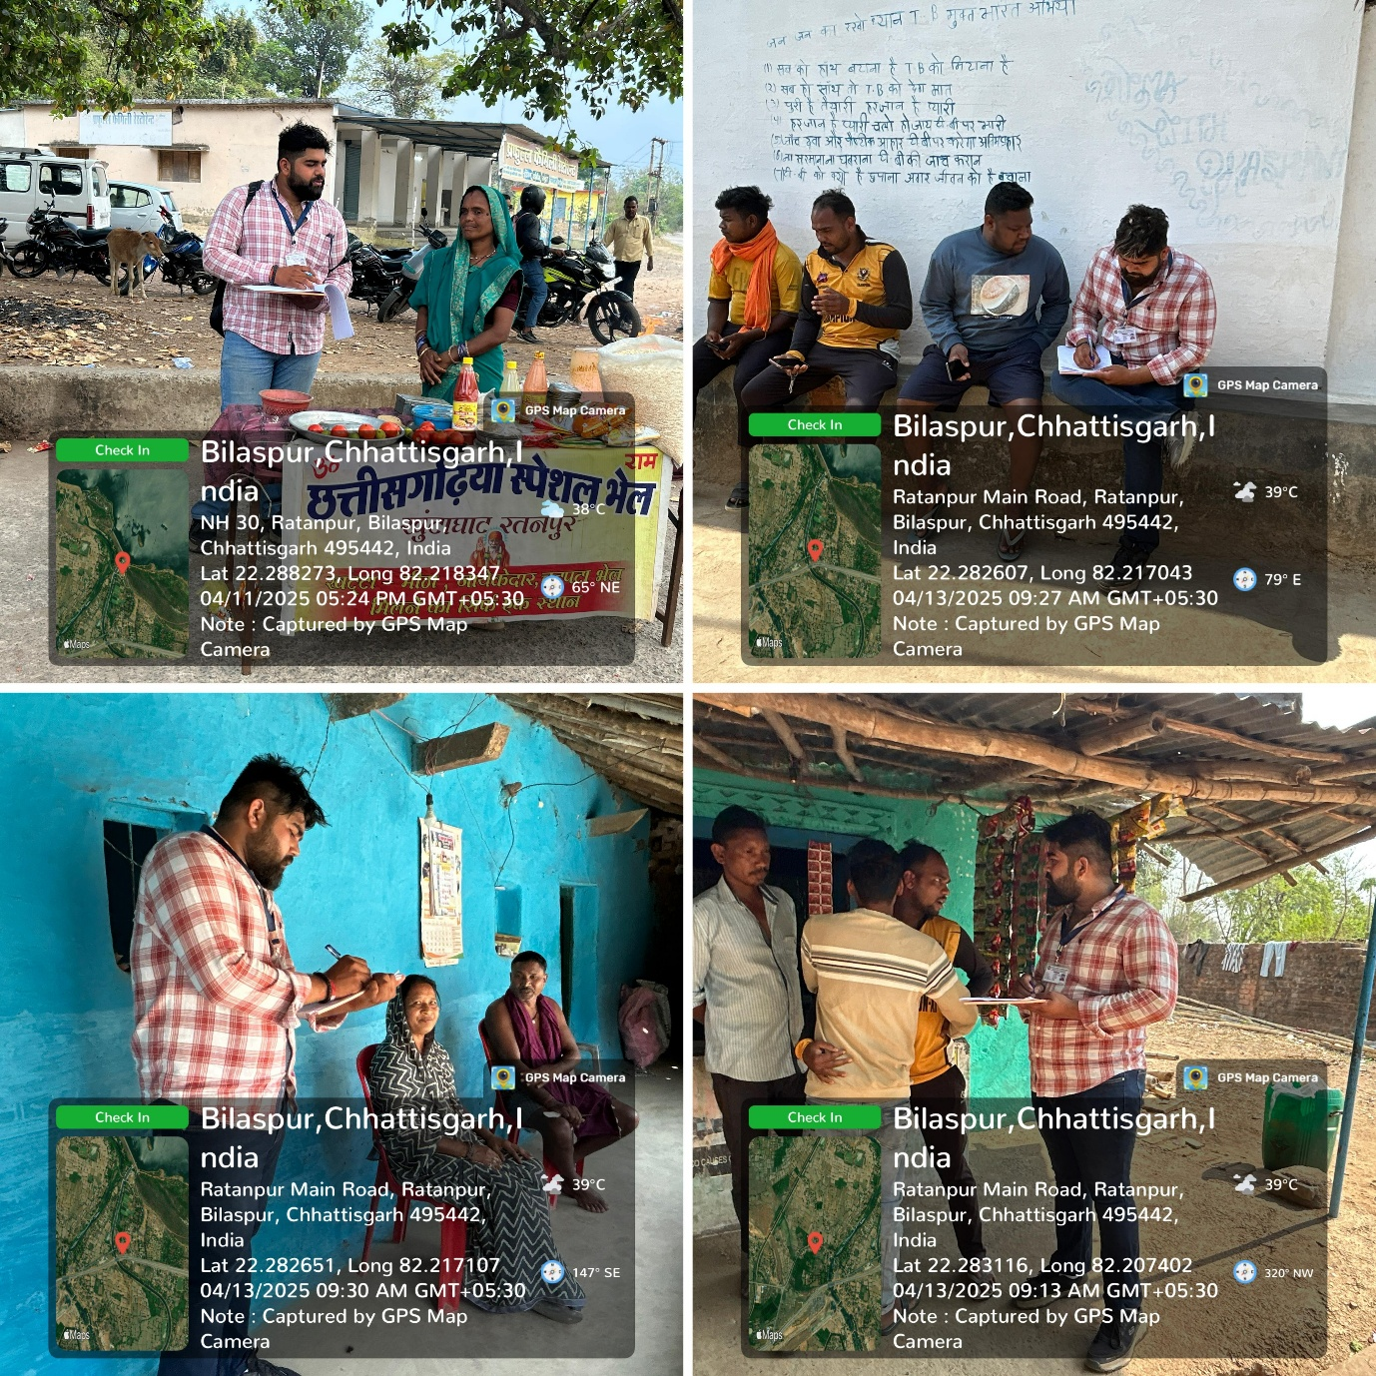
Fig 1. Households Survey of study area Khutaghat, Dam
(Das & Chatterjee, 2015) and Periyar (Rajasenan et al., 2012), where income benefits are positive but restricted to a minority due to uneven access to tourism markets and limited institutional support.
5.2 Access to Education and Health Services
Among engaged households:78% reported regular school attendance for children.
65% had some access to basic healthcare facilities.
Among non-engaged households:Only 45% reported consistent schooling.
Just 35% had dependable access to healthcare.
Ecotourism engagement enabled families to prioritize children's education and health due to improved financial capacity. However, field discussions revealed that infrastructure such as roads and clinics remain underdeveloped, limiting long-term impact.
This finding supports the Social Exchange Theorywhen communities perceive benefits such as improved education and healthcare due to ecotourism, their participation and acceptance of tourism increase. However, without public investment in infrastructure, tourism alone cannot drive service accessibility.
5.3 Gender Participation and Skill Development
In ecotourism-engaged households, 52% of women were engaged in income-generating roles such as cooking for tourists, selling handicrafts, or acting as assistants in camps.
In non-engaged households, this was only 28%, and most roles were unpaid domestic labor.
Skill development training (e.g., in hospitality or guiding) had reached 60% of engaged families but only 20% of non-engaged.
Interviews showed that women were enthusiastic about tourism but lacked structured support from local institutions. Traditional gender norms and lack of exposure were key barriers for broader participation.

Table 1 Hypothetical Dataset: Socio-Economic Factors & Ecotourism Involvement

ID | Income (₹/month) | Education (1–5) | Gender Participation (0/1) | Employment (0/1) | Food Security (1–10) | Ecotourism Involvement (0–10)
1 | 7500 | 2 (Primary) | 0 (No women) | 1 (Employed) | 5 | 2
2 | 12000 | 3 (Middle) | 1 (Women involved) | 1 (Employed) | 6 | 4
3 | 9800 | 3 (Middle) | 1 (Women involved) | 1 (Employed) | 5 | 3
4 | 5600 | 1 (Illiterate) | 0 (No women) | 0 (Unemployed) | 3 | 1
5 | 14500 | 4(High School) | 1(Women involved) | 1 (Employed) | 7 | 5
6 | 11000 | 3 (Middle) | 1(Women involved) | 1 (Employed) | 6 | 4
7 | 8700 | 2 (Primary) | 0 (No women) | 1 (Employed) | 4 | 2
8 | 16000 | 5 (Graduate+) | 1(Women involved) | 1 (Employed) | 8 | 6
9 | 7200 | 2 (Primary) | 0 (No women) | 0 (Unemployed) | 4 | 2
10 | 9800 | 3 (Middle) | 1(Women involved) | 1 (Employed) | 5 | 3
30 | 15500 | 4(High School) | 1(Women involved) | 1 (Employed) | 8 | 6

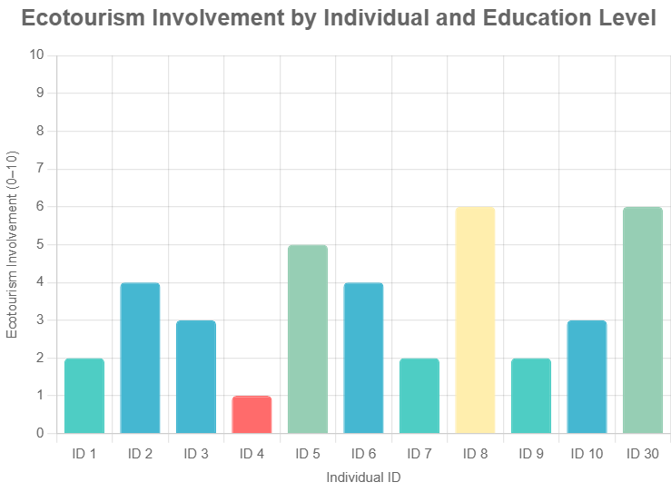
Fig:2This chart displays each individual’s ecotourism involvement score as a bar, with colours indicating their education level. The tooltip provides additional context by showing both the involvement score and education level when hovering over a bar.
Pandya (2022), who noted that without targeted gender inclusion policies, women remain marginalized in ecotourism ventures. Khutaghat reflects the same trend, where a small number of women benefit but broader female inclusion remains unrealized.
5.4 Food Security and Economic Stability
Households involved in ecotourism reported greater food security, particularly during dry agricultural seasons. They were able to purchase food grains and diversify their diets due to tourism income. Non-engaged households often relied solely on seasonal farming or NTFPs (non-timber forest products), leading to periodic food shortages.
This reflects global trends (UNEP, 2015) where community-based tourism can contribute to resilience against seasonal economic shocks. However, unless ecotourism is scaled and formalized, its effect on broader food security will remain limited.
5.5 Community Perceptions of Ecotourism
Focus group discussions showed that the majority of community members supported ecotourism, viewing it as a positive development. However, concerns were raised about:Lack of local ownership and leadership in tourism.Unequal distribution of benefits.Fear of external business operators taking control without community input.
These perceptions echo findings in other Indian sites where ecotourism succeeded only when managed by and for the local community. Without participatory models, tourism may reinforce inequalities or lead to conflict.
To gain deeper insights into the perceptions, challenges, and aspirations of local communities regarding ecotourism development at Khutaghat Dam, qualitative data was collected through six semi-structured interviews and three focus group discussions. Participants included local residents, women’s groups, panchayat representatives, forest staff, and individuals informally involved in tourism activities.
Methodology
- Participants: 6 Key Informant Interviews (KIIs), 3 FGDs (8–10 members each)
- Themes Explored:
- Awareness and perception of ecotourism
- Livelihood aspirationsand Environmental issues
- Infrastructure and accessibility
- Community participation
- Women’s involvement

Thematic analysis was conducted by transcribing the qualitative responses and identifying codes, which were later grouped under broader themes using an inductive approach.
Table 2 Summary of Themes, Sub-Themes, and Representative Quotes
Theme | Sub-Themes / Codes | Representative Quotes
Perception of Ecotourism | - Enjoyment of natural beauty  - Lack of awareness  - Seasonal nature of tourism | “Log to aate hain par sirf ghoomte hain, kuch fayda nahi hota.” (People come, but only for sightseeing; we don’t benefit.)
Livelihood Aspirations | - Homestay potential  - Local guides  - Handicraft and food stalls  - Youth interest | “Agar training mile toh hum bhi tourist ko guide kar sakte hain.” (If we receive training, we can also guide tourists.)
Challenges in Participation | - No formal training  - Limited planning involvement  - Lack of awareness  - Exclusion of women | “Mahilaon ko kabhi nahi poocha gaya.” (Women have never been asked.)
Infrastructure Issues | - Bad roads  - No signboards or maps  - Lack of toilets  - Limited transportation | “Pahuchne ke liye road hi theek nahi hai.” (The road to reach the area is not even proper.)
Environmental Concerns | - Litter left by visitors  - Noise and wildlife disturbance  - Lack of enforcement | “Kachra chhod ke jaate hain tourists.” (Tourists leave behind garbage.)
Cultural Identity and Pride | - Interest in showcasing local festivals  - Traditional art and dance  - Cultural storytelling | “Hamari lok kala dikhaane ka mauka milna chahiye.” (We should be given a chance to showcase our folk art.)

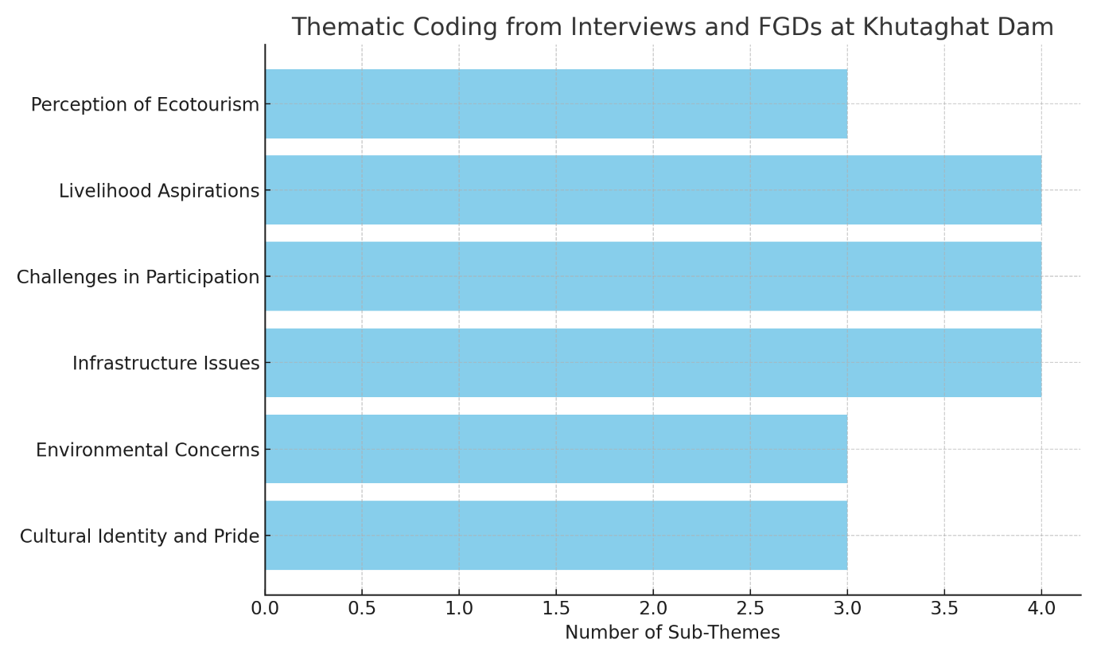
Fig:3 Bar diagram representing the thematic coding of interviews and FGDs at Khutaghat Dam.
5.8 Key Challenges Identified
Lack of infrastructure (roads, sanitation, electricity).
Weak institutional support from government bodies.
No formal training or certification for guides or homestays.
Gender inequality and low youth participation.
No formal revenue-sharing mechanism for reinvestment in local services.
5.9 Summary of Findings: To illustrate the socio-economic differences, the following graph compares households engaged vs not engaged in ecotourism:
Engaged in ecotourism households showed:
Higher average monthly income (₹9,500 vs ₹5,200)
Better access to education (78% vs 45%)
Improved healthcare access (65% vs 35%)
Greater female participation in livelihood (52% vs 28%)
Higher rate of skill development training (60% vs 20%)
These results (visualized in the chart above) suggest that even modest ecotourism involvement can have a meaningful impact on improving community well-being. However, many households remain excluded due to lack of awareness, institutional support, and training.

Table 3 Comparison of socio- economic -indicators: Engaged vs. Non- Engaged households
Indicator Engaged Households Non-Engaged Households
Average Monthly Income ₹9,500 ₹5,200
School Attendance 78% 45%
Access to Healthcare 65% 35%
Women in Livelihood Roles 52% 28%
Skill Development Exposure60% 20%
Food Security (year-round) High Moderate/Low

Fig 4 Comparison of socio-Economic Indicators: Engaged vs. Non-Engaged Household

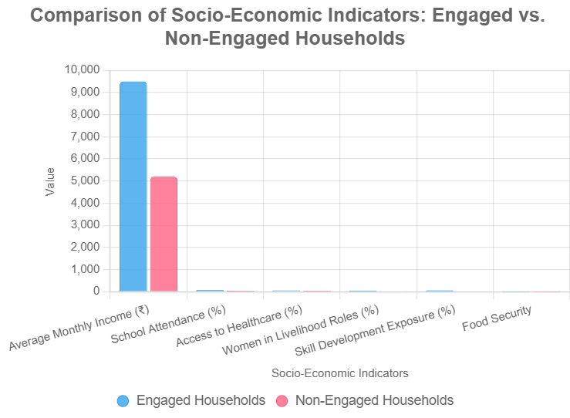

5.10 Conclusion
Understanding the connection between the growth of ecotourism and the socioeconomic circumstances of local populations was the goal of the research carried out in the vicinity of Khutaghat Dam in Bilaspur, Chhattisgarh. Ecotourism in this area has shown favorable effects on a number of socioeconomic indices, including income, education, gender engagement, and food security depite its early and restricted stage
Families who participated in ecotourism activities, such as hosting homestays, escorting visitors, operating food stands, or selling regional goods, reported comparatively greater monthly revenues than those that did not. Especially in the off-harvest months, this extra cash helped people augment their agricultural revenue. As a result of these wages, family spending has clearly improved, particularly in the areas of food availability and education for children.
Additionally, ecotourism has been linked to easier access to healthcare and education. Numerous homes who took part said that their increased income enabled them to continue sending their kids to school and to get medical care when necessary. In homes with ecotourism, women's involvement in income-generating activities also rose; more of them worked in food preparation, traditional craft production, and hospitality services. This implies that, despite the fact that women's involvement in ecotourism is still mostly unofficial and unacknowledged, it might economically empower them. Enhancing food security via ecotourism was another positive outcome. Families were better equipped to buy food during hard times if they were generating extra cash from tourism-related activities. In rural regions where agricultural production might be variable, ecotourism has the potential to act as a buffer against seasonal poverty.
Nevertheless, ecotourism's overall influence at Khutaghat Dam is still restricted and dispersed. Nowadays, very few families operate in the tourist industry, and those who do often do so without official or institutional assistance. This restricts how much the advantages can be scaled and sustained. Additionally, structural problems including insufficient roads, sanitation, and energy infrastructure, limited access to training and skill development, and a lack of coordinated planning severely impede the expansion of ecotourism.
Numerous community members expressed a desire to engage in ecotourism but lacked the necessary finances, skills, or understanding, according to focus group discussions and interviews. Additionally, there was worry that if tourism was not properly managed, its advantages may be taken from the local population and given to outside companies or governmental organizations, replicating the exclusionary trends seen in other popular tourist destinations in india
Finally, it should be noted that while ecotourism at Khutaghat Dam has the potential to be a livelihood strategy and a tool for rural development, it is yet not fully used. Systematic planning, community engagement, gender-sensitive training, and infrastructure development are necessary for ecotourism to be really inclusive and successful. Ecotourism may only continue to help a tiny portion of the population without these fundamental supports, failing to make a significant contribution to the betterment of the larger community.
6.Suggestions
Ecotourism at Khutaghat Dam has the ability to favourably impact the socioeconomic growth of nearby communities, as shown by the study's results. But as of right now, its influence and reach remain restricted. The following suggestions are put out in order to guarantee sustainable, inclusive development and maximize the advantages of ecotourism:

1. Encourage the use of community-based ecotourism (CBET) models
Promote the establishment of tourist committees at the local level to oversee tourism-related activities provide direct local resident involvement in the planning, execution, and oversight of ecotourism initiatives make sure that the money made is used to fund community development projects like building new roads, schools, or health facilities.
2. Offer Training and Development of Skills
Plan programs that increase knowledge in the areas of waste management, sustainable practices, handcraft creation, hospitality, and tour guiding prioritize women and young people to guarantee increased involvement and skill development for certification and assistance, work together with regional NGOs, tourist bureaus, and technical schools.
3. Reinforce the Infrastructure for Tourism
Improved access roads, signs, potable water, sanitary facilities, and visitor and host safety precautions create standard tourist facilities that adhere to sustainable tourism guidelines, such as eco-lodges, information desks, and rest places.
4. Assure Fair Sharing of Benefits
Provide clear procedures for revenue distribution to all parties involved, particularly those who are underserved or do not work directly in the tourist industry to enable communities to manage and profit from tourism together, support cooperative tourist businesses or self-help groups (SHGs).
5. Encourage support from the government and institutions
To include Khutaghat Dam into local ecotourism circuits, work with the state's tourism and forest authorities offer seed money, microloans, or subsidies to regional business owners who want to make investments in tourism-related services incorporate ecotourism within MGNREGA or NRLM rural livelihood initiatives and Panchayat Development Plans.
6. Encourage Awareness and Education about the Environment
Spread awareness of the value of biodiversity, conservation, and environmentally friendly travel practices among both visitors and residents incorporate cultural exchange initiatives, eco-learning excursions, and nature paths to improve tourist experiences while protecting the environment.
7. Track and Assess Ecotourism's Effects use metrics such as gender engagement, economic growth, school enrolment, and conservation activities to create a regular framework for effect assessments.

Disclaimer (Artificial intelligence)
Option 1:
Author(s) hereby declare that NO generative AI technologies such as Large Language Models (ChatGPT, COPILOT, etc.) and text-to-image generators have been used during the writing or editing of this manuscript.
Option 2:
Author(s) hereby declare that generativ AI technologies such as Large Language Models, etc. have been used during the writing or editing of manuscripts. This explanation will include the name, version, model, and source of the generative AI technology and as well as all input prompts provided to the generative AI technology
Details of the AI usage are given below:
1.
2.
3.

Reference
Bagri, S. C., & Kala, D. (2016). Residents’ attitudes toward tourism development and impacts in Koti-Kanasar, Indroli, Pattyur tourism circuit of Uttarakhand state, India.
Bhushan, S., Dincă, I., & Shikha, S. (2024). Evaluating local livelihoods, sustainable forest management, and the potential for ecotourism development in Kaimur Wildlife Sanctuary, India. Frontiers in Forests and Global Change, 7, 1491917.
Das, M., & Chatterjee, B. (2015). Ecotourism: A panacea or a predicament?. Tourism management perspectives, 14, 3-16.
Das, M., & Chatterjee, B. (2023). Ecotourism a solution or deception for conservation: a case of Bhitarkanika Wildlife Sanctuary, Odisha, India. Journal of Hospitality and Tourism Insights, 6(3), 1380-1399.
Dr. Om Prakash Kumar (2023). Community-Based Ecotourism in Rural India: A Case Study of Environmental Conservation and Economic Empowerment. International Journal of Emerging Knowledge Studies. 2(11), pp. 521-528.
Edward, M., & Kumar, R. R. (2017). Ecotourism in Kerala-a case study on empowering the indigenous community. International Journal of Qualitative Research in Services, 2(4), 295-307.
Kumar, O. P. (2023). Community-based ecotourism in rural India: A case study of environmental conservation and economic empowerment. Int. J. Emerg. Knoweldg. Stu, 2(11), 521-528.
Kummitha, H. R., Kolloju, N., Jancsik, A., & Szalók, Z. C. (2021). Can tourism social entrepreneurship organizations contribute to the development of ecotourism and local communities: Understanding the perception of local communities. Sustainability, 13(19), 11031.
Mnisi, P., & Ramoroka, T. (2020). Sustainable community development: A review On The socio-economic status Of communities practicing ecotourism In South Africa. International Journal Of Economics And Finance, 12(2), 505-519.
Rajasenan, D., Varghese, M., & Bijith, G. A. (2012). Socio-economic aspects of sustainable ecotourism development: The case of Kerala.
Spicer, B. (2020). A literature review of ecotourism in India: Policy implications and research gaps. Routes, 1(1), 41-50.
The International Ecotourism Society (TIES). (2015)

