Land use and land cover change detection using geospatial techniques inthe Warana River Basin (WRB), Western Maharashtra

ABSTRACT
Mapping, analysis, and monitoring of land use and landcover in micro region is necessary for sustainable land development, planning and management. Evaluation of river basins requires the detection of land-use and land-cover (LULC) changes to determine the hydrological and ecological conditions for the sustainable use of their resources. This study assessed LULC changes over 30 years (1994–2024) in the Warana River Basin (WRB), located in Western Maharashtra. Multi-temporal Landsat-5, Landsat-7, and Landsat-8 Thematic Mapper (TM) imageries of 1994, 2004, 2014, and a high-resolution cloud-free Sentinel 2A MSI (Multispectral Imager) Level-2A(SR) image of 2024 were used for mapping LULC classes of the Warana river basin from 1994 to 2024.The Maximum Likelihood Classifier (MLC) was used for supervised classification in order to create LULC maps of the watershed. Ground realities have been discovered and confirmed by field observations and site-specific interviews, and the accuracy of the classified map was evaluated using a High-Resolution Planet scope image.Over the previous three decades, LULC in the study watershed has seen a number of complex alterations as a result of conventional traditional practices and police changes. Six major LULC classes, viz,Waterbody, Cropland, Barren, Forest, and Habitation,have been identified and indicate that major land use in the watershed is in cropland and forest.The result shows, overall,for 30 years, barren land and forest land decreased slightly by -5.06 % (-151.78 km²) and -7.51%(-225.17 km²) respectively, ultimately increasing Waterbody Cropland,Habitation was observed by 0.74% (22.29km²), 8.53% (256.05 km²), and 3.29% (98.62 km²).The analysis and findingsof the study highlight important policy implications for the sustainable LULC management in the Warana River Basin (WRB) of Western Maharashtra.
Keywords: Warana River Basin (WRB), Change detection, Land use land cover, Remote sensing and GIS.

- Introduction.
The process of extracting spatial characteristics from satellite images, such as vegetation, metropolitan areas, land cover, and water bodies, is known as feature extraction from remotely sensed imagery. Satellite photos are virtually analyzed without touching these items, using interpretation factors such as image color, tone, association, texture, and pattern information. Pictures taken in distinct electromagnetic spectrum bands make up multispectral pictures and data, which aid in the extraction of varied land cover elements (Raje, Prathamesh et al.,2023). The potential of satellite-based data as a basis for generating valuable information for LULC is by now widely recognized. (Lambin et al., 2003) Despite early attempts to use various interpretation approaches in LULC mapping dating back to the mid-1970’s(Anderson, 1976).Numerous LULC mapping and change detection approaches have been developed and used globally during the past few decades. (Mishra P.K.et al., 2019, Thakur et al., 2020, Lakshmi et al., 2022). According to these academics Lambin et al., 2000; Petit et al., 2001; Read and Lam, 2002, the land use has a major influence on socioeconomic and environmental systems operate, involving trade-offs for biodiversity, food security, sustainability, and the socioeconomic vulnerability of ecosystems and people. Water quality and its influence on land use patterns have been reported by scientists (Pandey S. et al., 2023, (Pathare S. et al., 2021, Risalet al., 2020).
The Western Ghats (Sahyadri Mountains Range) and Western Coastal (Konkan) regions are India’s most important units of Maharashtra State, susceptible to heavy rainfall. This case study aims to observe the land use and land cover change detectionto forecastdisasters caused many landslides in Western Maharashtra during July 2021 (Gound R. and Thepade S.,2023).
Manually???
“Virtually analyzed”

Manually???
“Virtually analyzed”
According to Forest Survey Report, 2023India’s carbon stock has reached 30.43 billion tonnes of CO₂ equivalent; which indicates that as compared to the base year of 2005, India has already reached 2.29 billion tonnes of additional carbon sink as against the target of 2.5 to 3.0 billion tonnes by 2030. The Western Ghats Eco-Sensitive Areas (WGESA) covers 60,285.61 km², with 44,043.99 km² (73%) under forest cover.
In the present study,multi-temporal Landsat-5, Landsat-7, and Landsat-8 Thematic Mapper (TM) imageries of 1994, 2004, 2014, and a high-resolution cloud-free Sentinel 2A MSI (Multispectral Imager) Level-2A(SR) image of 2024 were used for mapping LULC classes of the Warana river basin from 1994 to 2024. The research on natural resources assessment of Warana River Basin remains limited both qualitatively and quantitatively. Planning for conservation and sustainable development in this environment requires a spatial database, which is supported by the use of contemporary geospatial tools. The dataset provides ground realities of LULC status and traditional usage of biological resources, in addition to field surveys of the chosen localities.
- Materials and methods.
2.1Study area
Warana river basin in Ratnagiri, Kolhapur, and Sangli district of Maharashtra State, has been selected for the study. The study area lies between 16º0'47'' N 17º0'15'' N latitude and 73º30'15'' E to 74º0'30'' E longitude. The Warana River basin is situated in tropical and subtropical climate zone; it generally experiences warm to hot temperatures throughout the year. The temperature in the basin can range from around 30°C to 40°C. The total geographical area of the Warana River basin is 1,965 square kilometers. The location map of the study area is shown in figure1.The present study was conducted in Warana River Basin (WRB) located in the Western Maharashtra State, India (Fig. 1).

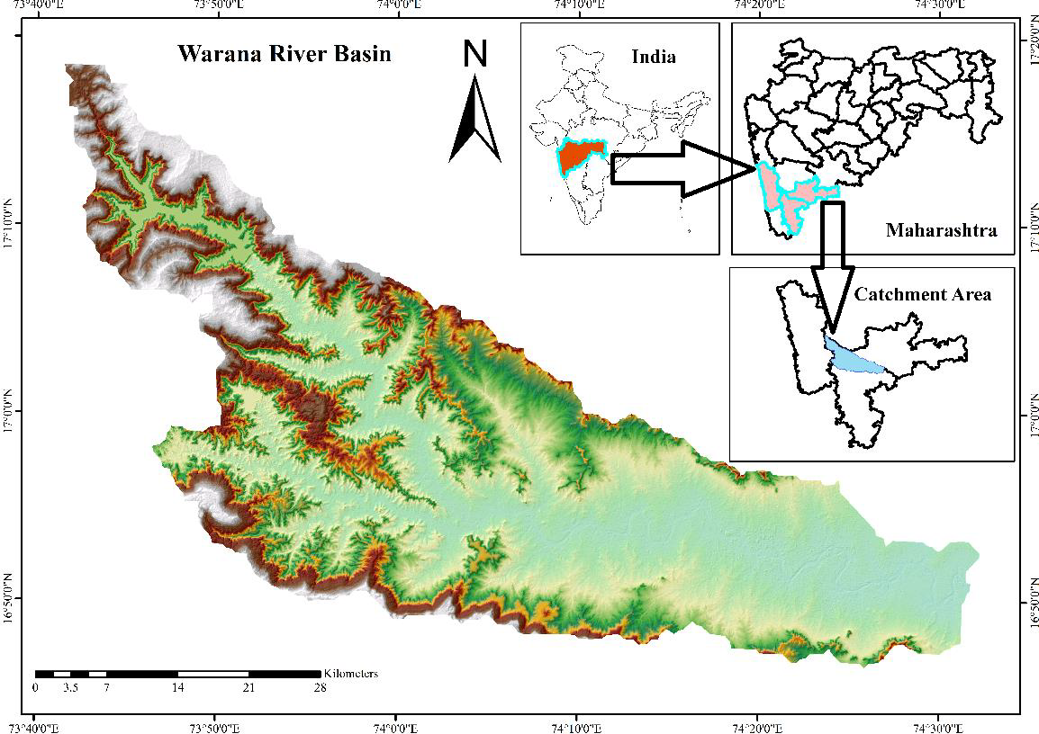

Fig.1 Geographical Location map of Warana River basin
The Warana River basin in Western Maharashtra is characterized by hilly and undulating terrain. The basin is located in the Western Ghats mountain range, which is a UNESCO World Heritage Site and is known for its rich biodiversity. The elevation of the basin ranges from around 200 meters to over 1,000 meters above sea level. The highest peak in the basin is the Amba Ghat, which rises to an elevation of around 1,150 meters and is located on the border between Kolhapur and Ratnagiri districts. The topography of the Warana River basin plays an important role in the hydrology and ecology of the region, influencing the distribution of water resources, vegetation, and wildlife. The steep slopes and rugged terrain also pose challenges for agriculture and transportation, making sustainable land and water management practices crucial for the wellbeing of local communities and ecosystems. The climate in the Warana River basin in Western Maharashtra is generally warm and humid. The Warana River basin receives an average annual rainfall of around 1,500 to 2,000 mm during June to September. This rainfall contributes to the flow of the river and helps to sustain agriculture and other livelihoods in the region.
The Warana watershed, located in Maharashtra, India, has a predominantly agricultural economy. The main crops include sugarcane, rice, and various vegetables, with a significant presence of sugar mills and allied industries. The region also engages in dairy farming, benefiting from cooperative movements. The river basin covers an area of approximately 1,965 km² and is an important source of water for irrigation, hydroelectric power generation, and other domestic and industrial uses. The average rainfall in the Warana river basin is around 1440 mm (56 inches) annually, which is higher than the average rainfall in some other parts of Western Maharashtra. The watershed consists of 44 villages and has a total population of 1,61,394 (COI, 2011). The watershed represents most of the human habitation zones that exist in the Sikkim Himalaya.
The satellite images were downloaded from the USGS Earth Explorer website.
2.2 Data source
Multi-temporal Landsat-5, Landsat-7 and Landsat-8 Thematic Mapper (TM) imageries of 1994, 2004, 2014 and a high resolution cloud free Sentinel 2A MSI (Multispectral Imager) Level-2A(SR) image of 2024 was used for mapping LULC classes of Warana river basin from 1994 to 2024 (Table 1). The primary uses of both sensors (TM and MSI) are in the fields of agriculture, inland water resources, forests, and LULC mapping and monitoring. The watershed border was also created using Bhuvan DEM. The satellite images were downloaded from the USGS Earth Explorer website. To gather more data on the study watershed, a topographic map (1: 50,000) was also obtained from Survey of India.
Obtained from the Survey of India website.
Sentinel Level-2A (SR) data is composed of 30*30 km² tiles (ortho-images in UTM/WGS84 projection). The Level-2A product results from using a Digital Elevation Model (DEM) to project the image in cartographic geometry. Per-pixel radiometric measurements are provided in Top of Atmosphere (TOA) reflectance along with the parameters to transform them into radiance. Sentinel 2A dataset consists of 12 multispectral bands out of which only ten bands have been used in the present study. Landsat-5, Landsat-7 and Landsat-8 TM level 2 datasets uses 7, 8 and 10 bands in actual study which were also available in TOA Reflectance and projected in UTM/WGS 84 projected coordinated system.
Table 1
Description of the satellite images used in the study.
Satellite | Sensor | Acquisition Year | Bands used | Spatial Resolution | Processing
Sentinel-2 | Multi Spectral Imager (MSI) | 2024 | Visible (B2, B3, B4) | 10m | Level-2A (SR)
Landsat 8 | Operational Land Imager (OLI) & TIRS | 2014 | Visible (B2, B3, B4), NIR (B5) | 30m | Level 2, Collection 2, Tier 1
Landsat 7 | Enhanced Thematic Mapper Plus (ETM+) | 2004 | Visible (B1, B2, B3), NIR (B4) | 30m | Level 2, Collection 2, Tier 1
Landsat 5 | Thematic Mapper (TM) | 1994 | Visible (B1, B2, B3), NIR (B4) | 30m | Level 2, Collection 2, Tier 1

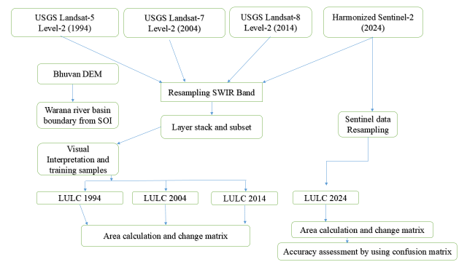

Fig.2 Methodological Workflow and data analysis
Remove sentence
2.3Methodology
The overall methodology of the proposed system is illustrated in Fig. 2. The detailed methodology for the study is as follows.
2.3.1 Pre-processing
Pre-processing of specific satellite data preserves the distinctive structure to link to the biophysical phenomena in the ground and the obtained images while adhering to the crucial procedure for analyzing LULC change detection. Bhuvan DEM was used to extract the boundary of the Warana river basin. Satellite imageries were available in TOA and converted in Bottom of Atmospheric Reflectance (BOA) using semi-automatic classification Plug-in of Arc-GIS software. After the conversion of TOA reflectance to BOA reflectance, sentinel SWIR bands were resampled from 30 m to 10 m. Thereafter, all five bands of satellite imagery were stacked and watershed boundary generated from Bhuvan DEM was used for sub setting all the imageries. Standard false colour composite (FCC) of all decades was created for mapping.
2.3.2Land-cover classification scheme
A classification scheme that establishes the LULC classes was taken into consideration in order to create the LULC map from satellite imagery. The appropriate number of LULC classes depends on the needs of a given project for a given application. (Arora and Mathur, 2001; Saha et al., 2005).
Table 2. Description of LULC used for classification
LULC category | Description of different LULC categories.
Waterbody | Areas covered by perennial river, streams and canals, lakes and reservoirs.
Cropland | Cropland and Pasture. Orchards, Groves, Vine-yards, Nurseries, and Ornamental Horticultural Areas.
Barren | Dry Salt Flats. Beaches. Sandy Areas other than  Beaches. Bare Exposed Rock. Strip Mines. Quarries, and Gravel Pits.
Forest | Shrubs, area under Agroforestry
Habitation | Residential. Commercial and Services, Industrial. Settlements and roads.

(Ref: USGS Professional Paper 964, "A Land Use and Land Cover Classification System for Use with Remote Sensor Data" by James R. Anderson et al. (1976).
2.3.3 Pre-processing and Image classification
All of the land use/cover classes were mapped using maximum likelihood classification, one of the most used image classification techniques, after the creation of the classification system. An empirical examination of satellite data, Google Earth photographs, and the watershed's top sheet were thoroughly examined prior to the training sample selection process. Different band combinations of Google Earth Maps, field survey data, and satellite imagery have been used to train data sets. Total 110 Ground Control Points (GCPs) in Google Earth were used to connect the Landsat data to the satellite picture of the research region, out of them 63 GCP’s were used for training purpose and 47 were for validation. This development made it easier to see the intriguing aspects of the research topic. The pixel group belonging to a predefined class was found by using several band combinations.

2.3.4 Post-Classification processing and change detection
To improve classification accuracy and decrease the number of incorrectly identified solitude sections, post-classification smoothing and refinement techniques like ground truthing used to comprehend the LULC alteration. This was accomplished by converting the chosen classed pictures (1994, 2004, 2014 and 2024) from raster to polygon layer and then intersecting them based on a common id for each LULC class. In order to identify the change, a new field was added to the attributes, and each polygon's information was then kept side by side with its former and current LULC classes. Finally, five change detection maps 1) change in Water body 2) change in Cropland 3) change in Barren land 4) change in Forest were generated 5) change in Habitation were generated.

2.3.5 Test of Accuracy Assessment
A crucial stage in the processing is the evaluation or validation of the LULC data's correctness. It establishes the information value of the resulting data for the user. Supervised categorization was used to group pixels of the same colour into a certain class. The accuracy evaluation is a crucial step in confirming the software's categorization correctness. The error matrix rule was used to verify the correctness of each Landsat picture categorization. The kappa coefficient, overall accuracy, and the correctness of the producer and user were assessed in this rule.
The degree to which each pixel matches the precise land cover conditions obtained from the ground truth point is known as the overall accuracy of the classified image. The accuracy of the producers determines the errors of omission, a metric that quantifies the classification accuracy of real-world land cover categories. The user's accuracy—the probability that a categorized pixel would correlate to the kind of land cover at its associated location—defines the errors of commission. The error matrix and kappa coefficient are now widely used techniques to assess the accuracy of picture categorization.
- Results
3.1. LULC status
Multi-temporal LULC covering six major classes: water-bodies, crop land, barren area, forest, and habitation of 1994, 2004, 2014 and 2024 are shown in Fig. 3. The spatial distribution pattern of LULC obtained from supervised classification is registered in Table 3.
Results from classified maps indicated that temporally, considerable changes occurred in LULC of Warana river basin from 1994 to 2024.The results from classified images in 1994 indicated that the area occupied by different classes viz, Waterbody 27.50 km² (1%), Cropland 664.27 km² (34%), Barren land 692.30 km² (35%), Forest land 548.48 km² (28%), and Habitation 32.48 km² (2%). Classified images from 2004 indicated that the area covered by water bodies, i.e., 40.70 km² (2%), crop land, and barren land was 814.39 km² and 814.94 km², respectively. both was 41% each. Forest land covered area 244.55 km² (12%) while Habitation contributed 50.44 km² (3%). Classified images in 2014 demonstrate that the area under the waterbody remains unaffected i.e. 2% as compared to the previous year. Crop land, barren, forest and habitation area contributed were 738.90 km², 847.19 km², 243.12 km² and 97.85 km² resp. Furthermore, classified images in 2024 illustrate that the areas covered by Waterbody, Cropland, Barren, Forest, and Habitation were 49.79 km² (3%), 920.32 km² (47%), 540.51 km² (28%), 323.31 km² (16%), and 131.09 km² (7%), respectively.

3.2. Field survey and accuracy assessment
The reference/ground and ancillary data were collected through a field survey as ground control points using GPS and direct local field measurements for ground verification, which was performed for image classification. The coordinates of the sample points in the field were recorded, and a total of 50 sample plots were selected for ground survey, with 10 sample plots in each LULC type. The sample points used in the study area are listed in Table 4. An accuracy assessment was conducted using a confusion matrix and ‘Kappa’ analysis to evaluate the overall accuracy of the images from 1994 to 2024.
Table 3
Sample points used in the study area.

Sample points | Location | LULC Type | Latitude | Longitude
1 | ShitturTufWarun | Crop land | 17⁰5’48.4512” N | 73⁰52’49.0188”E
2 | Shittur | Crop land | 17⁰5’46.644” N | 73⁰53’37.9032”E
3 | Ukhalu | Crop land | 17⁰6’53.9136” N | 73⁰52’29.9208”E
4 | Shauvadi | Crop land | 17⁰6’41.9508” N | 73⁰52’44.6448”E
5 | Mandur | Crop land | 17⁰7’28.5672” N | 73⁰52’46.542”E
6 | Sonavade | Crop land | 17⁰6’23.832” N | 73⁰53’44.916”E
7 | Arala | Crop land | 17⁰5’30.5628” N | 73⁰54’50.1048”E
8 | Karanguli | Crop land | 17⁰4’40.548” N | 73⁰56’7.0944”E
9 | Kalundre | Crop land | 17⁰4’15.6216” N | 73⁰56’41.9604”E
10 | Rile | Crop land | 16⁰58’44.9904” N | 74⁰3’7.596”E
11 | Chaware | Waterbody | 16⁰53’33.5976” N | 74⁰15’10.8468”E
12 | Kandwan | Waterbody | 17⁰1’41.2392” N | 73⁰51’7.8048”E
13 | Sangli | Waterbody | 17⁰7’48.468” N | 73⁰52’15.5892”E
14 | Kolhapur | Waterbody | 17⁰7’38.3988” N | 73⁰52’10.0632”E
15 | ShitturTufWarun | Waterbody | 17⁰5’36.6792” N | 73⁰52’31.6128”E
16 | Mandur | Waterbody | 17⁰7’47.118” N | 73⁰52’51.4776”E
17 | Arala | Waterbody | 17⁰5’46.5144” N | 73⁰54’32.2056”E
18 | Sangli | Waterbody | 16⁰57’52.5528” N | 74⁰4’53.004”E
19 | Ukhalu | Barren | 17⁰6’56.8908” N | 73⁰50’59.8092”E
20 | Shirala | Barren | 17⁰5855.6032” N | 74⁰8’13.29”E
21 | Sonavade | Barren | 17⁰6’7.2864” N | 73⁰54’5.7168”E
22 | ShitturTufWarun | Barren | 17⁰5’52.6272” N | 73⁰52’58.1664”E
23 | Sangli | Barren | 17⁰8’2.0976” N | 73⁰52’42.096”E
24 | Chaware | Barren | 16⁰52’40.7172” N | 74⁰15’49.8888”E
25 | Shittur Turf Warun | Forest | 17⁰5’38.1768” N | 73⁰52’34.266”E
26 | Mandur | Forest | 17⁰7’45.9048” N | 73⁰52’50.7792”E
27 | Shittur | Forest | 17⁰5’44.9088” N | 73⁰53’38.8032”E
28 | Ukhalu | Forest | 17⁰6’58.3092” N | 73⁰51’3.7116”E
29 | Sonavade | Forest | 17⁰5’57.6024” N | 73⁰54’11.9736”E
30 | Arala | Forest | 17⁰5’51.1692” N | 73⁰54’22.32”E
31 | Chaware | Habitation | 16⁰53’3.4836” N | 74⁰15’50.6988”E
32 | Shittur Turf Warun | Habitation | 17⁰6’9.3708” N | 73⁰53’17.8908”E
33 | Biour | Habitation | 16⁰58’19.848” N | 74⁰6’10.6776”E
34 | Ukhalu | Habitation | 17⁰7’9.0876” N | 73⁰52’11.4312”E
35 | Mandur | Habitation | 17⁰7’32.0952” N | 73⁰52’43.0284”E
36 | Karanguli | Habitation | 17⁰4’53.0292” N | 73⁰55’51.6864”E
37 | Charan | Habitation | 17⁰3’32.0508” N | 73⁰57’48.7692”E
38 | Mohare | Habitation | 17⁰2’45.5316” N | 73⁰58’16.6404”E
39 | Khujgaon | Habitation | 17⁰2’20.85” N | 73⁰59’18.0816”E
40 | Chincholi | Habitation | 17⁰0’56.7576” N | 73⁰59’2.724”E

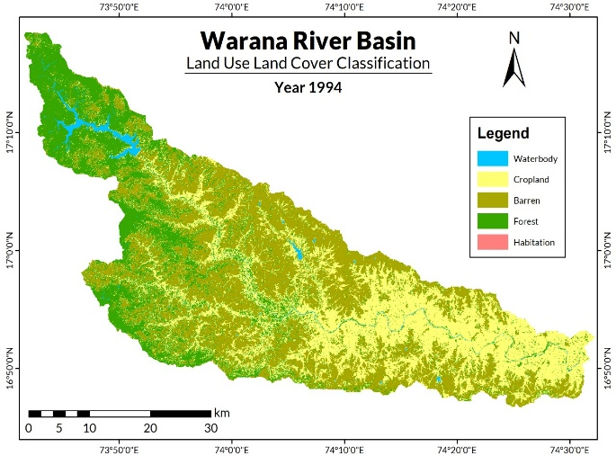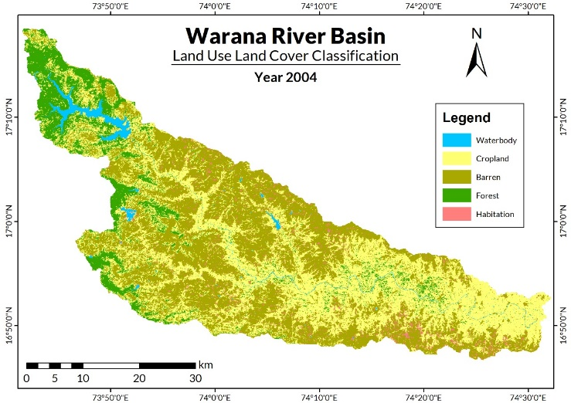
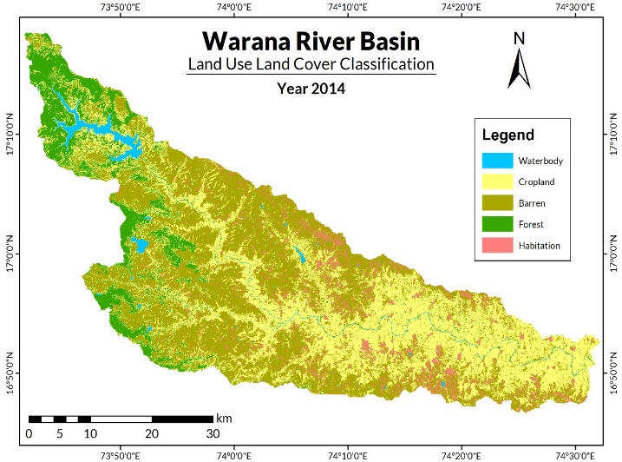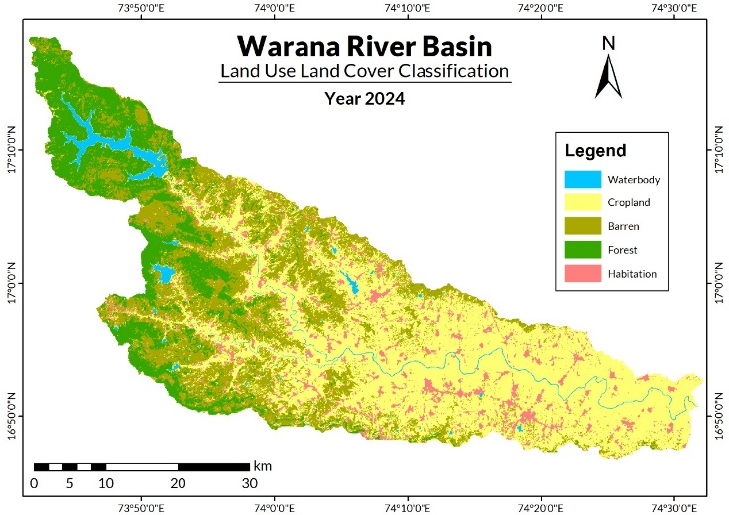

Fig. 3. Land use/cover change in different categories during years 1994, 2004, 2014 and 2024 in Warana River Basin.
Table 4
LULC distribution in Warana River basin of Western Maharashtra.
Resolution | 30m |  | 30m |  | 30m |  | 10m
iLULC Class | 1984-1994 |  | 1994-2004 |  | 2004-2014 |  | 2014-2024
iLULC Class | Area(km²) | Area(%) | Area(km²) | Area(%) | Area(km²) | Area(%) | Area(km²) | Area(%)
Waterbody | 27.50 | 1% | 40.70 | 2% | 37.96 | 2% | 49.79 | 3%
Cropland | 664.27 | 34% | 814.39 | 41% | 738.90 | 38% | 920.32 | 47%
Barren | 692.30 | 35% | 814.94 | 41% | 847.19 | 43% | 540.51 | 28%
Forest | 548.48 | 28% | 244.55 | 12% | 243.12 | 12% | 323.31 | 16%
Habitation | 32.48 | 2% | 50.44 | 3% | 97.85 | 5% | 131.09 | 7%
Total | 1965.02 | 100% | 1965.02 | 100% | 1965.02 | 100% | 1965.02 | 100%

4. Discussion
4.1 LULC patterns over the period of 1994–2004
Table 5 presents the quantitative changes in the land cover transition. The diagonals in the same table indicate the area of a certain class that stayed the same between 1994 and 2004, while the off diagonals value in the matrix indicates the movement from one class to another. Finding the anthropogenic influence on natural resources and assessing the effects of existing land use need the use of quantitative estimates of landscape dynamics (Yang et al., 2017). For the period 1994 and 2004 the area coverage under waterbody remains unaffected i.e 24 km² while major changes were observed from crop land to forest. About 214.94 km² of agricultural land got converted to forest. Similarly, barren land turned to forest and crop land by 110.66 km² and 71.80 km² respectively. It was observed that 32.55 km² and almost 26.69 km²of forest land and habitation got converted to crop land and barren land respectively. Such shift to crop land is due to traditional farming. During the year 2004 the area under forest remained unaffected with 208.76 km² area as compare to last decade. Among the total area of Warna river basin i.e 1969.81 km² the more shift was observed in case of barren land i.e.729.90 km² during 2004.
Table 5: LULC changes matrix as observed between 1994 and 2004 in the Warana River Basin.

1994(Area in km²) | LULC | 2004 (Area in km²)
1994(Area in km²) | LULC | Waterbody | Cropland | Barren | Forest | Habitation | Total
1994(Area in km²) | Waterbody | 24.05 | 5.36 | 2.20 | 9.09 | 0.00 | 40.70
1994(Area in km²) | Cropland | 0.65 | 536.12 | 62.52 | 214.94 | 0.00 | 814.23
1994(Area in km²) | Barren | 0.02 | 71.80 | 637.52 | 110.66 | 0.00 | 820.00
1994(Area in km²) | Forest | 2.19 | 32.55 | 0.96 | 208.76 | 0.00 | 244.48
1994(Area in km²) | Habitation | 0.59 | 18.35 | 26.69 | 4.78 | 32.48 | 82.88
1994(Area in km²) | Total | 27.50 | 664.18 | 729.90 | 548.24 | 0.00 | 1969.81

4.2 LULC patterns over the period of 2004–2014
Due to the urbanization over the period of 2004–2014, mostly barren land 30.23 km² got shifted to habitation. A vey negligible shift was observed in waterbody land class. Table no.6 shows that crop land and barren land has total 813.26 km²and 819.02 km² during the year 2014. It was clearly observed that the barren land remains unaffected with 667.20 km², but 60.29 km² and 84.47 km² was the shift of Crop land and habitation to barren land. There was a negligible shift i.e. 0.30 km² from waterbody to forest while 63.94 km² cropland got converted to forest.
Table 6: LULC changes matrix as observed between 2004 and 2014 in the Warana River Basin.
2004(Area in km²) | LULC | 2014 (Area in km²)
2004(Area in km²) | LULC | Waterbody | Cropland | Barren | Forest | Habitation | Total
2004(Area in km²) | Waterbody | 33.68 | 2.14 | 0.20 | 0.30 | 0.68 | 37.00
2004(Area in km²) | Cropland | 4.50 | 597.06 | 60.29 | 63.94 | 12.04 | 737.83
2004(Area in km²) | Barren | 0.42 | 151.93 | 667.20 | 1.49 | 30.23 | 851.27
2004(Area in km²) | Forest | 1.09 | 56.20 | 6.85 | 177.79 | 0.16 | 242.09
2004(Area in km²) | Habitation | 0.06 | 5.94 | 84.47 | 0.02 | 6.35 | 96.83
2004(Area in km²) | Total | 39.74 | 813.26 | 819.02 | 243.54 | 49.45 | 1965.02

4.3 LULC patterns over the period of 2014–2024
As per the data presented in table no.7, major shift was of barren land (850.45 km²) followed by crop land (737.79 km²), forest area (241.91 km²), habitation (97.26 km²) and waterbody (37.62 km²). As per the study of previous decades similarly waterbody land class has very negligible shifts. Due to the traditional agriculture and agroforestry the area under agriculture 570.90 km² remains unchanged. About 95.11 km² of forest area was converted to crop land i.e agriculture while 44.16 km² of barren land had come under cultivation and shifted to crop land. Tremendous increase in barren land area had observed from crop land i.e. 285.90 km².Similarly 80.33 km² of habitation area had reduced and contributed to barren land. Among the total shift under forest area i.e. 241.91 km² crop land and barren land contributed 20.21 km² and 13.47 km² with unaffected forest land of 206.57 km².
Table 7: LULC changes matrix as observed between 2014 and 2024 in the Warana River Basin.
2014(Area in km²) | LULC | 2024 (Area in km²)
2014(Area in km²) | LULC | Waterbody | Cropland | Barren | Forest | Habitation | Total
2014(Area in km²) | Waterbody | 36.99 | 9.12 | 1.60 | 1.07 | 0.67 | 49.45
2014(Area in km²) | Cropland | 0.50 | 570.90 | 285.90 | 20.21 | 44.25 | 921.75
2014(Area in km²) | Barren | 0.10 | 44.16 | 461.57 | 13.47 | 20.84 | 540.14
2014(Area in km²) | Forest | 0.01 | 95.11 | 21.05 | 206.57 | 0.19 | 322.93
2014(Area in km²) | Habitation | 0.01 | 18.51 | 80.33 | 0.58 | 31.32 | 130.75
2014(Area in km²) | Total | 37.62 | 737.79 | 850.45 | 241.91 | 97.26 | 1965.02

4.4 LULC change @ 10 years and 30 years during 1994-2024
The LULC changes occurred @ 10 years in Warana River basin during years 1994-2024are summarized in Table 8. The table indicates significant changes in the LULC classes in the study area in four different time periods (1994-2004, 2004-2014 and 2014-2024).
In the time interval of 10 years (1994-2004), the area covered under Waterbody increased by 1% (13 km²); Cropland increased by 15% (150 km²); the Barren increased by 12% (123 km²);Forest land decreased by 30% (-304 km²)and Habitation area increased by 2% (18 km²). Over the next 10 years (2004-2014), area covered by waterbody and crop land coverage sharply decreased by -0.27% (-2.74 km²) and -7.55 % (-75.49 km²) respectively while area covered by Cropland increased by 3.23% (32.26 km²). During the same duration forest area slightly decreased by -0.14% (-1.43 km²) and area under habitation increased by4.74% (47.41 km²).
Table 8. Overview of changes in LULC groups in each period
LULC Class | Change in area coverage(@ 10 years) |  |  |  |  |  | Overall Change @ 30 years
LULC Class | 1994-2004 |  | 2004-2014 |  | 2014-2024 |  | 1994-2024
LULC Class | Change in Area (Km²) | % | Change in Area (Km²) | % | Change in Area (Km²) | % | Change in Area (Km²) | %
Waterbody | 13.21 | 1 | -2.74 | -0.27 | 11.83 | 1.18 | 22.29 | 0.74
Cropland | 150.12 | 15 | -75.49 | -7.55 | 181.42 | 18.14 | 256.05 | 8.53
Barren | 122.64 | 12 | 32.26 | 3.23 | -306.68 | -30.67 | -151.78 | -5.06
Forest | -303.93 | -30 | -1.43 | -0.14 | 80.19 | 8.02 | -225.17 | -7.51
Habitation | 17.97 | 2 | 47.41 | 4.74 | 33.24 | 3.32 | 98.62 | 3.29

Graphical comparison of LULC changes @ 10 years during years 2014-2024 is shown in Fig 4.This figure shows that crop land area significantly increased during 2014-2024 while waterbody area slightly increased by 18.14% (181.42 km²) and 1.18% (11.83 km²) while area covered under Forest land and habitation was also raising trend by 8.02% (80.19 km²) and3.32% (33.24 km²).During the same years due to significant increase in crop land, waterbody, ,forest and habitation barren land coverage have significantly decreasing trend i.e. -30.67% (-306.68 km²).
A commonly utilized Kappa accuracy assessment technique was employed to evaluate the accuracy of the classified map from 2024. Accuracy assessment was conducted utilizing high-resolution (10 meters) satellite imagery from Sentinel-2. Total 47 random points were generated, ensuring a minimum of 8 points in each class (Table 9). The unavailability of clear Google Earth images precluded an accurate assessment of the 1994, 2004, and 2014 datasets. The overall classification accuracy for the 2024 classified image was determined to be 98%, accompanied by a Kappa statistic of 0.9732. Individual producer’s and users’ accuracy of all the classes are presented in Table 10.

Table 9
Overview of changes in LULC groups in each period (Km²).
LULC Class | Net change in 1994-2004 | Net change in 2004-2014 | Net change in  2014-2024 | Overall changes in  1994-2024
Waterbody | 13.21 | -2.74 | 11.83 | 22.29
Cropland | 150.12 | -75.49 | 181.42 | 256.05
Barren | 122.64 | 32.26 | -306.68 | -151.78
Forest | -303.93 | -1.43 | 80.19 | -225.17
Urban | 17.97 | 47.41 | 33.24 | 98.62

Fig. 4. Diagrammatic illustration of land use/cover change in percent in Warana River Basin.
4.5 Error matrix tables for land use and land cover classifications
Tables 10 present the error matrix for the LULC of Sentinel 2A (MSI) in the year 2024.It reveals that in the case of the waterbody area, there was a total of 8 points selected from classified data out of which 8 points were found correct when compared with reference data. In the case of class crop land, there, was total of 10 points selected from classified data out of which 9 points were found correct when compared with reference data and 1 point showed an error that belongs to barren. In the case of class barren land, 10 points were selected from classified data out of which 10 points were found correct when compared with reference data. Similarly, in care of forest and urban land 8 and 11 points were selected from classified data respectively, out of which all were found correct when compared with reference data.

Table 10. Accuracy Assessment Error Matrix of classified image 2024.
 | Classified Data | Reference Data
 | Classified Data | Waterbody | Crop land | Barren | Forest | Urban | Classified Total | Commission error
Classification | Waterbody | 8 | 0 | 0 | 0 | 0 | 8 | 0%
Classification | Cropland | 0 | 9 | 1 | 0 | 0 | 10 | 10%
Classification | Barren | 0 | 0 | 10 | 0 | 0 | 10 | 0%
Classification | Forest | 0 | 0 | 0 | 8 | 0 | 8 | 0%
Classification | Urban | 0 | 0 | 0 | 0 | 11 | 11 | 0%
Classification | Reference total | 8 | 9 | 11 | 8 | 11 | 47
Classification | Omission error | 0% | 0% | 9% | 0% | 0%

4.6 Producer and user accuracy for land use and land cover classifications
Table 11. Producer’s and User’s Accuracy assessment of 2024 classified map.
LULC Class | Reference total | Classified total | Number correct | Producer accuracy | Users Accuracy
Waterbody | 8 | 8 | 8 | 100% | 100%
Cropland | 9 | 10 | 9 | 100% | 90%
Barren | 11 | 10 | 10 | 91% | 100%
Forest | 8 | 8 | 8 | 100% | 100%
Urban | 11 | 11 | 11 | 100% | 100%
Overall Accuracy = 97.87
Kappa Coefficient = 0.97
The Kappa coefficient (K), overall accuracy, as well as user and producer accuracy were computed for the LULC classifications of (2024) and the derived values are shown in Tables 11. In the case of LULC classification for the year 2024 using Sentinel 2A (MSI) satellite, it can be seen that producer’s accuracy was maximum in classes: Waterbody area, crop land, forest and urban as 100 percent and minimum in class barren land as 91 percent, while user’s accuracy was maximum in classes: Waterbody area, barren land, forest and urban as 100 percent and minimum in class crop land as 90 percent. The LULC for 2024 using Sentinel 2A (MSI) satellite showed that the overall accuracy was 97.87percent with a Kappa coefficient of 0.97. It indicates a very strong agreement between the classified map and the reference data, further it suggests that the classification method used is highly accurate, and the resulting map is reliable for further analysis and decision-making. Accurate LULC maps can assist policymakers and stakeholders in making informed decisions, optimizing land resource use, and implementing sustainable development strategies. (Khan et.al 2024).
5. Conclusion
Overall over the period of 30 years’ barren land and forest land decreased slightly by -5.06 % (-151.78 km²) and -7.51%(-225.17 km²) respectively ultimately raising trend in Waterbody, Cropland, Habitation was observed by 0.74% (22.29km²),8.53% (256.05 km²) and 3.29% (98.62 km²). It may note that due to growing population there is increased pressure on land accordingly during the last decade government taken the great initiative in implementing the policies to support the farmers such as standardization of roads to 12ft (Maharashtra Land Revenue Code of 1966.TOI). corporate farming, modern farming techniques it helps to cultivate barren land.

Disclaimer (Artificial intelligence)
Option 1:
Author(s) hereby declare that NO generative AI technologies such as Large Language Models (ChatGPT, COPILOT, etc.) and text-to-image generators have been used during the writing or editing of this manuscript.
Option 2:
Author(s) hereby declare that generative AI technologies such as Large Language Models, etc. have been used during the writing or editing of manuscripts. This explanation will include the name, version, model, and source of the generative AI technology and as well as all input prompts provided to the generative AI technology
Details of the AI usage are given below:
1.
2.
3.

REFERENCES
Aragaw, HenokMekonnen, Manmohan Kumar Goel, and Surendra Kumar Mishra. 2021. ‘Hydrological Responses to Human-Induced Land Use/Land Cover Changes in the Gidabo River Basin, Ethiopia’. Hydrological Sciences Journal 66(4):640–55. doi:10.1080/02626667.2021.1890328.
Bagwan, Wasim Ayub, and Ravindra Sopan Gavali. 2023. ‘Dam-Triggered Land Use Land Cover Change Detection and Comparison (Transition Matrix Method) of Urmodi River Watershed of Maharashtra, India: A Remote Sensing and GIS Approach’. Geology, Ecology, and Landscapes 7(3):189–97. doi:10.1080/24749508.2021.1952762.
Belay, Haile, Assefa M. Melesse, and Getachew Tegegne. 2024. ‘Scenario-Based Land Use and Land Cover Change Detection and Prediction Using the Cellular Automata–Markov Model in the Gumara Watershed, Upper Blue Nile Basin, Ethiopia’. Land 13(3):396. doi:10.3390/land13030396.
Besha, Kokeb Zena, Tamene Adugna Demissie, and FekaduFufaFeyessa. 2024. ‘Effects of Land Use/Land Cover Change on Hydrological Responses of a Watershed in the Central Rift Valley of Ethiopia’. Hydrology Research 55(2):83–111. doi:10.2166/nh.2024.042.
by remote sensing: resettlement and rapid land-cover changes in south-eastern
Chong, Wei, Zhang Lin-Jing, Wu Qing, Cao Lian-Hai, Zhang Lu, Yao Lun-Guang, Zhu Yun-Xian, and Yang Feng. 2021. ‘RETRACTED ARTICLE: Estimation of Landscape Pattern Change on Stream Flow Using SWAT-VRR’. European Journal of Remote Sensing 54(sup2):356–62. doi:10.1080/22797254.2020.1790994.
detecting land-cover changes for the tropics. Int. J. Remote Sens. 23 (12), 2457–
Gadhave, Rutuja S., Shubham A. Gade, and Sonal R. Kalbande. n.d. ‘Land Use Land Cover and Change Detection of Rahuri Tehsil Using Remote Sensing and GIS’.
Gound, R.S., Thepade, S.D. (2023). A Case Study of Western Maharashtra with Detection and Removal of Cloud Influence: Land Use and Land Cover Change Detection. In: Kumar, A., Mozar, S., Haase, J. (eds) Advances in Cognitive Science and Communications. ICCCE 2023. Cognitive Science and Technology. Springer, Singapore. https://doi.org/10.1007/978-981-19-8086-2_54
Hussainzada, Wahidullah, and Han Soo Lee. 2021. ‘Hydrological Modelling for Water Resource Management in a Semi-Arid Mountainous Region Using the Soil and Water Assessment Tool: A Case Study in Northern Afghanistan’. Hydrology 8(1):16. doi:10.3390/hydrology8010016.
Joshi, Veena U., and Vikas Nagare. n.d. ‘LAND USE CHANGE DETECTION ALONG THE PRAVARA RIVER BASIN IN MAHARASHTRA, USING REMOTE SENSING AND GIS TECHNIQUES.’
Kavian, Ataollah, NargesJavidan, Abdolreza Bahrehmand, Yeboah Gyasi-Agyei, Zeinab Hazbavi, and Jesús Rodrigo-Comino. 2020. ‘Assessing the Hydrological Effects of Land-Use Changes on a Catchment Using the Markov Chain and WetSpa Models’. Hydrological Sciences Journal 65(15):2604–15. doi:10.1080/02626667.2020.1797046.
Kibii, Joshua Kiprotich, Emmanuel Chessum Kipkorir, and Job Rotich Kosgei. 2021. ‘Application of Soil and Water Assessment Tool (SWAT) to Evaluate the Impact of Land Use and Climate Variability on the Kaptagat Catchment River Discharge’. Sustainability 13(4):1802. doi:10.3390/su13041802.
Lakshmi, Y. Naga, Ekta Paul, and N. V. Gowtham Deekshithulu. 2022. ‘Land Use and Land Cover Change Detection in East Godavari District, India (2002-2020)’. Asian Journal of Agricultural Extension, Economics & Sociology 254–62. doi:10.9734/ajaees/2022/v40i931002.
Lambin, E.F., Rounsevell, M.D.A., Geist, H.J., 2000. Are agricultural land-use models
Lambin, E.F., Rounsevell, M.D.A., Geist, H.J., 2000. Are agricultural land-use models
Mishra, Prabuddh Kumar, Aman Rai, and Suresh Chand Rai. 2020. ‘Land Use and Land Cover Change Detection Using Geospatial Techniques in the Sikkim Himalaya, India’. The Egyptian Journal of Remote Sensing and Space Science 23(2):133–43. doi:10.1016/j.ejrs.2019.02.001.
Ngondo, Jamila, Joseph Mango, Ruiqing Liu, Joel Nobert, Alfonse Dubi, and Heqin Cheng. 2021. ‘Land-Use and Land-Cover (LULC) Change Detection and the Implications for Coastal Water Resource Management in the Wami–Ruvu Basin, Tanzania’. Sustainability 13(8):4092. doi:10.3390/su13084092.
Paul, Swapan. 2022. ‘Change Detection and Future Change Prediction in Habra I and II Block Using Remote Sensing and GIS – A Case Study’. International Journal of Engineering and Geosciences 7(2):191–207. doi:10.26833/ijeg.975222.
Petit, C., Scudder, T., Lambin, E., 2001. Quantifying processes of land-cover change
Puno, R. C. C., G. R. Puno, and B. A. M. Talisay. 2019. ‘Hydrologic Responses of Watershed Assessment to Land Cover and Climate Change Using Soil and Water Assessment Tool Model’. Global Journal of Environmental Science and Management 5(1). doi:10.22034/gjesm.2019.01.06.
Raje, Prathamesh Santosh, and Raj Dattatray Dalvi. n.d. ‘LULC Mapping For Identifying Change In Agricultural Land Cover Using Satellite Images’.
Raje, Prathamesh Santosh, and Raj Dattatray Dalvi. n.d. ‘LULC Mapping For Identifying Change In Agricultural Land Cover Using Satellite Images’.
Read, J.M., Lam, N.S.N., 2002. Spatial methods for characterising land cover and
remote sensor data (Vol. 964). US Government Printing Office.
Riebsame, W.E., Meyer, W.B., Turner, B.L., 1994. Modeling
Sinha, Rakesh Kumar, T. I. Eldho, and Ghosh Subimal. 2020. ‘Assessing the Impacts of Land Cover and Climate on Runoff and Sediment Yield of a River Basin’. Hydrological Sciences Journal 65(12):2097–2115. doi:10.1080/02626667.2020.1791336.
Stonestrom, David A., Bridget R. Scanlon, and Lu Zhang. 2009. ‘Introduction to Special Section on Impacts of Land Use Change on Water Resources’. Water Resources Research 45(7):2009WR007937. doi:10.1029/2009WR007937.
Tempa, Karma, Masengo Ilunga, Abhishek Agarwal, and Tashi. 2024. ‘Utilizing Sentinel-2 Satellite Imagery for LULC and NDVI Change Dynamics for Gelephu, Bhutan’. Applied Sciences 14(4):1578. doi:10.3390/app14041578.
Thakur, Tarun Kumar, Digvesh Kumar Patel, Arvind Bijalwan, Mammohan J. Dobriyal, Anirudh Kumar, Anita Thakur, Abhishek Bohra, and Jahangeer A. Bhat. 2020. ‘Land Use Land Cover Change Detection through Geospatial Analysis in an Indian Biosphere Reserve’. Trees, Forests and People 2:100018. doi:10.1016/j.tfp.2020.100018.
Twisa, Sekela, ShijaKazumba, Mathew Kurian, and Manfred F. Buchroithner. 2020. ‘Evaluating and Predicting the Effects of Land Use Changes on Hydrology in Wami River Basin, Tanzania’. Hydrology 7(1):17. doi:10.3390/hydrology7010017.
Wagner, P. D., S. Kumar, and K. Schneider. 2013. ‘An Assessment of Land Use Change Impacts on the Water Resources of the Mula and Mutha Rivers Catchment Upstream of Pune, India’. Hydrology and Earth System Sciences 17(6):2233–46. doi:10.5194/hess-17-2233-2013.
Zambia. Int. J. Remote Sens. 22 (17), 3435–3456. https://doi.org/10.1080/

