Geophysical and Remote Sensing Methods for Groundwater Potential Prediction in a Typical Basement Complex, Nigeria: The Power of GBT Model over AHP-MCDA.
Abstract
This study evaluates the effectiveness of a machine learning–based Gradient Boosting Tree (GBT) model for predicting groundwater potential and compares its performance with the conventional Analytical Hierarchy Process (AHP) model. Both approaches were applied using twelve groundwater potential predictors (GPPs): Digital Elevation Model (DEM), slope (S), drainage density (Dd), land use (Lu), aquifer resistivity (ρa), aquifer thickness (h), overburden thickness (b), hydraulic conductivity (k), transmissivity (Tr), storativity (St), diffusivity (D), and reflection coefficient (Rc). The GBT model was developed with Salford Predictive Modeler 8.0 using a 90:10 training–testing data split and k-10 cross-validation. Predictor importance was assessed, and the groundwater potentiality prediction index (GPPI) was generated and spatially analyzed in ArcGIS. Groundwater potential maps from both models delineated three zones: low, moderate, and high. The GBT-derived map indicated that low–moderate potential areas covered 56% of the study region, compared to 71% in the AHP-based map. Model validation using water column measurements from fifteen wells, analyzed with Spearman’s correlation, showed higher predictive accuracy for the GBT model (rs = 0.74; p = .002) than for the AHP model (rs = 0.66; p = .007). The results demonstrate that aquifer resistivity alone is inadequate for groundwater evaluation and underscore the importance of integrating multiple parameters. Overall, the GBT model outperformed AHP, establishing itself as a more reliable approach for groundwater potential prediction.

Keywords: GBT, AHP, Machine learning, GIS, Groundwater potentiality, geologic features.

1.0 Introduction
According to Boretti and Rosa (2019), the global demand for water, currently estimated at approximately 4,600 km³ per year, is projected to increase by 20% to 30% by 2050 due to a rise in the global population, expected to reach between 9.4 and 10.2 billion people—an increase of 22% to 32%. This growing demand has placed significant pressure on geophysicists to identify productive borehole drilling locations. However, the shortage of expertise among certain practitioners has been exploited, leading to a rise in unproductive or abandoned wells, financial losses and wasted time. A major challenge in groundwater exploration is the delineation of geologic features capable of hosting economically viable water quantities, particularly in Basement Complex terrains. These features are often localized due to restricted fractures and weathered rock formations (Fashae et al., 2014; Akintorinwa, 2015; Akanbi, 2018). Groundwater occurrence is influenced by factors such as geology, structural features, and climate (Ademilua, 1997; Ozdemir, 2011; Mogaji et al., 2021). While geology and structures determine the nature of the aquifer, climate governs the rate and amount of aquifer recharge (Lewis, 1987). For geophysicists, the nature of geologic formations hosting groundwater is often of greater concern than the groundwater itself (Jayeoba and Oladunjoye, 2013; Mogaji et al., 2021). These formations may exhibit varying degrees of fractures, faults, and incipient joints, resulting from tectonic events that exceed the rock's strength, causing it to lose cohesion along its weakest planes and enhancing permeability (Hencher et al., 2011). Such permeable materials contain extensive crack networks that facilitate the free movement of water. Weathered-fractured aquifers are highly heterogeneous due to the complexity of geological, structural, and geomorphological features (Akanbi, 2017). Groundwater is primarily hosted in two types of aquifers: weathered basement aquifers and fractured basement aquifers (Umar and Igwe, 2019; Shisaye et al., 2019). These aquifers contribute to the development of shallow and deep groundwater sources, respectively, with thicker aquifers significantly enhancing groundwater potential (Akintorinwa et al., 2020). The highest groundwater yields in Basement terrains are typically found in areas where thick overburden overlies fractured zones (Olorunfemi and Fasuyi, 1993).
Over the years, considerable efforts have been directed toward improving groundwater exploration, supported by extensive research and numerous publications. Groundwater modeling has emerged as a vital component of sustainable water resource management, with groundwater potentiality modeling proving particularly effective (Mogaji, 2016; Akinlalu, 2017; Sunmin et al., 2019). Akintorinwa et al. (2020) demonstrated the integration of geophysical, hydrogeological, and Geographic Information System (GIS) data within such models, providing valuable reconnaissance tools for delineating groundwater potential zones. By replicating the behavior of natural groundwater or hydrologic systems through physical or mathematical representation, modeling plays a crucial role in understanding and managing these systems (Rawal et al., 2016). In recent years, GIS has become indispensable in groundwater research and management, facilitating the creation of digital geographic databases, data manipulation, and visualization of model outputs. Its application has proven highly effective in addressing groundwater-related challenges (Adiat et al., 2013; Mogaji and Lim, 2016; Rawal et al., 2016; Akinwumiju and Olorunfemi, 2018; Akintorinwa and Okoro, 2019).
The accuracy of groundwater potential predictions depends on the predictors considered and the statistical models used for analysis. Researchers such as Mogaji and Lim (2016) and Akintorinwa et al. (2020) have emphasized that groundwater availability is strongly influenced by predictors such as overburden thickness, aquifer thickness, overburden resistivity, aquifer resistivity, aquifer hydraulic conductivity, and aquifer transmissivity. Established aquifer hydraulic properties—such as transmissivity, hydraulic conductivity, storativity, and hydraulic diffusivity—can be derived from geoelectric parameters as second-order parameters to better characterize groundwater potential (Lohman, 1972; Singh, 2005; Pradhan et al., 2013; Mogaji and Lim, 2017). Various statistical models, including machine learning algorithms, have been employed to analyze these predictors. Examples include random forest (RF), support vector regression (SVR), gradient boosting tree (GBT), and artificial neural networks (ANN) (Naghibi et al., 2014; Nampak et al., 2014; Mogaji and Lim, 2018). Among these, the Gradient Boosting Tree (GBT) model has gained prominence for its efficiency in solving complex and cognitive problems, making it particularly suitable for high-uncertainty and complex environments like Basement Complex terrains. Its application in groundwater potential estimation offers a promising approach to identifying optimal locations for groundwater exploitation (Sunmin et al., 2019).
Groundwater potential models can generally be classified as either knowledge-driven, such as the Analytical Hierarchy Process (AHP) and the DRASTIC model, which rely on expert judgment and are therefore subjective, or data-driven, such as frequency ratio, fuzzy logic, and entropy-based approaches. More recently, machine learning models including Random Forest and Classification and Regression Trees have been widely applied. Although these models are computationally efficient, their limited learning capacity often reduces prediction accuracy. In contrast, Gradient Boosting Tree (GBT) is highly effective in addressing complex and nonlinear problems. Such data-driven approaches, particularly GBT, are essential for groundwater potential assessment in geologically complex and uncertain terrains, such as Basement Complex areas. This study aims to provide valuable insights into hydrogeological conditions favorable for groundwater accumulation in Basement Complex terrains. By employing the sophisticated GBT data mining model, it integrates remotely sensed data and geophysical-derived Groundwater Potentiality Predictors (GPPs) to achieve higher accuracy in mapping and reliable prediction of groundwater potential zones.
1.1 Description of the Study Area
The study area lies within Universal Transverse Mercator (UTM) Zone 31, using the Minna datum. Its coordinates range from 788,400 to 789,400 mN (northing) and 536,800 to 538,200 mE (easting), covering approximately 480 square kilometers (Figure 1).
Elevations in the area vary between 67 and 98 meters above sea level. The region receives annual rainfall between 848.9 and 1,777.3 mm, with a potential annual evapotranspiration of approximately 188 mm (Akanni, 1992).
Geologically, the area is part of the Basement Complex of southwestern Nigeria, predominantly composed of crystalline basement rocks identified as older granites (Rahaman, 1988) (Figure 2). These granites, magmatic in origin, date from the late Precambrian to early Paleozoic era (Jones and Hockey, 1964). The widespread gneiss-migmatite complex in the region includes undifferentiated granite, charnockitic rocks, medium- to coarse-grained granite, and migmatite gneiss rocks (Rahaman, 1976). These rocks are generally characterized by low primary porosity and permeability. Consequently, groundwater occurrence in the area is largely controlled by secondary structures such as fractures, joints, shear zones, and weathered profiles. Productive aquifers are often located within the weathered regolith and fractured bedrock, with yields varying significantly depending on the degree of weathering and fracturing.

2. Materials and Methods
2.1 Database preparation using RS, GIS and Geophysics
To achieve the study's objective, two primary approaches were employed: remote sensing and geophysical methods. This section outlines the data preparation and acquisition process for integration into a Geographic Information System (GIS) to develop spatial databases (Figures 3 and 4).
- Remotely Sensed Data:
A Geographic Information System (GIS) serves as a framework for gathering, managing, and analyzing spatial data. Four remotely sensed datasets from the study area were extracted and processed using ArcGIS 10.6 software.

Figure 1: Base map of the study area

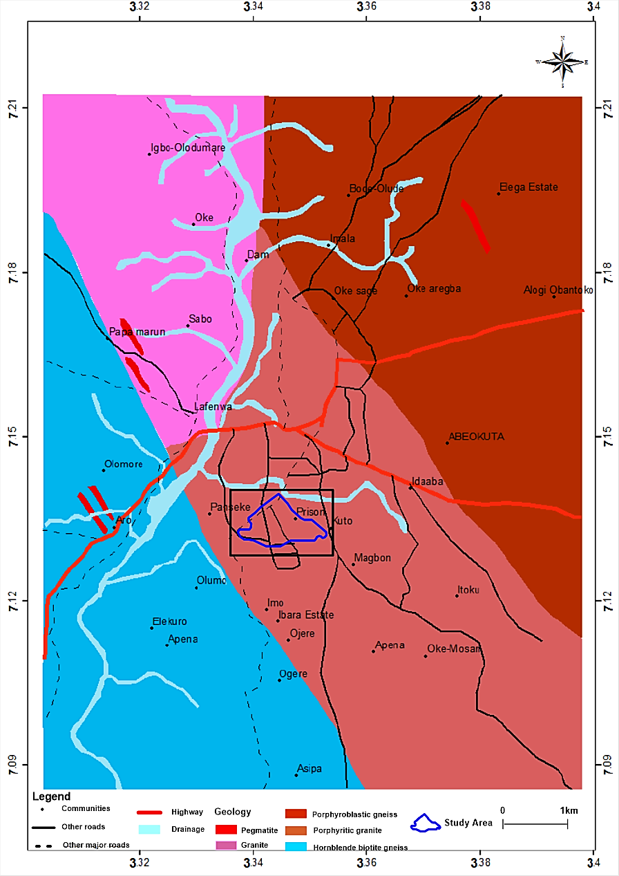
Figure 2: Geological map of the study area (Moroof and Gabriel, 2014)

Figure 3: Data acquisition map of the study area showing VES station

Figure 4: Methodology flow chart
The data's Z-values were plotted as spatial points against latitude and longitude coordinates using the Inverse Distance Weighting (IDW) interpolation method. The results were visualized in map formats to facilitate analysis and interpretation of spatial distribution patterns across the study area.
- Geophysical data: The geoelectrical data acquisition process is illustrated in Figure 3. A total of 62 Vertical Electrical Sounding (VES) surveys were conducted using the Schlumberger configuration, with electrode spacings (AB/2) ranging from 1 to 120 meters. Sounding stations were established randomly, maintaining an inter-station spacing of approximately 100 meters wherever possible.
The apparent resistivity (ρₐ) values were derived by multiplying the resistance (R) measured from the resistivity meter by the corresponding geometric factor (G) calculated according to Zohdy et al. (1974). The VES data were quantitatively interpreted using Auto Partial Curve Match software (Ogunbo, 2019). This software mimics the manual partial curve matching technique by plotting apparent resistivity (ρₐ) on the ordinate and half-electrode spacing (AB/2) on the abscissa, both on a logarithmic scale.
The resulting curves were segmented into branches based on gradient changes, reflecting resistivity contrasts between subsurface layers. Preliminary geoelectrical parameters (layer resistivities and thicknesses) were obtained and used as input for computer-aided iterative modeling (Vander-Velpen, 2004) to refine the geoelectrical parameters (Table 1).
The final VES interpretation results were used to derive second-order hydrogeologic indicators relevant to groundwater potential, following established equations by Lohman (1972), Singh (2005), Pradhan et al. (2013), and Mogaji and Lim (2017).
- Water column data: An inventory of fifteen (15) hand-dug wells was conducted across the study area. The water column height was determined by subtracting the static water level from the total well depth (Akintorinwa et al., 2020).
2.2 The MCDA-AHP model's theory utilized
The Analytical Hierarchy Process (AHP) technique, developed by Thomas Saaty in the 1970s, provides a systematic approach for quantifying weights in multi-criteria decision analysis (MCDA). Expert opinions from published research (Akintorinwa et al., 2020) were consulted to assess the relative importance of Groundwater Potentiality Predictor (GPP) variables concerning the groundwater potential of the underlying aquifer formations in the study area.
Expert-assigned weights were provided for various Groundwater Potentiality Predictors (GPPs) and calibrated using Saaty's scale, which ranges from 0 to 9 (Saaty and Vargas, 1991). Maximum weights were assigned to themes with the highest aquifer potential and minimum weights to those with the lowest. A pairwise comparison matrix of the GPPs (Table 2) was developed based on the results from the Saaty scale. Solving the matrix in Table 3, normalized weights (Nw) were computed and validated for consistency across the GPP indices.
The AHP technique employs the eigenvector method to normalize assigned weights, minimizing bias in expert opinions. To ensure accuracy, the consistency of the normalized weights was verified by calculating the Consistency Ratio (CR).

Table 1.Summary of VES interpretation result
VES | Layer Thickness (m) |  |  |  | Layer Resistivity (Ohm-m) |  |  |  |  | Curve Type
VES | h₁ | h₂ | h₃ | h₄ | p₁ | p₂ | p₃ | p₄ | p₅ | Curve Type
1 | 0.7 | 1.2 | 41.7 |  | 124 | 61 | 120 | 1514 |  | HA
2 | 0.8 | 11.3 |  |  | 77 | 47 | 1046 |  |  | H
3 | 0.7 | 2.7 | 0.8 |  | 45 | 17 | 1009 |  |  | H
4 | 0.8 | 0.9 | 1.3 | 13.5 | 81 | 32 | 484 | 32 | 2861 | HKH
5 | 1.9 | 25.1 |  |  | 136 | 39 | 1597 |  |  | H
6 | 3.9 | 8.2 |  |  | 113 | 40 | 2551 |  |  | H
7 | 0.8 | 2.9 |  |  | 100 | 76 | 1125 |  |  | H
8 | 1.3 | 6.0 |  |  | 93 | 31 | 1200 |  |  | H
9 | 2.6 | 11.8 |  |  | 83 | 28 | 1246 |  |  | H
10 | 1.1 | 1.8 |  |  | 82 | 18 | 1004 |  |  | H
11 | 2.0 | 3.3 | 8.4 | 74.5 | 180 | 68 | 1123 | 195 | 2930 | HKH
12 | 1.9 | 2.6 |  |  | 127 | 19 | 1019 |  |  | H
13 | 3.1 | 5.9 |  |  |  | 62 | 18 | 1237 |  | H
14 | 3.4 | 13.5 |  |  | 154 | 55 | 2446 |  |  | H
15 | 1.4 | 25 |  |  | 26 | 124 | 1215 |  |  | A
16 | 0.3 | 10.6 |  |  | 120 | 61 | 1014 |  |  | H
17 | 1.8 | 4.0 |  |  | 130 | 14 | 1757 |  |  | H
18 | 0.6 | 0.9 | 0.7 | 8.3 | 108 | 34 | 590 | 39 | 3723 | HKH
19 | 3.6 | 42.1 |  |  | 13 | 58 | 1530 |  |  | H
20 | 1.7 | 6.6 |  |  | 109 | 37 | 2891` |  |  | H
21 | 1.6 | 6.6 |  |  | 148 | 25 | 4222 |  |  | H
22 | 1.9 | 4.7 |  |  | 122 | 32 | 1696 |  |  | H
23 | 2.3 | 23.4 |  |  | 180 | 85 | 1093 |  |  | H
24 | 1.4 | 4.7 |  |  | 145 | 17 | 4507 |  |  | H
25 | 1.1 | 11.6 |  |  | 96 | 40 | 1518 |  |  | H
26 | 2.3 | 37.3 |  |  | 48 | 112 | 2845 |  |  | H
27 | 0.5 | 23.2 |  |  | 198 | 61 | 1100 |  |  | H
28 | 1.7 | 11.2 |  |  | 115 | 71 | 1211 |  |  | H
29 | 1.0 | 1.3 | 5.5 | 24.2 | 122 | 70 | 164 | 72 | 1895 | HKH
30 | 1.4 | 37.4 |  |  | 220 | 89 | 1022 |  |  | H
31 | 0.9 | 30.2 |  |  | 104 | 82 | 1340 |  |  | H
32 | 1.1 | 1.3 | 41.3 |  | 129 | 60 | 169 | 1421 |  | HA
33 | 1.3 | 14.4 |  |  | 259 | 153 | 1113 |  |  | H
34 | 6.7 | 27 |  |  | 150 | 40 | 1425 |  |  | H
35 | 0.5 | 1.3 |  |  | 211 | 57 | 1087 |  |  | H
36 | 1.9 | 17.3 |  |  | 177 | 51 | 1491 |  |  | H
37 | 1.3 | 2.8 |  |  | 415 | 381 | 2035 |  |  | H
38 | 1.0 | 4.8 |  |  | 367 | 254 | 1325 |  |  | H
39 | 0.9 | 0.9 | 40.5 |  | 396 | 297 | 598 | 13605 |  | HK
40 | 1.0 | 2.0 | 2.4 | 12.0 | 280 | 135 | 1795 | 81 | 1674 | HKH
41 | 1.9 | 8.3 |  |  | 286 | 101 | 1115 |  |  | H
42 | 2.3 | 9.3 |  |  | 243 | 122 | 1352 |  |  | H
43 | 2.2 | 18.7 |  |  | 276 | 40 | 3485 |  |  | H
44 | 3.6 | 10.6 |  |  | 154 | 19 | 2348 |  |  | H
45 | 1.1 | 3.1 |  |  | 109 | 34 | 1072 |  |  | H
46 | 2.3 | 3.6 |  |  | 303 | 19 | 1098 |  |  | H
47 | 0.6 | 11.2 |  |  | 347 | 77 | 2644 |  |  | H
48 | 1.8 | 7.9 |  |  | 237 | 112 | 1413 |  |  | H
49 | 3.8 | 15.2. |  |  | 161 | 24 | 1100 |  |  | H
50 | 1.9 | 8.0 |  |  | 101 | 45 | 3127 |  |  | H
51 | 0.7 | 2.1 | 2.8 | 17.1 | 256 | 84 | 301 | 38 | 1585 | HKH
52 | 2.3 | 3.6 |  |  | 18 | 33 | 1999 |  |  | H
53 | 0.9 | 2.0 |  |  | 51 | 14 | 1012 |  |  | H
54 | 1.9 | 40.4 |  |  | 15 | 47 | 1571 |  |  | H
55 | 1.7 | 7.3 |  |  | 125.7 | 40.3 | 2412 |  |  | H
56 | 1.1 | 3.0 |  |  | 67 | 30 | 8487 |  |  | H
57 | 2.7 | 4.5 | 15.4 |  | 84 | 208 | 32 | 1705 |  | KH
58 | 0.9 | 25.6 |  |  | 29 | 40 | 1269 |  |  | H
59 | 1.6 | 3.2 | 1.4 |  | 156 | 372 | 6 | 1110 |  | KH
60 | 1.8 | 5.6 |  |  | 122 | 27 | 4478 |  |  | H
61 | 5.9 | 7.8 |  |  | 169 | 14 | 1140 |  |  | H
62 | 0.8 | 1.2 | 12.5 |  | 65 | 191 | 26 | 1099 |  | KH

Table 2: AHP Matrix of Pair-Wise Comparisons of Groundwater Potentiality Predictors (GPPs)
Pairwise comparison 9 point continuous rating scale
Less important More important
1/9 1/7 1/5 1/3 1 3 5 7 9
Extremely Very strongly Strongly Moderately Equally Moderately Strongly Very Strongly Extremely
 | Dem | S | Dd | Lu | ρ | h | b | k | Tr | St | D | Rc | Weights | CR
Dem | 1 | 1 | 1/2 | 1/2 | 1/5 | 1/4 | 1/3 | 1/8 | 1/9 | 1/6 | 1/7 | 1/5 | 0.016 | 0.03
S | 1 | 1 | 1/2 | 1/2 | 1/5 | 1/4 | 1/3 | 1/8 | 1/9 | 1/6 | 1/7 | 1/5 | 0.016 | 0.03
Dd | 2 | 2 | 1 | 1 | 1/5 | 1/3 | 1/2 | 1/7 | 1/7 | 1/5 | 1/6 | 1/4 | 0.023 | 0.03
Lu | 2 | 2 | 1 | 1 | 1/5 | 1/3 | 1/2 | 1/7 | 1/7 | 1/5 | 1/6 | 1/4 | 0.023 | 0.03
ρ | 6 | 6 | 5 | 5 | 1 | 3 | 4 | 1/3 | 1/4 | 1 | 1/2 | 2 | 0.095 | 0.03
h | 4 | 4 | 3 | 3 | 1/3 | 1 | 2 | 1/5 | 1/6 | 1/3 | 1/4 | 2 | 0.047 | 0.03
b | 3 | 3 | 2 | 2 | 1/4 | 1/2 | 1 | 1/6 | 1/7 | 1/4 | 1/5 | 1/3 | 0.034 | 0.03
k | 8 | 8 | 7 | 7 | 3 | 5 | 6 | 1 | 1/2 | 3 | 2 | 4 | 0.188 | 0.03
Tr | 9 | 9 | 8 | 8 | 4 | 6 | 7 | 2 | 1 | 4 | 3 | 5 | 0.256 | 0.03
St | 6 | 6 | 5 | 5 | 1 | 3 | 4 | 1/3 | 1/4 | 1 | 0.5 | 2 | 0.096 | 0.03
D | 7 | 7 | 6 | 6 | 2 | 4 | 5 | 1/2 | 1/3 | 2 | 1 | 3 | 0.136 | 0.03
Rc | 5 | 5 | 4 | 4 | 1/2 | 2 | 3 | 1/4 | 1/5 | 1/2 | 1/3 | 1 | 0.068 | 0.03
SUM | 54 | 54 | 43 | 43 | 12.9 | 25.6 | 33.6 | 5.32 | 3.22 | 12.8 | 8.4 | 20.2 | 0.998 | 0.03

Table 3: The MCDA-AHP Normalized Weight Rating for the Groundwater Potential Predictors (GPPs)
GPPs Hydrologic themes | Category (Classes) | F | PF (%) | Average | Area Extent ( km² ) | Rating | Normalized Weight (Nw)
Digital elevation model (Dem) | 77 – 91 | 22 | 35 | 93.13 | 168 | 3 | 0.016
Digital elevation model (Dem) | 91 – 97 | 21 | 34 |  | 163 | 2
Digital elevation model (Dem) | 97 - 115 | 19 | 31 |  | 148.8 | 1
Slope (S) | 0 – 4 | 18 | 27 | 6.63 | 129.6 | 3 | 0.016
Slope (S) | 4.01 – 6 | 14 | 23 |  | 110.4 | 2
Slope (S) | 6.01 – 14.7 | 31 | 50 |  | 240 | 1
Drainage density (Dd) | 6.1 – 66.5 | 22 | 35 | 89.89 | 168 | 3 | 0.023
Drainage density (Dd) | 66.6 – 104 | 21 | 34 |  | 163.2 | 2
Drainage density (Dd) | 105 - 281 | 19 | 31 |  | 148.8 | 1
Land use (Lu) | 0 – 79 | 52 | 84 | 12.71 | 403.2 | 3 | 0.023
Land use (Lu) | 79 – 129 | 1 | 1.6 |  | 7.68 | 2
Land use (Lu) | 129 - 147 | 9 | 15 |  | 72. | 1
Aquifer resistivity (ρ) | 6 – 37 | 22 | 36 | 67.45 | 172.8 | 1 | 0.095
Aquifer resistivity (ρ) | 37 – 62 | 20 | 32 |  | 153.6 | 3
Aquifer resistivity (ρ) | 62 - 380 | 20 | 32 |  | 153.6 | 2
Aquifer thickness (h) | 0.91 – 10 | 31 | 50 | 14.83 | 240 | 1 | 0.047
Aquifer thickness (h) | 11 – 16 | 11 | 18 |  | 86.4 | 2
Aquifer thickness (h) | 17 – 74 | 20 | 32 |  | 153.6 | 3
Overburden thickness (b) | 0.3 – 1.98 | 39 | 63 | 2.45 | 302.4 | 1 | 0.034
Overburden thickness (b) | 1.99 – 2.82 | 8 | 13 |  | 62.4 | 2
Overburden thickness (b) | 2.83 – 13.7 | 15 | 24 |  | 115.2 | 3
Aquifer hydraulic conductivity (k) | 0.056 - 0.068 | 22 | 36 | 0.11 | 172.8 | 1 | 0.188
Aquifer hydraulic conductivity (k) | 0.069 - 0.087 | 20 | 32 |  | 153.6 | 2
Aquifer hydraulic conductivity (k) | 0.088 – 0.832 | 20 | 32 |  | 153.6 | 3
Aquifer transmissivity (Tr) | 0.1 – 0.9 | 33 | 53 | 1.57 | 254.4 | 1 | 0.256
Aquifer transmissivity (Tr) | 1 –1.7 | 13 | 21 |  | 100.8 | 2
Aquifer transmissivity (Tr) | 1.8 – 16.3 | 16 | 26 |  | 124.8 | 3
Aquifer storativity (St) | 0.000018 - 0.00011 | 27 | 44 | 0.0002 | 211.2 | 1 | 0.096
Aquifer storativity (St) | 0.00012 - 0.00019 | 15 | 24 |  | 115.2 | 2
Aquifer storativity (St) | 0.0002 – 0.0011 | 20 | 32 |  | 153.6 | 3
Aquifer diffusivity (D) | 464 - 6379 | 33 | 53 | 7966.28 | 254.4 | 3 | 0.136
Aquifer diffusivity (D) | 6380 - 8960 | 4 | 7 |  | 33.6 | 2
Aquifer diffusivity (D) | 8961 - 27886 | 25 | 40 |  | 192 | 1
Aquifer reflection coefficient (Rc) | 0.327 - 0.909 | 20 | 32 | 0.900 | 153.6 | 3 | 0.068
Aquifer reflection coefficient (Rc) | 0.91 - 0.954 | 15 | 24 |  | 115.2 | 2
Aquifer reflection coefficient (Rc) | 0.955 - 0.99 | 27 | 44 |  | 211.2 | 1

According to Saaty (1980), weights are considered reliable only when the CR is within 10%; otherwise, adjustments are required to address inconsistencies. The computed consistency ratio was 3%, indicating that the normalized weights were consistent and suitable for groundwater potentiality mapping.
The computation of the consistency ratio involves three steps:
- Principal Eigenvalue (λₘₐₓ) Calculation: The principal eigenvalue (λₘₐₓ) was computed using the eigenvector method, as reported by Mogaji et al. (2021) and Akintorinwa et al. (2020).
- Consistency Index (CI) Calculation: The CI was computed using Equation 1, where λₘₐₓ represents the average value of the consistency vector, and n denotes the number of factors.
$CI=\frac{λ\max{- n}}{n-1}$ (1)
- Consistency Ratio (CR) Calculation: The CR was determined using Equation 2.
$CR= \frac{CI}{RI}$ (2)
Where RI is the random index for twelve (12) criteria obtained from the standard table provided in Saaty (1980) given as 1.48.
The groundwater potential index (GPPI) was derived using the analytical hierarchy process (AHP) data mining technique. It was computed using Equation (3) as the product of the normalized weights (listed in column 8 of Table 3) and the ratings for each category (provided in column 7 of Table 3). The sum of these products yielded the AHP-GPPI, which is presented in column 14 of Table 4.
$AHP-GGPI= \sum{Nw×R}$ (3)
2.3 The GBT model theory and it algorithm
Boosting is an ensemble learning technique that constructs strong predictive models by combining multiple weak learners. It is widely used for both regression and classification tasks, as it aggregates the predictions of weak learners to produce a more accurate and robust model. In this study, the Gradient Boosting Trees (GBT) model was implemented using the Salford Predictive Modeler 8.0 software to integrate various groundwater potential conditioning factors (GPPs) for groundwater potential mapping, as outlined in Table 5.
The dataset was divided into training and testing subsets in a 90:10 ratio using the k-10 cross-validation method. Nine bins were utilized as the training dataset, while the remaining bin served as the testing dataset. This process was repeated iteratively for 'n' times, and the average accuracy was computed. Since the target variable was continuous, a regression-based supervised learning approach was employed. The residuals for subsequent boosting steps were calculated using the sum of squared errors.
For the GBT model in Salford Predictive Modeler 8.0, the learning rate was set to 0.01, the tree complexity to 5, and the bag fraction to 0.5, following the parameters reported in Sunmi et al. (2020). Using the training dataset, the GBT model computed the prediction probability based on Equation (4), as proposed by Friedman (1999).
$input data: \left\{〈x^{(i)},y^{(i)}〉\right\}{n \atop i=1}$ (4)
Table 4: GPPI modeling results for AHP-MCDA model
VES | Dem | S | Dd | Lu | ρ | h | b | k | Tr | St | D | Rc | AHP-GPPI
Nos. | Wx R | Wx R | Wx R | Wx R | Wx R | Wx R | Wx R | Wx R | Wx R | Wx R | Wx R | Wx R | ƩNW × R
1 | 0.032 | 0.032 | 0.046 | 0.069 | 0.19 | 0.141 | 0.034 | 0.564 | 0.768 | 0.288 | 0.408 | 0.204 | 2.776
2 | 0.048 | 0.048 | 0.046 | 0.069 | 0.285 | 0.094 | 0.034 | 0.376 | 0.256 | 0.192 | 0.136 | 0.136 | 1.72
3 | 0.048 | 0.016 | 0.023 | 0.069 | 0.095 | 0.047 | 0.034 | 0.188 | 0.256 | 0.096 | 0.136 | 0.068 | 1.076
4 | 0.048 | 0.032 | 0.069 | 0.069 | 0.285 | 0.094 | 0.102 | 0.188 | 0.256 | 0.096 | 0.408 | 0.068 | 1.715
5 | 0.048 | 0.048 | 0.046 | 0.069 | 0.285 | 0.141 | 0.034 | 0.376 | 0.512 | 0.096 | 0.408 | 0.136 | 2.199
6 | 0.048 | 0.016 | 0.023 | 0.069 | 0.285 | 0.047 | 0.102 | 0.376 | 0.256 | 0.192 | 0.136 | 0.068 | 1.618
7 | 0.048 | 0.016 | 0.069 | 0.069 | 0.19 | 0.047 | 0.034 | 0.564 | 0.256 | 0.288 | 0.136 | 0.068 | 1.785
8 | 0.048 | 0.016 | 0.023 | 0.069 | 0.095 | 0.047 | 0.034 | 0.188 | 0.256 | 0.096 | 0.136 | 0.204 | 1.212
9 | 0.048 | 0.048 | 0.046 | 0.069 | 0.095 | 0.094 | 0.068 | 0.188 | 0.256 | 0.096 | 0.408 | 0.136 | 1.552
10 | 0.048 | 0.048 | 0.023 | 0.069 | 0.095 | 0.047 | 0.034 | 0.188 | 0.256 | 0.096 | 0.136 | 0.068 | 1.108
11 | 0.048 | 0.048 | 0.046 | 0.069 | 0.19 | 0.141 | 0.102 | 0.564 | 0.768 | 0.288 | 0.408 | 0.068 | 2.74
12 | 0.048 | 0.032 | 0.023 | 0.069 | 0.095 | 0.047 | 0.034 | 0.188 | 0.256 | 0.096 | 0.136 | 0.204 | 1.228
13 | 0.048 | 0.016 | 0.023 | 0.069 | 0.095 | 0.047 | 0.102 | 0.188 | 0.256 | 0.096 | 0.272 | 0.068 | 1.28
14 | 0.048 | 0.016 | 0.046 | 0.069 | 0.285 | 0.094 | 0.102 | 0.376 | 0.512 | 0.192 | 0.272 | 0.068 | 2.08
15 | 0.048 | 0.048 | 0.023 | 0.069 | 0.19 | 0.141 | 0.034 | 0.564 | 0.768 | 0.288 | 0.408 | 0.068 | 2.649
16 | 0.048 | 0.048 | 0.069 | 0.069 | 0.285 | 0.047 | 0.034 | 0.376 | 0.256 | 0.192 | 0.136 | 0.204 | 1.764
17 | 0.048 | 0.016 | 0.069 | 0.069 | 0.095 | 0.047 | 0.034 | 0.188 | 0.256 | 0.096 | 0.136 | 0.068 | 1.122
18 | 0.032 | 0.032 | 0.046 | 0.069 | 0.285 | 0.047 | 0.068 | 0.376 | 0.256 | 0.096 | 0.136 | 0.068 | 1.511
19 | 0.032 | 0.032 | 0.046 | 0.069 | 0.285 | 0.141 | 0.102 | 0.376 | 0.768 | 0.192 | 0.408 | 0.136 | 2.587
20 | 0.048 | 0.048 | 0.023 | 0.069 | 0.095 | 0.047 | 0.034 | 0.376 | 0.256 | 0.096 | 0.136 | 0.068 | 1.296
21 | 0.016 | 0.016 | 0.069 | 0.069 | 0.095 | 0.047 | 0.034 | 0.188 | 0.256 | 0.096 | 0.136 | 0.068 | 1.09
22 | 0.016 | 0.016 | 0.023 | 0.069 | 0.095 | 0.047 | 0.034 | 0.188 | 0.256 | 0.096 | 0.136 | 0.068 | 1.044
23 | 0.032 | 0.032 | 0.023 | 0.023 | 0.19 | 0.141 | 0.068 | 0.564 | 0.768 | 0.288 | 0.408 | 0.204 | 2.741
24 | 0.016 | 0.016 | 0.023 | 0.023 | 0.095 | 0.047 | 0.034 | 0.188 | 0.256 | 0.096 | 0.136 | 0.068 | 0.998
25 | 0.032 | 0.032 | 0.069 | 0.069 | 0.285 | 0.094 | 0.034 | 0.376 | 0.256 | 0.192 | 0.272 | 0.136 | 1.847
26 | 0.016 | 0.016 | 0.069 | 0.046 | 0.19 | 0.141 | 0.068 | 0.564 | 0.768 | 0.288 | 0.408 | 0.136 | 2.71
27 | 0.032 | 0.032 | 0.046 | 0.046 | 0.285 | 0.141 | 0.034 | 0.376 | 0.768 | 0.192 | 0.408 | 0.204 | 2.564
28 | 0.016 | 0.016 | 0.046 | 0.023 | 0.19 | 0.094 | 0.034 | 0.564 | 0.512 | 0.288 | 0.136 | 0.204 | 2.123
29 | 0.032 | 0.032 | 0.046 | 0.069 | 0.19 | 0.141 | 0.102 | 0.564 | 0.768 | 0.288 | 0.408 | 0.136 | 2.776
30 | 0.032 | 0.032 | 0.069 | 0.069 | 0.19 | 0.141 | 0.034 | 0.564 | 0.768 | 0.288 | 0.408 | 0.204 | 2.799
31 | 0.016 | 0.016 | 0.069 | 0.069 | 0.19 | 0.141 | 0.034 | 0.564 | 0.768 | 0.288 | 0.408 | 0.204 | 2.767
32 | 0.016 | 0.016 | 0.069 | 0.069 | 0.19 | 0.141 | 0.068 | 0.564 | 0.768 | 0.288 | 0.408 | 0.204 | 2.801
33 | 0.032 | 0.032 | 0.046 | 0.069 | 0.19 | 0.094 | 0.034 | 0.564 | 0.768 | 0.192 | 0.136 | 0.204 | 2.361
34 | 0.032 | 0.032 | 0.023 | 0.069 | 0.285 | 0.141 | 0.102 | 0.376 | 0.768 | 0.192 | 0.408 | 0.136 | 2.564
35 | 0.032 | 0.032 | 0.023 | 0.069 | 0.285 | 0.047 | 0.034 | 0.376 | 0.256 | 0.192 | 0.136 | 0.204 | 1.686
36 | 0.032 | 0.032 | 0.069 | 0.069 | 0.285 | 0.141 | 0.034 | 0.376 | 0.512 | 0.192 | 0.272 | 0.136 | 2.15
37 | 0.032 | 0.032 | 0.023 | 0.069 | 0.19 | 0.047 | 0.034 | 0.564 | 0.768 | 0.288 | 0.136 | 0.204 | 2.387
38 | 0.048 | 0.048 | 0.023 | 0.069 | 0.19 | 0.047 | 0.034 | 0.564 | 0.512 | 0.288 | 0.136 | 0.204 | 2.163
39 | 0.048 | 0.048 | 0.023 | 0.069 | 0.19 | 0.047 | 0.034 | 0.564 | 0.256 | 0.288 | 0.136 | 0.204 | 1.907
40 | 0.032 | 0.032 | 0.069 | 0.069 | 0.19 | 0.094 | 0.102 | 0.564 | 0.512 | 0.288 | 0.136 | 0.204 | 2.292
41 | 0.032 | 0.032 | 0.046 | 0.069 | 0.19 | 0.047 | 0.102 | 0.564 | 0.256 | 0.288 | 0.136 | 0.204 | 1.966
42 | 0.032 | 0.032 | 0.046 | 0.069 | 0.19 | 0.047 | 0.068 | 0.564 | 0.512 | 0.288 | 0.136 | 0.204 | 2.188
43 | 0.016 | 0.016 | 0.069 | 0.069 | 0.285 | 0.141 | 0.068 | 0.376 | 0.512 | 0.192 | 0.408 | 0.068 | 2.22
44 | 0.016 | 0.016 | 0.069 | 0.069 | 0.095 | 0.047 | 0.102 | 0.188 | 0.256 | 0.096 | 0.408 | 0.068 | 1.43
45 | 0.016 | 0.016 | 0.069 | 0.069 | 0.285 | 0.047 | 0.034 | 0.376 | 0.256 | 0.096 | 0.136 | 0.136 | 1.536
46 | 0.016 | 0.016 | 0.069 | 0.069 | 0.095 | 0.047 | 0.068 | 0.188 | 0.256 | 0.096 | 0.136 | 0.068 | 1.124
47 | 0.016 | 0.016 | 0.046 | 0.069 | 0.19 | 0.094 | 0.034 | 0.564 | 0.768 | 0.288 | 0.136 | 0.136 | 2.357
48 | 0.032 | 0.032 | 0.046 | 0.069 | 0.19 | 0.047 | 0.034 | 0.564 | 0.256 | 0.288 | 0.136 | 0.204 | 1.898
49 | 0.032 | 0.032 | 0.023 | 0.069 | 0.095 | 0.094 | 0.102 | 0.188 | 0.256 | 0.096 | 0.408 | 0.068 | 1.463
50 | 0.048 | 0.016 | 0.023 | 0.069 | 0.285 | 0.047 | 0.034 | 0.376 | 0.256 | 0.192 | 0.136 | 0.068 | 1.55
51 | 0.048 | 0.048 | 0.046 | 0.069 | 0.285 | 0.141 | 0.102 | 0.376 | 0.512 | 0.096 | 0.408 | 0.136 | 2.267
52 | 0.048 | 0.032 | 0.023 | 0.069 | 0.095 | 0.141 | 0.034 | 0.188 | 0.512 | 0.096 | 0.408 | 0.068 | 1.714
53 | 0.048 | 0.032 | 0.046 | 0.069 | 0.095 | 0.047 | 0.102 | 0.188 | 0.256 | 0.096 | 0.136 | 0.068 | 1.183
54 | 0.048 | 0.048 | 0.069 | 0.069 | 0.285 | 0.141 | 0.034 | 0.376 | 0.768 | 0.192 | 0.408 | 0.136 | 2.574
55 | 0.016 | 0.048 | 0.069 | 0.069 | 0.285 | 0.047 | 0.034 | 0.376 | 0.256 | 0.192 | 0.136 | 0.068 | 1.596
56 | 0.016 | 0.032 | 0.046 | 0.069 | 0.095 | 0.047 | 0.034 | 0.188 | 0.256 | 0.096 | 0.136 | 0.068 | 1.083
57 | 0.048 | 0.048 | 0.069 | 0.069 | 0.095 | 0.094 | 0.102 | 0.188 | 0.512 | 0.096 | 0.408 | 0.068 | 1.797
58 | 0.032 | 0.016 | 0.069 | 0.069 | 0.285 | 0.141 | 0.102 | 0.376 | 0.768 | 0.192 | 0.408 | 0.136 | 2.594
59 | 0.048 | 0.016 | 0.046 | 0.069 | 0.095 | 0.047 | 0.034 | 0.188 | 0.256 | 0.096 | 0.136 | 0.068 | 1.099
60 | 0.032 | 0.016 | 0.069 | 0.069 | 0.095 | 0.141 | 0.102 | 0.188 | 0.256 | 0.096 | 0.136 | 0.068 | 1.268
61 | 0.016 | 0.016 | 0.023 | 0.069 | 0.095 | 0.094 | 0.102 | 0.188 | 0.256 | 0.096 | 0.408 | 0.068 | 1.431
62 | 0.048 | 0.016 | 0.069 | 0.069 | 0.095 | 0.141 | 0.102 | 0.188 | 0.768 | 0.096 | 0.408 | 0.136 | 2.136
Dem weight = 0.016; S weight = 0.016; DD weight = 0.023; Lu weight = 0.023; p weight = 0.095: h weight = 0.047; b weight = 0.034; k weight = 0.188; Tr weight = 0.256; St weight = 0.096; D weight = 0.136: Rc = 0.068

Table 5: Data partitioning and GBT-GPPI results
S/N | Cv Bin | Actual data (Tr) | Predicted data (GBT-GPPI)
1 | 9 | 5807 | 2026
2 | 1 | 200 | 516
3 | 4 | 77 | 294
4 | 2 | 1155 | 1204
5 | 10 | 3485 | 1748
6 | 8 | 771 | 711
7 | 4 | 300 | 561
8 | 8 | 307 | 304
9 | 9 | 550 | 763
10 | 6 | 123 | 295
11 | 7 | 24526 | 2232
12 | 3 | 292 | 395
13 | 5 | 296 | 564
14 | 7 | 1267 | 1481
15 | 2 | 3250 | 1948
16 | 1 | 677 | 705
17 | 5 | 290 | 372
18 | 7 | 830 | 696
19 | 9 | 2494 | 2076
20 | 9 | 430 | 391
21 | 7 | 401 | 358
22 | 6 | 371 | 404
23 | 3 | 2403 | 2210
24 | 3 | 258 | 302
25 | 10 | 565 | 533
26 | 8 | 4284 | 2238
27 | 10 | 1512 | 1810
28 | 1 | 989 | 1110
29 | 4 | 2855 | 2163
30 | 1 | 3651 | 1977
31 | 6 | 2567 | 1977
32 | 3 | 7178 | 2239
33 | 4 | 2544 | 1843
34 | 1 | 2092 | 1951
35 | 9 | 179 | 415
36 | 8 | 1212 | 1635
37 | 8 | 1605 | 1627
38 | 7 | 1583 | 1588
39 | 6 | 624 | 617
40 | 5 | 5826 | 1919
41 | 9 | 1377 | 1277
42 | 5 | 1694 | 1828
43 | 1 | 1354 | 1769
44 | 4 | 653 | 753
45 | 2 | 225 | 360
46 | 3 | 767 | 577
47 | 5 | 1073 | 1259
48 | 4 | 1313 | 1240
49 | 5 | 974 | 1338
50 | 1 | 549 | 545
51 | 2 | 1840 | 1773
52 | 2 | 658 | 1465
53 | 8 | 73 | 294
54 | 6 | 1931 | 1821
55 | 2 | 506 | 450
56 | 7 | 162 | 303
57 | 10 | 1660 | 1489
58 | 2 | 1060 | 1654
59 | 3 | 1449 | 568
60 | 10 | 368 | 374
61 | 6 | 1084 | 716
62 | 10 | 281 | 1709

Where $x^{(i)}$ are the twelve (12) groundwater potential predictors (GPPs) such as slope, resistivity, drainage etc. while $y^{(i)}$ is the target data, in this case total traverse resistance. The target data is usually a factor used for the computation process which gives the algorithm a clue that best describes the groundwater potential condition of that area. The most appropriate target data in this case should have been borehole yield or static water level measurement. However, due to the unavailability of this data, the nearest most suitable factor used in describing groundwater potentiality (transverse resistance) was used instead (Equation 5).
$initialise model: ho\left(x\right)=argmin\sum_{i=1}^{n}{L(y^{(i)}}, ŷ)$ (5)
The root node $h_{0}\left(x\right)$is computed by calculating the average of the target data (ŷ), which is the traverse resistance.
for $=1 to T$ ; where T is the total number of trees iterations
${compute pseudo residual r}_{i,t}= - \left[\frac{∂L\left(y^{(i)}, h{(x}^{(i)})\right)}{∂h{(x}^{(i)})}\right]$_{h(x)=}$h_{t-1}(x)$ (6)
We build the next tree based on the errors of the previous tree by computing the pseudo residual given as $r_{i,j}$. The pseudo residual was calculated by subtracting the actual data from the predicted data.
Fit tree to $r_{i,j }$values, and create terminal nodes $R_{j,t}$ for j = 1,….,$J_{t}$
for j = 1,….,$J_{t}$ ; $ŷ_{j,t}=argmin\sum_{X^{(i)}∈R_{i,j}}{L(y^{\left(i\right)}, h_{t-1}(x^{\left(i\right)})}+ŷ)$ (7)
Equation7 above was used to compute the loss by adding the actual data (in this case the prediction of the previous rounds) and the newly predicted round. The estimation of the groundwater potential index in relation to Gradient Boosting Tree (GBT-GPPI) model is constructed by combining all the trees.
Update: $h_{t}\left(x\right)= h_{t-1}\left(x\right)+ α\sum_{j=1}^{j}{ŷ_{i,t\left(X ∈R_{j,t}\right)}}$ (8)
GBT-GPPI expressed in Equation 8 is given such that a new decision tree h_{m}(x) is created by combining the previous model (iteration from initial trees) plus new prediction step weighted by the learning rate added to the ensemble so that the composition maximizes the likelihood. This process is the summation of the entire previously iterated model in other to reduce the errors and produce a more appropriate prediction.
2.4 The predictive model map validation scheme
To assess the predictive accuracy of a gradient boosting tree (GBT) model for decision-making in groundwater studies, performance evaluation is crucial (Chang-Jo and Andrea, 2003). The model's performance was evaluated by calculating the area under the curve (AUC) from the receiver operating characteristics (ROC) curve. The partitioned test dataset was used to validate the trained model. According to Zhu et al. (2010), AUC values are classified as follows: 0.9–1.0 indicates excellent performance, 0.8–0.9 represents good performance, and 0.7–0.8 signifies poor performance. The ROC analysis includes both a success rate curve and a prediction rate curve.
2.4.1 The water column validation (WC-VLD)
The primary objective of the validation process was to assess the accuracy of the AHP-MCDA and GBT prediction models by comparing theoretical model results with field data collected from hand-dug wells. Specifically, the water column heights in these wells were used to validate the groundwater potential map generated by the models.
Most residents in the study area rely primarily on community boreholes, a few hand-dug wells, and water supplied by the state water corporation. Consequently, only a limited number of hand-dug wells were available for documentation during the validation process.
To quantitatively analyze the output of the models, a statistical correlation algorithm, as described by Sedgwick (2019), was employed using IBM SPSS 21 software. Correlation analysis measures the strength and direction of relationships between variables (Kothari, 2004). For this study, Spearman’s rank correlation (rs) was selected due to its suitability under the following conditions:
- The variables are ordinal, classified into categories such as low, moderate, and high groundwater potential.
- The data follows a normal distribution.
- Monotonic relationships exist between the variables.
Correlation coefficients can range as follows:
- -1.00: Perfect negative correlation
- +1.00: Perfect positive correlation
- 0.00: No relationship between variables (Kothari, 2004)
The correlation analysis of the Groundwater Potentiality Prediction Index (GPPI) for both models was conducted using Equation 9.
$r_{s}= 1- \frac{6∑d_{i}^{2}}{n(n^{2}-1)}$ (9)
r_{s =} Spearman’s rank correlation coefficient
d_{i} = difference between the two ranks of each observation
n = number of observations
2.5 Geoelectrical predictors modeling approach (GPMA)
The groundwater potential mapping analysis (GPMA) was conducted by integrating measured geoelectrical data from sixty-two (62) locations into a mathematical equation. These data were processed and interpreted to image subsurface lithology, as illustrated in Figure 3. Eight geoelectrical parameters were used as predictors in this study. The aquifer resistivity (ρa), aquifer thickness (h), and overburden thickness (b), (Table 1), were derived using the autopartial curve match software developed by Ogunbo (2019) and iterated with 1D forward modeling (Vander-Velpen, 2004) for the delineated subsurface lithologies. Aquifer resistivity and thickness have been successfully evaluated for groundwater potential, while a relatively high overburden thickness has been shown to enhance borehole productivity in certain areas of the basement complex in southwestern Nigeria (Olorunfemi and Olorunniwo, 1987; Mogaji, 2016a).
These parameters were further reprocessed using established groundwater flow equations from Mogaji and Lim (2020) and Akintorinwa et al. (2020) to determine second-order hydrogeologic factors relevant to groundwater prediction modeling. The aquifer hydraulic conductivity (k) was estimated using Equation (10) as provided by Singh (2005). Hydraulic conductivity is a critical factor influencing groundwater discharge, as it largely determines the spatial variability of groundwater potential (Okugbue and Omonona, 2013).
Aquifer transmissivity, which measures the quantity of water an aquifer can transmit horizontally, was calculated using Equation (11) as modified by Pradhan et al. (2013). Aquifer storativity was determined using Equation (12) from Lohman (1972), while aquifer diffusivity was estimated based on principles established by Hiscock (2005) in Equation (13). The reflection coefficient (RC) was computed using Equation (14) as stated by Olayinka (1996). Olayinka (1996) noted that areas with lower reflection coefficient values (<0.8) typically exhibit weathered or fractured basement rocks, indicating higher groundwater potential.
The total transverse resistance (T), which has been widely recognized by researchers as a key indicator of groundwater potential, was selected as the target variable for this model (Toto et al., 2008; Akintorinwa et al., 2020). The total traverse resistance (T) for each vertical electrical sounding (VES) was calculated using Equation (15).
$k=0.0538e^{0.0071ρ}$ (10)
Where,
$k$ = Hydraulic Conductivity (m/day)
ρ = Aquifer Resistivity.
T = k x h (11)
Where:
T = Aquifer Transmissivity (m²day⁻¹)
k = Hydraulic Conductivity of the Aquifer (mday⁻¹)
h = Aquifer Thickness (m).
S_{t} = 3x10⁻⁶h (12)
Where:
S_{t} = Aquifer Storativity
h = Thickness (m)
$D= \frac{Tr}{St}$ (13)
Where:
D = Hydraulic Diffusivity Parameter
Tr = Aquifer Transmissivity (m²day⁻¹)
St = Aquifer Storativity (m)
$Rc= \frac{ρ2- ρ1}{ρ2+ ρ1}$ (14)
Where:
ρ₂ = Resistivity of the Layer below the Aquifer
ρ₁ = Resistivity of the Aquifer.
$T= \sum_{i=1}^{n}{hiρi=hiρi+h2ρ2+…+hnρn}$ (15)
Where:
h = Layer Thickness
ρ = Layer Resistivity
3.1 Results and discussion
3.1.1 Digital Elevation Model
During precipitation, meteoric water from the atmosphere flows as runoff from higher elevations to lower-lying areas. The Digital Elevation Model (DEM) map reveals that the study area is characterized by hilly formations in the southeastern region, with elevations exceeding 98 meters (Figure 5). The DEM map classified the study area into three elevation classes: < 91 meters, 92–97 meters, and > 98 meters. As shown in Figure 5, the highest elevations (> 98 meters) are concentrated in the southwestern part of the area, covering approximately 211.2 km² (44% of the study area). In contrast, the lowest elevations (< 77 meters) are found in the northern part, covering about 115.2 km² (24% of the study area) (Table 3). Areas with lower elevations significantly influence groundwater potential, as they allow surface water sufficient time to infiltrate into the subsurface, thereby enhancing groundwater recharge (Das et al., 2017).
3.1.2 Slope
Slope values in the study area range from 0° to 26°. These were classified into three categories:
- Gentle slope: 0° to 4°
- Moderate slope: 4.01° to 6°
- Steep slope: Greater than 6.01° (Figure 6)
The steep slope, covering an area of approximately 240 km² (Table 3), indicates a high runoff rate. As a result, surface water from precipitation is constantly in motion, limiting the time available for infiltration into the subsurface, thereby reducing aquifer recharge potential (Das, 2018).
Areas with gentle slopes, covering approximately 129.6 km², are relatively flat and create favorable conditions for groundwater potential. These slopes promote higher infiltration rates, allowing surface water to percolate more effectively into the subsurface, as noted by Raviraj et al. (2017).
3.1.3 Drainage Density
Drainage density was computed using the Line Density tool within the ArcMap software. The drainage pattern of the study area was derived from the Digital Elevation Model (DEM) by first filling the sinks in the DEM. Regions with high drainage density are identified as one of the factors contributing to rapid surface runoff, suggesting limited opportunities for water to infiltrate the subsurface and recharge groundwater.

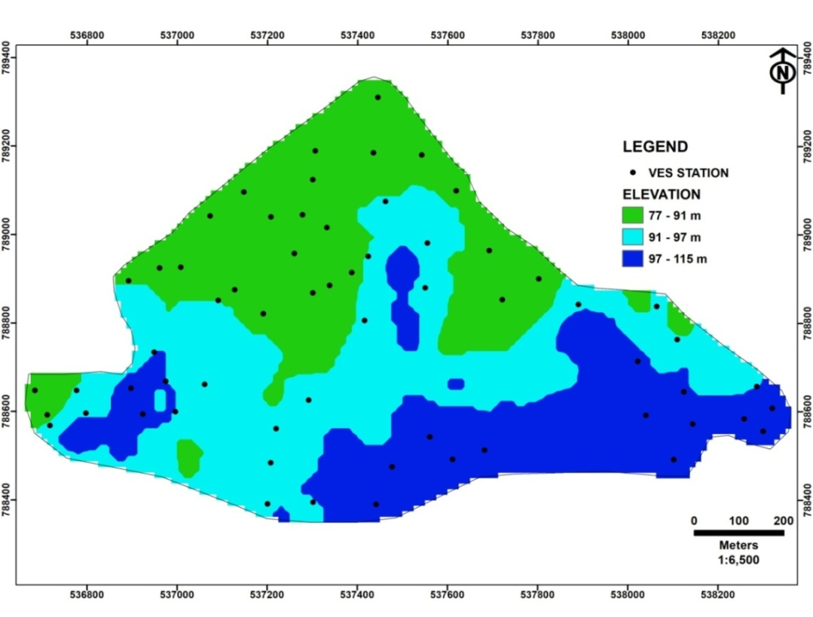
Figure 5: Digital elevation model map of the study area

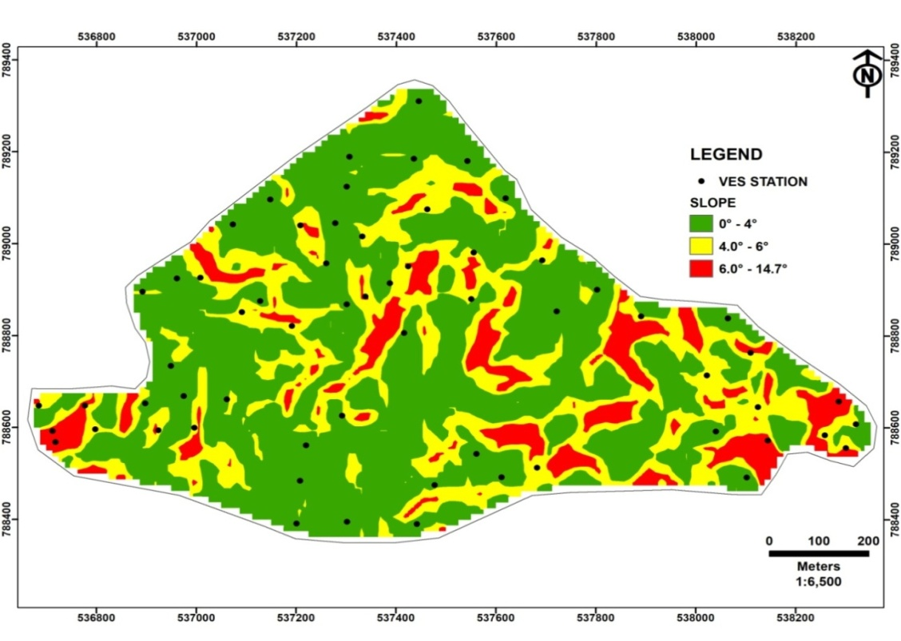
Figure 6: Slope map of the study area
As illustrated in Figure 7, the drainage density map of the study area indicates that the drainage network is uniformly distributed across the region.
The low drainage density class, ranging from 6.12 to 66.5 km/km², covers an area of 168 km² (35%) (Table 3). The study area is predominantly characterized by low drainage density, with an average of 90 km/km².
3.1.4 Land Use
Land use refers to the physical characteristics of the surface of the earth, which can include natural or cultivated vegetation, as well as human-made structures such as buildings. It encompasses various surface types, such as grass, asphalt, trees, bare ground, and water. The land use data for the study area was obtained from the ALOS PALSAR database provided by the Alaska Satellite Facility. The region is characterized by built-up areas, vegetation, and outcrops or bare land, as depicted in Figure 8. According to Shaban et al. (2006), vegetation plays a significant role in absorbing water, reducing water loss, and thereby positively influencing groundwater recharge.
The study area is predominantly covered by built-up surfaces, consisting entirely of non-porous materials such as roads and buildings. This significantly limits surface water infiltration, thereby reducing groundwater recharge. Built-up areas account for over 84% of the total investigated area, spanning 403 km² (Table 3), indicating a highly developed region.
3.2.1 Curve Types
The sounding curves in the area range from three to five layers. The observed curve types include the 3-layer A-type (10%), 3-layer H-type (71%), 4-layer HA-type (5%), 4-layer KH-type (5%), and 5-layer HKH-type (10%). Among these, the H-type curve is the most prevalent, covering an area of approximately 340.8 km² (Figure 9). The intermediate layer in the H-type curve is characterized by low resistivity, indicating a clay-rich formation saturated with water. This layer is highly porous but has a low specific yield and permeability. Consequently, while the groundwater reservoir has a high storage capacity, its ability to transmit water is limited, resulting in low groundwater potential.
3.2.3 Aquifer Thickness
Aquifer thickness (h) plays a crucial role in determining groundwater potential, with thicker aquifer units generally associated with higher groundwater potential. In the southeastern part of the study area, aquifer thickness ranges from 0.91 to 10 m (Figure 11), while the majority of the aquifer exceeds 11 m in thickness. Studies on groundwater potential in similar geological settings, such as Akintorinwa et al. (2020), indicate that aquifer thicknesses within this range are considered suitable for domestic water supply.
3.2.4 Overburden Thickness
The overburden thickness (b) in the study area ranges from 0.3 to 13.7 m (Figure 12), with over 63% of values classified as low (0.3 – 1.98 m). In most parts of the area, the overburden is relatively thin. Regions with thicker overburden are considered more favorable for high groundwater potential. This is because, during borehole installation, casing screens can be positioned to facilitate water seepage and infiltration from the surrounding geological materials, enhancing groundwater recharge. However, this approach should be avoided in areas susceptible to contamination.

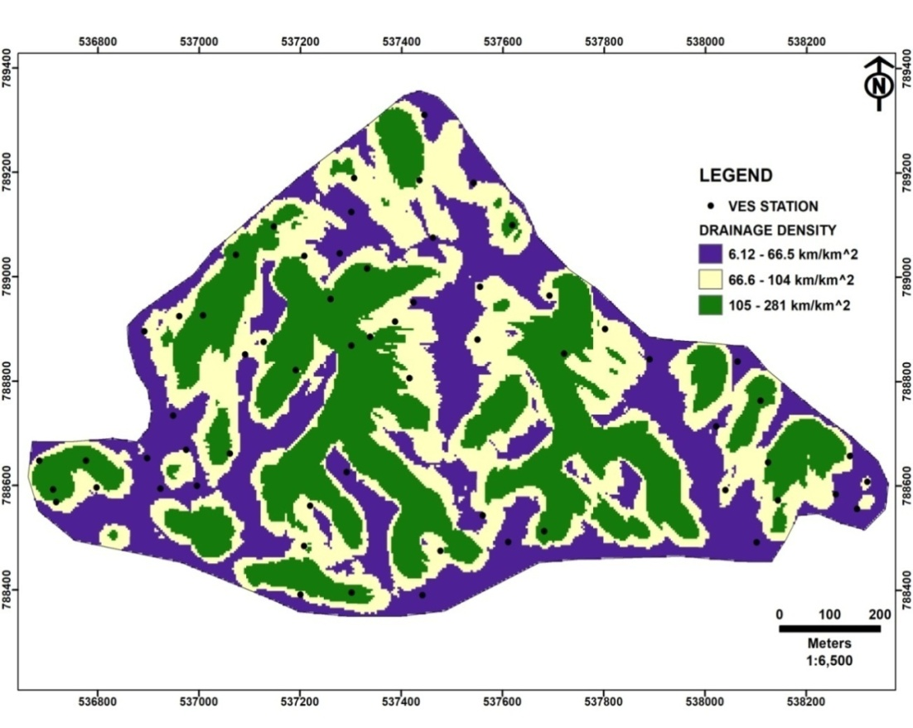
Figure 7: Drainage density map of the study area.
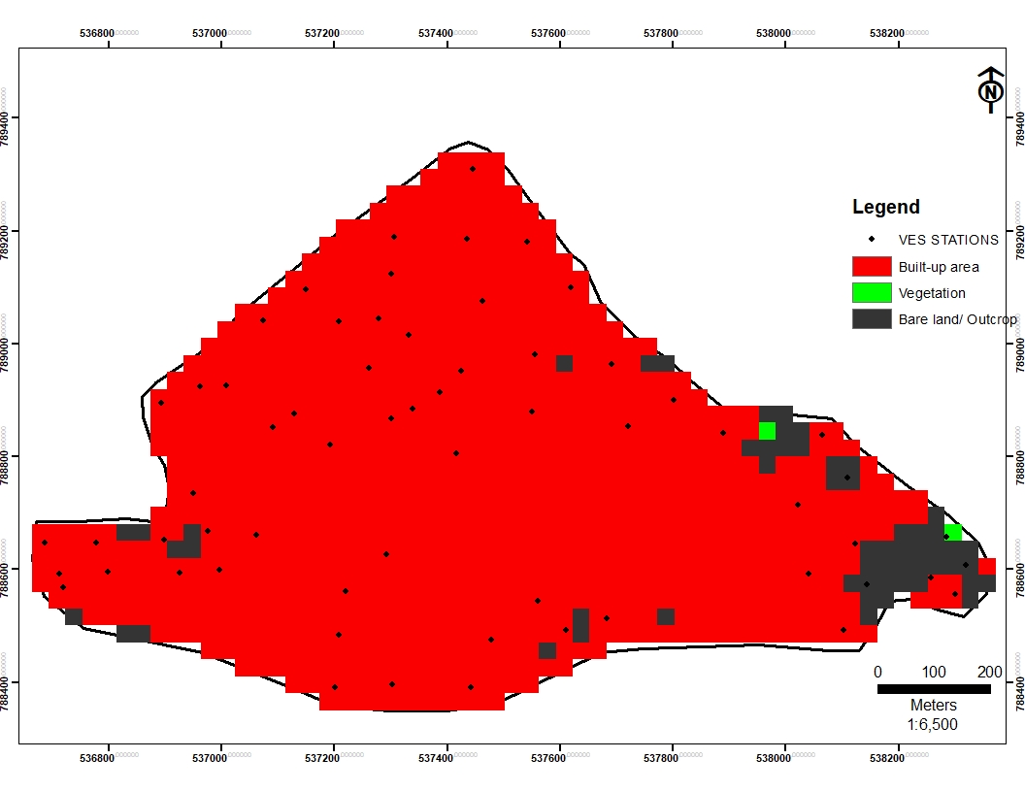
Figure 8: Land use map of the study area

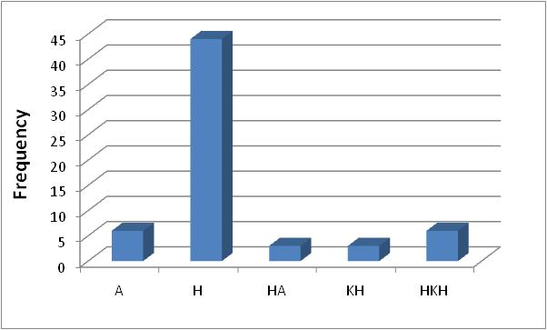
Figure 9: Bar chart showing the frequency distribution of the curve types in the area.
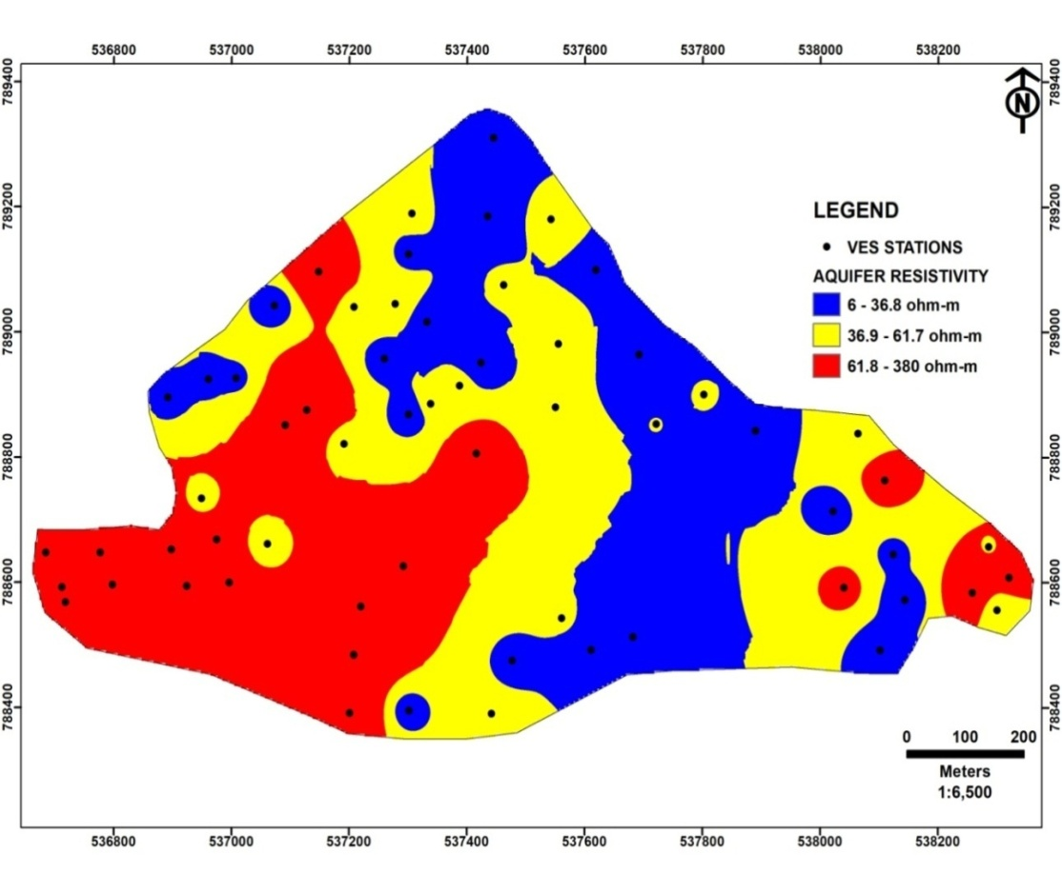
Figure 10: Aquifer resistivity map of the study area

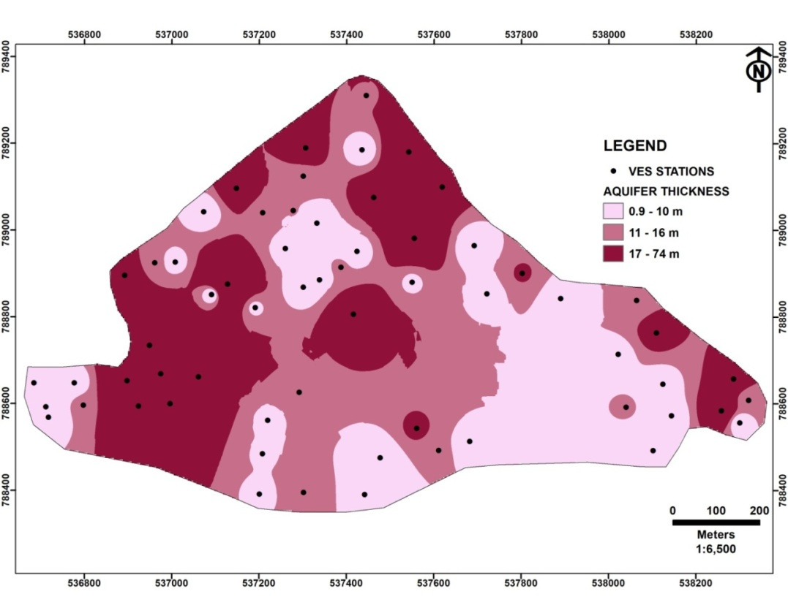
Figure 11.Aquifer thickness map of the study area
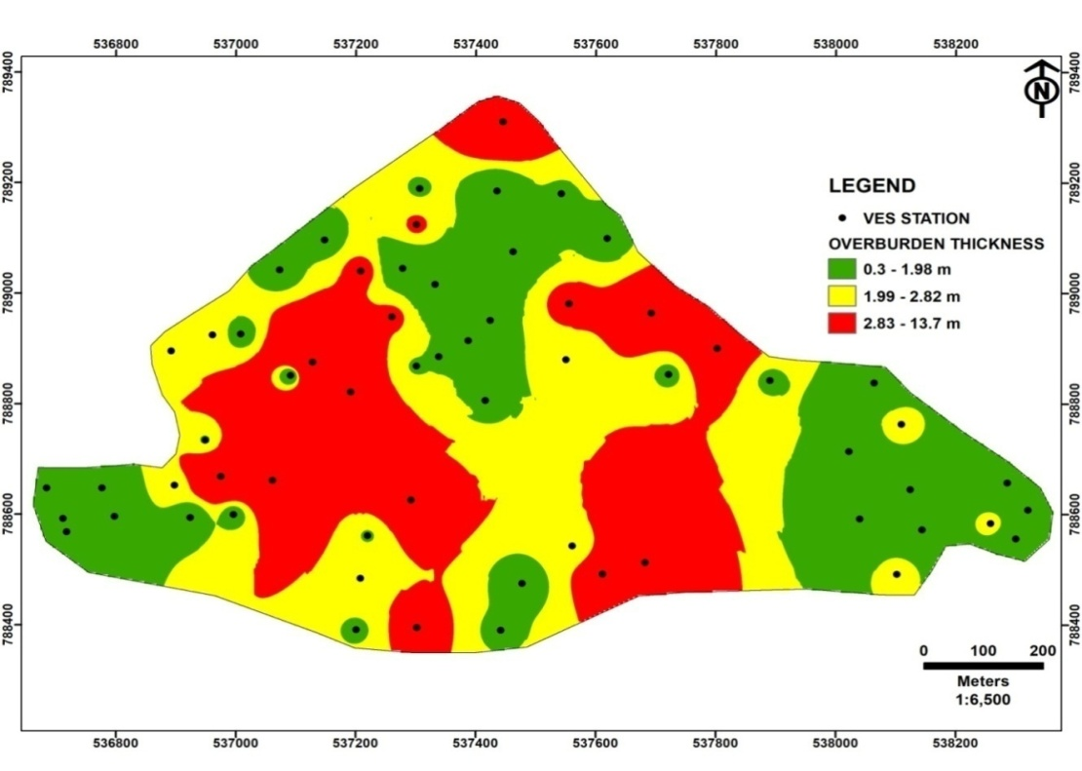
Figure 12: Overburden thickness map of the study area

3.2.5 Aquifer Hydraulic Conductivity
The hydraulic conductivity (k) map of the study area (Figure 13) shows that hydraulic conductivity decreases radially from the southwest (SW) to the northeast (NE). According to aquifer classification based on hydraulic conductivity values, the aquifer constitutes approximately 22% of the delineated geologic formation, covering an area of 105.6 km². This indicates that there are two primary geologic formations containing groundwater in the study area: the aquifer and the aquitard. A key distinction between these formations is that an aquifer both stores and transmits water, whereas an aquitard stores water but transmits it poorly, as exemplified by materials like sandy clay. Hydraulic conductivity values ranging from 10⁻⁴ to 10⁻¹ indicate an aquitard, while values between 10⁻¹ and 10³ signify an aquifer (Freeze and Cherry, 1972).
3.2.6 Aquifer Transmissivity
Areas with high aquifer transmissivity (Tr) values were identified primarily in the central part of the study region. These high transmissivity zones suggest the presence of substantial groundwater potential. In contrast, Figure 14 illustrates that the majority of the study area exhibits low aquifer transmissivity, with values ranging from 0.1 to 0.9 m²/day, spanning an area of 254.4 km². As a result, a significant portion of the study area is considered to have limited groundwater potential.
3.2.7 Aquifer Storativity
The eastern part of the study area is characterized by low storativity (St), ranging from 0.000018 to 0.00011, with a frequency of 44% and covering an area of 211.2 km². In contrast, the western part exhibits higher storativity, with a frequency of 32% and an area extent of 153.6 km² (Figure 15).
3.2.8 Aquifer Diffusivity
Aquifer diffusivity is directly linked to groundwater potential (Mogaji and Lim, 2016). The northeastern and southwestern parts of the study area exhibit high aquifer diffusivity, exceeding 8,961 m²/day (Figure 16). However, the overall diffusivity across the study area is predominantly low, indicating that the region generally has low groundwater potential.
3.2.9 Aquifer Reflection Coefficient
Low reflection coefficient values (less than 0.8) indicate weathered or fractured basement rock, which enhances groundwater potential (Olayinka, 1996). The central and western parts of the study area exhibit low aquifer reflection values (Figure 17), suggesting significant weathering and aligning with regions of high hydraulic conductivity.
Over 91% of the aquifer reflection coefficient (RC) values exceed the threshold established by Olayinka (1996), indicating that the layer is less porous and has limited potential for groundwater accumulation. In contrast, layers with lower reflection coefficient values, which are more porous, are suspected to have experienced some form of deformation. While the causes and origins of this deformation fall outside the scope of this study, the impact of the aquifer reflection coefficient (RC) on groundwater potential remains significant. These highly porous zones, characterized by intense deformation, show strong potential for groundwater accumulation and are considered promising targets for areas with high groundwater potential.

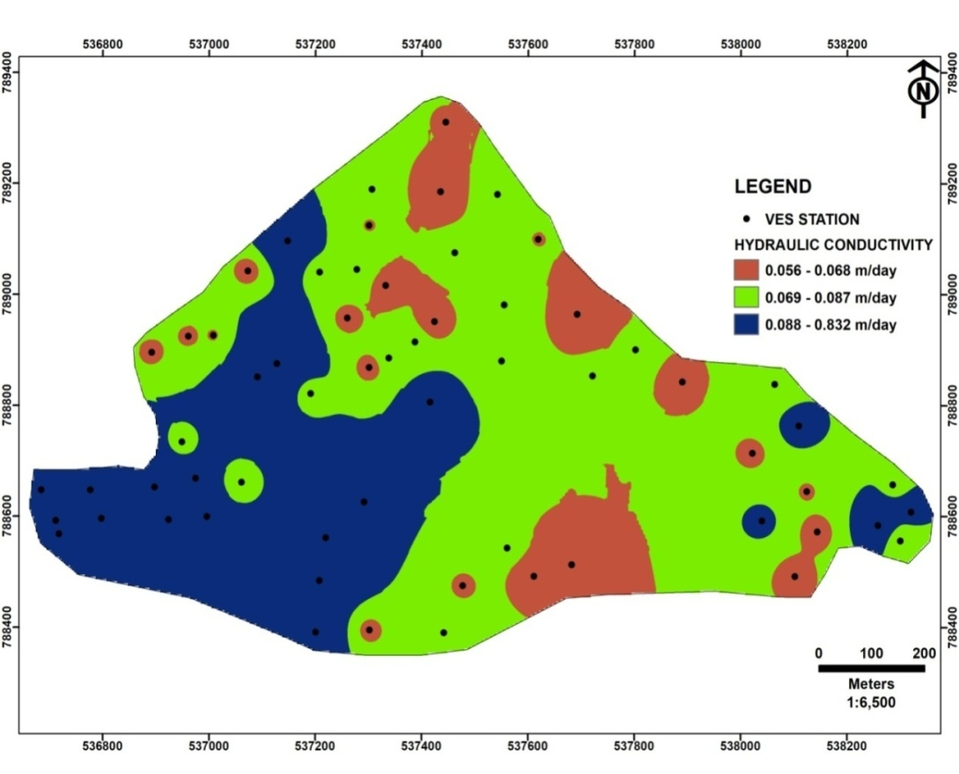
Figure 13: Aquifer hydraulic conductivity map of the study area
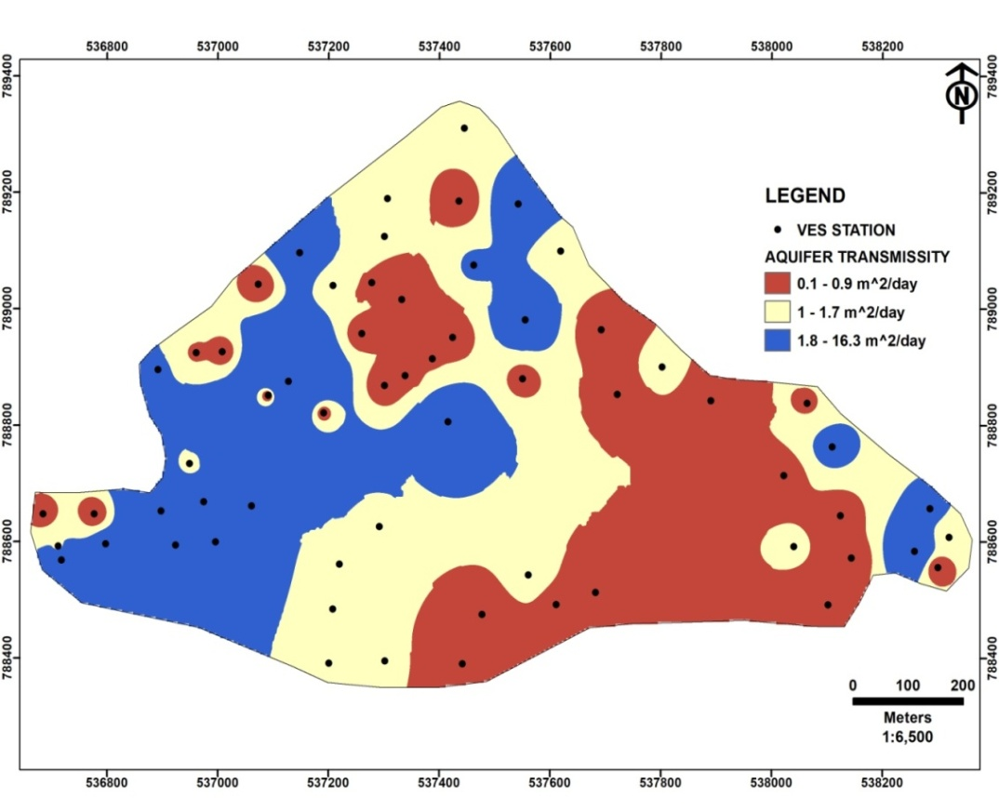
Figure 14: Aquifer transmissivity map of the study area
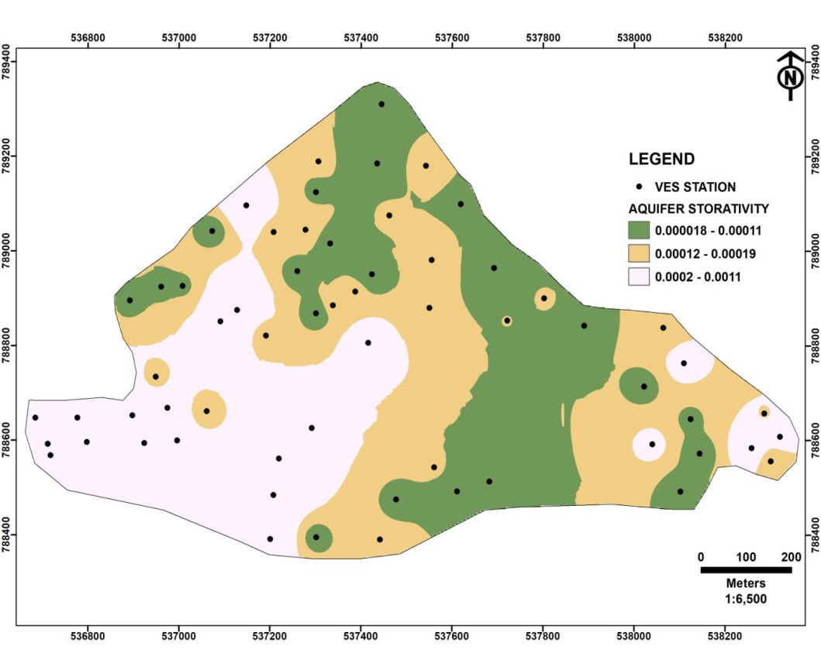
Figure 15: Aquifer storativity map of the study area
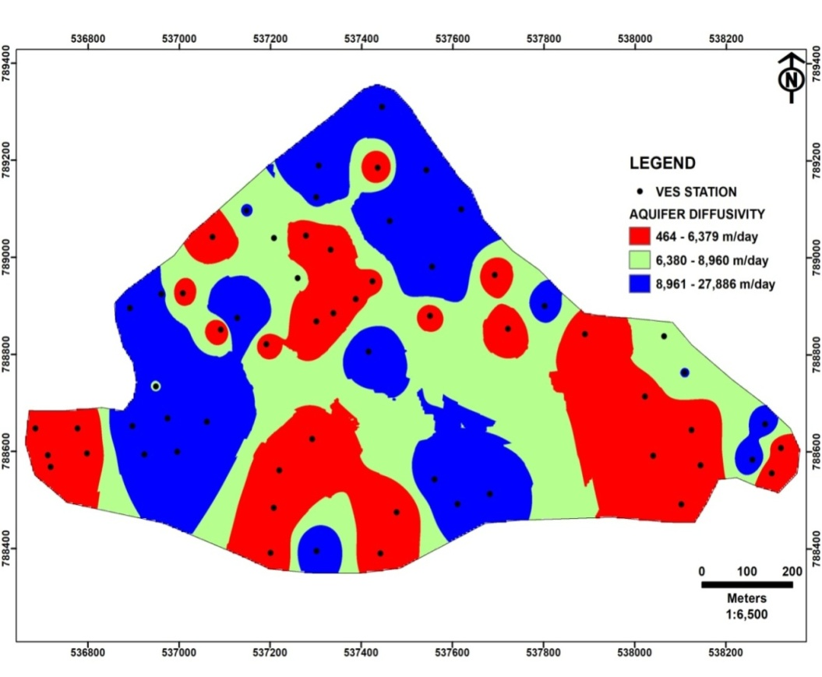
Figure 16: Aquifer diffusivity map of the study area
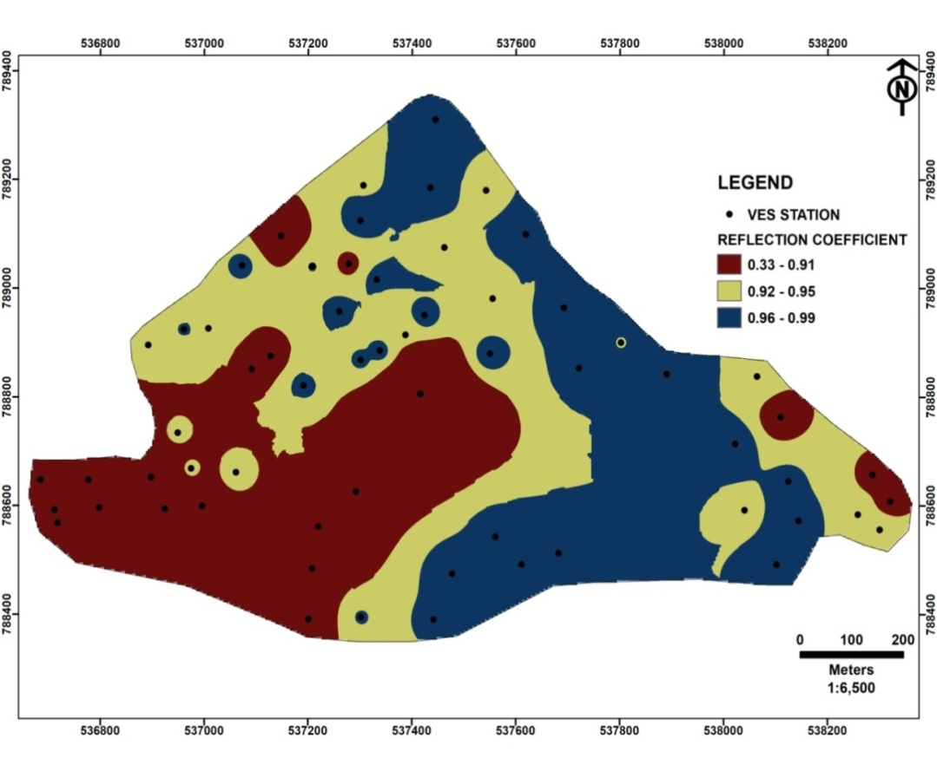
Figure 17: Aquifer reflection coefficient map of the study area
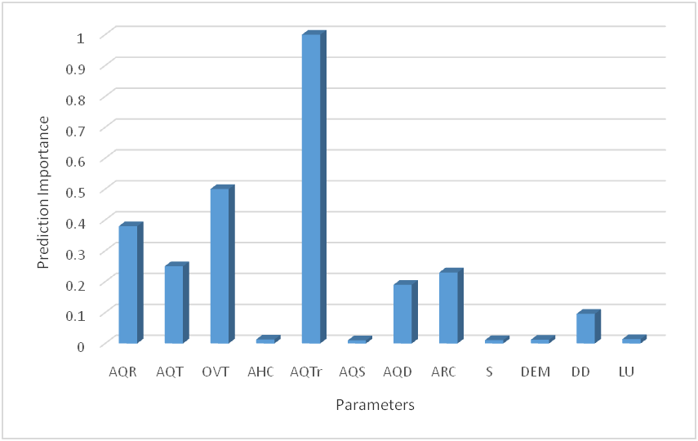
DEM:Digital Elevation Model; S: Slope ; DD: Drainage density; LU: .Land use; AQR: Aquifer resistivity; AQT: Aquifer thickness; OVT: Overburden thickness; AHC: Aquifer hydraulic conductivity ; AQTr: Aquifer transmissivity; AQS: Aquifer storativity ; AQD: Aquifer diffusivity; ARC: Aquifer reflection coefficient
Figure 18: GBT model prediction importance rating

3.3 AHP-MCDA model application results in groundwater potentiality
The primary objective of this study is to accurately map the characteristics of the aquifer units beneath the region's subsurface to support effective groundwater resource management. This is achieved using knowledge-driven Analytical Hierarchy Process (AHP) and data-mining techniques. The AHP-Groundwater Potential Index (GPPI) algorithm, as expressed in Equation 3, was developed by incorporating the weighted contributions of hydrogeologically significant factors (GPP themes). These factors were applied as the product of normalized weight (Nw) and rating (R), as detailed in Section 2.3. The results of the AHP-GPPI analysis, presented in Table 3 (Column 8), reveal that aquifer transmissivity (Tr) has the highest normalized weight of 0.256, while the digital elevation model (DEM) and slope (S) have the lowest normalized weights of 0.016.
3.4 GBT model application results in groundwater potentiality
The modeling of groundwater potential in delineated aquifer units within the field of groundwater hydrology and hydrogeology has been significantly enhanced through the application of gradient boosting tree (GBT) data-mining techniques. The GBT model was employed to assess various groundwater potential parameters (GPPs), which were subsequently ranked based on their predictive importance, as illustrated in Figure 18.
Aquifer transmissivity (Tr) has the highest prediction importance value of 1.0, followed by overburden thickness (b) at 0.50, aquifer resistivity (AQR) at 0.38, aquifer thickness (h) at 0.25, aquifer reflection coefficient (Rc) at 0.23, aquifer diffusivity (D) at 0.19, drainage density (DD) at 0.096, land use (Lu) at 0.014, hydraulic conductivity (k) at 0.013, digital elevation model (Dem) at 0.012, slope (S) at 0.01, and storativity (St) with a prediction importance of 0.01 (Figure 18). As illustrated in Figure 19, the success rate curve yields an AUC value of 0.95 (95%), indicating how effectively the model was trained using the dataset. Meanwhile, the prediction rate curve achieves an AUC value of 0.92 (92%), demonstrating whether the machine has accurately understood and recognized patterns in the data. In essence, this tests the machine's ability to apply what it has learned.
3.5 Groundwater prediction potential index (GPPI) Map
The results from the AHP-GPPI data mining technique identified three groundwater potential zones: low, moderate, and high. As shown in Figure 20, low groundwater potential areas range from 1.07 to 1.64, covering 187.2 km² (39%). Moderate potential areas fall within 1.65 to 2.22, spanning 153.6 km² (32%), while high groundwater potential zones range from 2.23 to 2.80, covering 139.2 km² (29%).
Similarly, the GBT-GPPI model (Figure 21) classified groundwater potential into three zones. Low groundwater potential areas range from 294.72 to 873.58, covering 220.8 km² (46%). Moderate potential areas, ranging from 873.59 to 1,345.8, cover 48 km² (10%), while high groundwater potential zones, within 1,345.9 to 2,238, span 211.2 km² (44%).

Figure 19: ROC graph plot showing the performances of the training and testing data
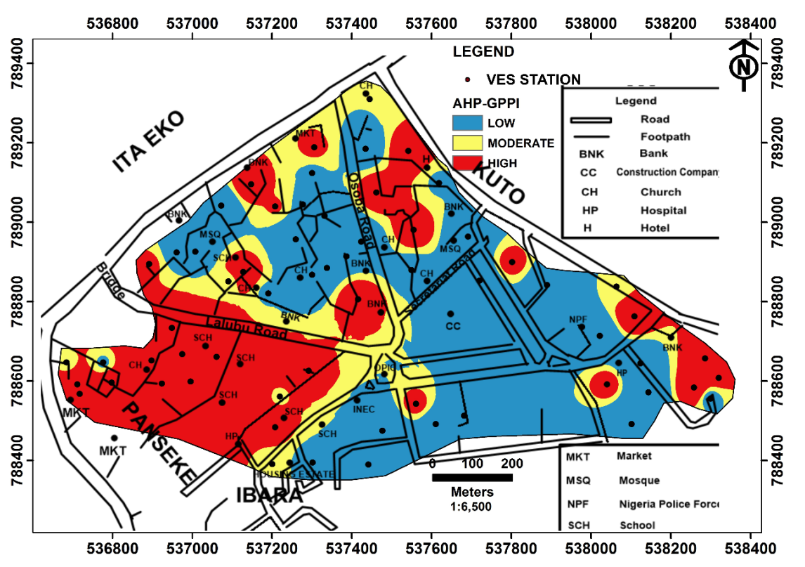
Figure 20: AHP-GPPI map of the study area
Figure 21: GBT-GPPI map of the study area
The northern and western parts of the map are predominantly characterized by high groundwater potential, as shown in Figure 20. However, over 56% of the area falls within the low to moderate groundwater potential zones.
3.5 Validation of the groundwater potential prediction (GPPI) Model
Insights from the data mining models were explored using the Water Column Validation (WC-VLD) approach, as detailed in Section 2.4.1 of this study. Figure 22 presents the water column map alongside well locations in the study area. The analysis reveals that low water column measurements (< 0.511 m) cover 192 km² (40%), moderate measurements (0.512 – 0.873 m) span 129 km² (27%), and high measurements (0.874 – 1.45 m) extend across 158.4 km² (33%). Based on these findings and the assumptions outlined in Figure 22, the Groundwater Potentiality Prediction Index (GPPI) derived from the AHP and GBT models was categorized into three classes. These categories were reinterpreted for numerical digitization and assigned values: low (1), moderate (2), and high (3) (Table 6). The categorized data was then recoded using IBM SPSS for statistical analysis.
To quantitatively assess the qualitative WC-VLD analysis, the corresponding water column measurement values were applied to the statistical correlation algorithm expressed in Equation 6, with results summarized in Table 7. The AHP-GPPI model demonstrated a strong positive correlation (rs = 0.662) with WC-VLD and a statistically significant value (p = 0.007). This indicates a 66% correlation between the AHP model results and water column validation. The p-value of 0.007 suggests only a 0.7% probability that the results occurred by chance, providing 99.3% confidence in their accuracy.
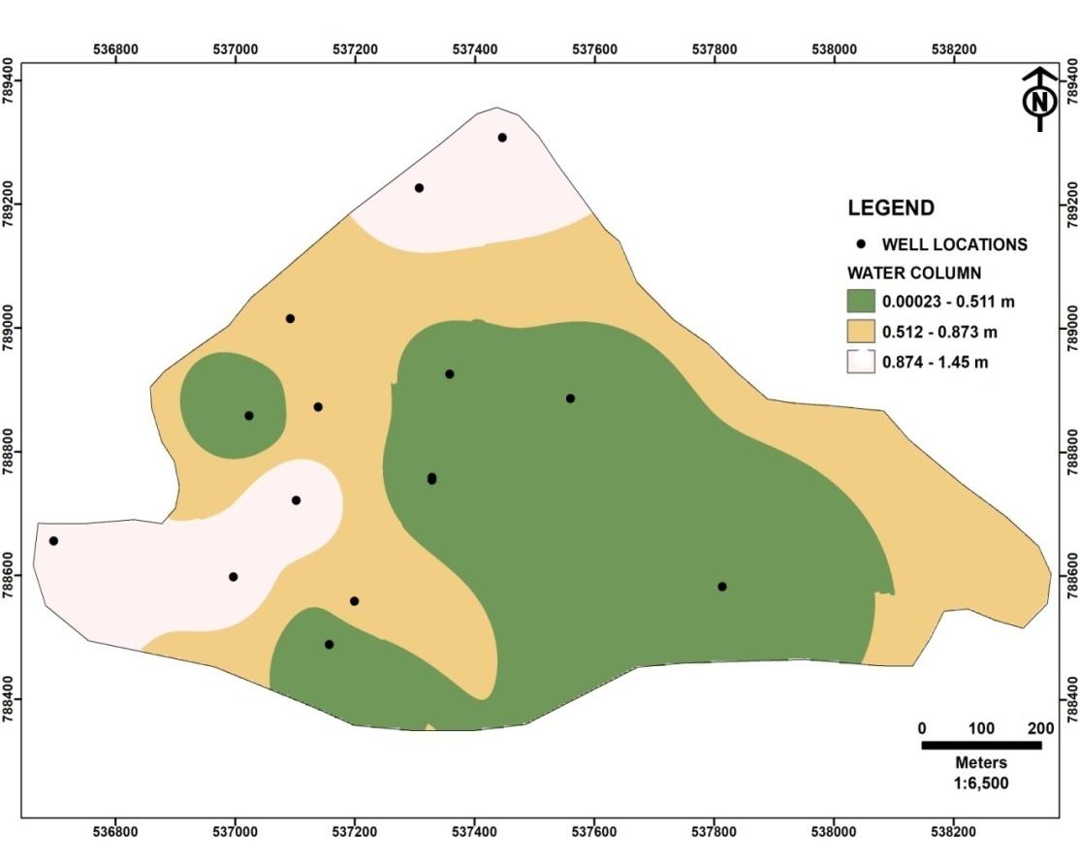
Figure 22: Water Column Level Map of the Study Area.
Table 6: GPPIs validation classes
Zonation classes | AHP-GPPI | GBT-GPPI | WC-VLD | Remarks
Low | 1.07 - 1.64 | 294.72 - 873.58 | 0 - 0.511 | *
Moderate | 1.65 - 2.22 | 873.59 - 1345.8 | 0.512 - 0.873 | **
High | 2.23 - 2.80 | 1345.9 - 2238 | 0.874 - 1.45 | ***
Low * moderate ** high ***
Table 7: Correlation analysis of GPPI with water column validation scheme
 |  |  | AHP-GPPI | GBT-GPPI | WC-VLD
Spearman's rho | AHP-GPPI | Correlation Coefficient | 1.000 | .636* | .662**
Spearman's rho | AHP-GPPI | Sig. (2-tailed) | . | .011 | .007
Spearman's rho | AHP-GPPI | N | 15 | 15 | 15
Spearman's rho | GBT-GPPI | Correlation Coefficient | .636* | 1.000 | .738**
Spearman's rho | GBT-GPPI | Sig. (2-tailed) | .011 | . | .002
Spearman's rho | GBT-GPPI | N | 15 | 15 | 15
Spearman's rho | WC-VLD | Correlation Coefficient | .662** | .738** | 1.000
Spearman's rho | WC-VLD | Sig. (2-tailed) | .007 | .002 | .
Spearman's rho | WC-VLD | N | 15 | 15 | 15
*. Correlation is significant at the 0.05 level (2-tailed).
**. Correlation is significant at the 0.01 level (2-tailed).
Similarly, the GBT-GPPI model exhibits a strong positive correlation with WC-VLD, with rs=0.738r_s = 0.738rs​=0.738 and a statistically significant p-value of 0.002. Compared to the AHP model, the GBT model demonstrates a stronger association of 74%, with a 99.8% confidence level. This indicates that the GBT model outperforms the AHP model in groundwater prediction based on the groundwater potential predictors used in this study.
4.0 Conclusion
The development of predictive modeling and data mining techniques in groundwater hydrology and hydrogeology is essential for informed decision-making. These techniques enable precise mapping and delineation of hidden subsurface structures that can serve as groundwater reservoirs (aquifer units) on a regional scale. This research focuses on the development of the Groundwater Potentiality Prediction Index (GPPI) data mining approach to enhance groundwater resource planning and management.
To achieve this, groundwater potential predictors (GPPs) derived from geophysical (subsurface) and remote sensing (surface) data sources were analyzed using the Analytical Hierarchical Process-Multi-Criteria Decision Analysis (AHP-MCDA) technique and a cognitive data mining tool, the Gradient Boosting Tree (GBT) model, in combination with GIS tools.
Surface hydrological parameters (SHPs) such as the Digital Elevation Model (DEM), Slope (S), Drainage Density (Dd), and Land Use (Lu) were extracted within the respective ranges of 77–115 m, 0–14.7 degrees, 6.1–281 km/km², and 0–147. Subsurface geoelectrical parameters (SGPs), including aquifer resistivity (ρ), aquifer thickness (h), overburden thickness (b), hydraulic conductivity (k), transmissivity (Tr), storativity (St), diffusivity (D), and reflection coefficient (RC), were estimated using processed and interpreted 1D depth sounding data based on the groundwater flow equation.
The AHP data mining technique determined the weightage contribution of each GPP, with aquifer transmissivity ranking highest at 0.256, while DEM and slope had the lowest weightage of 0.016. The Gradient Boosting Tree model further refined these predictors, assigning the highest prediction importance to transmissivity (1.00) and the lowest to slope (0.01).
Hydraulic conductivity classification and reflection coefficient analysis indicated that groundwater is primarily stored within two major geological layers: aquifers and aquitards. Validation results showed a 66% accuracy for the AHP model and 74% for the GBT model using water column validation schemes on the GPPI data mining techniques.
As a result, the developed aquifer potentiality prediction model can serve as a valuable tool for groundwater resource planners and policymakers in the study area and other regions with similar geological conditions.
In conclusion, the findings confirm that a sudden drop in aquifer resistivity does not necessarily indicate the presence of groundwater. Instead, multiple parameters must be integrated to gain a comprehensive understanding of aquifer characteristics.
Declaration of Interest
Authors declare that there is no funding for this research. Also, there is No Conflict of Interest.
Disclaimer (Artificial Intelligence)
Author(s) hereby declare that NO generative AI technologies such as Large Language Models (ChatGPT, COPILOT, etc.) and text-to-image generators have been used during the writing or editing of this manuscript.
References
Ademilua, O. L. (1997). A Geoelectric and Geologic Evaluation of Groundwater Potential of Ekiti and Ondo States, Southwestern Nigeria. Unpublished M.Sc. Thesis, Department of Geology, Obafemi Awolowo University, Ile-Ife, Nigeria, pp. 1–67.
Adiat, K. A. N., Nawawi, M. N. M., & Abdullah, K. (2013). Application of Multi-Criteria Decision Analysis to Geoelectric and Geologic Parameters for Spatial Prediction of Groundwater Resources Potential and Aquifer Evaluation. Pure and Applied Geophysics, 170, 453–471. https://doi.org/10.1007/s00024-012-0501-9
Akanbi, O. A. (2017). Hydrogeologic Characterization of Crystalline Basement Aquifers of Part of Ibarapa Area, Southwestern Nigeria. Ph.D. Thesis, Department of Geology, University of Ibadan.
Akanbi, O. A. (2018). Hydrogeological Characterisation and Prospect of Basement Aquifers in Ibarapa Region, Southwestern Nigeria. Applied Water Science, 8, 89. https://doi.org/10.1007/s13201-018-0731-9
Akanni, C. O. (1992). Aspects of Climate: Ogun State in Maps. In Onokomaiya et al. (Eds.), Rex Charles Publication, Ibadan, pp. 21–22.
Akinlalu, A. A., Mogaji, K. A., & Adebodun, T. S. (2021). Assessment of Aquifer Vulnerability Using a Developed “GODL” Method (Modified GOD Model) in a Schist Belt Environment, Southwestern Nigeria. Environmental Monitoring and Assessment, 193, 19.
Akinlalu, A. A., Adegbuyiro, A., Adiat, K. A. N., Akeredolu, B. E., & Lateef, W. Y. (2017). Application of Multi-Criteria Decision Analysis in Prediction of Groundwater Resources Potential: A Case Study of Oke-Ana, Ilesa Area, Southwestern Nigeria. NRIAG Journal of Astronomy and Geophysics, 6(1), 184–200. https://doi.org/10.1016/j.nrjag.2017.03.001
Akintorinwa, O. J., Atitebi, M. O., & Akinlalu, A. A. (2020). Hydrogeophysical and Aquifer Vulnerability Zonation of a Typical Basement Complex Terrain: A Case Study of Odode-Idanre, Southwestern Nigeria. https://doi.org/10.1016/j.heliyon.2020.e04549
Akintorinwa, O. J., & Okoro, O. V. (2019). Combined Electrical Resistivity Method and Multi-Criteria GIS-Based Modeling for Landfill Site Selection in Southwestern Nigeria. Environmental Earth Sciences, 78(5). https://doi.org/10.1007/s12665-019-8153-z
Akintorinwa, O. J. (2015). Groundwater Potential Assessment of Iwaro-Oka, SW Nigeria Using Geoelectric Parameters. Current Journal of Applied Science and Technology, 6(4), 364–377. https://doi.org/10.9734/BJAST/2015/14584
Akinwunmi, & Olorunfemi. (2018). Modeling Groundwater Flow System of a Drainage Basin in the Basement Complex Environment of Southwestern Nigeria. Proceedings of the International Cartographic Association. https://doi.org/10.5194/ica-proc-1-2-2017
Bayowa, O. G., Olorunfemi, O. M., Akinluyi, O. F., & Ademilua, O. L. (2014). A Preliminary Approach to the Groundwater Potential Appraisal of Ekiti State, Southwestern Nigeria. International Journal of Science and Technology, 4(3), 48–58.
Boretti, A., & Rosa, L. (2019). Reassessing the Projections of the World Water Development Report. npj Clean Water, 2, 15. https://doi.org/10.1038/s41545-019-0039-9
Chang-Jo, F. C., & Andrea, G. F. (2003). Validation of Spatial Prediction Models for Landslide Hazard Mapping. Journal of Hydrology, 30(3), 451–472.
Das, S. (2018). Geographic Information System and AHP-Based Flood Hazard Zonation of Vaitarna Basin, Maharashtra, India. Arabian Journal of Geosciences, 11(19), 576.
Fashae, O. A., Tijani, M. N., Talabi, A. O., et al. (2014). Delineation of Groundwater Potential Zones in the Crystalline Basement Terrain of SW Nigeria: An Integrated GIS and Remote Sensing Approach. Applied Water Science, 4, 19–38. https://doi.org/10.1007/s13201-013-0127-9
Freeze, R. A., & Cherry, J. A. (1979). Groundwater. Prentice-Hall Inc., Englewood Cliffs, Vol. 7632, 604 pp.
Hencher, S. R., Lee, S. G., Carter, T. G., et al. (2011). Sheeting Joints: Characterisation, Shear Strength, and Engineering. Rock Mechanics and Rock Engineering, 44, 1–22. https://doi.org/10.1007/s00603-010-0100-y
Hiscock, K. (2005). Hydrogeological Principles and Practice. Malden, Oxford, Carlton, 389 pp. ISBN: 0632057637.
Jayeoba, A., & Oladunjoye, M. A. (2013). Hydro-Geophysical Evaluation of Groundwater Potential in Hard Rock Terrain of Southwestern Nigeria. RMZ Materials and Geo-Environment, 60, 271–284.
Jones, H. A., & Hockey, R. D. (1964). The Geology of Part of Southwestern Nigeria. Geological Survey of Nigeria Bulletin, 31, 101 pp.
Kothari, C. R. (2004). Research Methodology: Methods and Techniques (2nd Ed.). New Delhi: New Age International Publishers.
Lewis, M. A. (1987). The Analysis of Borehole Yields from Basement Aquifers. Proceedings of the Basement Aquifer Workshop, 15–24 June 1987, Zimbabwe, Commonwealth Science Council CSC (89) WMR – 13, TP 273.
Lohman, S. W. (1972). Groundwater Hydraulics. Professional Paper 708. https://doi.org/10.3133/pp708
Mogaji, K. A., & Lim, H. S. (2016). Groundwater Potentiality Mapping Using Geoelectrical-Based Aquifer Hydraulic Parameters: A GIS-Based Multi-Criteria Decision Analysis Modeling Approach. Terrestrial, Atmospheric and Oceanic Sciences. https://doi.org/10.3319/TAO.2016.11.01.02
Mogaji, K. A., & Lim, H. S. (2017). Development of Groundwater Favorability Map Using GIS-Based Data Mining Models: An Approach for Effective Groundwater Resource Management. Geocarto International. https://doi.org/10.1080/10106049.2016.1273400
Mogaji, K. A., & Lim, H. S. (2018). Application of Dempster-Shafer Theory of Evidence Model to Geoelectric and Hydraulic Parameters for Groundwater Potential Zonation. NRIAG Journal of Astronomy and Geophysics.
Mogaji, K. A., & Lim, H. S. (2020). A GIS-Based Linear Regression Modeling Approach to Assess the Impact of Geologic Rock Types on Groundwater Recharge and Its Hydrological Implications. Modeling Earth Systems and Environment, 6(1), 183–199. https://doi.org/10.1007/s40808-019-00670-3
Moroof, O. Oloruntola & Adeyemi, G. O. (2014). Geophysical and hydrochemical evaluation of groundwater potential and characteristics in the Abeokuta area, southwestern Nigeria. Journal of Geoscience and Geomatics, 6(3), 162. https://doi.org/10.5539/jgg.v6n3p162
Naghibi, S. A., Pourghasemi, H. R., Pourtaghi, Z. S., & Rezaei, A. (2014). Groundwater qanat potential mapping using frequency ratio and Shannon’s entropy models in Moghan watershed, Iraq. Earth Science Informatics.
Nampak, H., Pradhan, B., & Manap, M. A. (2014). Application of GIS-based data-driven evidential belief function model to predict groundwater potential zonation. Journal of Hydrology, 513, 283–300.
Ozdemir, A. (2011). Using a binary logistic regression method and GIS for evaluating and mapping groundwater spring potential in the Sultan Mountains (Akşehir, Turkey). Journal of Hydrology, 405(1), 123–136. https://doi.org/10.1016/j.jhydrol.2011.05.015
Ogunbo, J. N. (2019). Auto Partial Curve Matching. Geophysics, 83(2), F21–F28. https://doi.org/10.1190/geo2016-0631.1
Okogbue, C. O., & Omonona, O. V. (2013). Groundwater potential of the Egbe-Mopa basement area, central Nigeria. Hydrological Sciences Journal, 58.
Olayinka, A. I. (1996). Non-uniqueness in the interpretation of bedrock resistivity from sounding curves and its hydrogeological implications. Water Resources, 7(1 & 2), 49–55.
Olorunfemi, M. O., & Fasuyi, S. A. (1993). Aquifer types and the geoelectric/hydrogeologic characteristics of parts of the central basement terrain of Nigeria (Niger State). Journal of African Earth Sciences, 16(3), 309–319.
Olorunniwo, M. A., & Olorunfemi, M. O. (1987). Geophysical investigations for groundwater in Precambrian terrains: A case study from Ikare, southwestern Nigeria. Journal of African Earth Sciences, 6(6), 787–796.
Omotola, O. O., Oladapo, M. I., & Akintorinwa, O. J. (2020). Modeling assessment of groundwater vulnerability to contamination risk in a typical basement terrain: A comparative study of vulnerability techniques. Modeling Earth Systems and Environment, 6, 1253–1280.
Pradhan, B., Neshat, A., Pirasteh, S., & Shafri, H. Z. M. (2013). Estimating groundwater vulnerability to pollution using a modified DRASTIC model in the Kerman agricultural area, Iran. Environmental Earth Sciences. https://doi.org/10.1007/s12665-013-2690-7
Rahaman, M. A. (1976). Review of the basement geology of southwestern Nigeria. In Geology of Nigeria (pp. 41–58). Elizabithan Publishing Company, Nigeria.
Rahaman, M. A. (1988). Recent advances in the study of the basement complex of Nigeria. In P. O. Oluyide, W. C. Mbonu, A. E. Ogezi, I. G. Egbuniwe, A. C. Ajibade, & A. C. Umeji (Eds.), Precambrian Geology of Nigeria (pp. 11–41). Geological Survey of Nigeria.
Raviraj, A., Kuruppath, N., & Kannan, B. (2017). Identification of potential groundwater recharge zones using remote sensing and GIS in the Amaravathy Basin. Journal of Remote Sensing and GIS. https://doi.org/10.4172/2469-4134.1000213
Rawal, D., Vyas, A., & Rao, S. (2016). Application of GIS and groundwater modeling techniques to identify perched aquifers and demarcate water logging conditions. Sciences, Volume III-8, XXIII ISRS Congress, 12–19 July, Prague, Czech Republic.
Saaty, T. L. (1980). The analytic hierarchy process: Planning, priority setting, resource allocation. McGraw-Hill, New York.
Saaty, T. L., & Vargas, G. L. (1991). Prediction, projection, and forecasting. Kluwer, Dordrecht.
Shaban, A., Khawlie, M., & Abdallah, C. (2006). Use of remote sensing and GIS to determine recharge potential zones: The case of Occidental Lebanon. Hydrogeology Journal, 14(4), 433–443.
Shishaye, H. A., Tait, D. R., Befus, K. M., & Maher, D. T. (2019). An integrated approach for aquifer characterization and groundwater productivity evaluation in the Lake Haramaya watershed, Ethiopia. Hydrogeology Journal, 27(6), 1212–1236. https://doi.org/10.1007/s10040-019-01956-7
Singh, K. P. (2005). A first attempt at determining relationships between geophysical parameters and aquifer yield. Presented at the 91st Conference of the Indian Science Congress, 3–7 January, Punjab University, Chandigarh, India.
Sedgwick, P. (2019). BMJ clinical research. BMJ. https://doi.org/10.1136/BMJ.g7327
Lee, S., Hyun, Y., & Lee, M. J. (2019). Groundwater potential mapping using data mining models of big data analysis in Goyang-si, South Korea.
Toto, E. A., Kerrouri, C., Zouhri, L., Basri, E., & Ibenbrahim, A. (2008). Geoelectrical exploration for groundwater in Al Maha Forest, Ain Jouhra, Morocco. Hydrological Processes, 22, 1675–1686.
Umar, N. D., & Igwe, O. (2019). Geo-electric methods applied to groundwater protection of a granular sandstone aquifer. Applied Water Science, 9(4), 112. https://doi.org/10.1007/s13201-019-0980-2
Vander, V. (2004). WinRESIST Version 1.0: Resistivity depth sounding interpretation software. ITC, Delft, The Netherlands.
Zhou, Y., & Li, W. (2011). A review of regional groundwater flow modeling. Geoscience.
Zohdy, A. A. R., Eaton, G. P., & Mabey, D. R. (1974). Application of surface geophysics to groundwater investigations. U.S. Geological Survey, TWRI, Book 2, Chapter D1.

