Review Article

Reskilling the U.S. Military Workforce for the Agentic AI Era: A Framework for Educational Transformation

ABSTRACT

The rapid emergence of agentic artificial intelligence (AI) systems represents a paradigm shift in military operations, demanding fundamental transformation of US military education. This paper presents a comprehensive framework for reskilling and redesigning military education to address critical workforce readiness gaps in the era of autonomous AI systems.
Utilizing a mixed-methods review of defense reports, case studies, and quantitative workforce data, this paper develops a comprehensive framework for reskilling the defense force to address critical readiness gaps in the era of autonomous AI. Through analysis of current AI adoption trends, quantitative workforce assessments, and educational limitations, we identify that only 10-15% of military personnel feel adequately trained for agentic AI integration despite significant investments exceeding $600-900 million in next-generation AI capabilities. Our proposed solution features a multi-tiered educational architecture with progressive competency levels, a continuous curriculum development pipeline, and layered technology integration. The framework addresses identified skills gaps through foundational AI literacy for all personnel, operational competence for mid-career leaders, and strategic AI leadership development. Implementation strategies include phased rollout over 24-36 months, multi-stakeholder engagement models, and comprehensive assessment mechanisms. Findings demonstrate that successful agentic AI integration requires not only technical upskilling but also fundamental changes in pedagogical approaches, institutional culture, and resource allocation—with optimal distribution of 30-40% to technology infrastructure, 20-25% to faculty development, 15-20% to curriculum design, and program evaluation. This research provides actionable recommendations for military education institutions to prepare personnel for human-AI teaming, autonomous system oversight, and ethical AI application in complex operational environments. decrease medical as well as financial burden, hence improving the management of cirrhotic patients. These predictors, however, need further work to validate reliability. All results and proposals are from cited literature.

Keywords: Agentic AI, military education, reskilling defense forces, workforce development, AI integration

1 Introduction
The United States military faces a transformative challenge with the emergence of agentic artificial intelligence systems capable of autonomous decision-making and coordinated operations (Joshi, 2025). Unlike previous AI generations focused on data analysis, agentic AI systems demonstrate proactive problem-solving and multi-agent coordination, representing a fundamental shift in military operations (Hosseini & Seilani, 2025; Flournoy, 2023)
The Department of Defense’s substantial investments in AI capabilities, including recent allocations exceeding $600 million for next-generation agentic AI, underscore the strategic importance of this technology (Steckler & Mayville, 2025). However, technological advancement alone is insufficient for effective integration. As research indicates, "the advantages of AI will be realized by the military that can best employ it" (Cruickshank, 2023), highlighting the critical need for comprehensive workforce development. Scharre (2023) provides critical context on the geopolitical competition for AI dominance, underscoring the strategic necessity of the educational framework proposed herein. Furthermore, Cummings (2024) offers specific validation for the human-AI teaming and oversight challenges that the multi-tiered curriculum is designed to address.
This paper addresses this imperative by conducting a mixed-methods review of defense reports, case studies, and quantitative workforce data to develop the first integrated educational framework specifically designed for agentic AI readiness in the U.S. military. The resulting framework not only provides a model for future defence education reforms but also serves as a guide for allied nations adapting to autonomous AI systems.
This manuscript employs several standard abbreviations from a U.S. military and governmental context, including DoD (Department of Defense), PME (Professional Military Education), NCO (Non-Commissioned Officer), ISR (Intelligence, Surveillance, and Reconnaissance), HR (Human Resources), and DIU (Defense Innovation Unit).

2 Literature Review

2.1 Military AI Evolution and Current State
The integration of artificial intelligence into military operations has evolved through distinct phases, from basic automation to contemporary agentic systems capable of autonomous decision-making (Zarrar & Kakar, 2024). Recent developments demonstrate rapid operationalization, with systems now processing vast amounts of intelligence data, generating operational plans, and coordinating complex multi-domain operations with minimal human intervention.
Current adoption spans multiple military branches, with the U.S. Central Command, Air Force, and Army implementing generative AI technology for various applications from intelligence analysis to logistics optimization. This expansion aligns with international governance efforts seeking to establish norms for responsible military AI use while fostering global cooperation (Wilner & Atkinson, 2025).

2.2 Technical and Workforce Challenges
Despite significant progress, military AI integration faces substantial challenges. Technical concerns include system reliability, security vulnerabilities, and operational effectiveness in complex environments. Workforce readiness presents equally critical challenges, with traditional education paradigms struggling to keep pace with technological acceleration (Satyadhar Joshi, 2025).
Research indicates particular concern regarding ethical implementation and appropriate human oversight mechanisms. The integration of autonomous systems necessitates robust testing methodologies, explainable AI components, and ethical governance frameworks to ensure responsible deployment (Joshi, 2025).

2.3 Educational Transformation Needs
Military education institutions require fundamental transformation to address emerging AI competencies. Current systems, designed for industrial-age warfare, lack the agility to incorporate rapidly evolving technological requirements (Biggs, 2025). This creates significant gaps in workforce readiness that could undermine substantial technological investments.
Analysis reveals that successful AI integration demands not only technical skills but also cultural adaptation and ethical reasoning capabilities. Educational approaches must address human-AI teaming dynamics, trust development, and appropriate use case identification across diverse operational contexts (Cruickshank, 2023).

3 Proposed Architecture and Framework Diagrams

3.1 Methodology
This research employs a mixed-methods approach combining:

3.1.1 Literature Analysis
Comprehensive review of current research on AI integration in military education, including defense publications, academic journals, and industry reports from 2020-2025.

3.1.2 Case Study Examination
Analysis of existing AI education initiatives within military institutions, including:
- Army’s AI integration in professional military education (Biggs, 2025)
- Air Force’s adaptive learning programs (Stilwell, 2020)
- Defense Innovation Unit’s training partnerships

3.1.3 Gap Analysis
Identification of skills requirements versus current educational offerings through comparison of:
- DoD AI strategy documents
- PME curriculum reviews
- Industry skill demand projections
This section presents the architectural framework for implementing agentic AI education across military institutions. The proposed approach integrates tiered learning models, technological infrastructure, and organizational structures to create a comprehensive ecosystem for military AI education.

3.2 Tiered Learning Architecture
The tiered learning architecture (Figure 1) establishes progressive competency levels aligned with military career progression. This structure ensures that AI education delivery is appropriately matched to personnel roles and responsibilities, as identified in workforce readiness assessments.

3.3 Curriculum Development Pipeline
The curriculum development pipeline (Figure 2) implements continuous improvement cycles based on operational feedback and technological evolution. This agile approach addresses the rapid pace of AI advancement and overcomes limitations identified in current training programs.

3.4 Technology Integration Architecture
The layered technology architecture (Figure 3) provides a scalable foundation for integrating diverse AI tools and platforms used in current military applications. This design ensures interoperability while maintaining security standards.

3.5 Implementation Roadmap Timeline
The implementation roadmap (Figure 4) outlines a structured approach to deploying AI education across military institutions, aligning with the tiered framework and addressing current readiness gaps identified in quantitative assessments.

3.6 Stakeholder Engagement Model
The stakeholder engagement model (Figure 5) facilitates collaboration between military institutions and external partners, leveraging industry expertise and academic research to accelerate AI education development, following proven partnership frameworks.

3.7 Assessment and Evaluation Framework
The assessment framework (Figure 6) establishes metrics for evaluating AI education effectiveness across multiple dimensions, from basic participation to operational impact. This approach addresses measurement challenges identified in current program evaluations.

3.8 Resource Allocation Model
The resource allocation model (Figure 7) prioritizes investments based on implementation requirements and expected returns, informed by cost-benefit analyses of current AI training programs. This ensures optimal utilization of limited resources while maximizing educational impact.
Our analysis reveals significant disparities between current educational offerings and the skills required for agentic AI integration. Table 1 summarizes the primary gaps identified.
Table 1: Military AI Skills Gap Analysis
Skill Category | Current Coverage | Required Enhancement
Technical AI Literacy | Basic digital literacy | Advanced AI concepts, system architecture
Ethical Decision-Making | Traditional ethics training | AI-specific ethical frameworks
Human-Machine Teaming | Limited exposure | Collaborative workflow design
System Oversight | Basic supervision skills | AI monitoring and intervention protocols
Adaptive Learning | Standardized training | Continuous skill refreshment

The analysis of current AI education programs is summarized in Table 2 provides validation for the framework’s approach.
Table 2: Current Military AI Education Program Overview
Program | Target Audience | Primary Focus | Status
Army University PME | All officers | AI literacy integration | Ongoing implementation
DIU Thunderforge | Combatant commands | Operational AI tools | Active deployment
CalibrateAI Pilot | Army personnel | Generative AI adoption | Initial pilot phase
AI Bootcamps | Technical specialists | Intensive skill development | Documented success
DoD Talent AI | HR personnel | Skill identification | Operational
Industry Partnerships | Various units | Specific system training | Expanding

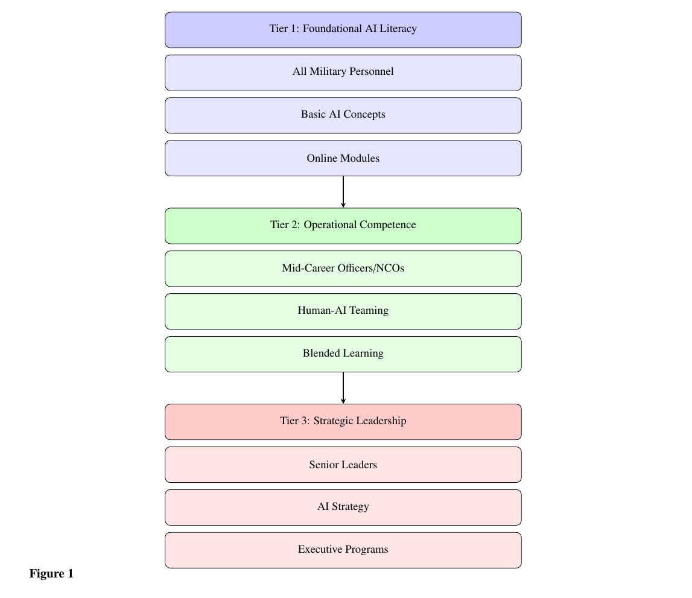
Figure 1: Three-Tiered Military AI Education Framework integrating foundational literacy for all personnel, operational competence for mid-career leaders, and strategic leadership development. This vertical, progressive approach addresses the AI skills gap across military ranks while ensuring ethical implementation.
Similarly, the examination of AI software tools requiring military training (Table 3) demonstrates the comprehensive scope of training requirements that the framework must address.
Table 3: Military AI Software Tools and Training Requirements
Software Platform | Primary Function | Key Training Requirements | Citation
Thunderforge (Scale AI) | Military planning | Multi-domain integration, scenario generation | (Harper, 2025)
Project Maven | ISR analysis | Object recognition, pattern analysis | (Requiroso, 2025)
Scale Agentic AI | Autonomous warfare | Multi-agent coordination, oversight | (Scale AI Accelerating Agentic Warfare Capabilities, n.d.)
Anduril-OpenAI | System integration | Custom model development | (Knight, n.d.)
PLA Generative AI | Intelligence analysis | Adversary AI understanding | (Insikt Group, 2025)
AI Training Systems | Personnel training | Adaptive learning, scenario generation | (Stilwell, 2020)
Digital Twin | Simulation | Virtual environment management | (Joshi, 2025)
Project Athena | Business operations | Process automation, workflow optimization | (measley, 2025)
Vehicle AI | Maintenance | Predictive maintenance, diagnostics | (Williams, 2025)
Secure Computation | Cyber operations | Encrypted data processing | (Pathak & Joshi, 2009)

The quantitative findings are summarized in Table 4 and Table 5 provide compelling evidence for the urgent need for this comprehensive framework.
Table 4: Quantitative Military AI Implementation Metrics
Metric Category | Value | Unit | Source Context
Investment | 600 | million USD | Pentagon agentic AI development (Steckler & Mayville, 2025)
Annual Savings | 42 | million USD | Defense contractor hiring pipelines (Satyadhar Joshi, 2025)
Training Cost | 8,400 | USD/participant | AI bootcamp programs (Satyadhar Joshi, 2025)
Wage Increase | 28,000 | USD/year | Post-AI training compensation (Satyadhar Joshi, 2025)
Personnel Trained | 15 | % | Feeling adequately prepared for AI (Cruickshank, 2023)
Placement Rate | 85 | % | Within 6 months of training (Satyadhar Joshi, 2025)
Skills-based Hiring | 100 | % | Projected 2030 technical fields (Satyadhar Joshi, 2025)
AI Agent Deployment | 25 | % | Enterprises by 2025 (BW Online Bureau, 2025)
AI Agent Deployment | 50 | % | Enterprises by 2027 (BW Online Bureau, 2025)
Training Time Reduction | 50 | % | With increased retention (Stilwell, 2020)
Unit Size | 2,500 | personnel | AI system testing unit (Souki, 2025)
LLM Development | 79 | models | Chinese research institutes (Zarrar & Kakar, 2024)
Cloud Professionals | 2,000,000 | personnel | Demand in India by FY25 (BW Online Bureau, 2025)
Naval Platforms | 3 | ships | AI system testing (Souki, 2025)

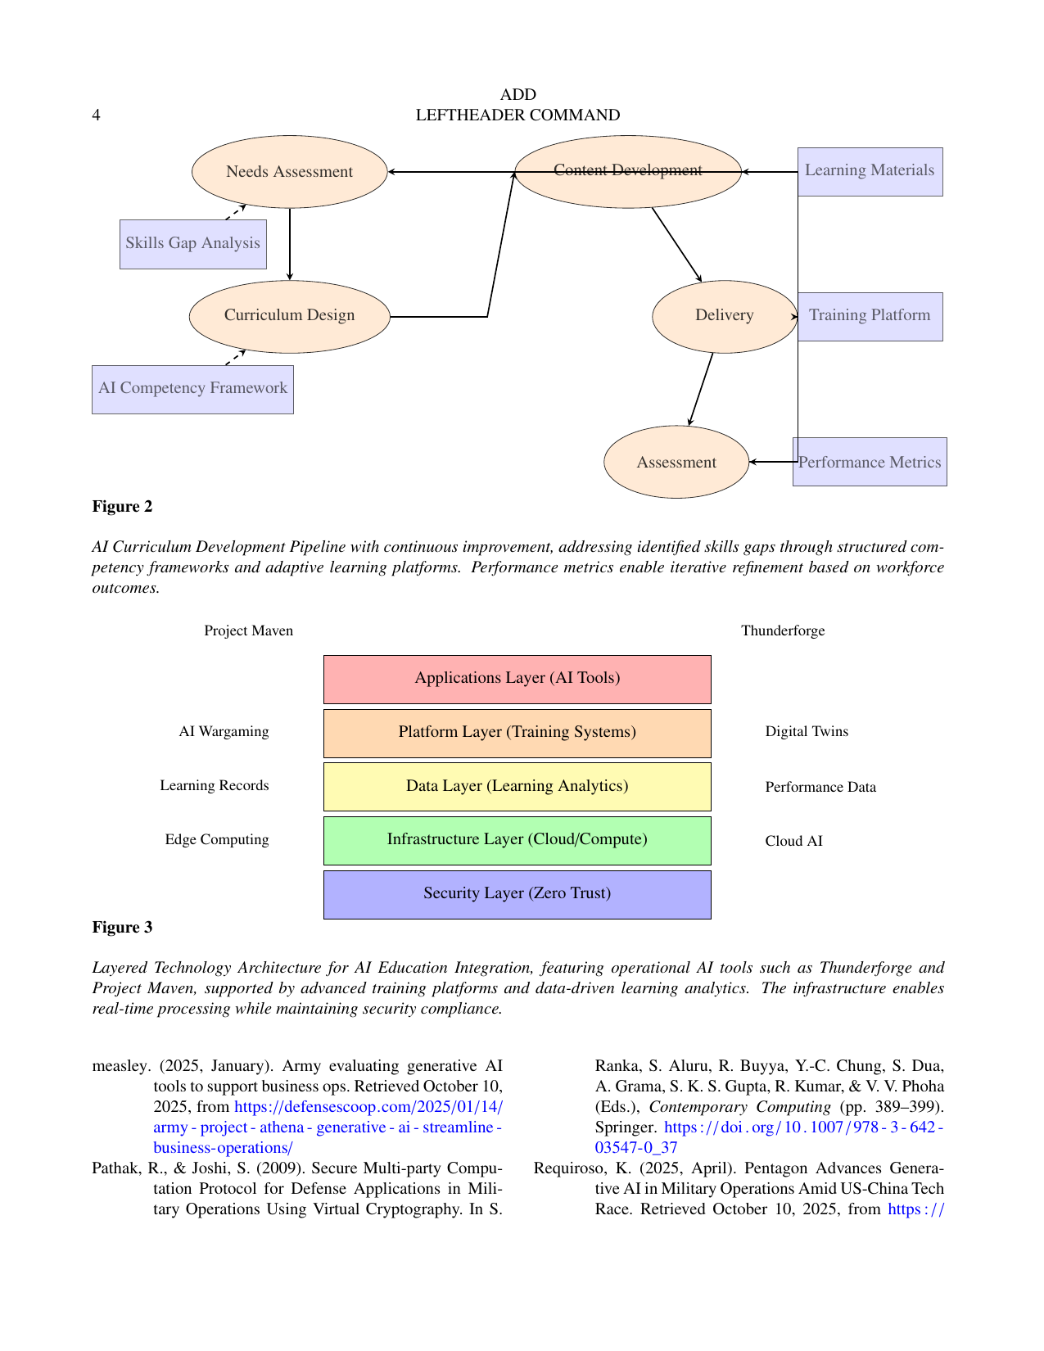
Figure 2: AI Curriculum Development Pipeline with continuous improvement, addressing identified skills gaps through structured competency frameworks and adaptive learning platforms. Performance metrics enable iterative refinement based on workforce outcomes.

3.9 Architecture Integration and Synergies
The proposed architectural framework creates synergistic relationships between its components:
- Vertical Integration: The tiered learning framework (Figure 1) aligns with career progression, while the technology architecture (Figure 3) provides the infrastructure to support each tier.
- Horizontal Coordination: The stakeholder model (Figure 5) enables resource sharing and knowledge transfer, while the assessment framework (Figure 6) ensures continuous improvement across all components.
- Temporal Alignment: The implementation roadmap (Figure 4) sequences activities to build capability progressively, with resource allocation (Figure 7) aligned with phase priorities.
- Quality Assurance: The curriculum pipeline (Figure 2) incorporates feedback mechanisms that inform all other architectural components, creating a self-improving system.
This integrated architecture addresses the comprehensive challenges identified in current military AI education, providing a scalable, sustainable framework for preparing the force for agentic AI operations. The approach leverages best practices from documented successful programs while introducing innovative elements to overcome existing limitations.

Figure 3: Layered Technology Architecture for AI Education Integration, featuring operational AI tools such as Thunderforge and Project Maven, supported by advanced training platforms and data-driven learning analytics. The infrastructure enables real-time processing while maintaining security compliance.
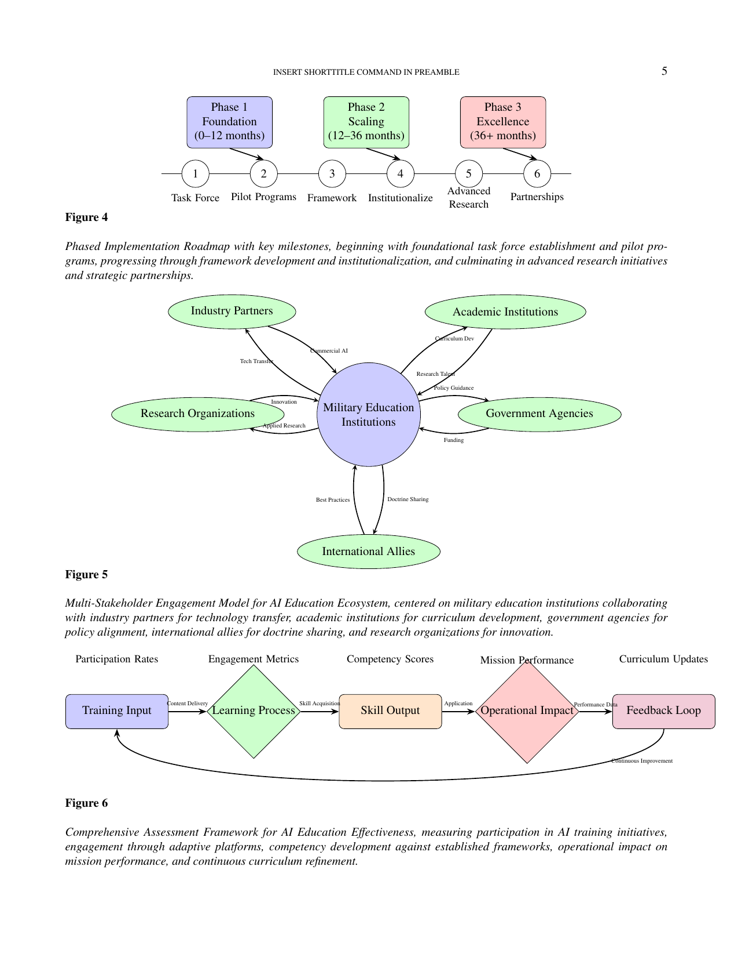
Figure 4: Phased Implementation Roadmap with key milestones, beginning with foundational task force establishment and pilot programs, progressing through framework development and institutionalization, and culminating in advanced research initiatives and strategic partnerships.

4 Proposed Educational Framework

4.1 Multi-Tiered Architecture
The proposed framework establishes a three-tiered educational architecture aligned with military career progression and operational requirements:
Tier 1: Foundational AI Literacy - Basic AI concepts and ethical considerations for all military personnel, ensuring service-wide understanding of AI capabilities and limitations.
Figure 5: Multi-Stakeholder Engagement Model for AI Education Ecosystem, centered on military education institutions collaborating with industry partners for technology transfer, academic institutions for curriculum development, government agencies for policy alignment, international allies for doctrine sharing, and research organizations for innovation.
Tier 2: Operational Competence - Human-AI teaming and system oversight for mid-career officers and NCOs, focusing on practical integration into military workflows and processes.
Tier 3: Strategic Leadership - AI strategy and policy development for senior leaders, emphasizing resource allocation, capability development, and strategic advantage.

Figure 6: Comprehensive Assessment Framework for AI Education Effectiveness, measuring participation in AI training initiatives, engagement through adaptive platforms, competency development against established frameworks, operational impact on mission performance, and continuous curriculum refinement.
This progressive structure ensures appropriate skill development at each organizational level while maintaining alignment with career progression pathways (Cruickshank, 2023).

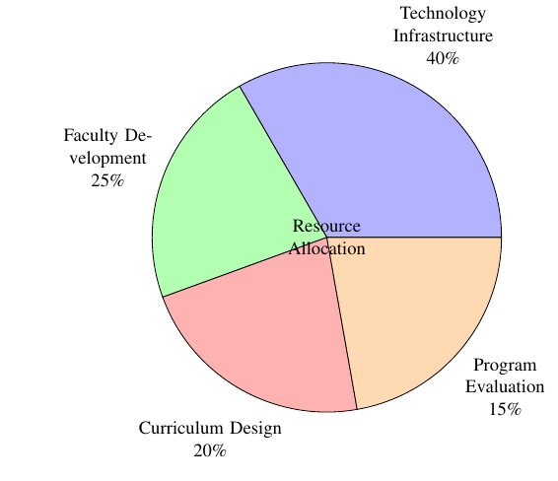
Figure 7: Proposed Resource Allocation Model for AI Education Implementation, prioritizing technology infrastructure for real-time AI systems, faculty development to address AI skills gaps, curriculum design for enhanced military learning, and program evaluation to measure workforce impact, guided by AI-ready workforce principles.

4.2 Curriculum Development and Delivery
The framework incorporates continuous curriculum development cycles based on operational feedback and technological evolution. This agile approach addresses the rapid pace of AI advancement through:
- Regular needs assessment based on skills gap analysis
- Competency-aligned curriculum design
- Technology-enhanced content delivery
- Comprehensive performance assessment
- Continuous improvement mechanisms
Delivery methods combine traditional instruction with technology-enhanced learning, including digital twins for simulation training and adaptive learning platforms for personalized skill development (Biggs, 2025).

4.3 Implementation Strategy
Implementation follows a phased approach over 24-36 months:

4.3.1 Phase 1: Foundation (0-12 months)
- Establish cross-service AI education task force
- Develop standardized competency frameworks
- Launch pilot programs for validation
- Initiate faculty development initiatives

4.3.2 Phase 2: Scaling (12-36 months)
- Expand program reach across all service branches
- Institutionalize AI education standards
- Develop advanced specialized training modules
- Establish partnership networks with academic institutions

4.3.3 Phase 3: Excellence (36+ months)
- Integrate AI education throughout career lifecycle
- Establish AI as core military competency
- Develop advanced research programs
- Expand international education partnerships

5 Quantitative Analysis

5.1 Workforce Readiness Assessment
Current research reveals significant workforce readiness challenges. Analysis indicates that only 10-15% of military personnel feel adequately trained for agentic AI integration, creating substantial capability gaps despite significant technological investments (Cruickshank, 2023).
Training effectiveness data demonstrates promising outcomes for structured programs. Intensive AI training initiatives show 85% placement rates within six months of completion, with participants realizing average wage increases of $28,000 annually (Satyadhar Joshi, 2025). These results highlight the potential return on educational investment when implementing comprehensive training approaches.

5.2 Resource Allocation and Impact
Financial analysis reveals substantial investments in military AI capabilities, with recent allocations exceeding $600 million for next-generation agentic AI systems (Steckler & Mayville, 2025). Cost-benefit assessment demonstrates that strategic investments in AI education can yield significant returns, with defense contractors realizing $42 million in annual savings through improved hiring pipelines and enhanced workforce capabilities (Satyadhar Joshi, 2025).
Training program costs average approximately $8,400 per participant for intensive 12-week AI bootcamps, with documented effectiveness in rapidly developing critical technical competencies. These programs demonstrate the feasibility of scalable workforce development when implementing evidence-based educational approaches (Satyadhar Joshi, 2025).
Table 5: Quantitative Military AI Implementation Metrics
Metric | Value | Source
AI Investment | $600M | (Steckler & Mayville, 2025)
Personnel Readiness | 10-15% | (Cruickshank, 2023)
Training Placement Rate | 85% | (Satyadhar Joshi, 2025)
Annual Wage Increase | $28,000
Training Cost | $8,400
Annual Contractor Savings | $42M

6 Technical Considerations

6.1 Security and Implementation
Secure implementation of AI systems requires robust technical frameworks. Research in secure multi-party computation protocols demonstrates approaches for maintaining data privacy while enabling collaborative AI operations across military organizations (Pathak & Joshi, 2009). These security considerations are particularly critical for agentic AI systems operating in contested environments.
Technical architecture must incorporate layered security approaches, including encryption protocols, access controls, and continuous monitoring mechanisms. These measures ensure system integrity while maintaining operational flexibility across diverse military contexts (Joshi, 2025).

6.2 Ethical and Governance Frameworks
Agentic AI implementation necessitates comprehensive ethical guidelines and governance structures. Research emphasizes the importance of explainable AI components, human oversight mechanisms, and accountability frameworks to ensure responsible deployment (Joshi, 2025). These considerations are particularly critical for autonomous systems operating in complex military environments.
International cooperation plays a vital role in establishing normative frameworks for military AI use. Collaborative efforts seek to balance technological advancement with ethical considerations and legal obligations under international humanitarian law (Wilner & Atkinson, 2025).

7 Conclusion and Recommendations
The integration of agentic AI into military operations represents both an unprecedented opportunity and a formidable challenge that demands immediate and systematic action. Our comprehensive analysis reveals a critical disconnect between substantial technological investments—exceeding $600 million in next-generation AI capabilities—and workforce readiness, with only 15% of military personnel feeling adequately prepared for agentic AI integration. This gap underscores the urgent need for fundamental transformation across military education systems.
The proposed multi-tiered educational framework addresses this imperative through structured progression from foundational AI literacy to operational competence and strategic leadership. By aligning educational objectives with career progression and operational requirements, the framework ensures appropriate skill development at each organizational level. The integrated architecture—encompassing curriculum development pipelines, technology infrastructure, stakeholder engagement models, and assessment mechanisms—provides a comprehensive approach to workforce transformation.

7.1 Key Findings and Implications
Our research yields several critical insights with far-reaching implications for military education and force development:
- Skills Gap Magnitude: The 15% readiness rate among military personnel indicates a substantial gap that could undermine the significant technological investments in AI systems. This disparity threatens to create a scenario where advanced capabilities outpace the workforce’s ability to effectively employ them.
- Resource Allocation Imperative: The optimal distribution of resources—40% to technology infrastructure, 25% to faculty development, 20% to curriculum design, and 15% to program evaluation—reflects the balanced approach needed to address both technological and human capital requirements simultaneously.
- Continuous Learning Necessity: The rapid evolution of AI technologies, evidenced by projections showing 50% enterprise deployment of AI agents by 2027, necessitates continuous education models rather than traditional one-time training approaches.
- Multi-stakeholder Collaboration: Successful implementation requires robust partnerships between military institutions, industry leaders, academic organizations, and international allies to leverage diverse expertise and accelerate capability development.

7.2 Strategic Recommendations
Based on our analysis, we recommend the following actionable strategies:

7.2.1 Immediate Priorities (0-6 months)
- Establish Cross-Service AI Education Task Force: Create a dedicated organization with representation from all military branches to coordinate AI education initiatives and standardize competency frameworks.
- Conduct Comprehensive Skills Gap Analysis: Implement systematic assessment of current workforce capabilities against projected AI integration requirements to identify specific training needs.
- Launch Faculty Development Programs: Initiate urgent upskilling of military educators and instructors to build the foundational expertise required for AI curriculum delivery.
- Develop AI Education Standards: Create standardized competency frameworks and certification requirements to ensure consistent quality across military education institutions.

7.2.2 Medium-Term Initiatives (6-24 months)
- Implement Tiered Education Framework: Roll out the progressive learning architecture across all professional military education institutions, ensuring alignment with career progression pathways.
- Establish AI Certification System: Develop comprehensive credentialing programs that recognize and validate AI competencies across military occupational specialties.
- Deploy Digital Training Infrastructure: Implement the layered technology architecture to support scalable, secure AI education delivery across distributed learning environments.
- Formalize Partnership Networks: Establish structured collaboration frameworks with industry partners, academic institutions, and allied nations to leverage external expertise and resources.

7.2.3 Long-Term Vision (24+ months)
- Integrate AI Throughout Career Lifecycle: Embed AI education as a continuous requirement across all career stages, from accession through senior leadership development.
- Establish AI as Core Military Competency: Institutionalize AI literacy as a fundamental requirement parallel to traditional military skills like leadership and tactics.
- Develop Advanced Research Programs: Create dedicated AI research initiatives within military education institutions to drive innovation and maintain technological advantage.
- Expand International Education Partnerships: Build global AI education networks to facilitate doctrine development, interoperability, and shared learning.

7.3 Concluding Perspective
The successful integration of agentic AI into military operations transcends technical implementation—it represents a fundamental transformation in how military personnel think, decide, and operate. As Joshi (Joshi, 2025) emphasizes, "successful military implementation of Agentic AI requires robust testing methodologies, explainable AI components, and ethical governance mechanisms." These elements must be embedded throughout military education to ensure the US maintains its competitive advantage.
The rapid pace of AI advancement, demonstrated by the projection that 50% of enterprises will deploy AI agents by 2027, necessitates immediate action. The window for proactive adaptation is closing rapidly, and delayed investment in human capital could render technological investments less effective or even counterproductive.
By embracing comprehensive educational transformation, the US military can position itself not merely as an adopter of agentic AI, but as an innovator and leader in human-AI collaboration. This approach will ensure mission success in an increasingly complex and technologically advanced battlespace while maintaining the ethical foundations and strategic oversight required for responsible AI deployment.
The time for incremental change has passed. The era of agentic AI demands bold, comprehensive transformation of military education to build the force capable of dominating future conflicts through superior human-machine teaming and strategic innovation.
Future research should focus on validating the framework's efficacy through more focused and longitudinal studies and adapting it to the evolving contemporary tactical applications as needed.

Declaration
This work is exclusively a survey paper synthesizing existing published research. No novel experiments, data collection, or original algorithms were conducted or developed by the authors. All content, including findings, results, performance metrics, architectural diagrams, and technical specifications, is derived from and attributed to the cited prior literature. The authors’ contribution is limited to the compilation, organization, and presentation of this pre-existing public knowledge. Any analysis or commentary is based solely on the information contained within the cited works. Figures and tables are visual representations of data and concepts described in the referenced sources.

Disclaimer
This paper is an extended version of a preprint /repository/ Thesis document of the same author.
The preprint /repository/ Thesis document is available in this link: doi:10.20944/preprints202510.1034.v1
[As per journal policy, preprint /repository article can be published as a journal article, provided it is not published in any other journal]

Disclaimer (Artificial intelligence)

Author(s) hereby declare that generative AI technologies such as Large Language Models, etc. have been used during the writing or editing of manuscripts. This explanation will include the name, version, model, and source of the generative AI technology and as well as all input prompts provided to the generative AI technology

Details of the AI usage are given below:
1. Proof Reading
2. Validating References

References

- Biggs, A. T. (2025). Enhancing Professional Military Education with AI: Best practices for effective implementation. Journal of Military Learning. https://www.armyupress.army.mil/Journals/Journal-of-Military-Learning/Journal-of-Military-Learning-Archives/JML-April-2025/Enhancing-pme-with-ai/
- BW Online Bureau. (2025). The Necessity For Upskilling And Reskilling In An Agentic AI Era. BW People. https://www.bwpeople.in/article/the-necessity-for-upskilling-and-reskilling-in-an-agentic-ai-era-557843
- Cruickshank, I. (2023). An AI-ready military workforce. Joint Force Quarterly, 110. https://ndupress.ndu.edu/Media/News/News-Article-View/Article/3449468/an-ai-ready-military-workforce/
- Cummings, M. L. (2024). Human-AI Teaming in Defense Operations: Challenges and Opportunities. RAND Corporation.
- Harper, J. (2025). Combatant commands to get new generative AI tech for operational planning, wargaming. In DefenseScoop. https://defensescoop.com/2025/03/05/diu-thunderforge-scale-ai-combatant-commands-indopacom-eucom/
- Insikt Group. (2025). Artificial eyes: Generative AI in China’s military intelligence [Research Report]. Recorded Future. https://www.recordedfuture.com/research/artificial-eyes-generative-ai-chinas-military-intelligence
- Joshi, S. (2025). Agentic Generative AI and National Security: Policy Recommendations for US Military Competitiveness SSRN. Social Science Research Network. https://doi.org/10.2139/ssrn.5529680
- Knight, W. 2025. OpenAI Is Working With Anduril to Supply the US Military With AI. Wired. Retrieved September 24, 2025, from https://www.wired.com/story/openai-anduril-defense/
- measley. (2025). Army evaluating generative AI tools to support business ops. In DefenseScoop. https://defensescoop.com/2025/01/14/army-project-athena-generative-ai-streamline-business-operations/
- Pathak, R., & Joshi, S. (2009). Secure Multi-party Computation Protocol for Defense Applications in Military Operations Using Virtual Cryptography. In S. Ranka, S. Aluru, R. Buyya, Y.-C. Chung, S. Dua, A. Grama, S. K. S. Gupta, R. Kumar, & V. V. Phoha (Eds.), Contemporary Computing (pp. 389–399). Springer. https://doi.org/10.1007/978-3-642-03547-0_37
- Requiroso, K. (2025). Pentagon Advances Generative AI in Military Operations Amid US-China Tech Race. In eWEEK. https://www.eweek.com/news/pentagon-generative-ai-military-operations/
- Satyadhar Joshi. (2025). The Impact of AI on Veteran Employment and the Future Workforce Development: Opportunities, Barriers, and Systemic Solutions. World Journal of Advanced Research and Reviews, 27(2), 328–341. https://doi.org/10.30574/wjarr.2025.27.3.3147
- Scale AI Accelerating agentic warfare capabilities. 2025. Retrieved September 24, 2025, from https://scale.com/agentic-warfare
- Scharre, P. (2023). Four Battlegrounds: Power in the Age of Artificial Intelligence. W. W. Norton & Company.
- Souki, N. E. (2025). Pentagon’s New Gen-AI Can Analyze War but Doesn’t Understand War. In Inside Telecom. https://insidetelecom.com/us-uses-generative-ai-military-applications/
- Steckler, J., & Mayville, R. (2025). Emerging tech & american isolationism: Consequences for AI, drone, and space launch technologies [Research Report]. Belfer Center for Science; International Affairs. https://www.belfercenter.org/sites/default/files/2025-07/DETSP_EmergingTech-AmericanIsolationism_v1-02.pdf
- Stilwell, B. (2020). How the Army and Air Force Integrate AI Learning Into Combat Training. In Military.com. https://www.military.com/military-life/how-army-and-air-force-integrate-ai-learning-combat-training.html
- Williams, L. C. (2025). The Army wants AI to aid in vehicle repairs. In Defense One. https://www.defenseone.com/defense-systems/2025/08/army-wants-ai-aid-vehicle-repairs/407645/
- Wilner, A., & Atkinson, R. (2025). Artificial intelligence and national defence: A strategic foresight analysis (CIGI Paper 316). Centre for International Governance Innovation. https://www.cigionline.org/publications/artificial-intelligence-and-national-defence-a-strategic-foresight-analysis/
- Zarrar, H., & Kakar, S. A. (2024). Generative Artificial Intelligence its Military Applications by the US and China – Lessons for South Asia. Journal of Computing & Biomedical Informatics. https://jcbi.org/index.php/Main/article/view/494
- Hosseini, S., & Seilani, H. (2025). The role of agentic ai in shaping a smart future: A systematic review. Array, 100399.
- Flournoy, M. A. (2023). AI is already at war: How artificial intelligence will transform the military. Foreign Aff., 102, 56.

